Sheila Vyas
Susie Wise
Project Milestone 1
November 4, 2004
Art Table Interface Design
ABSTRACT
The Art Table is a tangible interface for museum multimedia content. It is designed to engage social groups (dyads and triads of adults and children). Both our observation and research has shown that the museum experience is usually a social one, but unfortunately most multimedia content is designed for single user interfaces. The Art Table allows groups to explore multimedia content together to enhance the educational impact of their visit. The table-based interface will be tested with CS147 study participants and museum visitors at SFMOMA (where we derived the content).
TASK ANALYSIS
The users of our interface are SFMOMA museum visitors. We are targeting family groups. Currently there are separate activities for adults and children in the learning lounge. In general visitors come to the learning lounge as social groups and seeking more information about the art work they have seen in the galleries. They can either turn to the numerous books and exhibition catalogues in the lounge area or use the educational multimedia program. The program “Making Sense of Modern Art” provides artist videos, art work comparisons, and timelines. None of the media or the interfaces are targeted to children or families. Media use can prompt new or continued conversations.
IDEATION
We brainstormed a range of interactions for social groups in an art museum:

- Wall-size time-line with gesture to navigate
- Wall-size “make your own gallery”
  - Users can juxtapose digital representations of works in different ways
- Use RFID to tag favorite works or works for which you want more content later
- Take something from the galleries to a social space
  - Track your visit, map your visit
- Add social spaces to galleries
  - Couches with tablets so you can be social and get info at same time
- Sketch in the galleries
  - Introduce different art supplies (virtual and real) on different days
- Book mark items using handheld that you want
- Talking statues in galleries
- Talking statues in bathrooms
- Touch artworks with haptics
  - Everyone wants to touch the artworks, but the guard is always watching… now you can with haptics
- Take artist in your pocket
  - Handhelds with video content
- Pick up a “theme wand” when you enter museum
  - Different artworks trigger themes that can be followed
- Kids lead parents
- Scavenger hunt

Pictures of first prototype
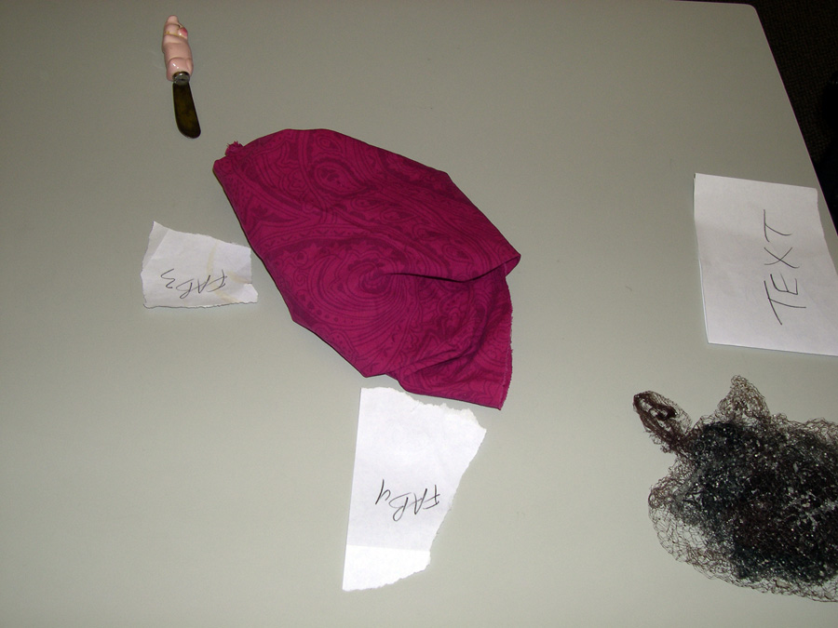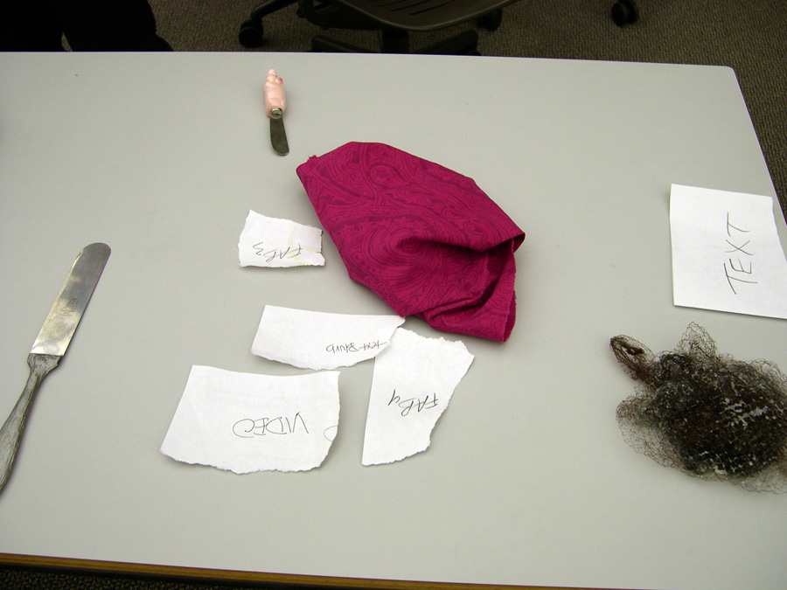
One tool placed on table Brings up related artworks

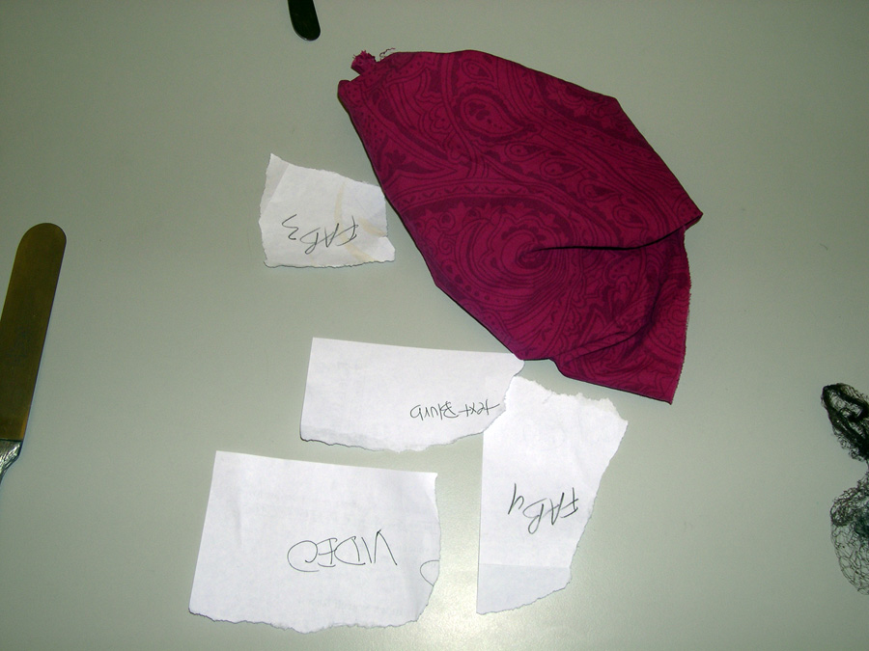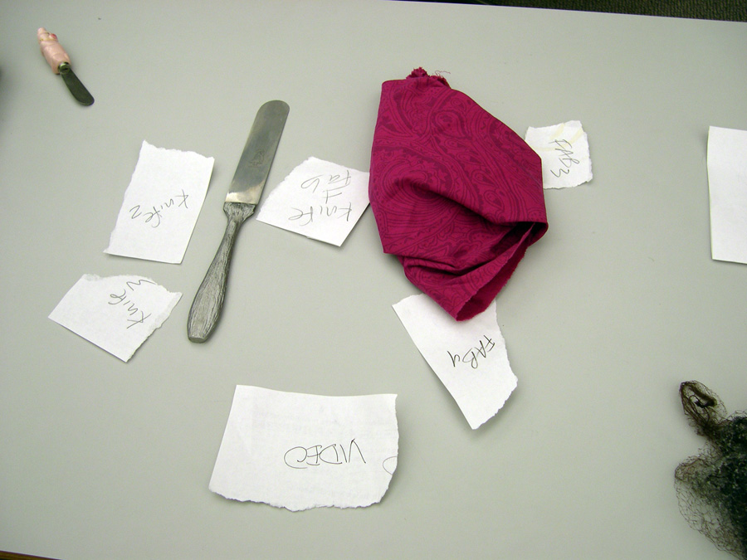
Dive deeper artist’s picture shows Place another tool – related paintings move to center

Additional sketches attached to hard copy handed in in class.
EVIDENCE
Observing social groups at SFMOMA we discovered that family groups were being particularly poorly served by the educational multimedia. We saw several families where the kids were at the computers, begging the parents to manipulate the adult-centric interface for them. Families looking for something child-friendly were also offered an area to play with blocks, but then were missing out on the artist videos. Our solution seeks to build an interface that will appeal to children’s tactile orientation and introduces both them and their parents to multimedia content.

Additionally, we determined that a table was appropriate because museum-goers often crave a place to sit down after walking and standing for long periods of time in the galleries. Finally, making the interface tangible reverses the frustration visitors have at being in an art museum where everything says “don’t touch.”
FURTHER EVIDENCE
We have tested our first paper prototype with two groups of CS147 students. In general we found that they liked the idea of using tangible objects to reveal rich multimedia content. However, there were some interface concerns were identified that we will look at for our next iteration
- At what point does the table reset when the tool have been lifted from the table
- The varying levels of abstraction of the tools caused some confusion as to how they related to the artworks
- What happens when a lot of people are working on table? When lots of people are selecting things and when things get knocked from table
- What happens when someone else selects a new item while a video is playing

Initial User Study
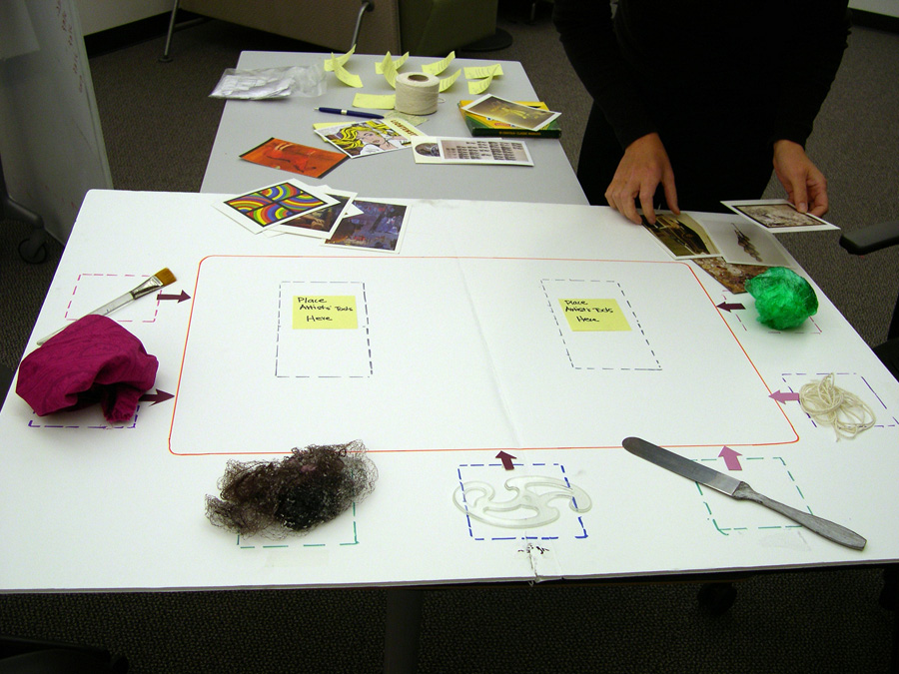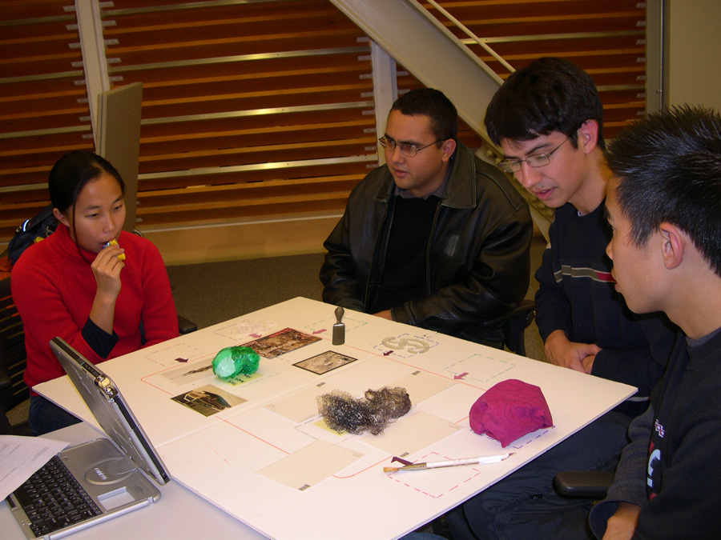
Paper prototype table setup Group 1 using table prototype

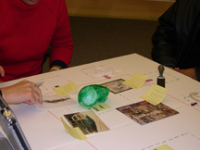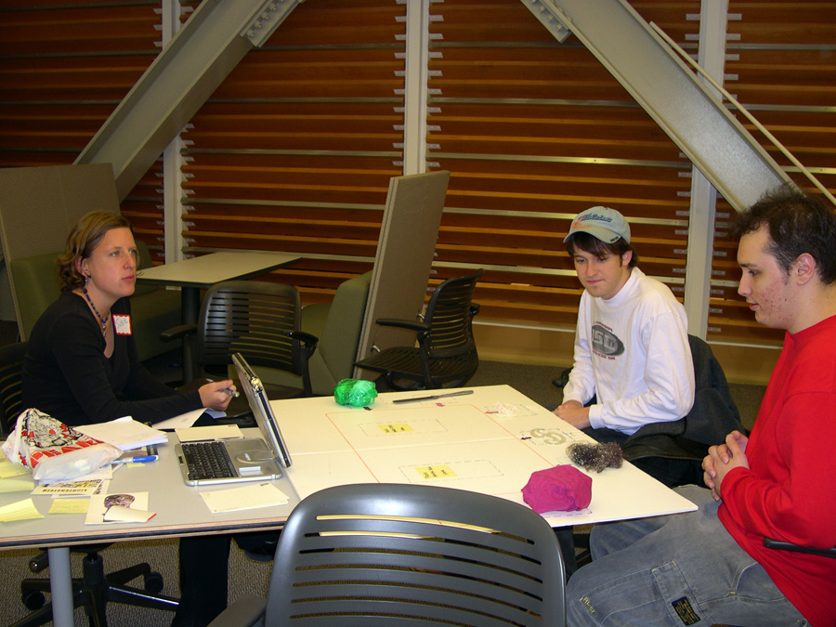
Group 1 interacting with prototype Group 2 using table prototype
EVALUATION PLAN
Our initial test plan is attached as Appendix A. We would like to get feedback on it from Scott or Ron.

We will continue to work on the prototype and are hoping to use the Diamond Touch set up for a more refined test. We have scheduled a second round of testing with CS147 students and have also arranged to test the prototype with staff and visitors at SFMOMA.

User Study Art Interaction Table
Phase 1, 11/3/2004

Susie and Sheila conduct test as a pair:
- One person is facilitator and computer
- One person is observer and note taker

Users:
- 2 groups of 3 people each
- Students from CS147

Questions we want to investigate:
- Is the Art Table perceived as a compelling, multi-user interface for the museum?
- Do users know that they can add objects to the table?
- Does it work allowing only 2 objects on the table?
- Do get a synthetic picture at the end?

Test principles:
- Low-fi test, not concerned with real content at this point
- What do you users say that we weren’t even thinking about?

Test matrix:
Table State/Action | Prompt/Question
 | We’re going to show you a very rough prototype and as much as you can we’d like you to think out loud. What do see? What does it make you think? Etc. There are no right and wrong answers. Just keep saying what you are thinking
SET UP | You are a group of friends. You don’t have much homework this weekend so you decided to go together to SFMOMA. You’ve been looking at art and you’ve just walked into an education area/lounge. Your feet are tired so you sit down. After a minute you notice that the table has a screen on it. You decide to check it out.
Art material tools on the table
(foam core prototype)

 | What do you think you can do here?
Point out the tools
 | What do you think these are for?
If I told you could use those (the art tools)…
 | What can you do with them?
Try moving an object into the center
 | What do you expect to happen?
Artworks into center with objects
Text blurb shows with each artwork
 | What do you think?
 | What can you do now?
Artwork clicked
Video triggered

Artist picture shows up next to text blurb
 | What can you do?
2nd object added to table
Artworks into center with objects
Text blurb shows with each artwork
Artwork with shared keyword has 2 text blurbs
Artwork from earlier state moves to new shared area
We can stop there | Thoughts?
If you were to describe this to someone else what would say it does?

Did it seem like something that made sense to do together as a group?

Could you ever imagine sitting down at a table like this?

What would you like to see work differently?

We had an idea that it’d be interesting if you could pick the trigger objects up in the gallery. Could you imagine that? When would you do it?

