Collaborative Learning with the Diamond Touch Table
Anne Marie Piper and Merrie Morris
Project Milestone 1

ABSTRACT
We plan to design a table top interface to facilitate small group learning activities within the context of Spanish language learning. The application allows students to apply knowledge of vocabulary and grammar as well as practice listening skills. Students need to practice both written and oral skills to become fluent in a foreign language. The table top interface serves as a medium for small group collaboration. It displays multimedia objects (text, audio, pictures) and provides users with various forms of feedback based on their manipulation of the objects. Since feedback plays an integral role in the learning process, we plan to study how different methods of presenting feedback affect small group collaboration. We will investigate how different modalities (visual, private audio, public audio) affect participation, communication, accuracy, and speed of completion for a small group learning exercise.

TASK ANALYSIS
Our user group consists of Spanish language learners who are primarily native English speakers. Users vary in written and oral abilities, but all have received at least one year of formal Spanish education or are currently enrolled in a Spanish class. Beginner and intermediate Spanish classes often have students participate in small group exercises to practice vocabulary and grammatical knowledge. Understanding language mechanics and developing vocabulary are only initial stages in learning a foreign language. The challenge is applying this knowledge to understand complex written sentences and spoken language.

It is challenging to create small group activities that allow students to apply grammar and vocabulary in a way that strengthens both written and oral skills. Even well designed activities require instructor feedback to guide student conversations and correct misunderstandings. Feedback as to whether or not information was correctly translated and interpreted is critical to the student’s learning process.

The current structure of small group activities is constrained by classroom resources (e.g. one teacher giving feedback, content from books or instructional materials, single user computing spaces). The technology we propose allows learners to work cooperatively with their peers to practice vocabulary, grammar, and listening skills. Typical feedback from an instructor in small group settings happens in a synchronous fashion. Our system allows multiple students to simultaneously read Spanish text, listen to Spanish audio, and receive feedback while collaboratively solving a problem.

IDEATION
Our ideas focus on using the table top display to achieve a learning goal. We need to design an interface and task so that collaboration around the table can be evaluated from both an HCI and learning perspective.

Initially we thought about creating a distributed knowledge task where each of the four users would receive private clues via audio and public clues on the table top interface. Group members would have to cooperatively share knowledge to solve a task (e.g. murder mystery, digital version of Clue board game).

Another idea was to investigate how rotating and annotating images on the table top display affects spatial cognition. We thought about doing this in the domain of map learning. With physical maps, learners often rotate and annotate to understand spatial representations. Investigation of an interface to support this map learning activity would illustrate the table’s affordances for learning, but may not be of sufficient depth for an HCI research project.

Our final idea is to create an application to support collaborative language learning, similar to magnetic poetry. We chose Spanish as the language topic. Currently, we are exploring many variations of small group tasks that would help us understand the affordances of table top interfaces for learning. Those ideas are described in detail in the appendix.

After much brainstorming and ideation, we decided to design an interface and task that will illustrate how feedback affects small group collaborative learning with a table top display.

EVIDENCE
Educational research shows that feedback is a critical part of any learning process. It is through feedback that learners know if they reached success or an error. Feedback that indicates whether an answer is correct or incorrect is important, but this binary response is only a starting point for achieving complete understanding. Working in small groups becomes valuable when a learner encounters a misunderstanding. Other group members are available to share knowledge and offer explanations. We plan to examine how various types of feedback affect task completion and group communication patterns in order to maximize the benefits of learning in small groups around a shared interface.

FURTHER EVIDENCE
In the future we want to evaluate the effects of presentation of individual contributions on group work. We are curious as to how presentation of accuracy statistics and individual contribution levels affect small group collaboration. Social dynamics often vary from the physical world when technology mediates interaction. First we must determine the effects of various types of feedback on small group collaborative learning tasks through this study. Findings from this study will then guide our investigation of how feedback on progress by other group members affects team dynamics.

EVALUATION PLAN
We plan to evaluate our hypotheses through several methods. First, we will collect data through observations of user testing sessions and log data about each user’s interactions with the table. Second, we will collect user feedback from questionnaires that address participation in the task and communication with team members based on the various forms of feedback.

We will hold at least four user testing sessions with four participants each. The sessions will last an hour each and include a Spanish learning task that provides feedback under one of four conditions: no feedback, (public) visual, private audio, public audio. All testing sessions will begin with the no feedback condition and then present tasks with the other forms of feedback in random order. Before each session begins, we will encourage participants to work together to solve the task and to speak in Spanish as much as possible.

APPENDIX – IDEATION

Popup Menu for Objects
One of the first design decisions we needed to address is functionality of objects on the table. If applicable to the learning task, we want users to be able to modify word objects (e.g. conjugate verbs, change gender of nouns). Currently, word modification options pop up radially. We need to compare this format’s usability with an ordered list of options. It is also important for objects to link with each other (words to words and words to pictures). This option could be available with a pop up menu as well.

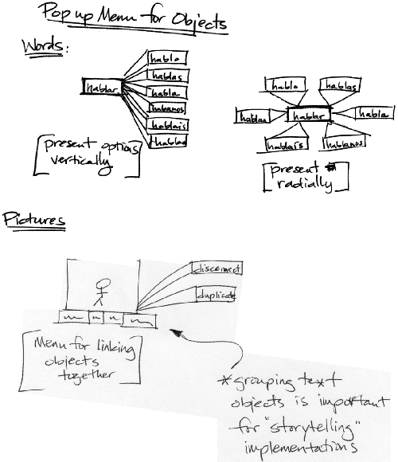

Sentence Interface
Our interface design is strongly influenced by the task we choose for investigating small group collaboration. One task we thought about for is to simply have participants create Spanish sentences and share them with other people at the table. This layout has a communal area in the center of the table as well as four individual workspaces. All objects reorient to the person who touched them last if in the communal area or to the owner of the workspace if within those boundaries. Dashed boundaries are not visible on the interface.

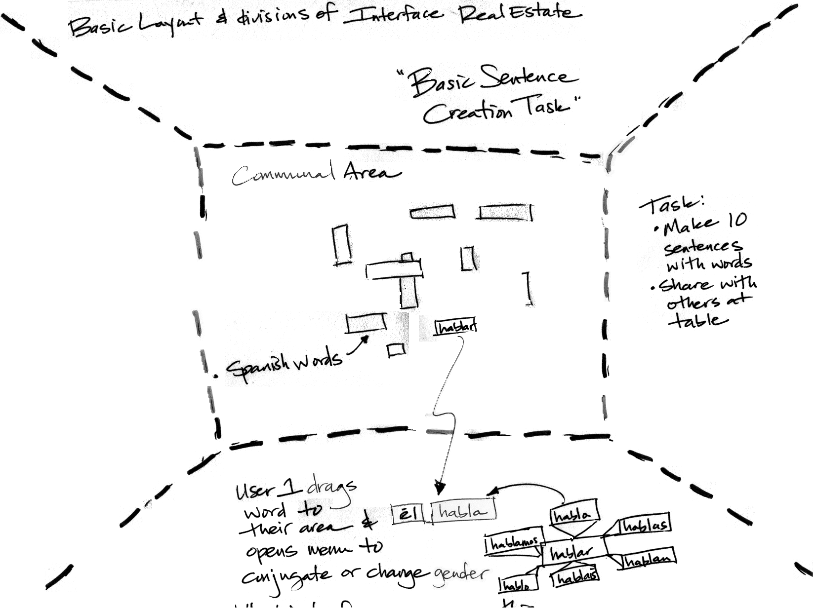

Comic Interface
An extension of the basic sentence creation task is to have users create comic strips to tell short stories. This interface also provides functionality to link pictures and text, and then store the grouped items in a comic template. The comic strip task makes moving groups of objects at the same time an essential design feature. Other versions of tasks that would require a similar interface design is collaborative storytelling. This task could require each person to add to a group story or add on to another person’s story.

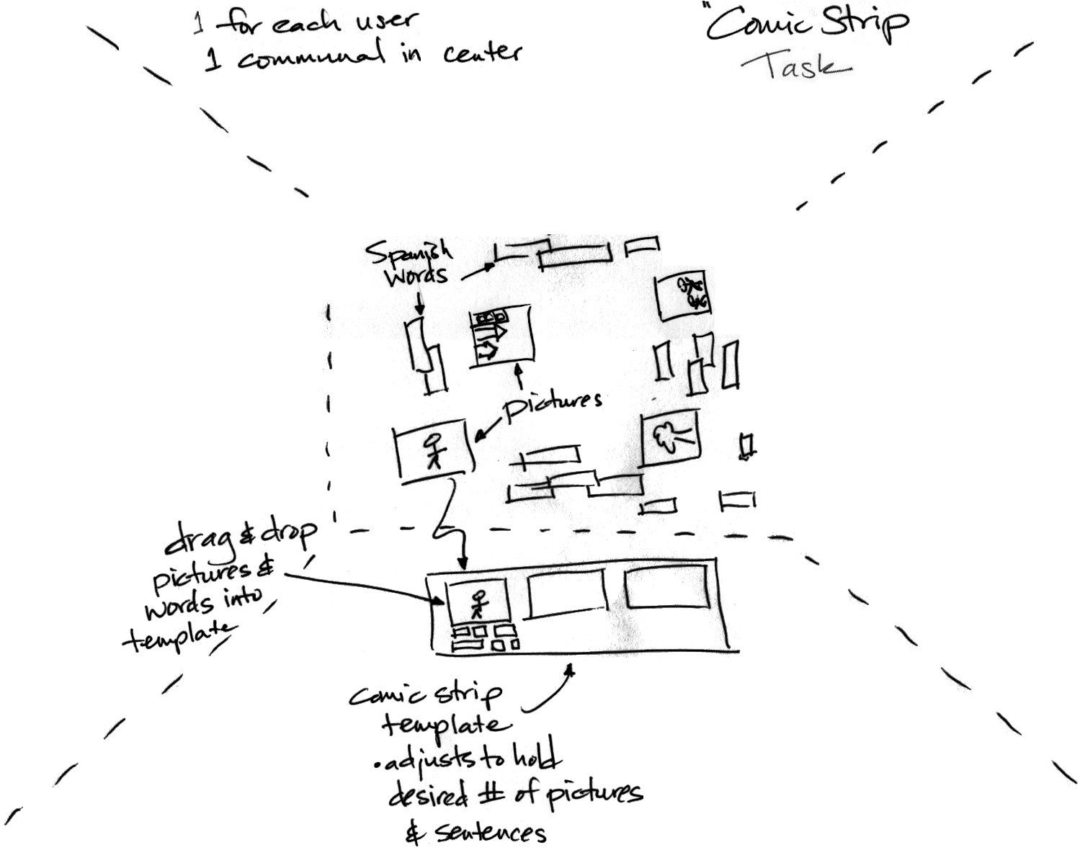

Sorting Task Interface
This interface is designed to support a group of four learners participating in a sorting task. Users sort items by placing them in “buckets.” Each bucket is visibly sectioned off from other interface areas. The system gives feedback as to whether or not the object was placed in the correct bucket. Feedback could be presented in various forms. Here we show an object flashing when placed incorrectly in bucket 3. We thought about having users sort text and picture objects that relate to different vocabulary topics (i.e. home, family, food, clothing, etc). All objects orient to face the owner of the space in which they reside.

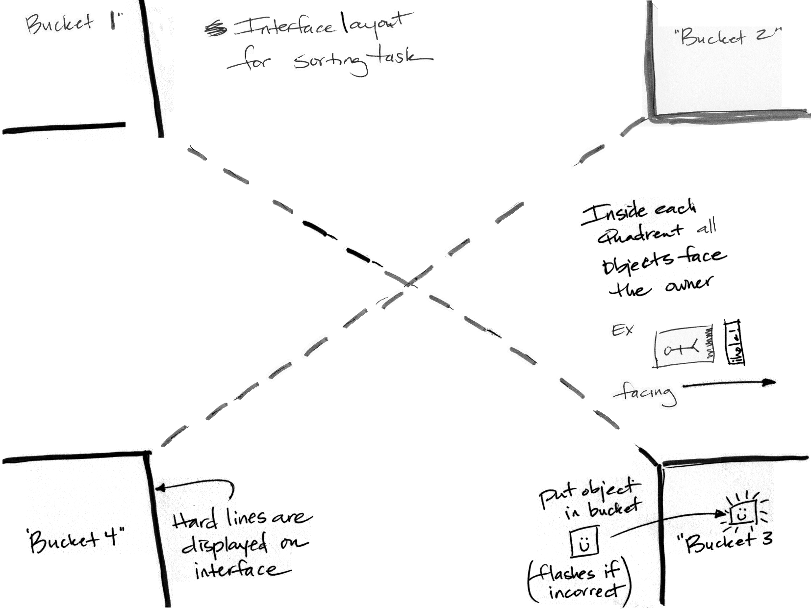

Forms of Feedback
The main goal of our system is to create a medium to support small group collaborative tasks. Part of supporting those tasks is learning which type of feedback affects learning positively and which type has negative effects. To do this we will vary the mode in which feedback is presented. Below are some ideas for manipulating the delivery of visual and auditory feedback.

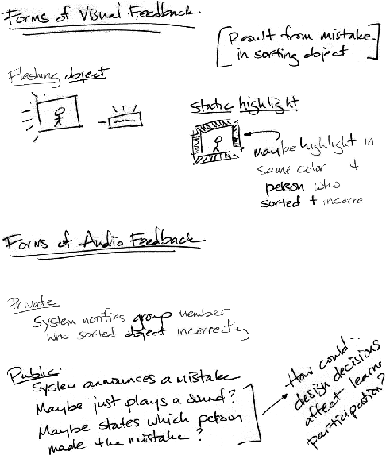
Country Sorting Task
Our most recent and well developed idea is the result of the above iterations. The task is to have users complete a sorting task with objects that relate to specific Spanish speaking countries. Objects will be short pieces of text and images with audio. In this interface an object will orientate to the user who last touched it. The areas for each country will be visibly sectioned off, so users know exactly where to place an object (top two divisions near Mexico and Cuba exist, but did not scan).



