
NightOwl
Get help now.

CS194H

Final Report

Griffin Dietz - Lachlan Green - Evan Nixon - Priyanka Rao - Zara Saraon

Problem Description
College students working late the night before an assignment is due often find themselves desperate for help, but unable to find it. Occasionally, students have friends in the class who they can work with, but more often than not those friends are either at a different place in the assignment, too far away, asleep or otherwise unavailable. Current methods for getting help, like Piazza or office hours, fail to solve this problem. Piazza is great for asking one off questions days in advance, but is little help when students want to check answers or work through problems, and may be no help at all late the night before an assignment is due. Office hours is more helpful for working through assignments, but is similarly unhelpful the night before something is due when TAs and professors are asleep or unavailable. Students are therefore left with no way to get help when they need it most, even though there are almost certainly many students around campus also in need of help on the assignment who would be interested in collaborating.

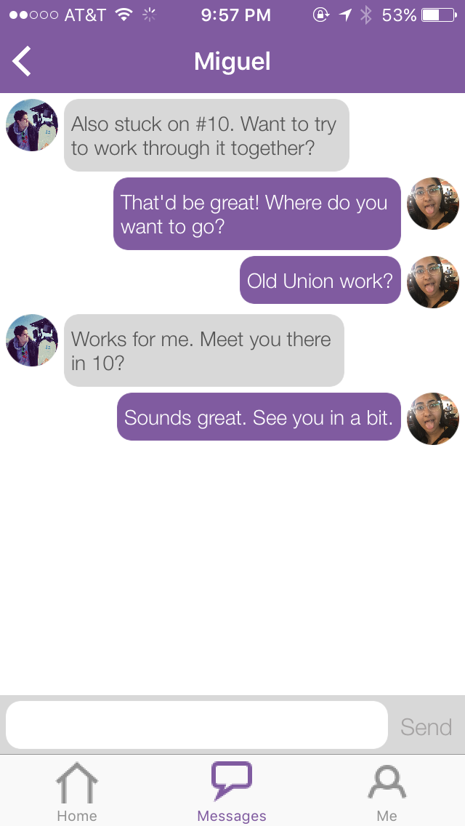
Solution Overview
NightOwl is an iPhone app that helps students find classmates who are awake, nearby, working on the same thing, and also interested in collaborating. This allows students to get help now. NightOwl allows students to make themselves available for any class they are enrolled in, and then presents them with a list of peers who are currently working on assignments in that class. That list of peers is then ordered by proximity in relation to the user’s location. Students can message those peers through the app, meet up with them, and collaborate on work.

Tasks
We created three tasks for users to perform in testing.

Task 1: Update list of current classes and set a new profile picture (Simple)
In this task, a user selects the Me tab to view their profile and sets up their class list and profile picture. When the + button is tapped, they are taken to a list of courses sourced from ExploreCourses. A search bar is present on this screen to help narrow down the search. Tapping a class adds it to the list of enrolled classes and returns the user to the previous page. In order for the user to get help in a specific class, they need to first update their class list on the app. We included setting a profile picture as part of this task because it is needed for users to recognize and meetup with each other.
Task 2: Become available/write a status (Medium)
Once a user has updated her list of current classes, she needs to decide which classes to get help on and indicate how far they are on the assignment. To do this, she first needs to navigate from the Me tab in the previous task back to the Home tab. There, she will edit her location, select multiple classes from her class list, and enter her status for each class. We decided that the user should not be able to become available for a class until a status is entered because a status allows for more useful interaction between users and helps add character to the app.
Task 3: Reach out to classmates (Complex)
Now that the user has decided what classes she needs help on, she must see who is nearby and at a similar place as she is in the assignment. She then reaches out to those people. From the home tab, tapping on the right arrow button brings the user to a list of classmates sorted by class and distance from the user. The user’s profile picture and status is shown and tapping on one of the other users in the list brings up a message screen through which the user can send a message.

Task Flows

Task 1: Update list of current classes and set a new profile picture (Simple)
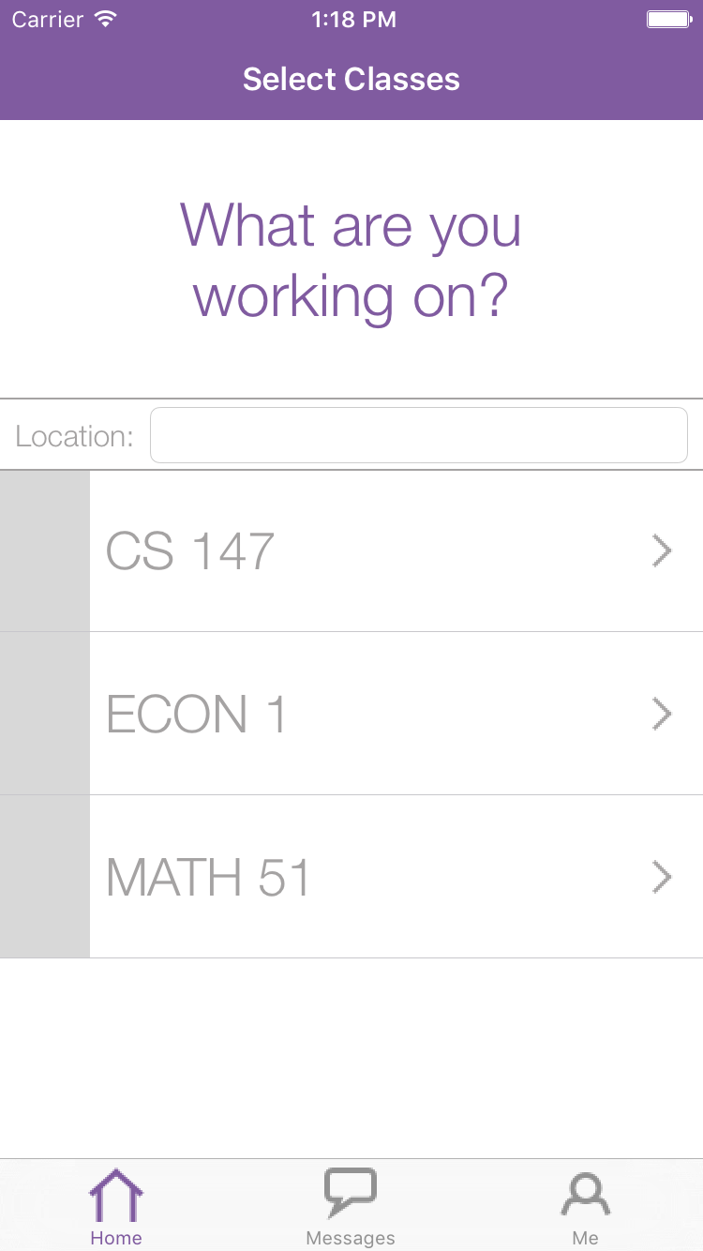
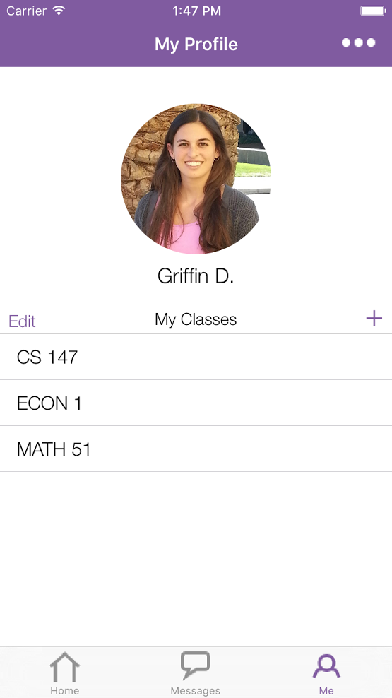
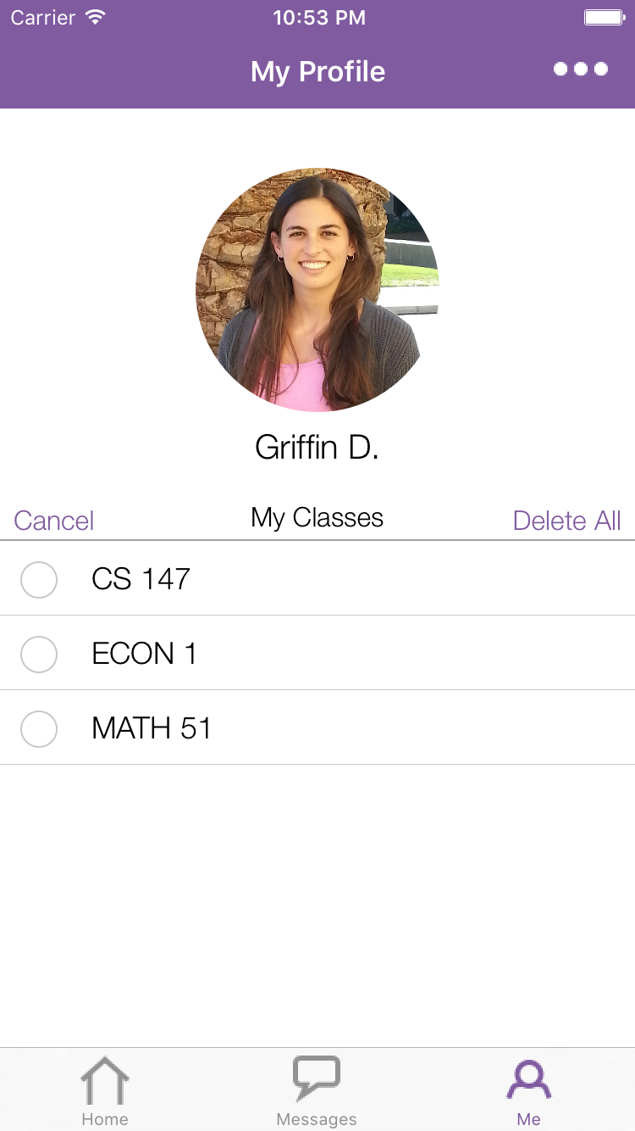
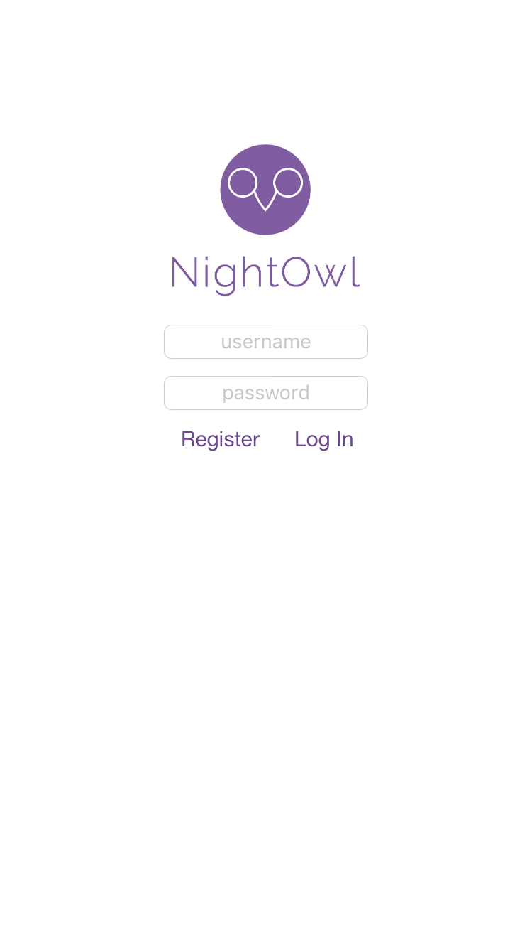

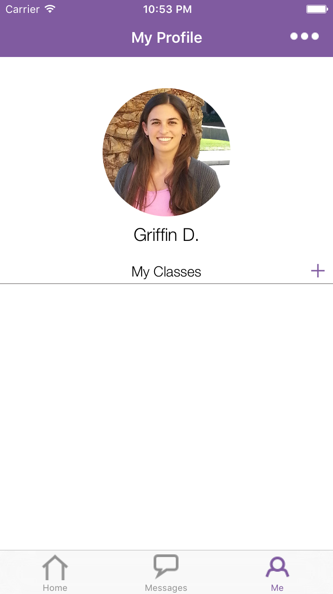
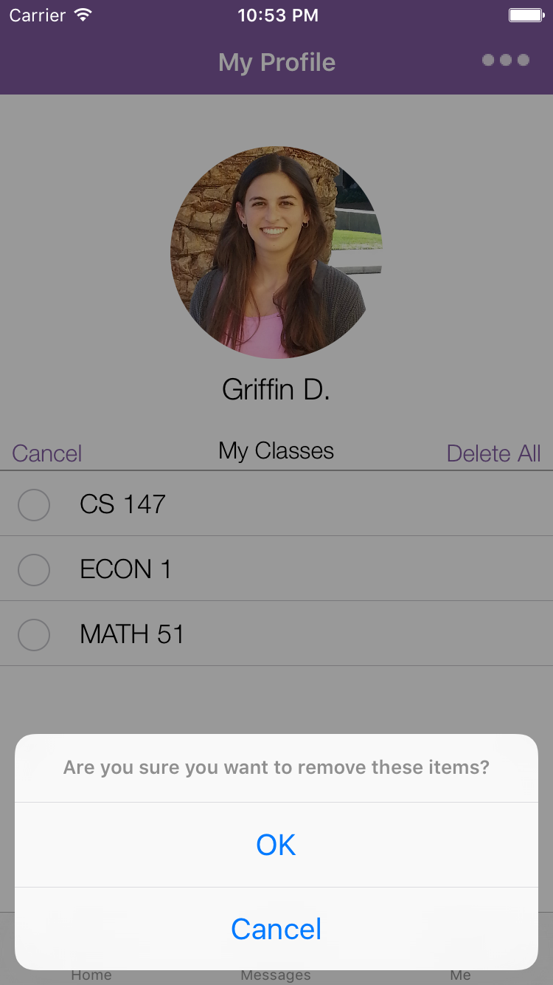
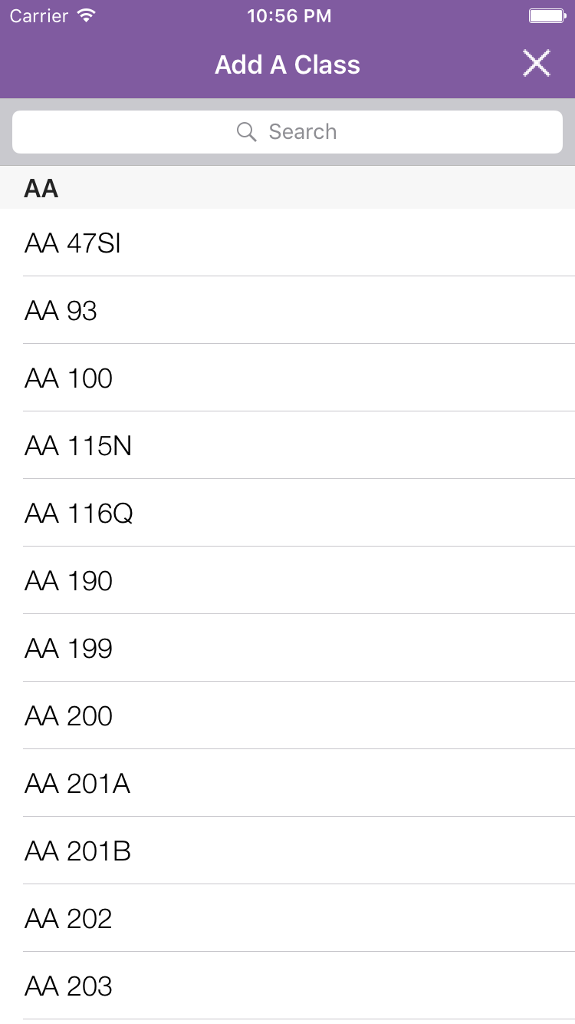
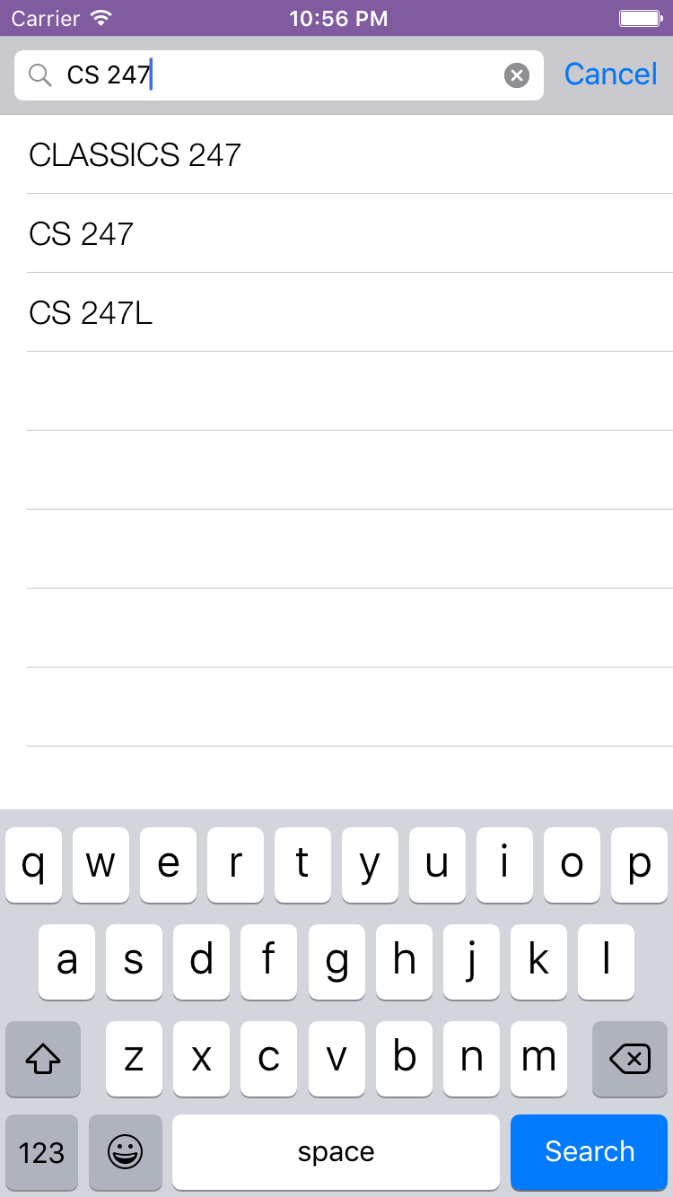

Task 2: Become available/write a status (Medium)

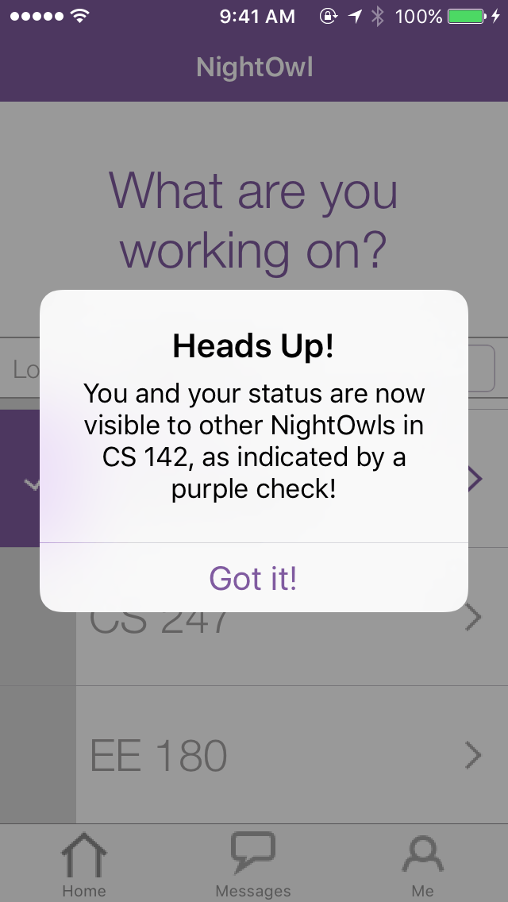
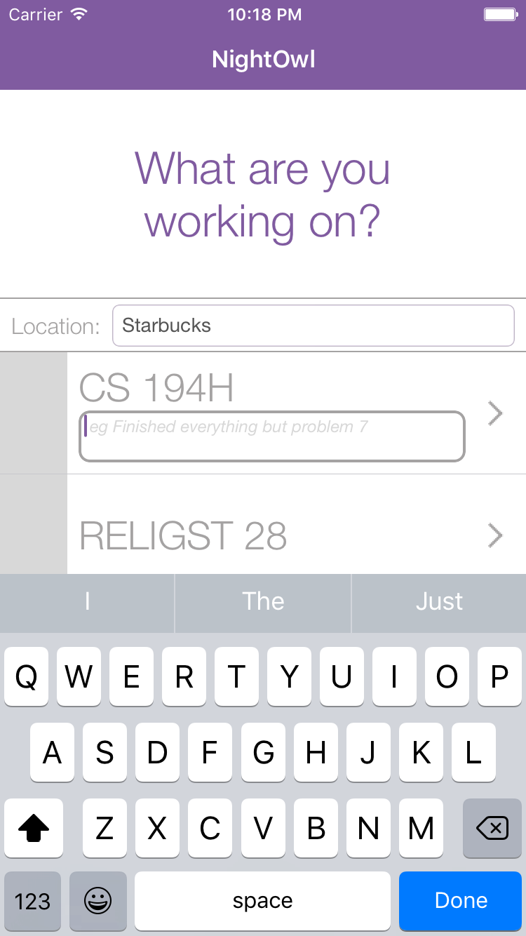
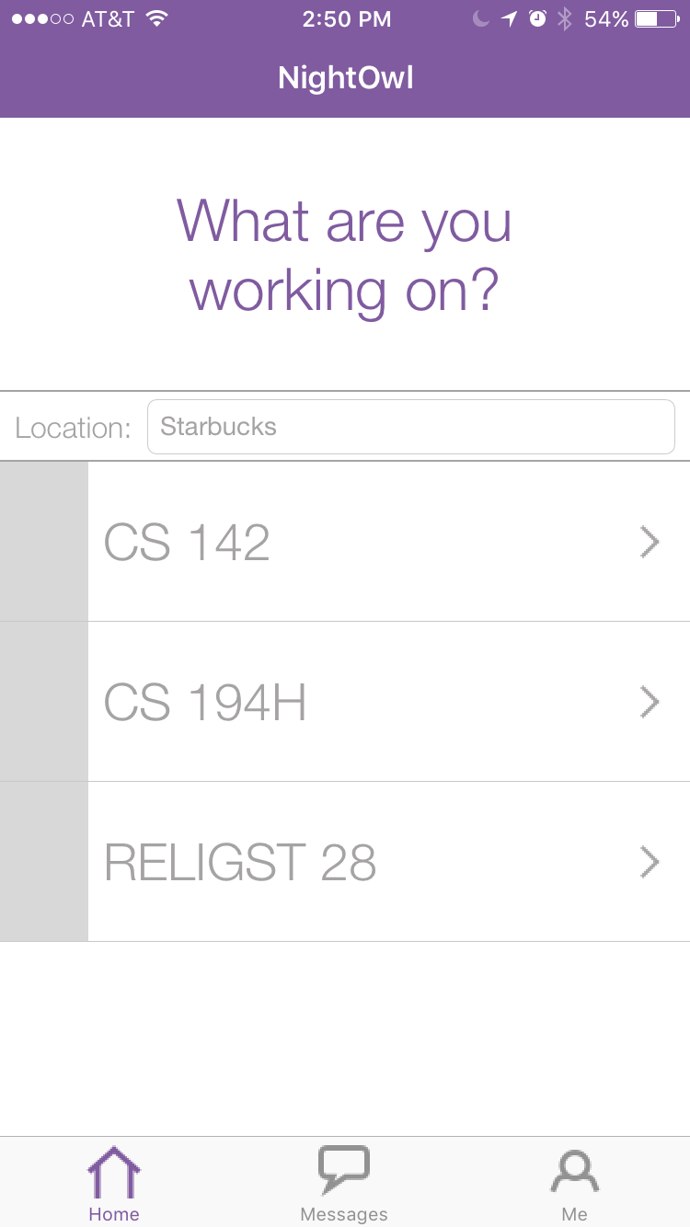
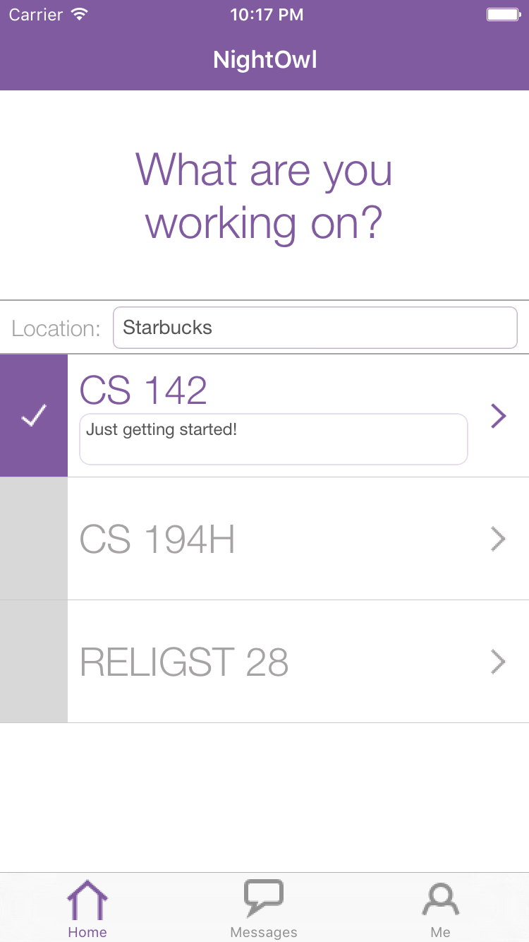

Task 3: Reach out to classmates (Complex)
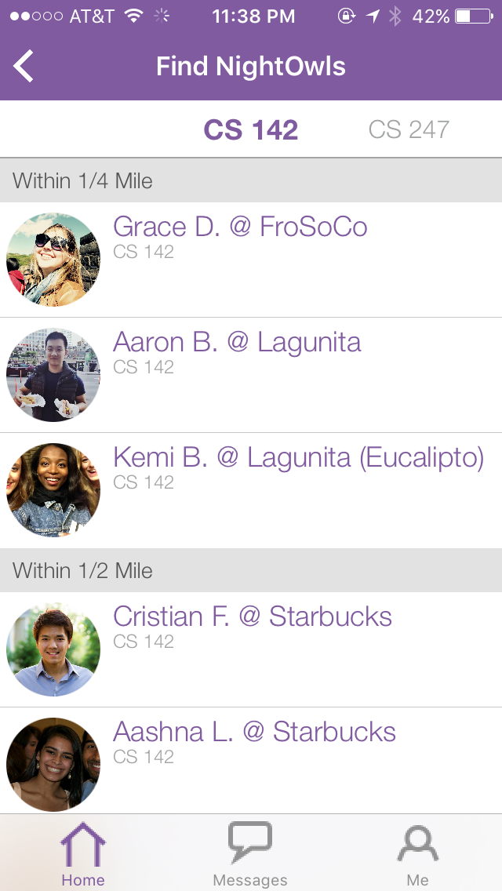
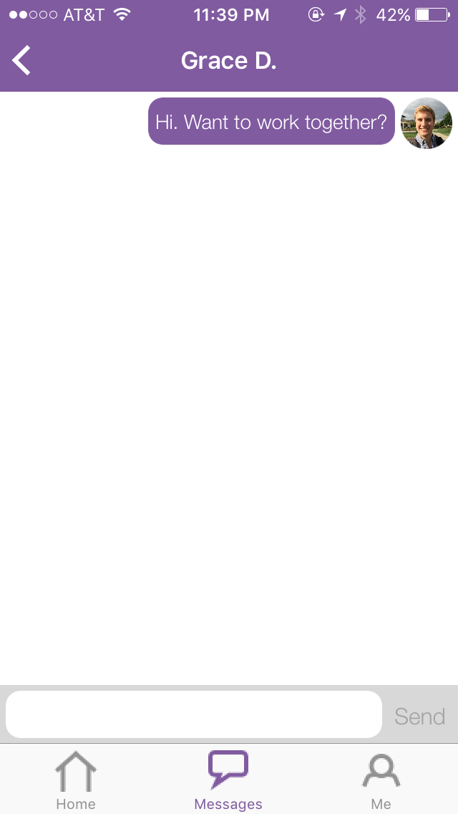

Design Evolution
- Needfinding, POVs, HMWs
- Experience Prototypes, Sketches
- Low-fi Prototype
- Medium Fi Prototype
- Hi Fi Prototype 1
- Hi Fi Prototype 2
- Hi Fi Prototype 3

Step 1: Needfinding, POVs, HMWs
The theme of our CS147 section was “Focus”. This led us to first interview people who exercised extraordinary focus in their daily lives. We talked to an Olympic athlete, a graphic artist, a Yoga instructor and a high school student with ADHD and learned a lot in reflecting on their common answers. In time, however, we would narrow our audience to college students in STEM, the group we were most interested in designing for.

After talking to a number of STEM students, we identified a number of points of view (POVs) that reflected our potential users, formulated some “How Might We” (HMW) statements, and created several experience prototypes to get feedback on some of our initial product ideas.

Below is one of the POVs we created in response to our interview with Muhammad, and some of the HMWs we brainstormed to respond to it, with our favorite solution bolded.

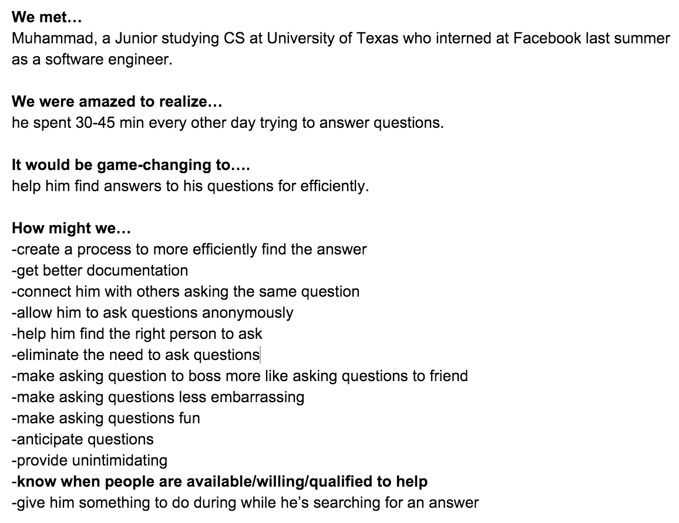
HMWs generated for one of our subjects

Step 2: Experience Prototypes, Sketches

Using our favorite solutions as a starting point, we created three experience prototypes that we could show users to test out the core experience of each solution. In the first prototype, we tested how people reacted when we made a buzzing noise each time they touched their phone when they were supposed to be working. In the second, we tested the concept of leveraging social pressure to enhance focus by penalizing a group of friends if one lost focus. In the third, we tested how much people liked being able to find first, second and third degree connections in the classes they were taking to form study groups at the beginning of the quarter. Our most significant insight from these tests was that students wanted to get help the night before an assignment was due far more than being penalized for losing focus or get help forming a study group at the beginning of the quarter. Two of our four participants actually described this need independently without our prompting. Below are pictures from those experience prototypes.

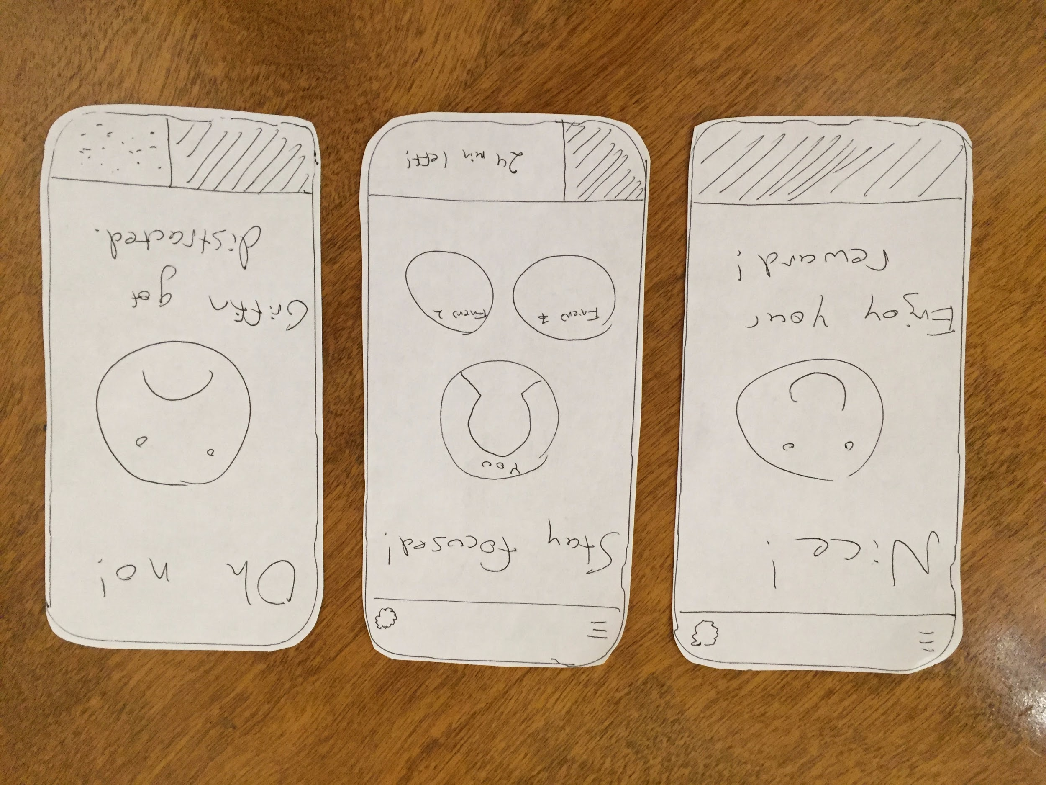
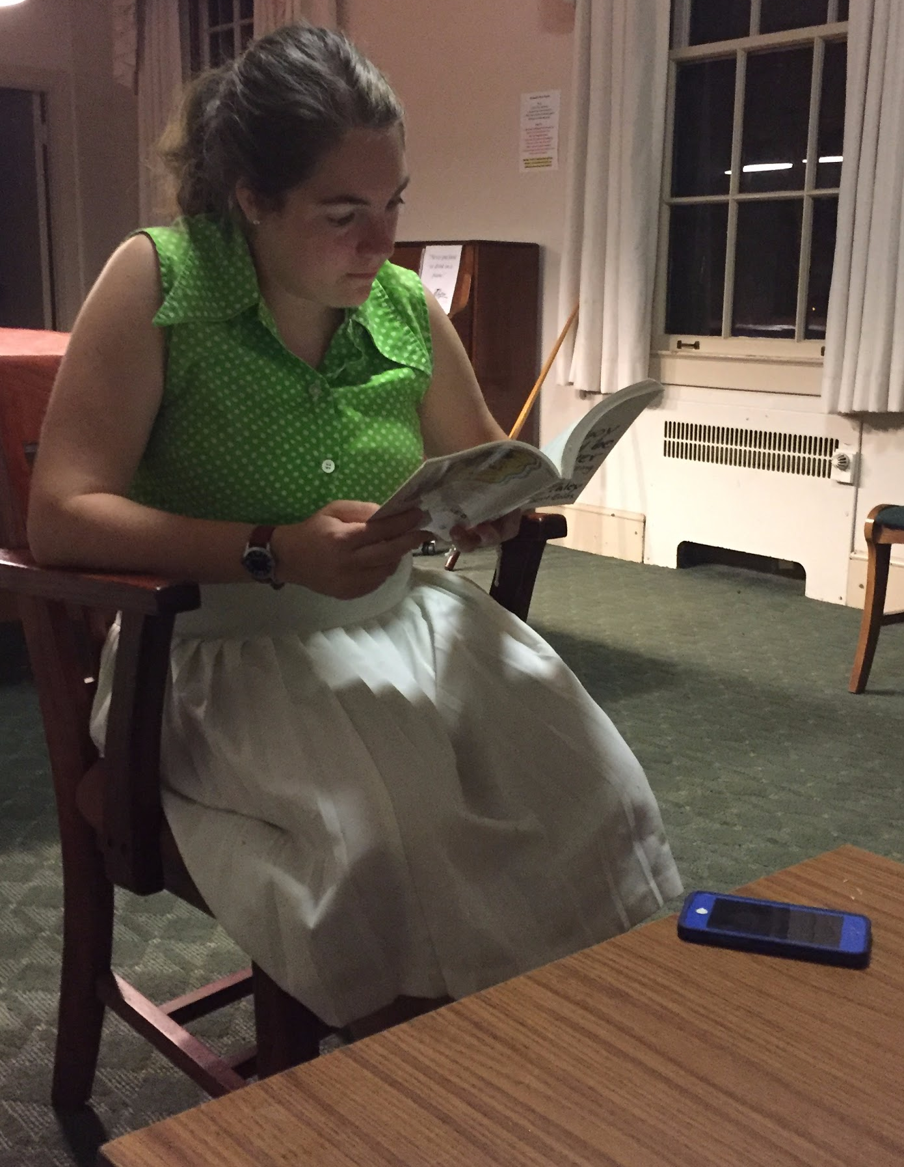
Experience Prototype 1 “Buzz”

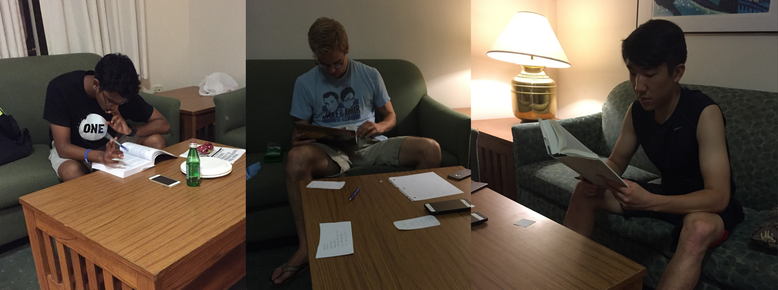
Experience Prototype 2 “Social Pressure”

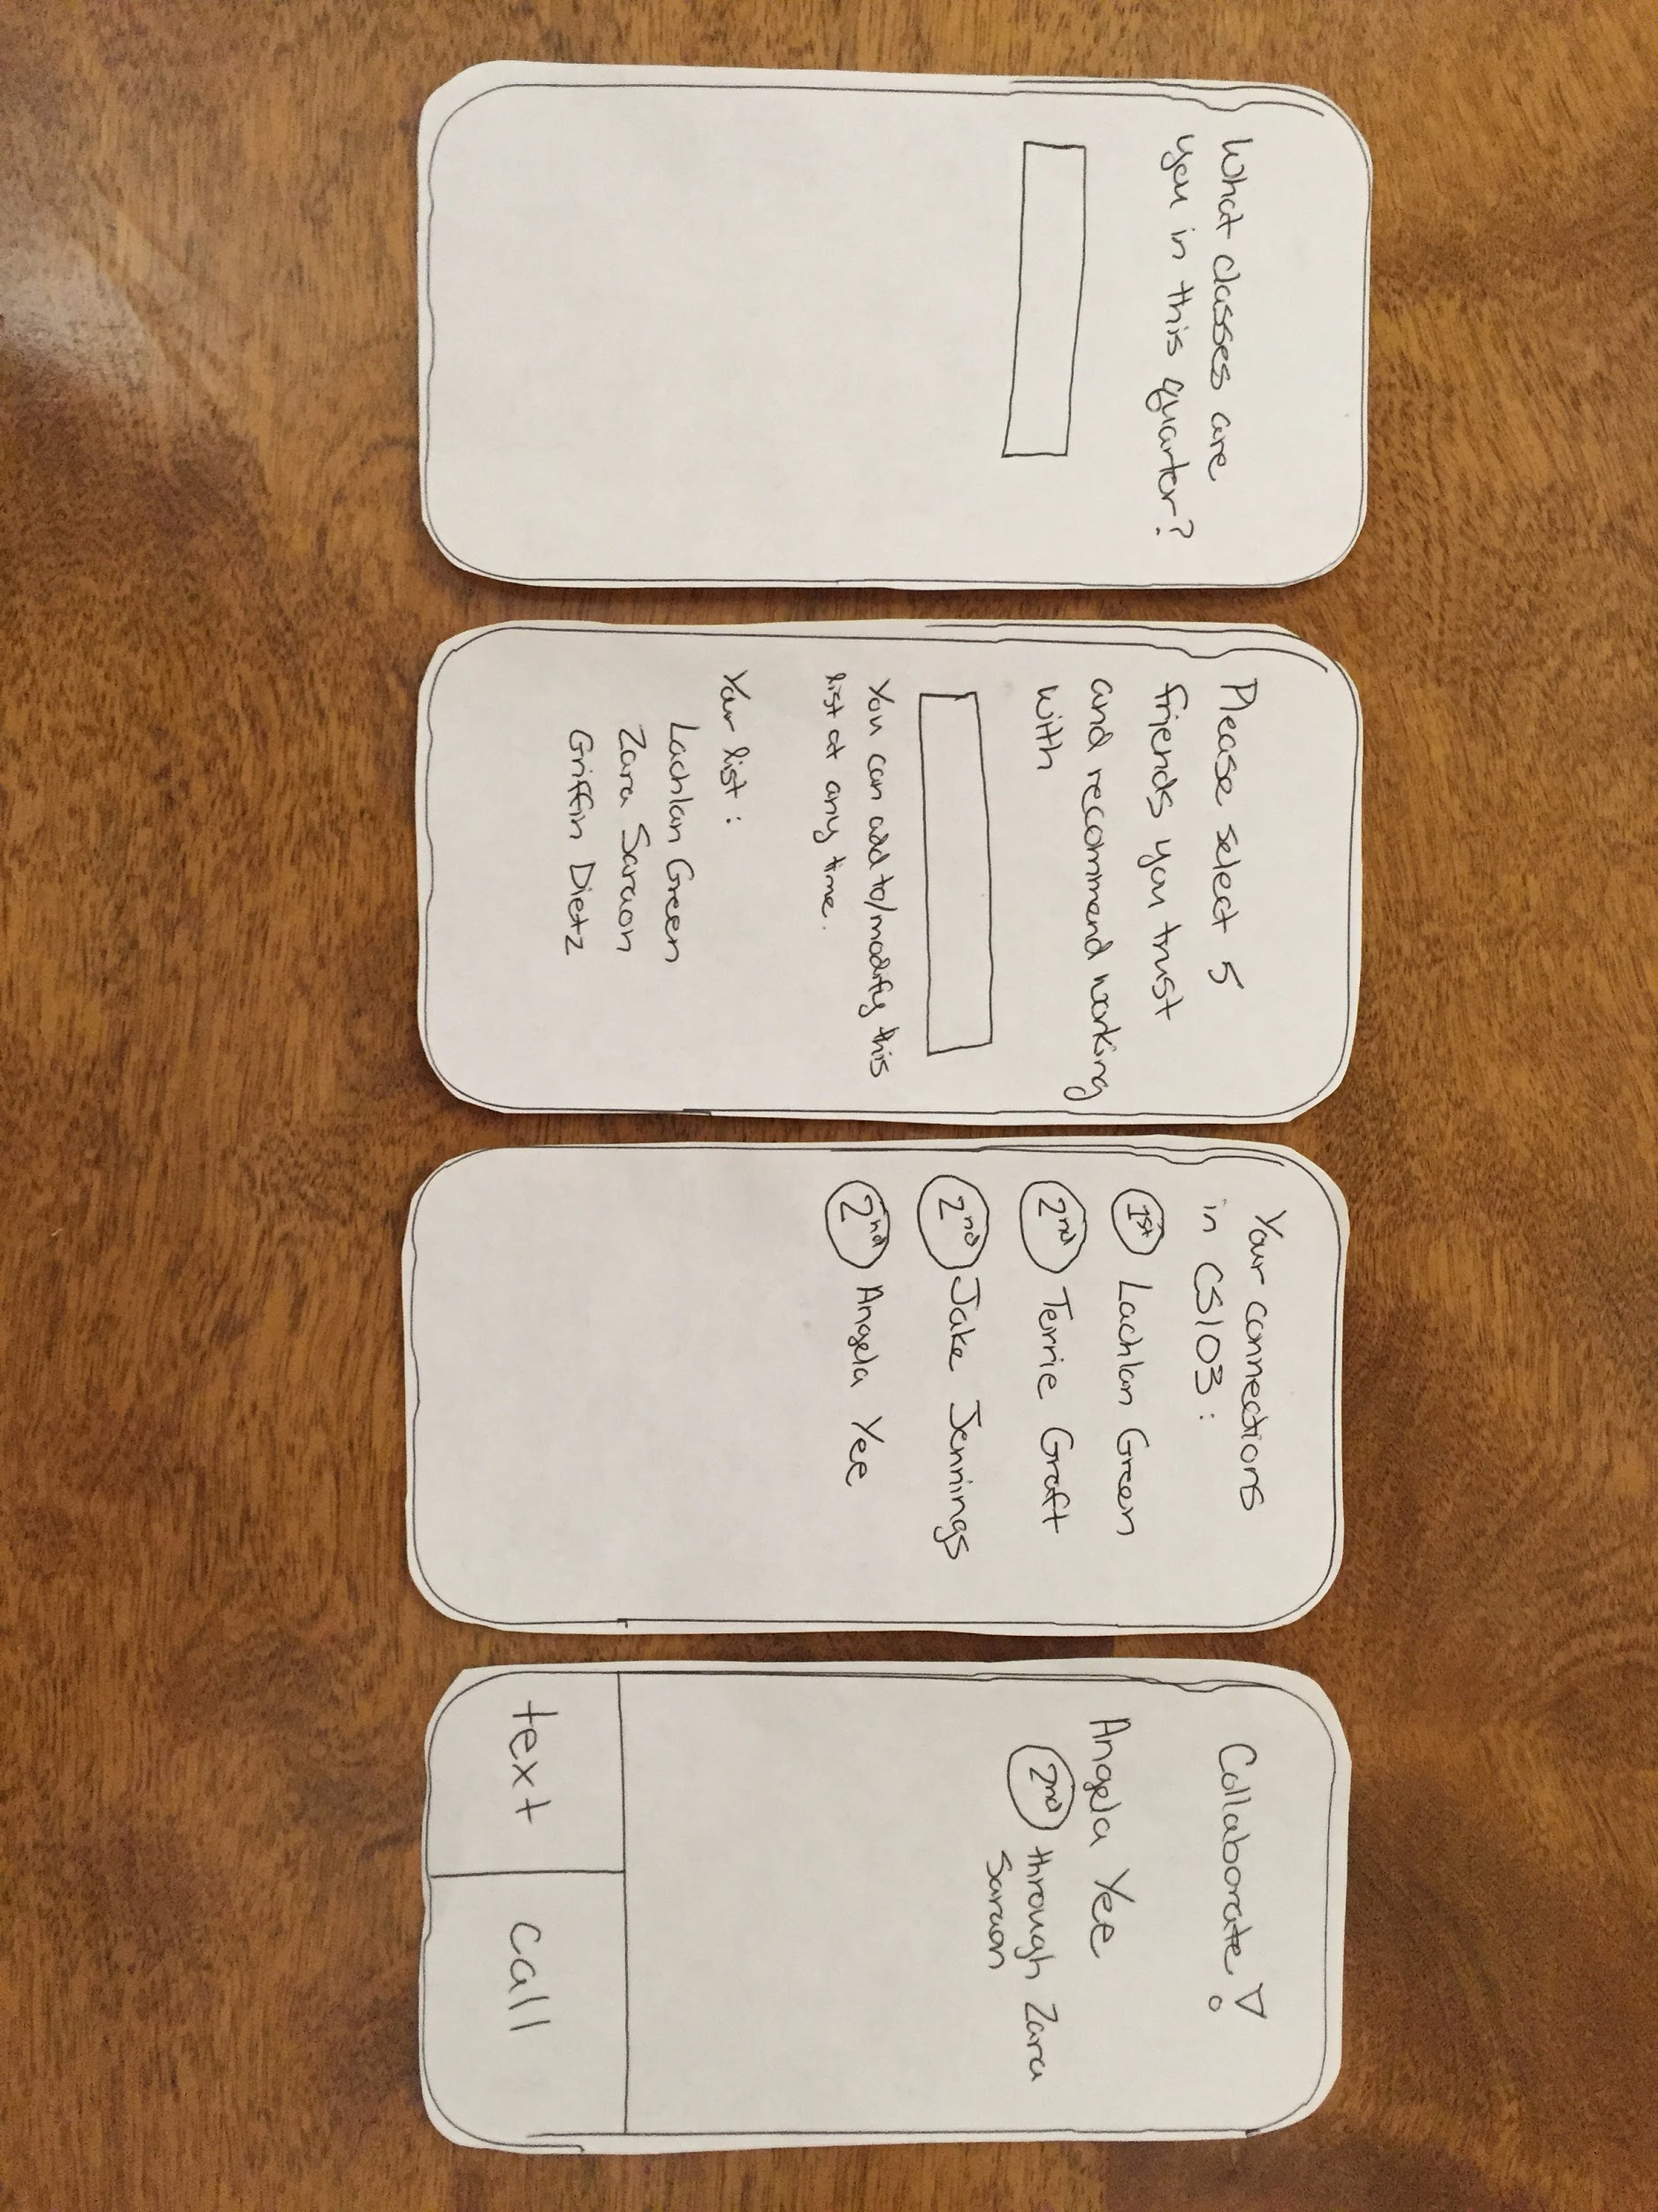
Experience Prototype 3 “Connecting Students”

Step 3: Low-Fi Prototypes

Next, we generated a large number of concept sketches, selected our favorite two to flesh out further, chose our favorite among those two finalists, and then developed and tested that final choice.
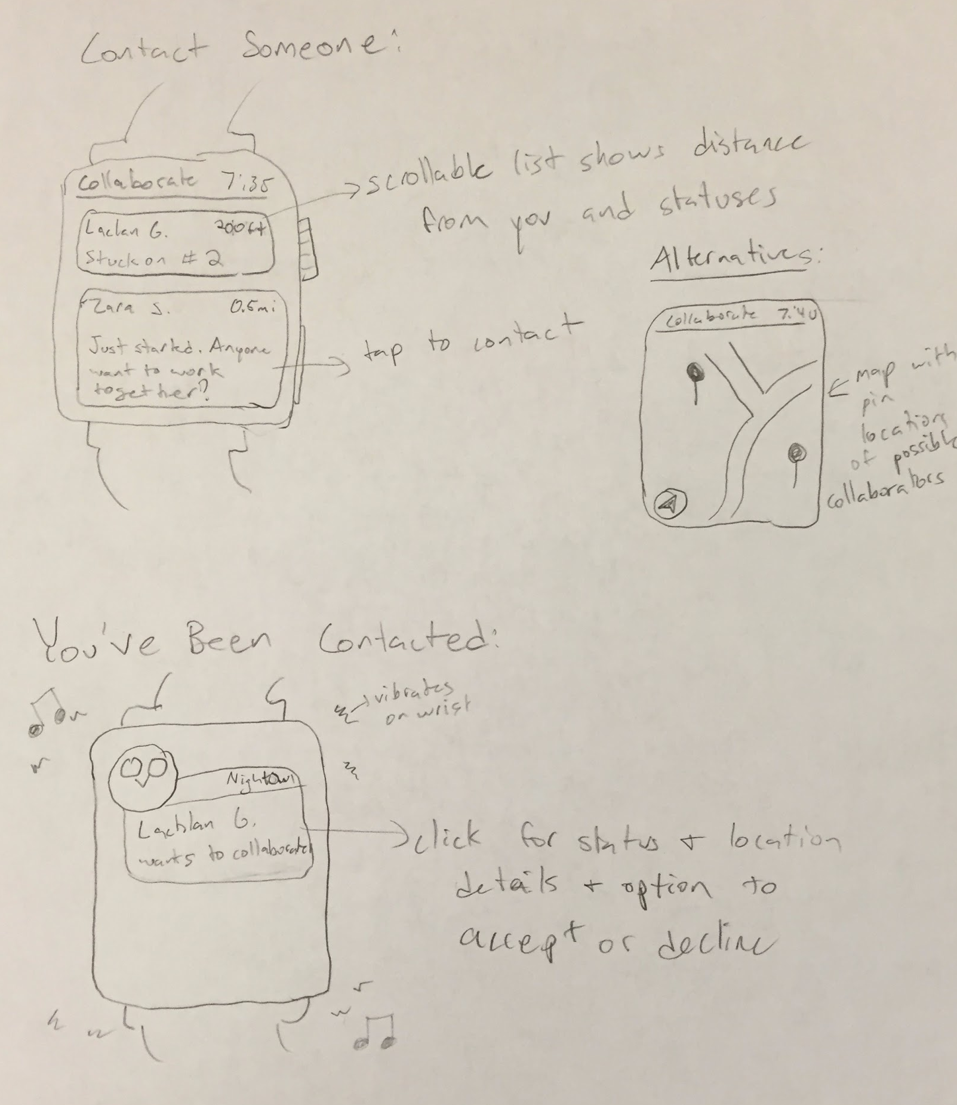
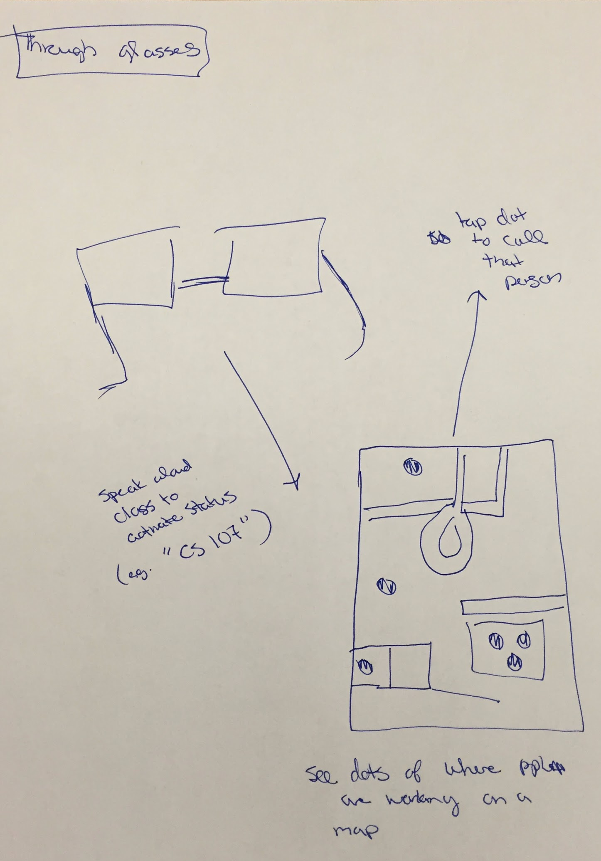

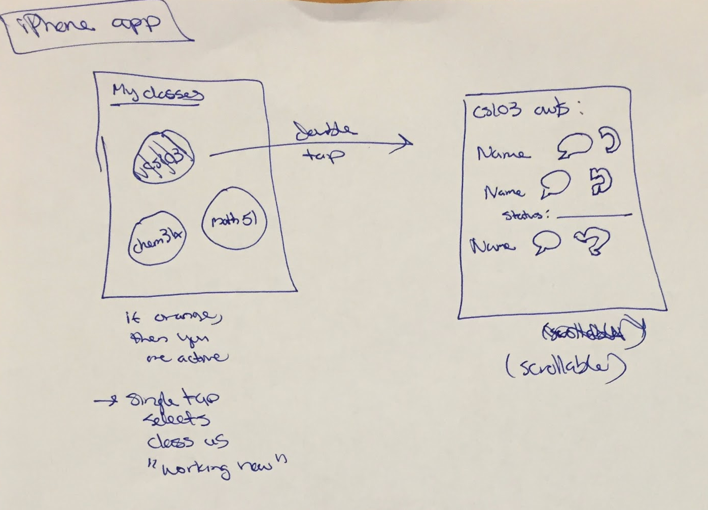
Concept sketches

We ultimately decided to go with a mobile app because we felt that without a clear functional advantage to using a wearable or a desktop app, the ubiquity of phones dictated that they should be our first choice. Because we had experience with iOS development but not with Android development, we chose to develop for the iPhone.

Our two final versions of our low fi prototype differed most significantly in what the user saw first and how much freedom the user was given to navigate throughout the app. Between these two designs (pictured below), we chose the “Individual First” approach that pushed the user to fill out what classes they were taking before being able to see who else was available, even though it added friction to the experience, so that we could service more relevant and useful content later on.

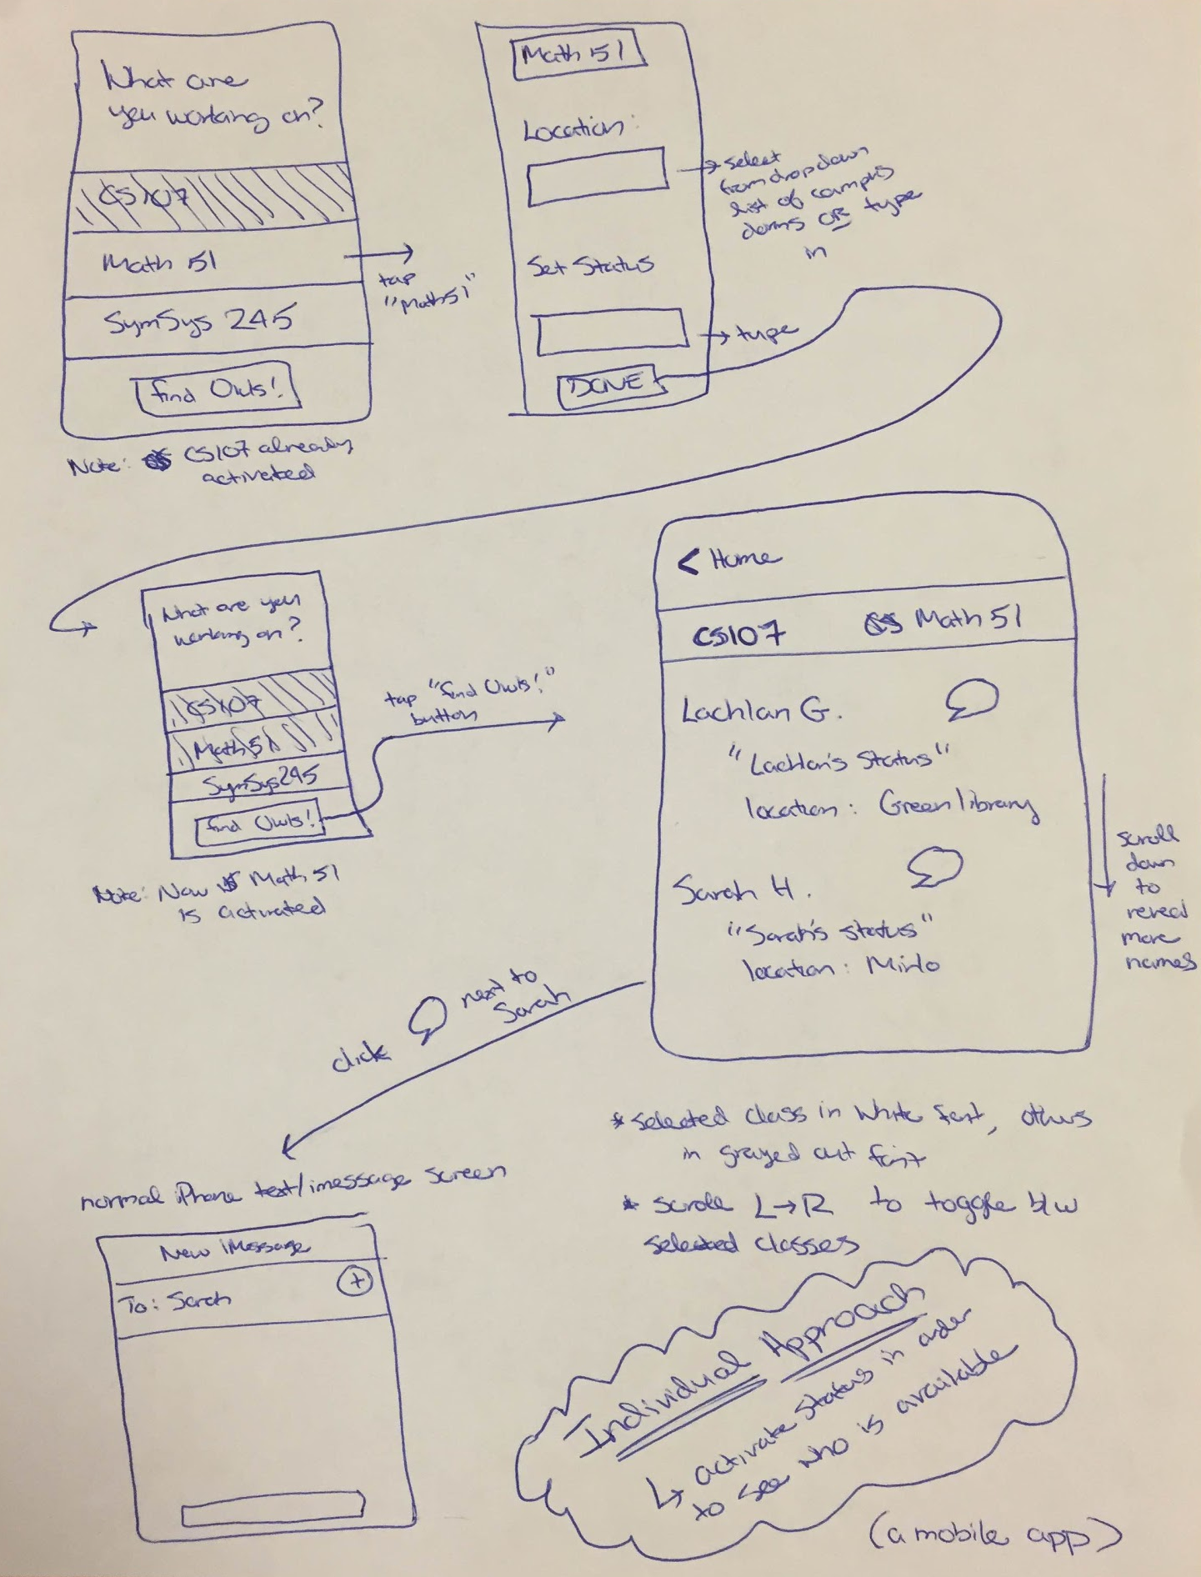
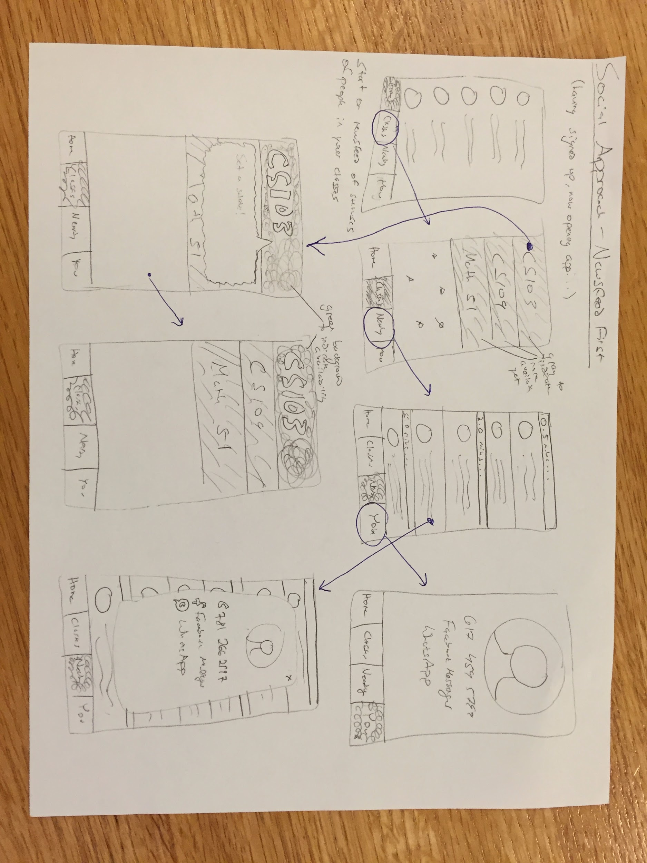
Individual First Social Approach

We then mocked up the Low Fi paper prototypes you see below based on the following three tasks:
- Simple Task: Respond to someone reaching out to you
- Moderate Task: Make yourself available and write a status
- Complex Task: Find people in your class working now and connect with them

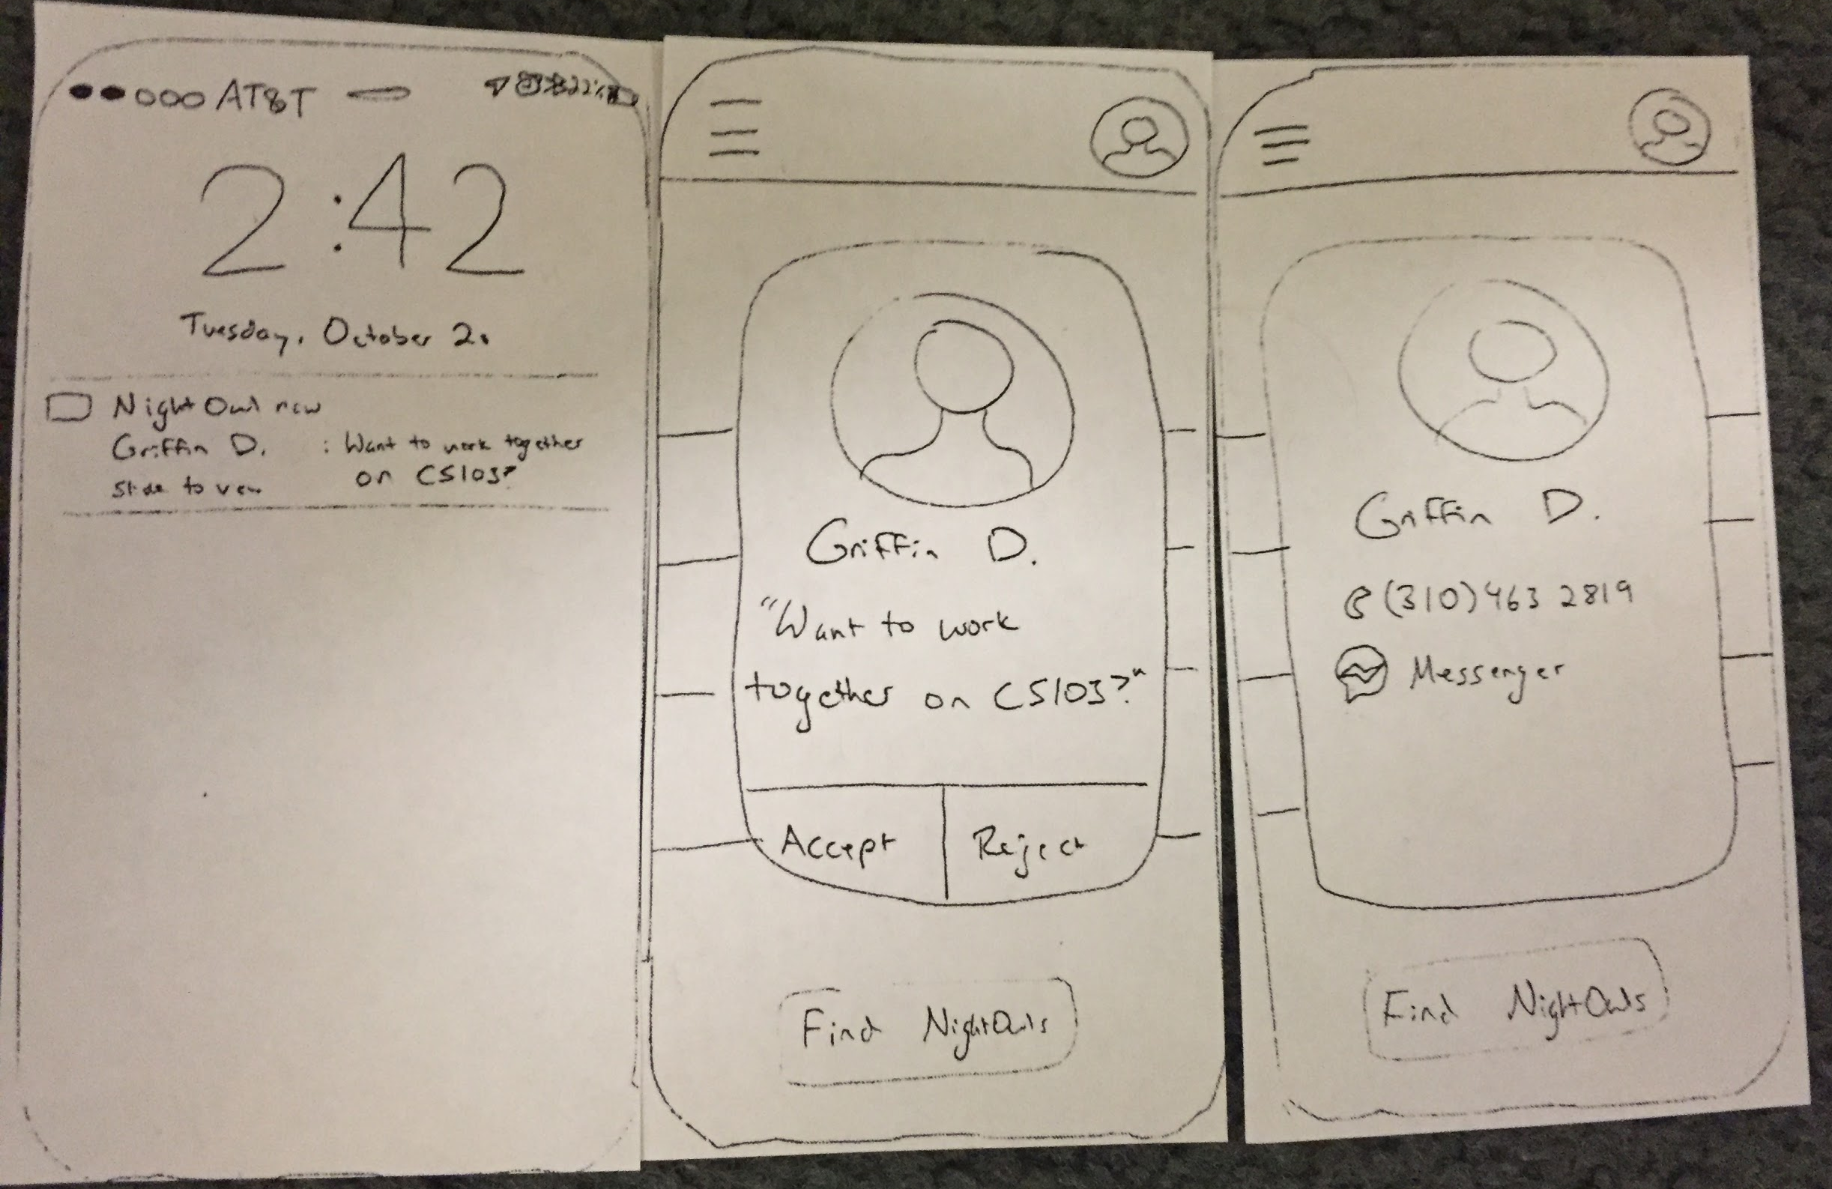
Simple Task: Respond to someone reaching out to you

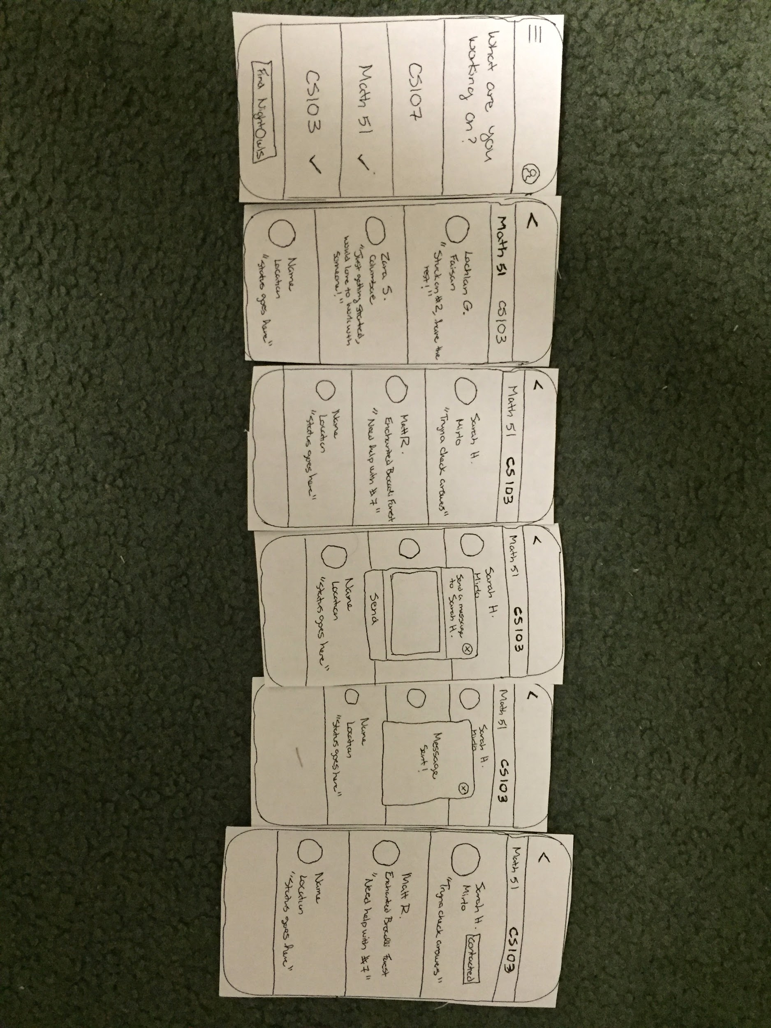
Moderate Task: Make yourself available and write a status

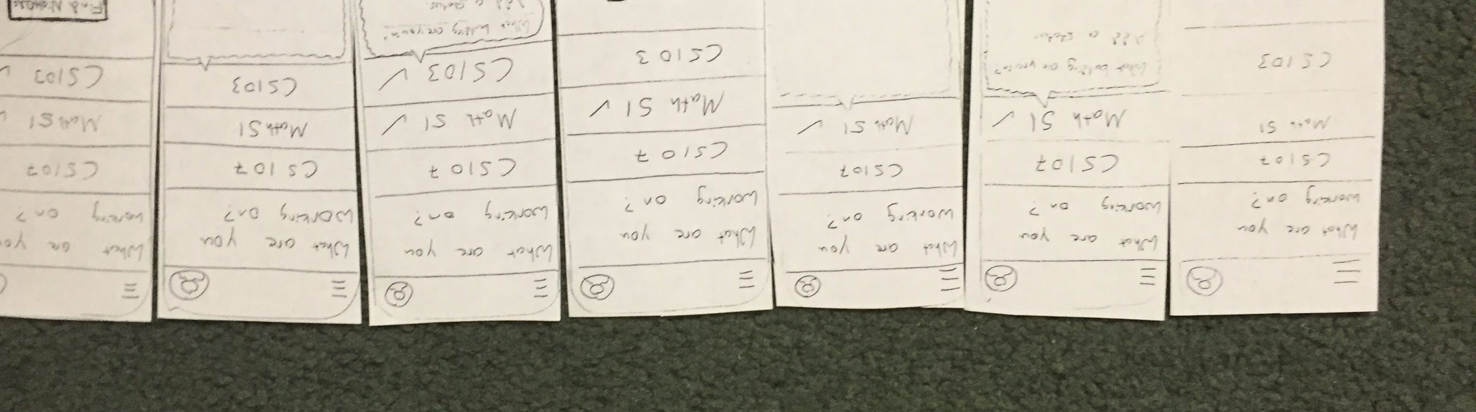Complex Task: Find people in your class working now and connect with them)

Our most significant learnings from these interviews were that people:
- Struggled with posting a status, particularly since there was no clear “Post” button
- Needed to be able to view their conversation threads, and
- Wanted to know more about other people using the service before reaching out to them
We directly addressed each of these in our next iteration.

Step 4: Medium-Fi Prototype and Heuristic Evaluation

For our next iteration, we used Sketch and Marvel to create a Medium-Fi prototype that responded to the feedback we received during our Low-Fi prototype testing. We made posting a status more clear with a large Post button that changed color when the appropriate information had been filled in, we added a Messaging tab where users could view their conversations with other users, and we added informative example text in the status and location fields that disappeared when the user began typing to help the user understand the purpose of those fields.

We also updated our value proposition to “Get help now” based on feedback we received from our TA and our peers, who felt “Get help now” was more immediate and compelling than “Connect with classmates. Collaborate on work.”

We also used Sketch to create higher fidelity UIs and Marvel to imitate the UX. These tools allowed us to create prototypes that felt significantly more real.

Some of the major design decisions we made during this process were the colors, the tab bar organization and the icons.

After playing around with a lot of different shades of blue and purple, we settled on this color (#805BA0). We decided to avoid blue mostly because it is doesn’t bring items to the forefront and is best as a background color (from CS147 lecture and our color handout). We chose this shade of purple mainly because it symbolically matches the nighttime aspect of NightOwl and because it was aesthetically pleasing yet not dull. We chose to use just one non-grayscale color to ensure that the UI was clean and simple (we also used two shades of gray and black for text and borders.) Deciding what sections to include on the tab bar required the most debate. We weren’t sure whether or not to separate out the action of making oneself available from the list of available students awake and available. Though separating them might make more sense from a high level, we felt that functionally, it made more sense to combine them since it’s important that the students we show a user are relevant to the classes that user is trying to work on at that time. For the icons, we wanted to maintain a minimalist design that still clearly conveyed each section, so sought to create icons in that style.

Here is the result from that step.

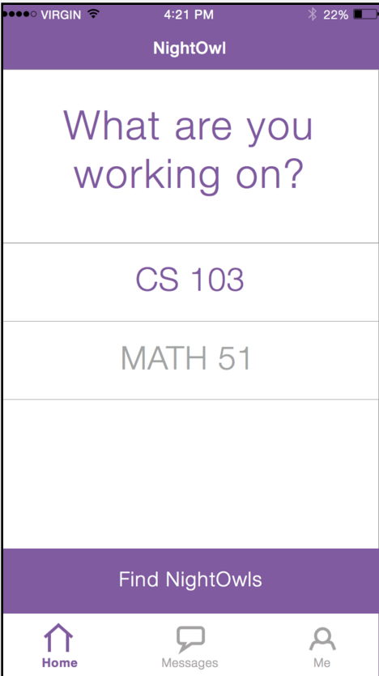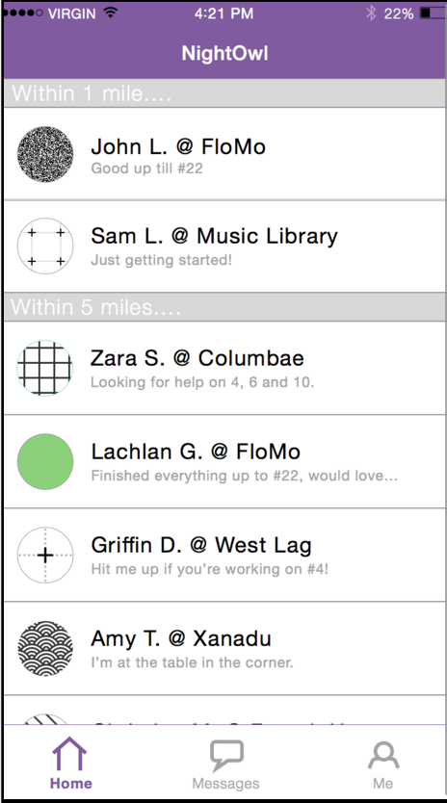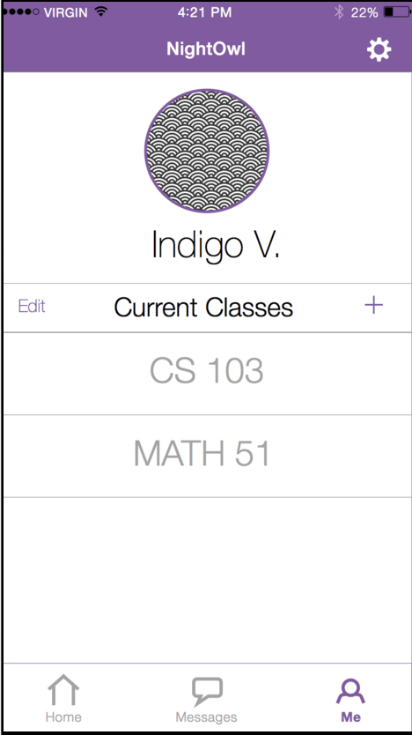

Screen 1 Screen 2 Screen 3

Medium-fi prototype screens

Once we had created the screens and connected them on Marvel, we handed off our prototype to a group of our classmates to conduct a Heuristic Evaluation. We would end up implementing many of the suggested changes in our Hi-Fi prototype. We discuss these changes in detail in the next section.

Step 5: Hi-Fi Prototype 1

Based on the feedback we received from the Heuristic Evaluation conducted by our peers on our medium-fi prototype, we developed our Hi-fi Prototype 1. We used Sketch to update our UI and to create icons, and used Xcode to build our native app using Objective C and .xib files.

We received a lot of great feedback during the Heuristic Evaluation, the majority of which we were able to incorporate into our app. The most significant changes included:
- Adding a back arrow after tapping on a class
  - Allowed users to navigate back to the home screen (see screen 2 to screen 1 above)
- Showing common classes between you and users you had talked to in the past
  - Made it easy to reach out to past study buddies
- Adding a purple check to selected classes
  - Indicated that you were active in those classes and not others
- Showing your status on the homepage for each class
- Highlighting which class a user has selected when that user is looking at their newsfeed

Here are some screenshots of some of the Hi Fi Prototype 1 screens we made in response to the feedback we got on the medium-fi prototype. This was also where we left the project at the end of CS147.

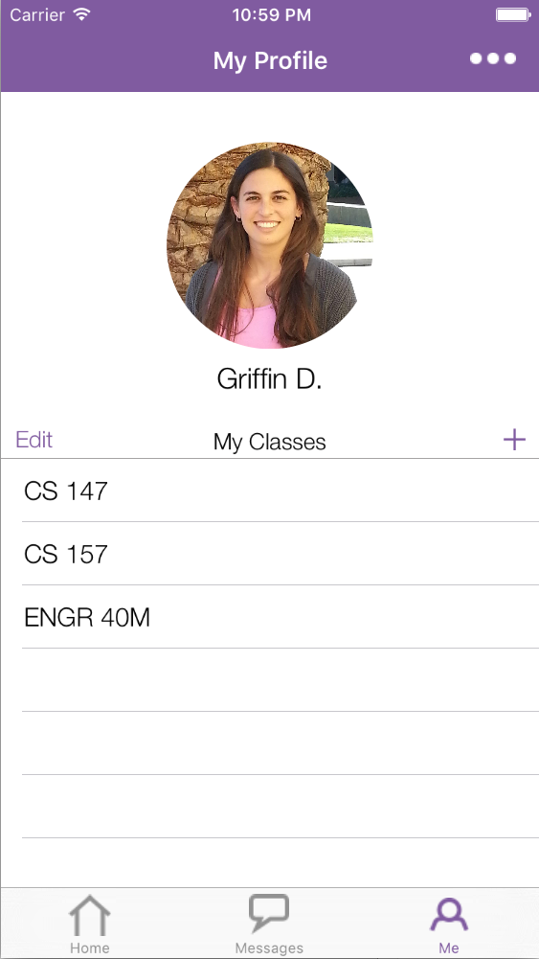
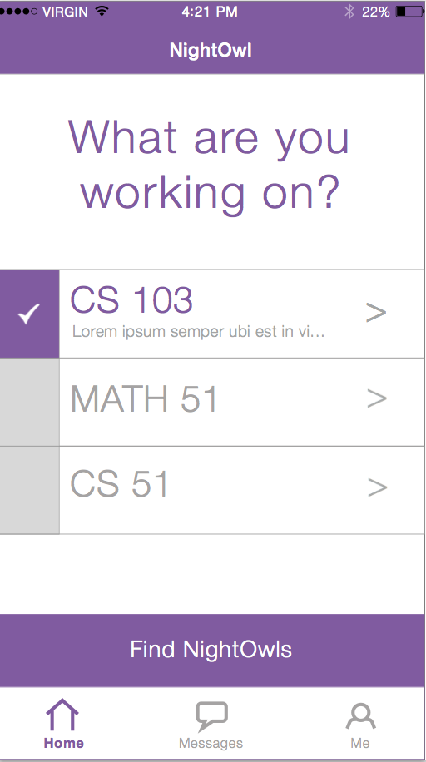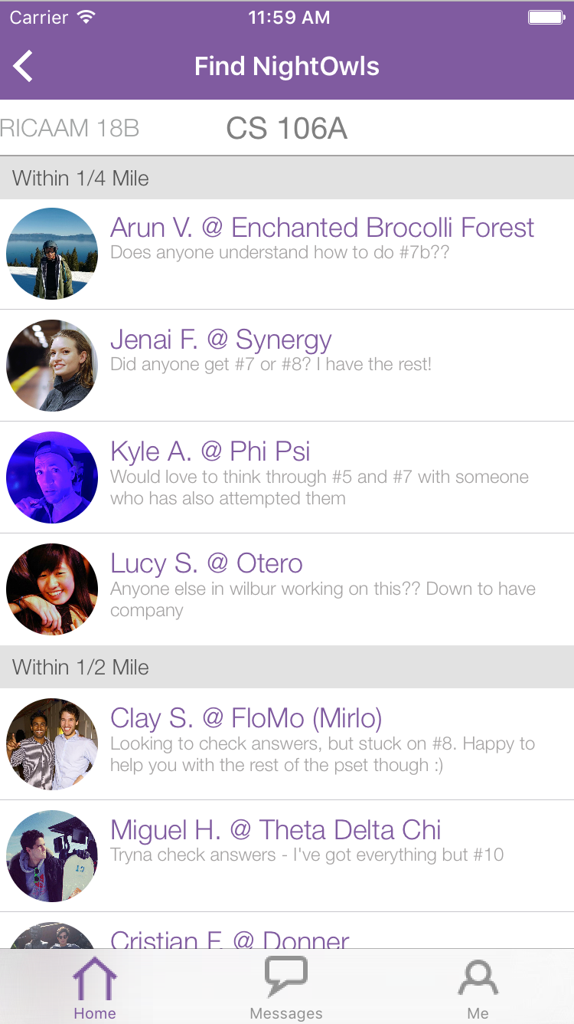
Hi-fi iOS screens
Step 6: Hi Fi Prototype 2
After conducting a lab usability study with a number of Stanford students, we incorporated the feedback we received from that work into our Hi Fi Prototype 2. Overall, students found the app very intuitive and seemed excited about when they might be able to use it. Still, we managed to make many changes in response to their feedback. The most significant were:
- Moving location to the homepage and auto-filling a user’s location using the Google Places API
- Having users add statuses directly on the homepage rather than making them navigate away
- Scrapping the “Find NightOwls” button and instead allowing users to navigate to the list of other NightOwls by tapping on the class.
We also added a Signup / Login screen and began integration work with our backend. We chose to use Parse for this and implemented user login and registration.
Here are a few images from the new screens:
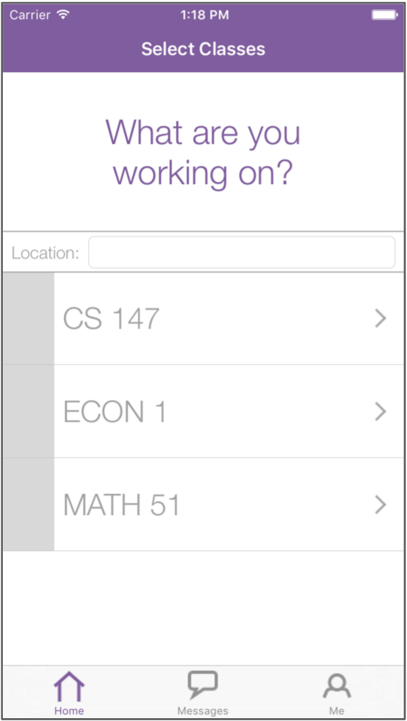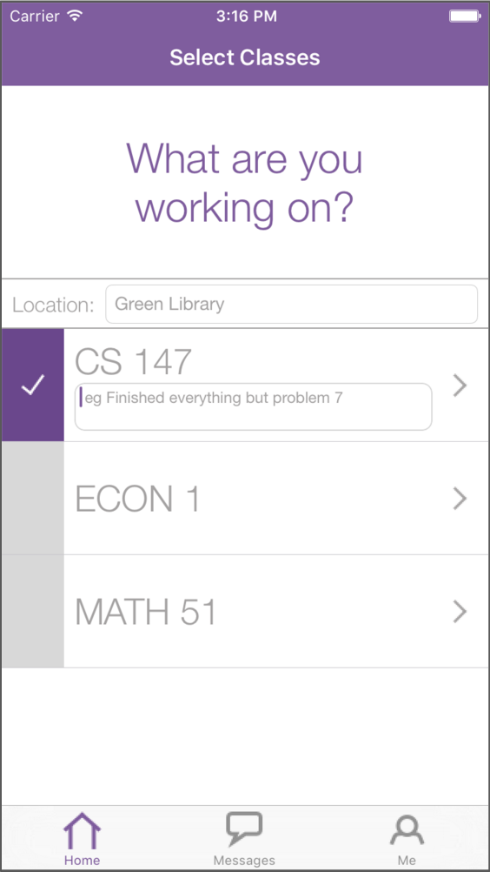
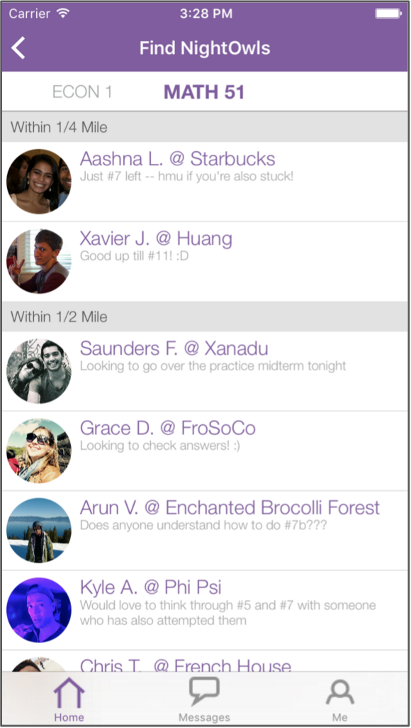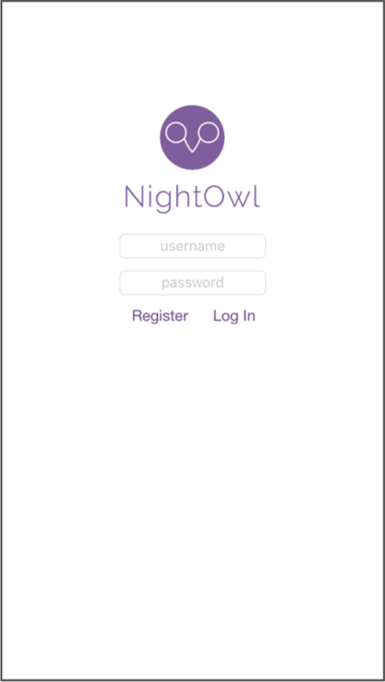
Hi Fi Prototype 2 Screens
Step 7: Hi Fi Prototype 3
Eager to test out these new changes, we conducted a Field Usability Test with our newest iteration, hoping to have students test our app in a setting reflective of how they might actually use it. We interviewed students using our app in libraries and dorm rooms, and once again got great feedback on what people liked and how we could make NightOwl better. We uncovered a number of small fixes that allowed us to finetune the UI. The most significant changes we made for Hi Fi Prototype 3 included:
- Adding a one time pop up message indicating to a user that they were now visible to other users after they had selected a class. Many people we interviewed didn’t realize they were active just by tapping on a class.
- Forcing users to add a status and a location before they could view classes. This increased the value of all NightOwl users by ensuring that at least some status and location was entered for each user.
- Making the search bar for finding classes static so it was more discoverable. A few of our study participants missed the search bar when trying to add a class and had to scroll for a long time to locate the class they wanted to add.
We also fleshed out the remainder of our backend with Parse - this was a major effort that made messaging “real” and removed the remainder of our “Wizard Of Oz” techniques. At this iteration, all messaging and user data came from a server and our app used mostly hard-coded or static data.
Here are pictures of the screens we added or updated:
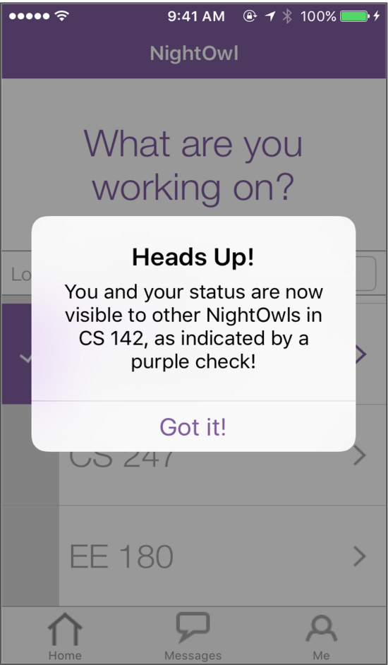
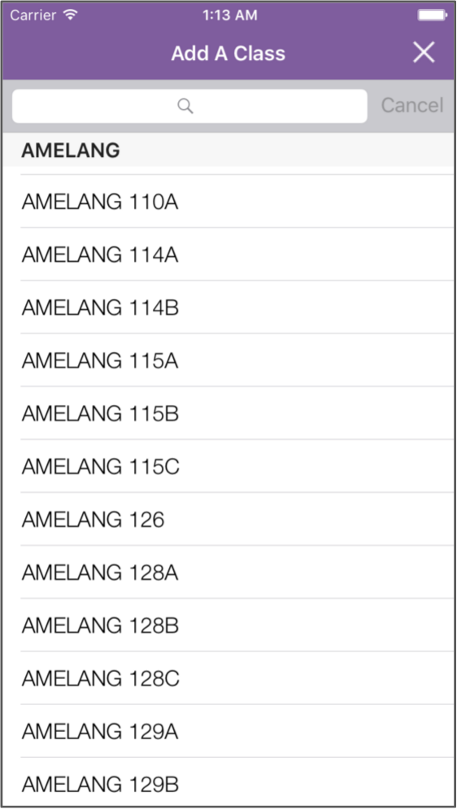
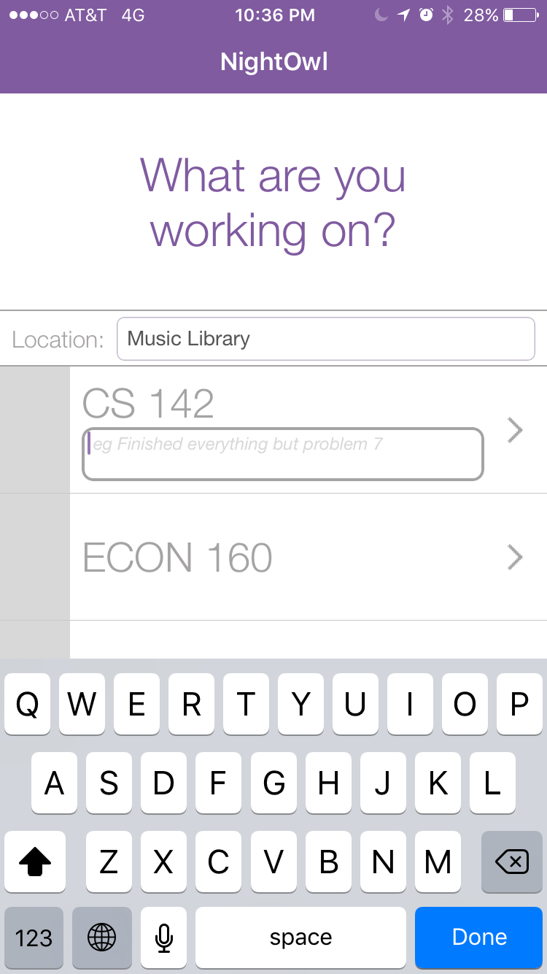

Updated or Added Screens in Hi Fi Prototype 3
We found that user testing, particularly with the users we are targeting in the environments that our users would really use the app, was the most valuable evaluation technique for surfacing substantial errors that we did not catch ourselves. More than any other technique, we were able to get an authentic window into the needs, questions and assumptions of the people we were designing for, and thus learn what we needed to change to most effectively help them solve their problems.

Final Interface

Final UI Design

Login Screen
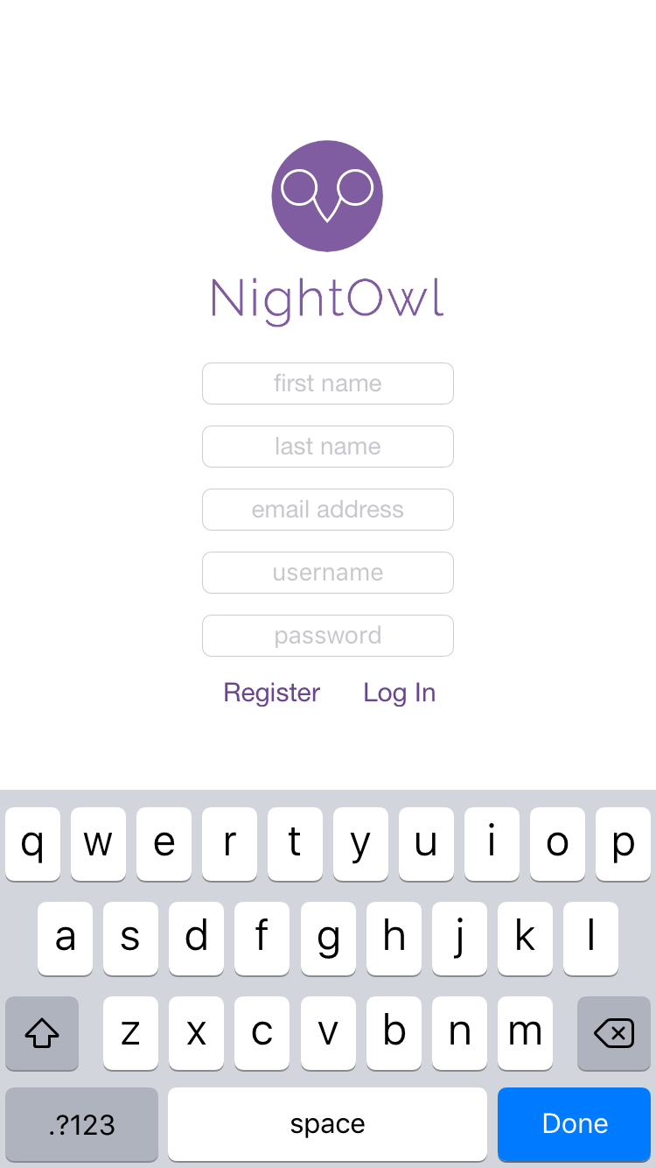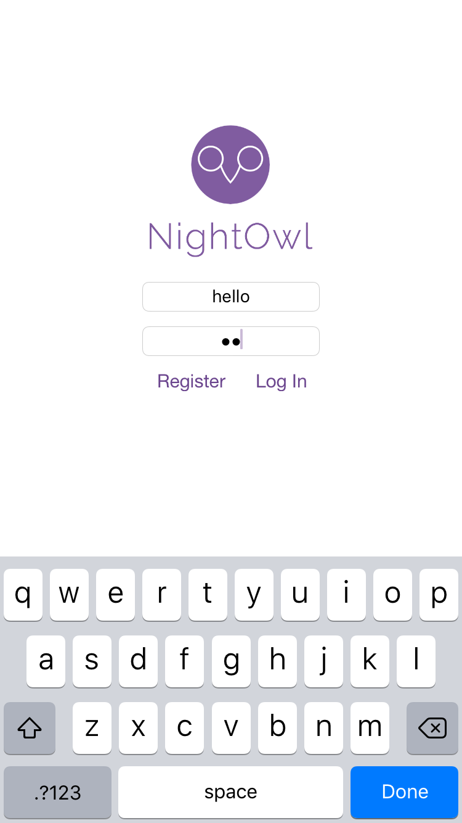

The Login screen is a user’s first experience with NightOwl. This is a relatively standard page - from here, the user can login and register a new account. We further choose to have the user enter an email address and password only once.

Home Screen
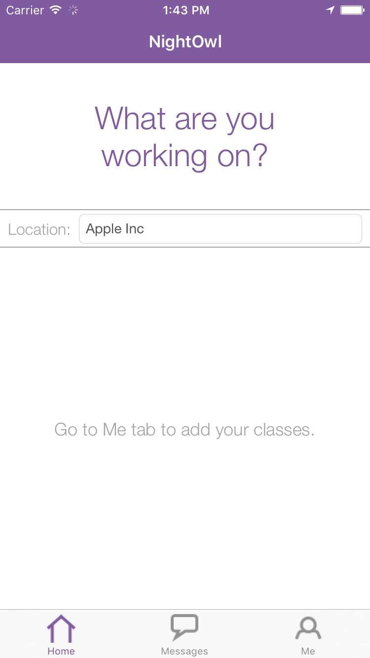

The Home tab is the first screen the user sees after logging in. They have a number of actions they can perform in this tab - but first it is important to note that they may switch to the “Messages” tab and “Me” tab using the bottom tab bar - we will discuss actions you may take in those tabs in the following subsections.

On their first login, users will see a screen prompting them to add classes. Users may add classes in the “Me” tab. We expect that users will not change classes frequently, and chose to hide this infrequent action outside of the home tab.

The user may first check or update their location in the bar near the top of the screen. This bar is prepopulated with information gathered from the Google Places API; we make a best-guess of a human-understandable name for the current location of where a user is. The user may edit this name if they wish. This location will be shared with other users who are looking for people to work with.

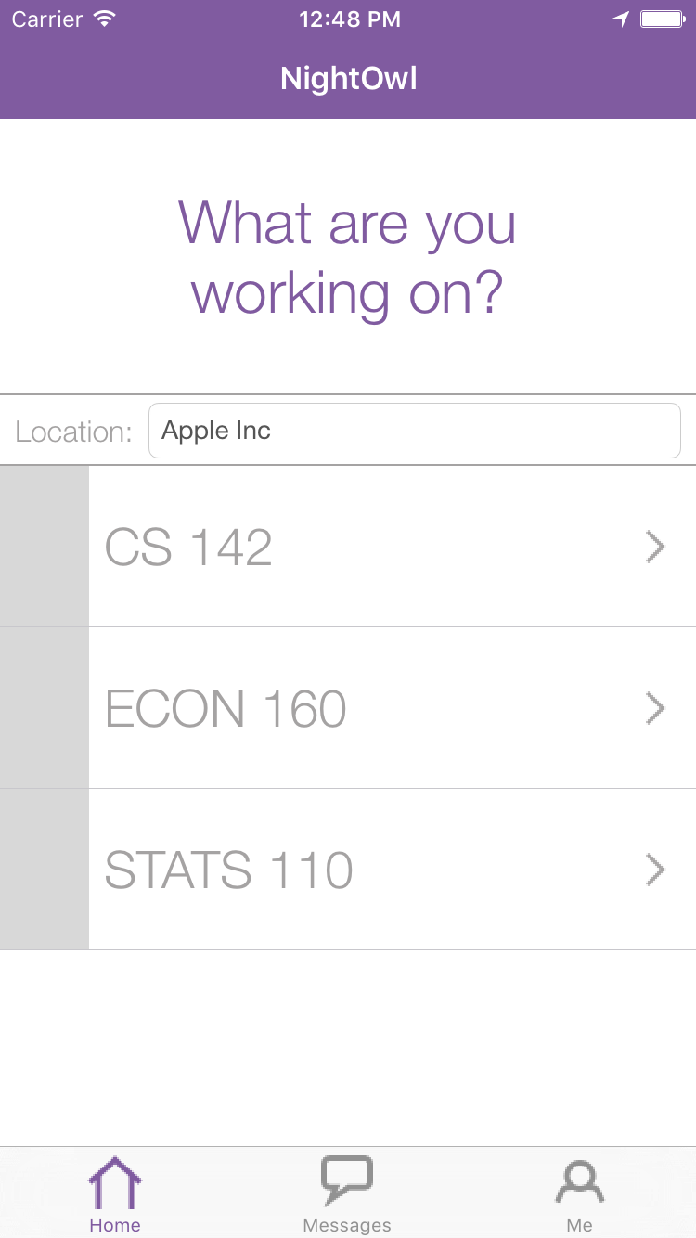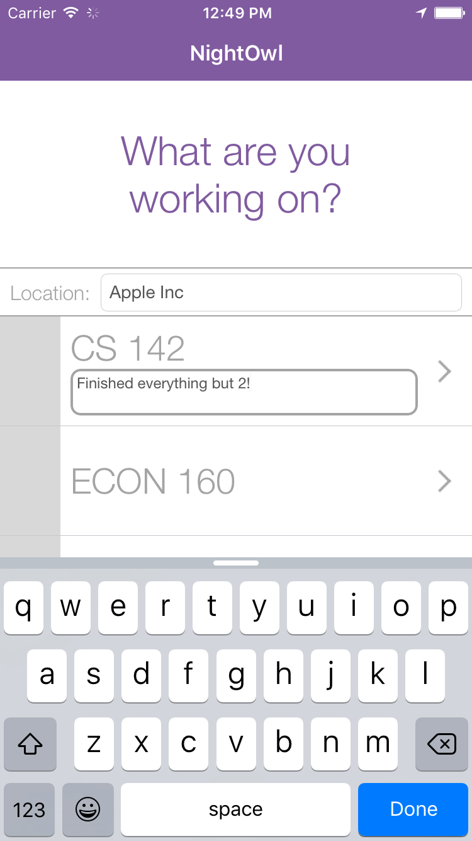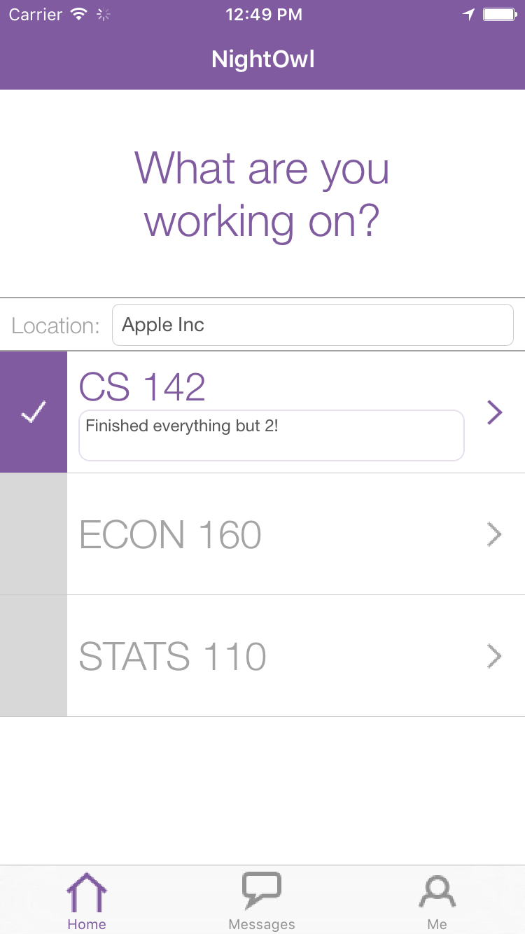

Once a user has registered for classes in the “Me” tab they will see a table cell for each class in the Home tab. The user is able to make each class “active” by touching anywhere in that table cell. The user is then prompted to enter a mandatory status in the text field that then appears. Once the user enters text and hits the Done button the class will be marked active, as signified by the purple check graphic next to the active class. If the user does not enter a status, they will not be marked active after pressing the Done button.

Once a user is active they become visible to other users enrolled in the same class - we will see how active users appear to other users in the below “Find NightOwls” section.

One of the design choices we iterated on most over the course of NightOwl’s development was how to display the status text box through the various stages of user-activeness. We chose to initially hide the status box; when the user first decides to become active in a class, they don’t need to know anything about a status. After touching the class and initiating the class activation process, the user is prompted to enter a status with a text box accented with a bold border. We find that the bold accent is an effective signal to users that the text box is “active”. After a user is finished entering their status and selects “Done”, we remove the bold accent from the status box and leave a narrower border. This signals users that the status box is still editable, but is not currently active.

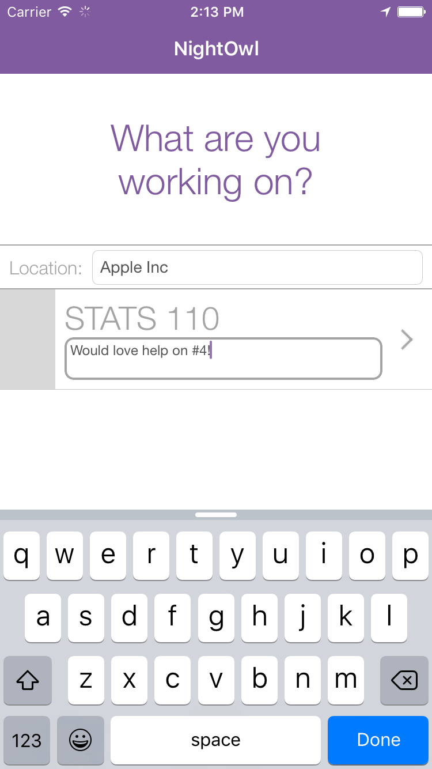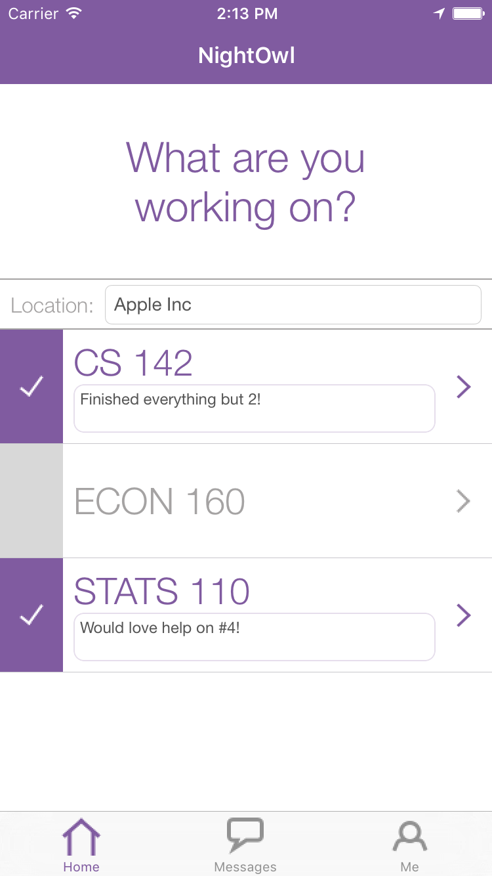

When activating a class, we animate the class list scrolling up so that the class-to-be-activated is located at the top of the class table. This ensures the user can see the text they are entering as their status as they type it - the class table will scroll back to the former position after a user is done activating that class. We think this is a nice professional touch that lends to a positive user experience.

Find NightOwls
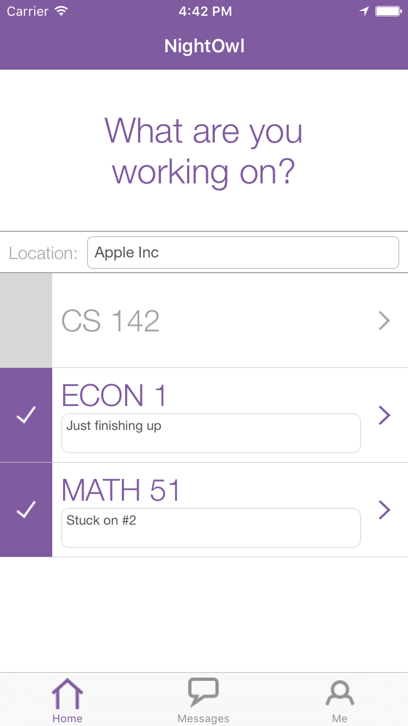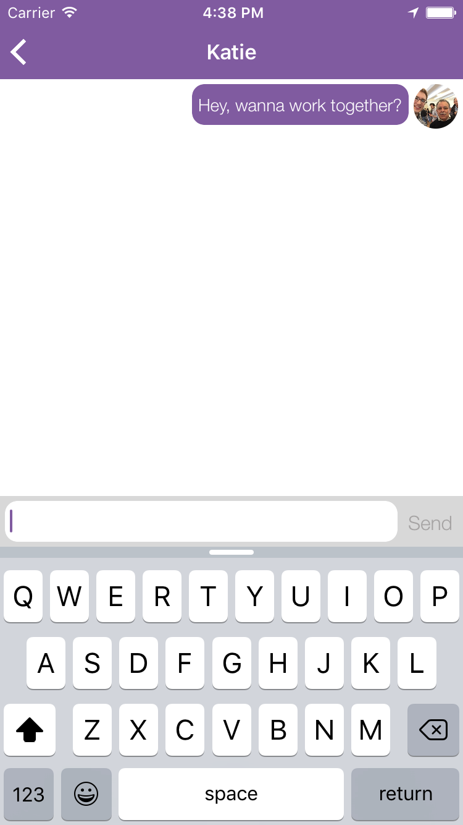
After activating a class, a user may click on the purple arrow on the right side of a class cell to perform the “Find Nightowls” action. This action allows users to find other users who are also active and seeking help - this is one of the core functions of this app.
When a user clicks the purple arrow to perform the “Find NightOwls” action, we segue to a new screen. This screen shows a list of users who are also active in that class, sorted in decreasing order of proximity. We may quickly switch between viewing NightOwls for all of our active classes using the ribbon at the top of the page - swiping right or left will allow the user to show active NightOwls for each of their active classes.
We chose to list users in order of decreasing proximity because in this case proximity is a proxy for meetup convenience - the closer a user is to you, the more convenient it is for the two of you to meet. We also place the human-readable location name in a prominent position in each cell - we think this location information will facilitate coordinating a meeting place for users.
From this “Find NightOwls” screen we may initiate a conversation with another user. By tapping a user, we will advance to an empty message screen. Here, we may type a message to that user inviting them to collaborate.

Messages
A user may view incoming and past messages by using the “Messages” tab. The user arrives at this tab by selecting the “Messages” button in the bottom tab bar.
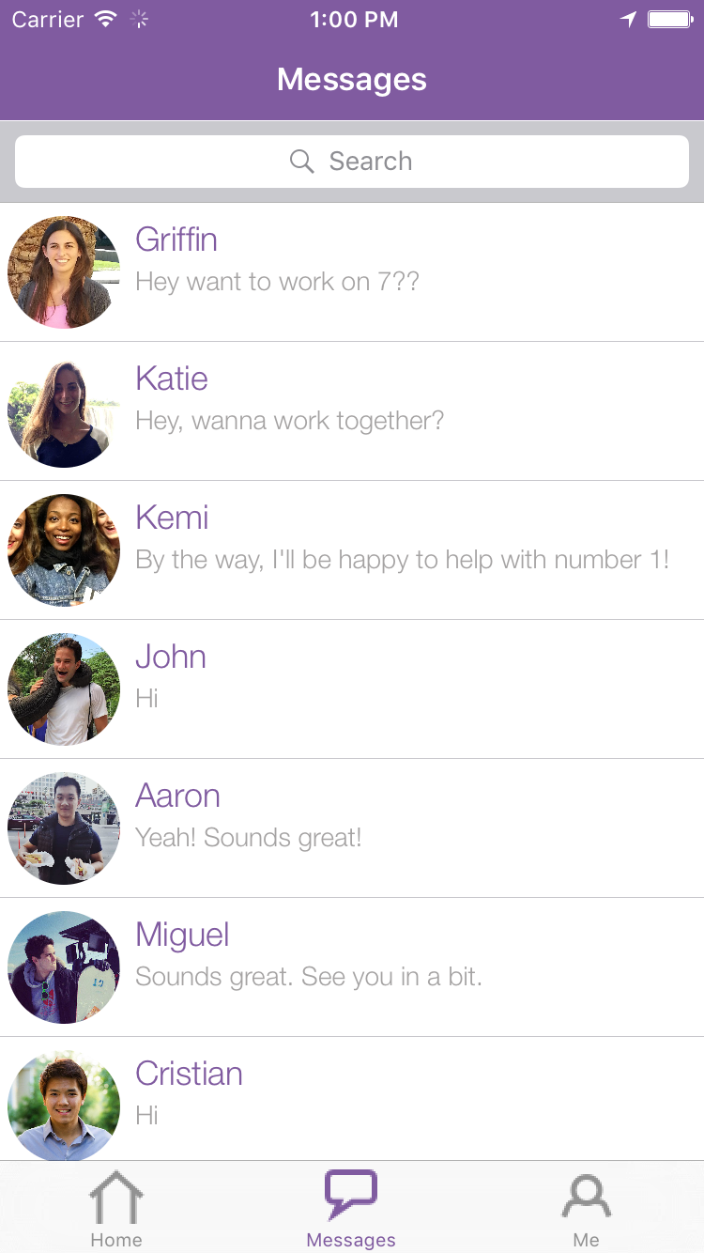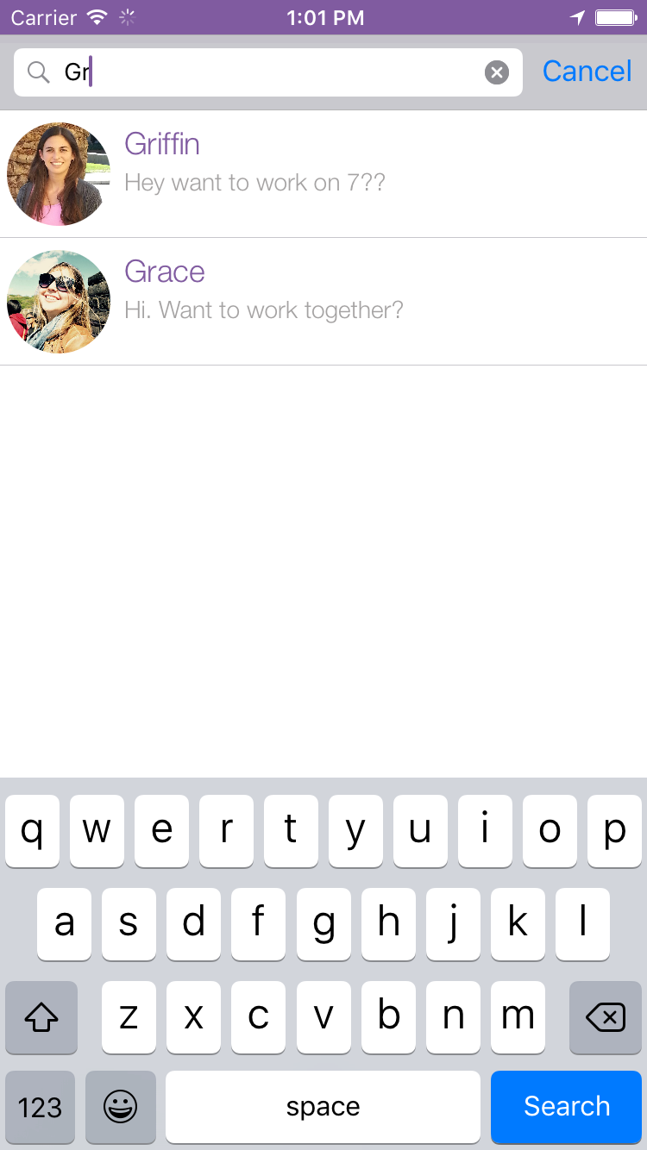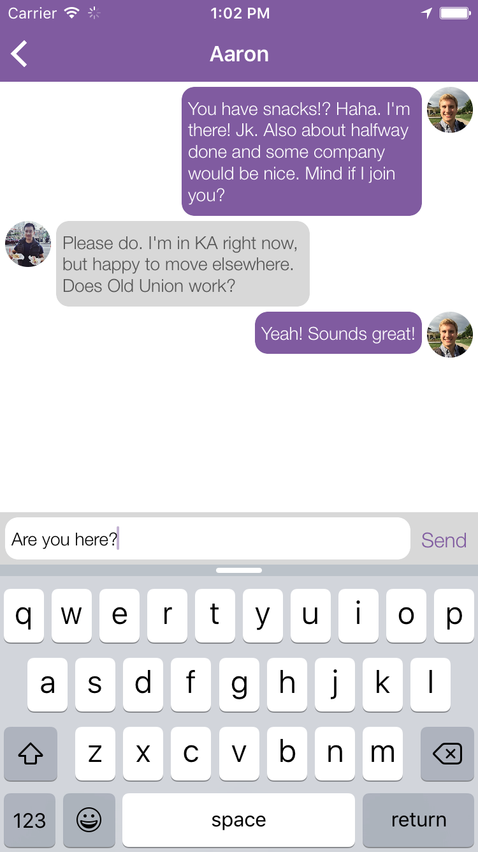
When the user first arrives at the “Messages” tab they are presented with a list of conversations they have taken sent and received. This is ordered by most recently sent/received (most recent messages are at the top).
In this messaging list we see just the name and picture of each user this user has interacted with - their location and status are not shown. This is because the user may not be currently active and may not have a current location.
We may decide to search for a user by name using the search bar at the top of the screen, or may swipe up or down in the messages list to directly select a user. When a user selects another user in the messages list, they see a screen showing their past conversation with that user and are able to send more messages.
We intend for this screen to be useful for users who want to return to a past conversation, or who might want to work with someone again who they have worked with in the past. Perhaps a user will reach out to several NightOwls, then return to this message page to continue conversations with those users after they respond.

Me
The user may select the “Me” tab by tapping the “Me” button on the far right side of the bottom tab bar. There are four things that a user may do from this tab: add classes, remove classes, change profile picture, and logout.
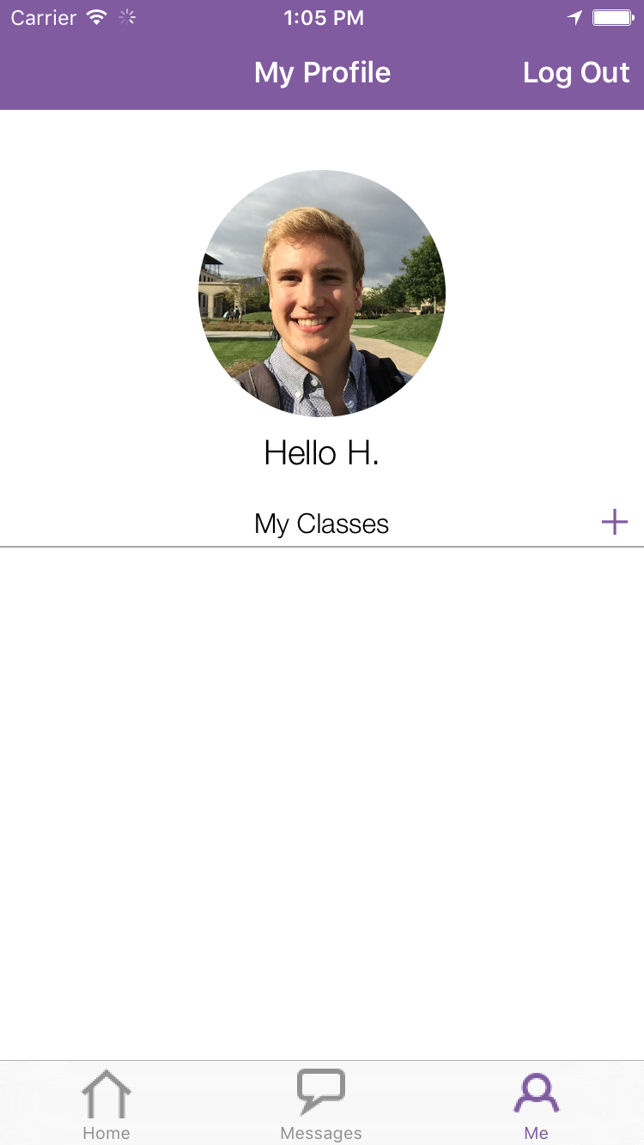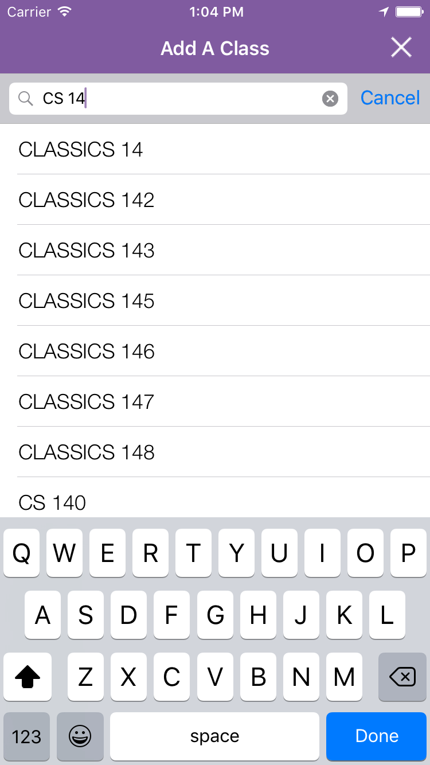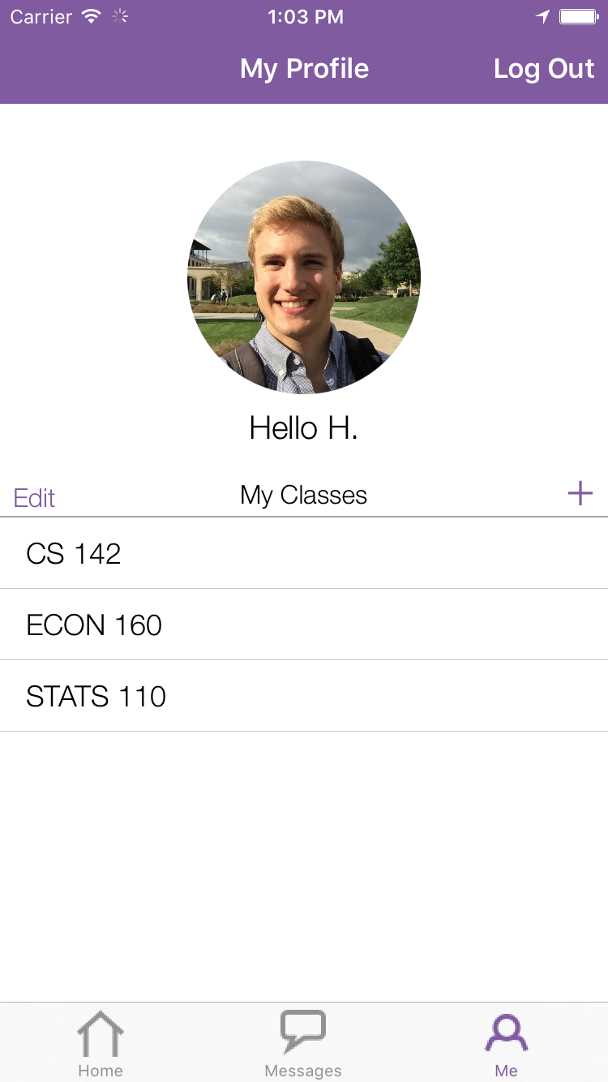
The first action that a user might do upon initially downloading this app and registering a user might be to add classes to their profile. When the user first arrives at the “Me” tab, their list of classes will be empty. The user may add classes by pushing the purple plus button to the right of the “My Classes” text. This will bring them to a list of Stanford course numbers - the user may use the search bar at the top of the page, or scroll directly to the class they wish to add. The user adds a class by pushing the table cell with the course number they wish to add.
We pin the search bar to the top of the screen here - this is the expected path to selecting a class (due to the large number of classes in Stanford’s course catalog). A user may return to their profile page without adding a class by tapping the white “X” at the top right of the screen. The user must repeat this process for each class they wish to add.
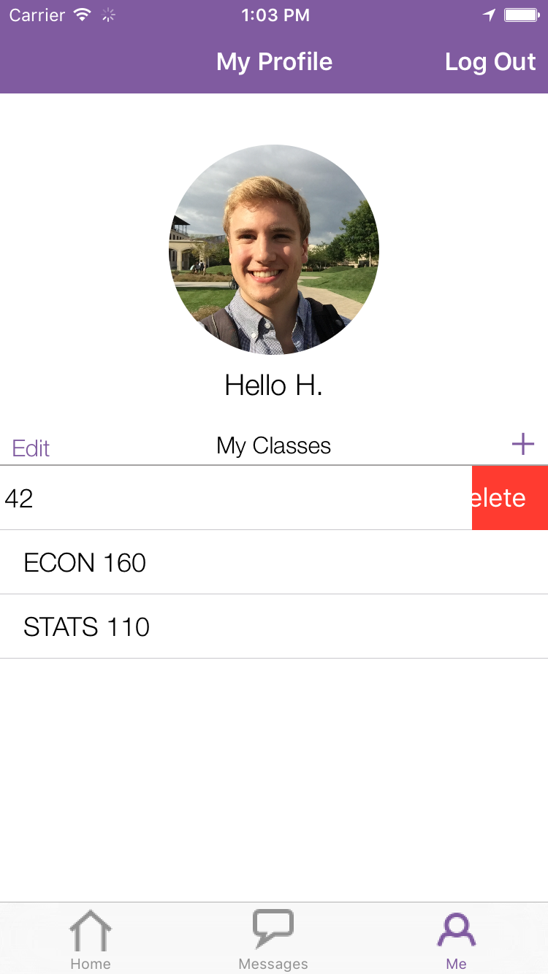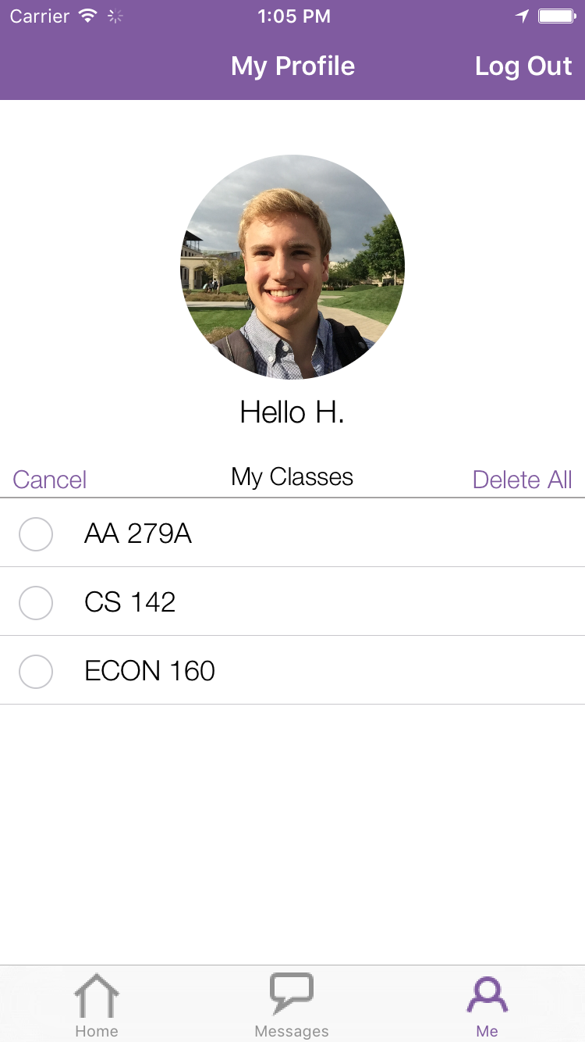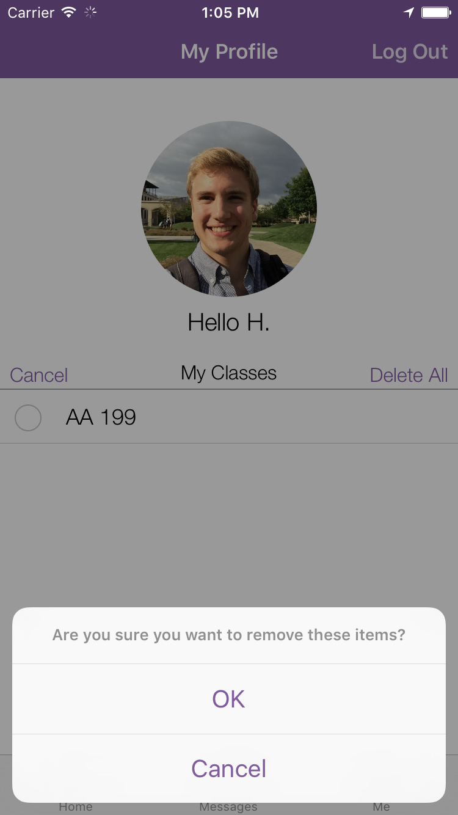
A user may remove classes in two ways - by sliding a class cell to the left, or by pushing the “Edit” button in the top left of the “My Classes” table. The swipe action allows a user to swipe left, then confirm their delete by pushing the red “Delete” button that reveals itself. The user may also delete classes by pushing the “Edit” button. This reveals selectable circles next to each class - a user may select one or several classes to delete. The user may delete all classes by pushing the “Delete All” button on the top right. Upon pressing any of the above delete buttons, the user must further confirm their action with a popup alert.
Deleting a class here will remove that class from the “Home” tab - users will no longer be able to make themselves active for that class and will not be able to search for NightOwls in that class. However, all messages exchanges a user might have had with users in that class will remain. We don’t see a purpose to removing those messages - it seems like it would be unexpected behavior and users might want to contact those people again (perhaps in a non-homework context).
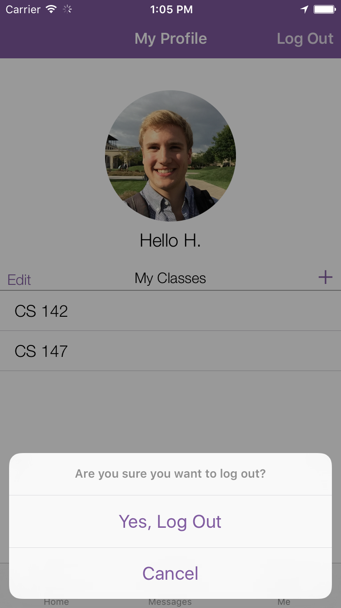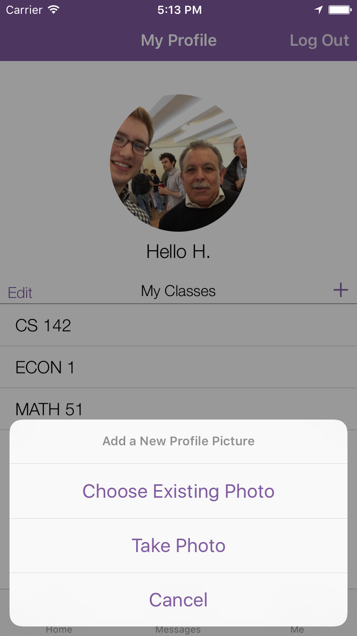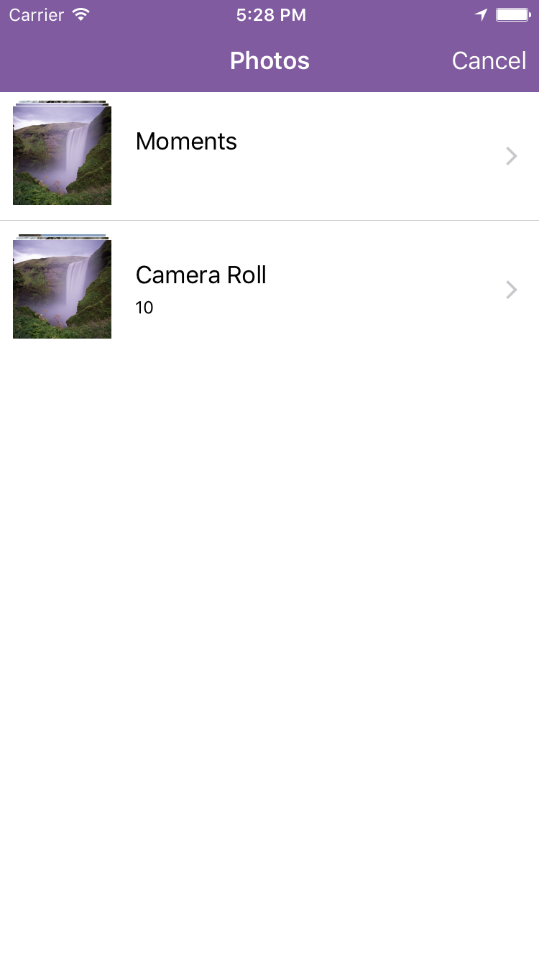
The remaining two actions a user may perform on the “Me” tab are to logout and replace their profile picture.
Users may logout by tapping the “Log Out” button in the top-right of the screen. They have to confirm their action with a popup dialog box. This returns the user to the “Login” page, and allows another user to login with this device. We do not expect this to frequently used, but feel it is a feature users expect.
Users may change their profile picture by tapping their image. This will bring up a dialog that allows users to either choose an existing photo or take a photo. These are both the built-in iOS functions, and lead to standard photo-access and camera flows.

What Is Left Unimplemented
Our app is very functional! All the features touted above are fully fleshed out - there are almost no “Wizard of Oz” techniques used to fake any parts of the app. The only Wizard of Oz technique is the explore courses data which is static and not updated whenever explore courses data is changed.
That being said, NightOwl is not as robust as most apps on the App Store. Some next steps for development might include error handling and other corner-case handling. NightOwl has been developed without great consideration for exceptional circumstances, and will not operate as expected without access to the internet.
If we had more time to iterate and implement, we would further flesh out a settings page to allow a user to adjust personal settings (i.e. privacy).

Tools We Used
We used a handful of digital tools in the creation of NightOwl.

Sketch
We used the digital design app Sketch to produce mocks for our UX design. We found it very useful for fast, effective visual prototyping of our UX. Sketch helped us to test our visual designs without sinking too much time into implementation.

Marvel
Marvel allowed us to simulate the experience of using the app by adding tappable regions to our Sketch mock ups. This was extremely valuable for getting a feel for the UX of the app before building it out.

Xcode
As an iOS app, NightOwl has been developed using Xcode as a dev environment. Xcode has been both helpful and tricky; it is amazing that Xcode can run apps directly on your phone, but only amazing when that feature works. We are grateful for the simplicity that Xcode usually provides, but sometimes are frustrated with confusing behavior and spaghetti-like configuration logic.

Objective-C
We used the Objective-C programming language to code the app. We chose this language (over Swift) because the developers felt they had more experience with it.

Lookback
We used Lookback to record the actions, voice, and facial expressions of our users during usability tests. This allowed us to gather quantitative data (such as time taken to complete a task and number of taps) and confirm our qualitative observations.

Final Cut Pro
We used Final Cut Pro to create professional quality videos for NightOwl. Final Cut is extremely useful and powerful - we found it very useful.

Git
Our team used Git to share our iOS code for NightOwl. We found code merging particularly useful in our creation of NightOwl and also appreciated GUI git functionality baked into Xcode.

Google Drive
Google Docs almost doesn’t seem like a tool we used because of its ubiquitous, invisible presence in document and file sharing - which I think is about as high a praise as you can give a file sharing tool. We used Google Drive to share our documents and presentations as well as other organizational materials, which was especially valuable to us.

Making it Real
Our Team
Our 5-person team has a variety of backgrounds and experiences that qualify us to realize our CS194H project as a product. While we all took CS147 and thus have a strong foundation in design, we have specialized areas we are each strong in as well. On the development side, Griffin and Evan are both CS students who have taken CS193P and are thus able to implement our app. On the design and user-testing side, Lachlan, Zara, and Priyanka focused on brainstorming design changes based on user feedback. As a group, we are able to work well and reached consensus on our business model. Perhaps most importantly, we share the same vision and passion for NightOwl. This is what makes us the best team possible to turn our prototype into a reality.

Business Model
If we were to turn our app into a real product, our target users would be all college students who benefit from collaborative work -- a major fraction of the the 20.4 million students on US college campuses today. Key partners that could benefit from access to our users include employers who are interested in hiring STEM students, tutors who want to advertise their services and even food or commerce businesses like Dominos or the local campus bookstore. Most of our revenue would come from advertisements from these partners. We also considered a credit system in which users can use credits to get homework help. Users could earn these credits by either paying for them or helping others and lose these credits by receiving help from others. However, while this would make the app sustainable in the long run, we would need to discuss it in more detail as a team before deciding on it. We feel that having users pay for credits may undermine the collaborative spirit of our app.
Summary
We envision NightOwl as the go-to solution for late night studying. NightOwl solves a problem that students face all the time -- being stuck on an assignment late at night and having no way to get help. The night before an assignment is due there are likely many students around campus who are stuck and interested in working together. However, at the moment those students have no way of finding each other. NightOwl allows those students to find each other and get to work. As a team, we kept this vision in mind every step of the way - from needfinding to design ideation to prototype iterations to usability testing. We debated and prioritized design changes based on how relevant and needed they would be for users. We now have an app that is almost fully functional and ready to be shown to the world. We hope to impact college campuses like Stanford by connecting people together and helping students lead more collaborative and productive lives.

