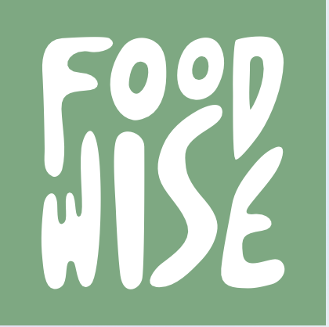

FoodWise
Your roadmap to real recovery.

Final Design Report
CS 147 Fall 2024
Mai M. - UI/UX, User Researcher
Ava L. - UI/UX, Designer
Na Young S. - UI/UX, Videographer
Elton M. - Lead Developer

1. Problem/Solution

Problem: Eating disorders are difficult to treat without external support, and while therapy is ideal, it is highly inaccessible and stigmatized. Most existing products we found in our market research were meant to be used in tandem with therapy, and overall lacked the structured approach you would find in a professional setting.

Solution: FoodWise is an app meant to guide users through the eating disorder recovery process through a fun, stage-based game interface. In making the recovery process more enjoyable and structured, we hope to empower the user to make real, tangible, and sustained progress.

2. Needfinding

- Interviews

We interviewed a total of 5 participants over the course of 2 weeks, all of which had some experience with disordered eating. Despite requiring that all participants had experienced this in some capacity, we also wanted to aim for a diversity of experiences, with different conditions, causes, and current places in the recovery process. This allowed us to find the commonalities between the diverse user base that we will have as an application dealing with this subject. Most interviewees were recruited through mutual connections, however two were recruited on University Ave.

We prioritized interviewing in person and with great care for the topic at hand. This is a sensitive subject after all and that cannot be overlooked. We sought to ask questions in a kind and not overly invasive manner, allowing the interviewee to slowly open up throughout the course of the conversation as we found this to be the most informative.

Compensation through a free bubble tea drink was offered, however not always accepted by the interviewee.

- Synthesis

Each interviewee gave us a variety of different insights on what causes their conditions, how they have recovered, and the difficulties they’ve found in the recovery process. We chose to approach synthesis by finding the common underlying issues and using those for our solution brainstorming.

These are the things we found our participants agreed upon/had in common:

I. Overworking oneself and the stress that comes from that makes it
incredibly easy to fall into bad eating habits.

II. Many felt that there was a significant amount of food misinformation
online which impacted both the development of their disordered
eating habits and their ability to recover

III. Therapy is exceptionally inaccessible and often financially strenuous.

IV. Finding the motive to recover on your own is exceedingly difficult.

V. Finding effective coping strategies for emotional regulation, relapse
prevention, and recovering once again post-relapse is exceedingly
difficult

VI. It is quite easy to fall into cyclical mindsets around recovery, adopting
an “all-or-nothing” mentality where they feel incredibly guilt for
any moments where they are experiencing relapse or the urge to
relapse.

VII. Negative body image is a hard thing to regulate/recover from,
whether on your own or with a professional.

3. POVs and Experience Prototyping

- Our POV Statements

From our needfinding, we developed 3 final POV statements

- We met J, a college junior from Philadelphia, who has a history of anorexia and, more recently, developed bulimia. At her lowest, she was eating around 300 calories per day and walking around 12 miles per day. We were surprised to realize that despite viewing her eating disorder as morally incorrect, when asked for what she believes is her healed, happy self, she identified a target weight (that she compared to someone in her sorority). We wondered if this means she finds her self-worth in how skinny she is and focuses on where she feels she doesn’t meet beauty standards. Hence, her comparison to others is a driving force of her eating disorder. It would be game-changing to shift her motivation for recovery to focus on health rather than weight/body image.

- We met JH, a college senior from Korea, who has a history of bulimia brought about by pressures of female beauty standards. We were surprised to realize that she puts extreme pressure on herself to lose weight and, as a result, has an all-or-nothing mentality when it comes to food restrictions and feels immense guilt (falling into a cycle of binging and purging) when she breaks her food rules. We wondered if this means her eating disorder behaves like an addiction in that it is 1) largely triggered by common life stress and 2) acts as an obsession with an (unrealistic and unhealthy) body standard. It would be game-changing to find a healthy way to prevent the likelihood of/avoid triggering a relapse into the addiction of an eating disorder.

- We met JH, a college senior from Korea, who has a history of bulimia brought about by pressures of female beauty standards. We were surprised to realize that even though she struggled with comparing herself to others, her eating habits improved when she had company. We wondered if this means the presence/company (in-person or virtual) of trusted friends/community can help prevent her falling back into eating disorder habits (binging and purging). It would be game-changing to have a trusted, on-call, and accessible community to act as a reliable support system in her recovery.

- HMWs

From these POVs, we generated a variety of How Might We statements, obtaining one primary HMW to further develop from each, which is highlighted.

- From POV 1
  - HMW make thinking/feeling about a food a positive/uplifting experience instead of oppressing?
  - HMW combat the glorification of unhealthy (overly skinny) bodies?
  - HMW we totally change beauty standards?
  - HMW provide messaging to combat toxic, unhealthy messaging around eating habits and food?
  - HMW use positive messaging and accurate information to change one’s mindset in recovery from an eating disorder?
  - HMW instill the belief that happiness does not come from appearance (or weight)?
  - HMW instill a half-glass-full mentality around self-perception and self-image?
  - HMW eliminate shame/stigma around eating disorders and seeking help/therapy for them?
  - HMW increase accessibility to food therapy specifically?
  - HMW encourage someone to seek professional help when signs of declining health from an eating disorder (such as losing one’s menstrual cycle) occur?
  - HMW re-establish beauty standards as defined by healthiness, not “being skinny”?
  - HMW instill confidence beyond just appearance (i.e. find confidence in friends, skills, experiences, etc.)?
  - HMW seek out and provide regulated health information?
  - HMW shift the mentality away from appearance-oriented toward health-oriented?
  - HMW eliminate body comparison to others’ bodies?

- From POV 2
  - HMW instill healthy thought processes + coping mechanisms for preventing relapse and for times of crisis?
  - HMW we help someone regulate their emotions (which are linked to eating behaviors)?
  - HMW remove triggers/frequency of triggers?
  - HMW break the cyclical nature of the eating disorder?
  - HMW break someone out of their negative spiral by looking at the stages of stress, binging, and purging?
  - HMW we incentivize someone to track/record their stress and eating habits in a non-oppressive way?
  - HMW discourage comparison with others?
  - HMW manage the all-or-nothing mentality?
  - HMW healthily encourage portion control?
  - HMW decrease personal stigma regarding eating disorders?
  - HMW regulate feelings after relapse and cut short negative feelings of guilt and self-hatred?
  - HMW help recovery after the relapse/purging?

- From POV 3
  - HMW involve other people (such as a community) in one’s recovery from an eating disorder?
  - HMW increase on-demand access to a supportive community in times of crisis (verge of relapse)?
  - HMW ensure that this community is healthy and reinforcing positive behaviors as opposed to negative ones?
  - HMW help someone to call on physical or virtual company to accompany one while eating (i.e. for a meal0?
  - HMW break down shame and hesitancy to partake in a community that is striving for recovery from and eating disorder?
  - HMW create authentic community that connects at a deeper, emotional level?
  - HMW create consistent engagement with such a community?
  - HMW create a community that collectively strives for an upward trajectory from an eating disorder?
  - HMW provide support to prevent relapse when a person is by themselves and there is no immediate, external intervention available?
  - HMW ensure that the community toward recovery is a safe space?
  - HMW incentivize people to join and share in this community space?
  - HMW provide support to prevent binging specifically and help with food portion regulation (not restriction)?

- Solutions and Experience Prototyping

Our top 3 HMWs that informed our solutions:

- HMW use positive messaging and accurate information to change one’s mindset in recovery from an eating disorder?
- HMW break the cyclical nature of the eating disorder?
- HMW involve other people (such as a community) in one’s recovery from an eating disorder?

Given these HMWs, we chose our top 3 solutions:

- Break the cyclical nature of eating disorders
- Create community to help with recovery
- Improve info and messaging for eating disorder recovery

We went forward with experience prototyping, creating one for each solution:

Note: We used Discord (see descriptions below) to test our experience prototypes with users. Before entering the Discord, we had users complete a short Google intro form.
- This Google form allowed us to obtain background information and the experience prototype(s) they wished to participate in
- We prioritized finding people who had issues with eating in the past, along with ensuring one of the participants was an interviewee
- As such, none of the participants had a relationship with food they described as being better than “Okay”, and all had experiences with an eating disorder

- HMW use positive messaging and accurate information to change one’s mindset in recovery from an eating disorder?
- Assumption: Access to well-regulated, curated, and engaging food information will aid in shifting the mindset of the participant in a way that supports recovery.
- Key aspects: We prompted participants with quizzes related to food information and myths. After they answered, we provided them with a source for the answer.
- What worked/didn’t work: Execution was not ideal; one user did not believe any of the fallacies and felt tricked. She did not learn from the activity. However, another user did find the experience more fun and educational. Information is most helpful when tailored to the user’s specific misconceptions, which was not exactly accomplished in this case.

- HMW break the cyclical nature of the eating disorder?
- Assumption: If one is reminded to eat/snack throughout the day, it could prevent them from not eating and/or later binging (and purging).
- Key aspects: We reminded the participant throughout the day to eat their meals through Discord.
- What worked/didn’t work: Found this to be ineffective, one participant stated she viewed this as another notification to ignore. Simple notifications are not sufficient to change habits. It is worth noting that some interviewees did forget to eat, and the notifications did not help prevent this.

- HMW involve other people (such as a community) in one’s recovery from an eating disorder?
- Assumption: Having access to people who are also going through the process of recovery could aid in emotional regulation, solidarity, and support.
- Key aspects: We placed three people in an anonymous Q&A/forum Discord server and prompted them with some questions to encourage discussion.
- What worked/didn’t work: This prototype received the most positive response. Even with a tiny test community, there was connection between users. However, it is unclear whether users would consistently interact over a larger time frame. The test was not a resounding success but still supports the assumption. However, we weren’t able to test during times of stress, so the emotional regulation aspect is not confirmed.

4. Design Evolution

- Solution

From our POVs and experience prototyping, we came up with our final solution: a stage-based guided process for structured support in recovery. Our interface contains cute visuals, interactive features, and game-like elements to create a pleasant and fun learning and growth experience. Our solution is designed for individuals of any age, gender, or background. It includes a personalized roadmap of learning modules, tailored toward the user’s specific responses to the introductory survey upon entering the app. The roadmap contains learning modules, each of which contains lessons on different topics for eating disorder recovery and journal reflections for the user to comp in lete. Our app also includes stress-, mood-, and food-noise tracking; a toolbox and customizable catalog of coping mechanisms; and emergency help feature in order to provide users with knowledge and habits for sustainable recovery.

Our rationale for this solution is that it provides a digestible, consistent, and informative way to heal from eating disorders. A main takeaway from our Needfinding process was to make recovery seem accessible and digestible. Through our roadmap process, we accomplish this. We also wanted users to feel encouraged by their progress, accomplished through the trackers. Also importantly, eating disorder behavior is highly emotional, thus forming the need for coping mechanisms to deal with these emotions–accomplished by the Toolbox–and during times of higher distress, with the Emergency Help feature. Finally, providing accurate, helpful information around recovery is also essential for knowing how to tackle one’s eating disorder–accomplished through the various lessons in the modules. Lastly, we wanted this to be an enjoyable journey towards a happier and healthier life, so gamifying the interface and making it fun helps achieve this.

- Tasks

- Introductory Survey (simple task)
  - Upon entry to the app, the user will complete a survey detailing a series of questions that provide the app with info about the user, their relationship with food, eating disorder status/history, etc. This task is simple because all users are required to complete it, and it does not require any knowledge about the app and its functions.
  - This task is important to the user base because it causes them to reflect and bring intention to their eating disorder recovery with the app, and it also allows them to input critical information surrounding their eating disorder habits and history that then informs the rest of their time and recovery journey in the app.
  - Annotated simple task-flow below:
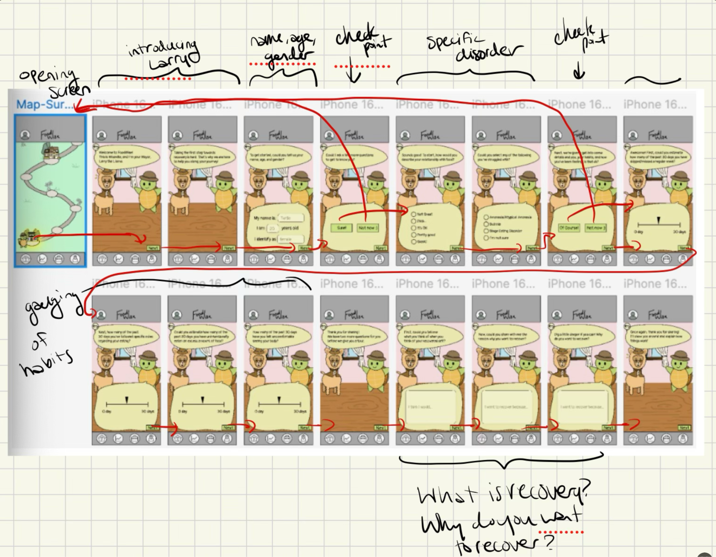

- Toolbox (moderate task)
  - Through the toolbox feature, a user can access, add, and edit different tools that they can use in their recovery journey. These tools are available to help prevent a user from lapsing back into ED behaviors (such as binging, purging, etc.). Each tool has a name, description, and also tags (such as Stress or Urges). An example of a tool would be something like “Take a Walk” with a description of “walk for ten minutes around the block to distract from urge to binge” with the tag “Urges.” We deemed this to be moderate because this task requires a bit more agency, interaction, and thought/effort on the part of the user.
  - This task is important to our user base because it provides them with an easily accessible set of tools that they can go-to when they are struggling to distract themselves from or move away from the temptation to participate in eating disorder habits (such as binging, purging, etc.). These tools are useful because they replace the eating disorder habits with a healthier alternative that provides the same effect (i.e. a sense of peace, stability, etc.). Completing this task consists of interacting with the described features (access, add, and edit tools).
  - Annotated moderate task-flow below:
    - Access an existing tool in your Toolbox:
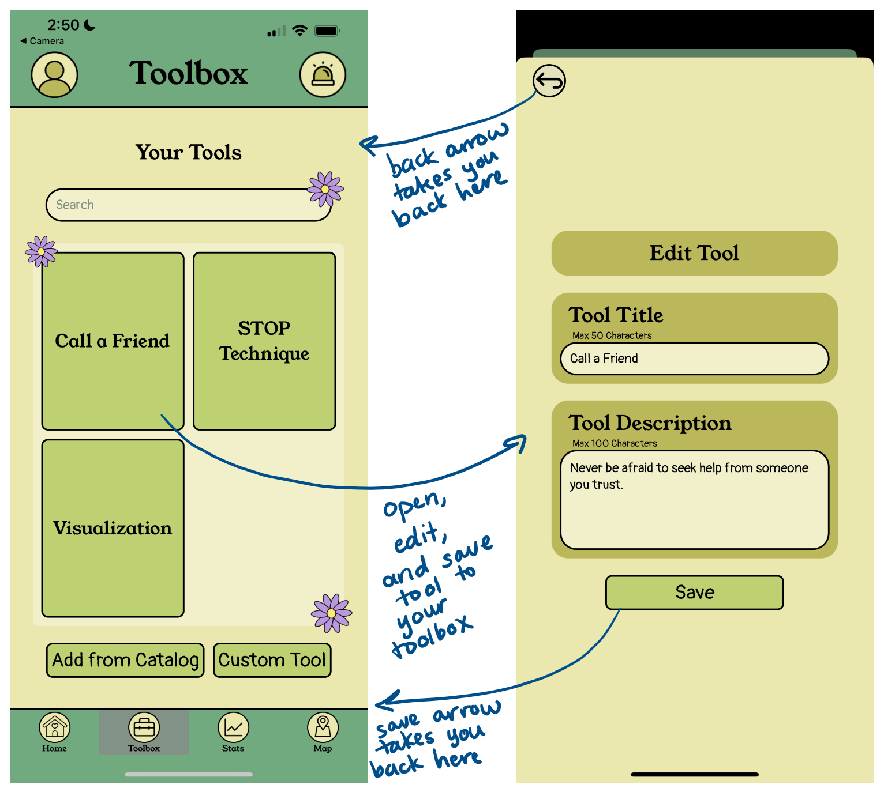

- Create and save your own custom tool in your Toolbox:
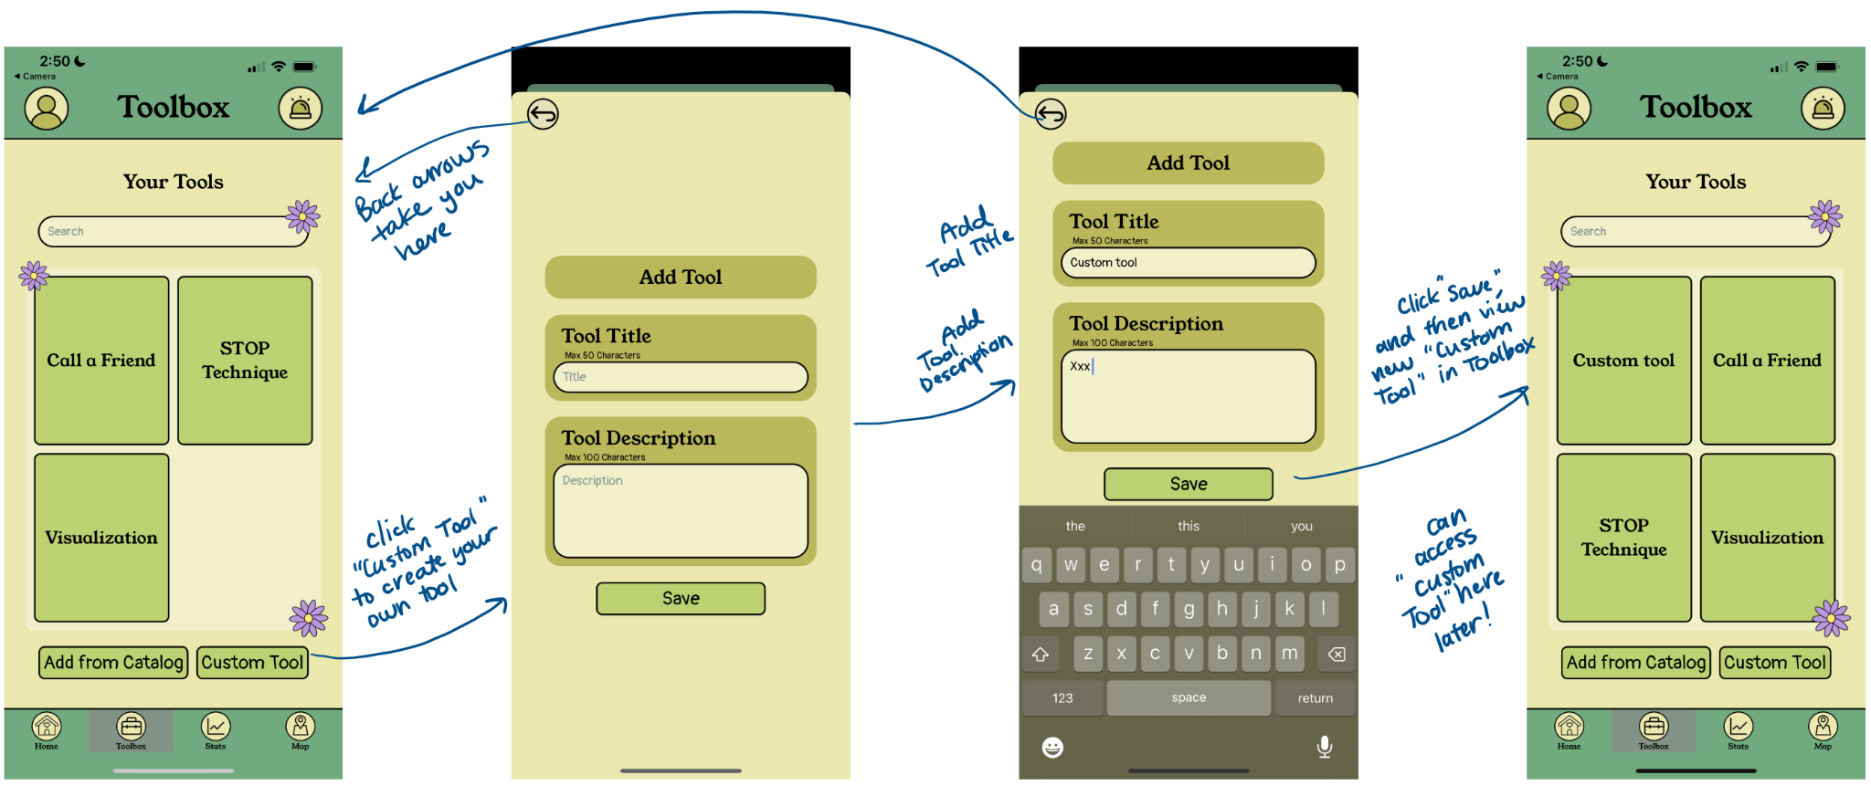

- First Module (complex task)
  - As seen on the home page, completing the current module (represented by a building on the map) consists of completing different lessons and lesson journals, found on the home screen. These lessons contain informative videos/text that educates the user on important topics to help their recovery. As part of this learning process, users also complete lesson journals in response to specific prompts relevant to the lesson at hand. These journals can be accessed in a log found through Lesson Journals on the homepage. Finally, completing a module also consists of completing Your Daily Checklist on the homepage. We deemed this as the complex task because it requires the most amount of engagement, learning, and time/energy from the user. Completing the task includes checking off your checklist, completing the lesson, and viewing the lesson journal.
  - Completing the first module is important to the user base because this is where the critical learning and reflections take place. When the user completes lessons, journals about them, creates a coping mechanism tool for their toolbox, visits a stop on the map, and writes a positive affirmation, they are actively engaging in the content and habits needed for eating disorder recovery. Our belief is that as the user continuously does these things in the app over a period of time, these knowledge, thinking, and habits will start to become a part of their daily life and massively aid in recovery.
  - Annotated complex task-flow here:

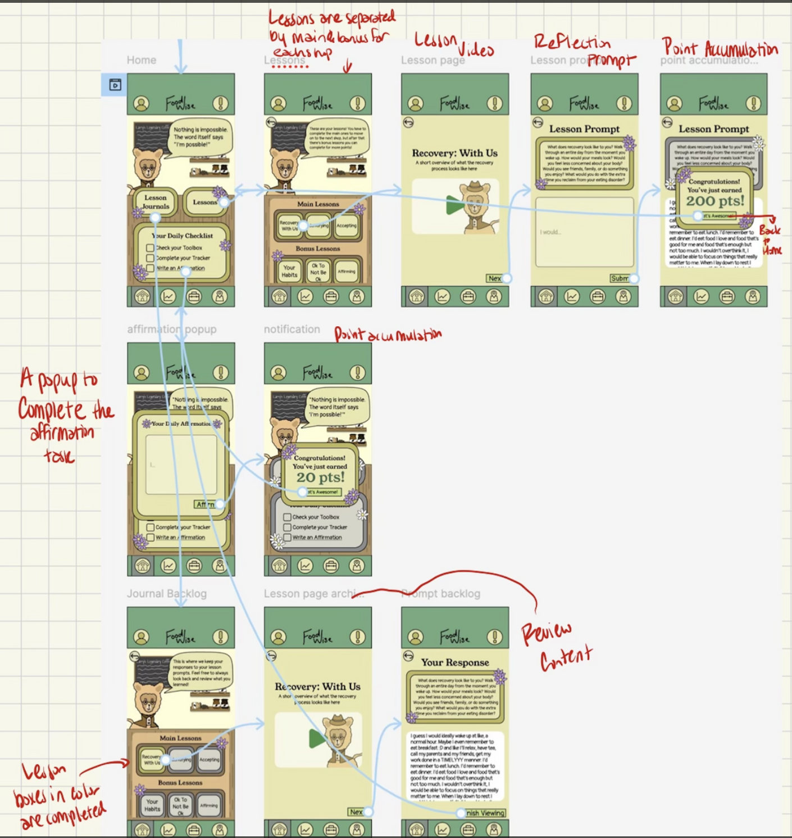

- Design Evolution Visualization(s) and Rationale

- Images of the major UI iterations in your project

- Header Designs:

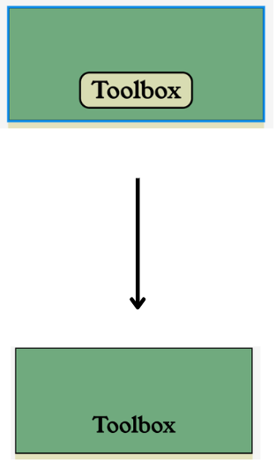
(“Toolbox” looks like a proper header and not a button)
- In making this revision, we removed Shape/Outline for Headers so that it doesn’t look like a button. The evaluation technique we used was evaluating for consistency. We realized that the original design of our headers looked too similar to our design for buttons and could be potentially misinterpreted as a button. We learned from user feedback that they were confused and some of them thought the header might be a button. In response to this implication, we adjusted the headers as in the screenshot above. This way, we incorporated more consistency in designs to help reduce user confusion and user errors. This will in turn create a more pleasant, intuitive, and easy user experience.

- Intro Survey
- We also cut down on and simplified our intro survey:

Before:

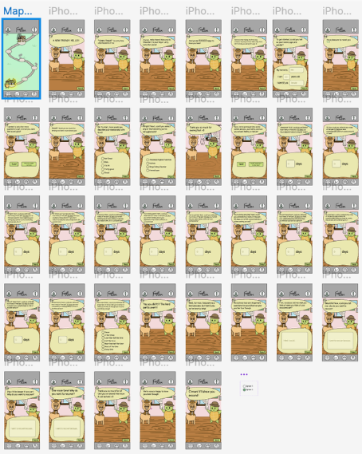

After (major reduction in screens for intro survey):

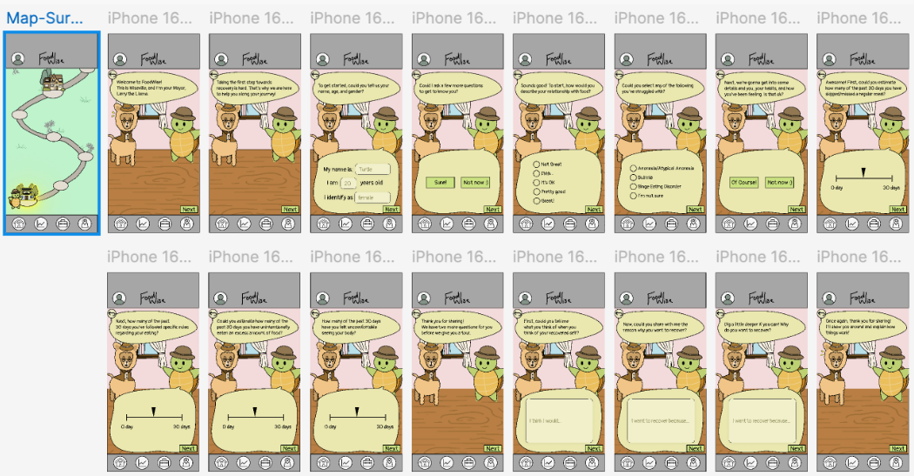

(intro survey is much more concise and feasible, without feeling too long)

- From user feedback, we learned that our initial survey contained too many questions and topics. This created an unpleasant user experience where it felt too long and complicated to actually get started with the app. As a result, we condensed and cut down on the amount of questions and, hence, user responses that were required of the intro survey. The hope with this is that we can glean the necessary information to tailor the recovery journey to the user while also creating a pleasant and quick experience for getting into the app.

- Emergency Button
- From our Heuristic Evaluation, we also changed the design of the emergency help button in the top navigation bar
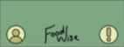
Before:

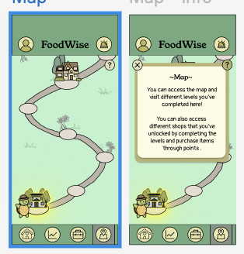
After:

- We learned during the Heuristic Evaluation that the original emergency button design did not convey the correct message. The testers believed that upon clicking the button, rather than emergency assistance, they would instead find more information about how to use the app. We decided to change the symbol to a siren instead to properly convey the message that this is used in the event of an emergency

II. Severity 3 or 4 Heuristic Evaluation Violations

For severity 3 and 4 violations, we received 6 violations total and, hence, made 6 changes total

- Violation 1: survey flow too long (severity 3, simple task, H12: Value Alignment and Inclusion)
- Feedback was that the survey was too long and could create friction for those who want simple and easy help as opposed to overwhelming help for their eating disorder.
- We made a fix by cutting down on and condensing the number of questions (and, hence, screens) for the intro survey. This way, the survey became much more pleasant and digestible.
- Screenshots of the change for the visualization below:

Before:

After:

- Violation 2: text too small in survey (severity 3, simple task, H8: Aesthetic and Minimalist Design)
- As the survey progresses, there are follow up questions the user completes, but these questions are more text heavy and, hence, the text gets smaller. Feedback was that the text is too small making it not only inconsistent but also difficult to read.
- We made a fix by reducing the number of words in the questions so that the text size remains consistent and large enough like before.
- Screenshots of the change for the visualization below:

Before:
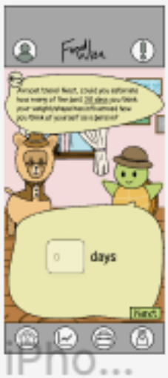

(Apologies for the blurriness, we could only get a screenshot of the prior version). As you can see, the text in the text box is small and plentiful. Hence, we reduced the amount of text so that it is sparser and larger as in the screenshot below (we also changed from a text box to a slider):

After (we also changed the text box entry to a slider for user ease):
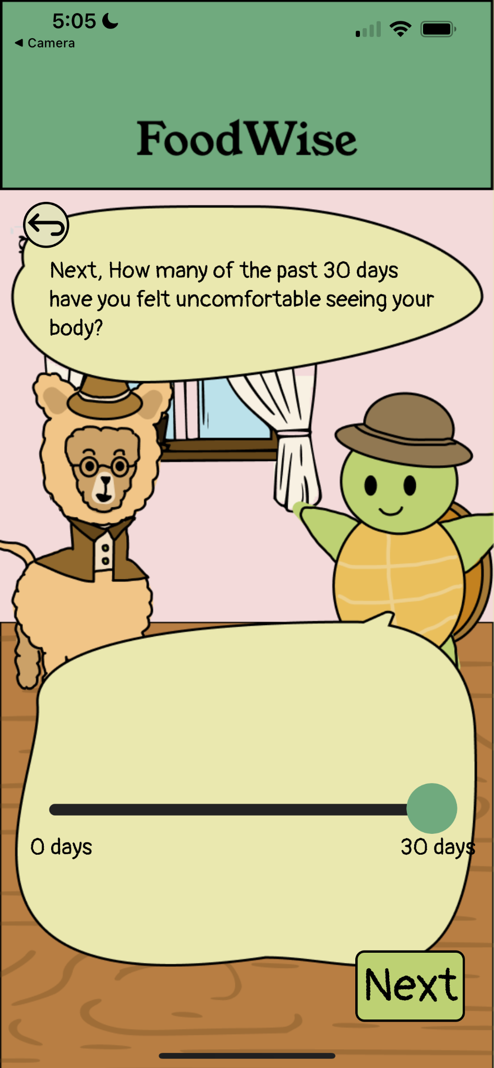

As you can see, the text is much sparser and larger and, thus, easier to view.

- Violation 3: no avenue for users to edit created tools (severity 3, moderate task, H3: User Control and Freedom)
- Feedback was that there was only the ability to add and modify tools in the toolbox, but there was no ability to remove a tool if the user no longer wants it.
- We made a change by creating a “Delete” feature when a user clicks on a tool in their toolbox, as in the screenshot below:

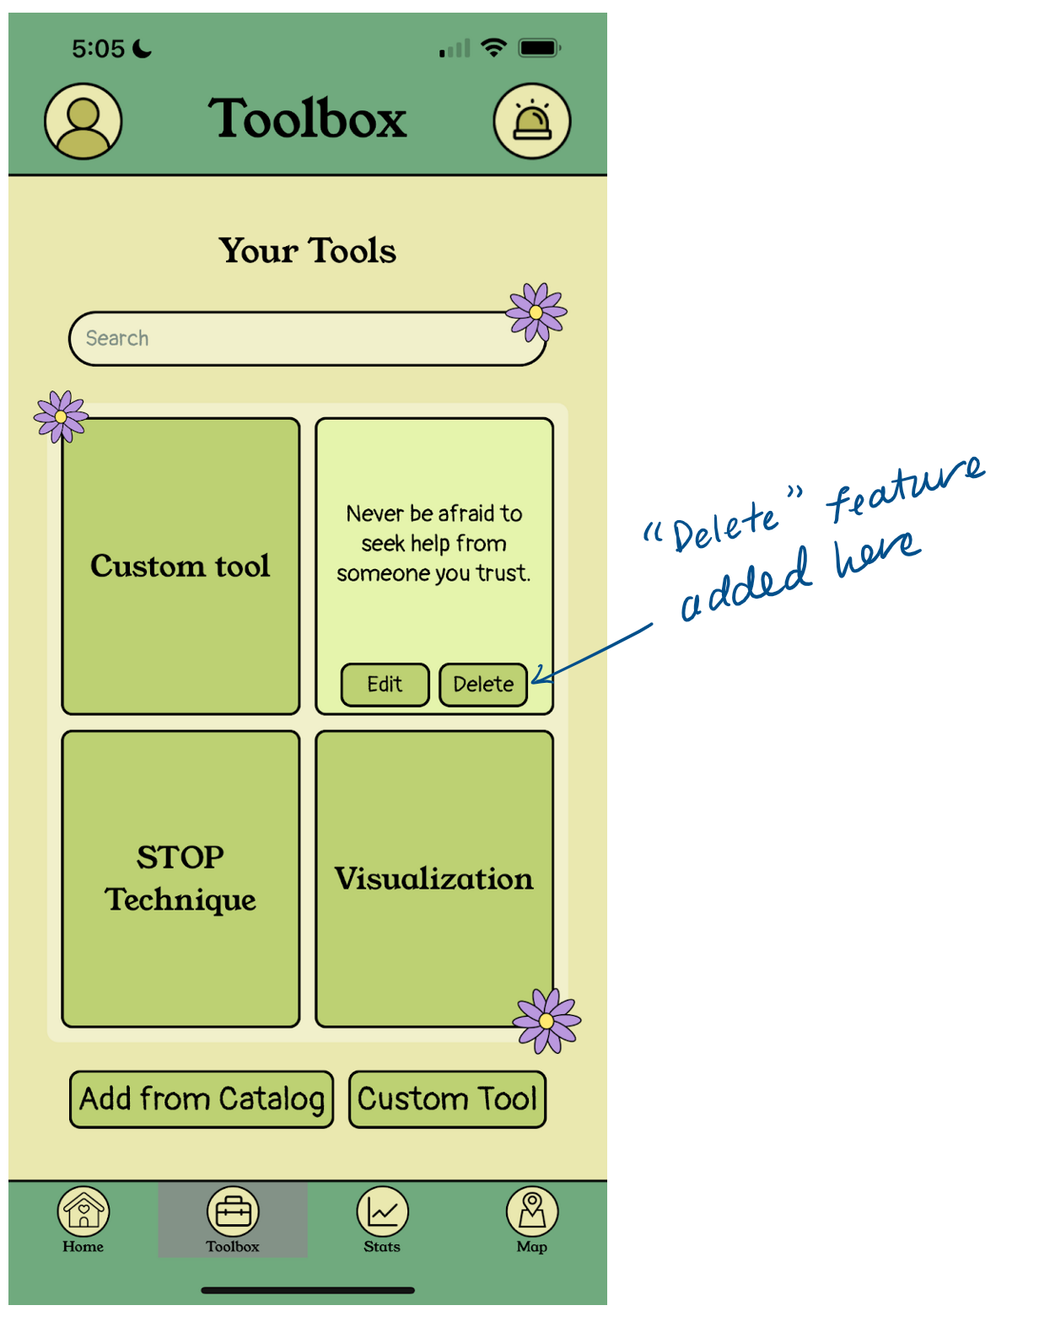

- Violation 4: some page interfaces are visually overwhelming and distracting (severity 3, all tasks, H8: Aesthetic & Minimalist Design)
  - There were several comments about how the introduction survey was too long and the texts were too condensed
  - We reduced the number of questions for the introduction survey and simplified word phrases to make texts sparser
  - We also removed the picture frames in the background to reduce unnecessary visual elements so users don’t get distracted
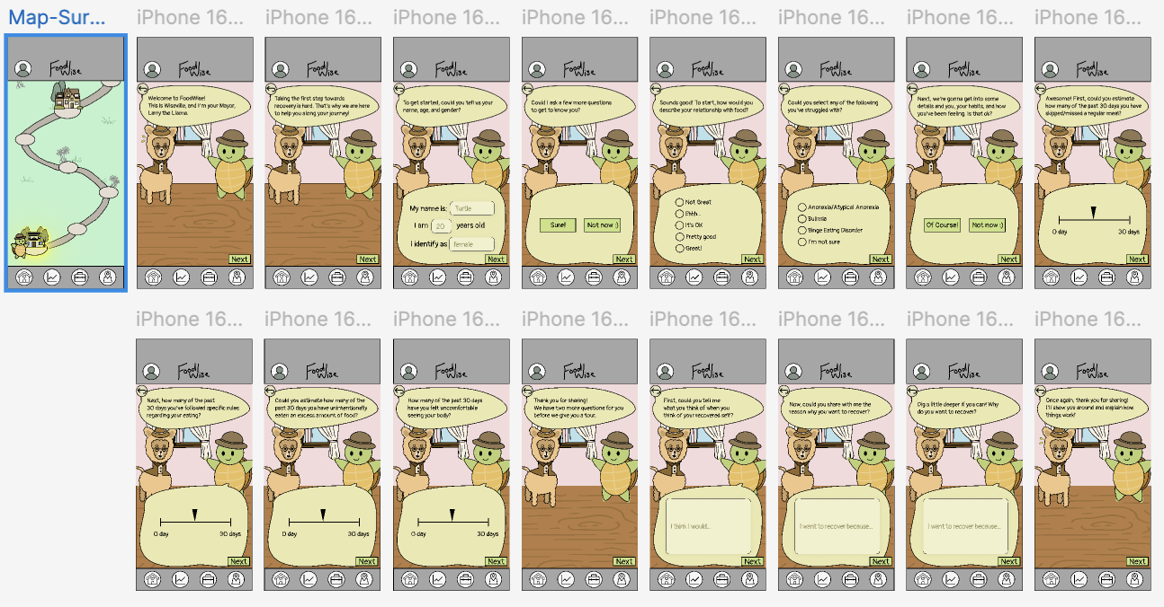
- Violation 5: home screen top right has “!” button, navigation bar buttons confusing (severity 3, extra violations, H2: Match b/w System & World)
  - We changed the emergency help button to an icon that resembles a siren so that it matches the function with the implications in real life
- Violation 6: no guidance for what to do/where to go on home page (severity 4, all tasks, H10: Help & Documentation)
  - Added a brief introduction tutorial that explains what each of the pages contains with an option for the users to skip
  - Added information (?) button in each main page (present in home page, tracker, toolbox, map, and quick help) so that the user can revisit this information on these pop-up pages
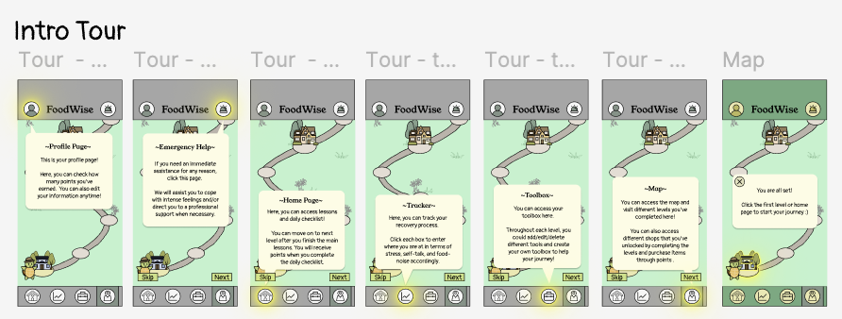

- Values in Design

For our design, we decided on the following values:

- Structure
- Allows people to see a tangible solution to their problem
- Is implemented through the roadmap which guides the user through their recovery in small, manageable steps
- Autonomy
- Empowers the user to regain control of their habits
- Is emphasized through the toolbox, which helps the user gain the ability to help themselves on the day to day
- Growth
- Necessary to instill hope. When you see your progress, you believe in yourself.
- It is shown physically through your progression through the roadmap as well as your trends in the tracker page
- Fun
- Vital to keep the user motivated to continue their recovery
- Is implemented through it feeling almost like a game through the fun UI and animals

One value tension we had was wanting to create a sense of autonomy and structure while making it fun. In a very serious and sensitive topic like eating disorders, we understood that users need support but also have to want to make a change themselves in order to reach sustainable recovery. We want them to feel like they have the autonomy and structure to seriously address their disorder, but we also want them to have a pleasant, fun experience without their engagement and time on our app feeling too heavy.

To address these tensions, we compromised by keeping a fun UI with the animals, designs, and colors feeling cute and gamified, but we made the language (throughout the app and especially in the intro survey and lesson modules) a bit more formal and sparse. We also made a very clear lesson page for each module so there was a sense of structure. This way, we were able to establish an environment that was fun and pleasant while also keeping the content formal, structured, and mature, allowing the user to feel autonomy and clarity in their recovery journey with FoodWise.

5. Final Prototype Implementation

- Tools Used
- Figma was used for designing and revising visuals. Several elements such as icons and background images were exported from Figma for use in the app.
  - Pros
    - Collaborative
    - Popular and established
    - Allows for prototyping
  - Cons
    - Lacking some graphic design capabilities
    - Limited pages
- React Native is the programming language used to develop the app. It offers cross platform compatibility, allowing the app to reach as many users as possible.
  - Pros
    - iOS and Android support
    - Taught in 147L
    - Many pre existing libraries and components
  - Cons
    - Fidelity comes at the cost of time investment
    - Difficult to keep features consistent between devices
- Git was used for version control, allowing for easy collaboration, and also version history in case a change needs to be reverted.
  - Pros
    - Effectively handles conflicts and independent editing
    - Centralized files
  - Cons
    - Difficult to coordinate working on the same feature
- Expo Go aids with testing during development, and allows users to interact with the prototype. Anyone with an up-to-date version of Expo Go installed can scan the QR code on our website with no download required, making it convenient and accessible.
  - Pros
    - Convenient to test and publish
    - No-download access for users
  - Cons
    - Requires that user has the Expo Go app

- Wizard of Oz Techniques
To provide an experience of a fully functioning app, there are certain functionalities that are only simulated, with a Wizard-of-Oz technique:
- Tracker: Several charts are displayed with fabricated user data. We used fabricated data for the charts since a first time user will not yet have inputted data, and we wanted the prototype to reflect the experience of a user who has been using the app for some time.
- Text Entries: Aside from the toolbox, all text entries and sliders do not have any impact on the app. With the limited scope of a demo, personalization based on these responses is unnecessary. Leaving out this feature allows us to simulate the full experience efficiently.
- Tools and Tasks: There is no way of tracking whether the user has actually completed a task, so they are marked as complete as soon as the user clicks them. This is generally accurate, and stands in for a more complex method of measuring task completion.

- Hard-coded Techniques
To provide an experience of a fully functioning app, there are some functionalities we implemented that are hard-coded:
- Emergency Assistance: The suggested activities are hard-coded to guarantee that the user always has access to options for distractions. There is no option to edit the list, as this could overlap with the toolbox functionality.
- Module Lesson: The lesson page inside the first module displays a mockup of a video that does not exist and, hence, is not viewable. Generating an actual video was outside the scope of the prototype, so this mockup is meant to show what the interface would look like if there were a video present.

6. Reflection & Next Steps

- Main Learnings

From this quarter, we learned several important lessons in design thinking, our studio theme, and our project. First, we learned how to properly iterate and incorporate feedback. One of the beautiful results of the different fidelity prototypes is that we learned how to incorporate feedback from our users and make small changes that eventually resulted in larger, overall improvements that were critical to the user experience. Additionally, regarding our studio theme, we learned the positive impact of FoodWise’s mission and the need-space it addresses for those suffering from eating disorders. From our Needfinding interviews, prototype users, and conversations at the project expo, we learned about how an eating disorder can truly diminish one’s quality of life and overall happiness. The positive feedback we received from users and at the expo was encouraging and fulfilling to see the ways that FoodWise could address the way that eating disorders harm lives across the world. Finally, from our project, we saw the fun, incredible way that teammates’ skill sets and experiences can complement each other to create something impactful and important.

In the future, we might dive more deeply into the methodology behind the roadmap and module/lesson approach. While we believe this approach is both digestible and effective, we would like to learn on a more granular level how and what information is most helpful to share for those on an eating disorder recovery journey. Additionally, we might implement other features to enrich user experience, such as a community feature where users could connect with those on similar journeys or also have access to professional coaches who can guide them on an individual level through their journey.

