Table of Contents
Team Member Names and Roles 3
Problem/Solution Overview 3
Needfinding 4
Interviews 4
Synthesis 5
POVs and Experience Prototypes 7
Final POV Statements 7
Example: HMWs from a POV 9
Top 3 Solutions 9
Experience Prototypes 10
Design Evolution 15
Final Solution 15
Design Evolution visualizations and rationale 19
Major UI changes 19
Values in Design 26
Final Prototype Implementation 27
Tools Used 27
Wizard of Oz Techniques 28
Reflection and Next Steps 28
Main Learnings 28
Next steps 29

Project Name and Value Proposition

Project Name
Lunar

Value Proposition
Closer Connections No Matter the Hour

Team Member Names and Roles
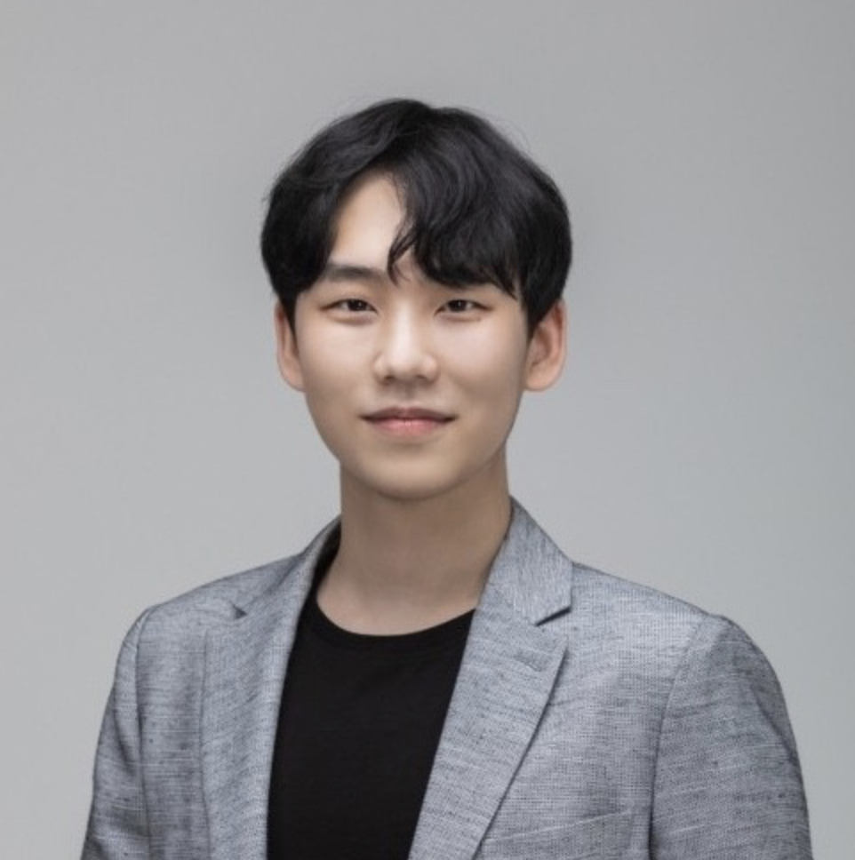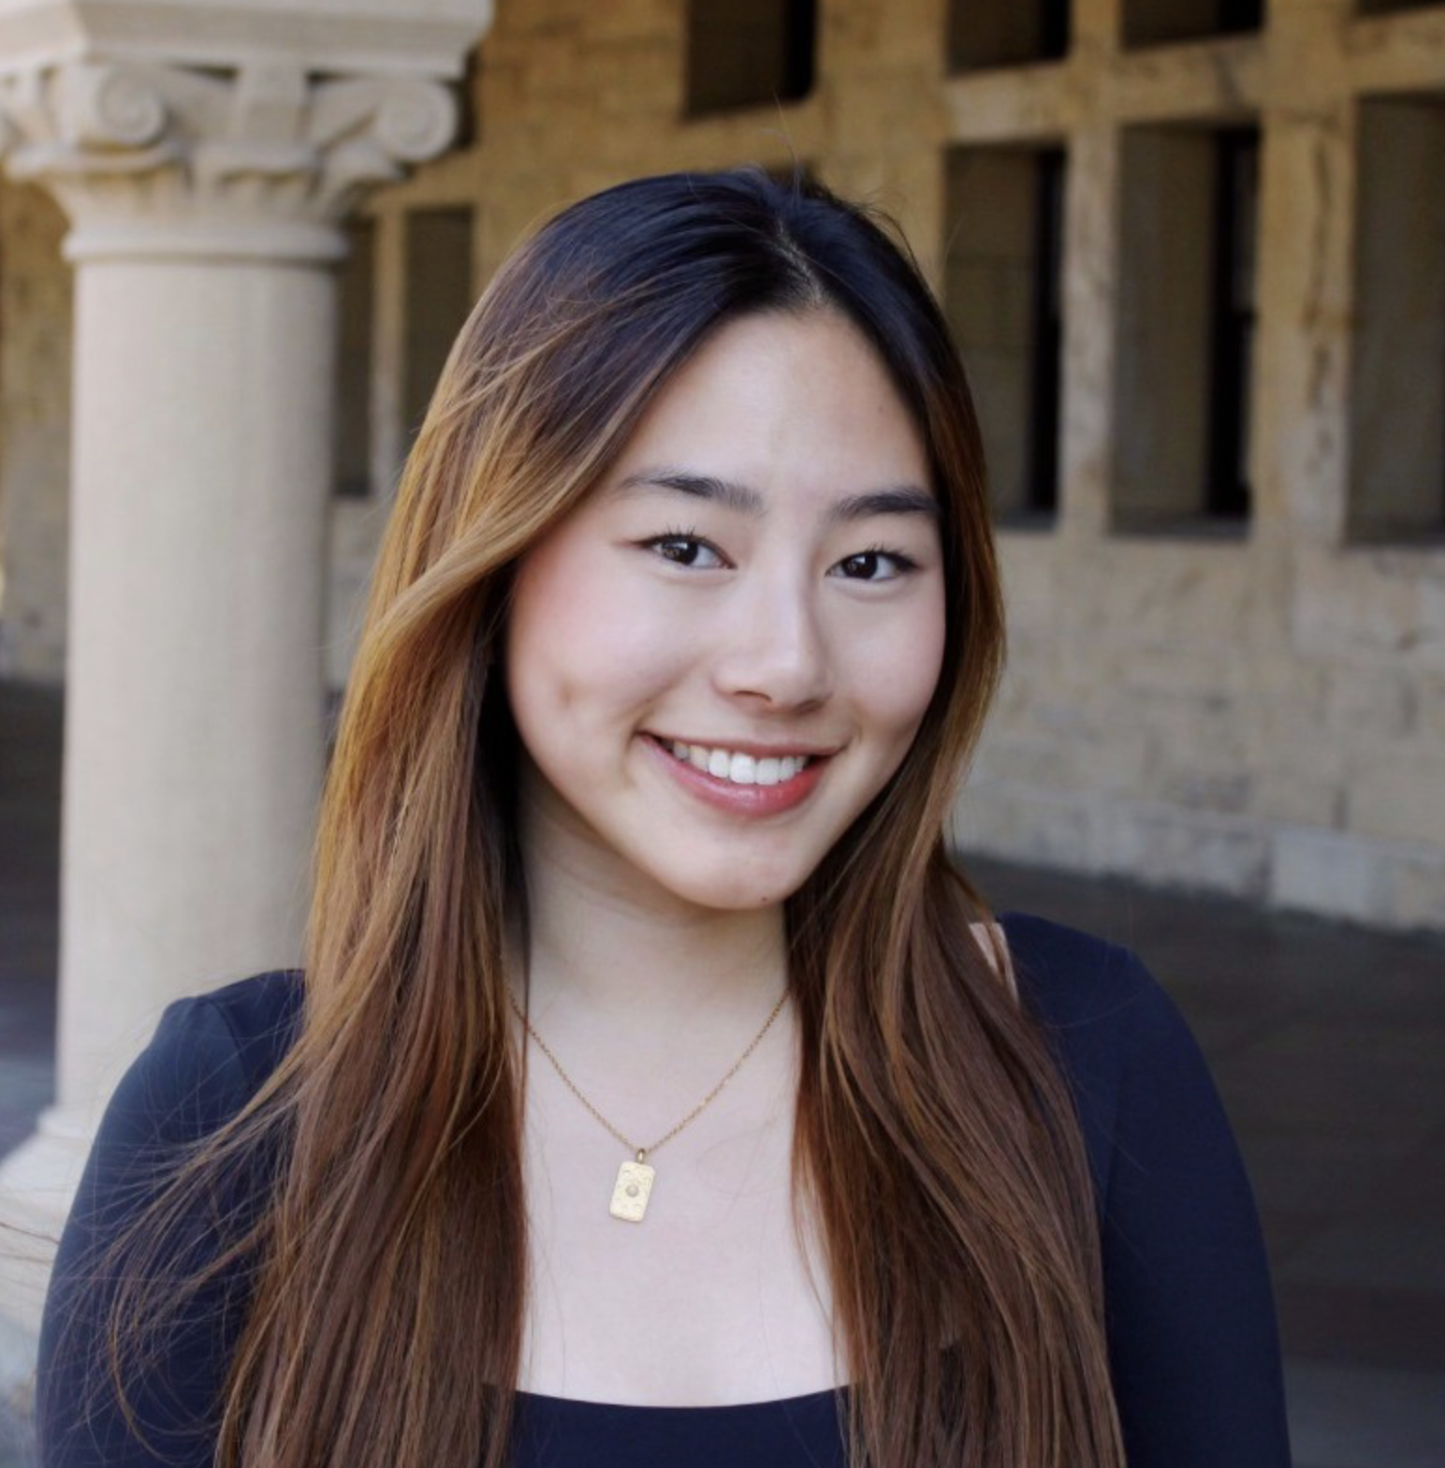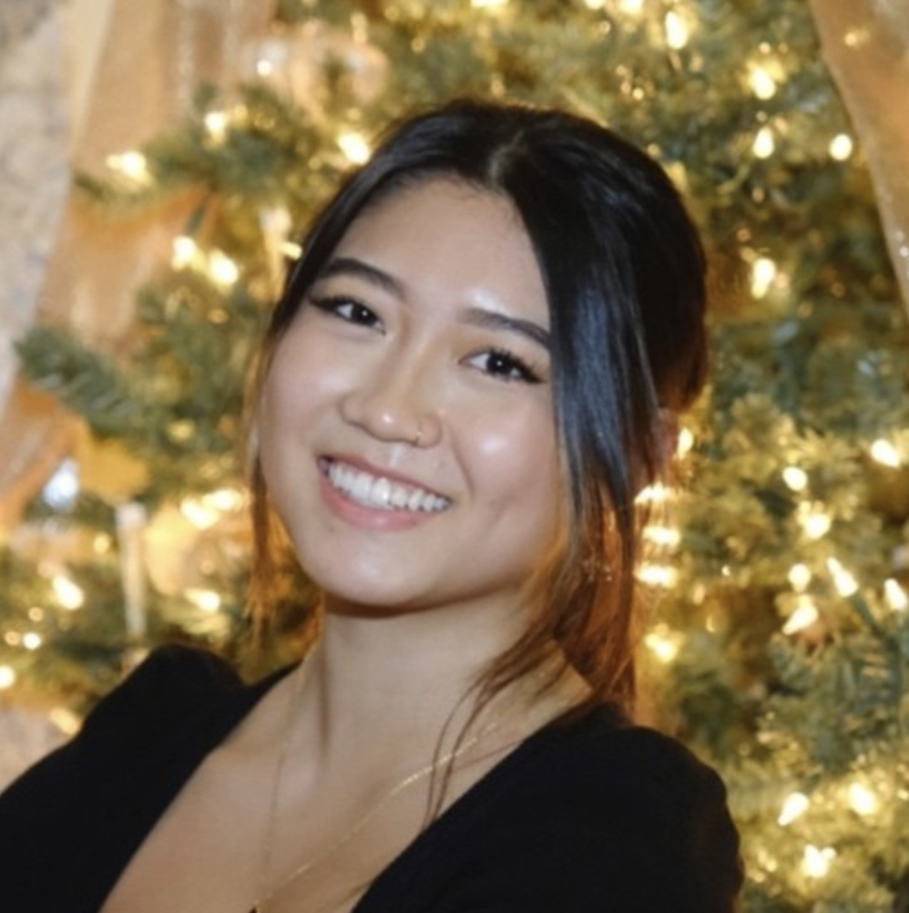

Evelyn Hur Sejoon Chang Christina Ba Sarah Yao
CS & Product Design CS & Product Design CS & Art Practice CS & Product Design
Designer + Engineer Designer + Engineer Designer + Engineer Designer + Engineer

Problem/Solution Overview
Nightshift workers are often lonely, lack support, and struggle to balance work and personal life.

Lunar is an online community of night shift workers with similar backgrounds and struggles sharing tips, resources, and support.

Needfinding

Interviews
As a team with prior experience in the healthcare space, we recognized the challenges night shift workers face as a significant barrier to maintaining healthy behaviors. We’ve witnessed the struggles of night shift hospital staff as they try to balance their professional responsibilities with their personal and social lives. This inspired us to focus our efforts on addressing this underserved yet crucial area.

We conducted interviews with four participants from diverse backgrounds and age groups, ranging from their 20s to their 60s, including student tutors and hospital workers, to explore and truly understand the emotions tied to their night shift experiences. This process was particularly challenging because night shift workers represent a highly niche group that requires targeted outreach. Unlike other demographics, we couldn’t simply approach them while they were working or conduct random surveys at locations like grocery stores. Connecting with them required careful planning and coordination in advance.

While we initially reached out to potential night shift workers at hotels, donut shops, and fast-food restaurants to ensure diversity in socioeconomic backgrounds, many were unable to commit to extended interviews due to time constraints or language barriers. To broaden our pool, we turned to Nextdoor, offering a $20 compensation to encourage participation. Additionally, we reached out to Stanford campus resources such as the fire department, police department, and Residential & Dining Enterprises (RD&E) to connect with more potential participants.

Eventually, we were able to secure four interviews:
- Ryan. R: a Stanford Police Department deputy working a graveyard shift
- Dr. Rena R: a physician and Nocturnist Section Chief at Stanford Hospital
- Calvin C: a Stanford senior tutoring high school students in Asia
- Drew D: patient transport at Stanford Hospital 5 nights a week

Each interview lasted 45-60 minutes and involved two team members—one conducting the conversation and the other taking notes. While we acknowledged that the interview pool was somewhat limited to Stanford due to the challenges of securing participants, we made every effort to include diverse perspectives. After each interview, we drew empathy maps to capture the interviewees’ thoughts, feelings, challenges, and needs, helping us better identify common pain points.

Synthesis
Our synthesis method involved first listing all the areas from the empathy map and extrapolating 2-3 key points from each section, focusing on surprising insights or tensions that emerged. We then identified contradictions or supporting points throughout the interview to find critical patterns in night shift workers’ challenges.

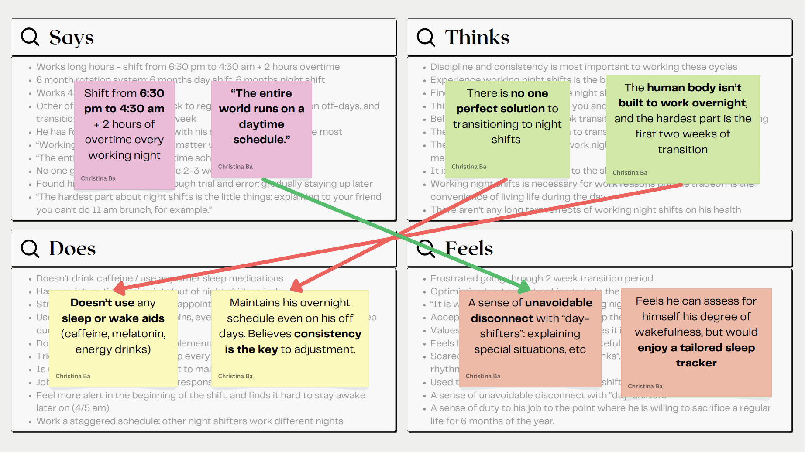
Deputy Ryan. R’s empathy map. Red lines mean contradictions, and green lines mean supporting ideas.

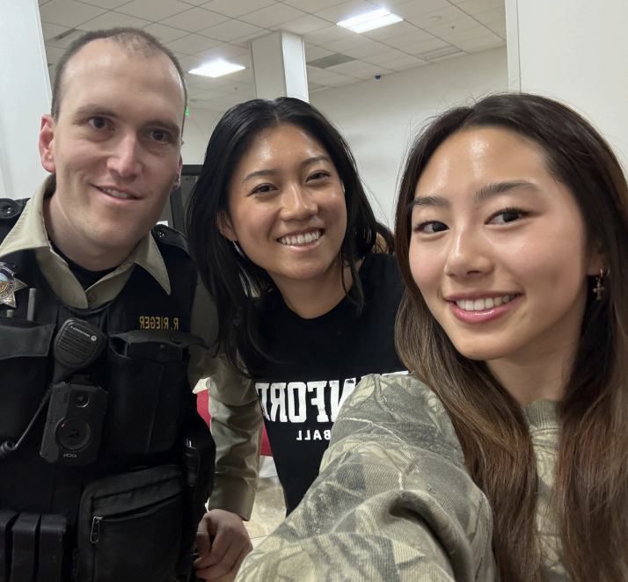
One of the most pivotal interviews that shaped our experience prototypes and eventual main focus was with Deputy Ryan. He shared how disoriented he felt when starting his night shift, citing the lack of support during the transition and the stark disconnect between daytime and nighttime operations. His struggles with adjusting to the night shift became a key insight for our project.
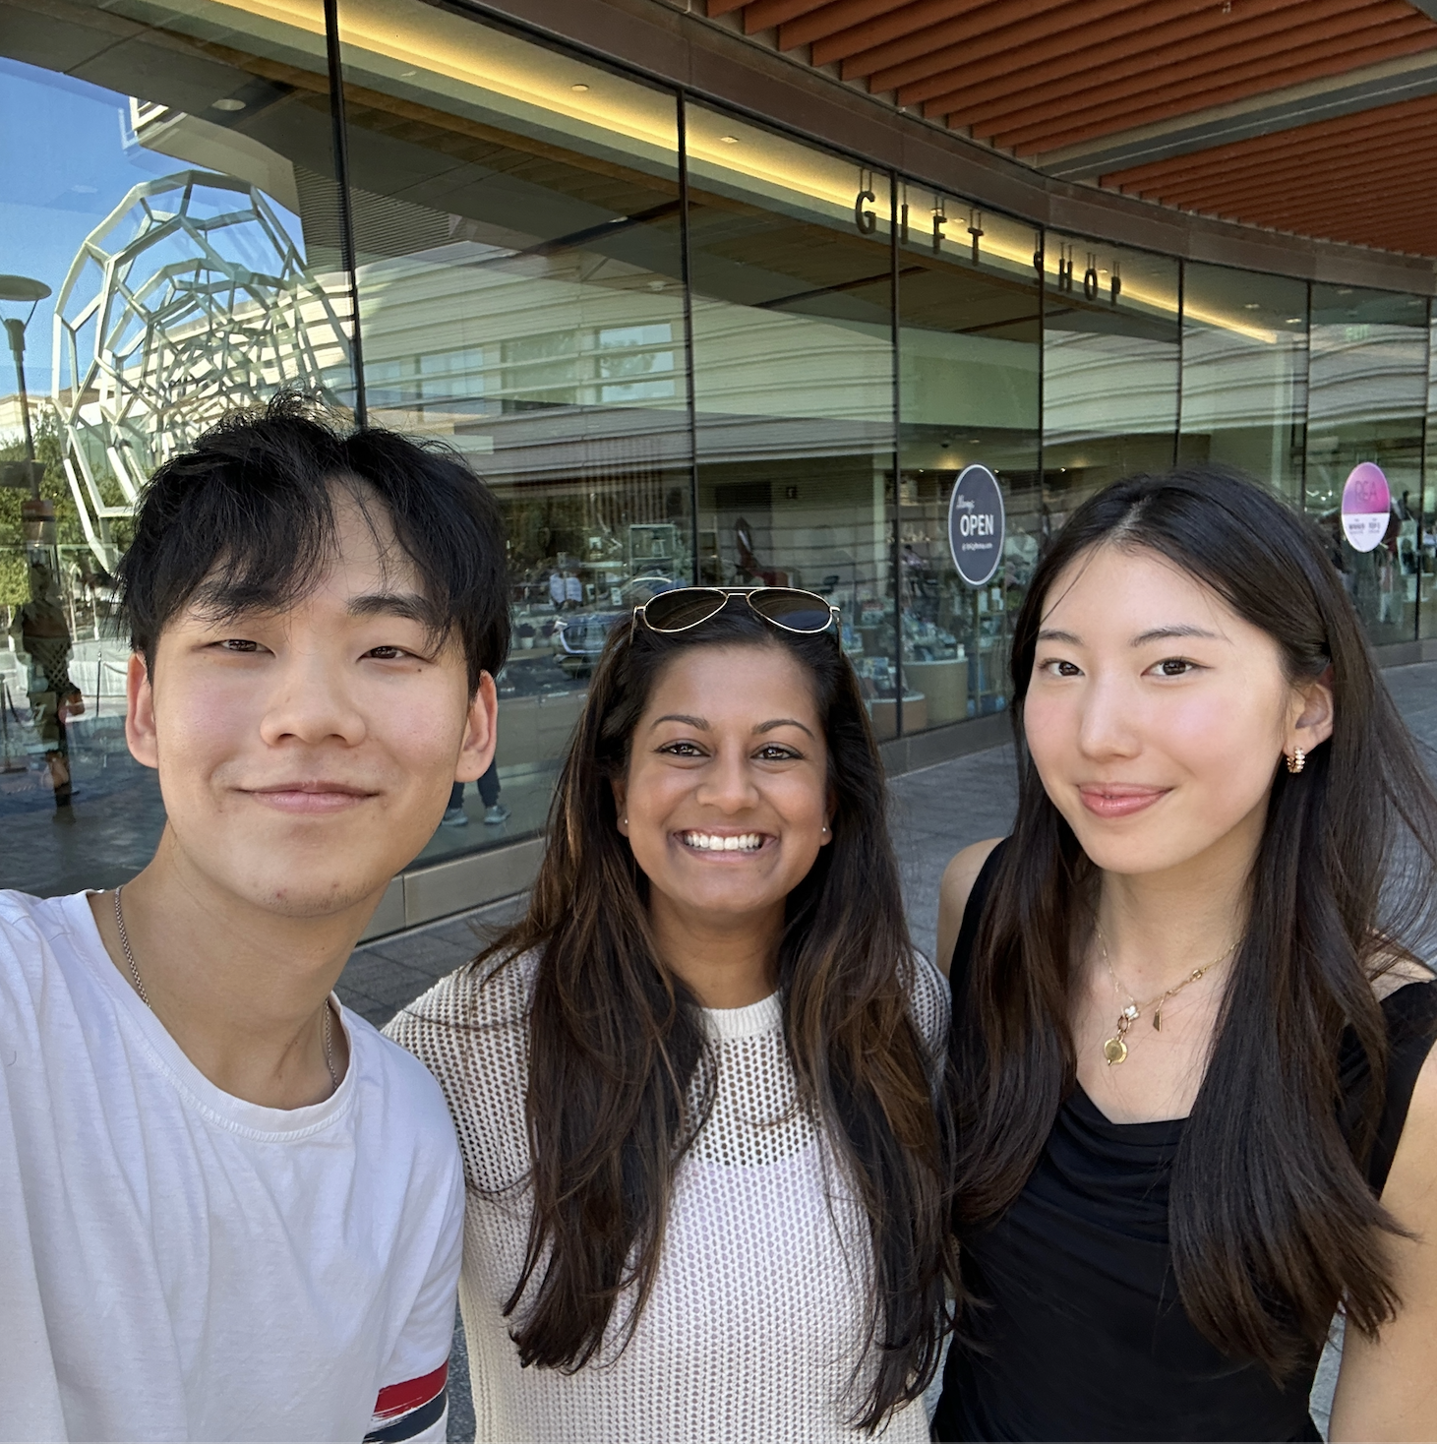
Although both hospital workers, Dr. Rena and Drew provided contrasting insights: one a physician and the other relying on night shifts for financial reasons. It was striking to see how Dr. Rena emphasized the impact on her deteriorating health, while Drew accepted the loneliness and stress due to financial necessity. It was also interesting to observe their different approaches to managing their health such as different uses of technology.
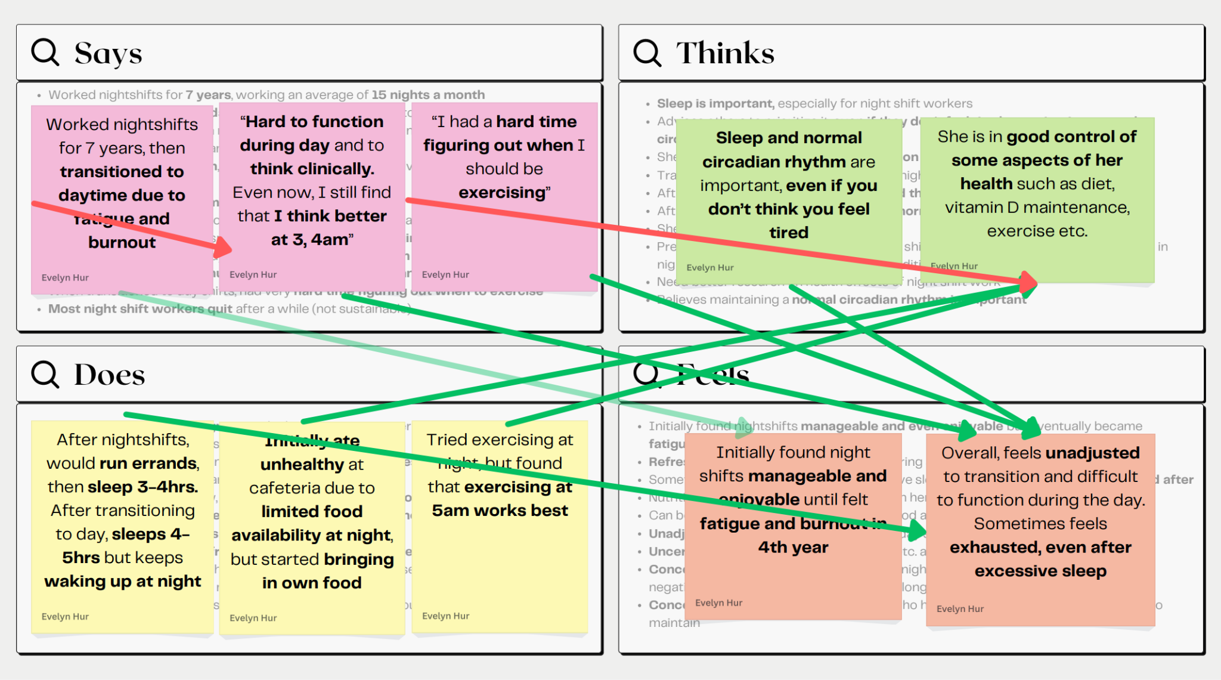
Dr. Rena’s empathy map.

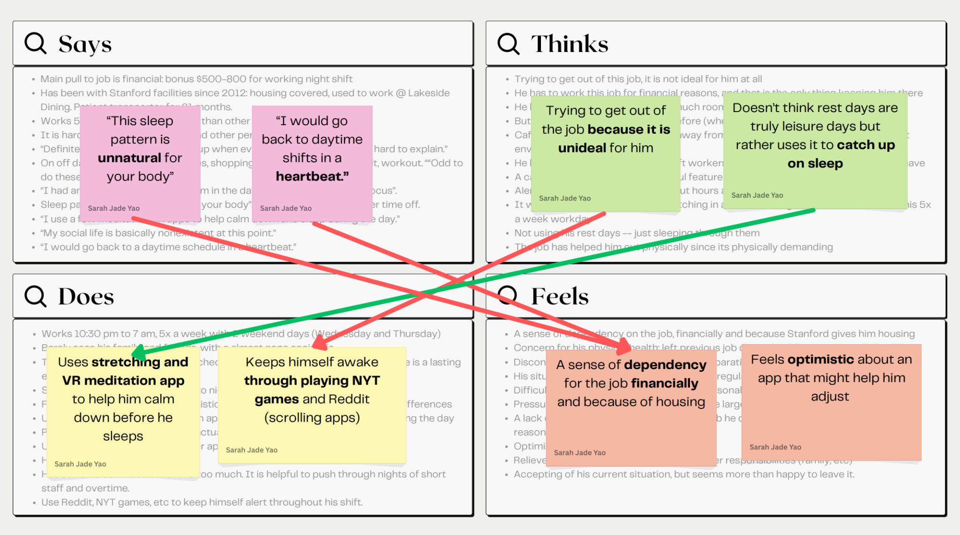
Drew D’s empathy map.

With this process, we learned that night shift work significantly impacts workers' quality of life, though the degree varies across individuals, whether it’s maintaining a social life, or trouble with routine and consistency. Transitioning from night to day shifts was highlighted as the most difficult aspect of the job, both part-time and full transitions. Ultimately, we understood the difficulty of finding a one-size-fits-all solution due to highly personalized methods and routines to endure a night shift.
POVs and Experience Prototypes
After completing our interviews, we wanted to focus on the scope of our needfinding and uncover rich insights from our interviews. To do so, we selected three of the most engaging interviews to fully unpack and understand. Our three interviews were David, Rena, and Ryan, and we created POV (point of view) statements with the intention of being able to better articulate their perspectives. These POVs allowed us to focus and frame the problem, provide a reference for evaluating competing ideas, effectively capture the heart and minds of our interview subjects, and provide directions for further exploration. From each of these POVs, we brainstormed around 10 HMW (how might we) statements for all three interviewees. The HMW statements served as an opportunity for us to explore the possibilities of various pathways of exploration in hopes of finding a solution.

Below are each of the three POV statements as well as the most relevant, corresponding HMW statements.

Final POV Statements
POV #1: David
- We met David who is a current night-shift worker at Stanford Hospital. He has been working there since 2012, which is when he transitioned from working for RD&E.
- We were surprised to realize that David has a “it is what it is” mentality, considering his personal life practically non-existent
- We wonder if this means David’s sense of financial dependency for his job makes him believe work and personal life can’t go hand in hand
- It would be game-changing to help David manage the smaller tasks in life so he has more time to care for his personal life

HMW Statements from David’s POV
- HMW rethink what creates connection between someone and their FAF?
- HMW allow users to complete errands without needing to physically be in the space?
- HMW allow a user to schedule appointments after business hours?

POV #2: Rena
- We met Rena, a physician and Nocturnists Section Chief at Stanford Hospital. She worked night shifts for 7 years, then transitioned to day shifts and part-time night shifts for 3 years
- We were surprised to realize that Rena says she’s in good control of her health, but still often experiences daytime fatigue even 3 years out of full-time night shifts
- We wonder if this means Rena perceives her health based on individual efforts made rather than objective health improvement
- It would be game-changing to encourage Rena to be more aware of and take actions to improve her wellbeing, even if she thinks she feels “OK”

HMW Statements from Rena’s POV
- HMW create a positive reinforcement style for maintaining healthy habits?
- HMW create an accountability tool to keep her consistent with her routine?
- HMW prepare her for day to night (or vice versa) schedule reset?

POV #3: Ryan
- We met Ryan, working a 6-month graveyard shift for the Stanford Police Department. This is his eighth month in the department, and he switches between night and day shifts twice a year
- We were surprised to realize that despite struggling to adjust early in his shift, Ryan refuses to touch any sleep or wake aids, such as caffeine, even when others in his cohort are heavily reliant on such substances
- We wonder if this means Ryan is confident in his long term health and adjustment strategies as opposed to short term relief from wake aids, having seen firsthand coworkers substance dependent.
- It would be game-changing to help night-shift workers to be in better control of their substance habits when it comes to sleep or wake aids

HMW Statements from Ryan’s POV
- HMW reduce dependency on caffeine for graveyard shift officers?
- HMW document the deputy’s tested adjustment methods and adapt them for wider use?
- HMW establish support from the police department to provide institutional night-shift transitory resources?

Example: HMWs from a POV
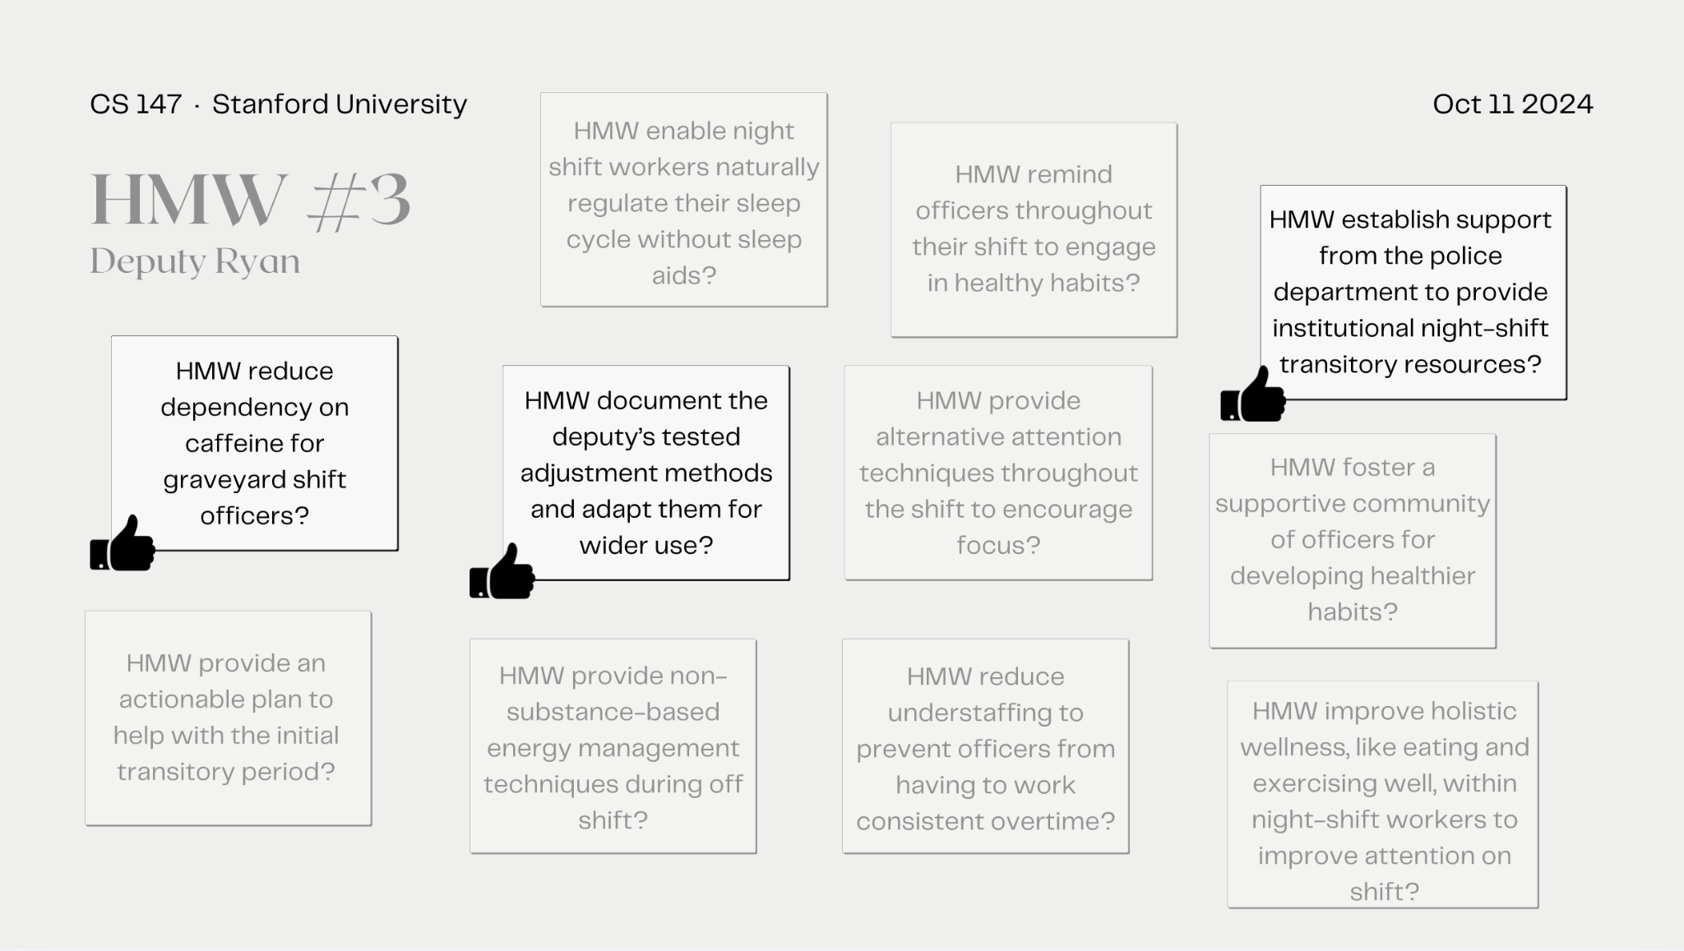
A Canva page depicting all the brainstormed HMWs from Ryan

Top 3 Solutions
- An app that finds open appointment times automatically based on user availability input
- An app that gradually prepares users to transition day/night shift routine before bed for better recovery and reset
- A platform to foster development of peer-to-peer resources to encourage growth of community and sharing of tips for sleep adjustment

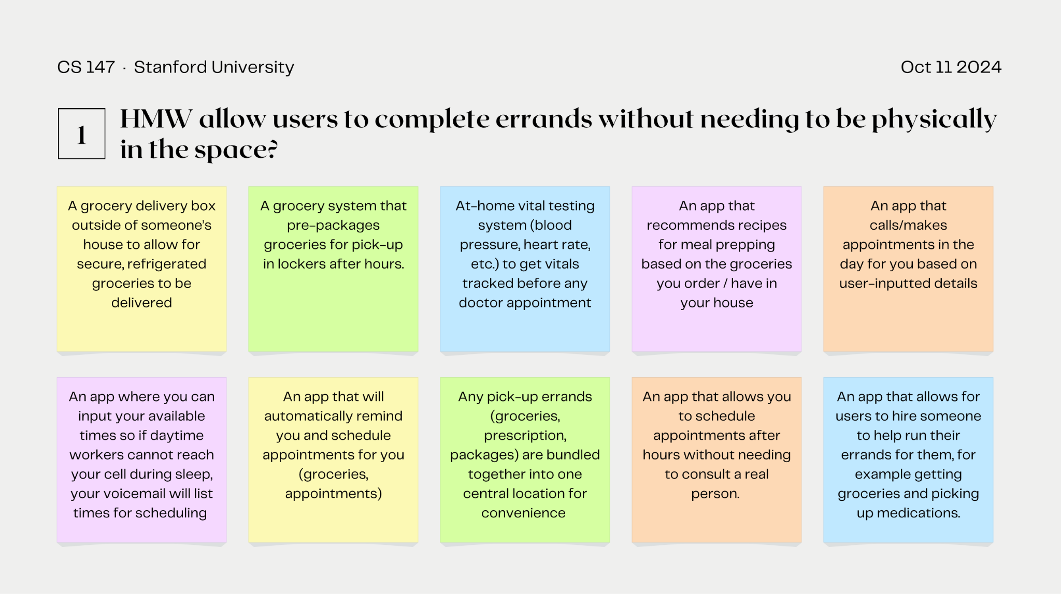
A Canva Page depicting all of the solutions we generated from Ryan’s HMW statement

Experience Prototypes
We knew that these solutions had to be backed up by creating experience prototypes that tested these assumptions.

Experience Prototype #1:
Our first solution was an app that finds open appointment times automatically based on user availability input. This solution was made in an attempt to address an avoidable common thread that our interviewees had expressed - scheduling appointments was difficult because when companies would call our interviewees to schedule appointments, they would often be asleep. This resulted in frustration and annoyance with scheduling appointments.

Key Assumption: Users want to have appointments scheduled for them based on their availability.

Key Aspects of set up: To test this, we requested participants select schedule availability on a pre-filled Google Form.Then, we sent them hypothetical appointments throughout their day based on their schedule. Users accepted or rejected the appointment. At the end, they filled out a survey about their experience.

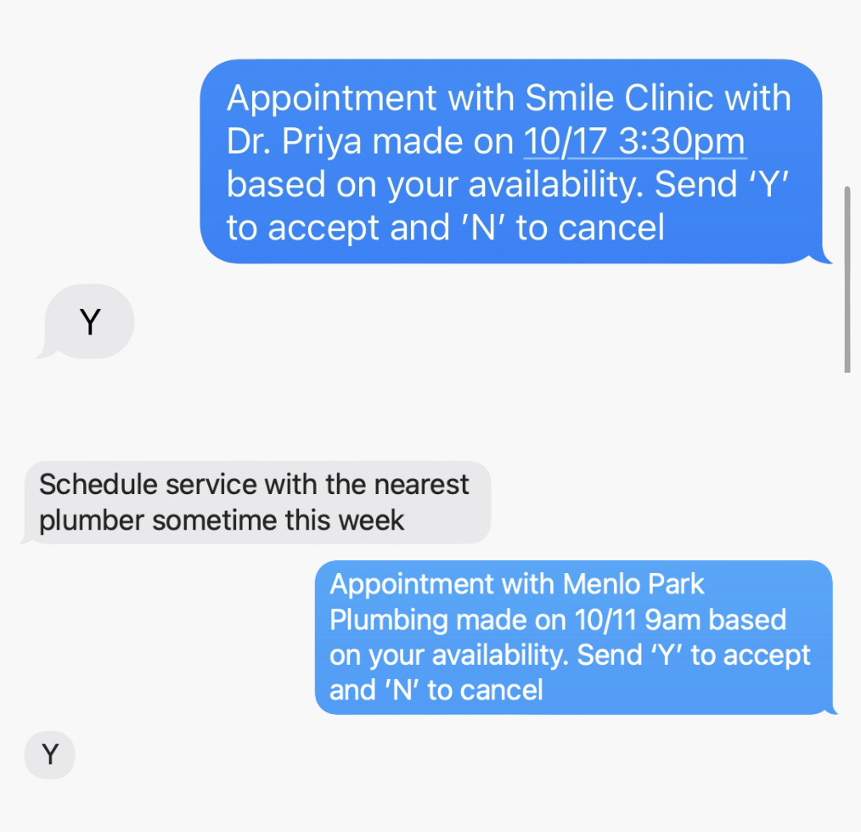
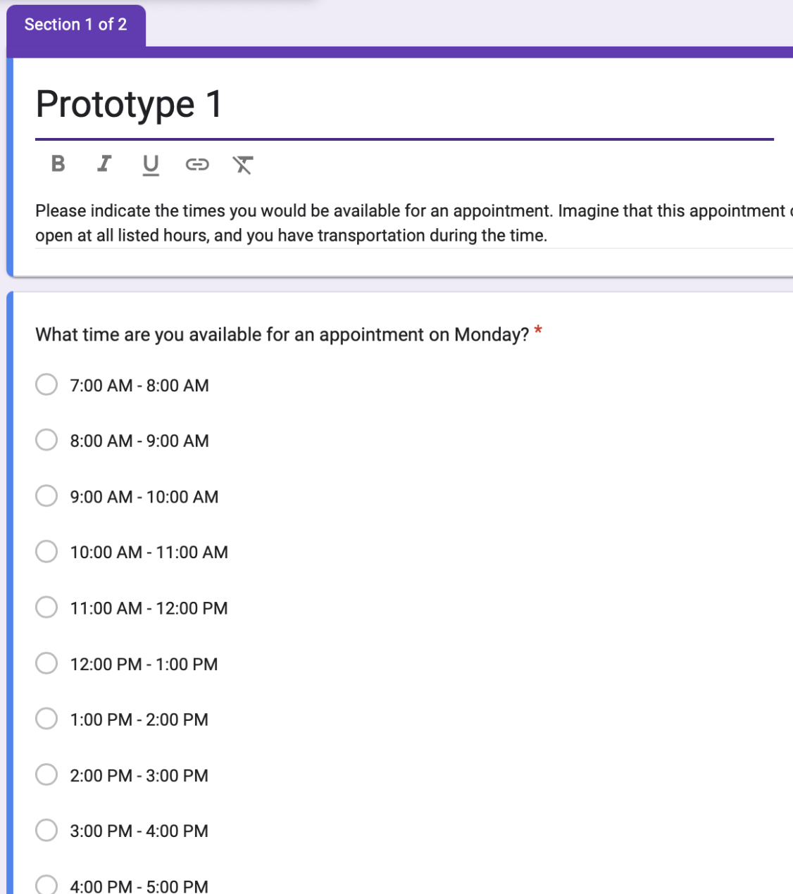

Left: A Google form that was sent out to all of our testers to determine their availability
Right: Text messages we sent out testing if users would accept an appointment at a
time that they were and weren’t available

We tested this prototype on another night shift deputy who works a graveyard shift in patrolling. He said that this would “reduce lots of mental stress” from manually looking for non-conflicting slots. However, he also said that providing a scheduled time had its pros and cons - it might help reduce clutter but could also take up free time that a user wanted to use for something else.

Implications: We deemed these results validated. From this experience prototype we learned that rather than hypothetical scenarios for a user, we should actually book the appointment for the user. We also needed a way to know when they are not working but times they wanted to block out to protect.

Experience Prototype #2:
Our second solution was geared more towards helping users consistently and accurately follow recommended times for sleeping and waking up. This was an app that was in line with catering to a users’ general sleeping health and wellness.

Key Assumption: Users will consistently and accurately follow recommended times for sleeping and waking up.

Key Aspects of set up: We tested this prototype through creating a goal sleep schedule and giving it to someone newly adjusting to a night shift, then evaluated the results.
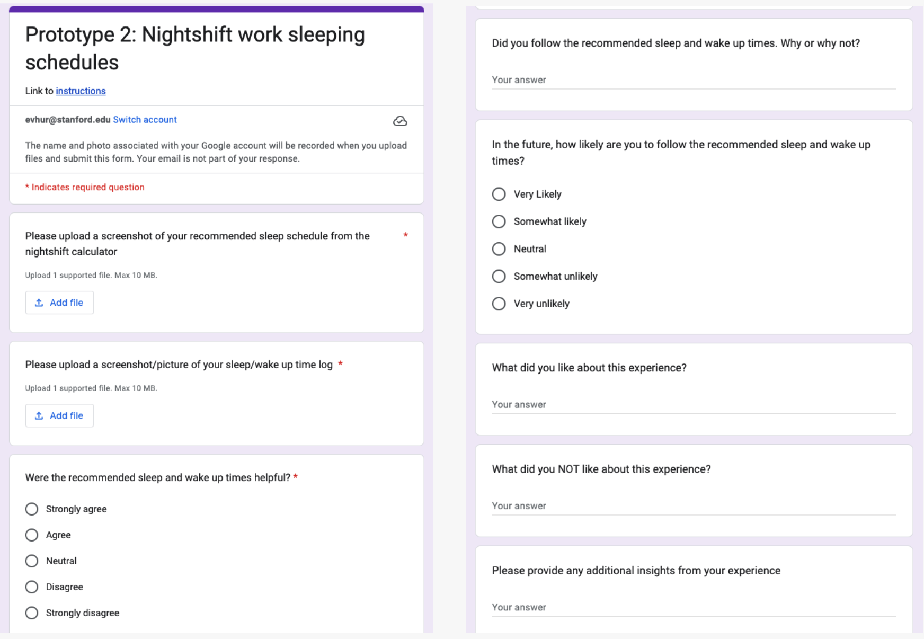
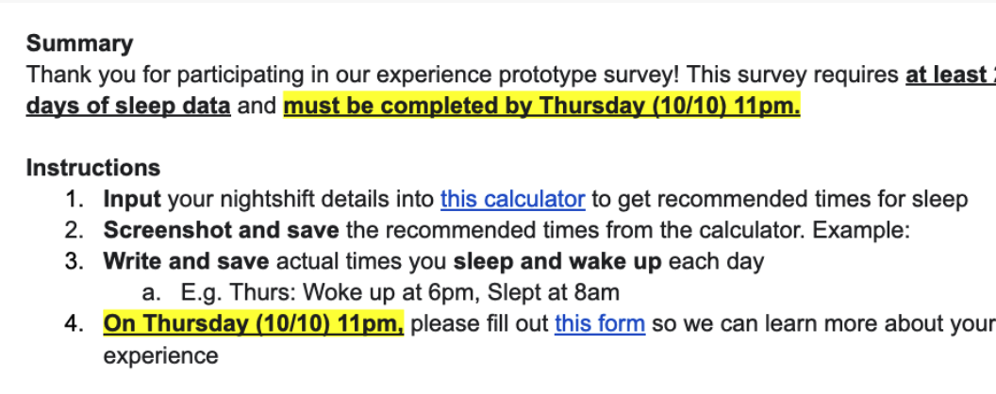

Above: Instructions for users to input their nightshift details into a calculator to generate a sleeping schedule

Right: Reflection of how useful the sleep tracker and scheduler prototype was

We tested this prototype on a Stanford senior who sleeps at 5-7 AM on the weekends. The user liked how the proposed sleep schedule put sleeping habits and wellbeing top of mind for him and it revealed that there were significant differences in his current sleep schedule to an ideal one. However, the user felt that the recommended times were sometimes unrealistic given his variable schedule.

Implications: We deemed these results partially validated and learned about several key implications. From this experience prototype we learned that we should consider recommendations as a guide to make users more self-aware of their wellbeing. We realized we should also aim to direct users to focus more on their personalized goal setting rather than just generalized recommendations. Furthermore, we wanted to reconsider this solution to make an individual’s body feel “best” rather than putting it in generalized conditions.

Experience Prototype #3:
Our third solution was geared towards being able to help nightshift workers share and get access to resources and tips that would assist them in their daily lives. This would serve as an all-encompassing resource for nightshift workers to find a community to share and adopt existing tips and solutions.

Key Assumption: New night shift workers are willing and able to adopt existing methods that are proven to work.

Key Aspects of set up: We tested this through creating a pamphlet documenting Deputy Ryan’s transition methods and evaluated adoption of tips on new night shift workers. Then, we collected feedback on helpfulness and willingness to adopt them.
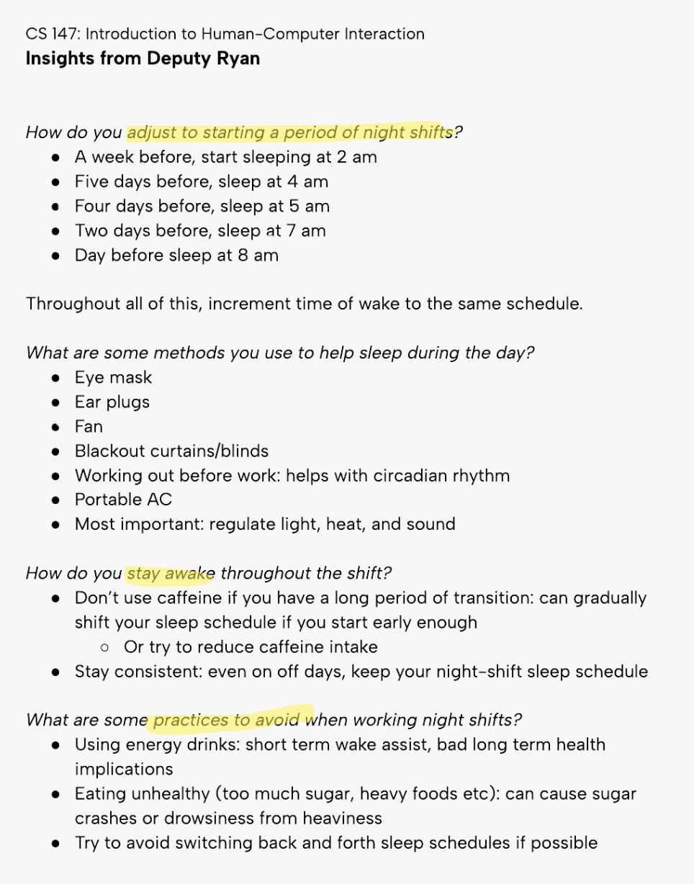
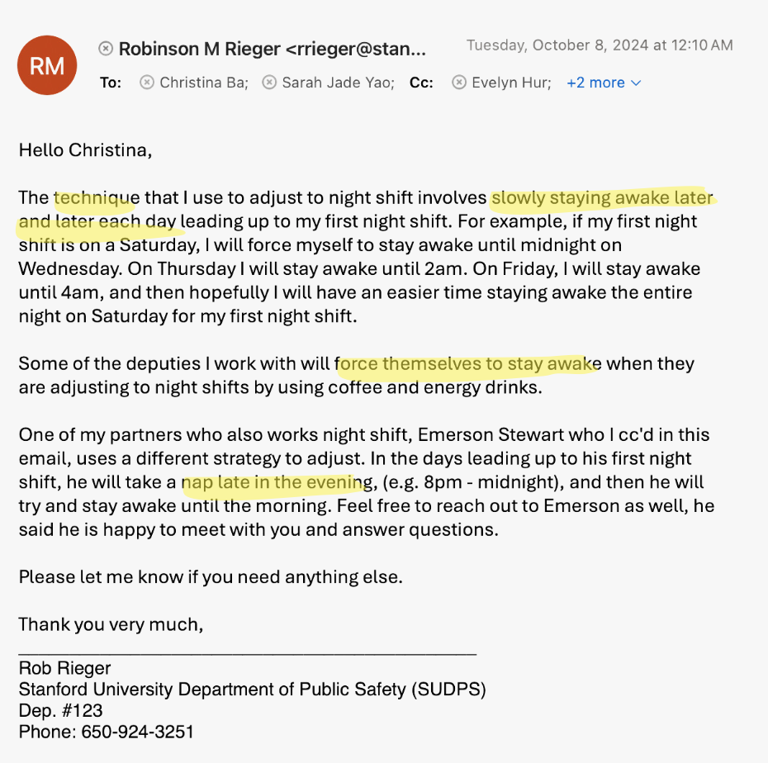

Left: Tips that a nightshift worker had provided us via Email
Right: The pamphlet we compiled to share the nightshift worker’s tips
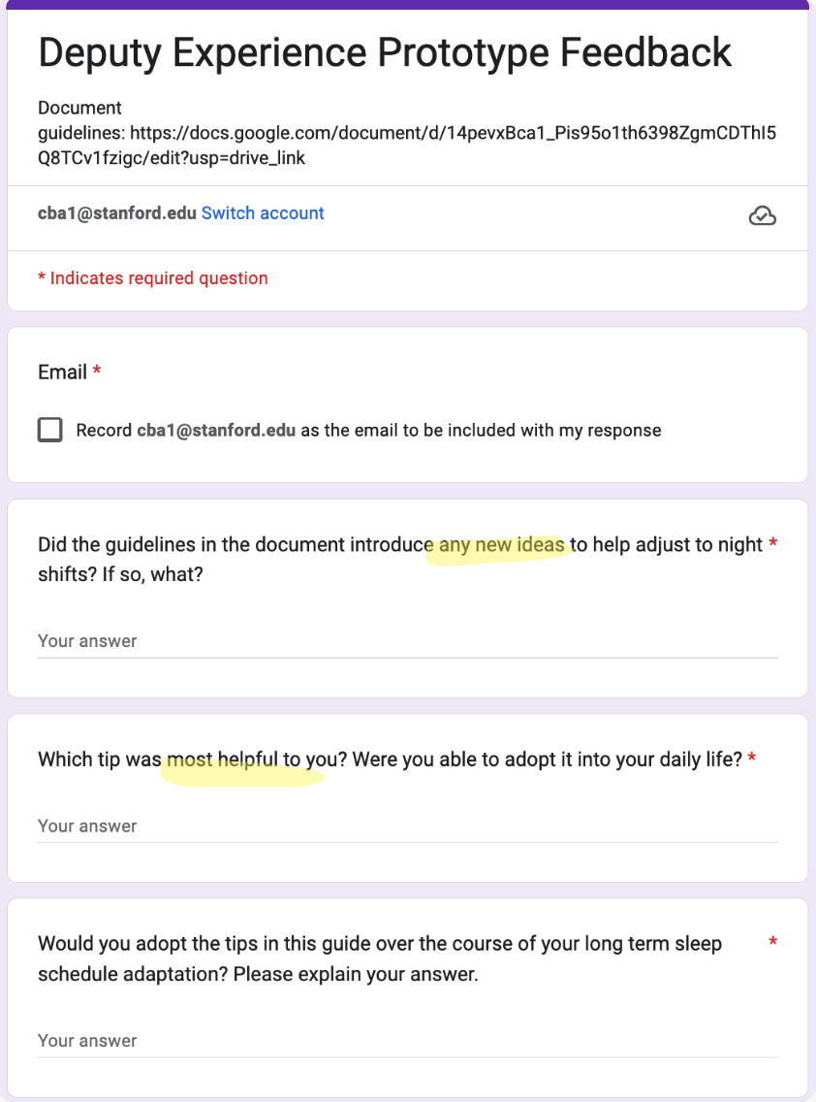

Image: A Google Form that was sent out to those who viewed our pamphlet for evaluation

We tested this on a student that sleeps regularly at 7AM. The user reported that he was most drawn to the tip about sleep aid tools - eye masks, fans, etc. for daytime sleep. The user was somewhat inspired to create his own concrete, comprehensive plan to follow. The user also mentioned that specific sleep times weren’t as helpful since he had his own biphasic sleep schedule. His schedule is more subject to spontaneous changes due to school work.

Implications: Going forward, we were able to draw a few key insights. We wanted to make sure to test these tips over a period of time such as a few weeks instead of a few days for concrete results analysis. We also wanted to provide tips that were actionable within a week, instead of having to be adopted over more time. Furthermore, we wanted to incorporate more flexible tips applicable to users’ diverse situations.

Design Evolution

Final Solution
Description: An online community of night shift workers with similar backgrounds, work schedules, situations etc. to share resources, tips, and support each other

Rationale: We chose to pivot from our original solution “Automated appointment scheduler and sleep schedule recommender” to our final solution based on 1. re-reviewing our insights from needfinding and 2. Choosing to pivot to a solution that was specifically more tailored to night shift workers.

First, we noticed that there was a common theme of lack of connection (whether existing or potential) from our user interviews. For instance, a night shift physician said, “I recently got out of a relationship because my partner would never see me after work and it was just hard...” Another night shift custodian said, “I try to at least spend more time with my daughters... but work is work.” On the flip side, another worker pointed out the lack of potential relationships forming: “Because of night shifts, my social life is basically non-existent.”

Second, while our original solution would help night shift workers with scheduling errands and routine work, our solution was missing the emotional component we saw from our needfinding that was specific to night shift workers. An appointment scheduler could be helpful to anyone. Therefore, we pivoted our solution to an online community tailored to the unique challenges of diverse night shift workers that could support each other.

Tasks

Simple Task: Viewing and pinning relevant resources within a night shift community group

Why is it important? Viewing others’ posts allow them to gain useful advice, insight, and support/comfort related to the unique challenges of night shift work. Pinning posts also allow users to save posts that may be handy to look back on in the future— specific advice or recommendations such as convenient places to book appointments, sleeping tips etc.
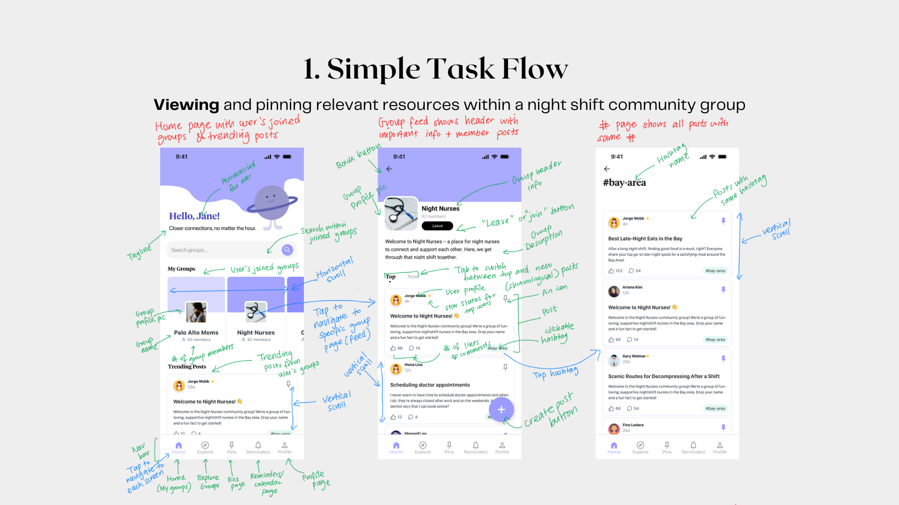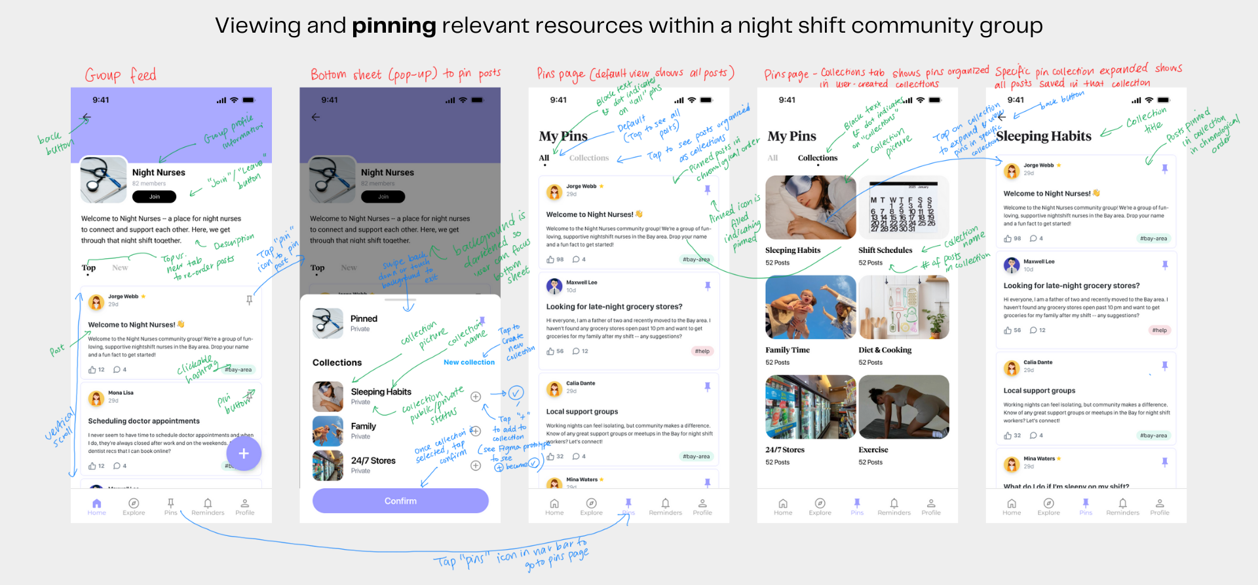
Med-fi UI screenshots and annotations for simple task flow

Medium Task
Sharing wisdom and contributing to a community forum

Why is it important? Posting/commenting allows users to not only ask questions or seek advice regarding night shift work, but also share wisdom with others that benefit other users.
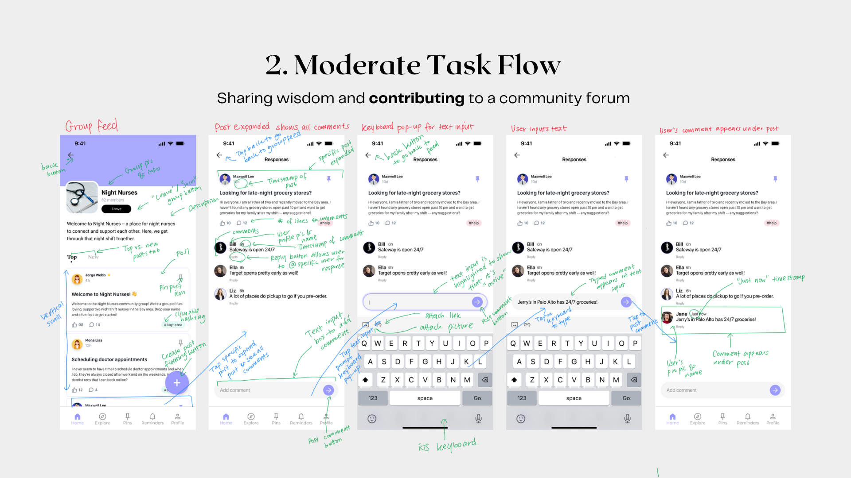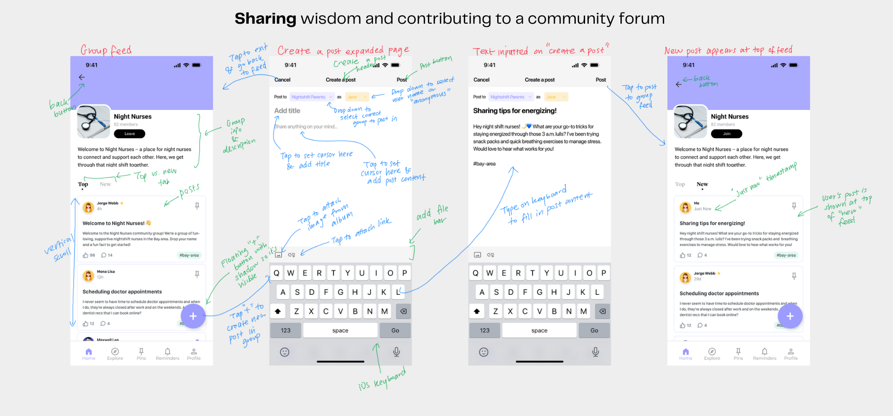
Med-fi UI screenshots and annotations for medium task flow

Complex Task
Taking action on post suggestions through calendar and reminders integration

Why is it important? This bridges the gap between passively taking advice/insights to implementing them into a user’s schedule so that they can improve their work-life balance, form or maintain relationships, and improve overall well being.

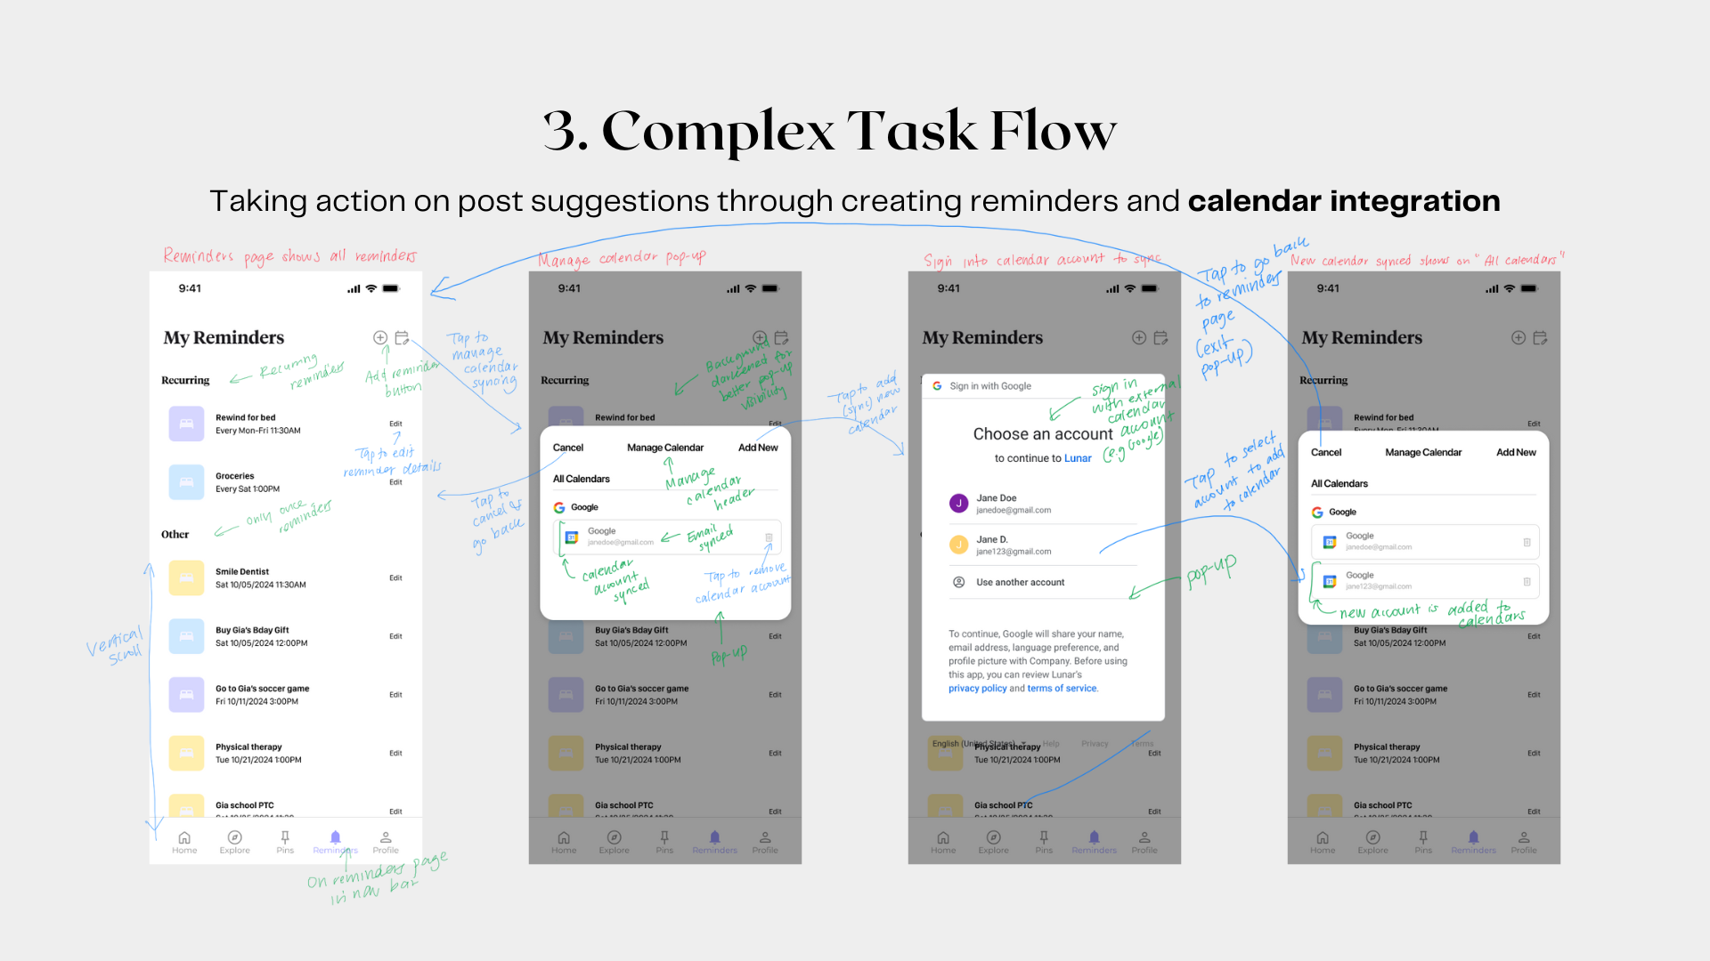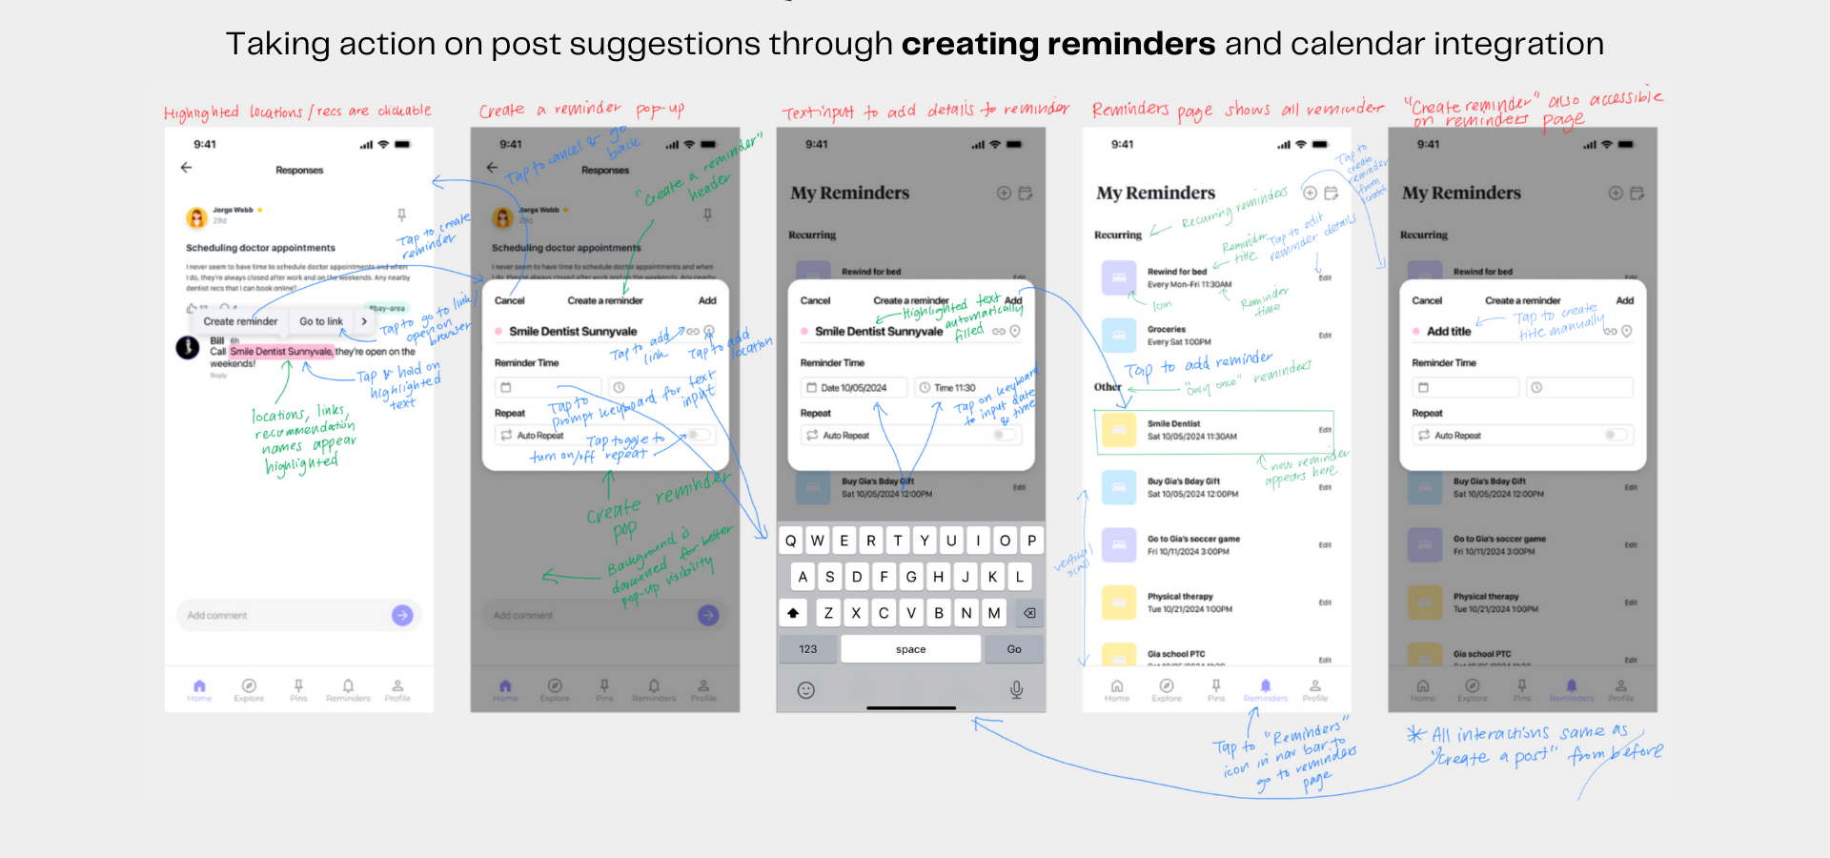
Med-fi UI screenshots and annotations for complex task flow

Design Evolution visualizations and rationale

Lo-fi to Med-fi UI changes
What we learned: Through user testing of our paper prototype, we identified an average of 6 errors across the entire task flow, with task times generally being average to low, suggesting that the flow was generally easy to navigate. However, many of the errors were concentrated around the complex task, primarily due to problems with consistency between the "pin" and "save" icons, which were visually different but served the same function. Additionally, users were confused by the purpose of certain buttons, such as "share calendar," which needed further clarification. To improve, we could enhance the clarity of navigation elements, such as making the bottom navigation tab more intuitive and adding options like a back, cancel, or exit button to allow users to easily undo actions.

Implications: Because there were limitations in lo-fi sketching and paper prototypes, we realized there were additional things to consider when implementing our med-fi prototype. For example, we had to consider navigation to different pages, what drop down menus would look like, different methods of text input etc.

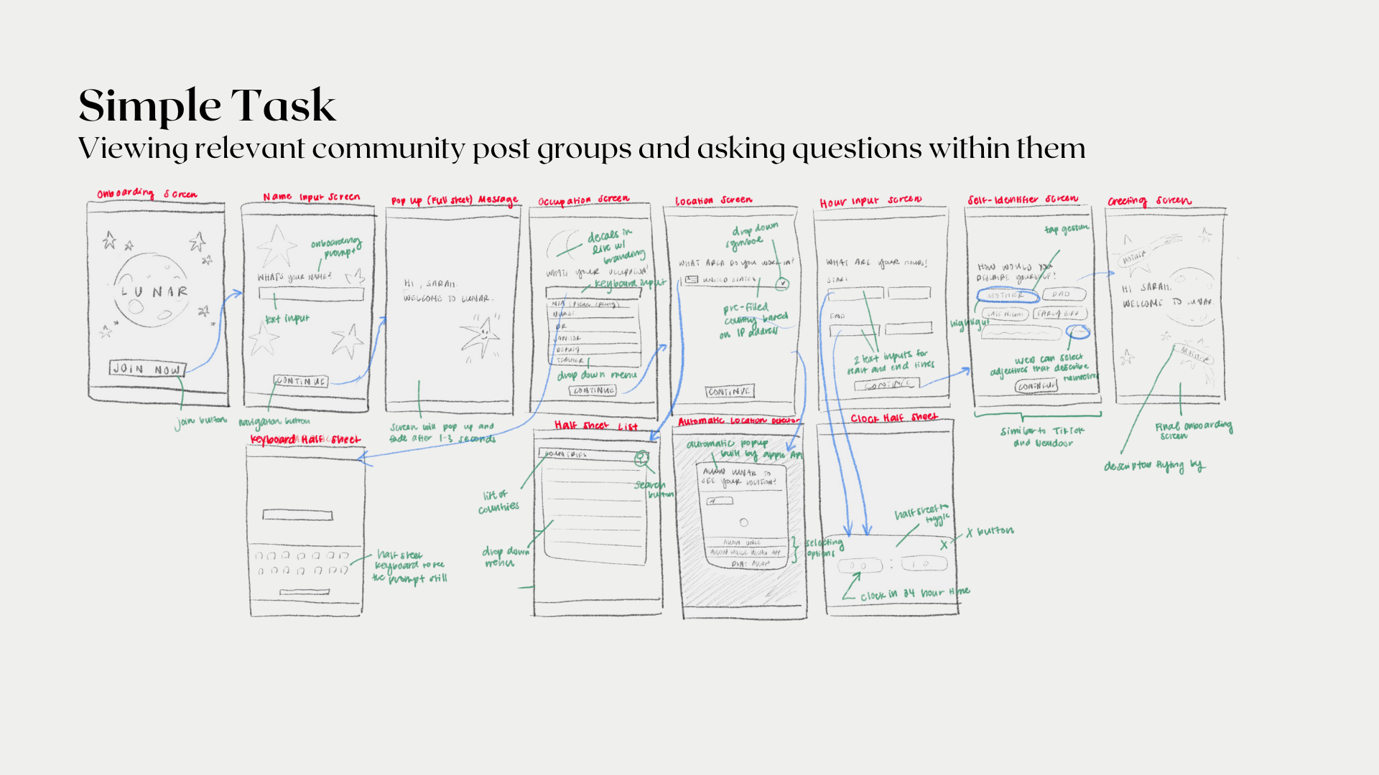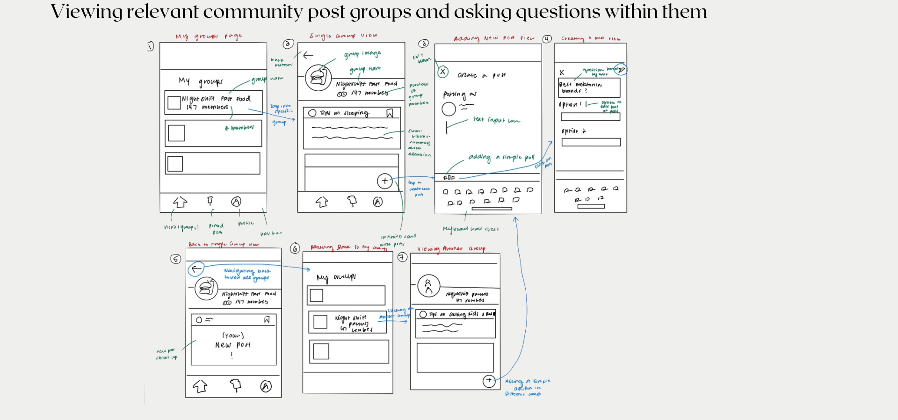Lo-fi prototype for simple task
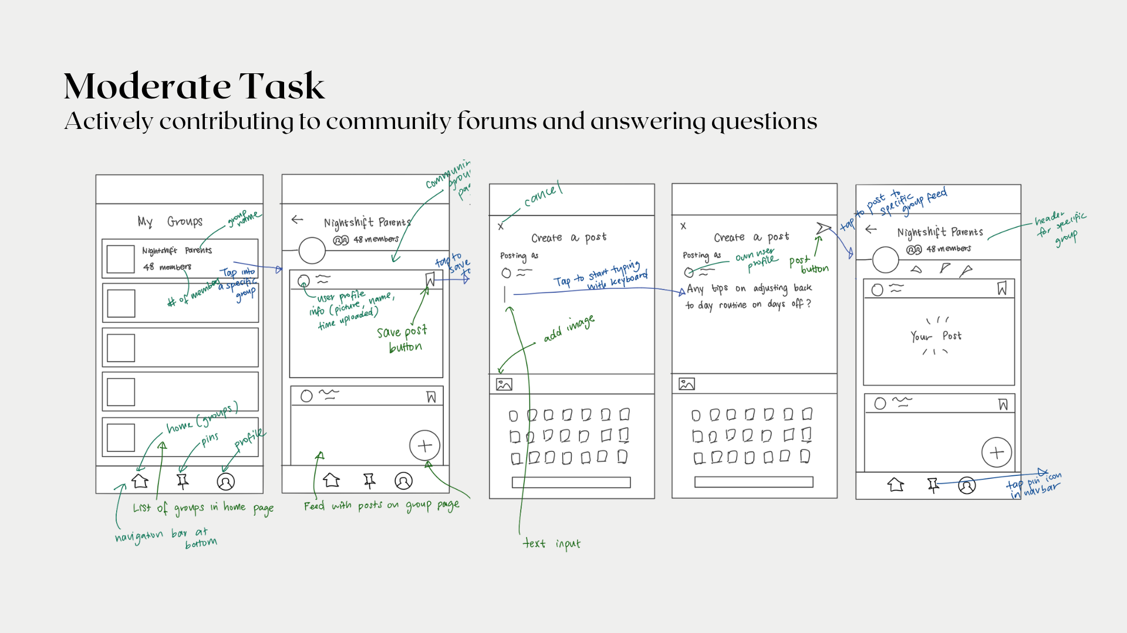
Lo-fi prototype for medium task

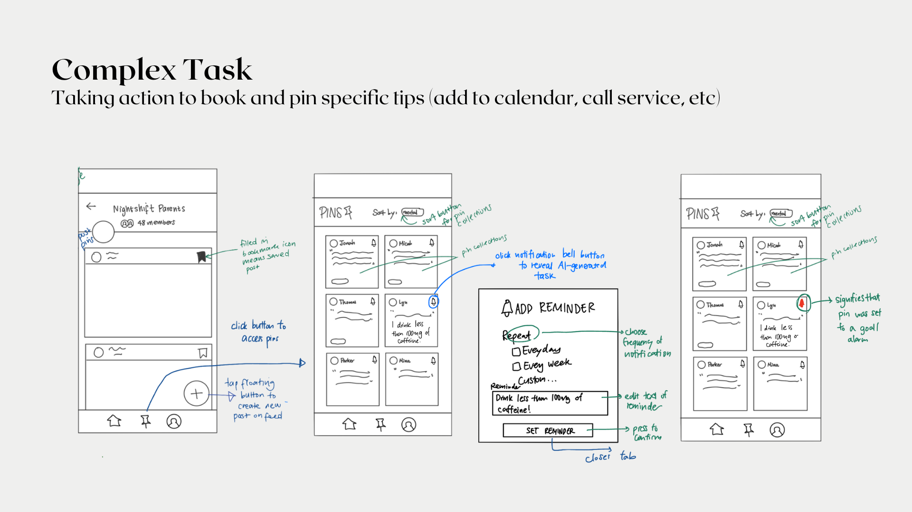
Lo-fi prototype for complex task

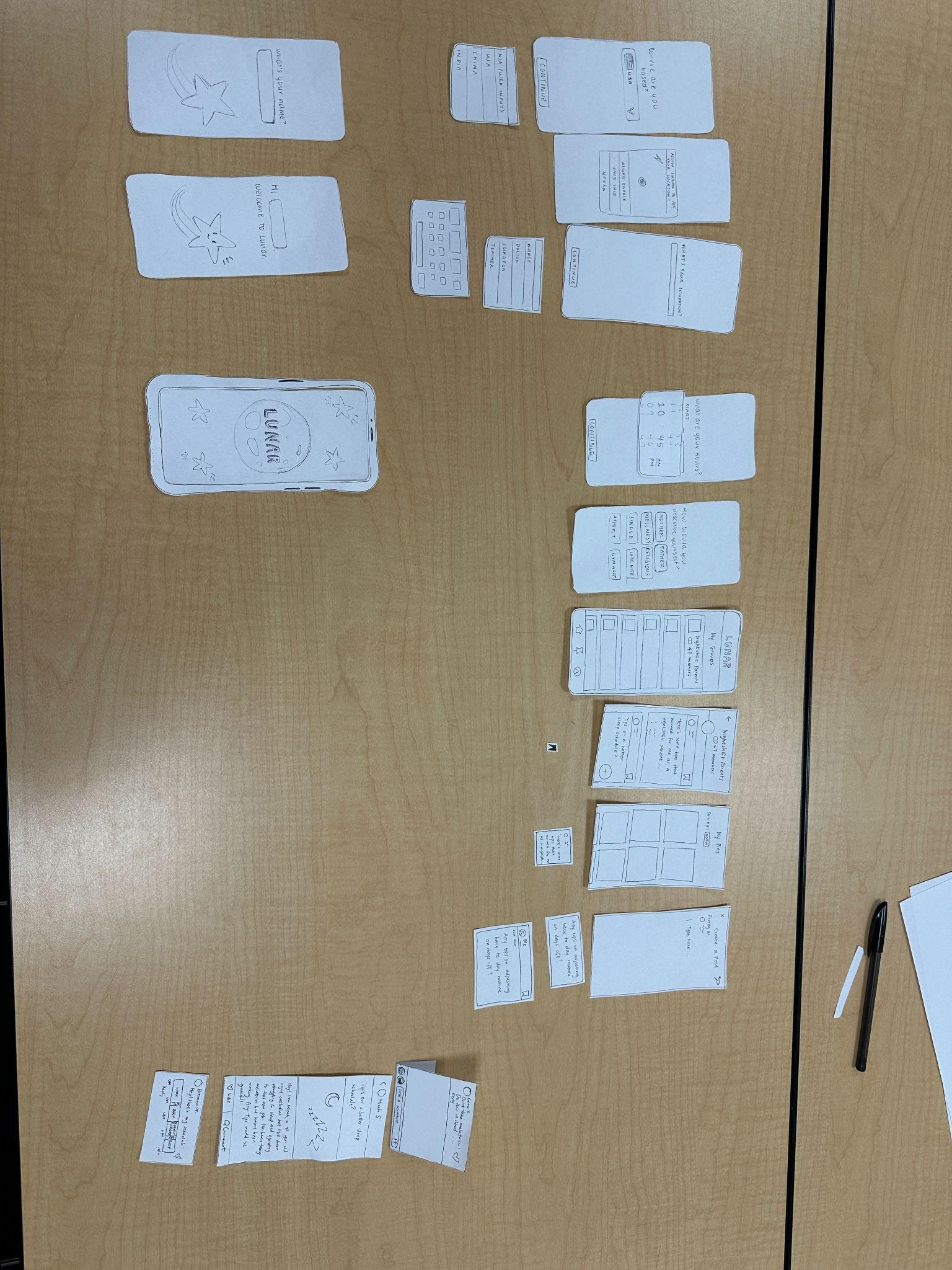
Paper prototype for simple, medium, and complex tasks

Med to High-fi UI Changes
What we learned: We needed to keep both style and functionality consistent so that we not only have a visually aesthetic app, but also so that we can match user expectations. Therefore, we fixed inconsistencies like the back button, button size and color, text size etc. We also learned to focus on accessibility by making text size bigger for better readability and changing icon colors so users with color blindness can distinguish between them better.

Implications: From our learnings, we chose to revise 40 out of 67 violations. The most common violations were from H4 Consistency and Standards and the most common severity level was level 2. We chose to fix major violations in consistency in visual design (text, icons, buttons, spacing etc), consistency in functionality (back button, navigation, pins pop-up), readability and accessibility (adjusting text size and color for better readability), error prevention (fixed ‘cancel, ‘exit’, ‘back’ buttons and allow user to edit and delete posts and reminders), and lastly matching user expectation (match user expectation of drop downs, text inputs etc).
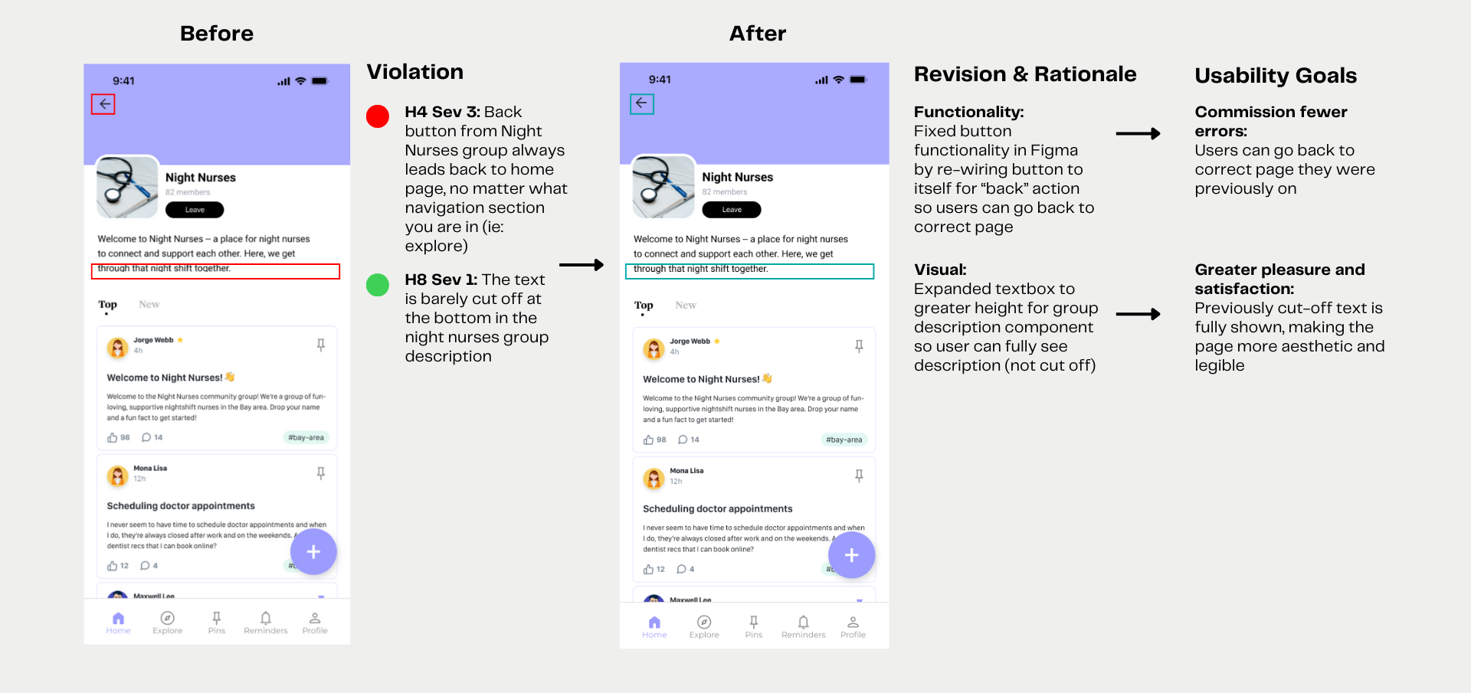
Design revisions, rationale, and progress towards usability goals for simple task

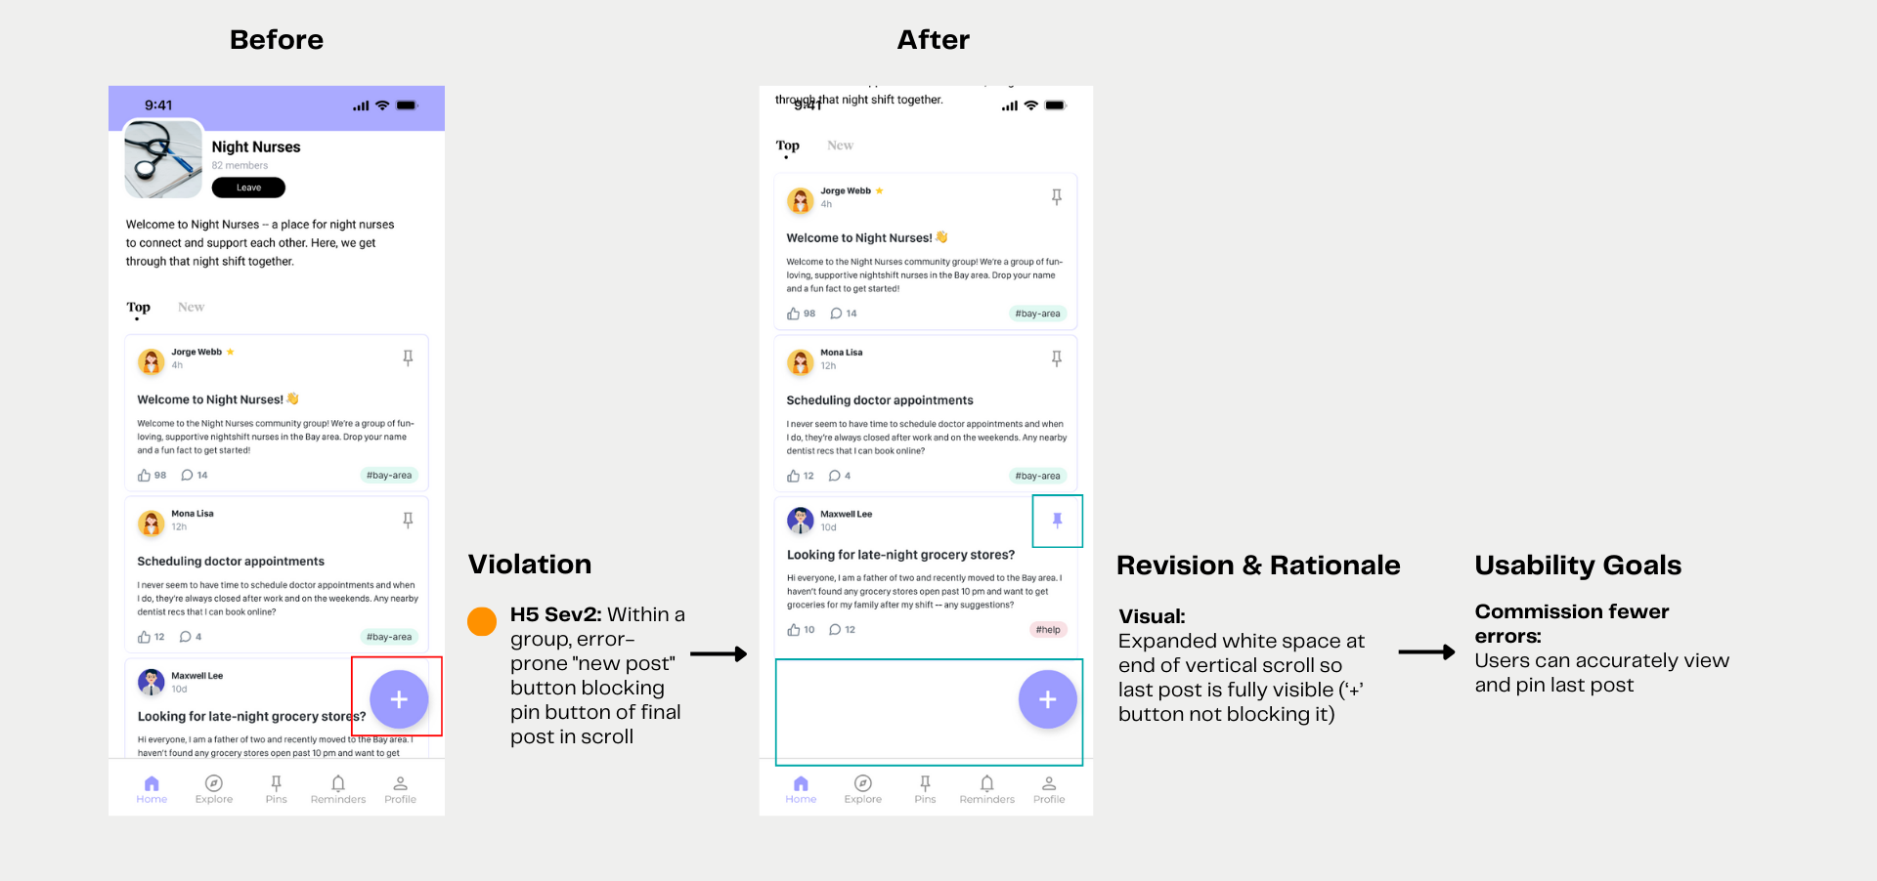
Design revisions, rationale, and progress towards usability goals for simple task
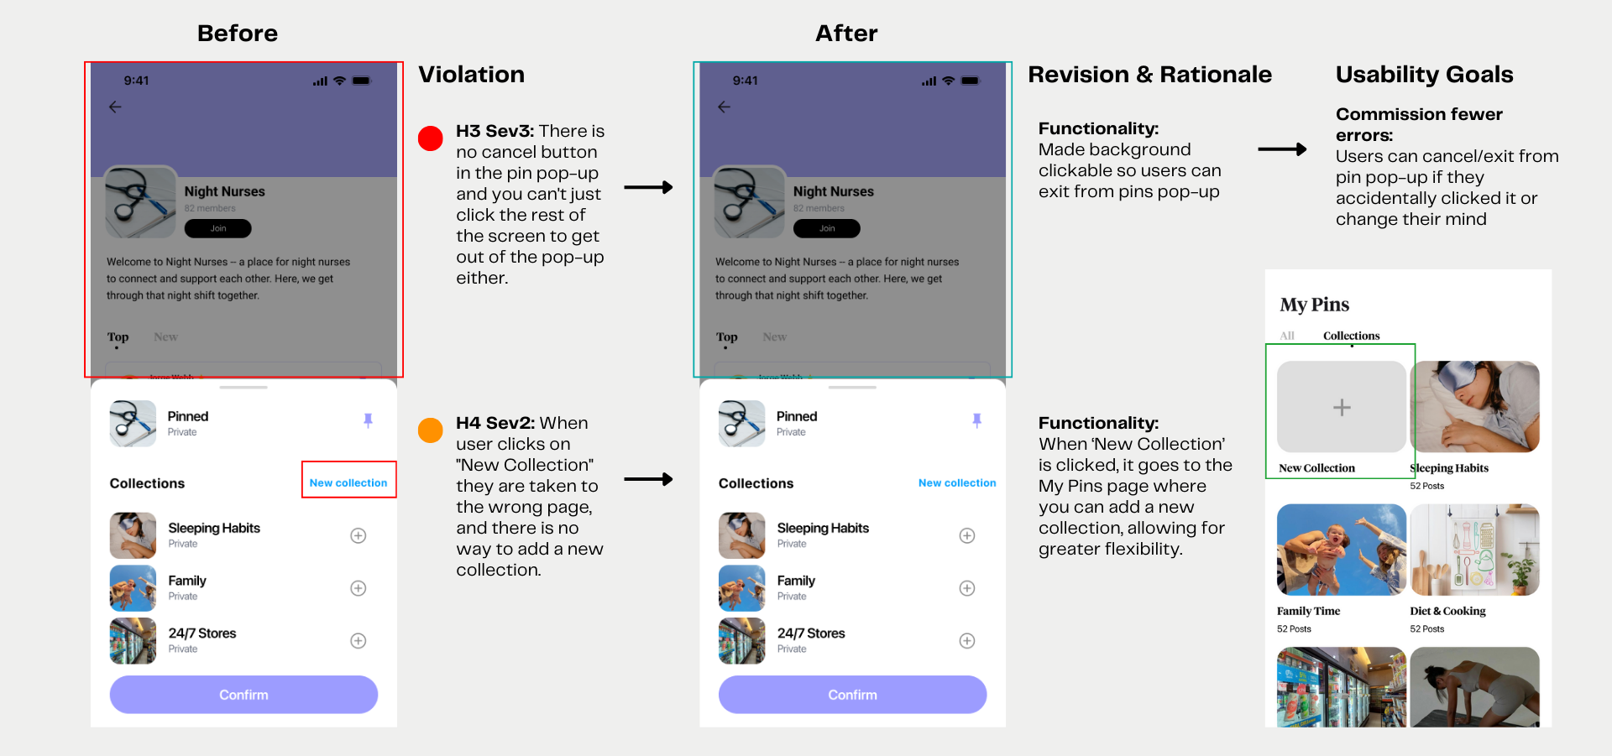
Design revisions, rationale, and progress towards usability goals for simple task

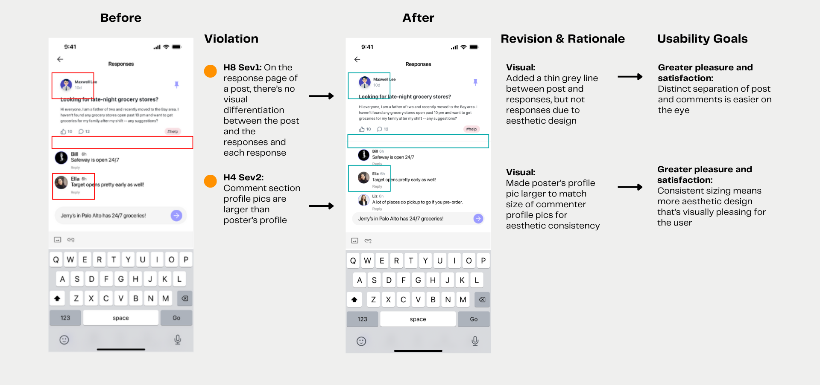Design revisions, rationale, and progress towards usability goals for medium task

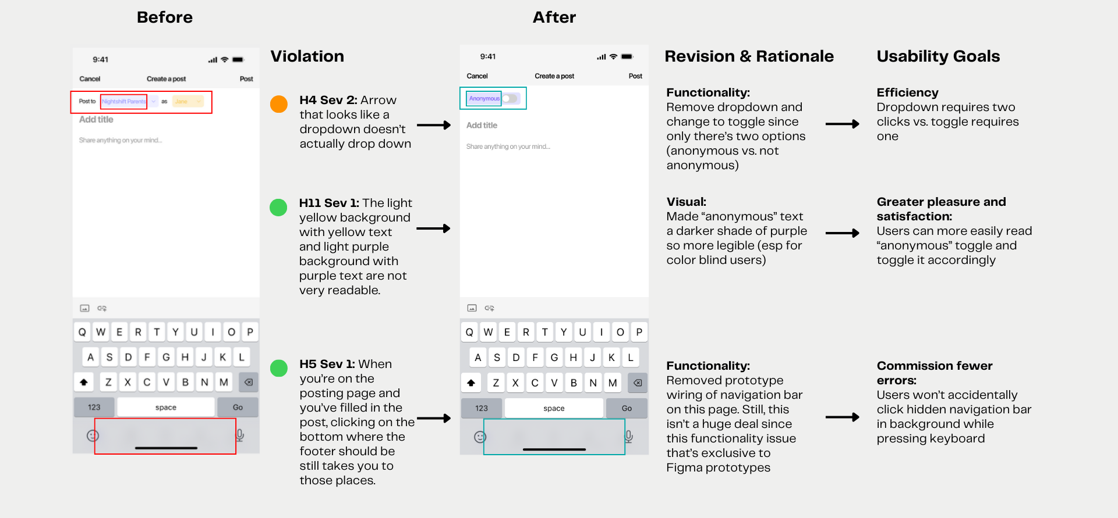
Design revisions, rationale, and progress towards usability goals for medium task

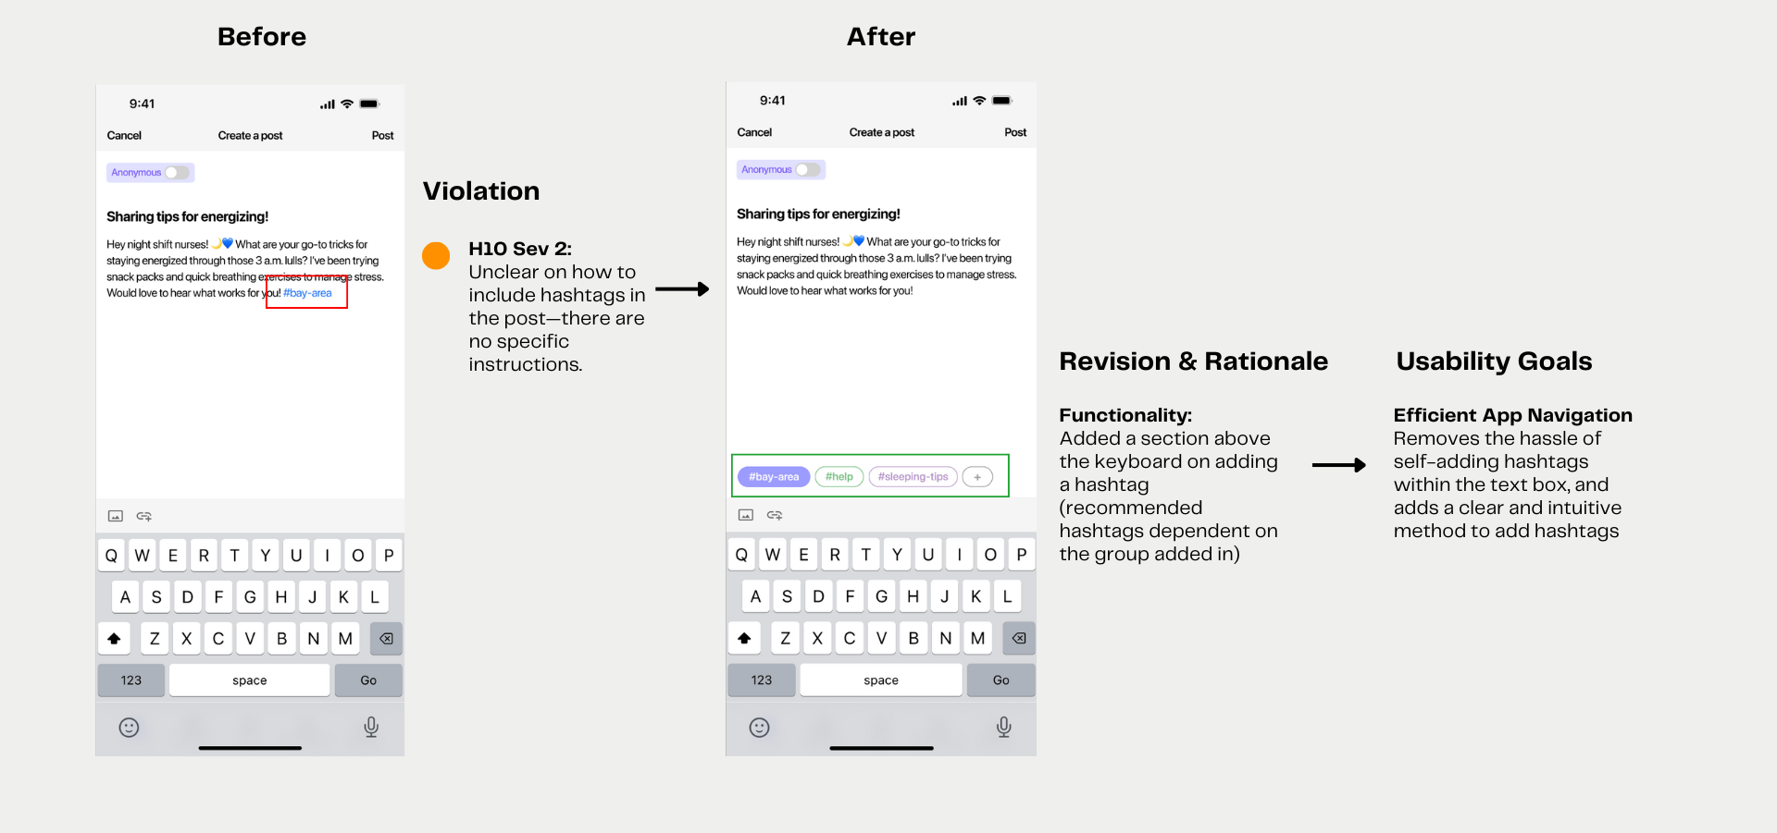
Design revisions, rationale, and progress towards usability goals for medium task
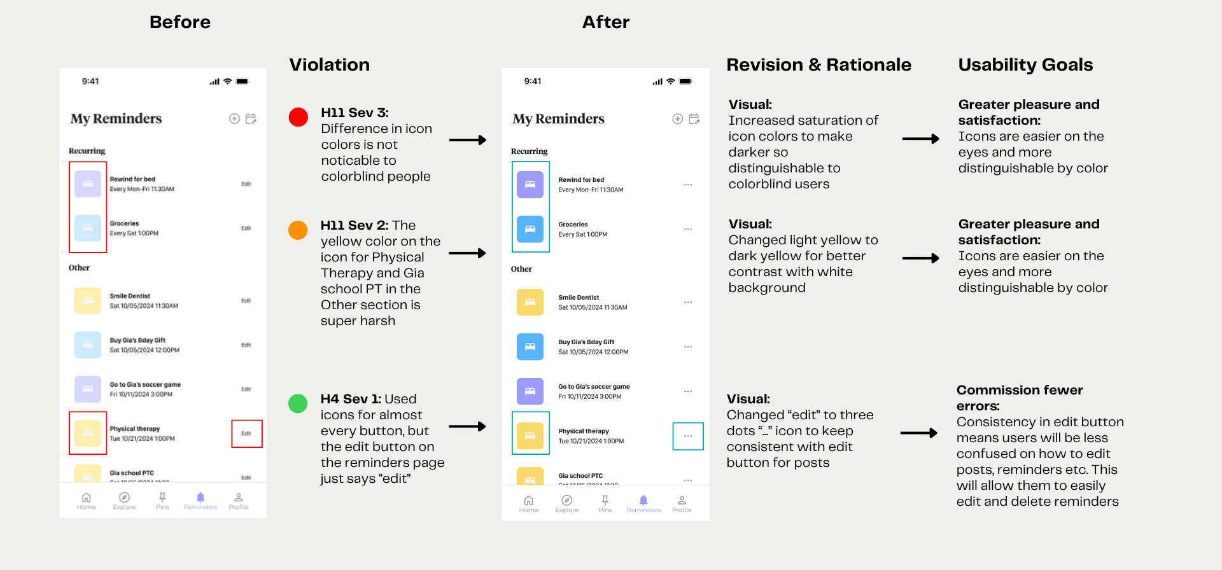Design revisions, rationale, and progress towards usability goals for complex task

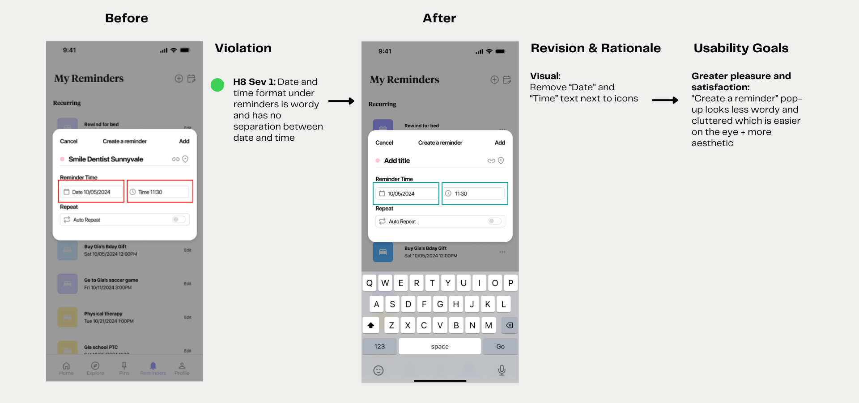
Design revisions, rationale, and progress towards usability goals for complex task

Severity 3 and 4 Violations Addressed for High-fi
We had 14 severity 3 violations and 0 severity 4 violations. In total, we fixed 9/14 violations. Common reasons for not fixing a severity 3 violation included ‘Wizard of Oz’ implementation (feature was hardcoded), evaluator misunderstanding, and aesthetic design tradeoffs.

HE | Task | Description | Fixed | Rationale
3 | Simple | There is no cancel button in the pin pop-up and you can't just click the rest of the screen to get out of the pop-up either | Yes | Fixed so user can tap background to exit if they accidentally click pin icon
7 | Simple | No option to search for posts | Yes | Combined search for groups, posts, hashtags so users can easily search for desired content without having to manually scroll. We combined this into a single search bar because it looked too cluttered with two or more search bars
7 | Simple | No way to search for pinned posts | No | Similar platforms purposely don’t include search for pinned/saved posts since user is most likely going to search for most recently pinned posts in chronological order
6 | Moderate | When I post anonymously, the post still shows up as “me” as the poster | No | Hardcoded - we said in README to post as "Jane", not anonymous
3 | Moderate | There's no way to delete a post or delete a comment once it's posted | Yes | Added three dots icon in top right corner to edit/delete post
7 | Moderate | While there are posts on the app, the app creation process appears to be rather hidden (at least took me a while to figure out) | No | Based on similar platforms, the “+” button is intuitive and once found, can be easily navigated to again. There’s also an aesthetic design tradeoff if we include the text “create post” inside the circular floating button so we didn’t make any changes
4 | Complex | After adding a new calendar, it adds a new reminder to the screen too | No | This was hardcoded - in README, user is meant to add reminder FIRST, then add calendar AFTER
11 | Complex | Difference in icon colors is not noticeable to colorblind people on reminders page | Yes | Changed icon colors to darker colors with higher saturation and contrast so users (esp colorblind) can see icons better
12 | All tasks | Verifying ID with Clear in onboarding | Yes | Changed from CLEAR to work email verification to be more inclusive of users
7 | All tasks | There are different tags, pins and users on the platform, however the search functionality appears to be only present for groups | Yes | Combined search for groups, posts, hashtags so users can easily search for desired content without having to manually scroll (same as prev page)
3 | Extra Violation | In the onboarding, once i reach the CLEAR verification, the back button does not bring me back anymore | Yes | Fixed back button functionality so users can go back to edit response
4 | Extra violation | Able to skip the CLEAR verification without agreeing or disagreeing | No | CLEAR verification is NOT mandatory so we should keep the ‘skip' button
4 | Extra violation | Back button from Night Nurses group always leads back to home page, no matter what navigation section you are in (ie: explore) | Yes | Fixed back button functionality so users can go back to correct page (prev page)
12 | All tasks | Verifying ID with Clear in onboarding | Yes | Hardcoded - we said in README to post as "Jane", not anonymous
4 | Extra violation | In the second part of the onboarding process, particularly in the screens "How would you describe yourself?" and "Join Groups from your interests", there are a series of selectable tile options however only some of them are populated, others appear empty. | No | Not essential part of tasks

Values in Design
Throughout each stage of our design process, we wanted to be purposeful about the values intertwined into our product. As Lunar is built for a specific user group, it was very important to ensure the unique values and priorities of night-shift workers were met. The primary values we tried to embed into our design were trust, personalization, and compatibility.

- Trust
To display trust, we wanted Lunar users to be able to build trust and rapport by
receiving genuine responses and authentic insights from other night shift workers that can empathize with them. From the ground up, Lunar puts a spin on traditional online support groups by making them much smaller and intimate, designed specifically to foster more trust between group members, with each community group capped at a hard 80 members. The option to verify identity during onboarding also provides increased online trustworthiness between members who can be sure others are real people by the verified check-mark next to their name. Finally, frequent contributors are awarded a “Star” by Lunar itself to boost their trust and engagement with their top posts.

- Personalization
To demonstrate personalization, we wanted everyone on Lunar to be able to get an experience specifically tailored to their needs and unique positions. We focused on building this into our onboarding, which is structured specifically to ask important questions to profile each user into the most relevant community group suggestions. Users can also control their degree of personalization by choosing how much information to provide during onboarding, allowing them to share as much or as little information about themselves as they want.

- Compatibility
Finally, to embed compatibility we wanted users to be able to intuitively and seamlessly integrate Lunar’s functionalities into their existing organization systems. As a night-shift worker, finding time to update an app is already hard enough, so we wanted Lunar to be a quick and easy addition to any user’s existing workflow. Design-wise, this is touched on in onboarding with an option at the end of the process to sync with the user's calendar. To ensure flexible compatibility, Lunar can be connected across the most common personal calendar apps (Apple Calendar, Google Calendar, etc). Posts suggesting specific actions have an option to integrate with the user’s established calendar or the in-app reminders tab.
Value Tensions
While designing for these three values, there were some value tensions that came into play.

For example, there was a conflict between trust and personalization: users who may not want to share as much information about themselves in onboarding (using the skip page feature) may be put into broader community groups with less intimate and trusting relationships as a result. To resolve this, we implemented multiple smaller communities—for example, three 50-person “Nightshift Nurses” instead of one 150-person one, to keep that small-group feeling across a larger group of people.

There was also a conflict between personalization and compatibility, arisen from Lunar’s methods of calendar connection. Reminder/calendar compatibility is limited to most commonly used apps, which may make Lunar less personalized to users with unique preferences (for example if users do not use a digital calendar at all). We attempted to resolve this issue by offering both iOS and Android calendar compatibility, but given Lunar’s premise as a mobile app, there was no way for us to permeate into the paper or non-digital space in terms of integration compatibility.

Final Prototype Implementation

Tools Used
- Goodnotes for lo-fi sketches
  - Pros: Easy to use as all members of our team were familiar with digital note-taking apps. Undo and erase were also easy.
  - Cons: Paid subscription, no way to collaborate.
- Figma for med-fi design
  - Pros: Highly customizable and many templates/icons from common mobile apps that could be imported. Components and scalable objects made it easy to copy common design aspects across screens. Real time collaboration and specific comment location made it easy to work on designs together as well.
  - Cons: Learning curve for more advanced features.
- React Native/Expo Go + Supabase for hi-fi design
  - Pros: Two of our members are enrolled in 147L, so we are familiar with the RN/Expo framework.
    - Expo also allows for a seamless app setup, and the structure is intuitive for first time app builders. It is often used with RN so the two have specialized setup that make the process much easier.
    - Supabase is also touched on in 147L and is relatively easy to learn and import into React. The schema view in particular is extremely helpful as it shows exactly how tables are related and provides a top-down visual of table organization.
  - Cons: Adapting Supabase into a RN app that is not social media based would probably have been much more difficult as we were shown a similar setup for Buzz, a social media app, and was able to recycle the database import from that.

Wizard of Oz Techniques
- The groups that show up on the home screen are Wizard of Oz’ed: The database saves all information (posts, likes, comments, reminders, collections) except for user onboarding information. The app experience is hard coded for one user’s user_id, so choosing interests/groups in the onboarding experience does not affect what loads in the home screen.

Hard-coded Techniques
- Some posts’ like counts are hard-coded on the Supabase to ensure correct ordering in Trending posts feed.
- Selection of highlighted events/locations to set a reminder to is hardcoded, so only one highlighted portion can be selected, where in reality AI would detect it.
- Calendar integration and “add event” popup (from reminders tab) is hardcoded due to difficulties with Expo Calendar frontend display.

Reflection and Next Steps

Main Learnings
We had several key learnings from this process that we wanted to reflect on:

- Letting Users Drive the Iteration Process

Before coming into this project, many of us had worked on previous design projects that were built for a specific user in mind. However, what we gained from this course was the level of empathy and research that went behind interviewing and gathering insights from our user base. Consequently, by understanding our users deeply and allowing them to actively contribute and participate in the design process, whether that be through experience prototypes, low-fidelity prototypes, or sharing their experiences, we were able to find a lot of value in this entire robust experience.

- Using Robust Evaluation and Design Techniques

Again, from previous design courses we had taken, we were only able to understand an extent of the level of evaluation and reflection that went into the design cycle. More specifically, creating mind-maps, HMW and POVs allowed us to deeply empathize with our users and utilize reflection methods that bridged our analysis together.

- Build Technically and Quickly

We also were able to reflect deeply about the project timeline and how to build a project from the ground up. All the way from brainstorming to sketching to building out a lo-fi, med-fi, and high-fi, we were able to work quickly and get MVPs done. This forced us to think deeply and intentionally about the work that we were putting out, especially because we had limited time and we knew we had to keep on building from our previous steps.

Next steps
If we had more time, we would have loved to fully implement a dynamic home screen (with group suggestions based on user input) and AI to detect post details that can be converted into reminder suggestions. Currently, both are hard coded but are integral to the functionality and purpose of Lunar’s user experience. 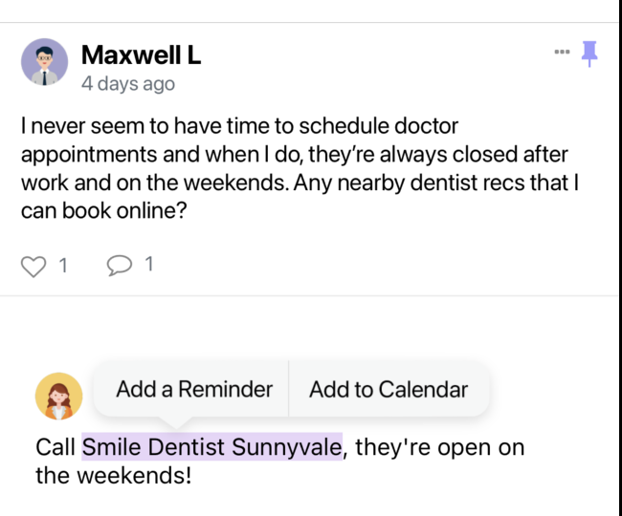 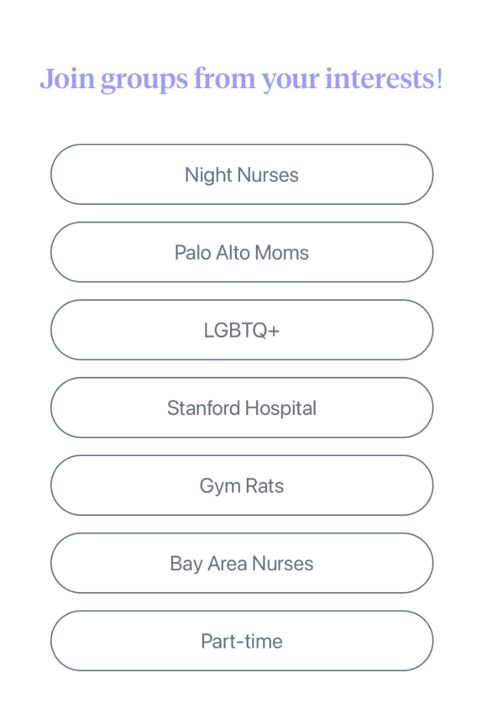
[Highlighted text selection] [Dynamic group suggestions in onboarding]

Above are visuals of the features we would like to fully implement on the back-end.

