Fitbud
Your new pal, here to make fitness fun and easy.

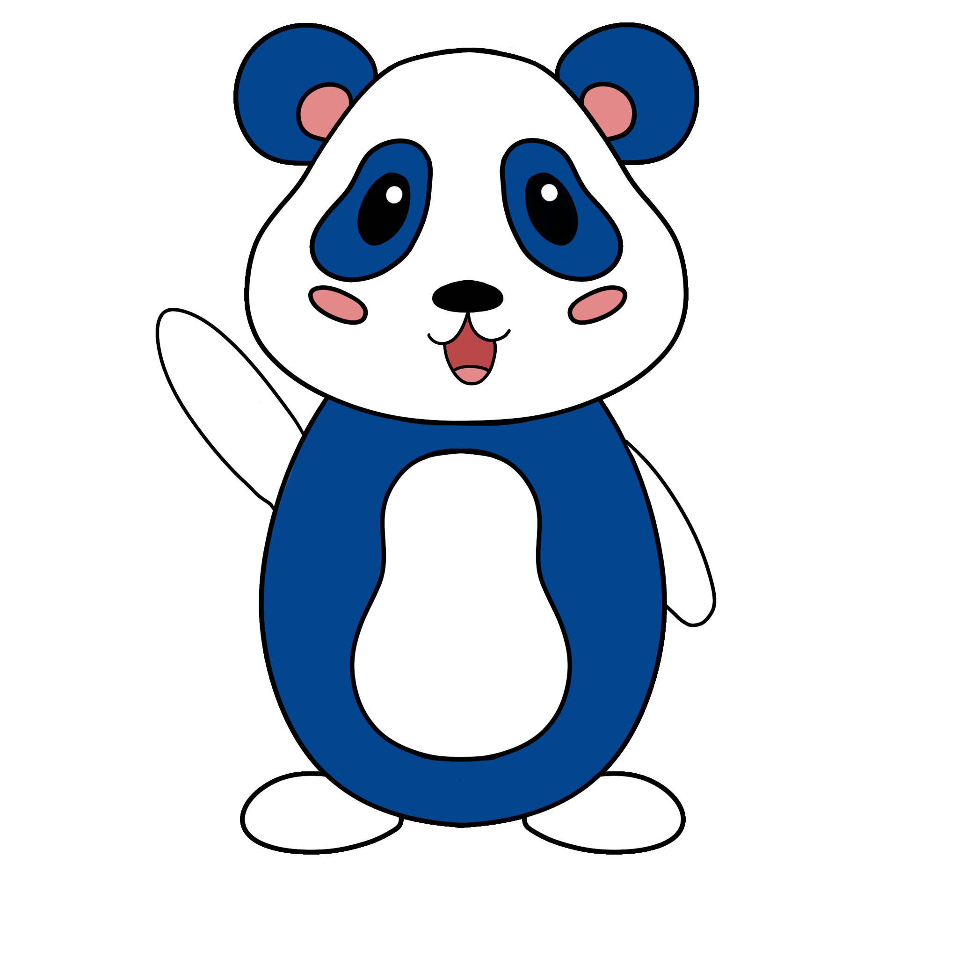
Buddy

Team Members & Roles
Designers: Christelle Millos-Lopez, Akanshya Bhat
Developers: Jake Restiano, Ethan Yuen

Summary
Introduction
  - Value Proposition
  - Problem/Solution Overview
Needfinding
  - Interviews
  - Synthesis
POVs & Experience Prototypes
  - POVs
  - HMWs

  - Top 3 Solutions
  - Experience Prototypes
Final Solution
  - Description
Tasks
  - Simple Task
    - High-Fi Simple Task Flow
  - Moderate Task
    - High-Fi Moderate Task Flow
  - Complex Task
    - High-Fi Complex Task Flow
Design Evolution
  - Initial Sketches
  - Low-Fidelity Prototype
  - Usability Testing
  - Major UI Changes from Low-Fi to Medium-Fi
  - Medium-Fidelity Prototype
  - Major UI Changes from Medium-Fi to High-Fi (Heuristic Evaluation)
Values in Design
  - Inclusivity
  - Flexibility
  - Safety
  - Privacy
  - Inspiration
  - Tensions in Values
High-Fi Prototype Implementation
  - Tools Used
  - Hard-Coded Features
  - Wizard of Oz Features
  - Limitations
Reflection and Next Steps
  - Design Thinking Process
  - Unintentional Good
  - Future Work

1: Introduction
Fitbud is an application that provides users with an in-app workout buddy of their choosing who creates intuitive and compelling workout plans based on a user's current workout habits and goals, while also scheduling workouts with friends if desired.

Value Proposition
Your new pal, here to make ﬁtness fun & easy

Our Problem
People, regardless of their current ﬁtness levels or social ﬁtness preferences, don’t actively try to change their ﬁtness-related habits without support as it requires a lot of activation energy, effort, and planning to make it consistent.

Our Solution
Our app provides you with a gamiﬁed virtual workout buddy that schedules your workouts, keeps you accountable, and accompanies you through your workout - adapting to your needs and making it easier to exercise.

2: Needfinding
As part of our design process, we conducted several rounds of needﬁnding interviews. We started oﬀ with a broad domain of people's active lifestyles and after collecting data from our interviewees, we narrowed down this domain to ﬁnd a particular need.

Interviews
Who we interviewed: In order to avoid limiting user need information, we interviewed a total of 9 participants (listed below) that were strictly non-Stanford people within a wide age-group of 18-65 years of age with a variety of active lifestyles (sedentary, moderate, intense). We conducted a total of two rounds of interviews.

First Round of Interviews
Interviewees: :

Person | Age | Lifestyle | Where
Jill | 45 | Active | Stanford Potter House
Rishi | 20 | Active | Gym
Anissa | 23 | Sedentary | Local coﬀee shop?
Bernardino | 57 | Sedentary | Stanford Tresidder
Sean | 57 | Moderate | Stanford Tresidder
Bennita & Achim | 64 & 65 | Active | Stanford Tresidder

How we recruited participants: Most interviews were conducted in public spaces, such as Stanford campus' Tresidder. Other in-person interviews were conducted at local gyms, and coﬀee shops. For in-person interviews conducted at Tresidder, we randomly chose participants that were willing to give us around 20 minutes of their

time. As for the rest of the people interviewed in-person, they were found via personal connections and were asked to meet up at a common area (i.e. gym, coﬀee shop) to conduct the interview.

How we interacted with them: After participants agreed to interviewing with us, we asked them to sign a consent form to use the information gathered in the interview for presentation and recollection purposes. We designed a script of questions to use for each interview that was meant to be loosely followed since we were still in the initial stages of design and did not want to limit ourselves to a particular solution. We sought diﬀerent perspectives and insights from participants.

Information gathered: Our interviews revealed conﬂicting desires of companionship when working out with some people preferring to workout alone and others strongly expressing a need to workout with other like- minded individuals. However, people who expressed wanting to workout alone did express their discomfort with such being due to social anxiety and embarrassment. Every interviewee presented a need for motivation either it be through other people or self-induced.

Second Round of Interviews
Interviewees:

Person | Age | Lifestyle | Where
Yusuf | 24 | Active | Zoom
Madeleine | 22 | Active | Stanford Shopping Center
Jessica | 45 | Moderate | Stanford Shopping Center

How we recruited participants: After our ﬁrst round of interviews we attempted to diversify our age group a bit more and look for people that were within a younger age group of 18-25. Most interviews were conducted at the Stanford Shopping center. Here, we, once again, chose participants that were willing to give us around 20 minutes of their time. This time, we had one interview conducted via Zoom.

How we interacted with them: We, once again, asked our participants to sign a consent form to use the information provided for our needﬁnding. However, following our ﬁrst round of interviews we once again decided to make some changes based on the insights we got from our ﬁrst participants. This time we revised our domain to "helping people ﬁnd motivation and community in exercise", meaning we were more interested in people's thoughts on the social aspect of exercise and self-motivation. As a result, we included some questions in our script related to those subjects, but still allowed the conversation ﬂow freely without restricting ourselves to the script.

Information gathered: Through these interviews we realized that there was no one speciﬁc way that people liked incorporating the idea of other people in their workouts. However, they all sought motivation (as in our ﬁrst round of interviews) and enjoyed doing activities that suited their particular lifestyles.

Synthesis
After analyzing each individual interview to see how much we could learn from each one, we looked at all of our interviews and came up with four main insights. First, we learned that the way you perceive your age aﬀects your activity levels. We happened to interview quite a few older individuals and each one had a diﬀerent activity level depending on their perspective of how their age either allowed them to move more or limited them from moving. From here, we deduced that a need is a source of empowerment and education to know what their bodies are capable of. Yet another insight we reached was that people are not actively looking to make change in their lifestyle; they are content with where they are at the moment. One of the most common things we heard was something along the lines of “it is the way it is". This told us that people need some way to motivate them or spark interest in their lives that will inspire change. A third insight that we found was the lack of exercise experience and subsequent fear of being judged are major obstacles for newcomers. The need that we found from this is that people need a comforting, welcoming, and informative environment as beginners to working out. One of our key discoveries is that in general, people are ﬁrmly divided on whether or not they want a companion when exercising; if they do want a workout buddy, it is imperative that this buddy have the same ﬁtness goals as them. At this point in the design process, this wasn't an insight that we could derive a need for, but it was still an important observation that came up a lot and one that we made note of. Our ﬁnal insight was one that is more common, and yet was still incredibly relevant to our interviewees' collective experience; time and money are obstacles to an active lifestyle. As such, we came to the conclusion that people need to be informed about other forms of accessible activity available to them.
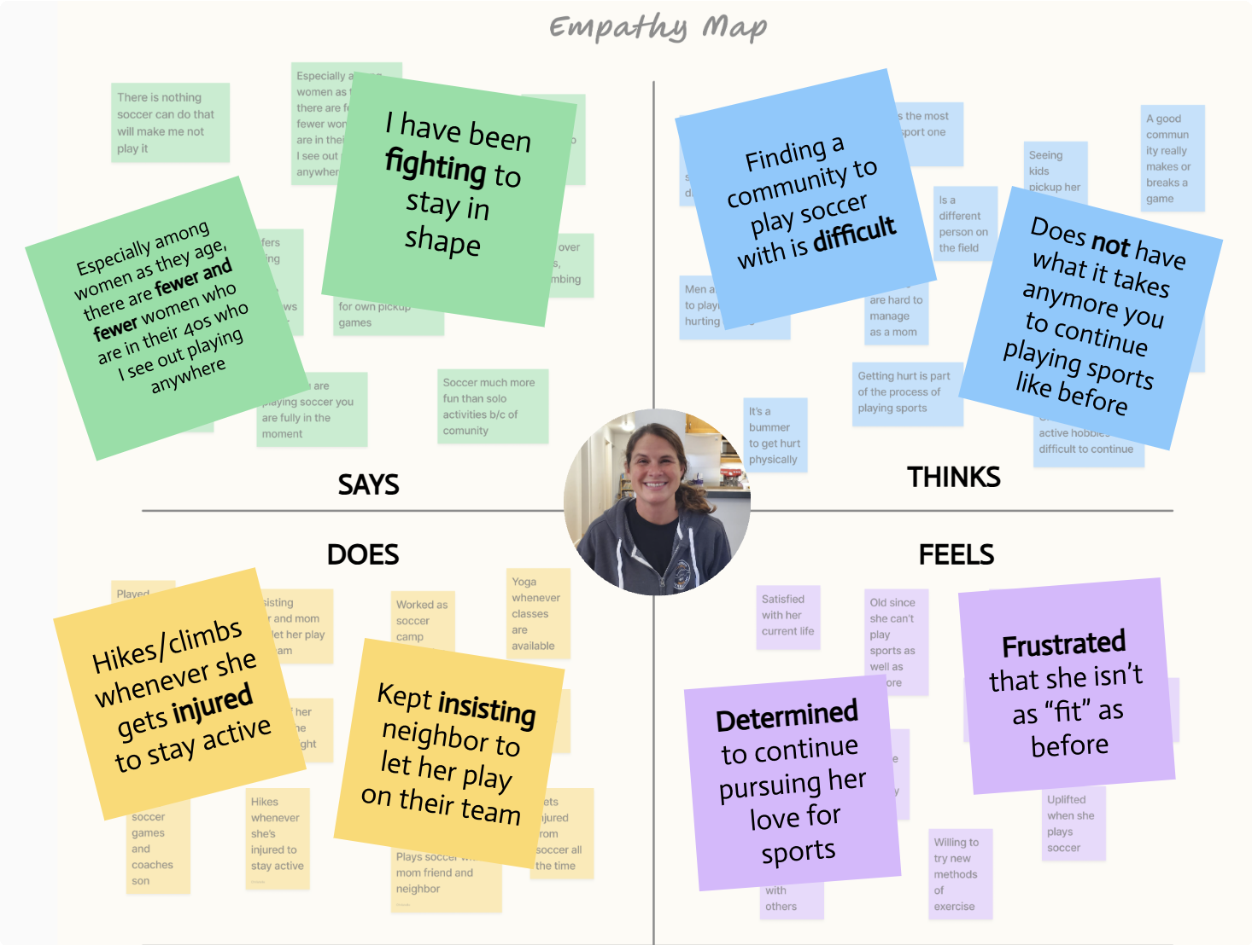
Jill's Summarizing Empathy Map

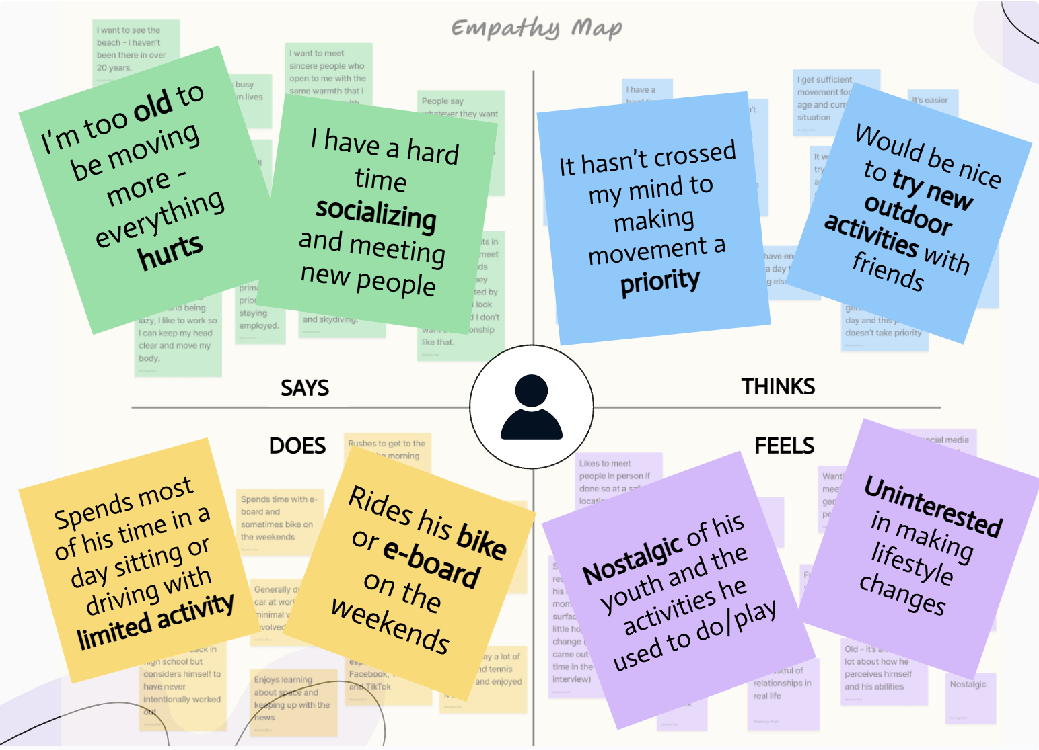
Bernardino's Summarizing Empathy Map

2: POVs & Experience Prototypes
From our needﬁnding interviews, we were able to gather enough information about each individual to generate 3 point-of-views (POVs) and 10 how-might-we's (HMWs) from each point-of-view. In these POVs, we dive deeper into who we met and what we might be able to provide from what they seemed to need. From each POV, we were able to brainstorm ways to help people get what they need.

POVs & HMWs
For our POVs, we chose 3 individuals (Anitta, Yusuf, and Madeleine) who seemed to present particularly interesting approaches to our domain.

Anitta
POV:
We met Anissa, a recent college grad working as a physical scientist in San Francisco who does not consider herself to be an active person.
We were surprised to notice that she wanted guidance to get started working out, but she had a fear of being judged by others.
We wonder if this means that she lacks a supportive presence that will help her work towards these goals.

It would be game-changing to provide her with a way to meet others that she can exercise with, learn from, and can ease her into working out.
HMWs:
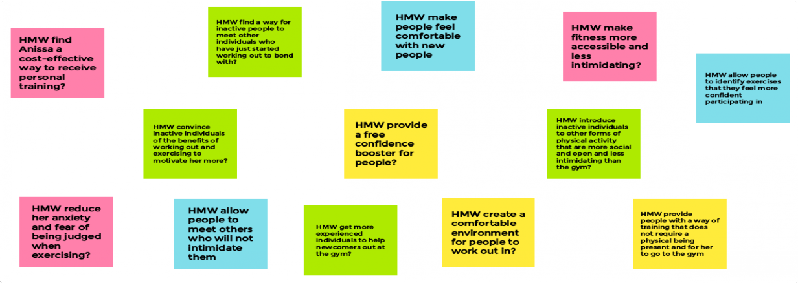

Yusuf
POV:
We met Yusuf, a kinesiology student, avid bodybuilder, and aspiring physical therapist.
We were surprised to notice that, though he has a relatively active social life, he never goes to the gym with anyone despite expressing a desire to do so.
We wonder if this means he ﬁnds it diﬃcult to ﬁnd suitable workout buddies to make working out more fun.
It would be game changing to help him ﬁnd a lifting partner who could enhance his workouts.
HMWs:

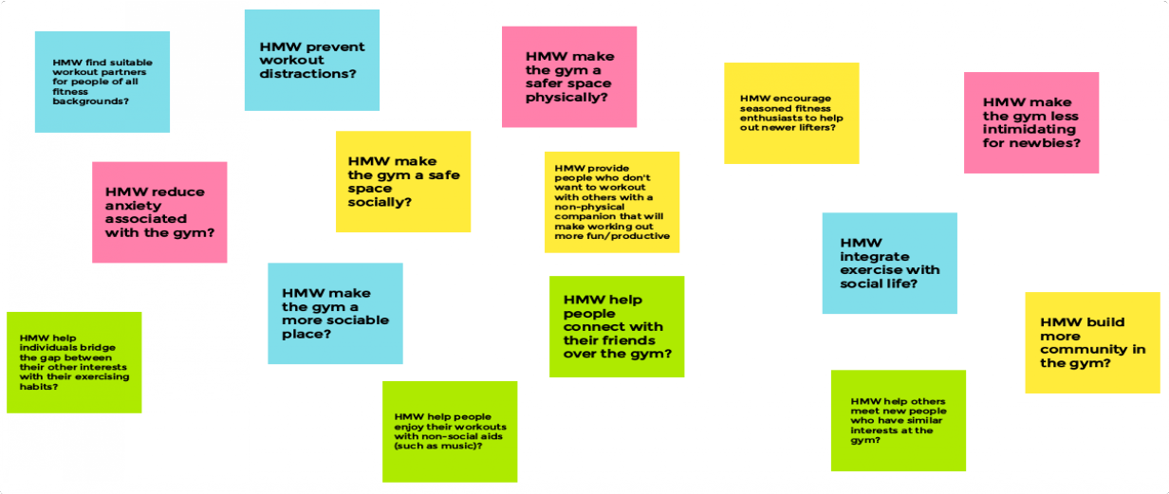

Madeleine
POV:
We met Madeleine, a newly grad and potential med school Stanford student from Palo Alto who has been working at SoulCycle for 5 years now because of her love for cycling.
We were surprised to notice that she uses her studies in human biology to inform herself about health and ﬁtness through research papers to avoid misinformation online.
We wonder if this means that she does not have a trustworthy information source that could provide this information in an easily-accessible manner.
It would be game-changing if we could provide her with information at the tips of her ﬁngers that would be credible and educational in terms of ﬁtness and health.
HMWs:
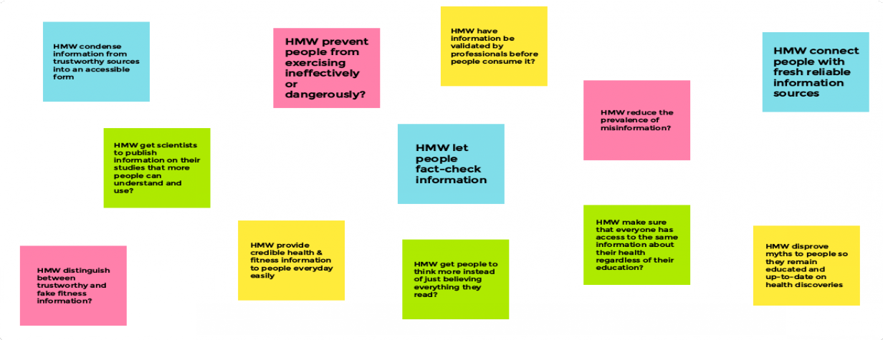

Top 3 HMWs
Out of the HMWs shown in the previous section, we decided to move on with the 3 HMWs we determined would give us a good direction in how to provide a solution for each individual.

How might we make ﬁtness more accessible and less intimidating?
How might we ﬁnd a suitable workout community for people of all ﬁtness backgrounds?
How might we provide people with trustworthy and helpful guiding information about exercising and ﬁtness?

Top 3 Solutions
For each of our top 3 HMWs we developed a solution we resolved would be the best ﬁt to address not only those 3 individuals' needs, but also of the rest of the people we interviewed.

- Get Guidance:
Match people with more experienced ﬁtness buddies to provide guidance
- Find Your Match:
Have people create a custom proﬁle with their exercising habits and ﬁnd people that have a certain percentage of similarity
- Individually-Curated:
A platform that tracks/provides workout routines and nutrition habits and gives recommended changes

Experience Prototypes
For each solution, we created an experience prototype that were tested by new random individuals we recruited.

Experience Prototype #1: "PT" Matching
Key Assumptions:
Being at the gym alone is scary
Not just showing people what to do but why do it will help demystify ﬁtness
Correcting one’s form and technique will help them stay safe and feel less self-conscious

Description:
The "PT" Matching experience prototype had 3 key steps: participant ﬁnding, workout, and evaluation. In this experience prototype, we found lifters with little to moderate lifting experience, asked them about and noted their ﬁtness goals and interests. We randomly chose a willing lifter to participate in our experience prototype. Before we did anything, we gave the participant a form to ﬁll out regarding their current experience level, workout frequency, preference in working out alone or with someone, and level of motivation and comfort in gym. We then took this lifter through a ~90 minute tailored workout designed by an experienced lifter (instructor). The instructor explained and demonstrated to the particpant how certain exercises should be

performed and why they were to be done (i.e. their beneﬁts and how they relate to the participant's goals and interests). After the workout, we had the participant ﬁll out a post-workout form with the some of the questions of the pre-workout form to see if anything had changed and some extra after-session questions.
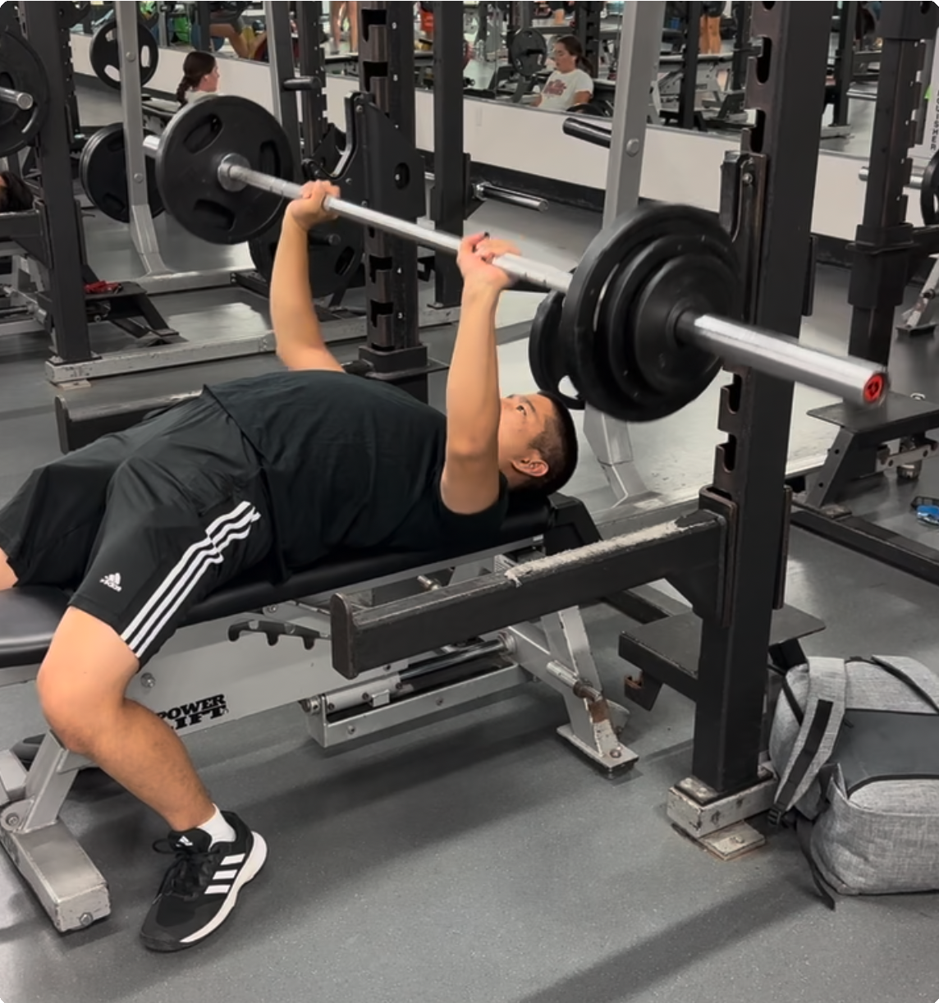

Results:
What worked:
We saw an increase in motivation and comfort levels in the gym Participant became more inclined to workout with other people
We noticed that having another person to guide the participant seemed to be helpful as the participant denoted having enjoyed and appreciated learning new exercises
What didn't work:
The workout seemed to have been a physically challenging in some aspects as participant noted some muscle soreness after the workout
Participant pool was not as diverse as we desired and might have been biased towards people that already had some experience working out
Implications:
We were able to aﬃrm our assumptions that working out alone can be scary, guidance can make working out more comfortable, and understanding exercises is useful
It was easier to get oﬀ track or reinforce bad habits when working out alone and that having a trainer ensures workout eﬃciency and prevents dangerous situations
We should continue trying to ﬁnd a way to educate people about exercises with some sort of instruction

Experience Prototype #2: Speed Dating
Key Assumptions:
There are people who want workout buddies with similar goals and aims but cannot ﬁnd them

People are willing to meet a stranger with similar goals and invest the time in this process

Description:
The Speed Dating experience prototype was composed of talking and evaluating. We recruited a random individual to talk to one of the people in our team. These conversations were prompted by questions designed by the team with the goal to ﬁnd out people's working out/activity preference compatibility. Before the conversation, we had the participant ﬁll out a pre-experience form about their activity levels, mood, and preferences when exercising. We then started a 5-minute timer for the conversation where both participants answered our questions in a timely manner. At the end of the conversation, we used a rubric to determine if both participants were compatible exercise-wise. We also had the new participant ﬁll out a post-experience form telling us about their updated mood, ideals, and thoughts about the experience prototype itself.
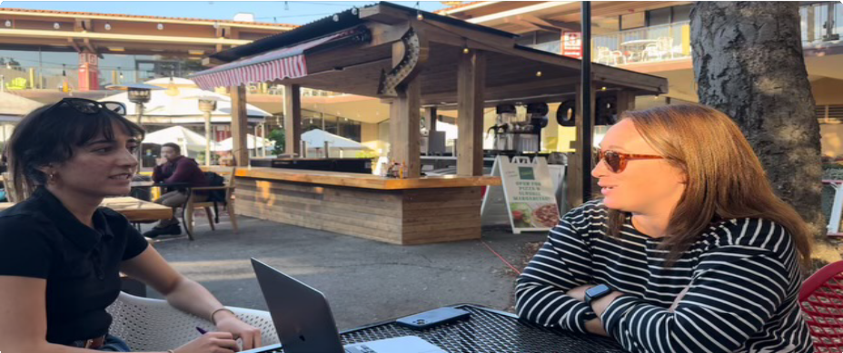

Results:
What worked:
The participant seemed to enjoy the casual conversation format
We were able to see exactly how both participants' habits aligned
The given questions facilitated and guided the conversation eﬃciently providing the participants enough comfort to be more vulnerable with their responses
What didn't work:
We noticed that some answers were telegraphed by the questions We got qualitative and not quantitative data
We did not have an answer to "what's next" after participants were told they matched or did not match Implications:
Our answer to our ﬁrst assumption was still a bit unclear indicating that not everyone wants to ﬁnd a
workout buddy
We realized that a matching feature only works if the feature is used by people who actually want to ﬁnd others to workout with
We need to take into account people's preferences and comfort with others before matchmaking them

Experience Prototype #3: Nutrition and Fitness Quiz

Key Assumptions:
Some people would like others to critique their workout/nutrition habits Receiving feedback will empower people to exercise more

Description:
The Nutrition and Fitness Quiz at a high-level was an informative quiz that would be provide individuals curated exercising advice. We reached through our networks to ﬁnd a random participant that was willing to sit down and take a computer-based quiz (Buzzfeed quiz) for a couple of minutes. We had the participant ﬁll out a pre- experience prototype form telling us about their current mood, thoughts, and workout preferences. We then had them take the short quiz on a computer until the end. We rewarded participants with a healthy snack as a reward for taking their ﬁrst step towards their health and ﬁtness journey. Finally, we had the participant ﬁll out a post-experience prototype form telling us about their mood, thoughts, and workout preferences after the quiz.
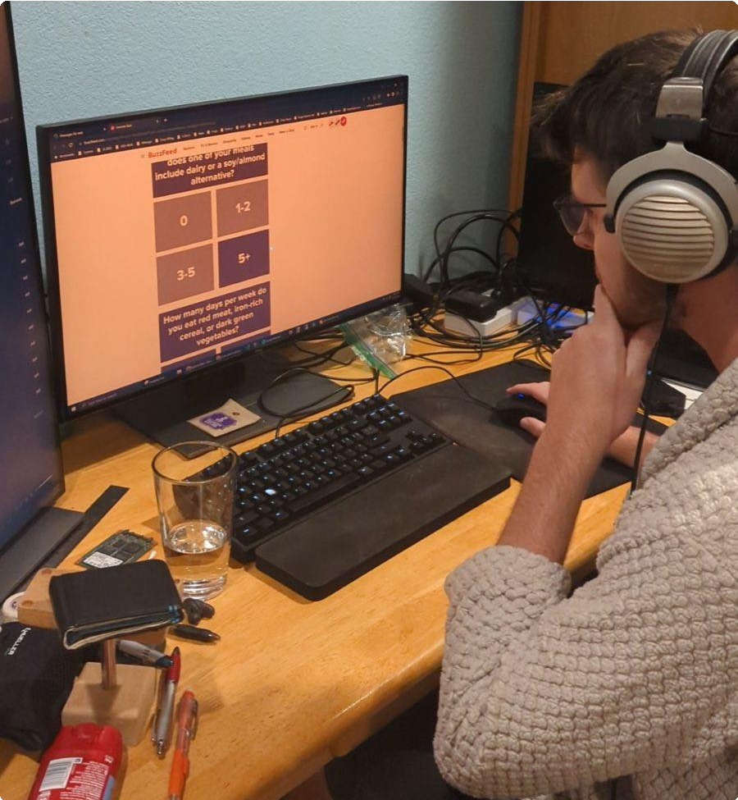

Results:
What worked:
Participant indicated being amused and intrigued by the analysis of their health habits Participant felt that the experience prototype was engaging and succinct
What didn't work:
Participant felt that the response options were too vague/not speciﬁc enough Participant was not conﬁdent in the accuracy of results
The given results did not cause an increase in motivation or happiness Implications:

We have to ﬁnd a way to obtain speciﬁc/accurate results that will be more trustworthy to the average person
People appreciated being evaluated and receiving feedback so we should provide some sort of feedback mechanism for people based on their progress
Feedback does not necessarily increase motivation so we need to ﬁnd a way to increase motivation another way

4: Final Solution

Description
Our app provides you with a gamiﬁed virtual workout buddy that schedules your workouts, keeps you accountable, and you through your workout - adapting to your needs and making it easier to exercise.
accompanies

Rationale
Based on our needﬁnding interviews and experience prototypes we realized that people who were looking to start working out or continue doing so desired a motivating force to get them to keep going. However, not everyone wanted a physical person to workout with. Nevertheless, they did appreciate learning and receiving guided instruction and feedback.

Target Audience
16+ year olds with a need for exercise motivation and looking to start or continue exercising.

Who might be left out
People who have a lot of experience working out and have enough self-motivation to continue working out. People with life-threatening medical conditions

Ethical implications
Privacy - user's calendar information and medical conditions are shared with us.

5: Tasks
Based on our solution, we designed 3 tasks for our app users based on their frequency and complexity.

Simple Task
Create a workout plan in an environment accessible to me and schedule that works for me.

This task involves the virtual buddy accessing a user's calendar and based on user preferences, block out their calendar with workouts and suggested places to workout in. We believe this task will be most frequented/used since it is the main focus of the service. We designed the app to prevent users from having to look in their calendars, see where they can workout, check if there are any conﬂicts, and manually block out a time in their calendars to workout. Users will be using the scheduling feature to update their current schedule, create new ones, or remove workouts.
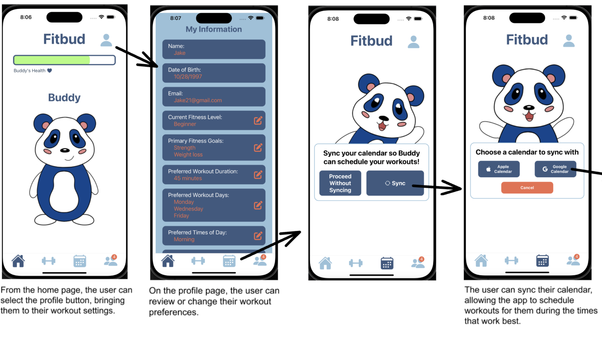
Part 1
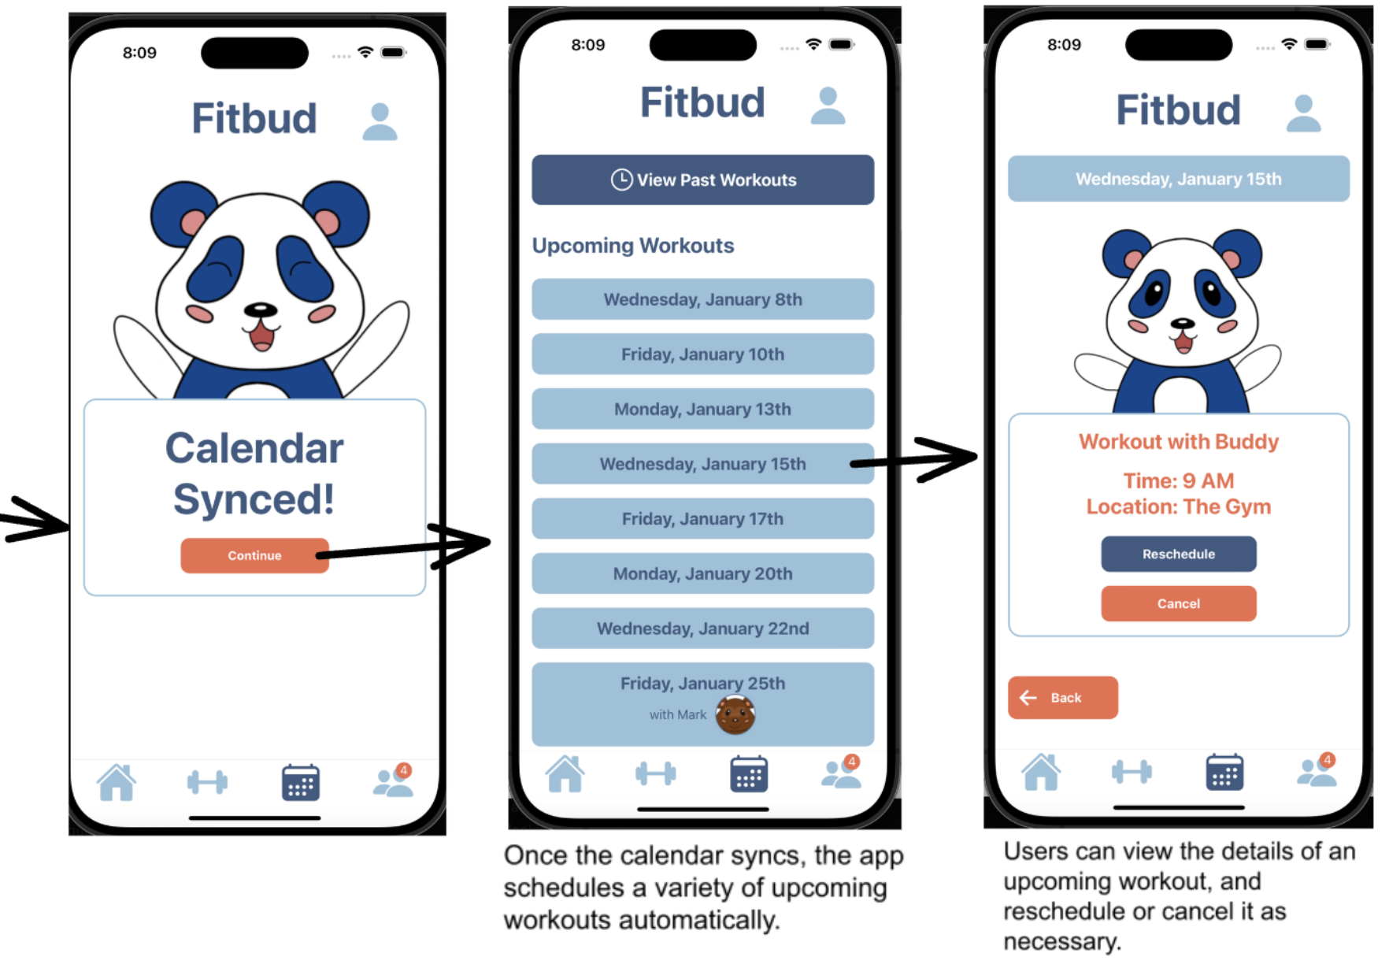
Part 2

Moderate Task
Have an accountability system for my commitment to ﬁtness

This task involves users interacting with their virtual buddy to keep him alive, mainly through completing their assigned scheduled workouts. We believe this task will be less frequented by users, but still moderately used since people will most likely regularly use the service to complete their workout and come back for their next workout. Moreover, there the most interaction a user can have with their virtual buddy is to workout and play with it in the home screen, which, for the latter, might not be as interesting to users looking to strictly use the service as a serious workout motivator.
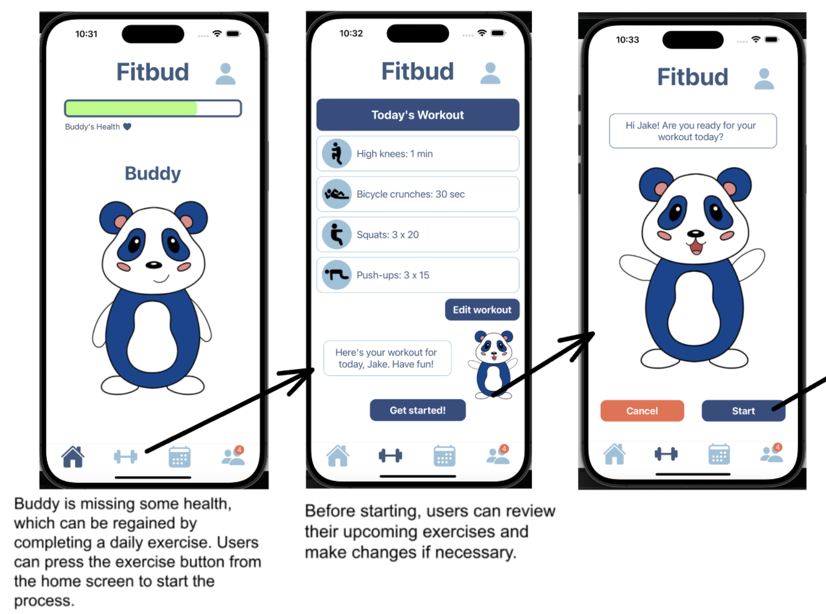
Part 1

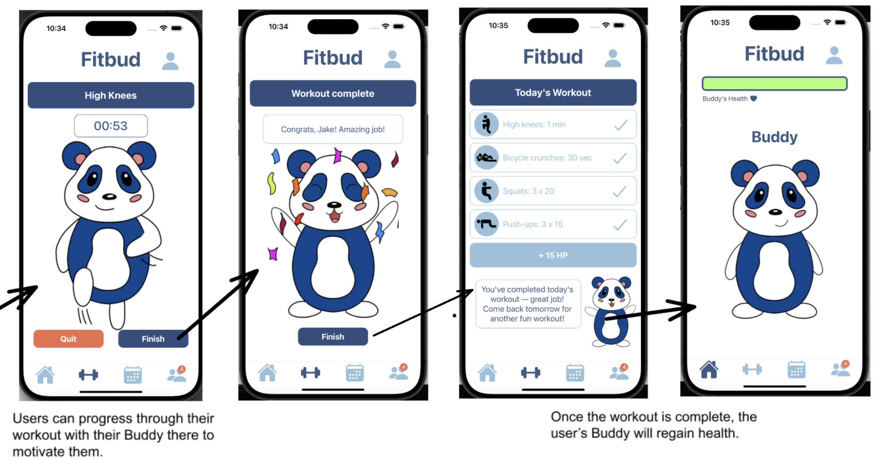
Part 2

Complex Task
Connect with friends who are also exercising

In this task, users are able to connect with friends that are also using the service to workout. As with the simple task, the virtual buddy will schedule a workout that works with both users' schedules. We believe this feature will be used with less frequency than other tasks because of its dependency on people's workout preferences. As our experience prototype results showed, not everyone enjoyed workout with other people, therefore this feature might not be used at all by said users.

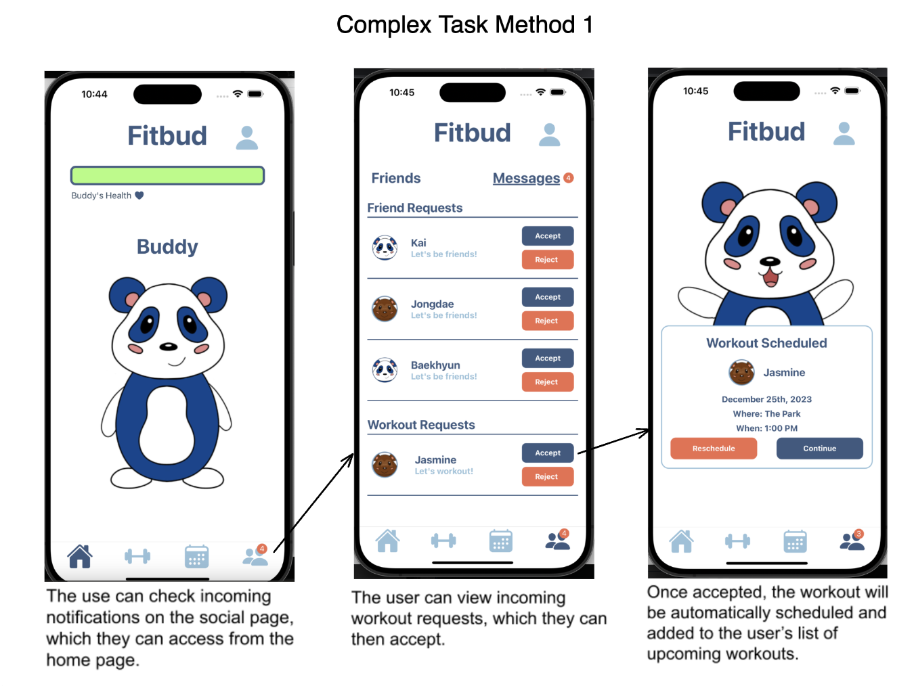
Part 1
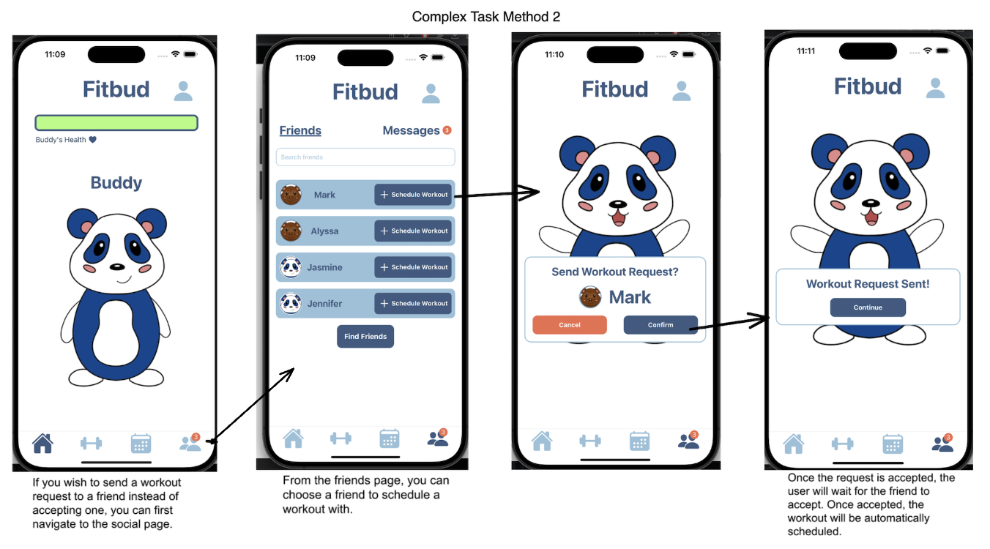

6: Design Evolution
Part 2

Once our tasks were deﬁned, we had to ﬁnd the most suitable platform to provide this service to users that will enhance its appeal and keep users engaged without any complications. This process involved sketching, prototyping, and testing.

Initial Sketches
To start oﬀ our designs, we ﬁrst brainstormed several platform ideas and after careful consideration decided to narrow it down to two platforms: mobile app and augmented reality (AR).

AR Version
First Sketch:
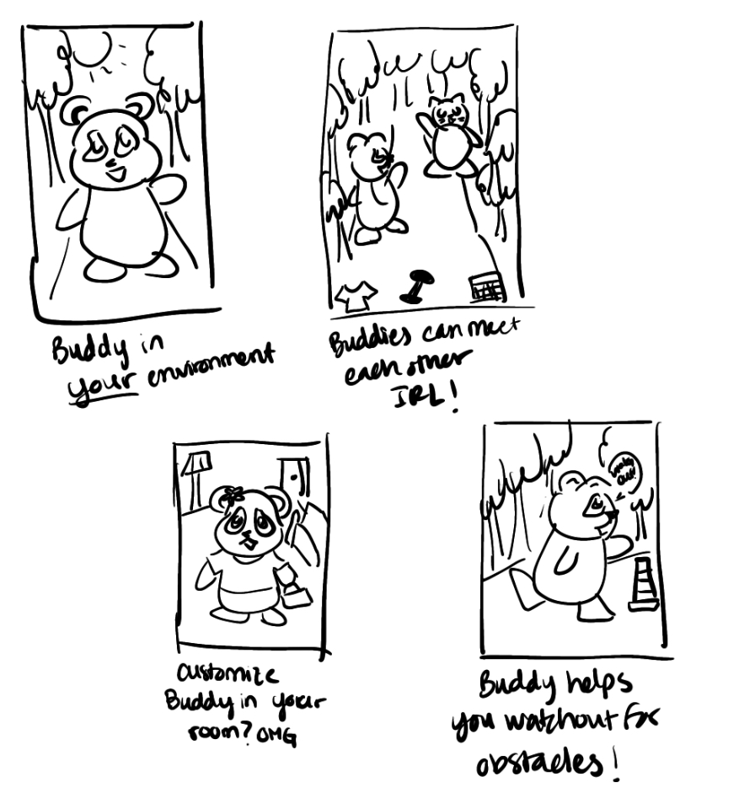
Revised Sketch:

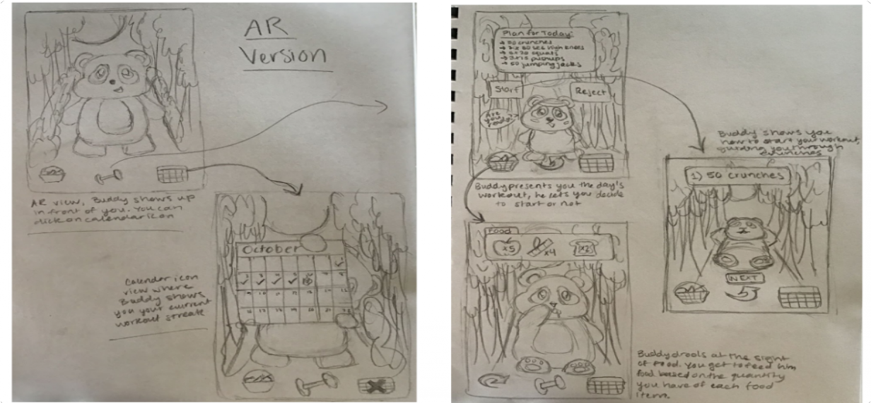

With AR, we felt as though the experience with Buddy would feel more realistic as it would appear in your environment. Furthermore, it would be more interactive, making it an experience more like one with a personal trainer. Additionally, if the user wanted, they would be able to change the location through the background to really help use the virtual aspect to create a new and more enjoyable ﬁtness experience for the user. However, with this format, it may be diﬃcult to use outside when not working out in your room. Additionally it may lead users to get too absorbed in their phones and ignore the real world, similar to the eﬀect that Pokemon Go has. We also thought that since the format is more novel and people aren't as familiar with it, it may have more of a learning curve and that could act as an additional roadblock to working out.

Mobile Version
Initial Sketch:

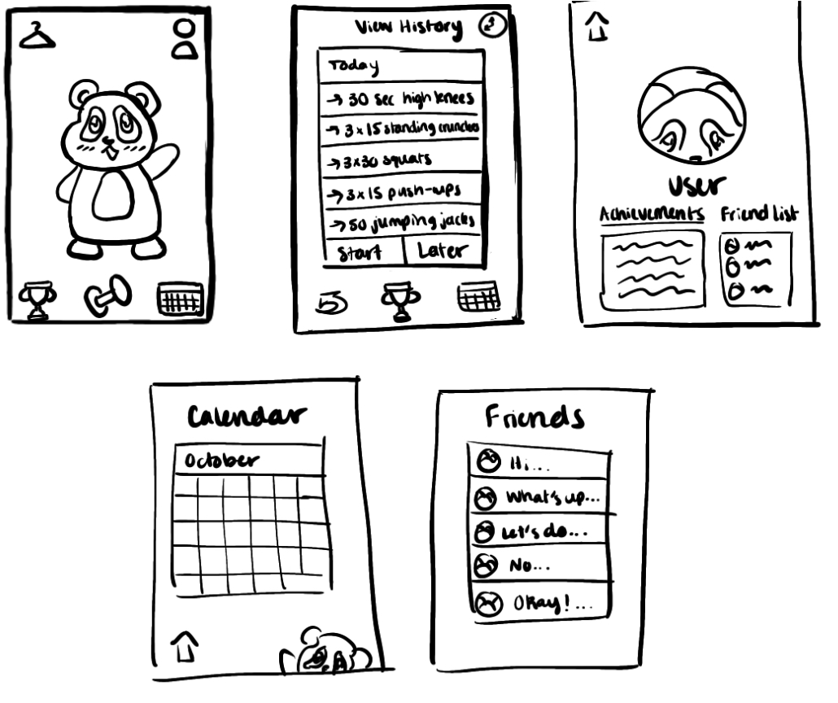
Revised Sketch:
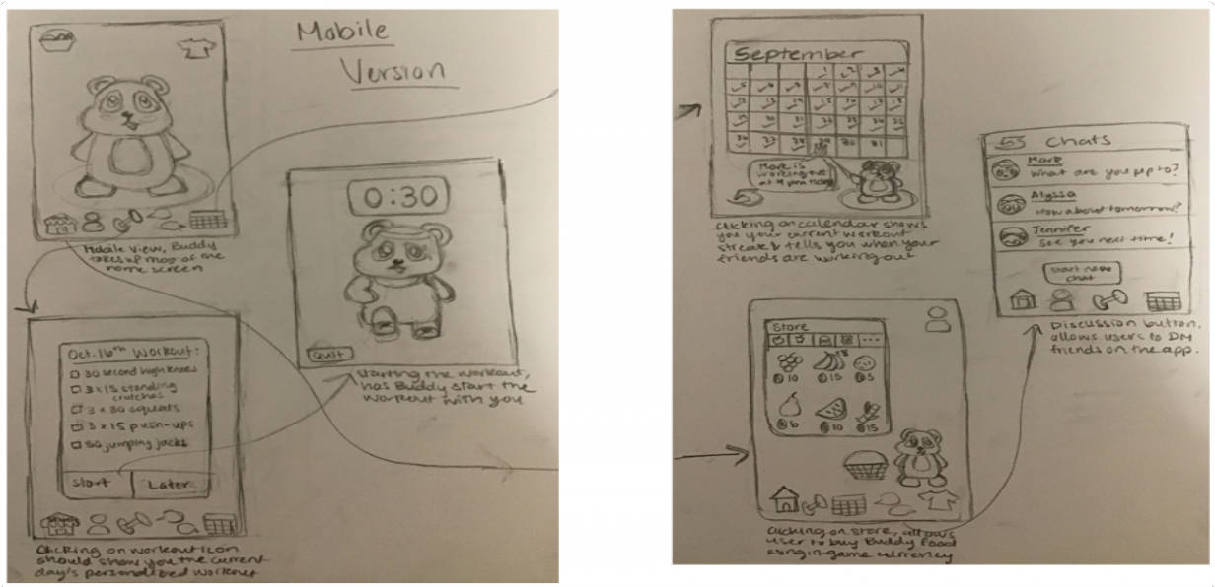

Our other top choice was a mobile app, which had a variety of pros. For one, it is very accessible as most people nowadays have smartphones. As a result, it is also convenient to use at any point in the day.
Furthermore, since apps are not as novel of a concept as AR, people would be more willing to try out a new app. Finally, a mobile app would allow us to combine many features, including visual, audio, chat, etc. However,

it is possible that it might feel less immersive and interactive. Additionally, it can be problematic as phones have a lot notiﬁcations and other apps, which might be distracting for users.
In the end, we chose a mobile app since our goal is to reach as many people as possible and ease their blocks to beginning ﬁtness and using a familiar method is better than trying a novel strategy. The beneﬁts of AR were not suﬃcient to justify using it.

Low-Fidelity Prototype
For our low-ﬁ prototype, we implemented the task ﬂows for each of our three tasks, one of which was slightly diﬀerent than our ﬁnal three tasks.

Simple Task
Create a workout plan in an environment accessible to me and schedule that works for me
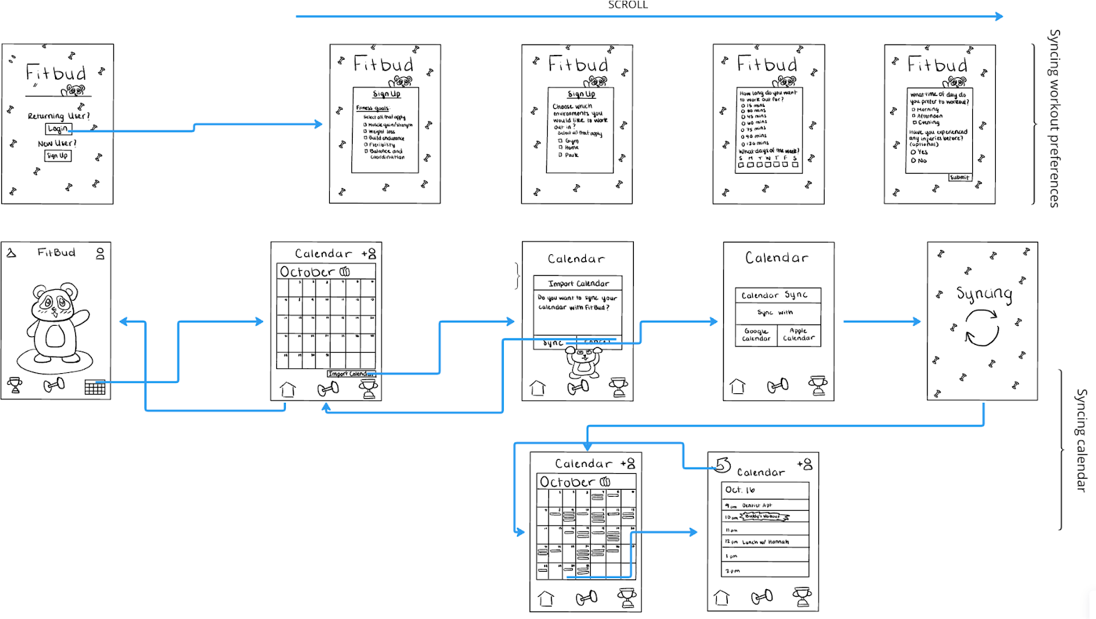

Moderate Task
Have an accountability and reward system based on my commitment to ﬁtness

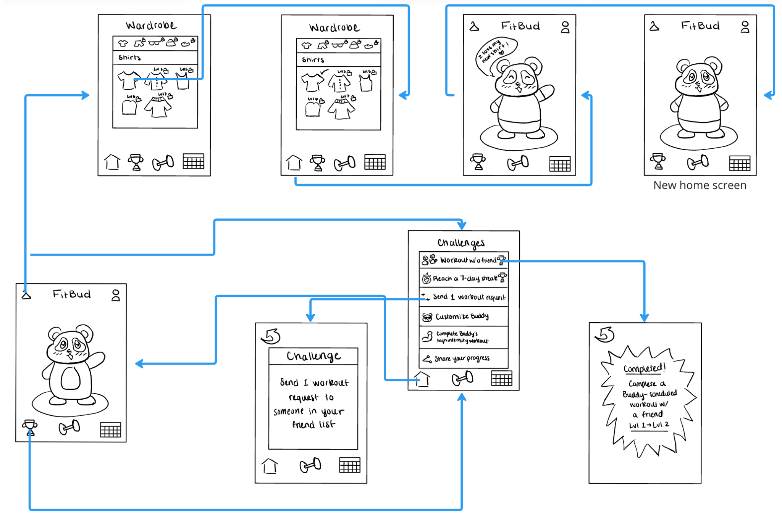

Complex Task
Connect with friends who are also exercising
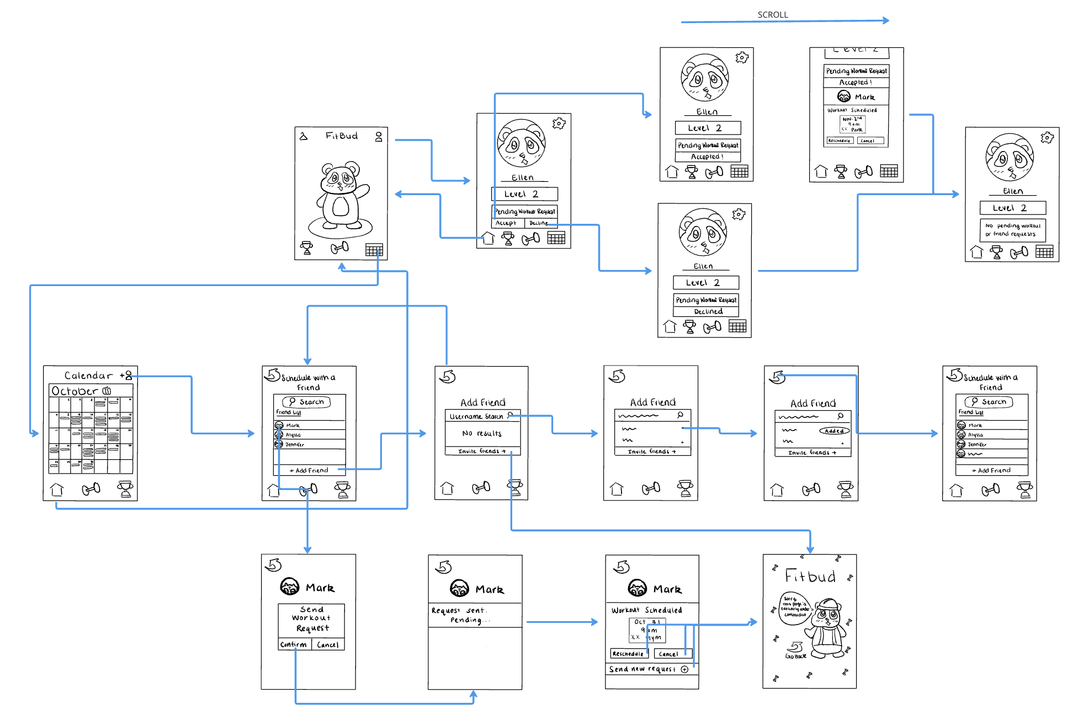
To view the whole prototype and zoom in on details, please go to this link.

Usability Testing

Methodology and Participants

For the usability testing, we interviewed ﬁve individuals, 4 individuals in their 20s and 1 individual in their 30s. We recruited participants by approaching individuals on University Avenue or at Tressider for the most part. We wanted to get a wide range of testers with diﬀerent ﬁtness levels, with a slight emphasis on less active individuals, to see their familiarity and understanding of our app, as well as their reactions to the concept.
Every individual was tested in person and we followed a script to ensure consistency amongst tests. We asked participants to share their thought processes as they went through our task ﬂows.

Usability Goals
We went into our usability tests with two primary usability goals: eﬃcient and fun. Eﬃciency was added with the intent that tasks should take little time to complete and the UI should be fairly simple to navigate. Our key measurement for this goal was that the average time taken to complete tasks should be under 2 minutes. As for our goal of fun, we wanted to ensure that the user enjoys working out with the app more than without and the added concept of Buddy is motivating and rewarding. For the key measurement for this goal, we wanted users to express joy at least once when interacting with their buddy (i.e. smile, laughter, or comment that shows their enjoyment).

Process Data
Through our testing, we found there were some major issues with our current design. Every participant had trouble ﬁnding workout history because the view history button didn’t look like a button even when found.
People also confused workout history in “workouts” with the calendar. Finally, every participant also struggled distinguishing “add friends” and “invite friends” features. Three participants found it diﬃcult to distinguish between completed and incomplete challenges and weren’t sure how to ﬁnish a speciﬁc exercise in the workout (with no timer). Two participants pointed out workout requests contained no information and were confused as to what they were accepting in a workout request. Overall, we found that these were some important changes that we needed to implement and realized that features that seemed intuitive to us were not as intuitive to new users.

Bottom-Line Data
We found that the simple task achieved usability goals quite well. Testers were able to set up proﬁles and import their calendar fairly easily; users generally completed these tasks in under 1.5 minutes. There were more diﬃculties with the moderate task. We found that challenges were not very motivating and were more passive. Few expressions of joy were made during these portions. We realized that interacting with Buddy should be more prominent, as users made the most expressions of joy while doing so. As for the complex task, we achieved our goals (they were generally completed in under 2 minutes), but there were separate issues. Users couldn't see from whom the workout request was received and were unable to view other proﬁles.

Major Changes from Low-Fi to Medium-Fi

Workout Request
We received feedback from testers that users wanted more information from workout requests, such as who the request is coming from, when the workout is for, etc. As a result, we changed the medium-ﬁ prototype to include the name of the requestor in the workout request. We made this speciﬁc change because we realize it is important to know who the sender of the request is, but we chose not to add the time or date of the workout as

the main point of Fitbud is to abstract away and automatically schedule without putting the burden of ﬁguring out whether it is an appropriate time or not. This was done to further our usability goal of eﬃciency as it provide additional information to allow the user to quickly decide whether they want to accept or decline the request.
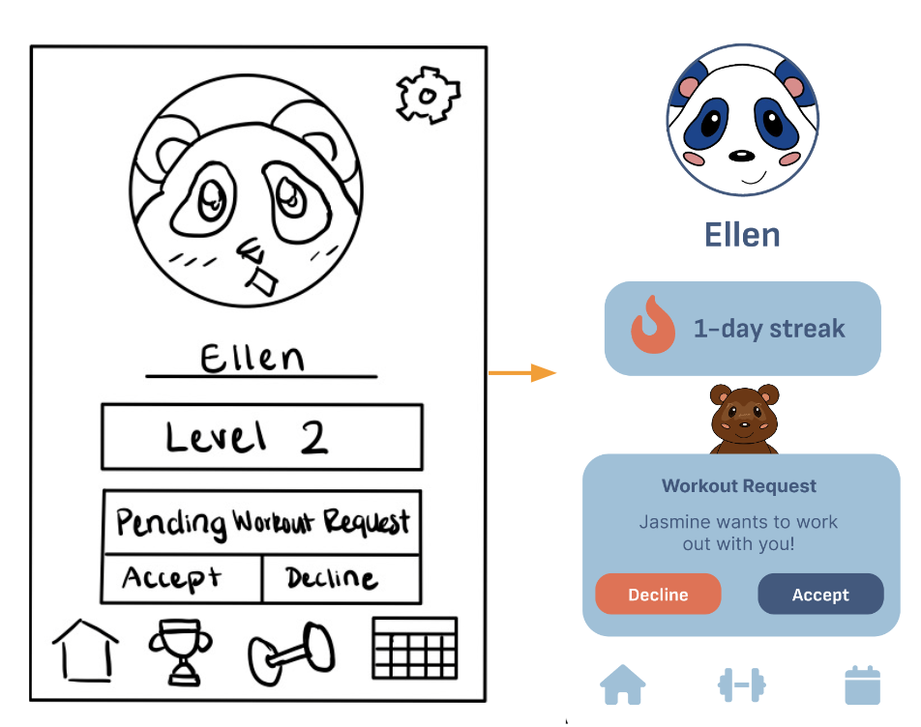

Calendar/Schedule
Through testing, we saw that users found a duplicate of a standard calendar app within Fitbud redundant. As a result, the calendar was removed and was replaced by a workout scheduler with upcoming workouts, workout history, and group workout scheduling. We found that we agreed with the testers and Implementing a duplicate mobile OS calendar would be an unnecessary hassle as there are no need to see non-ﬁtness related events in a ﬁtness app. This was done to further the usability goal of eﬃciency: streamlining and simplifying the app allows the user to stay focused on ﬁtness without cluttering the interface.

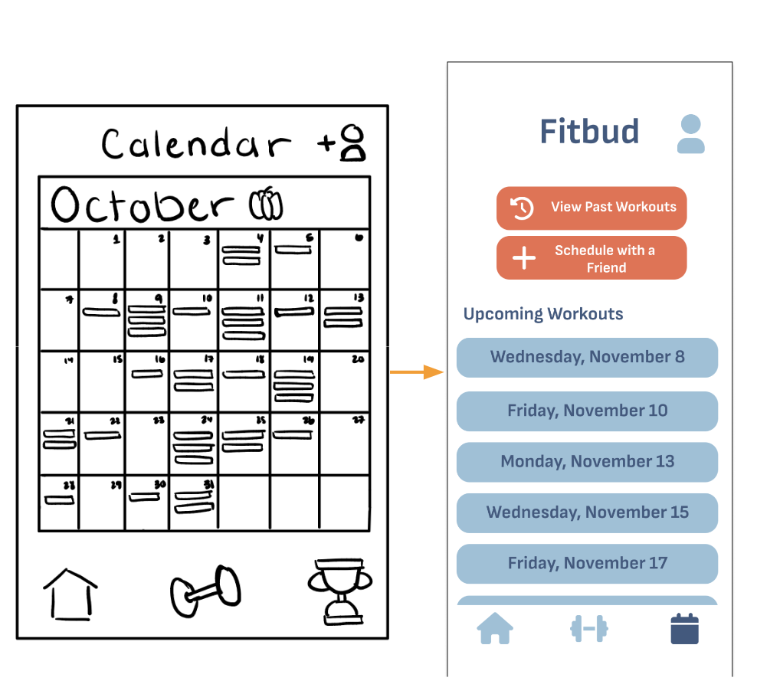

Navigation Bar
Testers did not like how the navigation bar changed depending on which page the user was viewing and sometimes completely disappeared. Additionally, testers did not understand the purpose of challenges. As a result, we made it so the navigation bar is always present and contains the same three buttons — home, workout, and schedule — with a darker shade of blue to indicate the currently selected page. We removed the challenges icon on the navigation bar and completely removed the page. Once again, we agreed with testers and found that maintaining a consistent navigation bar is standard practice — having it change and disappear led to confusion and ineﬃciency. Additionally, the challenges were unnecessary and felt out of place with the rest of the app; it was not incredibly relevant on the task ﬂow. Overall, we worked once again to advance the usability goal of eﬃciency as these changes made navigating the app more intuitive and seamless.

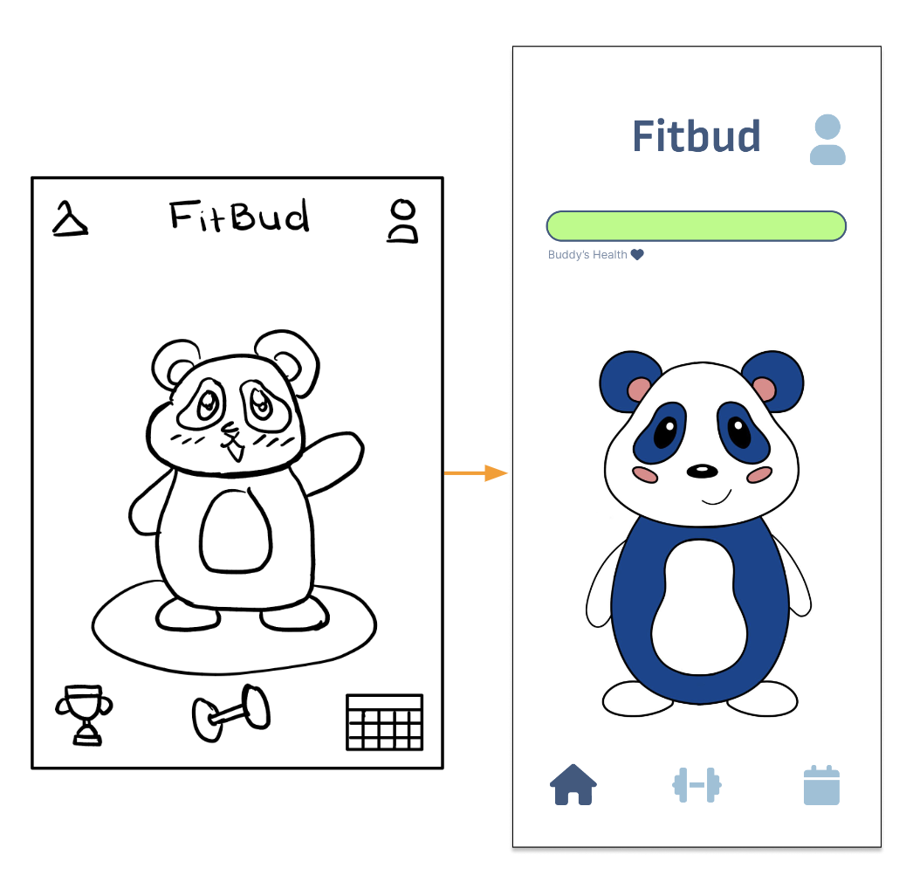

Editing Workouts
Through our testing, we found that users want the ability to edit workouts. We created an edit button on “today’s workout” screen, allowing users to enter “editor mode”. This was done since workouts are auto-generated according to the user’s preferences, but the user may want to switch it up due to preference, injury, or other reasons. Overall, this furthers our usability goal of fun since it allows the user some freedom to choose the exercises they want to do will make workouts more enjoyable.

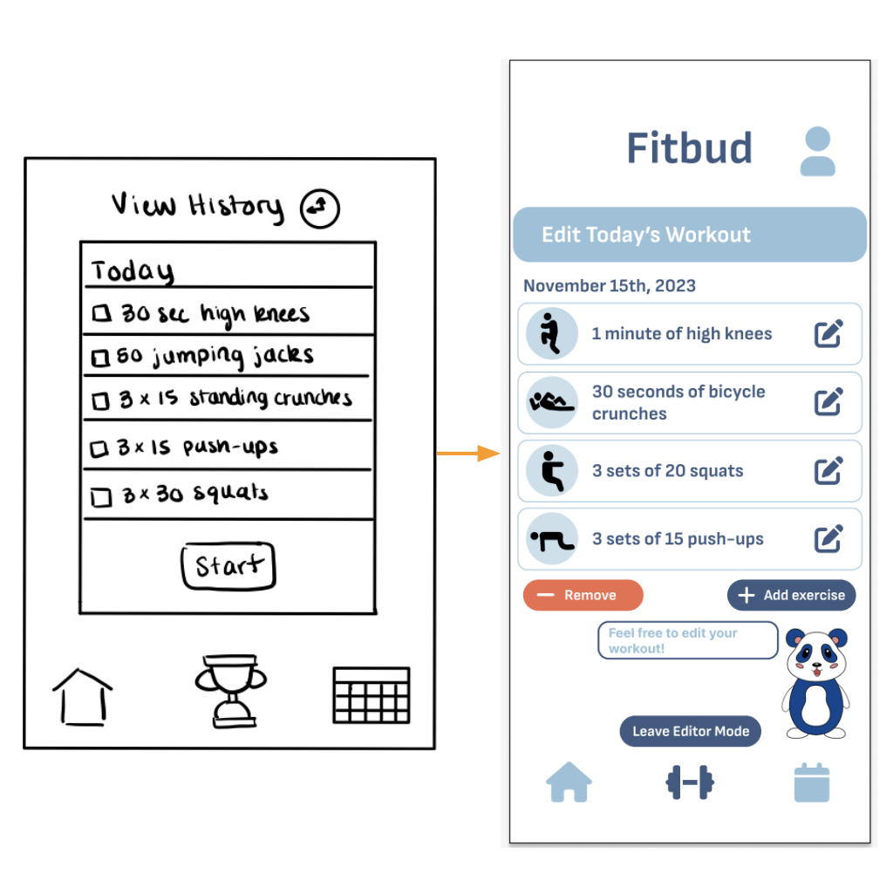

Skip Exercise Removed
Users found skipping and resuming workouts to be awkward and confusing. As a ﬁx, we completely removed the skip button. This is because the act of skipping an exercise part-way through and resuming later undermines the eﬀectiveness of a workout. It also makes it diﬃcult for the user to keep track of which exercises have been completed. Additionally, the change to allow for editing described above ensures the functionality is still intact. Overall, once again, we furthered the goal of eﬃciency as the user must readily know which exercises have been completed at all times, allowing them to ﬁnish a workout in a straightforward manner.

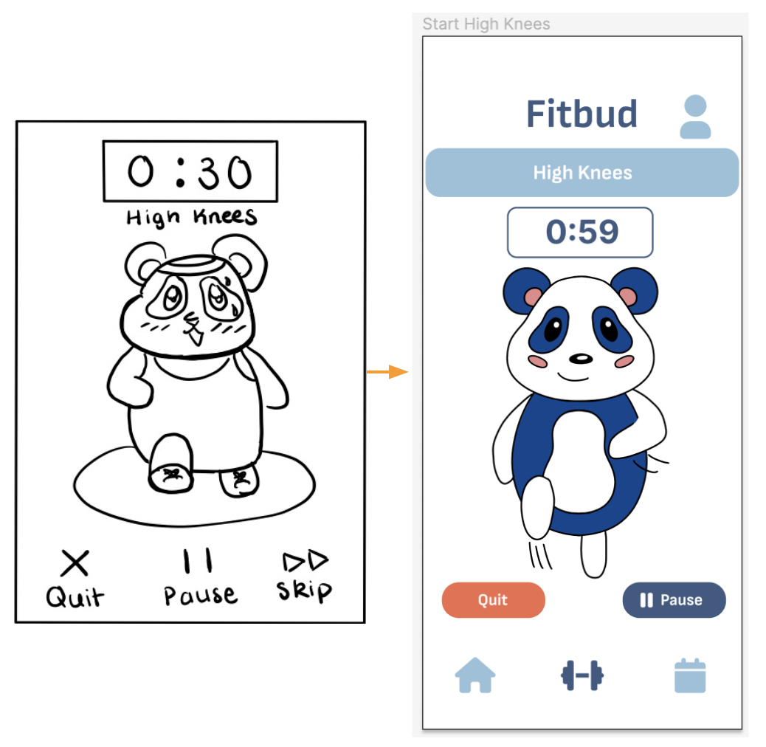

Medium-Fidelity Prototype

Simple Task
Create a workout plan in an environment accessible to me and schedule that works for me
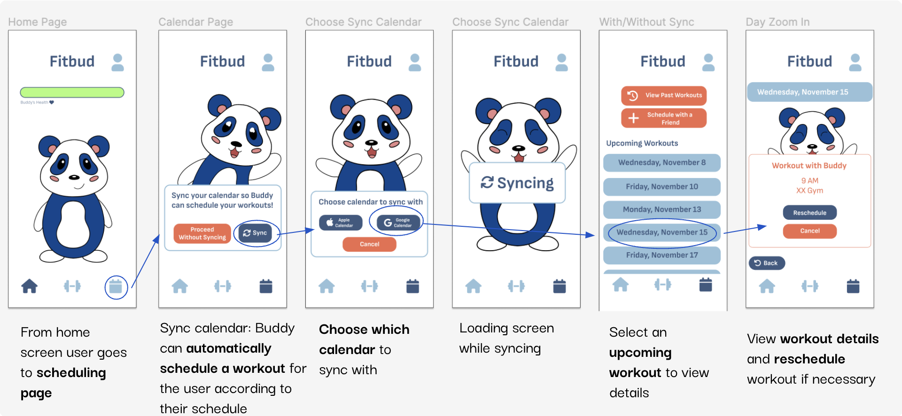
Workout Scheduling; if the user doesn't sync the calendar, workouts are scheduled according to their

Moderate Task
Have an accountability system based on my commitment to ﬁtness
**This task was edited and the reward system was removed as feedback was provided that it wasn't very eﬀective as it was and the task could be achieved without it.

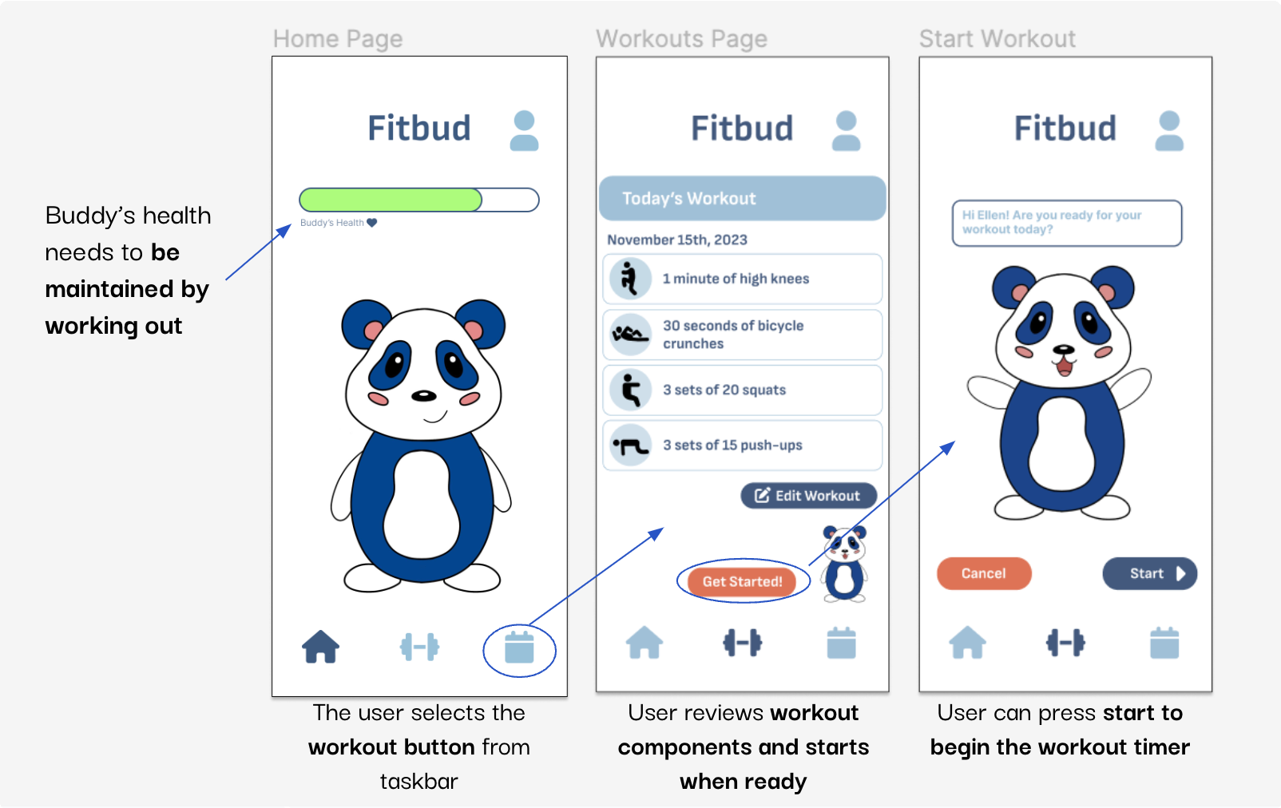
Buddy’s Health Motivates User
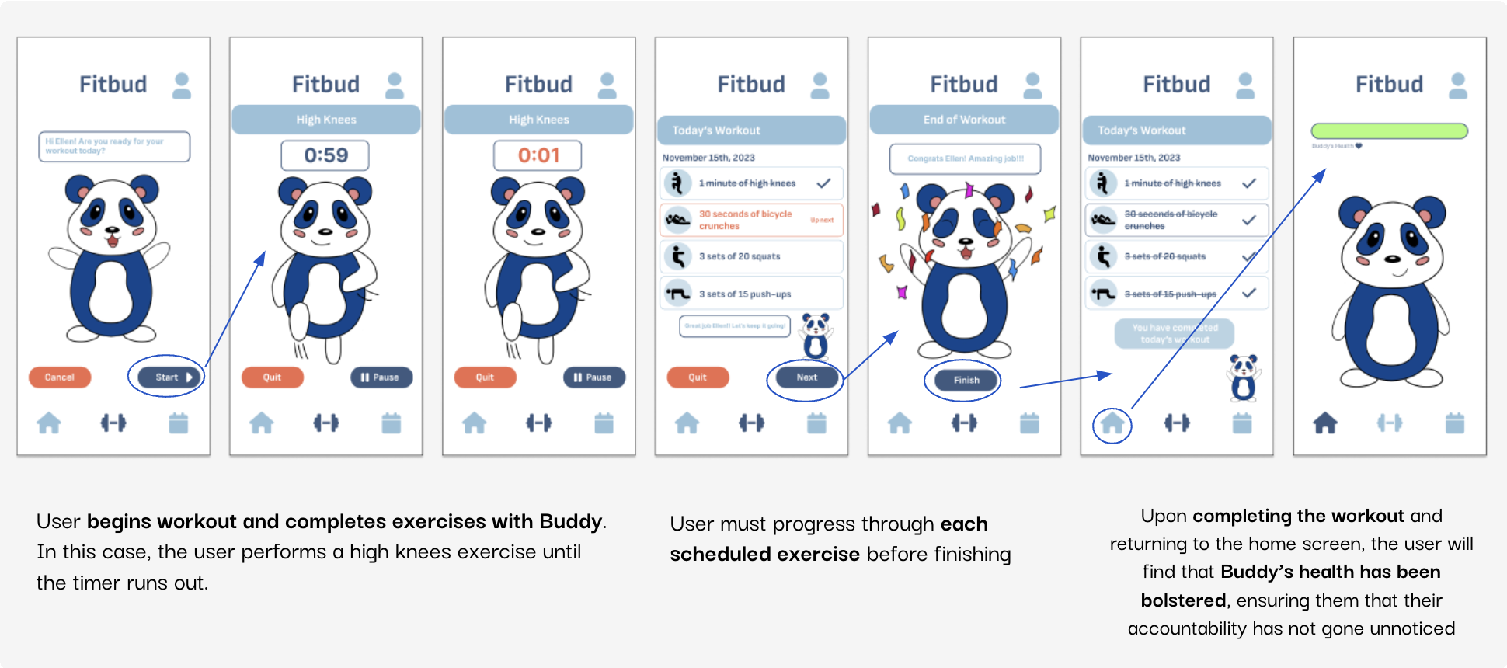

Complex Task
User Maintains Buddy’s Health by Completing a Workout

Connect with friends who are also exercising

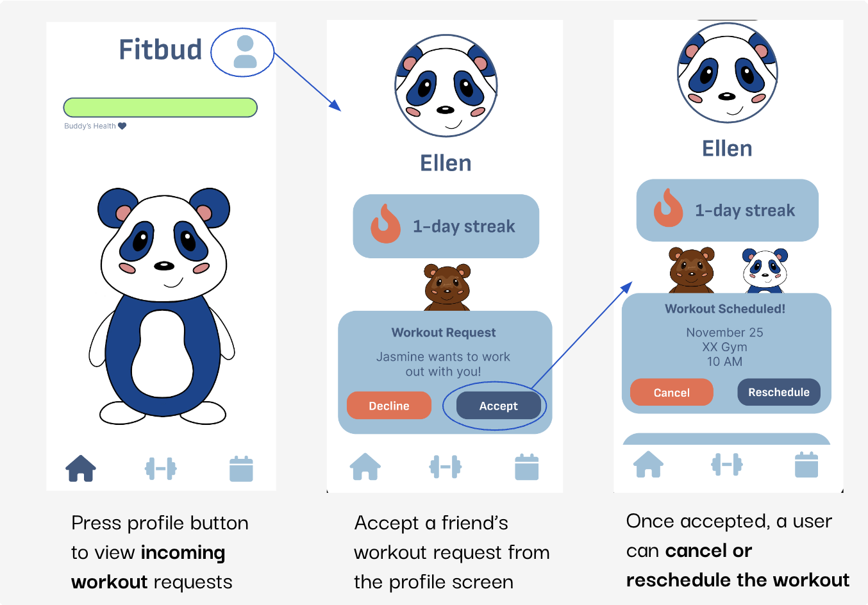
Accept Workout Request
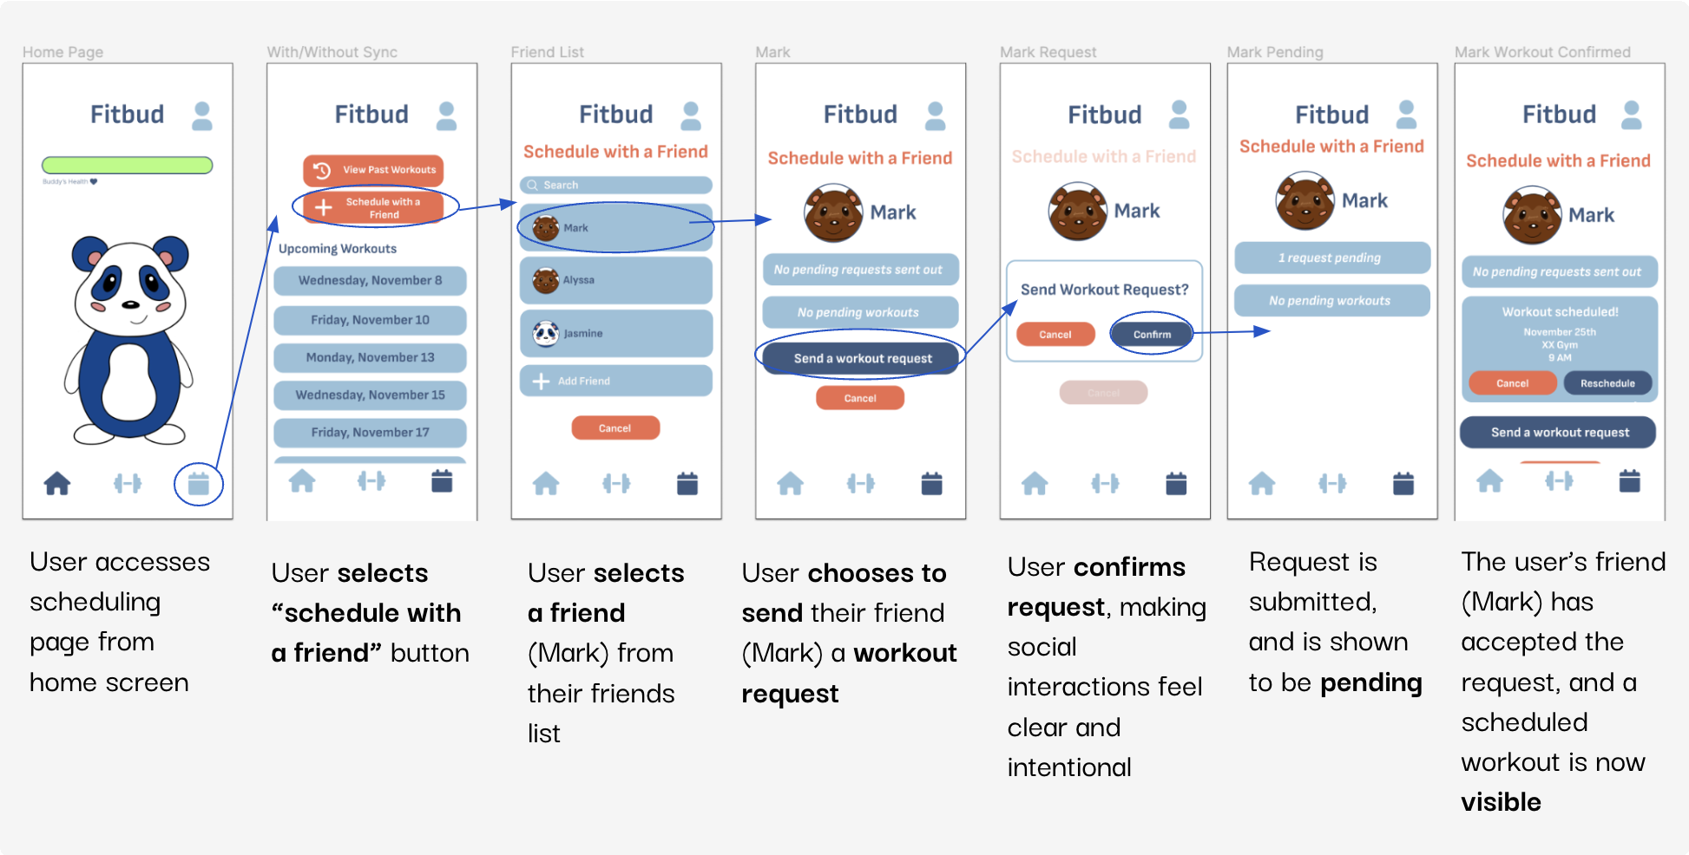
Send Workout Request

Major Changes from Medium-Fi to High-Fi (Heuristic Eval)
Based on the feedback our classmates gave us during our heuristic evaluation, we were able to better our prototype and design to prepare for the last step of this process. We had 41 heuristic violations, where the speciﬁc breakdown was as follows:
Count
Severity Level

1 | 15
2 | 21
3 | 9
4 | 2
Here, we will discuss the severity 3 and 4 violations in more detail and how we addressed each one.

Severity 3 Violations
H1: Visibility of System Status
Description: Uncertainty of where to move on from the home screen - especially from onboarding. Home screen is largely dominated by Buddy, who does not mention anything related to ﬁtness upon being pressed.
Fix: Adding a prompt to the homescreen by Buddy showing you what your ﬁrst steps (welcoming you and looking at your workout plan) should be.
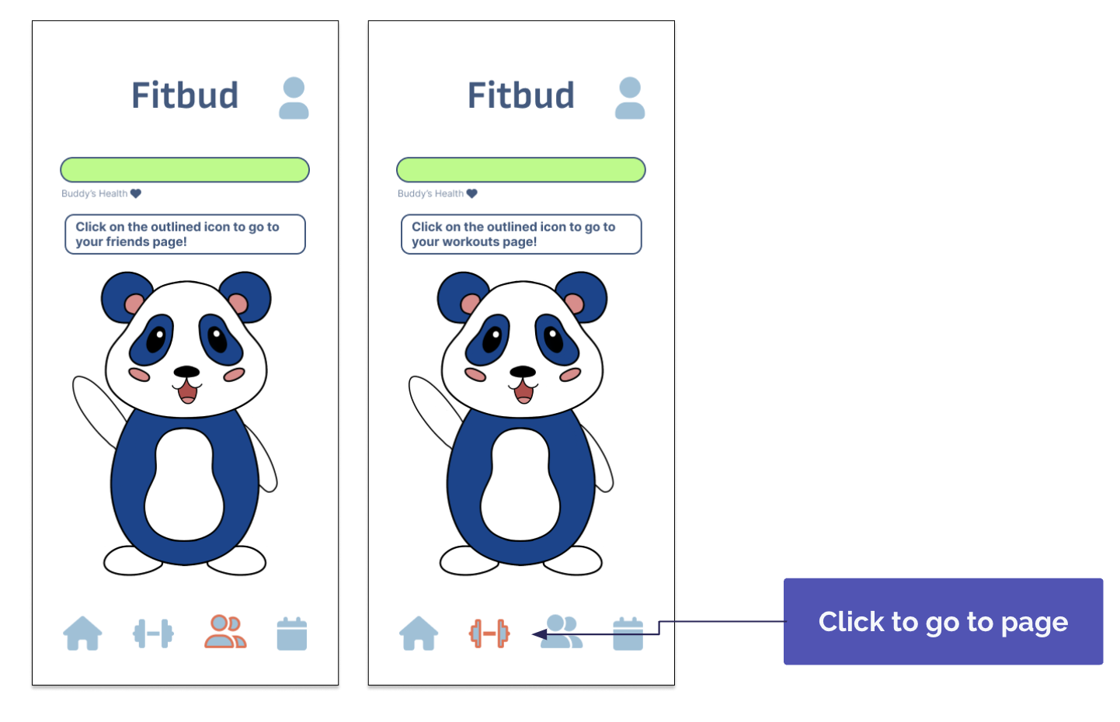

H1: Visibility of System Status
Description: No clear feedback on how my calendar has synced/how my workout calendar has changed after I have synced it- are these tasks aligned with my calendar?
Fix: Adding in a “calendar synced!” notiﬁcation.

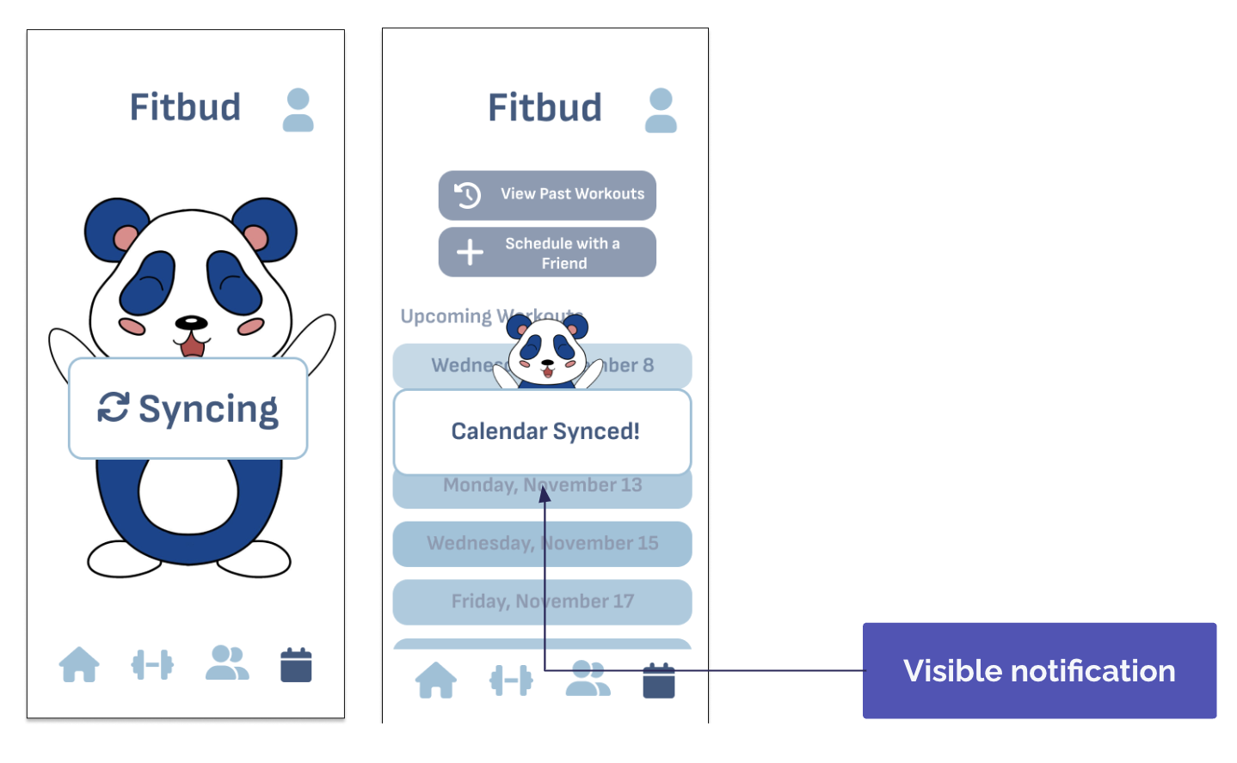

H6: Recognition Not Recall
Description: No correlated notiﬁcation when a user is sent a workout request in their proﬁle page.
Fix: Add a notiﬁcation ping on the friends icon on the navbar (new), so users will be alerted to a new request without needing to remember to check their proﬁle.
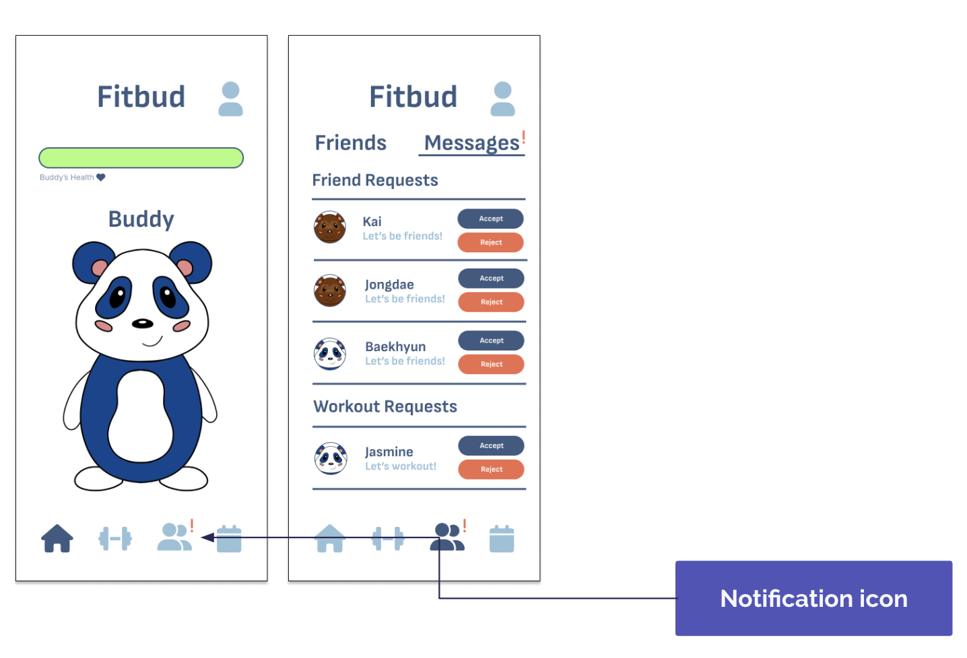

H3: User Control & Freedom
Description: User does not have the ability to undo calendar syncs/remove user data.
Fix: Add a button in the settings page that allows users to remove their calendar/any other form of user data from the application.
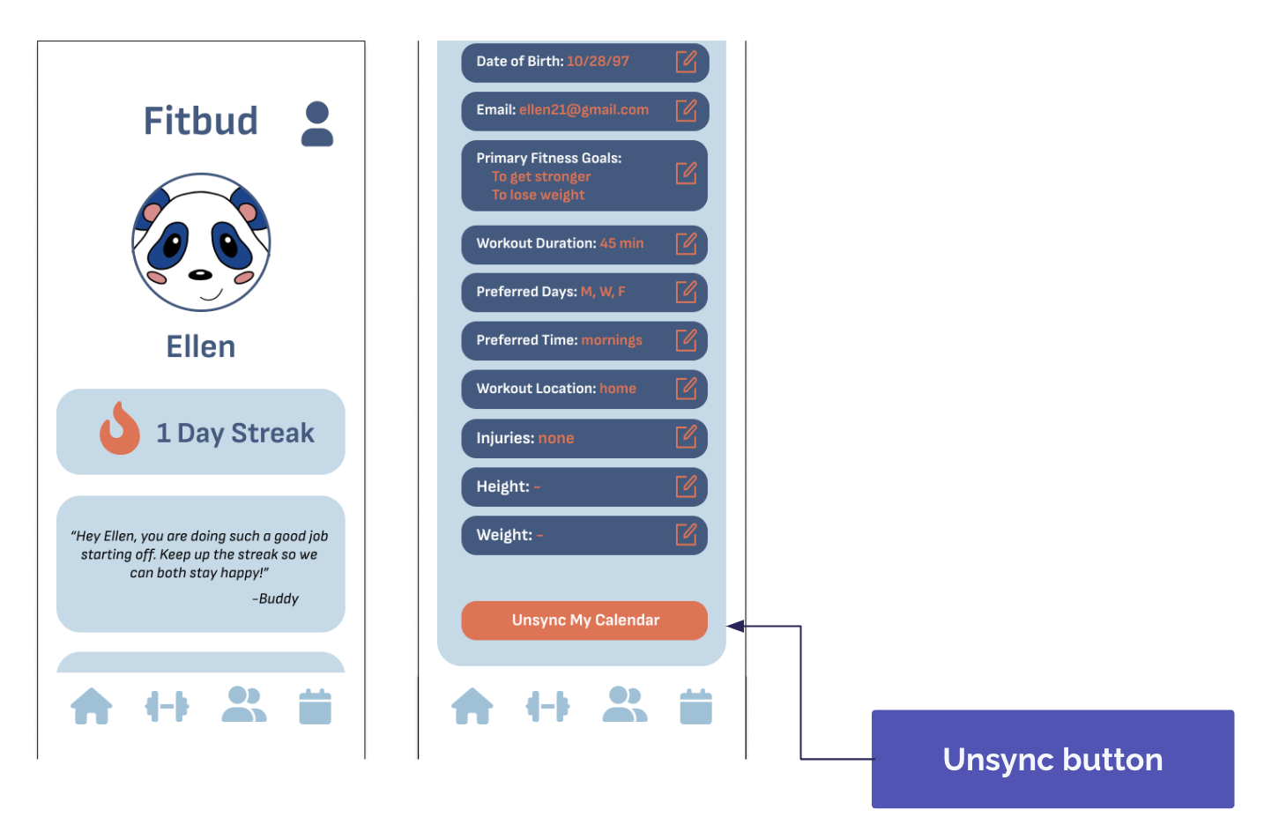

H11: Accessible Design
Description: Key buttons like “Get Started” on the workout screen are the same size and hierarchy as “Edit Workout” and do not stand out.
Fix: Enlarge the “Get Started!” button and make that a primary read of the screen.

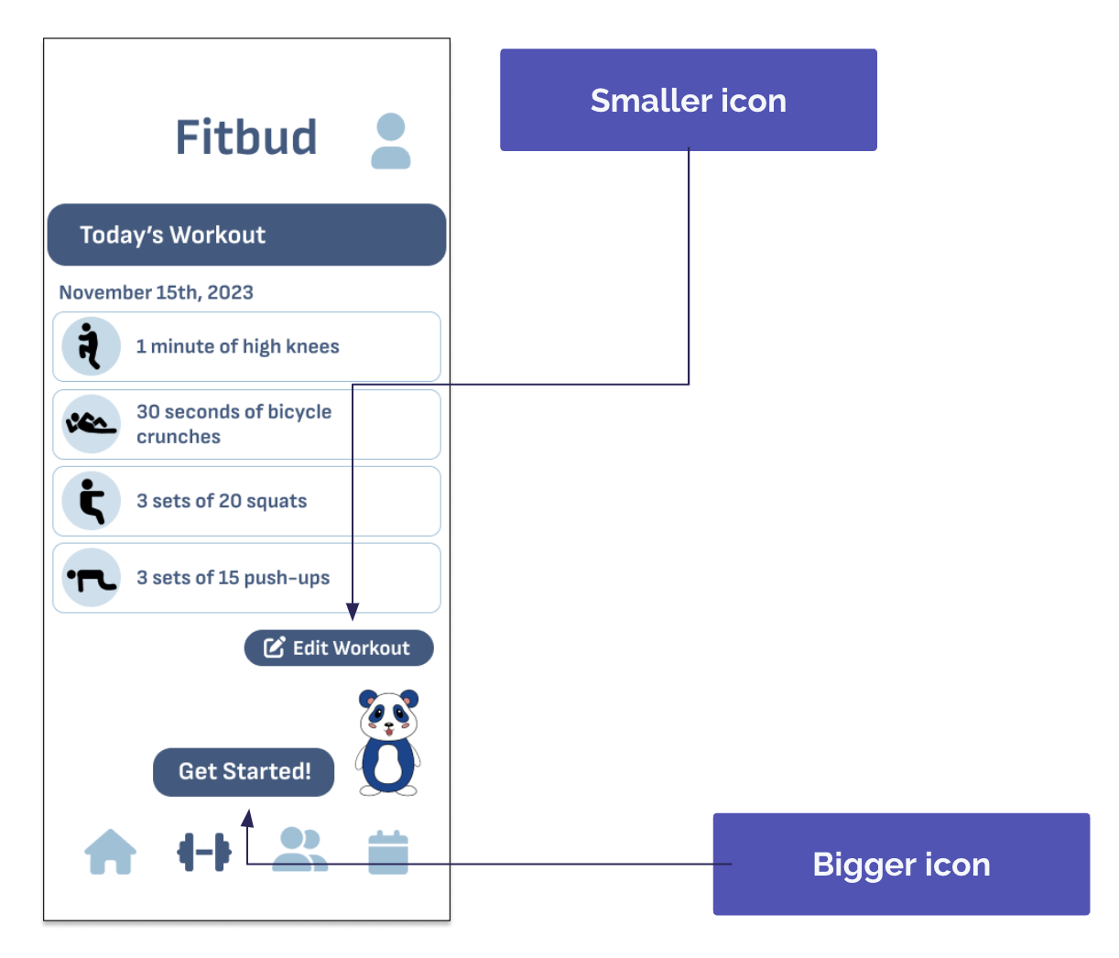

H12: Value Alignment & Inclusion
Description: Fitness goals in onboarding are oriented towards ﬁtness lingo- ex: “build endurance” or “ﬂexibility” versus “balance and coordination”.
Fix: Reword or expand on ﬁtness goals that may align with goals non-ﬁtness oriented users may want- ex: “I want to get stronger/gain muscle”

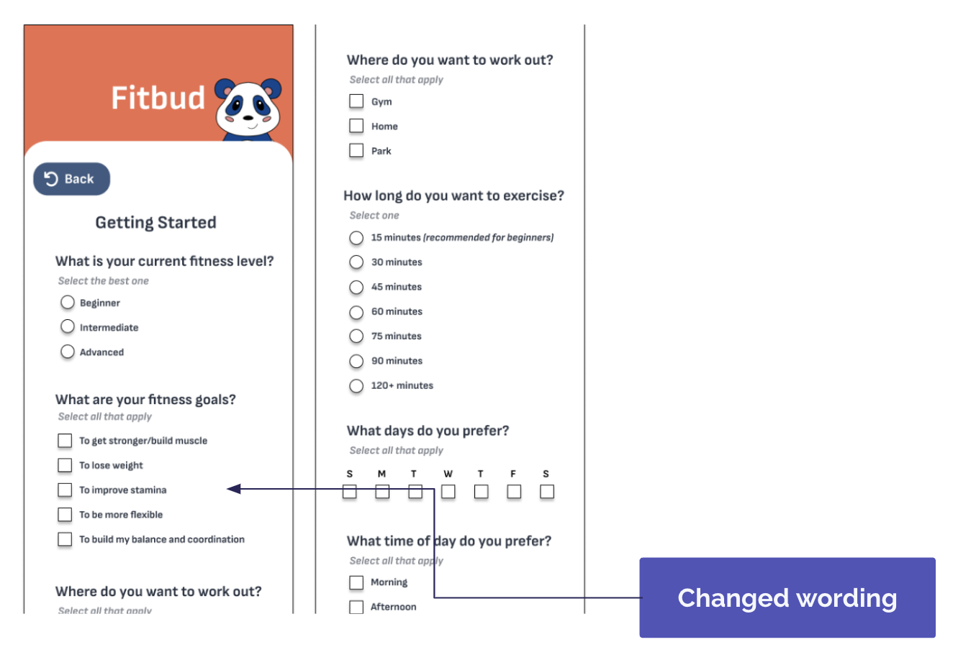

H12: Value Alignment & Inclusion
Description: No measure of user’s ﬁtness level or satisfaction level taken in intro survey or before/after workouts
Partial Fix: Within the intro questionnaire, respectfully ask question(s) about the user's current ﬁtness level and capabilities. The ability to edit workouts allows the users to adjust the exercise according to their desires.
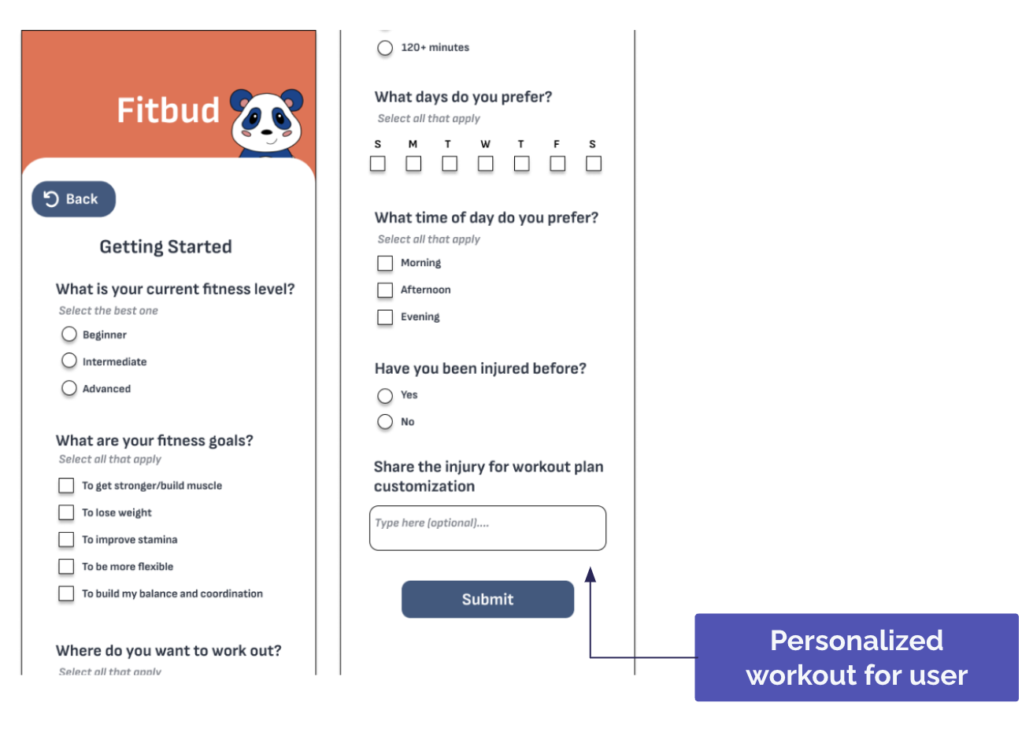

H11: Aesthetic and Minimalist Design
Description: Visuals for workouts are small and can be unclear as to what they are envisioning.
Fix: The visual is only an icon and is not meant to represent the workout. However, we slightly enlarged the icon and then added an information page on the exercise if you click on the icon that explains in more detail what the exercise entails.
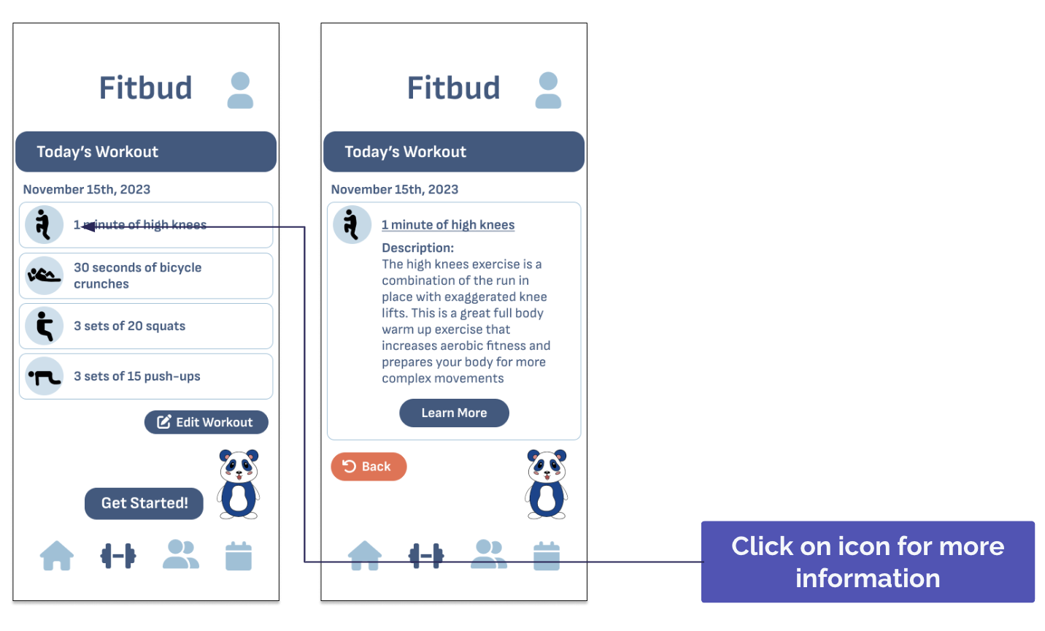

H8: Aesthetic and Minimalist Design
Description: Very cluttered interface in past workouts page; would beneﬁt from summarization.
Reason to not ﬁx: Suggestion was not speciﬁc enough and we have already simpliﬁed a lot of our user interface with previous edits. Simplifying more would take away understanding of the app.

Severity 4 Violations
H1: Visibility of System Status
Description: No clear indication for how to change the status of Buddy’s health mentioned on the homescreen, but not mentioned at the end of a workout or anything similar.
Fix: Add a tutorial to show how to use the app for users who sign up. This tutorial contains a message that outlines how to keep up Buddy’s health.

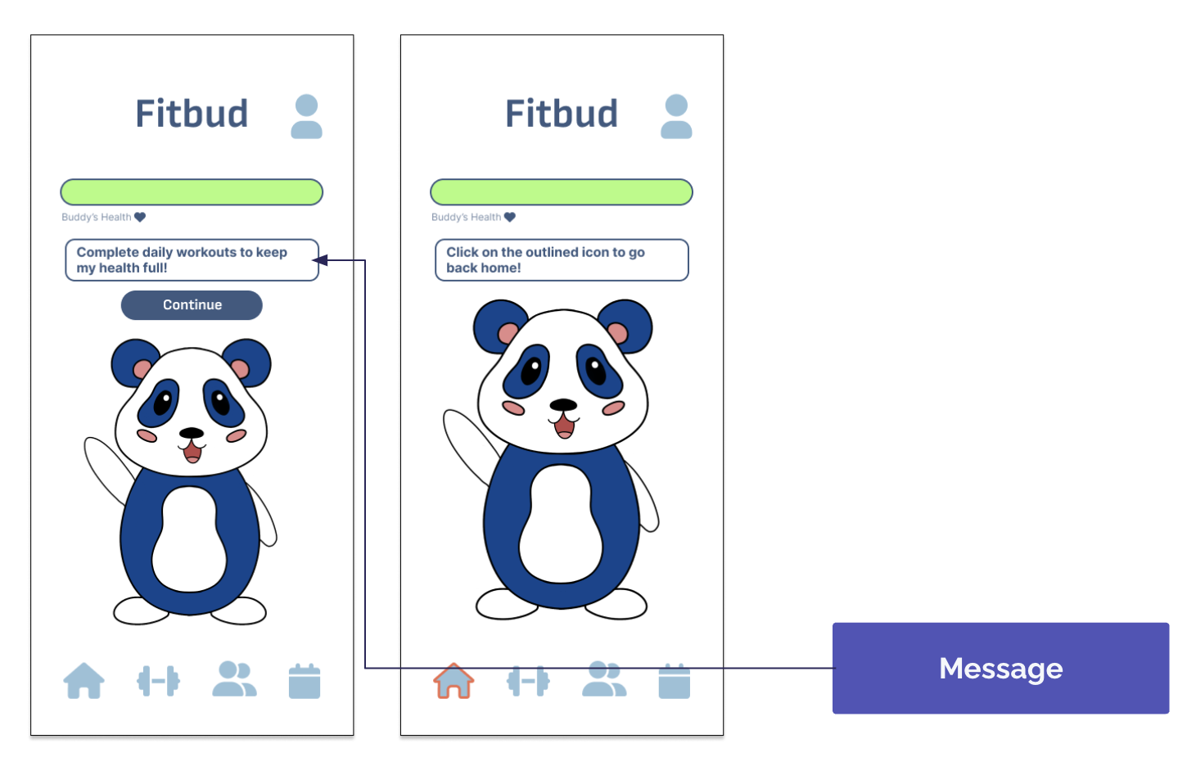

H12: Value Alignment and Inclusion
Description: Having workouts associated with Buddy’s health may not be inclusive.
Fix: While this idea is necessary to urge the user to care for the buddy and motivate them to workout, Buddy can be revived after this occurs and give the user a free pass to restart if this does happen.
**This was not an interface change, but rather a conceptual product change.

Summary of Major Design Changes for High-Fi
Overall, with the help of our heuristic evaluation, we were able to make the necessary changes to improve our design. Here are some of the biggest ﬁxes that we made.
- The addition of the friends page as a new icon on the navigation bar
A lot of our social tasks had been split over diﬀerent pages and diﬀerent buttons, making for an overall confusing experience for any user of the app. Moreover, there was no speciﬁc location to see when you get any notiﬁcations from friends for things like friend requests. With the friends page, we consolidated sending and receiving workout requests, viewing friends, adding friends and accepting/rejecting friend requests, and any other social tasks onto one screen.
- Tutorial
The evaluators struggled to completely understand how to complete certain functions or determine how exactly to boost Buddy's health and this was a recurring theme that occurred in the heuristic evaluation. As a result, our solution to collectively solve all of these problems was to add a tutorial that explains how our app works and how to keep Buddy alive right when the user signs up and uses the app for the ﬁrst time.
- Fixing alignment and color consistency
One of our bigger design problems came from some a general lack of alignment and consistency in colors (i.e. for buttons, grids, etc.) As a result, we really focused on alignment as we progressed from the medium- ﬁ prototype and made changes.
- Improved general visibility

Due to our color scheme and some choices that we made in that regard, some text and background colors had low contrast, making it diﬃcult to read. One of our changes was improving readability by both making text bigger, adding more spacing, and also ensuring there was enough contrast between text colors and background colors.

7: Values in Design
While completing each step in the design process for Fitbud, we wanted to keep several values in mind to ensure that they were present at every stage and were really built into the core of our app. This way, both users and any stakeholders are able to clearly and easily understand the purpose and intentions of our app. These ﬁve values are inclusivity, ﬂexibility, safety, privacy, and inspiration, which are described in further detail below.

Inclusivity
Our app aims to make it so this app can be used by any individual by making it an adaptable tool with ﬂexible features that make it so users can select the features that they want and get customizable workout tools that ﬁt their speciﬁc needs. One speciﬁc example of this is how the workouts are ﬂexible according to the locations that the user identiﬁes as being available to them (i.e. gym, home, or park). This information allows the algorithm to tailor workouts that ﬁt the environment and the equipment they have available in that environment, making it so that anyone is able to get workouts ﬁt for them.

Flexibility
By tailoring workouts to a user’s needs and schedule, they should feel ready to face their goals without intimidation or obstacles that could damage self-esteem. One key aspect of Fitbud is the way it syncs workout times according to the user's availability (imported with a calendar). This way, they get their workouts scheduled and planned without having to do any work. With features like this, it's important that we allow the user to change things if things come up or change. As a result, Fitbud allows everything that is provided, such as the timing or the actual workout routines, to be edited and changed according to their needs. By both removing the activation energy for users and still providing them ﬂexibility instead of rigidity, the app serves to truly act as a tool instead of something that can be interpreted as more of a strict coach.

Safety
Users should not feel prompted by workout gamiﬁcation to overwork themselves or attempt exercises that are beyond their experience level or exercises that may be unsafe given an injury. It's also important that the users execute the exercises correctly to minimize the risk of injuries. As such, the "buddy" in the app can only gain a certain amount of XP each day based on the one workout provided per day. This way, users will be prompted to use the app in a safe manner. In terms of actual physical protection, the app asks for a user's injuries and provides workouts that are suited to their body and ﬁnding the safest way for them to move their bodies.

Privacy
Users share personal info and schedule info so that Buddy can plan their workouts. They should trust that this information is not available to their friends or developers. In this day and age, we realize that digital calendars

contain a lot of information about an individual and a lot of it is information that we want to keep private. As a result, we want to assure the user that we will not be using their data for any purpose other than to plan workouts at a time that is best ﬁt for their busy schedule. We allow the users to unsync their calendars at any time that would like to. Additionally, with the implementation of a "friends" aspect to the app, we worked to limit this feature only to friends (which can only be added after mutual conﬁrmation, to prevent any undesired behavior. Even though the social aspect is limited to friends, it would be unethical to share a user’s information, thus friends cannot view each other’s calendars, just their scheduled workout time after both parties agree to wanting to schedule a workout session together.

Inspiration
In Fitbud, the companionship of a fun and cute virtual buddy provides support and motivation, which is one of the key features in motivating users to workout, regardless of whether or not they like working out with others. The goal is to keep Buddy healthy by exercising and feel rewarded by seeing their Buddy thrive. Furthermore, we want to protect their self-esteem and make sure Buddy's XP is motivating to them instead of acting as another roadblock to their building an exercise habit. As a result, we allow Buddy to be revived even after they lose all XP to keep the focus on rewarding and allowing the user to build a new ﬁtness habit instead of punishing them. Adding on to this point of only rewarding, Buddy will only oﬀer words of encouragement and motivation to prevent losses of self-worth. The goal of the app really is to emphasize how Buddy acts a motivator and a source of inspiration to help users form their new ﬁtness habits.

Tensions in Values

Inspiration vs. Safety and Inclusivity
We decided that Buddy would “die” if users do not maintain their workout goals. This is meant to be motivating and inspirational while also holding users accountable to their goals. However, failing at their goals and facing punishment could lead to self-worth issues for those starting out. This could damage mental health and make users feel unwelcome, presenting a safety and inclusivity concern. To address this tension, we added a feature striking the balance by having Buddy be reborn after death in an encouraging and inspiring manner.

Inclusivity and Flexibility vs. Privacy
In order to promote inclusivity, users will input workout preferences. In order to promote ﬂexibility, users will sync a calendar and allow Buddy to schedule their workouts. This collection of data could cause privacy concerns, as users may feel that their information is at risk by using our product. To address this tension, we made it so friends will not be able to view a user’s personal information or their calendar in order to prevent the leaking of personal information. They can only view the date/time of scheduled workouts with trusted friends.

8: High-Fi Prototype Implementation

Tools Used
For our high-ﬁdelity prototype, our primary tools were React Native, Expo, XCode Simulator, VSCode, and Figma.

React Native was our primary tool for this app and we found that it simpliﬁed a lot of the heavy lifting involved in developing this prototype as we were able to use a lot of the built-in features and components. However, we also had some diﬃculties with React Native as we struggled to work with states to pass variables from one screen to another. One particularly diﬃcult challenge that we weren't able to overcome was the use of the navigation bar component that made it so something was always selected on the navbar. Since we made the decision to create a user proﬁle icon that was on a diﬀerent location on the screen, we had to create a proﬁle page for each individual screen present in the navigation bar. With issues like these, it would've been better to build our own such components when we encountered problems, but for the sake of time and feasibility, we were unable to do so. VSCode was our IDE and we were able to use this to share the code between developers as we worked on diﬀerent components. XCode Simulator was incredibly helpful in allowing us to see how our screens looked on an iPhone 15 Pro Max (which is what our app was optimized for) and was easily accessible on our devices as we were developing. Expo is what we used to export the app and share the prototype. Finally, Figma was what we used to workshop any design changes and what we used as a framework for the development of our screens. It allowed us to make changes without too much commitment to ensure we were making the best possible choices for our app. However, we had to keep in mind that we had time constraints and had to limit the design choices we made in Figma since it could be diﬃcult to translate them all to the high-ﬁ prototype.

Hard-Coded Features
Our app is able to execute functionality for all three of our tasks, but does not have a completely functional backend due to our restrictions on time. As a result, the one friend that you are able to search for and add is Kyungsoo and he has been hard-coded. There is also one suggested friend that appears that has also been hard-coded, although in reality, this would be speciﬁc to the user. Furthermore, our database of workouts is limited and has been hard-coded. This prototype does not have the ability to generate workouts tailored to the user’s goals and preferences, as we do not have an algorithm to generate these workouts according to user input. As a result, the workout edits that can be made are also limited, as we have a limited database of exercises.

Wizard of Oz Features
Similarly to our hard-coded features, we employed the Wizard-of-Oz technique to simulate some features of the app for the purposes of demonstration. For one, regardless of whether a calendar is synced to the app or not, upcoming workouts and past workout history are magically generated and your calendar cannot actually be synced. The user additionally already has a workout history, even if they sign up for the app, to show how the features work. The user magically has some friends already. Finally, the user has messages, workout requests and friend requests, that magically appear when you log in to the app.

Limitations
There were some issues that we ran into while developing our prototype that we weren't able to resolve or address due to time and the limitations of our tools. First of all, as previously mentioned, whenever you press the proﬁle button, the icon of the page you were last on is still highlighted dark blue as though it is selected. Due to the navigation bar component that we used from React, we are unable to make it so nothing is highlighted (since the proﬁle button is at the top of the screen instead of within the navigation bar). If you travel away from the screen, and return without closing the proﬁle or viewing the original screen (for example, calendar), you

need to click the icon on the navigation bar again to restore the screen. This essentially means if you were on the calendar screen and open the proﬁle and then navigate to another screen like workout, when you return to calendar you will see the proﬁle. To ﬁx this, tap the calendar icon on the navigation bar for a second time to view the actual calendar screen.
We also cannot save edits to the proﬁle and workouts. The reason the workout edits are not saved is because we have hard-coded in the exercise ﬂow (for when the user is completing the workout) and edits to the workout would require us to change the timer and the exercises. The changes to the proﬁle are related to the onboarding and not any speciﬁc task, so they remain unchanged. Similarly, workouts cannot be cancelled at the moment (as in the button is not functional) because they would simply lead to the removal of the workout from the list and the implementation led to some issues that we were unable to resolve in time.
Workouts cannot be paused because the timer feature that we used in React does not allow for any such additional functionality. Resting time between workouts in high-ﬁ is not implemented to avoid user having to wait before doing the other exercises. This feature was counter-productive to demonstration purposes, but would be implemented in the real app.
Lastly, due to feasibility and time constraints, Buddy's animation for diﬀerent workouts could not be generated but in theory, there would be an image of Buddy doing the speciﬁc workout.

9: Reflection & Next Steps Design Thinking Process Listening to What Real People Want
One of our biggest learnings was going into the design process without any ideas or any expectations. As a group, it was very diﬃcult for us to continually not jump automatically to the solutions as we learned more about the problem. One of our ﬁrst ideas was matching workout buddies - something we came up with without listening to too much of the needﬁnding process. We very quickly realized that it wasn't such a good idea and felt a bit stumped about where to go and what direction we might ﬁnd our solution in. But we realized that the more we didn't just assume that we knew the perfect solution, the more we realized that just by following the needﬁnding process we can learn so much. As a result, many of our primary functions in our app came from things that we heard individuals share all the way from the needﬁnding stage. For example, we came up the idea to have a virtual workout buddy after hearing people's reservations — including safety concerns and personal preference — about having a system matching real gym-goers with each other. We added detailed descriptions for each of our recommended exercises because we learned from out needﬁnding interviews that people ﬁnd it diﬃcult to discern valuable ﬁtness knowledge from misinformation. We even added the ability to connect with friends to schedule group workouts in our app, as several of our needﬁnding interviewees claimed that they had trouble ﬁnding time to work out with friends.

Testing with Non-Developers and Non-Users
Our other learning about the design process was the importance of testing, especially with individuals who had no previous notions about your speciﬁc app and could give feedback with fresh eyes. Each time we completed a prototype, it felt as though we had created something that was good enough to be called the ﬁnal solution right then. This was especially true towards the beginning of the design process where we were just learning about how to prototype and design. But as we began testing, it became abundantly clear that we were nowhere near a perfect solution. We knew that iteration and testing were important, but we didn't realize to what extent. The more we tested, the more we began to realize that more user testing would reveal more problems. By the end of

the quarter, our attitudes as a team had changed towards how we perceived our prototype and we especially began to realize the value of showing our app to new potential users to gain the most valuable feedback.
For example, some main takeaways after extensive testing of our low-ﬁ prototype include our navigation bar (which we modiﬁed to always remain static instead of dynamically changing what icons were available depending on the current screen), removal of our challenges feature (which people found unnecessary), and reorganization of our app to make our task ﬂows easier to complete. Then, according to feedback from our heuristic evaluations, we added a substantial tutorial section upon registration, added a notiﬁcation ping on our friends icon to make workout and friend requests more visible, and standardized margins and button sizes.
Clearly, without the feedback from testing, we never would have gotten our app to where it is today and if this has taught us anything, it's that we have so much room to grow - we just need to test more to ﬁgure out exactly how!

Unintentional Good
In the process of developing Fitbud, we learned a lot about reconciling goals of positive change and laziness. In general, people know what's good for them and may even set goals accordingly, looking to change their habits and lifestyle. Nevertheless, the hassle of incorporating substantial change into one's hectic life often results in a lack of signiﬁcant progress and an inability to remain true to one's commitment. We saw in our needﬁnding interviews how various stressors make committing to an active lifestyle more diﬃcult than it ought to be. Our original ideas interpreted this lack of commitment as insuﬃcient motivation, and we thus thought to create an app centered around ﬁnding people to work out with, as we ﬁgured workout buddies would motivate and push each other towards the achievement of their goals. We soon realized that we were misguided: most people suﬀered not from a lack of motivation, but from an inability to overcome the activation energy hump to take steps towards their goals — the key limiting factor for people was not "I don't want to," but rather "I can't," whether it be due to lack of time, knowledge, or conﬁdence. We then landed on the idea of Fitbud, not only providing a source of motivation in Buddy and his health bar, but addressing several of the main issues preventing people from working out — we overcome people's lack of time or unwillingness to ﬁnd time by automatically scheduling (both individual and group) workouts given an imported calendar, we create personalized workouts and exercise descriptions to help people who lack the knowledge to plan their own workouts, and so on.

Future Work
There are several directions we would like to take with Fitbud in the future. First, a functional backend would allow us to store the preferences ﬁlled out by the user and remember actual workout and friend data. Then we would create an algorithm to generate real workouts tailored to the user's goals and experience level, as we are currently just using hard-coded workouts. We would like to add animations to Buddy, demonstrating how to do a speciﬁc exercise and perhaps expressing emotion according to his health bar. We didn't account for what would happen in the case of a depleted health bar, so we ought to come up with a way for him to be reborn.
Farther down the line, we would like to return to our original idea of a level system — maintaining Buddy's health could additionally allow the user to gain experience points, which would unlock access to unique items to help keep Buddy happier than ever (for example, returning to the original wardrobe idea). This would foster a healthy competitive spirit among the user and their friends, since their Buddies and levels would be visible to each other. An idea we received at the project expo was to integrate our app with gyms and ﬁtness clubs, perhaps further incentivizing one to work out — for example, having a higher level Buddy could enable access to certain gym perks or even discounts. There are a myriad of ways in which we could further gamify the app and enhance the user experience, and we hope to continue designing and iterating in the future.

