kin.
Weave your family story one thread at a time.

Sketching Report
CS147 Fall 2023
Jack Clark, Shuvi Jha, Jasmine Narine, Steven Pu
October 27, 2023

Table of Contents
Concept Sketches 3
Two Further Fleshed Out Realizations 8
Low-fidelity Prototype
Main Pieces of Functionality 10
Task Flows with Transitions & Interactions Labeled 11
Birds-eye View Image of the Entire System 16
None-core Task Flows 16

Concept Sketches

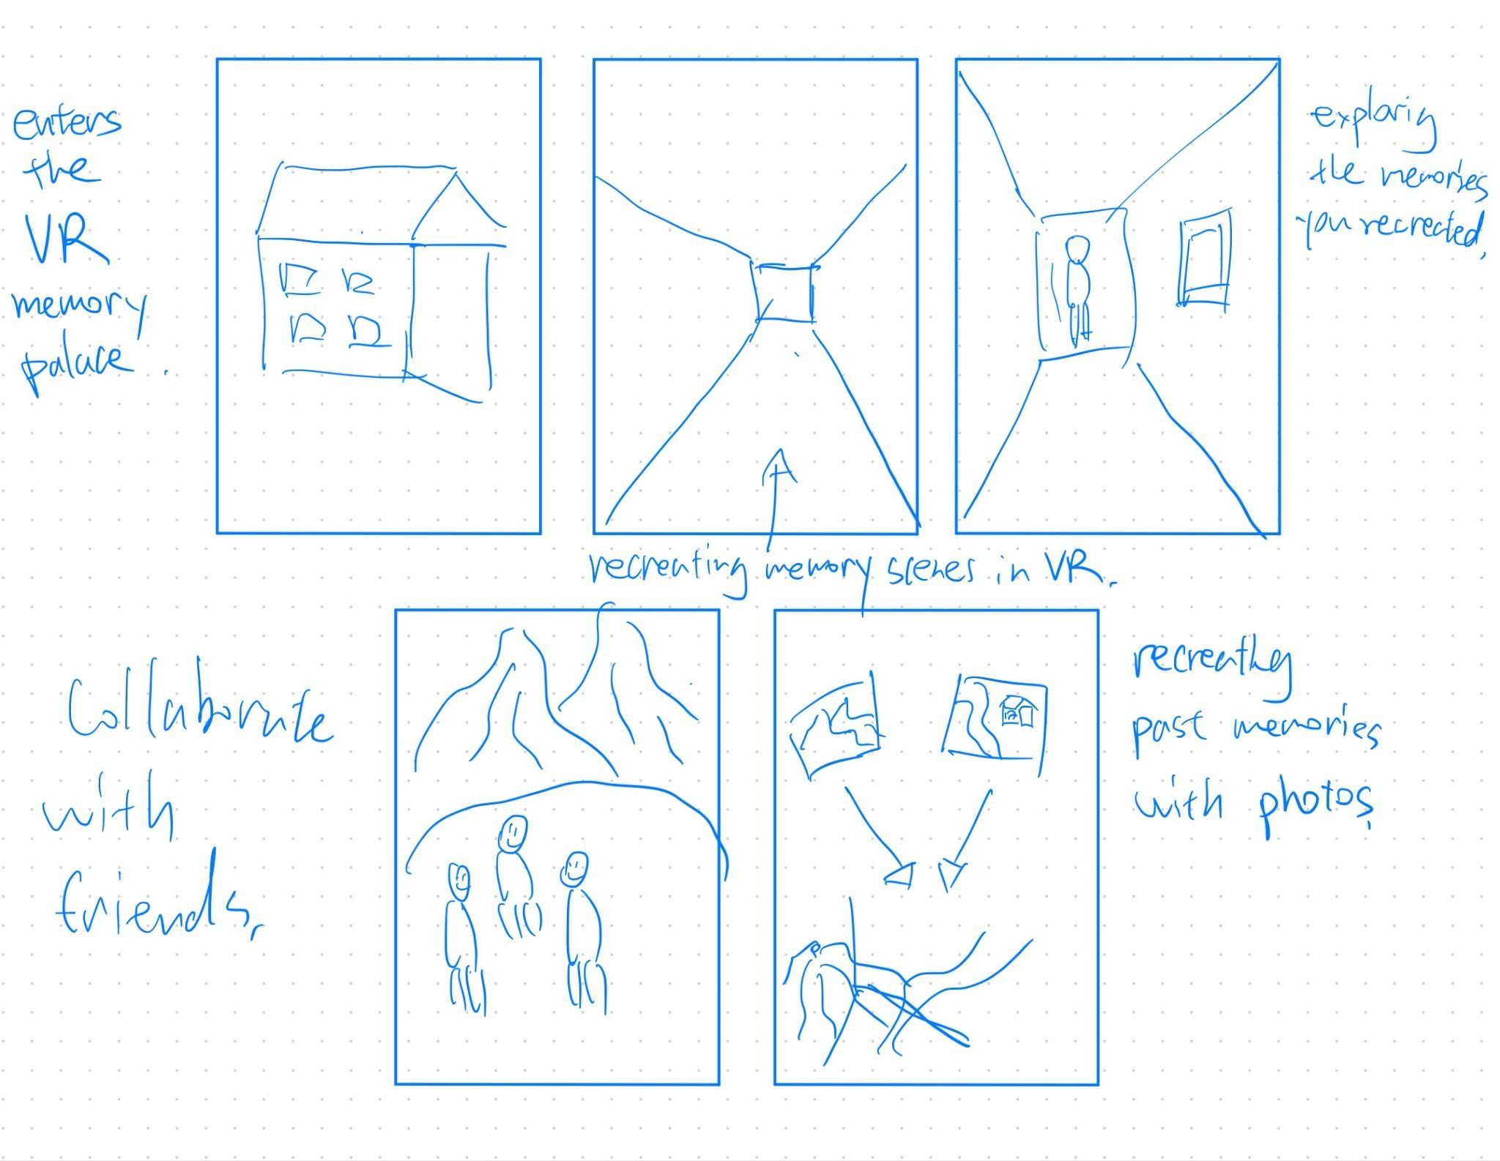
Key feature: Recreating and generating experiences/memories from voice descriptions and past photos from scratch.

Figure 1. This is a concept sketch for the VR realization.

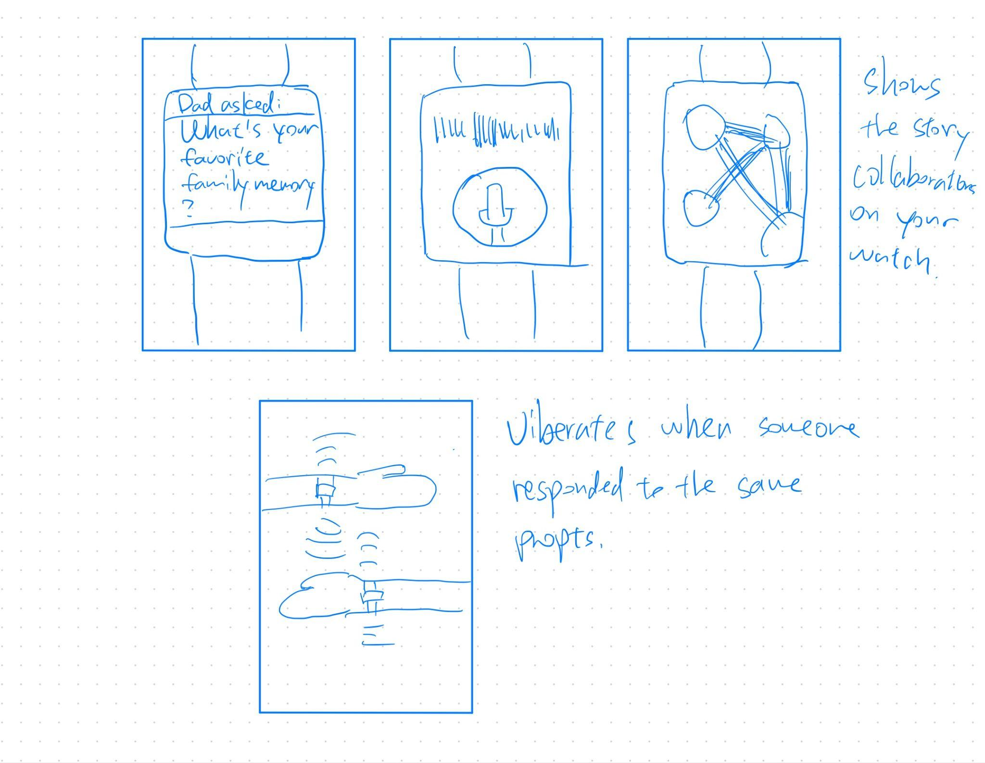
Key feature: Convenient and timely notifications when family member responds to prompts - allowing inspirations at the speed of thought.

Figure 2. This is a concept sketch for the Wearable (Apple Watch) realization.

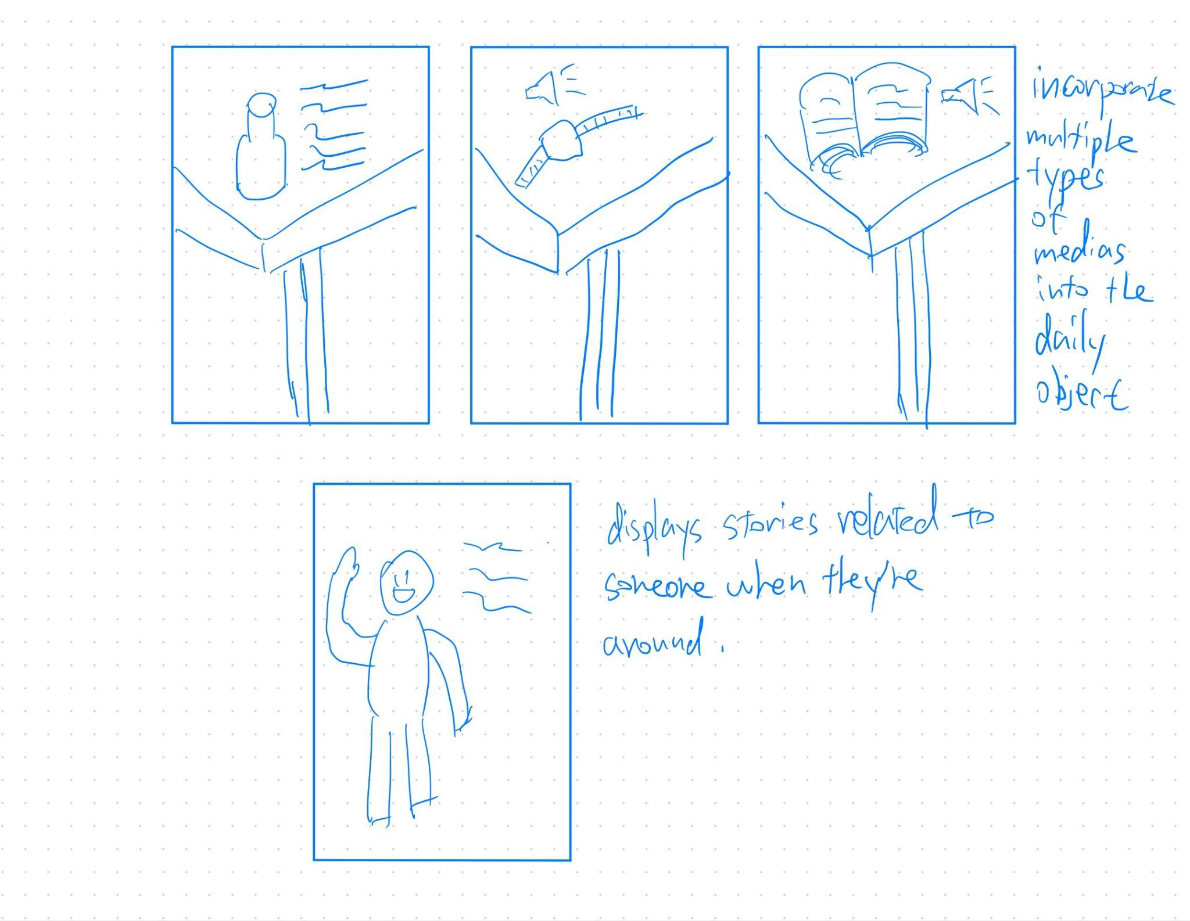
Key feature: Making certain real world objects memorable by incorporating live stories and meanings to them in the AR world.

Figure 3. This is a concept sketch for the AR realization.

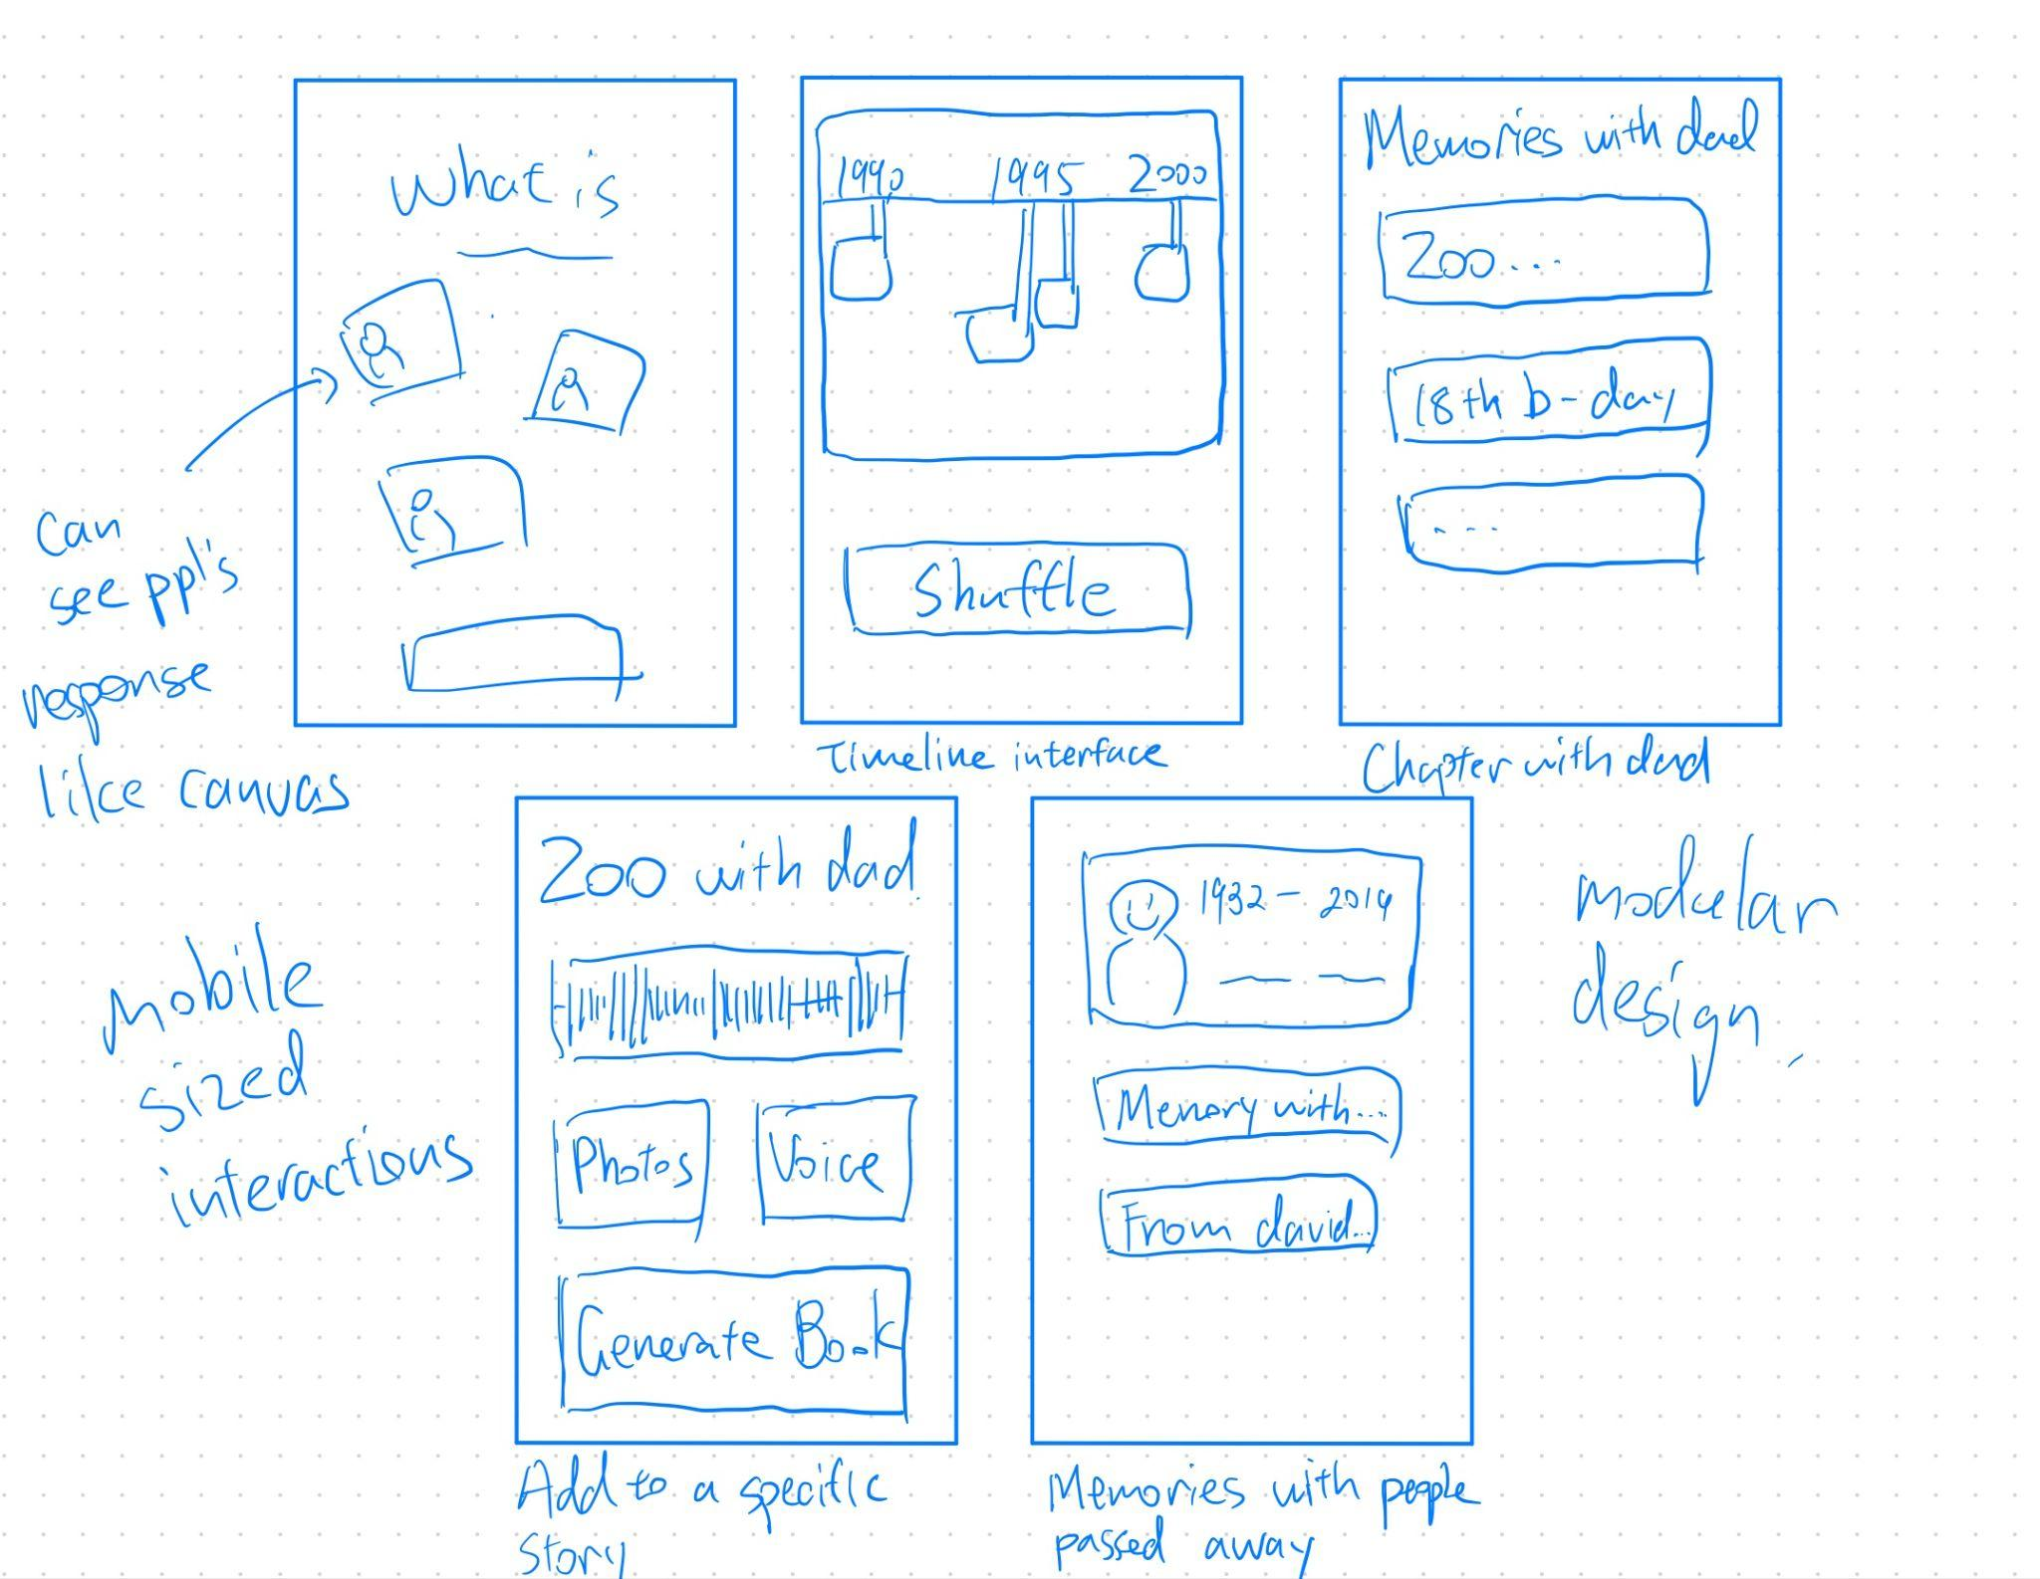
Key feature: Wide range of functionalities and visualization make the process of documenting family stories fun and collaborative.

Figure 4. This is a concept sketch for the Mobile Application realization.

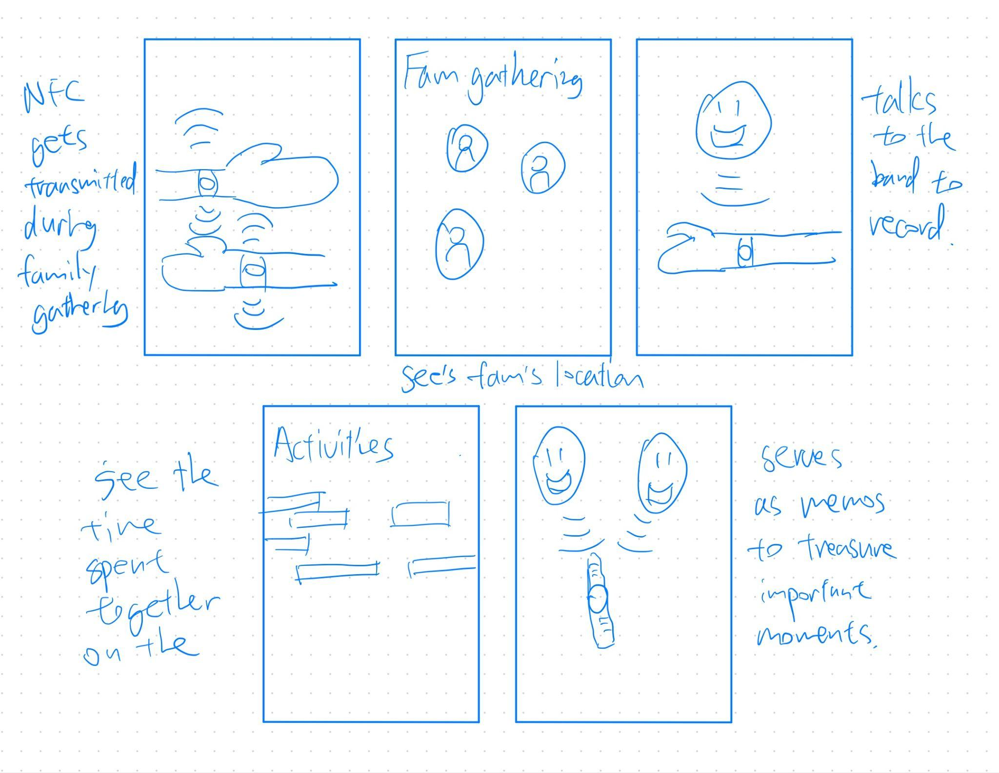
Key feature: Making documenting family gathering more spontaneous and fun with NFC capabilities.

Figure 5. This is a concept sketch for the NFC Tags realization.

Two Further Fleshed Out Realizations
We decided to move forward with our Wearable (Figure 2) and Mobile App (Figure 4) ideas.

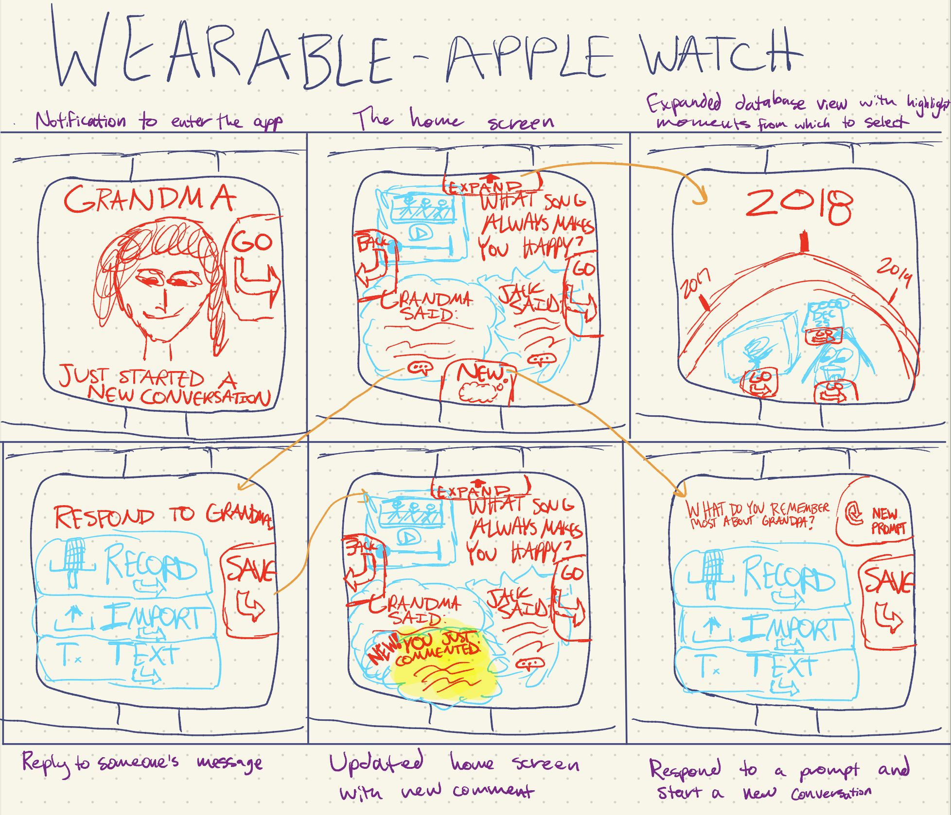
Figure 6. Storyboard of a wearable (Apple Watch) realization

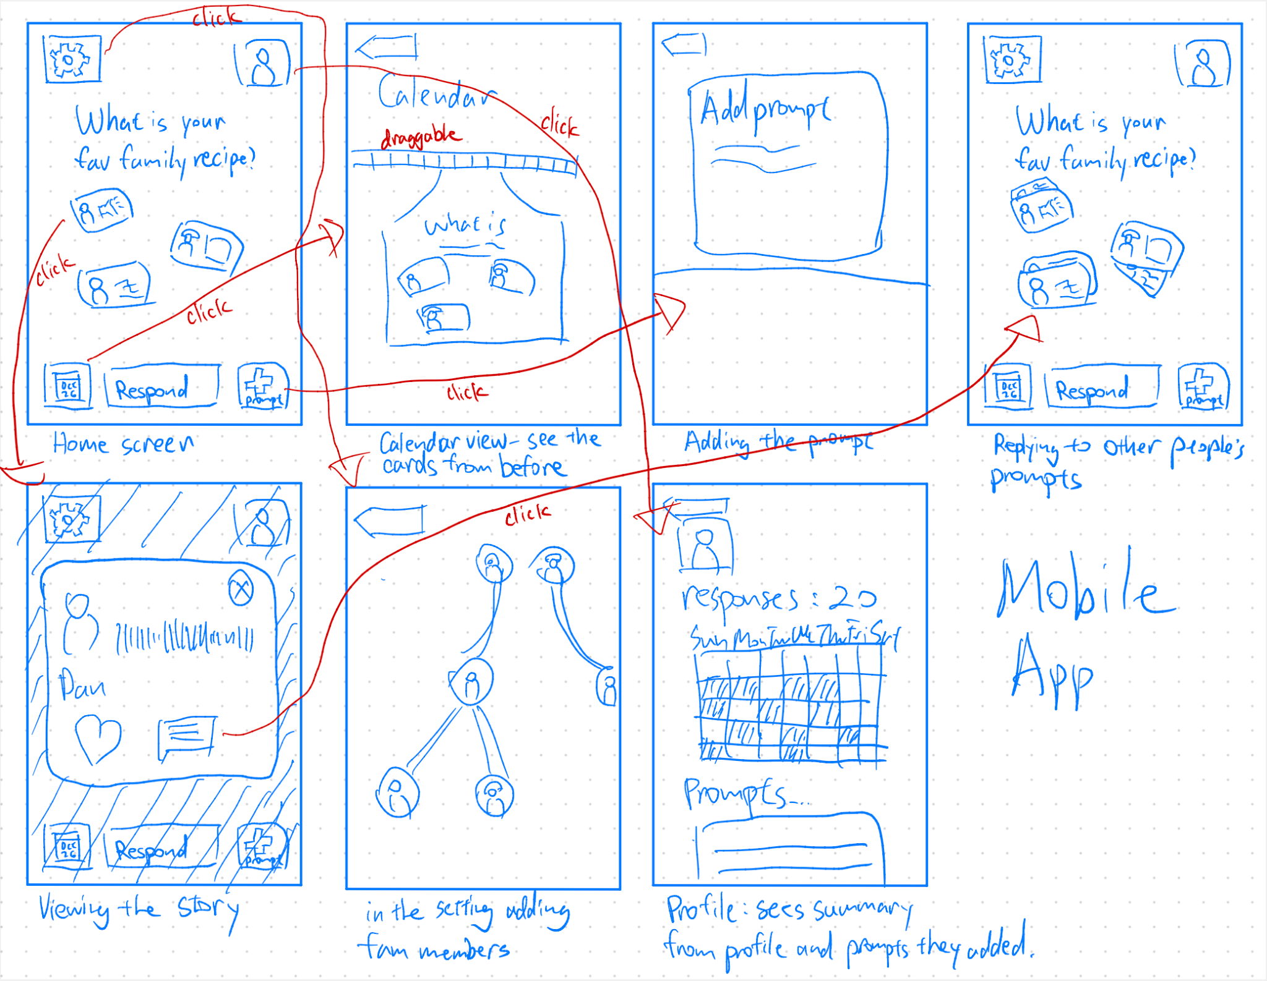
Figure 7. Storyboard of a Mobile Application realization.

Low-Fidelity Prototype
The prototype was initially created on an iPad and then transferred screen by screen to Figma. Subsequently, interactions between screens were incorporated, seamlessly linking the sketches so that specific buttons, when tapped, would guide users to the corresponding screens.

- Main Pieces of Functionality

Screen Name | Brief description | User functionalities
Home | The nexus point for users to get anywhere on the app | - Navigation to each of the other pages  - See own responses, responses of their family members, and brief previers of conversation between family members
Respond | Where the user goes to respond to a prompt | - Choose between a text, audio, or file response  - Input the response via any of the 3 modalities  - Submit the response
Reply | Where the user goes to reply to someone’s prompt response (e.g. comment section) | - See family members’ comments in full detail  - Choose between a text, file, or reaction reply  - Input the reply of any of the 3 modalities  - Submit the reply
Submit prompt | Where the user goes to submit their own prompt to be asked on a future day | - See a description of how the prompt system works within the app  - Input a prompt of their own
History | Where the user can see previous days’ conversations | - See responses to previous prompts  - See replies to previous responses  - Filter by date to find more specific conversations  - Search by keyword to find more specific conversations
Profile | Where the user can see more information and edit their profile | - See badges and assess progress towards goals  - Edit profile photo or name

The primary method of interaction with the interface is touch. However, there are non-text forms of interactions: the user may be prompted to type, speak, browse files, or link a song from Spotify. Each of these are dependent on user choice: we envision the user being given full control over how they communicate and what they are communicating.

Our vision with the home page is that, at a minimum, you can go on the app and, without pressing anything, see today’s conversation, which is intended to be valuable in and of itself. At best, you are given full agency to respond to the daily prompt yourself, interact with your family in our form of a comment section, and also contribute to future conversation through submitting a prompt of your own. Our primary goal is to make familial conversation as frictionless and enjoyable as possible, and an informative home page that can stand on its own is essential to achieving that.

We see the fun, daily appeal of the app to both: 1) engage young people used to a gamelike environment, 2) make the user experience for older users as simple and accessible as possible. The core functionality (and simple task) of responding to a prompt is the biggest button on the screen. In our testing, we found that the “RESPOND” button was by far the most pressed button and was so prominent that when people were confused on a task they would just press the button anyway. More complex tasks are behind more complex interactions like tapping on a response thumbnail (in the case of the moderate task), or tapping on the small “choose prompt” button in the button right.

- Task Flows with Transitions & Interactions Labeled

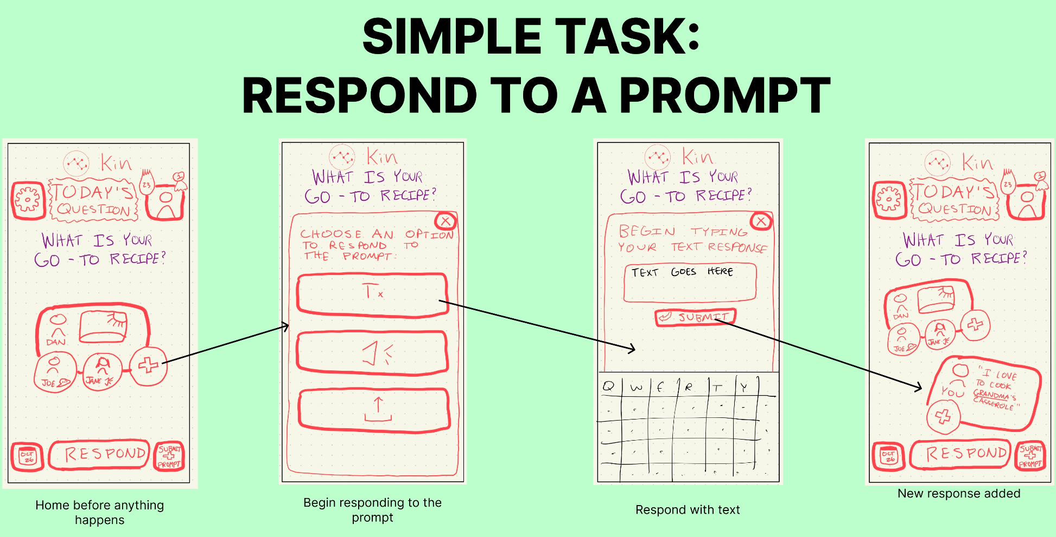
Figure 8: Simple task of responding to a prompt.

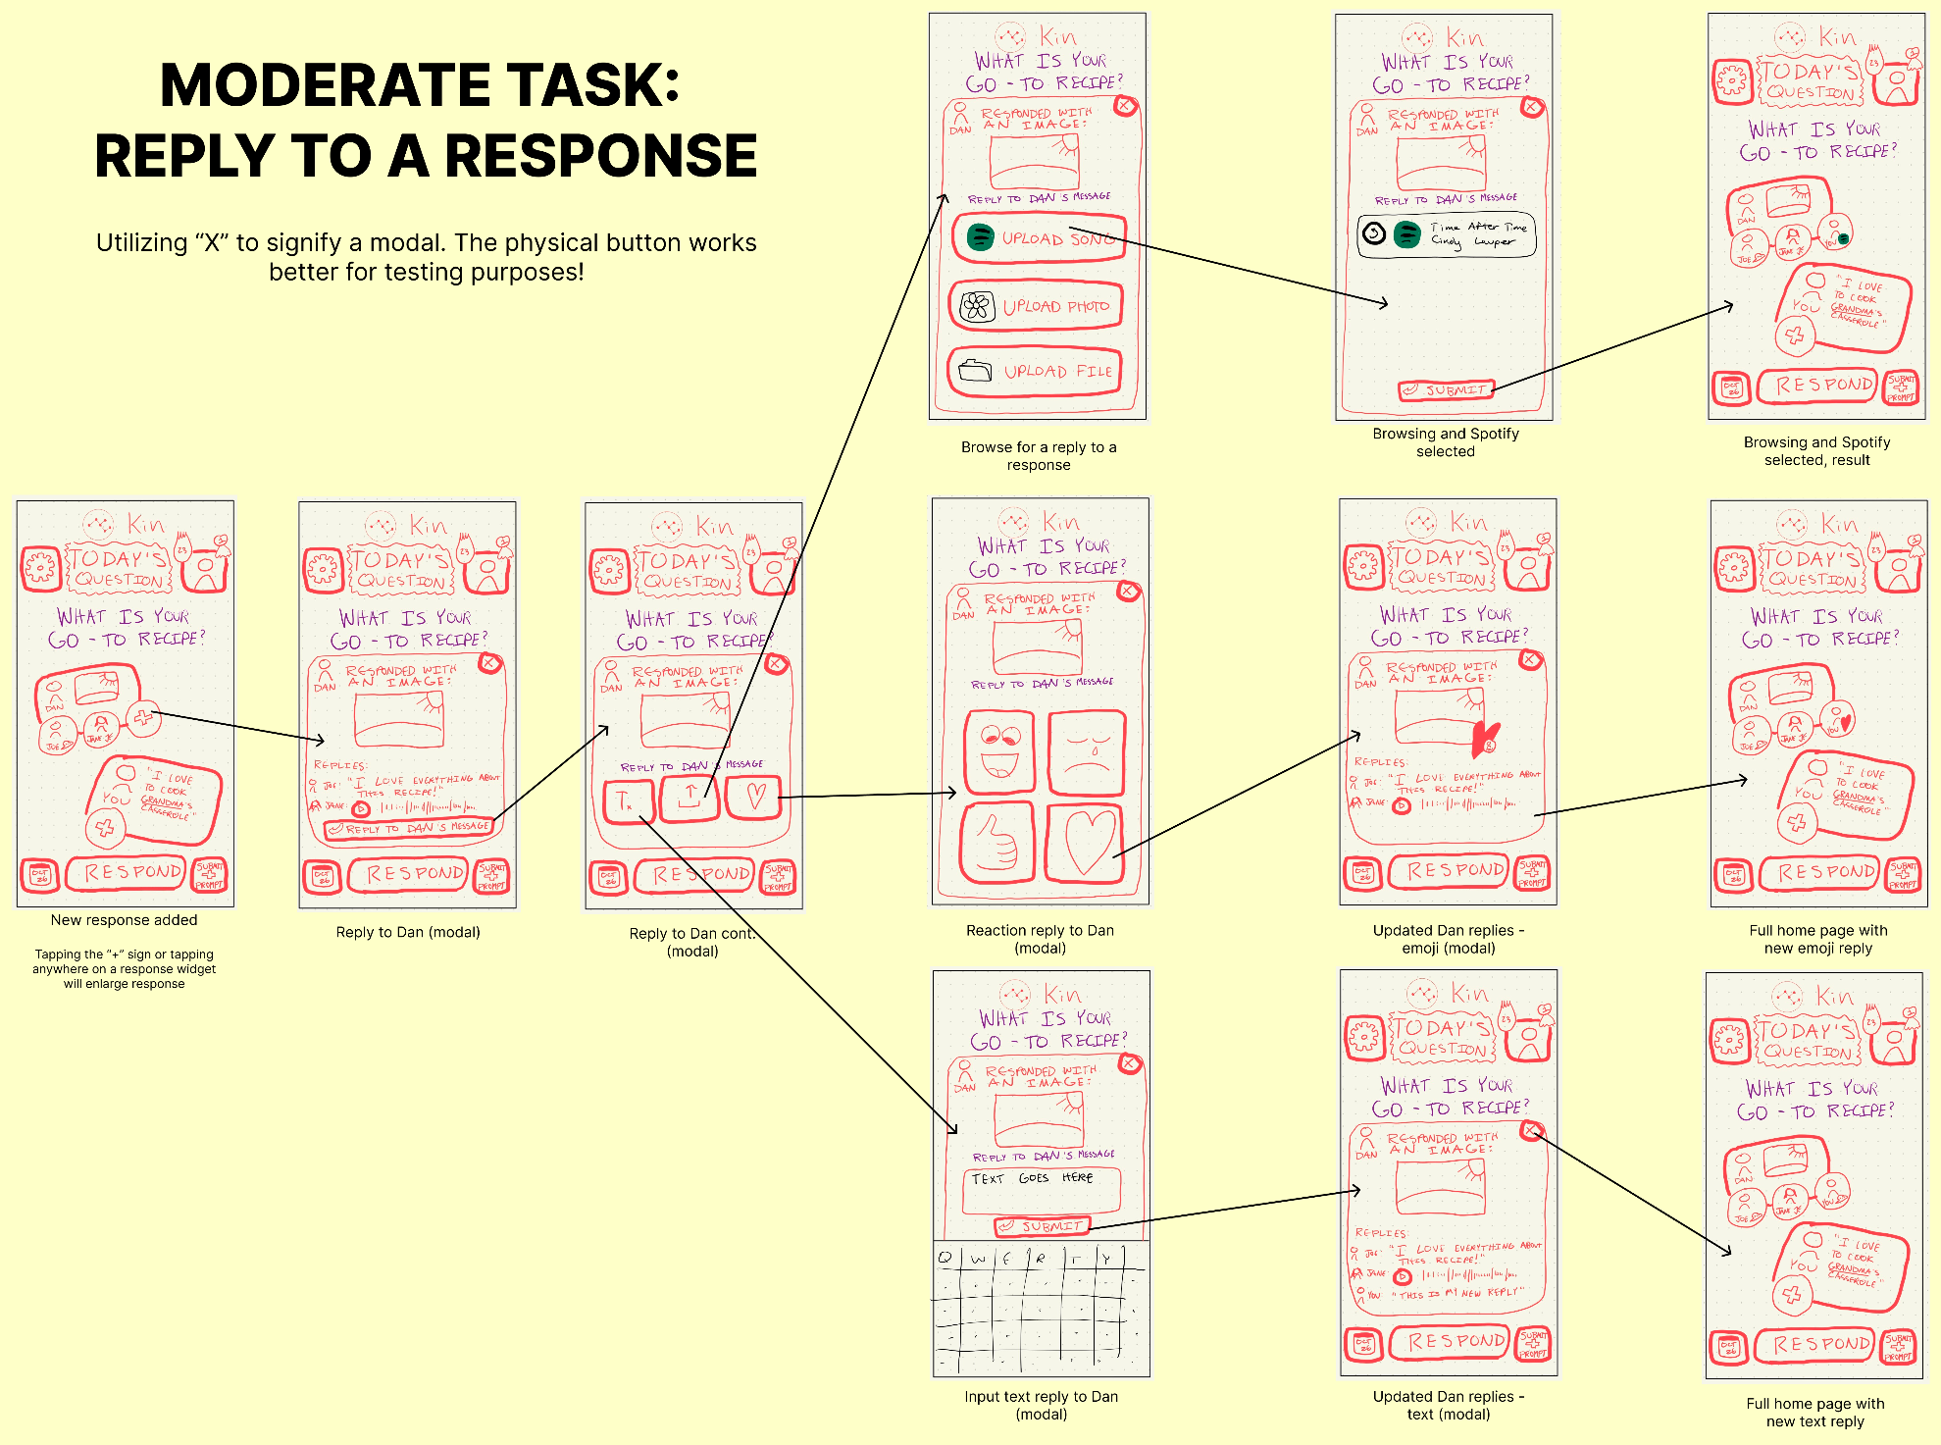
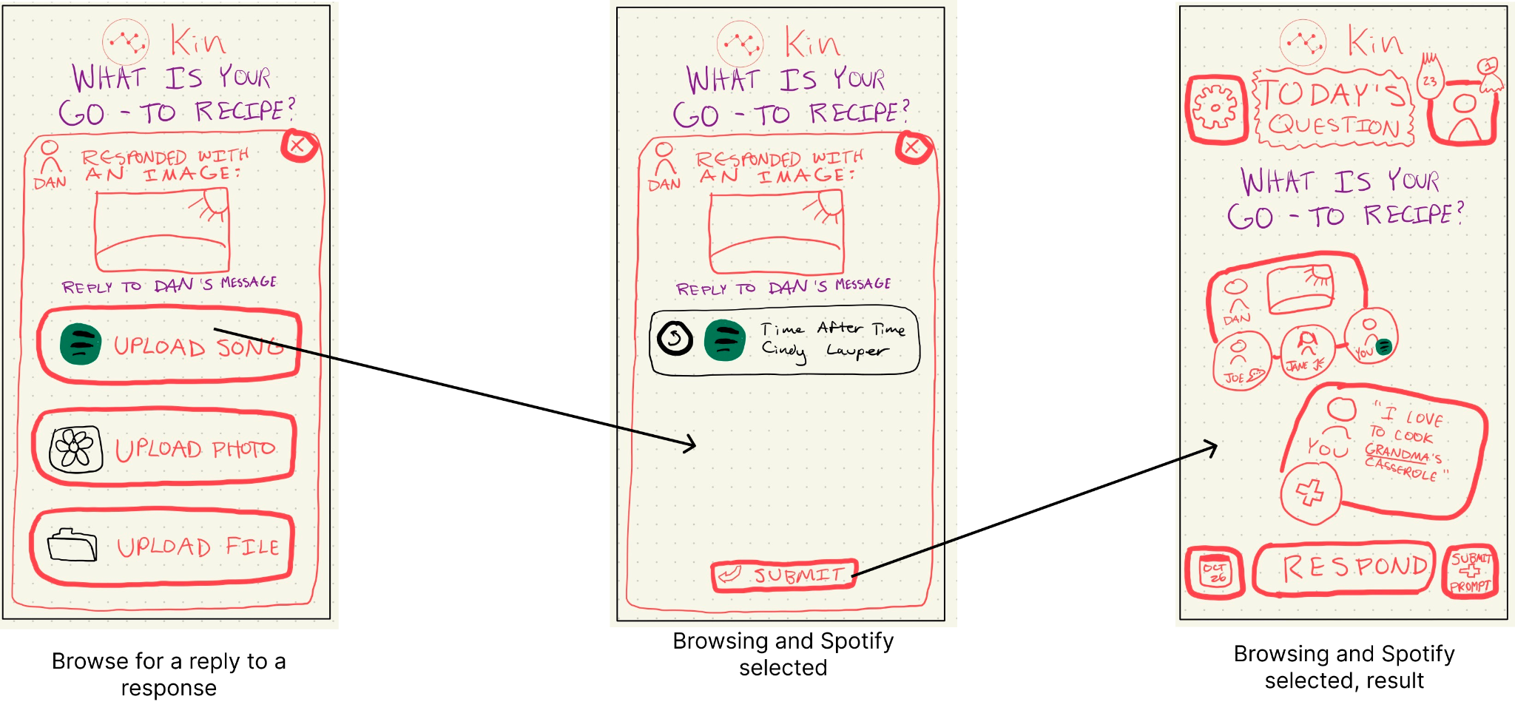
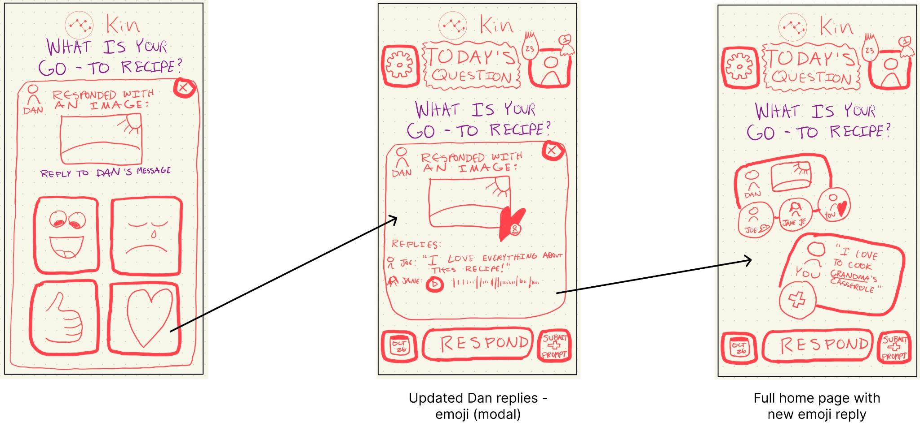
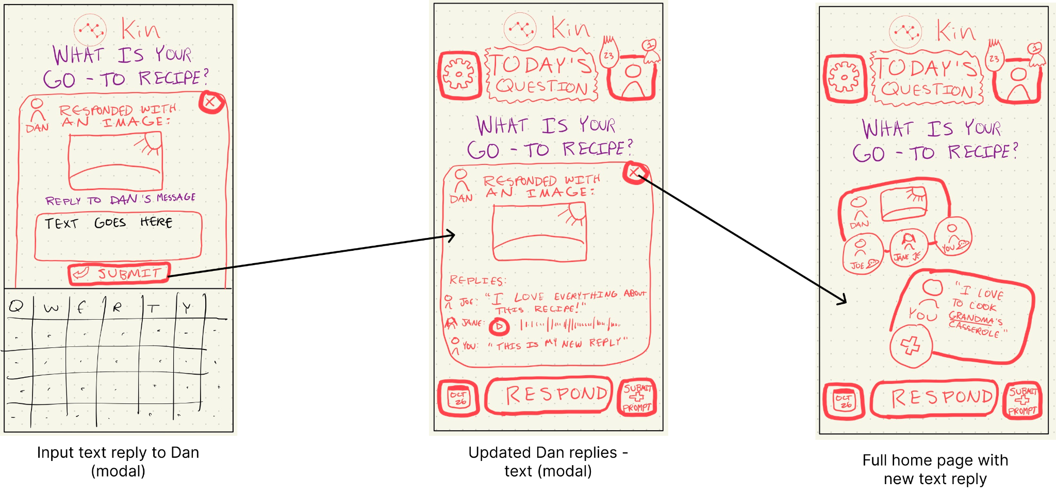

Figure 9: Moderate task of replying to a response.

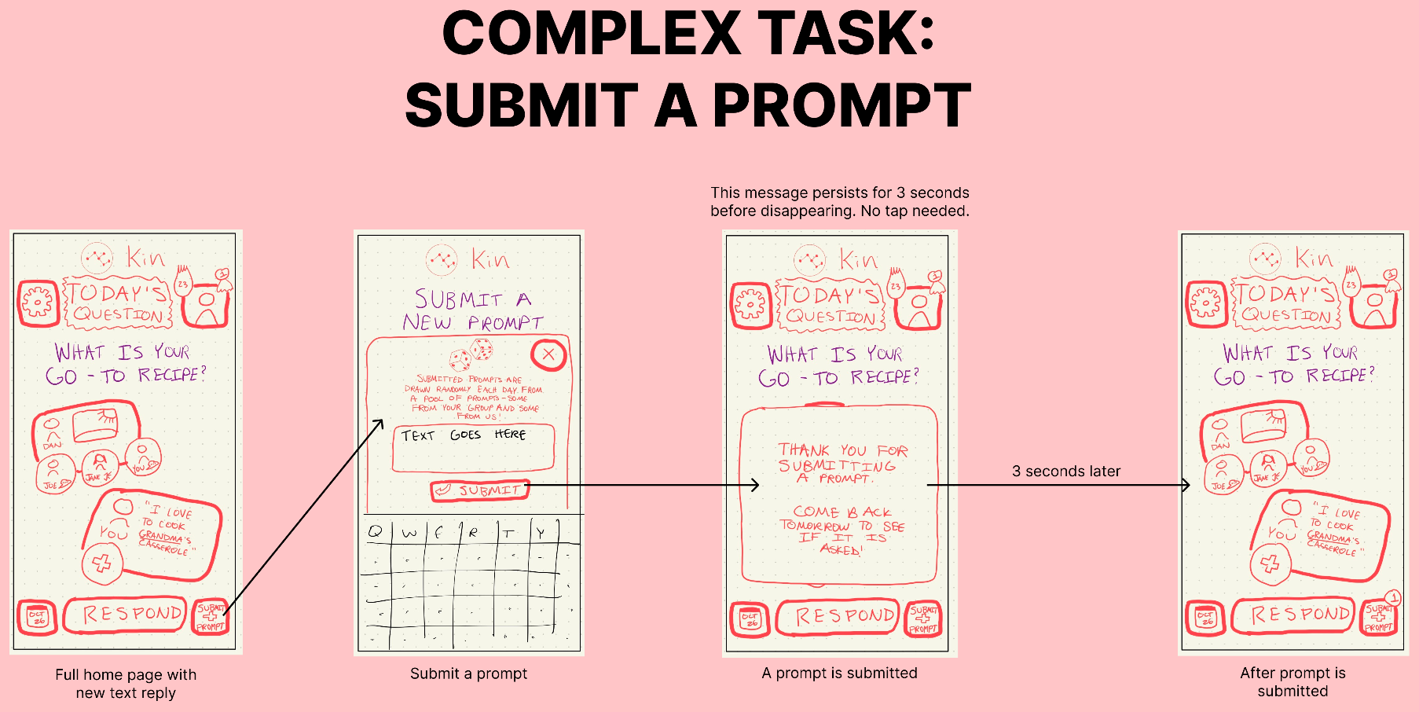
Figure 10: Complex task of submitting a prompt.

We provide the disclaimer “SUBMITTED PROMPTS ARE DRAWN EACH DAY FROM A POOL OF PROMPTS - SOME FROM YOUR GROUP AND SOME FROM US” to explain our system of essentially pulling prompts out of a hat each day. When there aren’t any submitted user prompts, our system will generate prompts that will supplement. These suggested prompts will learn from previous responses to assess what prompts would be appropriate.

- Birds-eye View Image of the Entire System
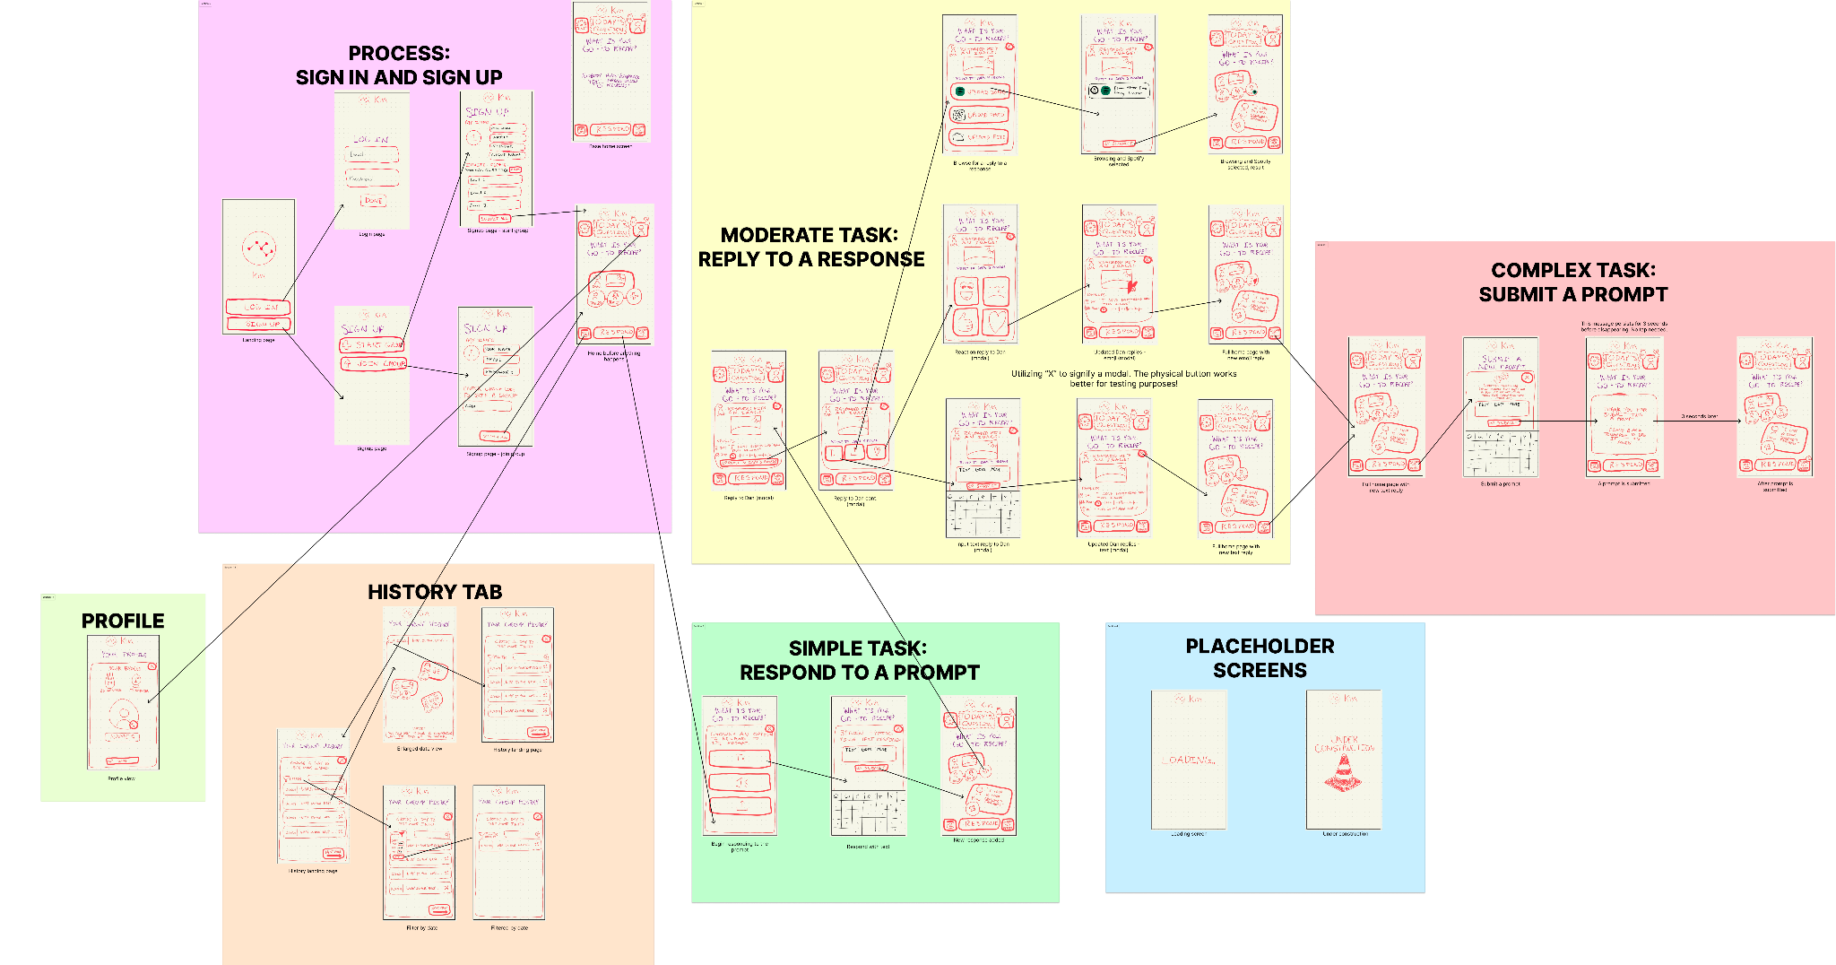
Figure 11: Bird’s Eye View.

- Non-core Task Flows
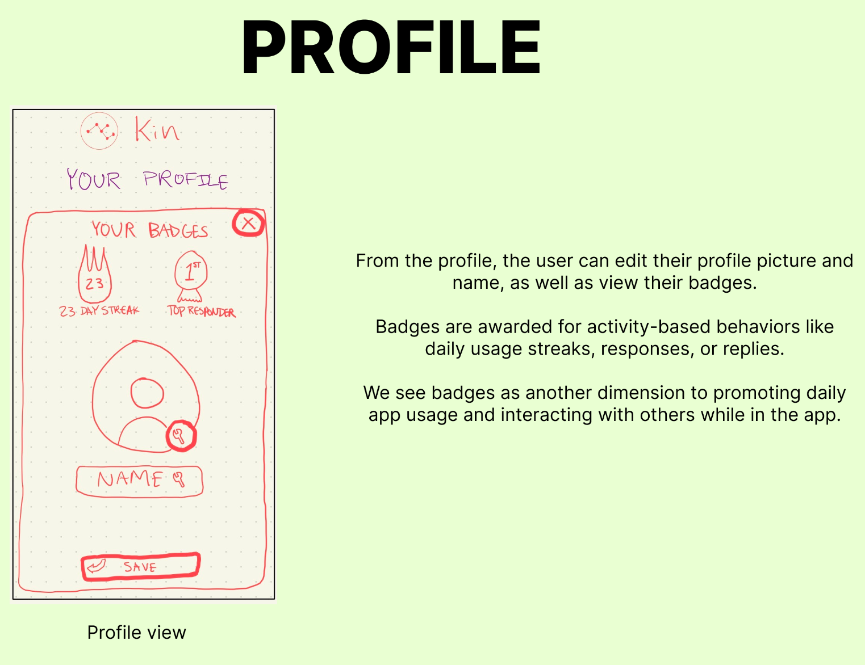
Figure 12: Profile screen.
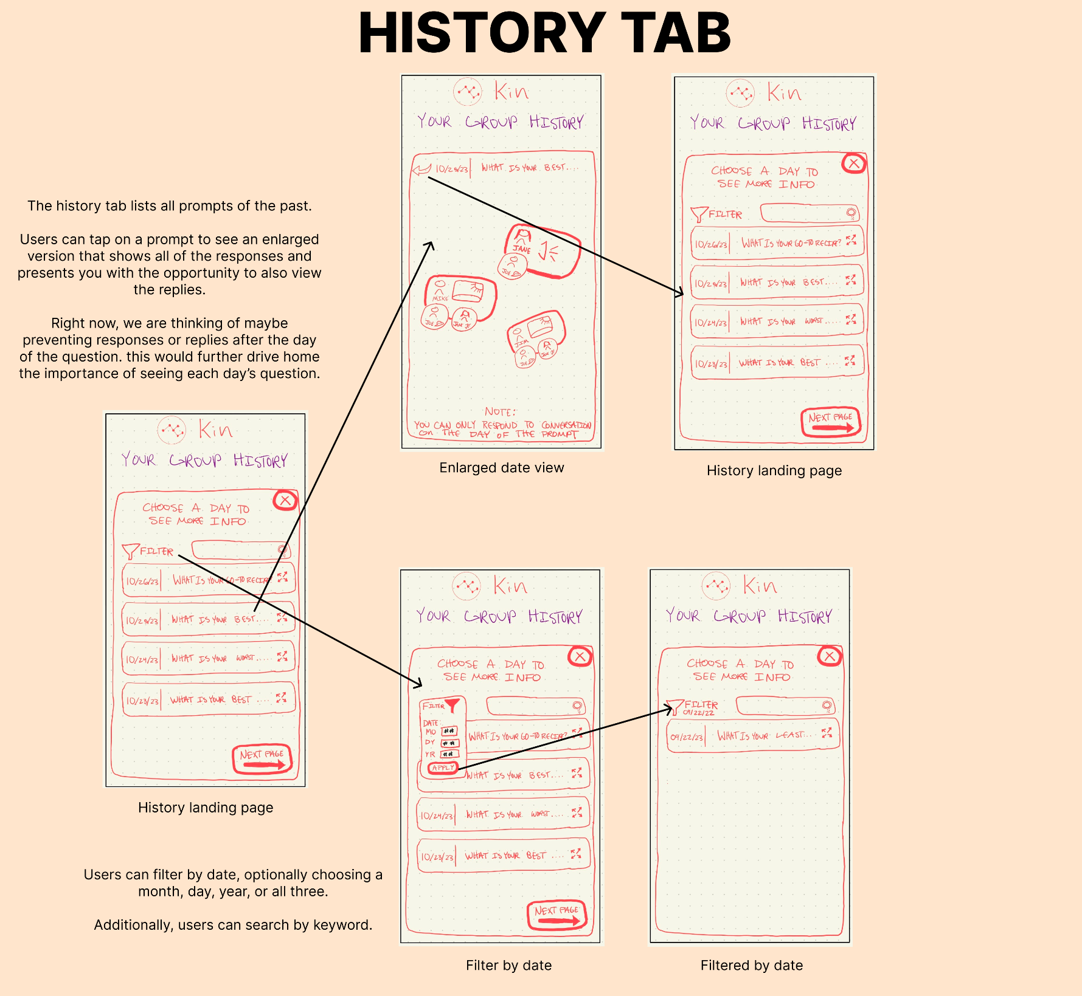
Figure 12: Profile tab.
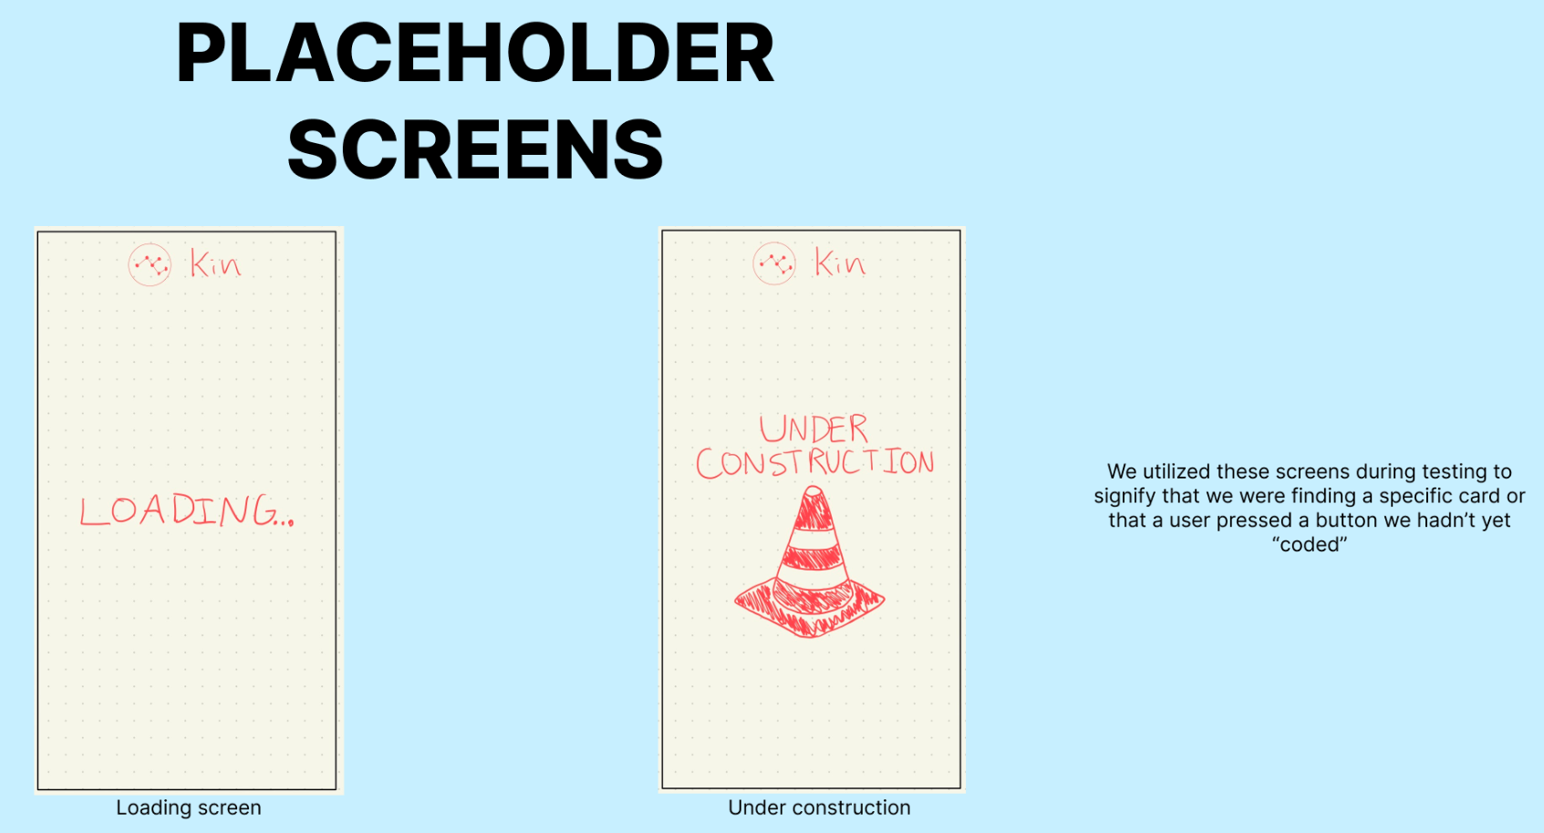
Figure 13: Placeholder screens.

