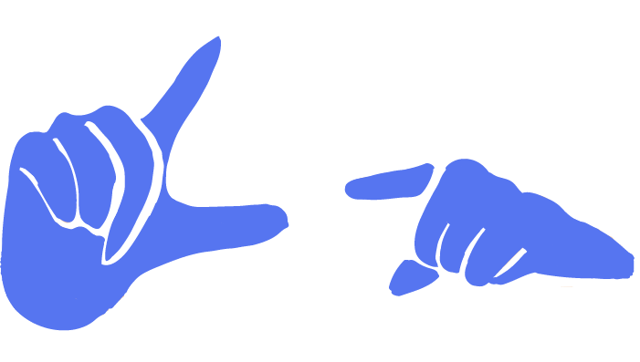

TrainGone Final Report
Express yourself beyond words.

CS 147: Autumn 2023

Jennifer Fung, Dria Lee, Arjun Sharma, Daniel Trejo
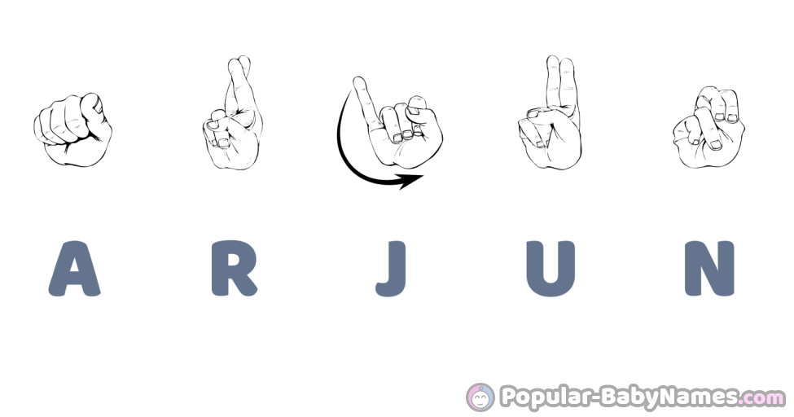
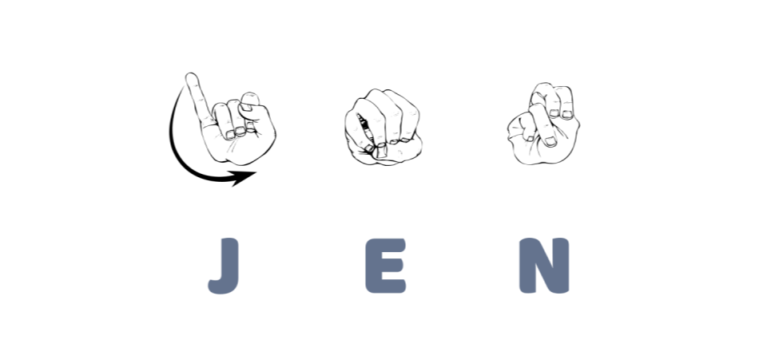
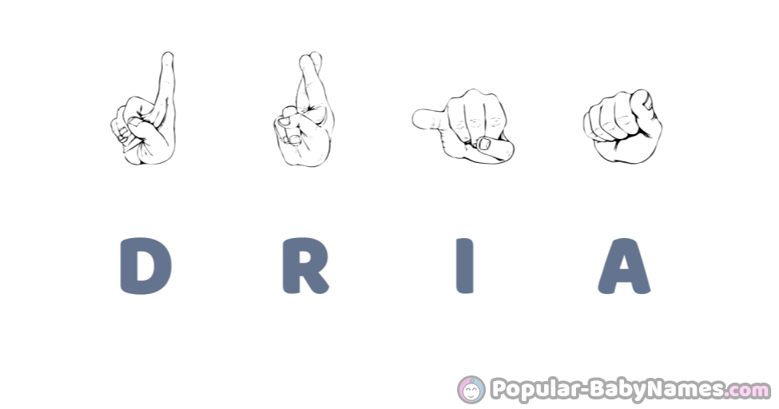
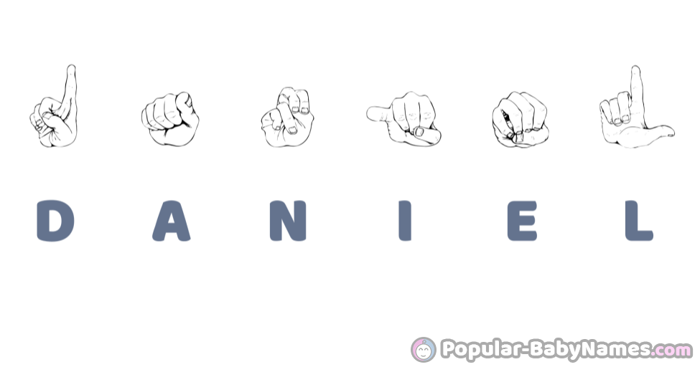

TEAM MEMBER NAMES AND ROLES

PROBLEM/SOLUTION OVERVIEW (2-3 SENTENCES)
This platform is designed to bridge the gap between ASL learners (who may struggle to recognize new signs) and members of the Deaf community (whose primary language is ASL and may not necessarily know the English translation for a sign).

While current ASL dictionaries assume that the user already knows an English word and is seeking the corresponding ASL sign, there is no intuitive platform that allows a user to identify the English word for an ASL sign based on its visual parameters (handshape, body location, palm orientation, and movement).

TrainGone functions both as a “reverse ASL dictionary” and a social educational platform where one can contribute to an ASL sign’s dictionary entry by uploading a video of themselves using the key ASL sign in an example story. This allows ASL learners to gain contextual exposure to unfamiliar signs by seeing crowdsourced examples, and fluent ASL signers to engage in storytelling, the foundation of Deaf culture and community.

Needfinding
During the interview process, it was important to meet with participants who had a diverse range of relationships with ASL. Interviewee backgrounds included a deaf native ASL signer, two ASL interpreters, one developer of an sign language AI motion capture software, a hearing ASL student of 6 years, and an ASL student of 3 years with a disability that will cause them to become deaf in a few years. These participants were recruited by Jennifer, who grew up in the Deaf community and asked people that she personally knew to refer potential interview candidates to her. The majority of these interviews were conducted by Jennifer in person and in English, with the help of OtterAI to transcribe and synthesize interview content. The interview with the deaf individual was done in American sign language.

Through our interviews, we unearthed many surprises, contradictions, and tensions.
There are many misconceptions surrounding not only ASL, but signed languages in general. For example, ASL is a completely different language from English. Thus, conceptually accurate interpretations (ASL) are not the same as word for word translations (Signed Exact English or SEE). There is a halfway point between ASL and SEE called PSE (Pidgin Signed English) that follows English syntax rules but uses ASL vocabulary. Sign languages are not universal, they are regional. While the US, England, and Australia are all English-speaking countries, each country has its own sign language. ASL is derived from French Sign Language.

We also learned about nuances within the Deaf community. While some deaf people identify as disabled, others push back against this label as a form of self-empowerment. Not all deaf people use sign language. Some (typically those with assistive technology or late-deafened individuals) use alternate methods of communication like lip-reading. Some use both. Some deaf people prefer literal translations for the sake of preserving the original message while others prefer that interpreters focus on interpreting the meaning behind the message.

There were many challenges that our interviewees expressed struggling with. For example, advanced ASL students that have a strong desire to continue learning often feel stranded if they don’t have a Deaf community to immerse themselves in, and despite being able to sign, an individual interpreter might not always be the right fit for a deaf client (depending on accent, style, etc). Most importantly, our interviewees emphasized that the barrier between the hearing and deaf community is not one of disability, but a linguistic barrier, rooted in the lack of a shared language. Deafness is more than a disability, it’s a cultural and linguistic identity.

POVs & experience prototypes
POV #1: Melanie
- We met… Melanie, an ASL student and influencer but not currently enrolled in ASL classes in her college.
- We were surprised to realize that… Despite being an ASL tik tok influencer, it’s been hard for her to retain her ASL communication skills.
- We wonder if this means… whether there is a lack of ASL speakers in her community or lack of integration between them.
- It would be game changing to… help learners connect and learn with one another.

How might we:
- Increase everyday exposure to learning languages?
- Foster a post-course community where speakers can practice their language together?

POV #2: Dee
- We met… Dee, an ASL interpreter for Wycliffe Bible Translators who helps deaf communities around the world.
- We were surprised to realize that… when meeting with international teams, the common language is often ASL, despite having hearing people on both teams.
- We wonder if this means… ASL has the most potential to connect people across different languages.
- It would be game changing to… utilize teaching ASL for people to communicate across different parts of the world.

How might we:
- Empower signers to communicate and connect on a global scale?
- Bridge speakers of different languages through a signed language?

Solutions
- Organize “hang outs” where post-learners can spontaneously meet up and practice their targeted language together
  - Assumption: The spontaneous meet-up would provide the perfect opportunity for students wanting for opportunities to practice
  - Experience prototype: Sending 6 Stanford students who have previously taken a Spanish course a text at 10 am inviting them to come to Coupa and speak in Spanish together.
  - Analysis:
    - What worked/didn’t work: One student responded enthusiastically to go but then didn’t show up. Half of participants didn’t see the message or didn’t respond until after the meetup. When asked why they were not able to attend, participants all said they were busy.
    - Implications: Spontaneous, same-day events are difficult for people to commit to. Even if students have interest, language practice is oftentimes less of a priority than other, more pressing matters. In order to motivate people to prioritize language learning, we must either present it in a way that seems like less of a commitment and has a lower barrier to entry, or simply give them more notice ahead of time.

- Create a video platform that relies solely on visual information and eliminates sound.
  - Assumption: Viewers would receive the same quality of experience without audio as with audio. We wanted to understand to what extent audio affects a person’s social media experience.
  - Experience prototype: Observe two hearing students listen to three different TikToks once without audio and once with audio, and rate their experiences.
    - Monologue-style video
    - Sports Highlight video
    - Dance video
  - Analysis:
    - What worked/didn’t work:
      - Monologue: Understanding of content was the same with and without audio. However, it was easier to focus with the audio.
      - Sports Highlight: Without audio, it was still exciting to watch. The audio vastly improved the experience by eliciting more emotion from participants. Both reported getting goosebumps after watching the video with audio.
      - Dance: The sound is needed to provide a rhythm for the dance and to help participants understand why the dancers were moving in such a way. Without the audio, the video looked “silly”
    - Implications: Audio in social media elevates the learning experience because it activates two senses and styles of learning (audio, visual) for the viewer. We learned that we can improve social media experience through other senses as well. However, since audio has proven to be the most effective medium of learning, it would be beneficial to mold the other sense-based learning to be as similar to audio as possible. This could be through visual cues or haptics that mimic the sound of a video.
- Language karaoke platform for language learners to sing songs in their target language and engage with others
  - Assumption: People learning a language would have fun singing songs in their target language, incentivizing language practice.
  - Experience prototype: Ask one participant learning Spanish to watch two different Spanish karaoke songs on YouTube (Despacito by Luis Fonsi and Bailando by Enrique Iglesias) and sing along to them.
  - Analysis:
    - What worked/didn’t work:
      - Both songs selected were popular Spanish songs that the participant had heard before, which made it exciting and easier for the participant to follow along.
      - Having a live person ‘judging’ the participant (e.g. pronunciation) to simulate the app’s feedback mechanism made the participant feel self conscious.
    - Implications: People who are still learning new languages do not feel comfortable singing in front of an audience. It seems a language karaoke application would work best for those who are already comfortable singing, as well as proficient in the language they are learning.

DESIGN EVOLUTION

Final Solution - TrainGone

Tasks
- Simple Task: Identify Word
The core component of TrainGone is to include an intuitive way for users to search through ASL words without knowing the English word. This feature differentiates us from current ASL-English reverse dictionaries as we provide our users with the ability to search signs by hand shape, palm orientation, hand location, and movement.

- Moderate Task: Learn from others
ASL learners learn sign definitions best through exposure. We aim to provide our users with a large selection of definitions through different contextual videos to help them grasp the meaning behind a new sign.

- Complex Task: Create own definition
Our last task is to allow our users to create their own meaning behind a word through posting their own video. After completing the first two tasks, the user should have developed an understanding of a word and be able to share their own perspective on its meaning to others.

Low-Fi Prototype

For our low-fi prototype, we developed a wide variety of sketches ranging from a variety of mobile applications to AR/VR devices. Out of all of these, the two realizations that excited us the most were mobile applications and virtual reality.

- Mobile Application
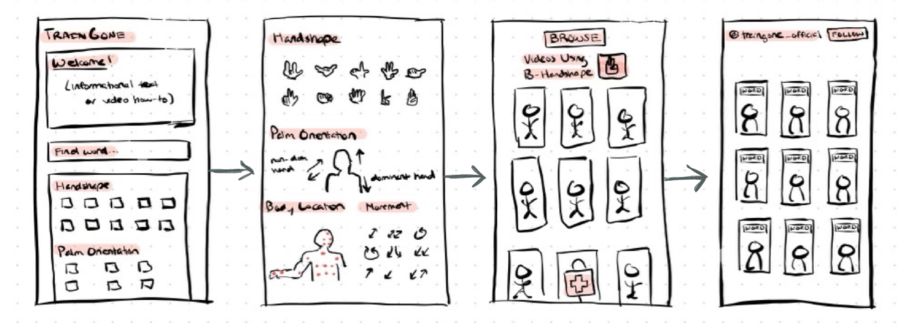

- Mixed Reality Application
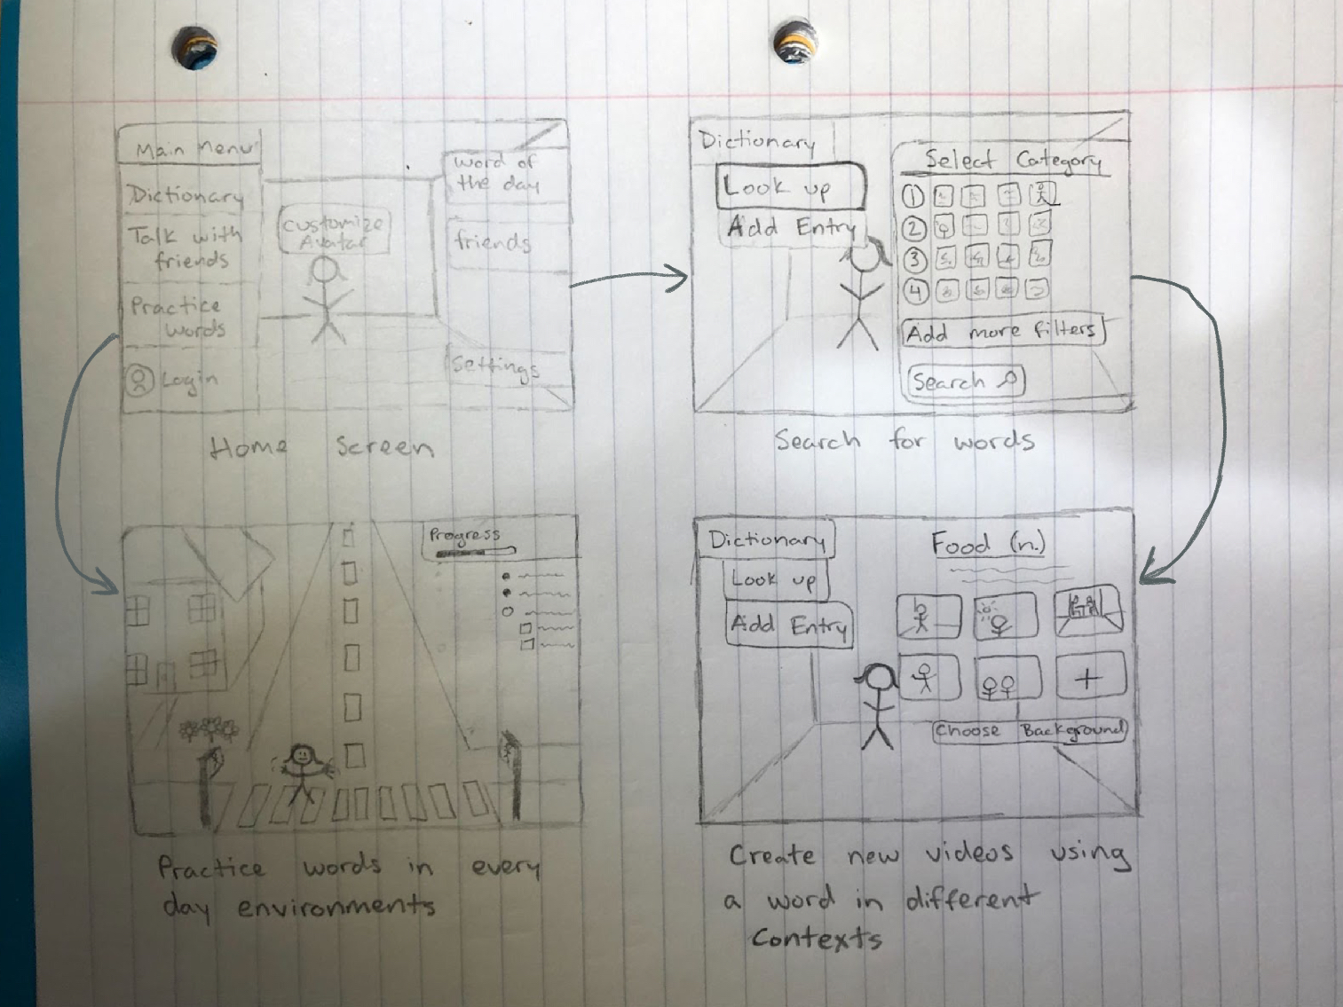

We were big enthusiasts of our VR idea as it involved the user experiencing and practicing signs through realistic, everyday environments. The user would be able to create their own avatar, which would mimic their chosen sign. However the technology for this application was not feasible so we turned towards ideating around a mobile application. While we could not use VR, we believed we could still immerse our user in a digital social environment.

We then started to ideate through sketching the main concepts for our mobile app, addressing our three tasks.

- Searching a word
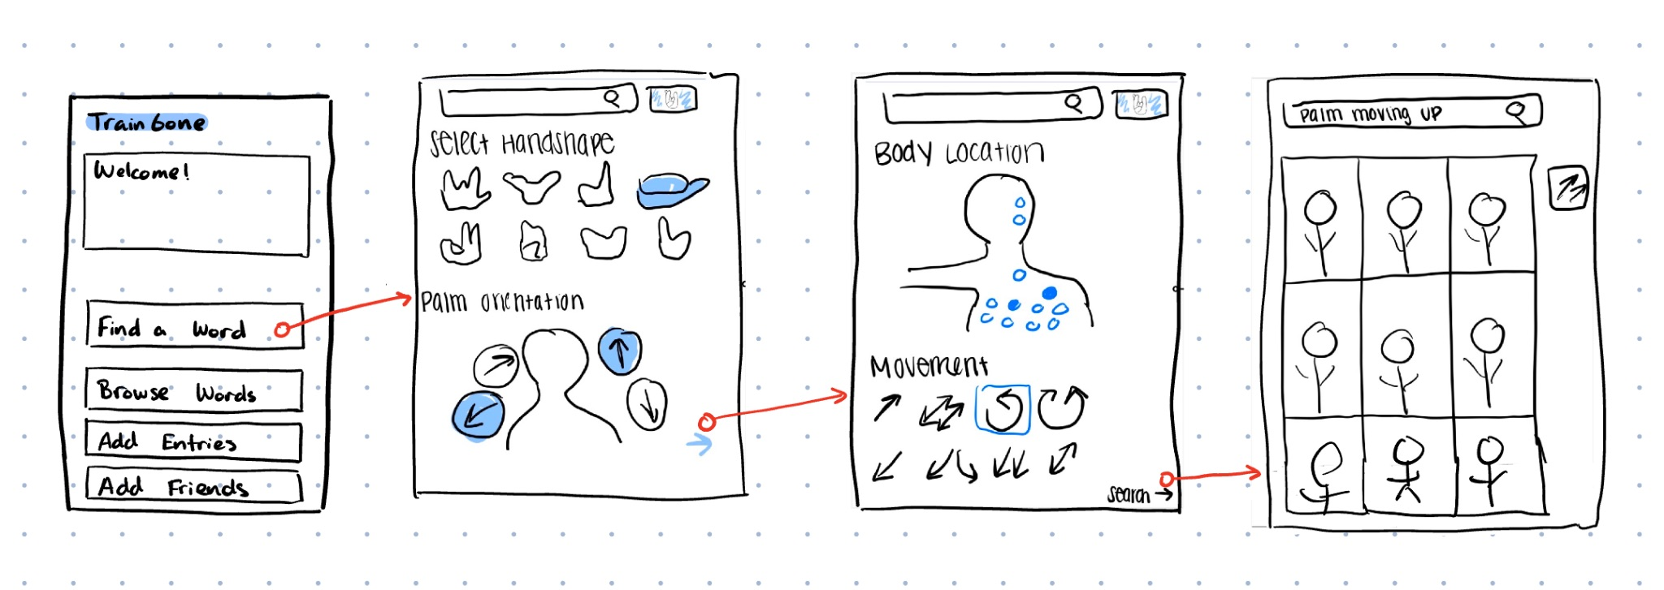

- Exploring words through different contexts
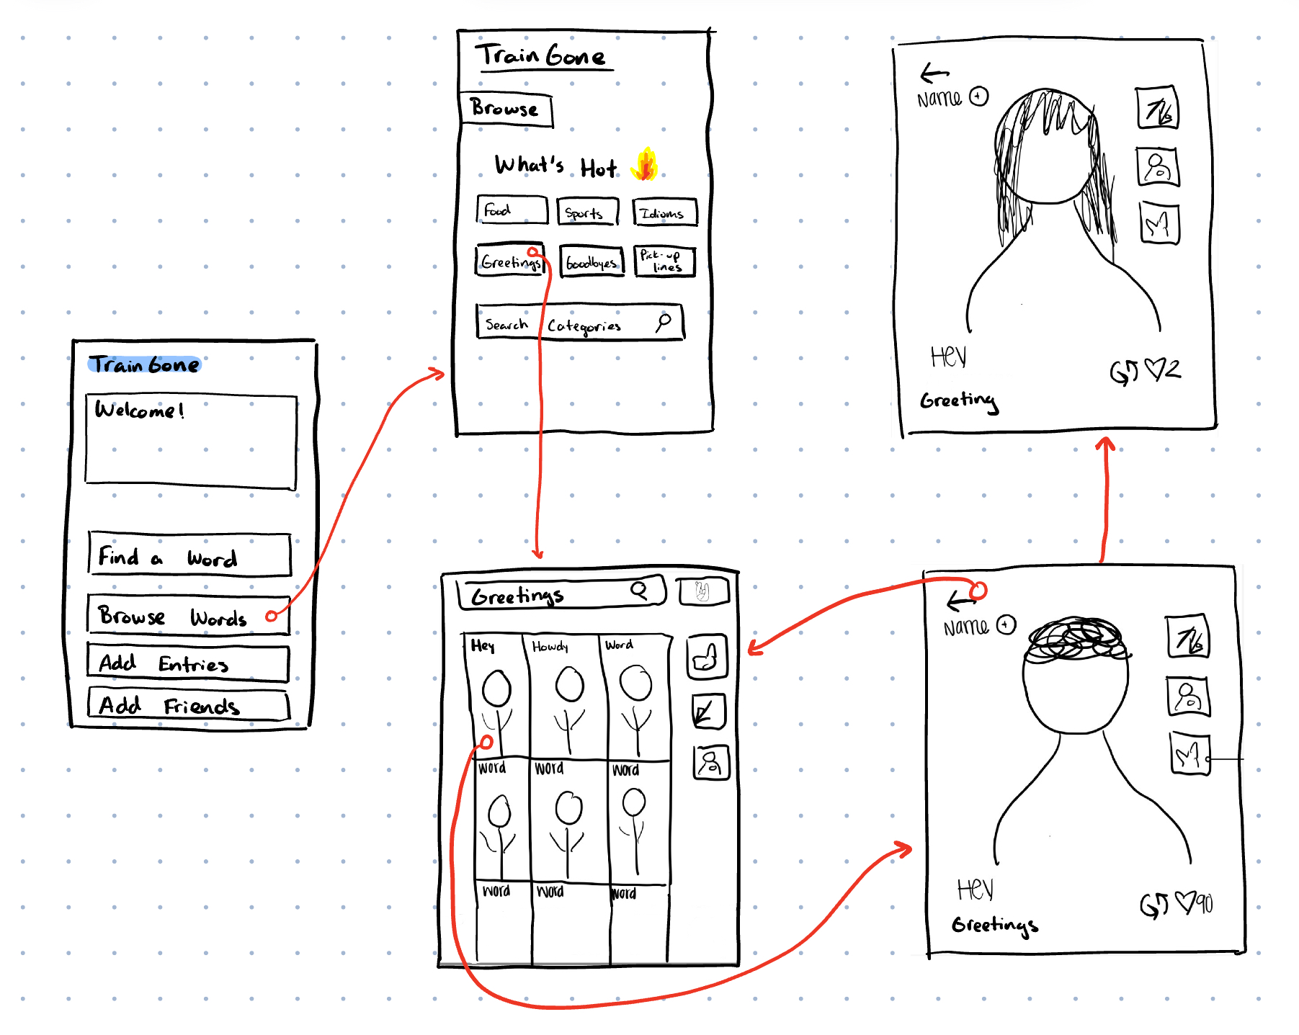

- Posting your own definition
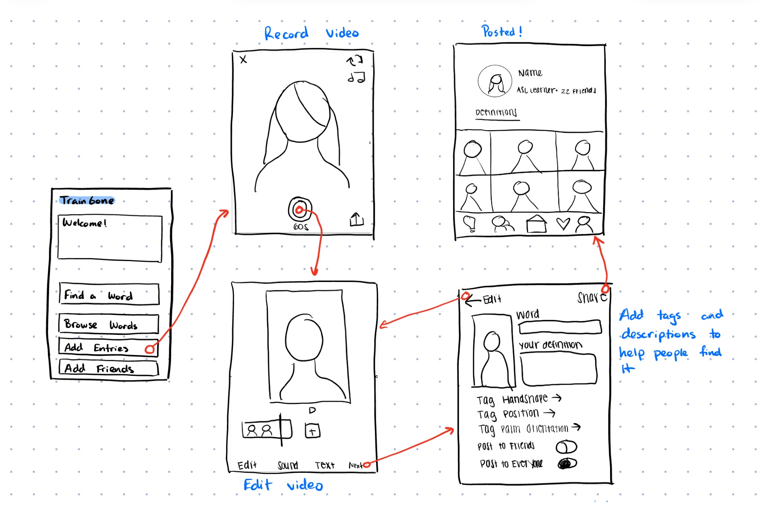

Usability Testing
After sketching out our low-fi prototypes, we dove into usability testing. We interviewed three people: 1 university student interested in learning ASL, 1 ASL learner, and 1 graduate with no experience with the language. We were particular about choosing these users as we wanted our app to be an inclusive environment, and both intuitive and enjoyable regardless of one’s familiarity with ASL.

Here is some feedback we received:
- Design was intuitive and aesthetically pleasing for all users
- Lack of back button
- Icons were confusing and unfamiliar
- Hand sign search did not make sense to those with no experience

We also recorded the number of errors our users made in completing each task. While all our users were engaged and excited throughout the flow, those with less ASL familiarity gathered more errors with recognizing icons and exploring the interface. Specifically, our first task of searching a sign consisted of different palm orientations and hand signs that would be unfamiliar without explanation to someone with no background in ASL.

Testing our prototype therefore proved to us a success and an error. Our idea was capable of captivating a large range of users, but we had to find a way to make our tasks intuitive. In particular, we spent hours brainstorming on our first task. Searching for a particular hand sign would involve a lot of steps that would be hard to convey in words, but just icons would not be enough.

Our next big steps going into the med-fi prototype would be:
- Make icons explicit and easy to understand
- Add back button and navigation bar
- Add interactions
- Turn searching by sign into the home page

Med-Fi Prototype

- Identify Word
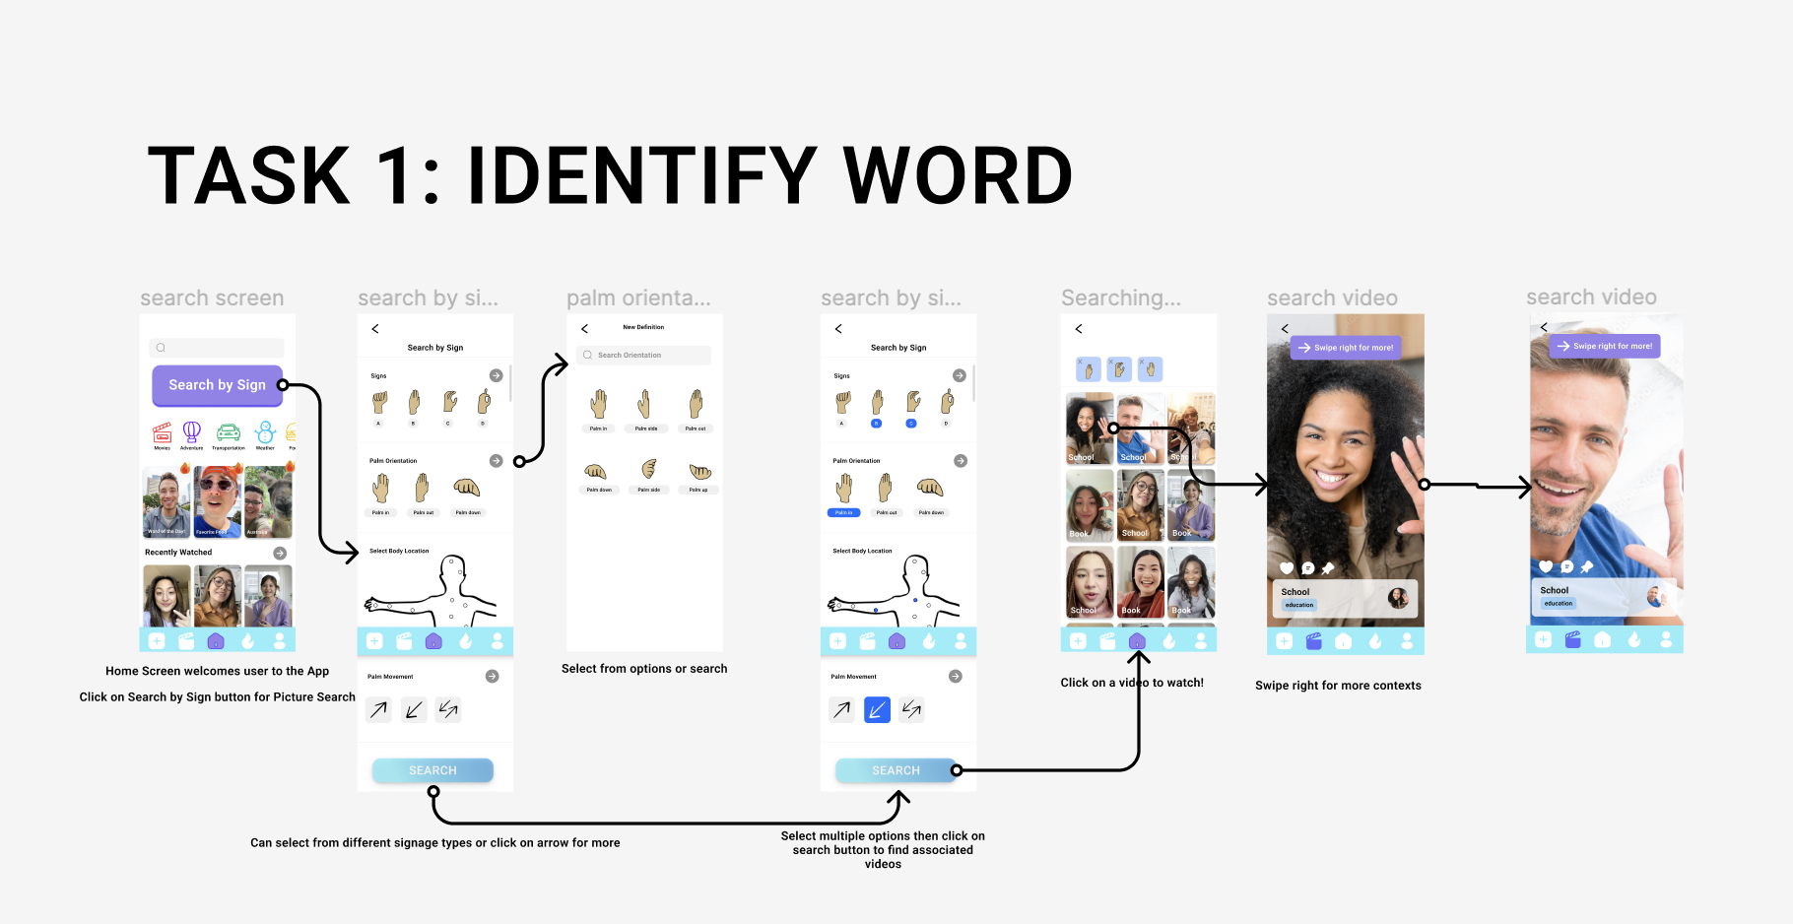

- Learn from others
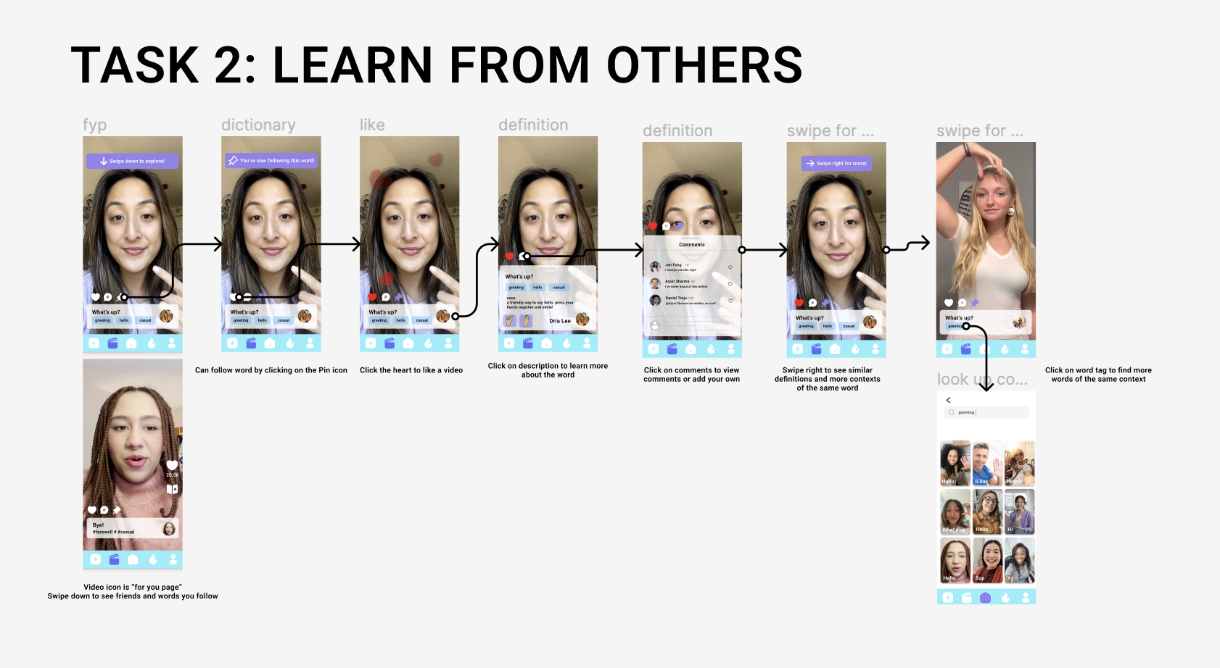

- Share your own content

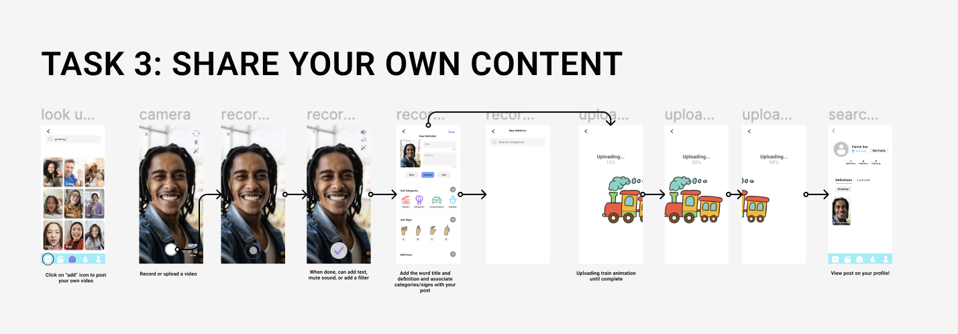

Heuristic Evaluation

After completion, we shared our prototype with another group within our studio for a heuristic evaluation. Upon receiving their feedback, we decided to focus on correcting the severity 3 and 4 violations. In total, we had 67 violations, 12 of those were from severity 3 and 4.

Severity 3 Violations:
- H2: Match Between System and Real World: Terminology of handshape, palm orientation, and body location may not be familiar to users unfamiliar with ASL or even those familiar.
  - Fix:
- H3: User Control and Freedom: No swipe left to go back
  - Fix: Adding Swipe Left
- H3: User Control and Freedom: User cannot “x” out a particular body location
  - Fix: Add option to cancel body language after search is completed.
- H10: Help and Documentation: No help or documentation for users who may need assistance for using the app.
  - Fix: Create tutorials and support modals that assist users as they complete tasks.
- H4: Consistency and Standards: Two videos have different corresponding icons
  - Fix: Created consistency between frames
- H3: Flexibility and Efficiency of Use: Lack of shortcuts for expert users who want to quickly navigate through video feed
  - Fix: added option to customize feed based on level
- H3: User Control and Freedom: No option to save draft of post
  - Fix: Added option to save to drafts
- H3: User Control and Freedom: No option to retake video
  - Fix: Added option to go back and retake video
- H4: consistency and standards: Limited parameters
  - Fix: Added parameters from “search by sign”
- H2: Match between System and World: Order of buttons could be better organized
  - Fix: Rearranged buttons with home screen first
- H2: Match between System and World: Confusing between “liking” a video and learning a video
  - Fix: Eliminated wording of “Learning” in profile and replacing it with “Dictionary” which adds words through liking

Severity 4 Violations:
- H4: Consistency and Standards: Like count and bookmark buttons only present some of the time
  - Fix: Removed buttons on next video

Hi-Fi Prototype
We built our hi-fi prototype by incorporating design changes from our heuristic evaluation. Below are the complete task flows reflected in our high fidelity prototype.

Task 1: Searching a Sign
Search for a sign’s English translation through visuals.
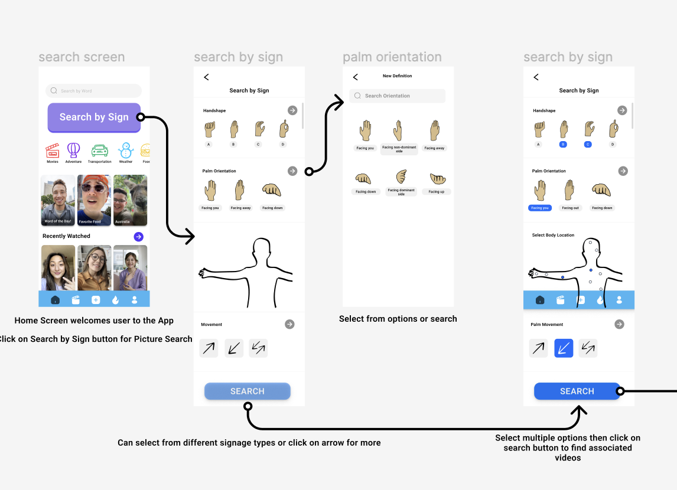

Task 2: Learning Signs through Context
Learn new definitions and check out similar through your video feed.
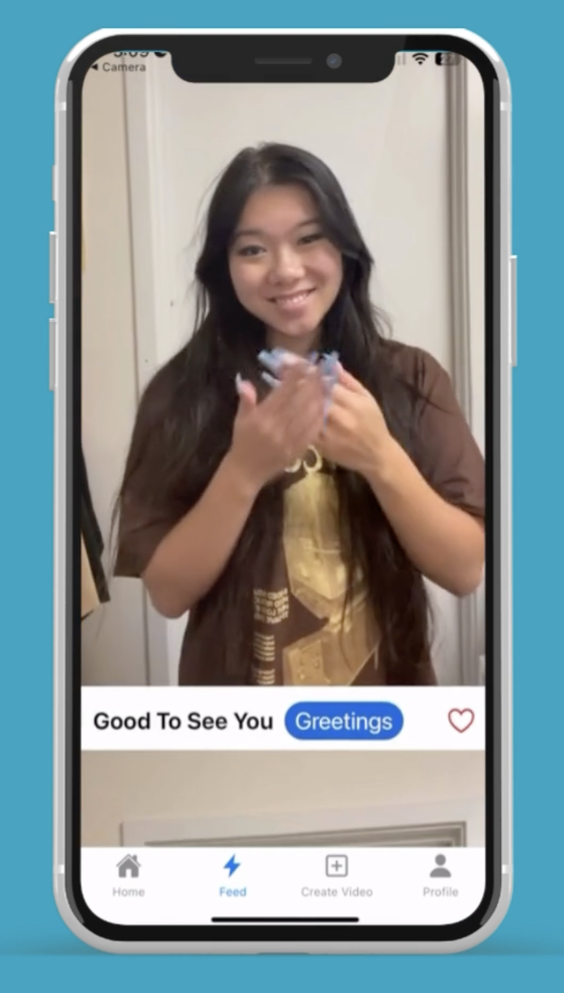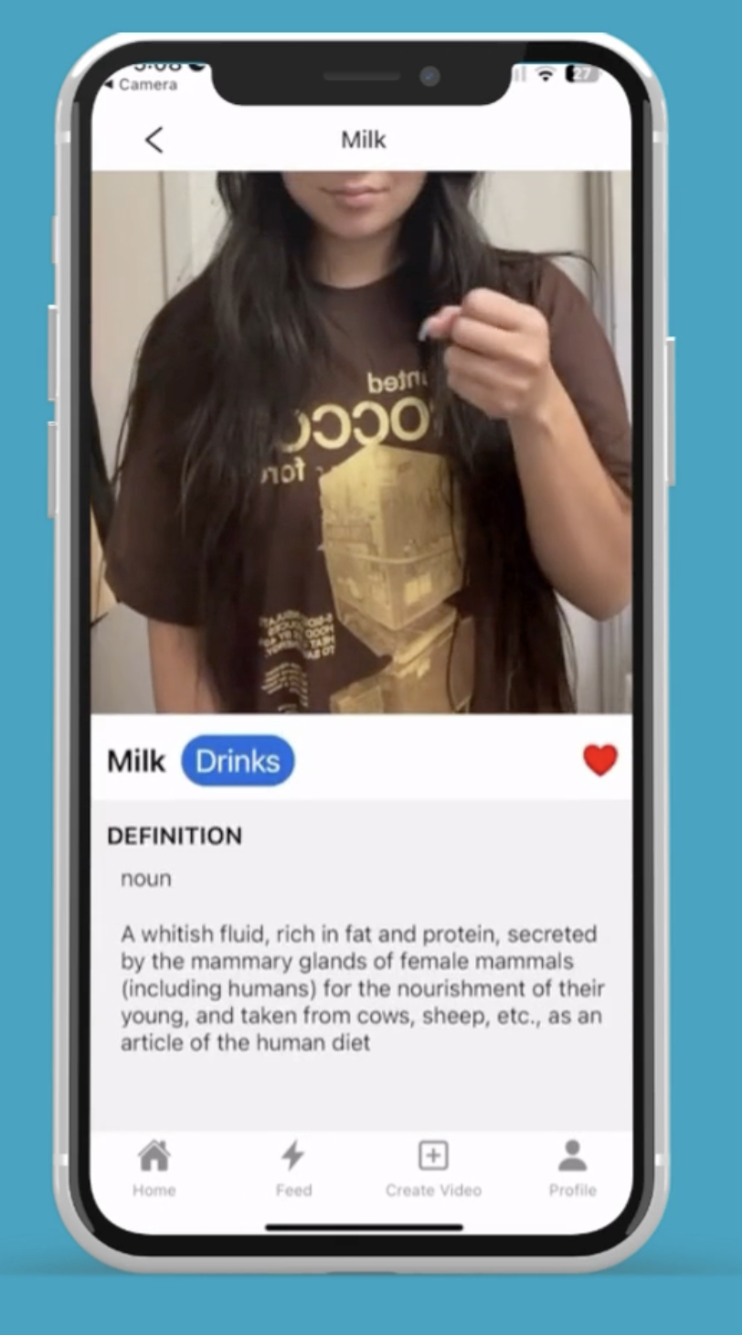

Task 3: Sharing your own content
Record a video, create a definition, and post to your profile!
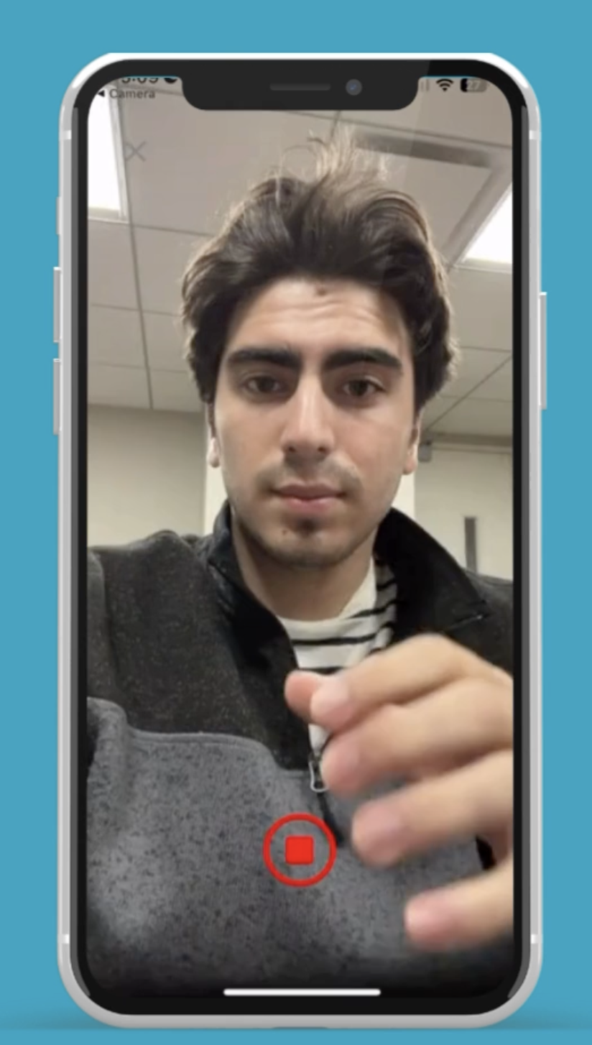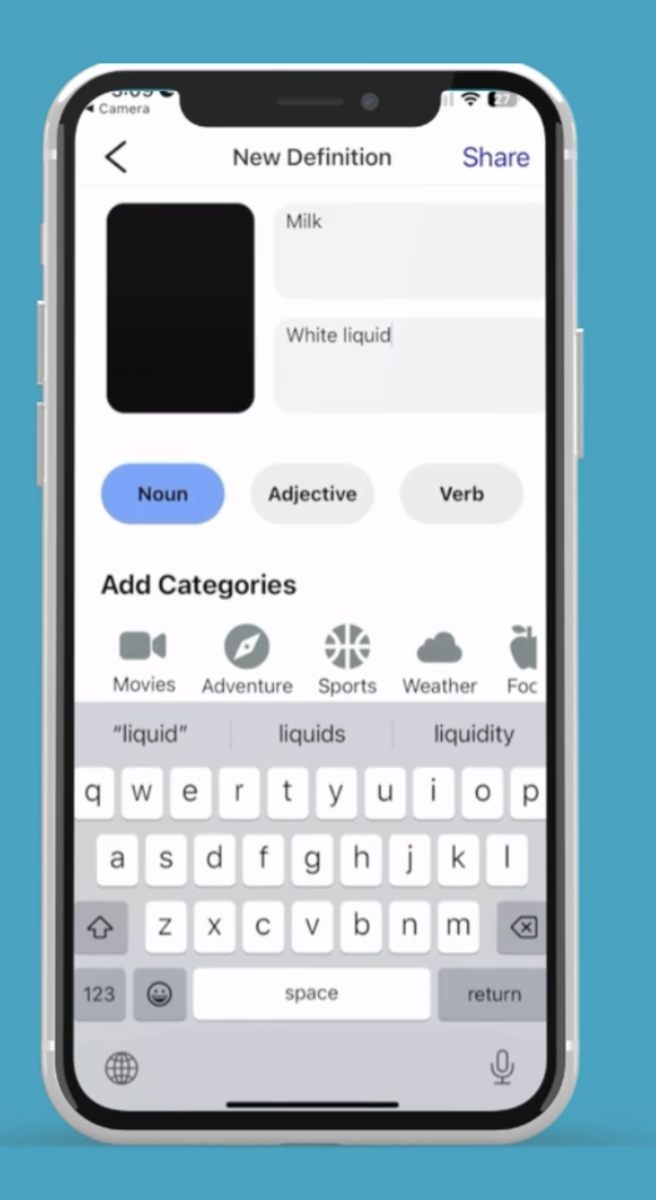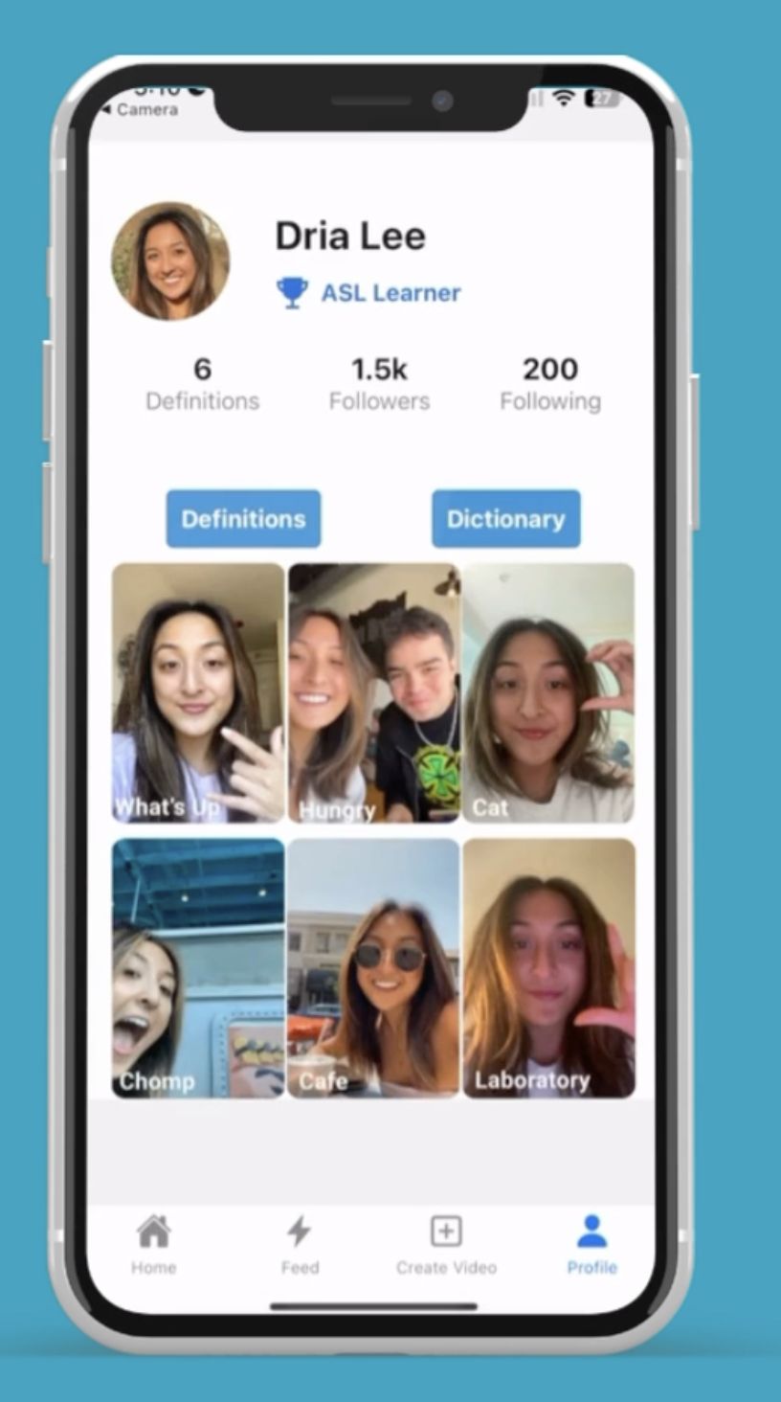

Values in Design
Throughout our process of designing TrainGone, we prioritized the following four design values to focus on in each step:

- Accessibility
- Unity
- Inclusivity
- Education

We used these values in fulfilling our vision of building a welcoming community of ASL learners and teachers.

Accessibility
We wanted TrainGone to eliminate limitations in both video creation and communication between ASL speakers and learners. Our application provides a straightforward design with customizable tags and captions so users can understand one another without the need for audio.

Unity
Unity surrounds our vision for building a welcoming community for both ASL speakers and learners. Regardless of one’s familiarity with ASL, we wanted TrainGone to be an intuitive and engaging platform for anyone to use. Users can view one another’s learning level and interact with videos at their level of learning.

Inclusivity
We want TrainGone to provide the opportunity for everyone to be heard. By eliminating the need for audio in the app, users can rely solely on visuals to interact with one another.

Education
TrainGone is rooted in the idea of an ASL to English reverse dictionary. Current models of reverse dictionaries lack an intuitive design and are frustrating for ASL learners to use. There are many steps involved in searching for an ASL word and these dictionaries often lack direct translation to English. From this observation, we began building TrainGone to provide a more intuitive solution for learning new ASL words.

Final Prototype Implementation

Tools used
To create our final prototype, we used Figma, React Native, and Expo. Each of these tools provided invaluable help in the implementation of our final project, however some came with drawbacks.

- Figma
We used Figma in the initial stages of our final prototype implementation by looking at the feedback from the heuristic evaluation and making changes to the existing medium-fi prototype until we were satisfied with the final design. Since our medium-fi prototype was housed in Figma, it was very easy to make changes - both small and large - to end up with our final design. The downside to using Figma as a base for our final prototype was that it is a lot easier to design a static figma prototype as opposed to a dynamic, functioning app. As a result, when we transferred our design from Figma to React Native, we had to leave out some details of the app.

- React Native
The React Native framework was the backbone of our final prototype. We used the React Native libraries almost exclusively in our implementation. The biggest benefit to using React Native is that it supports both Android and iOS. Since we value inclusivity in our project, we felt that this cross-platform feature was vital. Additionally, since React Native is a popular framework, there exists a lot of documentation for its features, and is easily accessible, which facilitated our ability to research different components for our app. The down-side to React Native was the way it handled videos and usage of the camera. We had to use other tools in order to implement videos and the camera to our app.

- Expo
In addition to React Native, we used Expo. Firstly, and most importantly, we used Expo to see how our app interface was looking in real-time, without having to do too much work. Secondly, we used Expo’s libraries to implement the video components of the app and gain access to the phone’s camera.

Hard-coded Techniques
The complex task for our project - creating a video - was fully implemented in our prototype. However the other two tasks, to look up a word and to browse other users’ videos, was limited by the fact that we did not have an existing user base. This meant that there were no entries of words that the user could look up, nor could the user look at other people’s videos. Therefore, we had to hard code some data in order to complete the other two task flows. We created nine dictionary entries, each belonging to one of three categories:
- Drinks: Water, Coffee, Milk
- Sports: Baseball, Soccer, Football
- Greetings: Hello, Good to see you, What’s up
In addition, we added thumbnails of videos in the home screen and profile screens. This was all done to give the appearance of an existing, fully functioning app.

Wizard of Oz Techniques
Since we do not have an existing network of users, it would be difficult and counter-productive to create a large amount of videos and then an algorithm to display them on our prototype. Since the specifications of the algorithm do not affect the overall user interface and experience with a prototype, we decided to imitate the video feed for the user. The aforementioned handful of videos that were created were displayed on the feed, so that when the user swiped, it would appear as if there were an infinite amount of videos, similar to other social media platforms. In reality, had the user scrolled down far enough, he/she would arrive at the end.

Key Learnings
This quarter, we learned a whole deal about the design thinking process and how to create a whole app from scratch. Going into this, none of us could imagine the idea we had come up with. Looking back, we’ve learned that the best solutions have been the most unexpected. Three core learnings stood out to us.

- Emphasize the “WHY”?
Firstly, we learned how crucial it is to dig deeper into the needfinding process. As we interviewed each of our participants, the most interesting stories developed when we pressed for more information. It takes both vulnerability from the interviewee and from the interviewer to understand a person’s story and what is really happening underneath the surface.

- Don’t dive in right away
When we got to the step of experience prototyping, our group had already begun to form a mental image of our solution. If we were not forced to test experience prototypes, we would never have realized our solution would not be desirable nor have worked. We began testing a language app, where users could meet up spontaneously and practice a language with those in close proximity to them. Testing our experience prototype required little cost but a lot of benefit, as it proved how bad our idea was.

- Utilize robust testing
Lastly, we learned how crucial it is to participate in a robust heuristic testing with a group of people uninvolved in our project. Most of our design changes came from this step, as our partnered team revealed a whole list of things we had brushed under the surface. When designing in a short period of time, it’s impossible to not think of every little detail. Therefore, we found this step to be incredibly useful before implementing our hi-fidelity prototype.

Final Remarks

Thank you for taking the time to learn about TrainGone and read our report. Creating this project was an incredible experience where we not only learned a lot, but got to take away a really cool idea and our own app.

Finally, thank you Professor Landay and Grace for supporting us along our journey!

