
connect vulnerably and consistently

Table of Contents
Project Name and Value Proposition
Team Member Names and Roles
Problem/Solution Overview
Needfinding
- Interviews
- Synthesis
POVs & Experience Prototypes
- Final POV Statements and Sample HMWs
- Top 3 HMWs
- Top 3 Solutions
- Description of Experience Prototypes
Design Evolution
- Final Solution
- Tasks
- Design Evolution Visualization and Rationale
- Values in Design
Final Prototype Implementation
Reflection and Next Steps

Project Name and Value Proposition

Project Name
Tell Me More

Value Proposition
Connect vulnerably and consistently

Team Member Names and Roles

Gabriel Iluma
Developer/Designer
Paige Olson
Developer/Designer
Chloe Pae
Developer/Designer

Problem/Solution Overview

Problem
Friends want to stay in touch and understand what is going on in each other's lives, but often struggle to have meaningful conversations or express vulnerabilities that could elicit support.

Solution
Tell Me More allows groups of friends seeking more meaningful connection to answer a daily prompt aiming to encourage vulnerability. Then, each friend’s answer is broadcasted to the whole group, providing an easy outlet to express emotions or worries. ​

Needfinding

Interviews
We interviewed a total of six people with different backgrounds, opinions, and life stages. Our interviewees ranged from ages 20 to 60 and held a variety of occupations including student, artist, venture capitalist, teacher, CEO, and entrepreneur. We sourced interviews using word-of-mouth, contacting friends of friends via iMessage and Email. Four interviews took place at cafes on the Stanford campus and two interviews were held on Zoom for logistical reasons (the participants were based in Malaysia and Nairobi).
At first, we narrowed down our studio domain from Preserving the Past to Preserving Relationships. For our first round of needfinding interviews, we interviewed four people: Sita (student), Jennie (artist and mom), Anton (venture partner), and John (serial entrepreneur). We asked interviewees about the closest people in their lives, who they talked to in the past 24 hours, and methods for staying connected with friends and family. We uncovered valuable insights from these interviews: large friend groups are comfortable in that planning is easier but not every member of the group would necessarily hang out alone with every other member (Sita), seeing people in groups is more efficient but less meaningful (Anton), people seeking meaningful connections will avoid intimate conversations out of fear of vulnerability (John), and having a set time to talk to long-distance friends is effective in maintaining relationships (Jennie). In this first round of interviews, we were able to build rapport and be flexible with our interview outline. However, we had difficulty identifying the surprising moments in the interview

and therefore tried to ask follow up questions to the truly surprising insights in the next round.
After analyzing the first four interviews, we redefined our domain to Preserving Intimacy in Platonic Relationships because we noticed that interviewees revealed more struggles and insights about these types of relationships. We sourced two more interviewees by looking for people in extreme long distance friendships : Natachi (CEO of Ndeza Collective who had just moved to Kenya, away from all of her friends and family) and Hollie (academic technology specialist who has kept the same three best friends for decades). In this round of interviews, we focused on questions that lead to stories and avoided leading questions. Our interviewees shared that building friendships feels like dating in its performative nature but there are ways to skip these performative first steps (Natachi) and that some people are willing to proactively and dramatically change their own lives in order to accommodate friends (Hollie).

Synthesis
We synthesized our data by creating empathy maps for all six interviews. We then identified the most important parts of each empathy map and used these insights to infer needs. Through this process, we discovered the most important needs voiced from our interviewees were the needs to easily connect with friends in a way that is meaningful yet does not induce fear of rejection. Surprisingly, we found that this fear of rejection existed regardless of the closeness of the relationship. This surprising insight at the beginning of our process stuck with us throughout the rest of our process.
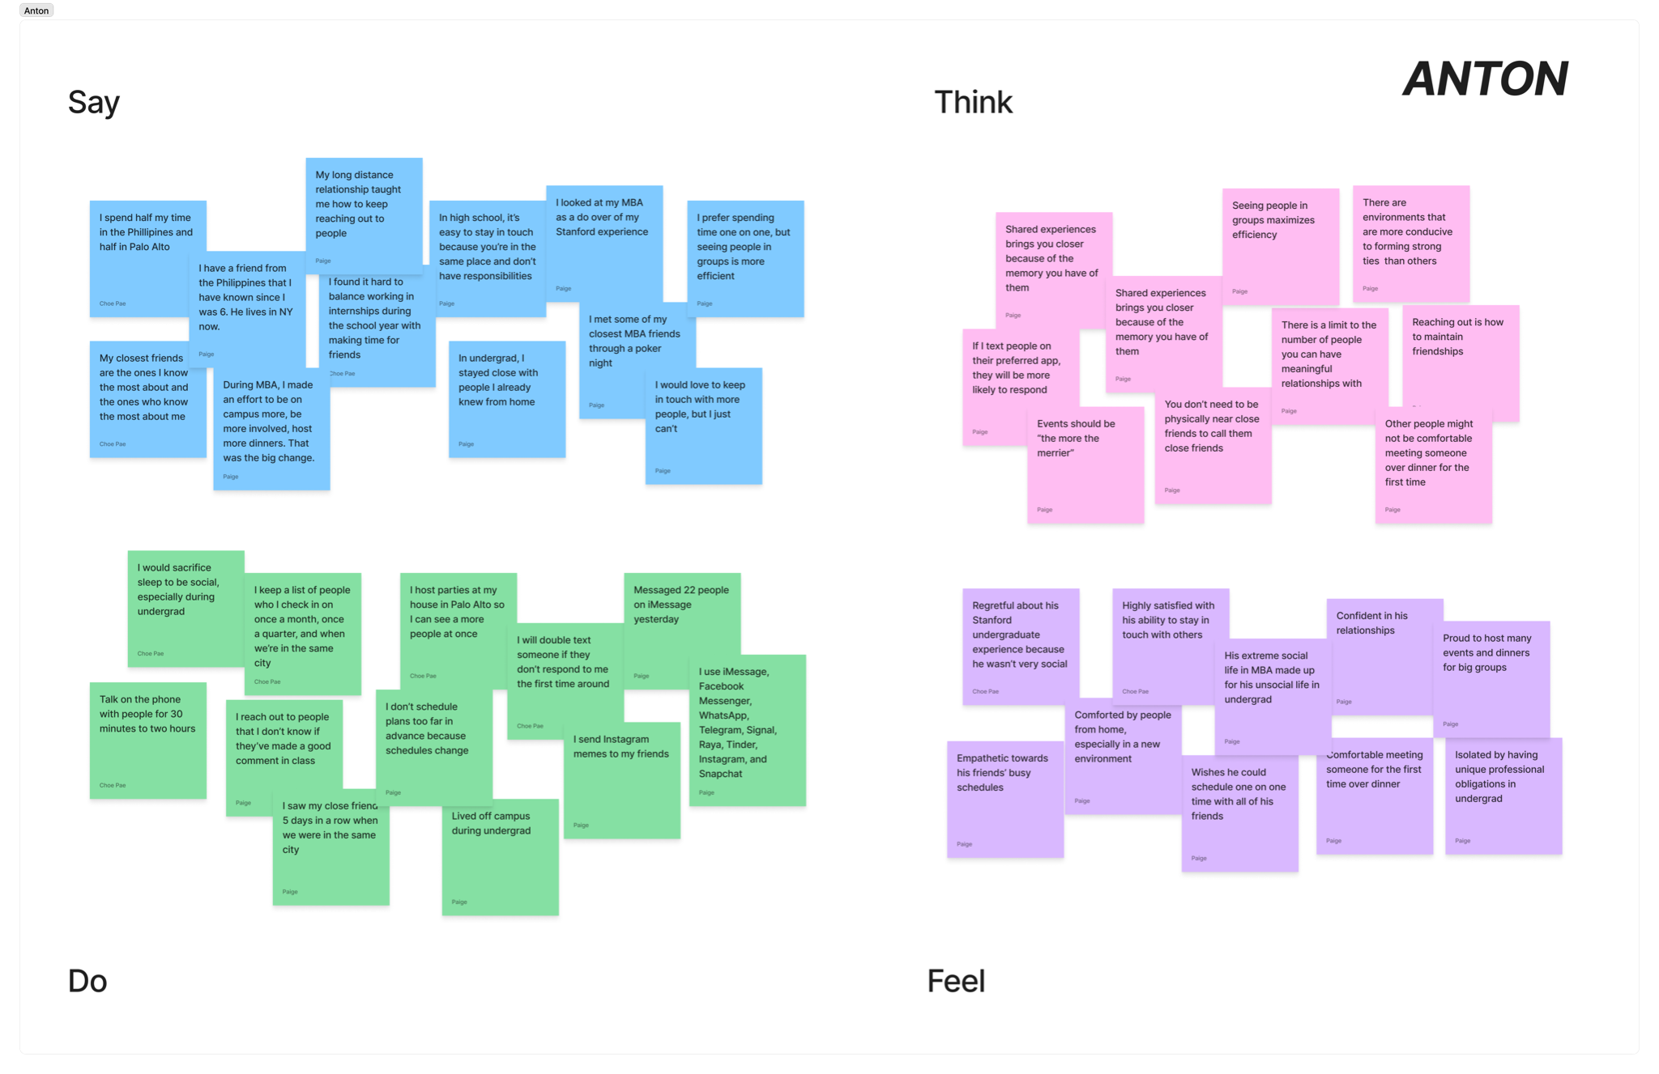
Figure 1: Empathy map for Sita, a sophomore at Stanford who described the difficulties in scheduling plans without feeling vulnerable.
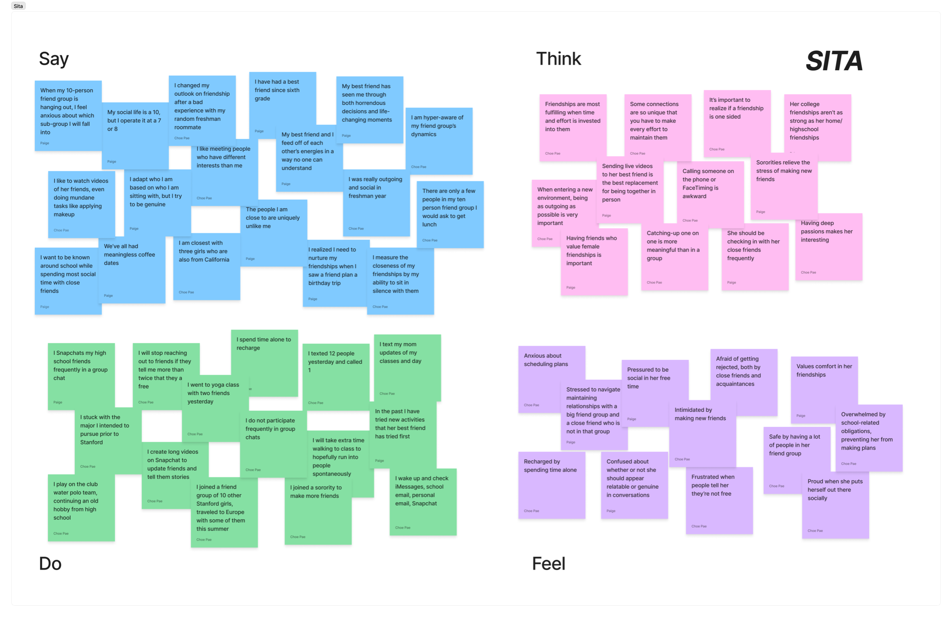
Figure 2: Empathy map for Anton, a venture partner who struggles to organize his friendships in a way that doesn’t feel clinical.
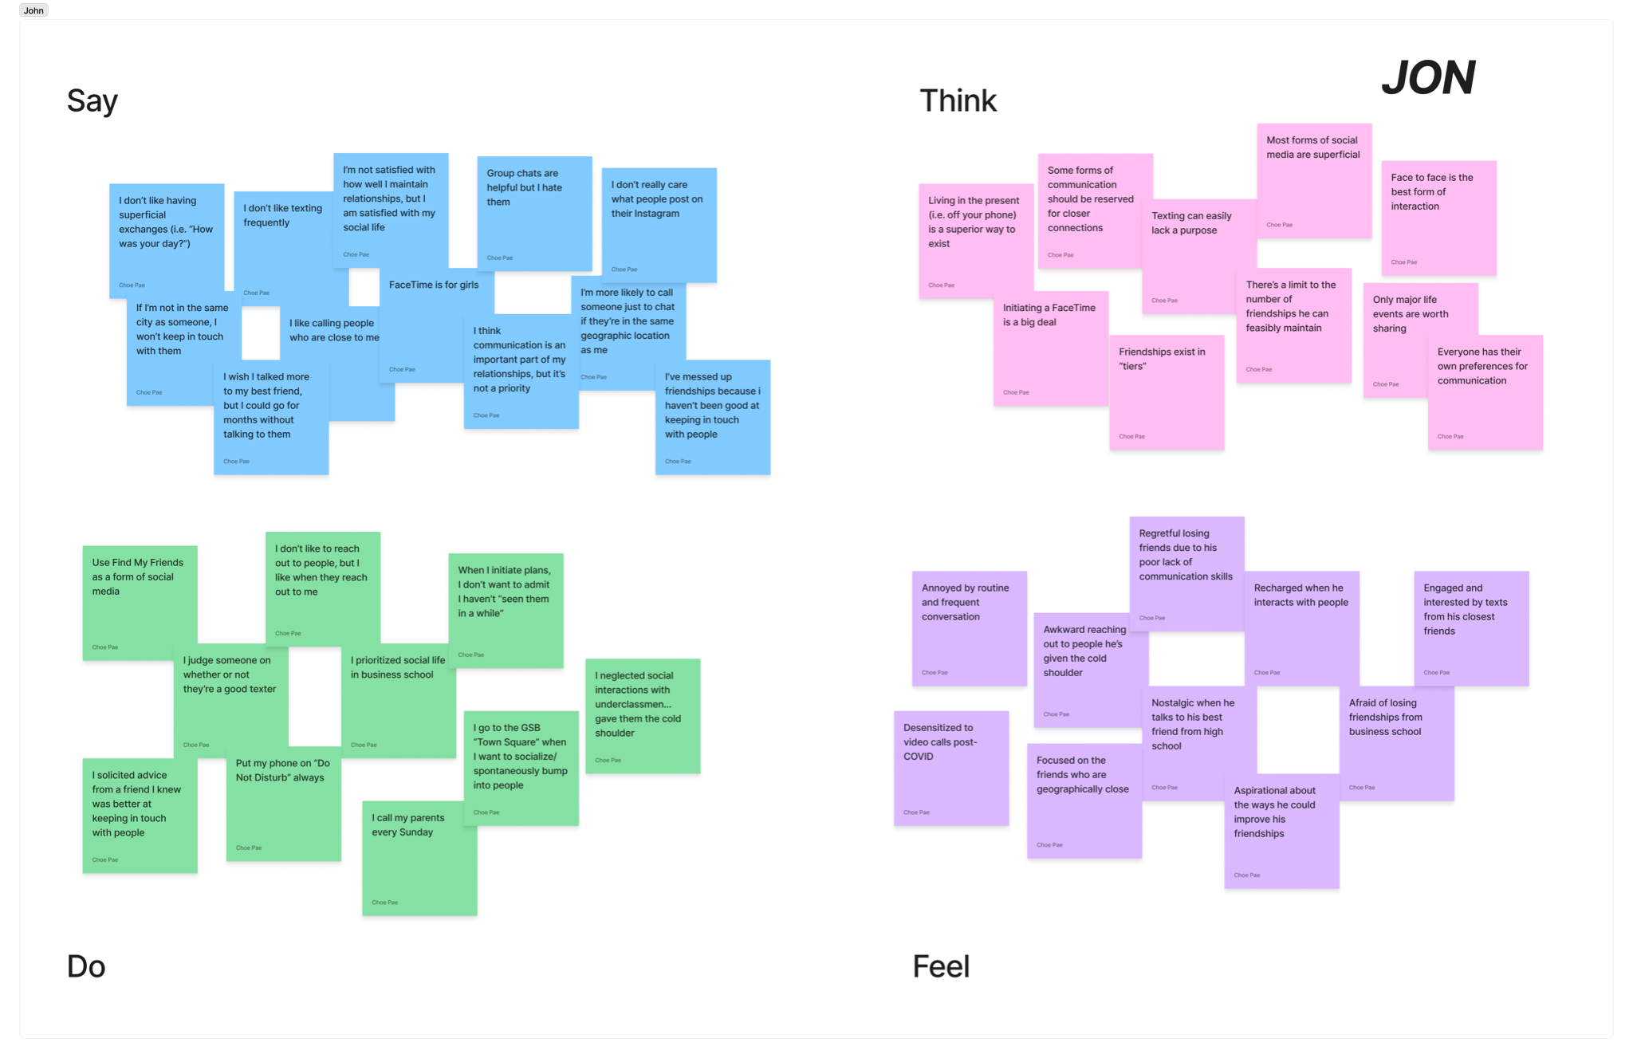
Figure 3: Empathy map for Jennie, a painter and mother who reflected on the way she adds friends to her existing routines.
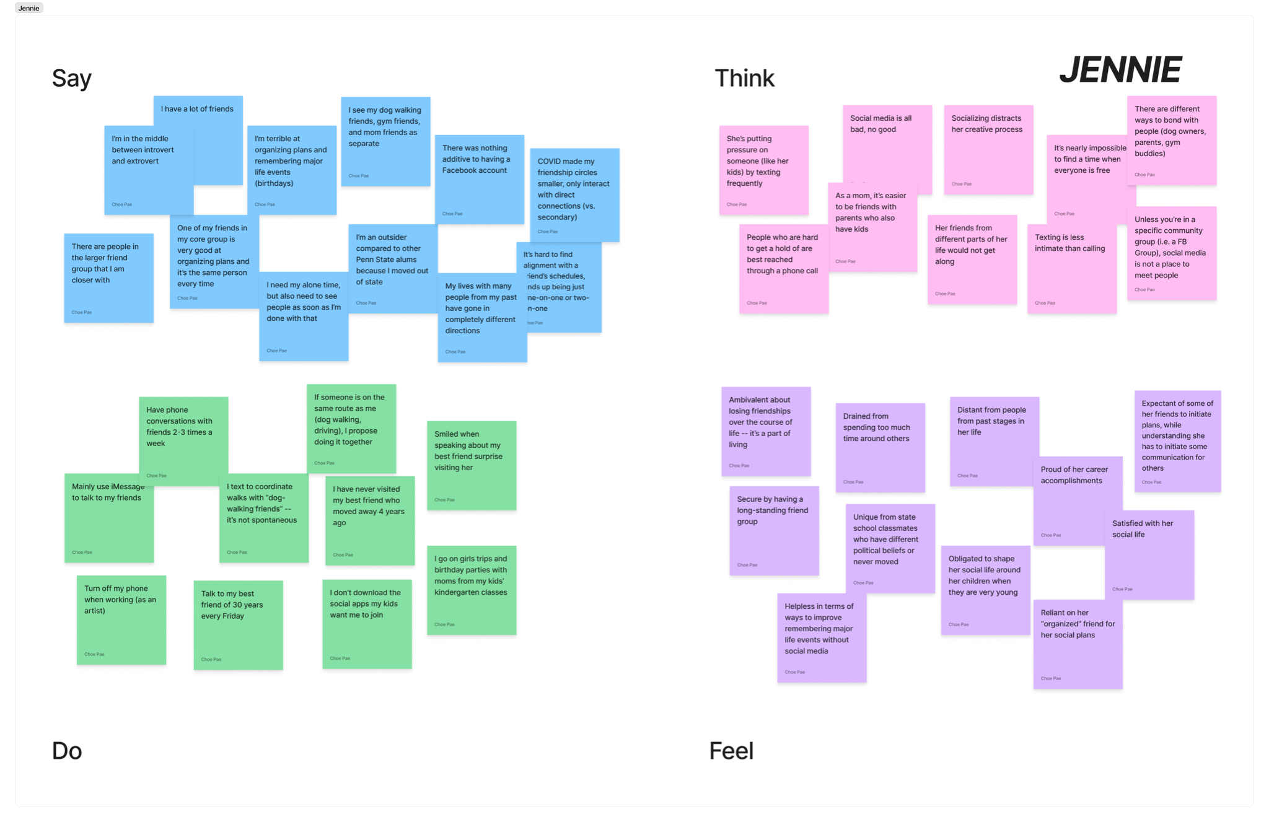
Figure 4: Empathy map for Jon, a serial entrepreneur who explained that he does not enjoy catching up with friends because conversations are often surface-level.
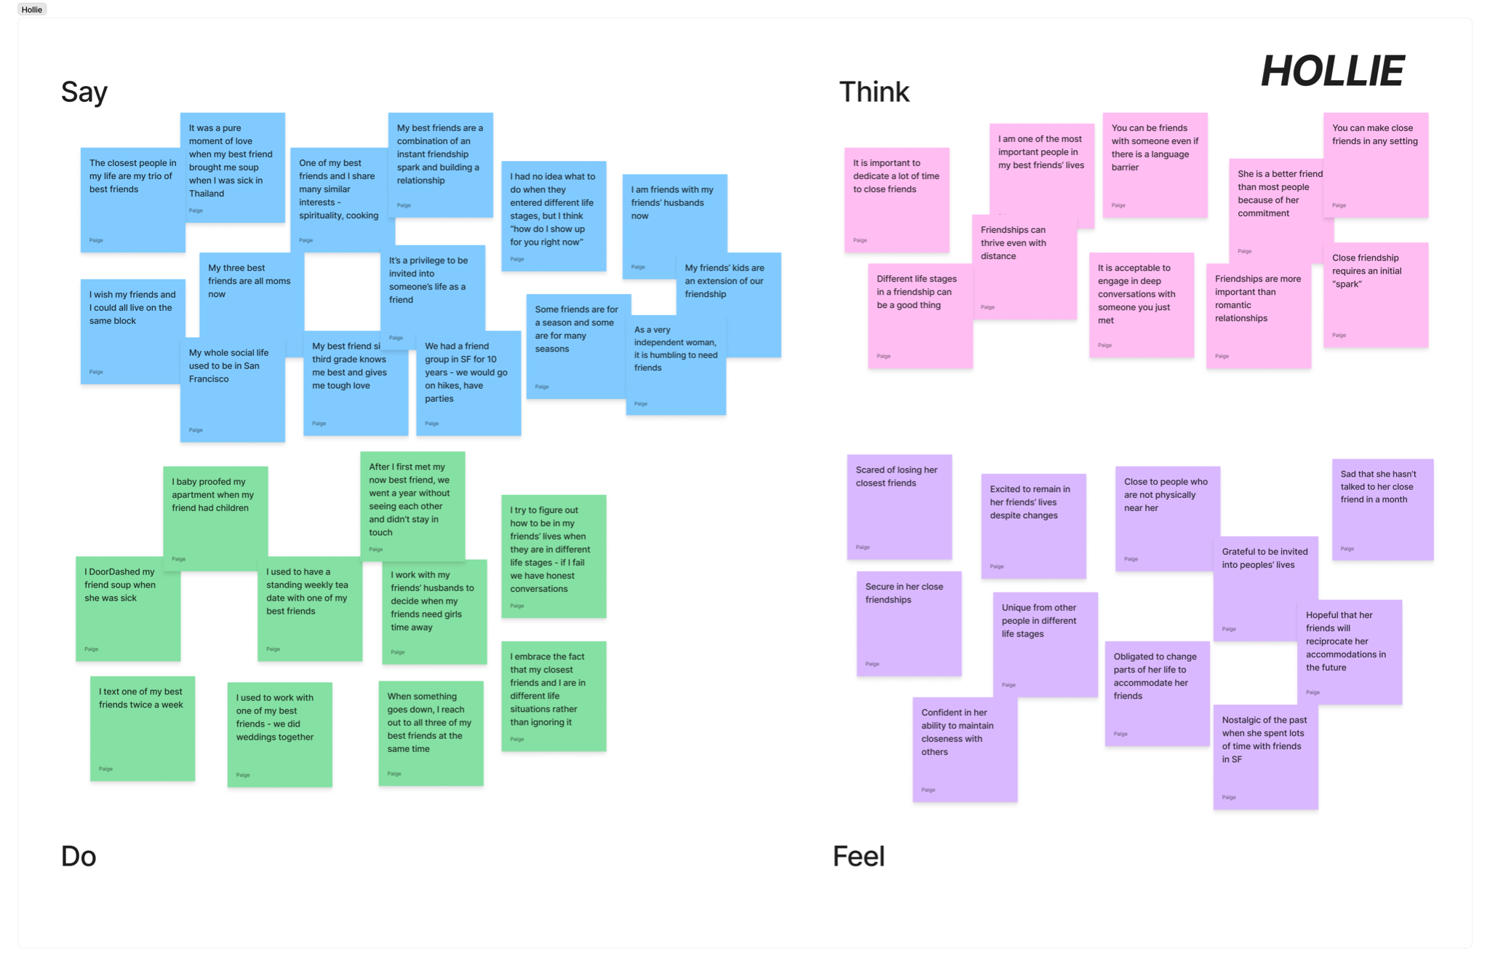
Figure 5: Empathy map for Natachi, a recent college grad who moved to Kenya without any friends or family and talked about the ways she has made close friends in Kenya.
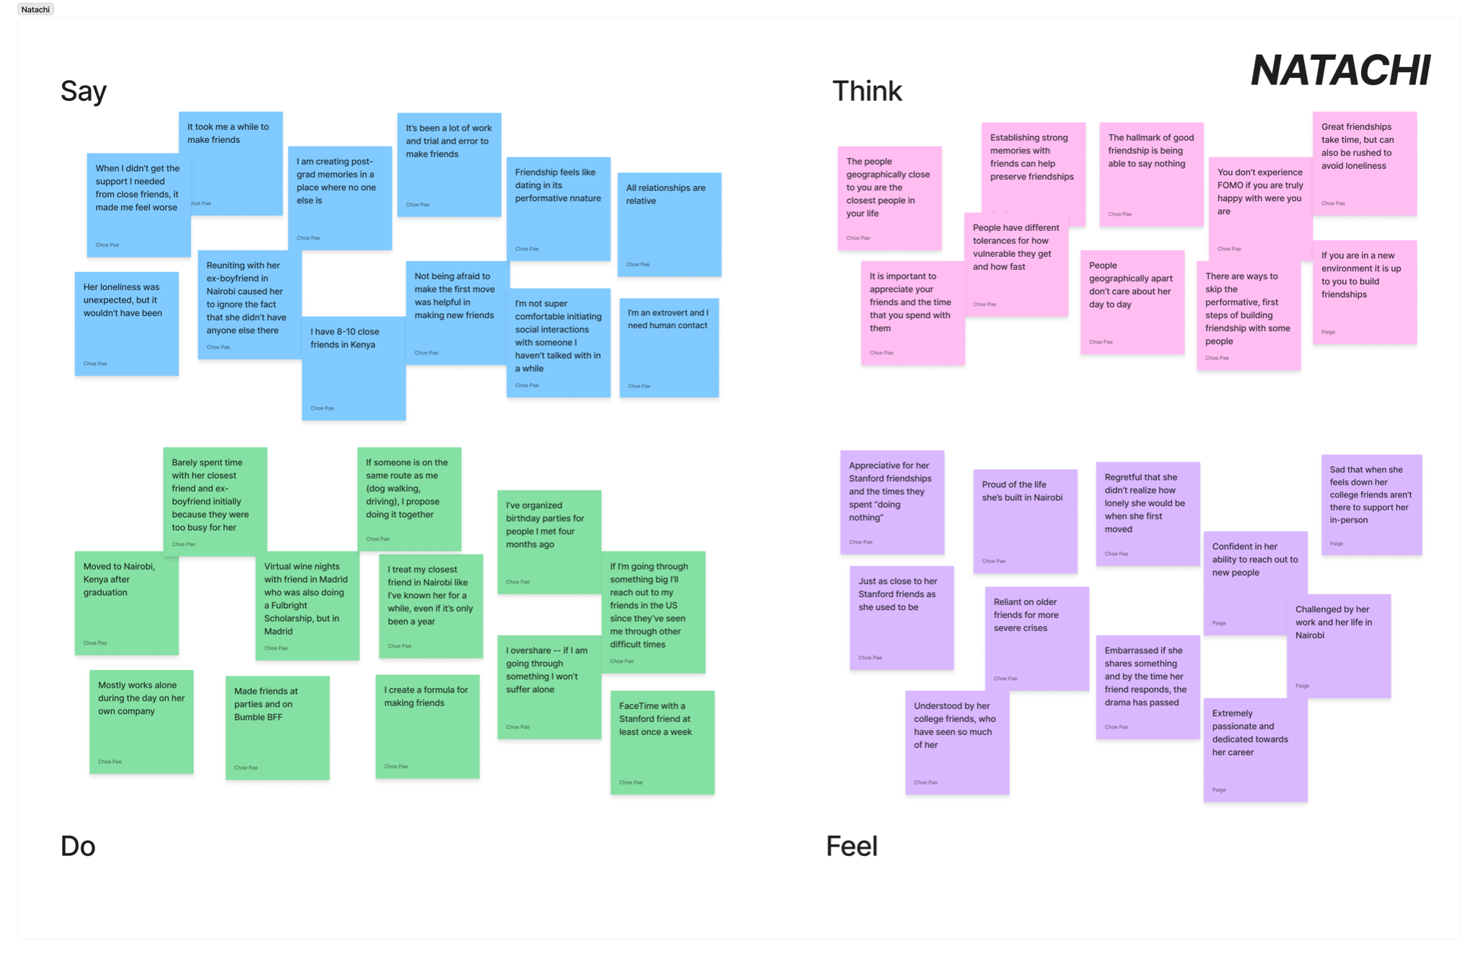
Figure 6: Empathy map for Hollie, an academic technology specialist who is extremely grateful to be invited into her friends’ lives and families.

POVs & Experience Prototypes
After synthesizing our interview data to discover key insights and needs, we created POV statements for our most engaging, relevant, and interesting interviews (Sita, John, and Hollie). For each POV, we brainstormed several HMW statements, aiming to quickly create as many ideas as possible using techniques such as exploring the opposite, breaking the POV into parts, and going after adjectives. Then, we selected the three best HMWs and brainstormed at least 10 solutions for each. Finally, we selected the three best solutions and designed an experience prototype for each solution.

Final POV Statements and Sample HMWs

Sita’s POV:
- We met Sita, a sophomore at Stanford in a friend group of 10 people.
- We were surprised to notice that to achieve spontaneity in her friendships, she intentionally leaves for class early to try to run into her friends.
- We wonder if this means that Sita might feel vulnerable or exposed when initiating structured plans (due to the possibility of rejection) and instead relies on spontaneous encounters to avoid this fear.
- It would be game-changing if we can empower Sita to impulsively initiate moments with friends without the anxiety associated with making the first move.

Sita’s Sample HMWs:
- How might we empower individuals to initiate time with friends without feeling needy?
- How might we not bear sole responsibility of event-planning for her friend group?
- How might we make planning hangouts as easy as booking an Uber?

John’s POV:
- We met John, a serial entrepreneur and recent graduate of Stanford GSB who is satisfied with the relationships in his life, but recognizes that there is room for improvement.
- We were surprised to notice that despite wanting to have meaningful relationships, John will only connect with friends who are in the same geographic location as him - “out of sight, out of mind.”
- We wonder if this means that John believes that distance in friendships ultimately leads to superficial relationships because friends end up “catching up” instead of having meaningful conversations.
- It would be game-changing to reframe distance as an advantage in creating more intimate platonic relationships.

John’s Sample HMWs:
- How might we create more intimate interactions in long-distance relationships?
- How might we make catching-up the most exciting part of a friendship?
- How might we make being vulnerable fun?

Hollie’s POV:
- We met Hollie, a self-identified “very independent” woman and the only woman amongst her three long-term best friends without children.
- We were surprised to notice that in contrast to simply drifting apart, Hollie has proactively accommodated (i.e. by babyproofing her apartment) the shifts in her friends’ lives and priorities to sustain the bonds she cherishes the most.
- We wonder if this means Hollie is acutely aware of the mismatch between her and her friends’ life stages, and hopes that the accommodation she’s making will signal her sustained relevance to her friends.
- It would be game-changing to provide Hollie and her friends ways to appreciate the relevance they still hold in each other’s lives, especially as their life paths diverge.

Hollie’s Sample HMWs:
- How might we help Hollie find more effortless ways to remain relevant?
- How might we encourage empathy in friendships despite a lack of shared experience?
- How might we detect when cherished friendships are drifting apart?

Top 3 HMWs
- How might we make planning hangouts as easy as booking an Uber?
- How might we make being vulnerable fun?
- How might we detect when cherished friendships are drifting apart?

Top 3 Solutions
- Integrated Calendar System
A system that identifies opportunities for friends to hang out. Users would take a daily quiz about their schedule and be matched with friends based on availability and preferences.
- Shared Daily Journal
A daily journal for friend groups that provides prompts to encourage greater vulnerability. A user can only view their friends’ submissions once they have answered the question.
- Check In Nudges
Leveraging user-set “friendship goals”, the system would “nudge” users, reminding them to reach out to specific friends at a specified cadence.

Description of Experience Prototypes
- Integrated Calendar System
Assumption: People think that even quick, in-person hang-outs strengthen their friendships
Set Up: We asked people to interact with a close friend they wouldn't normally see daily for 10 minutes. Afterwards the friend answered questions (“How close do you feel to the person you chose?” and “Are you glad you took the time to talk to them?”) asking them to reflect on the exercise and describe the effect - if any - it had on their friendship with that person. We used iMessage to reach out to participants and send them the survey. Our participants were two Stanford undergraduates.
Results/Implications: We found that participants were glad they had these short hangouts, they felt closer to their friends after, and that participants were willing to initiate these conversations. However, conversations were seen as "a break from work" not a friendship investment, people were too busy to see friends in person during the day (these conversations happened at night), and further testing would be needed on relationships that are already strong. Our takeaways from this experience prototype were that short in-person hangouts are beneficial to the overall friendship and people are able to see friends, but need to be encouraged to do so.
- Shared Daily Journal
Assumption: Short, online expressions of vulnerability are powerful enough to encourage a habit of opening up (compared to FtF).
Set Up: Pairs or trios of friends filled out a 4-question Google Form asking them what they were most grateful for that week, which part of their week they needed support the most, something they were looking forward to, and if there’s anything they wished their friends knew was going on. Once all group members filled out the form, they were sent a copy of their own responses and their friends via email. They then completed a survey asking them to reflect on the exercise and if they reached out to any friends after viewing the responses. Our participants were six Stanford undergraduates, split into two groups of three.
Results/Implications: We found that participants checked in on their friends via text or in-person after reading responses, viewed the questions as introspective and reflective, and realized they were worried about similar things. However, participants felt "weird" being vulnerable on a computer, participants weren't the same "level" of vulnerable (which upset those who opened up more), and prompts weren’t deep enough to uncover new insights among very close friends. Our takeaway from this experience prototype was that short expressions of vulnerability are powerful in eliciting support, but being online makes it difficult.
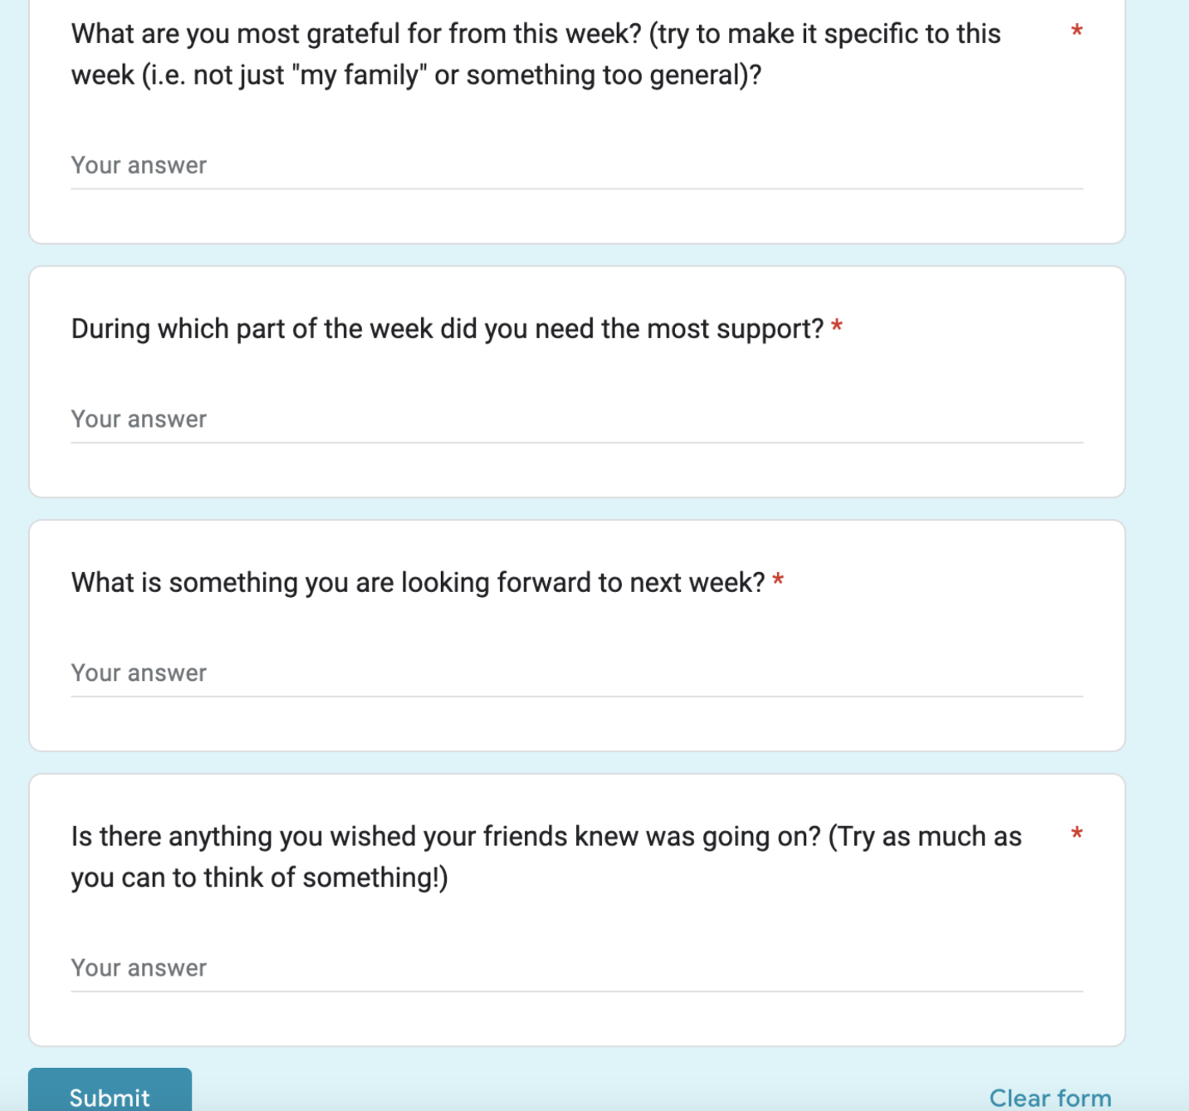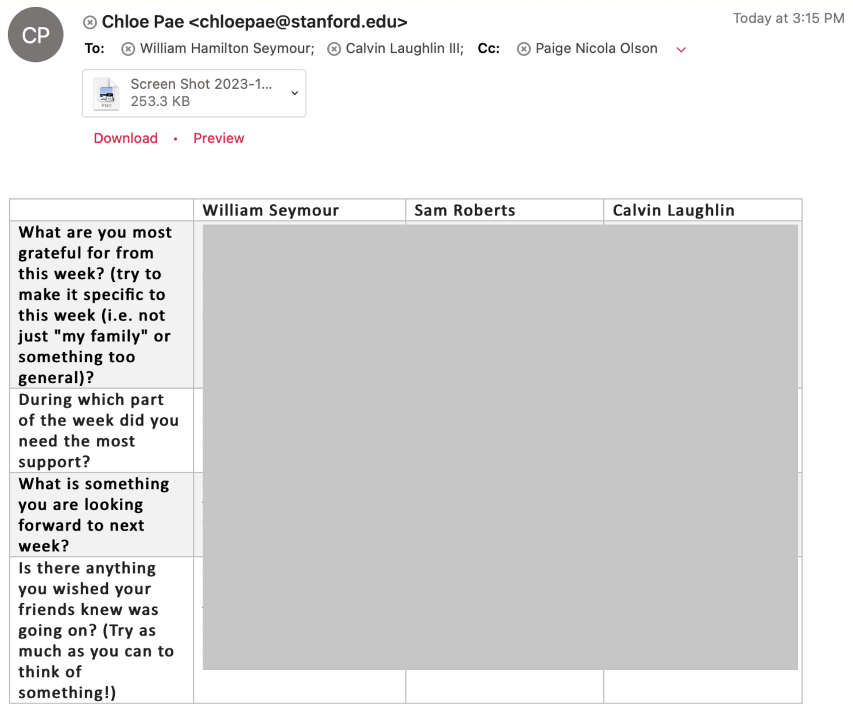
- Check In Nudges
Assumption: People would be unafraid to reach out in the first place.
Set Up: Over the course of one day, “nudges” were sent to encourage each participant to reach out to 5 friends. At the end of the day, the user was asked to reflect on the effectiveness of the activity (“How many friends did you actually reach out to?”). Our participants were five Stanford undergraduates.
Results/Implications: We found that participants reached out to 2-3 friends on average and that participants liked being reminded to reach out and reported that Nudges and the resulting interactions "made their day better." However, some people thought the prototype took too "clinical" of an approach to friendship and some found that it had already been "too long" to reach out to a friend, so they ignored the Nudge. Our takeaways from this experience prototype were that participants were unafraid to reach out to individuals proximate to them, but shied away from those they lost touch with and people often need their hand-held with how best to reach out
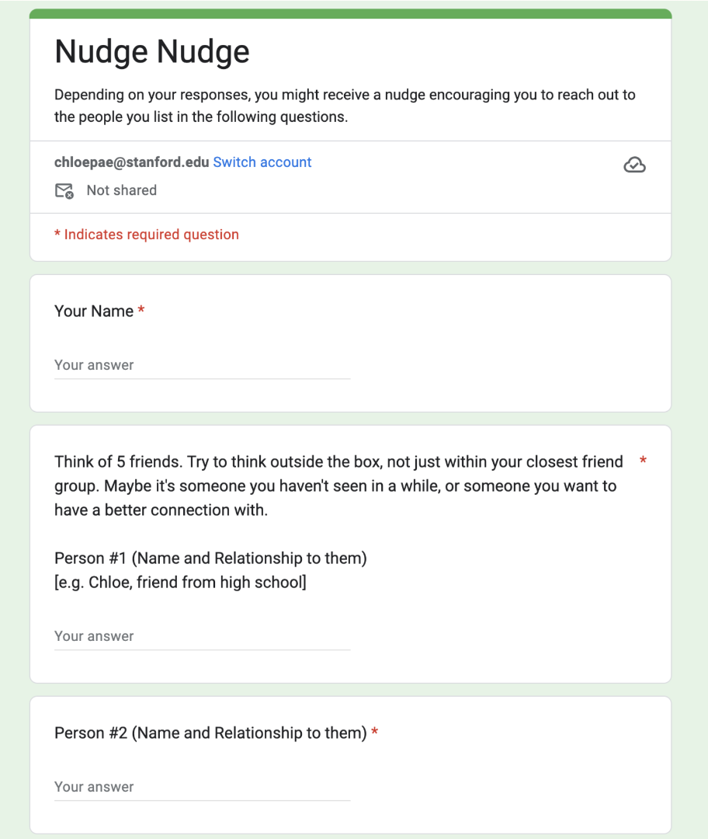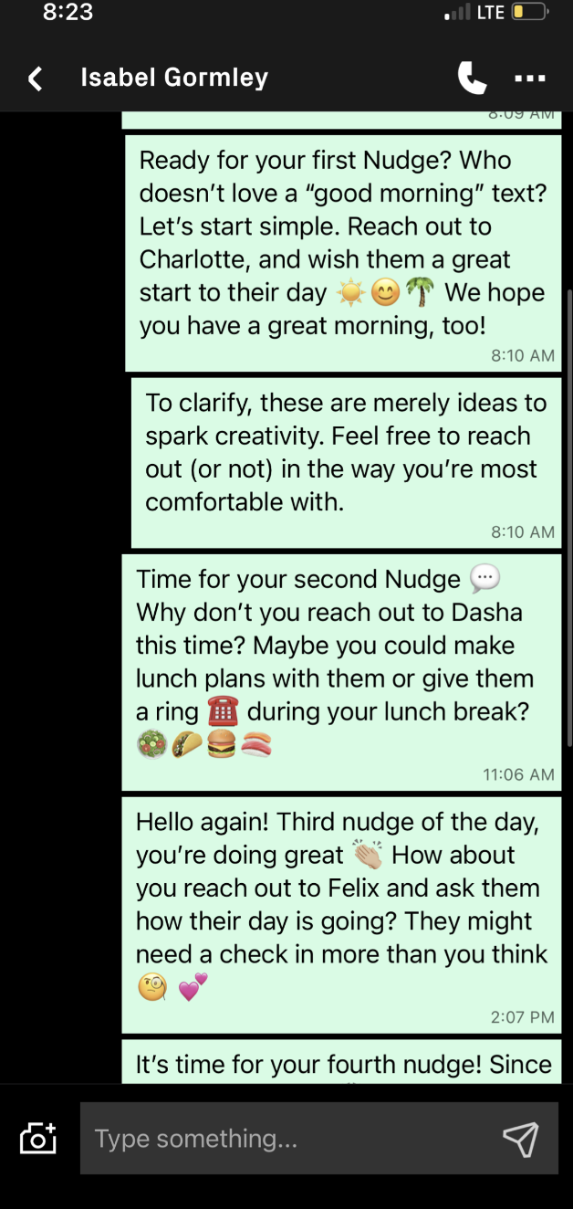

Design Evolution

Final Solution - Tell Me More

Description
A platform that allows friends to answer a daily prompt focused on meaningful conversation, then broadcasts each friend’s answer to the whole group.

Target Audience
Tight knit groups seeking to maintain or strengthen emotional connections.

Rationale for Selected Solution
From our experience prototypes, we found that these insights were most helpful in guiding us towards a solution:
- Short, online expressions of vulnerability are powerful enough to elicit support and connection. In our Shared Journal experience prototype, friends reported reaching out to support one another after viewing their group’s responses. Friends also revealed that they discovered new insights about their closest friends through our experience prototype, and realized that their current procedures in place were insufficient for truly making sure their friends were healthy mentally.
- People want to feel like they’re on the same level of vulnerability with their friends. In the Shared Journal experience prototype, one participant wrote answers that were much more vulnerable than their friends. In her follow-up survey, this person expressed frustration that their friends were not as vulnerable in their responses.
- Some people needed help reaching out to certain friends, possibly because too much time has passed since they last communicated. In the Check In Nudges experience prototype, many participants reached out to friends following the nudges. However, some participants reported that it had simply been too long to reach out.
Using these insights, we decided which features to incorporate into our solution and decided upon 1) intimate questions to encourage vulnerability and reflection 2) nudges to encourage communication at a regular cadence, and 3) a feature that allows friends to view each other’s vulnerable responses. We then brainstormed a platform that could incorporate each of these features and settled on Tell Me More. Tell Me More sends groups of friends a daily vulnerable prompt, only allowing users to see friends’ responses after they have responded, Since prompts our daily by default, they serve as a regular nudge to interact with friends. This repeated interaction should create a norm around levels of vulnerability, reducing the risk of unbalanced vulnerability among friends.

Tasks
- Simple task: Answer a prompt in order to see your friend group’s responses
Creating a response to a prompt and sending it to a group is integral to our goal of promoting vulnerability and reflection . We believe this task will be used most frequently as it is easy to do and happens daily (or at a set frequency). This task requires users to navigate to the groups page, fill out a response to the prompt, then view their friends’ responses.
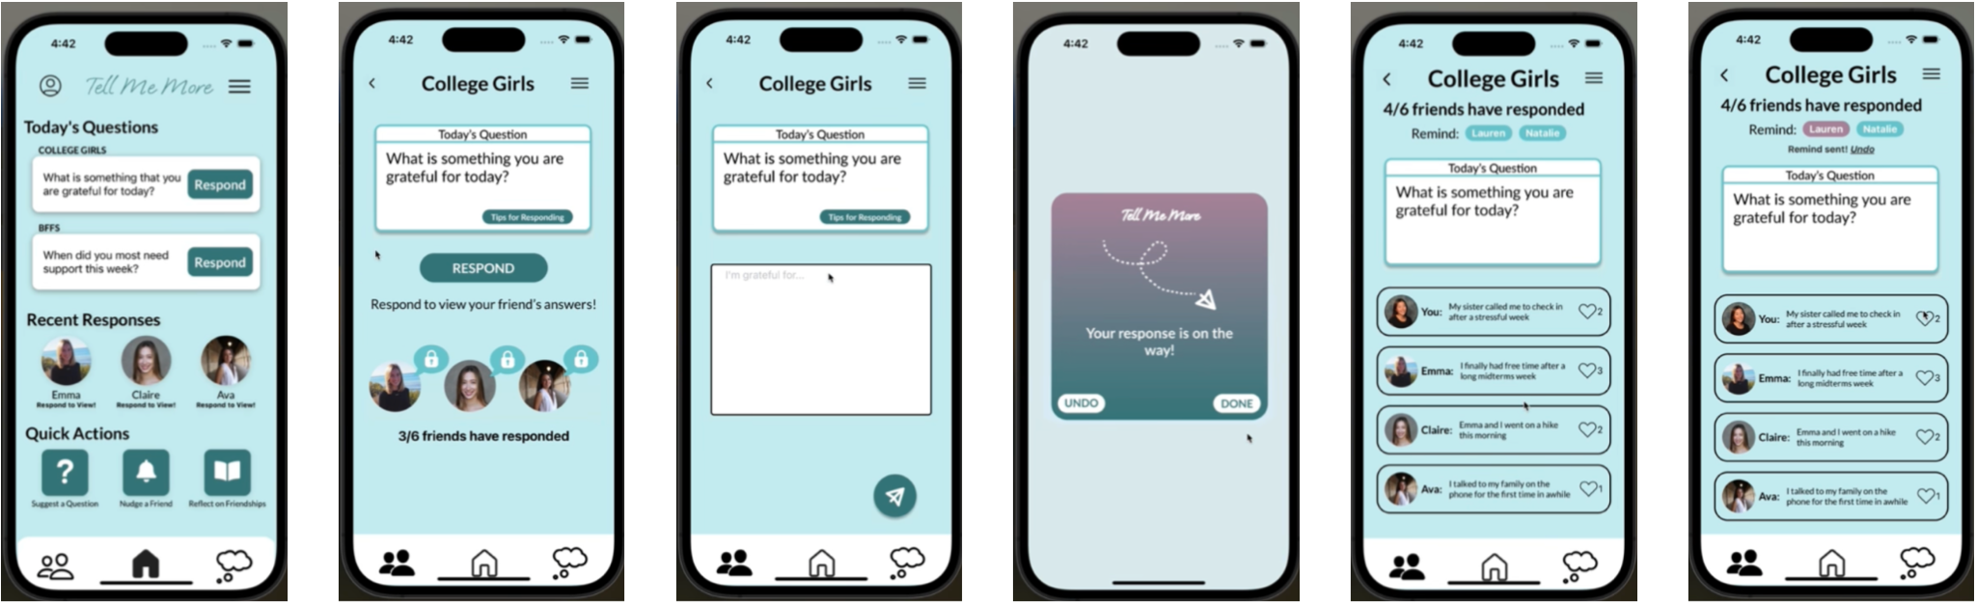Begin on Home page -> Click Respond -> Click Respond again -> Answer prompt and send response -> Receive confirmation and click Done or Undo -> View / like group’s responses!
- Moderate task: Suggest a question for the group to answer
To encourage friend groups to give answers to things of interest to the group, we offer users the ability to suggest their own questions. We give users the option to suggest questions to one group or multiple groups. This task requires users to navigate to the “Suggest a Question” form, write a question, and send it to selected groups. Note: This is one of many ways to Suggest a Question!
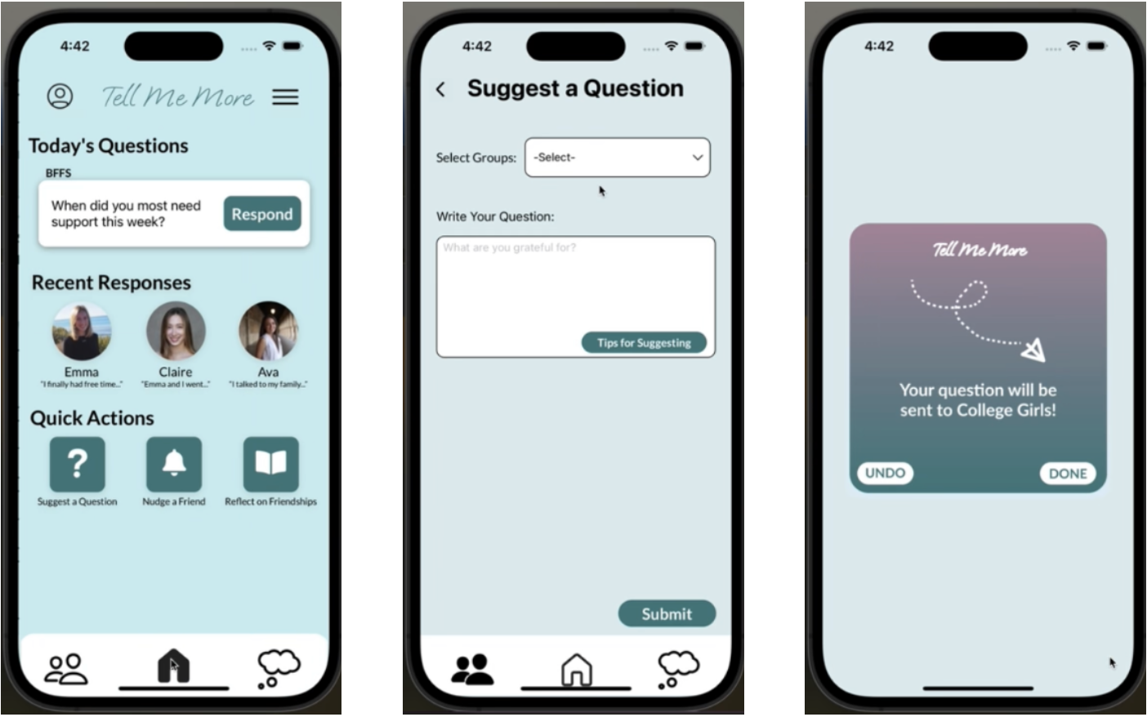
Begin on Home page -> Click Suggest a Question -> Pick a group, write question, and submit -> Receive confirmation and click Done or Undo!
- Complex task: Build a group of friends to encourage sharing vulnerable thoughts
Tell Me More is meant for small, tight-knit groups and therefore creating a group is an important part of the experience. This is the complex task because a user would only have to create or join a group a few times in their Tell Me More experience. This task requires users to navigate to the groups page, then fill out the “Create a Group” form and add friends.
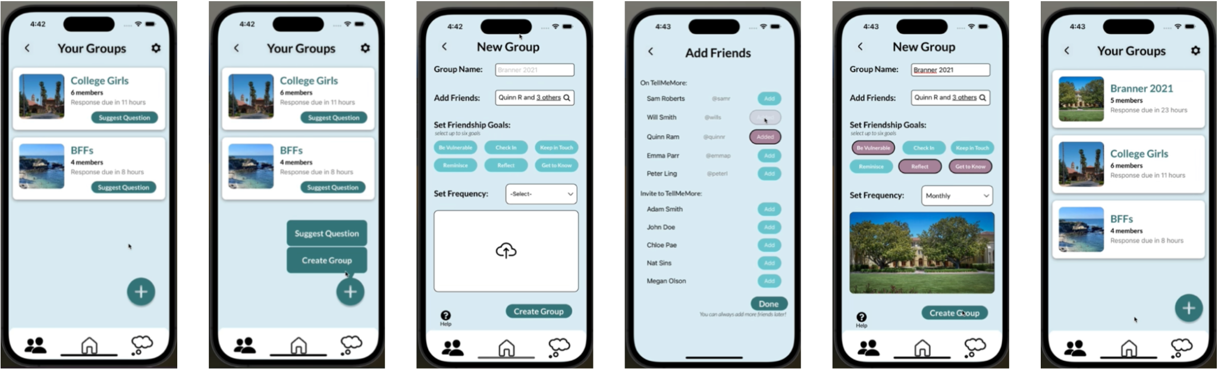
Begin on Groups page -> Click plus and select Create Group -> Input name, add friends, select friendship goals, set frequency, and upload photo -> Click create group and view new group on Groups page!

Design Evolution Visualization and Rationale

Low Fidelity Prototype/Initial Sketches
Before constructing our low fidelity prototype, we brainstormed various realizations for our solution including wearables, mobile applications, augmented reality, and virtual reality. We were most interested in a mobile application or augmented reality.
- Mobile application
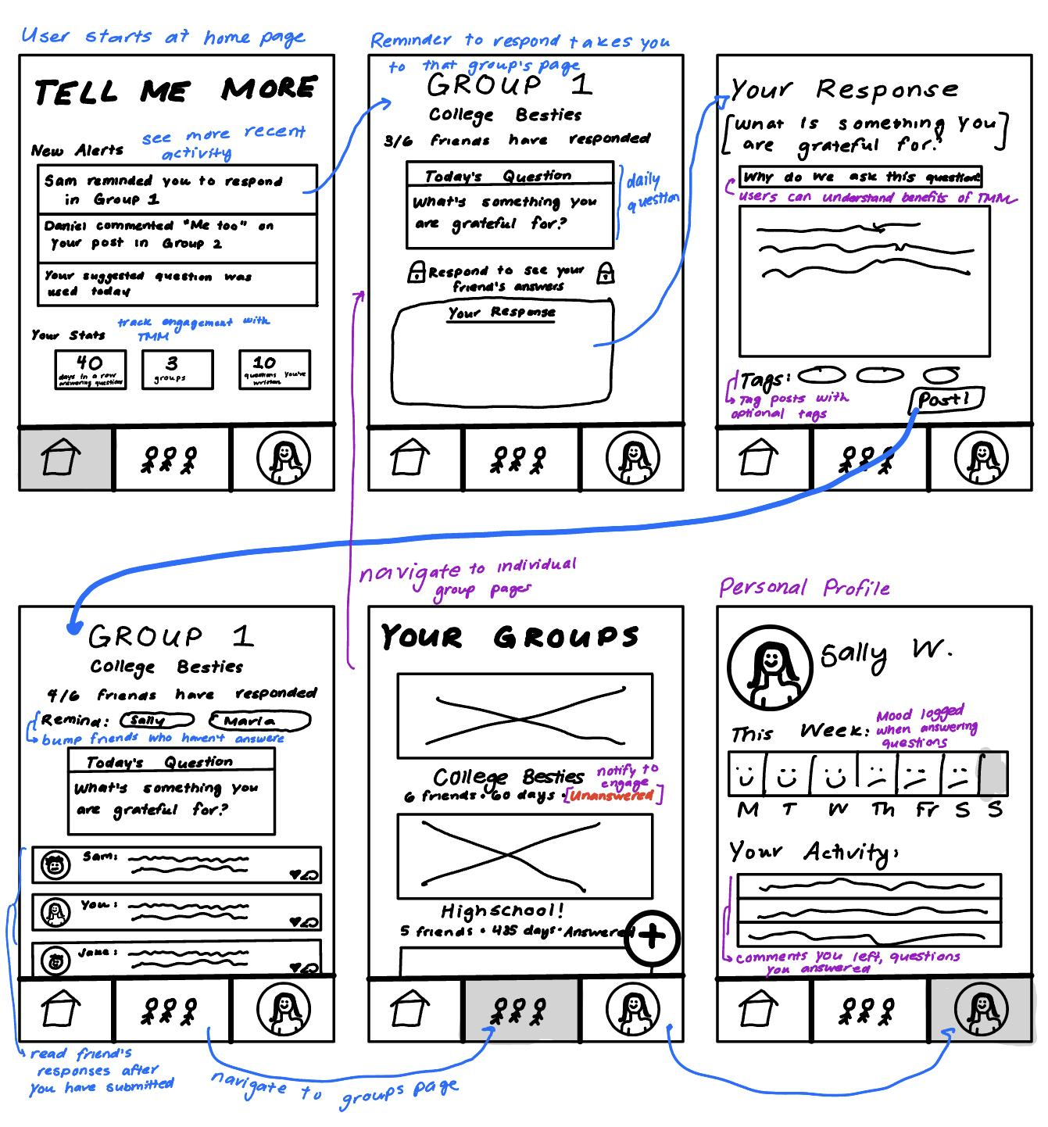
- Augmented Reality
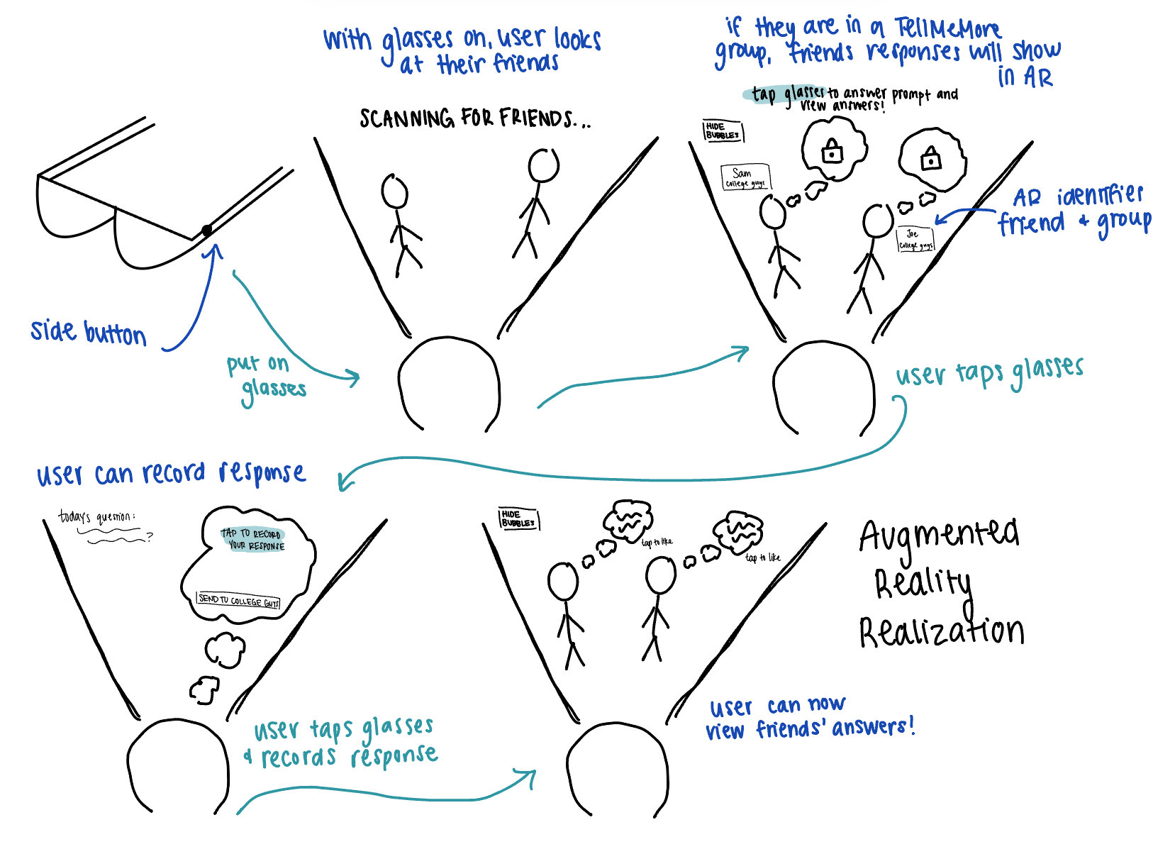

We like AR because of its seamless integration with the real world that may promote greater vulnerability. However, AR requires friends to interact face to face and is not accessible to most people. Our goal is for users to build a habit of vulnerability, which requires repeated instances of vulnerability. Therefore, it is important to use a realization that users can access easily and often. On the other hand, a mobile application is a more common realization, leading to greater accessibility. After analyzing the feasibility of each realization, we decided to proceed with the mobile application.
We then used Notability to sketch our task flows and create our Low Fidelity Prototype.
- Answer a prompt to see friend group’s responses
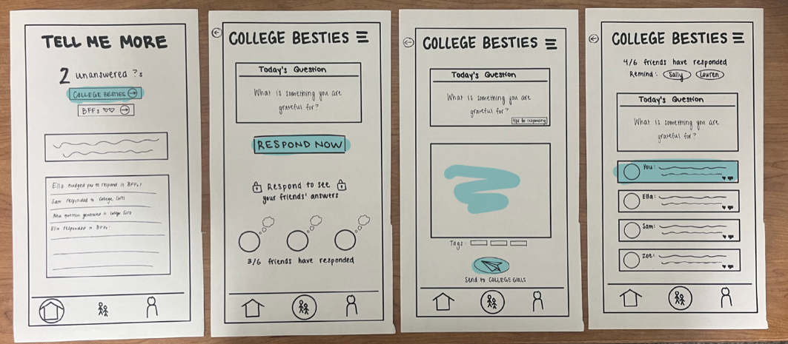 Click on group name -> Click “respond now” -> Answer prompt -> View group responses
- Suggest a question
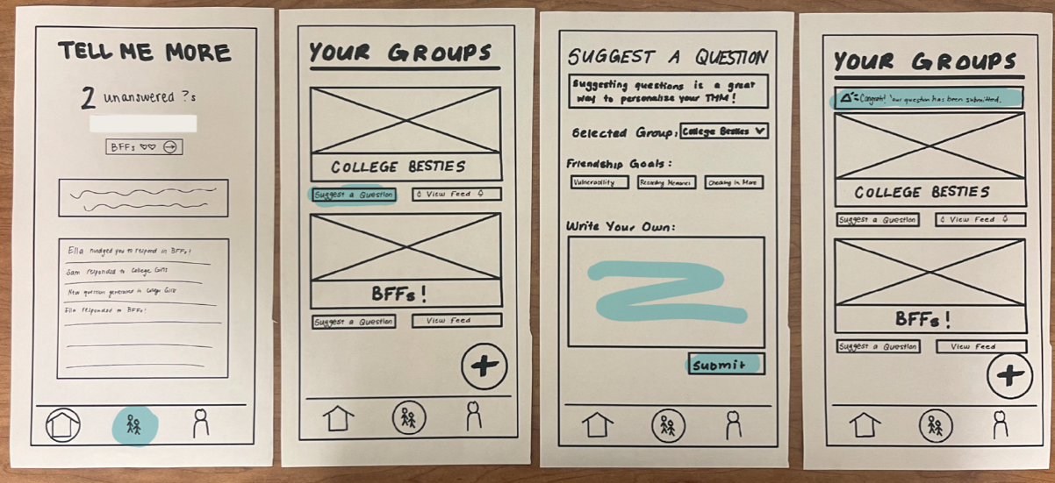Navigate to groups -> Click suggest a question -> Write question & submit!
- Build a group of friends
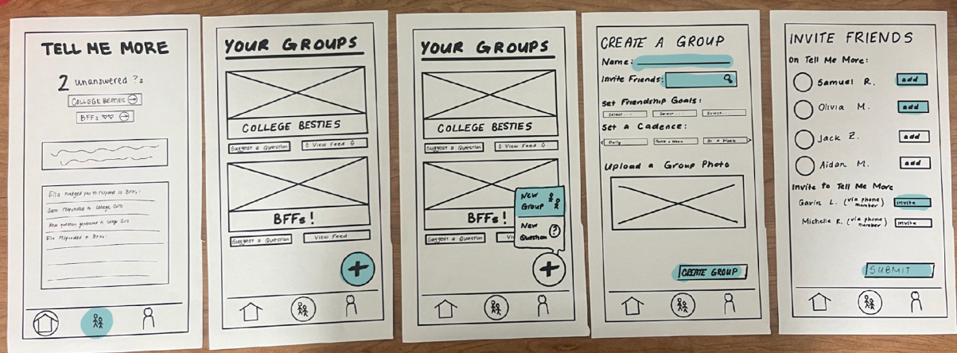Navigate to groups -> Click plus -> Click new group -> Fill out fields -> Add friends

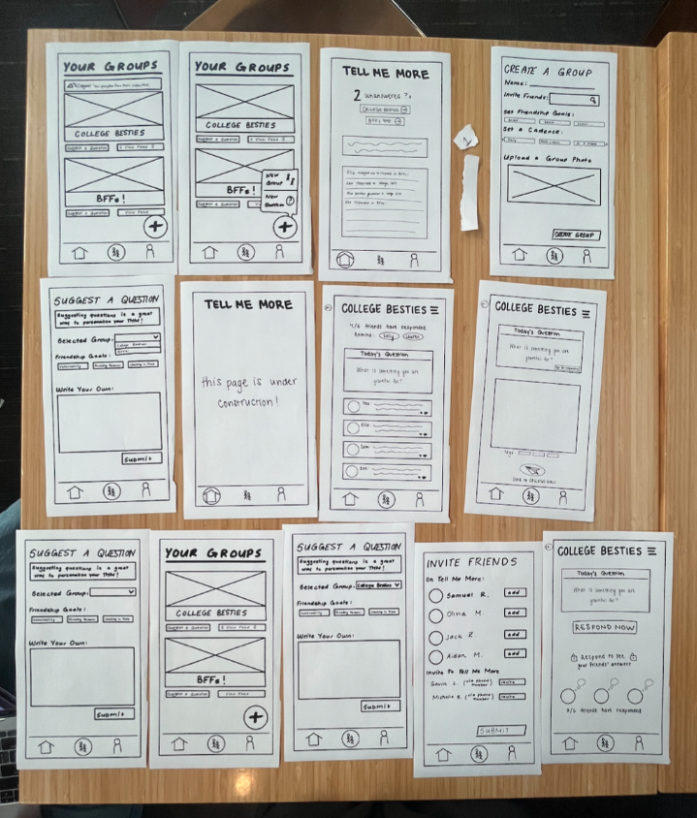
Usability Testing
To get feedback on our low fidelity prototype, we conducted usability tests at the GSB. We printed each screen of our low fidelity prototype on paper. We recruited participants by walking up to them and asking for five minutes of their time. Our participants were a student at UC Berkeley, a student at Stanford, a tourist visiting Stanford, and a GSB staff member.
We defined usability goals and key measurements prior to testing.
Usability Goals and Key Measurements
Our first usability goal is efficiency because filling out questions and interacting with others should be simple, encouraging users to return at a regular cadence. We measured this goal by the number of errors, time spent per task, and severity of errors. Our second usability goal was pleasing, as we want users to enjoy using the app and expressing vulnerabilities. We measured this goal by user rating and qualitative data.
Usability Test: Results and Implications
Usability Goal: Efficiency
- Total errors (across 4 participants):
  - Simple: 0
  - Medium: 1
  - Complex: 1
- Average severity of errors: 2.5
- We excluded speed because it was dependent upon the amount of time the user took to speak aloud about their thought process
Usability Goal: Pleasing
- Average rating of experience and concept (1-10 scale): 7.5
- Qualitative descriptions of experience:
  - “Felt clear, but vulnerability wasn’t inherently encouraged”
  - “Cool idea, would use with my friends and other groups”
Key Interviewee Quotes:
- “The groups button is confusing.”
- “It’d be nice to have a better version of WhatsApp” → didn’t understand purpose
- “I would click on Tips for Responding for sure”
- “It’s pretty simple and easy to use”
- “Felt clear”
- “I would share if I trusted others not to exploit my answers”
Overall, we were happy with both the results of both usability goals. However, we uncovered a few key findings that sparked design changes moving forward.
- For some participants, it was unclear what purpose the Groups tab served. Therefore, we will make the Groups page more intuitive by moving some of the functionality on the Groups page to the Home page.
- The design of the low fidelity prototype is misaligned with the purpose of Tell Me More, meaning the UI is not novel enough to encourage connection. Therefore, we will incorporate a motif into the app by centering features around a calm theme.
- The Home screen did not have a clear purpose, and none of the tasks could be carried out directly from the Home screen. Therefore, we will make the Home screen more action oriented.
Our next big steps going into the med-fi prototype were:
- Implement the three design changes above
- Brainstorm ways to make users feel more comfortable being vulnerable

Medium Fidelity Prototype - First Draft
- Answer a prompt to see friend group’s responses
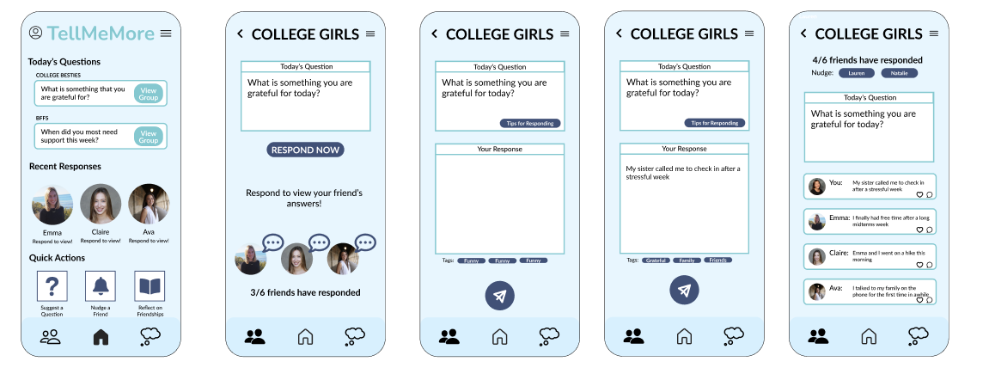Click respond → Click respond now → Input response & send → View friends responses!
- Suggest a question
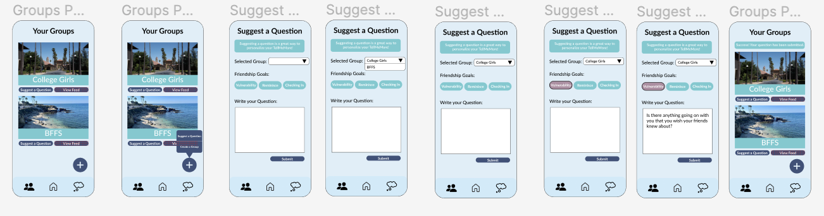Click suggest a question → Select group → Input question and friendship goal → Submit → Confirmation!
- Build a group of friends
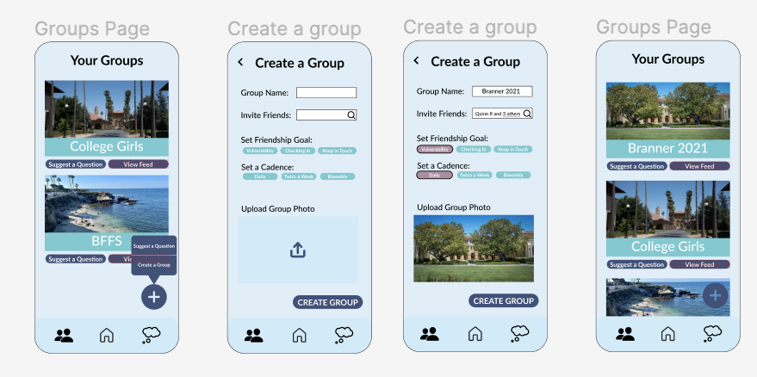From Groups, click + → Input name, add friends, set goals, add photo → New group!

Expert Review: Results and Implications
We brought this medium fidelity prototype to our CS 147 section where we received feedback from an industry expert, our TA, and our classmates. We received the following feedback and made these major revisions for our final medium fidelity prototype:
- Color scheme may be hard to read
  - Changed color scheme to be easier to read
- Change View Group to Response because it is a confusing UI flow
  - Changed “View Group” to “Respond”
- Chat icon look almost as clickable as the button
  - Changed chat icon color and added a lock icon
- Menu bar is too low contrast
  - Increased contrast
- Logo looks a little too crowded
  - Made logo smaller and changed the font
- “Tags are super tiny” and it’s unclear if users can add their own tags
  - We deleted the tags because they were unnecessary and confusing
- Tags and hearts don’t appear anywhere in the app - How do I know when people have liked my stuff?
  - Changed like and comment to like and like count
  - Removed comments to encourage offline communication
- Don’t add additional buttons to home screen after task
  - Removed buttons on home screen that appear after answering a prompt
- Try to show that send button corresponds to response field, not everything on the screen
  - Used gestalt principles to make it clear that the response is the only thing being sent
- It would be nice to see more of a calm theme
  - Changed color scheme to be prettier
  - Changed logo font
  - Added calm welcome page
  - Added “response is on the way” popup

Medium Fidelity Prototype - Final
- Answer a prompt to see friend group’s responses
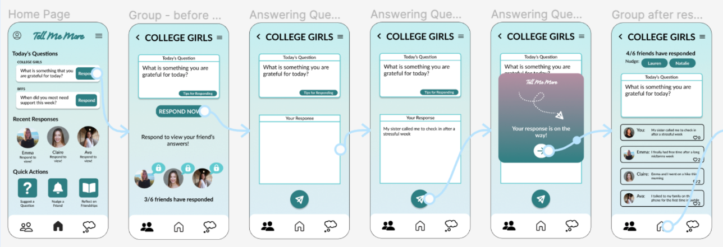Click respond → Click respond now → Input response & send → View friends responses!
- Suggest a question
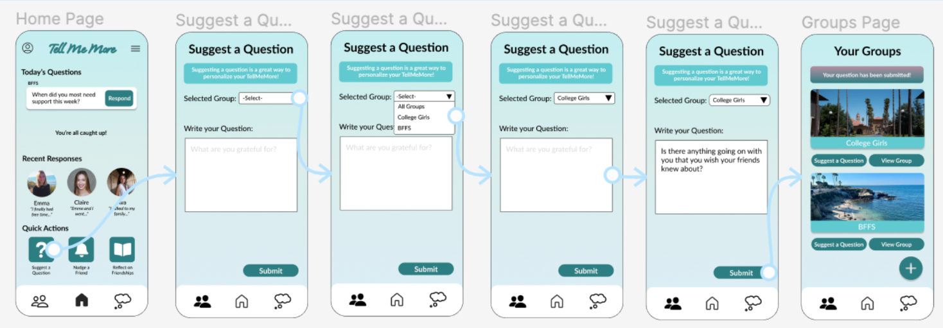Click suggest a question → Select group → Input question and submit → Confirmation!
- Build a group of friends
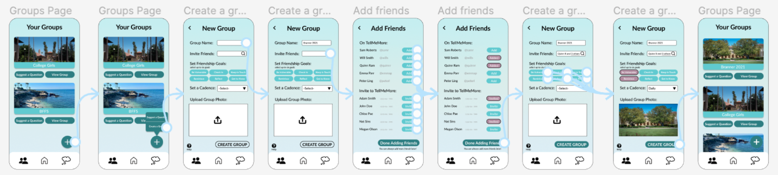From Groups, click + → Input name, add friends, set goals, add photo → New group!
We sent the medium fidelity prototype to a group of students in CS 147 studio for a heuristic evaluation. They found 89 total violations, including 53 severity 3/4 violations and 36 severity 1/2 violations. We addressed 32 of the severity 3/4 violations and 20 of the severity 1/2 violations. Our most violated heuristics were H3 User and Control (19 violations), H4 Consistency and Standards (15 violations), and H11 Accessibility (11 violations).

Heuristic Evaluation Design Changes
Major Design Changes
- Groups page redesign
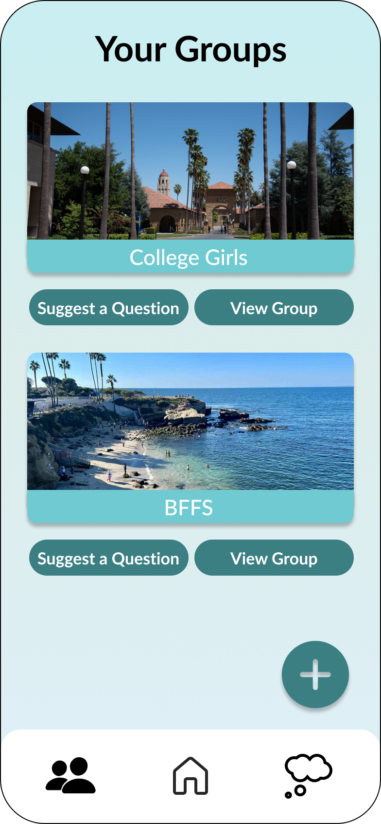
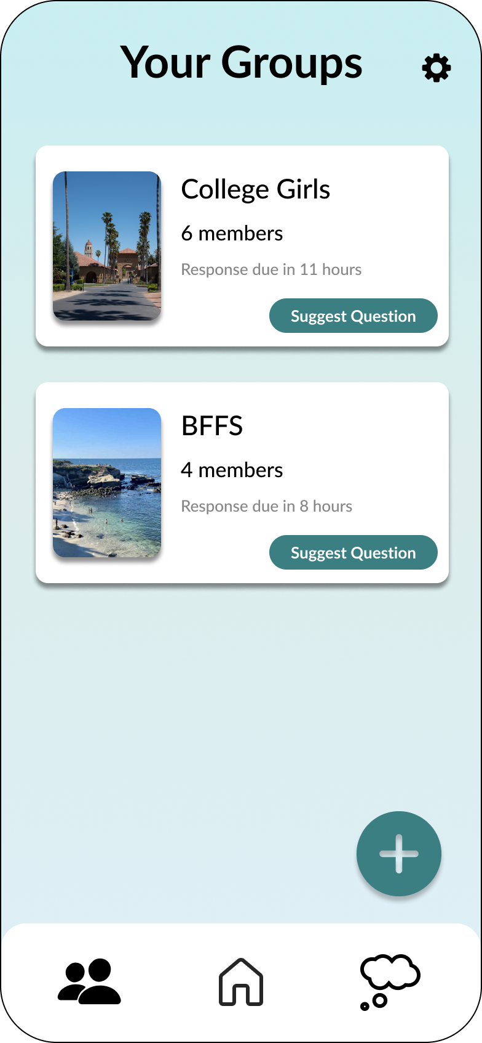
Before After
Violations Addressed
- H4 Consistency and Standards / Severity 3: “Suggest a question” button does not have enough padding.
- H11 Accessibility / Severity 3: Low contrast between group names and backgrounds.
- H11 Accessibility / Severity 3: Text in the menu that pops up from the plus button was too small to read.
- H8 Aesthetic and Minimalist Design / Severity 3: View Group button is unnecessary because a user would assume you could tap anywhere.

- Text boxes made consistent
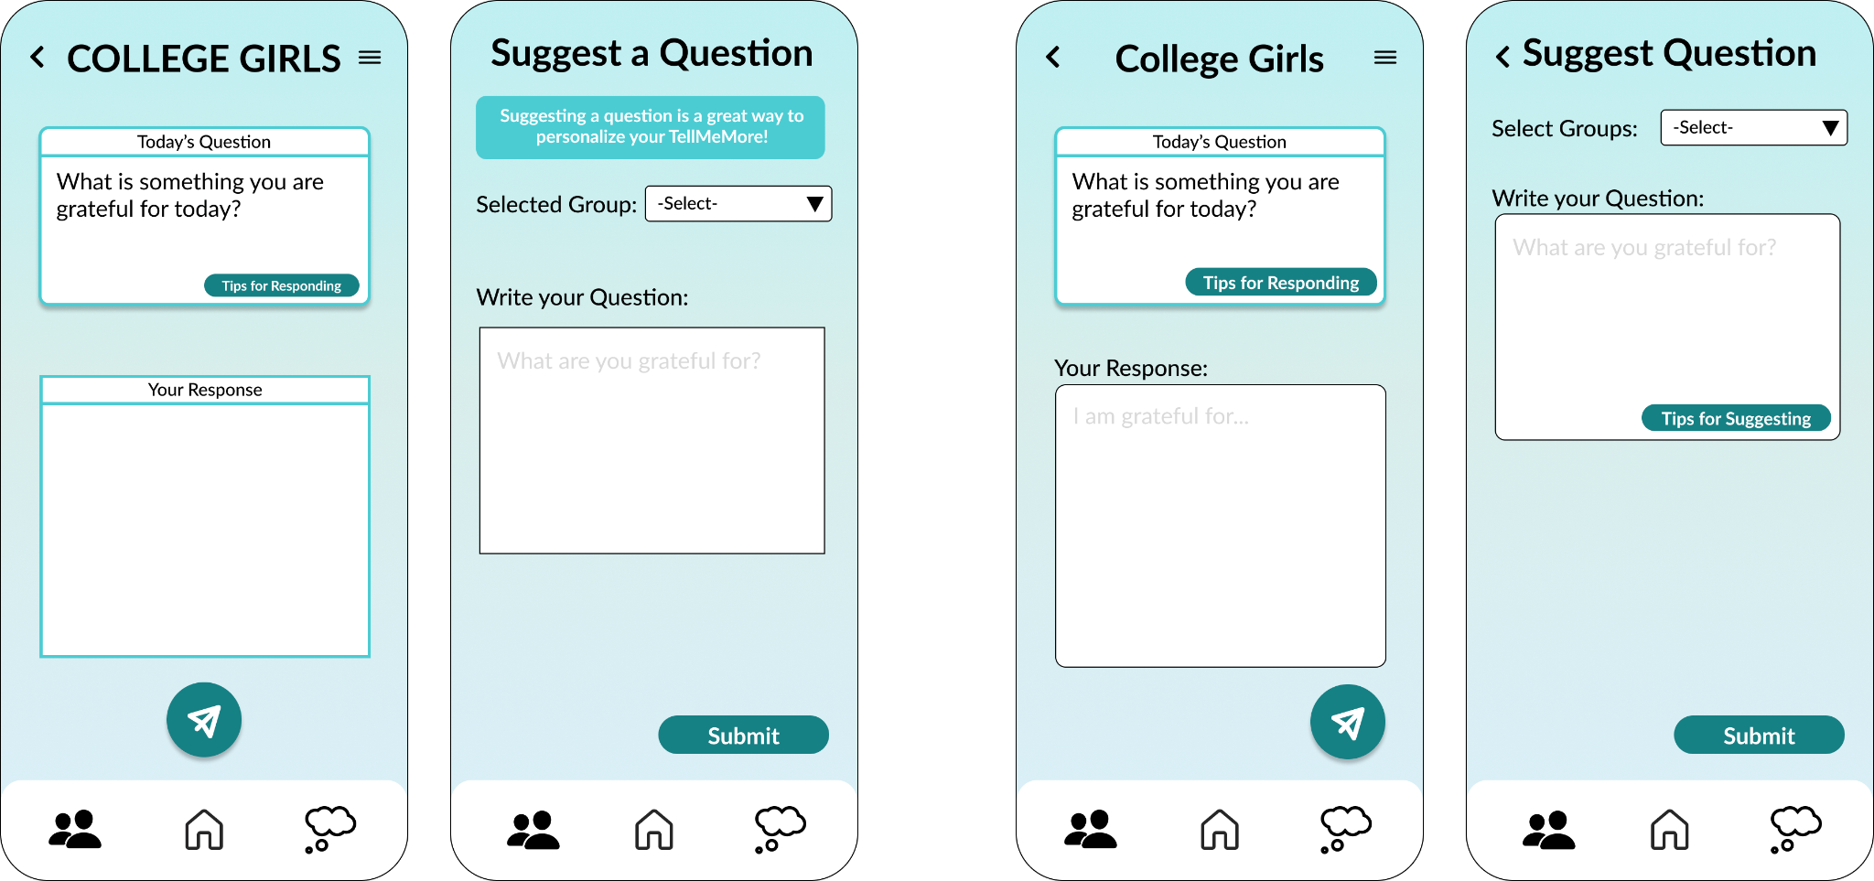
Before After
Violations Addressed
- H4 Consistency and Standards / Severity 3: The text box for responding to a prompt and suggesting a question look different
- H4 Consistency and Standards / Severity 3: Some input boxes are rounded with blue borders and others are square with black borders.
- H6 Recognition Rather Than Recall / Severity 3: Some text boxes have filler text and others don’t

Additional Severity 3 /4 Violations Addressed
- Button consistency
  - H4 Consistency and Standards / Severity 3: “Respond Now” button doesn’t match “Respond”
  - H4 Consistency and Standards / Severity 3: “Done Adding Friends” does not match convention “Done”
  - H4 Consistency and Standards / Severity 3: “Create Group” button is not colored in.
- Accessibility
  - H11 Accessibility / Severity 3: Text in “Tips for Responding” is too small
  - H11 Accessibility / Severity 3: Usernames and phone numbers don’t have enough contrast.
- Terminology
  - H4 Consistency and Standards / Severity 3: Inconsistency between “Invite” and “Add” friends.
  - H2 Match Between System and Real World / Severity 3: “Cadence” is confusing.
- Lack of undos
  - H3 User Control and Freedom / Severity 3: No way to undo sending a response
  - H3 User Control and Freedom / Severity 3: No way to undo suggesting a question
  - H3 User Control and Freedom / Severity 3: No back arrows when suggesting a question
  - H3 User Control and Freedom / Severity 3: No back arrows on new group page
- Lack of instructions
  - H10 Help and Documentation / Severity 3: No instructions for what happens after suggesting a question

Severity 3 / 4 Violations That Were Not Addressed
- Extra features: if we had more time, we would implement a settings page that addresses these issues. 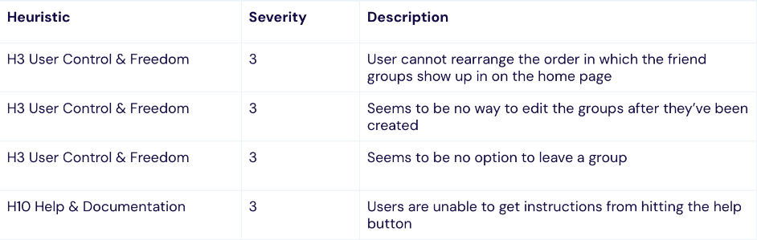
- Figma functionality: these violations are Figma specific and will not be problems in our prototype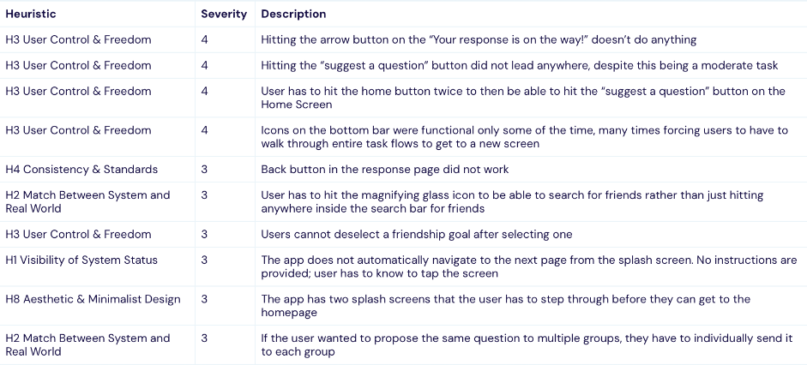
- Violations we did not address & justifications 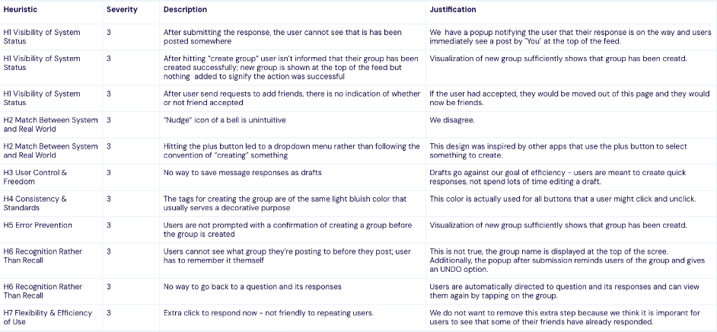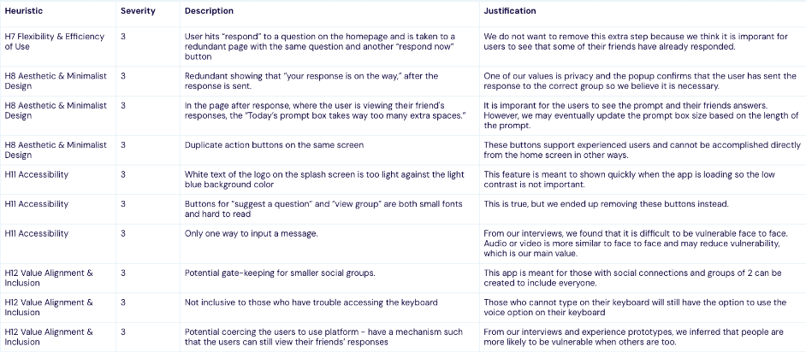

High Fidelity Prototype (Final)
- Answer a prompt to see friend group’s responses
- Suggest a question
- Build a group of friends

Values in Design
Throughout the design process, from our initial sketches to our high fidelity prototype, we were intentional about reflecting our values in Tell Me More. We identified five main values to encode into our design.
- Connection
- Vulnerability
- Reflection
- Community
- Privacy

Connection
We want friends to feel like they really understand what is going on in each other's lives and to reach out with love and support. Our suggested prompts attempt to elicit deeper conversations and vulnerability from our users.

Vulnerability
We aim to encourage people to step out of their comfort zones and share emotions with friends. We use relaxing and soothing colors like light blue to evoke feelings of comfort and calmness with the goal of eliciting vulnerability.

Reflection
We remind users to reflect on their relationships and the support that they give their friends. Prompts allow users to reflect on their own emotions. We also have dedicated a separate page to reflect on actionable steps to support one’s friends.

Community
Not only will we encourage individuals to check in on friends, but we hope users feel a strong sense of community within their groups. Friends can customize their groups to create unique communities on Tell Me More. For example, users can set a cadence for questions, friendships goals, and upload group photos.

Privacy
Any post that a user makes on Tell Me More will be viewed by their group only. We will not use user data without permission. Friends' responses will be locked until a user shares a reflection of their own. Users' responses will also disappear after 24 hours.

Value Tensions
Vulnerability / Privacy. We want our users to be able to initiate meaningful conversations on our platform and be truly vulnerable. Our prompts are geared towards encouraging emotional responses. However, users may feel weary about sharing personal thoughts or moments if they fear exposure by their friends or the platform itself. We managed this value tension by including confirmations with undo buttons after submitting a response in order to reassure users that their responses would only be seen by their group.
Community / Reflection. We want Tell Me More users to connect with their friends, but also utilize the platform as an opportunity to reflect on their own emotions and how successful they are at showing up for their friends. There may be a tension here between how users should utilize and spend time on Tell Me More, but we believe that self reflection can positively impact community and relationships, so we do not want to sacrifice either feature.

Final Prototype Implementation

Tools Used
To build our prototype we used React Native, a cross-platform mobile app framework. For simulation, we used Expo. We used Figma to design the interface.
In general, React Native was a relatively intuitive application framework to learn and offered many benefits. However, there were limitations with React Native that made implementing certain features difficult. For instance, implementing the “likes” feature was more complex than we had anticipated. Expo and Xcode’s Simulator were helpful resources that allowed us to test our application on a real iPhone X. Being able to simulate our app as we developed was beneficial for testing the development. Figma was very helpful throughout the design process. However, for some buttons and icons, it was difficult to transfer the Figma design into the code. For instance, our logo font was bolded in Figma, but this was not possible in React.

Hard Coded Techniques
Since our tasks occur in the context that a user already exists and has friends and friend groups on the platform, our prototype operates under the assumption that a user has already created an account and added several of their friends.
- Recent responses on the Home screen
- The user’s friends and profile photos
- The friend groups on the Groups page
- For the simple task, users can input any answer but the response shown on the following screen is preloaded.

Wizard of Oz Techniques
- Friends to add to a group or invite to Tell Me More should be customized to the user, but are the same for all users.
- The users, groups, prompts, and answers are automatically loaded to mimic a social network. When the user responds to a prompt, their answer automatically receives 2 likes. In our actual implementation, each of these features would be unique to the user.

Reflection and Next Steps

Key Learnings
- Empathy and Open Mindedness in Needfinding
Through our interview process, we learned that it is crucial to listen to and empathize with real users. We developed the ability to go into interviews without a preconceived idea for a solution and without assumptions about what users might want. Many key features of our app were designed and implemented as a direct result of needs we discovered through our interviews and experience prototypes. For example, our Shared Daily Journal experience prototype participants shared that our prototype allowed them to tell their friends about a difficult piece of news they were struggling to share, which was a powerful result that we did not expect.
- Utilize Robust Testing and Evaluation Techniques
Throughout this process, we learned several important testing techniques. User feedback from our usability testing of our low fidelity prototype revealed that we designed our prototype purely for functionality, not to encourage vulnerability. Expert feedback in section taught us about the importance of consistency in colors, buttons, and text boxes and reiterated that our prototype should feel calm in order to make users feel comfortable being vulnerable. Our heuristic evaluation revealed almost 90 violations, and forced us to think carefully about each design detail, leading to a large number of revisions.
- Values Shape Design Decisions
We learned the importance of relying on our mission statement and values when making design decisions. Our values informed a number of design decisions ranging from removing the notifications section to rounding the edges of our buttons and text boxes. By setting values grounded in needfinding data, we were able to leverage design tools to evoke vulnerability.

Limitations and Future Work
Although we have made significant progress on our prototype, some parts of the design could not be implemented given the limited time frame. For example, the following features appear on the interface but are not functional:
- The user’s profile icon - in our real implementation, we would create a proper onboarding process in which the user creates an account.
- “Tips for Responding” and “Tips for Suggesting” buttons
- Reflect tab in the navigation bar and Reflect on Friendships quick action
Additionally, in the future we would implement a Settings / Information page with more details about our values and mission.

Thank you for coming along on Tell Me More’s design journey! Creating this project was a valuable experience from needfinding interviews, to brainstorming solutions, to developing and iterating on our final product. We would like to thank Professor Landay and TA Grace Zhou for an excellent quarter!

