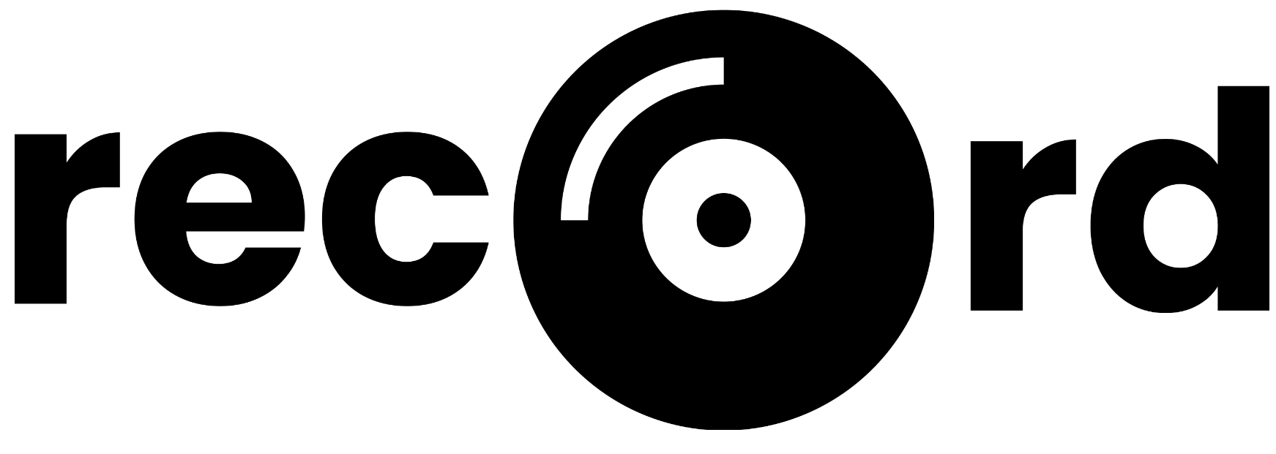

About 2
Quick Start 2
iOS Quick Start 2
Android Quick Start 2
Limitations 3
Unpolished Interactions 3
Missing Loading States 3
Missing Error states 3
Contains Subtle Bugs 3
Fake Buttons 3
Lack of Accessibility 3
Security Issues 3
Song UI Only Plays Track Previews 3
Spotify API Rate Limiting 4
Hard-coded Data 4
Hard-coded Journal Entry Data 4
Hard-coded Verbiage on the Insights Tab 4
Wizard of Oz 4
Tailored Insights 4
Spotify Authentication 4
Spotify Song Previews 5
How To’s 5
How to log in / create an account. 5
How to record your song of the day. 6
How to record a rating for your day. 7
How to record emotion ratings. 8
How to record a long-form journal entry. 9
How to review previous recordings. 10
How to delete a recording. 11
How to review your emotional / musical trends over time. 12
How to adjust the date range on the insights page. 13
How to log out. 14

About
Record is a music-centric journaling app that shows you trends in your emotions over time. Record lets you associate your emotional states with songs, then generates insights for you based on those associations.

Quick Start
Our high-fidelity prototype was built using Expo. Follow the quick start instructions below to check out our prototype via the Expo Go app.

iOS Quick Start
Step 1. Click here to download the Expo Go app from the App Store.

Step 2. Scan the following QR code with an iOS device to open it in Expo Go.



Android Quick Start
Step 1. Click here to download the Expo Go app from Google Play.

Step 2. Scan the following QR code with an Android device to open it in Expo Go.

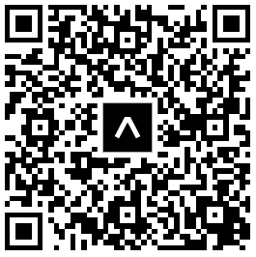

Limitations
Our app is a high-fidelity prototype, and thus is far from production-ready. Our app’s limitations are listed below.

Unpolished Interactions
Some of the interactions in our app are unpolished. For example, when elements are expanded / collapsed there isn’t a gentle animation in place to make that action smoot.

Missing Loading States
While we have implemented some loading states, some are still yet to be implemented. For example, when you swipe left in our calendar UI, you are briefly shown a string date before the calendar renders instead of being shown a styled loading state.

Missing Error states
While we have implemented some error states, some are still yet to be implemented. For example, we don’t handle the case where there is an error during an HTTP request to either the Spotify API or our database API. We currently just log the error to the console.

Contains Subtle Bugs
Our app contains some subtle UI bugs. For example, if a user gets to the end of a song that is playing, the pause button doesn’t turn back into a play button.

Fake Buttons
Some of our buttons are fake. For example, the buttons at the top of the calendar view don’t do anything upon clicking them.
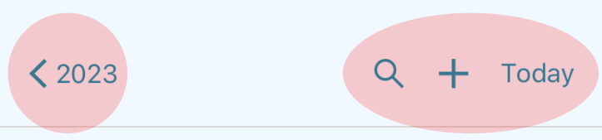

Lack of Accessibility
We did not optimize accessibility while building out our prototype. For example, most of our images don’t have proper alt tags.

Security Issues
We did not prioritize data security while building out our prototype. Our database is wildly insecure. Backend API keys are exposed and passwords are stored in plain text.

Song UI Only Plays Track Previews
We fetch MP3 files from the Spotify API, which only returns 30 second song previews. We do not have access to full tracks.

Spotify API Rate Limiting
Our Spotify application is currently in “development mode” which means that Spotify heavily rate-limits the number of API requests that we can make in a short period of time. If a lot of people are testing our app simultaneously, there is a strong chance that some of the song UI won’t render due to Spotify rate-limiting our app’s request.

E.g. you might be on the app and notice that song recommendations are missing. This is because our app has called Spotify’s /recommendations endpoint too frequently in the past ~30 seconds.

Hard-coded Data
We tried to use as much real data in our app as possible given our time constraints. E.g., user account data / recording data is saved in a MongoDB database; song data is fetched from Spotify. That being said, there are a couple pieces of data that we had to hardcode.

Hard-coded Journal Entry Data
Record’s emotional / musical insights functionality is only useful if the user has used our app over time. However, we wanted to ensure that anyone who creates an account for demo / testing purposes could get a feel for how our insights functionality works.

Therefore, when a new user account is created, we also create fake historical journal entries / emotion ratings for that user. The data that the user will see on the insights page leverages this pre-populated historical data.

Hard-coded Verbiage on the Insights Tab
Because we know the structure of the hard-coded emotion ratings data mentioned above, some of the verbiage on the insights page is hard-coded to reflect the known trends in that data. For example, the hard-coded data reflects emotional mood swings, so we render an insight card that says “Things are changing and so are your emotions! You had some mood swings over the past couple of weeks.”

Wizard of Oz

Tailored Insights
While we were developing the algorithms required to generate emotional / musical insights, we were using the hard-coded historical emotion ratings data mentioned above for testing purposes. Therefore, our insight algorithms are probably overly tailored to suit our test data.

Spotify Authentication
When you use the Spotify API, you’re supposed to have users authenticate with their Spotify account before your app can make requests to the Spotify API. In order to avoid forcing users to authenticate via Spotify while trying out our prototype, we connected our app to Leilenah’s personal Spotify account in the backend. This is wildly insecure for Leilenah’s Spotify account 🤡, but it removes a barrier to entry for our users.

Spotify Song Previews
Spotify does not always return MP3 previews for songs. E.g. if you request 10 song recommendations from Spotify, half of them could be missing MP3 previews. We don’t want to show our users songs that they cannot play, therefore we request more songs than needed for our UI, and then we filter out the songs that don’t have an MP3 preview file.

E.g., if we want to show the user 4 song recommendations, we will request 20 recommendations from Spotify and then find 4 songs out of the 20 that have MP3 previews. This typically works out, but there is a slim chance that less than 4 songs will contain song previews.

How To’s

How to log in / create an account.
Click the “No Account? Sign Up” link on the app’s initial screen. If you encounter an error during account creation, you can log in with our test user credentials – username: testuser, password: seal.

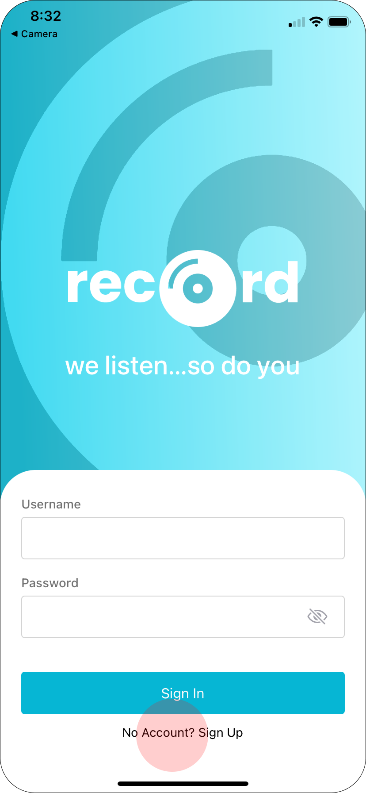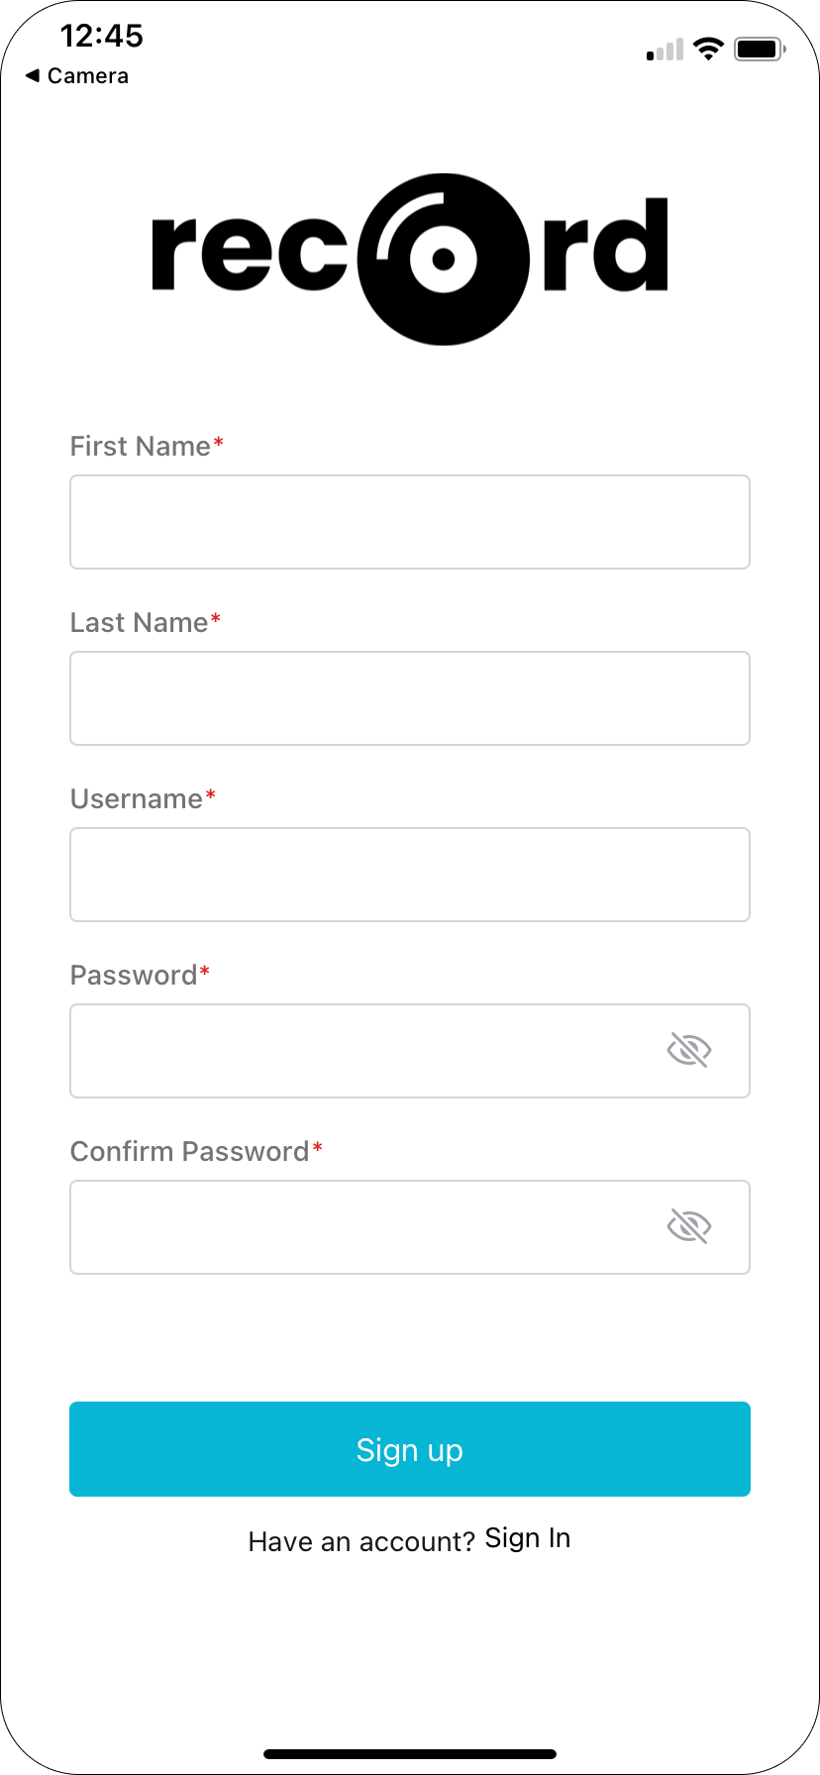

How to record your song of the day.
There are two ways to record your song of the day. To quickly select the song that we recommended to you, press the + button on the song card. To see more recommendations or search for a song of your choice, click the Edit button on the song card. Click the Save button to collapse the song card.

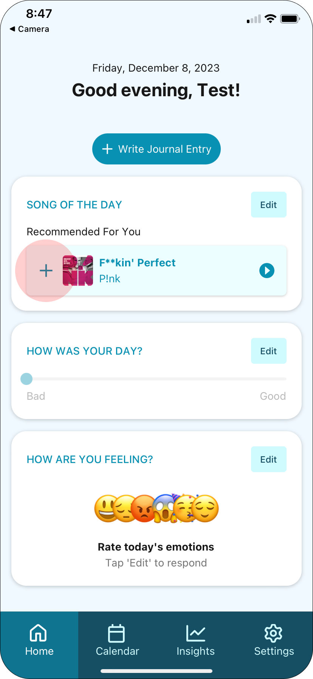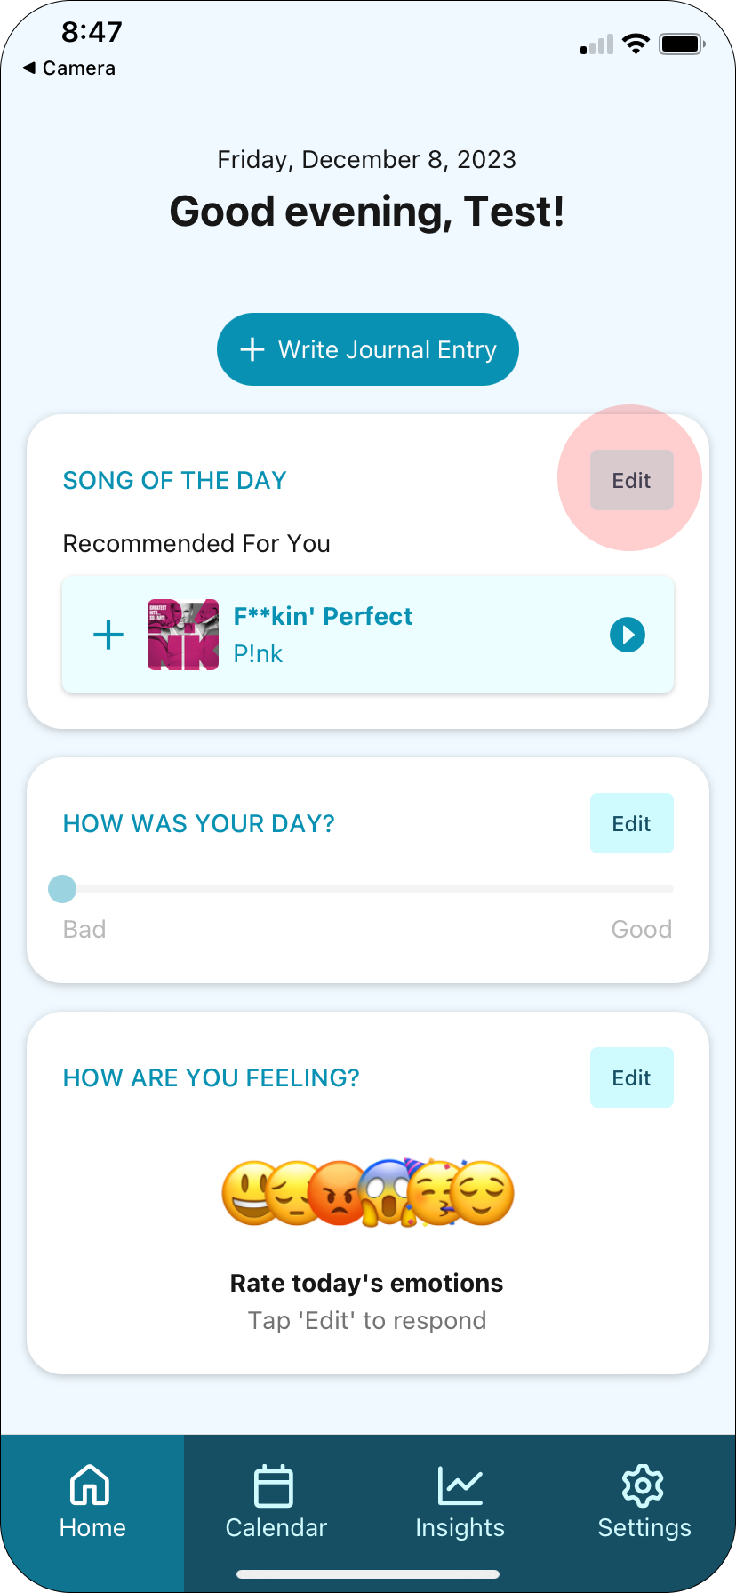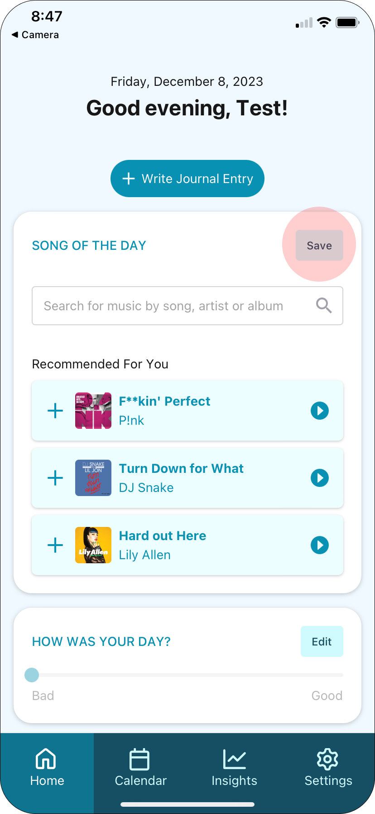

How to record a rating for your day.
To record a rating for your day, click the Edit button in the “How was your day” card and slide the slider below the Edit button to indicate how bad / good your day was.

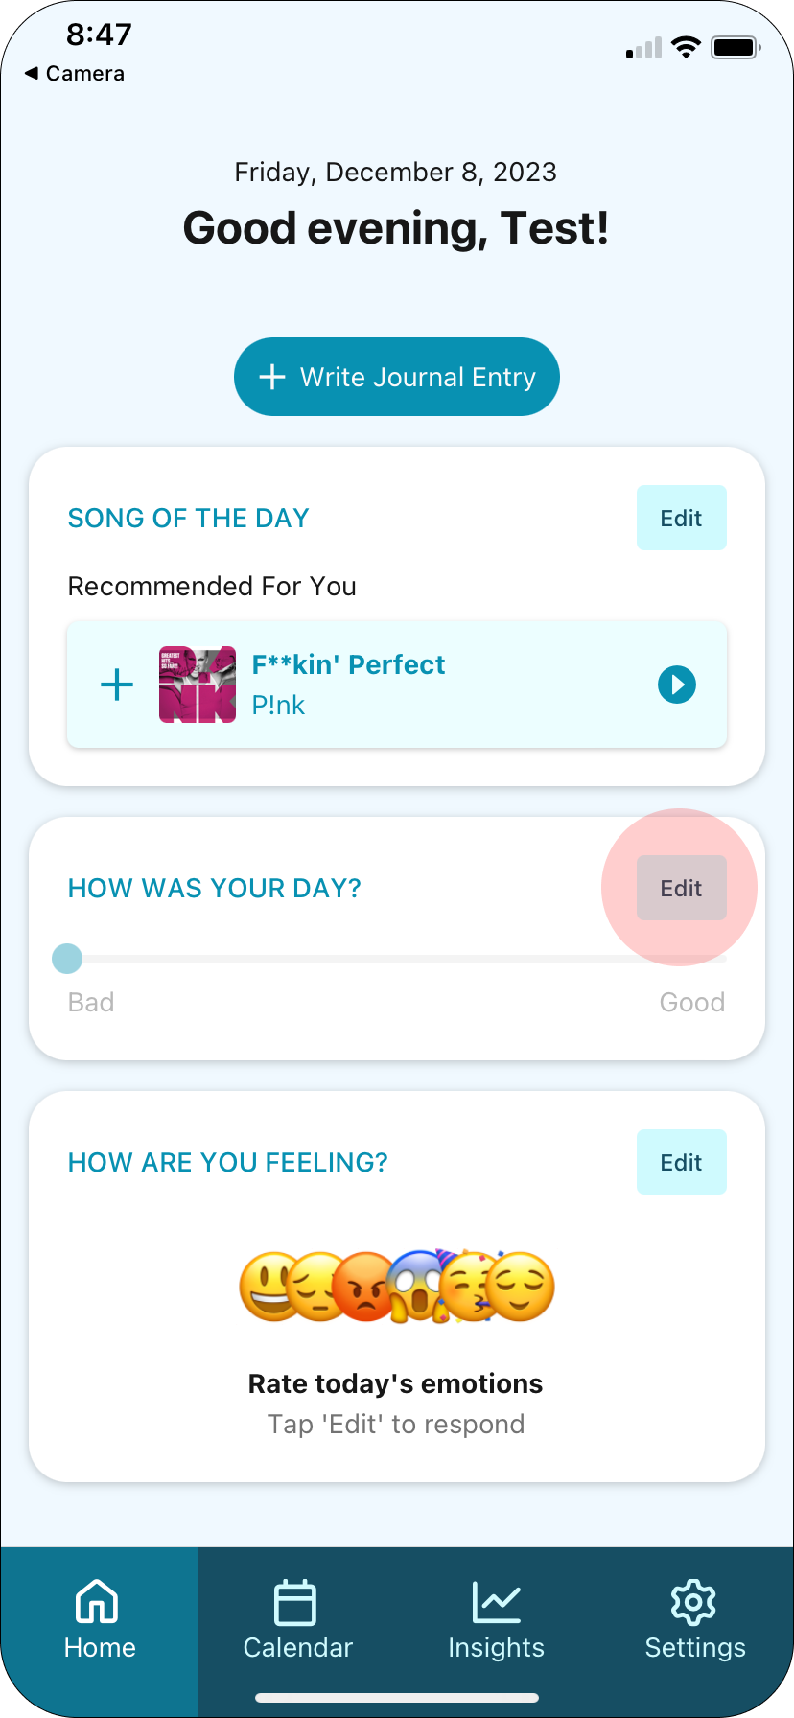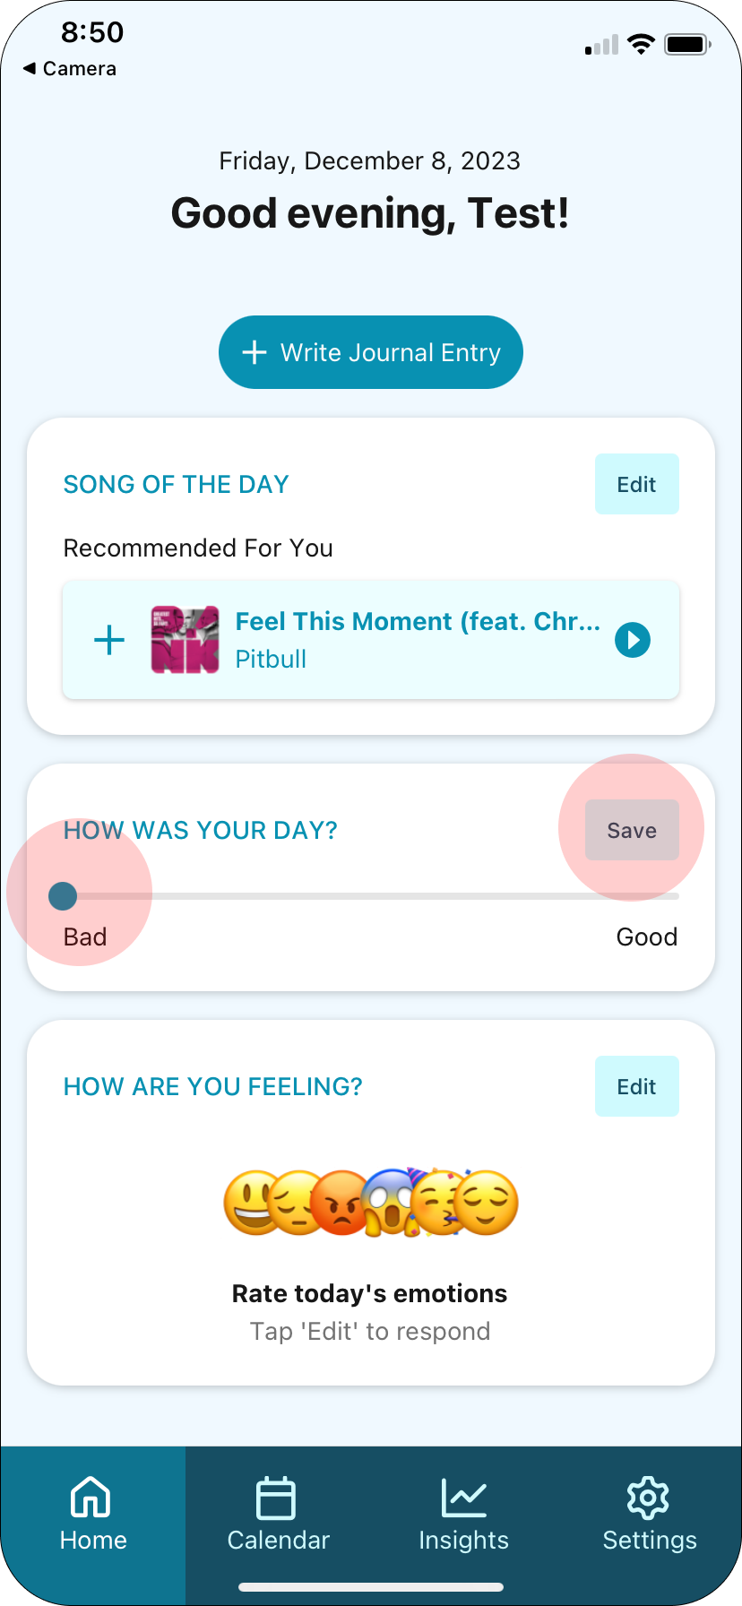

How to record emotion ratings.
To record how happy, sad, angry, nervous, excited or calm you’re feeling, click the Edit button in the “How are you feeling” card to expand the emotion rating sliders.

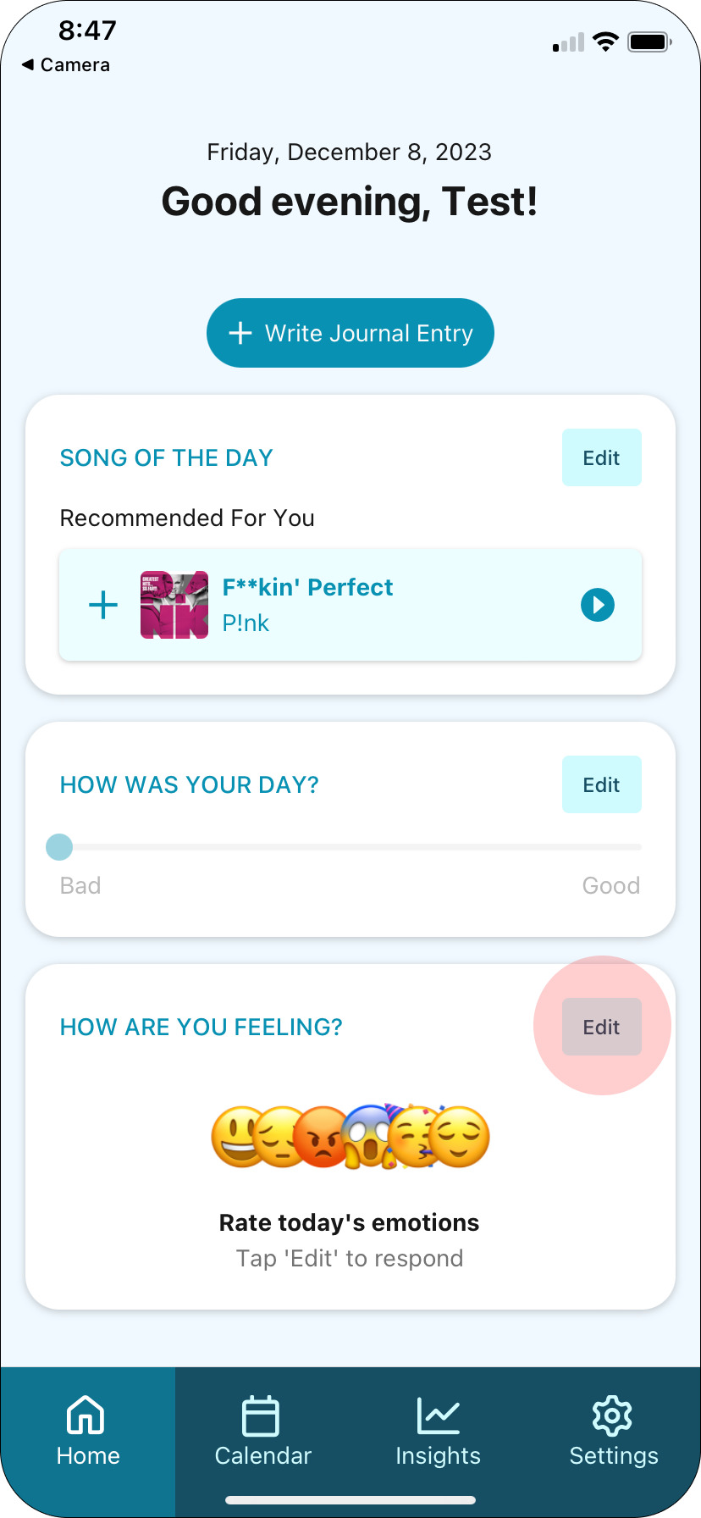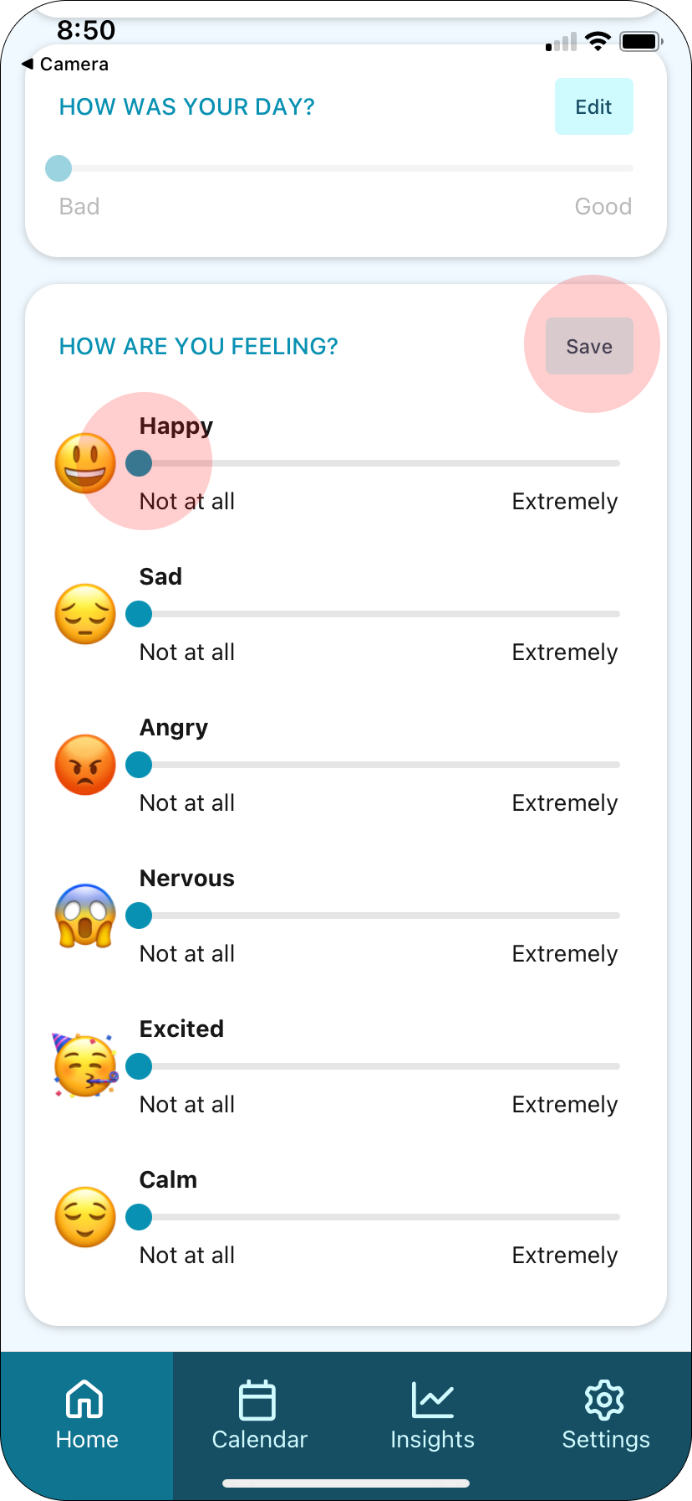

How to record a long-form journal entry.
To record a long-form journal entry, click the “+ Write Journal Entry” button on the home screen. This will take you to a text-area that you can press to start typing into it.

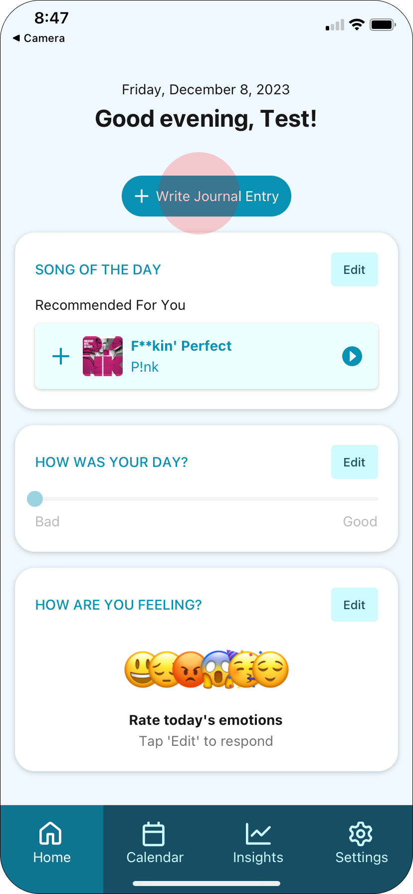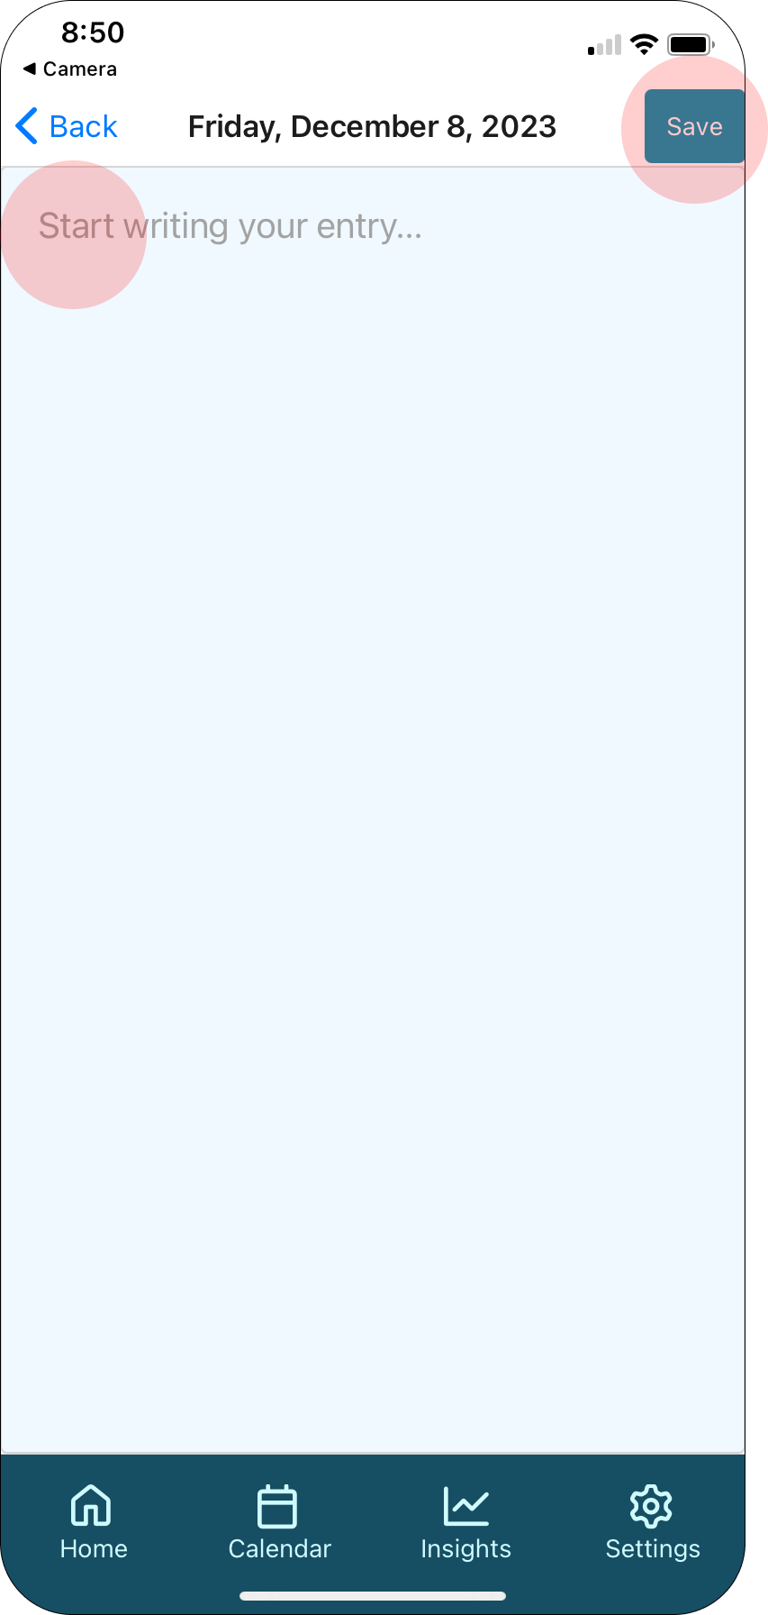

How to review previous recordings.
To review previous recordings, click the Calendar icon in the navigation bar. Select a date in the calendar to see what you recorded that day. Click the expand icon to expand your entry. Click the expand button again to collapse it back beneath the calendar.

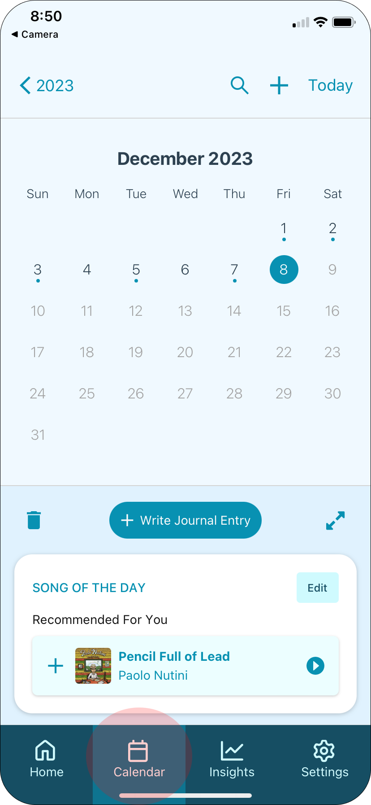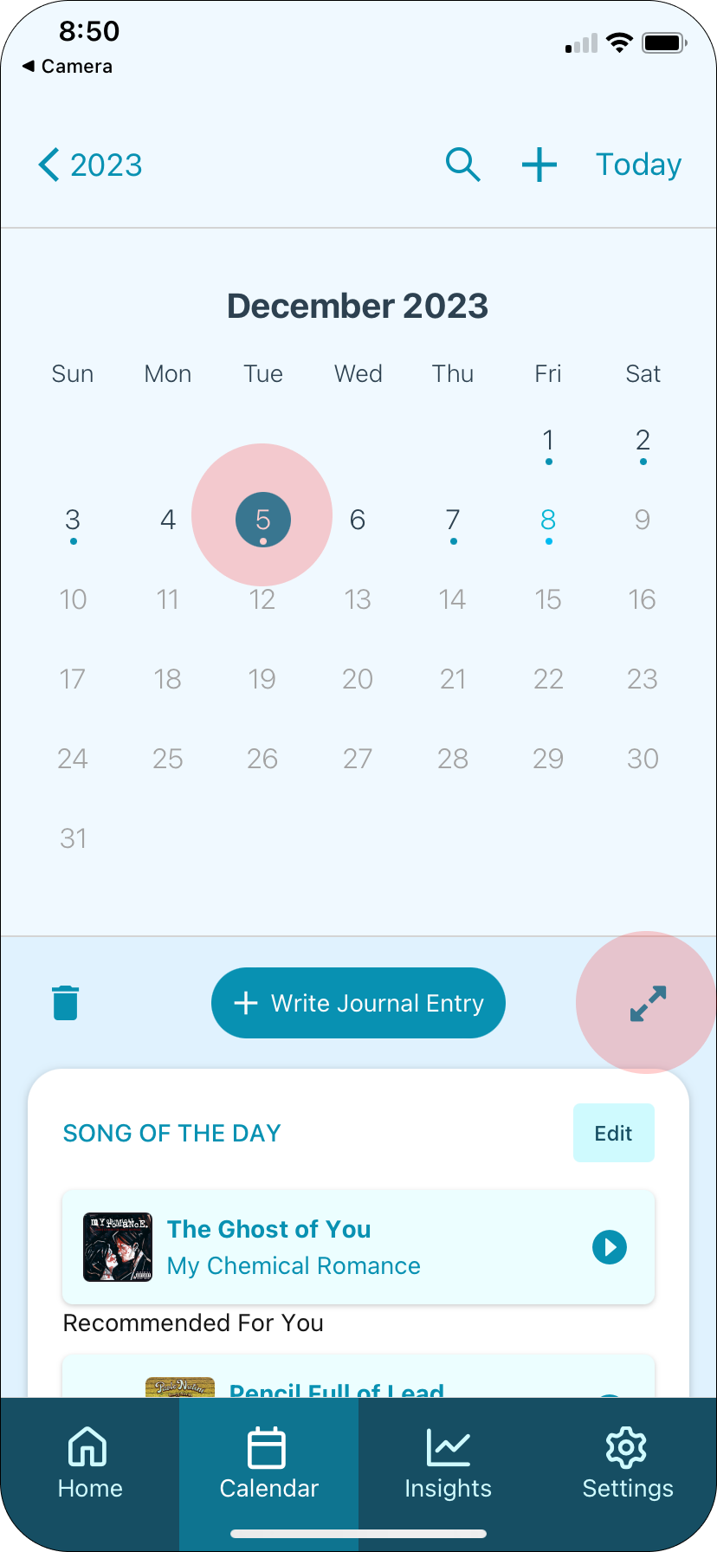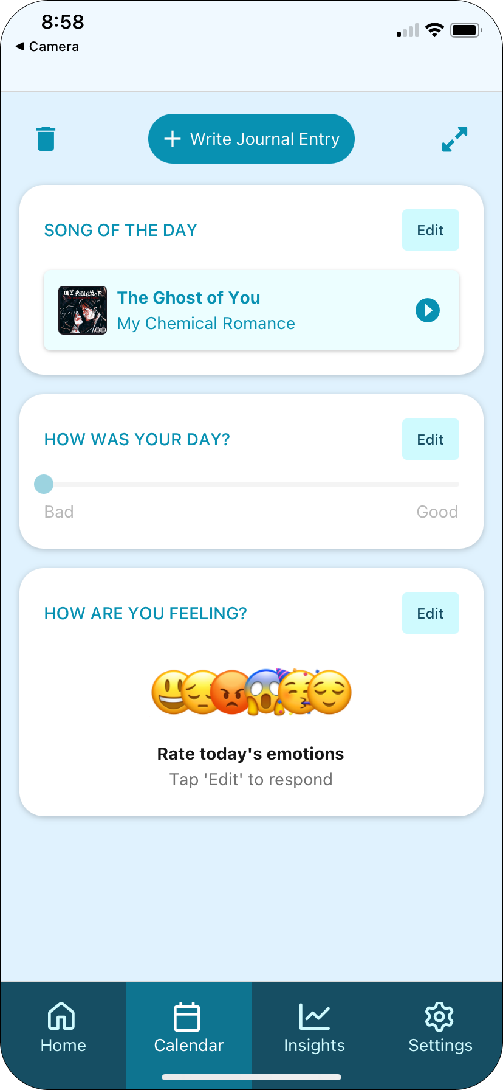

How to delete a recording.
To delete a recording, navigate to the recording in the calendar view, and click the trash icon associated with the recording.

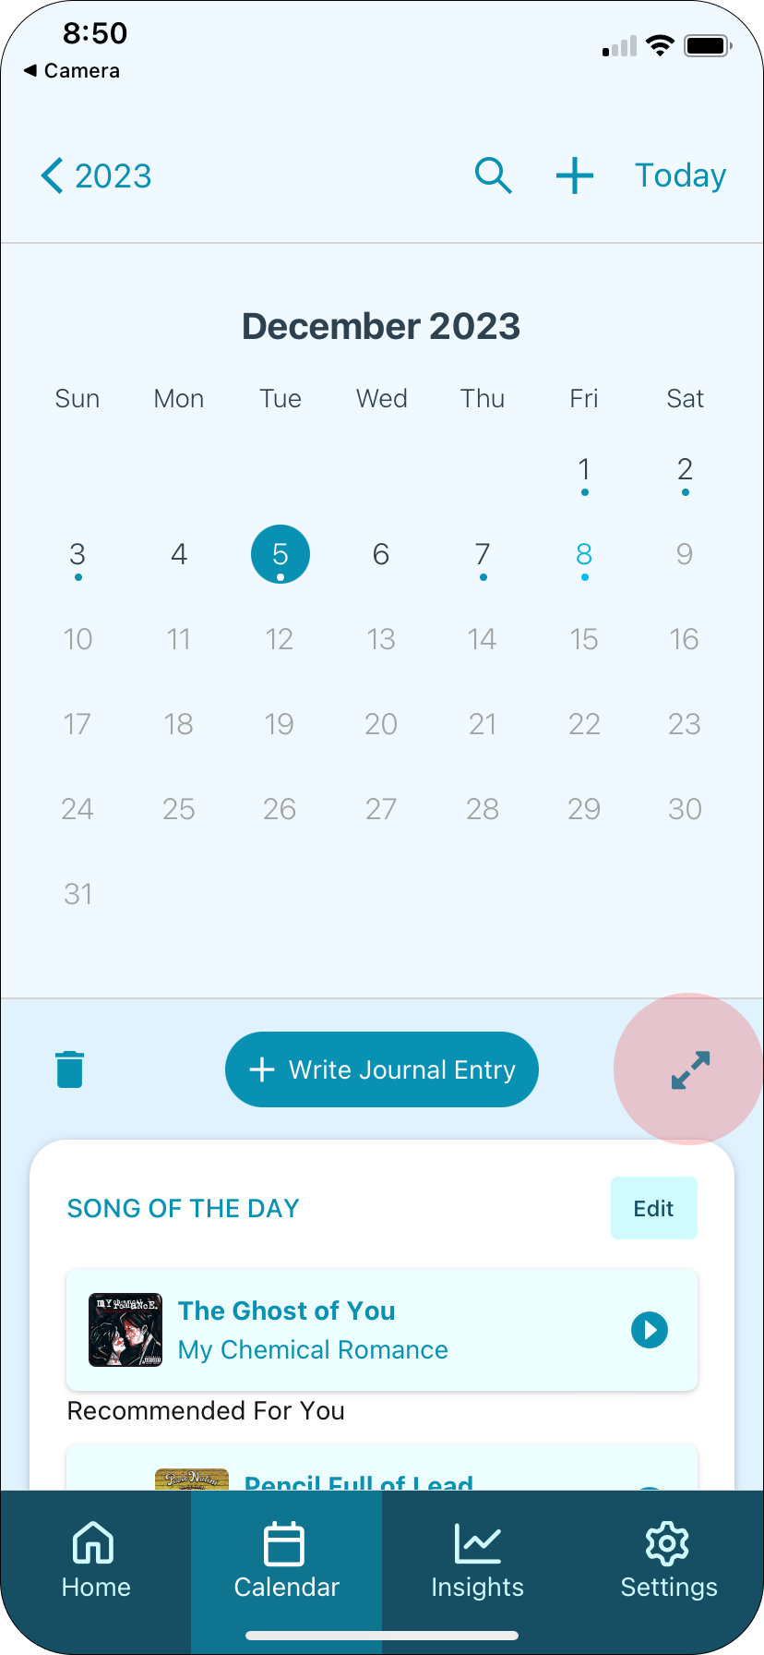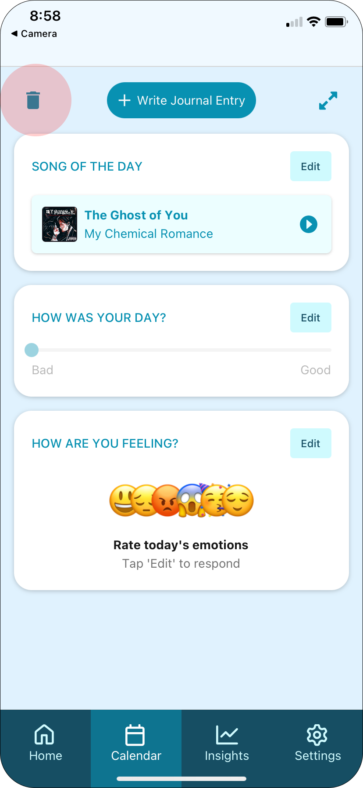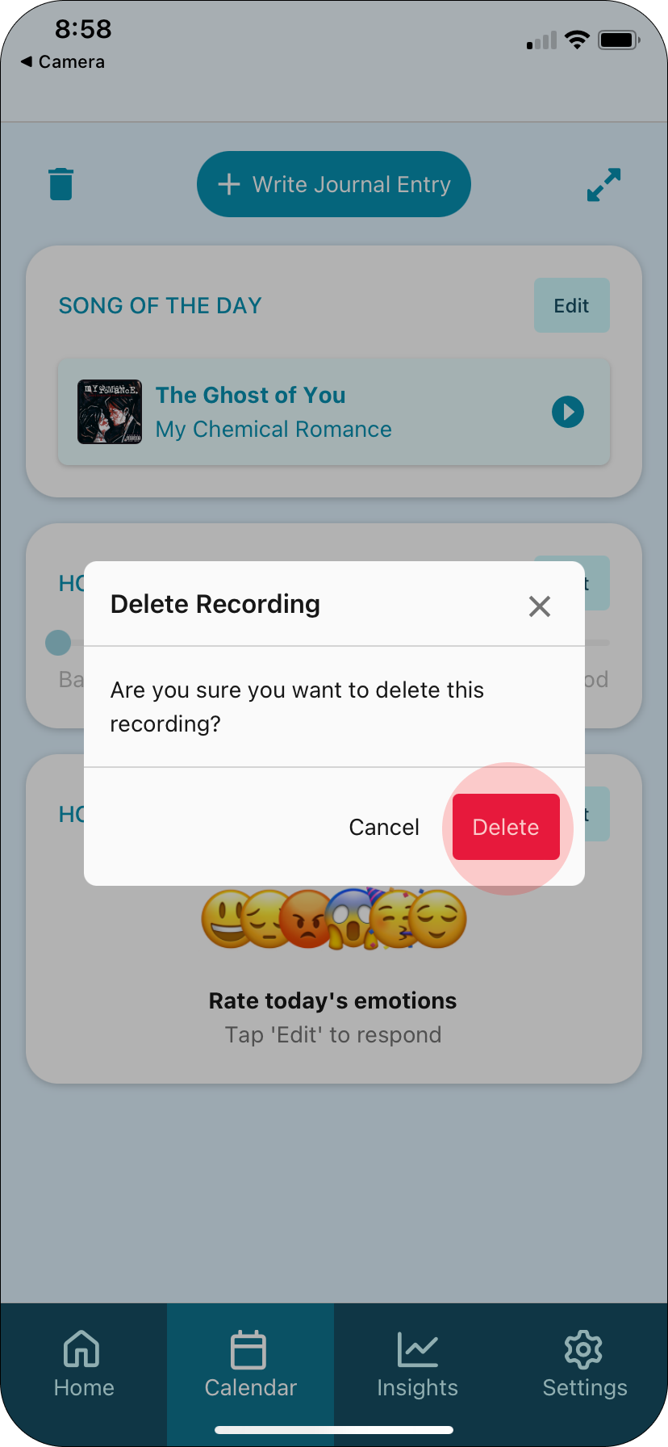

How to review your emotional / musical trends over time.
To review your emotional / musical trends over time, click the Insights icon on the navigation tab. To learn more about an insight, click the Learn More button in the insight card. Scroll down the page to explore more insights.

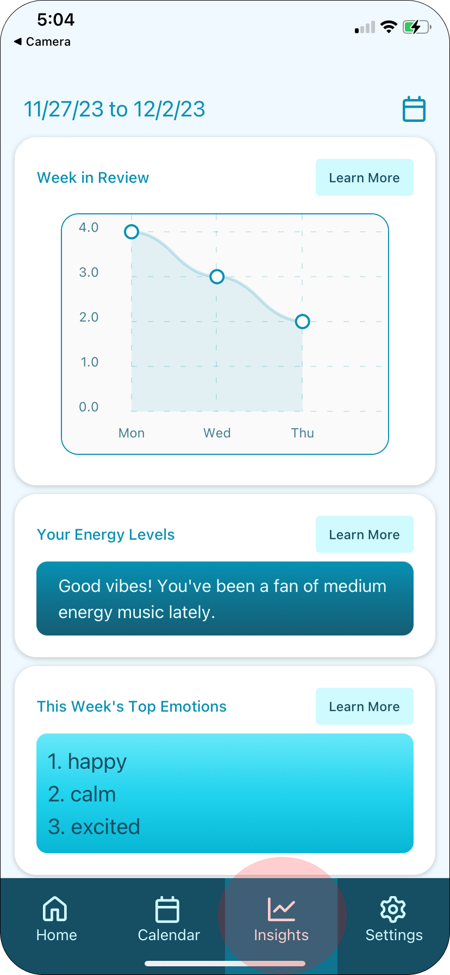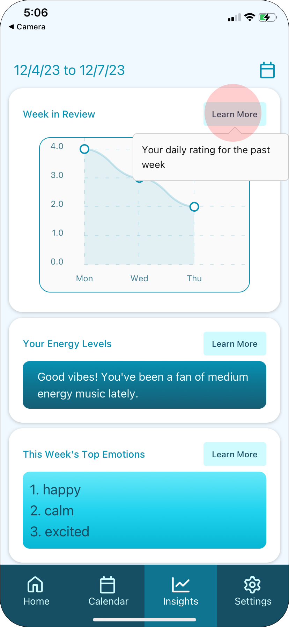

How to adjust the date range on the insights page.
Select the calendar icon in the upper right corner, then select your desired dates and press Save.

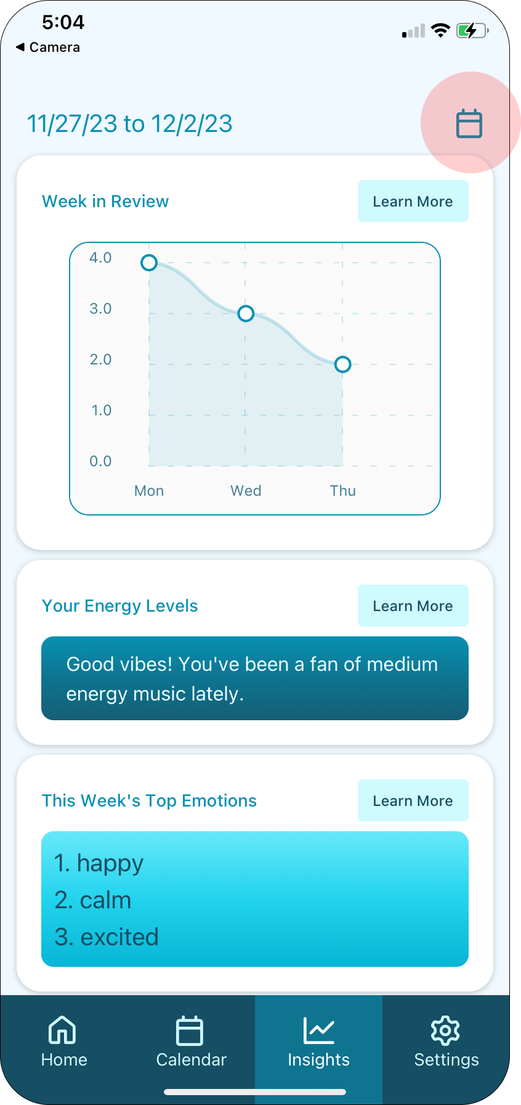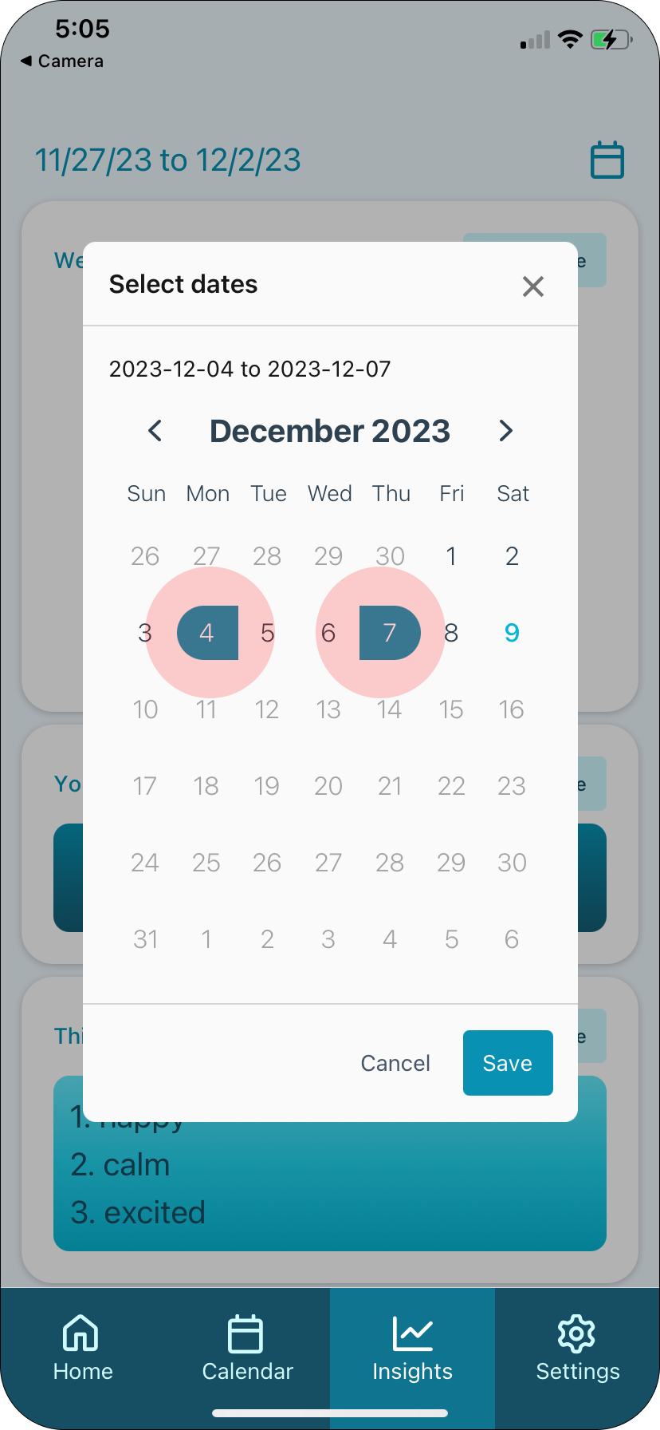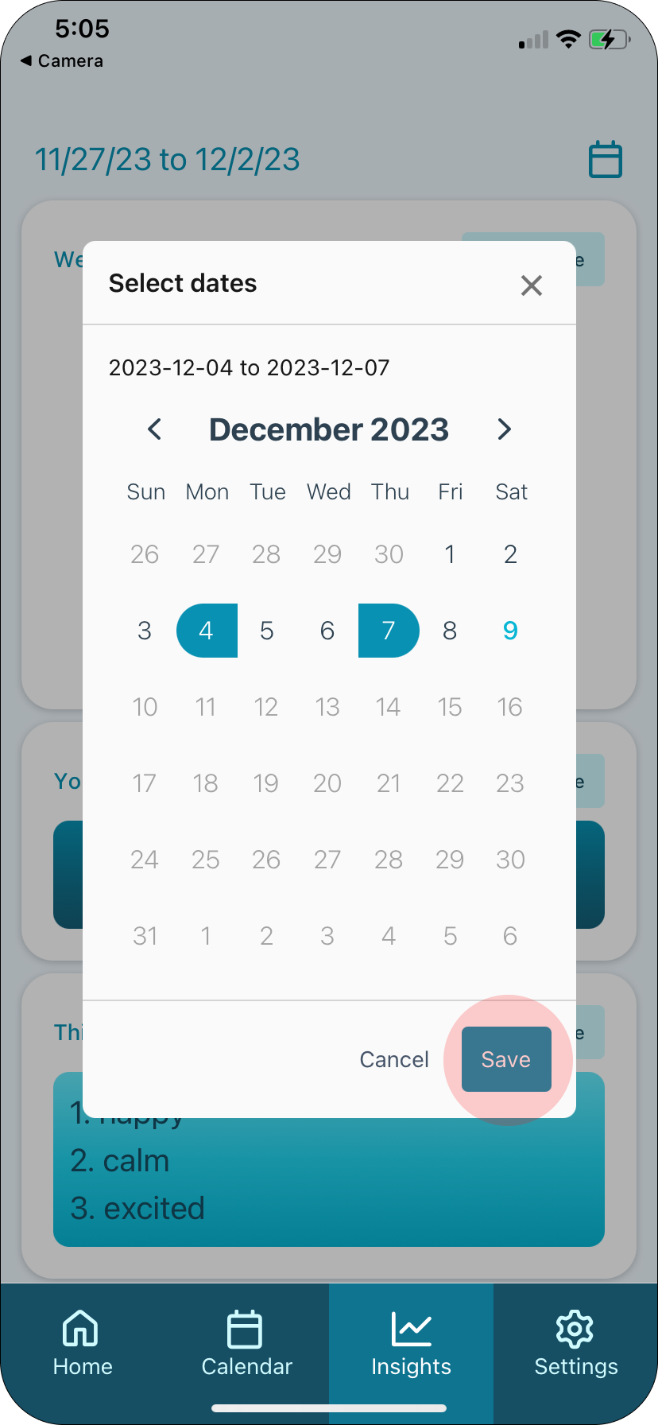

How to log out.
Click the settings tab on the navigation bar, then click the Log Out button.

