
Analyze your emotions musically.

Overview

About Record
Record is a music-centered journaling app that is optimized for quick entries that can be added on-the-go. Someone might use Record when they feel some emotion that they want to quickly record in the moment, or perhaps when they hear a song that they want to associate with a thought.

Users will eventually be able to schedule reminders to create an entry, so some users may use Record as a tool for regular self check-ins (as opposed to a tool that they open only when they actively feel that they want to record something).

Record includes a “trends” view that shows the user their emotional and musical trends over time. This page includes insights into the user’s emotional state, as well the relationship between their emotions and their musical preferences. Someone might navigate to the trends page in a moment of self reflection.

How it Works (High-Level)
- Select how you’re feeling.
- Select a song.
- Optionally enter a long-form journal entry.
- Optionally review your emotional / musical trends over time.

Using the Prototype

Prototype Overview
Record’s medium-fi prototype is built entirely in Figma. Click here to access the prototype.

In this section, we provide a comprehensive overview of the screens associated with each task flow and describe how screen interactions work. When you click on any area within the interface, you will see bounding boxes, also known as 'hotspots,' which indicate where you can interact with the app. All interactions are initiated by tapping. Users can use predetermined buttons to navigate through three different task flows and for general navigation within the prototype.

During the task flows, the 'Back' button typically takes you back to the previously visited screen. However, upon completing the 'simple & moderate' task flow, if you click on the 'Home' icon in the navigation, it will reset the entire flow.

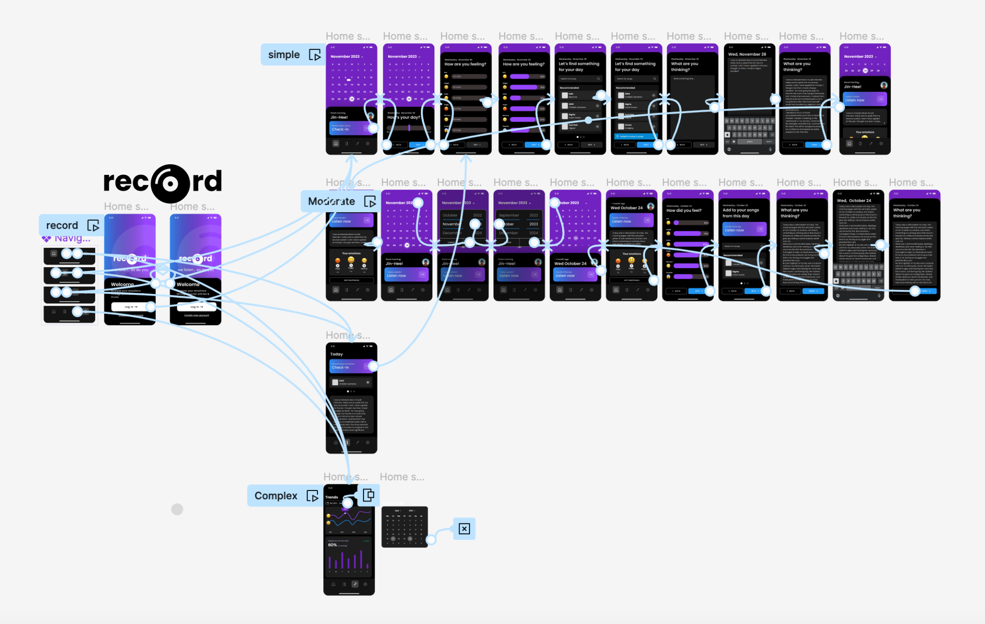

Task Flows
- Simple Task: Swiftly record a journal entry.
- Moderate Task: Review and modify a journal entry from a previous day.
- Complex Task: Contemplate emotions over time.

Navigation
- Home Icon: Initiates the simple flow.
- Journal Icon: Opens today's journal entry.
- Trends Icon: Reveals journal trends.
- Settings Icon: Currently non-functional.

Login Screen
- To begin using the app and initiate the simple task flow, tap the 'Login' button on the home screen.

Journal Screen
- Tap the 'Check in' call-to-action (CTA) to commence the Simple Task Flow.

Home Screen
By default, the home screen begins with the Simple Task Flow.

Simple Task Flow:
- Tap the 'Check in' CTA in the bottom sheet on the Home screen to start the simple task flow, which initiates in the bottom sheet.
- After the app prompts, "How's your day," tap 'Next' to set today's status.
- Select any emotion to establish ratings for all emotions (predefined).
- Tap "Next" to proceed to the next screen.
- Tap "Halo" to add a song to your day.
- Tap "Next" to continue to the next step.
- Tap the text area ("Write something here") for text input.
- Tap the text area again to dismiss the keyboard and reveal the complete journal entry.
- Conclude the check-in for the day by tapping "Finish."
- To access today's check-in responses, drag the bottom sheet up (click and hold).
- Hide today's check-in details by dragging the bottom sheet down (click and hold).
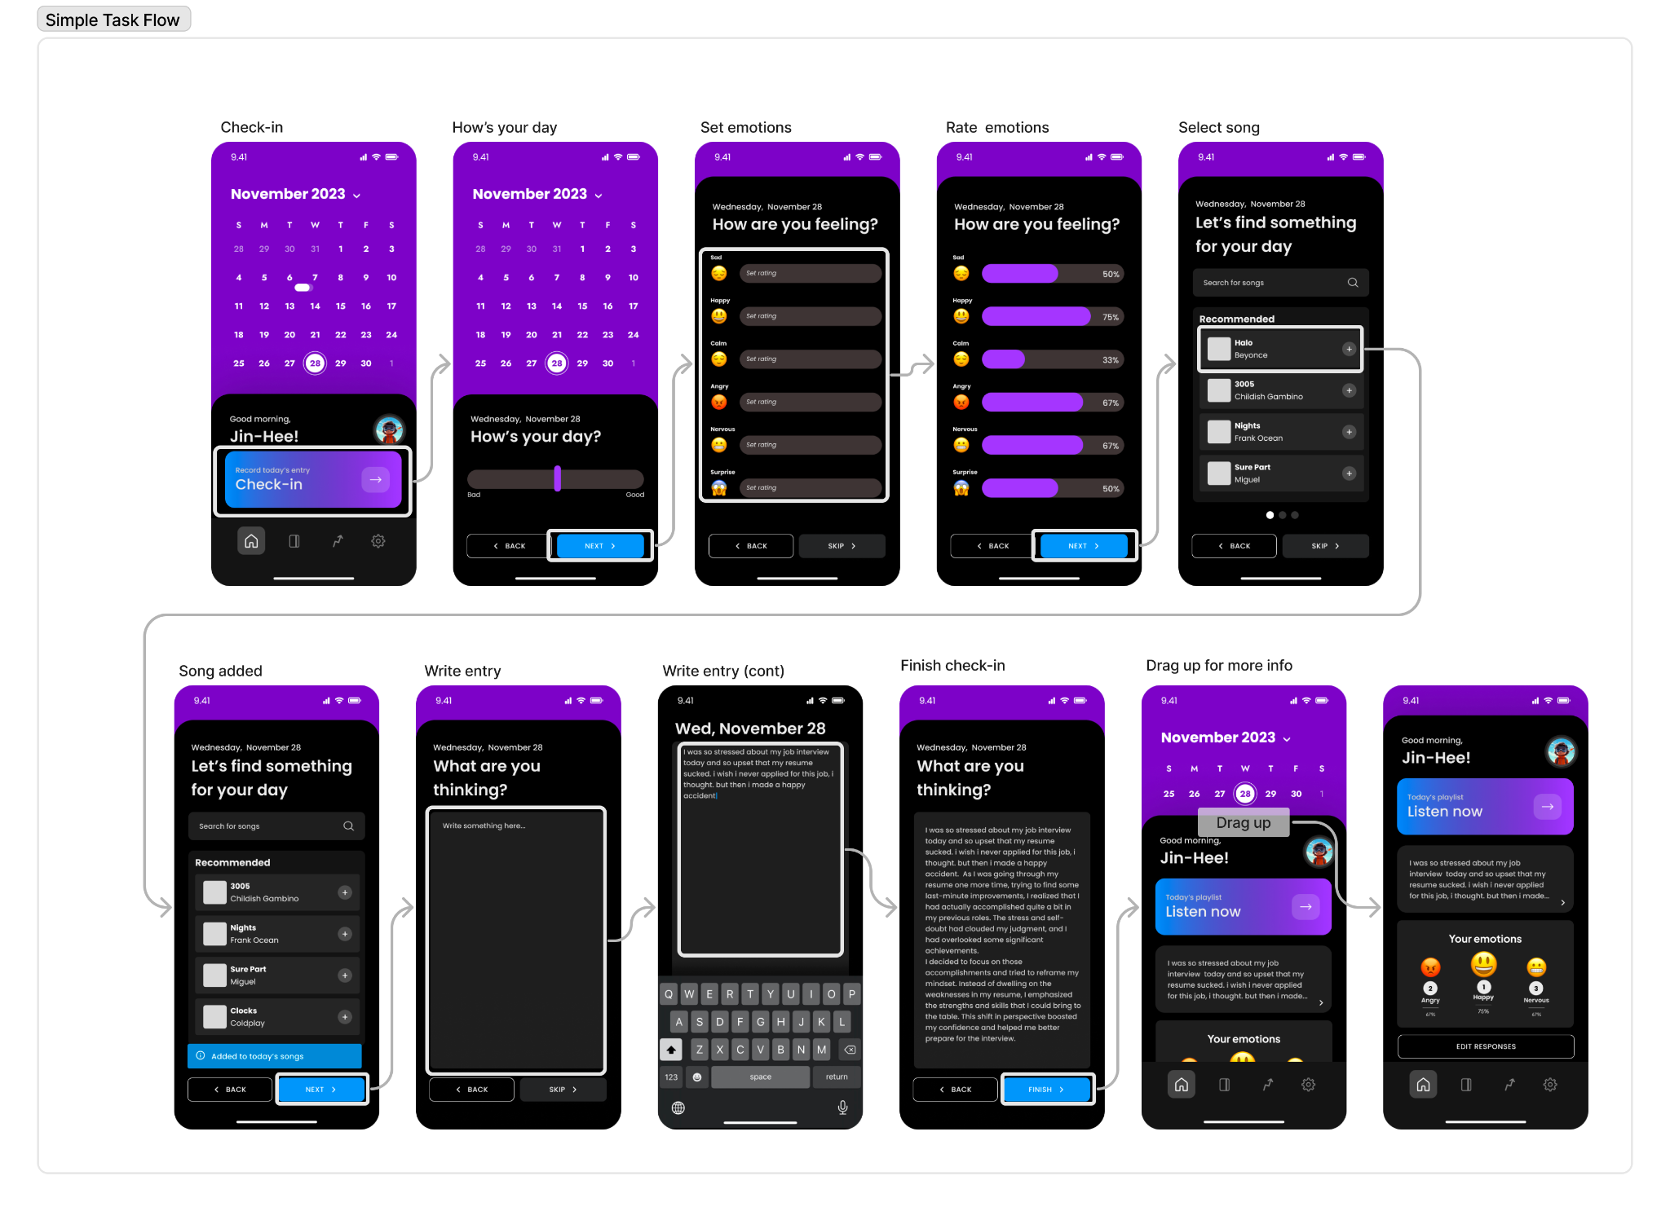

Moderate Task Flow:
The moderate task flow follows the simple task flow.
- Tap the date (November 2023) to modify the date.
- Select 'November' to change the month to 'October.'
- Confirm the date change by tapping 'OK.'
- To view your responses from the check-in on October 24, drag the bottom sheet up (click and hold).
- Tap the 'Edit Responses' button to make changes to this day's entry.
- Proceed by tapping 'Next' to choose songs for your journal entry.
- Tap 'Next' again to edit the journal entry.
- Tap the text area ("Write something here") for text input.
- Dismiss the keyboard and reveal the complete journal entry by tapping the text area.
- Conclude the editing for the day's entry by tapping "Finish.”
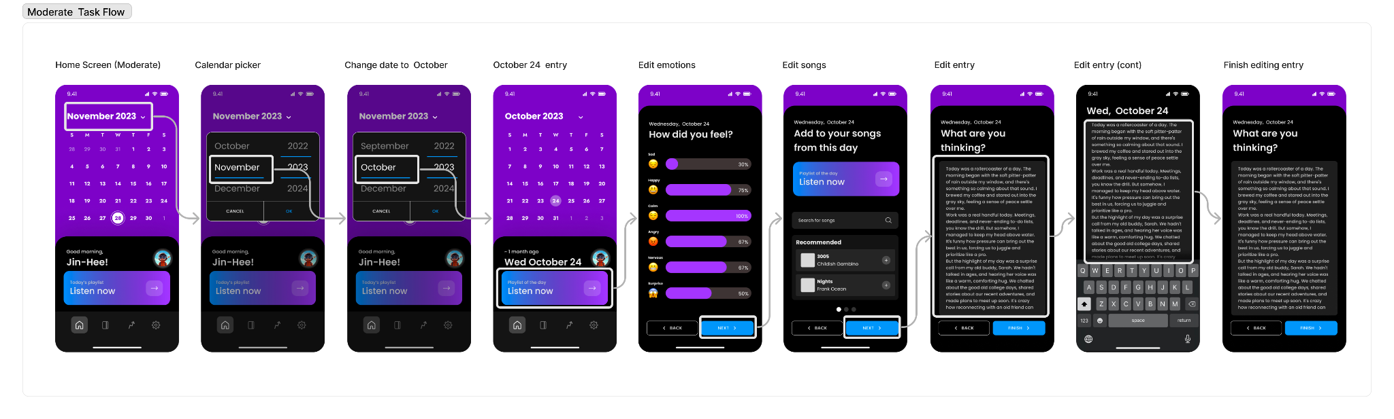

Trends Screen

Complex Task Flow

- Scroll up and down to view different trends on user’s data.
- Tap date picker to toggle date picker.
  - If date picker overlay is on, tap anywhere to dismiss it.

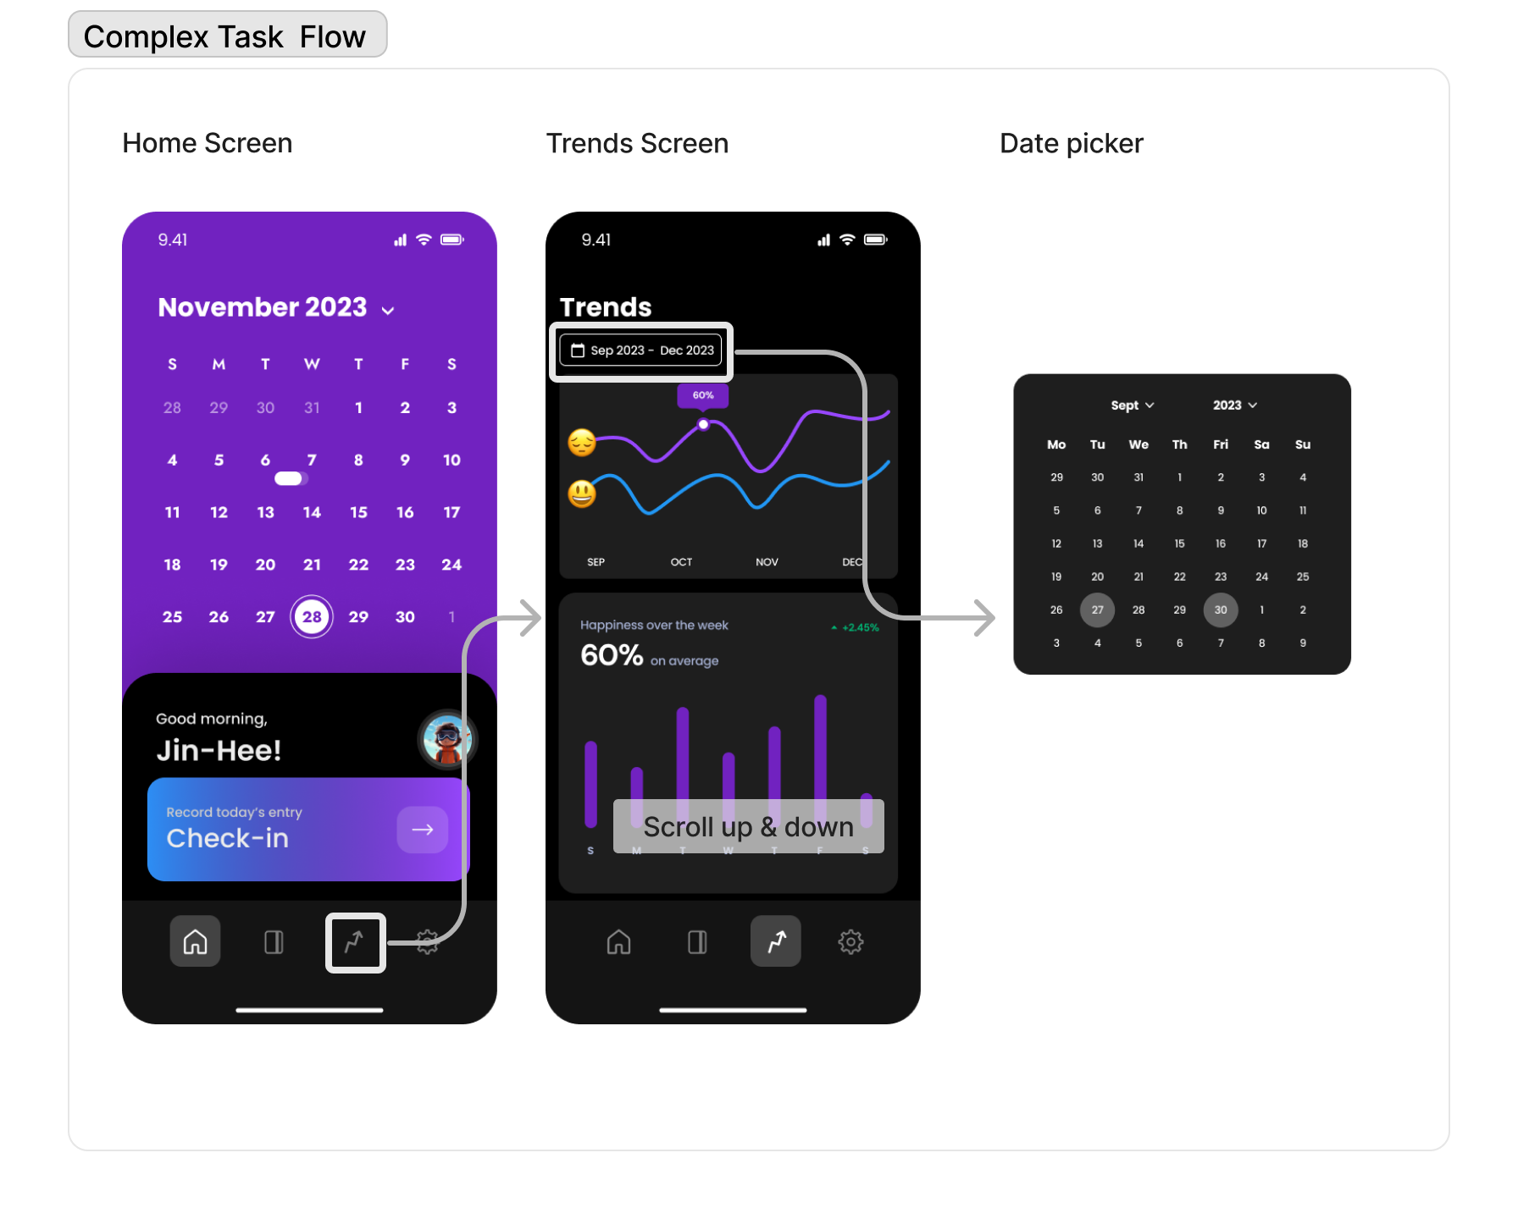

Limitations
As mentioned, our medium-fi prototype is built purely using Figma, and is therefore not connected to a database. The prototype is hard-coded with journaling data pertaining to a single pre-existing user – ✨Jin-Hee ✨.

Our primary reason for hard-coding Jin-Hee's data is that we wanted to mitigate the risk of prototype users running into bugs while trying to enter / save custom data. Providing the prototype users with pre-populated hard-coded data allows them to focus on the user flow / heuristics, as opposed to getting sidetracked by bugs that might arise.

Our secondary reason for hard-coding Jin-Hee's data was a lack of time / resources. The time it would take to build a database for the medium-fi prototype was not worth the benefits of doing so at this stage of development.

Another limitation is the app doesn’t actually play music / recommend playlists yet - we plan to integrate with the Spotify API to achieve this for the high-fidelity prototype.

Hard-coded Items
The hard-coded items in the app are the following:
- Date on the calendar
  - This is because we wanted to replicate the experience of opening a diary at a time.
- Positions of sliders when you rate your day and feelings
  - This is to demonstrate the way that a user can interact with inputs on the screen.
- The journal entry text
  - This is because we currently don’t support a backend system to store entries.
- Song suggestions
  - This is because we currently don’t support a backend system to get song recommendations from the Spotify API.
- Your emotions and how you rate them
  - This is to demonstrate the way that a user can interact with inputs on the screen & show the value proposition of our app.
- Old data in the Trends section
  - This is because we currently don’t support a backend system to store entries’ data and analyze them.

Wizard-of-Oz Techniques
In this section, we detail what Wizard-of-Oz techniques we used to simulate automation and our rationale behind using these in our prototype.

The user magically gets a list of music recommendations tailored to their tastes.

We wanted to represent what it would look like when users would get music recommendations without needing to fully implement the complex algorithms or data analysis processes to pull songs that they would like.

The user’s journal entries are analyzed already with the most relevant information to them in the ‘Trends’ screen.

We wanted to show the benefits a user would experience when using the application. We preloaded data & trends to keep the focus on how the user will interact with and benefit from the app. Also, we are not sure what information we want to present to the user yet, and complex technical details and algorithms may not be fully developed or decided upon at this stage.

