
Analyze your emotions musically

 |  |  | 
Sophia R.  UX Designer | Ellie V.  UX Researcher | Amy L.  Product Manager | Leilenah M.  Software Developer

Problem
Many people listen to music as a means of coping with their emotions – the problem is that the act of listening to music in an unstructured manner doesn’t always leave people with the emotional insights that they need.

Solution
Record – a music-centric journaling app that shows you trends in your emotions over time. Record lets you associate your emotional states with songs, then generates insights for you based on those associations. This solution is grounded in our belief that showing people visualizations of their emotions over time in an engaging, data-driven and music-centric manner will enable them to more effectively understand / cope with their emotions.

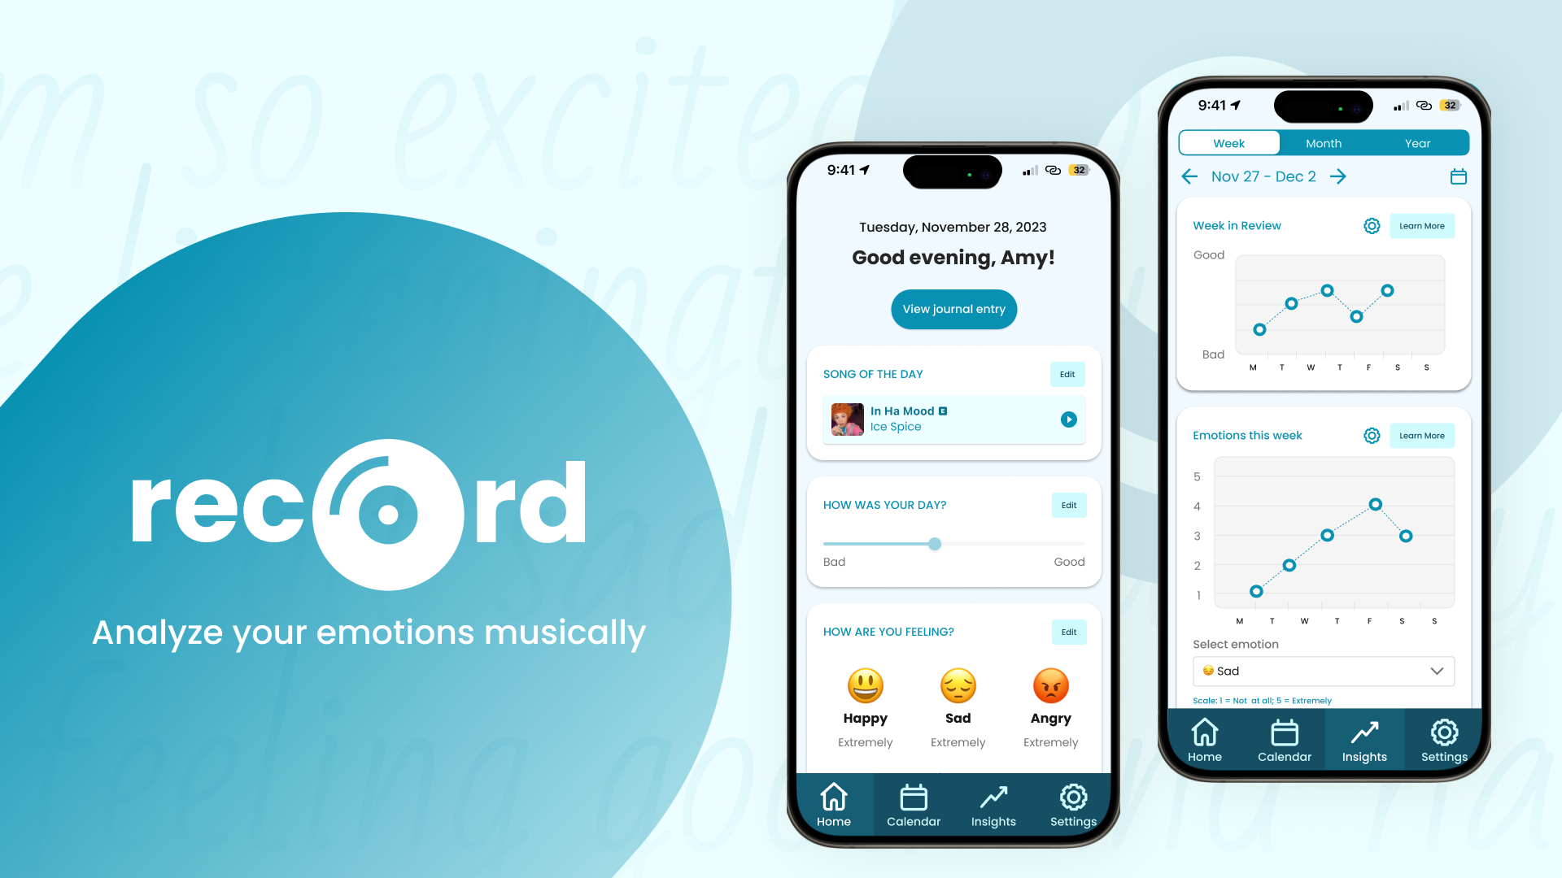

Needfinding

Interviews
When we initially embarked on the needfinding process, our problem domain was “people who play and/or produce music.” Therefore, it was important to us that the majority of our interviewees were musicians.
We interviewed 5 people during our needfinding phase including 1 professional musician, 2 “casual” musicians (both of which are involved with the Stanford band), 1 music producer / radio DJ, and one person who started playing music as a young child, but then stopped (Appendix A).
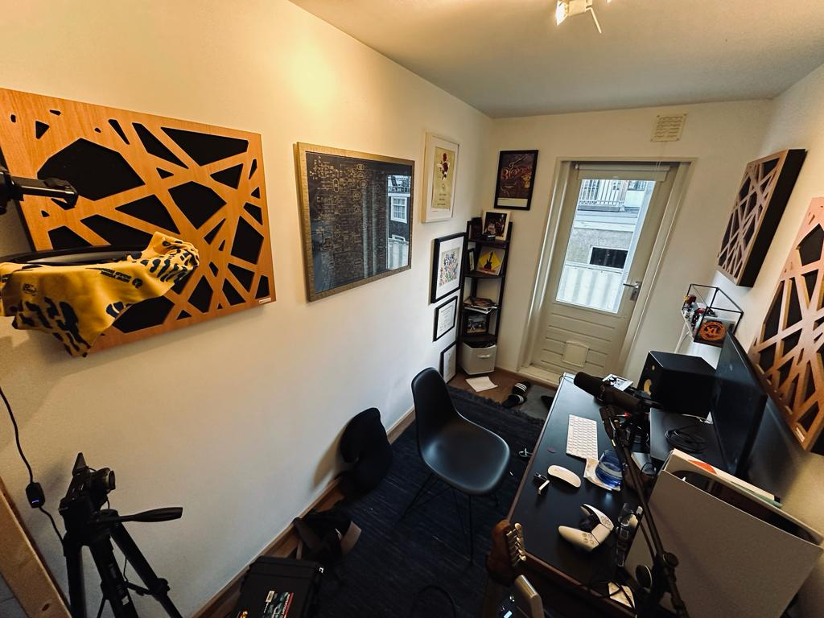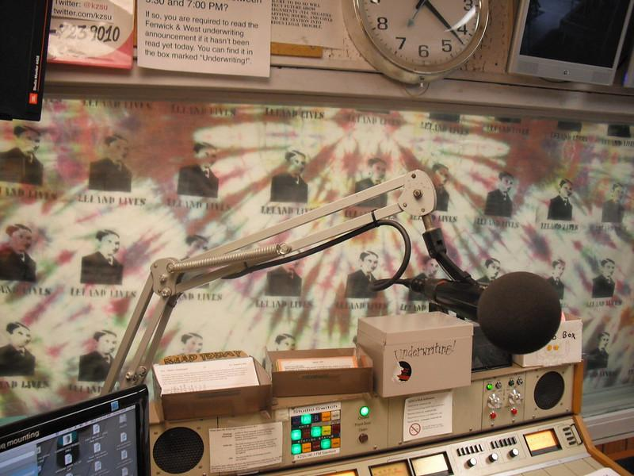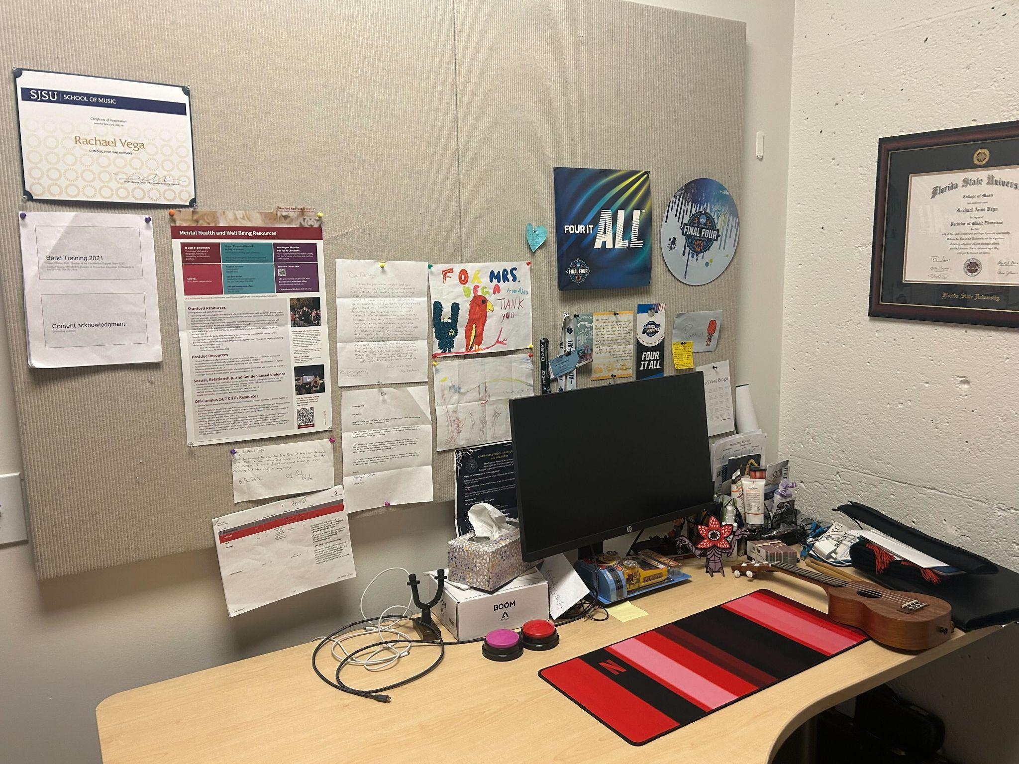

Figure 1. Photos of our interviewees’ natural environments
Our first step toward unpacking our needfinding interviews was to create empathy maps. We did this exercise for 3 out of our 5 interviews (Appendix B).
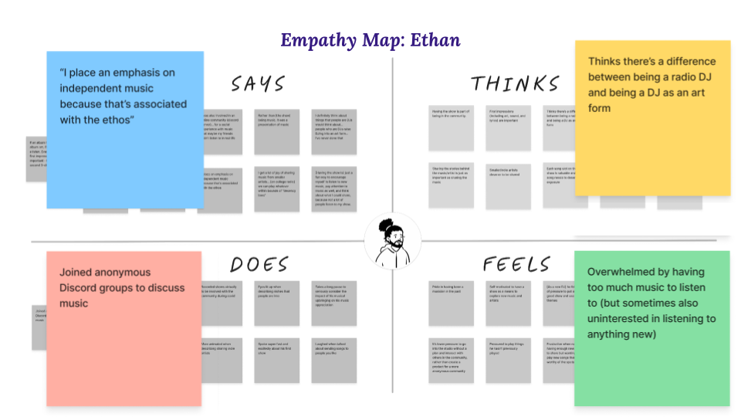

Figure 2. Ethan’s empathy map & key observations
After creating our empathy maps, we made a list of observations, inferences and insights from our interviews that we found compelling (Appendix C). We then narrowed in on three insights from our interviews that we wanted to explore further:
- Music can be an effective tool for enhancing cultural understanding and appreciation.
- Music can be used to identify, explore, and alter emotions.
- Musicians want to spend their time on their craft, and not on other tedious tasks (even if those tasks could help increase their popularity).

POVs, HMWs & Experience Prototypes
After conducting our initial needfinding interviews, we constructed three Point of Views (POVs). For each POV, we also brainstormed How Might We’s (HMW) and solutions. In total, we brainstormed 98 HMWs (Appendix D) and 80 solutions (Appendix E). Those solutions were the basis of the three experience prototypes that we created.

POV #1: Candice
- We met Candice, a casual consumer of music and 30-year-old new mother living with her husband in Southern California.
- We were surprised to realize her husband shares “hispanic music” with her, and she “gets down” to it, although she doesn’t speak Spanish.
- We wonder if this means she connects with her husband’s culture through his music.
- It would be game-changing to help Candice to gain a deeper understanding of her husband’s culture despite the language barrier.

How might we…
- Top HMW: HMW bridge the language gap for people listening to music outside their own culture?
  - HMW remove the language barrier for people enjoying new music?
  - HMW make music discovery outside one’s culture more accessible?

Solution
A product that, given any song in a different language, provides cultural context in your native language while listening.

Experience Prototype: Listen & Learn About Cultures
We tested the assumption that people want to know the history of a song and its meaning while listening to music. For example, if an English-speaking user is listening to the Spanish song “Bailando” by Enrique Inglesias, our product might show the user the English translation of the song as it’s playing, as well as provide information about the origins of “Bailando.”
In preparation for the prototype, we set up a device for playing the song "Bailando”, lyrics of "Bailando" in Spanish and English, pieces of paper to draw on and a writing utensil, and information on the cultural and historical context of the song. We tested our experience prototype on an English speaker who had limited experience listening to music in Spanish.
First, we gathered participant information, including cultural backgrounds and musical preferences. After playing an excerpt of the song, we asked our participant to share their initial impressions. Then, the participant listened to the song in real-time while annotating their thoughts and emotions. Following this, they were asked to draw an emotional timeline of their feelings during the listening experience.
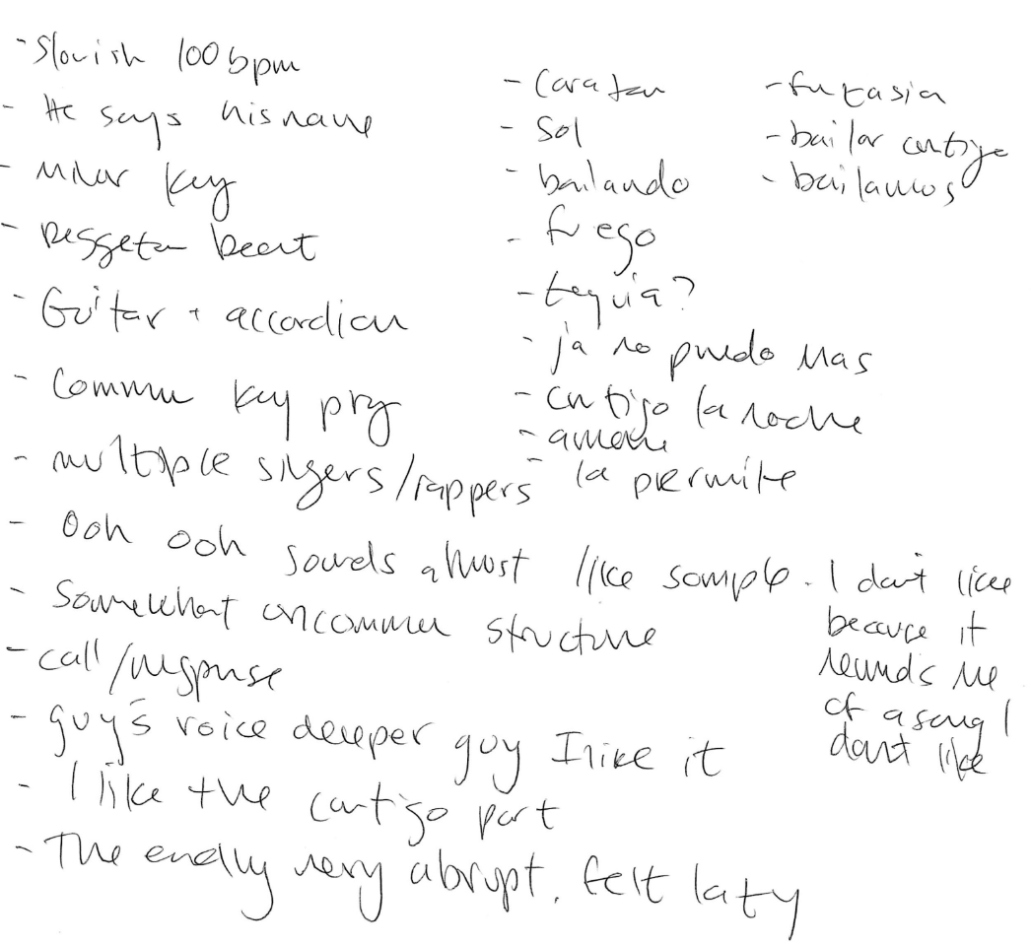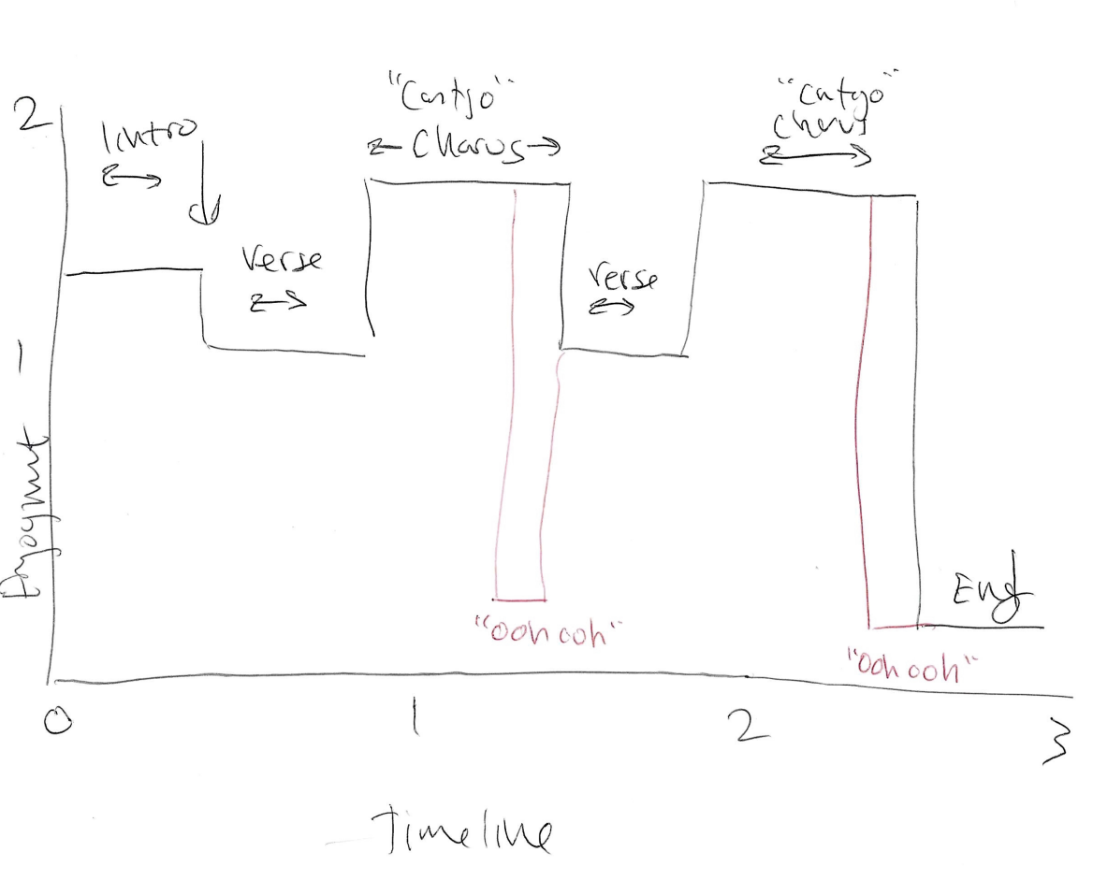

Figure 3. Real-time annotations (left) & emotional timeline graph (right)
Then, we showed our participant the lyrics to the song in both Spanish and English and asked them to compare.
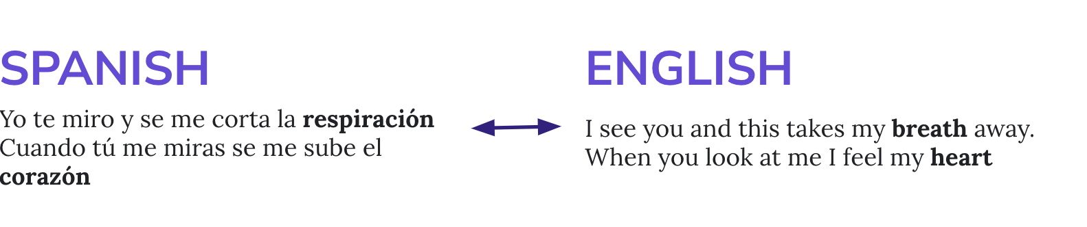

Figure 4. Example translation of “Bailando” lyrics
Lastly, we asked our participant if they wanted to learn information about the song "Bailando," including its cultural and historical context, its impact on Latin music, and any interesting facts about its creation.
What worked from our prototype was that our participant opted in to learn about cultural context and impact on Latin music, even though they did not speak Spanish, nor did they actively seek out music with Spanish lyrics. Thus, we learned that listeners are “happy” to learn about the culture without being a fan of the music. We also learned that non-native speakers can still interpret the intent of a song without understanding it; in our participant’s words, they “could sense what the gist of the song was just by listening to it.” However, our experience prototype had too much information all at once (lyrics, translation, song itself). This inspired us to focus on the listening experience going forward and not focus on this solution.
• • •

POV #2: Connor
- We met Connor, a 23-year-old recent Stanford graduate who plays the trombone and was formerly in the marching band.
- We were surprised to realize they use music to help quell feelings of anger, but are unable to use music to help quell other types of negative emotions like sadness.
- We wonder if this means there is something specific about the emotion of sadness that makes it difficult to alleviate via music.
- It would be game-changing to enable Connor to resolve emotions through music, furthering their self-discovery.

How might we…
- Top HMW: HMW let music be the map for emotional exploration?
  - HMW support those who prefer to sit with their sadness using music?
  - HMW personalize music for emotional impact?
  - HMW turn melodies into emotional storytellers?

Solution
A digital diary that uses natural language processing to curate music that goes along with the user’s diary entries.

Experience Prototype: Mood Journaling with Music
For this experience prototype, we wanted to simulate the experience of having personalized music suggestions based on journal text. Through this prototype, we were testing the assumption that music consumers would enjoy personalized music to explore or alter their emotions. In preparation for the test, we curated a list of songs associated with certain moods, and we asked the participant about their current mood and ideal mood.
This experience prototype had three parts: mood journaling, music selection for the current mood, and music selection for the ideal mood. The participant journaled in silence, then showed the tester their journal entry.
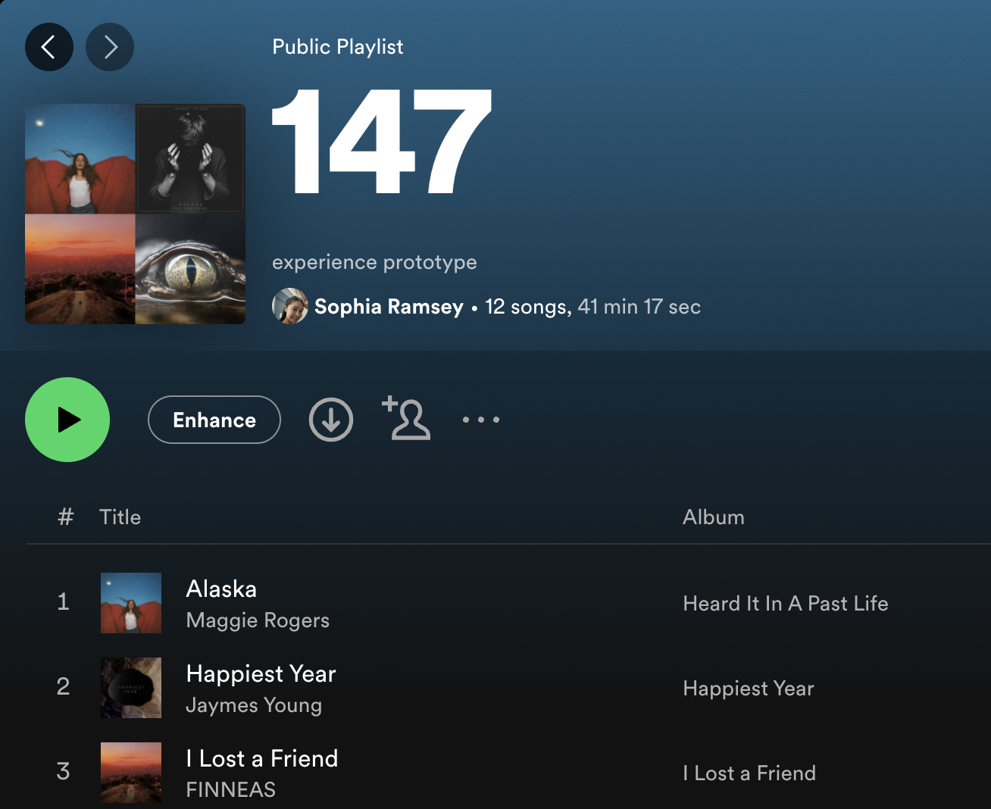

Figure 5. Personalized music suggestions
The tester then selected songs from the list to match the journal entry’s mood, and the participant was prompted to reflect on the song and how well it mirrored their sentiments. Finally, the participant selected songs from the list to match their ideal mood, and reflected on how they felt and how their current and ideal moods differed.
This prototype was successful in that the participant enjoyed having personalized music suggestions. However, the concept of having songs chosen through NLP on journal entries would not be entirely helpful, as the participant spent the majority of the entry venting and discussing emotions she did not want to experience. This solution needed to be altered so that the focus was on sentiments and ideal feelings, while not being overly specific. To help this issue, a filtering mechanism could help users avoid certain artists, songs, and genres, while still providing freedom to recommend songs.
Based on the feedback for this experience prototype, we decided to pursue this solution. We decided on a journaling app, but we allowed users to select their own songs to add to their entries instead of getting AI-generated recommendations based on the sentiment in their entries. This would prevent the aforementioned issues, but still provide enough information to provide trends that allow users to track and explore their emotions.
• • •

POV #3: Elliott
- We met Elliott, a professional guitarist, music Youtuber, and new dad in his mid-30’s, currently living with his wife in Amsterdam.
- We were surprised to realizeElliott believes aesthetically pleasing YouTube videos helps with video performance; but he refuses to spend more than 6 hours editing a video.
- We wonder if this means musicians want to spend their time on craft, and not on other tedious tasks (even if those tasks could increase their popularity).
- It would be game-changing to enable Elliott to perform tedious tasks in ways that are artistically gratifying.

How might we…
- Top HMW: How might we make doing tedious tasks feel like making music?
  - HMW help musicians simplify their sources of income?
  - HMW make the logistics of professional musicians feel like music making?
  - HMW make tedious tasks for musicians feel fulfilling?

Solution
A task manager that intersperses tedious tasks with breaks of creative tasks that encourage you to make music.

Experience Prototype: Tedious Tasks + Music Making
Our experience prototype involves our participant switching between tedious tasks and music-making tasks and rating their level of engagement with each task. This prototype was meant to test our assumption that adding musical tasks to tedious tasks would make the tedious tasks seem easier to complete. However, we were surprised to notice that rather than the musical tasks making the tedious tasks seem easier to accomplish, our participant felt that the tedious tasks made the musical tasks more engaging.
The test for our prototype proceeded in two parts. First, we asked our participant to perform a tedious task that involved lots of attention, such as drawing 5 visually distinct houses. Once they finished this tedious task we asked them to create a short snippet of original music using Garageband for iPad. We then played back the snippet they created. We repeated this process, asking the participant to draw 5 visually distinct boats before the next pause for music. We then repeat one more time, asking them to draw 5 visually distinct cars. We finished this part by playing back all the audio snippets they created and then asking them some debrief questions, including how engaging each task was.
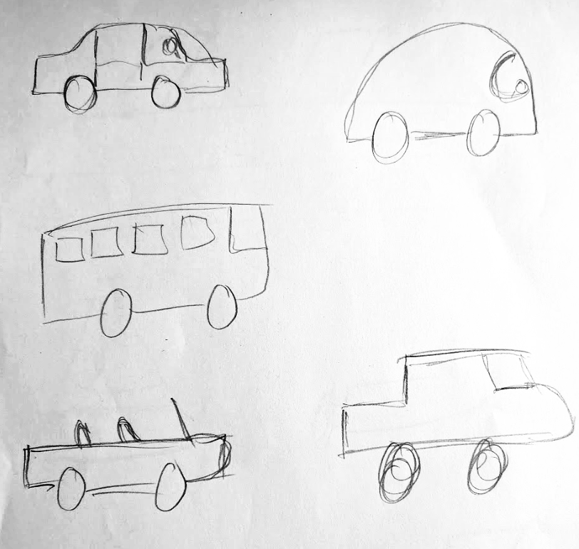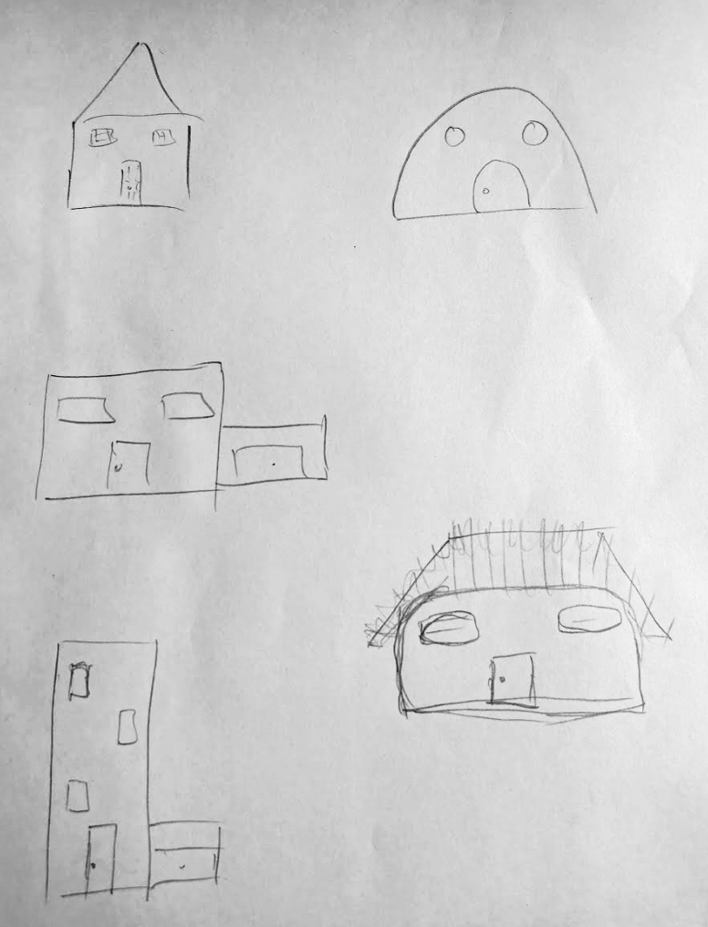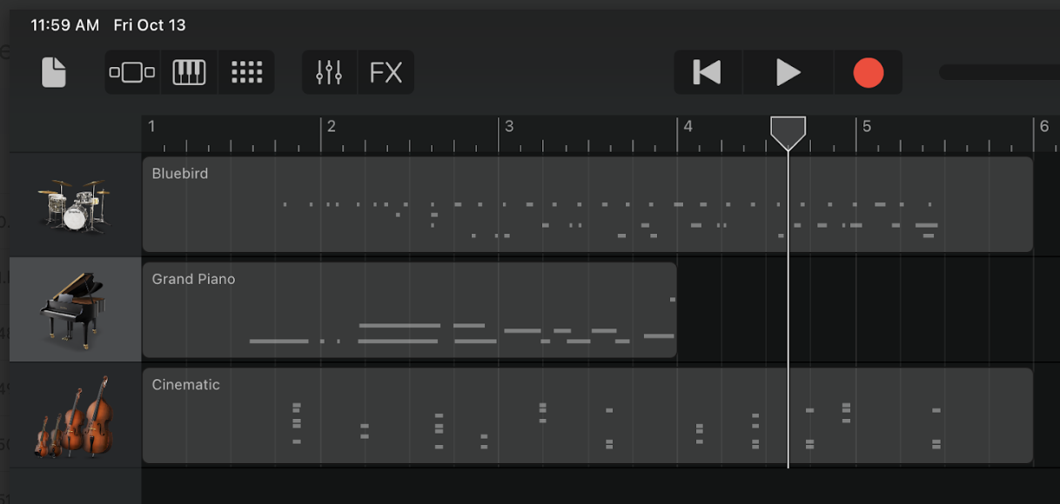

Figure 6. Creative tedious task drawings (left) and Garage Band music making (right)
For part two of our prototype, we asked our participant to perform tedious tasks, as before, but the part two tasks were more mindless than part 1 tasks. The tasks were (1) write your morning routine in at least 10 steps, (2) draw a grid of 50 circles, and (3) pick a room in your house and draw a map of it. After each task, we again asked the participant to create a short snippet of original music with Garageband for iPad. At the end of the 3 tasks we again asked a series of debrief questions.
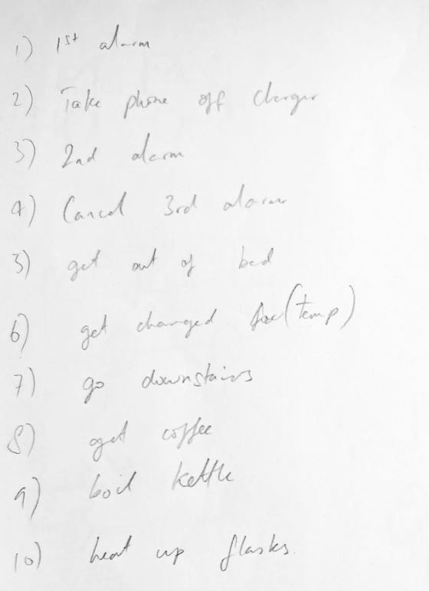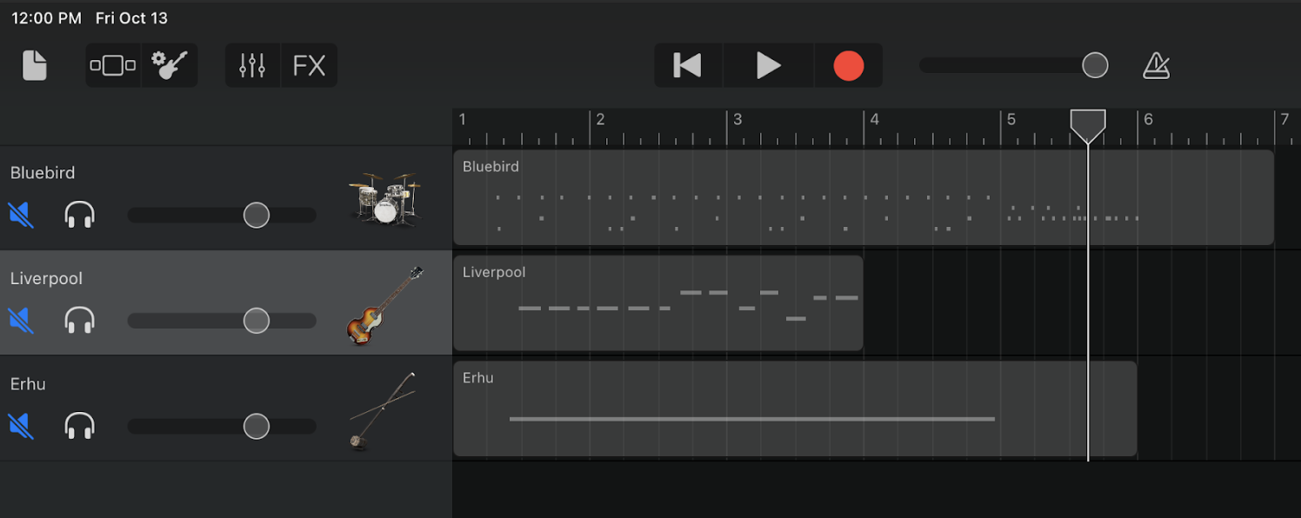

Figure 7. Mindless tedious task drawings (left) and Garage Band music making (right)
Overall, we learned from our participant’s responses that making music felt easier when combined with the tedious tasks. This is interesting because our original assumption was the opposite - that tedious tasks would feel easier when paired with musical tasks. Our participant said that the breaks to do tedious tasks took pressure off of music making. Unfortunately, though, they also said that the music making sessions felt too short, like they were getting cut off. If we were to iterate on this experience prototype, we would try to balance the tasks and music making without cutting off the creative flow by making the music-making sessions longer.

Design Evolution

Final solution
Many people struggle to connect with their emotions on a deep and meaningful level. We learned from our interviewees that "sadness was getting in the way of me doing things." Many of our interviewees turned to music to attempt to deal with their emotions, even though it doesn't always work. For example, an interviewee mentioned how "after I had my son, and I was kind of going through postpartum depression, I really dove into music at that time." Thus, we asked ourselves, "How might we use music to help people analyze and reflect upon their own emotions?"
Our final solution is a music journaling app where users can record a journal entry, select their emotions, and choose a song of the day. Then, we provide the user with metrics about their emotional and listening history. Our solution is based on insights gathered from interviews where individuals expressed a struggle to connect with their emotions. By centering the solution around the primary user's love for music and interest in emotional insight, we address a genuine need.
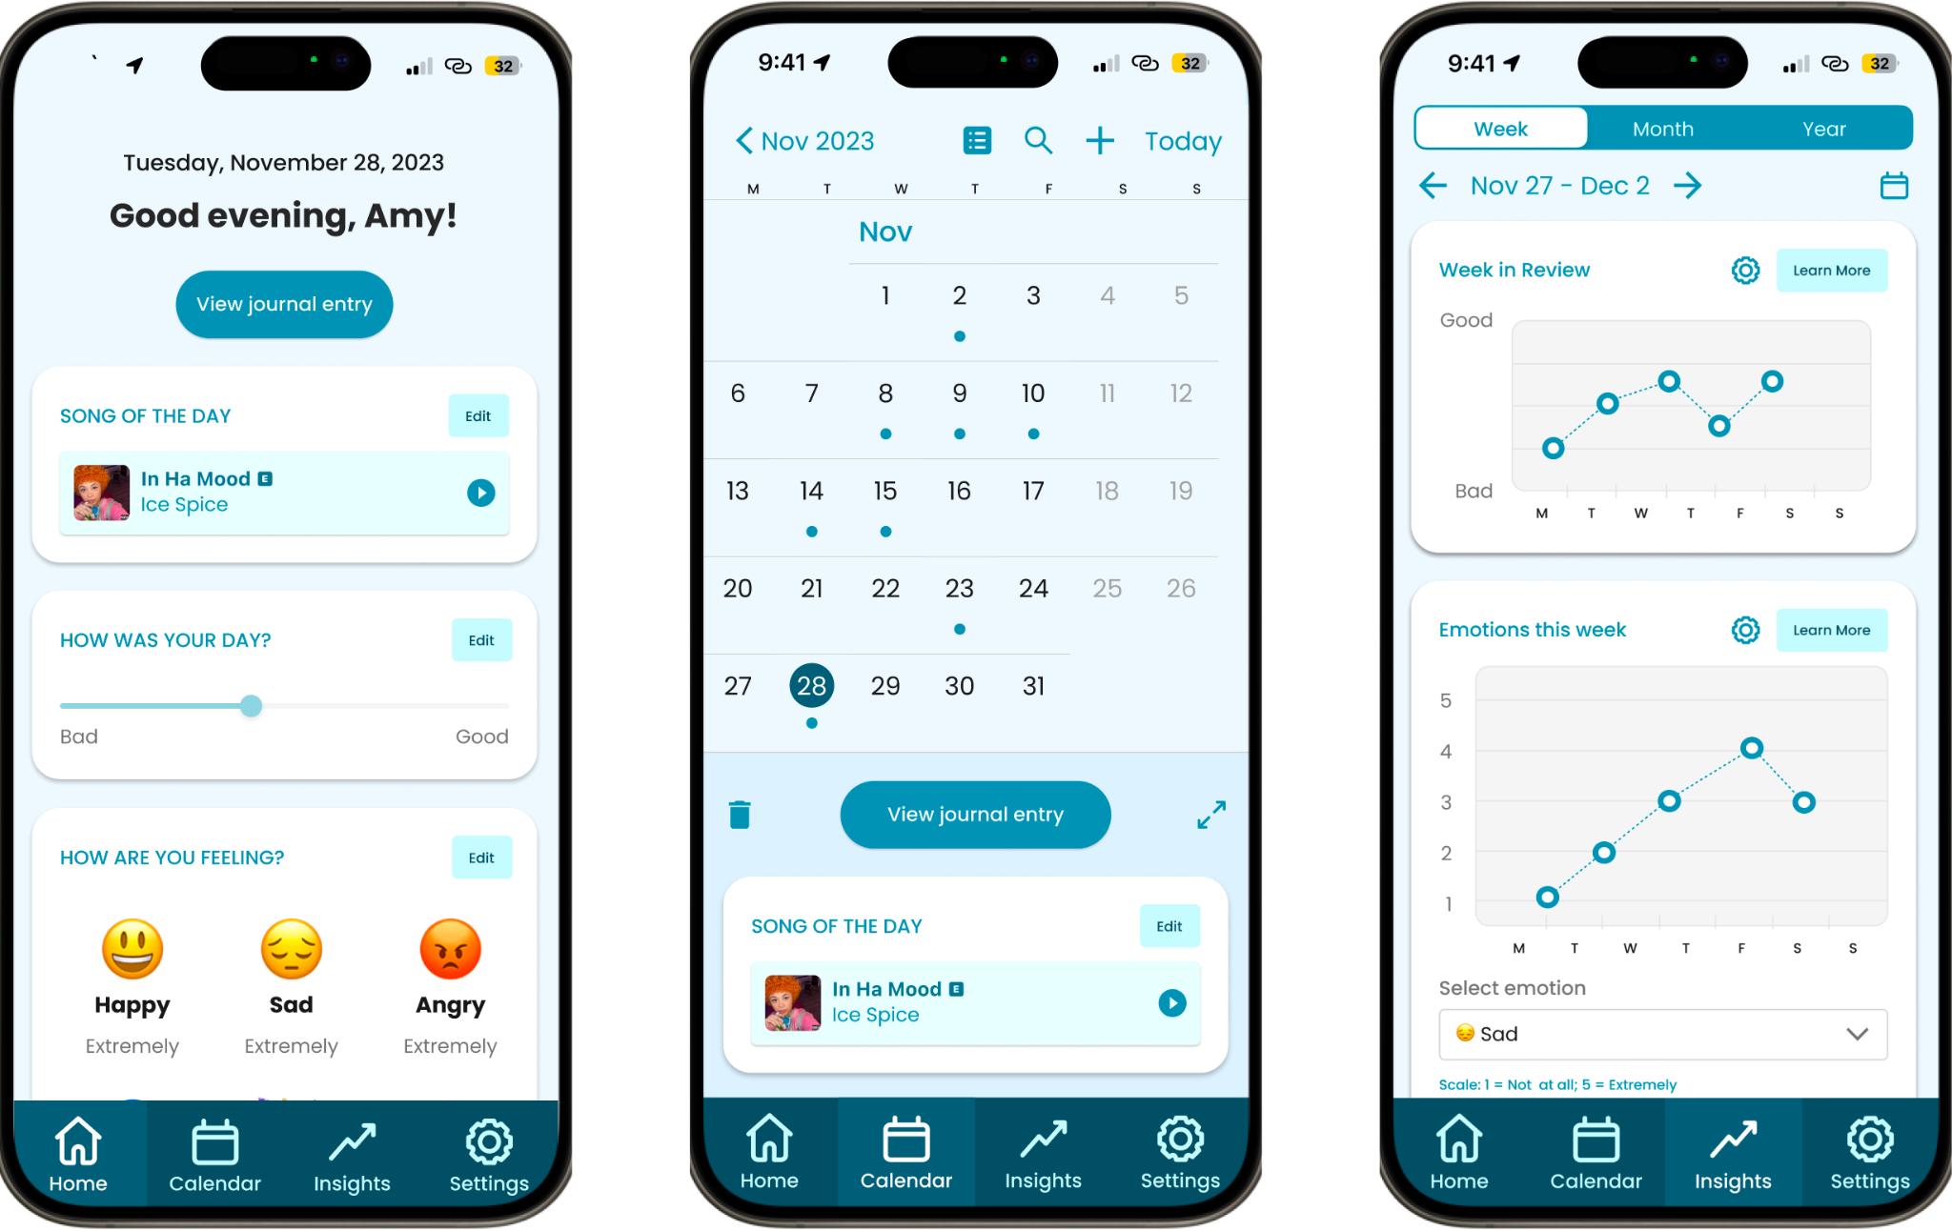

Figure 8. From left to right, write a journal entry, view past entries, and analyze trends
Building on interview findings that individuals turn to music during emotional struggles, our solution directly integrates music into the reflective process. The act of associating emotions with a daily song encourages users to explore their feelings through a medium they already find comfort in.
As a journaling app, Record builds on habit-forming features to address the identified struggle of connecting with emotions on a deep level by fostering regular self-awareness and analysis. Additionally, Record goes beyond simple journaling by offering metrics about users' emotional and listening history. This data-driven approach not only enhances self-awareness but also empowers users with valuable insights into their emotional well-being over time.

Tasks
We highlight the most important tasks in order of complexity (ancillary tasks in Appendix D).

Simple Task: Record your day
This task is important because the emotional / musical insights that we provide to the user are all based upon the data that the user inputs while completing this task. We can’t provide meaningful insights to a user if they don’t consistently create recordings over time.

Simple Subtask #1: Record your song of the day.
There are two ways to record your song of the day. To quickly select the song that we recommended to you, press the + button on the song card. To see more recommendations or search for a song of your choice, click the Edit button on the song card. Click the Save button to collapse the song card.
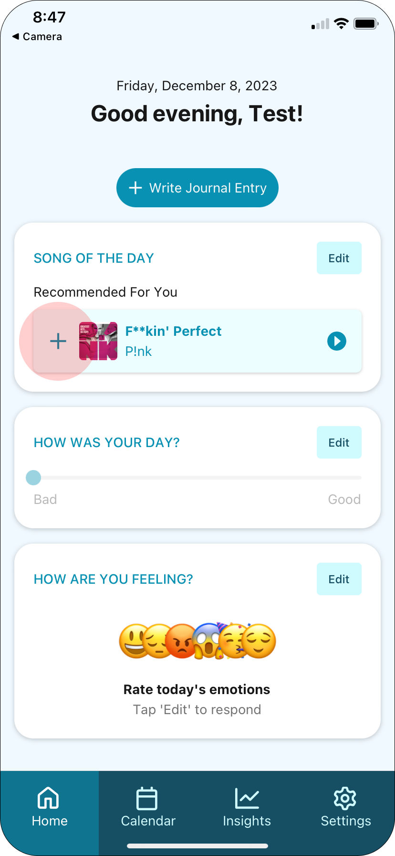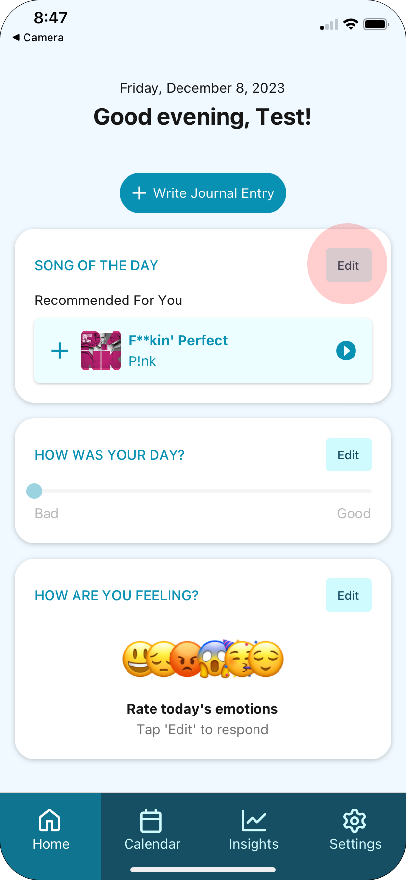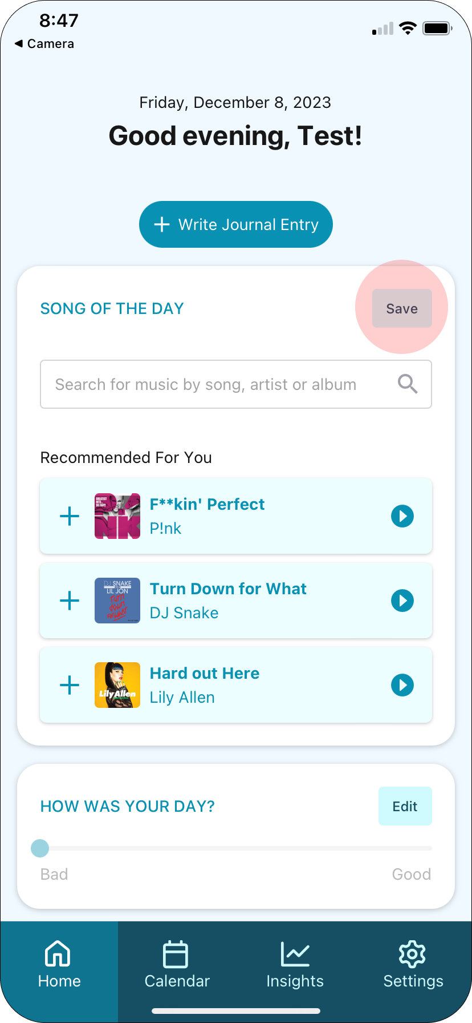

Simple Subtask #2: Record a rating for your day.
To record a rating for your day, click the Edit button in the “How was your day” card and slide the slider below the Edit button to indicate how bad / good your day was.
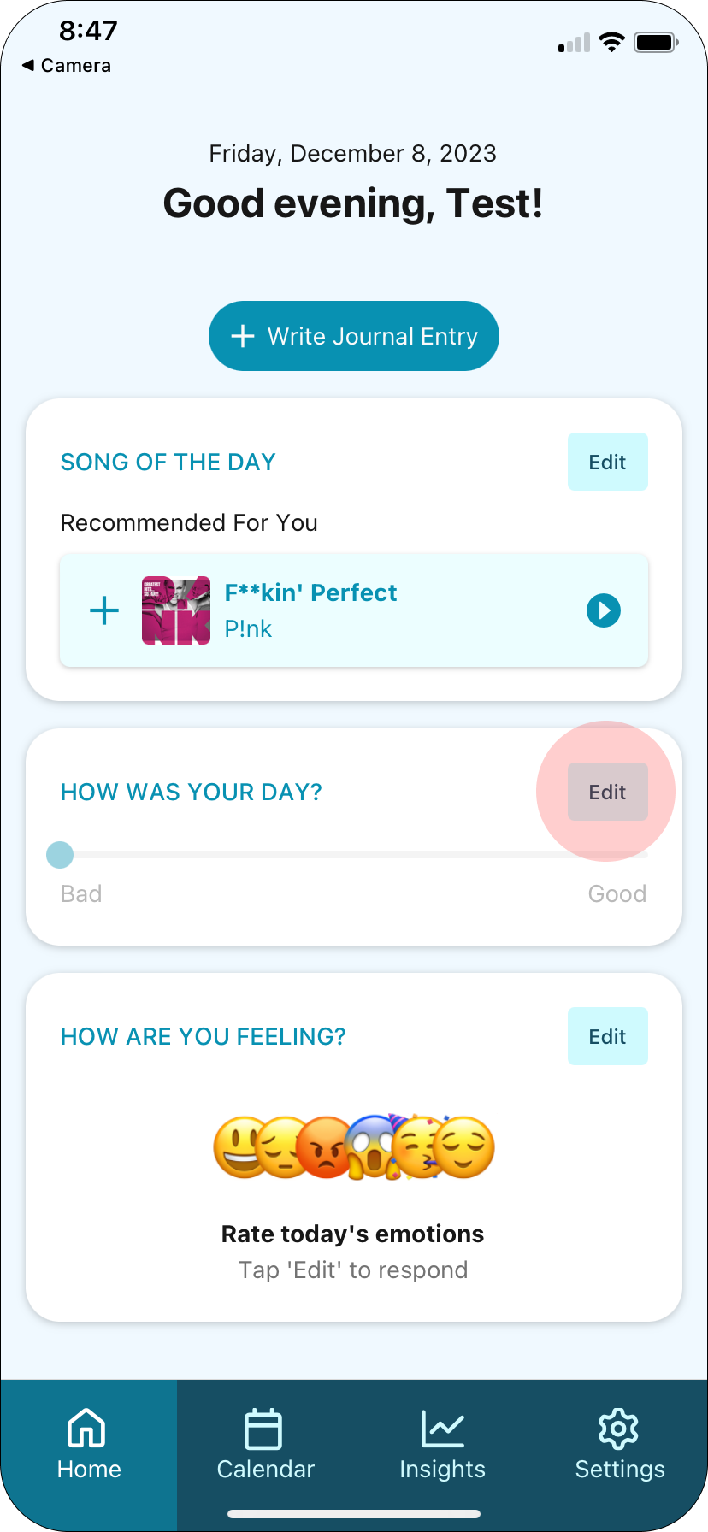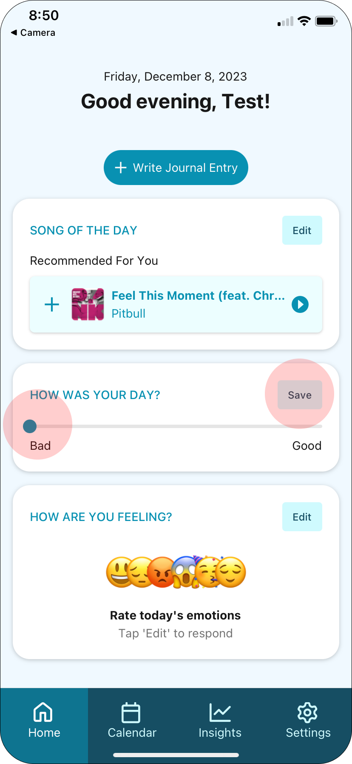

Simple Subtask #3: Record your emotion ratings.
To record how happy, sad, angry, nervous, excited or calm you’re feeling, click the Edit button in the “How are you feeling” card to expand the emotion rating sliders.
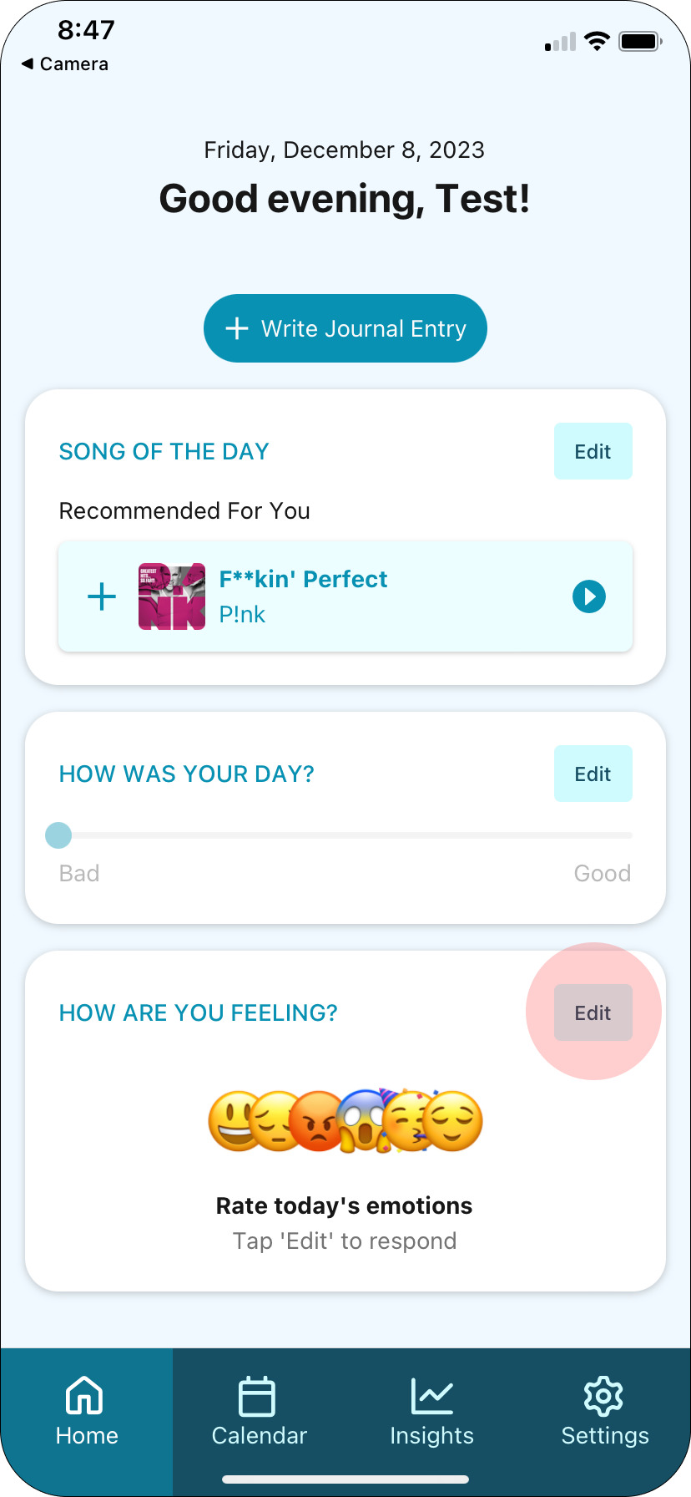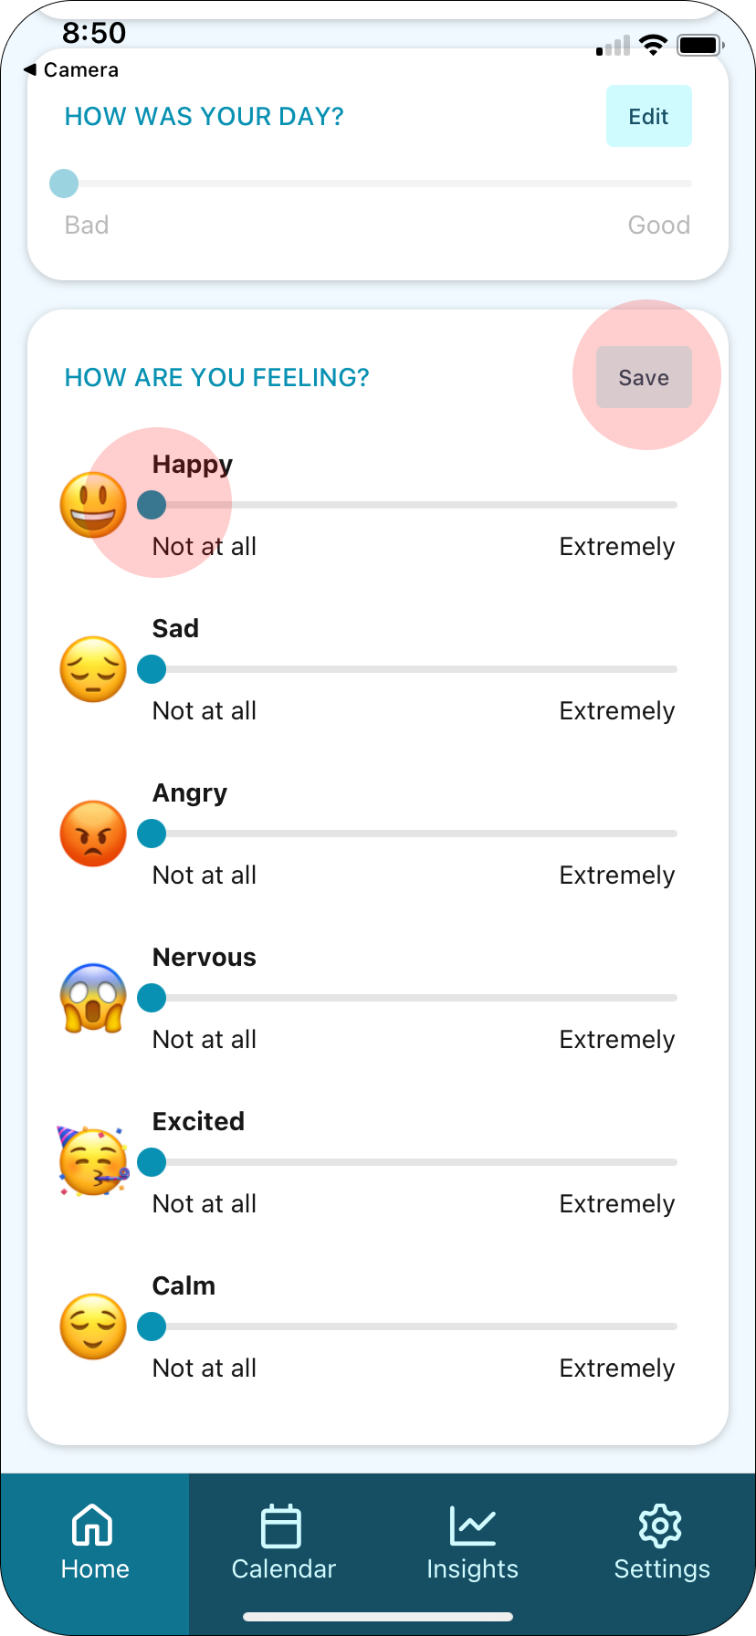

Simple Subtask #4: Record a long-form journal entry.
To record a long-form journal entry, click the “+ Write Journal Entry” button on the home screen. This will take you to a text-area that you can press to start typing into it.
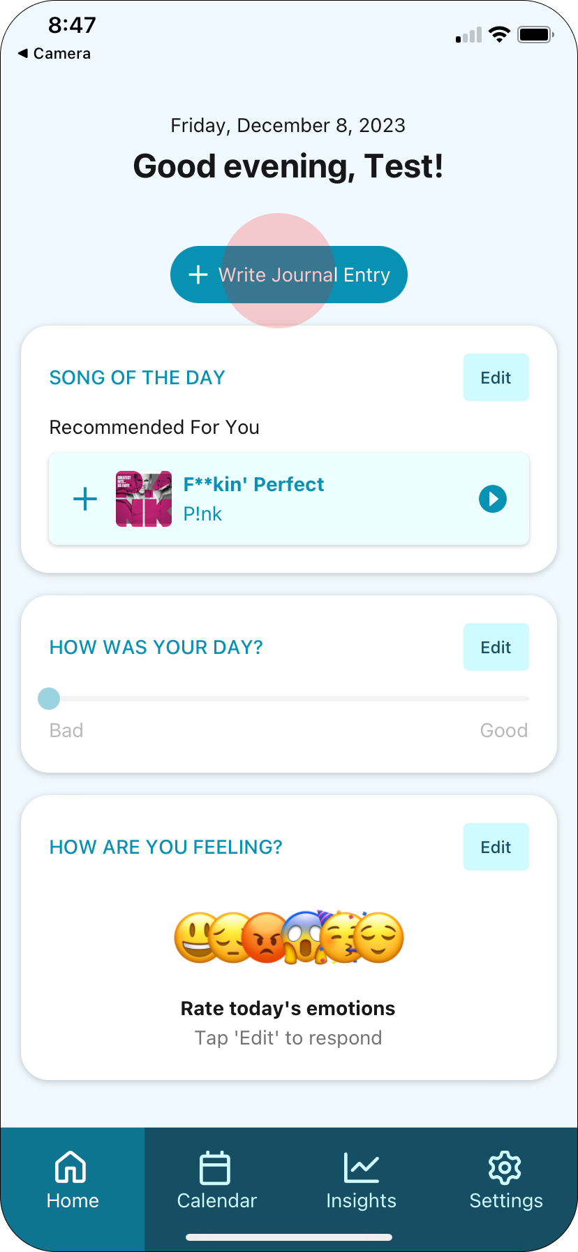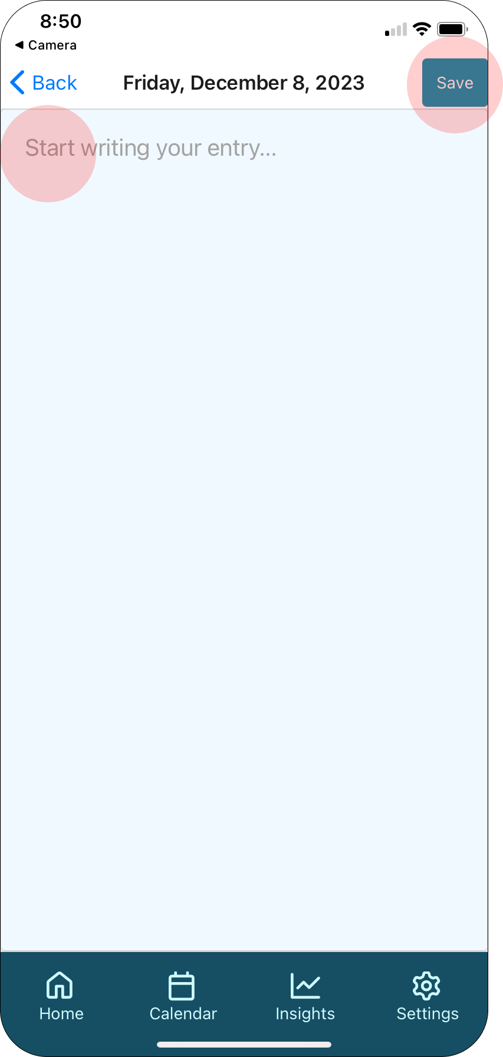

Moderate Task: Review and modify a recording from a previous day.
This task is important because it supports some users’ desires to reflect upon their past by reviewing and optionally modifying their previous recordings. Record is all about self-reflection, therefore it was important to us to include this feature for users who self-reflect in this way.

Moderate Subtask #1: Search for a previous recording.
To review previous recordings, click the Calendar icon in the navigation bar. Select a date in the calendar to see what you recorded that day. Click the expand icon to expand your entry. Click the expand button again to collapse it back beneath the calendar.
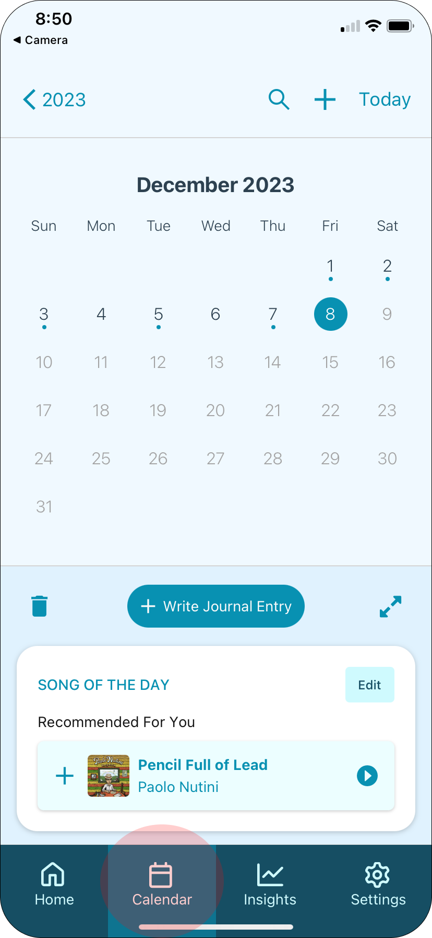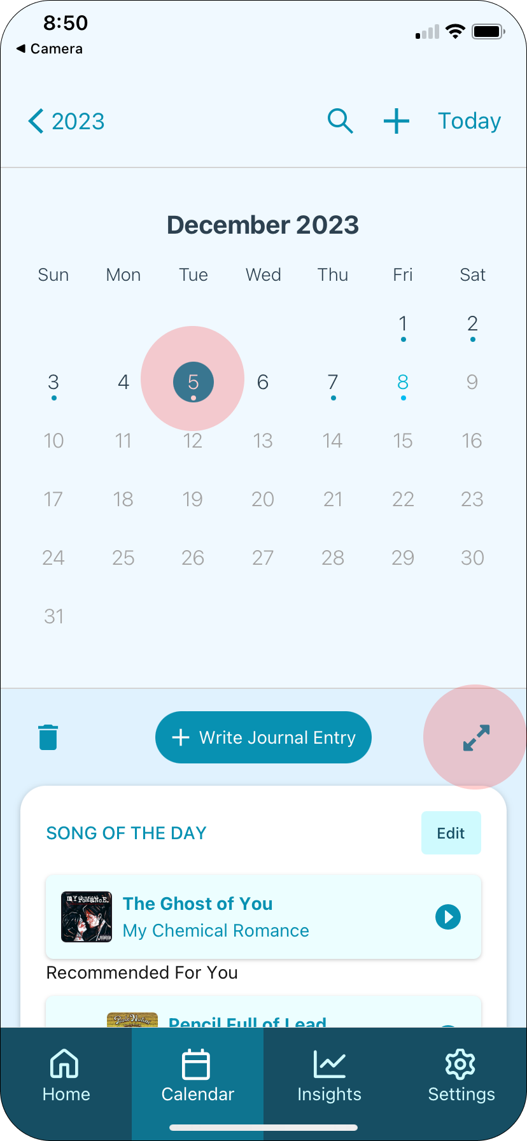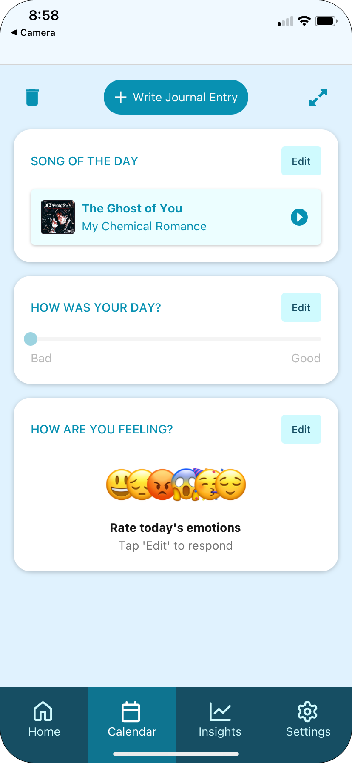

Moderate Subtask #2: Edit a previous recording.
See simple task annotations.

Moderate Subtask #3: Delete a previous recording.
To delete a recording, navigate to the recording in the calendar view, and click the trash icon associated with the recording.
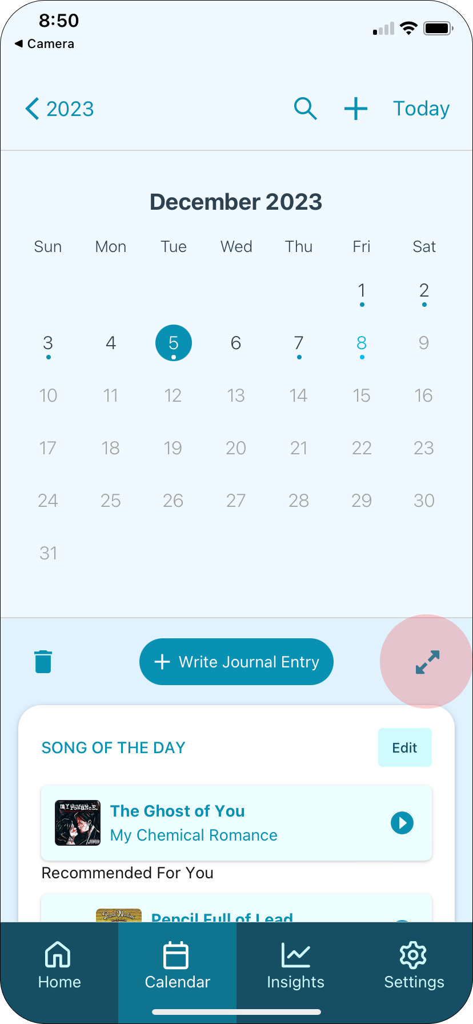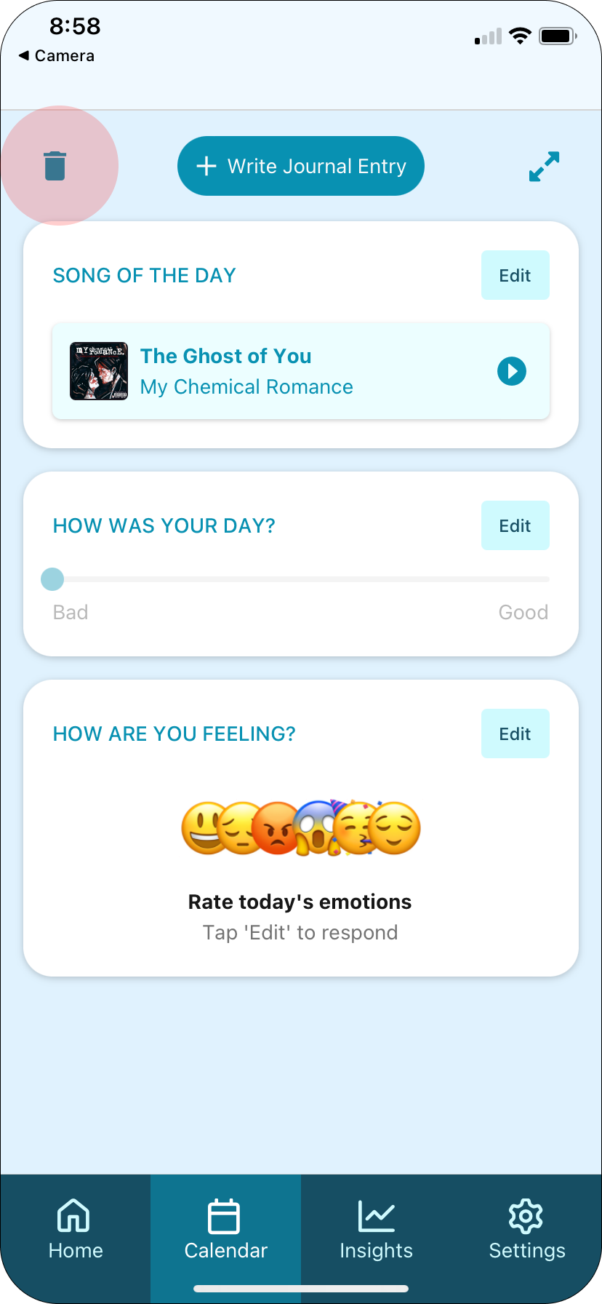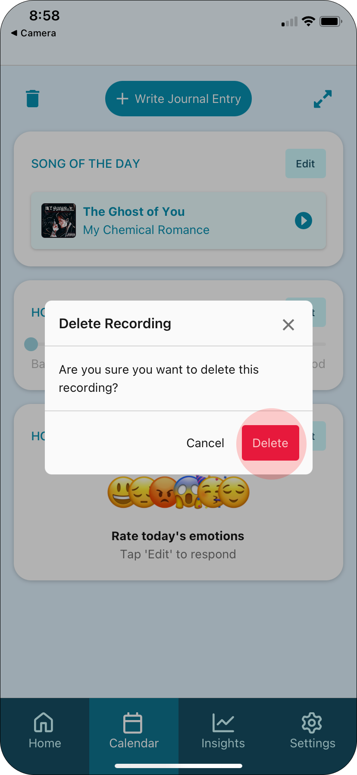

Complex Task: Interpret trends in your emotions and music over time.
This task is important because the musical / emotional insights that we provide to users are meaningless if users don’t know how to interpret them. It was important to us that our insights were visualized in a way that is accessible to the average user.

Complex Subtask #1: Learn how to interpret the insights page.
To review your emotional / musical trends over time, click the Insights icon on the navigation tab. To learn more about an insight, click the Learn More button in the insight card. Scroll down the page to explore more insights.
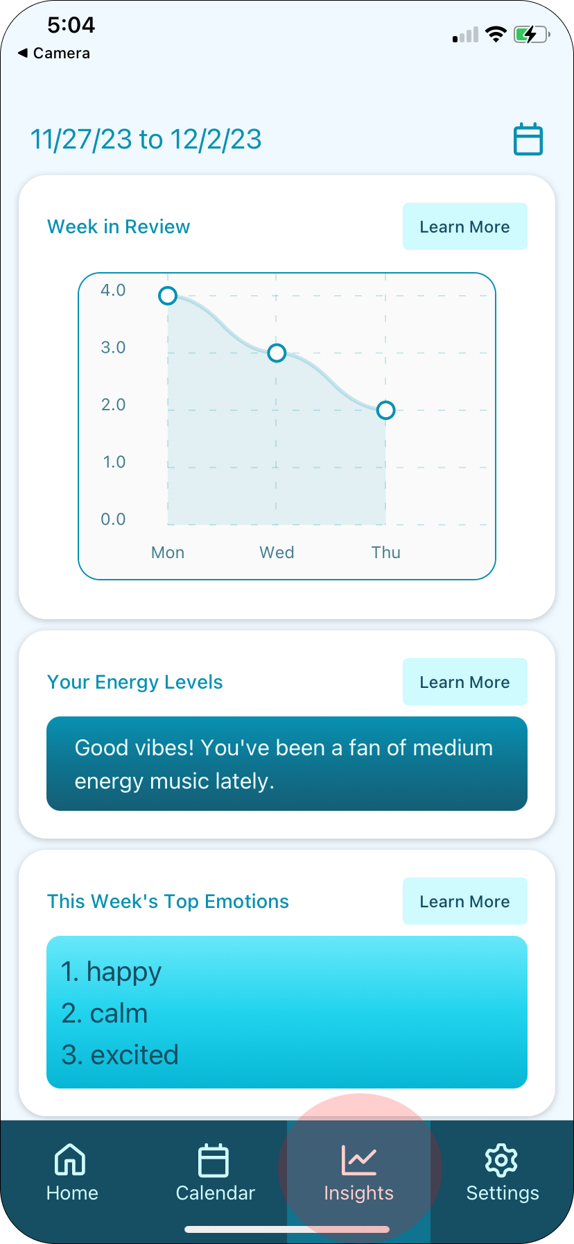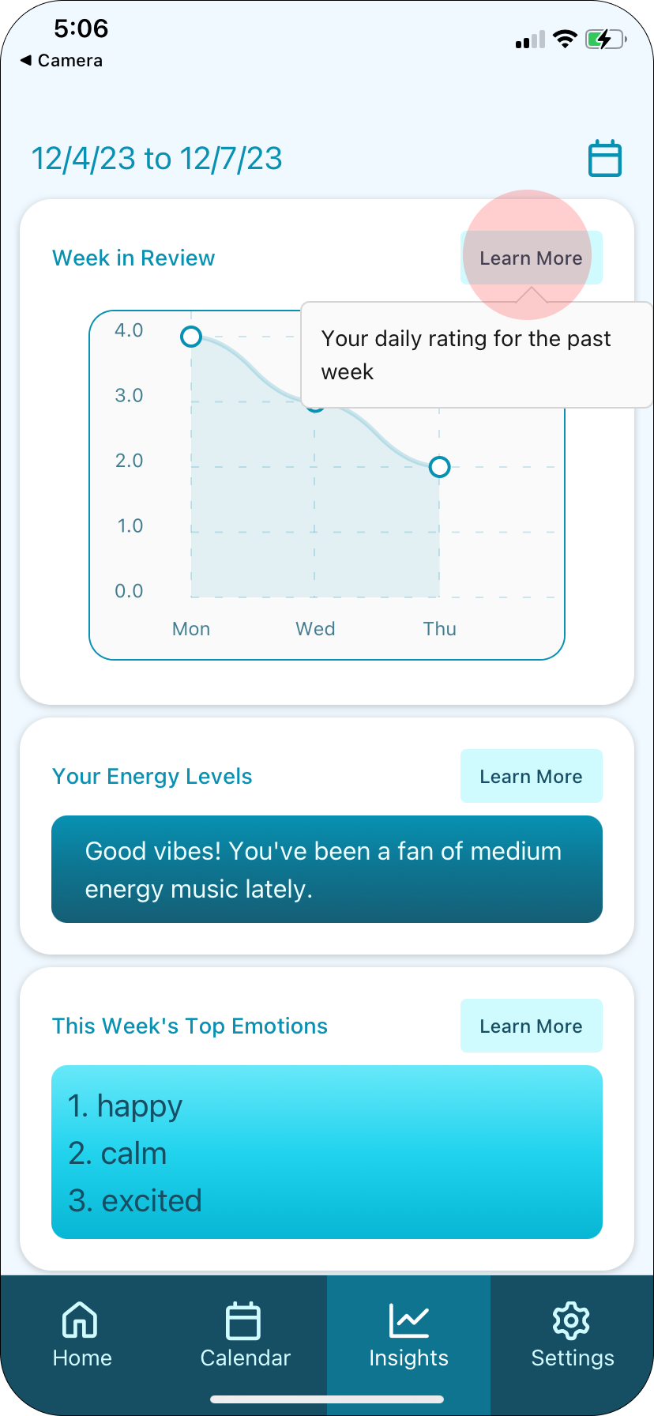

Complex Subtask #2: Adjust the date range for the data shown on the insights page.
Select the calendar icon in the upper right corner, then select your desired dates and press Save.
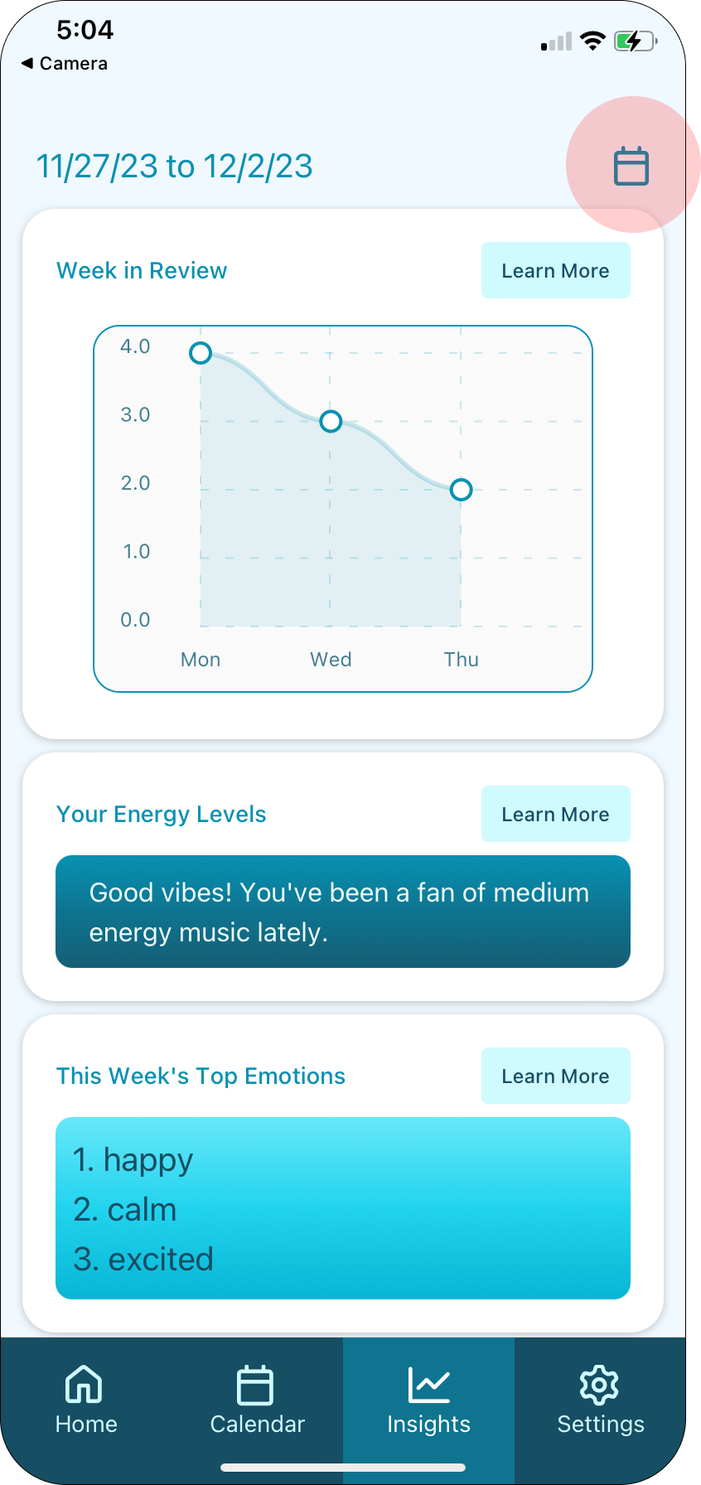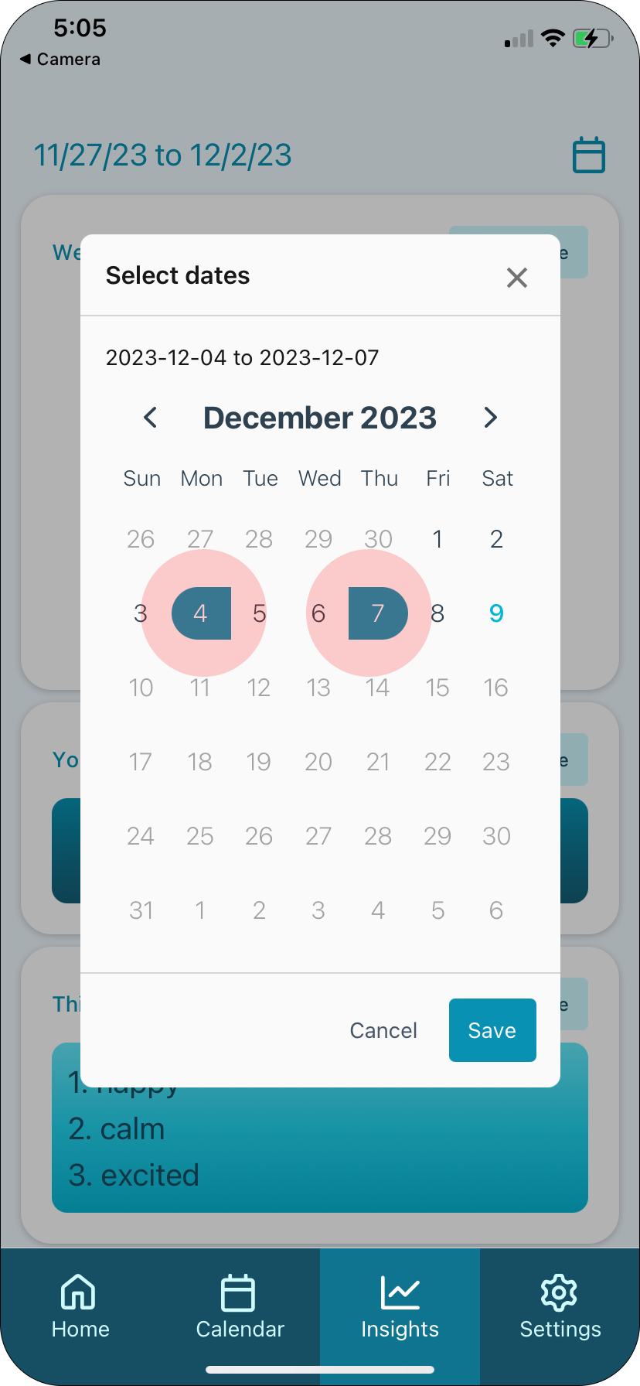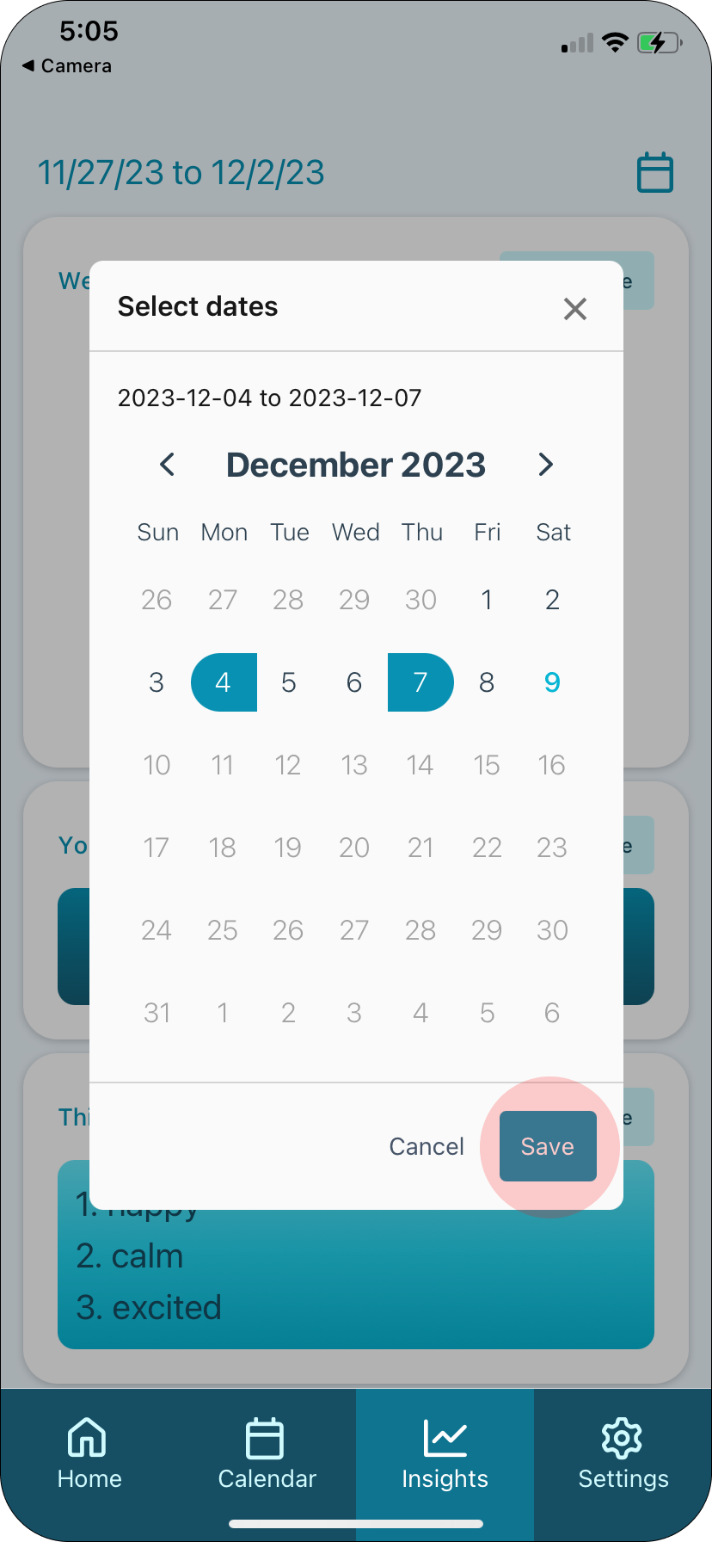

Design evolution visualizations and rationale

Home Screen
Our initial plan was to have an iPad app, so that users could have a more traditional journaling experience using an Apple pencil to write. We planned to let users select a song and top emotions, and the majority of the experience was writing a journal entry. As we prototyped, we shifted our focus toward quick logs, with an optional textual entry that was more out of sight. We wanted the focus to be more on journaling than on manually selecting previous days and reflecting, so we eventually removed the calendar from the home page and added it to a separate tab.
Our home screen originally included a sidebar with additional information, when we were planning on creating an iPad app. In our medium-fi prototype, we switched to a mobile app and removed the sidebar, focusing more attention on the quick log function. In our final design, we moved the calendar so we could focus more on the alternate features, and we opted for a scroll view instead of a moveable card.
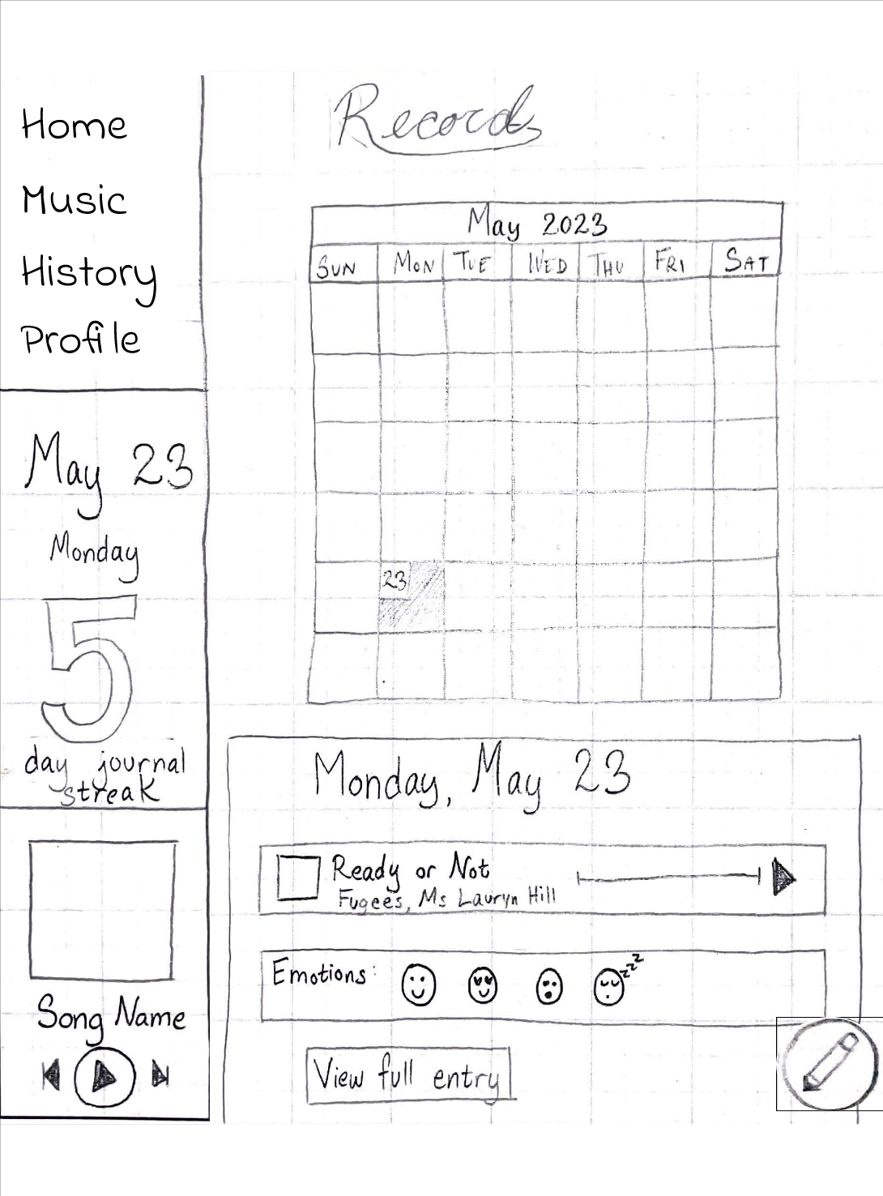 | 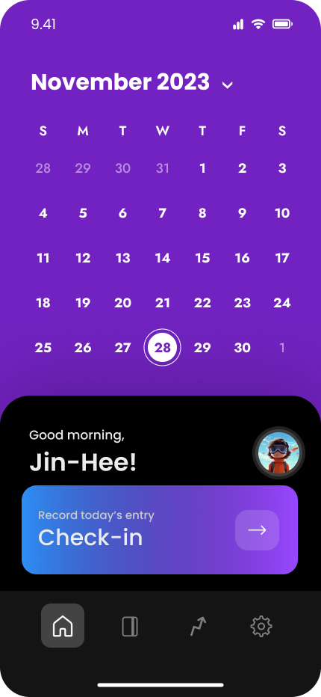 | 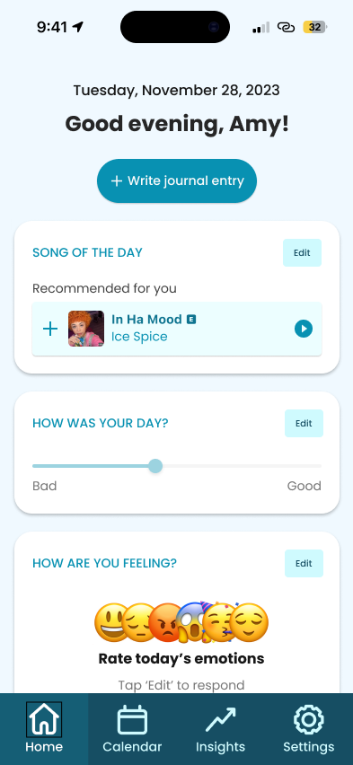

Figure 9. From left to right: low-fidelity prototype, medium-fidelity prototype, high-fidelity prototype

Journal Entry
Our journal entry page changed a lot over time, since we shifted our focus from long freeform text entries to quick emotion logs.
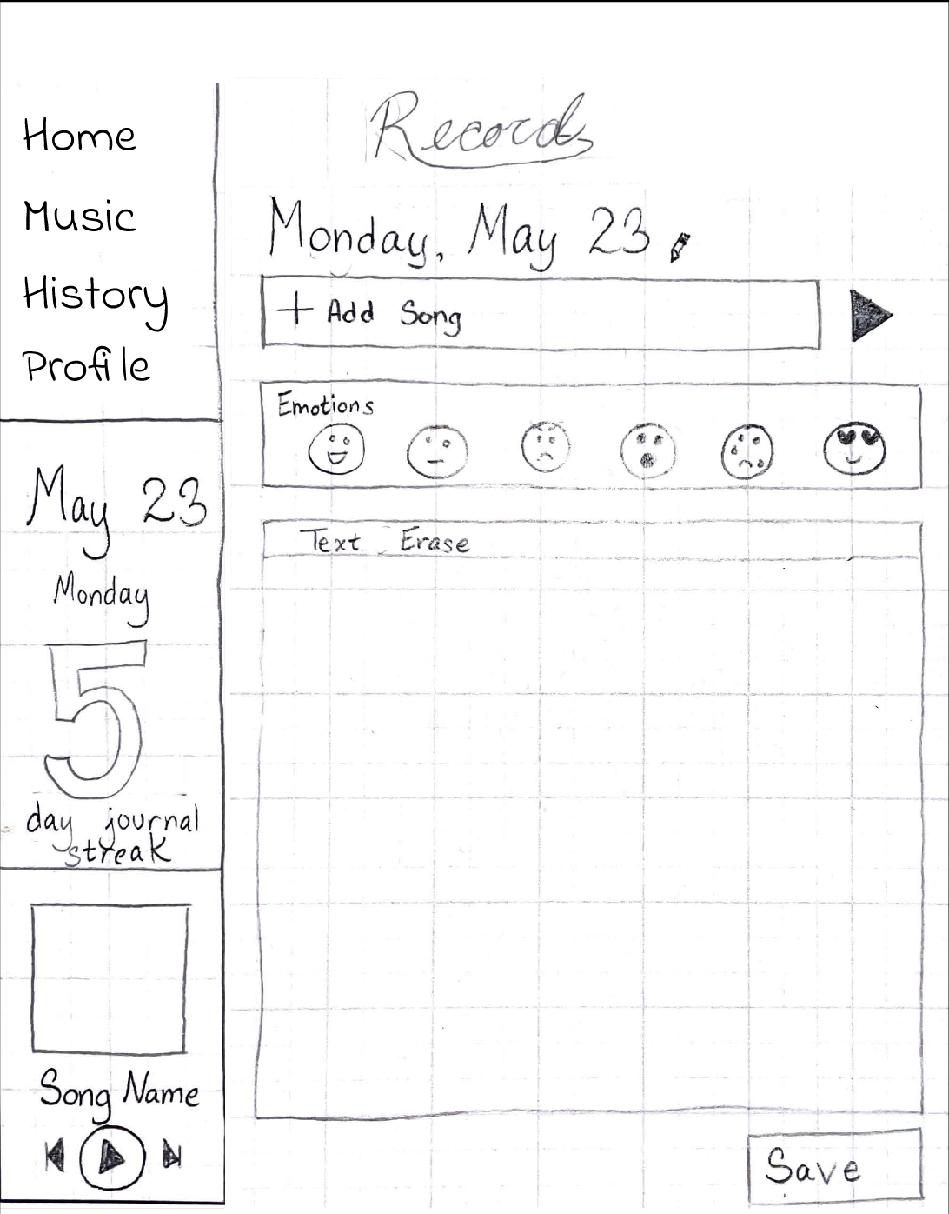

Figure 10. Low fidelity prototype of journal entry page

The medium-fi prototype forced users to complete the entire journal entry task flow consisting of several different screens, which didn’t support our goal of making journaling quick and easy.
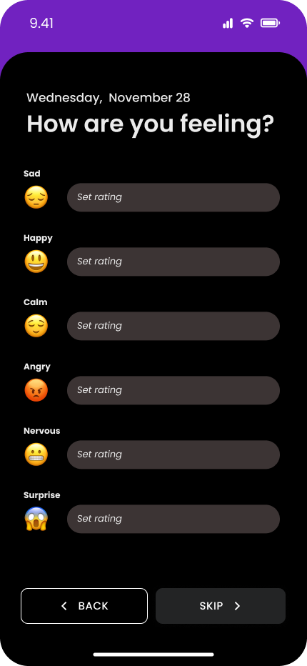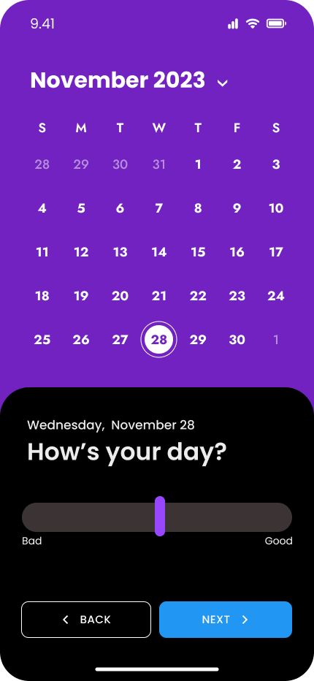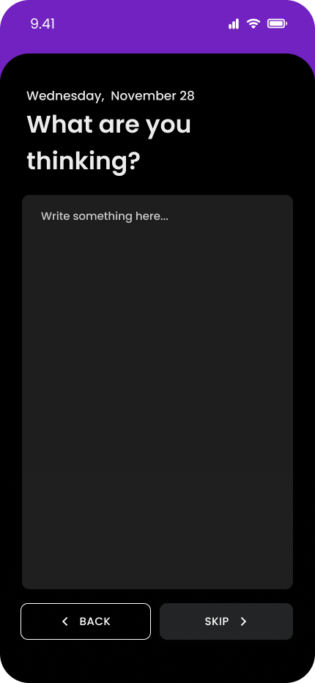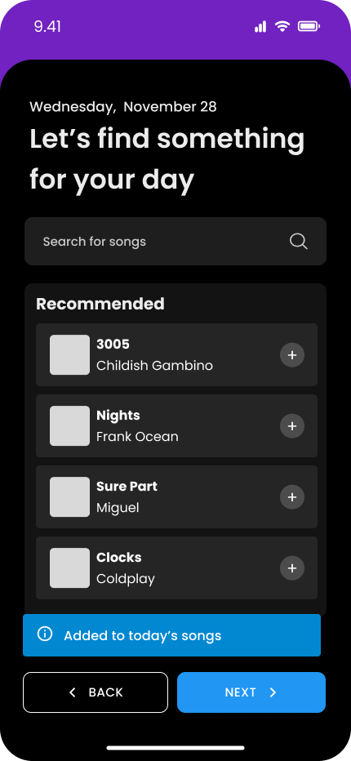

Figure 11. Medium-fidelity prototype task flow
Thus, our final prototype consisted of one screen with an option to write an entry.
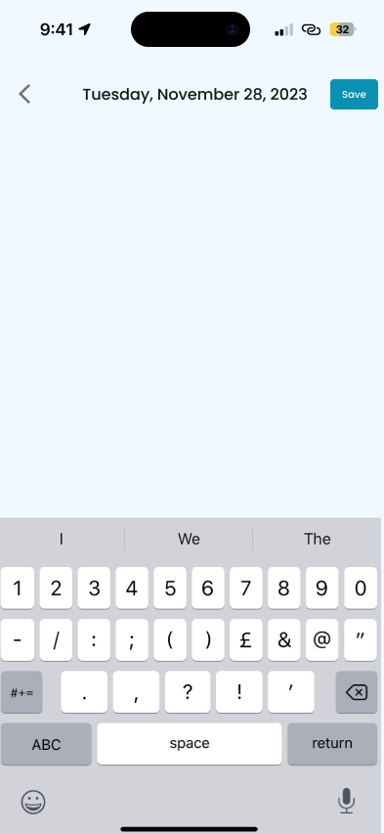

Figure 12. High-fidelity prototype

Calendar
Our calendar shifted from being on the home screen to being in a separate tab, as our focus shifted toward saving quick journal entries. The summary of the selected day’s journal entry at the bottom stayed consistent throughout all of the designs.
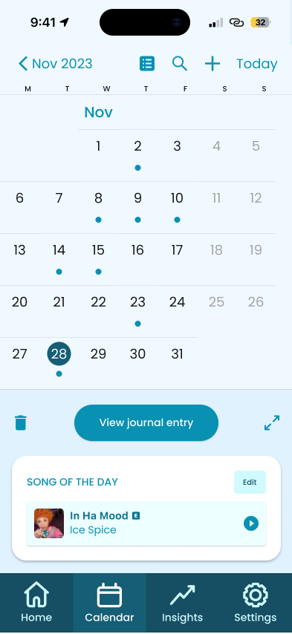

Figure 13. From left to right: low-fidelity prototype, medium-fidelity prototype, high-fidelity prototype

Insights
Finally, our insights page changed a lot over the different iterations. Our low-fi prototype had three sections on this page: listening, journaling, and feeling, where users could see different types of statistics. We removed these three sections and consolidated them into one section for our medium-fi prototype.
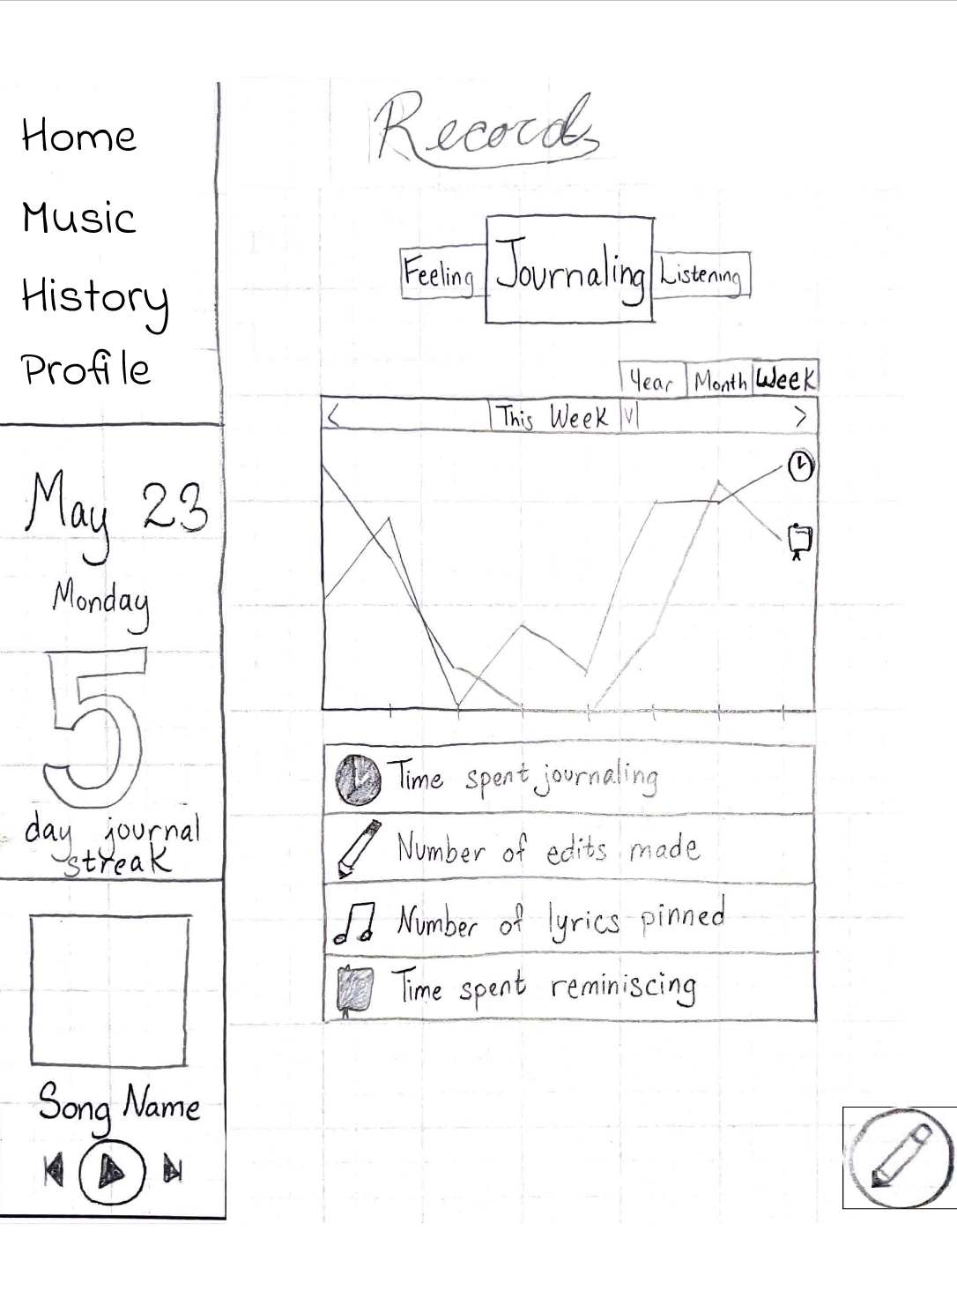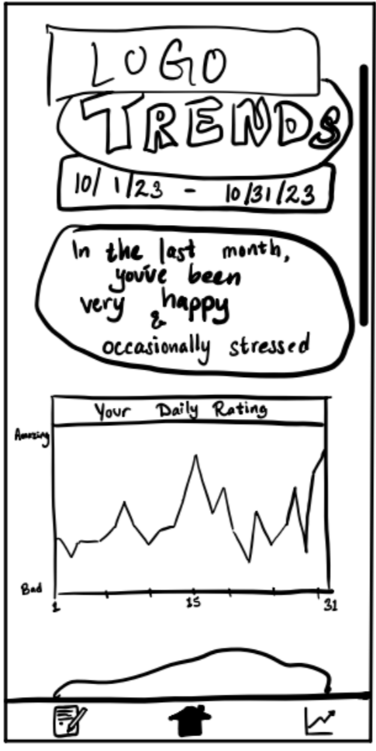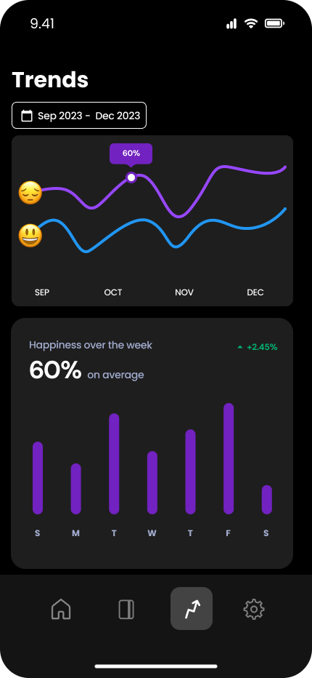

Figure 14. From left to right: low-fidelity prototype, revised sketches, medium-fidelity prototype
Our prototype testing showed that users wanted text summaries of their data, so that they did not have to interpret different types of graphs. In our high-fi design, we included different forms of data presentation including graphs, lists, and text, and we included data about users’ emotional and musical data.
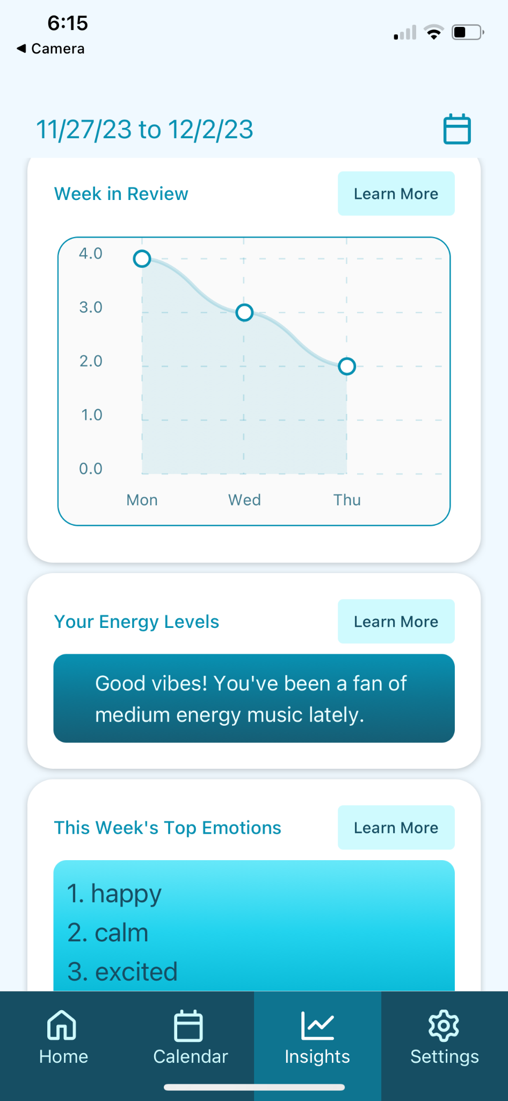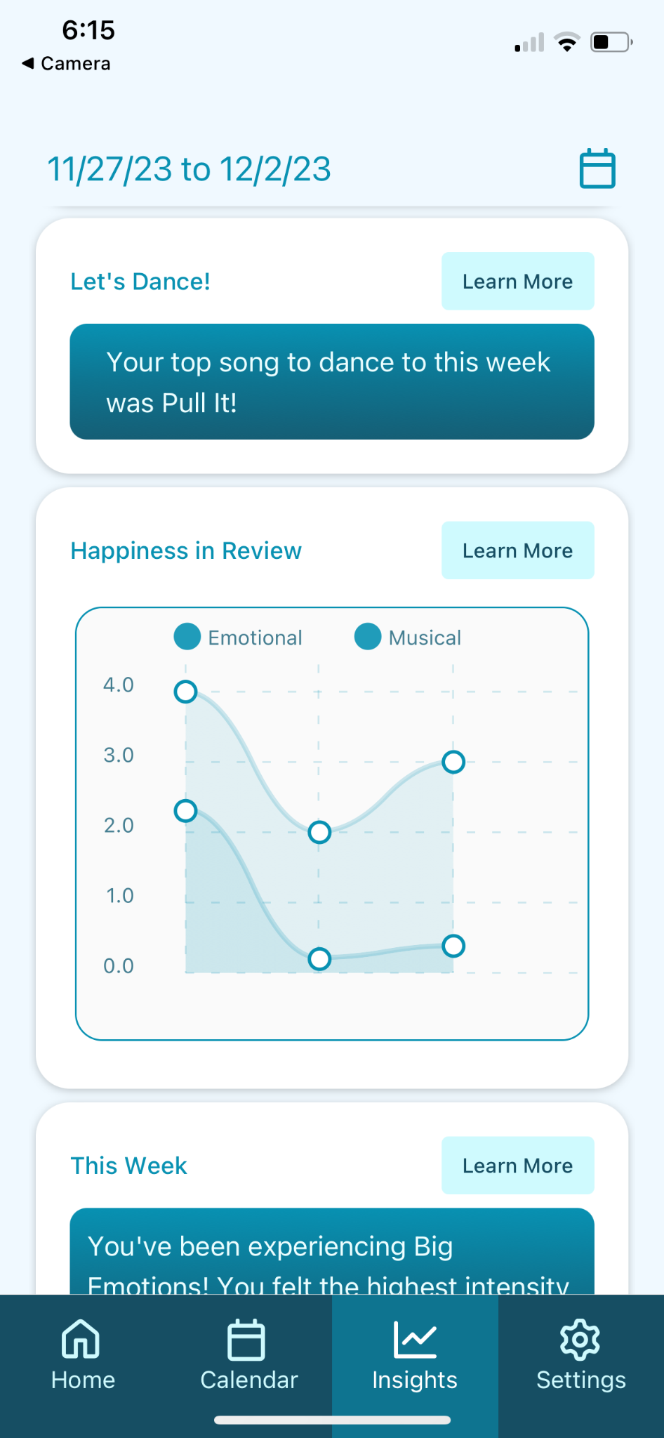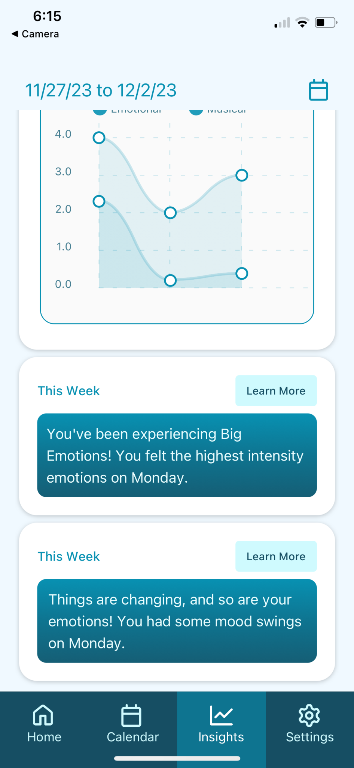

Figure 15. Screenshots of high-fidelity prototype

Heuristic Violations
We had a total of 81 heuristic violations (Appendix F). The most common violations were H4: Consistency and Standards (13) and H8: Aesthetic and Minimalist Design (13).
Our overall takeaways were that we need to improve our first read, intentionality, and interpretability. To do so, we focused more on journaling, simplified color use and action items, and clarified icons, action items, and data meaning.

First Read
One of our biggest violations was that the calendar took up a majority of the screen during the check-in (quick log) process, and it is colored purple, which in other places indicates a call to action. To address this issue, we moved the calendar to a separate tab so it’s not the first read, and we redesigned the coloring of the app with more intentionality.

Before  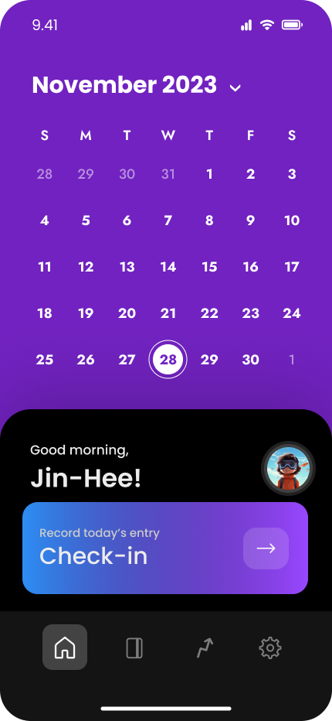 | After  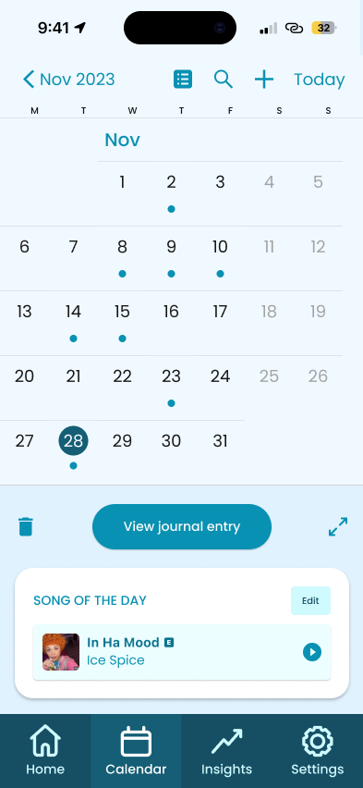

Home Screen Actions
Another violation on the home screen was that it was not obvious that users can drag up on the journal summary card. Since we removed the calendar from home, we were able to remove the card and make the screen scrollable, with a focus on the journal summary.
Before  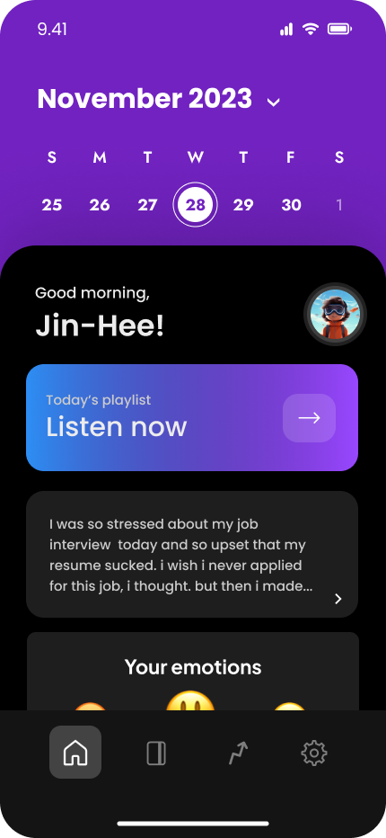 | After  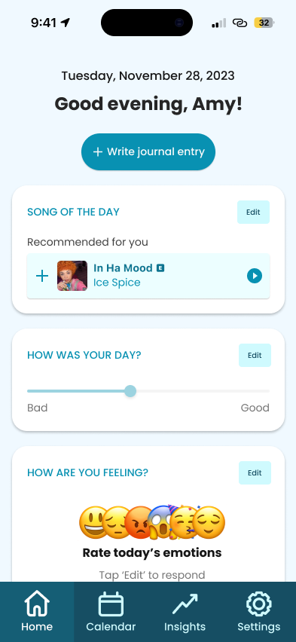

Journal Entry Actions
On the journal entry screen, the back and save buttons would be covered by the keyboard, so there was no clear way to submit the text. To avoid this issue, we placed the back and save buttons at the top of the screen.
Before  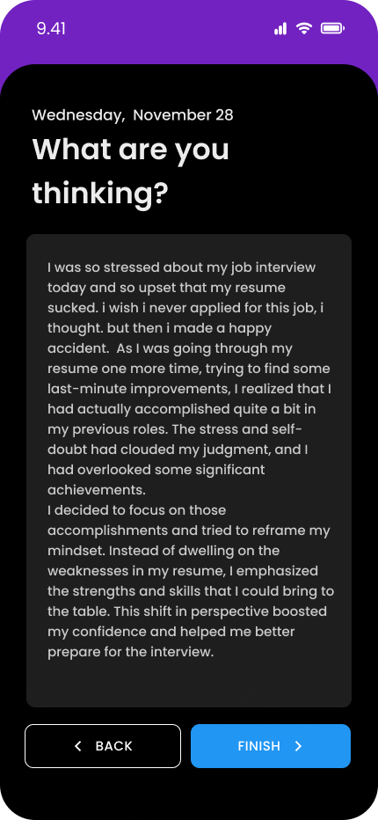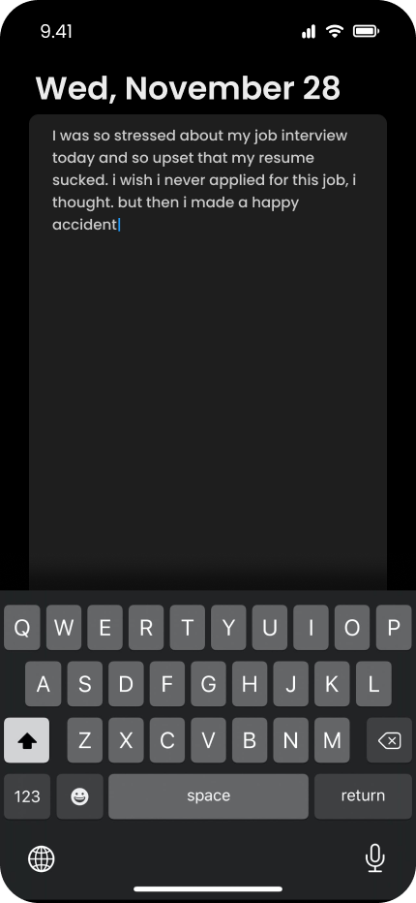 | After  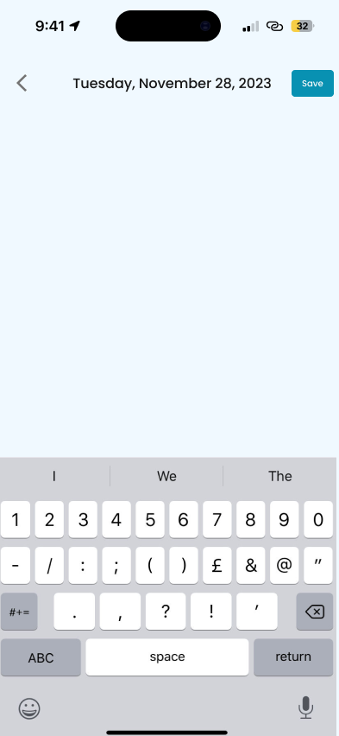

Data Collection
One violation that appeared in the journaling as well as the trend evaluation was that percentages did not have any real-world meaning for users, especially when it comes to emotions. To address this issue, we switched to sliders and added labels to help guide the user when logging emotions, and we did not have any numerical data on the insights page aside from graphs, which explained how their data was calculated.

Before  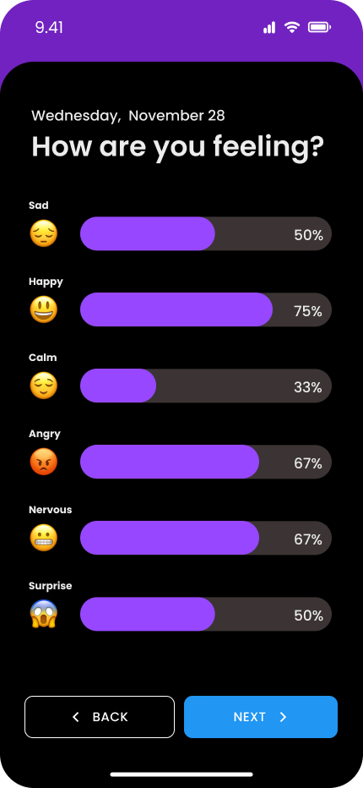 | After  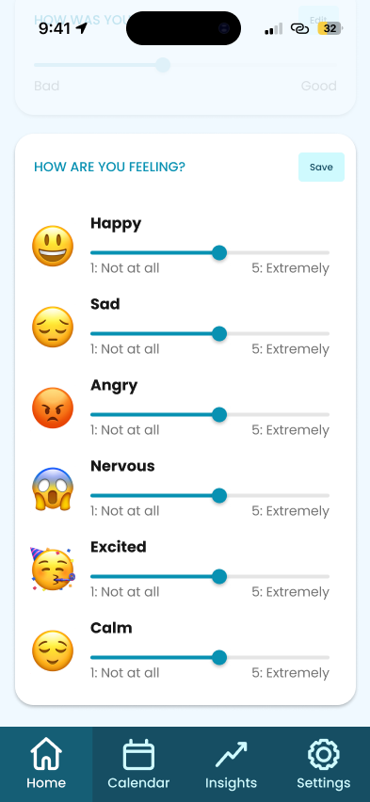

Color Scheme
One of our largest violations was that the combination of black, dark gray, light gray, and bright purple was too straining for users. To encourage mindfulness and prevent distraction, we switched to a light mode color scheme with less saturated colors.
Before  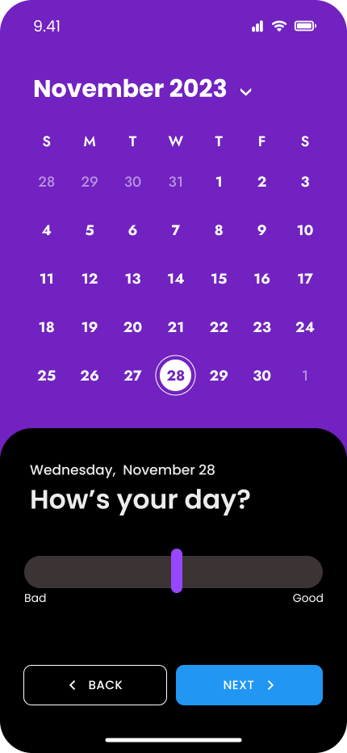 | After  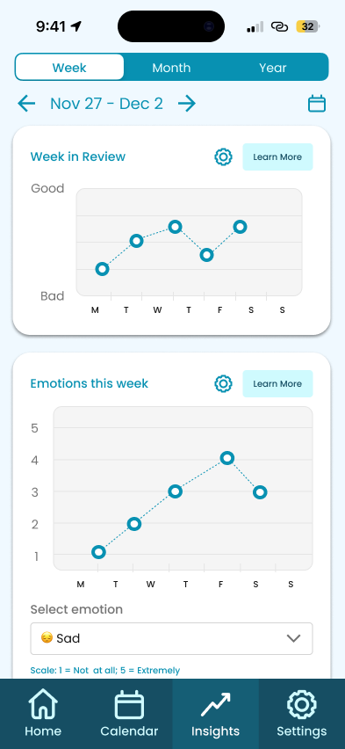

Values in design
We identified four key values we wanted our design to promote: Privacy, Emotional Awareness, Mental Wellbeing, and Habit-formation. A discussion of how each value came to bear on our design is included below:

Key Values

Privacy
Our design hinges on users sharing data representing their emotional states. Because emotions are so personal, we expected users to consider data entered into our app to be quite sensitive. This was confirmed in our lofi-prototype tests - the inclusion of a “profile” screen in our navigation bar communicated to our testers that there was a social element to our app. They were hesitant to interact with this screen and told us they preferred not to share their journal entries with friends. In light of this, we felt we needed to ensure a high level of privacy for our users.
To accomplish our privacy goals, we aim to be transparent in our design about what data we collect and we give users control over their data. In the interest of transparency, we only collect and store data that the user enters manually. We do not collect data behind the scenes e.g. location data. In addition, we do not hide our aggregation or synthesis of data. All analyses we perform are presented to the user in our “Insights” screen. In so doing we make sure the user has full knowledge of the information we collect and generate about them. In addition, we make sure that data transparency is meaningful by giving the user the option to delete any journal entry they wish. If a user isn’t pleased with the amount of data we store or with the way we aggregate their data, we give them the agency to delete it from our system. Users can therefore make informed decisions about what data they wish to share, and they maintain control of their data even after sharing it with us.

Emotional Awareness
As a journaling app, our goal is for our users to gain an improved understanding of their emotions. We propose to leverage music to help our users gain insight into their emotions. We believe that emotional awareness requires emotional reflection, which is why we include features to help users reflect on their emotions over time. We allow users to look back on previous journal entries in our “Calendar” screen to facilitate emotional reflection. Additionally, we offer higher-level analyses of emotional trends over time on our “Insights” screen as a jumping-off point for further emotional reflection. We hope these features encourage our users to bring more mindfulness to their emotions than they otherwise would.

Mental Wellbeing
In addition to valuing emotional awareness, we also value good mental wellbeing holistically. To promote mental wellbeing, we decided to build our app’s core functionality around an existing mental health practice - that being journaling. Because we are not experts, we decided to stick to a conventional, tried-and-true wellness practice rather than get experimental with our users’ mental health.

Habit Formation
We hope to support users’ development of healthy habits like daily journaling. Many of our lo-fi prototype testers expressed frustration at the inconsistency of their journaling practice, if they engage in journaling at all. We want to help users achieve their journaling goals, and therefore we want to make it as effortless as possible to create new journal entries. Our aim is to allow users to log a journal entry in as few taps as possible. Therefore, we made our app’s home screen a quick-log task flow that allows users to log data in just one or two taps. Additionally, allow users to log each data point (Overall day rating, song of the day, and individual emotion ratings) independently. If a user just wants to log an overall day rating but hasn’t given thought to other data points, they have the ability to log a journal entry with only an overall day rating. This affordance minimizes the cognitive load of recording a journal entry and makes it quick and easy to journal, therefore making it more likely that users will return the app daily.

Value tensions
After considering the above values, we identified two value tensions, which we discuss in detail below:

Emotional Awareness & Privacy
We collect user data to encourage emotional awareness for our users, but collecting lots of data undermines our goal of ensuring a high level of privacy. We believe that the best solution is to let users set their own balance. Attempting to resolve this tension by deciding on some balance between data collection and data privacy then blanket applying that balance to all users is bound to dissatisfy someone. Instead, we allow users to decide how much data they want to record and give them the option to delete any data stored by our app.

Habit-formation & Mental Wellbeing
We want to make daily journaling easy for users, but habits can become unhealthy, especially when used as a replacement for necessary mental health interventions. We want to promote healthy habits without promoting over-reliance. Therefore, we want to minimize the amount of time users spend in-app by making it as quick as possible to record a journal entry. If we were to continue this project we would also want to link users’ to external, professional mental health resources directly from the app.

Final prototype implementation

Demo
To watch our video demo, please watch our video recording.

Quick Start
Our high-fidelity prototype was built using Expo. Follow the quick start instructions below to check out our prototype via the Expo Go app.
iOS Quick Start | Android Quick Start
- Click here to download the Expo Go app from the App Store.  - Scan the following QR code with an iOS device to open it in Expo Go.  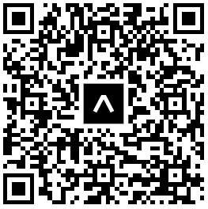 | - Click here to download the Expo Go app from Google Play.  - Scan the following QR code with an Android device to open it in Expo Go.  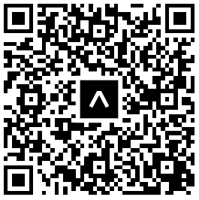

Tools Used


Purpose
Create universal native apps with React that run on Android, iOS, and the web.
Pros | Cons
- Source code can work for Android, iOS and web.  - Uses React Native, which is familiar to the team.  - The Expo Go app makes testing your app on a mobile device easy if you have the app.  - Provides the ability for anyone with the Expo Go app to scan a QR code and view your app on their phone. | - Requires users to download the Expo Go app to test the app on their phone.  - Requires lots of configuration in order for it to work reliably across web and mobile.



Purpose
Create universal native apps using the popular React framework.
Pros | Cons
- Makes it very easy for people who only have web development / React experience to build native apps.  - Developers don’t have to learn Swift / Kotlin – they can build using JavaScript.  - It’s a very popular framework, so there are a lot of npm packages built to support it.  - It’s intertwined with Expo (one of our other tools). | - Performance is slightly worse than in native applications.  - It’s not a great choice if your interface has a lot of complex interactions due to React’s rendering infrastructure.  - It’s not an exact 1:1 to React web development, so it’s easy to get thrown off by the minor differences.



Purpose
A React-based component library that helps you build consistent UI across Android, iOS and Web.
Pros | Cons
- Provides nicely-styled components that you can easily drop into your app.  - Allows for component customization if desired.  - Figma plugin allows designers to pull components directly from NativeBase into their designs.  - Greatly reduces frontend workload, as components | - Generally none – component libraries are awesome 🙂  - Potential con: your app could end up looking like every other app that uses this library.  - Potential con: relying too heavily on component libs could stifle designer creativity.



Purpose
Schemaless data storage.
Pros | Cons
- It is schemaless, which means we can easily change the structure of our data if needed.  - Can be easily hosted via MongoDB Atlas.  - Atlas provides a nice UI for viewing your database.  - Provides a Data API that can be used to easily make changes to your database from your app.  - It is familiar to the team, as it is taught in CS 142. | - The schemaless model means that it is up to you app’s developers to ensure that your data is well-formatted.  - In order to save time, we opted to hit the Data API directly from our frontend, which is WILDLY insecure.  - While hitting the Data API from your frontend is possible, you’re not supposed to do that. There should be a layer in between your frontend and the Data API.



Purpose
Leverage Spotify’s music data from your app.
Pros | Cons
- Gives us access to a wealth of music information from our app.  - Provides music information in extreme detail, including things like a song’s danceability level for example.  - Provides best-in-class song recommendations.  - Enables best-in-class song querying. | - You only get 30 second previews of songs – you don’t have access to the full track.  - For some tracks, the 30 second preview is not available.  - The API is designed for users of your app to authenticate using their personal Spotify accounts. We didn’t want users to have to do that, so we had to implement a wildly insecure and hacky workaround.

Algorithms

Emotion-based Song Recommendations
Our app recommends songs to users based on how they’re feeling. Users can input how happy, sad, angry, nervous, excited, and/or calm they feel on a scale from “not at all” to “extremely.” We then tailor the user’s song recommendations based on their highest-rated emotion (with preference given to “positive” emotions in the event of a tie).
We mapped each emotion to a musical genre offered by Spotify. The recommendations that the user sees will be within the genre that maps to their highest-rated emotion. For example, if the user’s highest rated emotion is anger, their song recommendations will be death metal songs.
😃 Happy | 😔 Sad | 😡 Angry | 😱 Nervous | 🥳 Excited | 😌 Calm
Happy | Sad | Death Metal | Jazz | Dance | Ambient

While this algorithm is overly simplistic and far from perfect, it demonstrates our desire to have the musical experience in our app be heavily linked to our user’s emotional states.

Emotional / Musical Insights
For the insights, we had seven categories that aimed to bring together users’ emotions and listening habits. Our data from the insights is calculated dynamically, so it all comes from data in our journal entries database and from the Spotify API.
First, we had a line graph with the rating the user assigned to each day in the given time period. This data came strictly from our MongoDB database. The x-axis includes the days that have journal entry data. For short (one week or less) time frames, the day name is displayed. For date ranges within a month, the day of the month is displayed, and for date ranges over a month, the date is displayed as MM/YY.
Next was a textual summary of the energy levels of the songs that the user selected in the time period. The songs are stored in our MongoDB database and their audio features, including energy level, are fetched from Spotify. All of the energy levels are averaged, and the summary is rendered depending on the average level.
The third insight was a list of the user’s top emotions from over the time period. This is calculated by averaging each emotion’s value from the database and identifying the top three.
Fourth was a statement of the user’s song with the highest danceability from the given time period. This is done by fetching all of the songs from our database and comparing their audio features from Spotify.
The double line graph was a comparison between the happiness and the selected song’s valence for a given day. Valence is the positivity conveyed in a musical piece, which is a feature that Spotify stores. This graph compares the two features as a way to highlight how emotions and music are intertwined.
Next is a textual summary of big emotions. We calculated this by averaging the intensity of all of the emotions per day and selecting the day with the maximum value.
Our final insight was a textual summary of mood swings. This is done by calculating the average change in each emotion every day in the given time period. The day with the greatest change is listed as the day with the highest mood swings.

Limitations
Our app is a high-fidelity prototype, and thus is far from production-ready. Our app’s limitations include the following:

Unpolished Interactions
Some of the interactions in our app are unpolished. For example, when elements are expanded / collapsed there isn’t a gentle animation in place to make that action smoot.

Missing Loading States
While we have implemented some loading states, some are still yet to be implemented. For example, when you swipe left in our calendar UI, you are briefly shown a string date before the calendar renders instead of being shown a styled loading state.

Missing Error States
While we have implemented some error states, some are still yet to be implemented. For example, we don’t handle the case where there is an error during an HTTP request to either the Spotify API or our database API. We currently just log the error to the console.

Contains Subtle Bugs
Our app contains some subtle UI bugs. For example, if a user gets to the end of a song that is playing, the pause button doesn’t turn back into a play button.

Fake Buttons
Some of our buttons are fake. For example, the buttons at the top of the calendar view don’t do anything upon clicking them.
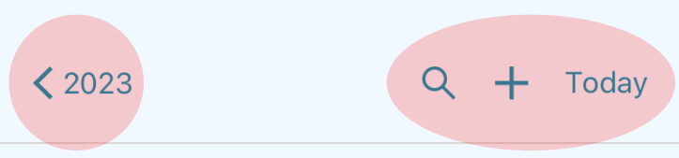

Figure 16. Hard-coded buttons

Lack of Accessibility
We did not optimize accessibility while building out our prototype. For example, most of our images don’t have proper alt tags.

Security Issues
We did not prioritize data security while building out our prototype. Our database is wildly insecure. Backend API keys are exposed and passwords are stored in plain text.

Song UI Only Plays Track Previews
We fetch MP3 files from the Spotify API, which only returns 30 second song previews. We do not have access to full tracks.

Spotify API Rate Limiting
Our Spotify application is currently in “development mode” which means that Spotify heavily rate-limits the number of API requests that we can make in a short period of time. If a lot of people are testing our app simultaneously, there is a strong chance that some of the song UI won’t render due to Spotify rate-limiting our app’s request.
For example, you might be on the app and notice that song recommendations are missing. This is because our app has called Spotify’s /recommendations endpoint too frequently in the past ~30 seconds.

Wizard of Oz Techniques

Tailored Insights
While we were developing the algorithms required to generate emotional / musical insights, we were using the hard-coded historical emotion ratings data mentioned above for testing purposes. Therefore, our insight algorithms are probably overly tailored to suit our test data.

Spotify Authentication
When you use the Spotify API, you’re supposed to have users authenticate with their Spotify account before your app can make requests to the Spotify API. In order to avoid forcing users to authenticate via Spotify while trying out our prototype, we connected our app to Leilenah’s personal Spotify account in the backend. This is wildly insecure for Leilenah’s Spotify account 🤡, but it removes a barrier to entry for our users.

Spotify Song Previews
Spotify does not always return MP3 previews for songs. E.g. if you request 10 song recommendations from Spotify, half of them could be missing MP3 previews. We don’t want to show our users songs that they cannot play, therefore we request more songs than needed for our UI, and then we filter out the songs that don’t have an MP3 preview file.
For example, if we want to show the user 4 song recommendations, we will request 20 recommendations from Spotify and then find 4 songs out of the 20 that have MP3 previews. This typically works out, but there is a slim chance that less than 4 songs will contain song previews.

Hard-coded Data
We tried to use as much real data in our app as possible given our time constraints. E.g., user account data / recording data is saved in a MongoDB database; song data is fetched from Spotify. That being said, there are a couple pieces of data that we had to hardcode.

Hard-coded Journal Entry Data
Record’s emotional / musical insights functionality is only useful if the user has used our app over time. However, we wanted to ensure that anyone who creates an account for demo / testing purposes could get a feel for how our insights functionality works.
Therefore, when a new user account is created, we also create fake historical journal entries / emotion ratings for that user. The data that the user will see on the insights page leverages this pre-populated historical data.

Hard-coded Verbiage on the Insights Tab
Because we know the structure of the hard-coded emotion ratings data mentioned above, some of the verbiage on the insights page is hard-coded to reflect the known trends in that data. For example, the hard-coded data reflects emotional mood swings, so we render an insight card that says “Things are changing and so are your emotions! You had some mood swings over the past couple of weeks.”

Reflection & Next Steps

Reflection
In this course, we learned a lot about how customers can be involved in the design process. We realized that the features that we think are cool and novel may not actually be the most useful features for practical implementation. For example, we originally wanted to use natural language processing on journal entries to recommend songs to users. However, we found that users may write entries about emotions they don’t want to experience, so recommending songs could push them into an emotional state that isn’t ideal. We had to scale back some of our ideas to fit what would best suit our intended users, but that allowed us to explore and focus on new features that were exciting as well.

Next Steps
If we had more time, we would add more security to our database. Right now, we just plainly store different login information and a bunch of journal entries that we wrote, which each have their associated userID. In real life, we would want more security, including hashing passwords and journal entry text. This would ensure that users feel safe using our product.
We would also want to speed up loading time, since there is currently a delay when navigating to the calendar and the insights page due to the sheer volume of information that needs to be prepared. Since the calendar is hooked up to the month’s journal entries, it fetches and stores all of the journal entries so that users can quickly switch between dates. However, this has tradeoffs with the amount of time necessary to initially render the calendar. Similarly, the insights page needs to fetch all of the date range’s journal entries and analyze them before it renders. We made some small improvements, such as using a flat list instead of a scroll view for each insight component, but there is still a delay when rendering the page or switching dates with the date picker.

Appendix

Appendix A: Needfinding Interviews
# | Name | Details
1 | Candice | Candice is a music lover and stay-at-home mom in her early 30s who started playing the clarinet as a child, but gave up on it. Candice is an acquaintance of Leilenah’s, so we had Leilenah reach out to Candice directly to recruit her. Candice lives in Southern California and did not have access to Zoom, so her interview was conducted via FaceTime.
2 | Connor | Connor is a “casual” musician and former trombone player for the Stanford band in their early 20s. Ellie and Connor played in the Stanford band at the same time, so Ellie reached out to Connor directly to recruit them. Connor was interviewed in-person on campus at Tressider.
3 | Elliott | Elliott is a professional guitarist, music YouTuber and guitar teacher in his mid-30s living in Amsterdam. Elliott was our “extreme” user. He is a casual acquaintance of Leilenah, so she reached out to him directly to recruit him. Since he lives in Amsterdam, the interview had to be conducted via Zoom.
4 | Ethan | Ethan is a music producer / radio DJ for KZSU Stanford 90.1 FM in his early 20s. Sophia had been introduced to Ethan on a previous occasion, so she reached out to him directly to recruit him. Ethan was interviewed in-person on campus at Stanford’s radio station.
5 | Rachael | Rachael is a “casual” musician and director for the Stanford band in her late 20s. Rachael is a casual acquaintance of Ellie, so Ellie reached out to her directly to recruit her. The interview was conducted in person in Rachael’s office on campus.

Appendix B: Empathy Maps
Higher-resolution versions of our empathy maps can be found here.

Appendix C: Observation + Inference = Insight
Observation | Inference | Insight
Elliott noticed that having aesthetically pleasing YouTube videos helps with video performance; but he refuses to spend more than 6 hours editing a video. | He may find the process of editing videos to be tedious and uninteresting. | Musicians want to spend their time on their craft, and not on other tedious tasks (even if those tasks could help increase their popularity).
Elliott perceives his YouTube content to be too niche, when he “make[s] stuff that interests me, which are… a tad too esoteric for the typical individual.” | There may be a lot of people who would be interested in his content, but his content just isn’t getting onto their radar. | Musicians are artists, not marketing strategists.
On top of playing his guitar at gigs, Elliott is also a guitar teacher; He also runs a guitar-focused YouTube channel. | He may need to teach the guitar and run his YouTube channel as a means of supplementing his income. | Musicians often have to work multiple jobs in order to cover their living expenses.
Rachael said that working with musicians at a lower skill level “wasn’t what [she] was looking for out of collaborating” when using Daisie. | Her skill level may be higher than average, so there may be a smaller pool of musicians at that same level. | Highly skilled musicians want to find other highly skilled musicians to collaborate with.
Rachael used a music collaboration site called Daisie to find musicians to collaborate with. | There may have been a lack of musicians for her to collaborate with in person. | Musicians have a hard time finding people to collaborate with in person, so they turn to apps to meet other musicians.

Appendix D: HMWs
POV | HMWs
Candice | 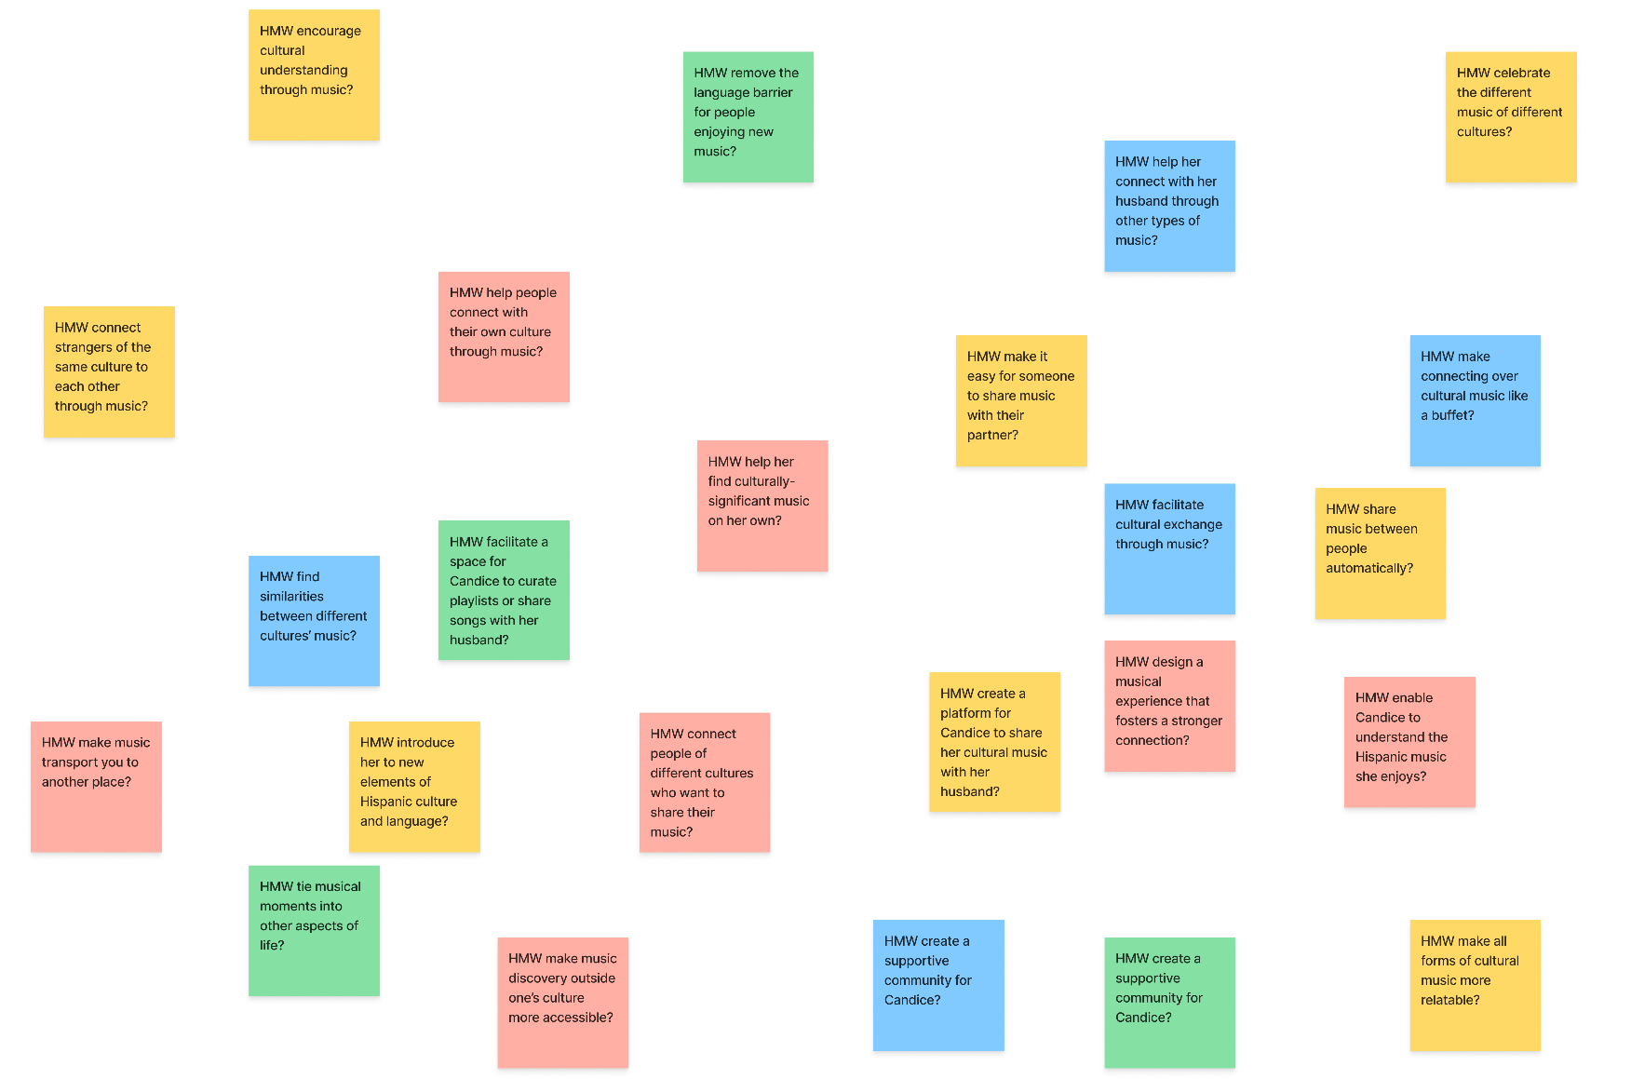
Connor | 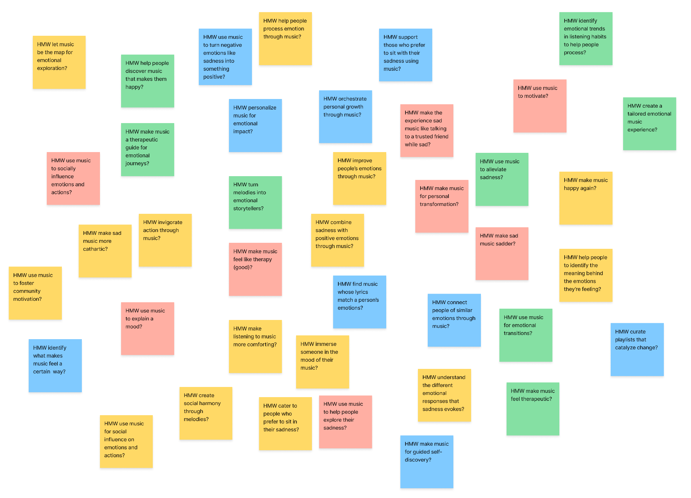
Elliott | 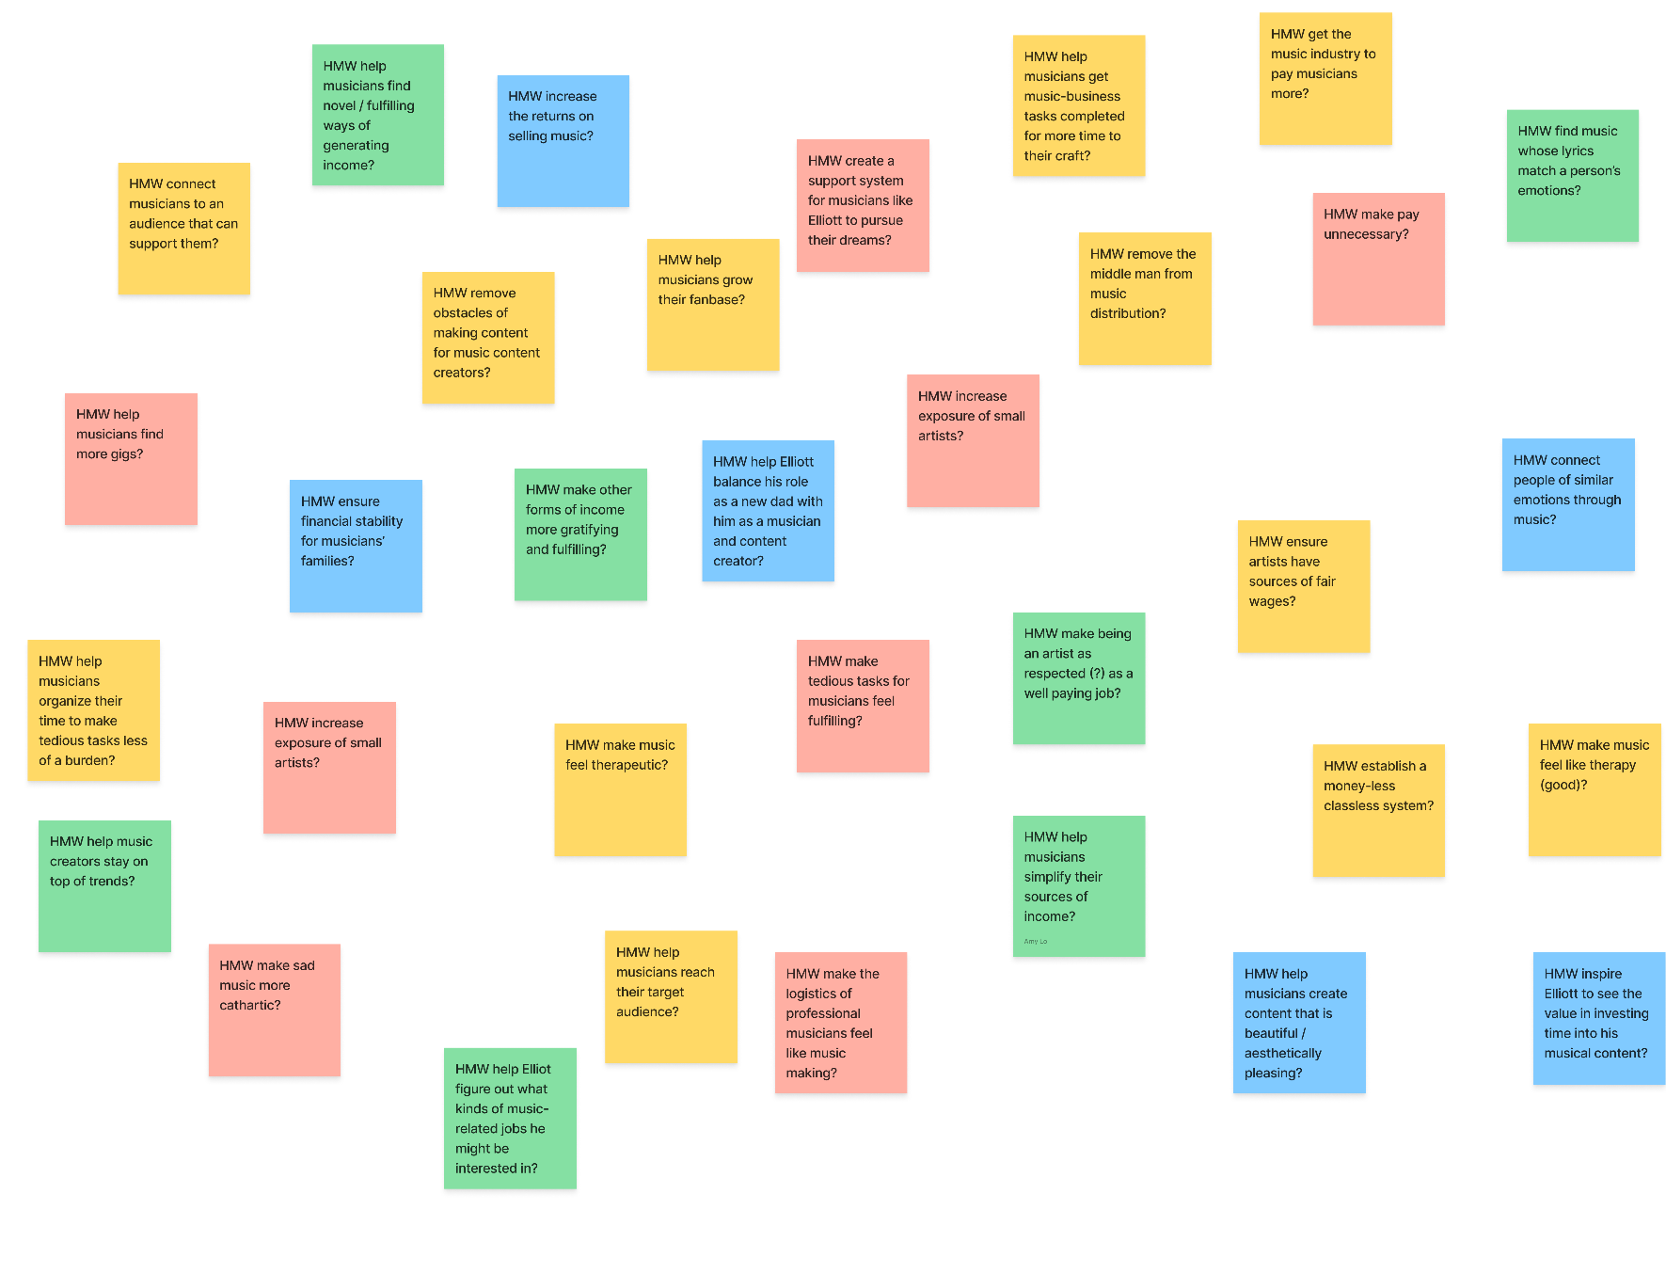

Appendix E: Solution Ideation
POV | Solutions
Candice | 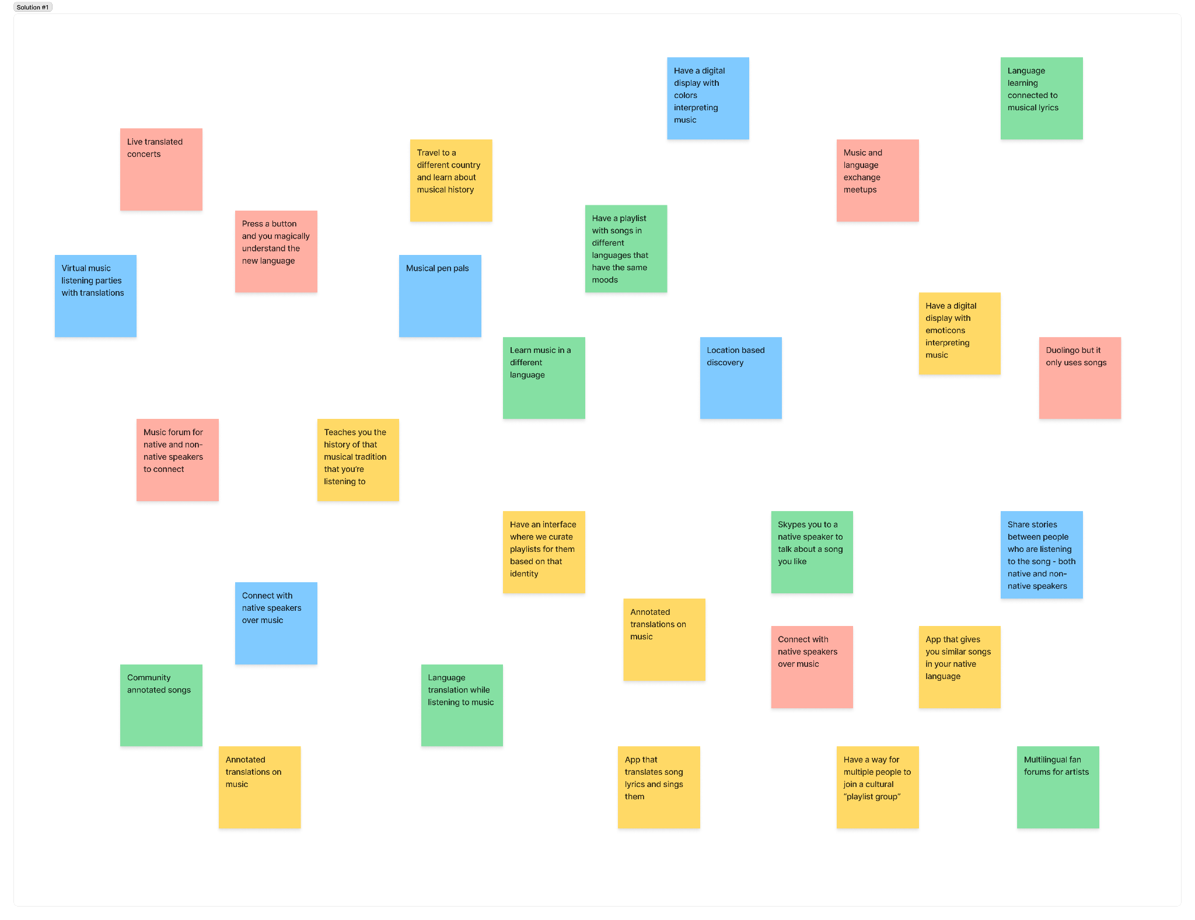
Connor | 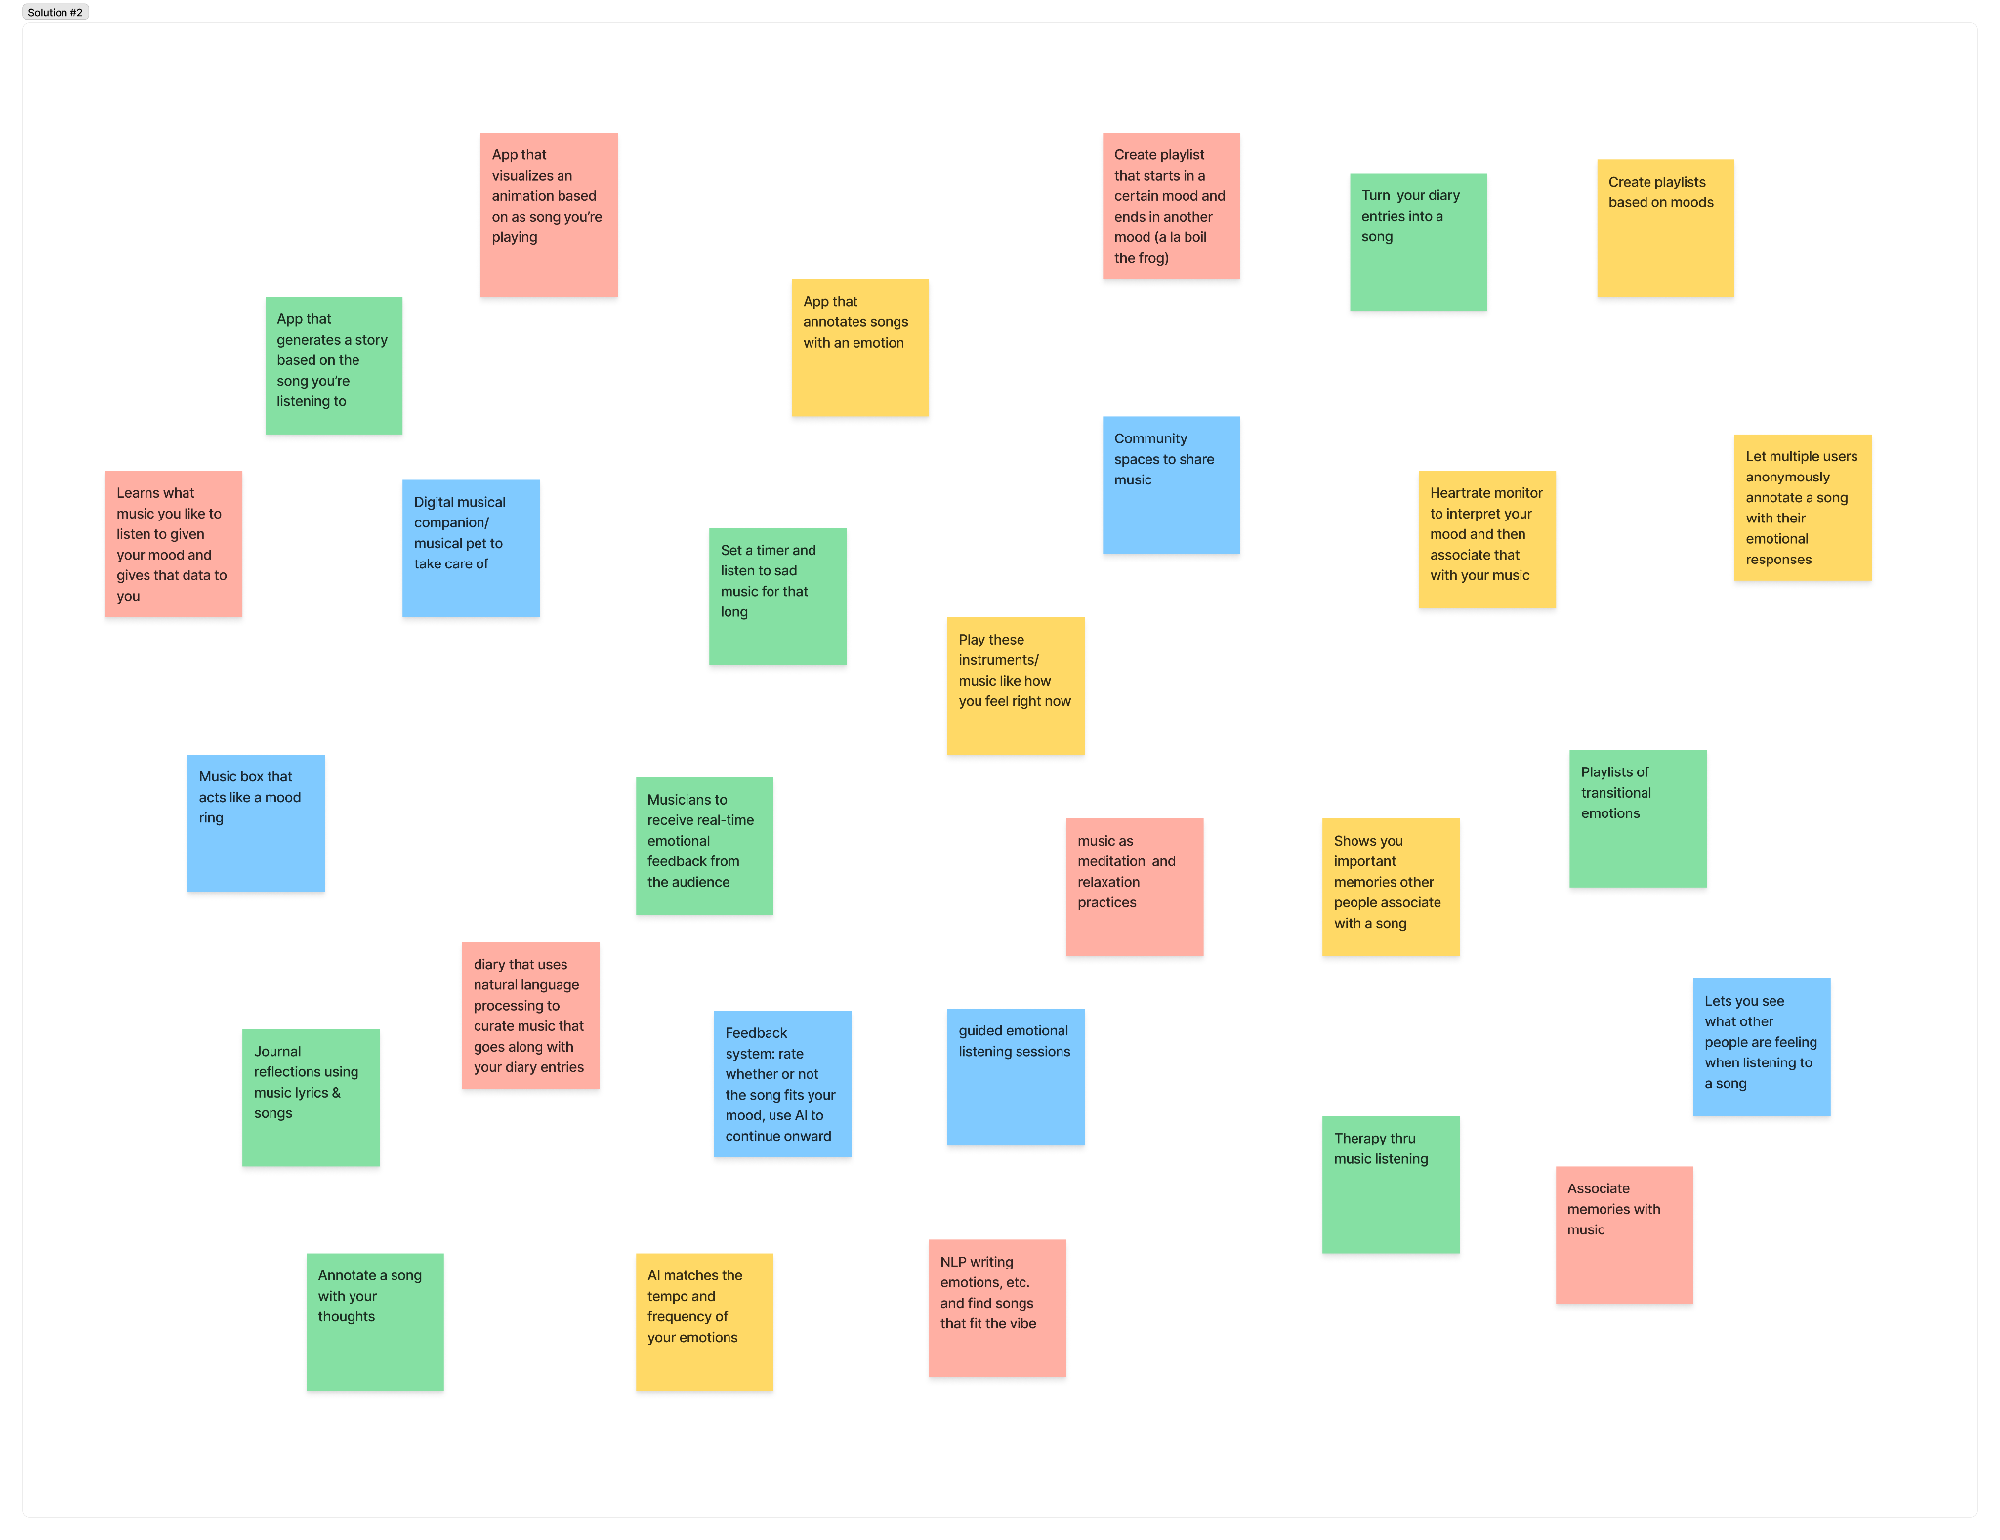
Elliott | 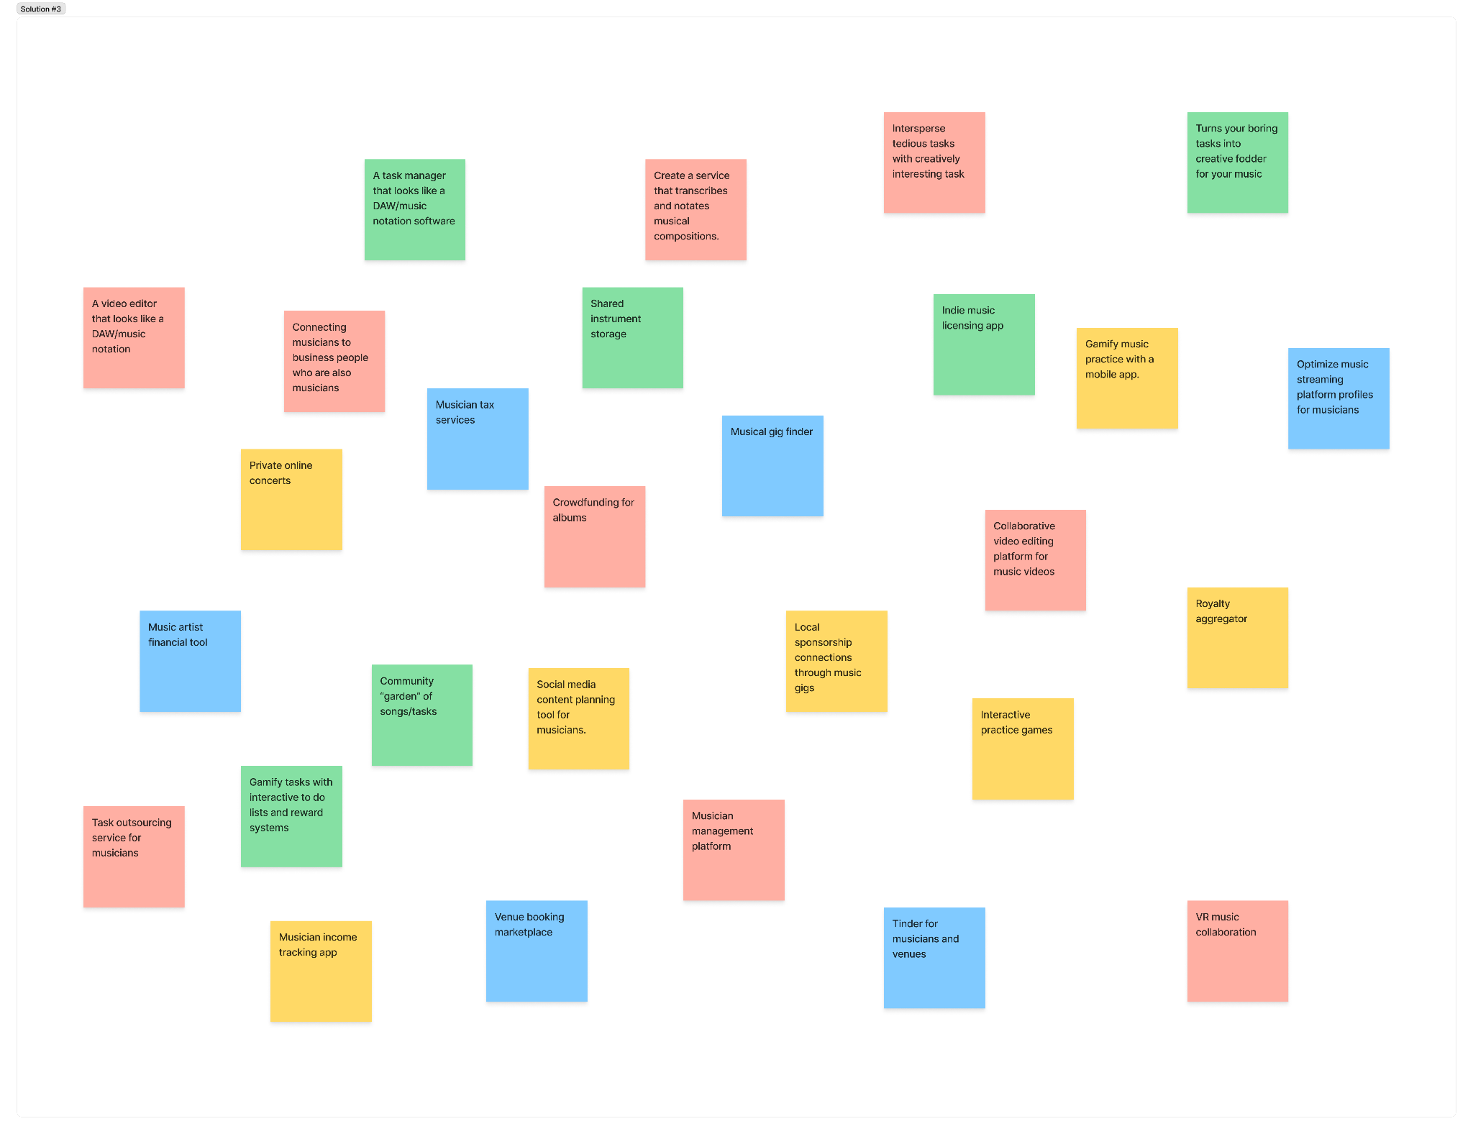

Appendix D

Ancillary Task #1: Log in / create an account
Click the “No Account? Sign Up” link on the app’s initial screen. If you encounter an error during account creation, you can log in with our test user credentials – username: testuser, password: seal.
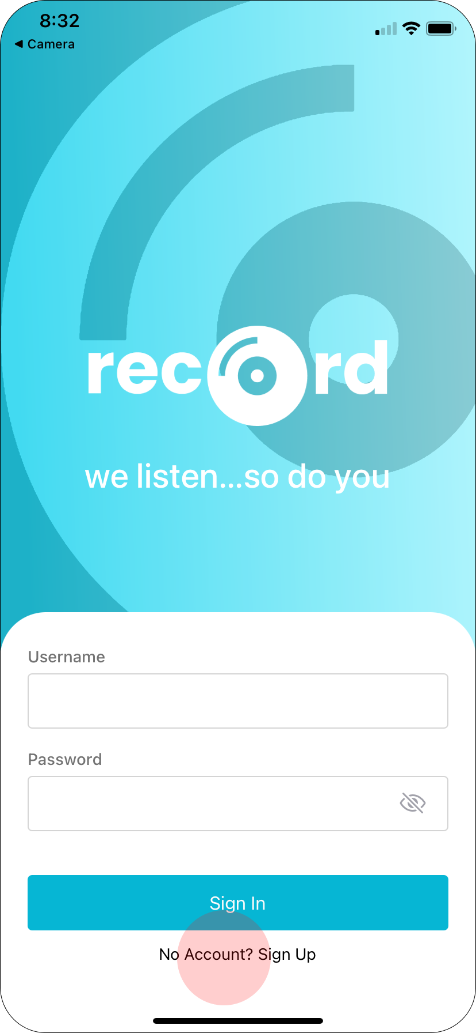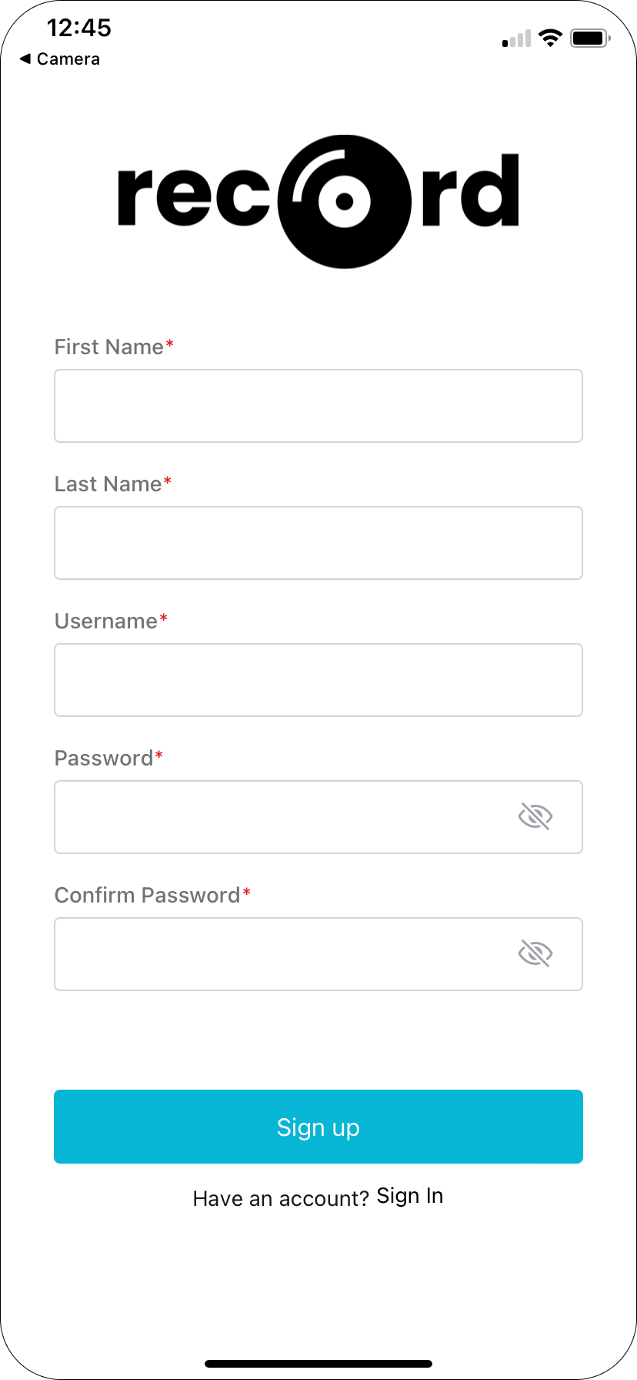

Ancillary Task #2: Log out
Click the settings tab on the navigation bar, then click the Logout button.

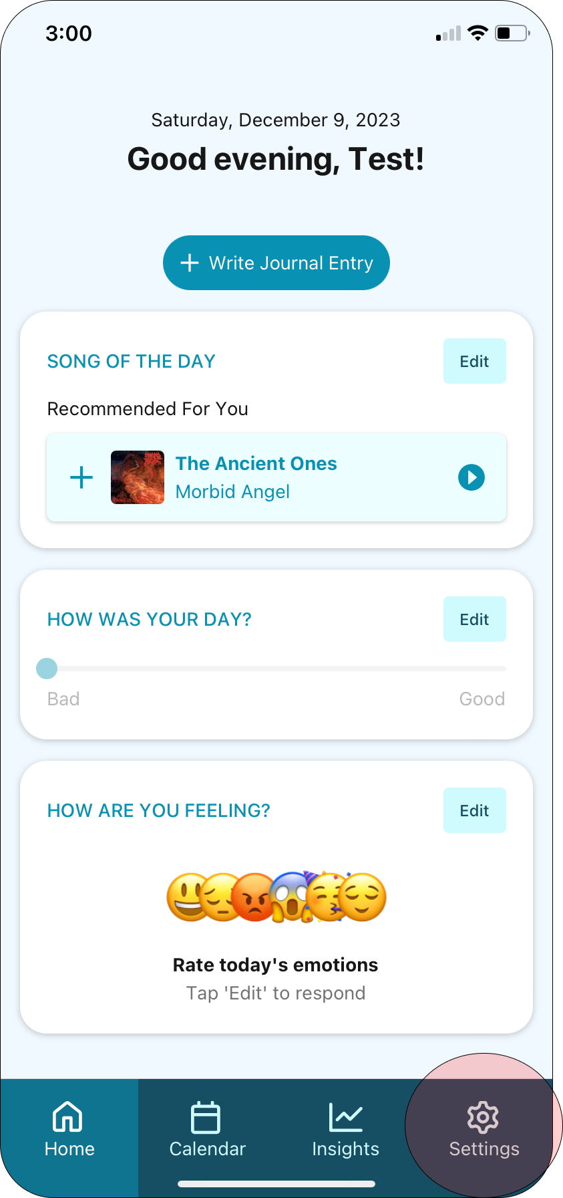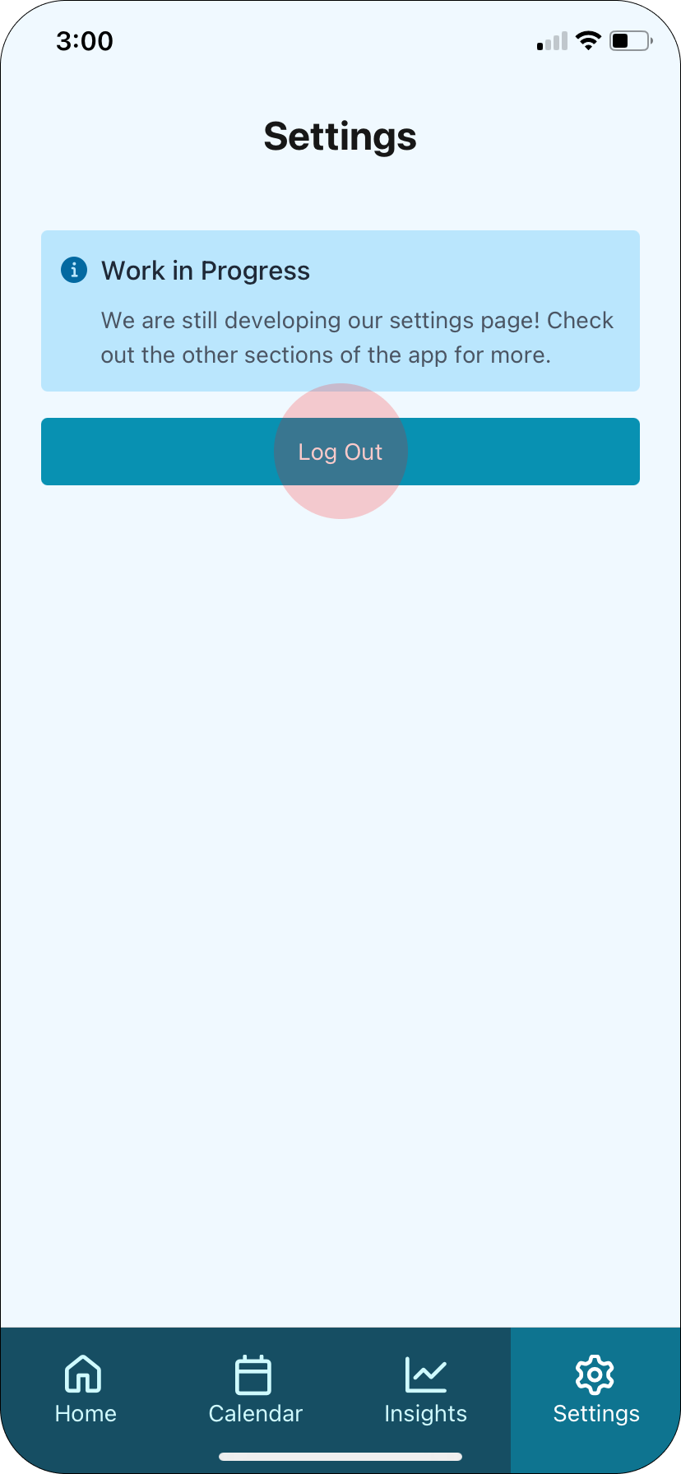

Appendix F: Heuristic Evaluation
Category | # Viol.  (sev 1) | # Viol.  (sev 2) | # Viol.  (sev 3) | # Viol.  (sev 4) | # Viol. (total)
H1: Visibility of Status | 2 | 3 | 1 | 0 | 6
H2: Match Sys & World | 3 | 1 | 1 | 0 | 5
H3: User Control | 1 | 2 | 4 | 0 | 7
H4: Consistency & Standards | 11 | 3 | 1 | 0 | 15
H5: Error Prevention | 2 | 5 | 1 | 0 | 8
H6: Recognition not Recall | 0 | 1 | 4 | 0 | 5
H7: Efficiency of Use | 0 | 5 | 1 | 0 | 6
H8: Minimalist Design | 9 | 1 | 3 | 0 | 13
H9: Help Users with Errors | 0 | 0 | 0 | 1 | 1
H10: Help & Documentation | 0 | 1 | 2 | 0 | 3
H11: Accessible | 6 | 2 | 1 | 0 | 9
H12: Value Alignment & Inclusion | 0 | 3 | 0 | 0 | 3
Total Violations by Severity | 34 | 27 | 19 | 1 | 81

Simple Task Violations
- H3. User control and freedom / Severity: 3 / After clicking into the text box in “What are you thinking?” page, there is no way to go back out of the text box.
The back button was originally on the bottom of the journal entry screen, but it was covered up by the keyboard when a user was typing. We moved the back button to the top of the screen, so it is visible at all times.
- H6. Recognition rather than recall / Severity: 3 / After clicking into the text box in “What are you thinking?” page, the question disappears and is replaced by the date.
The header now only says the date, and there is no question prompt. The journal entry text box now fills the whole screen, except for the header.
- H3. User control and freedom / Severity: 3 / After finishing typing in the text box in “What are you thinking?” page, there is no clear way to submit the text.
The journal entries were originally going to autosave, this was not clear to users. There is now a save button in the header, opposite the back button.
- H8. Accessible design / Severity 3 / The page where a user can input their journal entry consists of a black and light gray background with very light gray writing. The black background overpowers the focus that is meant to be on the writing and makes the user strain more to see their journal entry.
We originally wanted the app to have a dark mode design, but transitioned to a light design.
- H2. Match between system and the real world / Severity: 3 / On “How are you feeling?” page, unclear about what the percentages for each emoji mean.
We removed the percentages, but we kept the sliders and added text, so now each emotion is on a sliding scale from “not at all” to “extremely”.
- H6. Recognition rather than recall / Severity: 3 / There is no indication of the recent song selected on the ‘What are you thinking?’ page.
We chose to ignore this suggestion, because our low-fi prototype feedback was that users wanted an empty screen when journaling so they could focus on the text. Users can easily go back and forth between the journal text and the rest of the log with one click.
- H3. User control and freedom / Severity: 3 / On the “Let’s find something for your day” page, there is no way to undo the action of adding a song to today’s songs.
We redesign the page to allow for users to add and remove songs easily. There is a plus button when a song has not been added, and that becomes a minus button once it has been added so it can be removed.
- H6 Recognition rather than recall / Severity: 3 / There is no way to see what songs are already added in the playlist after adding.
In the redesign, the songs added to the playlist have a different button (plus vs minus) and they move to the top of the screen with the other selected songs.

Moderate Task Violations
- H3. User control and freedom / Severity: 3 / When clicking and dragging the journal details for the date chosen, there is no ability to drag back down to choose a different date.
We did not address this issue, since this issue was caused by Figma limitations.
- H7. Flexibility and efficiency of user / Severity: 3 / It is not entirely obvious that the user can hold and drag up on the section at the bottom of the page to see more information about the post.
We redesigned this screen to remove the card. Now, all of the information is permanently displayed on the screen, and it is scrollable. The information in the last block of the page will be cut off midway through to indicate that the user should scroll to see more.

Complex Task Violations
- H4 Consistency and standards / Severity: 3 / Date picker at top of screen corresponds to the dates for line graph directly below, but the bottom box addresses “Happiness over the week.”
The entire Trends page now focuses on one date range, so the data should all reflect the same time period.
- H8 Aesthetic and Minimalist Design / Severity: 3 / The date picker on the trends screen doesn’t vary in color, which makes it difficult to distinguish between different dates.
We redesigned the date picker and now allow the users to separately select the start and end dates.

General Violations
- H9 Help users recognize, diagnose, and recover from errors / Severity: 4 / If users tap second to left icon on bottom bar, then go back to home page, data input from previous check in is not saved.
We did not address this issue, since this issue was caused by Figma limitations and our flow. Our design autosaves data.
- H10 Help and documentation / Severity: 3 / No text on icons in bottom bar.
We replaced the icons with more clear ones, but we also added text.
- H11. Accessible design / Severity: 3 / The journal entry portion featured on the day overview on the home page does not have a header.
We changed the formatting, so the headers are consistent.
- H5. Error prevention / Severity: 3 / Calendar on homepage is colored purple, which in other places on app indicates a call to action. Calendar is also majority of screen during part of check-in process.
We changed the color scheme to a lighter color, and also changed the background of the calendar to the ordinary background color to emphasize dates that are clickable.
- H8. Aesthetic and minimalist design / Severity: 3 / Calendar is bright purple and the majority of homescreen.
We created a new Calendar tab so that the first read on the home screen is the journal entry. The calendar screen still has the same functionality.
- H6. Recognition rather than recall / Severity 3 / It is not clear that the bottom block with the user’s name and profile picture can be dragged up.
We redesigned this screen to remove the card. Now, all of the information is permanently displayed on the screen, and it is scrollable. The information in the last block of the page will be cut off midway through to indicate that the user should scroll to see more.
- H10. Help and Documentation / Severity: 3 / The app lacks a section that explains the app’s functionality/FAQs.
We chose not to implement this section, since the app should be simple and straightforward.
- H1. Visibility of system status / Severity: 3 / It is unclear what the second icon from the left in the bottom navigation bar represents.
We replaced the icons and added text underneath.

