Snippets
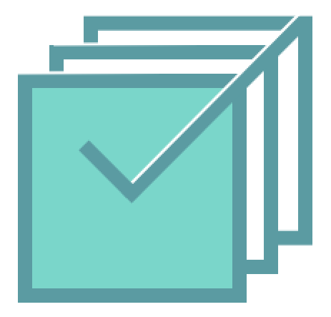
Alejo N G Yi F Tolúlọpẹ́ Ò

Table of content
Mission Statement
Value Proposition
Problem and Solution Overview
Needfinding Interviews
POVs & Experience Prototypes
Design Evolution
Our solution
Tasks
Our prototypes
Low-fidelity prototype
Medium-fidelity prototype
Major design changes from lo-fi to med-fi
High-fidelity prototype
Major design changes from med-fi to hi-fi
Values in design
Final Prototype Implementation
Summary & Next steps

Mission Statement 2
Value Proposition 2
Problem and Solution Overview 2
Needfinding Interviews 2
POVs & Experience Prototypes 6
Design Evolution 9
Our solution 9
Tasks 10
Our prototypes 11
Low-fidelity prototype 11
Medium-fidelity prototype 13
Major design changes from lo-fi to med-fi 15
High-fidelity prototype 15
Major design changes from med-fi to hi-fi 20
Values in design 23
Final Prototype Implementation 24
Summary & Next steps 25

Mission Statement
To empower people to microvolunteer in their spare time

Value Proposition
Repurposing spare time and promoting volunteering

Problem and Solution Overview
We interviewed multiple people who are very passionate about doing social good and surprisingly found that, despite their strong willingness to volunteer, they often find themselves overwhelmed with life and can’t commit regularly to donate their time to NGOs. As a result, we created a mobile app where NGOs can post micro-volunteering tasks that can be done in various amounts of time so users can choose to do them whenever and wherever they want. Users can help NGOs with microvolunteering tasks when they are on a bus, waiting for food, or when they are bored, leveraging their skills and their spare time.

Needfinding Interviews
We conducted two rounds of needfinding interviews. In the first round, we interviewed 4 people (we present some pictures in the appendix):
Manuela, a 23-year-old recent graduate, and animal lover. We found Manuela does not have a lot of time to volunteer during the week and can only volunteer close to her house. For her, volunteering seems like a high commitment activity. Below is her empathy map:
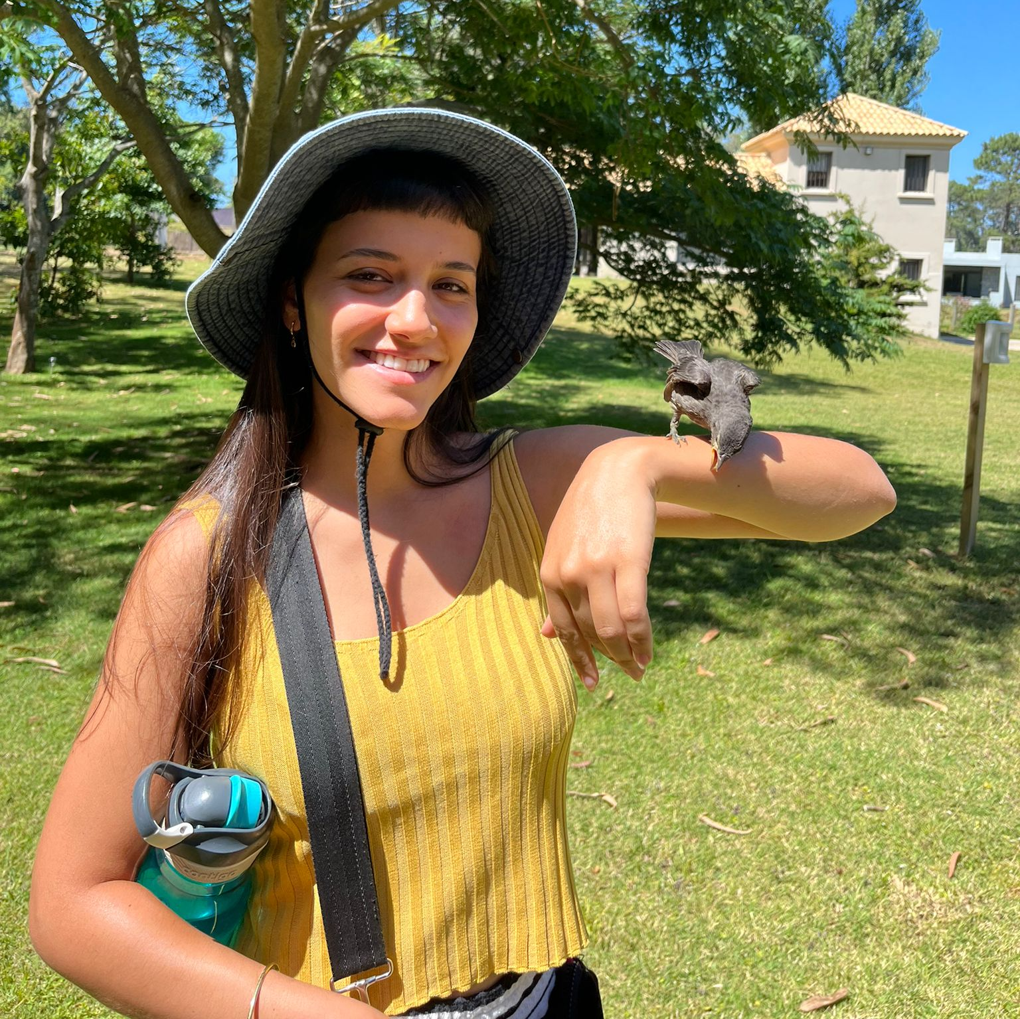
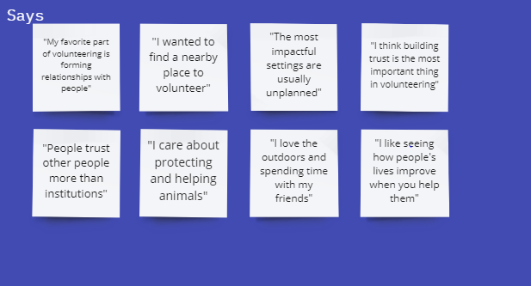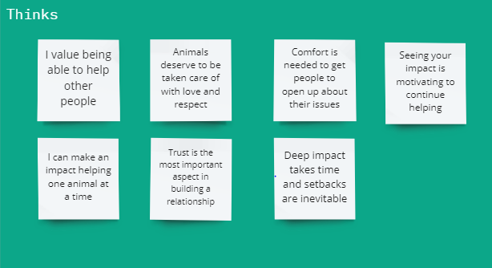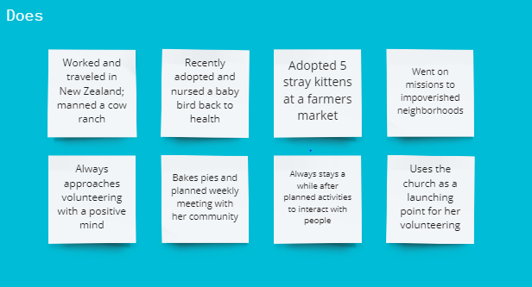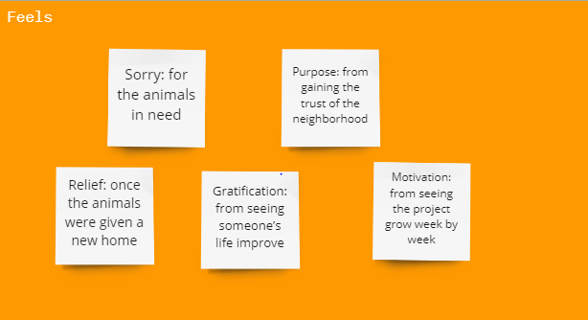
Next, we interviewed Alicia, a sociology coterm at Stanford, founder of a non-profit organization. She told us about her experience as a young founder working with other NGO founders. For her, the issue was having too many people working on the same problem at once without collaborating. Below is her empathy map:
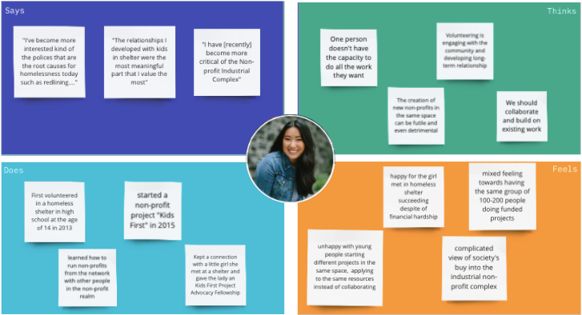
After that, we interviewed Seth, an NLP Researcher and volunteer at the International Linguistics Olympiad. He taught us that, while volunteering itself can be fun and valuable, it is important to feel connected to the actual cause of the organization. When people are motivated by the organization, they are more likely to continue volunteering. Below is his empathy map.
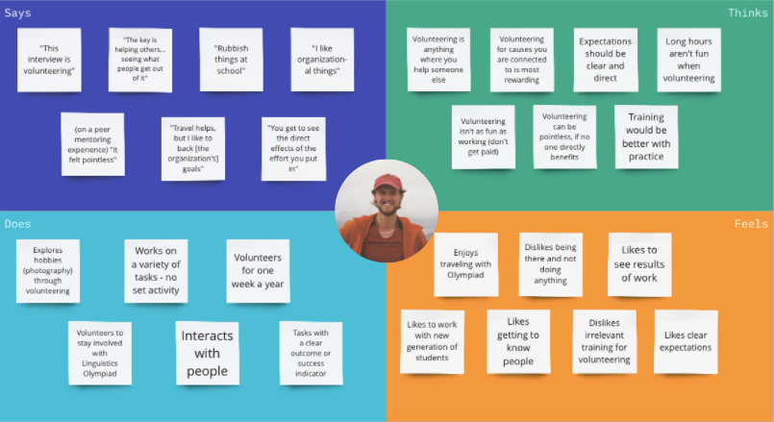
Finally, in our first round of interviewing, we talked to Claire, a tech consultant and previous volunteer. Claire emphasized that a lot of volunteers enjoy the social aspect of volunteering, which makes it hard for them to stay connected when the work goes virtual. For her, remote volunteering is a challenge to be fixed. Below is her empathy map.
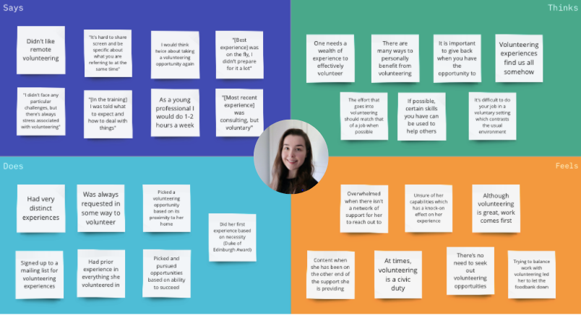
From our first round of interviews, we noticed that everyone mentioned that seeing the impact was very valuable. We also noticed that the ease of volunteering made it easier for volunteers to stay committed. Our interviewees thought the collaboration and community aspect were really important to them. Most of the volunteers started volunteering in their local community. They had positive feelings associated with doing work for others, supporting others and seeing the impact of their work. They had negative feelings around the systemic aspect of it and how to balance volunteering with work.
Our first round of interviewees had a very narrow age range, and life experience, so for the second round of needfinding interviews, we intentionally diversified our interviewees. All of our interviewees were over the age of 30.
We interviewed:
Juan Jose, is a businessman who runs Chicas Programadoras. Juan Jose talked to us about the two sides of volunteering: getting to the people you want to help (reaching girls interested in tech) and getting volunteers who are willing to commit their time. For both, motivation is key. Nevertheless, each party is guided by different motivations and each should be tended for.
Next, we spoke with Tyler Benjamin, a medical student from Colorado who previously served in the US Army for over 10 years. He reinforced the idea that, while motivation is essential to volunteering, sometimes time constraints overwhelm your ability to help others.
Finally, we talked to Diana Lancaster, a leader at Girlguiding in Hong Kong. She told us that for her, training was incredibly important to make sure every volunteer that interacts with children is ready for what may come. Also, she told us that there are a lot of small tasks that seem to take a long time but would not require a lot of skill. Sadly, in order to do these tasks, people still go through unnecessary training.
We had some insights about motivations for volunteering after the first round of interviews and wanted to explore that further in the second round. From the second set of interviews, we learned that social media and brand recognition, in general, is a key method in attracting volunteers, but when some volunteers have specific skill sets (e.g. speaking a specific language), they may have to search for a long time before finding the causes they want to help. At larger organizations requiring a long-term commitment, it is hard to get volunteers to commit.
The insights we gained from all our interviews were that motivation was identified as a key factor in both choosing to volunteer and recruiting volunteers. We also found that there is a correlation between a passion for a cause and time dedicated to finding an opportunity or staying in it. Also, many dedicated volunteers transition from being beneficiaries, to volunteers to leadership or policy roles.

POVs & Experience Prototypes
Following our synthesis of all the needfinding interviews, we came up with several Point of View (POV) statements and selected our top three:
- We met Tyler, a 38-year-old first-year med student from Colorado who formerly served in the military for 10 years providing humanitarian aid in Afghanistan. He volunteers to resettle Afghan refugees into communities in Colorado. We were surprised to find Tyler randomly emailed organizations related to Afghan resettlement, until one responded, offering to help. We wonder if this means there aren’t many well-established routes for volunteers to connect with organizations. It would be game changing if we were able to connect volunteers with organizations that can maximize their skills
- We met Manuela, a 23 y/o volunteer from Uruguay who repeatedly volunteers at impoverished neighborhoods with her church group. We were surprised to find that Manuela only volunteers on weekends and is very close to where she lives, despite wanting to volunteer more and with different communities. We wonder if this means that she has very limited time and cannot afford to volunteer further away or during the week. It would be game changing for her if we could make it less burdensome to volunteer
- We met Diana, a 59-year-old girl guide leader/board member from Hong Kong, who also worked closely with schools. We were surprised to find Diana regretted that she left the girl guiding association in her twenties and thirties despite wanting to continue. We wonder if this means she didn't understand how important it was for her to volunteer before she quit. It would be game changing if we could get people to understand the value of their commitment to volunteering
We then did some brainstorming to generate How Might We (HMW) statements from each of the POVs.
From POV 1 our favorite HMWs were:
- HMW help volunteers promote their skills
- HMW NGOs build trust to attract more volunteers
- HMW make it less of a time commitment for people to make an impact
- HMW better promote volunteering opportunities
From POV 2 our favorite HMWs were:
- HMW help her volunteer more efficiently
- HMW reduce the time and effort needed to volunteer
- HMW help her find local opportunities more easily
- HMW remove the need for travel to volunteer
We then brainstormed solutions and shortlisted our top three:
- An app that allows people to complete small tasks for NGOs in their spare time
- A wearable that tracks daily locations and provides a summary of NGOs close to the route taken
- Collecting and showing volunteers’ reviews of the NGOs

We then came up with experience prototypes to test a key assumption about each solution.
Solution #1: An app that allows people to complete small tasks for NGOs in their spare time
Assumption: People will actually enjoy using spare snippets of time to do such tasks.
Experience Prototype: We asked people to do small tasks (splitting names) in their spare time (watching tv, procrastinating, etc.).We told them the work would be used to help NGOs and recorded any extra comments.

What worked:  - Participant would definitely use this in their spare time (maybe 15 min a day)  - They now believe volunteering can be a low commitment activity  - Pre response: volunteering takes 2+ hours  - Post response: 15 minutes is enough  - Felt more productive than just being on their phone | What didn’t work:  - They did not like how impersonal the volunteering was (would prefer an emotional connection)  - The work itself was not very fulfilling. Copying names over does not seem more productive than social media (issue with prototype)  - Would find it challenging to know how to break up tasks (from the perspective of the NGOs)

Solution #2: An app that tracks daily locations and provides a summary of NGOs close to the route taken
Assumption: The proximity of the volunteering opportunity to the user’s route home will have an effect on their takeup of an opportunity.
Experience Prototype: We asked participants for their most common route (home, work, etc.), pinned some NGOs along their way, and then asked them about their likelihood to volunteer in their neighborhood. We also recorded any extra comments
What worked:  - Responses for how likely are you to volunteer in your neighborhood went from 1.5/5 to 3.5/5 when showed the experience prototype  - Average expected volunteer time fell from around 4 hours to around 2 hours  - Discovered many places to volunteer they didn’t even know existed  - Could easily see themselves walking to the volunteer location | What didn’t work:  - Hard to understand what each pin represents (there is very little information in the prototype)  - Still don’t have too much time to volunteer  - They would want to be able to specify the radius of search (given their mobility or transportation capacity)

Solution #3: Collecting and showing volunteers’ reviews of the NGOs
Assumption: Other volunteers’ reviews will attract new people to volunteer at certain NGOs
Experience Prototype: We provided two versions of a list of NGOs, one with descriptions only and one with descriptions accompanied with ratings and either positive or negative reviews. Users were asked to rate whether they would volunteer at each NGO and interviewed afterward.
What worked:  - Good knowledge of work culture and colleagues at the NGOs from reviews  - Users Trusted the NGOs more if told the reviews were from real volunteers  - Users felt more motivated to volunteer at the highly-rated NGOs  - Reviews were viewed as more important than the descriptions  - Reviews impacted the user’s decisions of going to an NGO or not heavily | What didn’t work:  - Users may doubt whether the reviews are from true volunteers if the website is not well-established  - Users definitely don’t volunteer at the NGOs with terrible reviews, so we need to make sure the reviews are not biased or we screen out haters who attack with no reason

Design Evolution

Our solution
From the experience prototype tests, we think experience prototype #1 addressed most of the pain points our interviewees and participants reported - not having enough time to volunteer - we decided to dig deeper on our experience prototype #1 and work on our final solution based on the feedback we got. Our final solution was an app that allows people to complete small tasks for NGOs in their spare time. The reason why we think this is the best solution to our problem is that it leverages technology to connect potential volunteers and organizations, empowering them to do social good, as they may wish, in their spare time.

Tasks
- Easy: Complete a random snippet (open a snippet, work on it, and submit!)
  - Reasoning: when a user only has five minutes and they want to do some volunteer work for NGOs, they may just work on a random task in their feeds. So our easy task would be opening a snippet, starting working on it, and submitting it.
- Moderate: Save a snippet to finish later
  - Reasoning: When a user is on a bus and wants to do volunteer work, they may browse different volunteer tasks. They may find a task that they want to do but they figure they won’t be able to finish before they get off the bus. They want to do it after they have dinner. So they may save a snippet and work on it later.
- Hard: Find snippets by skills and/or domains
  - Reasoning: When a user has some skills that they want to make use of their skills to volunteer, such as graphic design, languages, accounting, etc, they can look for specific volunteer tasks that need their skills. When a user is specifically interested in some domains, such as education, medicine, or animal welfare, they can look for snippets from NGOs in these domains.

Our prototypes

Low-fidelity prototype
- Easy: complete a random snippet 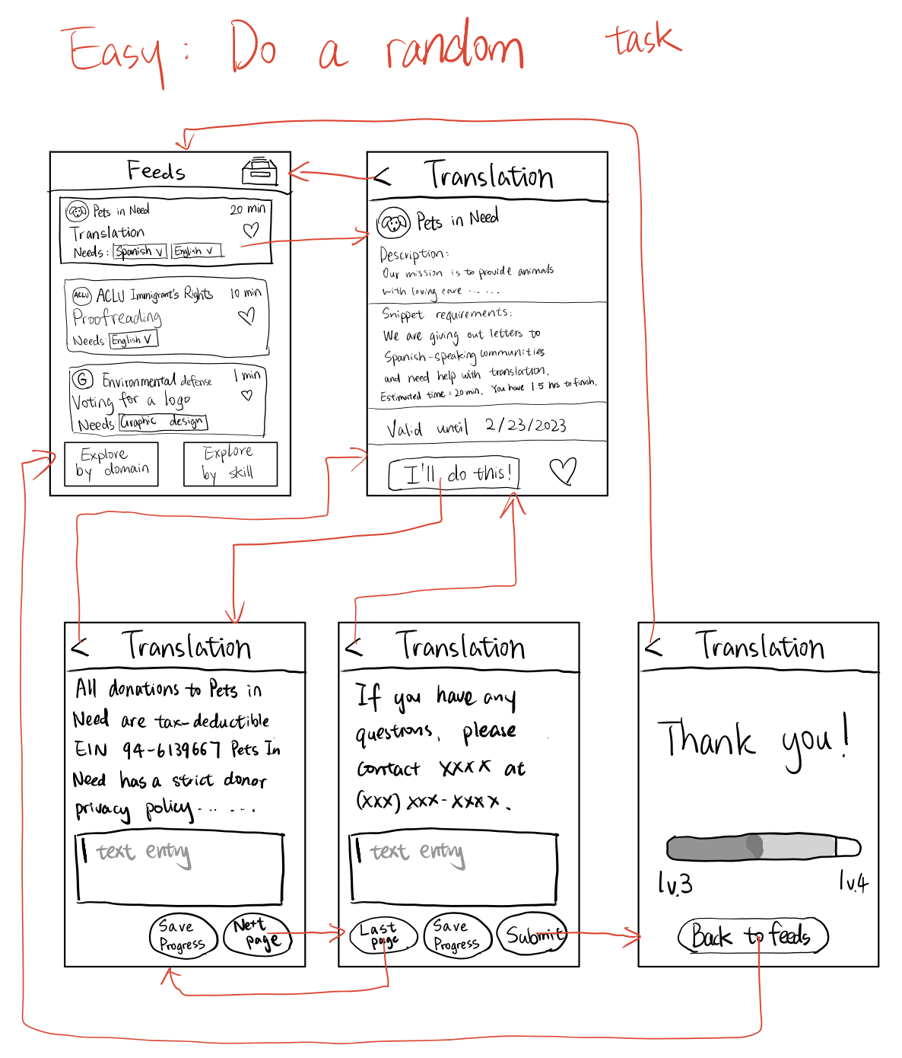
- Moderate: filter by skills and/or domain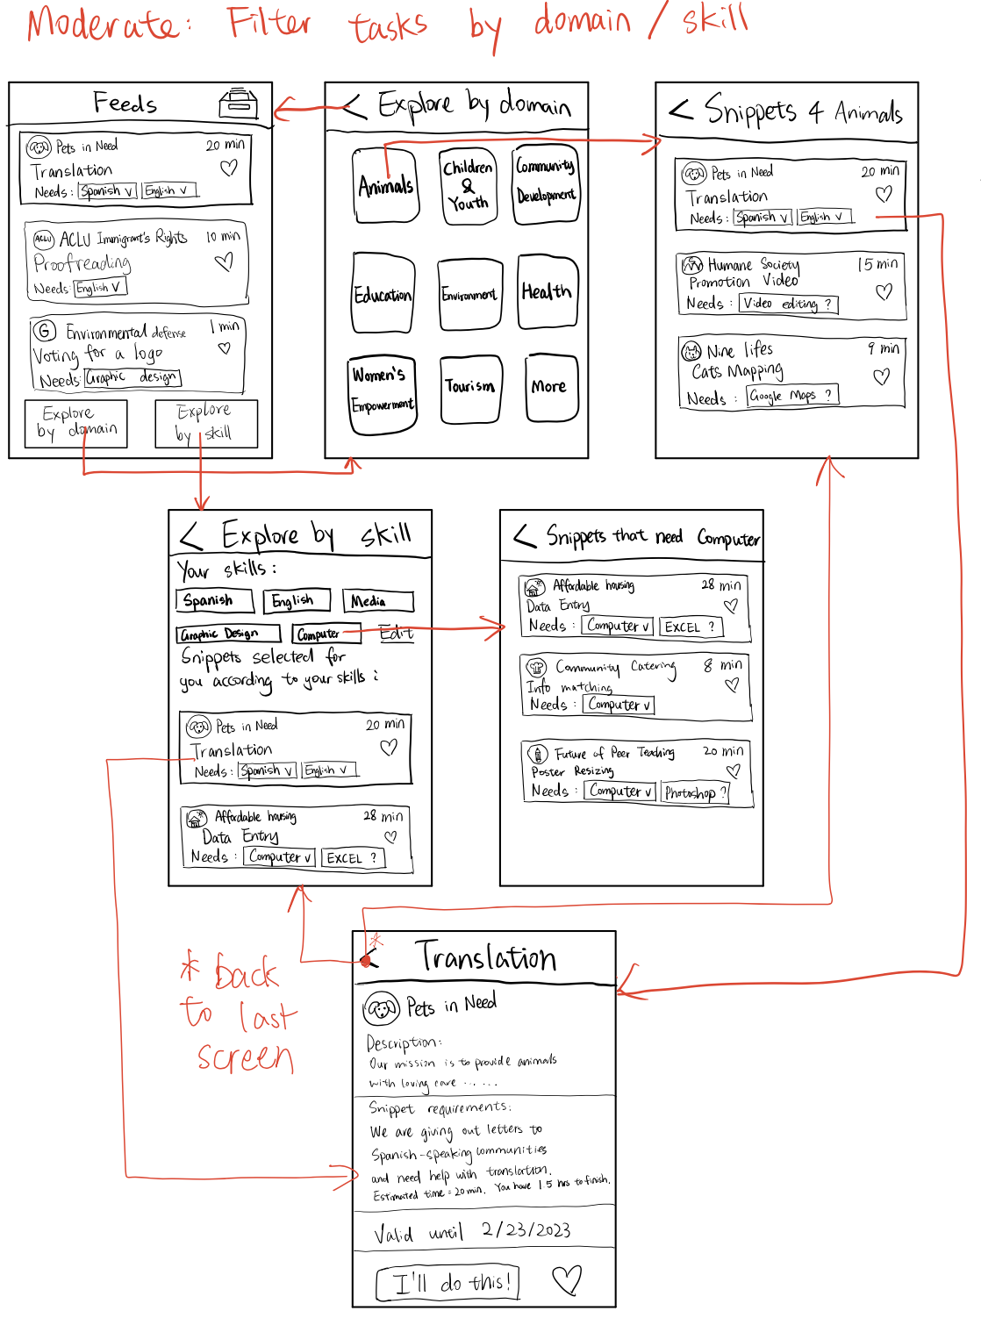
- Extra moderate: like snippets to do in future spare time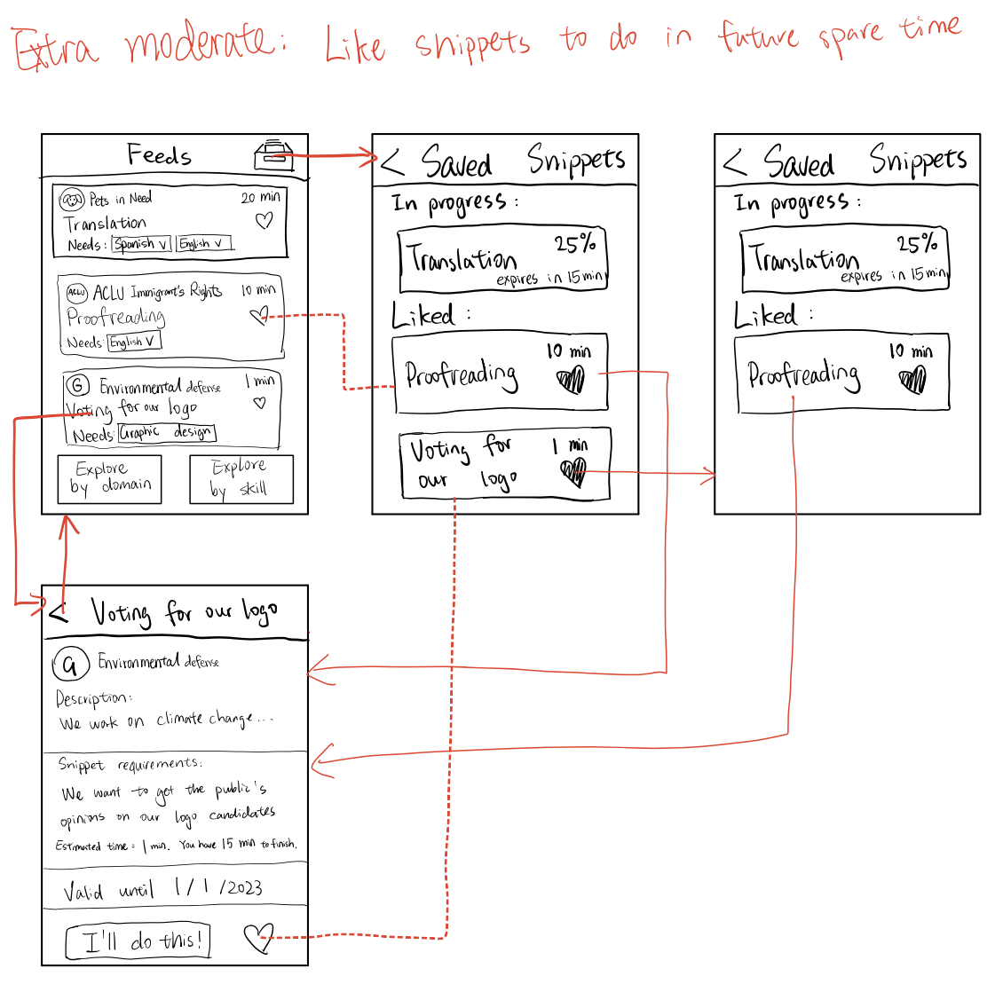
- Hard: save snippet in progress and finish later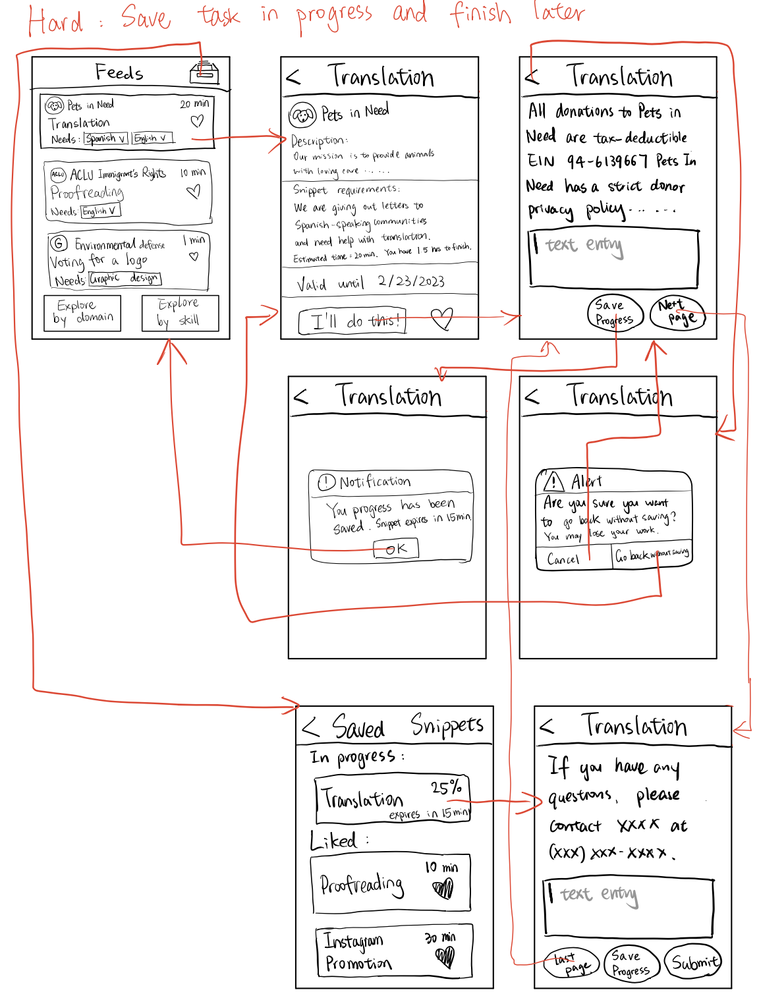

Medium-fidelity prototype
- Easy complete a random snippet: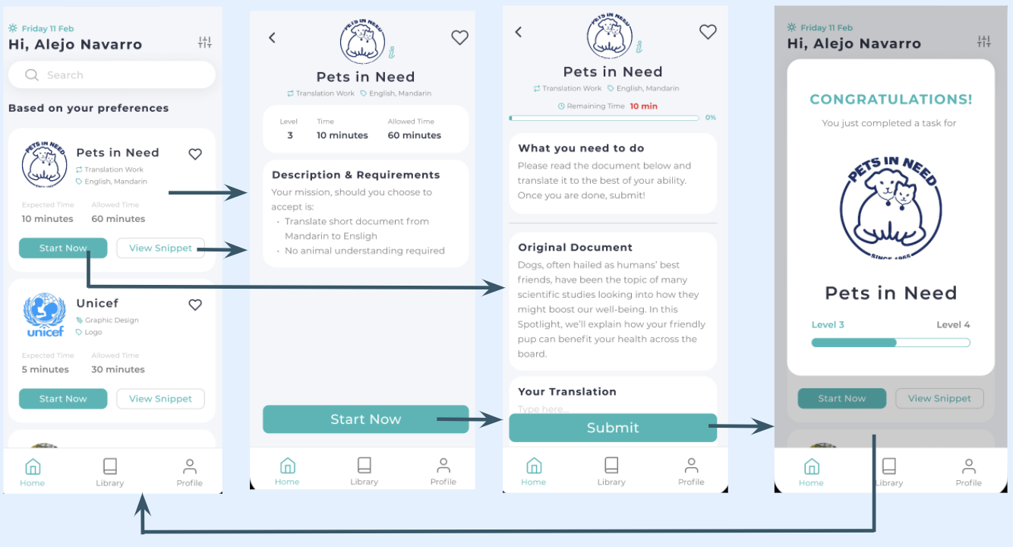
- Moderate: filter snippets by skills and/or domains 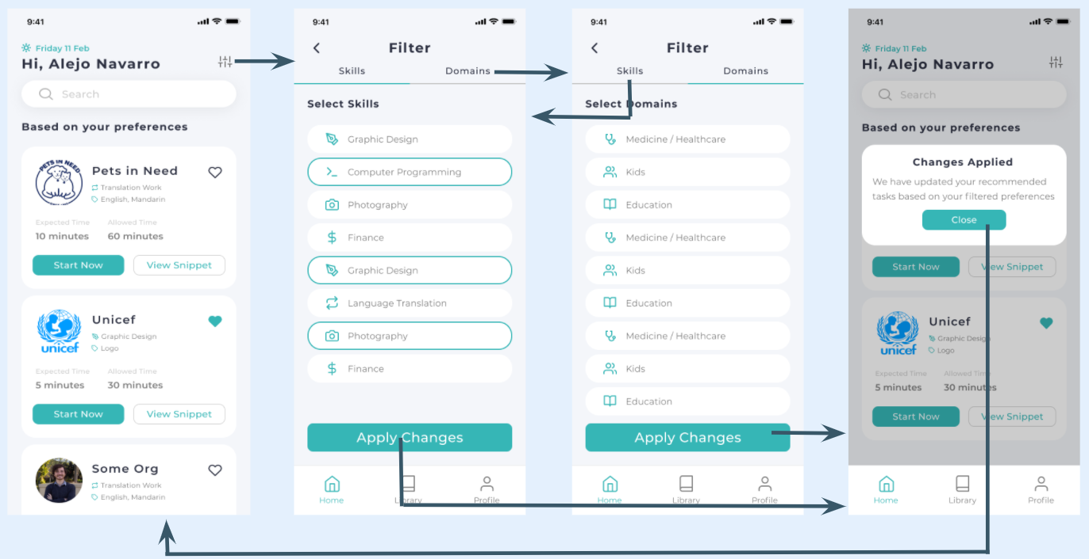
- Extra moderate: save a snippet to finish later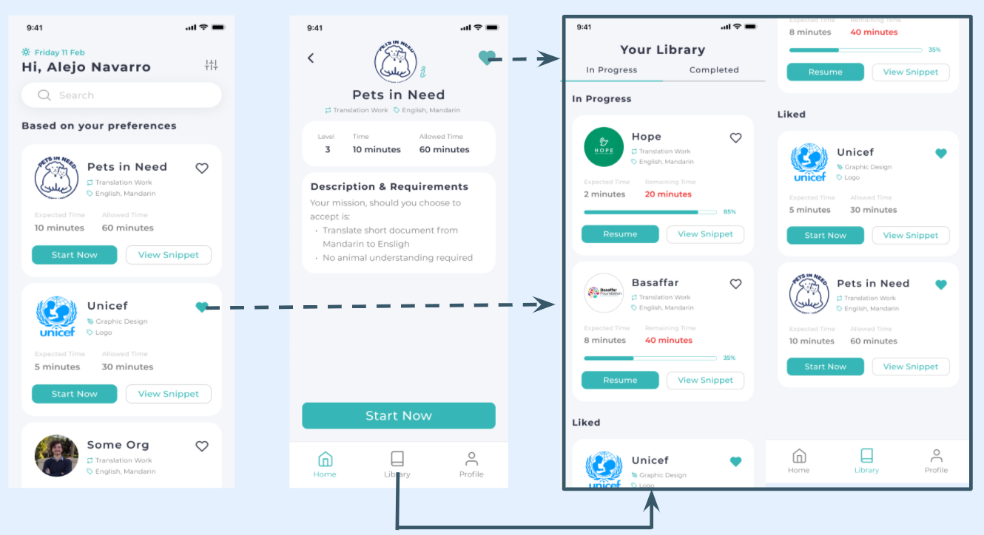
- Hard: retrieve liked, in-progress, completed snippets in the library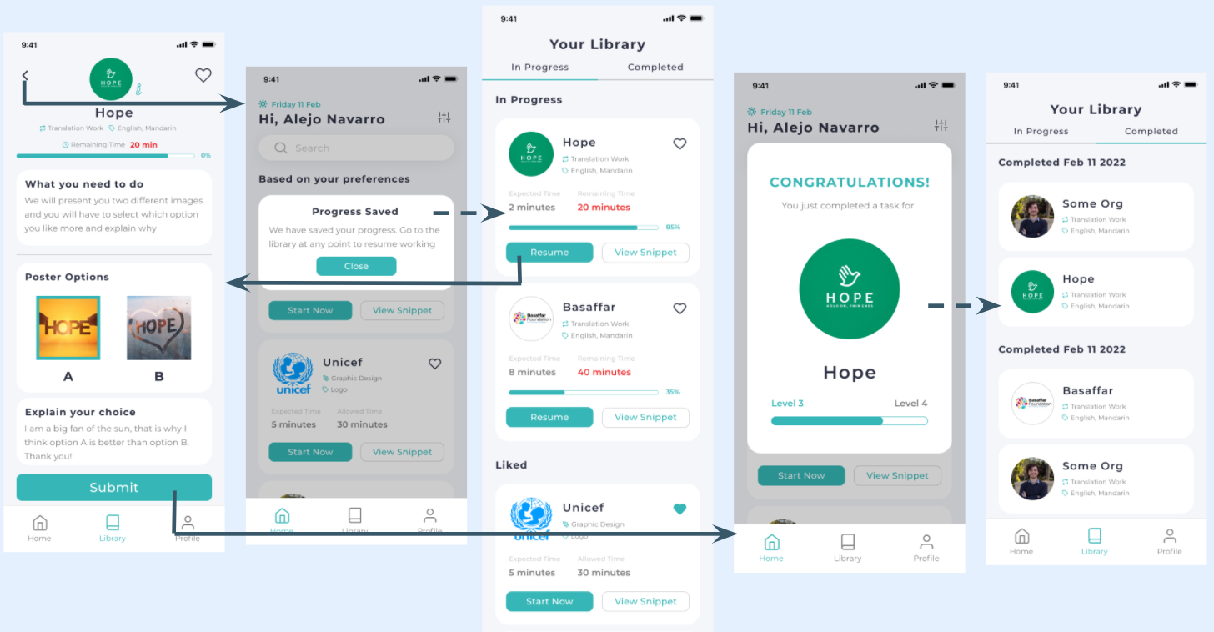

Major design changes from lo-fi to med-fi
We got feedback by recruiting participants to try our low-fi prototype on the Marvel app. 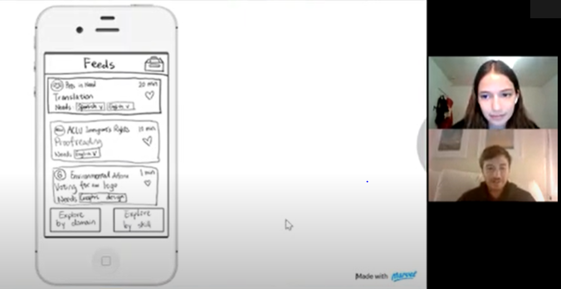
We also got feedback from classmates and our CA Pablo after presenting our prototype in our weekly studio.
Changes we made (by task):
- Easy - completing a snippet: Most parts of the easy task remain unchanged, except that we allow the user to start without seeing the description from the snippet cards.
- Moderate - filtering: We simplified the filtering task a lot according to the feedback we got from our lo-fi prototype. It seemed unnecessary to have filtering pages for skills and domains separated so we combined them.
- Extra moderate - liking: Most parts of this task remain unchanged, except that the liked tasks are now on the Library page.
- Hard - saving: Users wanted their progress to be saved automatically instead of saving their work manually, so we removed that saving feature. Users will be noticed that their work was saved when they exit their in-progress snippet and will be able to find it in their library and resume it later.

High-fidelity prototype
Note: green arrows indicate the main task flow; purple arrows indicate the other interactions.
- Onboarding: When a user opens our app for the first time, they will go through several onboarding screens, which explain the mission of our app, how our app works, how to save a snippet to finish later, and how to filter snippets. After the onboarding screens, the user will advance to the home screen, where they can see a list of snippets. 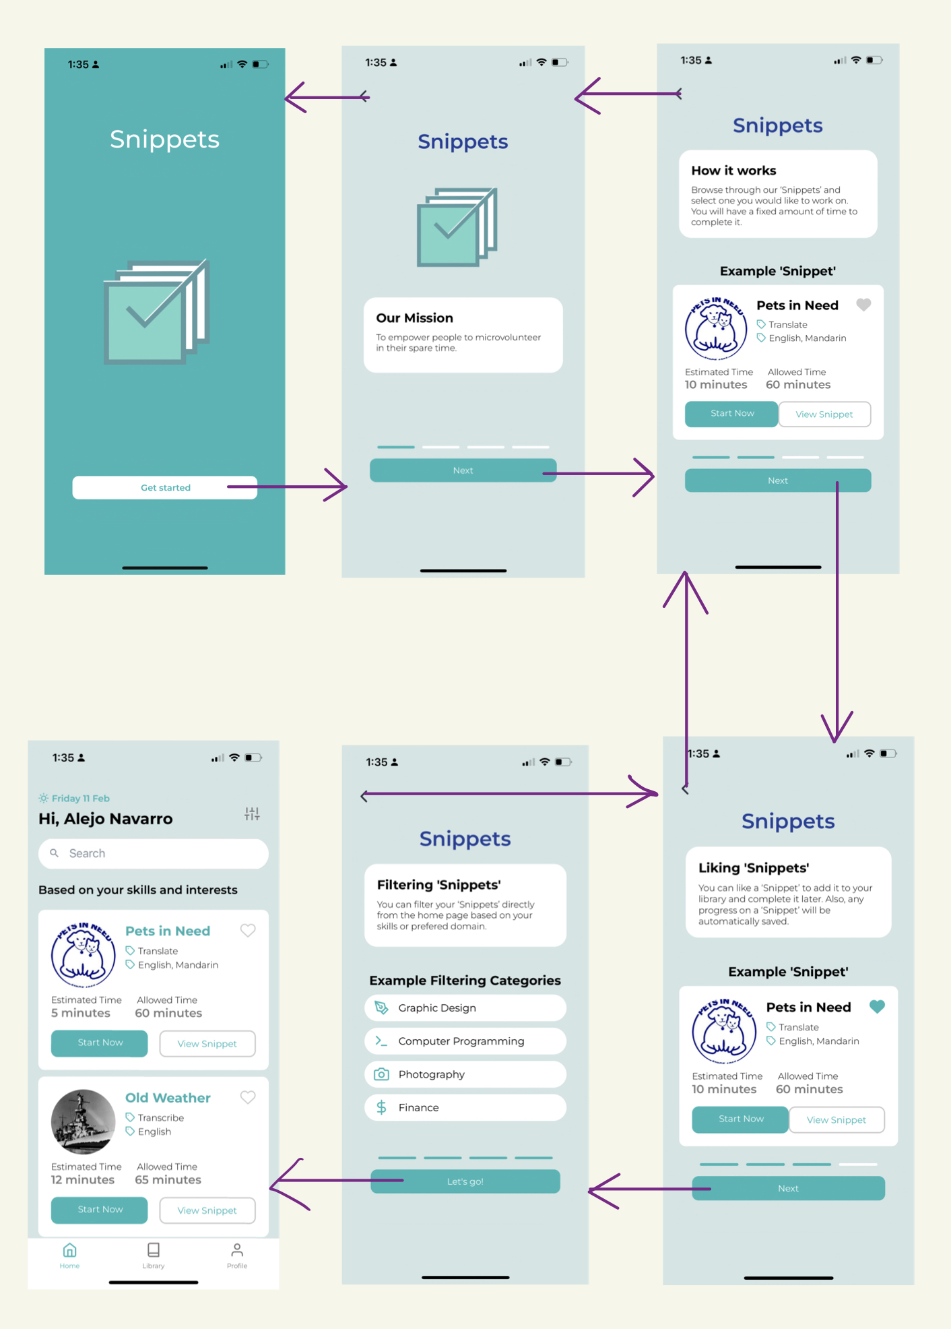
- Easy - complete a random snippet: user can start working on a snippet by clicking “start now” in a snippet card. Then they will be directed to the working page where they will see what the snippet needs the user to do and work on the snippet. When they finish, they can submit their work and see a pop-up window congratulating them for finishing a snippet.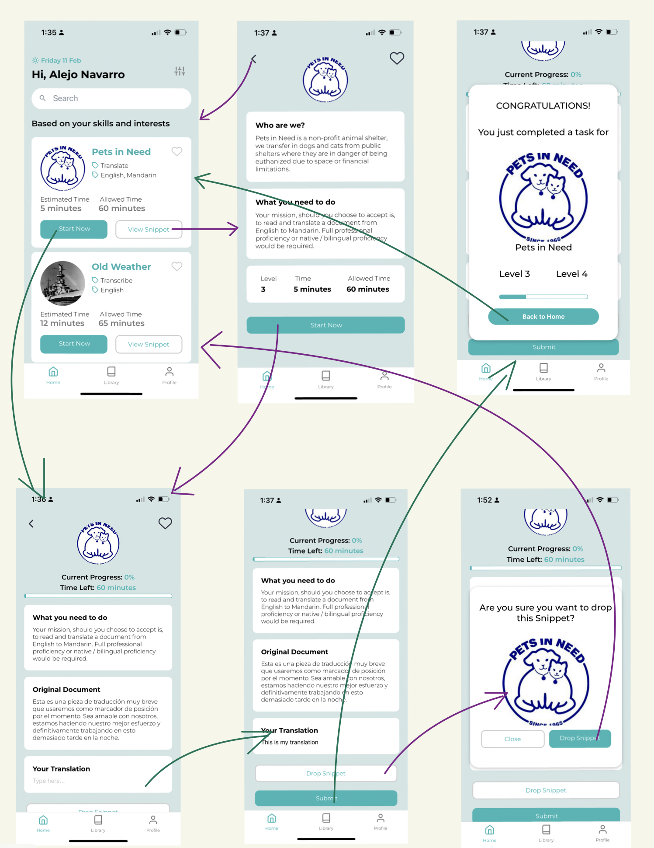
- Moderate - save a snippet to finish later: There is a library page where users can keep track of in-progress, liked, and completed snippets. When a user starts working on a snippet and quits in the progress, their work will be automatically saved. They can later resume the snippet in the “in-progress” tab on the library page. When a user wants to save a snippet for future spare time, they can click the heart of a snippet (in the snippet card or in the snippet details page) and will be able to find it in the “liked” tab on the library page. After the user finishes a snippet, that snippet will disappear from the snippets list on the home page and go to the “completed” tab in the library and the user can review their work there.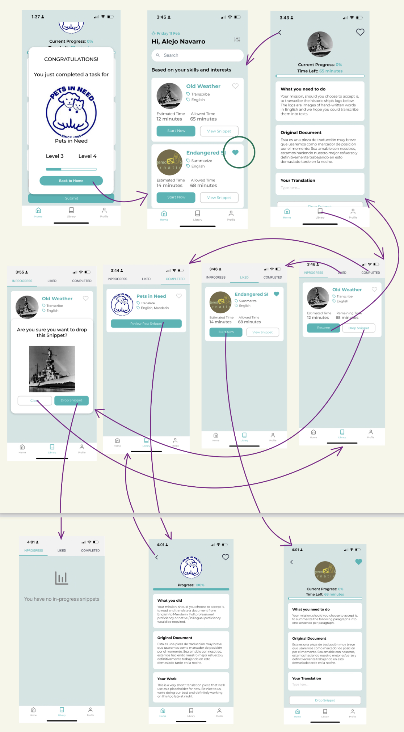
- Hard - filter snippets based on skills and domains: when a user wants to filter their snippet feeds on the home page, they can click on the filtering button on the upper right corner of the home page and be directed to the filtering page. They can filter the snippets by skills or domains. After they make their changes, they can click “Apply changes” and their feeds will be updated to match the skills and domains they chose.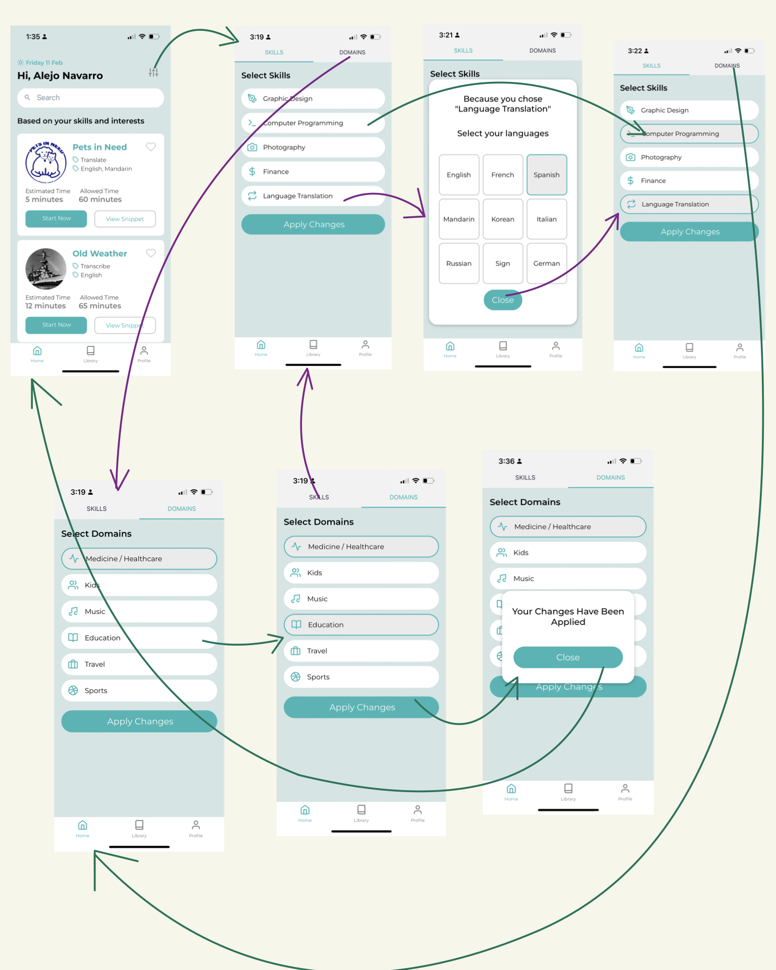
- Additional screens - the profile page: users can check their volunteer level and learn about what that is and how their level impacts them. The more snippets a user finishes, the higher level they will achieve. NGOs might delegate more significant tasks, contact, or give special thanks to the higher-level users. 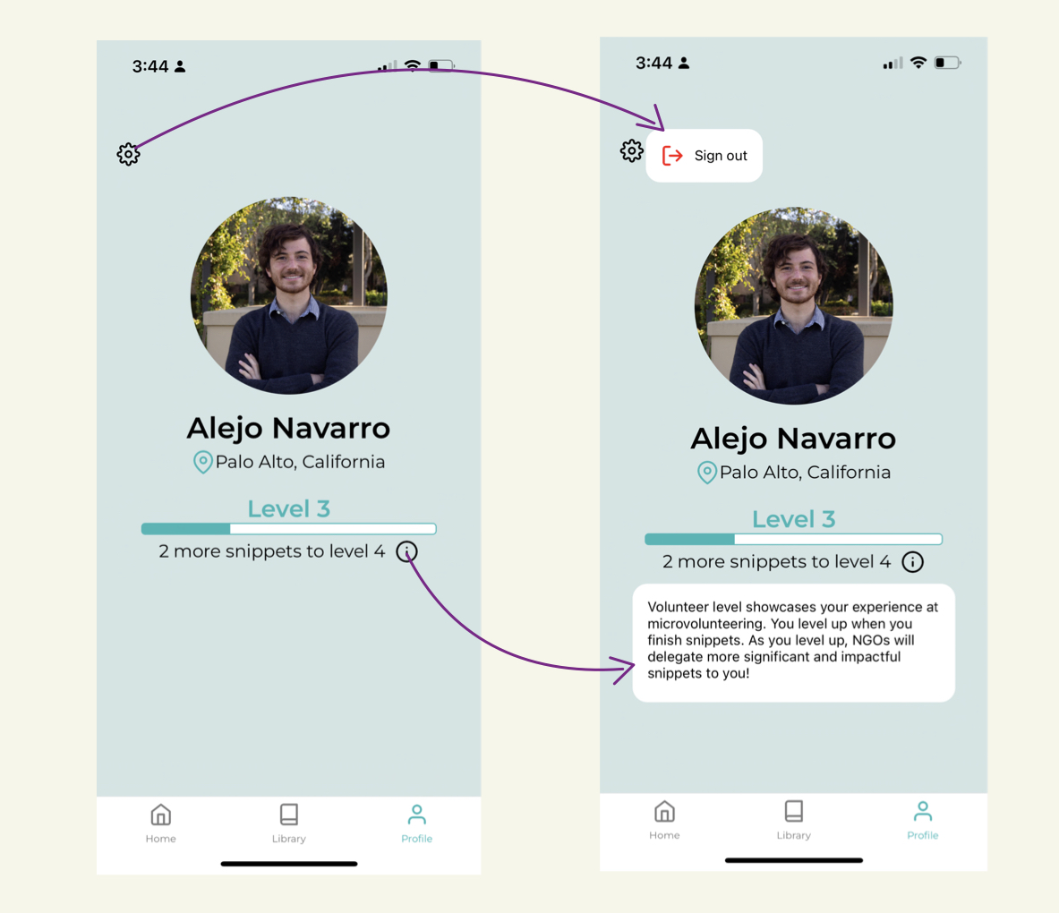

Major design changes from med-fi to hi-fi
We got heuristic evaluations from our classmates. 63 heuristic violations were mentioned in the evaluation. Among them, there were 20 severity 1, 30 severity 2, 12 severity 3, and one severity 4. We mainly addressed the severity 3 and 4 violations.
- Severity 4 violation
  - HE feedback: Some users may take up too many tasks, leaving none for the rest
What we changed: Allow users to have a maximum of 3 “In-Progress” Snippets at once
Reasoning: Users will not be able to take more tasks than they can complete at any given point
- Severity 3 violations
  - HE feedback: bad contrast, small text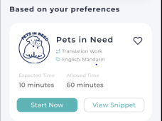
What we changed: color changes, larger text 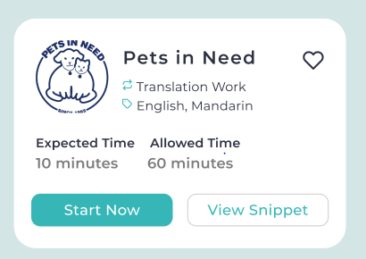
Reasoning: These give better visibility and make our app accessible to more people who might have found it difficult to see the texts

  - HE feedback: Navigator of the library page is not intuitive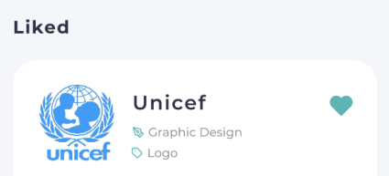
What we changed: split up the navigation 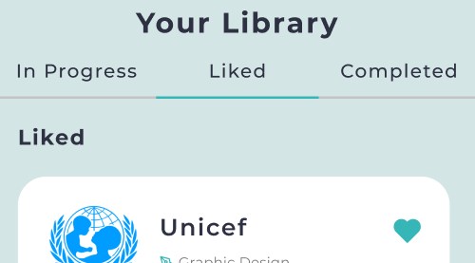
Reasoning: clear navigation will streamline tasks & help avoid errors

  - HE feedback: not always allow exits
What we changed: added quick exists
Reasoning: when users accidentally click on some buttons and advance to a page, they should be able to quickly exit the wrong page and go back to their original page. This change helps users recover from mistakes more easily.

  - HE feedback: information on the profile page is not clear about what they are.
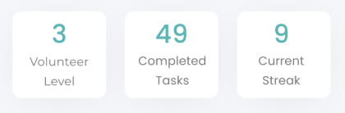
What we changed: redesigned the profile page to simplify and explain what leveling up means.
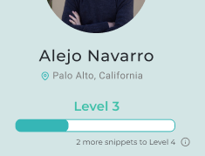
Reasoning: our new design shows a clear/intuitive explanation of the leveling up process in a language the user understands.

  - HE feedback: There are several places with unclear feedback after actions
What we changed: added confirmation modals and deletion modals
Reasoning: clear confirmations & feedback will allow users to know where they are and help prevent errors or unexpected behavior.

- Other design changes
  - HE feedback: Confusing wording (several places)
What we changed: Add more descriptive phrasing.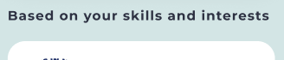
Reasoning: This helps users understand why they get their feeds.

  - HE feedback: Using the same icon for two different functions.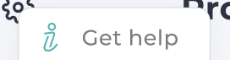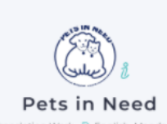
What we changed: We actually removed both of these functions and made more intentional icon choices for other functions.
Reasoning: Using the same icons for different functions may confuse the users. So we decided to only use “i” for info buttons on the profile page.

- What we chose not to change
  - HE feedback: Time restrictions are not inclusive.
Reason for disregarding: time limits are meant to be excessive (much more time allowed than necessary.)

Values in design
- Service: allow users to volunteer their time for a good cause
  - We designed our app to be a “service first” platform
  - The main action buttons in all pages encourage users to complete Snippets
  - Organizations are promoted through prominence in the Snippets
  - Leveling up is based on quantity and quality of service
- Productivity: provide an alternative to mindless scrolling
  - Repurposing wasted time gives an intrinsic sense of productivity
  - We clearly outline the purpose of the Snippet (NGO goal) to make users feel productive
  - We stand as a (productive) replacement for endless scrolling
  - All Snippet work is directly tied to a greater purpose
- Dynamism: allow for low commitments and fast changes to tasks
  - Our app is meant to be used for a few minutes as a time
  - We placed a strong emphasis on the time commitment of each Snippet
  - Task flows are optimized to spend the least amount of time possible on each Snippet
  - We added instant feedback for users to feel like they come in, help out and leave
- Fun: create an enjoyable experience for volunteers
  - Nothing would work if users don’t enjoy the experience
  - We added progress tracking and leveling up as a way to increase engagement
  - Animations will be added to make the app more playful (hard to prototype)
  - We added a social component to make the experience a shared one
- Conflicting values: Service (organizations need users to commit for them to have a long impact on a community) vs. Dynamism (which encourages fast-changing activities and low commitment from volunteers). We haven’t addressed this conflict in this existing iteration yet. However, we have some plans for possible solutions:
  - As users worked on more and more projects for an organization, they can join the organization for long-term commitments
    - We can adjust recommendations in the filters to reflect this
    - We can add highlights within history or profile
  - Organizations can contact frequent users to encourage them to join for different roles
    - We can send notifications to NGOs with people interested in their mission

Final Prototype Implementation
We used React Native as the language for our application and used Expo to build and visualize the app. For the IDE, we used VS Code as this is the environment we are most familiar with. We had differing levels of experience with React Native on our team, which definitely forced us to do some self-learning and collaborating when we got to the app-building stage of the class. Since React Native is such a popular language for developing apps, there is a lot of support online and libraries easily implement components. For example, we were able to import libraries for the progress bars and Modals, which made it easier for us to focus on the more challenging components of the app. One of these more challenging aspects was getting the app components to look the same as our Figma screens. For Figma, we could easily place a grid over our screens and make sure everything was aligned properly. Sadly, for our app, we had to work with flexboxes, layouts and different possible screen sizes. Right now, our app only works for iPhone 13 (not pro) with all the correct dimensions.
There are several Wizard of Oz techniques we applied to make our prototype work. For starters, the feed on the home page is not customized for the signed in user. Ideally, we would like to have some algorithm that takes user’s preferences and outputs a ranked list of the Snippets users can choose from. Similarly, once a user changes their filter preferences, we update them in the saved state but we do not change any algorithms for the feed, we simply navigate users back and pretend like the feed was updated. Additionally, when a user completes a Snippet, they are leveled up manually by having a progress bar move. However, the details of how many points are added or how the levels change is left unspecified.
Most of our data is hardcoded. We do have a working database for the app but we are only using it to fetch data and for authenticating users into the app to make sure they see the onboarding only the first time they log into the app. That means we are not dynamically modifying our database and rely on the hardcoded data for the app. For example, the NGO data and Snippets data we have are all hard coded. After that, we do store anything the user modifies as they complete, like or save Snippets within their application state, but this would not persist if a user reloads the application.

Summary & Next steps
This quarter, we were in The Future of Philanthropy & Volunteering themed studio. Volunteering has been a very popular concept for a long time. However, there are a lot of challenges people may face when they want to volunteer. To find out what people think of volunteering nowadays, we spoke with NGO leaders, college students, a veteran who works with refugee assistance programs, a former NGO mentor who quitted in her 30s and rejoined in her 50s, aging from 20s to 60s and having different levels of past volunteering experience. We were surprised to find that despite their vastly different background and experience in the field, many of them share one common challenge: they don’t have time to volunteer as much as they wish they could have. Therefore, our team thought that it would be game changing if we can help people volunteer in less time-consuming ways. That’s why we started designing “Snippets”, a platform that empowers users to microvolunteer in their spare time.
In this quarter, we got a quick experience of how a product is being made. We went all the way from needfinding to the high-fidelity prototype and pitch. We repetitively iterate over design, prototype, and evaluate. As we iterated, we got a lot of valuable feedback from interviewees, the teaching team, and classmates during usability tests, group sessions, and heuristic evaluations. We went through the process of refining our prototype to essential tasks, making trade-offs, and more accessible and user-friendly. We look forward to learning more about design and using what we learned in this course to future design occasions!

Appendix
Needfinding Interview Pictures

Alicia
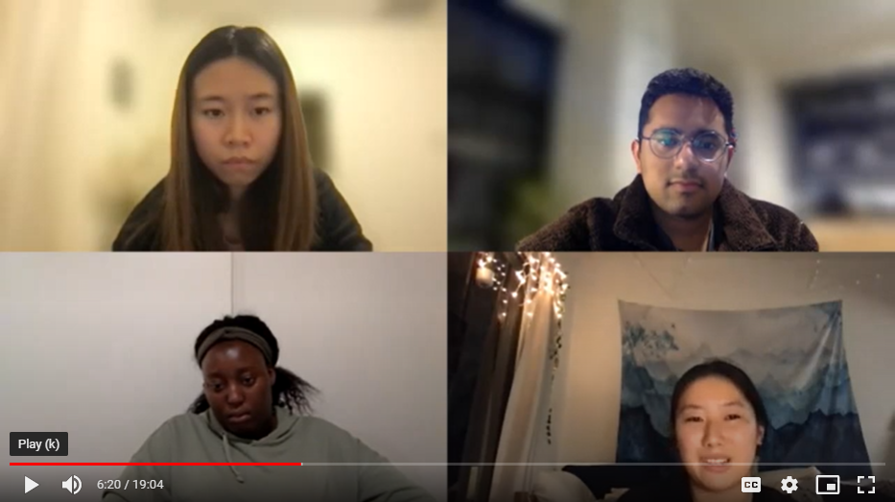

Claire
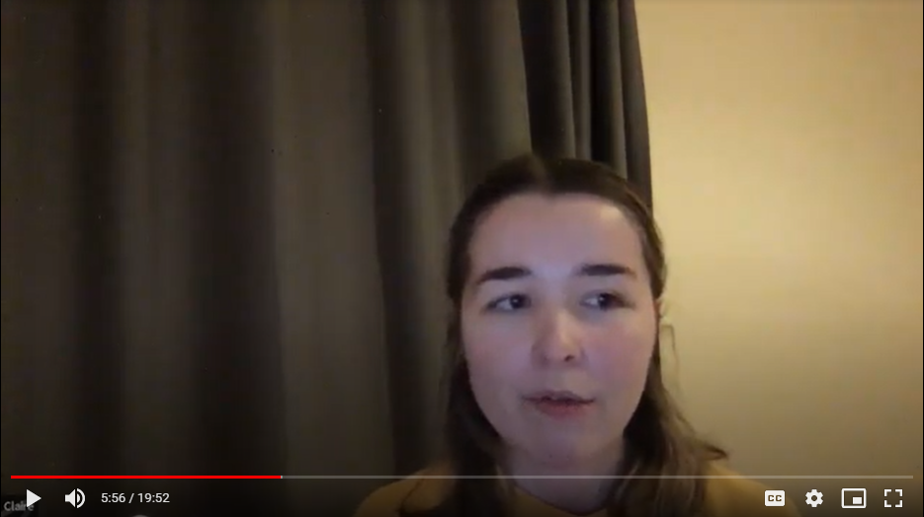

Seth
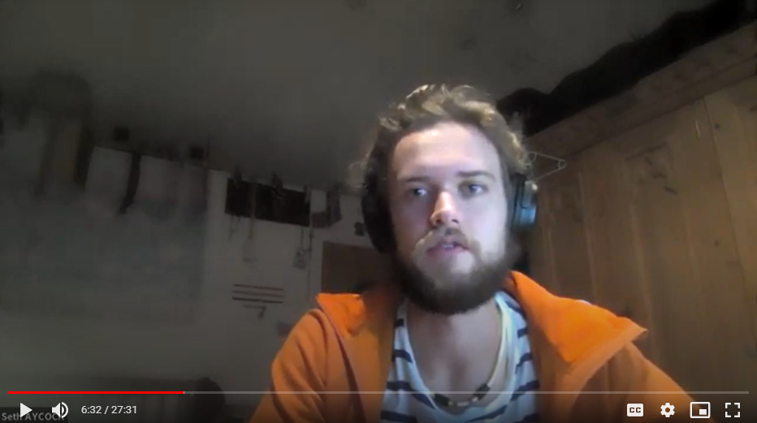

Diana
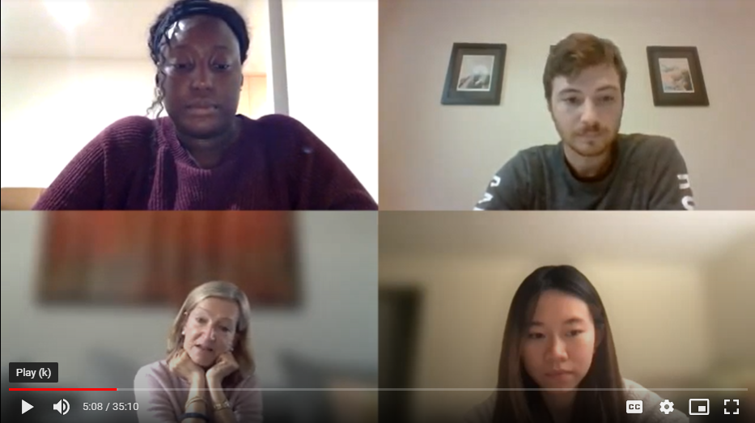

Juan Jose
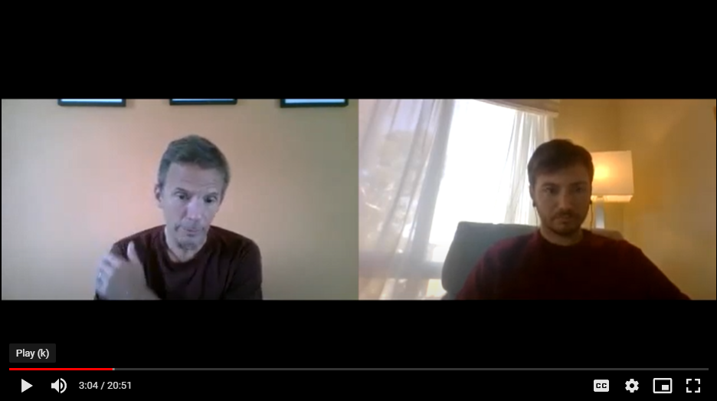

Tyler
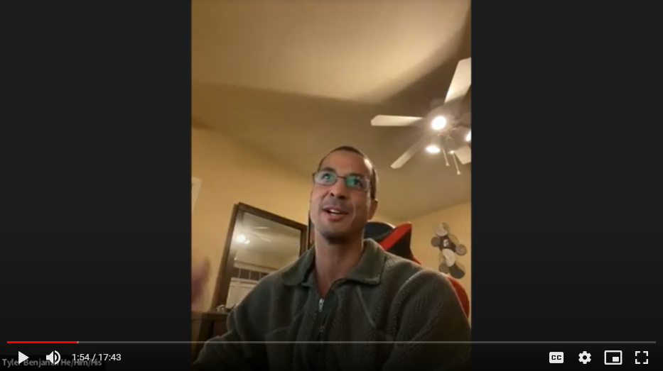

Extra POVs

Claire
- We met Claire, a tech consultant based in Scotland who did remote consulting for a local food bank.
- We were surprised to realize how little she enjoyed the experience, which she attributed to a lack of social interaction.
- We wondered if this means Claire connotes social interaction with a good, motivating volunteering experience.
- It would be game changing to provide her with volunteering opportunities that suit her preferences.
Alisha
- We met Alisha, who started volunteering in high school and led a non-profit project herself
- We were surprised to realize that she was so jaded by non-profit founders working on the same thing separately and applying for the same resources.
- We wondered if this means Alisha thinks non-profit founders should collaborate on their projects to avoid wasting resources.
- It would be game changing to help non-profit founders with similar interests to find each other and encourage them to collaborate.
Juan Jose
- We met Juan, a 57 year old businessman from Uruguay who founded Chicas Programadoras to help teach teenage girls to code and Involucrate to help connect volunteers with non-profit organizations
- We were surprised to find that Chicas Programadoras focuses their efforts on Instagram to reach out to girls about participating in their clubs
- We wonder if this means they are worried other conventional advertising routes will not reach young audiences
- It would be game changing if we were able to help Chicas Programadoras adapt to their users needs for recruiting
Extra HMW
