Snippets
Alejo N G Yi F Tolúlọpẹ́ Ò
Introduction
Mission Statement
To empower people to do microvolunteering in their spare time
Value Proposition
Repurposing spare time and promoting volunteering
Problem/Solution Overview
Volunteering is often equated to sacrificing great amounts of time for a good cause. However, people often find themselves overwhelmed with life activities such as education or employment, amongst others, and can’t commit regularly to donate their time to NGOs. We want to create a platform that would allow people to do microvolunteering (volunteering short periods of time) in their spare time as they navigate through life.

Sketches
Concept Sketches
We brainstormed 5 different design ideas or modalities for our solution. These were: 1) devices on public transport, 2) wearable devices, 3) video, 4) audio/speech and 5) mobile apps. Below are the concept sketches for each potential solution.
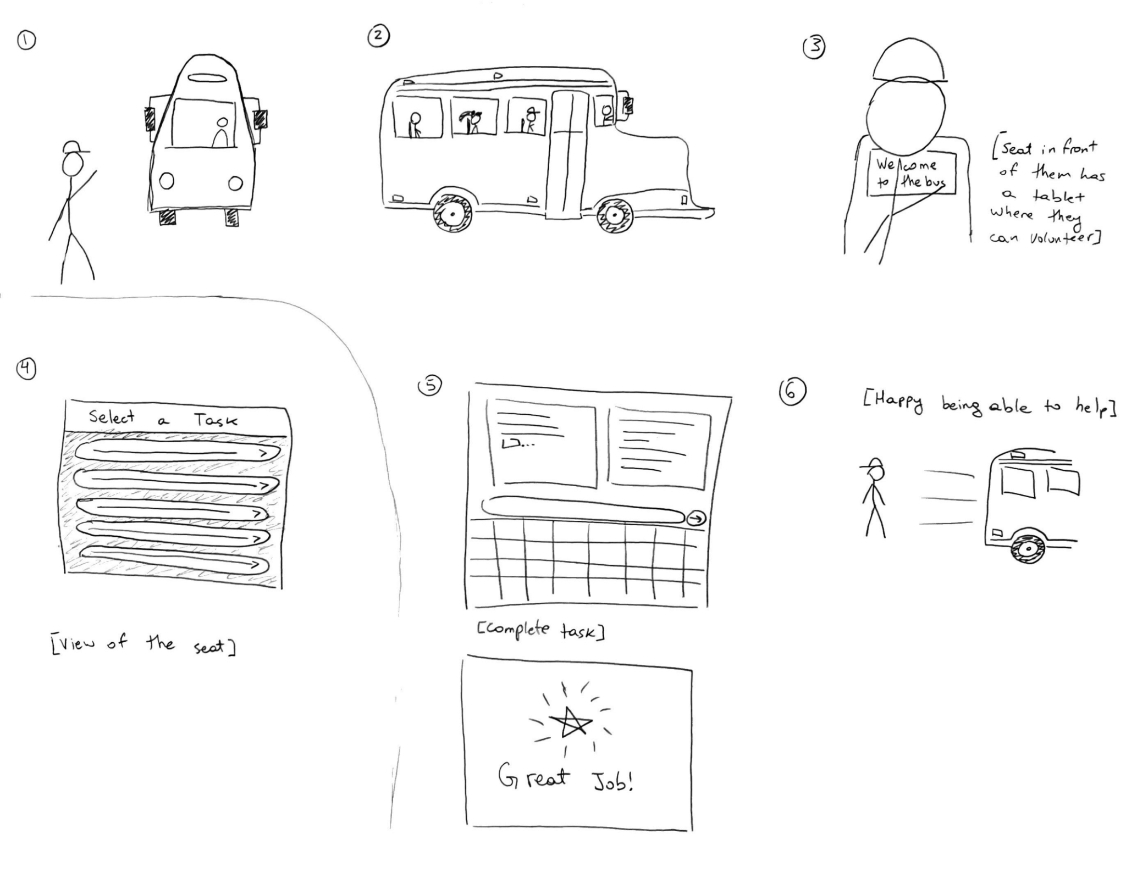
Figure 1: Devices on public transport
(Users can microvolunteer during journeys on devices on public transport.)
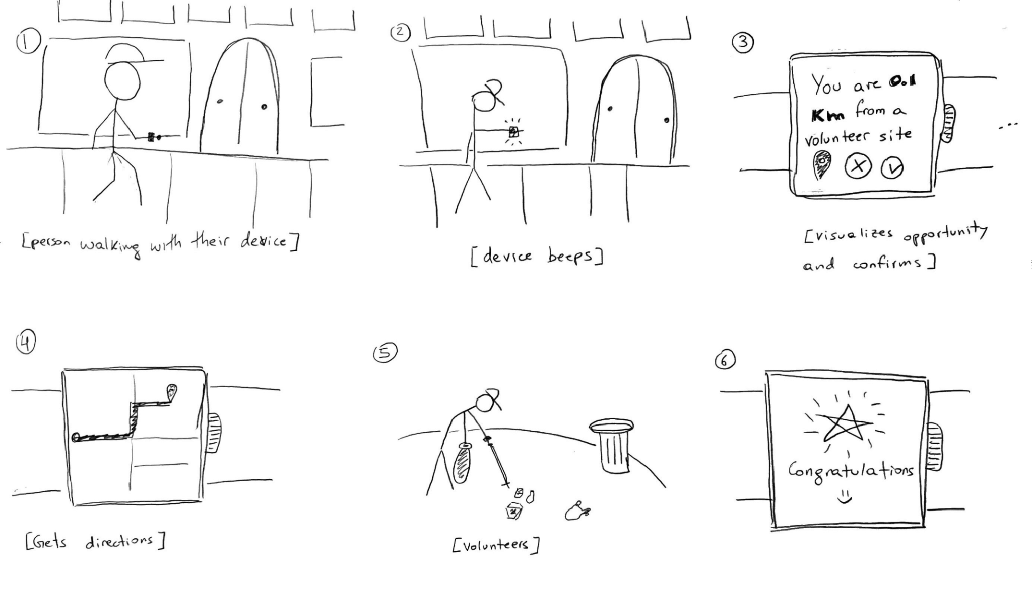
Figure 2: Wearable devices
(Users are notified of opportunities close to where they are located)
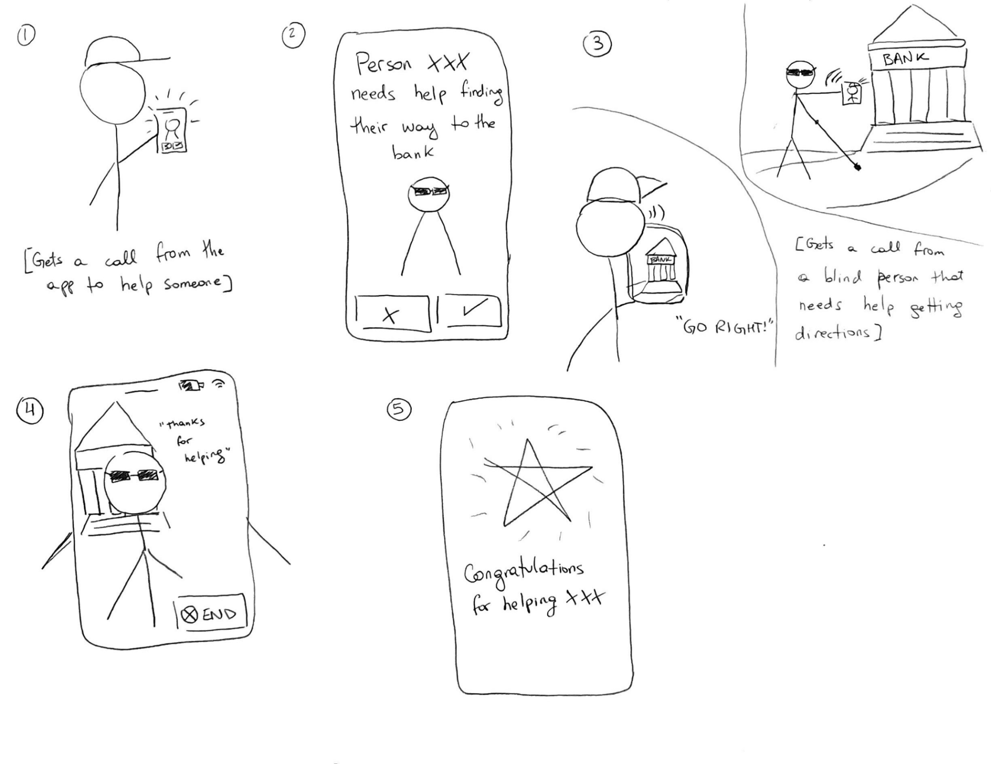
Figure 3: Video
(Users can leverage short video calls to help blind people navigate)
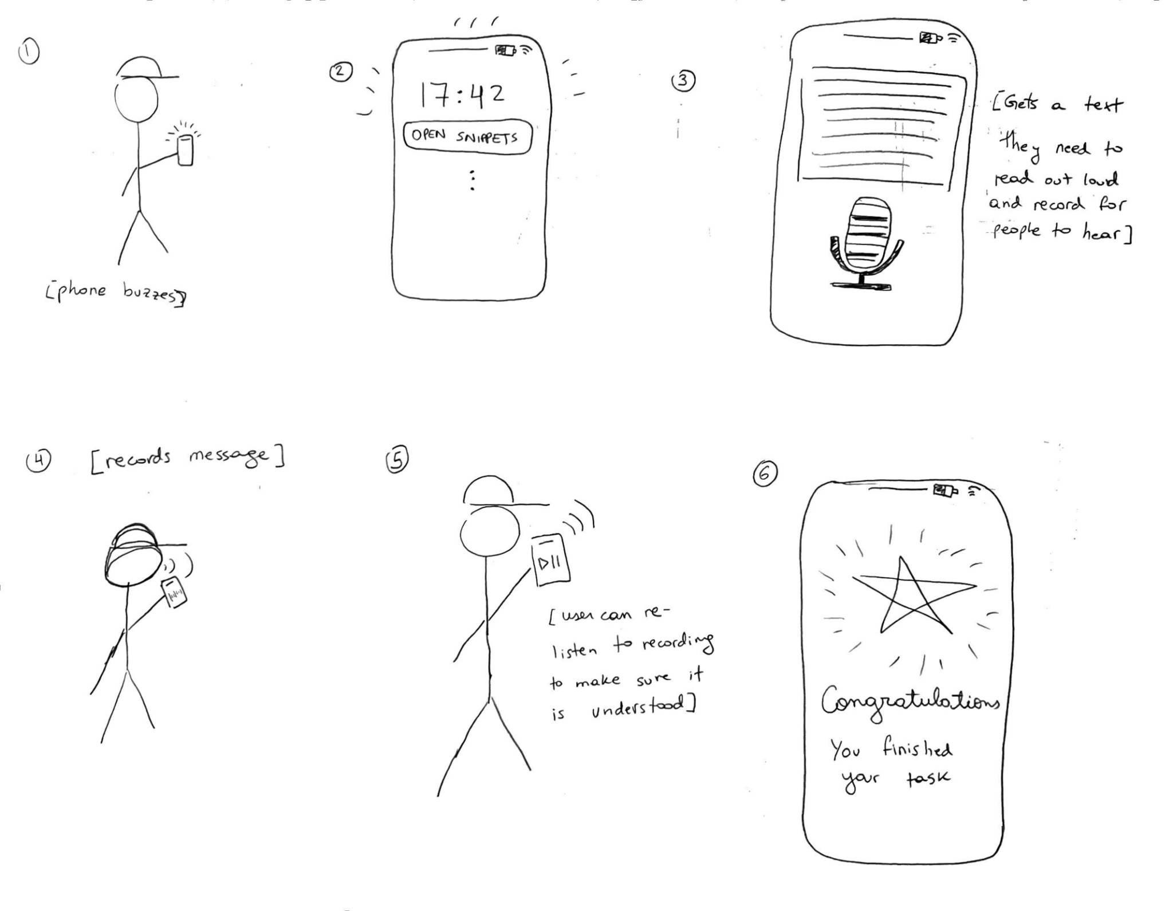
Figure 4: Voice app
(Users use voice recordings to activate and complete snippets on the go)
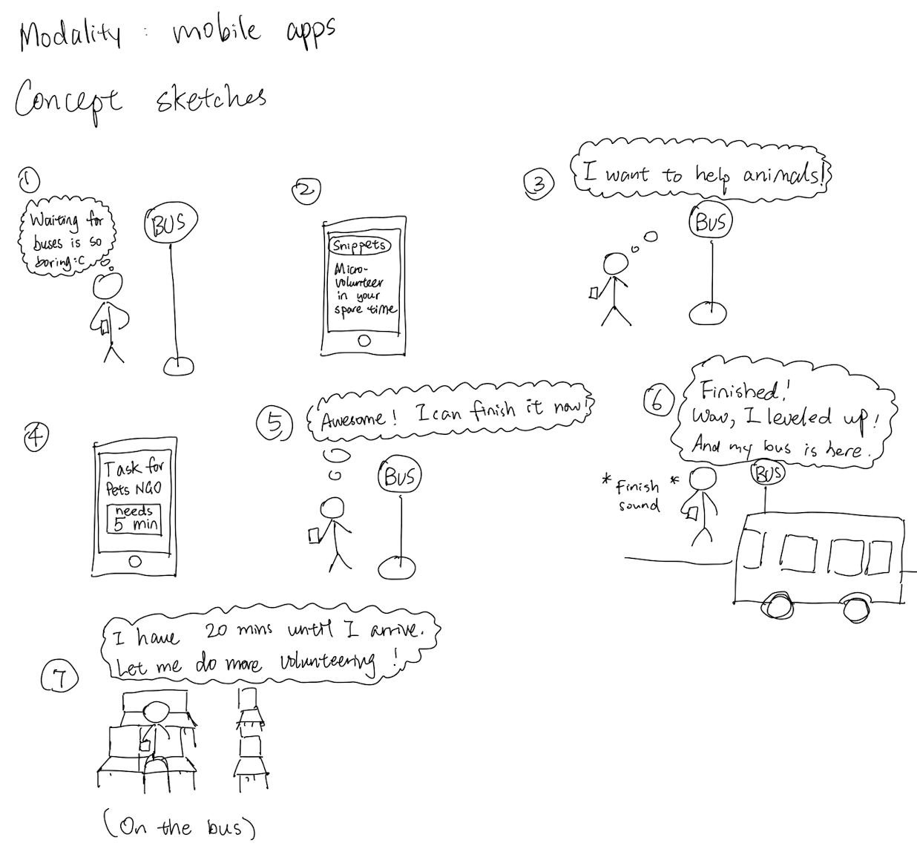
Figure 5: Mobile app
(Users can complete diverse tasks with different modalities on their smartphone)
Top Two Designs
Our top two designs that we decided to storyboard in greater detail were ideas 1) and 5). That is the devices on public transport or “snippets on wheels” and the mobile app concept or “snippets in your pocket.” Below are the UI sketches and storyboards for each concept.

Snippets in your pocket
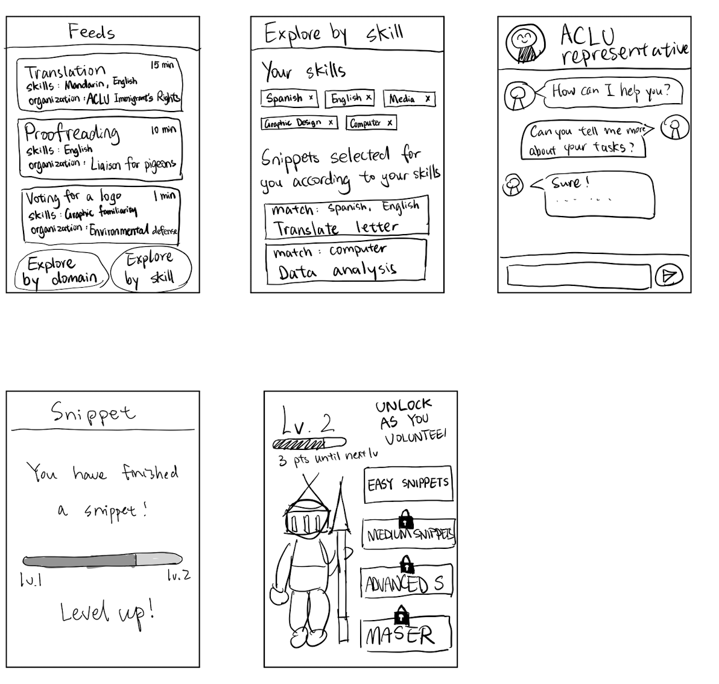
Figure 6: Mobile app - UI Sketches and Storyboard

Snippets on wheels
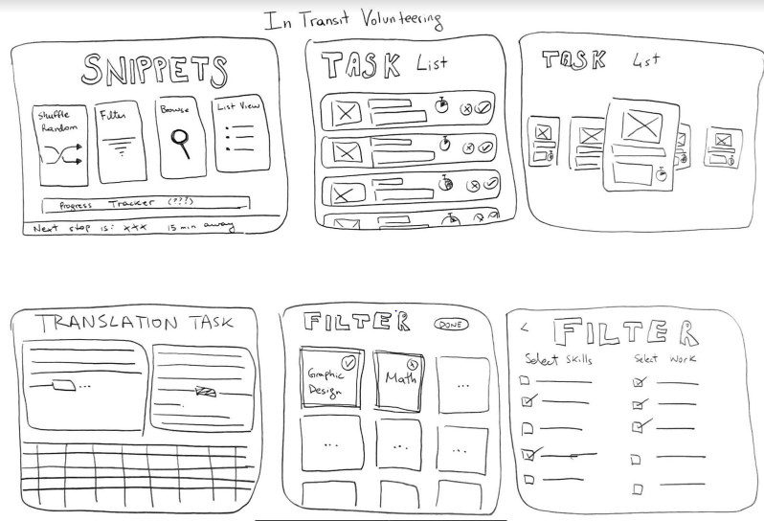
Figure 7: Devices on public transport - UI Sketches and Storyboards

Selected Interface Design
Selection Analysis and Rationale
We decided to list out the pros and cons of each idea to find out which one would be the best to move forward with. Below is our reasoning.

Snippets in your pocket
Pros | Cons
- Can connect volunteers and non-profits worldwide  - A mobile app can leverage several modalities (voice, video and text)  - The tasks can be done in any types of free time, not just on public transport  - Could replace other time wasting activities done on the phone  - People are already used to this modality of use. Would be easy to adapt the purpose | - Does not fully include extremely motivated volunteers  - Puts a lot of weight on non-profits to divide the tasks  - Cannot standardise the user experience of volunteering due to different non-profits listing different types of opportunities  - People would still be hooked on their phone  - Harder to use the environment to prompt users (could use notifications?)

Snippets on wheels
Pros | Cons
- Meets people where they are - virtually no effort for potential volunteers to get involved  - Leverages specific time wasting situation  - Novel approach could entice people to try it out  - Environmental cue (seeing the device) would prompt users | - Restricted to the country or mode of transport a potential volunteer is using  - Tasks may not be completed before user gets off public transport  - Excludes people that don’t use public transport  - Reduces the scope of feasible tasks - sound related or slightly longer tasks may not be compatible with this solution  - People are not used to working on transportation (might even get sick/nauseous)

Decision
We decided to go for the mobile app as it leverages several modalities (audio, video, text, etc.), which becomes harder for devices on transportation. Additionally, a mobile app is more versatile to user’s needs/availability as it can be used anywhere. Finally, we believe it would have the easiest adoptance of modality as users are used to using their phone for many tasks already.
Tasks Selected
- Simple Task: completing a snippet (small piece of work)
- Moderate Task: filtering snippets based on user skill and domain of interest
- Complex Task: saving snippets to be completed at a later time

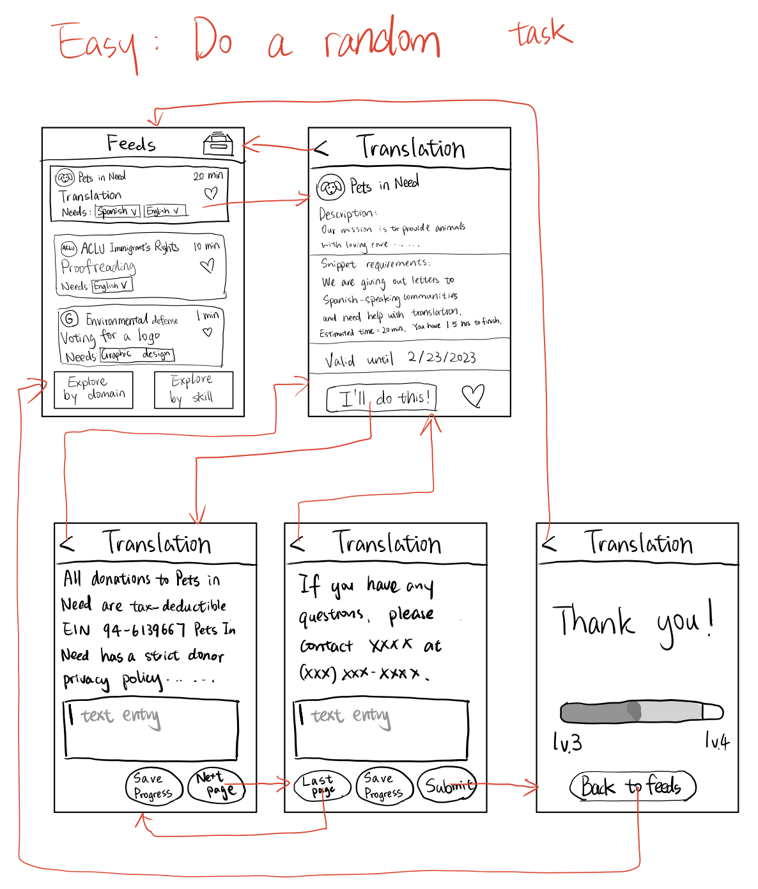
Figure 8: Simple Task Storyboard - Completing a snippet
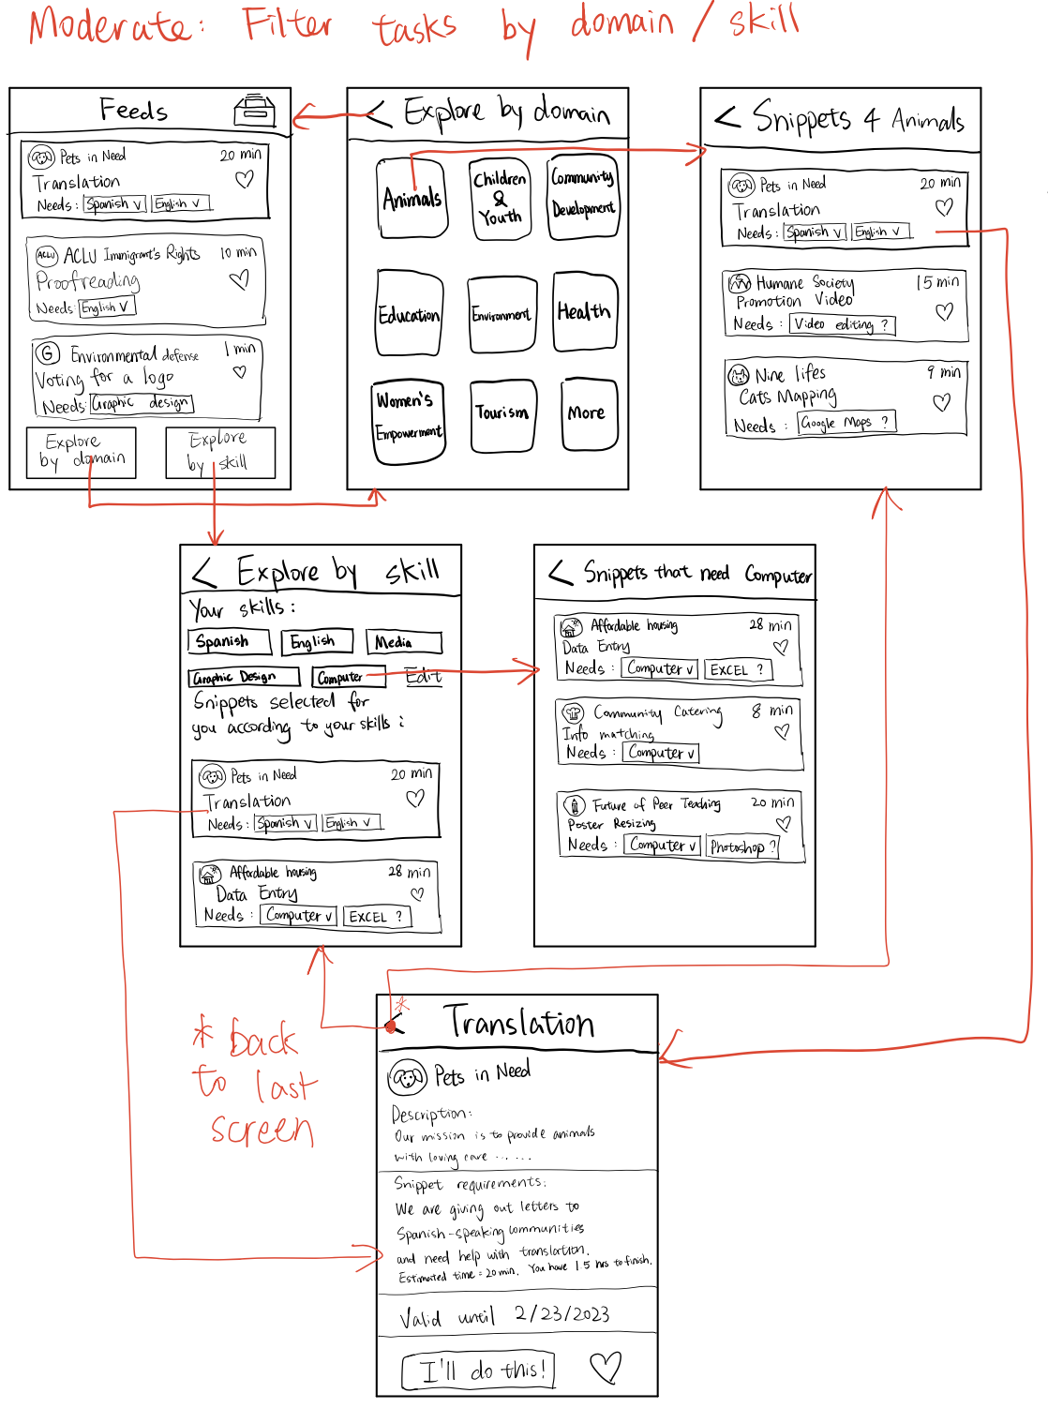
Figure 9: Moderate Task - Filtering snippets based on skill & domain
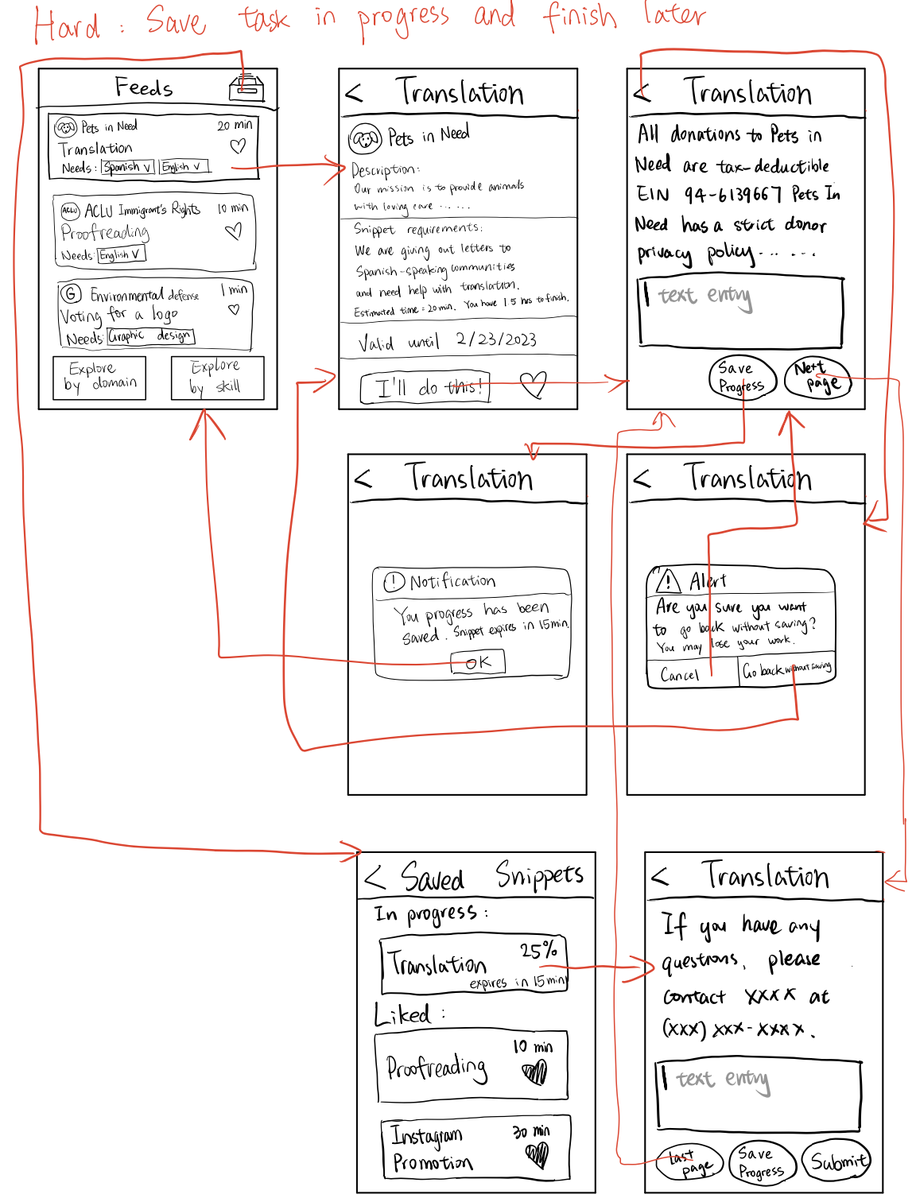
Figure 10: Complex Task - Saving a task to complete later
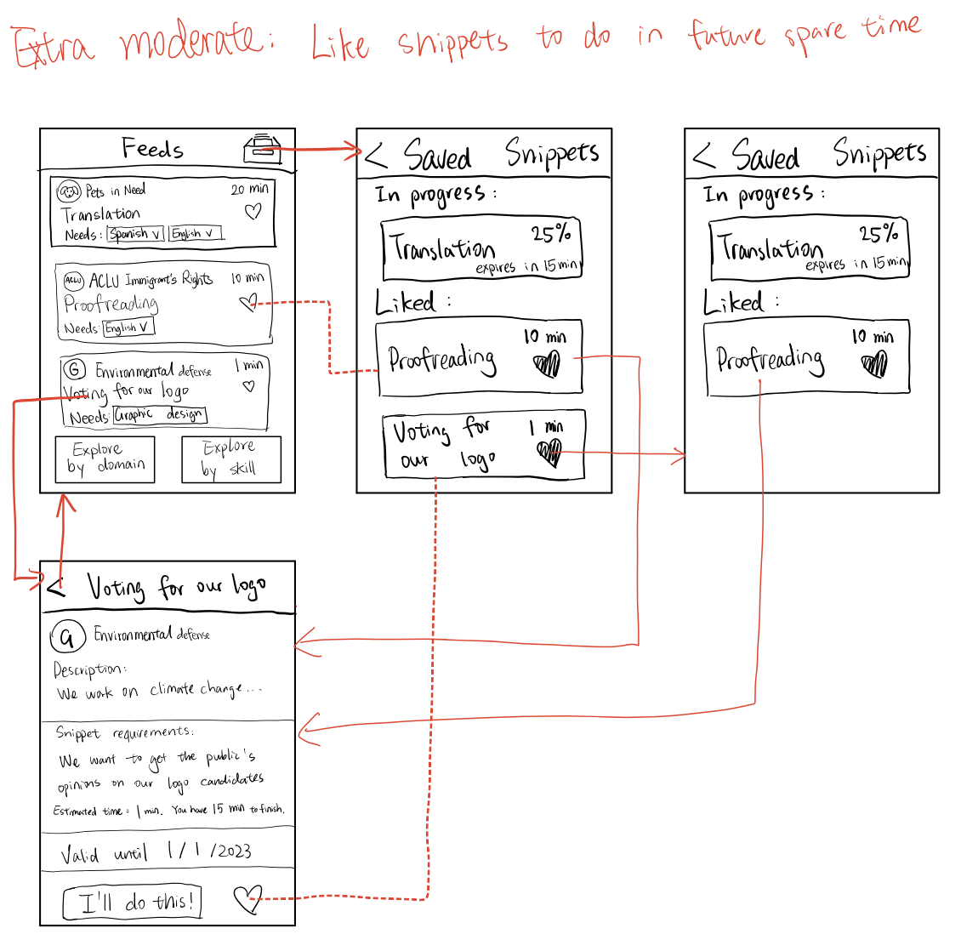
Figure 11: Extra Moderate Task - Like tasks for later

Prototype
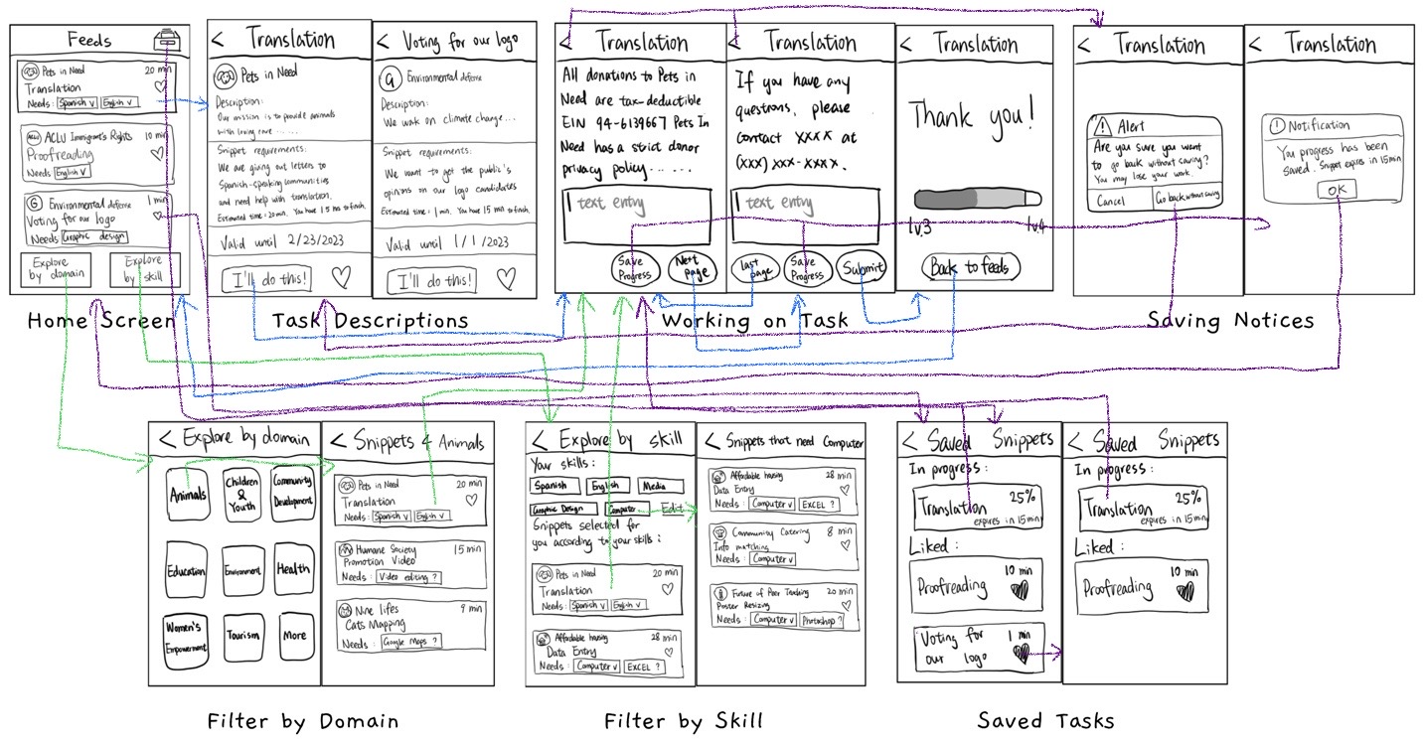
Figure 12: Full Prototype (all screens and arrows)
Description
We have prepared a low fidelity prototype of the main tasks for our app with the intention of showing it remotely to users. The app will be presented using MarvelApp to mock the actual behavior of the finished component. Users will be able to click on the connected components to navigate through the screens. Below are the main interface elements of our prototype.
Interface Element | Functionality
Snippets feed | Clicking on any element in the Snippets feed (aka a snippet) will take the user to a description page for the snippet where they can select to take on a task
“I’ll do this” | Clicking on this button launches the snippet and allows users to start completing the required piece of work
“Next Page” | Clicking on this button moves users through the snippet
“Save” | Clicking on this button allows users to save their progress as they complete a snippet
“Submit” | Clicking on this button allows users to submit their work for an NGO
“Back” | Clicking on any back button should always take users to the previous screen they were on
Explore by domain or skill | Clicking on either of these buttons enters users into filtering mode, where they can select their skills
Domain page | Users can select which domain they want to explore for their tasks
Skills page | Users can input their skills and filter the tasks accordingly
Heart icons | All heart icons on the app represent liking snippets to be completed later
Archive icon | The archive icon allows users to see the snippets they liked and the ones they saved to be completed later. They can launch snippets from this page directly

Testing Methodology
Participant Demographic
- Julia - 20 year old college student from Berkeley (bioengineering) very interested in volunteering. She was recruited through a friend of one of our siblings. The interview was carried out using MarvelApp over Zoom
- Josefina - 25 year old CS master’s student from Berkeley (originally Peru) who has limited experience with volunteering but extensive UI/UX experience. She was recruited through a TreeHacks friend from Berkeley. The interview was also carried out using MarvelApp over Zoom
- Fengzhou - 20 year old undergraduate student from Washington University in St. Louis, majoring in Computer Science and Philosophy-Neuroscience-Psychology. He doesn’t have much volunteering experience. The interview was carried out using MarvelApp over Zoom.
Our choice for young participants stemmed mainly from our belief that young users have a more ‘intuitive’ approach to exploring apps (as opposed to a more deliberate approach). Their feedback will help us directly identify which components of the app add unintentional friction due to a mismatch between expectation and reality.

Environment & Procedure
As explained above, all interviews were carried out remotely over Zoom using MarvelApp. We told users about the general concept of the app and talked them through the basics of our three tasks: completing a snippet (easy task), filtering snippets (moderate task) and saving snippets to complete later (complex task). Nothing more was explained.
Tasks
- Simple Task: completing a snippet (small piece of work)
- Moderate Task: filtering snippets based on user skill and domain of interest
- Complex Task: saving snippets to be completed at a later time
Usability Goals
Usability Goal | Measurement Metric
Ease of use or efficiency | Clicks required to complete a task
Discoverability | How easy it is for users to find the tasks
Robustness | Amount of errors completing the task

Test Measurements
We wanted to measure how easily our users would discover the tasks (where they had to go to do them) and if there was anything unexpected about the process. Additionally, we wanted to see if there were any pain-points within the task flows once they got started. Lastly, we wanted to see if there would be many errors in the task flows (forcing the users to correct themselves or go back). Last, but not least, we care deeply about the feedback our users can give us about the experience, what can be improved and what did not match their expectations.
Team Member Roles
- Alejo: greeter / facilitator / observer
- Yi: greeter / facilitator /observer
- Tolúlọpẹ́: observer
- MarvelApp: computer

Results
Clicks required to complete a task
Task | User 1 | User 2 | User 3 | Mean
Complete a snippet | 6 | 6 | 10 | 7.3
Filter | 3 | 5 | 7 | 5
Save snippet for later | 12 | 9 | 15 | 12

Feedback & Observations from Interviews
Task | Positives | Negatives/Improvements
Complete a snippet | - Very easy and intuitive to complete  - Easy to find tasks, understand what you need to do and complete them  - Quick and fun  - Enjoyed the “completed task” at the end  - (No errors in any) | - Slightly confused about the “Next Page” vs “Save Progress” buttons (maybe we can differentiate them more  - Would love a way to see which tasks were completed  - Would love to be able to sort tasks based on length
Filter | - Understood clearly how to select by skill and domain  - Quick to understand what each button does  - Likes that you can select multiple in the skill side  - Flow is very short and straightforward  - Likes that the snippets reinforce the skills selected  - (1 or 2 errors max) | - Would prefer the placement to be higher (not bottom)  - Did not see them at first  - Prefers the style of the filter by domain (by skill looks less appealing/more web like)
Save snippet for later | - Likes the ability of saving tasks for later  - Some took a bit of time to discover the saved option. Once discovered it was readily available.  - Nice to see progress once you come back to saved  - Appreciated the functionality and being able to see progress  - Several errors | - Confused about the difference between saved and liked  - The saved icon could be better  - Saved icon not in expected positioning (expects instagram chat function)  - Does not understand difference between heart in task and save progress in task  - Did not expect saving a snippet from the feed to take them to the saved box  - Did not understand when they could save a task

Discussion
Overall, we got extremely constructive feedback about our design and task flow, with some clear successes and some clear pain points.
First, we were pleased to find that all tasks were relatively easy for users to complete. That means that from end to end it never took more than 5 to 7 steps for users to complete either the simple or the moderate tasks. The number of clicks reported also accounts for users clicking on ‘dead space’ in the Marvel app, with no links to following pages. Additionally, we were mostly satisfied with the discoverability of the features in the app. Users found were able to find the simple and moderate tasks almost immediately.
The main issue fell with our complex task, saving and completing later. Not only was this the hardest task to find, it was also confusing for some that did not understand the difference between liked snippets and saved snippets. Several users mentioned confusing iconography, one blatantly stating “maybe I’m just too used to Instagram”. This suggests that icons play a major role in the ease of use of our app, and it’s better to avoid deviating from well-known connotations of icons. In retrospect, we probably do not need both concepts and can easily cut one. This caused a lot of users to click back and make small errors several times, which impacted our robustness measurement. We will be looking at rethinking and redesigning this complex task.
Another, smaller, issue was the placement of the filtering feature, which contradicted what users expected. They expected the feature on the header and we presented it as buttons close to the bottom. This is an easy fix but a good fix to keep in mind early on. Similarly, there was dissonance between the two different types of filtering, which would benefit from having a uniform look and feel.
Sadly, we were not able to encode any real task completion, which limits our ability to know what the pain points are in the actual snippet completion task. In the future, we could add some more friction to simulate the act of completing a snippet.

Appendix
Prototype MarvelApp
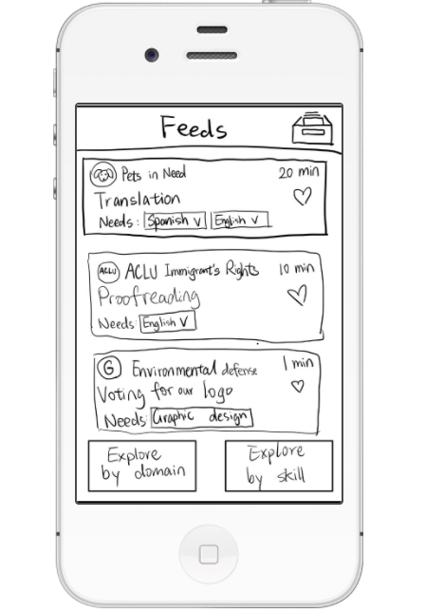
Greeting script
Hello [name]. Thanks so much for taking the time to test our app. Today you will be walking through our concept app Snippets. This is a very rough draft, so anything you see that shouldn’t be there or anything that feels awkward. Feel free to fully express yourself. Snippets is an app that allows people to do microvolunteering in their spare time. We will ask you to complete three tasks: Completing a snippet, Filtering tasks and saving a task to complete later. We will ask about your experience completing the task. Let’s get started!
Testing Procedures and Logs
Key Tasks To Performs

Task | Level
Complete a snippet | Easy
Filter based on skill/domain | Moderate
Save snippet for later | Complex

Usability Goals and Metrics

Usability Goal | Measurement Metric
Ease of use or efficiency | Number of clicks required to complete a task
Discoverability | How easy it is for users to find the tasks
Robustness | Low error rates

Procedure
We have prepared the prototype to be shown remotely to users. We will take pictures of our LowFi prototypes and connect them using marvel pop.

Log of Critical Incidents Interview #1

Task | Positives | Negatives/Improvements
Complete a snippet | - Very easy and intuitive to complete  - Easy to find tasks, understand what you need to do and complete them  - Quick and fun  - (No errors) | - Slightly confused about the “Next Page” vs “Save Progress” buttons (maybe we can differentiate them more
Filter | - Understood clearly how to select by skill and domain  - Also seemed very quick  - Likes that you can select multiple in the skill side  - (No errors) | - Would prefer the placement to be higher (not bottom)  - Prefers the style of the filter by domain (by skill looks less appealing/more web like)
Save snippet for later | - Likes the ability of saving tasks for later  - Once discovered, it was great to have easily accessible tasks  - Nice to see progress once you come back to saved  - Good to save from home page or snippet  - Several errors | - Confused about the difference between saved a liked  - The saved icon could be better  - Saved icon not in expected positioning (expects instagram chat function)  - Does not understand difference between heart in task and save progress in task

Log of Critical Incidents Interview #2

Task | Positives | Negatives/Improvements
Complete a snippet | - Clear and intuitive how to get a task  - Very easy to complete  - Enjoyed the “completed task” at the end  - (No errors) | - Also confused by save but much less so  - Would love a way to see which tasks were completed  - Would love to be able to sort tasks based on length
Filter | - Very easy to understand what each button does  - Flow is very short and straightforward  - Likes that the snippets reinforce the skills selected  - (Only 1 or 2 errors) | - Did not like the placement  - Did not see them at first  - Also preferred style of domain
Save snippet for later | - Understood where the saved tasks would be in the flow  - Appreciated the functionality and being able to see progress  - Several errors | - Confused about difference between liked and saved  - Did not expect saving a snippet from the feed to take them to the saved box  - Did not understand when they could save a task

Log of Critical Incidents Interview #3

Task | Positives | Negatives/Improvements
Complete a snippet | - The process of completing a snippet was intuitive and easy  - The feeds page was clear | - Proceeded to the archive (upper right corner icon) right away, thinking that was his personal profile and expecting to find everything there  - Questioned what would happen if multiple people were working on the same task at the same time
Filter | - Very easy to understand what each button does  - Flow is very short and straightforward  - Likes that the snippets reinforce the skills selected  - (No error) | - Asked how we would deal with tasks that couldn’t be done in the app, say in-person tasks
Save snippet for later | - Found it intuitive and straightforward  - Found it easy to do  - Told the difference between Like and Save without any difficulty | - The position of the archive made him think that it is a personal profile instead of an archive  - He wanted to have his skills and information stored in a personal profile page  - He wanted to chat with people from the NGOs in the app

Consent Form
This student team is interviewing and observing as part of the coursework for Computer Science course CS 147 at Stanford University. Participants provide data that is used to understand the possible opportunities of the design. Data may be collected by interview, observation and questionnaire.

Participation in this experiment is voluntary. Participants may withdraw themselves and their data at any time without fear of consequences. Concerns about the experiment may be discussed with the researchers (Yi Feng, Alejo Goldaraz, Touloupe Ogunremi) or with Professor James Landay, the instructor of CS 147:

James A. Landay
CS Department
Stanford University
650-498-8215
landay at cs.stanford.edu

Participant anonymity will be maintained by the separate storage of names from data. Data will only be identified by participant number. No identifying information about the participants will be available to anyone except the student researchers and their supervisors/teaching staff.

I hereby acknowledge that I have been given an opportunity to ask questions about the nature of the research and my participation in it. I give my consent to have data collected on my behavior and opinions in relation to the Philanthropy and Volunteering Snippets’ research. I also give permission for images or audio/video recordings of me being interviewed to be used in presentations or publications, as long as I am not personally identifiable in the images/video. I understand that I may withdraw my permission at any time.

Name ______________________________________________

Participant Number ____________________________________

Date _______________________________________________

Signature___________________________________________

Witness name ________________________________________

Witness signature_____________________________________

