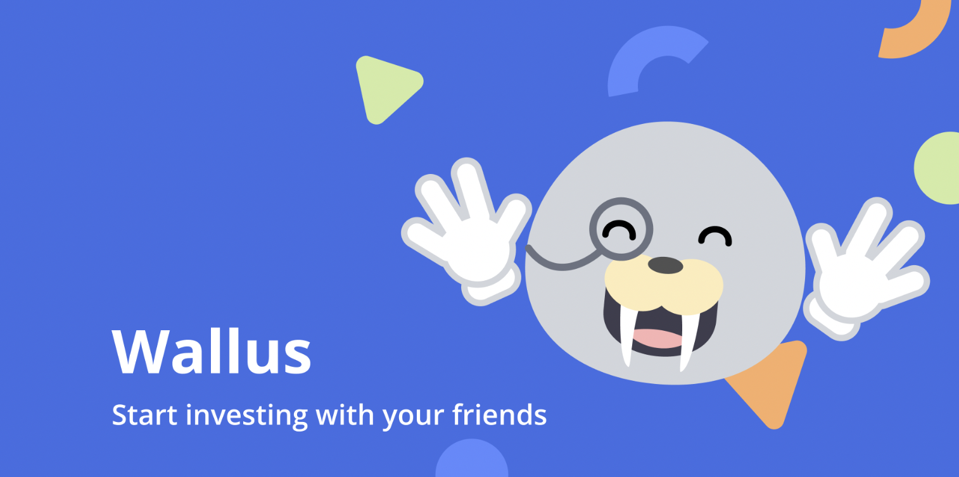

Final Report

CS 147 Autumn 2022
Madison Fan, Avika Patel, Juben Rana, Xinyi Wang

Stepping Through Time Studio

Table of Contents
 | Value Proposition & Team
 | Problem & Solution Overview
 | Needfinding
 | Point of Views & Experience Prototypes
 | Design Evolution
 | Final Prototype Implementation
 | Reflection & Next Steps

Value Proposition & Team

Value Proposition
Educate and support investment rookies to gain investment literacy.

Team Members & Roles
In general, all members participated in each part of the process. The following roles only suggest where one might have been more involved:

Madison Fan: Design ‘25, UI/UX Designer, Poster Designer
Avika Patel: CS ‘24, Presentation Lead, Pitch and Reporting
Juben Rana: CS ‘24, App Developer, Website Developer, Video Editor
Xinyi Wang: CS ‘24, App Developer, Video and Interviewee Liaison

Problem & Solution Overview
Investing in the stock market has numerous benefits including earning profits and saving money that exceeds inflation. Despite the importance and benefits of financial investments, people shy away from investing due to the lack of confidence, experience, and relevant knowledge. Wallus helps combat these barriers by encouraging investment rookies to grow investment knowledge through investing in stock choices with their friends. With in-app education, advice, and community support, individuals who are cautious of stocks can start their investing journey!

Needfinding
When we narrowed down our topic within the Stepping Through Time studio, we decided to focus on “financial literacy in the stock market,” knowledge that would allow users to take control of their futures.

Interview Participant Selection
Knowing that financial literacy is affected by a range of confounding factors, we determined three that stood out — Age, Income, and Independence — and intentionally chose interviewees that would give us insights into these target groups as shown in Figure 1 below.

Age:
Interviewee #1 (Child): “Penelope” a 12-year-old middle schooler who is not earning.
Interviewee #2 (Octogenarian): “Mary” a 81-year-old Chinese Paleontologist with a college-aged granddaughter.

Income:
Interviewee #3 (High): “Allison” a middle-aged Stanford Researcher.
Interviewee #4 (Lower): “James” a 19-year-old living alone with a high-school diploma.

Independence:
Interviewee #5 (Involved Parents): “Olivia” a 20-year-old with an MBA mom and investor dad who was taught investing from an early age.
Interviewee #6 (Uninvolved Parents): “Harrison” a 19-year-old self-taught investor who continued to build a coalition of high school economic clubs.

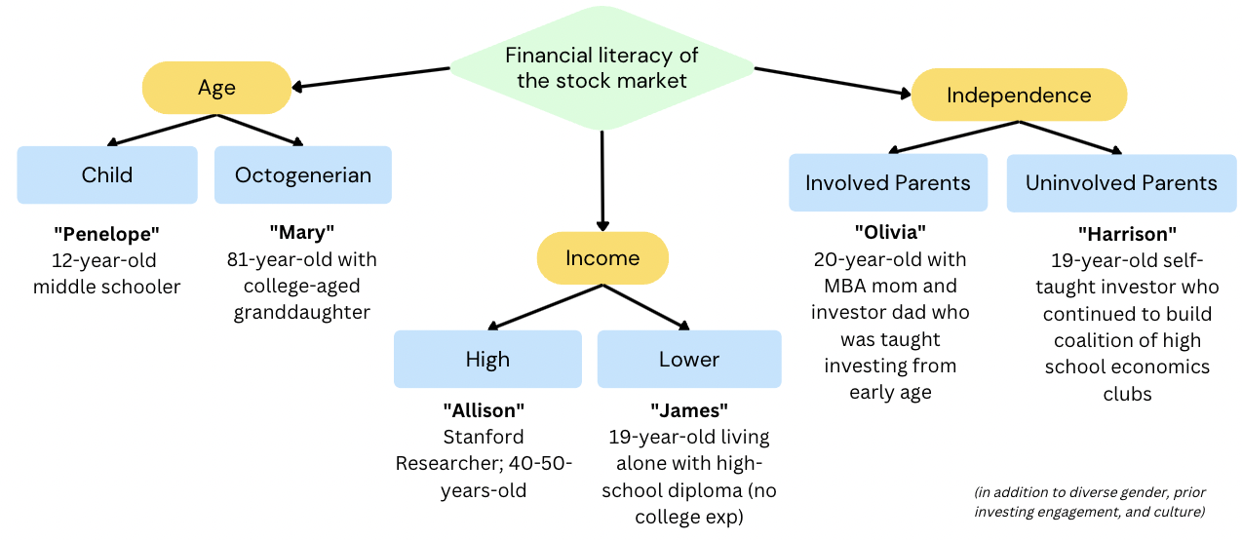
Figure 1. Shows the interview participant selection across the axis of Age, Income, and Independence when investing in the stock market.

After our initial set of 6 interviews and insights, we interviewed 3 additional individuals to supplement our findings for the individuals who are interested in personal investing but don’t because of various constraints.

Additional Interviews:
Interviewee #7: “Clare” a 29-year-old Meta SWE who doesn’t invest beyond corporate stock packages.
Interviewee #8: “Hazel” a recent college graduate working at Nvidia but doesn’t invest.
Interviewee #9: “Ryan” a 20-year-old pre-seed startup CTO on LOA from colelge.

Methodology
The interviewees were recruited from personal connection, cold emailing, and standing outside the Stanford Visitor’s Center. Each was compensated with appreciation and a promise to be updated through the quarter on our project. Finally, each interview (excluding Mary’s) was conducted in person. Some were audio or video recorded.

The main questions we asked include:
- How did you learn about personal finance? What was the process?
- Can you tell me about a time when you faced a challenge in investing?
- How do you, if at all, educate your kids on personal finance and investment?
- What are the reasons you invest or do not invest?
- How do people around your age and in your social circle make investment decisions? How are they similar or different from the choices you would make?

Results
We reviewed notes from each interview and relistened to recordings to compile notes from each interviewee. From there, we created individual Empathy Maps for each interviewee that documented the Say and Do from the content of the interviews. Using this information, we inferred insights into the Think and Feel of each interviewee that can help with finding a product need in the financial literacy space.

“Penelope” (Middle-schooler): Considers personal finance boring and irrelevant to someone who isn’t actively working to earn money.

“Mary” (81-year-old Chinese Paleontologist): Believes investing is convoluted, hard to understand for scholars, and difficult to keep up with compared to a “safer” bank option.

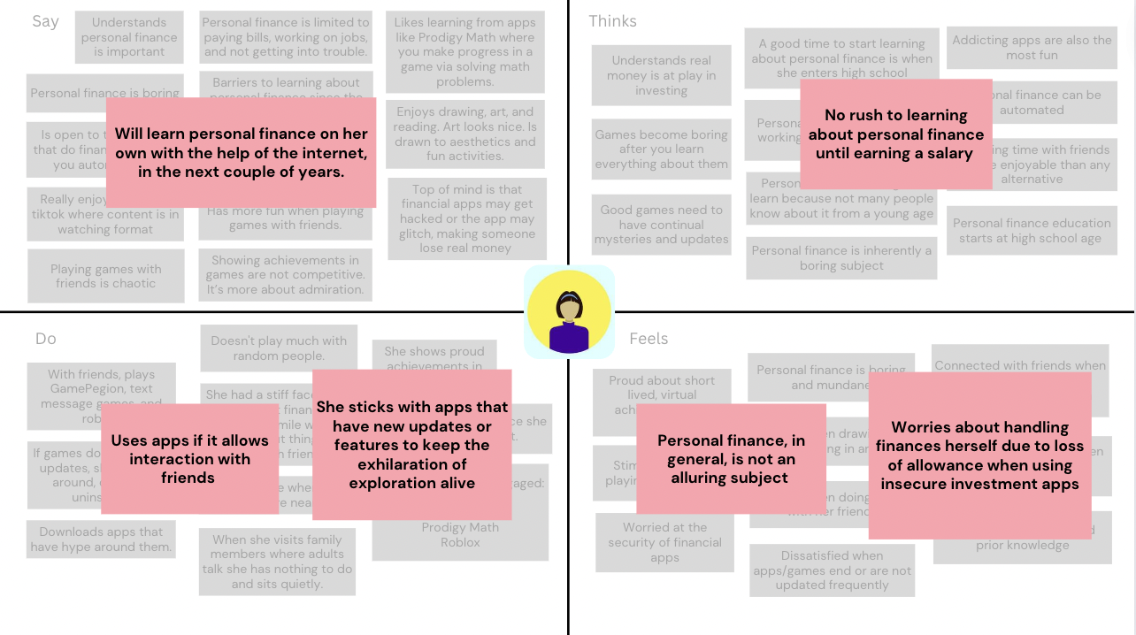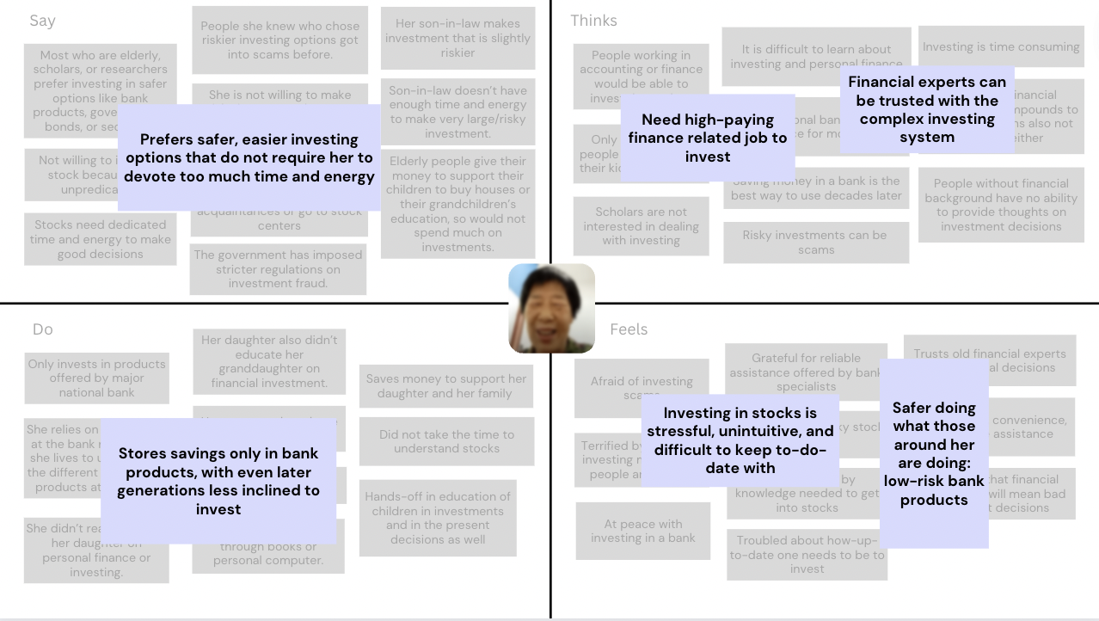
Figure 2 & 3. Empathy Maps for“Penelope” and “Mary”.

“Allison” (Stanford researcher): She needs to parse through a lot of information to make smart investment decisions — time that she doesn’t have with work and a family. Regarding introducing her kids, she doesn’t know how to introduce financial concepts to them without it seeming too adult.

“James” (High-school diploma and working): Believes investing is important but there is jargon that an average trader would never understand. Investing is complicated for a newbie who only wants to make a return without knowing the atomic complex details.

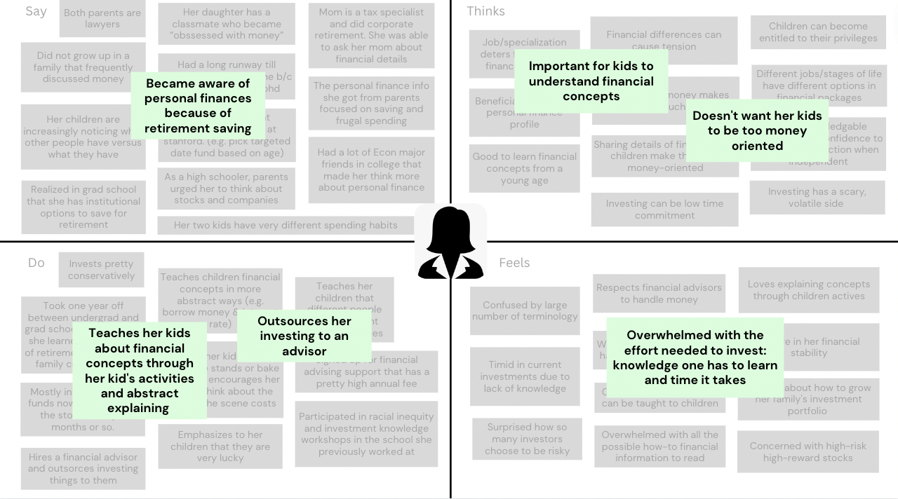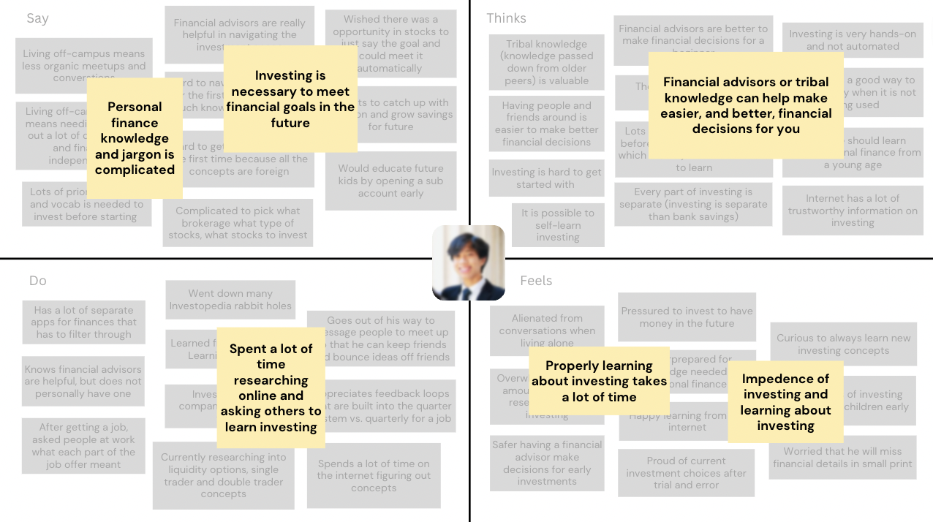
Figure 4 & 5. Empathy Maps for“Allison” and “James”.

“Olivia” (Berkeley ‘24 with experienced investor parents): Stocks are necessary to stay ahead of inflation, but easy to gamble with because they are intangible assets.

“Harrison” (Stanford ‘25 self-taught investor): It can be easy to start following the wrong advice and get pulled into schemes for unsafe investments. Learning to invest can come from the smallest things, even toys for little kids.

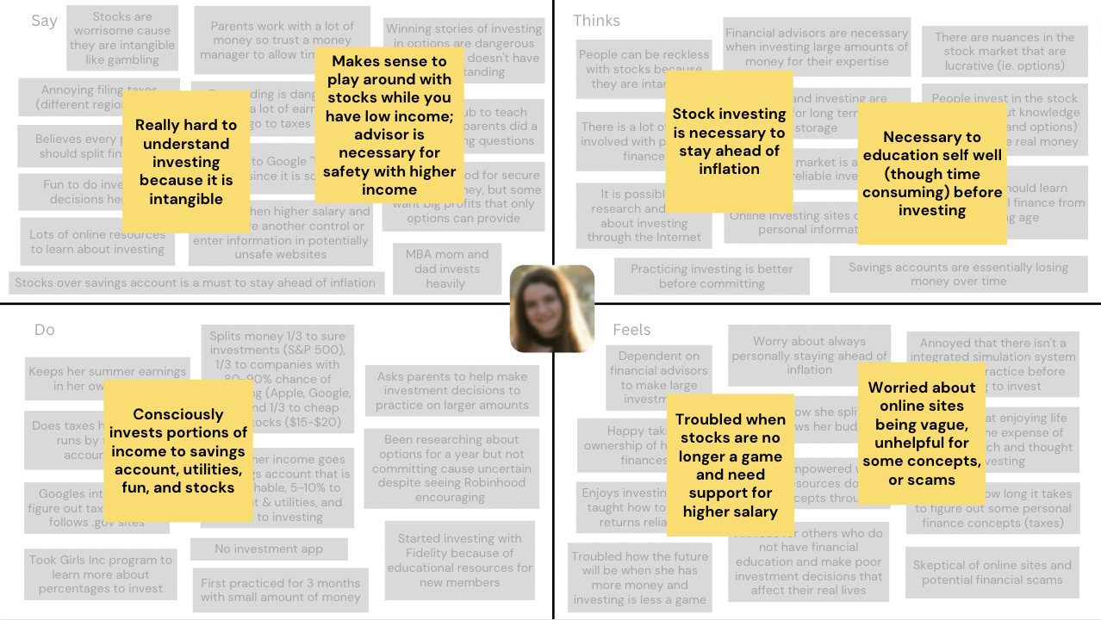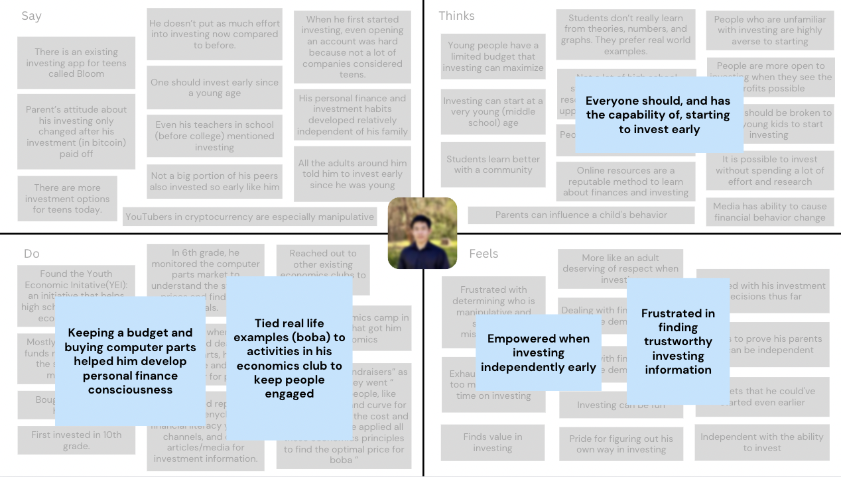
Figure 6 & 7. Empathy Maps for“Olivia” and “Harrison”.

“Clare” (29-year-old Meta SWE): Being in a circle of people who invest is a motivating factor for newbies to start investing themselves. People independently interested will be discouraged by the impression that investing is complicated and inaccessible.

“Hazel” (Stanford ‘22 working at Nvidia): Simulations with fake money can give false sense of confidence. Real investing is overwhelming to dive into alone without family.

“Ryan” (20-year-old pre-seed startup CTO): Finances and investing are boring, though important. Many inexperienced folks invest dangerously and don’t change unless someone close to them tells them otherwise.

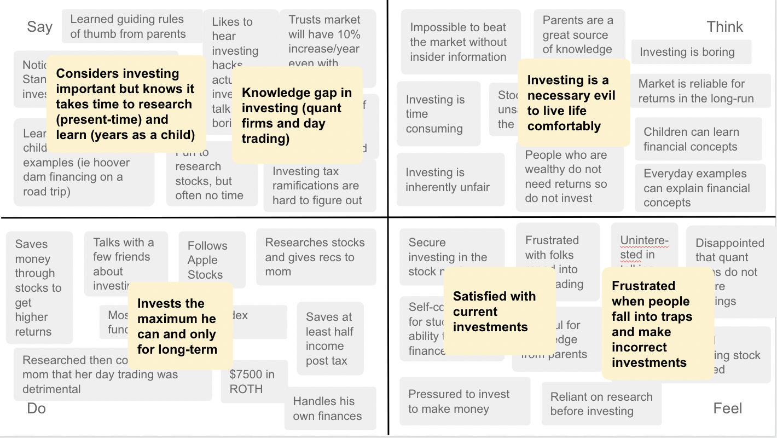
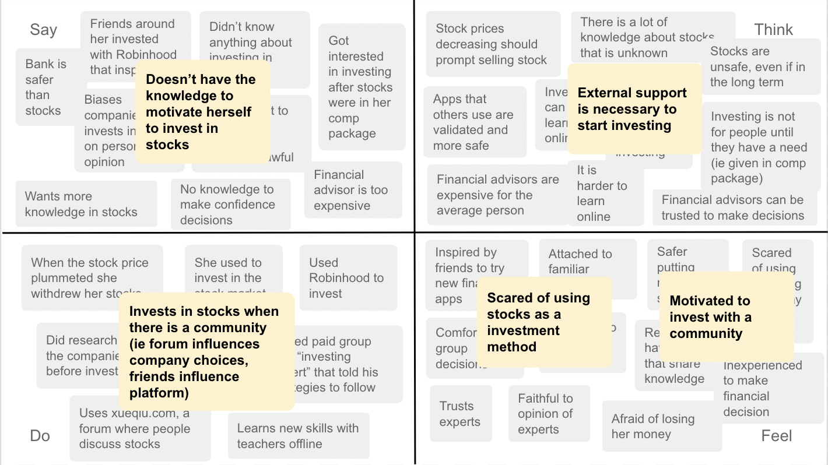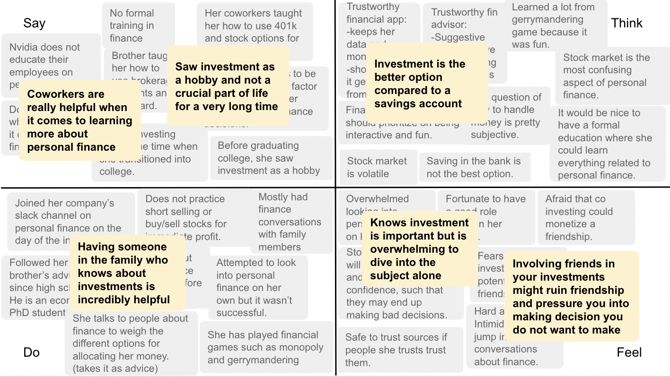

Figure 8,9, & 10. Empathy Maps for
“Clare,” “Hazel,” and “Ryan”.

Synthesis
After compiling the individual empathy maps, we looked deeper to analyze contradictions, tensions, and surprises that could provide insight to a gap in the current product landscape and where we can fit into.

Contradictions we found in interviews:
- Parents may not be supportive of teen investment until they see good results. New investors may not trust investing till they see good results.
- Parents want to teach children about finance concepts early but don’t want them to know too much about the “adult” details.
- For those who choose to keep money in savings accounts for safety in the future, they are actually losing in the long term because of inflation.
- People agree that it would be nice to have some place formal to learn everything related to personal finance, but don’t cross the activation energy to take a class or start searching themselves.

Tensions we found from interviewees:
- People are easily discouraged by unsuccessful investment stories in their social circle or the time it takes to learn about investing and the financial jargon.
- Younger children are less excited about personal finance because they have no income, despite early practice being necessary for a better future.
- Older people have trouble keeping up with investment trends and making sound decisions as the market might update without them knowing.
- Newbie investors get caught up in the excitement and gambling of day-trading, however they lose money to market fluctuations and trends. Long-term index funds are the move but most don’t realize that through the prevalent media.

Surprises that stood out to us:
- Some younger generation individuals learn personal finance independently from their parents.
- People’s willingness to invest (and even childhood habits) can be influenced by those around them.
- While students can make their own financial decisions and have fun being independent, higher salaries, complex income packages, and buddy lives means they inevitably need to find a trustworthy financial advisor.
- Being in a circle of people who invest is a motivating factor for newbies to start investing themselves.
- Having a person knowledgeable about investing in a group can eliminate the need for a financial advisor. Some individuals really do enjoy the process of researching and validating a good investment choice.
- Young adults and college students enjoy talking about finances with friends, though the topic doesn’t come up often.

Taking all these wide range of insights, we condensed into a final set of needs that we should solve for through our CS147 journey. Those key learnings are:
- Getting started investing in stocks is not just a literacy problem. There are plenty of resources, but there are constraints of time, support, and confidence that prevent people from starting to invest.
- It is empowering and fun to invest at a young age. However, people find it hard to keep up with, so they often choose to minimize investing later in life.
- Influencing folks to invest is as much a branding game as a product game. Things like (1) necessity of investing (2) building trust of an online platform (3) rewriting the mindset that investing is hard to start must be overcome.
- It is enjoyable to learn about finances from friends and social circles can influence investing behavior, however there are not many opportunities to.

Point of Views & Experience Prototypes
Using the interview synthesis, we came up with 3 POV statements to guide our brainstorming. We combine known user attributes and surprises to infer needs and insights for three interviewees in the statements.

Final 3 POVs & HMW Brainstorm
(1) “Penelope” POV
We met … Penelope, a middle schooler who is the youngest in a family of three children brought up in a household not very much into investments
We were surprised to notice … she thought personal finance is about paying bills, working jobs, and being an adult
We wonder if this means … she feels that personal finance is irrelevant to her
It would be game-changing to … make younger children more aware of the importance and relevance of personal finance

Key “Penelope” HMWs
- HMW make personal finance fun for kids?
- HMW include financial learning in the daily life of kids?
- How might we include children in parent’s personal finance decisions?
- HMW make parents *want* to teach their kids about personal finance?

(2) “Mary” POV
We met … Mary, an 81-year-old paleontologist who has a college year granddaughter
We were surprised to notice … that she prefers investing in bank products because the stock market is unpredictable, needs dedicated time to make good decisions, and hard to keep up to date
We wonder if this means … her lack of time for learning how to invest results in fear of investing
It would be game-changing to … make investing less daunting for people with no experience or relevant knowledge

Key “Mary” HMWs
- HMW clear people’s misconceptions about investing?
- HMW make investing require no experience?
- HMW increase people’s confidence in investing?
- HMW make investing low effort?

(3) “Olivia”
We met … Olivia, a 20-year-old college student with an MBA mom and investor dad who taught her who to invest in 6th grade
We were surprised to notice … she finds investing fun now but is worried about the future when she accumulates wealth and will have to let control over her personal finance go to a financial advisor
We wonder if this means … she finds investing increasingly worrisome as she accumulates wealth
It would be game-changing to … make people feel in control of their personal finance regardless of their income

Key “Olivia” HMWs
- HMW increase transparency in the investment process?
- HMW make investment feel like saving money in a bank?
- HMW eliminate the need for a financial advisor?
- HMW remove emotion from investing?

Final 3 HMWs
With a heat map voting system, we were able to finalize our final three HMW statements that would be used for solution brainstorming.
- HMW make investing low effort?
- HMW increase transparency in the investment process?
- HMW make investment feel like saving money in a bank?

Solution Brainstorming and Narrowing
For each of the three HMWs, we brainstormed solutions broadly. With a heat map voting system we separated each of the ideas that 3+ team members would be willing to work toward and put into a quantitative voting process. Each member ranked each idea on the axis of (1) Personal Interest (2) Novelty (3) Significant UI learning possibility and (4) Impact on a scale of 1-6. The top ideas were then discussed and finalized!

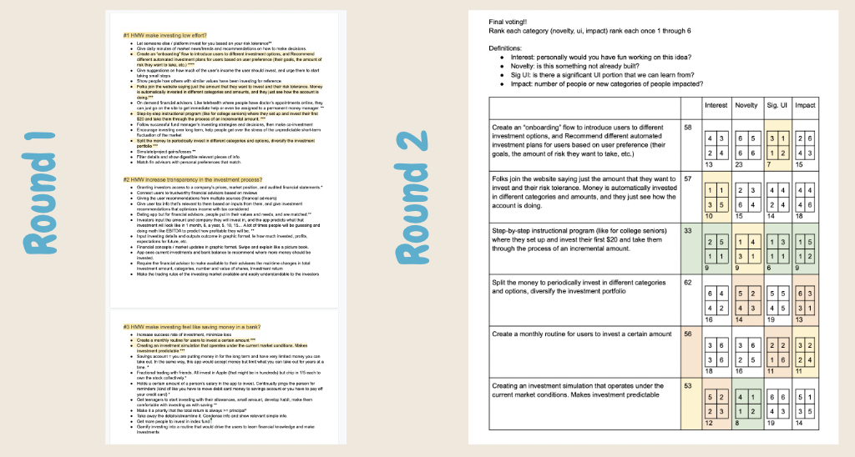
Figure 11. Show the two stages of the solution brainstorming and discussion
process to finalize our top three solutions.

Top 3 Solutions & Experience Prototypes
Through the process outlined above, we were able to reduce our options to three top solutions. For each of these, we brainstormed assumptions then plotted on an axis of unknown/known and vital/non-vital for user experience. The assumption that was most unknown and vital for user experience would be the assumption tested through an experience prototype. These experience prototypes were in-person tests to validate or invalidate our assumptions. If the assumption was verified, it could be a solution that we continue with building!

(1) Solution #1
Solution: Automate investing site for beginners: low effort required and all details taken care of.

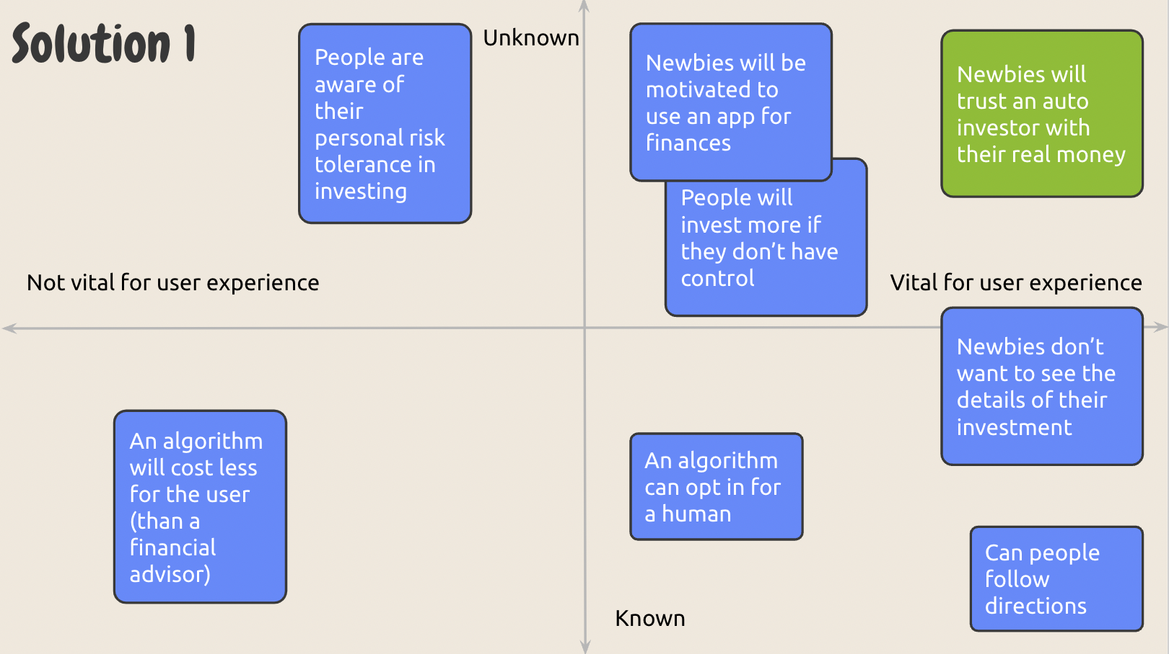
Figure 12. Plotting and choosing assumptions for Solution #1.

Assumption: Investment newbies will be willing to let go of control and trust a robo-advisor with their real money.

Experience Prototype: Tested whether people are comfortable giving up choice control by having a stranger getting food for them at a dining hall.

Set-up: One member of our team would approach people in the dining halls to be participants. The participant would share their dietary preferences and restrictions and the team member would bring back a personalized meal for them. The participant would share how they like the given selection, how accurate it is, and how they felt giving up control of something that has intimate, everyday relevance to individuals.

Results:
Things that didn’t go well
- Had to get the participant alternatives due to long lines; accidentally chose a food option the participant does not like but did not specify in his dietary preferences
New Learnings
- Participants expressed wish to maintain control over their choices for flexibility and autonomy
- Participants reported that they would not trust someone they didn’t know to get food for them
Insights
- People are not comfortable with handing control over something of personal importance to service providers they don’t know well
- When it comes to decisions that need to be tailored to suit individual preferences, people prefer the flexibility and autonomy that comes with making choices themselves

Summary: We are not moving forward with auto investing because building trust that people have for an auto investing platform is hard and will take a long time. Furthermore, our target users are people with misconceptions and mistrust about investing to begin.

(2) Solution #2
Solution: Step-by-step instructional program for students where they set up and invest their first $20 and take them through the process of an incremental amount.

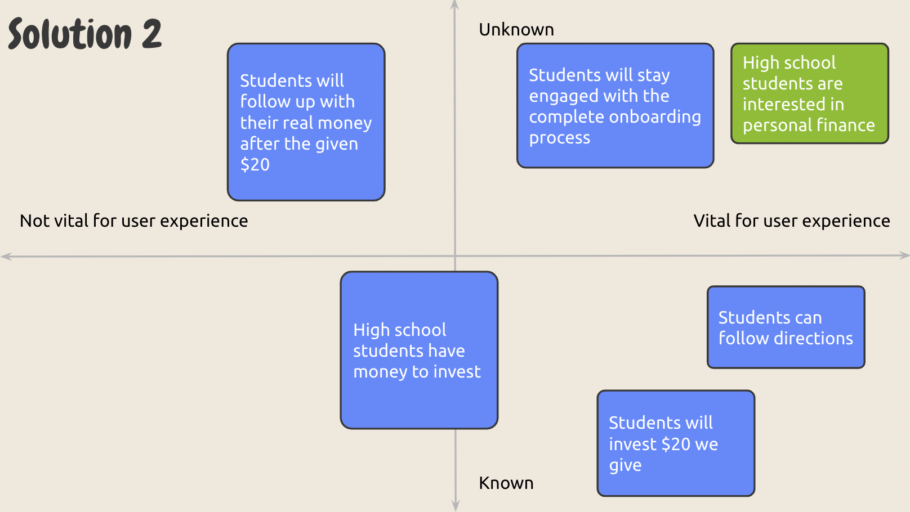
Figure 13. Plotting and choosing assumptions for Solution #2.

Assumption: High school students are interested in personal finance.

Experience Prototype: Tested if high school students would be interested in a personal finance investing club without being forced.

Set-up: We went to Palo Alto High School to collect sign-ups for a “Personal Finance Club.” We stood in 3 different places around campus (1) in-front of a classroom (2) in a communal outdoor space (3) loop where kids wait to get picked up. We spent time both just standing with the sign and allowing students to come up or directly asking passing students if they would be interested in joining the club.

Results:
Things that didn’t go well
- Stood for a total of ~20 minutes and asked ~50 people, but got only 2 signups
New Learnings
- Students passing were intrigued by the sign and stopped to read, before continuing again
- Students were kind, said “thank you,” and listened to my full sentence before rejecting the offer
- One student signed the paper because he heard me ask about personal finance and was already interested. Later he pulled our second sign-up by encouraging her that it's important.
- One student responded with “I don’t do my family’s finances”
Insights
- Students don’t have an interest in personal finance because there isn’t urgency
- When forced on students (asking them to join or through a class) without them knowing the subject of personal finance, students will not be interested
- If something is eye-catching even people unfamiliar will pause to look
- People will create new habits if encouraged by their friends

Summary: We are not moving forward with the educational program idea because it is hard to force a subject onto students who are not already interested in the topic.

(3) Solution #3
Solution: Investing with close friends and family.

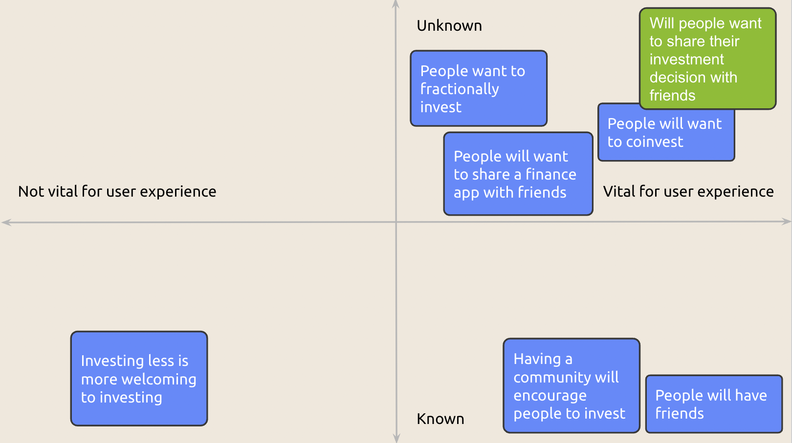
Figure 14. Plotting and choosing assumptions for Solution #3.

Assumption: People want to share their investment decisions with friends.

Experience Prototype: Tested if friends would be fully honest about the stocks they invest in even in an anonymous form.

Set-up: We sent out an anonymous google form to group chats that, on the first page, asks the participant to share their investment details. By filling out the form, they are sharing investing details with their friends (ie. the creators and senders of the form). We created two following pages that asked how much information the participant was initially hiding from us to see how transparent they are willing to be.

Results:
Things that didn’t go well
- Though most were transparent with the kinds of investments they were making, some did not want to share the specific stocks they invested.
New Learnings
- The information that people hid were mostly related to failed investments
- People preferred sharing in general terms

Insights
- People are comfortable sharing stocks and investing process in detail with friends

Summary: We will be moving on with this idea because the assumption was generally valid: folks are comfortable and willing to share investment decisions with close friends.

Design Evolution
The solution moving forward centered around investing with close friends & family to help support the transition for newbies into stocks. This is also where our name comes from! Wallus = wallet + us!

Final Solution
In the current world, each person has their own investment account and portfolio. This area is often excluded to people with prior knowledge or comfort, and conversation about investing is rarely brought up for those afraid of the current system.

Wallus changes this by making investing community-driven for the first time. Folks join the app through a friend’s invite where they can invest in the same stock. This can be expanded with in-app groups where everyone in the group owns the same stock, can chat about status, and see the progress of their investment together.

The second aspect of the app is education. As new investors are onboarded, the Walrus mascot is there to help explain concepts and simplify information. The app itself redesigns investing without trend graphs and numbers focused on less day-trading or gut decisions. For decisions along the way, Wallus is also embedded in the final solution with warnings and suggestions to new users that are just learning.

Rationale
To help guide our final decision, we took a great deal of inspiration from our interviews and experience prototypes.

Our main rationale for this solution is that getting started investing isn’t just a literacy problem, but also a branding problem. There are plenty of resources, but there are constraints of time, support, and confidence that prevent people from starting to invest. As a result, Wallus users can hop onto decisions of others with no time of their own. They also have the support of more experienced investors through the chat and also passively learning through their feed. As they engage, they can grow confidence in investing by seeing others/a community engaging along with conscious design choices that eliminate the traditional intimidating parts of investing. Having friends on the app, inviting, and sharing builds trust for a previously opaque process, and we hope that Wallus is that stepping stone for people to get comfortable with investing.

Below we can look further into the evidence for our solution decisions.

(1) From Interviews
We looked at the “Before” that we observed or interpreted in our Empathy Maps and built our “Wallus” solution to service these insights.
- Penelope
  - Before: Personal finance is about paying bills and working jobs
Wallus: Personal finance hold a community building purpose
  - Before: Games are engaging, especially when played with or as a competition with friends
Wallus: People collaborate and share portfolios, seeing progress together or against other groups
- Mary
  - Before: Could not keep up with trends as her children/grandchildren
Wallus: A group can be created across the family so younger generations choose the stock and older can automatically join decisions
  - Before: Considers banks the safest investment
Wallus: If friends are investing in stocks, it can seem more safe and approachable to do the same … plus we’re (wallet + us) giving bank vibes!
- Allison
  - Before: Investing in stocks is overwhelming and takes a lot of time
Wallus: Others can do the research and users join in as contributors
  - Before: There is a tough balance between sharing financial concepts with kids and making them “too adult”
Wallus: Owning stocks, fractional stocks, and investing are all much more accessible through a gamified community system
- James
  - Before: Lots of opaque information that makes it difficult to learn investing
Wallus: Only need one friend to send an invite and folks can join existing researched and learned investment choices with no effort of their own
  - Before: Wants something to input expected return over time and anatomical details are automatically figured out
Wallus: As little or as much investment decision as wanted!
- Olivia
  - Before: Worried about letting control go to a financial advisor
Wallus: Friends and close ones are the financial advisors. Compared to an external advisor, they are also putting money on the line so will make conscious and well-thought out decisions
  - Before: The idea that stock investing is necessary to beat inflation is not well-known to all
Wallus: Gamifying and making a community makes people want to invest, making them more receptive to acting when they also hear the why
- Harrison
  - Before: Tricky to navigate as a solo-learner
  - Wallus: Breaks down investing to the simple act of adding money. Decision making and research can come later with experience!
- Clare
  - Before: She followed onto others getting Robinhood and joined
Wallus: It is one thing to join a platform because others are, and actually knowing how to. Through Walrus, they would join because others invite them, but also know exactly where to commit
  - Before: Considers investing too complicated so doesn’t start
Wallus: The start to a habit here could be as small as $5 and trust in a friend! Joining in is simple and takes no thought
- Hazel
  - Before: Knows investment is important but hard to dive in alone
Wallus: Can do all investing with friends!
  - Before: Saw investment as a hobby and not crucial for a long time
Wallus: Can start the transition process of hobby → crucial earlier but having an app that people engage with at younger ages
- Ryan
  - Before: Mom dangerously day traded
Wallus: Since the portfolio is shared among many people, day trading is inherently discouraged and people join for long-term investing
  - Before: Considered investing a necessary evil for saving money
Wallus: Makes investing more enjoyable, and a end-in-itself instead of a means-to-end
  - Before: Knowledge gap in investing is very apparent
Wallus: Groups can be made with ranges of experience so knowledge is always shared and spread

(2) From Experience Prototypes
We looked at the “Observations” that we noticed during our tests and built our “Wallus” solution to service these insights.
- Experience Prototype 1
  - Observation: Participants do wish to have control of their choices for flexibility and autonomy
Wallus: Ultimately all investment choices are independent
  - Observation: Participants would not trust someone they didn’t know to make decisions
Wallus: All portfolios and investment decisions are made by friends.
- Experience Prototype 2
  - Observation: Students don’t have an interest in personal finance because no urgency
Wallus: Friend notifying and inviting them can create urgency
  - Observation: When the practice was forced without prior knowledge, students aren’t interested
Wallus: Joining is completely their decision and they would commit
  - Observation: If something is eye-catching, even people unfamiliar with finance will pause
Wallus: Gamification/community can catch the eye of those that don’t invest
  - Observation: People will create new habits if encouraged by their friends
Wallus: The platform only needs one friend that invests to encourage others!
- Experience Prototype 3
  - Observation: People were transparent with what kinds of investments they were making
Wallus: The premise of the app will work!
  - Observation: The information people hid were mostly failed investments
Wallus: Failing together (which is inevitable sometimes) is less embarrassing
  - Observation: Majority don’t invest despite knowing the practice
Wallus: Enough catalyst to get the rest of their friends investing
  - Observation: The best investment knowledge is not known by all
Wallus: Investing independently is dangerous and will bring less returns, thus investing as a group can spread/enhance knowledge
  - Observation: If someone is pointed out hiding something, they will own up and truthful share
Wallus: The more the platform is used, the more open people will be
  - Observation: People will own similar stocks, but not all are universal
Wallus: There are a lot of similarities that mean people can co-own stocks

Tasks
Simple: Accept an invitation from a friend to join an existing investment group.
This task is essential to the user base because it is what brings them to the app and how they stay engaged with the group feature. Through an invite from another friend, the individual would join the app and accept to be a part of a group to start learning to invest. Since community is the main goal of the app, the in-app groups must work and people should be able to seamlessly join.

Moderate: Create a new investment group and invite your friends to join.
This task is important to the user base because that is how they would be able to engage in the community aspect. Without the ability to invite friends, each user would be investing alone. Thus, having this flow built out is very important.

Final: Use in-app resources to learn about the market and invest in an index fund recommended by Wallus.
This task is important as a user gets more experienced with investing and is ready to start making new investments. The Markets tab is more known to experienced investors, so could be overwhelming to new users. We hope to make this flow seamless so beginner investors can onboard, understand, and engage in the flow easily and start their own investment group through this.

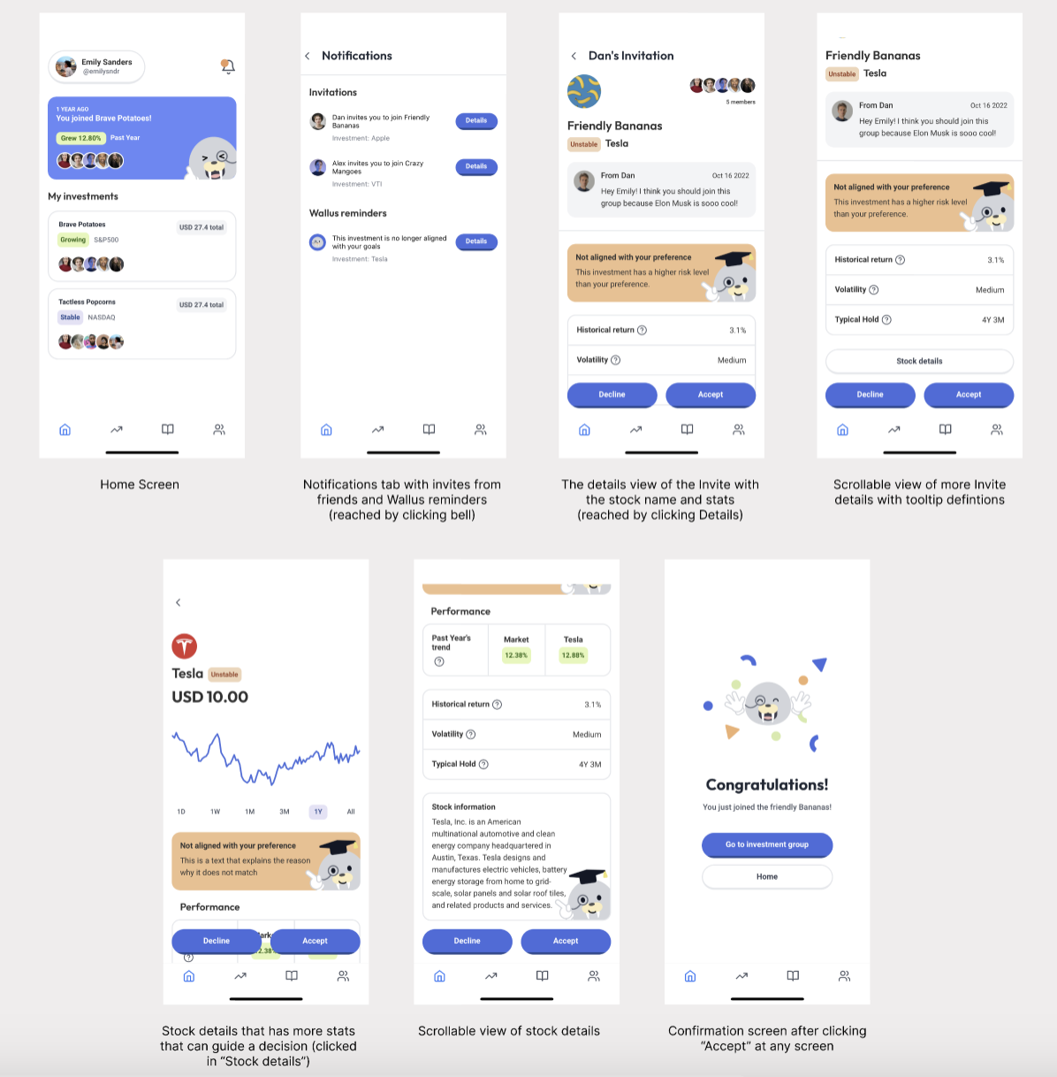
Flow 1. This is the annotated flow of Task 1 (accept an invite) screenshotted from the Wallus high-fidelity app prototype
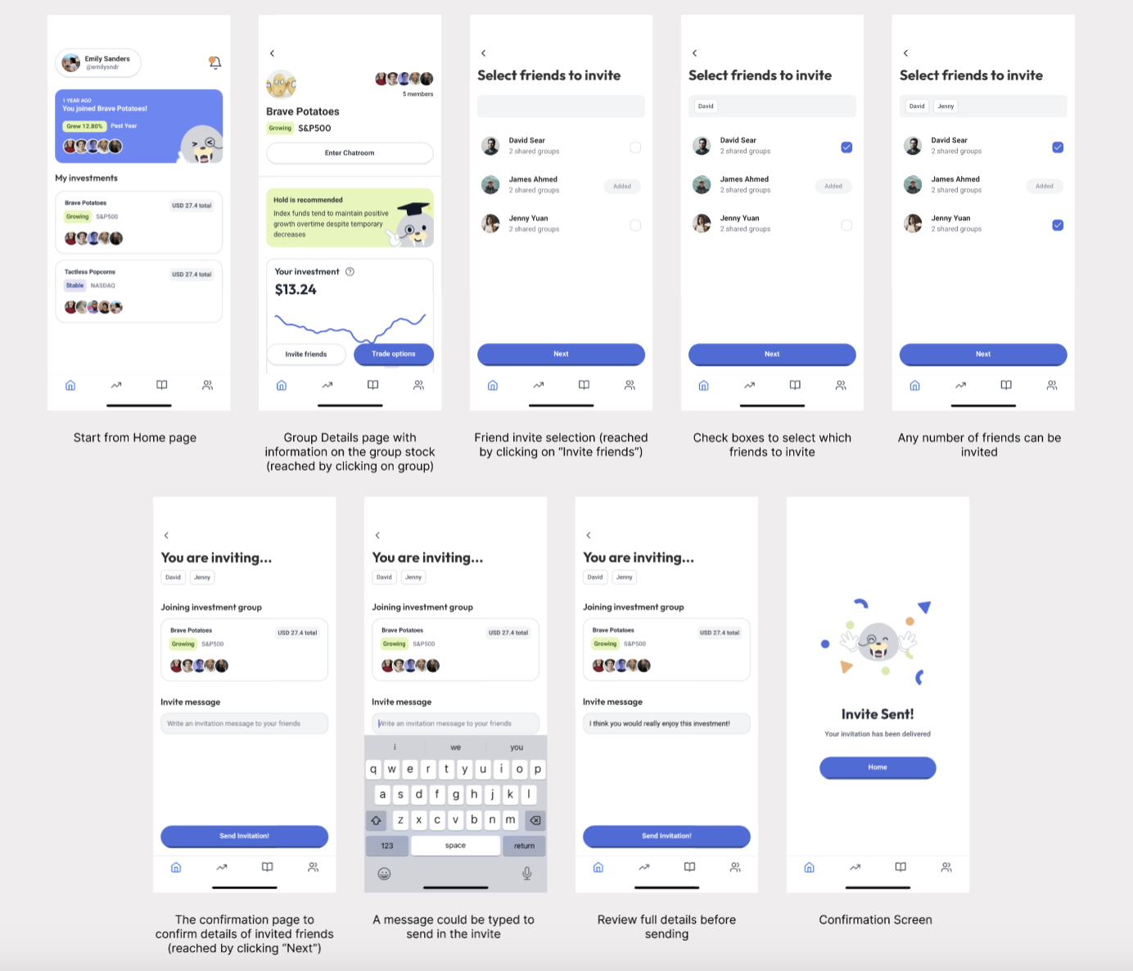
Flow 2. This is the annotated flow of Task 2 (send an invite) screenshotted from the Wallus high-fidelity app prototype

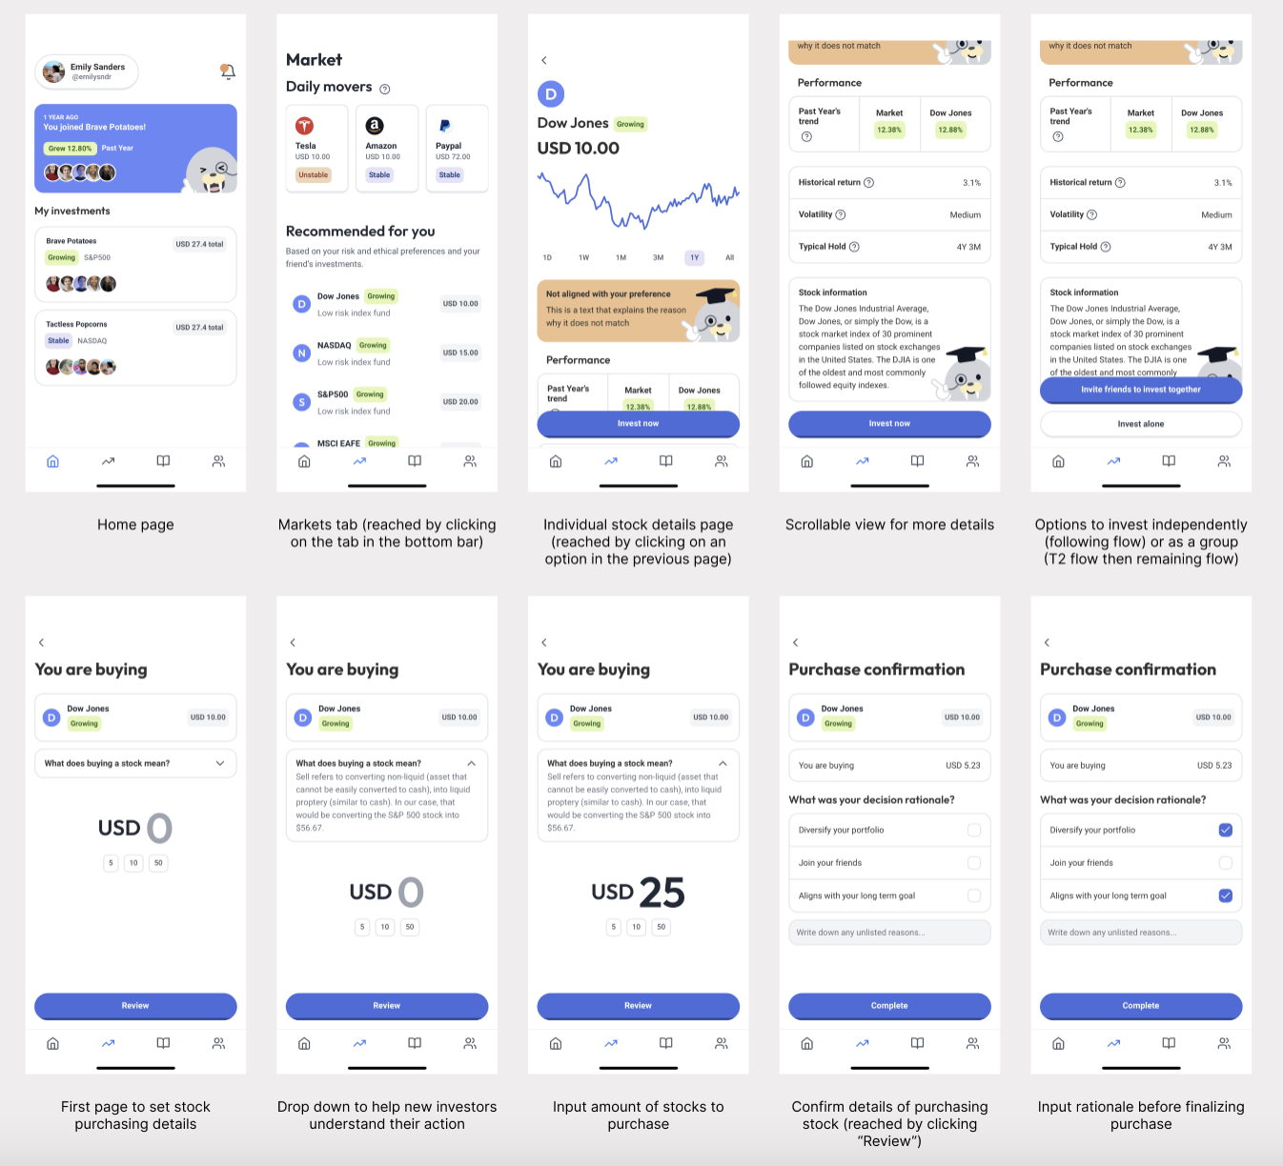
Flow 3. This is the annotated flow of Task 3 (learn and purchase a stock from the market) screenshotted from the Wallus high-fidelity app prototype

Design evolution
Low-Fi Prototype
Our first step of the design process was building the low-fi prototype. Our low-fi prototype was a drawn and printed realization of the app that could test the task flows and quickly iterate designs.
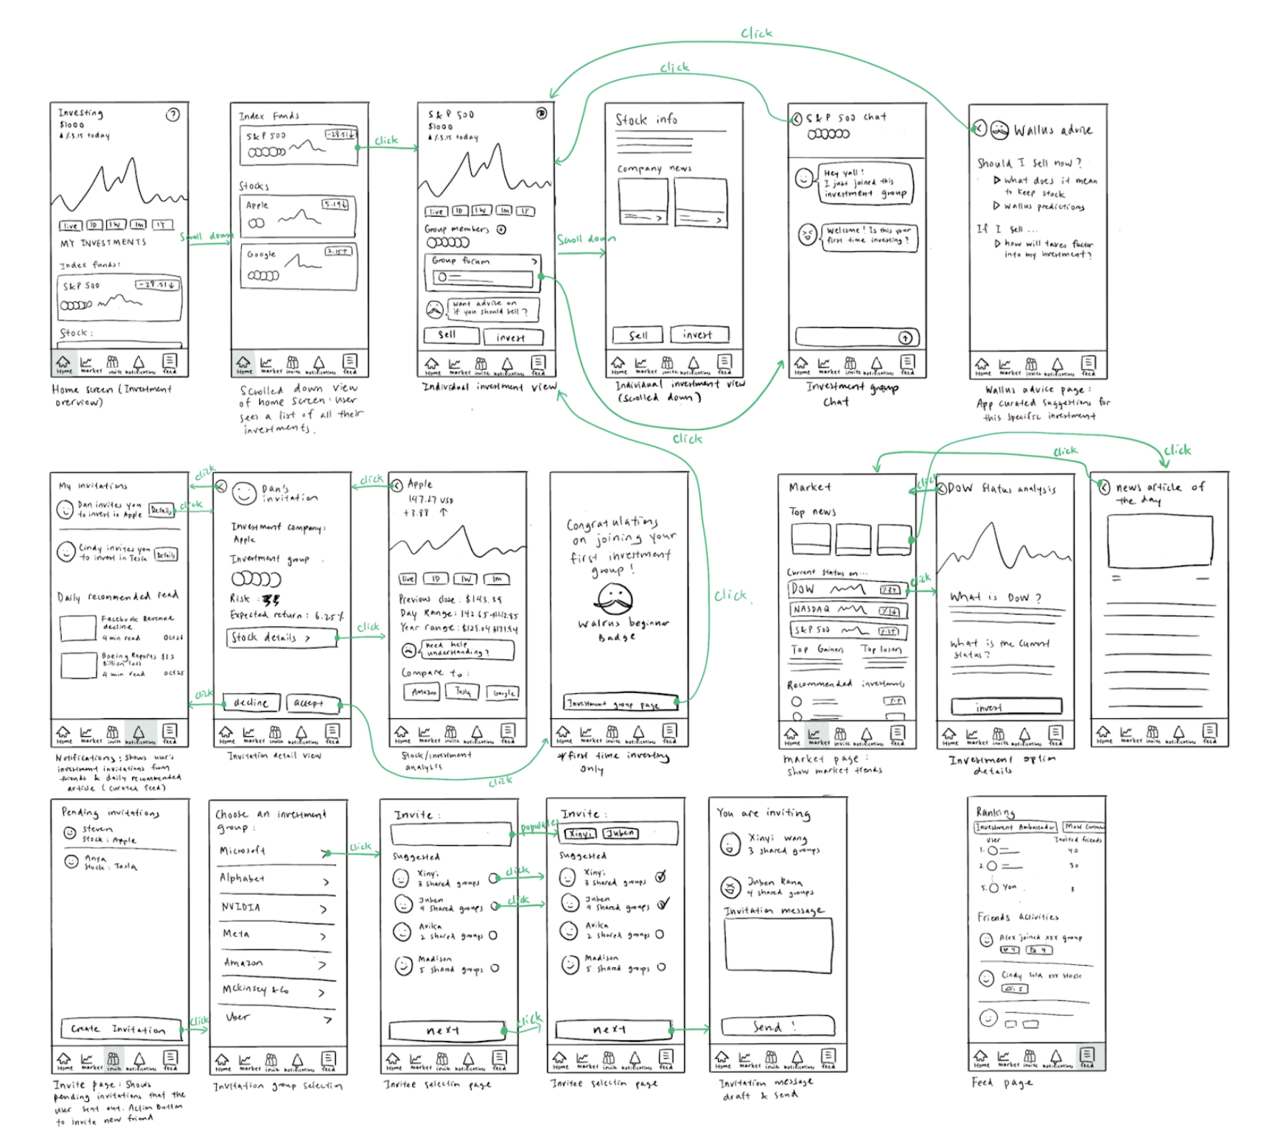
Figure 15. Low-fi prototype full system

The simple task of accepting an invitation looked like the image below. It is notable that we have a great deal of design that is similar to a traditional investment app (daily recommended news, stock comparisons, and charts).

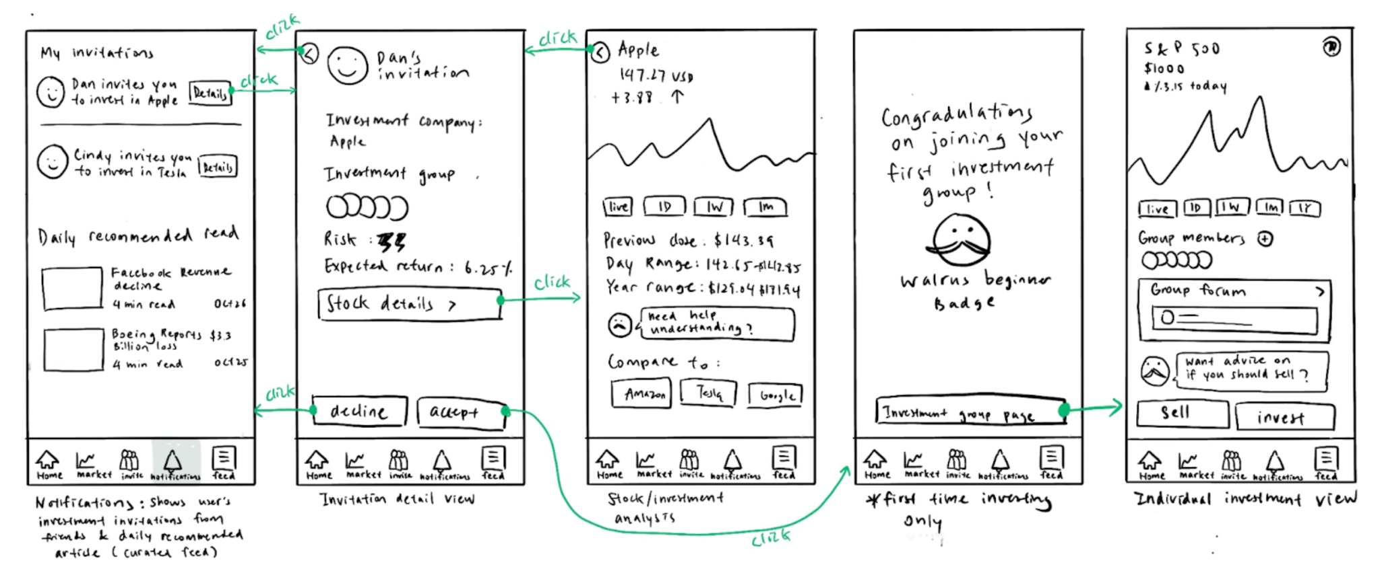
Figure 16. Low-fi prototype of Task 1 (simple task)

The second flow to send an invite is shown below. It is a simple flow of selecting a stock and friends to invite to send.

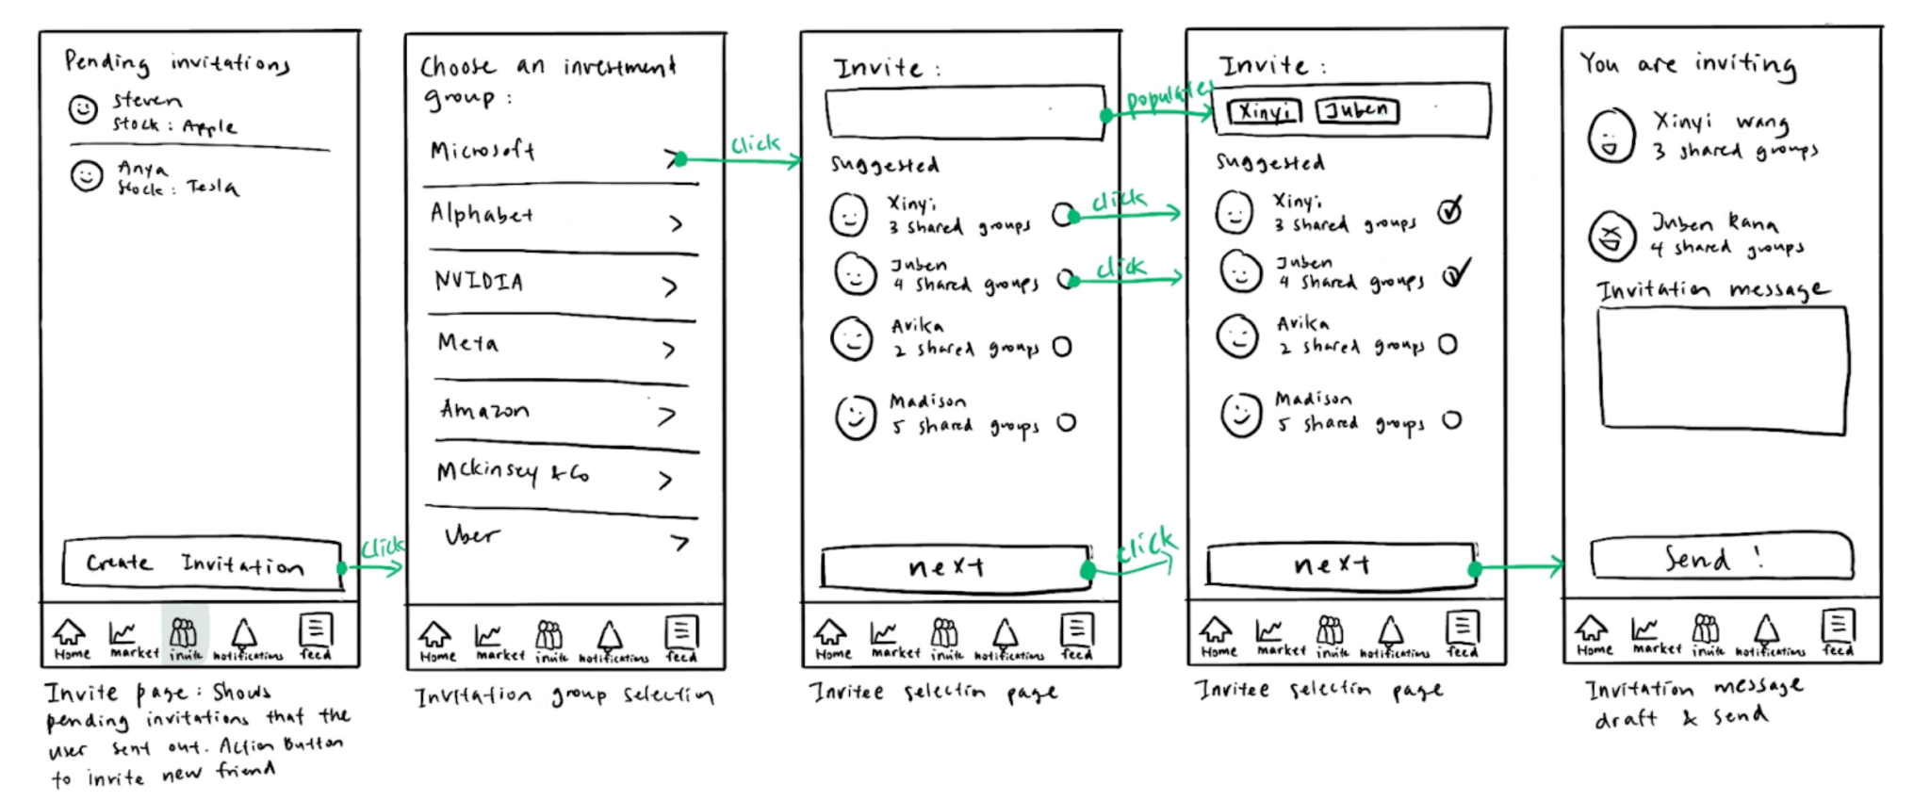
Figure 17. Low-fi prototype of Task 2 (moderate task)

Finally, we designed the complex task. Notable here is we anticipated the complex task to only be 2 screens: clicking into the market tab and into a specific stock. This was because the brunt of the complexity would come from understanding the page and navigating. As a result, future design iterations will also focus on the content of Market!

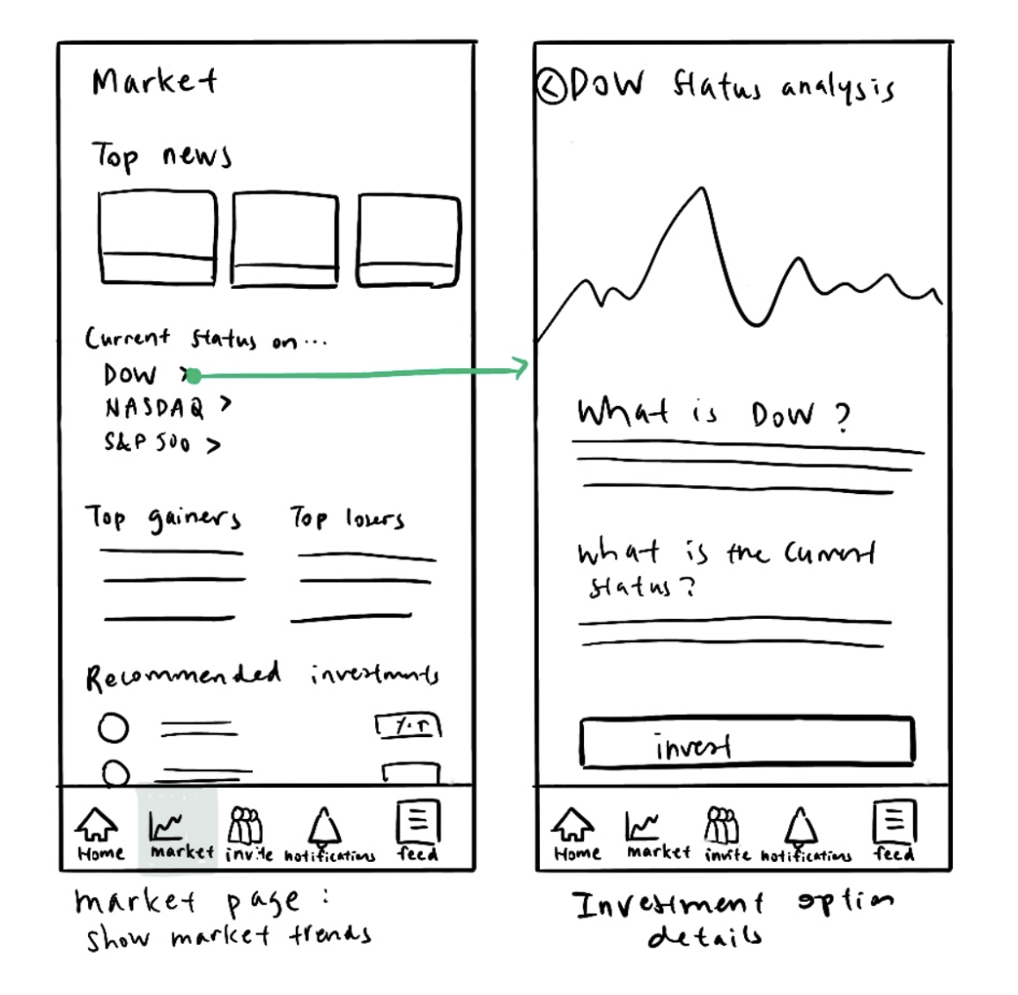
Figure 18. Low-fi prototype of Task 3 (complex task)

Usability Testing
In order to evaluate the design of our low-fi prototype, we organized a set of usability tests. We located ourselves in Main quad with a paper printout of the low-fi designs. Participants (strangers visiting the campus) were asked to click through pages as we switched pages to give the experience of playing with a real app. Features like a sticky note chat, check marks to place on invite screens, and a disappearing notification bubble sticker helped to make a more realistic experience to the prototype.

We observed the interactions of the users to evaluate the effectiveness of our design. The first metric we used to evaluate was Approachable. This goal was tested as how users were able to understand the interface and find out what it meant through their verbal feedback. The second goal we evaluated was Intuitiveness by recording process time of all task steps.

Some of the key things we learned
- Task 1 (accept invitation)
  - It was unintuitive to have daily recommended reading on the same page as the invitations the user is receiving.
  - People were hesitant to accept an invitation without complete information, even if the investment was a fake situation.
  - People wanted to do certain actions on subpages. There were too many click-ins each with a different set of actions so it was difficult for users to find what they were interested in.
- Task 2 (send invitation)
  - Confusing wording whether the invitations here are invitations that the user is receiving or sent out
  - A more personal/intimate group name than company name
- Task 3 (learn about market)
  - Not all users knew what to look at when seeing the “Market” Tab
  - Wish to be able to compare with other investment options cause newbies have no idea what they are getting into

This led us to determining our biggest UI changes:
- Task 1 (accept invite)
  - Changing the wording of “pending invitation”
  - Allowing users to give investment group names
  - Erring on the side of more information by including risk, industry, amount compared to the current portfolio, etc
- Task 2 (send invitation)
  - Remove daily recommended read section
  - Give more info on how user’s friend(s) have committed
  - Provide more info on how the new investment fits into user’s portfolio
  - Allow users to accept or decline request in stock details view
- Task 3 (learn about market)
  - Show comparing options in stock detail page
  - Provide additional explainers on what each section means
  - Redesigning the Markets page to focus on “Featured” with a short explanation

Analyzing along the usability goals:
- Goal 1: Approachable
  - Users with less experience had trouble understanding the market page
  - Users erred on the side of having more information to feel comfortable with the investment choice they were making
- Goal 2: Intuitive
- Users generally figured out how to complete tasks in short time
- Users wished they had the flexibility to do an action without having to navigate back and forth

This led us to determining additional large UI changes:
- Goal 1: Approachable
- Commitment to adding “?” to explain the basic what and how of all features
- Adding faces of group members at all possible locations (incl Create Invite)
- Creating a Community tab that will help emphasize the friendliness of investing
- Goal 2: Intuitive
- Reduced the number of pages to 4 common actions by a user
- Add search page for users, concepts, groups not easily found by user in the app
- Include tutorials only near features (not as a library in Markets tab)

However, we are very aware of the limitations of the usability test.
- The test was done in black and white. Color could be a big reason people focus on and click different features than they might have with us.
- We asked the user what tasks to complete and thus could use context clues to pick the option that seems right. However, in a world where the user gets the app themselves, this test was not able to reveal if the purpose of features is intuitive.
- This test started with human-to-human connection. Oftentimes, people will be kinder and more patient if they see a human connection. Perhaps if this test was done without a person initiating the conversation, then we could see more frustrations and rage clicks.

Our next set of designs is shown below, incorporating much of the feedback listed above. Going forward, prototypes will be designed in color and higher intractability.

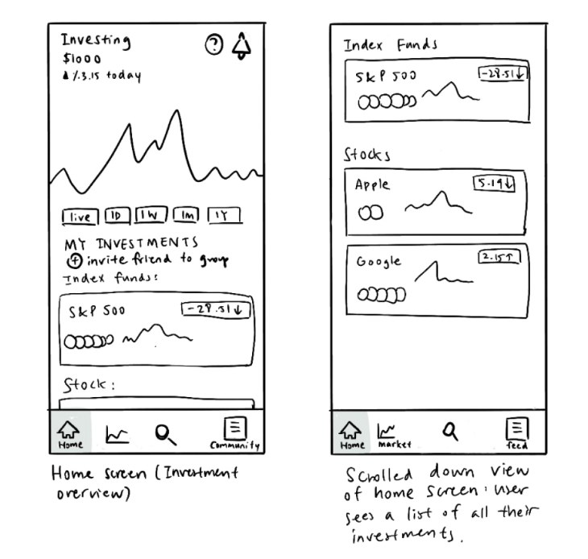

Figure 19. Redesigning Home to show the overall portfolio, investment groups, and large CTA to invite a friend to a group.

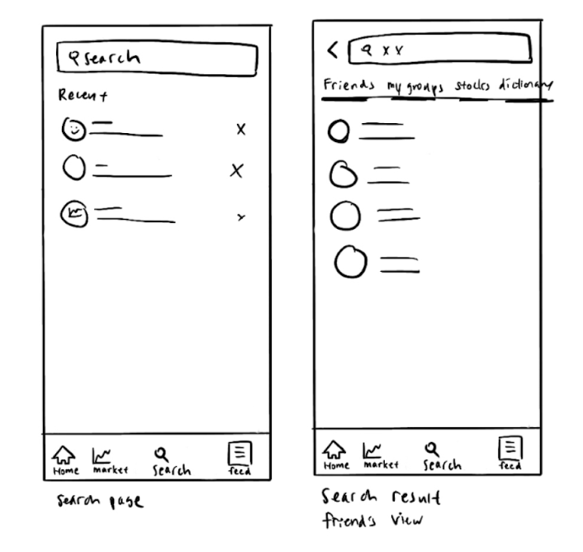

Figure 20. Designing Search with Friend’s profile, the groups the user is in, stock research, and an investment dictionary.

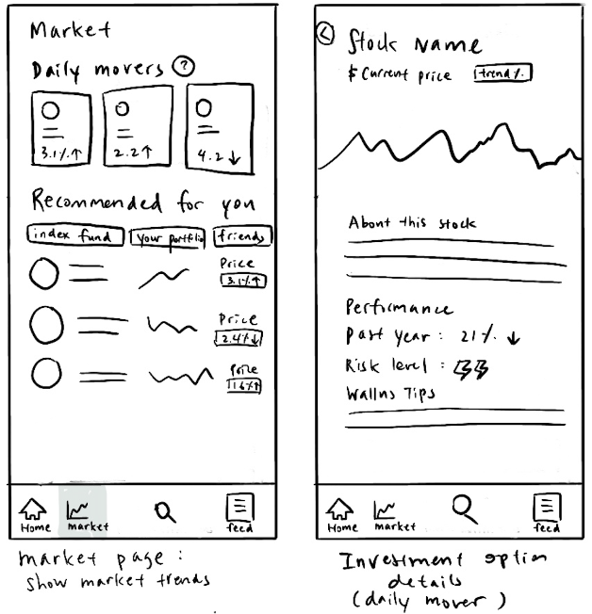

Figure 21. Redesigning Market to be more recommendation driven with featured investments from index funds, friends, and personal preferences. The only other information kept is daily market tops.

Medium-Fi Prototype
Given our feedback and designs, we hoped to our next stage of the design process: Medium-Fi Prototypes! Our low-fi prototype was a digitized version of our realizations on Figma with screens connected to allow interaction in the simulation view.

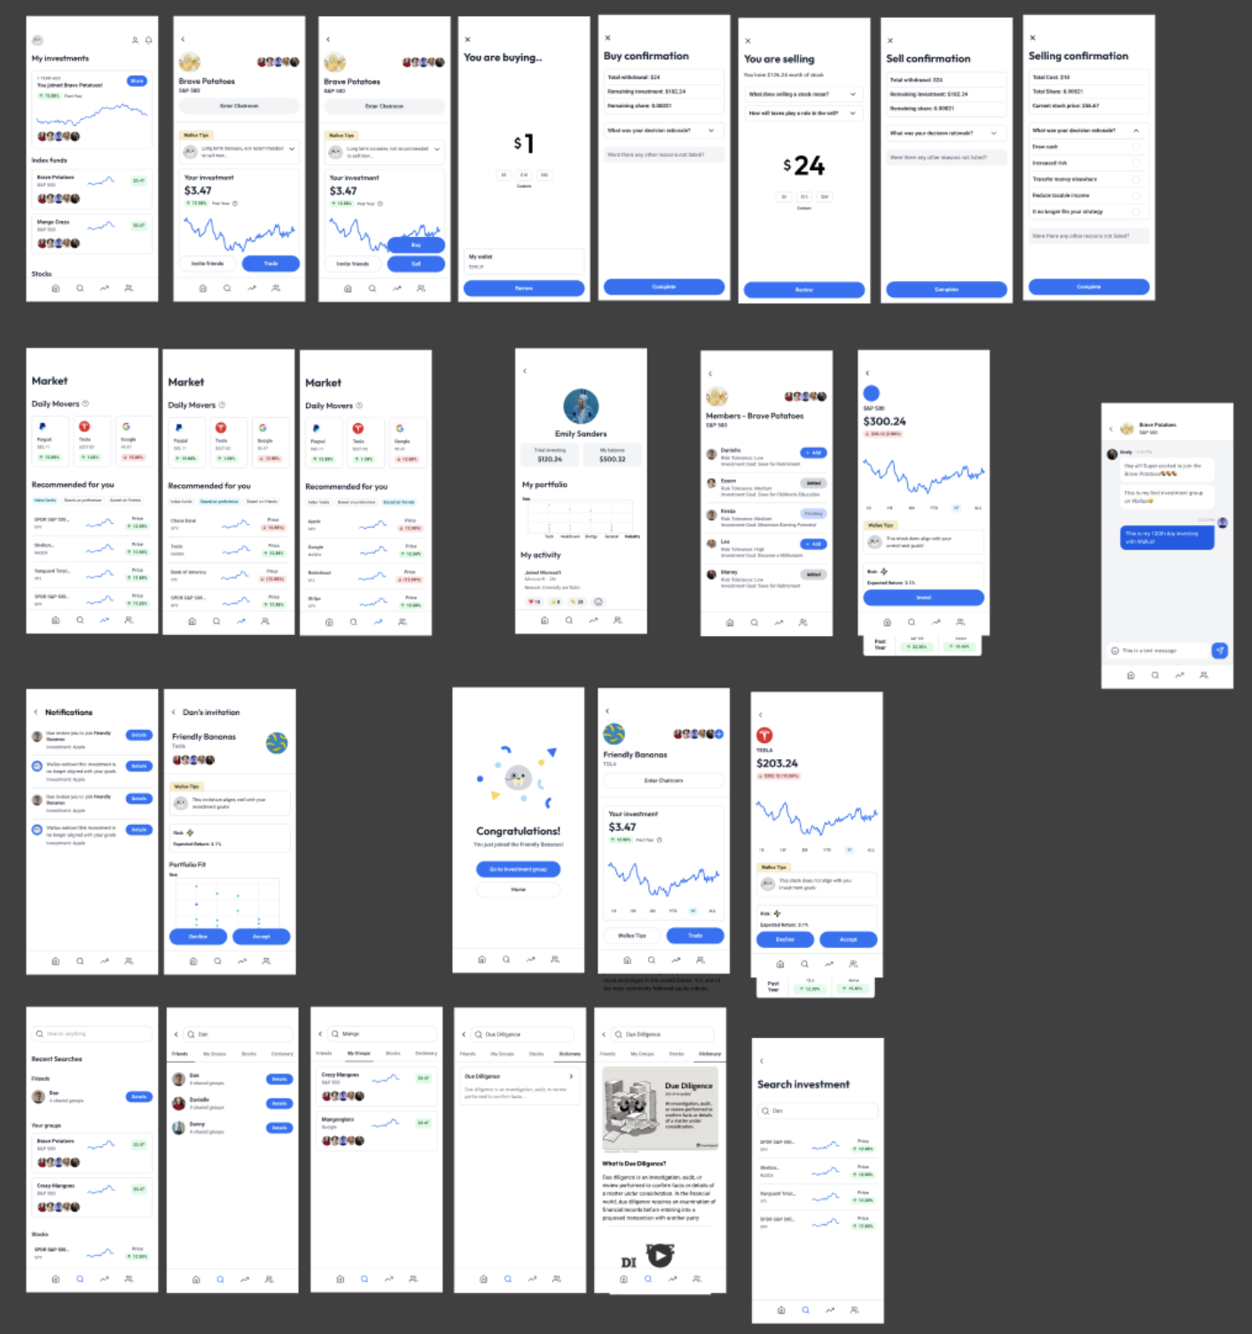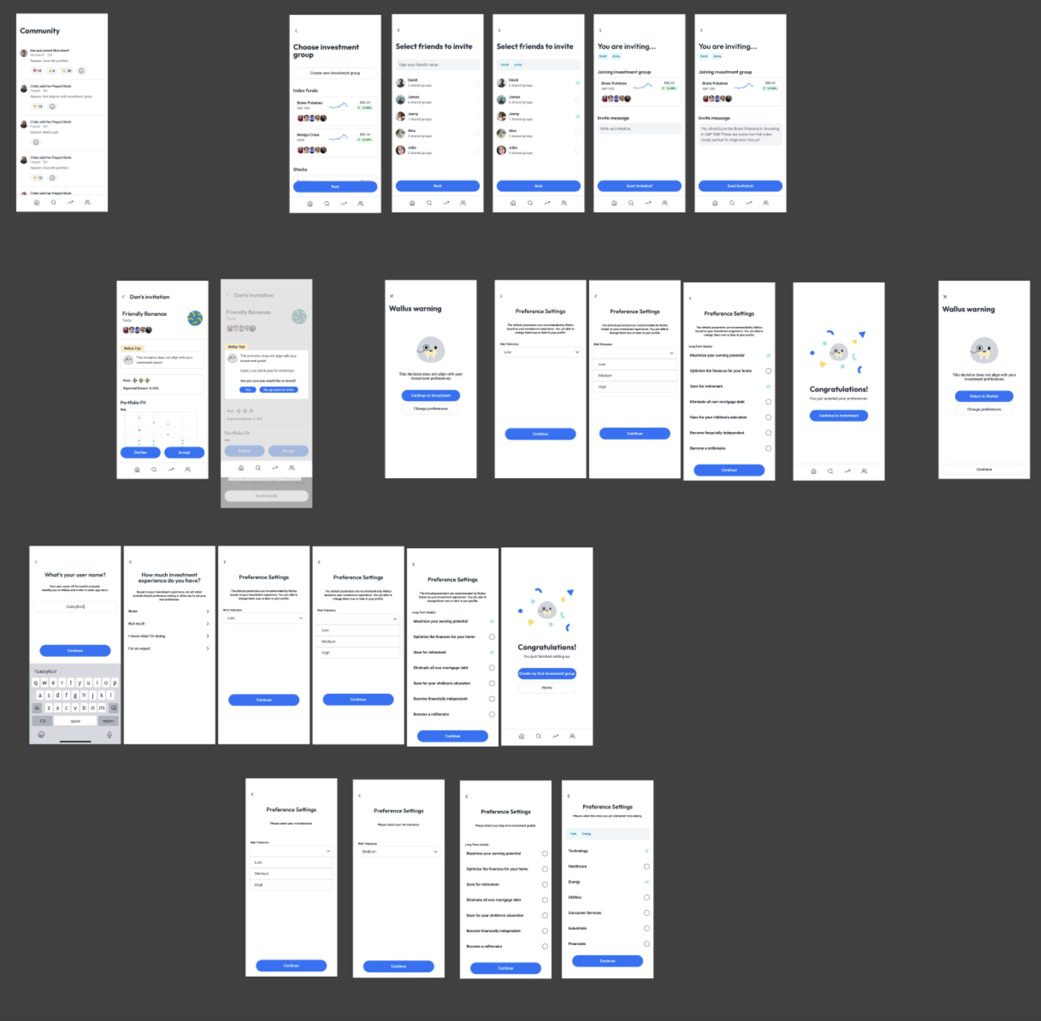
Figure 22. Medium-Fi prototype on Figma

To help quickly prototype, we built out a design system of color, typography, and components that could be copied across our design and anticipate coding later.

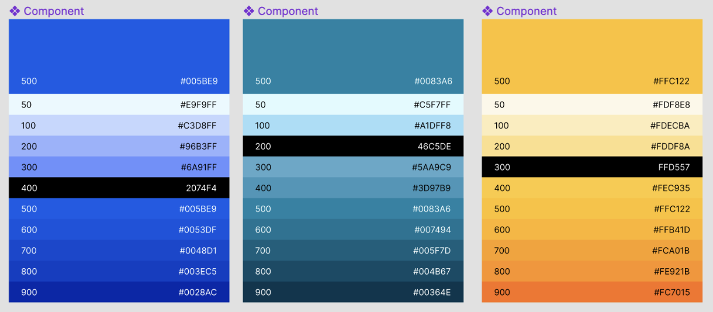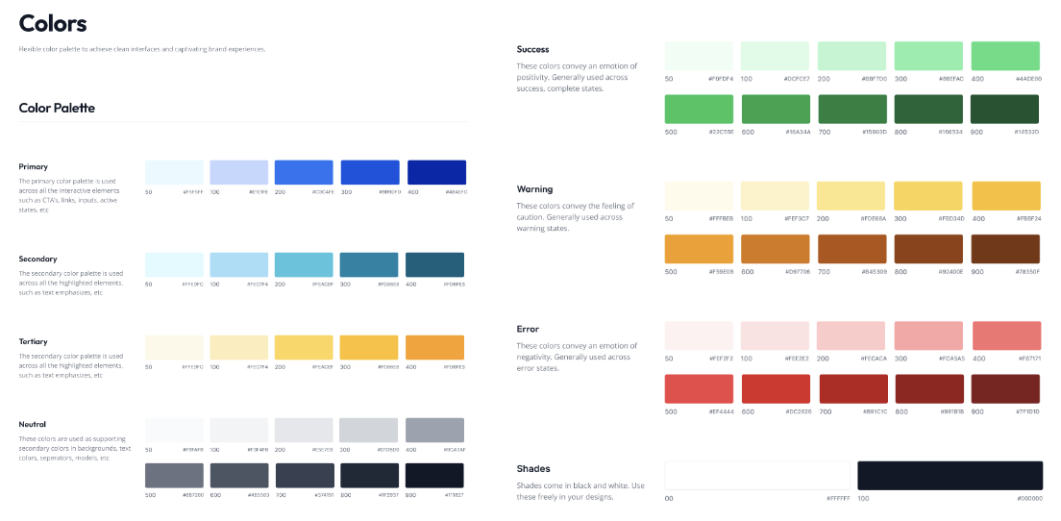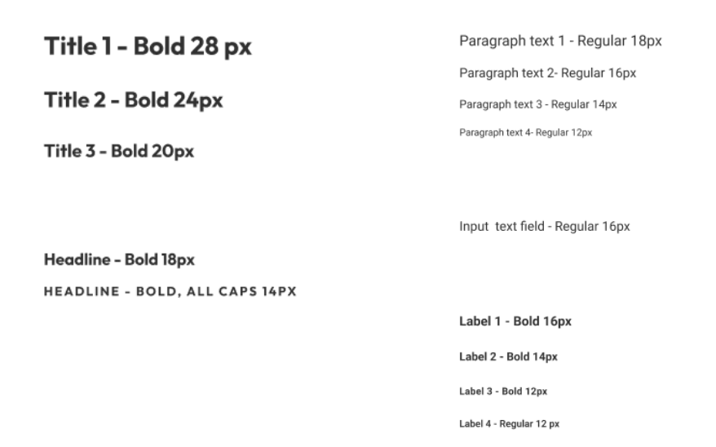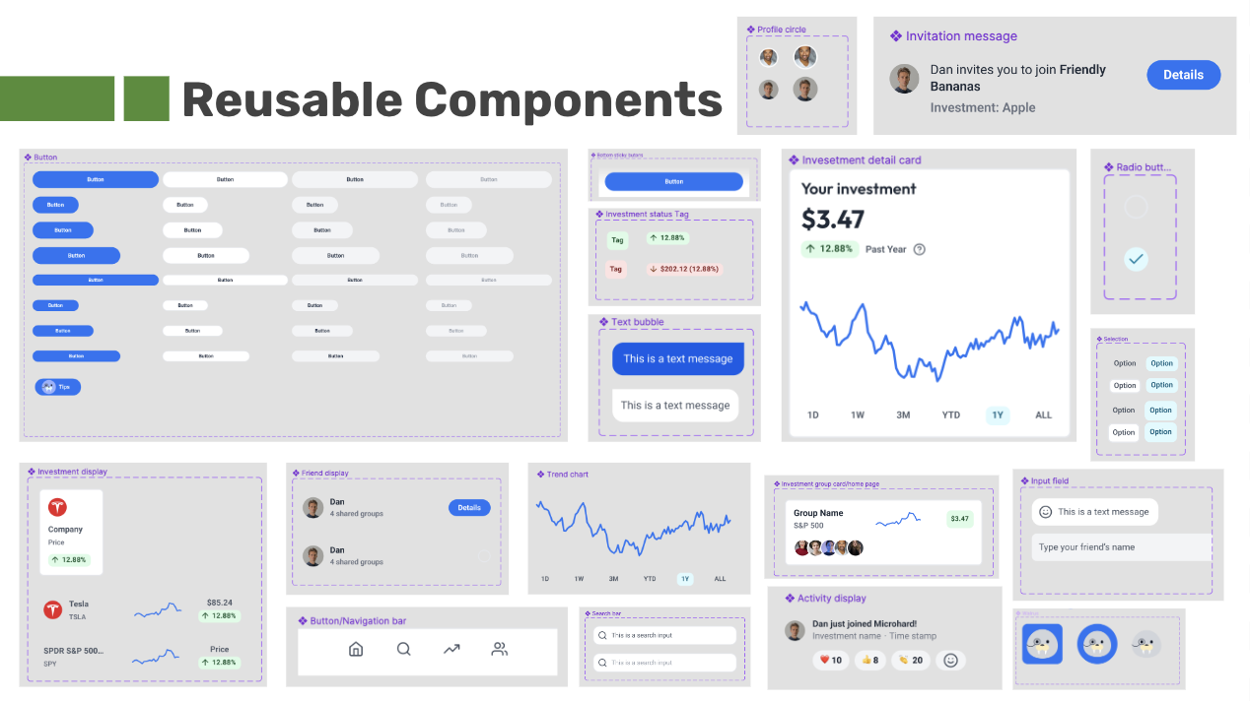
Figure 23. The design system built out in Figma that included colors, typography and commonly used components that could help build the screens.

Below is each of the three flows annotated in our medium-fi.

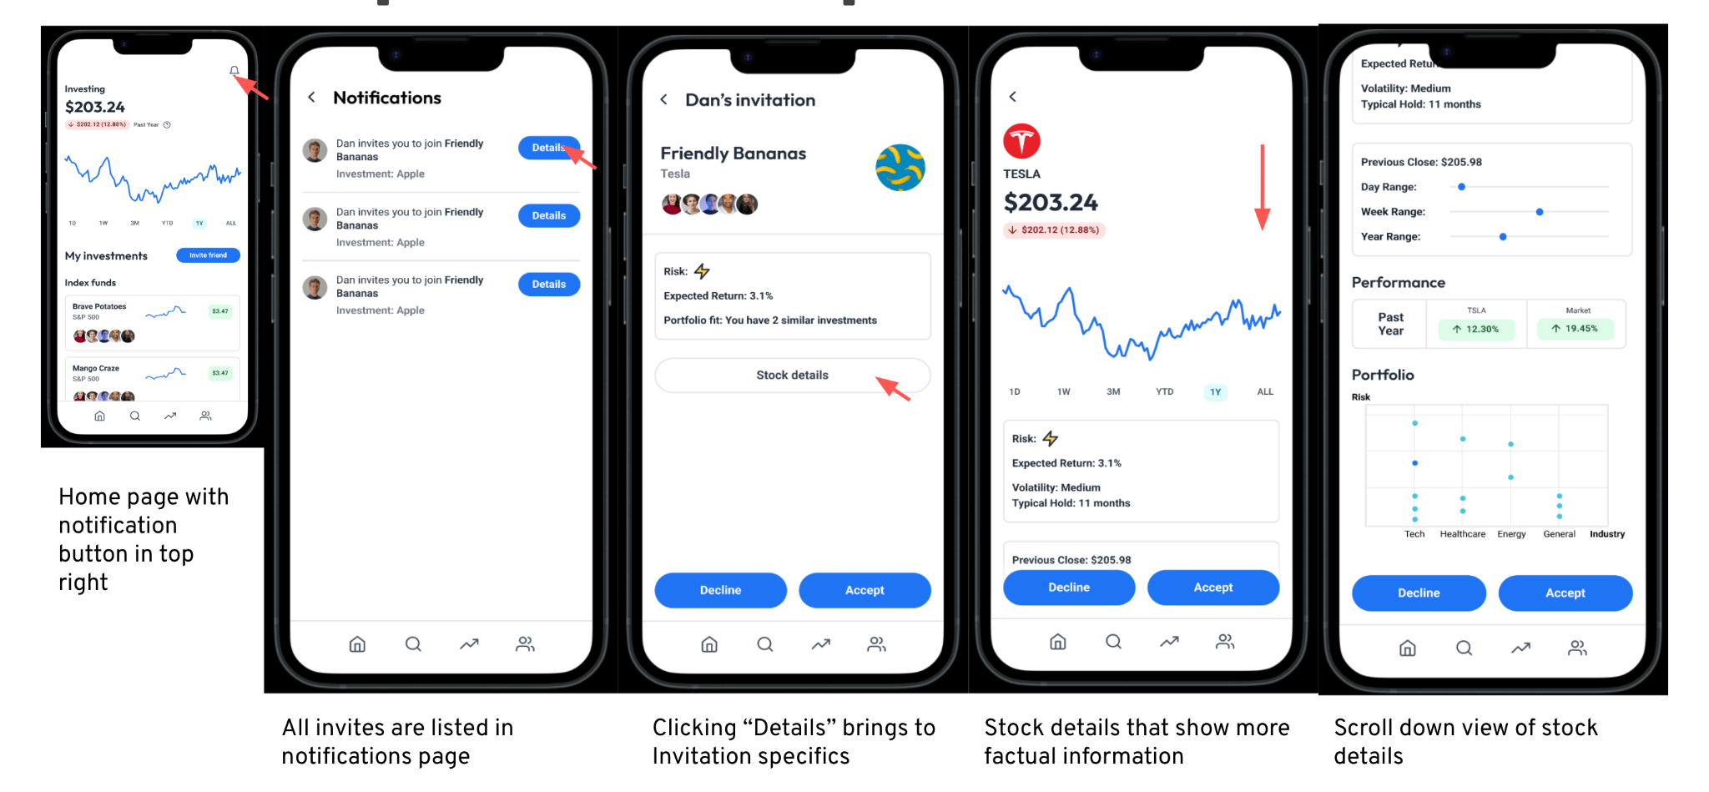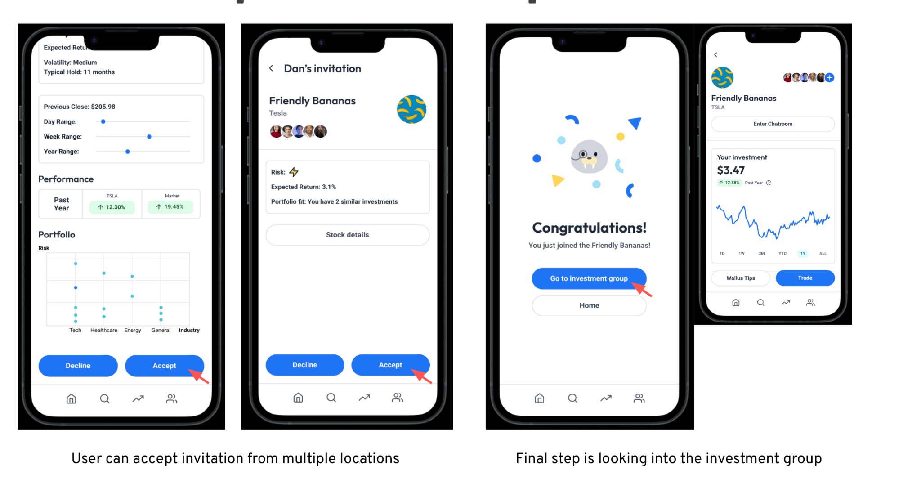
Figure 24. Medium-fi design for Task 1 (accept invite)
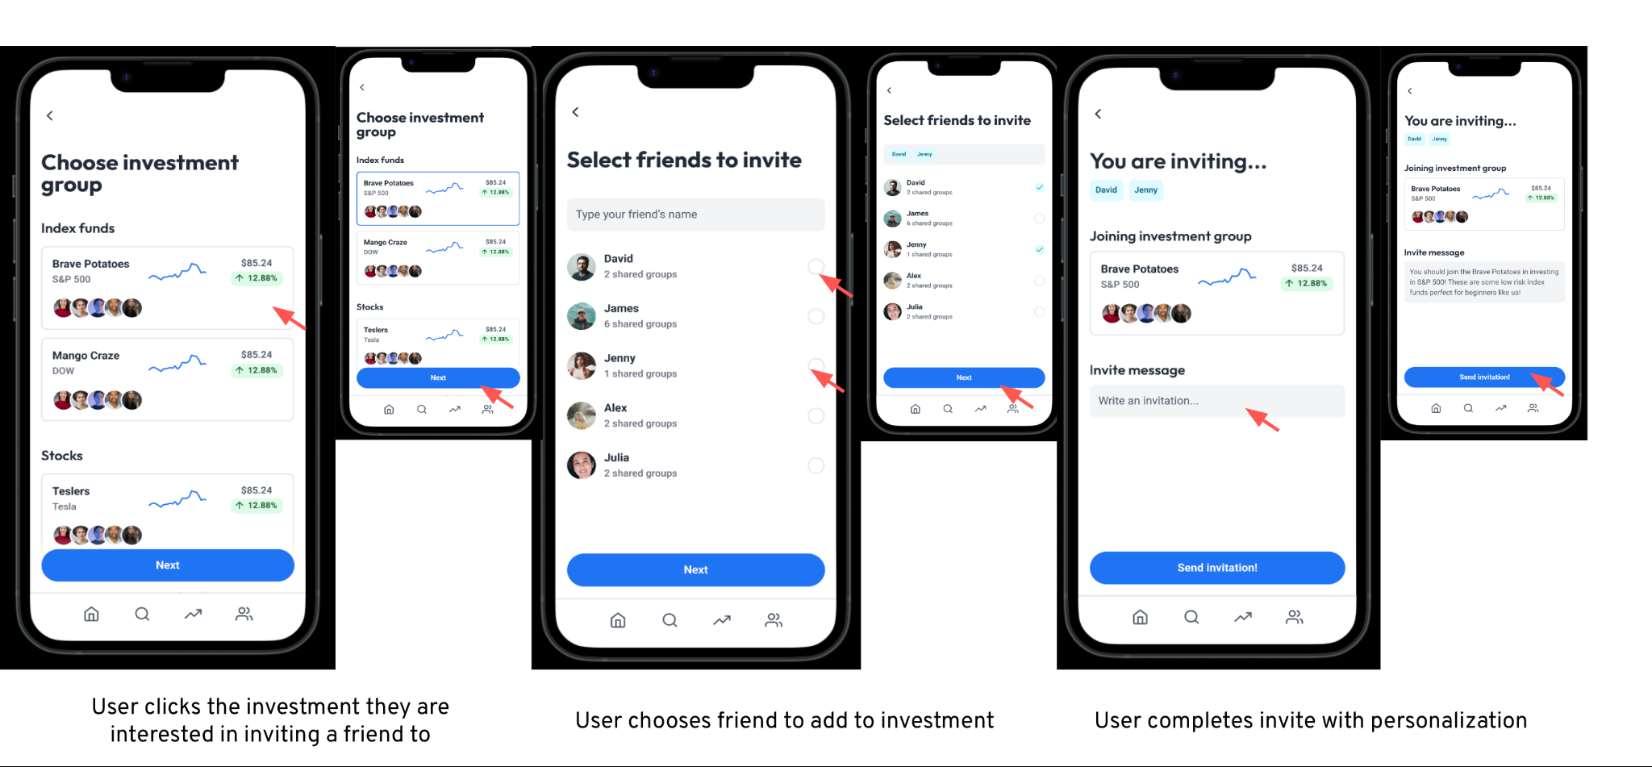
Figure 25. Medium-fi design for Task 2 (send invitation)

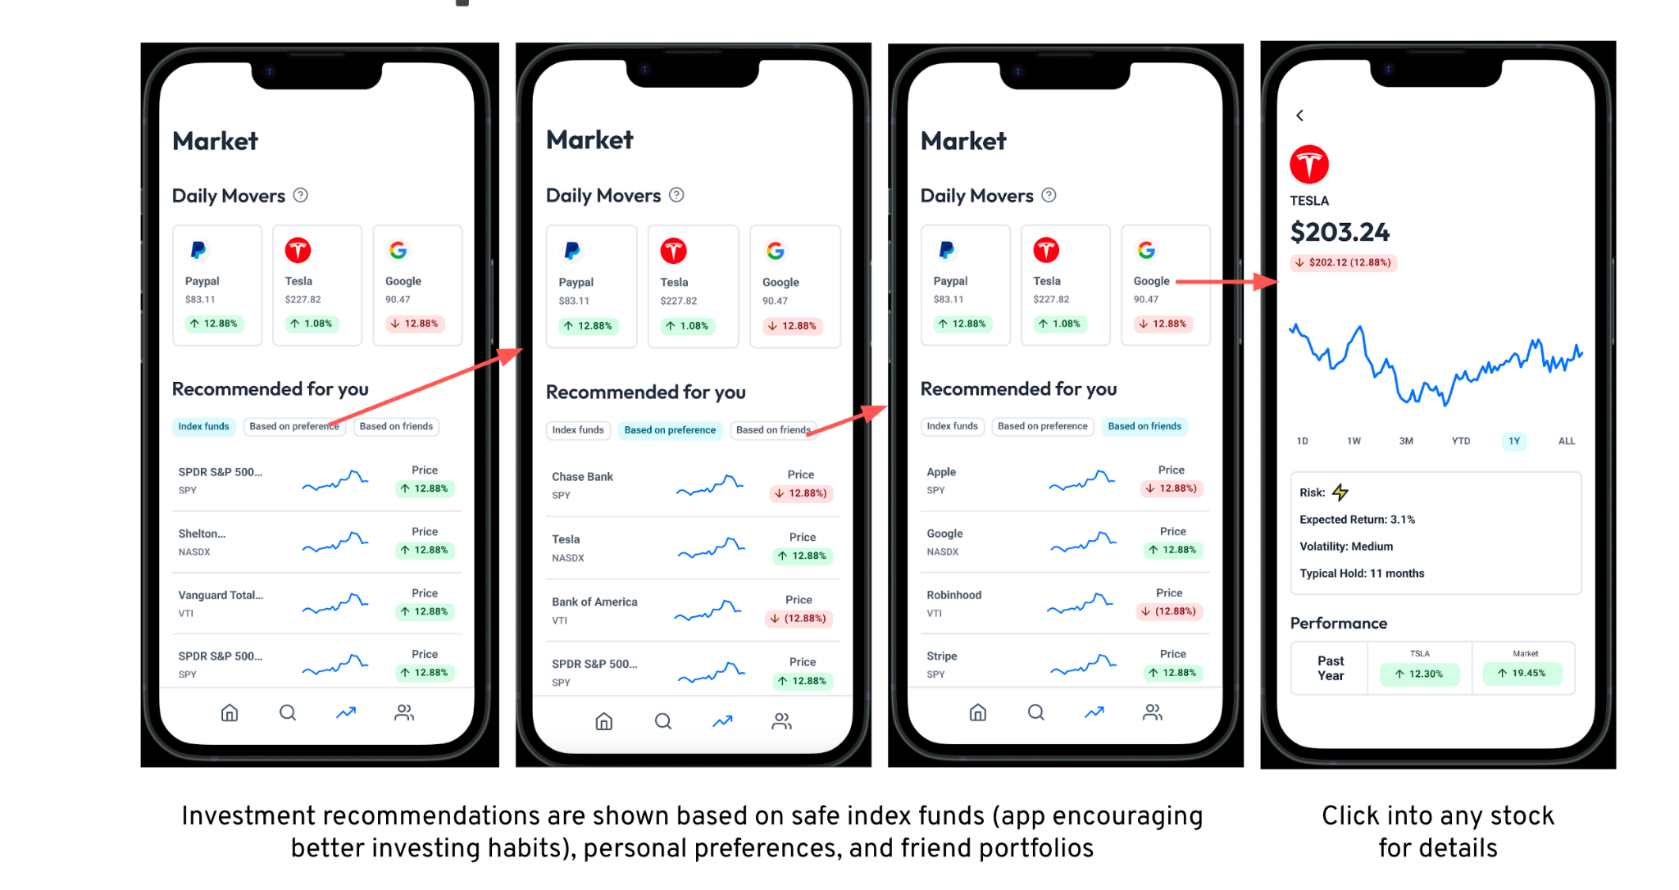
Figure 26. Medium-fi design for Task 3 (learn about the markets)

As we designed and iterated in Figma (a collaborative web tool that allows for interface design), we were very aware of the limitations of the platform. The pros of the platform include real-time collaboration, cloud based (no back-and-forth file sharing necessary), interactive elements, Figma Mirror to test, and plug-ins. On the other hand, the cons include necessary internet connection, no accountability for authors of edits, requiring a high tech computer, and varying levels of experience.

Particular limitations include
- Incomplete content: Many of the tutorials and dictionary definitions have not been developed, thus are marked as Coming Soon in the design. Numbers and charts are also arbitrary.
- Click only: Many of our features will allow scrolling, such as the home feed (investment groups) and market (recommendations) which were not experienced with just clicking in Figma.
- Limited search: While there are a range of stocks, friends, or concepts that a user can search with the Search feature, the design only has a pre-set example for each. Specifics of choices are non-existent.

Going to the last leg of our design journey, we will work past these limitations and build an interactive high-fi application.

Studio Feedback
After showing our studio the medium-fi prototypes, we received a lot of feedback along similar themes to iterate on.

The first theme of the studio feedback was lacking an education aspect despite having a target audience of beginners. We found:
- Wallus tips are too low hierarchy, especially ones for deciding to sell or keep a stock given uncertainty of new investor
- How can the user reflect on their past decision making? How can the user learn from their friends?
- Not enough guidance from the App
- The experienced user should not be burdened with teaching responsibility

Change 1 for this was bringing Wallus tips to higher in the hierarchy. Before, the user can access tips from Wallus by clicking into the button “Wallus Tips”, which would be in the investment home page. However, we realized that the information was too hidden from the user and should take higher priority. In our new change, we feature a shortened version of wallus tip at the first view of the investment group page.

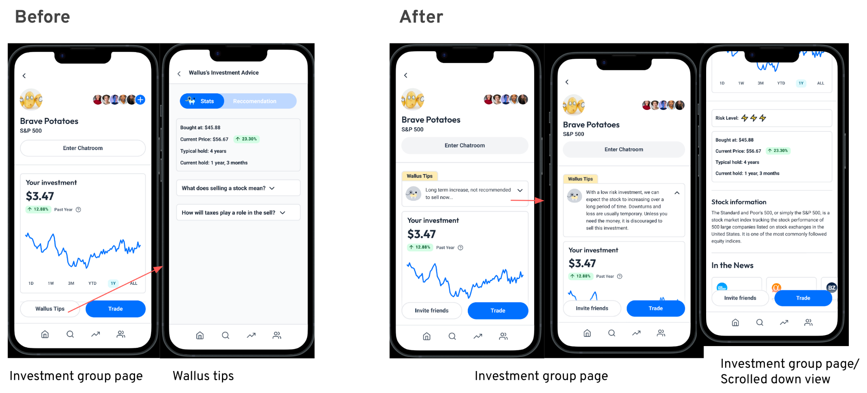
Figure 27. Design change bringing Wallus tips to directly prevalent.

Change 2 is a new implementation that requires users to input a decision rationale everytime they invest or sell. This has the goal for ensuring new users make decisions based on reason and not impulse. Plus, keeping a log of decision rationale allows the user to reflect on their past decision and sharing with friends allows users to learn from their friend’s investment mindset.

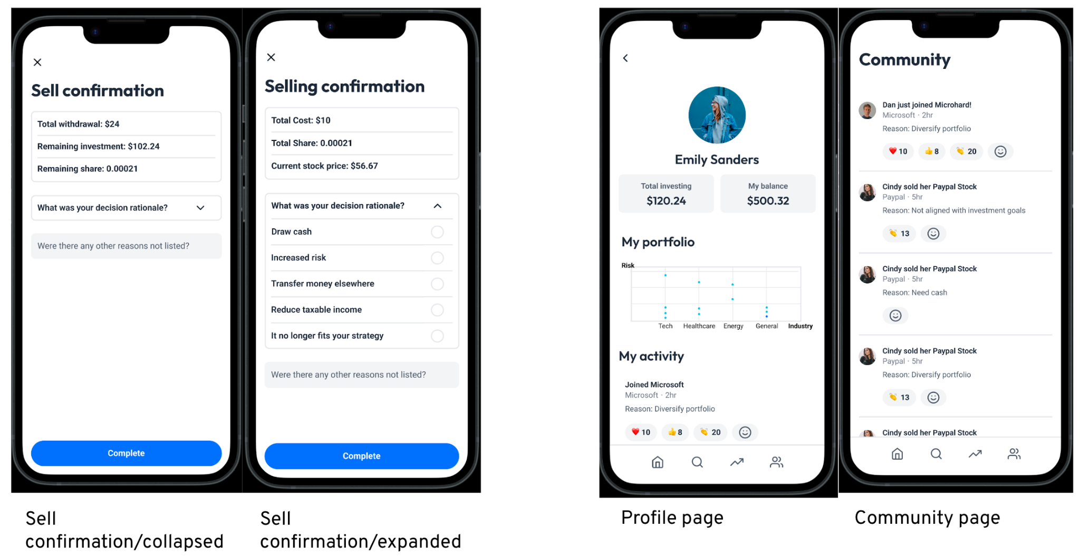
Figure 28. New flow that requires users to input their rationale for decision making.

Finally, change 3 reflects the need for more feedback to new users. To let the app give the user more guidance, we decided to have Wallus Tips more present throughout all decision making processes rather than just accepting an invitation to join a group: when the user is buying a stock on their own, buying or selling the stock, etc. We realized that to do all of this, we first need to create an onboarding process, in which the user tells Wallus their experience level, risk tolerance (defaulted to low if they are inexperienced), and long term goals.

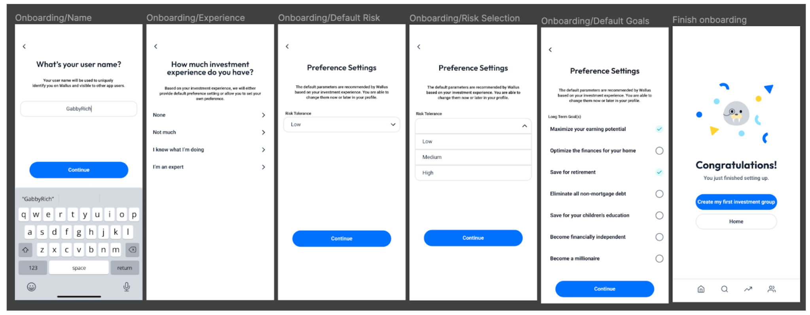
Figure 29. Newly designed onboarding process to provide contextualization for a new user and how Wallus Tips could be prevalent throughout the process.

In the final implementation, we came up with 3 ways to increase Wallus’s guidance:
- Display Wallus tips in invitation views and individual stock views: this can guide users when they are deciding whether they want to join a new group and when they are starting a new investment on their own
- Interrupt flows with Wallus warning page: when the user is about to do something that does not align with their inputted preferences, Wallus interrupts to warn. This page presents the option to continue if the user wishes, and a button to change their investment preferences if that has changed.
- Push Wallus notifications: this grabs the user’s attention about a particular investment group without requiring them to click into the group. The user can read more by clicking on details.

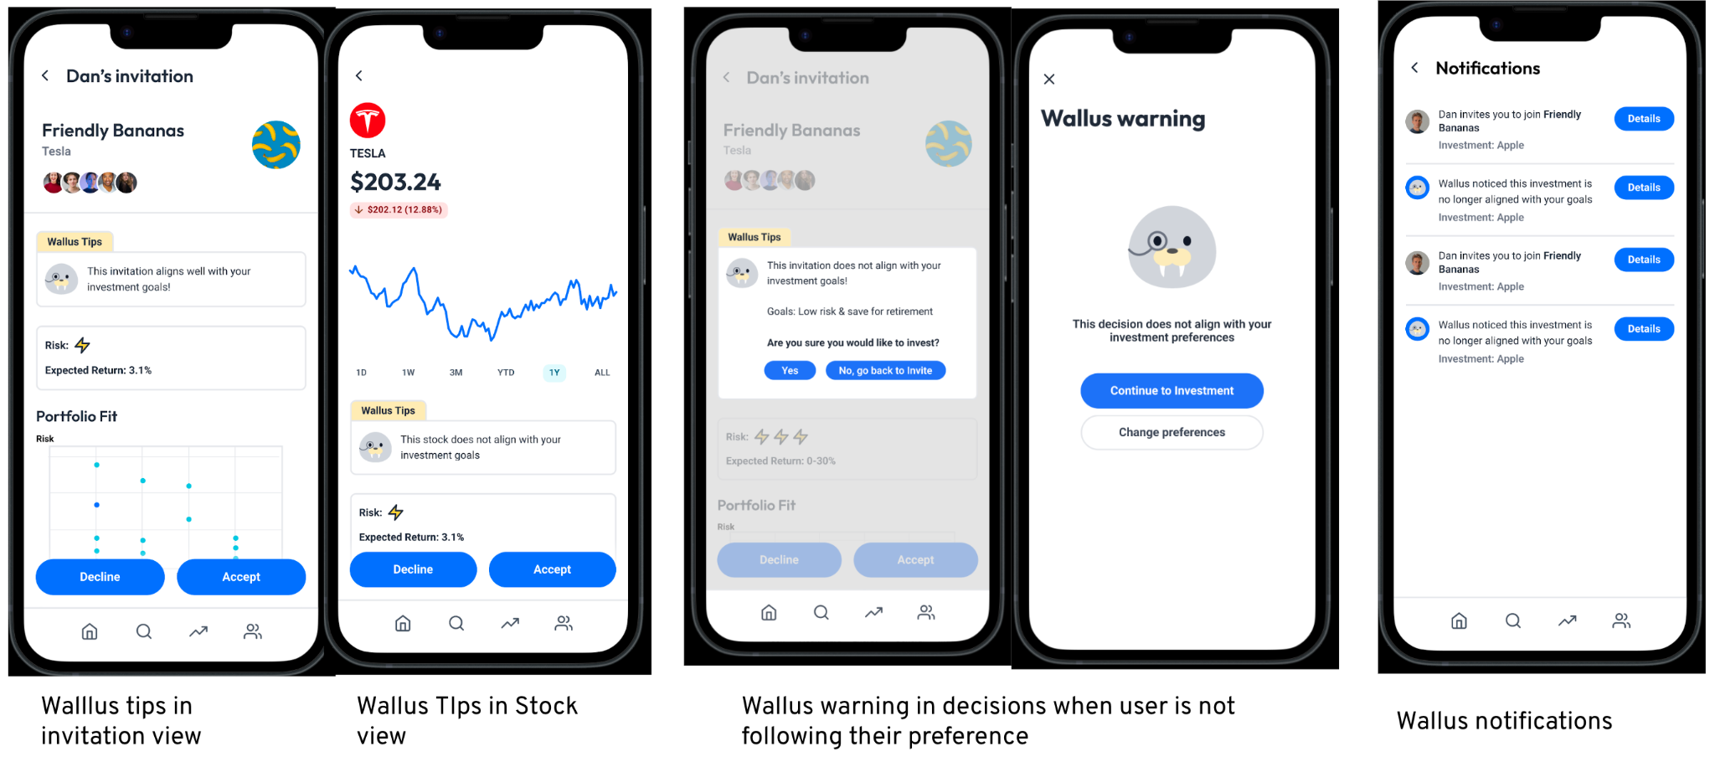
Figure 30. Instances of increasing Wallus Tips for users.

The second theme of the studio feedback was how Wallus will be inclusive to those without investment friends. We decided not to act on this feedback for a few reasons:
- We recognize this app assumes in person friends to use app with, but we think it is important to keep it this way because interacting with online strangers financially can be extremely risky and dangerous.
- With the education changes built in, a Wallus will still be a beginner friendly investing app compared to other investing options.
- Our studies through the experience prototypes showed that about 50% of people invest. This means it is likely that each person has at least one person that could get them involved in Wallus.

The third theme of feedback was that the application has information overload for new investors. We heard:
- Many screens are text heavy and not friendly enough to new users
- There are information that are less relevant and can be removed
- Lots of features and words are unnecessary for individuals investing less commonly and less amounts

Our first change to this was removing the chart from the Home page. As we looked at the home page, we realized the trend graph that we originally had to show the user’s overall portfolio trend is not very helpful to our target audience. These daily trend graphs are mostly helpful to day traders who want to surf the rises and dips; however, Wallus wants to help people build long-term healthy investing habits that do not require them to stare at the trend graph all day. We decided to instead move the “community card” from the community tab to the home tab. The purpose of this is to emphasize the user experience around community and community building. The boring and scary part of investing has changed to be a fun and welcoming experience!

Second, we re-evaluated all pages and removed extra information. From the Investment group page and Wallus Tips, we removed the percentage trends for Past year and Past 6 months. We also took out the portfolio landscape chart from the investment group page and instead put it in the profile page because it is not a high priority information that the user would like to know about the stock itself. We got rid of the group trend chart because it may raise an unhealthy competitive mindset in the users who joined at a “better” or “worse” time and earned more.

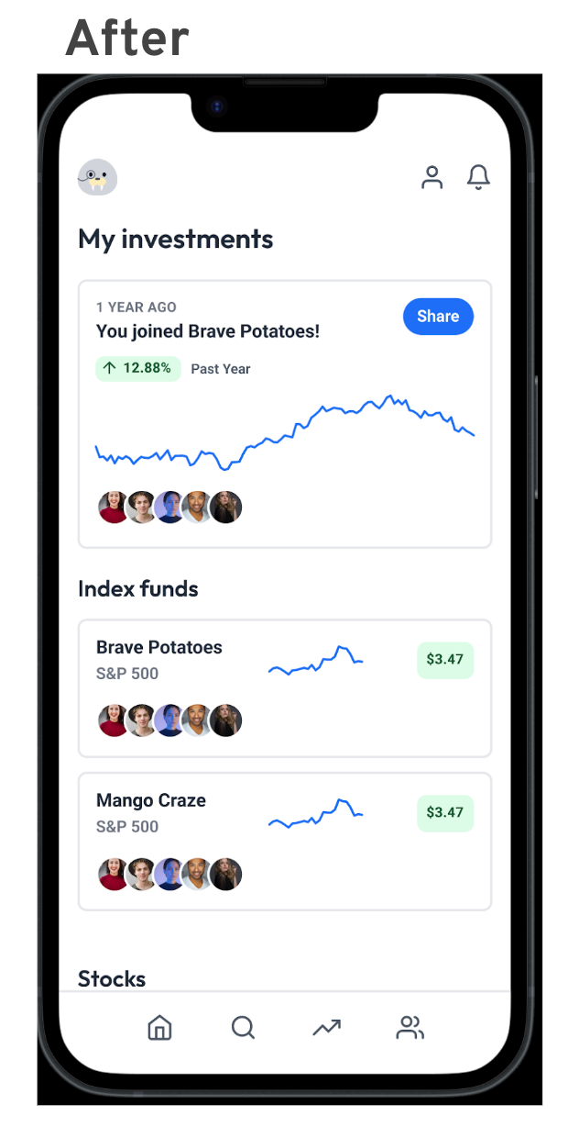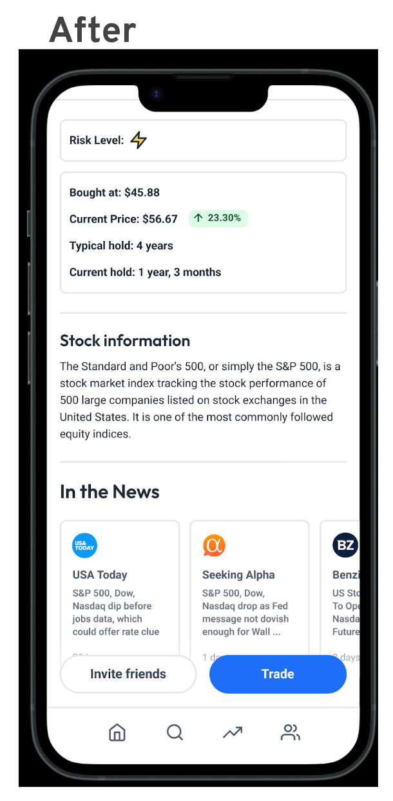
Figure 31. New simplified screens that help beginners better understand investing.

Finally, we heard that our UI is not novel. The main points include:
- The current visual style looks like a standard investing app
- Branding does not give the “approachable” and very “friendly”

To this, we made the colors more playful and made a point to include Wallus cartoon elements throughout the screens.

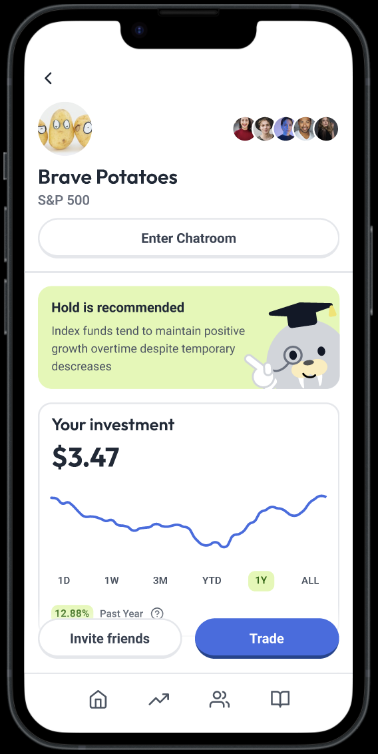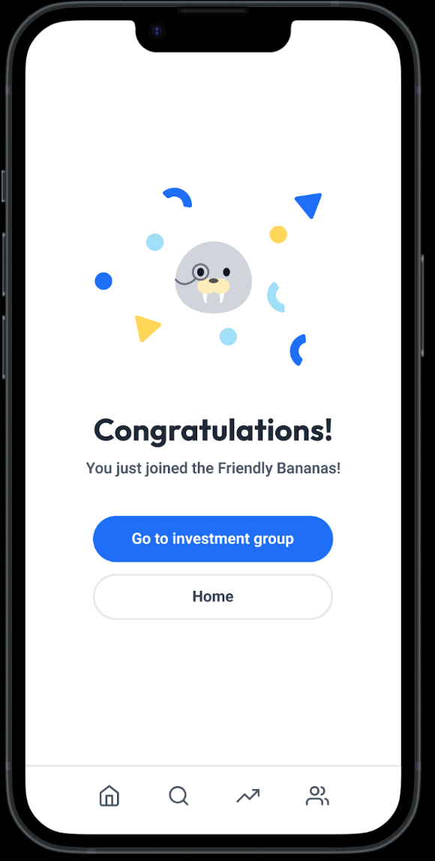
Figure 32. Newer design that includes brighter colors and Wallus mascot
Heuristic Evaluation
Once the designs were complete, the next step of the process was Heuristic Evaluations from our peers. On a scale of 0-4, design violations were marked and addressed in our design. Each of the SEV 3 and SEV 4s are discussed below:

SEV 3s
- Wallus decisions made without explanation
  - Solution: Wallus redesigned to include a title and “why description”
- Markets tab uses categories like “Daily Movers” that are ambiguous
  - Solution: We added “?” tooltips throughout the app to help define terms for new investors
- Axis in charts are not defined
  - Solution: Deleted this feature after considering a simplification of our information
- Lots of unnecessary info that is difficult for new users and screen readers
  - Solution: Rethought each page and included only necessary information that is digestible to a new investor
- %s are displayed in green and red without metric defined and how to interpret
  - Solution: Red is replaced with deep orange so no mental model for the color red is translated to a rash user action
  - Solution: Instead of current price of a stock, the total invested is shown on the home page to reflect behavior similar to that of a bank investment
  - Solution: Instead of the trend graph that shows dips and gains in a day, words like “Growing” “Stable” and “Unstable” are used considering long-term trends
- Profile is not accessible everywhere
  - Solution: We decided to keep the profile only visible from the Home page since the user will not be using the profile button often.
- No limit on the number of people invited to a investment group
  - Solution: Decision to keep no limit on the number of people since we hope the application is used for educational reasons as well. Unlimited group sizes could be used for classrooms where only one person is investing any many are learning.
- “Recommended for you” is vague and unclear how decisions were made
  - Solution: Simplified the section to just be a singular list that is recommended, rather than separated for index funds, by friends, and by preferences.
- Report or anti-harassment feature
  - Solution: Great idea for a future investment!
- Unclear what “Invest” means (more details or invest money)
  - Solution: Clarified wording as “Invest Now” with option to invest individually or with a group.

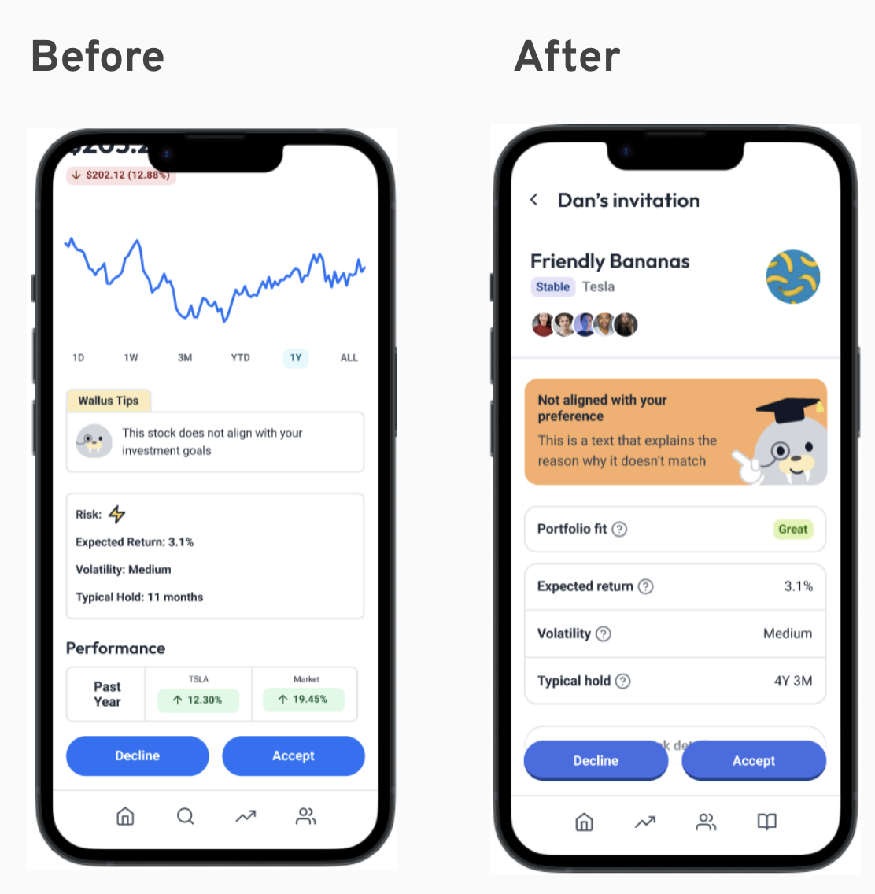
Figure 32. SEV 3, many words are used without explanation, is solved by adding tooltip definitions to each instance of a jargon.

SEV 4s
- Not many “?” pop ups to explain jargon on the app
  - Solution: Added the symbol to every jargon remaining on the site
- Information is displayed in the standard, existing format of investment apps
  - Solution: Redesigned the features and thought about what information is important for a new investor. These changes are discussed later in this report.
- Community card has no definition
  - Solution: This refers to the Homepage card. We made it more prominent by replacing the background color with blue and adding the Walrus mascot.
- Dictionary is nested too deep in the app
  - Solution: Made the Search tab purely for dictionary terms
- Buy and Sell screens do not show what the user is purchasing
  - Solution: Adding more relevant context details to the page for Buy/Sell
- No confirmation screen for declining an invite
  - Solution: Decided not to because the user is redirected to the Home page. Instead we made the button deactivated that prevents them from proceeding.
- View activity of past purchases and sells
  - Solution: In the profile tab to help users track past action
- View overview of current portfolio
  - Solution: Decided to remove because a newbie would not be analyzing the overview of a portfolio/might not be building a “portfolio”

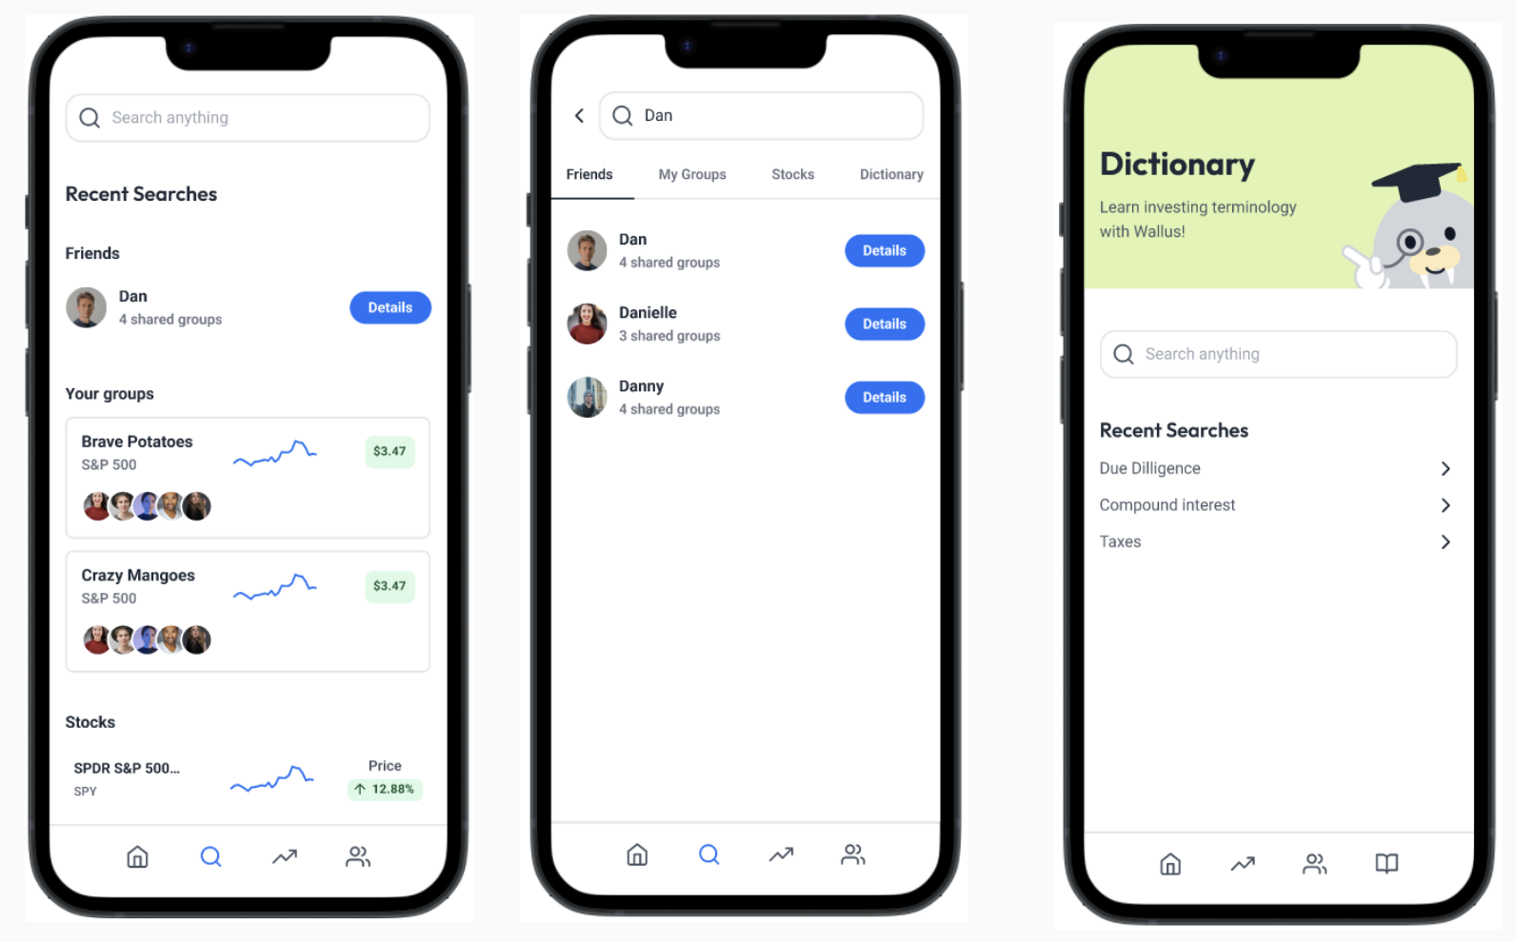
Figure 34. SEV 4, dictionary is nested too deep in the app, is solved by changing the Search tab to only focus on Dictionary.

In addition to these changes, there were many thoughtful considerations added to the final design. At this stage we also largely chose to redesign our visuals such that we conveyed a different message than traditional investing apps — redesigning investing.

This was done through a new visual design. While the previous design did not feel friendly to all reviewers and conveyed a similar feel to existing products, we decided to remove features unless they were strictly necessary for a new investor. This includes:
- Taking away the trend graph from the home page as it doesn’t mean much without context
- Wallus mascot included to give a welcoming feel
- Bright colors and rounded edges to share a sense of fun
- Orange and green used to represent states of the stock, instead of red and green suggesting good/bad
- Show total amount of money invested instead of gains and losses
- Describe stock in user friendly words like “Growing” or “Unstable” over 1-year calculations that account for long-term trend

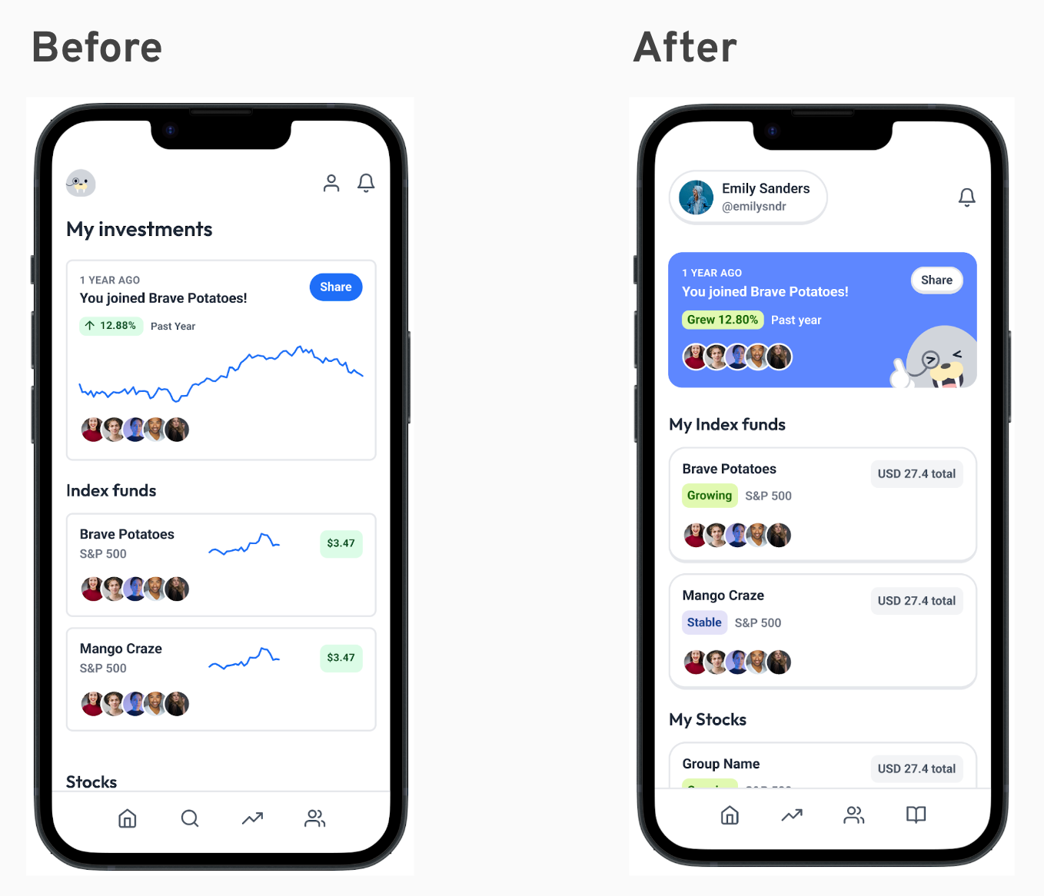
Figure 35. Redesign of Home to be more welcoming and intuitive to new investors, only including the necessary information considering a preference for long-term investing.

A second way that was accomplished was through community features including:
- Highlight the community card on the Home page
- Each stock detail has the reasoning your friends joined the group listed in the Group Details page
- Explicit member list from group details to show who all is in it together
- Community page labeled at the top and reactable components included

Final Design
The final Figma design is highly interactive and culminates all the feedback till now. It can be found with annotations on the purpose of each set of screens at the link: Figma.

Values in Design
We have a number of ethical values we hope to embed in our final solution through concise design choices.

Values
First is Inclusion, where all users (especially those with little to no experience with investing) find Wallus intuitive, helpful, and inviting. These values were embedded in the specific design features when:
- Groups equally represent all members regardless of all prior investments and size of investment
- Onboarding procedure is personalized and includes educational content
- All parts of the app are hyperlinked to definitions and include “?” buttons with tutorials to understand what a concept is and how to interact with it
- Explanations of “what can be next” are defined at every user decision

Second is Privacy, where user information and investments are kept private to only necessary individuals. These values are seen in the app when:
- User’s investment amount is private
- The only stocks of a user that will be visible to friends are the ones the user and a friend have together
- No investment will be visible to anyone the user is not a friend of

Third is Autonomy, when users have full control of their money. We focus on this by:
- All features in Wallus will give users the decision to determine where their money is invested, in which groups, what amount, and how long the investment is kept
- While Wallus will make recommendations to the user based on preferences, the user has the ultimate decision to invest

Finally, we center on Safety, with no frauds and all user’s money is honestly kept where in the place they choose to invest in. Wallus accomplishes this by:
- The investments in stocks through Wallus genuinely mean an investment into that stock ticker
- Money invested through Wallus is not held by the app and real-time invested

Conflicting Values Consideration
Given so many values, there are two that conflict. These are inclusion, so that beginners can be guided through the app, and autonomy so that folks can determine which friend investment groups they should join. By giving users educational resources, curated recommendations, and guidance on best courses of action at each point for a stock, we provide a lot of information that can influence the investing of a user. However, we want to make sure that autonomy of thought is still maintained by the user.

We will make sure to keep our values in check through our design decisions. Namely make sure Wallus emphasizes that all educational videos are there to build a user’s investment context and include in depth reasoning of pro/con for recommendations. This will make sure the app is able to help newbies while also always keeping interpretation open!

Final Prototype Implementation

Tools
The final prototype implementation was coded using a wide set of tools. The final mobile application was coded using React Native. Figma was used to create and download icon assets, while the development environment included Visual Studio Code, GitHub Desktop, and Expo. Each of these tools came with their own set of pro/cons. Namely was that each tool required onboarding steps, where some of us might be more experienced than others. However, the pro that each allowed for collaboration outweighed the inexperience and we all learned to use the tools for collaboration asynchronously, testing without publishing, and without downloading much extra software. The largest limitation was that coding a high fidelity prototype takes a lot of time, thus many of our features including chat, feed, and emoji reactions were not fully implemented.
React Native Libraries and Packages used
As we chose to code in React Native, we used a number of React Native libraries and packages. We evaluate the pros and cons of each of these choices below:

- Supabase
This was our backend and database solution for the project.
We used it for user registration, user authentication, and real time subscription to enable our live chat feature.
Pro  - It provides a lot of features used in the backend, all in one place.  - It presents us with the world renowned database Postgres that is 100% portable. | Cons  - It is constantly evolving, making third-party tutorial and documentation deprecated and the official documentation pretty bare bone.

- Expo
This was the platform used to make our app. It is a set of tools built on top of React Native.
Pro  - Setting up a project is easy and can be done in minutes.  - Sharing the app is easy via a QR code or a link.  - We do not have to build the app before running it. So, we get live feedback when we save the code. | Cons  - We couldn't add native modules for ios or android.  - We couldn't use libraries that use native code in Objective-C or Java.

- Lucide Icons
We used this set of icons for various buttons in the app.
Pro  - Easy to use preexisting everyday icons. | Cons  - Makes the app look generic because other apps use it too.

- React Hook Form
This is a library that we used to validate our login and registration forms.
Pro  - Allows us to easily validate form entries in different ways. | Cons  - To use it properly, we had to create our own custom text input component which added a bit of complexity when learning to use it for the first time.

- React Native Walkthrough Tooltip. We used this to create tooltips.
Pro  - Allows us to effortlessly create a well designed tooltip with different themes. | Cons  - There is no customization for a close button, which was part of our original tooltip design.

Wizard of Oz
Personalizations and recommendations are implemented by Wizard of Oz. Most notable are Wallus's Tips in Detail Pages and Recommended for you in Markets.

Hard-coded Elements
Finally, many elements were hard-coded including:
- User profile including name, image, prior investing history, investment groups, and investing history
- Community page including the rationale and reactions
- Numbers and charts in Investment Details pages
- Notifications displayed
- Dictionary term entries.
- Friends that can be invited to an investment

The final prototype can be tested by downloading “Expo Client” from the App Store and logging in with username stilakid@stanford.edu and password @WallusLovesPudding. On your mobile browser, go to this link and click on the “Open in Expo Go” button!

Reflection & Next steps

Key Takeaways
In general, being exposed to such a rigorous design process was honestly refreshing and, although arduous at times, very rewarding. All of us came into this project from different backgrounds with different skills and specialities, and it was mesmerizing to see this project come to life when we put all our different skills together. In essence, this class truly highlighted the value of teamwork.

There was so much to learn throughout this quarter for the design thinking process, the studio theme of time, and the project. Some main ones are listed below:

Iterative Designing

After going through this class, we learned a lot about the importance of feedback and numerous iterations of a design before it can be built. Not until our last round did we realize that our Home page was not built for new users, something that one iteration that we were used to could not suffice.

Needfinding
This portion of the needfinding process was new to us but one that paid the greatest dividends going forward. We learned about the importance of being intentional with who we choose to interview, keeping open-ended questions, and taking through observations to build insights and leaps that can guide the future of the whole project.

Brining users to test early
Initially, we were hesitant to test out the feasibility of our mobile app through a paper form. However, after seeing the learnings we had through these interviews, we realized the importance of testing early and testing easy with real users. Though our future work might not have paper prototypes, showing drawings to stakeholders is something we can always add to our workflows.

Communicating work effectively
At every step of the journey, we had a presentation. The final step even went above and beyond with communication through print, app, in-person speech, video, and writing being represented by the poster, expo app, pitch, demo video, and this report. Having all of these down was crucial to successfully communicating the project and journeying to an unknowing audience. This is something that we all can add to the technical projects we take on in the future.

Future Investments
There are many possible future investments that we learned through our Heuristic Evaluations or due to time constraints in implementation.

On the technical side, we would like to eliminate all the hard-coded elements of the application (including users, groups, tips, and history) so that a new user can join with a fresh plate and interact with their friends as a real app. Additional new additions include
- Connecting to APIs that pull real market data for stock prices and details
- Long-term implementation can look into integrating with banks or Stripe for purchasing real stocks
- Expand chat to more than 2 users
- Making the dictionary have a full set of terms
- Community page to allow reactions for each of the updates
- AI in Wallus’s tips that adjust based on user preferences by the groups they join and the investments they make
- Bookmarking or flagging interesting stocks or sharing with friends
- Reporting harmful content flows

On the design front, we hope to continue iterating on the amount of information that is strictly necessary to show a new investor. We hope to continue editing the details in the Home, Invite, Group Details, and Markets page. We also would love to continue designing Wallus icons, perhaps ones that are region, stock, or time of year specific!

Final Remarks
Thank you for joining us on our design journey. We enjoyed understanding a new topic, designing Wallus, and bringing the idea to life and hoped you enjoyed learning about the steps in our design process creating Wallus and hope you enjoyed learning about the various stages of our design process. Please feel free to check out our website at https://web.stanford.edu/class/cs147/projects/SteppingThroughTime/Wallus/ to see our high-fi prototype in action!

