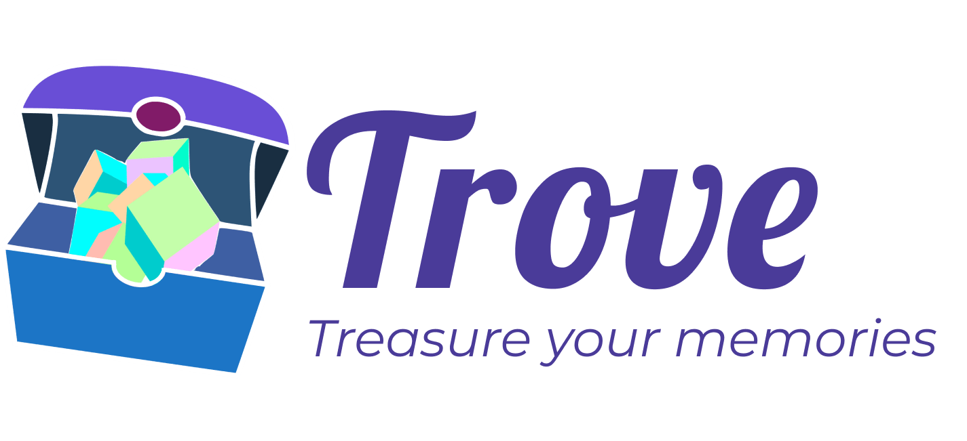Final Report

CS 147 Autumn 2022

Stepping Through Time

Elizabeth F., Hyunseok H., Janine F., William L

# Table of Contents

Value Proposition & Team

Problem & Solution Overview

Needfinding Interviews

Point-of-Views & Experience Prototypes

Design Evolution

Final Prototype Implementation

Reflection & Next Steps

# 

# 

# 

# 

# 

# 

# **Value Proposition & Team**

## Value Proposition

Trove - Treasure your memories.

## Team Members and Roles

Elizabeth F. - Designer and Engineer

Hyunseok H. - Designer and Engineer

Janine F. - Designer and Technical Writer

William L. - Designer and Lead Engineer

# Problem & Solution Overview

People struggle to revisit the emotions they feel whenever they view art. Current tools exist to record our reflections, such as 2D photos and journals; however, it’s still difficult for people to re-experience those emotions. Utilizing the design process, our team came up with the product Trove. Trove is a location-based mobile app that allows users to discover and create Augmented Reality (AR) art pieces and tie them to locations in the physical world. Through this immersive AR technology, users can form stronger and longer-lasting connections with art that they’ve interacted with.

# Needfinding Interviews

Before conducting our needfinding interviews, we needed to determine our domain. Based on our team members’ general interests and the theme of our studio, we decided to explore the intersection of art, AR technology, and memories. Once we established our domain, we found seven participants who each had unique relationships with art and technology. Specifically, we interviewed two docents from the Cantor Art Museum, two professors who specialize in VR/AR, a musician, and two university students with contrasting views on the value of art.

The majority of our interviewees were sourced by either word of mouth or through email. The exception of this were the two docents, whom we conducted an impromptu interview with during our visit to the Cantor Arts Museum.We interviewed the majority of our interviewees in-person and a few over Zoom. For each interview, we asked questions that related to the interviewee’s background. Below are examples of the kinds of questions we asked:

* When you perform music, how do you remember your pieces?
* Which would you say is your strongest: your visual, audible or verbal memory?
* As an artist, what excites you about AR/VR technology?
* What are some common and beneficial applications of VR and AR?
* How often do you have the opportunity to visit museums or exhibitions?
* How do you remember or keep track of the art exhibits you were inspired by?

After our interviews, we created empathy maps for each of our interviewees in order to highlight their tensions and needs. From the empathy maps, we were able to identify five compelling insights:

1. Viewing art doesn’t need to be a shared experience
2. People generally don’t synthesize their thoughts on art while viewing it - they do so after.
3. VR and AR technology provide unique opportunities for 3D art and immersive experiences.
4. Art is primarily remembered first by the emotion it evokes. Details of the piece itself are remembered after and, in some cases, not at all.
5. People who are knowledgeable about art like and prefer discussing art with other knowledgeable people.

*An example empathy map we created for one of our participants during our needfinding interviews.*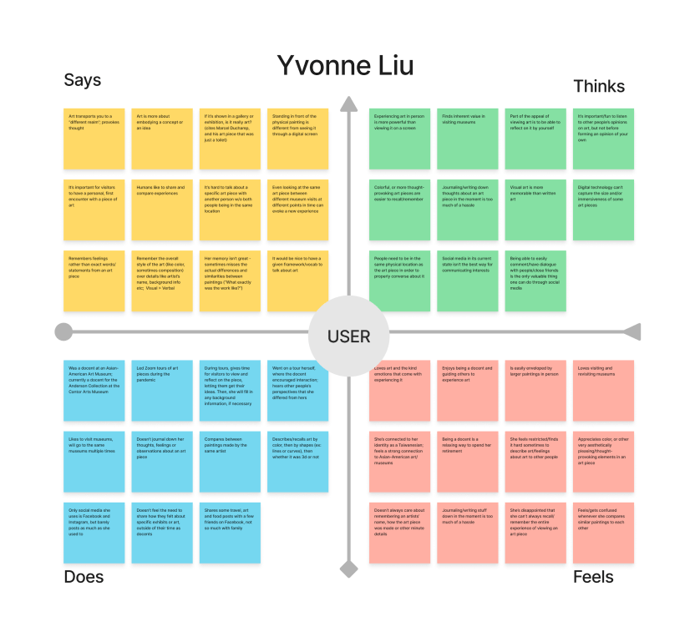

# Point-of-Views & Experience Prototypes

After our needfinding, we chose three of our interviewees to create Point-of-View (POV) statements for. From each POV, we generated How Might We (HMW) questions and chose the most promising HMW to propose a solution for.

## POV 1 - Yvonne Liu

**Reason for choice**: She’s an avid art lover who provided valuable perspectives on how people remember artistic experiences.

**We met** Yvonne Liu, an experienced docent at the Cantor Arts Center and a lover of physical art.

**We were surprised to** learn that she doesn’t keep records or notes on art pieces she’s really enjoyed.

**We wonder if** this means that she gets frustrated when she tries to remember the emotions she feels as she looks at art.

**It would be game-changing to** give her an easy way to re-experience emotions she feels when interacting with art.

**How might we..**

* …expand the vocabulary of describing the emotions of art?
* **…simulate the experience of seeing a piece of artwork for the first time again?**
* **…transport a museum exhibit into a person’s home?**
* …incorporate reflecting on art into mindfulness habits?
* …help Yvonne keep track of her favorite art pieces and her reactions to them?

## 

## POV 2 - Thomas Kook

**Reason for choice**: He represents an average user who likes art.

**We met** Thomas, who often takes photos and videos of everyday art and shares them with his friends via Instagram stories.

**We were surprised to notice** that he prefers going through jumbled, non-curated collections of his art memories.

**We wonder if** this means he inherently enjoys and values the variable “Reward of the Hunt” even in search of their memories.

**It would be game-changing to** make going through art a fun experience by finding the sweet spot between curated and random content

**How might we…**

* …pair art pieces with other mediums that evoke similar emotions?
* …recommend Thomas random-generated content based on his interests?
* …show Thomas new styles of art that he might not be familiar with?
* …make going through your camera roll a surprising and fun experience?
* …gamify the experience of posting one’s art and viewing other people’s art?

## POV 3 - Veronica Graham

**Reason for choice:** She was in the unique position to offer both a creator and teacher point of view.

**We met** Veronica, who is a VR artist/creator and lectures a VR art class at Stanford.

**We were** surprised to notice that she believes a work of VR art is a shared experience between the creator and the user.

**We wonder if** this means that her goal as an artist is to establish an emotional connection with her audience.

**It would be game-changing to** give artists a simple way to build shared experiences with their audience.

**How might we…**

* …create a safe space for the artist’s audience to provide feedback?
* …help users identify which artists they want to connect with?
* **…have artists collaborated with their audience on their next art work?**
* …provide ways for the audience to learn from the art styles of their favorite artists?
* …include the audience in the artist’s creative process for a given piece?

## Top HMWs and their Respective Solutions

* HMW simulates the experience of seeing a piece of artwork for the first time again?
  + Solution 1: Pair artwork with music or other mediums that evoke similar feelings or themes.
* HMW have artists collaborate with their audience on their next art work
  + Solution 2: Create a space that allows people to easily collaborate to produce a community art piece.
* HMW transport a museum exhibit into a person’s home?
  + Solution 3: Create a location-based AR app, where art is displayed at certain locations for people to discover and interact with.

## Experience Prototype 1

Solution

Pair artwork with music or other mediums that evoke similar feelings or themes.

Assumption

People can make emotional connections between new pieces of art and those which they have already observed.

Prototype Setup

To test this assumption, one of our team members sat in front of Tresidder Union and asked passersby to view a painting that we had on display. Then, after given some time to reflect, participants were asked the following two questions:

* What do you feel emotionally when you look at this painting?
* When you look at this art piece, does it remind you of any other art pieces? Can you think of any that made you feel the same way as you do about this painting?

Main Observations

For the first question, most of the participants were willing and able to describe what they saw in painting and provide their own interpretation of the mood the painting evokes. However, for the second question, participants were unable to or struggled to make connections between the painting they saw and other works of art they’ve viewed in the past.

Limitations and Implications

There are a couple of things we could have done to improve this prototype. First, we could have selected people who expressed interest in art; it may be a factor in why some of our participants had trouble answering the second question. Second, we could have allowed them to make connections to other mediums besides art. Finally, the initial painting we chose may not have evoked strong enough emotions to relate to other memorable art they’ve seen. Despite these limitations, it was clear that participants enjoyed forming their own reflections on art.

## Experience Prototype 2

Solution

Create a space that allows people to easily collaborate to produce community art pieces.

Assumption

Community members have an aligned goal.

Prototype Setup

To test this assumption, we gathered a group of residents from a music and arts theme dorm and provided them with one giant sheet of paper and sharpies. Participants were told that they had 15 minutes to draw anything on the paper and had the option to draw individually or with other participants.

Main Observations

In general, our assumption was proven wrong - most people ended up doing their own individual drawings, and there wasn’t an overall cohesive theme to the overall art piece. However, people seemed to enjoy doodling around each other and would often be willing to add other people’s drawings if asked to do so. They also showed signs of willingness to collaborate in other ways, such as sharing materials/passing markers to each other when asked, and helping each other name their drawings. Moreover, they were curious about what other people were drawing, and would laugh together over their drawings. Overall, it seemed that this was a positive experience for everyone.

Limitations and Implications

The participants already knew each other, which most likely is the main reason why they were so cordial with each other. This may not have been the case if they were all strangers to each other. Including a prompt for them to draw gives clearer indication on the validity of our assumption. Overall, it seems that people are more likely and willing to collaborate if they’re in a space where they feel comfortable expressing themselves and their abilities.

## Experience Prototype 3

Solution

Create a location-based AR app, where art is displayed at certain locations for people to discover and interact with.

Assumption

People are willing to move short distances to discover AR art.

Prototype Setup

Team members placed a simple art piece by the side of Memorial Church. They then approached visitors in the main quad, handed them a sticky note “notifying” that an AR art piece was nearby, and gave the participants the choice to accept or decline the notification and search for the art piece.

Main Observations

None of the participants found the art piece, and they had different reasons for not doing so. For example, some participants weren’t interested in looking for the piece in the first place; others showed interest but were preoccupied with completing other activities, such as taking pictures or completing another scavenger hunt. These observations show that people may not be as interested or aware of Augmented Reality pieces, nor are willing to explore further if it disrupts their plans.

Limitations and Implications

Although our assumption was proven wrong with this experience prototype, there are things we could have done a better job indicating why our assumption didn’t work. For example, when testing this prototype, we may have chosen participants that aren’t interested in art. Moreover, we chose a location and met with strangers impromptu. Because of this, we had participants who weren’t prepared to engage with the prototype beforehand, and thus could have contributed to their unwillingness to search for a random art piece.

# Design Evolution

## Final Solution

Based on what we learned from our experience prototypes, we formed a solution that’s a combination of Experience Prototype 2 and 3. Although our initial assumption from EXP 2 was wrong, it was notable to see the participants enjoyed creating their own and viewing each other’s artwork. From EXP 3, it was clear that simply knowing that an AR art piece was nearby was not appealing to participants; there needs to be a greater incentive for people to go out of their way to find an AR art piece.

***Our final solution****: A location-based Augmented Reality (AR) app where users create AR art pieces (called Treasures) and tie them to a specific location. Treasures can only be viewed in the locations in which they were made. Users can also find and interact with other users’ Treasures.*

## 

## Main Tasks

*Task 1 (Simple) - Create your own Treasure by scanning in a physical object.*

Since Trove relies on user content, it’s important for us to demonstrate a common way for users to create their own content (i.e. create a Treasure). This task also is an example of one of our values, creative expression, in practice.

*Task 2 (Moderate) - Navigate to new Treasure and decorate it.*

This is one of the main functions of our app. It shows one of the main ways users will view and interact with art.

*Task 3 (Complex) - View and edit a Treasure entry in your Trove.*

“My Trove” contains all the Treasures that you created or saved from other users. It displays another main way for people to interact and reflect on the art they’ve viewed.

Below are each of the Task Flows in our High-fi Prototype:

*Task 1 - Create your own Treasure by scanning in a physical object.*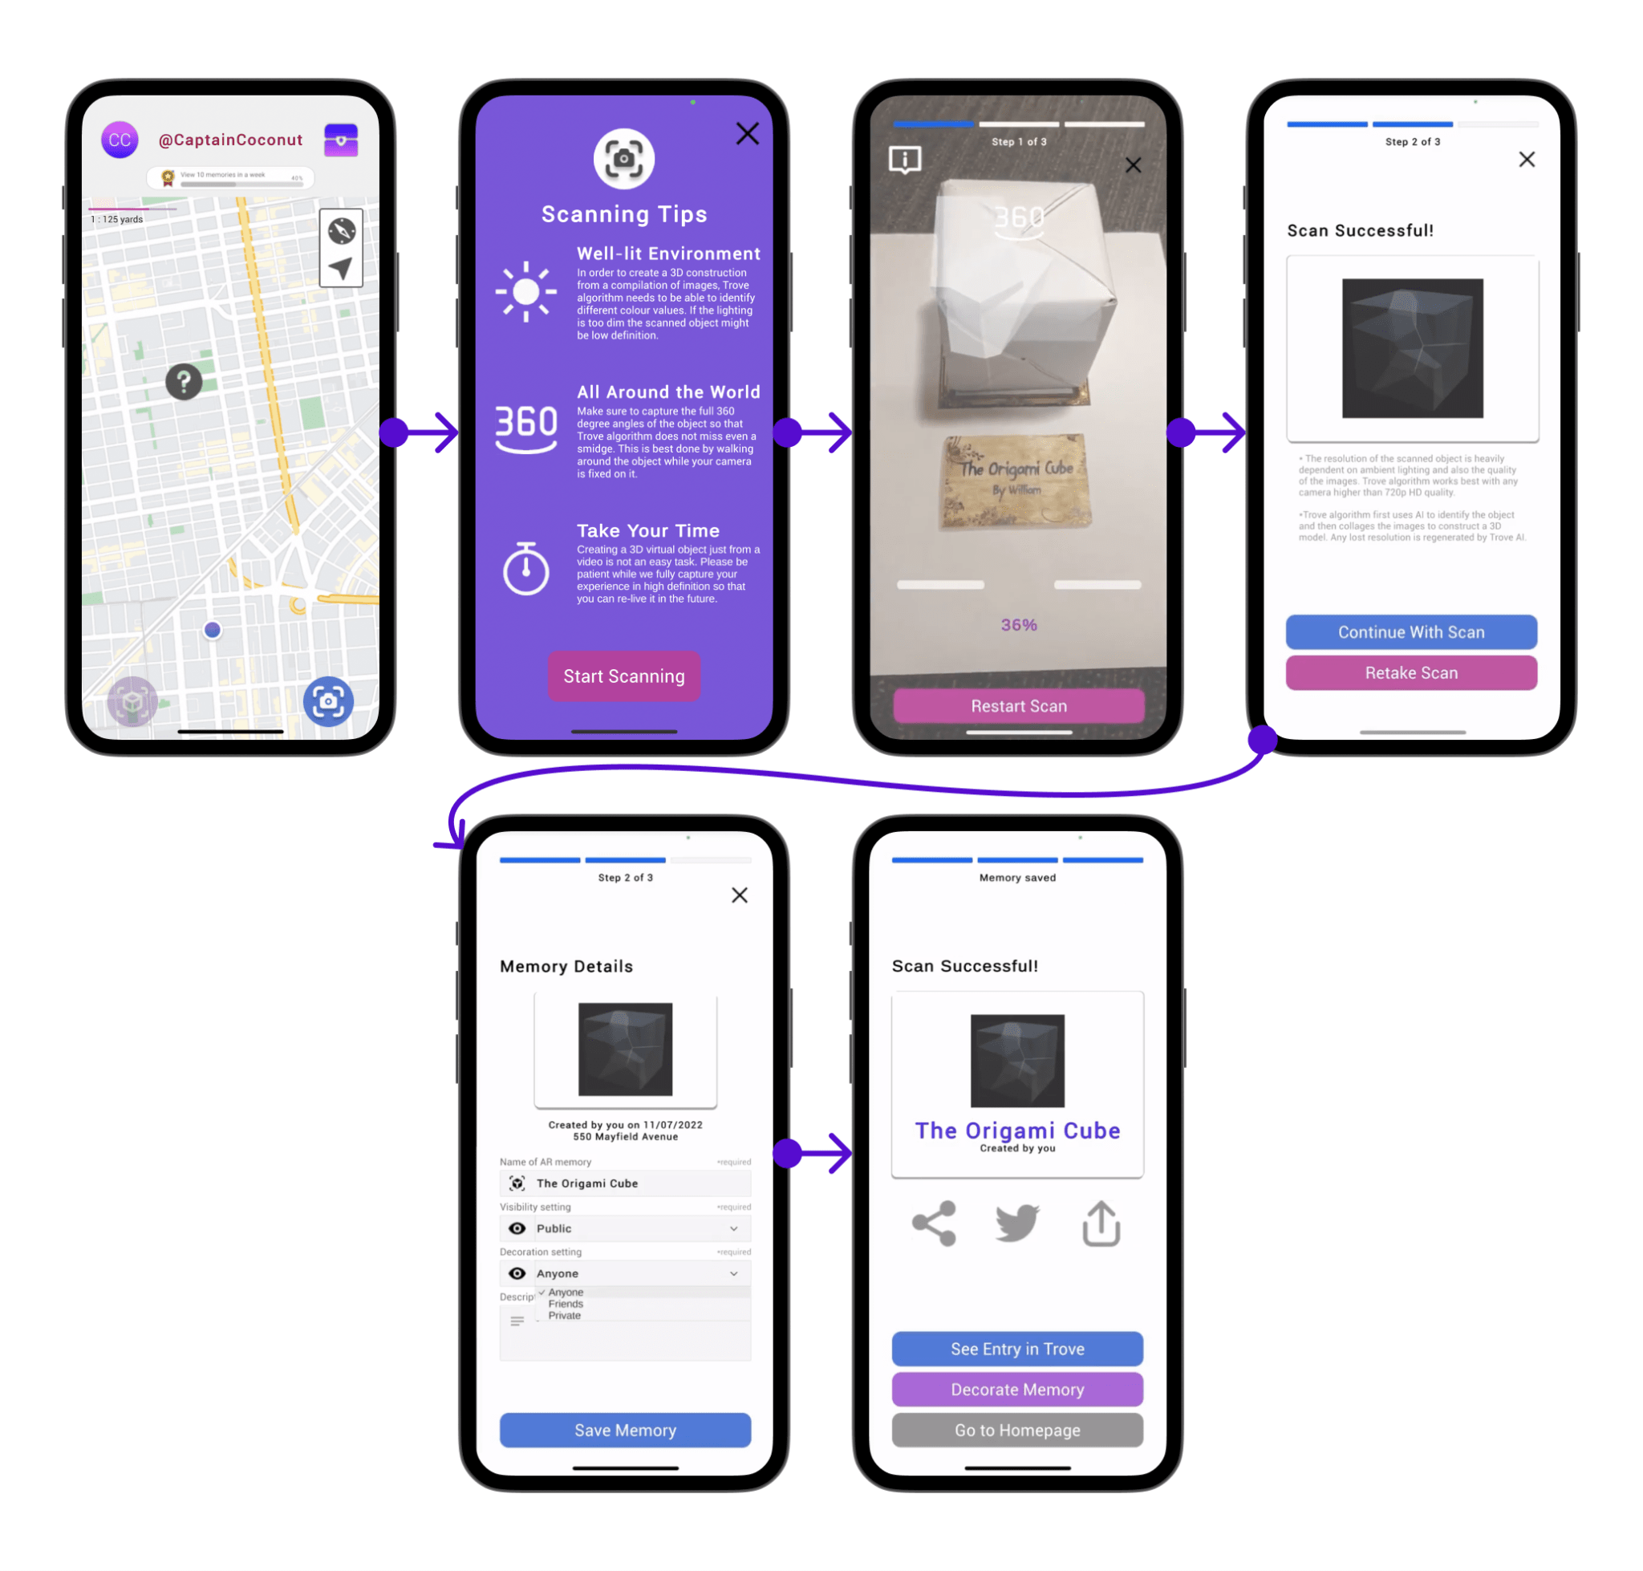

#### 

*Task 2 - Navigate to new Treasure and decorate it*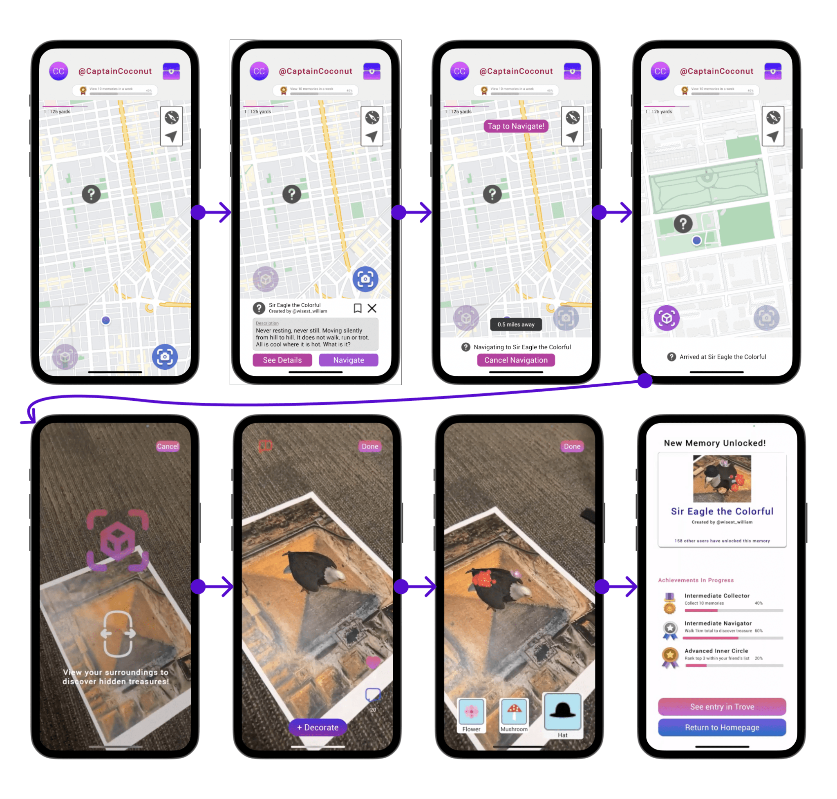

*Task 3 - View and edit a Treasure entry in your Trove.*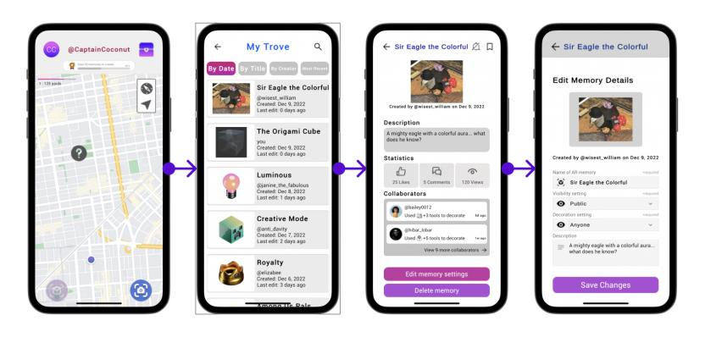

## Initial Design

After selecting our final solution, we explored possible modalities for our product, including map-based exploration, AR glasses, VR app, smart watch, and AR mobile app. After considering the pros and cons of each, we decided to choose an AR mobile app as our modality. Next, we storyboarded our three tasks, showing how each task would be demonstrated through our selected design realization. Below are example sketches from our top 2 realizations.

Sketches of our top two realizations: a smart watch (left) and an AR mobile app (right).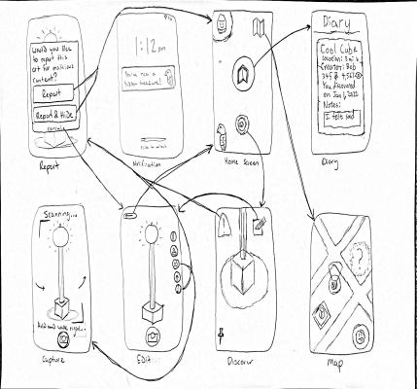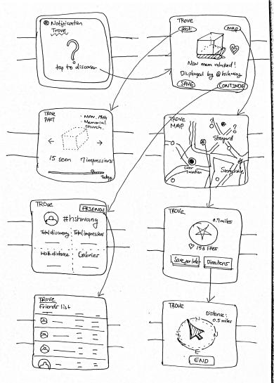

## 

## Low-fi Prototype

*Creation*

To create our low-fi prototype, we used both FigJam and paper prototyping. We used FigJam first in order to create a rough visual on what we’d want our overall system to look like. We decided on key screens based on our task flows and listed what kind of features each screen would have. Next, we created a paper prototype for usability testing. Below are the key screens in each of our task flows:

*Task 1: Key Screens in Low-Fi Prototype*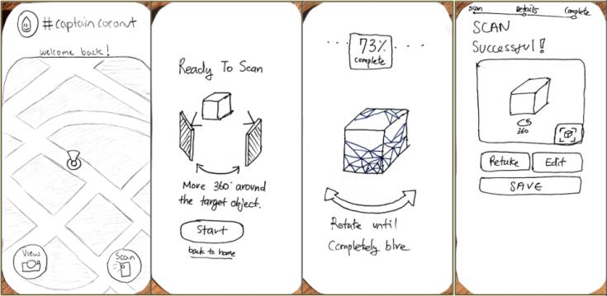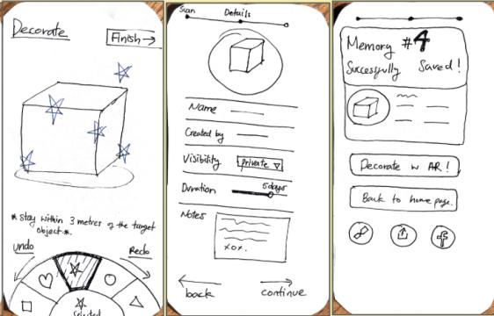

*Task 2: Key Screens in Low-Fi Prototype*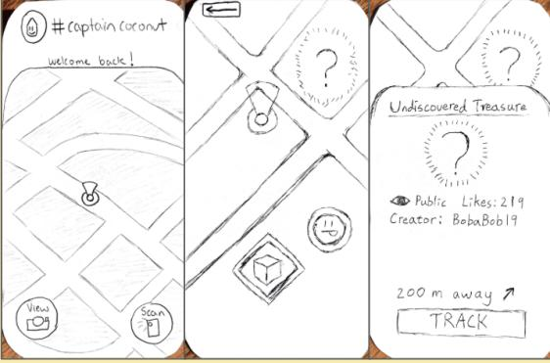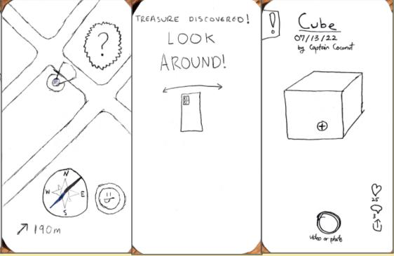

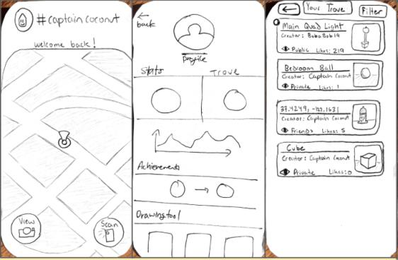

*Task 3: Key Screens in Low-Fi Prototype*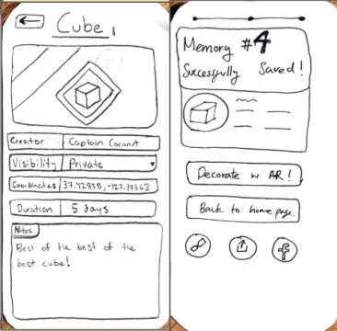

*Usability Testing*

Our target audience are 1) People who are artists or are interested in art and 2) are familiar with using social media apps. Therefore our goal for our usability testing was to find younger participants (ex: teens, young adults, millennials) who are engaging with art/architecture around them. We found four participants - one was a tourist taking pictures in Main Quad, one was a Cantor Arts Museum visitor, one was a university student interested in Product Design, and one was a photographer and heavy Snapchat user. For each participant, we explained what our app was and instructed them to complete our three tasks using our paper prototype. We showed them how to interact with our app, but not how to specifically perform our tasks. We encouraged the participants to think-aloud their thought process in navigating our app, and we made a critical log to document positive and negative incidents. After they completed all three tasks, we asked them how they felt about the tasks and the overall interface. During our usability testing we were looking at efficiency (i.e. how seamless it was to navigate our tasks) and level of enjoyment of the participants’ experience.

*Results & Feeback*

In summary, here are the design choices that participants found to be positive:

* UI was simple and clean; not too much clutter
* Navigating to a new Treasure was enjoyable;
* Customization option of Treasures made the experience more personable.

Here are the main issues our participants had with the low-fi prototype:

* They were confused on what the purpose of our app was.
* Although people liked the idea of a decoration page, the UI wasn’t intuitive, especially the decoration wheel.
* Accessing your Trove felt too cumbersome; there were too many steps
* Some of the floating-action button (FAB) icons didn’t match the user’s conceptual model of what the icon meant
* The instructions to scan in an object were confusing; people were scanning the phone in different directions than we envisioned

We also gathered feedback from our studio. They echoed similar confusion that our participants had about the purpose of our app and the need for more onboarding. They also advised us to adjust our tasks to match more of the needs of our target audience.

## Major Design Changes: Low-Fi to Medium-Fi

To create our Medium-Fi prototype, we decided to use Figma because of its robust and sleek prototyping tools. Our most notable UI changes between the Low-Fi and Medium-Fi Prototype and their visualizations are listed below.

*Changing the Decoration UI*

Our participants found the wheel confusing to interact with. In response, a continuous horizontal scroll of decoration tools that the user can swipe through.

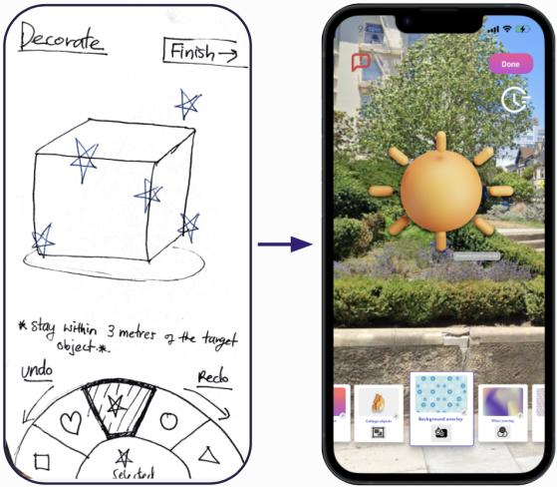

*Comparison of the Decoration page. The wheel (left) was replaced by cards in a horizontal scroll (right).*

#### 

*Eliminated use of compass as main navigation tool*

The compass didn’t reflect navigation in urban environments where directions aren’t in straight lines. Moreover, our participants had trouble interpreting directions from a compass.

In response, we removed the compass and adopted a Google Maps interface for navigation.

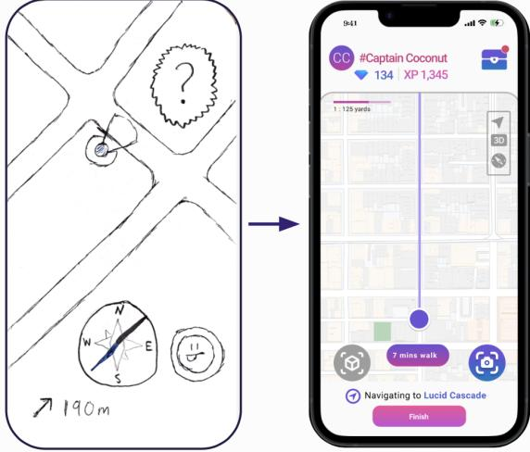

*Comparison of the Navigation Page. The compass (left) was replaced by GPS directions and a Google Map interface (right).*

#### 

#### 

*Adding onboarding for scanning in a physical object*

For Task 1 in our Low-Fi prototype, participants didn’t understand how to move their phone around to properly scan an object. In response, we added an instructions page that explains what scanning is and how to do it. We also added a percentage icon to notify the user of their progress while they were scanning.

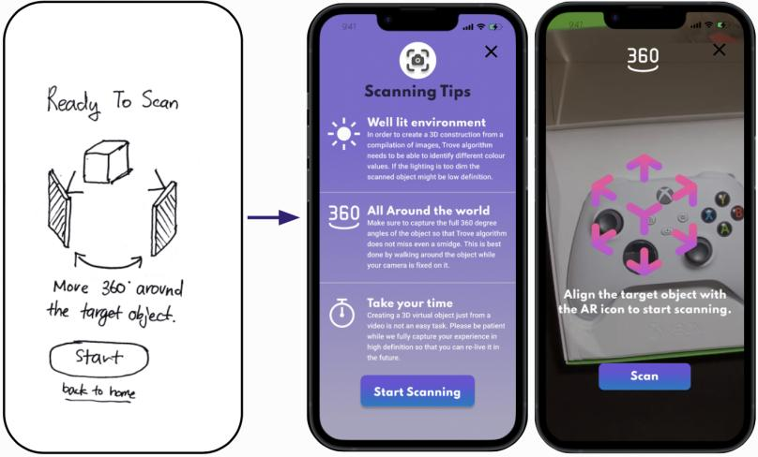

*Comparison of Scanning Onboarding. In the Medium-Fi (right), we added a scanning tips page and instructions on how to scan.*

#### 

#### 

*Creating a new FAB for My Trove*

Participants found accessing their Trove through the user profile to be too cumbersome, especially since it’s a major function. In response, we created a new FAB button with a treasure chest icon on the homepage that takes you directly to “My Trove”.

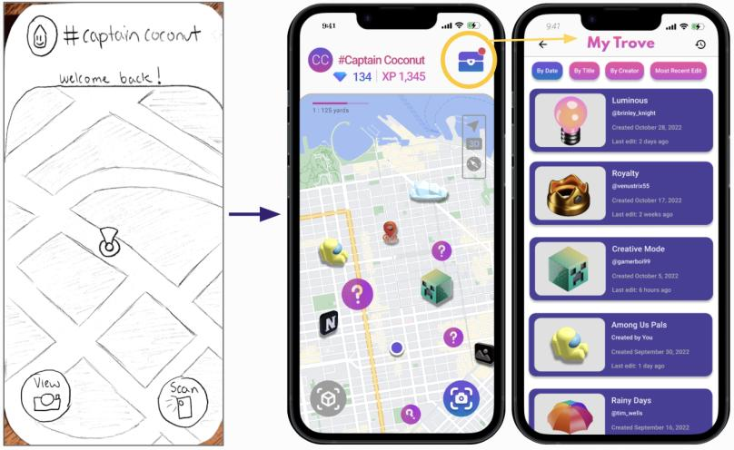

*In the Medium-Fi (right), a treasure chest icon was added on the homepage that takes the user directly to their Trove.*

In addition to the UI changes in our Medium-Fi prototype, we revised how we described the purpose and functionality of our app to be more concise and understandable to the general user.

## Major Design Changes - Medium-Fi -> High-Fi

In order to transition to the high-fi prototype, we had a heuristic evaluation done for our medium-fi prototype. There were 87 violations, 30% which were severity 3 or 4. Below are the major violations (severity 3 & 4) that we addressed for each task, as well as any notable minor changes that were made.

*Major UI Changes for Task 1*

* H1: Visibility of system status / Severity: 3
  + Problem: During scanning, progress is reflected by a percentage number, which is not the most visual or intuitive.
  + Solution: Show a digital form of the object that also reflects scanning progress. The more visible it is, the closer to finishing. In addition, at the top, the scanning page is labeled as Step 1 out of 3.
* H6. Recognition not Recall / Severity: 3
  + Problem: The two buttons on the bottom for scanning and viewing an object do not represent their function clearly and distinguishably enough.
  + Solution: Icons for both the scanning and viewing button were replaced to be more pertinent and recognizable to the specific action.
* H10. Help & Documentation / Severity: 3
  + Problem: When scanning an object, only the “360” icon at the top provides information on what to do once you’ve started. The user can’t access the scanning tips after the scanning starts.
  + Solution: Captions were added to the scanning page to provide additional instructions.

*Minor changes for Task 1*

* H3. User Control & Freedom / Severity: 1
  + Problem: While scanning in an object, there is no button to restart or redo just a portion of the scan. One would have to click the ‘X’ and start over.
  + Solution: Added a retake scan on the scanning page.
* H8: Aesthetic and Minimalist Design / Severity: 1
  + Problem: On Page/Step 2 of the scanning process, “Retake Scan” is above “Continue with Entry”, despite the latter being the most likely first option that users would want to make.
  + Solution: Switched “Continue with Entry'' to be on top. Color was changed from fuchsia to blue to assert importance.

*Violations not Addressed for Task 1*

* H2. Match between system and the real world / Severity: 3
  + Problem: It is unclear what the purpose of scanning is, whether it’s to share, keep for yourself, make the object customized by decorating etc.
  + Reason for not fixing: Ideally this would be included in a general onboarding/tutorial page, but we did not have time to implement this.
* H3. User control and freedom / Severity: 3
  + Problem: The artist is unable to limit (or expand) the options for decorations that people add to their art, or opt out of their art being decorated at all.
  + Reason for not fixing: This is not necessary to demonstrate the main part of our task.
* H5. Error Prevention / Severity: 4
  + Problem: The objects in the map seem like digitally produced, animated objects (iceberg, Among Us character), that could not exist in the real world (which makes sense as they are classified as AR art). However, when I scan an object, it seems like it must be something that is physical. It is confusing why others’ objects seem digitally produced.
  + Reason for not fixing: Our team thought this was more of a severity 1 than a severity 4. In addition, this fix wasn’t necessary to fully demonstrate this task.
* H7. Flexibility and efficiency of use / Severity: 4
  + Problem: The platform only permits the scanning of physical objects. An advanced user may want to upload art they produce digitally for others to view, whether 2D or 3D.
  + Reason for not fixing: Although our team agreed this would be beneficial for creative expression, we thought this was not necessary in order to show the main functionality of Task 1.
* H10. Help and Documentation / Severity: 3
  + Problem: The app uses the abbreviation “AR”, instead of “Augmented Reality” in the scanner introduction page since the beginning. Given that the target user is a beginner, they could be confused by the use of ‘AR’ without explanation if they haven’t been exposed to the technology before
  + Reason for not fixing: Ideally this would be included in a general onboarding/tutorial page, but we did not have time to implement this.

*Major UI Changes for Task 2*

* H1 Visibility of System Status / Severity: 4
  + Problem: After arriving at an object, the user still has the option to scan in their own object. It is unclear if this means scanning in an alternative object in the same spot, adding a new scanned object to the existing art, or if this button is a mistake and should not be there.
  + Solution: The scanning button used to create your own Treasure is grayed out.
* H4 Consistency & Standards / Severity: 4
  + Problem: While navigating to an object, the finish button is pink and at the bottom of the screen, reminiscent of the continue flow buttons elsewhere throughout the app.
  + Solution: “Finish” was changed to “Cancel Navigation” in order to make it clear on what pressing that button does.
* H5 Error Prevention / Severity: 3
  + Problem: Throughout every screen on the process of navigating to an object, the options to view an object and scan in an object are both still present and clickable, even though they would take you away from this flow. Users may tap those buttons by accident and be disrupted from the task of navigating to the AR component.
  + Solution: View and scan buttons were removed once navigation begins.
* H7: Flexibility and Efficiency of Use / Severity: 3
  + Problem: When the user clicks on a question mark for art they want to discover, the info provides previous comments, like, # of edits etc, but doesn’t provide the description of the art piece, or what feelings it evokes. The user may care more about content and feelings than distance / other people’s input or opinions on the art.
  + Solution: Added a description of the art piece. Hid comments, likes and # of edits under “See Details”.
* H8 Aesthetic & Minimalist Design / Severity: 3
  + Problem: The “Caution!” page pops up when trying to navigate somewhere. It uses triangles with exclamation points and bright pink. The “caution!” page popup is distracting and could result in the user’s gaze being directed to their phone in confusion — which is the opposite of what it is intended to be doing. Additionally, the exclamation points are associated with an error that the user needs to address, exacerbating this problem.
  + Solution: The “Caution!” page was removed altogether. Ideally, this would be mentioned during onboarding.
* H11: Accessible design / Severity 3
  + Problem: In the Viewing Screen, many icon buttons’ colors here are not standardized and do not have a good color contrast with the background.
  + Solution: Changed colors to have higher contrast and match the design system.
* H11: Accessible design / Severity 3
  + Problem: The text in the decoration option cards is too small.
  + Solution: Enlarged the text and included a clearer image.

*Violations Not Addressed for Task 2*

* H1 Visibility of System Status / Severity: 3
  + Problem: After decorating, the top right still says “Done”. It is unclear if your edits are saved or if there is a way to Cancel.
  + Reason for not fixing: Our team believed that “Done” conveys that something was saved. However, we made an error in not providing an option to cancel the edits.
* H3. User control and freedom / Severity: 3
  + Problem: there is no eraser for decorations, only undo. Users may want to erase a decoration they did towards the beginning, which is only possible with undoing if they delete most of their art.
  + Reason for not fixing: We made an error in not providing an option to cancel the edits.
* H4 Consistency & Standards / Severity: 3
  + Problem: After tapping on a question mark, the map changes to zoom in showing instructions. The way to exit is an ‘X’ about a quarter way up the screen on the right, which is different from either the traditional upper left location of a back button or the ‘X’ in the upper right on the screen when scanning an object.
  + Reason for not fixing: Team believed this was a severity 1 instead.
* H7: Flexibility and Efficiency of Use / Severity: 3
  + Problem: The user can see other peoples’ comments when they are about to begin the navigation, but there is not a place (at least in this prototype) where they can add their own. It limits the user’s ability to interact with the art if they can’t comment on it
  + Reason for not fixing: This was not essential for the functionality for Task 2.
* H10 Help & Documentation / Severity: 4
  + Problem: After successfully navigating to the object, you get an alert instructing you what to do next. Instead of instructing the user what to do in this instance, the design should be clear enough that they know what to do upon arrival.
  + Reason for not fixing: Ideally this would be included in a general onboarding/tutorial page, but we did not have time to implement this.
* H12. Value alignment and inclusion / Severity 3:
  + Problem: The achievement “Advanced Inner Circle” could be a bit exclusive for users who tend not to create many entries or walk a long distance to discover treasures.
  + Reason for not fixing: Though we agree this violation, we thought this was more a severity 2 since this was’t essential towards completing Task 2.

*Major UI Changes for Task 3*

* H1 Visibility of System Status / Severity: 3
  + Problem: When you click on a treasure in the trove, you enter a page where you can freely edit or change attributes of the object. There is no “edit” or “save” button, however.
  + Solution: Added a FAB titled “Edit memory settings” that navigates you to an editing page. On the editing page, a FAB “Save” button was added as well.
* H3: User Control & Freedom / Severity: 4
  + Problem: When you are editing an entry in your trove, there is no way to actually edit the object itself. It is confusing why, while editing an item in the trove, you can’t actually interact with or edit the item itself.
  + Solution: Added a FAB titled “Edit memory settings” when you view a specific entry in your Trove.
* H11: Accessible design / Severity 3 /Found by: D
  + Problem: On the “My Trove” main page, the text color in each card may not achieve the accessibility ratio.
  + Solution: Changed the color of each card to be a light gray, and the text to be black.

#### 

*Violations not Addressed for Task 3*

* H6: Recognition rather than recall / Severity: 3
  + Problem: It is unclear whether the “Last edit” is by the owner of this trove or the creator of the memory or some other users.
  + Reason for not fixing: We recognize this violation as more of a severity 2. It’s not essential towards completing Task 3.
* H7: Flexibility and efficiency of use / Severity: 3
  + Problem: Description: The trove entry doesn’t allow you to view the progress of your art (what other people have added). The absence of an opt-in feature to view progress of the art limits its usability to an interactive artist. It may be essential to the nature of the art that the artist sees its evolution.
  + Reason for not fixing: We didn’t have enough time to implement this.

## 

## Values in Design

Based on our needfinding and usability testing, we aimed to prioritize three values: Creative Expression, Making Art Interactive, and Community-Building. Our app demonstrates these values by:

* Introducing a new, novel tool (scanning in a physical object) for users to use when creating their own Treasure
* Providing the option to decorate Treasures with AR decorations
* Turning the activity of viewing art into a treasure hunt
* Actively editing memory settings
* Having the ability to see and add on to Treasures other than your own

However, some of our values were more prominent in our app than others. Community-Building was not as reflected in our final design as we would have liked, as many of the potential social media features were hard-coded. For example, there was an idea to center a task around sharing the location of a Treasure with a friend, but we did not have time to implement this. In hindsight, we ended up prioritizing novelty the most and in consequence sacrificed much-needed attention towards Community-Building.

We also recognize that our app could compromise users’ safety should it be deployed at scale. For example, we would need to prohibit certain types of location from being used as hotspots for Treasures, such as roads and private/protected property. We would also need to limit the number of Treasures that can be placed in an area to prevent overcrowding.

# Final Prototype Implementation

## Tools used, Pros and Cons

Our development platform was Unity, a popular 3D game engine. We chose to use Unity because it has built-in support for AR image tracking, which is necessary for our product. Auxiliary 3D tasks like detecting where a user taps on a 3D model for decoration is also made very easy by Unity. However, the biggest drawback to using Unity was the UI. Unity makes it hard to create a real backend, so a lot of our screens had to be hard-coded entirely. This would likely not have been the case if we had developed the app in React Native. Unity also makes it difficult to have clean UIs, as it's not a development platform aimed at mobile apps

## Wizard of Oz Techniques

The scanning procedure is implemented by Wizard of Oz. We would have needed to implement a real, computer-vision scanning algorithm to complete this task… and that’s relatively novel technology that was not feasible for the duration of this project. Furthermore, we were only able to make it downloadable for Android devices.

## Hard-coded Techniques

In order to showcase everything we imagined for our app, we had to hardcode a variety of elements.

1. User profiles (including your own) were hardcoded. The user profiles shown in the comments, the Statistics screen, and the Collaborators screen are static values. They are also shared across all of the Trove entries.
2. Trove entries are hardcoded. On the ‘Edit memory settings’ screen, users can modify the default values. However, those changes are not propagated across screens.
3. Likewise, the details for the new Trove entries are hardcoded after the Decorating and Scanning screens. Again, users can modify the values on the ‘Edit details’ screens, but those changes will not propagate through the app.
4. Navigation is hardcoded. It was unreasonable to expect users to walk across the city to experience our app! As such, we implemented a button which allows users to simply tap the screen to navigate.
5. The map itself is hard-coded. We are not tracking the user’s location. Instead, we have arbitrarily placed them in San Francisco.
6. The achievements seen throughout the app are static values.
7. There are two hardcoded AR tracking images, one for scanning, one for decorating.

## Other Limitations

1. Major bug: AR tracking will fail to work if Scanning and Decorating are accessed in the same session of the app. After successfully Scanning, completely close the app before attempting Decorating, or vice versa.
2. There is no data being saved, locally or remotely.
3. While an icon for the Profile page is shown, there is no Profile screen.
4. While icons for bookmarking a memory and turning on/off notifications for a memory are shown, they are unclickable.
5. There are only two AR objects implemented, one for the Scanning Task and one for the Decorating Task.
6. There are only three tools to use during the Decorating task.
7. Account creation is not implemented. Similarly, there is no sign-in page.
8. Users can access the report screen when viewing an AR memory. However, the actual report functionality is not implemented.
9. An auxiliary task we had hoped to implement but were unable to is Time Travel. Time Travel would allow users to see the full history of an AR memory when viewing it.

# Reflection & Next Steps

As the class has come to an end, our team has come to realize how difficult design thinking can be. Although we were able to create a product in ten weeks, it is apparent that we made many, many mistakes during the design process that affected the quality and applicability of our end product. More specifically, there were two major pain points our team had:

*Needfinding*

Trove consistently suffered from unclear values because we didn't find a concrete need at the very beginning. By the time we realized this, it was too late to conduct more interviews that would be more relevant to our solution. Moreover, because of the lack of a concrete need, we ended up making a product that aligned more with our wants and biases, rather than the needs of our target audience; we tried adding more features than were actually needed. However, we believe that these problems arose more because of the short timeline of the class.

*Mismatch in Values*

We did not establish concrete values until after we started development of our medium-fi prototype. Moreover, the values we chose were made to fit our solution, rather than the other way around. As mentioned before, we, in reality, ended up prioritizing novelty over our other named values. In consequence, our tasks didn’t fully reflect those values. We neglected to implement UI that would convey those values in a more concise, simple manner.

*Insufficient Definition of Purpose and Tasks*

Much of the criticism we received throughout developing this product was confusion on the purpose/function of our app, and how our specific tasks reflect the needs of both our target audience and our established values. Unfortunately, we did not implement this kind of feedback as much as we should have; we felt we were unable to incorporate such feedback without drastically changing our project. Moreover, our project took a more unconventional approach to our studio’s theme, which was “time”. It was another case in which we molded the theme to fit our selected needfinding insights and solution.

Although we considered our product to be unsuccessful, we’ve learned valuable lessons about the design process along the way. CS 147 highlights the importance of brainstorming not only in the design world, but in every aspect of life. The creative 'pipeline' we learned in the first few weeks of the quarter have forever changed how we approach design choices on a day-to-day basis. We also recognize the importance of the “Define” stage, especially while creating experience prototypes and the low-fi prototype. The more effort put into crafting genuine POVs, HMWs, and experience prototypes, the more valuable feedback we can receive to greatly improve the next iteration of our product. Lastly, we felt that our studio theme was interesting. Even though it wasn't reflected as much in our final product as we first envisioned, it got us to think - What does it really mean to center yourself at a particular time?

If we were to continue this project in the future, here were some of the ideas we had on possible additions or changes:

* Shifting Trove to be more of a journaling platform. It would be fully customizable to the user's preferences, with built-in options for visual and audio media, and a layout that could be entirely re-structured at a moment's notice.
* Creating a “Time Travel” feature, where users can view the full revision history of a Treasure. This would communicate our values in a way that our app currently lacks.
* More diverse ways to create and decorate a Treasure.
* In order to draw users to the app first, Trove could partner with local artists and museums to create Treasures that people can first start looking for.
* Adding a robust onboarding process; change it to be our complex task.

#### Acknowledgements

We would like to give special thanks to Professor Landay for his instruction of CS147, and to our CA, Krishnan Nair, for his valuable guidance and support.