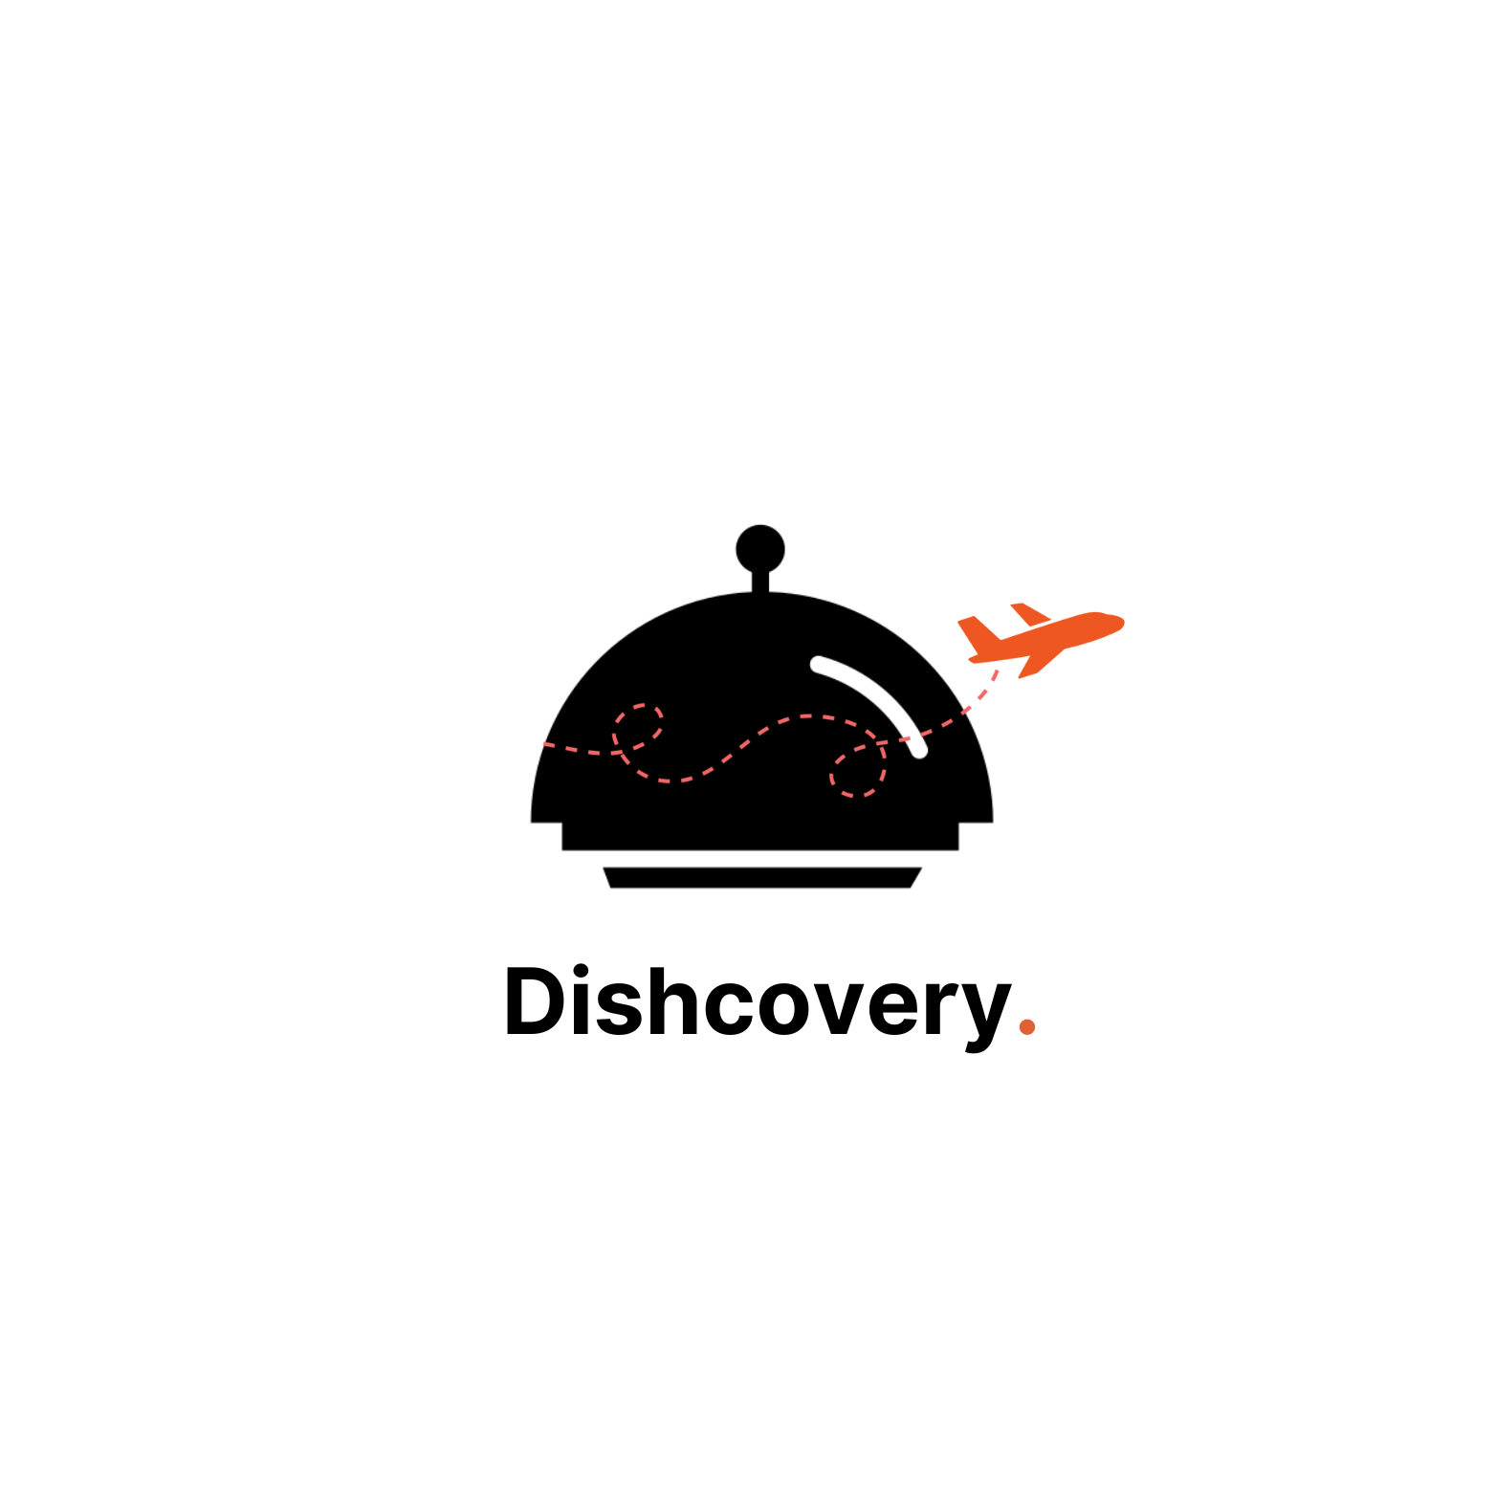

Final Report

Table of Contents
- Value Proposition
- Team Member Names and Roles
- Problem/Solution Overview
- Needfinding
- POVs, HMWs, and Experience Prototypes
- Solution Generation
- Design Evolution
- Final Prototype Implementation
- Reflection and Next Steps

Value Proposition
Dishcovery is your cultural culinary companion from the grocery store to the kitchen.

Dishcover-ers and Roles

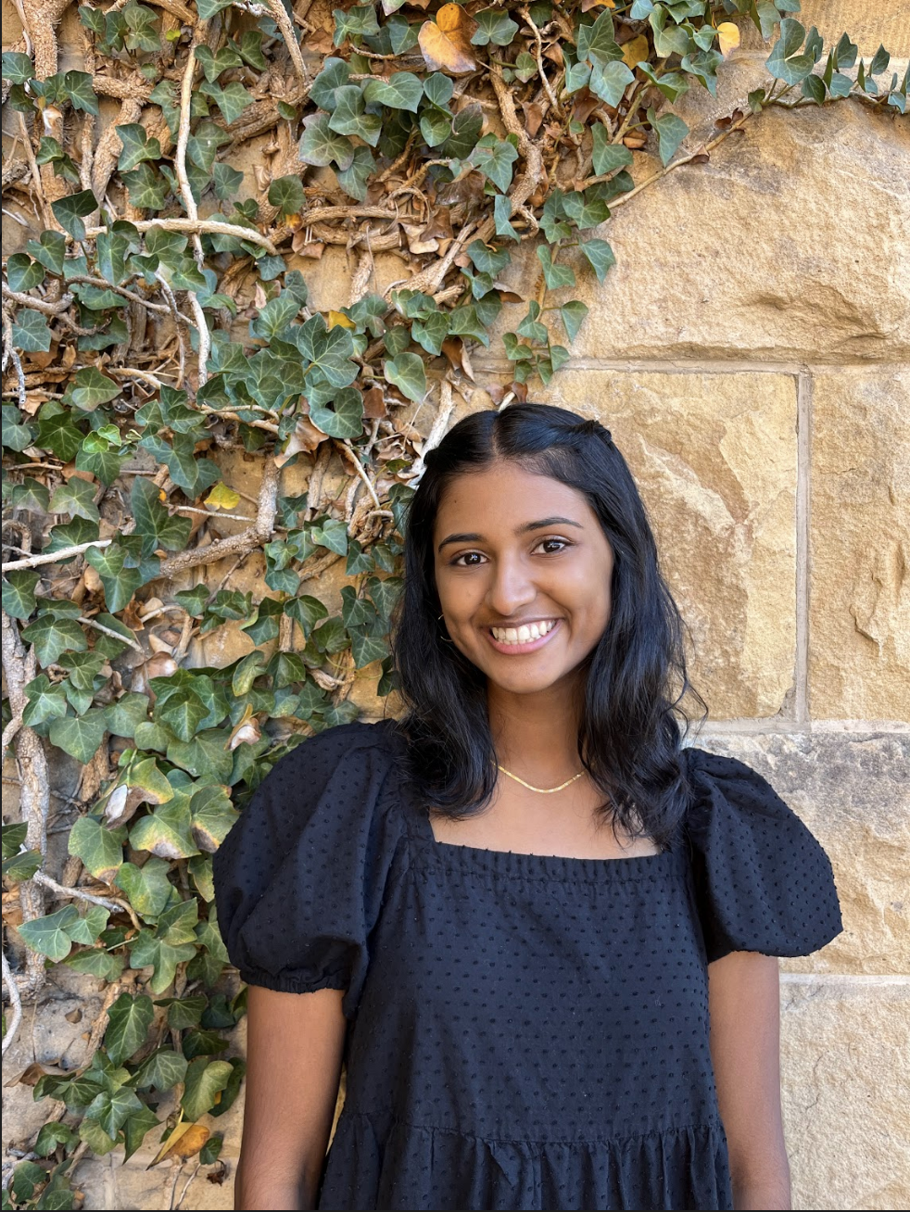

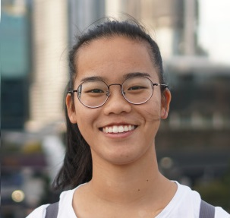

Defne Genc
Role: UI Designer
Dish of Choice: 🍵

Kyla Guru
Role: Software Engineer
Dish of Choice: 🍰

Amrita Palaparthi
Role: Product Manager
Dish of Choice: 🧀

Janet Zhong
Role: Software Engineer
Dish of Choice: 🍜

Problem/Solution Overview
Through our needfinding interviews, we observed hesitation and insecurity around trying to cook foods from other cultures. As we followed this thread, we found that the source of the hesitation came in fact, from the ingredients rather than the dishes themselves. Moreover, Dishcovery’s mission is to help users recognize, learn about, and cook with foods from around the world. Dishcovery uses image recognition to identify new ingredients and enable you to delve into their cultural context. Dishcovery can help find authentic recipes using these specific ingredients, effectively providing a cultural culinary companion from the grocery store to your kitchen.

Needfinding
In our needfinding process, we interviewed a total of six people who had vastly different relationships with cooking, ranging from head chefs at a business/dining halls (extreme user) to an everyday consumer of food (typical user) to industry experts like store owners and startup founders. We recruited our interviewees by going to a variety of different settings where these user groups may exist (e.g. Farmers Market stands, coffee shops, Asian markets, Stanford dining), and asking whether they would be willing to share about their food experiences with us. Each interview was in-person, around 30-minutes in length, and there was an interviewer and an observer/note-taker present for each interview. In short, the profiles of our interviewees are as such:
- Martin: 30’s, no strong cultural ties, not particularly “food-motivated”
- Grace: Immigrant from Taiwan and store-owner of Asian grocery store
- Jaclyn: Immigrant from Peru and head-chef of Comida Peruana
- Sofia: Immigrant from Mexico, Chef at Xanadu House at Stanford
- Amy: Server at Decadence at Stanford
- Jeson: Immigrant from Malaysia, Founder of OpenChefs (cultural food delivery option)
Moreover, from Martin at Verve Coffee, we learned that although he prides himself on being able to recognize “well-made food with high quality ingredients,” he remains hesitant about cooking the same cultural meals alone at home. This was similar to Amy--who hasn’t gotten herself to cook her favorite and most savored meal, her mom’s Southern hot-water cornbread, ever since her mom’s passing. When asked why, she remarked that she would consider making it only if she “found a recipe that lived up to her mom’s flavors”.
Additionally, we observed from Grace that this hesitation to start cooking authentic recipes may root from an overall issue of cultural dissonance she noticed in her store customers as well--Grace shared with us that when customers come in with recipes for Asian cooking, the ingredients they are searching for are not normally authentic, and there is a general hesitation towards seeking out authentic ingredients due to language barriers, insecurity, or unfamiliarity.
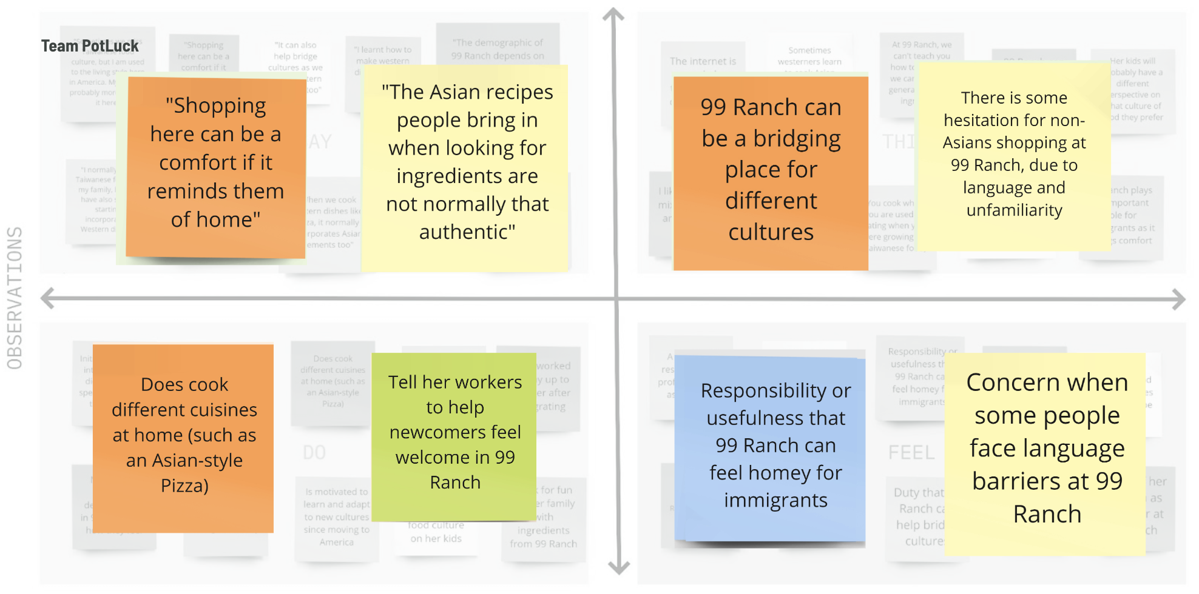Empathy Map for Grace, Manager of 99 Ranch showcasing how she felt like the store brought people “home,” yet users still were hesitant or unsure how to blend their preferences with traditional ingredients and culture.
Additionally, through Jaclyn’s strides to bring Peruvian culture to the Bay Area, another interviewee, she resonated with the idea that she herself had not had as good of Peruvian food in the US as what she was able to find in Peru. She believed that the context behind the food is what makes the experience meaningful and what makes people mindful of what they put in their bodies--something missing from experiences people have at Peruvian restaurants in the US. In fact, she gave us some of her delicious, homemade quinoa to try and told us a story of how quinoa came to be in the ancient Incan empire. She described that the Chasqui Peruvian Messengers would gain strength by eating quinoa on long journeys to deliver messages.
Recurring themes that we saw through our initial interviews was the overarching value on authenticity in cooking (including the critical use of authentic ingredients in order to make the dish as a whole authentic), general differences in outlook amongst potential users ranging from seeing cooking as transactional (a means to an end for income) or a deeply personal and intentional experience. Moreover, though we sensed a deep pride of certain individuals in their own cultural cuisine, we also sensed a general hesitation of interviewees towards cooking cultural foods or sharing their cultural food outside the culture, due to worries about perfectionism and being unsure that cultural cuisines would be palatable to individuals of different cultures.
With this, we headed into our brainstorming/ideation phase with efforts to break down the barriers of entry to cooking cultural foods—ensuring the use of traditional ingredients and providing enough enriching context to empower the user to make culturally-grounded decisions around trying new cuisines.

V. POVs, HMWs, and Experience Prototypes
Following our interviews, we decided to proceed with developing POV statements for Sofia, Grace, and Martin. The resulting POVs are as follows:

Martin
We met…
- Martin, a real estate developer and avid biker from Oakland in his 30s, who makes only very simple meals for himself a few times a week.
We were surprised to realize that…
- Despite taking pride in his ability to appreciate well-made, home-cooked meals and making an effort to focus on the cultural authenticity of food, he doesn’t describe himself as food motivated and feels like cooking complex dishes for himself isn’t worth the time and effort investment.
We wonder if this means…
- He needs to understand the personal stories and cultural context of food in order to be more emotionally connected to it and be excited to cook it as a worthwhile experience.
It would be game-changing to…
- Help people feel connected to the cultural context and stories behind dishes in a way that makes cooking other cuisines feel personal.

HMW statements we generated included:
- “How might we help people share the personal and cultural meaning of their food with others so that they can understand and appreciate them?”
- “How might we connect food with specific memories and shared experiences?”
- “How might we make the process of cooking a more complicated meal for oneself feel worthwhile?”

A HMW statement we pursued was:
“How might we present recipes in their proper cultural or historical context without losing personal stories associated with them?”

Our HMW was focused on helping “non-food-motivated” people like Martin connect with other cultures by being inviting and by providing them with the information they may need. For this, we came up with a solution of a map displaying the food journeys an ingredient goes through, with cultural context and personal stories associated with them.

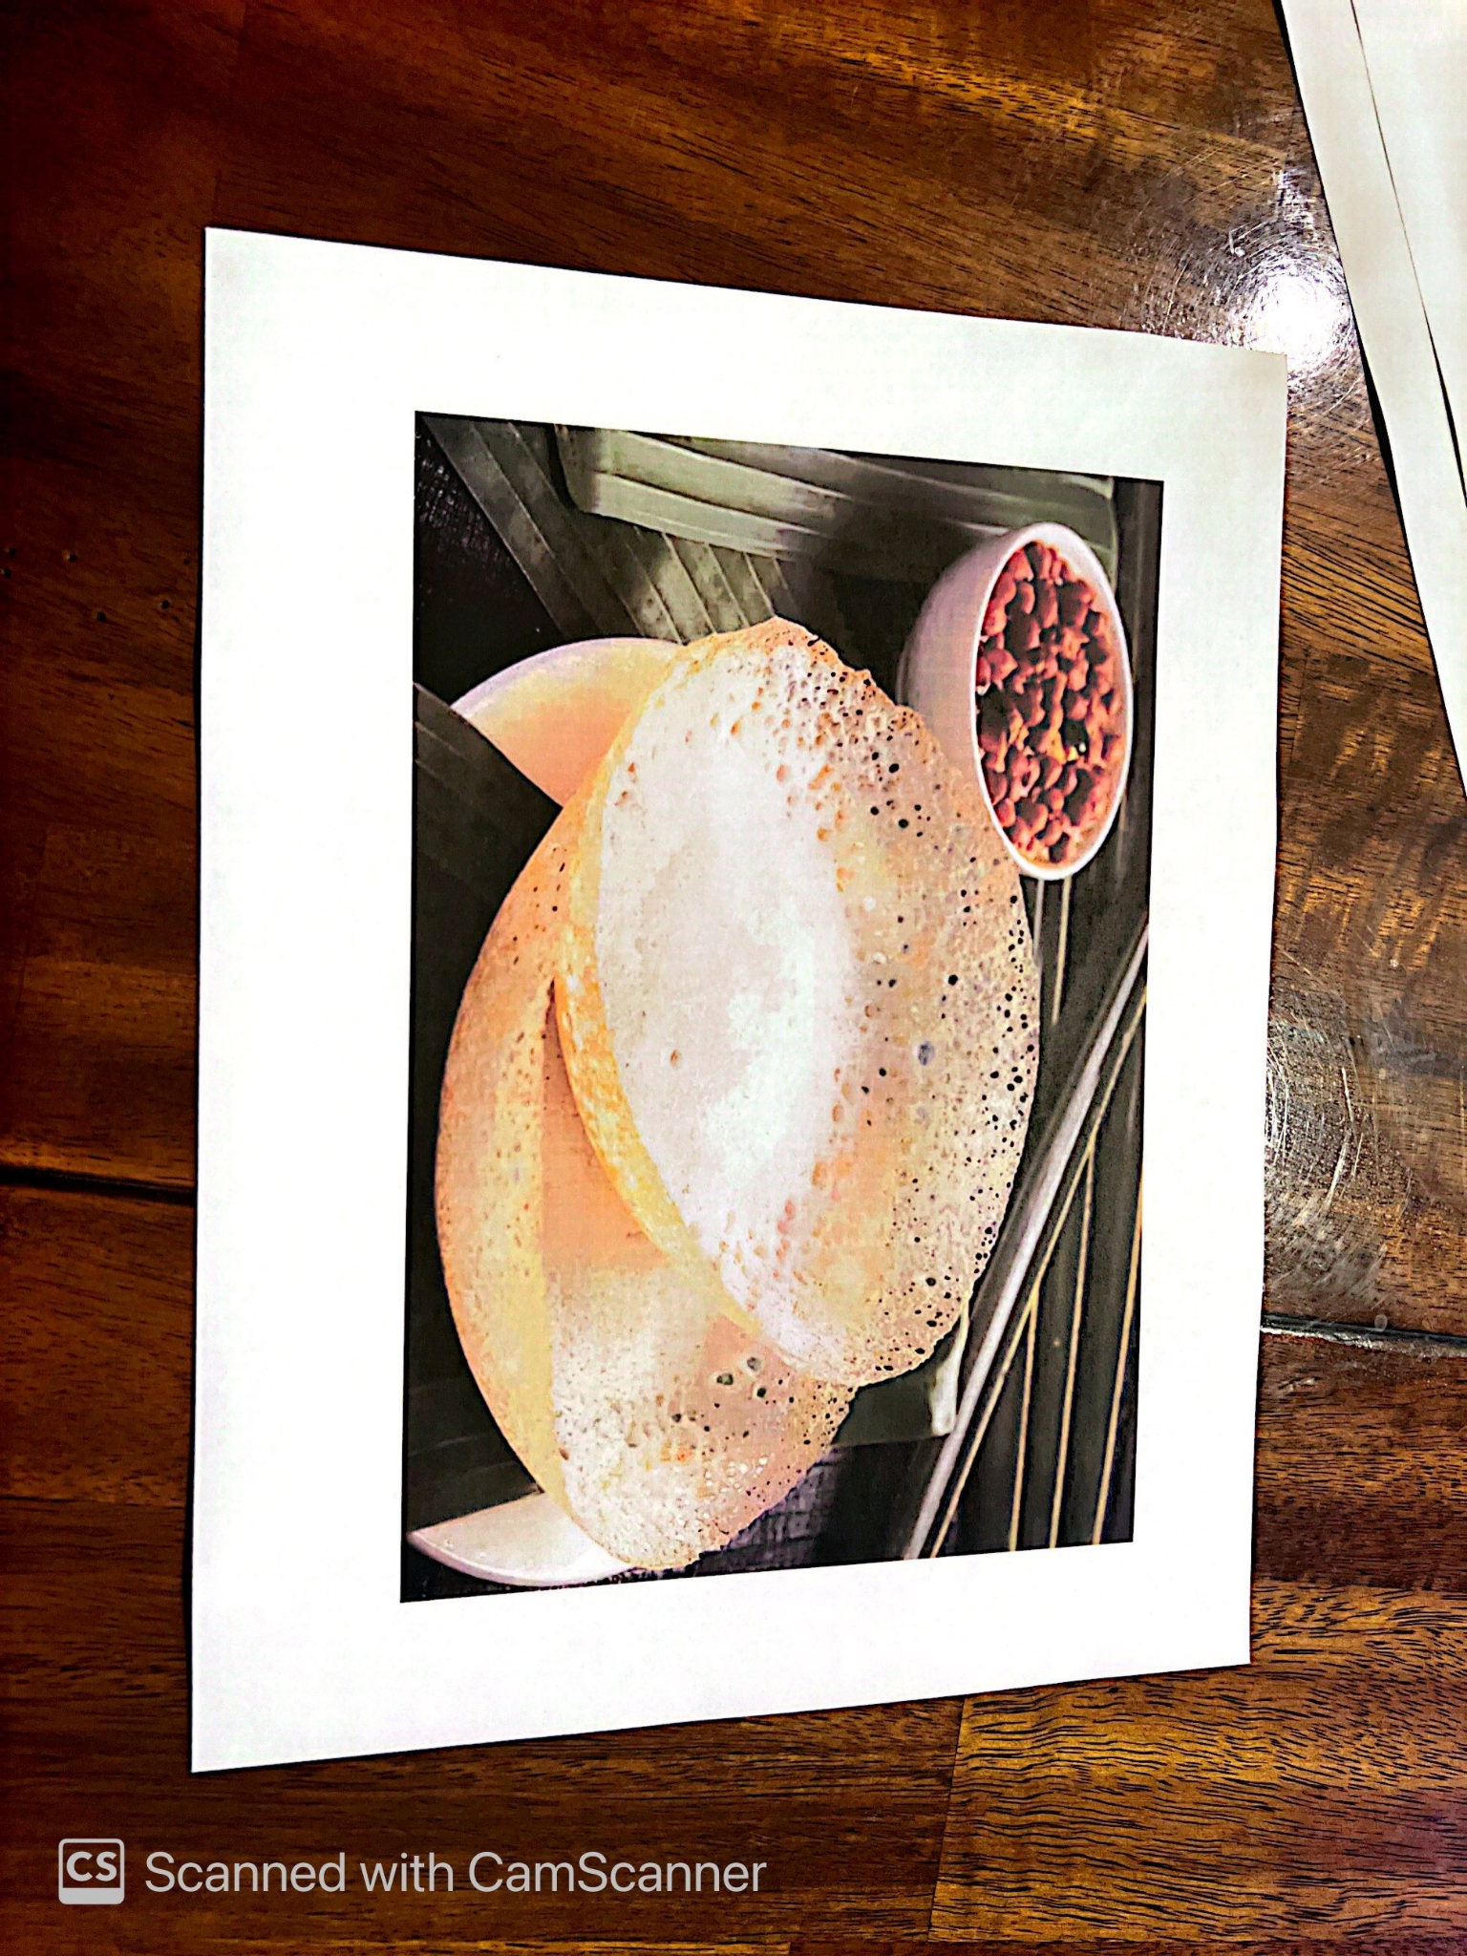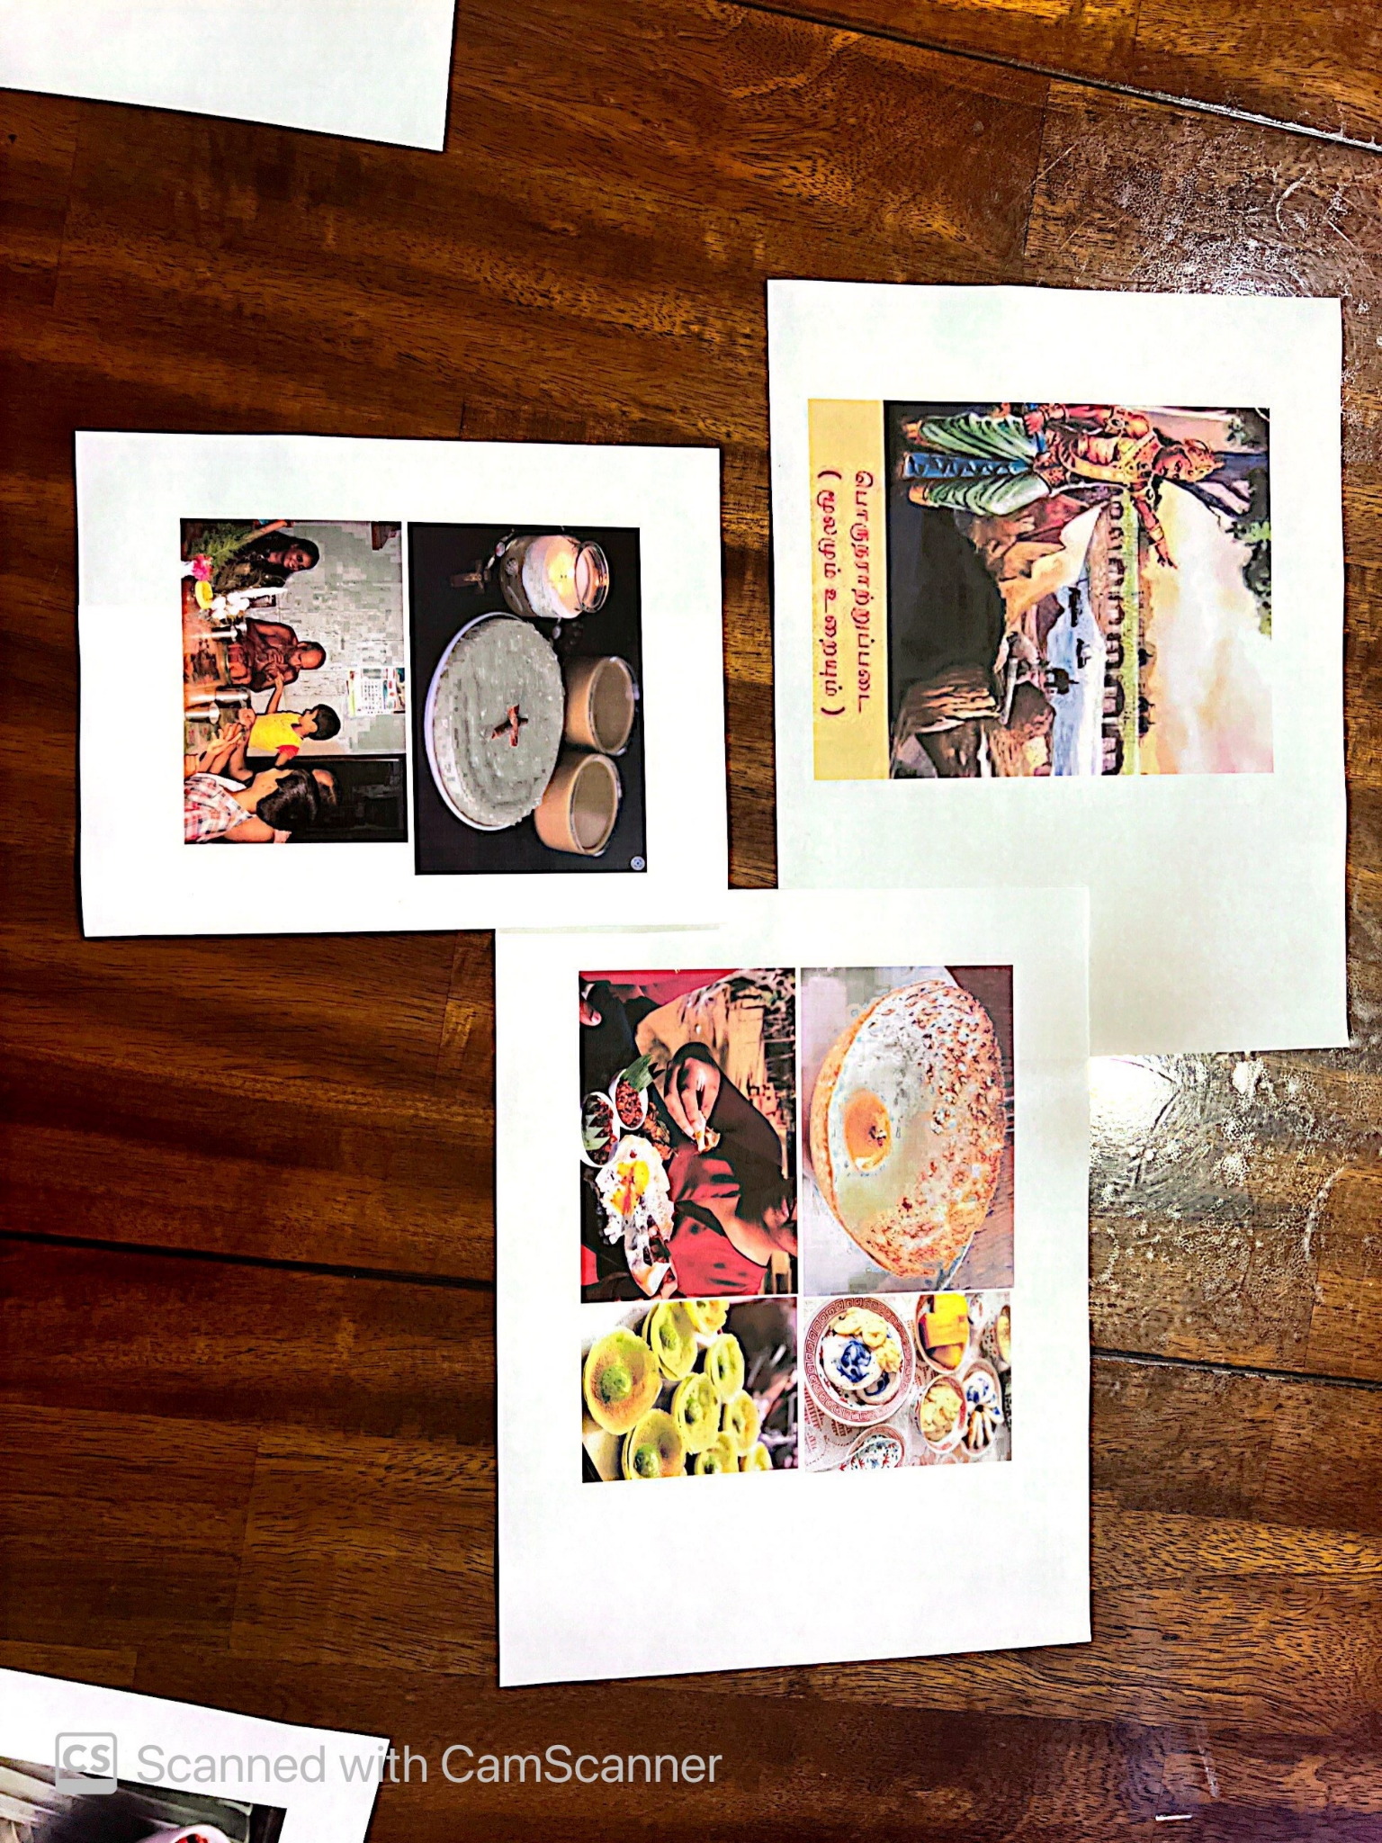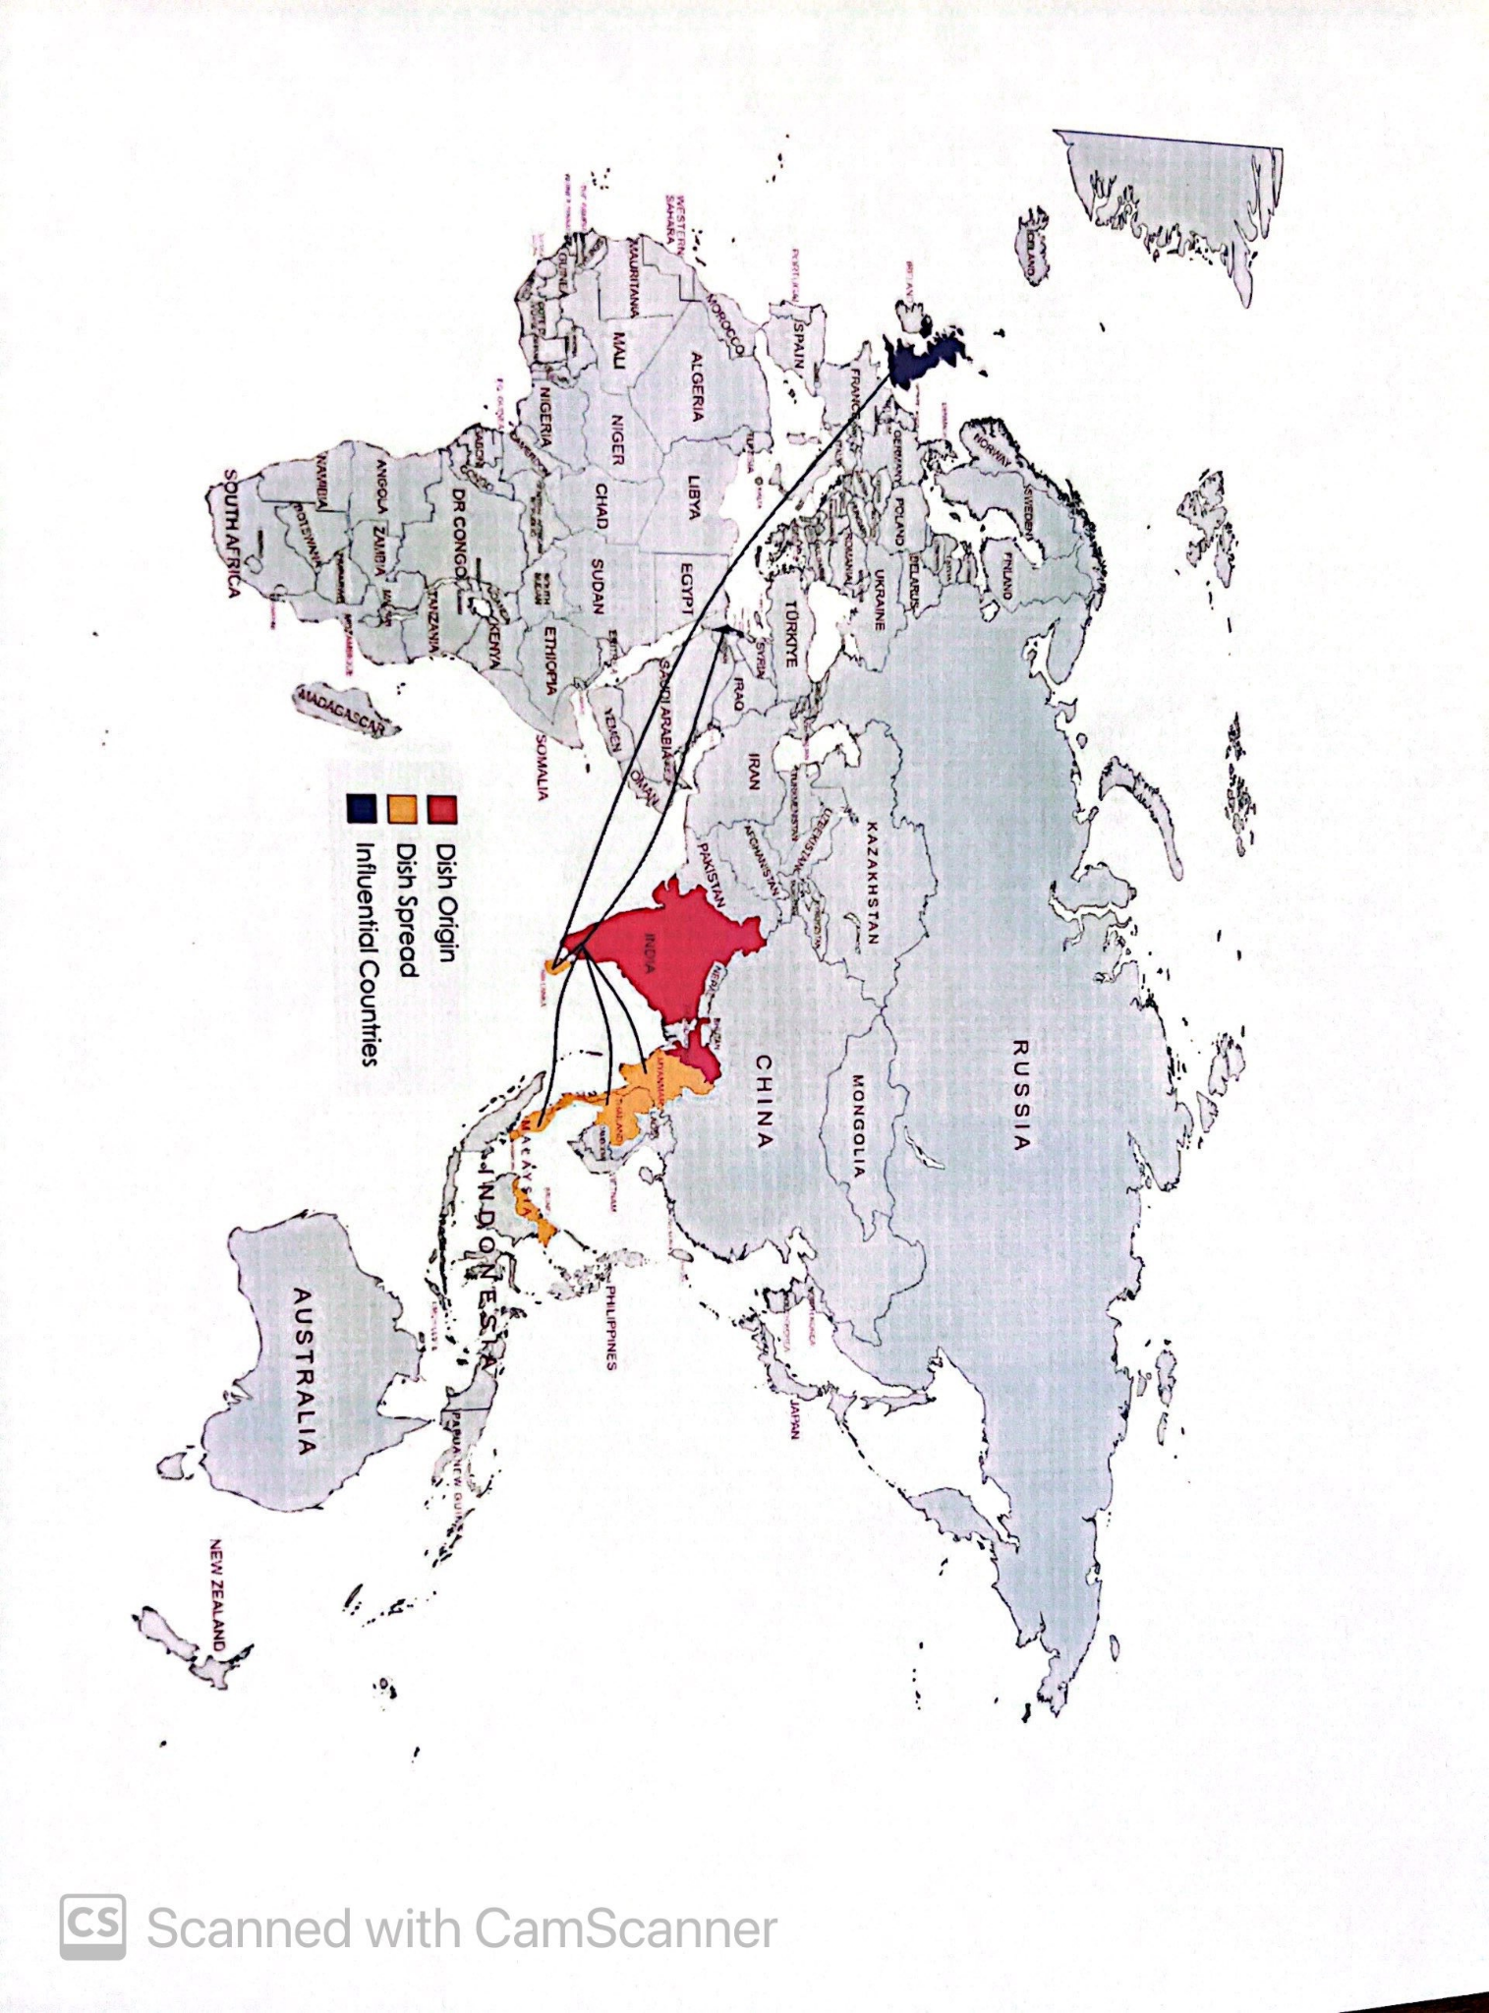
The picture that we showed our participants on the far left (an Indian dish called Appam), followed by the context and the map shown to the user about the dish to test whether the history, stories, and culture behind dishes is what excites users.

The experience prototype that stemmed from this POV/HMW combination was to show people pictures of dishes that they’ve likely not seen before, then to ask them how they feel about eating it and what they think it’s used for. After presenting them with some more context about the history and origins of the dish, we’d ask them to repeat their rating.

This prototype tested the assumption that having more information about a dish would make it more appealing to people. Our results showed that every participant was more likely to say they would consider eating or cooking the dish.

What worked:
- Visualizing the qualities of the ingredient on a map made participants realize its popularity.
- Participants verbalized becoming excited and intrigued upon hearing about the history of the ingredient.

What didn’t work:
- One participant was a bit confused by images of alternate versions of the dish, asking which one they would be cooking.
- The food journey did not provide any references to get started with cooking the dish, which Participant 03 noted as something they would need to move forward.

Sofia
We met…
- Sofia, the chef for Xanadu House at Stanford, who hated to cook but came here as a hasher and learned her cooking skills on the job to become a chef.
We were surprised to realize that…
- Despite having hundreds of screenshots of recipes on her phone, she said she had a much easier time learning most of the dishes she knows how to cook from someone else in real life with kinesthetic learning and real-time interaction.
We wonder if this means…
- She doesn’t directly benefit in terms of confidence from unfamiliar, complex recipes online until she has someone show it to her as she cooks it.
It would be game-changing to…
- Provide the confidence of someone else’s expertise and assurance with real-time feedback when Sofia wants to try cooking a new dish.

HMW statements we generated included:
- “How might we convey to Sofia that students actually like trying new foods?”
- “How might we create an environment that encourages sharing unfamiliar foods?”
- “How might we use unfamiliarity itself to make cooking more exciting?”

A HMW statement we pursued was:
“How might we use real-time feedback to infuse comfort into the process of preparing complex foods?”

We came up with a solution that would allow users to learn by doing in the form of a sensory app using feedback through a wearable device to show when the user made a mistake, or is doing the right thing.

From this, we designed an experience prototype meant to give users haptic feedback while cooking. For this, we recruited two strangers to use some provided cooking ingredients (pots, spatulas, bread pans) to teach each other how to make one of their favorite dishes. We asked the other participant involved to repeat the process from memory, both with and without auditory and haptic feedback (in the form of a tap) from the “teacher” participant who gave the recipe.

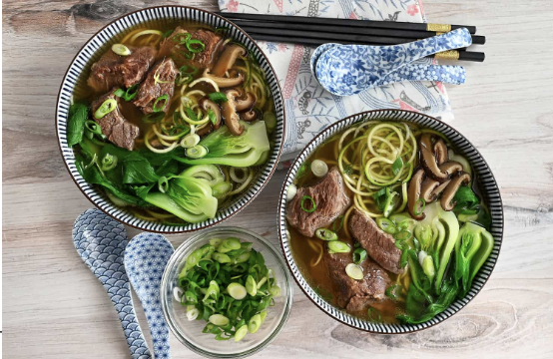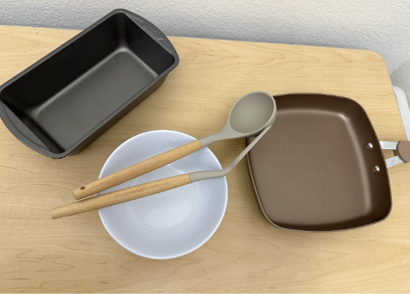
The cultural dish that our “teacher” participant had chosen to demonstrate on the left, and the tools used by the participant to recreate the verbal instructions provided once while receiving no feedback, another with verbal feedback, and another with haptic feedback.

The assumption being tested was that access to proprioceptive and kinaesthetic learning in cooking accelerates learning. Our results showed that although the tapping was generally very helpful, repeating the recipe from memory with the correct motions was overall not very difficult when the participant being tested was concentrating on getting the recipe right.

What worked:
- Auditory feedback for corrections.
- Mimicking the movements of the recipe-giver.
- Any feedback to remove hesitation.

What didn’t work:
- Haptic feedback wasn’t as necessary after access to sensory feedback.
- Taps are binary and would not help if the participant got stuck, particularly when the motions required for the recipe are specific.

Grace
We met…
- Grace, the manager of 99 Ranch in Mountain View, who cooks at home and observes customers who are looking for ingredients for Asian cooking.
We were surprised to realize that…
- She noticed a lot of people didn’t bring in authentic recipes when looking for ingredients, instead defaulting to westernized versions of traditional Asian foods.
We wonder if this means…
- She was concerned that a lot of authenticity behind food was lost through language barriers or inauthentic recipes.
It would be game-changing to…
- Connect people exploring new cuisines to authentic recipes or expert sources of information.

HMW statements we generated included:
- “How might we make it easier to find authentic recipes?”
- “How might we make grocery stores more informative to people unfamiliar with the types of cuisines offered?”
- “How might we create a measure of authenticity for recipes?”

A HMW statement we pursued was:
“How might we make it so that unfamiliar ingredients speak for themselves?”

From this HMW, we developed a solution to create a grocery shopping cultural assistant that uses image recognition to inform a shopper on the qualities of a selected ingredient.

We had many key assumptions to test, including:
- Understanding where an ingredient comes from will make a foreign ingredient less intimidating.
- People have time when grocery shopping to scan things and read/ watch more about it (we had to answer the question about whether most people are in a rush at the store).

Our experience prototype tested these assumptions by asking participants to rank unlabelled ingredients which are likely foreign to them (lemongrass, khmeli suneli, jackfruit). We’d ask them to rank them 1 to 5, 1 signifying that they’d never buy them, and 5 signifying that they’d definitely buy them.

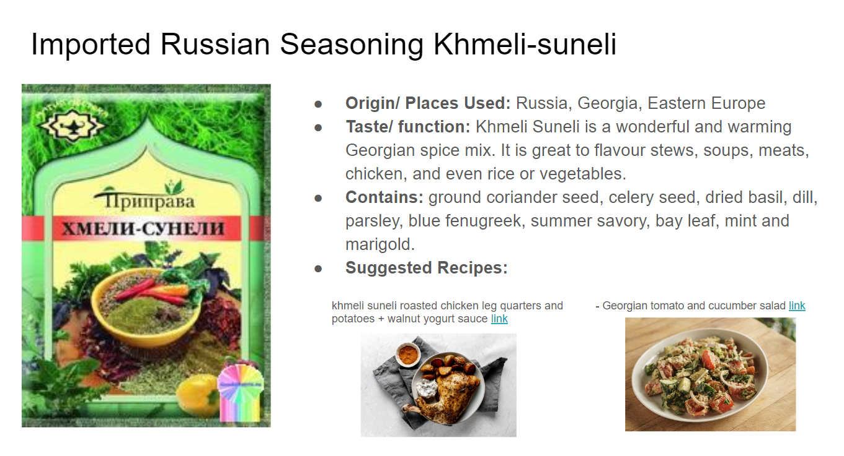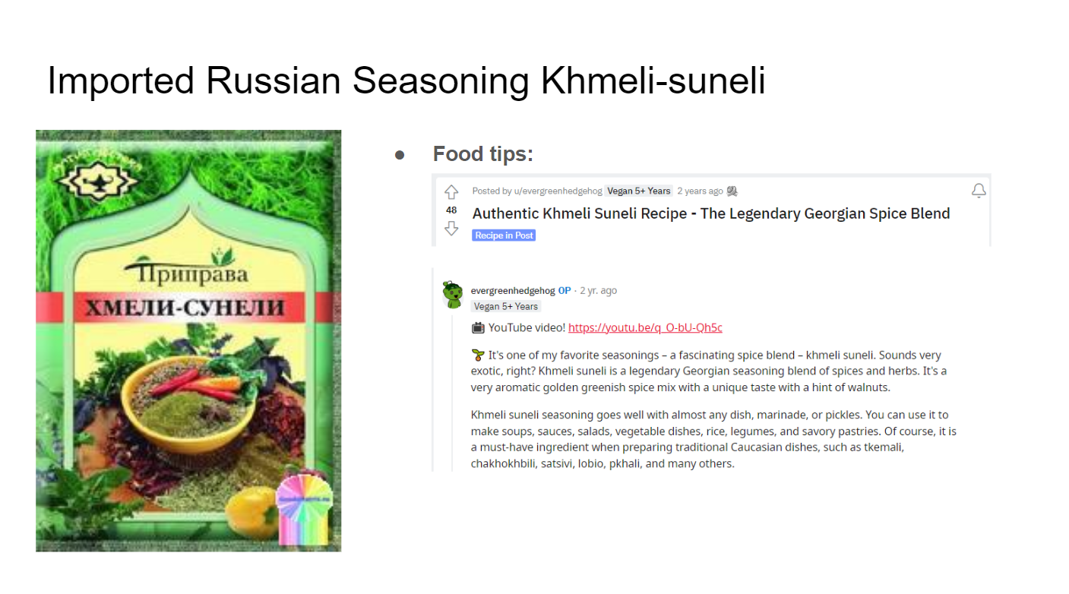
Presenting the user with different varieties of information to test whether this might influence decision-making around purchasing foreign ingredients. The context presented here included taste/function, geographic roots and origins, suggested recipes, and food tips, including YouTube video clips.

After that, we’d give them information about the geography, pronunciation, taste profile and cooking tips for that ingredient and repeat the rating. We saw that overall, ratings for each ingredient increased.

What worked:
- Knowing more about the ingredients influenced ratings in every case.
- We saw that any form of information helped overall, so it was interesting to think about which forms of information would be the most interesting.

What didn’t work:
- We didn’t really have specific means of testing whether or not shoppers had the time or incentive to use this while shopping.
- We saw that people sought convenience over novelty, and would need to find a way of marrying the two.

VI. Solution Generation
Following our POVs and HMWs and the results we gained from our prototypes, it was time to devise some solutions. After aggregating ~60+ collective solutions that our team brainstormed independently, we noticed certain themes overlapping throughout each team member’s designs:
To have some insight into how our brainstorming resulted in a select few solution, is an excerpt from our ideation phase, with the recurring themes:
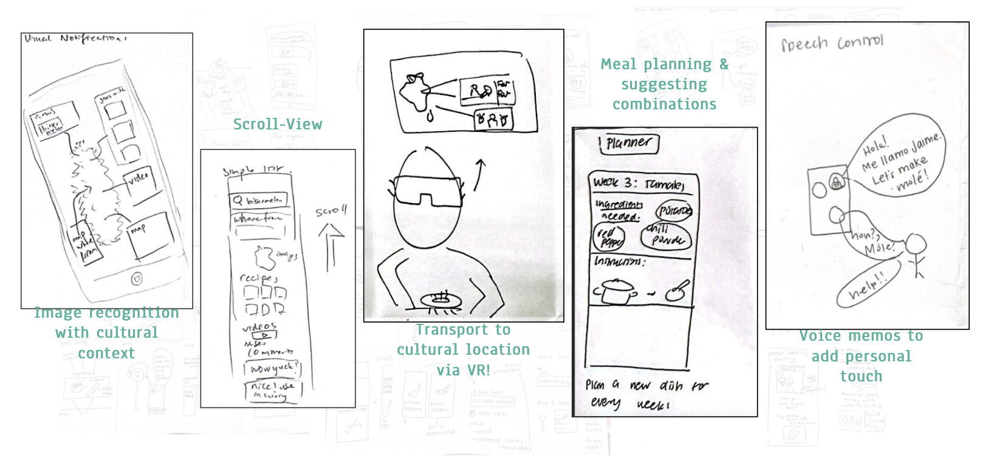
Our Final Two:
- An augmented reality pantry planner that could visualize for users how to use more intimidating ingredients.
- A grocery shopping companion using image recognition to allow users to get to know their ingredient before buying it, providing recipe ideas to encourage its use.
For each of these two ideas, we analyzed the benefits and risks of pursuing each design, anticipating potential roadblocks in the way of implementation, and concerns related to reaching our app’s intended core values in authenticity (that roots from accuracy), cultural representation, accessibility, and the ethical use of data. To weigh the pros and cons of our two design options, we analyzed:

 | Pros | Cons
Augmented Reality for Pantry Planning | - Work with what you have, integrates into your lifestyle (habit)  - Makes it easier to shop  - More incentive to buy cultural ingredients that go well with existing ingredients you already own  - AI recommendation software can be added to understand recipes they haven’t cooked before and what they’ve enjoyed in the past  - Potential to integrate with image recognition: showing what the final product food could look like?  - Helps people visualize final dish/ cooking while they are in the mode about to cook | - People may be too lazy to input everything in their pantry  - Does not really target the non-food motivated audience  - Who do we source recipes from? How do we decide which recipes to recommend?  - Additional, expensive hardware for AR  - Not accessible to visually impaired users  - If they are already in the pantry, will they have a lot of incentive to go out and buy new ingredients?
Image Recognition | - Real-time, fits into the cultural companion narrative as an app that is with you while you shop  - Very clear relation to our needfinding interview with 99 Ranch  - Variety of information is easily available to add as part of the visual experience of scanning an ingredient  - Users can already have experience with using image recognition/scanning through their camera for things like QR codes  - Requires no additional hardware, only a phone with an integrated camera | - Risk of inaccuracy  - Curating the information that populates about a certain ingredient may be difficult and require an understanding of accurate data sources to find this information  - Inaccessible for those that cannot hold their phone up for a longer period of time to capture the photo  - Visual focus might not be as accessible for visually impaired users  - People who are shopping for groceries in-person may be in a rush and won’t want to explore too much
Ultimately, our team decided to move forward with the image recognition vision because of the need for efficient ingredient detection for use in authentic cooking recipes and increasing awareness about the cultural context of an ingredient (i.e. as Grace from 99 Ranch and Jaclyn from 99 Ranch both described).
Additionally, we realized that this was an idea that our team was excited about, and was practical. In general, we decided that the incentives would not be aligned for user-driven data-entry for the panty app. The image recognition would make life easier for the user, all-the-while inspiring users to make more culture-driven decisions while shopping and in their kitchen.

VII. Design Evolution

Description of Tasks
Based on our image recognition solution, the higher-level functionality of our app that we envisioned was that a user would be able to:
- Scan a foreign ingredient
- Learn about its and cultural geographical context
- Find recipes using that ingredient
- Save any recipe they encounter on the app for later use
- Explore recipes by dish, ingredient, or culture using a search function
This consolidated into three tasks for the user with varying complexity:
Simple task: Locate and scan a foreign ingredient.
This task is important because it uses the central functionality of the app, which we hope would draw intrigue from users. If users are excited about the scan functionality and are encouraged to use it, this would lead to them learning more about many ingredients.
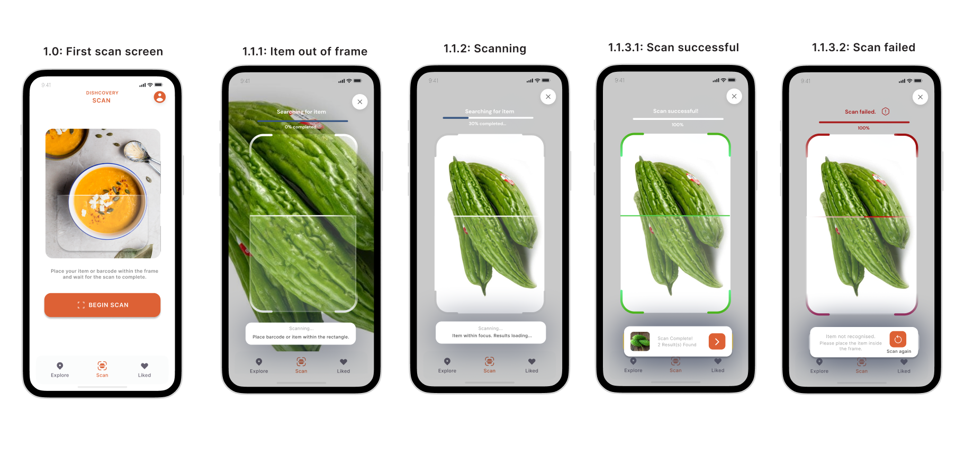
Medium task: Learn about the context of that ingredient.
This task is important to provide a transition between our simple and medium tasks. By learning more about the ingredient, users are encouraged to experiment with it, which was also a result affirmed by our experience prototypes.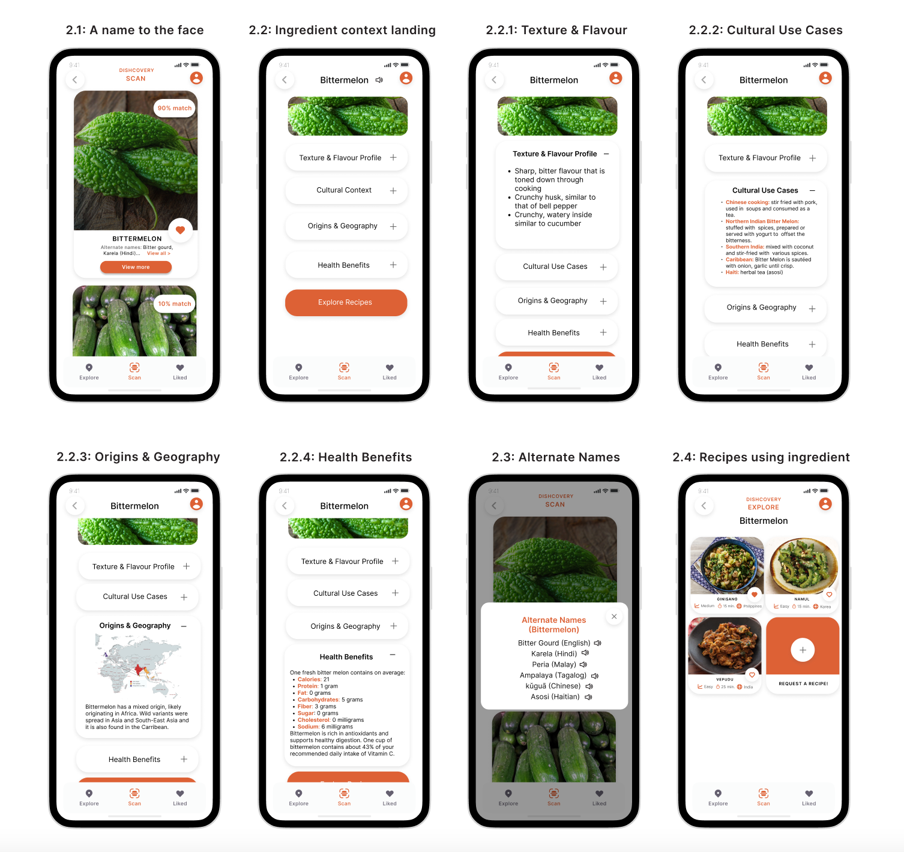
Complex task: Cook culturally authentic dishes using that ingredient.
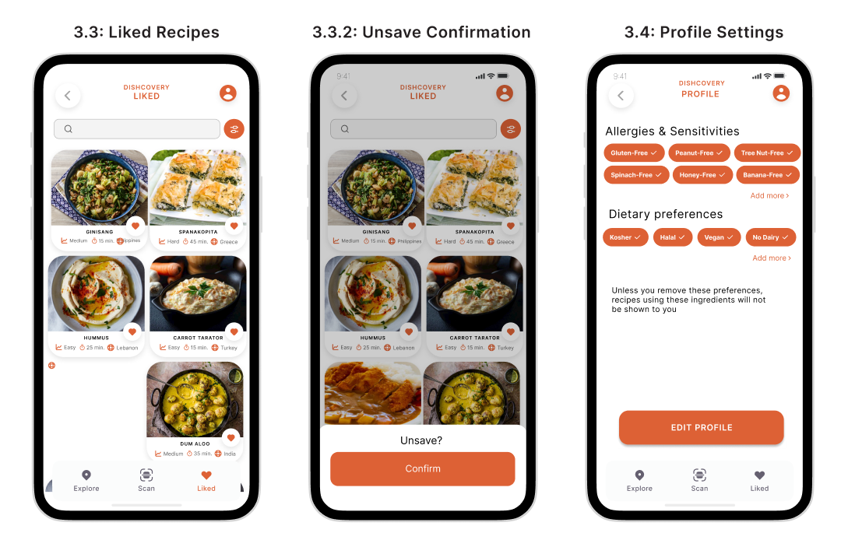
The fulfillment of enjoying a meal using a potentially intimidating ingredient is one of the most important results we’d like to provide for our users. Once users cook using the recipes on Dishcovery, they’ll have obtained a new experience and added a new recipe to their arsenal, hopefully encouraging them to repeat the process with a different ingredient.
We also have a Save functionality, which is important because it allows users to go back to recipes they may not have time to cook in the moment they save them.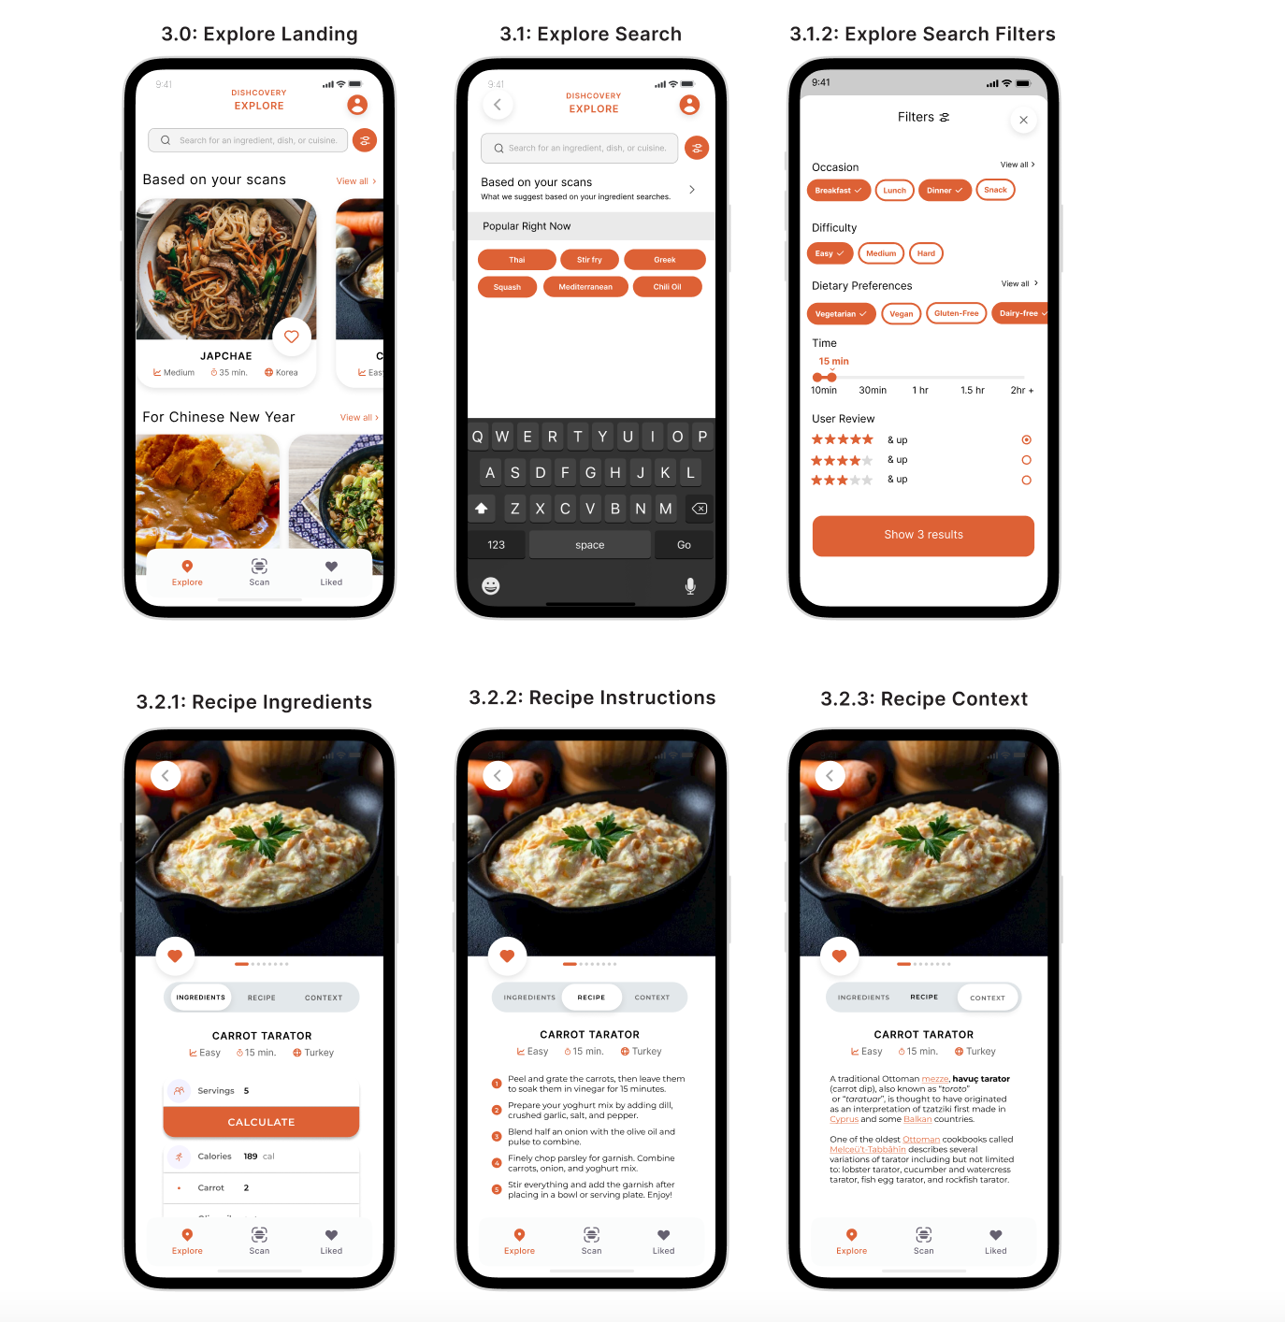

Design evolution for Task 1: Scan an unfamiliar ingredient
Med-Fi Figma design
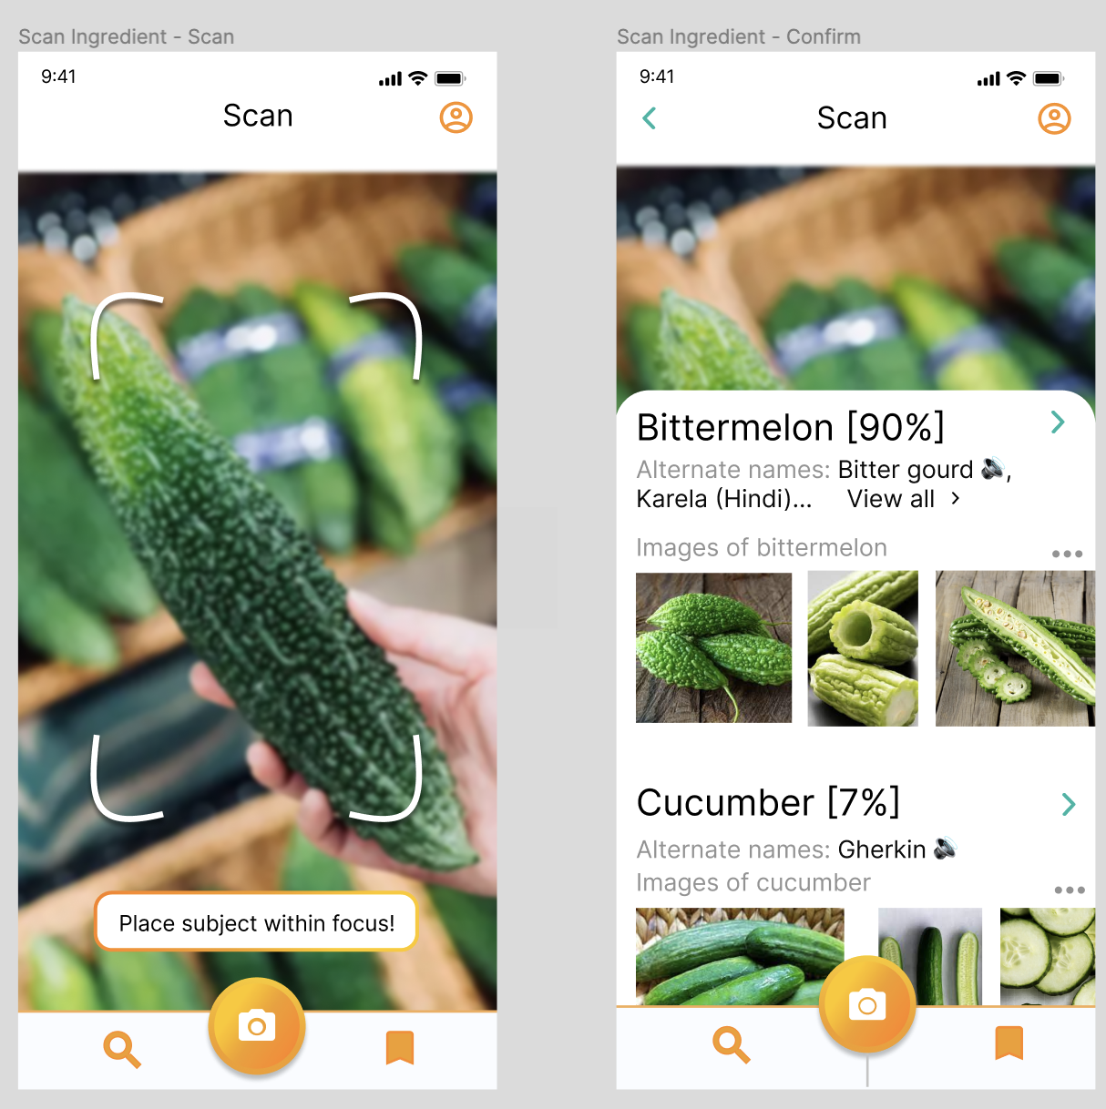
Med-Fi Figma design, v2
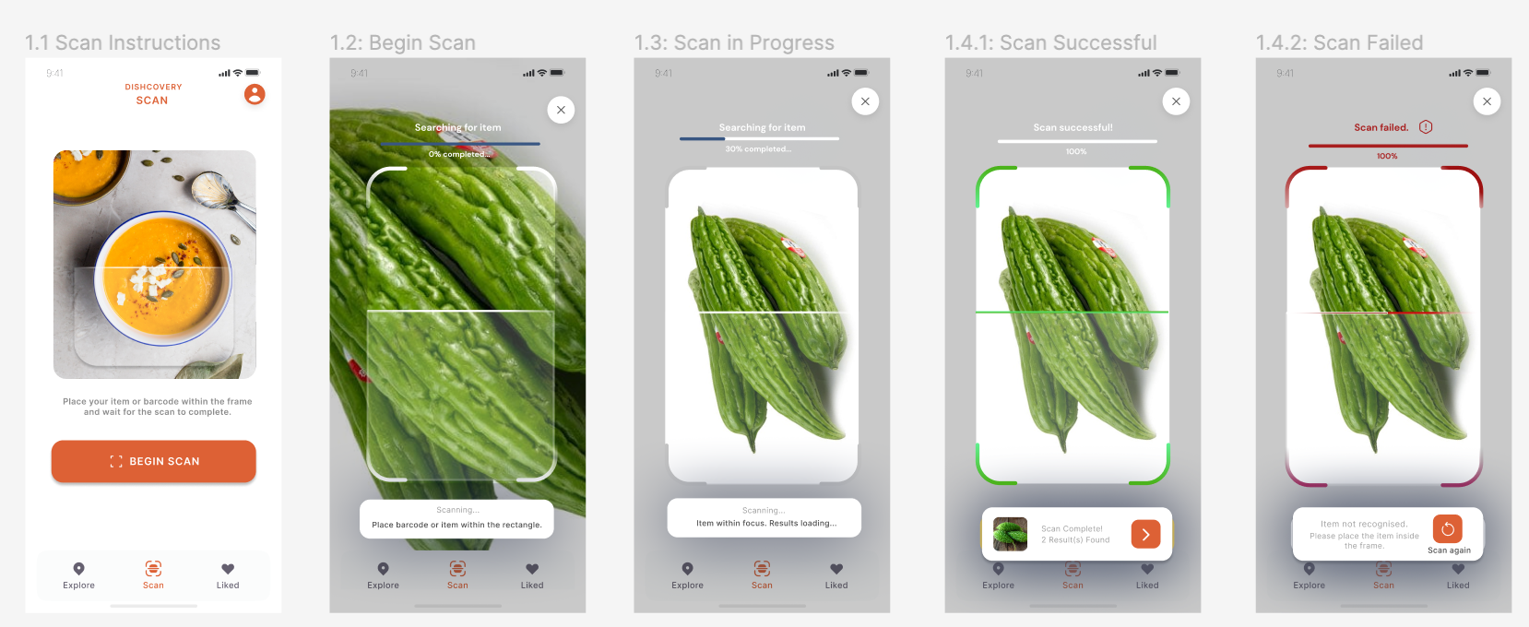
After a heuristic evaluation was run on our design by peers, we ranked the problems found by severity and set out to rectify them. For this task flow, here were the issues we prioritised solving, which led to the second iteration of our design:
- S3: Removal of gradients to introduce a cleaner aesthetic.
- S3: Clear instructions for placing item in focus and search in progress.
- S4: Clear errors to guide user towards accurate scan results.
Severity | Description | Solution/Rationale
4 | No confirmation when item scans or when the item isn’t recognised. | - Use colors, confirmation, and warning as appropriate.
4 | Some buttons are not working properly in the prototype. | - Addressed in implementation
3 | No warning for when the subject isn’t in focus. | - Added a warning to place the subject in focus.
3 | Color scheme hard on the eyes. | - Changed to a single accent color and removed gradients.

Design evolution for Task 2: Scan an unfamiliar ingredient
Med-Fi Figma Design:
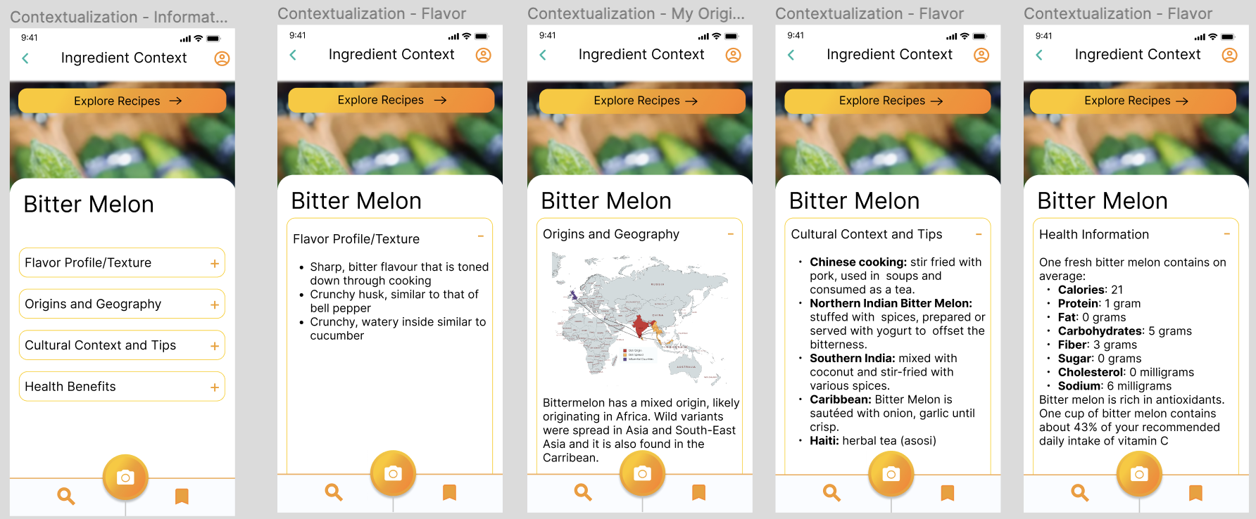
Med-Fi Figma Design, v2:
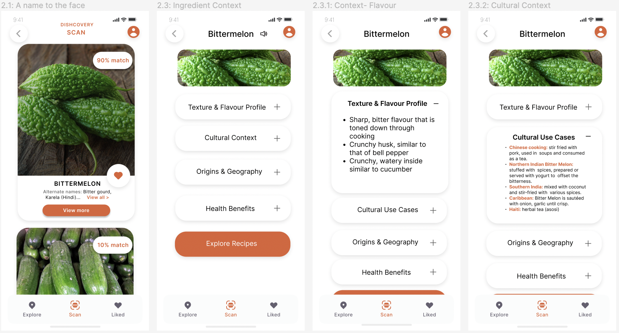
Problems found and changes implemented following heuristic evaluation:
Severity | Description | Solution/Rationale
4 | “View all” button was not visible because it’s in the same color as the text. | - Changed to accent color.
4 | Need to re-scan to go back to the context from recipes. | - Added a back button.
3 | Inconsistent tab names, spacing and punctuation. | - Standardised using components.
3 | Which recipes and cultures to include? | - “Request recipe” option added for inclusivity.

Design evolution for Task 3: Authentic cooking
Med-Fi Figma prototype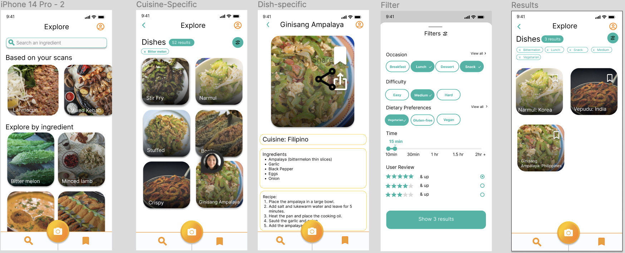
This task flow facilitated the user’s journey towards cooking with a foreign ingredient for the first time. This is why using fewer colors and having a cleaner interface was essential, so that the user wouldn’t be confused or distracted during an already-difficult task.
Med-Fi Figma prototype, v2
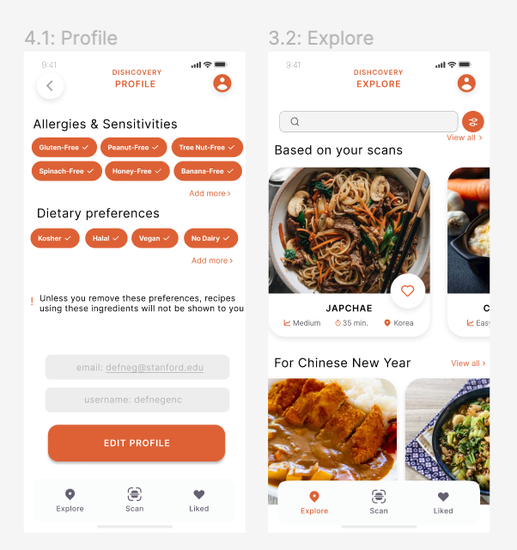

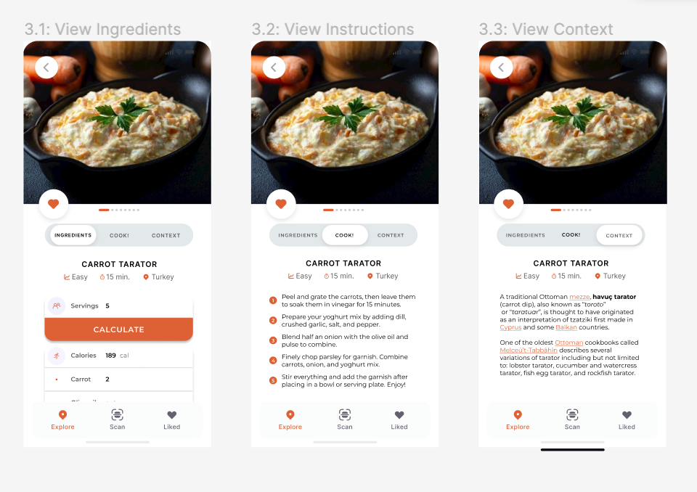
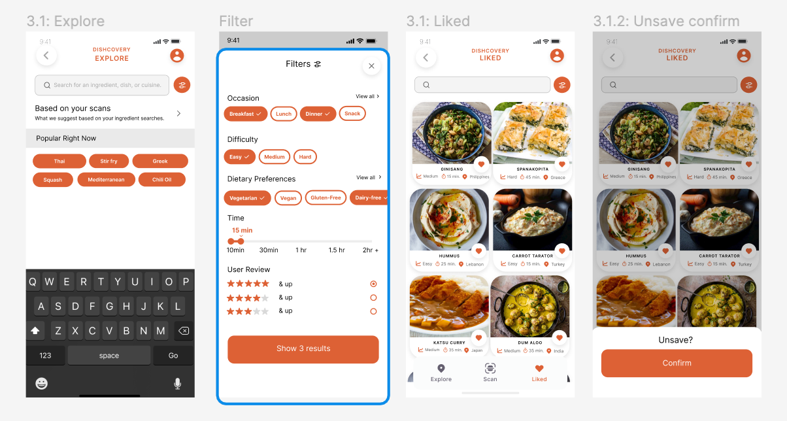
Problems found and changes implemented following heuristic evaluation:
Severity | Description | Solution/Rationale
4 | Some buttons and texts take the user to the wrong destination. | - Addressed in prototype and implementation.
3 | Inconsistent fonts and headers. | - Addressed in prototype and implementation.
3 | No confirmation before un-saving. | - Confirmation added.
3 | Filters buttons move when changed. | - Used auto layout for filters.

We were also notified that we had not included religious dietary preferences in the Profile settings, which we added in the second iteration. Another less severe violation found was that users could not search within their Liked recipes, which is another functionality we added.

Values in Design
The values of our app are that it’s approachable, educational, and culturally enriching. We wanted our design to give the user a homey feel where they would find delight in saving recipes and scanning their food items.
To consolidate these values in our final design, we opted for:
- Lots of visuals, with recipe cards devoted mostly to images when exploring and saving.
- A warm accent color which is vibrant yet welcoming.
- A clean visual design incorporating a single accent color, with lots of whitespace.
- A simple navigation bar that keeps the scanning feature central.
- An abundance of ways to search for dishes, cuisines, or ingredients.
- Profile settings that accommodate a large variety of preferences.
Some conflicts within our values that we had to balance and reconcile were:
- Simplicity versus offering an abundance of options and information: we wanted users to be able to access a variety of information in many different forms while keeping the app sleek and simple. For this, we made it possible to view ingredient and recipe contexts in separate pages, as well as add dietary restrictions in the Profile tab and allow the Filters tab to emphasise other information such as meal type and difficulty.
- Easy to use and understand versus culturally enriching: we wanted a simple, easy-to-understand design while highlighting the cultural richness that our app provides. For this, along with the user-friendly interface, we included ways for users to see a variety of cultures on every Explore/Liked page by making the country/cuisine a recipe is from very visible on its recipe card.

VIII. Final Prototype Implementation
Tools used:
We used a myriad of software and design tools to make our final prototype. These include:
- We redesigned our entire app on Figma (link). See our revamped med-fi design.
- We wrote our code in React Native using Expo and tested it with the Expo Go app.
- We used Github (link to our Dishcovery repository) and VS Studio Liveshare to code collaboratively.
The coding tools or tutorials we used include:
- We used the Clarifai food recognition API (link) for our image recognition. We followed similar steps to this Clarifai AI tutorial (link), but modified it to do food recognition, and to fit Dishcovery’s UI.
- For the recipe coding, we used some aspects of this tutorial (link) and this github repository (link). But most of it has been heavily modified to fit our design.
- We manually sourced our context for ingredients, context for recipes and recipes using blogs or websites from Google as well as generating them on ChatGPT. We then tried to manually verify for authenticity or accuracy, in case ChatGPT had any biases.
Pros and Cons of these tools:
Using Figma was a powerful software for creating the design of the hi-fi prototype as the ability to add components and have a neat layout of frames allows the entire prototype to be seen on one screen. Having the redesigned design helped immensely when coding, as it not only gave something to aim for, it also provided much more clarity when coding different features, as we could test what they should look like on the Figma prototype. One downside of Figma is that the learning curve was a little bit steep, but well worth it in the end.
Using React Native is useful as it can work on both android and iOS, and is slowly becoming the industry standard. Expo is also much better than native coding. One down side of using React Native and Expo is that downloading the packages using npm could sometimes be very convoluted, as there were many package dependencies issues, especially when integrating the image recognition API. In particular, we had a lot of issues getting the Axios and Clarifai package to work together, and we could only solve this by downgrading Axios (link). Although this is a downside of Expo/ React, we think that alternatives would not necessarily have been better. Using Github and VS Studio Liveshare were both extremely helpful to work collaboratively. The only downside of Github is that sometimes we had issues merging our changes, but this is still the preferred method than any other alternative. VS Studio was helpful when we worked together, but not needed when we were asynchronous. In general, it was very useful for debugging together on zoom, when we may not be colocated.
Clarifai API was a core feature of our final prototype. Although we did not have to get the prototype to be functional for this class, we found that having it implemented in general made us all very excited about what Dishcovery could do, and was also very useful to have for demo purposes. The benefit of Clarifai is that all the machine learning training is already done for you - you simply have to plug in the API to your device. This vastly simplifies the process, as building an image recognition model would have otherwise taken some time, as we would need to source food data and train a model, or convert a huggingface model (open source machine learning models) into something usable with a mobile app. However, although it is much easier to implement, using a ready-made solution is not without downsides. Clarifai food recognition is limited as it can only recognize the items in the Clarifai food item library (see the list here). This has issues as it means only the most general food items would be recognized, but Dishcovery’s core value is that it would be able to recognize foreign ingredients from other cultures, which may not be that common. Thus, a high priority for Dishcovery for future works would be to use a machine learning model that can work on foreign food items. This may mean training our own model on ethnic ingredients.
The vast amount of tutorials available in React Native was very useful as it is a good starting point. One downside is that combining various sources meant our code became a little bit harder to organize, as different design systems or file organization have been used in the various tutorials. Thus, it may have been useful to build everything from scratch with highly modularized code, though we were also limited by time. In terms of sourcing the recipe and ingredient context, the obvious downside to manually sourcing this from google and blogs is that it is very time-consuming and non-scalable. However, the benefit is that it is the best way to verify the accuracy compared to automated methods. Ideally, this information would be sourced directly from people whose culture we are representing through ingredients or recipes.
We did also use ChatGPT to generate some recipes and context. The benefit is that it is much faster than Google and actually sometimes has comparable results. Furthermore, the recipes and ingredients came out neatly formatted. In comparison, using blogs and websites in Google for recipes was difficult as there were so many different formats. The big downside and a major concern is to check whether ChatGPT was biased in any way. Even being trained in predominantly English text would bias it as this skews what information it learns from. Thus, we have to make sure there is some process to manually verify that this information is authentic and correct.
Wizard of Oz techniques and hard-coded features:
- The database of recipes is only 8-12 recipes and is hard-coded.
We have manually sourced this using google and ChatGPT. Ideally there would be a database of recipes perhaps pulled from a Recipe API.
- The cultural context of our selected items is currently hard-coded and stored locally on the app.
In practice, this could potentially be sourced by searching the internet and interviewing individuals who prepare traditional cultural recipes. Care must be taken to ensure this information is authentic, as it is a core value of Dishcovery.
- Accuracy of image recognition is Wizard of Oz-ed
Our image recognition is fully functional via Clarifai API food image recognition. However, Clarifai gives many options and so for the purposes of the demo we have Wizard of Oz-ed the accuracy of the search results. Our image recognition only uses guesses that are in both the Clarifai API food-item library (around 500 generic ingredients) as well as our custom library of cultural food items. Currently we only have three items, bitter melon, cardamom and lemongrass. So if one scanned a cucumber, it would probably come up as bitter melon. This is useful for our demo but we would need extra screens to pick the right item from a range of Clarifai results if this were real.
- The “liked” recipes are hardcoded
The “liked” page is not functional at the moment due to time constraints but could be coded using Async Storage, Supabase or Firebase. For now, there are a few recipe cards hard-coded onto the “liked” page to display what this might look like if the user were to save recipes to view them later.
- The search results, filter page and profile page are hard coded to search only for “bitter melon.
The search results, filter page and profile dietary requirements are not yet functional. A way to implement this is the Algolia search API, or a more rudimentary search using filtered arrays.

IX. Reflection and Next Steps
Our main learnings can be broken down into main categories, in the areas of the design process and keeping culture alive (our studio theme!):
Design Process and Our Project

🍜 Exciting solutions in design stem from real problems and needs that users have rather than simply from the mind of a single individual. Approaching the needfinding process with an open mind, ready to be surprised by insights and stories that interviewees can provide, can yield unexpected insights and help generate a variety of creative ideas.
🍜 The design thinking process requires continuous iteration. Even before creating our low, medium, and high-fidelity prototypes, our team often found ourselves revisiting old ideas for solutions, our needfinding interview results, and our POVs to see what perspectives we might be missing and how our values in design might evolve. We also iterated on our prototypes repeatedly, redoing large portions of our low and medium-fi designs to incorporate TA feedback, peer feedback, and our thoughts on how well our usability goals were achieved.
🍜 Heuristic evaluation was an incredibly helpful tool for us to improve upon our design. It was especially valuable to have a formal framework for helping us think through important facets of our design to the user and notice lapses in categories like Consistency and Standards and Aesthetics and Minimalist Design. Because we could then categorize these errors by task, heuristic, and severity, we could much more easily tackle the challenge of re-designing our medium-fi and high-fi prototypes to incorporate changes.
🍜 We learned a lot about how to work with diverse tools like Figma, Marvel Pop, and React Native. After implementing a large project with these frameworks, we are much more comfortable using them to aid in the design process from experience prototypes to final applications. We also learned how to work as a team to conceptualize, plan, and implement a large design project, building on each other's strengths and areas of expertise to create something we are all proud of.
Studio Theme - Keeping Culture Alive
🌎From our exploration and the work of other members of our studio, we learned that people connect with and express their culture in a variety of ways. All teams in our studio focused on culture as a shared topic, and it was amazing to see the diversity of solutions and stories that stemmed from it, ranging from our focus on understanding foreign ingredients to preserving multilingualism through memories.
🌎We learned how to give and receive feedback on design from the early stages (30%) to the final product (90%), and how to best incorporate these insights into our project. We also were able to dive into how feedback transforms over the course of conceptualizing and building a project, and how different types of feedback are most effective at various points in the design process.
Future flights to Dishcover:
1️⃣ Ethically sourcing a variety of traditional cultural recipes and storing them in a database to leverage in our app rather than hard-coding set recipes.
2️⃣Making the labeling of dishes and ingredients more accurate of the blends of cultures across the world and including variants of any singular dish based on how it is prepared across different cultures. It may be useful to be able to swipe in the same screen through different variants of the recipes and also different images of the recipes.
3️⃣It would be useful to add more community-based features such as including the option in our implementation for the user to add a known or local recipe if they do not see it represented. This is because many authentic recipes may be passed down in families and may not be widely sourced on the internet. In the same vein, if the verification of the accuracy and authenticity of dishes could be crowd-sourced such as allowing users to upvote on authenticity, this may be a more equitable way to obtain this information, as opposed to just the Dishcovery team trying to verify it on their own. In a similar vein, it could be a useful feature if recipes were tied to certain users. It could be a way for food / culture influencers to become well known. There may be certain user’s who are particularly passionate about sharing their cuisine, and it would be useful to have a feature where one could search through the recipes recommended or written by that user. They may even be able to form their own groups where people could share or ask for more personal cooking tips, or for user’s to share and encourage each other with dishes they have made.
4️⃣ We could improve the AI model we used to capture more diverse and less common ingredients so that we can equally represent foods from cultures around the world. This may involve training our own image recognition model specifically for ethnic ingredients. It may also be useful to have a thumbs up or thumbs down feature so that users can give feedback about the accuracy of the predictions.
5️⃣ It would be interesting to experiment with different media such as tik tok like videos of food-preparation. Currently, a lot of people get food inspiration from tik tok, Instagram Reels or YouTube shorts, and it would be interesting to incorporate this form of media into the recipes or cultural context pages.
6️⃣ A feature in our initial designs that did not make it to the prototype was automatic translation. As one of our use cases is exploring ethnic grocery stores more freely, it would be useful to have an image recognition feature that can translate foreign text into the user’s language, as language barriers is one of the main barriers to exploring ethnic cuisines. Similarly, it would be very useful if Dishcovery was available in many languages besides English.
7️⃣ Another feature in our initial design that did not make it to the prototype was habit-tracking/ pantry tracking. Features such as adding ingredients to shopping lists, or being able to document and save photos of your cooking in a gallery could be useful for building long term habits of exploring cultural cooking. However, simplicity is also a key value of our app, so user testing could be done to see whether added features such as these makes our app more convoluted to use.
8️⃣There are many accessibility features of Dishcovery that could be better enhanced. This includes more text to speech features. It would also be useful to explore how Dishcovery could be made accessible to people who may not be as familiar with technology. Some families and older generations may have more insight into cultural or traditional recipes but may be more unfamiliar with using iphone apps. Increased user testing of how to make Dishcovery accessible to this demographic would be useful. It would also be useful to see how Dishcovery could be made more accessible to people who are visually-impaired. Currently, our scanning UI is difficult to use for this demographic. It could be that our image recognition could be helpful in some way to identify colors or types of ingredients, but the user-interface in its current form would not be accessible enough, and further user testing should be done so that we can be more inclusive in our app.
9️⃣ It would be useful to further explore how cultural cooking could be made more novel and fun, as this ties with our value of reducing intimidation of unfamiliar cuisines. This could be through gamification ideas such as a “surprise me” feature that could give users randomly generated, novel ingredients, recipes or cuisines. It could be fun to have the home page have a UI of a spinning globe, which you can “spin” and which will bring you to a page with new cuisines, thereby ‘dishcovering’ new cuisines. Another way to increase cultural awareness is through very well curated cultural news content. If there was a timeline of thoroughly sourced and well-presented news of cultural festivals all over the world, we think this would also increase the value of Dishcovery, as sometimes people are willing to explore new things but are simply unaware that it exists.

