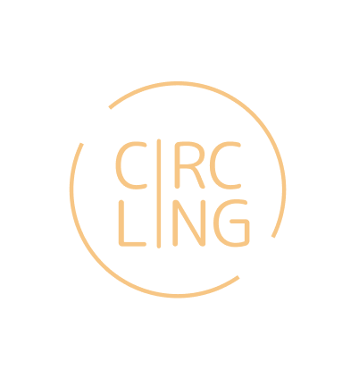

$Stay in touch with your languages$

**CircLing README**

Sharon Cheng, Richard Cheung, German Enik, Jessica Zhang

**Tools Used**

We built our prototype using React Native and Expo. We used Expo Go on Apple’s Xcode Simulator and our mobile devices to render the app.

* Hi-Fi Prototype Source Code: <https://github.com/richiboi/circling-prototype>

**Operating Instructions**

To run the prototype:

* Install [Expo Go](https://expo.dev/client) on your mobile device
* Scan the QR code below (based on your OS):

|  |  |
| --- | --- |
| iOS | Android |

**Limitations**

**Hard Coded Items**

* Our main limitation is that the app does not actually access a user’s local text messages, calls, and contacts – all messages and contact data are hard-coded. This includes:
  + Memories (messages with their platform and date)
  + Insights (today’s progress and activity)
  + Friends (including their language progress and activity)
  + Chats with contacts
  + Onboarding platforms (i.e. Messages, Calls, Messenger)
* Additionally, language filters, activity frequency display, and goals are pre-set.

**Wizard of Oz Features**

* Another limitation is that certain features are not implemented in the backend, such as:
  + Memory feed (uses AI to bring back memories a user wants to see at the moment they open the app)
  + The friends search bar
  + Adding friends and languages
  + Goal editing options and saving goals
  + Choosing the timeframe to view insights activity by (such as by week)
  + Syncing with platforms (onboarding)