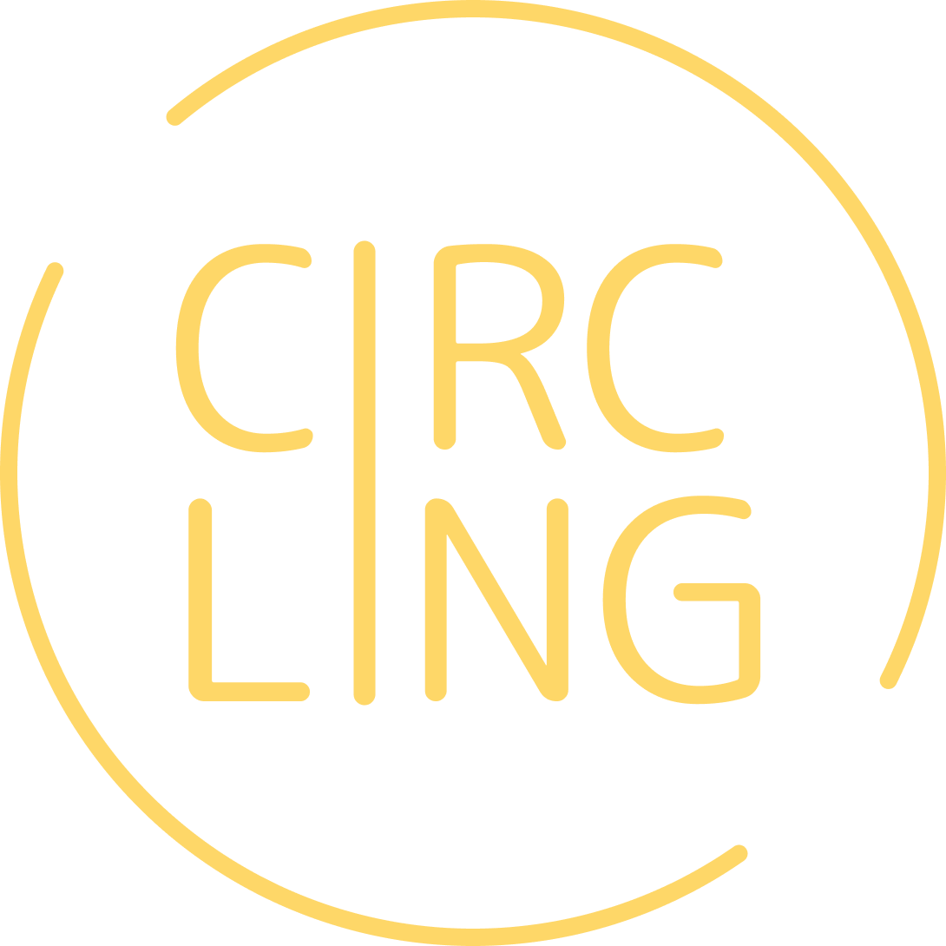

***CircLing***

***Final Report***

CS 147 Autumn 2022

Sharon Cheng, Richard Cheung, German Enik, Jessica Zhang

**Project Name & Value Proposition**

**CircLing**

* A way to preserve, keep track of, and share your language using your day-to-day conversations with your family & friends circle.
* Stay in touch with your languages!

**Team Members & Roles**

* **Sharon Cheng** - User Researcher & UX Designer
* **Richard Cheung** - UX Designer & Mobile Developer
* **German Enik** - UX Designer & Web/Mobile Developer
* **Jessica Zhang** - UX Designer & Mobile Developer

**Problem & Solution Overview**

**❓ Problem:**

After meeting a Latina cashier at EVGR, we identified the problem that many first and second-generation American people mostly maintain their native language via older family members.

**🔍 Solution:**

Our solution is to eternalize language connection between the user and their family & friends via their ‘language footprint’ made of texts and calls, and provide data insight on each user’s language use, thereby assisting the user to preserve their multilingualism.

**Needfinding**

**📰 Interviews:**

* **Round One Interviews:**
  + For our round one interviews , we paired up and formed teams of 2 - one interviewer + one scribe. We recruited four interviewee groups (each one consisting of two family members) through cold outreach in/outside of local Palo Alto coffee shops. We audio recorded if possible and did real-time transcribing on laptops. The target audience for these interviews were non-Stanford students and people who speak more than one language.
* **Round Two Interviews:**
  + We conducted our round two interviews both on campus and virtually. We had two interviews in-person on campus which included a staff and a student, and the other two interviews were conducted virtually. We still followed the 2-person interviewer + scribe format for our interviewing teams.

**📰 Synthesis:**

* **Empathy Maps examples:**

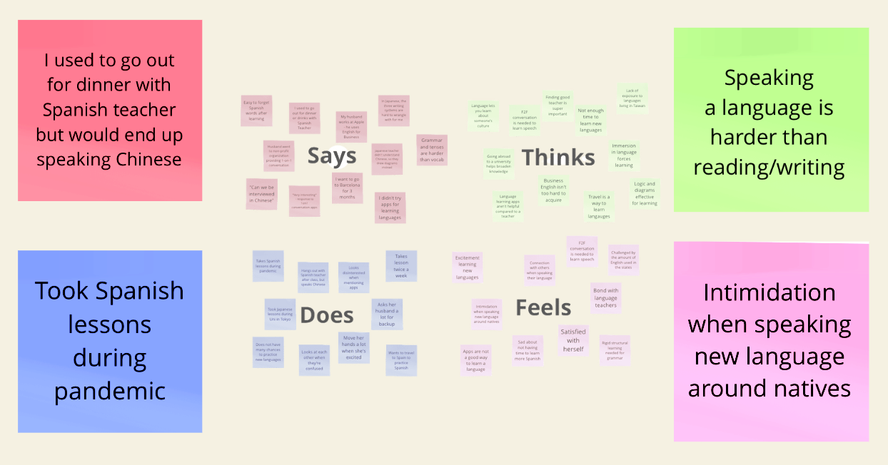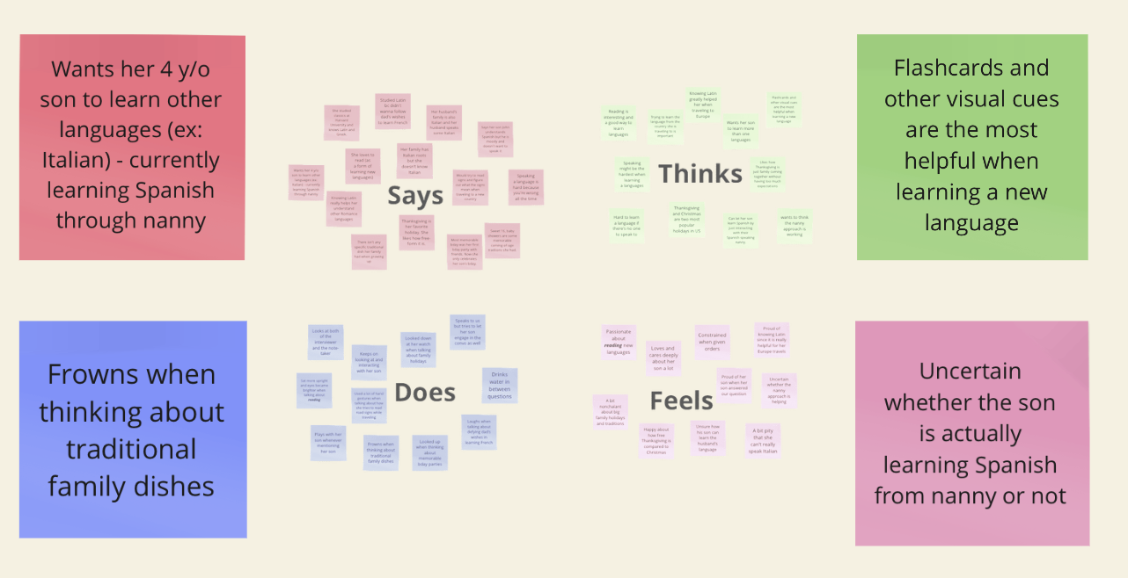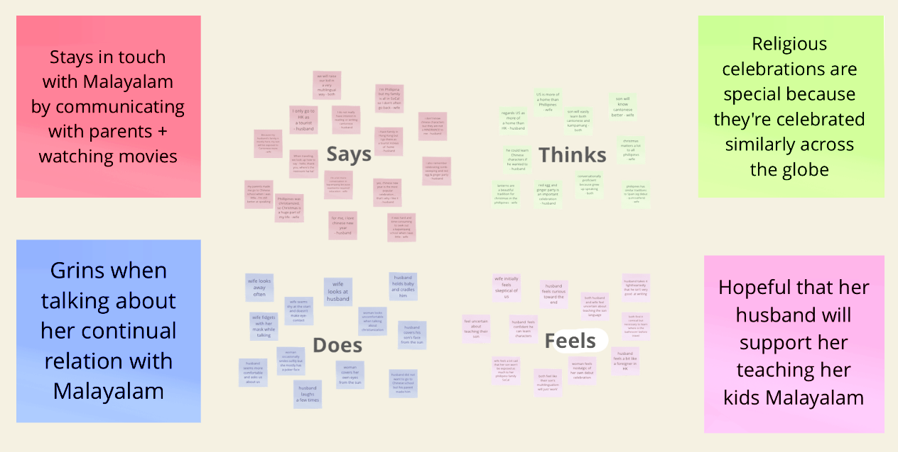

* **Holistic Synthesis:**  We talked to a total of 7 people/pairs of people of diverse linguistic backgrounds about their experiences with language and culture. Here are some common findings:
  + Preserving family's culture seems to not be a strong-enough motivation for people to learn their family's native language
  + Parents with cultural backgrounds want their kids to be multilingual, but they are uncertain about how to best teach them.
  + Speaking a new language can feel very intimidating and it is really easy to make mistakes in front of others.
* From our synthesis, we decided to narrow our scope and focus on just language but not festivals as the former seemed to have a larger problem space.

**POVs & Experience Prototypes**

**💡 Final POVs:**

1. Mom who studied Classics at Harvard with a 4 y/o son
   1. **We met** a mom who studied Classics and is American with Italian roots.
   2. **We were surprised** that even though she studied Latin and Greek, she totally rejected Italian just because her father told her to take it.
   3. **We wonder** if this means people might have some repulsion towards her their family’s native language and are more inclined to learn “new” languages (grass is always greener on the other side… new languages are cooler).
   4. **It would be game-changing** to make family language seem interesting and cool for kids from a young age.
2. Korean-Chinese American student
   1. **We met** a second-generation college student whose mom immigrated to the U.S. from Korea and dad immigrated from China.
   2. **We were surprised** to learn that she felt like she learned more Korean from K-dramas than Korean school.
   3. **We wonder** if this suggests that learning in non-traditional forms is more effective than in traditional settings.
   4. **It would be game-changing** if she could learn language from entertainment.
3. Latina Cashier at EVGR marketplace
   1. **We met** a young Latina cashier from East Palo Alto at EVGR Marketplace, whose Spanish-speaking grandma passed away.
   2. **We were surprised** to learn that while she lost all her Spanish after the passing, she loves singing the songs that her grandma sang her.
   3. **We wonder** if this means that these songs act as an eternal connection to her grandma and language.
   4. **It would be game-changing** if her grandma recorded her songs in Spanish more and left them as memories for her granddaughter.

**💡 Final HMWs:**

1. Create environment for kids to practice their family’s native language
2. Merge entertainment into language learning
3. Support/Help families to record their cultural stories

**💡 Top 3 Solutions:**

1. A global news app for language learners adjustable based on language proficiency
2. An interactive experience for kids to talk to a virtual avatar in specified language
3. Language Memories: an extension that builds a footprint of your texts/calls with other close people over time, saving highlights and calculating stats of your use of language

**💡 Experience Prototypes:**

1. A global news app for language learners adjustable based on language proficiency
   1. **Assumption**: Reading stories in a language one is studying is encouraging if it’s the right level of language.
   2. **Prototype**: German wrote paragraphs in Russian, asked his amateur-Russian-speaker friend to read, and interviewed them about their experience.
   3. **Findings**:
      1. What worked: The participant felt like she learned the most from the easiest paragraph since it complemented her skill level the most.
      2. What didn’t work: When asked why, she said she liked “short sentences”, which might be difficult to find in real life.
      3. Implications: Being able to tailor one’s news feed or other readings to the right level of language difficulty can be helpful.
2. An interactive experience for kids to talk to a virtual avatar in specified language
   1. **Assumption**: Kids are willing to speak a specified language back to someone who speaks that language to them, kids don’t want to feel judged when practicing speaking, and kids will open up and be engaged by an avatar enough to keep speaking language.
   2. **Prototype**: Using Apple’s Memoji feature, Jessica spoke in Chinese to one of her younger brother’s friends who hadn't heard Jessica’s voice before. Jessica spoke in Chinese with him using Facetime disguised as an avatar.
   3. **Findings:**
      1. What worked: User spoke Chinese back without question. When the user didn’t know a Chinese word, he didn’t care about messing up or talking with poor grammar.
      2. What didn’t work: Conversation was shallow because the user didn’t know enough Chinese.
      3. Implications: Kids have fun speaking with animated characters and they may speak a certain language an avatar speaks because they think that avatar only knows the language they began speaking in (halo effect).
3. Language Memories: an extension that builds a footprint of your texts/calls with other close people over time, saving highlights and calculating stats of your use of language
   1. **Assumption**: People enjoy seeing their text recaps since conversation highlights are valuable for people
   2. **Prototype**: Sharon manually looked for text conversations from a year ago today in her group chat and took screenshots. She then sent the screenshots back to her group chat and saw how her friends react.
   3. **Findings:**
      1. Things that worked: People had great reactions to seeing their past messages, and it brought back nostalgic memories.
      2. Things that didn’t work: Texts were shallow and short.
      3. Implications: Texts can bring back fond memories, but they can also raise privacy concerns since they contain extremely sensitive information. Showing people negative text messages could result in undesirable effects.

**Design Evolution**

**🎨 Final Solution:**

* Description: CircLing: an app that eternalizes a user’s connection with their language via a ‘language footprint’ made of texts and calls from their past. App provides data insight into user’s language usage, thereby helping to preserve their multilingualism.
* Rationale: Looking back on text messages evoked positive, emotional reactions from our ‘Language Memories’ participants. We also noticed that many of our participants send and receive texts in different languages. Tracing back to our interview with the Latina Cashier, we wanted to help solve the problem of losing touch with a language, so we decided to build an app to help people retain their native and secondary languages via text memories.

**🎨 Tasks:**

1. Simple: View a memory in Chinese.
2. This task is important because the core goal of the app is to resurface past text messages to help users stay in touch with the languages they use.

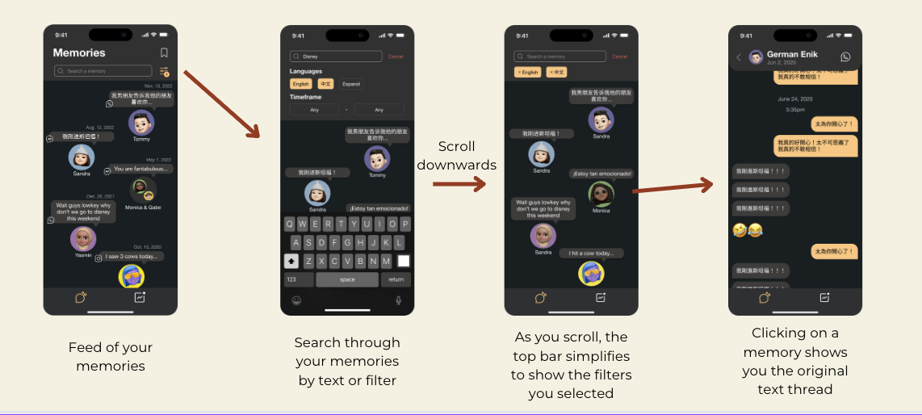

1. Medium: Save a memory.
2. This task is important because saving memories allows users to easily refer to the messages they find most meaningful or helpful for their language practice.

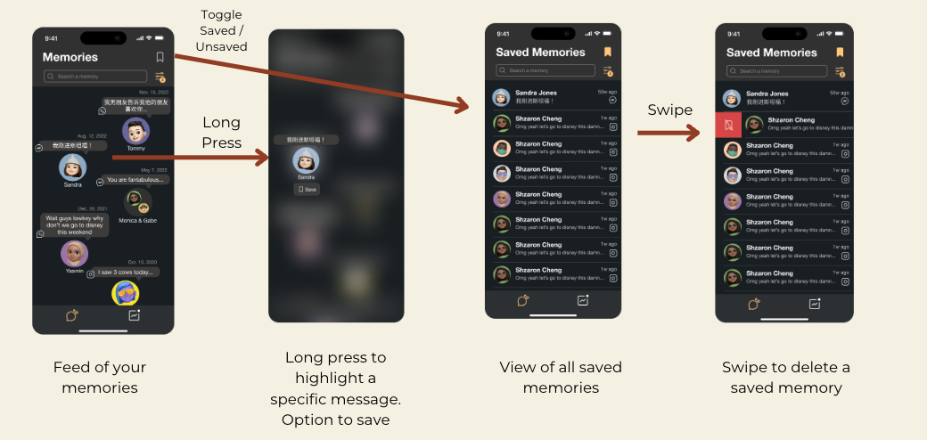

1. Complex: See how your language use compares with a friend.
2. Since using language (speaking, reading, writing) is inherently social, seeing how one’s language use overlaps with a friend provides interesting insights and can help motivate both parties to stay on top of their language usage goals.

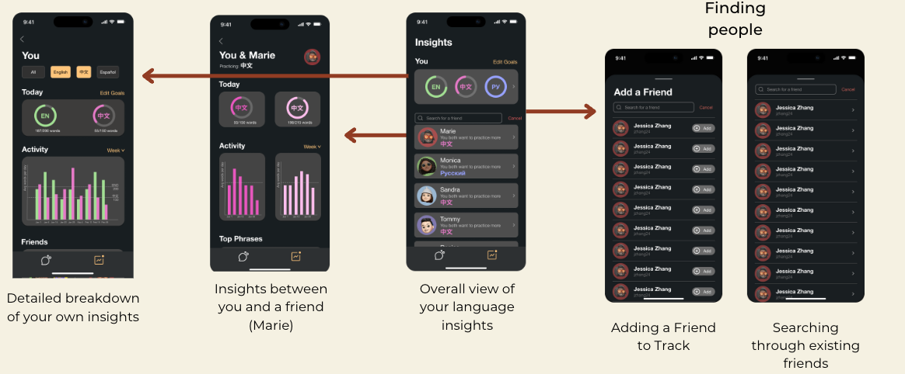

**🎨 Design Evolution Visualization & Rationale:**

* **Major UI Changes [ → Med-Fi]**

1. Overall Design Colors [med-fi → med-fi]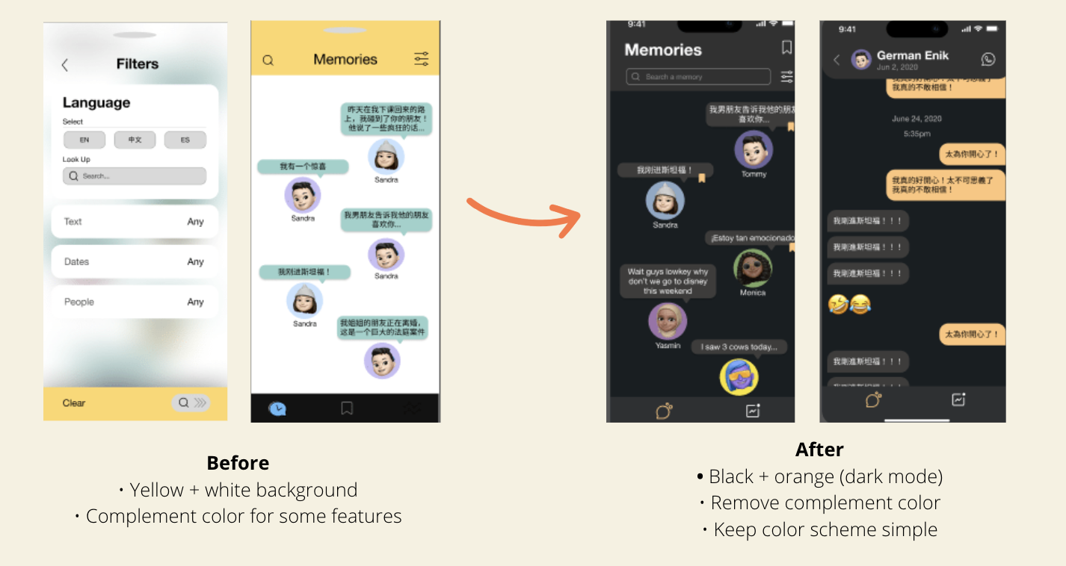
2. Evaluation technique: We asked participants of our med-fi for their color preference.
3. What was learned: Everyone preferred the new dark theme – it was easier on the eyes and seemed less cartoon-ish.
4. Implication: We revamped our entire color palette.
5. Saving Memories [low-fi → med-fi]

*Added new ‘save’ feature in Memories Home page and ‘Saved Memories’ page*

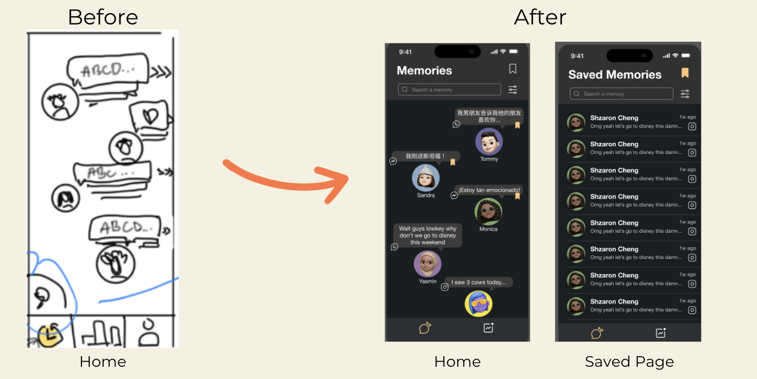

1. Evaluation technique: We were originally thinking about adding a ‘saving memories’ feature to our lo-fi but didn’t end up including it. However, we wanted to see if our participants might find it useful. We first asked participants if they ever reference the ‘Favorites’ feature in photos apps helpful. We followed up and asked each of them if they would use a “Save’ feature in their text messages.
2. What was learned: Almost everyone said the ‘Favorites’ feature was helpful for guiding them to find their most memorable or important photos in a giant photo roll. Similarly, since they said they often feel overwhelmed by the number of text messages they receive, being able to save certain ones would help them pinpoint important messages that were received.
3. Implication: We added the saving memories feature in our med-fi. Memories would be indicated as saved by the orange saved icon in the right, and users navigate to the ‘Saved Memories’ page using the big save icon in the top right corner.
4. Set Goals [low-fi → med-fi]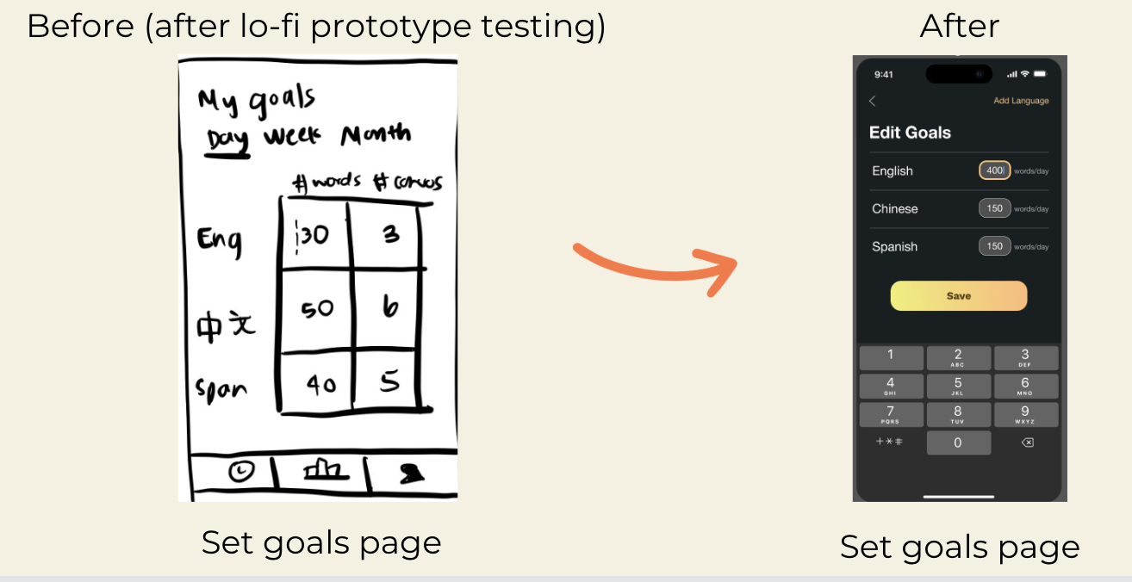
5. Evaluation technique: We asked participants of the low-fi prototype to set their goals to 50 English words per day.
6. What was learned: Participants quickly tapped on the correct box (English # words), showing us that the editable chart format was intuitive.
7. Implication: We made our med-fi cleaner, opting to allow users to only edit the number of words per day for a more concise UI.
8. Insights Page [low-fi → med-fi]

*Added rings, filters, activity, & top phrases*

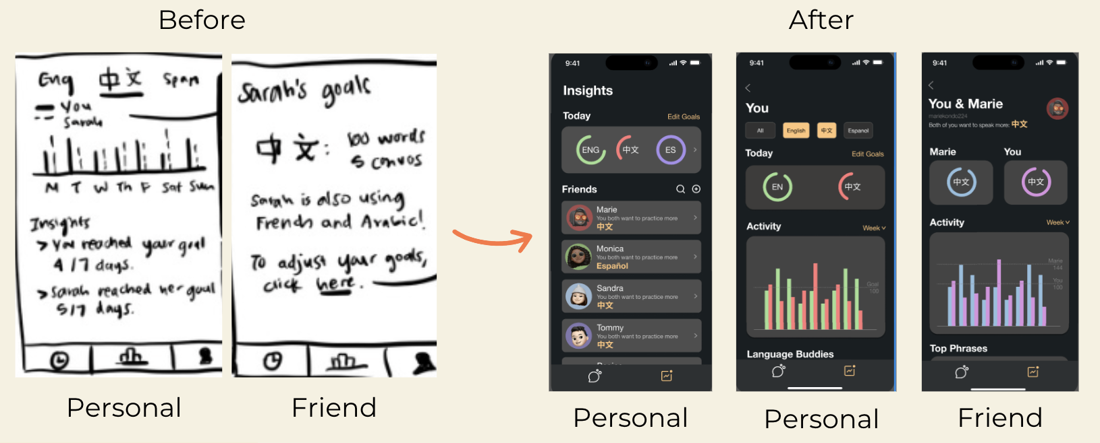

1. Evaluation technique: We asked our participants for qualitative feedback: to choose which features out of our existing lo-fi ones would be most helpful for insights.
2. What was learned: They expressed that it was interesting to see insights with a friend and helpful to view their weekly progress on a chart, but they weren’t sure how to navigate to their goals. They also indicated that they would like to see their progress for the current day relative to their goal, and that the current prototype’s personal insights page was incomplete and unintuitive.
3. Implication: We added daily progress rings into our med-fi, as well as insights with individual friends. We created a 1) personal insights page and 2) insights with a friend page so that users could compare their progress, activity, and top phrases with a friend.

* **Major UI Changes [ → Hi-Fi]**

1. Memories Home Page [Med-fi → Hi-fi]

*Getting rid of saved icons, adding chronological dates (descending), fixing filter consistency, adding group chats*

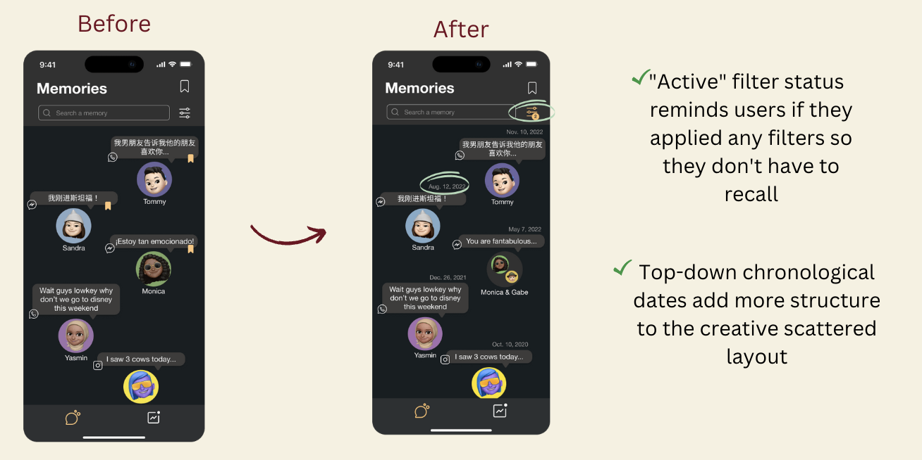

1. Evaluation technique: We asked our evaluators to give us feedback on any of the 12 heuristic evaluations we might have violated.
2. What was learned: Our heuristic violations included:
   1. User cannot see which filters have been applied (H1/3)
   2. User cannot see when the message is from (H6/3)
   3. User cannot tell how the messages are sorted (H2/4)
3. Implications:
   1. We first fixed the consistency of the filter icon.
   2. Next, we added dates to texts and sorted them chronologically, with the most recent texts at the top. We also opted to remove the save icon.
   3. We also added group chats to emulate real world situations.

2. Hiding Messages [Med-Fi → Hi-fi]

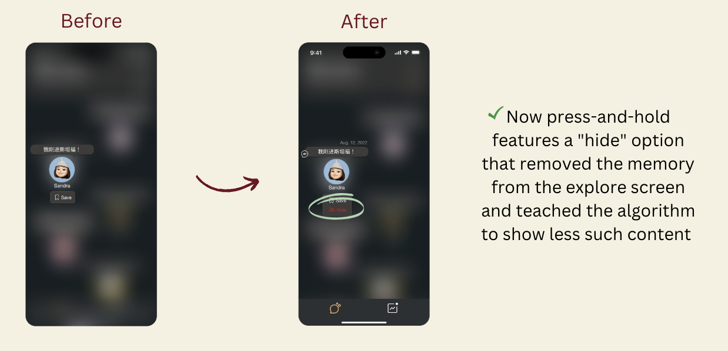

1. Evaluation technique: We asked our evaluators to give us feedback on any of the 12 heuristic evaluations we might have violated.
2. What was learned: Our heuristic violation was that users cannot filter out sensitive memories that might be harmful or damaging. (H12/3).
3. Implication: We created a press-and-hold feature to remove memories that might be damaging and teach the algorithm to show less of such content. We also allowed users to save and hide messages from chat, shown below.

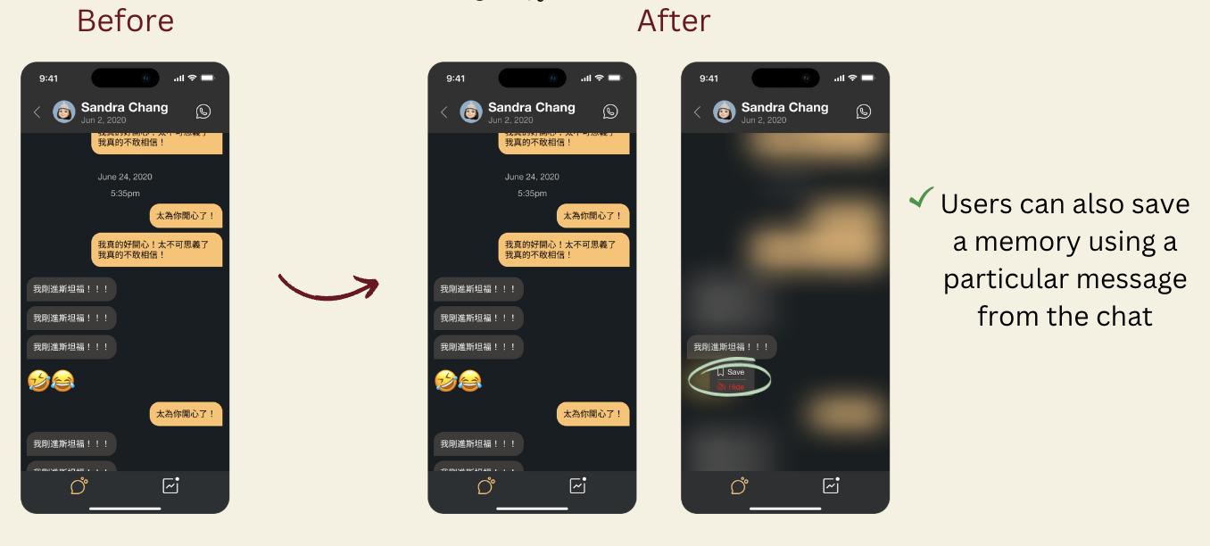

3. Saved Memories [Med-Fi → Hi-fi]

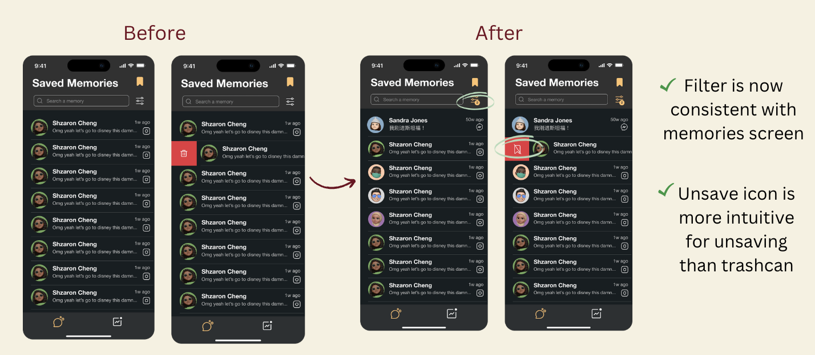

1. Evaluation technique: We asked our evaluators to give us feedback on any of the 12 heuristic evaluations we might have violated.
2. What was learned: Our heuristic violations included:
   1. Filter is inconsistent with previous screen (H4/3)
   2. It is unclear whether the trash can will delete or unsave a memory (H5/3)
3. Implications:
   1. We made the filter icon color consistent with the previous page
   2. We changed the trash can icon to the unsave icon

4. Insights [Med-Fi → Hi-fi]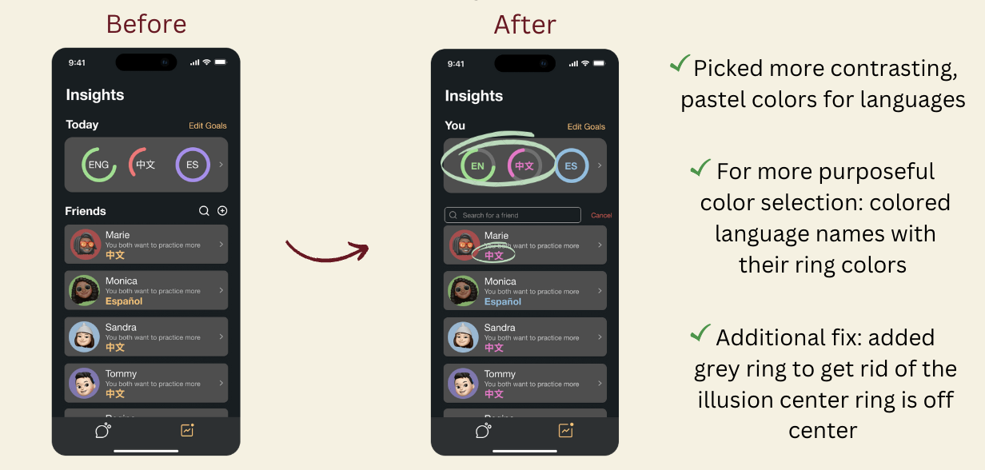

1. Evaluation technique: We asked our evaluators to give us feedback on heuristic evaluations we violated.
2. What was learned: Our heuristic violations included:
   1. Red and green are poor color choices for accessibility (H11/3).
3. Implications:
   1. We chose more accessible colors and used more purposeful color selection throughout the entire app.

5. Personal Insights [Med-Fi → Hi-fi]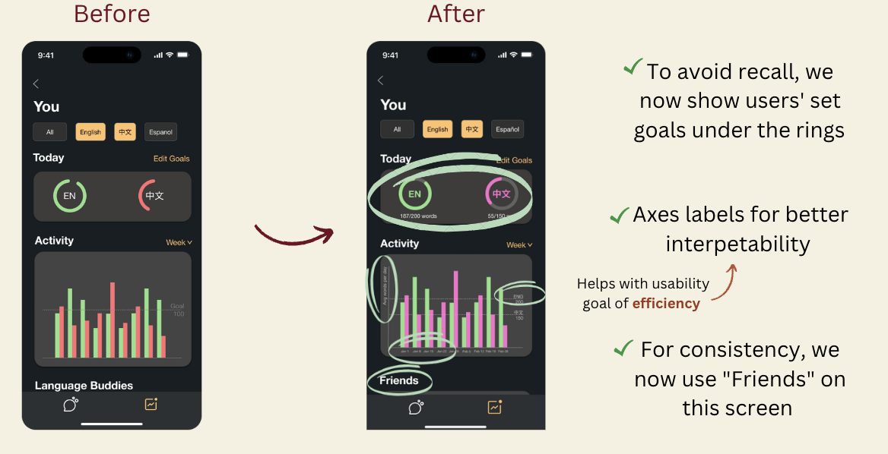

1. Evaluation technique: We asked our evaluators to give us feedback on heuristic evaluations we violated.
2. What was learned: Our heuristic evaluations included:
   1. ‘Language Buddies’ isn’t a widely known term (H2/3)
   2. ‘Language Buddies’ is inconsistent with ‘Friends’ used on a previous page (H4/3)
   3. There is an inconsistent number of pairs of bars and days per week (H2/3, H6/3)
   4. Poor color selection with red/green (H11/3)
3. Implications:
   1. For consistency, we use ‘Friends’ instead of ‘Language Buddies’
   2. We added axes with labels for better interpretability
   3. To avoid recall, we show users’ set goals under rings
   4. We also make font colors consistent with their language, and make the primary color of insights with a friend speaking that language the same color, shown below

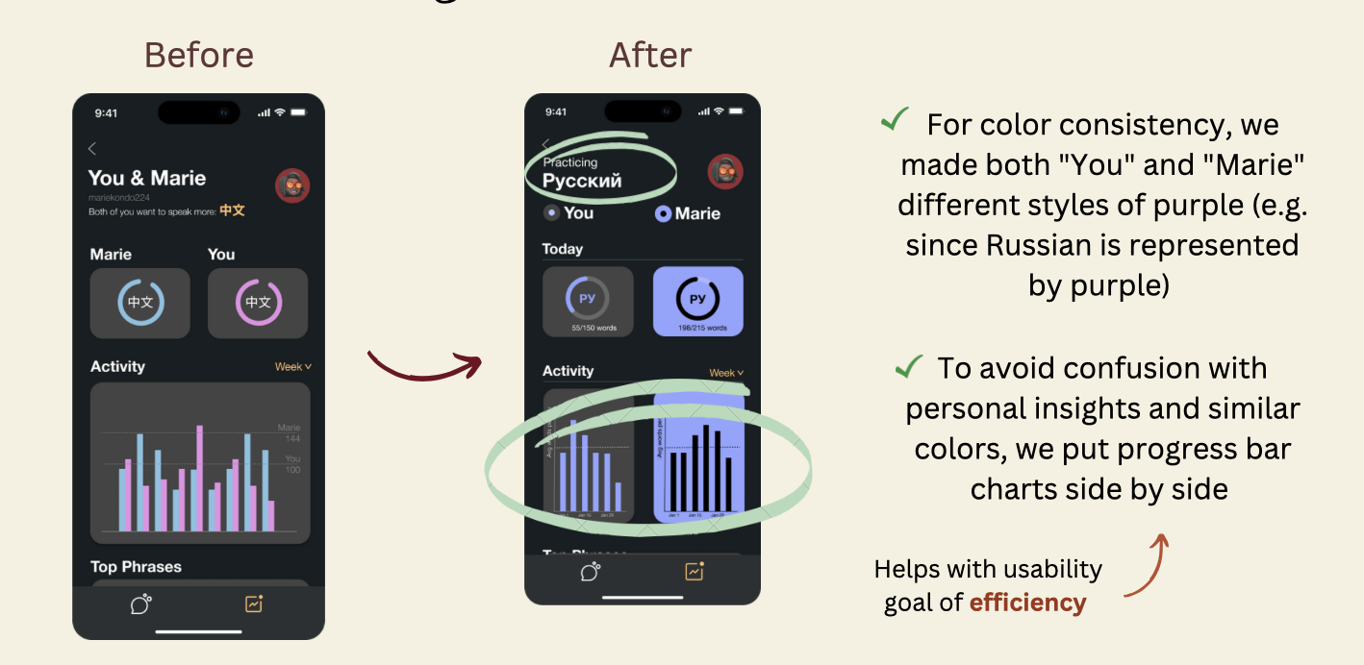

6. Goals [Med-Fi → Hi-fi]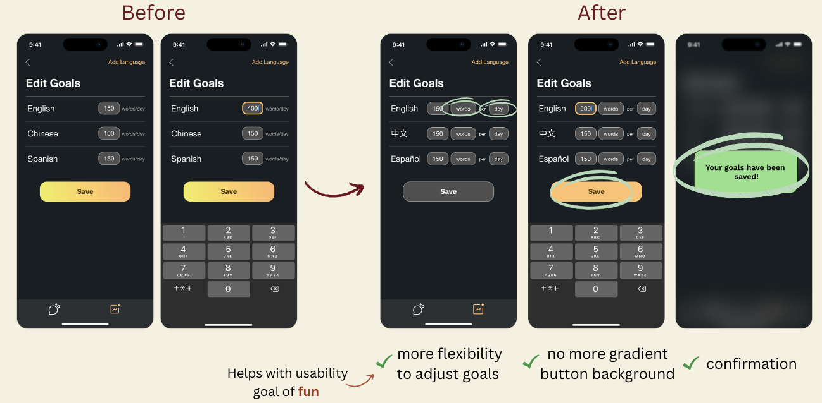

1. Evaluation technique: We asked our evaluators to give us feedback on heuristic evaluations we violated.
2. What was learned: Our heuristic evaluations included:
   1. User doesn’t have the flexibility to edit goals beyonds words/day (H3/3)
   2. There is an inconsistent use of color between ‘save’ and the rest of the app (H4/3)
3. Implications:
   1. We enabled the user more flexibility to adjust goals (words/messages/conversation, frequency i.e. day/week/month)
   2. We removed the gradient from the ‘save’ button
   3. We give the users confirmation that a goal has been saved

7. Onboarding [Med-Fi → Hi-fi]

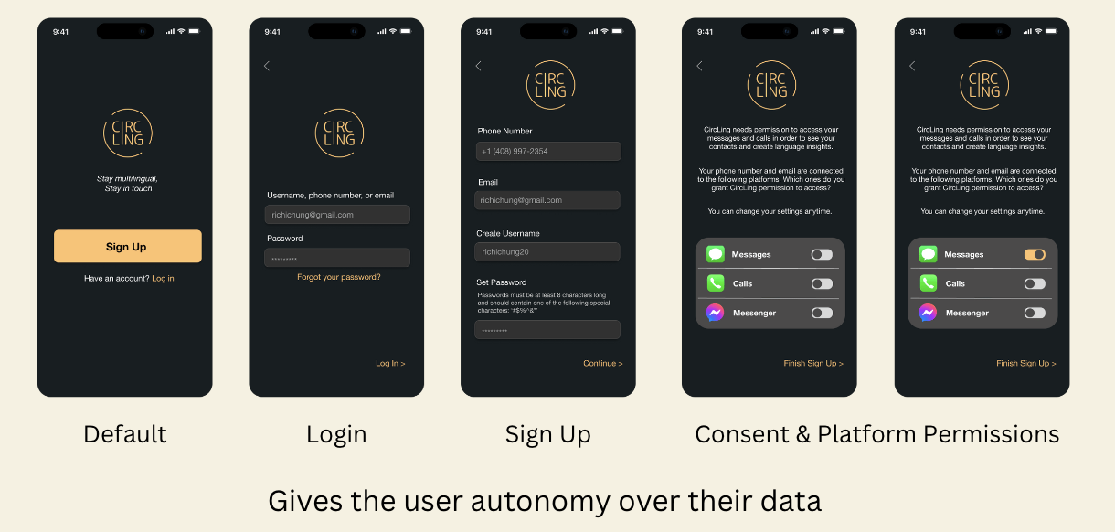

1. Evaluation technique: We asked our evaluators to give us feedback on heuristic evaluations we violated.
2. What was learned: Our heuristic evaluations included:
   1. It’s confusing to users where messages are coming from, and this could raise concerns about data privacy
3. Implications:
   1. We created an onboarding flow to help users understand where their data is coming from and to give users autonomy over how their data is being shared.

8. Memory Feed [not addressed]

1. Evaluation technique: We asked our evaluators to give us feedback on heuristic evaluations we violated.
2. What we learned: Our heuristic evaluations included:
   1. Users cannot block another user (H3/3)
   2. Users cannot favorite a friend (H6/3)
   3. Users cannot star memories (H7/3)
   4. Users cannot archive memories (H9/3)
   5. Users cannot filter out triggering keywords (H12/3)
3. Implications:
   1. We loved the suggestions, but we didn’t follow through with the fixes due to time constraints and the fact that they are out of scope for our main tasks.

9. Format Inconsistencies [not addressed]

1. Evaluation technique: We asked our evaluators to give us feedback on heuristic evaluations we violated.
2. What we learned: Our heuristic evaluations included:
   1. Saved memories and memories are different formats, with one being structured and the other scattered (H4/3)
   2. Friends and insights are two different topics, so they should be separate screens
3. Implications:
   1. We kept memories and saved memories separate because memories are meant to be more exploratory, mimicking the freeness of memories in our minds
   2. Clicking on friends leads you to more insights. We didn’t want our app to have too many complex flows, so we stuck with having friends and insights on the same page

**🎨Values in Design:**

* **Language Preservation**

In the app, users can:

* + See their texts in different languages
  + View insights on their language usage
  + Set concrete goals for language usage
* **Privacy**

We make it a priority to:

* + Protect user data
  + Guarantee that users have a say about which messaging platforms the app can access
  + Outline a transparent privacy policy and enable user to edit privacy settings

❌ **Conflict [Language Preservation vs. Privacy]**

* While we want to enable the app to look at user’s text messages to provide them the most comprehensive language insights, first and foremost, the user must consent to having that data be shared. Text messages can be an intimate part of someone’s past, and it’s important that a user’s information is only shared if they want it to be shared.
* Thus, privacy takes precedence over language preservation.
* **Collaborative Learning**

Users can:

* + Share goals and progress with friends
  + See top phrases with friends
* **Informed Consent**

We want to ensure users:

* Are aware of who has access to their data and how their data is shared
* Can choose what information they want to display and who they want to display it to

❌ **Conflict [Collaborative Learning vs. Informed Consent]**

* We hope users are willing to share their language process and goals with friends, but we can’t guarantee that. Since the app already asks for so much of a user’s data, their autonomy over their messages is more important than it being shared with friends for collaborative learning purposes.

**Final Prototype Implementation**

**⚙️ Tools Used:**

* **Figma** (design components):

**👍Pros:**

* Accessible and easy to use
* Helpful tools like grids for alignment
* Reusable components and color styles
* Easy imports for images
* Seamless collaboration

**👎Cons:**

* Learning curve for those who aren’t familiar with the platform
* Sometimes laggy
* Interaction mapping can be difficult when there are many screens
* **React Native** (framework):

**👍Pros:**

* Functional on all platforms (iOS, Android, Windows)
* Reusable and pre-developed components
* Hot reloading
* Supported by external tools

**👎Cons:**

* Hard to debug
* Requires installing many dependencies, which can be confusing for people not familiar with it
* **Expo** (SDK):

**👍Pros:**

* Makes testing of the app possible
* Easy to use once downloaded
* Immediate results and live reload
* Can view on desktop or mobile

**👎Cons:**

* Reliance on networks connection frequently leads to load issues
* Does not support native modules
* **VSCode** (IDE):

**👍Pros:**

* Multipurpose: supports a wide range of programming languages
* Built-in debugger
* Easy to install extensions
* Integrated terminal
* Intelli-Sense to help finish code and debug

**👎Cons:**

* Sometimes laggy/unresponsive
* The setup/some workflows can be unintuitive for new users
* **Git/GitHub** (collaboration):

**👍Pros:**

* Makes collaborative coding possible
* Allows users to back up code (version control)
* Open-source code allows developers to learn from and build off of others’ projects

**👎Cons:**

* Steep learning curve for new users

**⚙️ Wizard of Oz Features:**

* **Memory Feed:** uses AI to bring back memories that are fun for user to re-read, with a bias for bringing back memories in a language user is falling behind their goals for
* **Search Bar:** user can search for memories and friends using keywords
* **Friend/Language-Adding:** user can add friends and languages to their profile
* **Goal Saving:** user can edit and save goals
* **Time Frame Selection:** user can choose the timeframe to view insights activity by (such as by week)
* **Syncing with Platforms:** during onboarding, the user can choose which messaging platforms they consent CircLing to access
* **Top Phrases:** uses a cheap computationally inexpensive language processing technique like tf-idf to pull out phrases characteristic of the user

**⚙️ Hard-Coded Techniques:**

All message and contact data are hard coded, including:

* Memories (messages with their platform and date)
* Insights (today’s progress and activity)
* Friends (including their language progress and activity)
* Chats with contacts
* Onboarding platforms (i.e. Messages, Calls, Messenger)

**Reflections & Next Steps**

**🌟 Main Learnings:**

* **Design Thinking**

1. The design thinking process is an iterative process defined by five steps: empathize, define, iterate, prototype, and test. In order to create good design, you must first understand what problems people are facing. Then, you should brainstorm many solutions and hone in on the ones that best cater towards your user needs. Next, begin prototyping – this will require many iterations with refinements along the way. The main takeaway is that the design process requires empathy and feedback at every step of the way.
2. Be intentional with your selection of participants – they should come from diverse backgrounds and advocate for important, realistic user needs.
3. Good design is meticulous to the core. Every color, layout, and interaction decision should be meaningful, consistent, and accessible.

* **Culture**

1. Culture is defined differently by everyone, but it is frequently associated with family, food, festivals, language, and art.

* **CircLing**

1. People’s connection with their languages heavily depends on their environments and the people they are surrounded by. Language retention is a more common issue than we thought.
2. People generally enjoy looking back on past text messages, and it can quickly stir up emotional reactions.
3. Exploring unconventional UI layouts can be novel and fascinating, but they should still somehow align with people’s mental models.
4. With time constraints and many ideas for building an app, it’s critical to consider what most users will use the app for to prioritize features.
5. Sometimes you can get a concrete feel for a feature only after prototyping it in code since design tools like Figma are great but not totally comprehensive; for example, it took us implementing floating avatars with memories to realize that reading moving text makes us dizzy.

**🌟 Future Steps:**

1. Add a feature for audio memories retrieved from user’s calls. Several expo attendees shared with us that they practice their native language mostly with grandparents, and older people tend to prefer texting less. Additionally, some languages (e.g. Chinese) differ in pronunciation a lot more than in writing.
2. Experiment with the design of the memory feed, and test out different versions to see what participants find most useful. Ideas include adding more alignment to the page or segmenting it into different sections with headers such as ‘1 year ago’ and ‘London Trip’.
3. Conduct more user interviews to see what people want out of language insights – beyond goals, activity, and top phrases, what is most helpful for multilingual people? One idea is tracking code-switching patterns.
4. Expand the current data insights and let users examine their language usage trends more thoroughly. For instance, clicking on a bar chart can enlarge it and show user exactly what messages they sent in a specific week / day.
5. Track language usage also through intake of information in addition to output of information. The current prototype is meant to compute language usage via writing language, but users also learn via reading. We’d like to account for both somehow.
6. Stay flexible with language definition. Languages are a spectrum rather than a bucket, so we are open to let users define their language in their own terms (e.g. if you talk in a dialect of Russian to your mom, the system will assume all messages in your chat are that dialect of Russian instead of using a Language recognition model in the back end).
7. Connect the messages to different platforms, so that when a user clicks on an icon, they are led to that messaging platform.
8. Design CircLing’s notifications – how will we remind our users of memories if they forget to visit the app?