

**Final Report**

Maya Harvey, Gaya Tarcar, Jonathan Affeld, Janelle Rudolph

CS 147 Autumn 2022

**Introduction**

When your community never talks about their physical and mental symptoms, it can be hard to determine what is normal and what is not. At a younger age, it can be hard to report symptoms because of lack of conversations around a wide variety of medical conditions as well as social pressures to keep these things quiet. It is LucIDLy’s goal to solve this problem.

**Value Proposition**

Daily self-help with friends

**Problem/Solution Overview**

The problem we are tackling is *how do we let users feel confident and enjoy independent self assessment while connecting this with a form of community*? LucIDLy is geared towards younger people who need these conversations to be had in their community in order to assess when their symptoms pass the threshold of normal.

Our proposed solution is to make an empowering and fun routine to help the user better understand how they are feeling currently and over time by *using an idle game model with a habitat and creatures where the user is prompted to answer daily questions about their wellbeing, and upon completion of these questions they will earn coins/rewards that will enable them to expand and evolve their garden and creatures.* To incorporate the necessary community aspect, *users also will be able to visit other users' habitats and talk to other users - when the user is prompted to answer questions about their well-being, they will have the option to invite others to see how they’re doing, or they can ask to check on their friends to see their health updates.*



**Needfinding**

The domain we were most interested in was uncovering unmet needs of seemingly normal people with unique medical histories. We wanted to pull from a diverse group of people who brought different perspectives from different backgrounds on the topic.

We interviewed six people willing to share their experiences from their unique backgrounds. Four of our participants had medical problems ranging from anxiety to epilepsy to a brain tumor. The other two had dealt with people in their lives with underlying medical conditions, and we felt this was necessary for our needfinding because of potential understanding gaps that exist between those with “invisible” medical issues and those that do not. Because we were dealing with participants with severe medical issues that were not visible to the eye, we were careful to conduct our interviews with proper language to prevent tokenism. And, to protect their privacy, we asked all of our participants to sign a consent form prior to the interview.

We had a script for our interview process, but let the conversation flow naturally. Below are some of our key guiding questions:

* What unique challenges or experiences have your or a loved one’s health issues brought into your life?
* What tactics have you used to accommodate people with different medical backgrounds than you?
* Was there a time when your community was lacking in healthcare?

We gained many valuable insights using empathy maps and reviewing our notes to come up with a wholesome synthesis of our interviews. We learned:

* Finding community is a method for dealing with isolation and healthcare challenges, but is often difficult to find and many people struggle to reach out to communities like this.
* Some people that one might think are obligated to help individuals with healthcare concerns (i.e. parents) may actually obstruct access to healthcare
* Loved ones often want to help their friends with medical conditions as best as they can, but it can be extremely stressful for this group to perceive the healthcare challenges that these people deal with
* People have many financial reasons for not visiting the doctor, but young people seem to keep their issues to themselves despite having no financial obligations

**POVs**

After synthesizing our data, we gathered the three richest insights to come up with some point of view statements to begin coming up with solutions. During this process, we decided to choose the insights that none of our team members could have come up with without our interviews.

**Point of View for Participant 3:**

**We met** participant 3, a 3rd year Psychology student from India who suffers from an anxiety and panic disorder.

**We were surprised to realize** that when she confided in her parents, they denied her problems and didn’t get her professional help.

**We wonder** if, because her feelings were invalidated by trusted and respected people in her life, this made her feel less confident in her judgment regarding her physical and mental well-being

**It would be game changing** help her feel confident in her independent self

assessment

**For participant 3, How Might We Make discussing disabilities in the workspace welcoming instead of inciting fear?**

**Point of View for Participant 1:**

**We met** participant 1, a Junior athlete in Beach Volleyball at Stanford with epilepsy that could have been prevented if she made lifestyle changes when she was young

**We were surprised to realize** that she thought her symptoms were normal when she was young

**We wonder** if she thought that everyone experienced her symptoms because her symptoms weren’t recognized by her community

**It would be game changing** to bring her community into helping her have a better understanding of her

**For participant 1, How Might We Increase public knowledge of symptoms in an engaging way?**

**Point of View for Participant 6:**

**We met** participant 6, a certified music therapist and program coordinator for the Disability Community (DisCo) at Stanford University with epilepsy

**We were surprised to realize** that she felt most isolated when talking about her disability in professional spaces due to people looking at her with fear

**We wonder** if this means that she felt compelled to hide her medical history or not talk about her disability to avoid discomfort

**It would be game changing** to make her feel more comfortable living with her disability in her workspace

**For participant 6, How Might We have her enjoy assessing herself routinely?**

**Solutions and Experience Prototypes**

**Solution 1:** Celebrity Database

This solution was inspired by Participant 1 and their desire for others to be more aware of common, typically unnoticed symptoms. Participant 1 felt that if their symptoms were more in the public eye, they could feel more comfortable expressing when they were experiencing them to their community. We decided that one of the best ways to draw something into the public eye would be for a celebrity to talk about it. Because celebrities have much more going on in their lives that they need to share, it is understandable that they are not always talking about the mental and physical health issues that they might be dealing with. So, our solution was to create a notification based app that sends users daily facts about celebrities’ medical histories.

We then created an experience prototype to test the assumption that people care about celebrities' medical histories. This solution would be geared more towards people with little knowledge about the symptoms we would be sharing, which is where this assumption came from. To test this, every few hours we would send our participants an article over text about a medical condition and record their emotions and thoughts. After they notified us they were done reading however much they wanted we would follow up with an article about a celebrity with this medical condition and again ask for their emotions and thoughts. Afterwards, we would have them reflect on how their feelings changed and the overall experience.

The main components that worked were that people reflected on disabilities presented to them and all participants were excited to learn new information about celebrities. However, the overall emotions associated with the

experience prototypes were sad- “empathetic, depressing, dismal.” People also took a while to respond, which may or may not have impacted the accuracy of the descriptions of their emotions.

**Solution 2:** Guess that Symptom Game

This solution was also inspired by Participant 1. Again, participant 1 really emphasized how difficult it was to open up to her community because they did not know how their friends and family would react to hearing about her symptoms and how to treat them because they had never had to enter a conversation about them. Our goal for this solution was to essentially gamify learning about different common symptoms by creating a true or false quiz game. The idea would be to make people more comfortable learning and thinking about medical issues by making the learning more fun and collaborative.

We created an experience prototype to test the assumption that the quiz will be fun regardless of the amount of knowledge a person has. To test this, we asked participants if they wanted to play a game that would teach them about different medical conditions. Then, we would provide symptoms that are

both real and fake, then ask the participant to guess if the symptom is from a real medical condition or not. As an extra add on, some participants played the game in a group, and others played alone. At the end, we would ask how the experience made them feel.

There were many takeaways from this prototype experience. People wanted to play the game more and expressed interest in learning about the causes of certain conditions and symptoms that were not explained. One participant verbally noted that they wished to follow up on symptoms they were personally experiencing. The people who played in a group really enjoyed the competitive aspect. However, user engagement and excitement when getting answers wrong depended on outside stimulus. There was greater energy and more positive responses were generated in a group compared to individual participants, which would be hard to implement into an app. Some people were slightly uncomfortable to hear about the symptoms and felt pressure to answer quickly. Another important reflection on this experiment was the ethical implications. We realized that it could be problematic to create of ‘fake’ disorders and symptoms because it could be considered making fun

of having conditions. In our final solution, we did not want to focus our conversation around fake disorders.

**Solution 3:** Daily Survey Idol Game

The idea for this solution was rooted in participant 6’s experience. They expressed a need to make describing their symptoms and reflecting on them on a day to day basis easier and more accessible to the younger version of themselves. Our solution based on this need was to create an idol game where a user can nourish their idol by completing daily physical and mental health surveys. Our solution would cater to more than just mental health, as participant 6 expressed a lack of understanding of her physical health symptoms.

We created an experience prototype to test the assumption that people want to see growth in their habitat and feel satisfied by it. To test this, we asked participants to text us whenever they felt a change in their mental or physical being. We would respond with an idol character. As the participants sent us more updates, their initial idol character would evolve. We asked participants to then write down in their notes app how receiving the new idol made them feel, and at the end of the day have them send their note to us.

Again there were clear aspects that worked and did not work. People were excited to see their idol and wanted to see it grow more. The feelings of discomfort they texted us were replaced by happy feelings. But, leveling up the avatar was not as personal because people could say anything and the avatar would level up. The mood boost participants got was also mostly temporary.

**Design Evolution**

After weighing the strengths and weaknesses of all our solutions, we decided the idol game solution most accurately reflected the needs we found in research and got some for the best results from our experience prototypes. The celebrity game got the learning goals across, but left users feeling dismal and not as energized as we had hoped. The guess that symptom game was very fun and got good reviews, but the ethical implications that came with it overpowered the positives in terms of the goals our team was trying to reach. So, we settled on the idol game.

We coined our solution as “LucIDLy: Help with Friends.” LucIDLy is an empowering and fun routine to help the user better understand how they are feeling currently and over time by using an idol game model with a garden and a personalized creature where the user is prompted to answer daily questions about their wellbeing. Upon completion of these questions they will earn coins and rewards that will enable them to expand and evolve their garden and creatures. To incorporate the necessary community aspect, users also will be able to visit other users' habitats and talk to other users over chat. To strengthen community ties, users can also share resources with their friends to help the community grow.

We believe that “Health With Friends” is uniquely applicable to lucIDLy. After conducting market research, we discovered that the overwhelming majority of self-care and health apps focused on just the user, without any kind of community aspect or connection to other users. Rather, these apps keep data localized for only your personal use, and maintain complete privacy. lucIDLy is unique in the market in that no other self-care app allows you to also support and be supported by a community in your health journey - as such, “Health With Friends” is this first value proposition of its kind.

**Tasks**

1. **Simple Task:** Record one’s current mental and physical wellbeing. This is the most basic aspect of LucIDLy that most directly reflects the needs of our user base. Every aspect of the app starts with this task in order to earn coins and interact with friends.
2. **Moderate Task:** Track wellbeing and health insights over time. This task is to both help people with mitigating the symptoms they are experiencing and to show people their progress. We found that when people feel alone or do not understand what their symptoms might mean, they are less likely to seek help. This task gives our users a little bit of help without them having to go out and get it.
3. **Complex task:** Make others aware of how one is feeling. This is our novel task that will be one of the key factors of engagement for LucIDLy. With features like inviting friends over, chatting, and sharing resources, this task with not only strengthen user engagement with the app, but it will strengthen a community around the app as well as start more conversations about day to day symptoms in these communities.

**Implemented Task Flows:**

**Task 1:**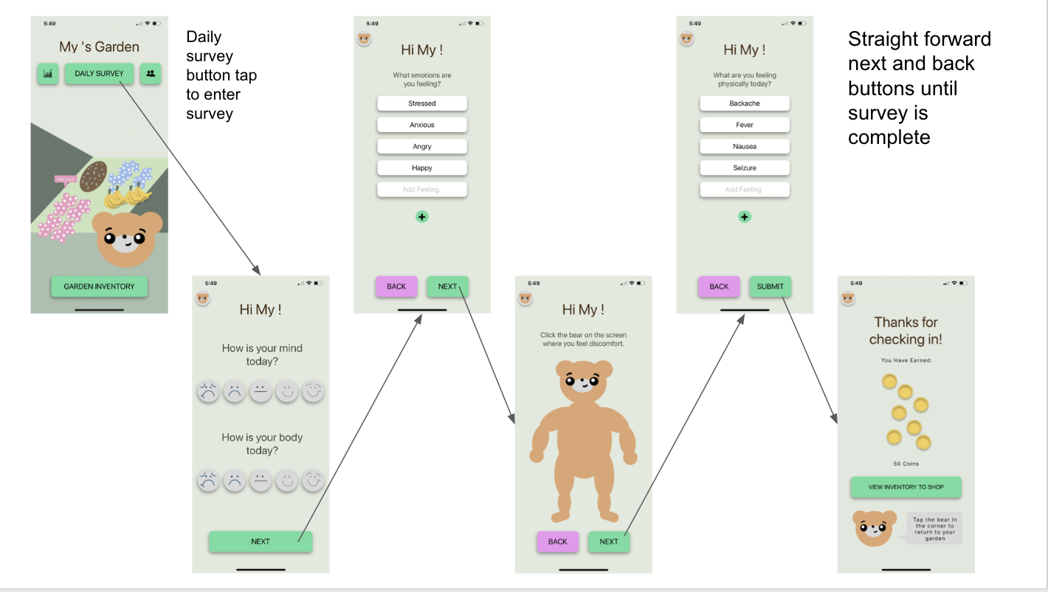

**Task 2:**

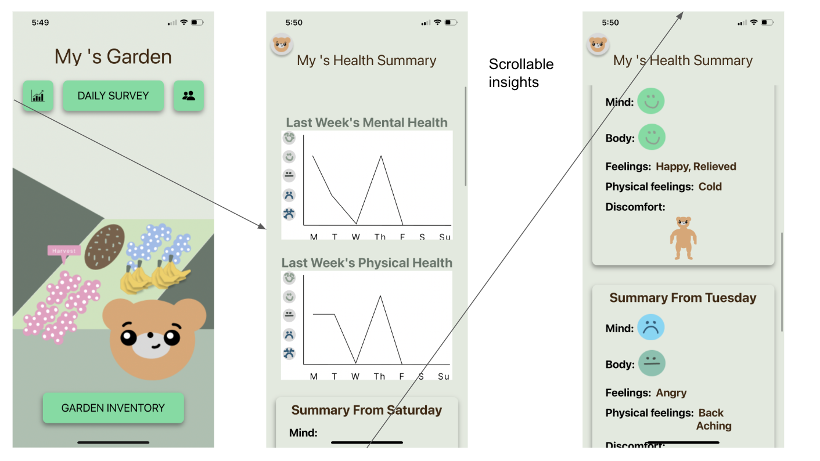

**Task 3:**

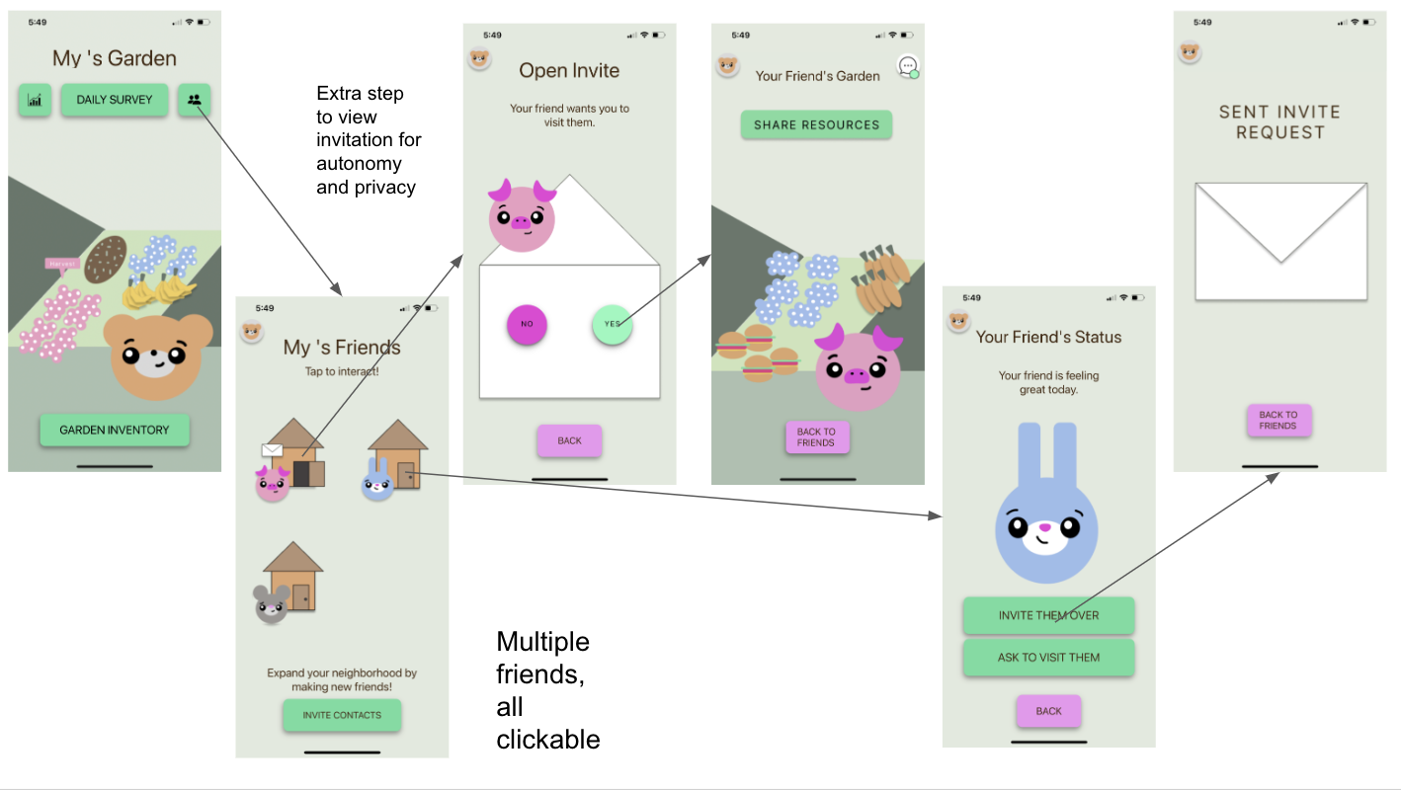

**Design Iterations and Evolution**

We began our design with our low-fi prototype, where the idea was fleshed out but our design still was not quite developed. Our goal was easy usability considering we used a paper prototype, hence the limited design.

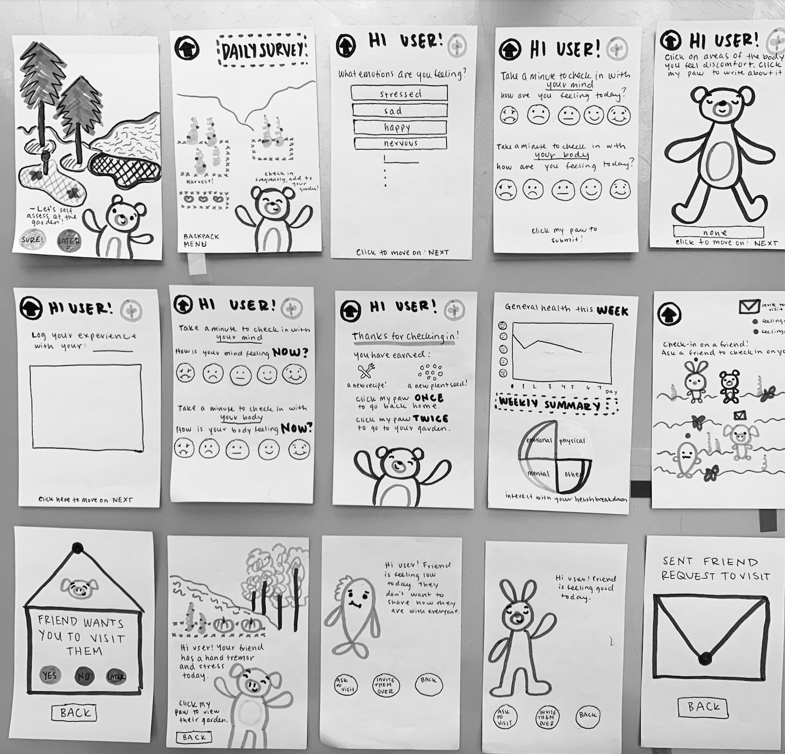

Low-Fi Key Screens

Our initial test users understood the idea and were excited about the potential of this solution, but had some major issues with clarity and efficiency. In task 1, the second face screen was redundant, and the “log your experience” page was inefficient and not often used. The task 2 weekly summary screen was very unclear, as almost no one could even understand that the pie chart was a button. Task three made much more sense to people, but there were still areas of improvement. Moving towards the med-fi, we wanted to take the design up a notch. We were novice designers all new to Figma, so we experimented with a lot of different techniques and design principles going into our next design iteration.

To fix the issue with button clarity in task 1, we initially thought the best route was to differentiate buttons with different colors and more obvious button forms like sliders pictured below. We thought the pink stood out enough to tell users what to do, and initially thought to make less “important” buttons with different colors. We also blocked out big sections of text with colored background headers to make the text more aesthetically pleasing. For our task 2 and 3 implementations, we wanted to make the home screens for these tasks novel because so much of our app was a basic survey. We decided to keep the pie chart for task 2 to see weekly insights, and believed that making it colorful would help people see it was clickable. We also made the background of the friends page a globe to represent that these were actual people in the world, rather than just online: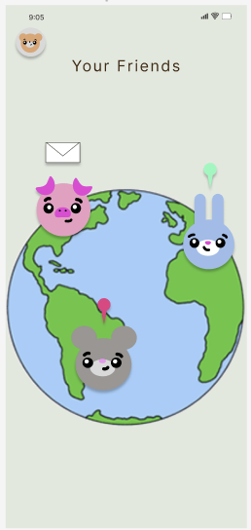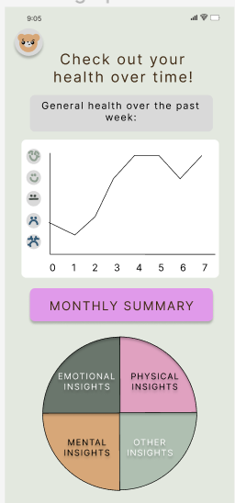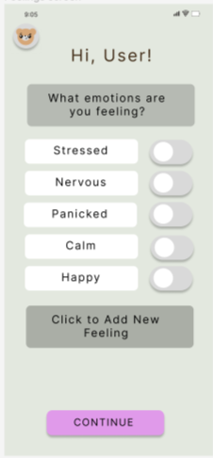

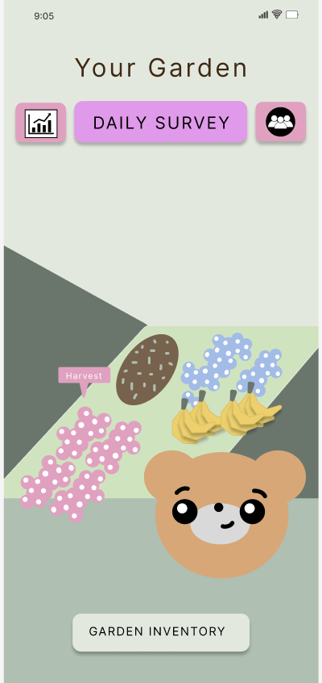

Mid-Fi Key Screens

In our heuristic evaluation, we learned that we overdid it with our design. We found our main issue lay with a lack of UI consistency that was detrimental to usability. Specifically we had too much text and inconsistency in buttons and that made them confusing and added general clutter. We thought we were adding clarity by adding more color and text, but we learned the hard way that this actually had the opposite effect. Most of these errors were reflected in heuristic severities of 1-2, but the most severe were found in our 3-4 errors. Below is a further explanation of our heuristic 3-4 errors:

1. **H1: Visibility of System Status / Severity 3**
   * **Task:** Earning Coins, receiving recipes
   * **Description:** After you complete a survey, you are supposed to receive coins, but there is no indication of where those coins go, what you can do with them, how they influence your harvest, etc. also there is no indication of where the recipe goes once you return to the home screen.
   * **Rationale:** if coins are incentives and have functions, it should be clear what happens to them and how the user is able to use them!
   * Fix: Got rid of earning recipes, added a coin section in the inventory

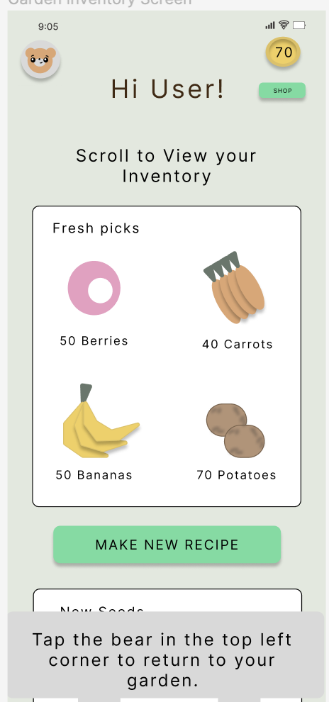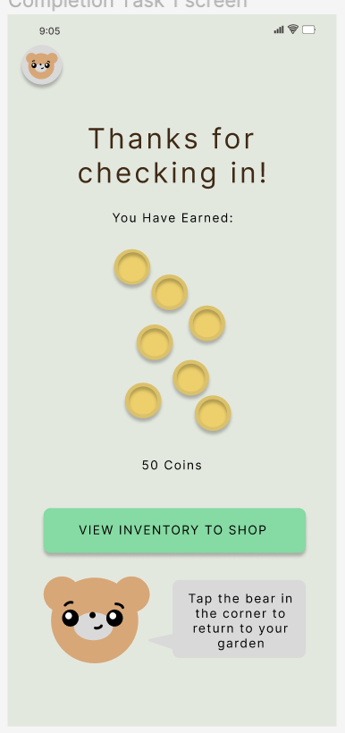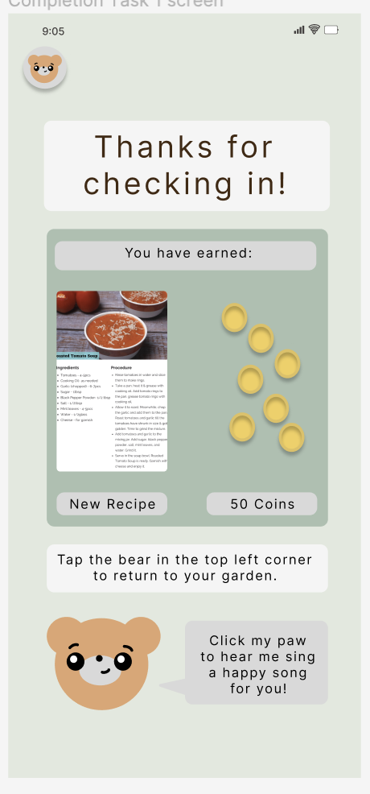

1. **H3: User control and freedom / Severity 4** 
   * **Task:** Record one’s current mental and physical well-being
   * **Description:** Can’t go back to the previous question
   * **Rationale:** If the user changes their mind at a later point in the survey and wants to edit their answers to the previous question, there aren’t any buttons that let them go back. The only option for the user is to exit the entire survey and lose all progress.
   * **Fix:** Add a back button to go back to previous questions.

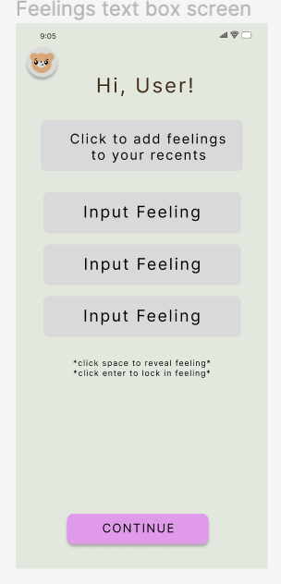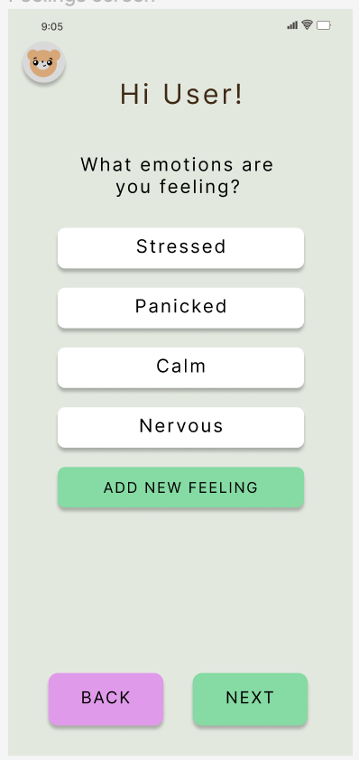

1. **H3: User Control and Freedom / Severity 3** 
   * **Task:** Friends globe view
   * **Description:** As a user, when I see a globe, my first intuition is to be able to interact with the globe in some way to see my friends around the world
   * **Rationale:** This intuition to be able to interact with a globe generates confusion when as a user, I’m unable to rotate the globe in any way and am stuck on a fixed image
   * **Fix:** Change globe to “house” view to get rid of confusion

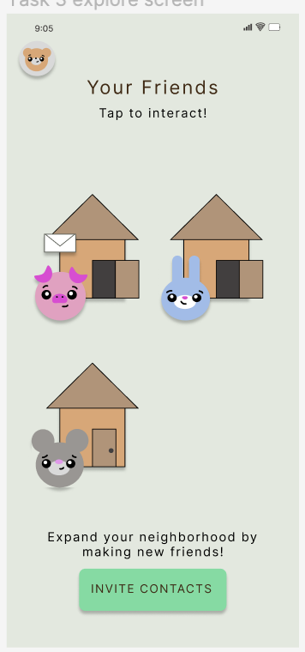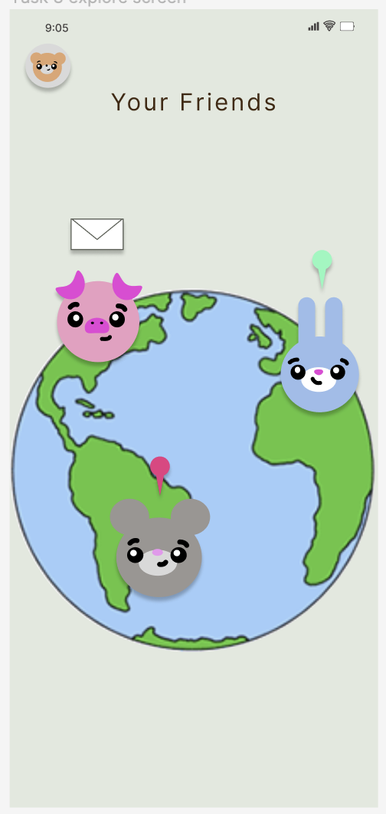

1. **H4: Consistency and standards / Severity 4**
   * **Task:** Record one’s current mental and physical well-being
   * **Description:** Bear icon confusion
   * **Rationale:** The bear icon in the left corner as an exit button can be confused with settings or a personal profile page which usually has such a generic icon.
   * We chose not to fix this issue because there is no profile page in our app, so we felt that it was unnecessary to differentiate the bear in the corner from a profile image. Also, the garden essentially is a user’s profile page, so it is guiding the user exactly where they are supposed to go.
2. **H4: Consistency and Standard / Severity 3**
   * **Task:** Inviting a friend over to my garden
   * **Description:** The page after sending an invite contains a back button
   * **Rationale:** The standard for a back button is that a back button will redirect you to the last page you were at by undoing any changes you made in the last page
   * **Fix:** Rename back button to return to friends
3. **H5: Error Prevention / Severity 4** 
   * **Task:** Record one’s current mental and physical well-being
   * **Description:** Click on multiple faces at the same time
   * **Rationale:** If the user makes a mistake the first time picking and proceeds to click a new face, the old face still lights up. Thus the users can click on all of the faces to indicate how they’re feeling i.e being extremely happy and sad all the time which isn’t possible. This is also a contrast with the “Choose one” message above.
   * **Fix: This was fixed in our High-Fi** and was a result of the limitations of figma. In the final implementation, only one face lights up at a time.
4. **H6: Recognition rather than recall / Severity 4** 
   * **Task:** make others aware of how one is feeling
   * **Description:** Doesn’t display friend’s name
   * **Rationale:** In the world map screen, there are avatars of the animals but there aren’t any names of which friends is it. The user would have to recall from memory which friend has which avatar so it adds an additional mental step.
   * We chose not to fix this error. If the app were to actually be created, there would be real names for the animal icons, but we did not want to confuse users testing our final implementations with names they had never seen before when the main point was to show friendship.
5. **H6: Recognition rather than recall / Severity 3**
   * **Task:** make others aware of how one is feeling
   * **Description:** Doesn’t display recipient’s name
   * **Rationale:** Before the user sends out a request to visit, they only see the animal avatar but couldn’t tell who this avatar represents. They would have to dig back into their memory in order to retrieve that information before they are confident they send the request to the right person.
   * Again, this error is almost the same as the previous one, so we did not fix it. We felt that simply having the picture was enough to get the task completed and the point of sending a friend invite request across.
6. **H10: Help and documentation / Severity 3** 
   * **Task:** Garden/Home Screen
   * **Description:** No information on harvest
   * **Rationale:** For those who are new to the app and don’t know about the inventory yet, they might be hesitant to click harvest the fruits because it isn’t clear what would result in. Do they lose their fruit stock, points, money...etc.
   * **Fix:** Add a more direct button from the harvest page to the inventory page so that the harvest is immediately clear

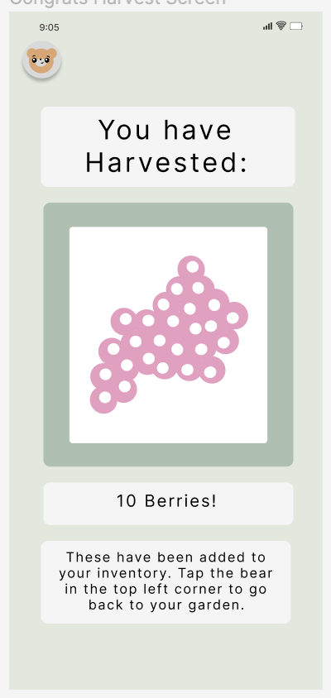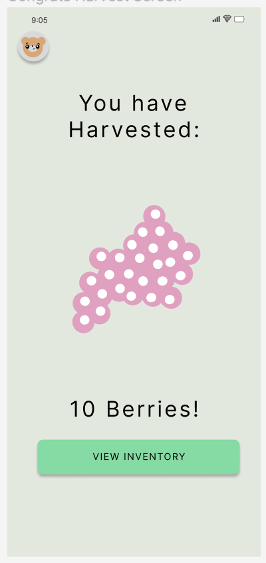

1. **H4: Consistency & Standards / Severity 3** 
   * **Task:** Daily Survey
   * **Description:** On the emotions page the “click to add new feelings” button is in dark gray which is being used for deactivated buttons
   * **Rationale:** the user should not have to read the box to know it is selectable
   * **Fix:** change the color of the button to know it is selectable 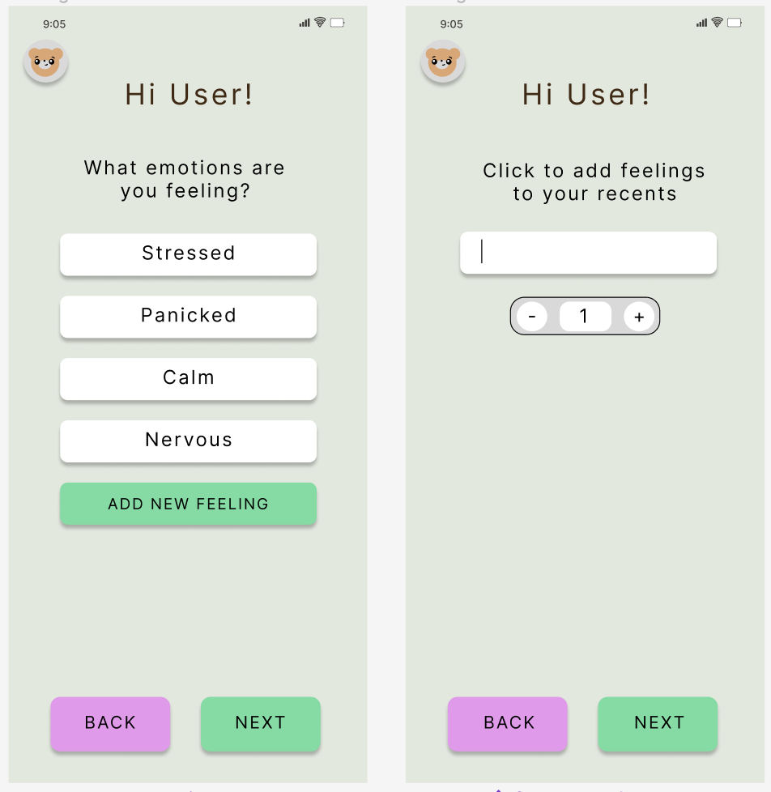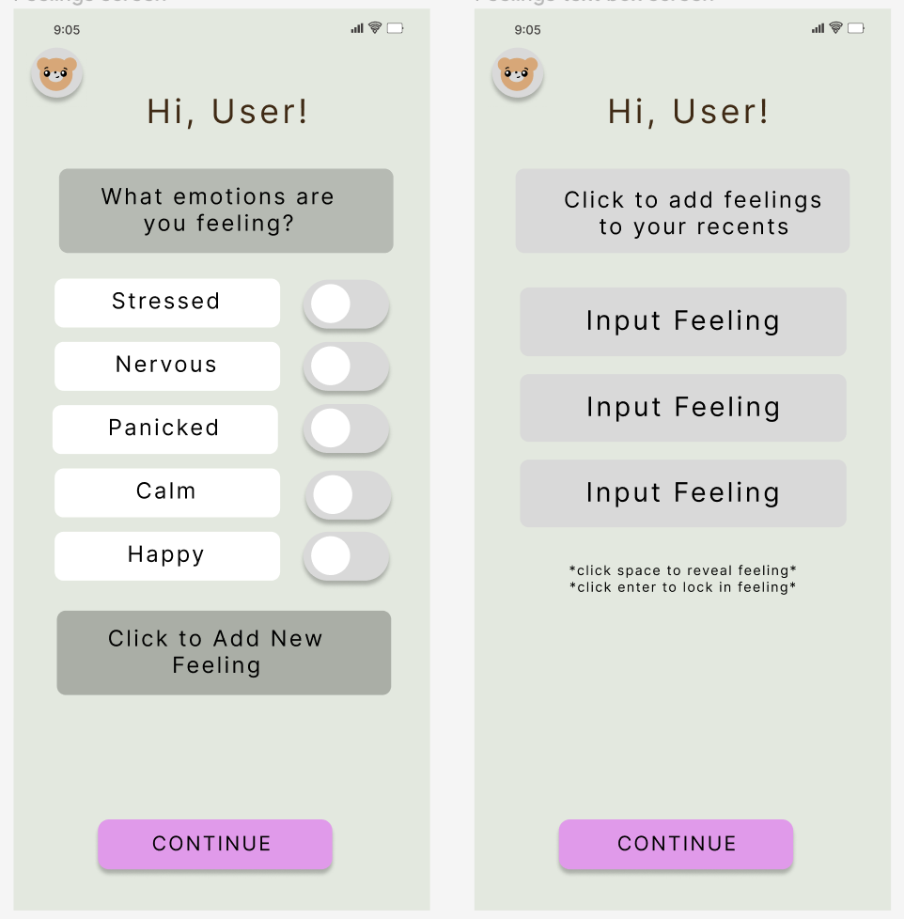

The heuristic evaluation taught us a lot about how less is more. With a cleaner and simpler design, along with a few extra added screens to solve some other usability problems, our final Figma prototype looked like this:

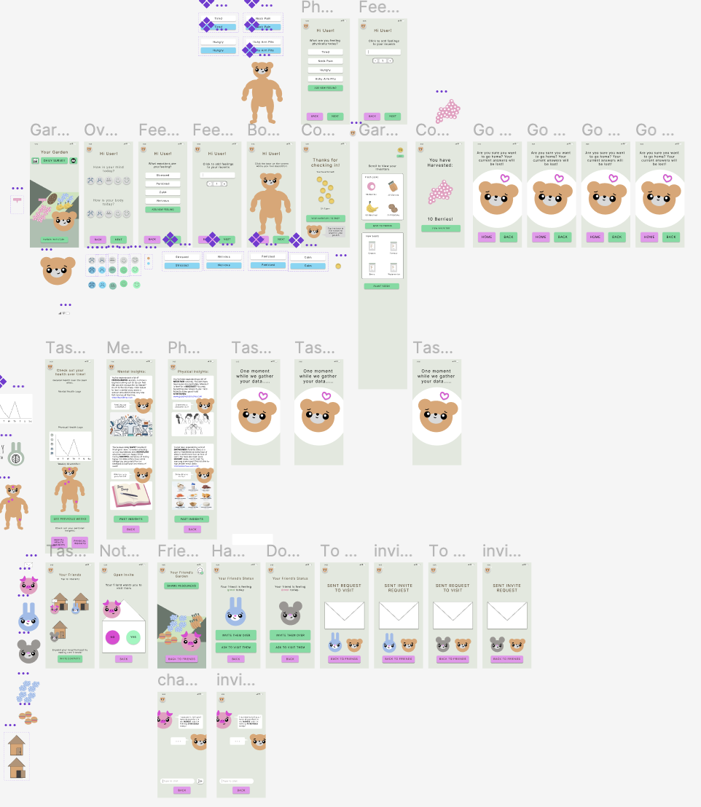

**Values in Design**

**Our Values:**

* Privacy and Agency. We want our users to feel safe and in control while sharing their personal health information with us.
* Community. We want our users to discuss their health with their community to foster a more supportive, open discourse about medical conditions.
* Accountability. We want users to consistently track their wellness over time.

**Design Features:**

For privacy and agency, we focused on the “sharing with friends” and “survey” tasks. In sharing with friends, we wanted the choice to share information to be completely up to the user. They have the power to choose what to share. The only way a friend can visit another friend is by sharing a request to visit, so if that other friend does not feel like sharing or does not want any visitors, they can simply decline this request. The same goes the other way- if a friend invites a friend to come over, they do not have to go over until they are ready or ever at all. In the survey task, we allowed users to skip questions if they liked. If a user does not feel comfortable sharing with anyone except themselves how they are feeling, we want to respect that wish for privacy.

For our value of community, we were originally lacking in our med-fi prototype before the heuristic evaluation. You could visit friends and ask to learn more about their health, but that was about it. So, to enhance this value, we added a feature where friends could share their garden resources with other friends during a visit. We also added a chat feature to foster deeper conversations (or lighter ones) about whatever the users want to talk about. We figured setting up reward systems like sharing resources and chats would bring users back to the app and make an effort to expand their communities.

Key privacy and community screens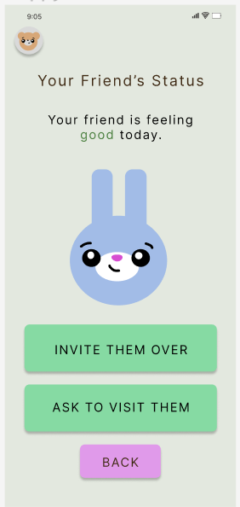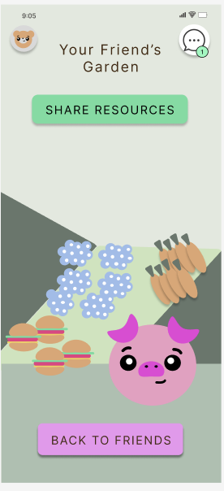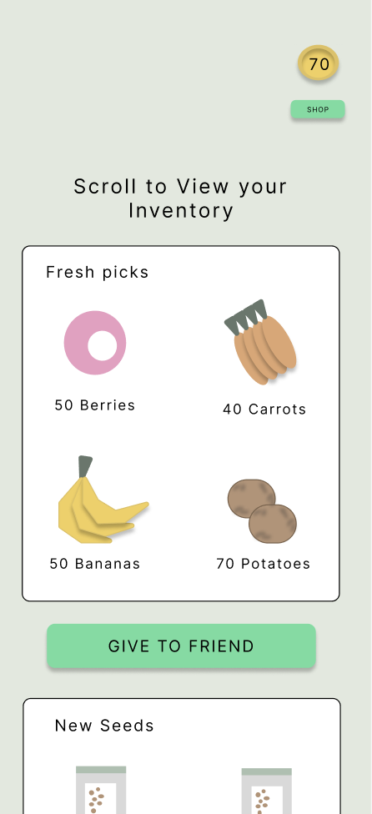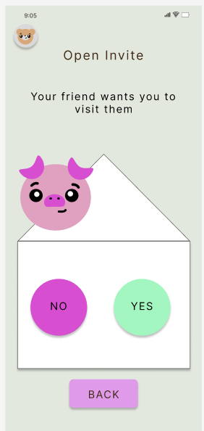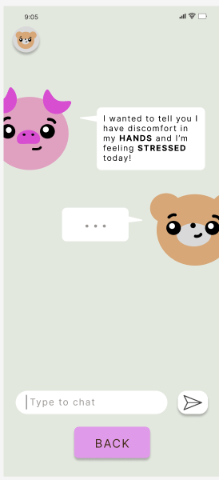

We encoded accountability into task 1 and task 2. In task 1, users are prompted daily to check in with their bodies and answer various questions about their health. Upon completion of this survey, users receive rewards that they can use to grow their garden. In order to grow a bigger and better garden, users *must* hold themselves accountable and complete the daily survey to maximize resources. Users can see their own and their friends’ gardens; thus, they can track their progress tangibly by looking at the health and size of their garden. In task 2, Users can track their recent health stats to see how far they’ve come. We hope that this will inspire users to create health goals for themselves to improve their health status.

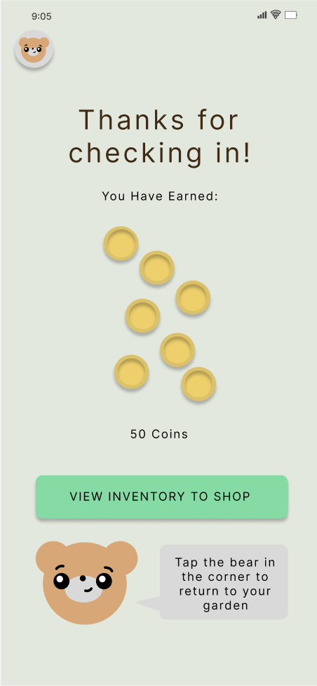

Key accountability screens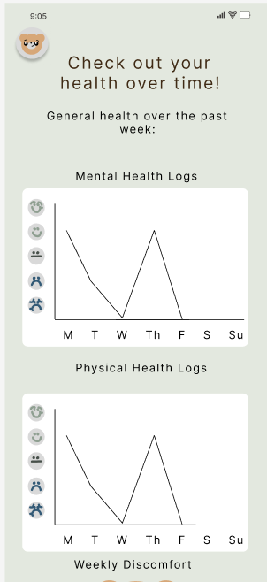

**Conflicting Values**

* Privacy vs Accountability. We will be using the users information and storing it to track their health performance to inspire accountability. This requires storing their health data which could be a privacy violation if stored improperly. This would not come up until our app actually used a database, however. We would need to know exactly where their data was being held and if it was encrypted.
* Agency vs Community. We want to give users the agency to share their information at will. However, the community aspect of lucIDLy is built on the assumption of transparency; we believe that users would have to share some degree of health information with each other to foster this. We reached a middle ground by giving the user the agency to choose whom they want to share their information with and giving them the ability to have friends visit them without explicitly sharing health information until they willingly give it in a chat.

**Final Prototype Implementation**

1. Tools used
   * React Native
     + Pros
       - Simplistic, and extension of React. Most of our group members were familiar with React.
       - Works for cross-platform applications
       - Large user base, many errors have been experienced by others and have help and documentation to solve them
     + Cons
       - Lack of alternatives to popular packages (Hard to find right open source libraries to fit for our app)
         1. Only one well documented graphing package. Hard to use and nondescript errors with no help page
       - Hard to update dependencies together. Updating one package causes other to break
   * Expo
     + Pros:
       - Ease of access to testing the app
       - Live reload (don’t need to refresh to see changes you’ve made)
       - Cloud storage for our app, no wires
     + Cons:
       - Nondescript error messages. We would have to look up errors on Stack Exchange, and even then there were sometimes no clear answers
       - Sometimes long load times
2. Wizard of Oz

Health Insights/Graph: Due to the lack of historic use, there is no past data to draw from - as such, the prototype ‘magically’ analyzes supposed past health data to give the user a graph based on their history, without demonstrating how this occurs.

Rewards: Since there is no past user data to demonstrate the ‘progress’ that this user might have made as reasoning for why they are receiving specific rewards, we have acted as the algorithm that will determine the quality and quantity of rewards that the user receives from checking in.

Friend Status: Users are unable to manually set their own status. However, on the world-view screen, we are still able to view other friends’ statuses even with skipping this step. This is so that users can understand the results of this feature and how it might impact friend visit requests without having to do anything on their end.

Login: Upon opening the app, users are prompted to input a username and password to create an account. This information is not actually stored anywhere other than the username being used to address the user throughout the remainder of the app.

Graphs: Graphs would update after the user submitted the survey depending on their response. When we tried implementing the only graph package for React Native, we found that it crashed when new props were appended to it. In response, we instead created 10 different graphs with different possible outcomes depending on what the user inputted for their daily survey. This way, the graphs were already stored and we could just pull up whichever graph matched the survey information.

1. Hard Coded

Bear screen in survey: Only button users could click was their stomach.

Reward for completing the survey: The reward every single time is just 50 coins, when in a true implementation we would want to make the rewards different to add variety.

User information: As there are no users on the app, historic user data has been hard-coded, except those pertaining to recent survey answers. All friend data - habitats, current status, etc. has been hard-coded so that there are friends to interact with.

Inventory: As there is no historic use by the current user, all objects in the inventory must be hard-coded.

Health Insights/Graphs: Again due to the lack of historic use, the graphs page has been fabricated and hard-coded to provide an example, though the historic answers reflect what the user has actually put in.

Survey Questions: The answer choices for survey questions have been hard-coded, such as the bear only having the stomach as the option to select for discomfort. Furthermore, there have been emotions and feelings provided already for survey questions, though users can add more.

Inventory and Chat Page: The inventory was non-clickable because adding seeds and goods to the garden was not part of our tasks. Also, our chat page was non-interactive because we did not have another user on the other side of our interface.

**Reflection and Next Steps**

There were many valuable takeaways from this project from the design thinking process, to our studio theme, to our own project.

**Design Thinking**

There were two key takeaways we learned from the design process. The first was specificity when crafting questions for needfinding and POVs to generate solutions. We learned that in order to come up with specific solutions that solve specific, insightful problems, one first has to ask the right questions and pull from the answers the right words and insights. We started very vaguely in our POVs and did not specifically describe the needs of the people we interviewed, which in hindsight could have led to many problems. With specific emotions we were able to create specific values. With a specific solution we could create specific tasks. It was this specificity that led us to success in our refinement later. No matter how much editing we did to our design, we still had the specific core ideas and values that drove our project. The second key takeaway was how important design iteration is and the value that comes with feedback and evaluation. It was difficult at first to receive so much feedback, as we thought we were doing something wrong. But, as we became more familiar with the design process, we learned that it is actually a skill to be able to take feedback and turn it into progress. Our design was too simple in the low-fi according to feedback, which caused confusion. We tried to fix this in the mid-fi by really overdoing our design with colors and text, but our feedback helped us realize that this was even more confusing. Without testing and receiving feedback over and over again, yes we would have been less frustrated, but we also would have gotten nowhere as developing designers and our project would have been messy and unprofessional.

**Our Studio**

The main takeaways from the Equitable Healthcare studio was how there can be so many different problems and solutions within one realm. All of our groups had vastly different approaches to the idea of “equitable healthcare.” We made a grow-a-garden game, one group made a scavenger hunt, and another made a family cooking app. Upon reading that previous sentence, it is not immediately clear that any of these things have anything to do with healthcare. That was the beauty of this studio- we all found so many different and creative ways to address different subjects in equitable healthcare without the looming stigma tied to them.

**Our Project and Next Steps**

There was so much to learn from the total experience of our project. Most of us having never asked questions about equitable healthcare before, we were very surprised to learn so many alarming things about the resources that people have. The main inspiration behind our project was a woman who told us that her life threatening medical condition could have been avoided if she or someone close to her had been able to identify her symptoms when she was a young girl. Our project aimed to get people more in tune with their health, and eventually solve this problem. That being said, we ran into many roadblocks along the way that mainly had to do with ethics. When dealing with healthcare, we had to be extremely careful with our word choice and the emotions we were attaching to certain words as to not offend anyone or to downplay any medical conditions. As can be seen in our values section, there were many values that went beyond having to do with user engagement. Iterating through our project gave us a new lens for accessibility that we may not have gotten out of a different project or studio.

That being said, we spent a lot of time encoding our values into our project tasks, which did not leave much room to think about the aspect of growing the user’s garden and upgrading the user’s animal avatar. If we had more time, we would have liked to incorporate this aspect into final hi-fi design to give the people trying our app a more immersive experience. We would make the inventory clickable and allow people to plant things, and we would have a shop page where users could purchase new seeds. We would have also liked to include a screen that levels up our avatar by feeding it or dressing it up, but none of us really have the technical expertise for that yet.

All in all, we enjoyed creating LucIDLy and hope you enjoyed learning about our process. If you want to see more, please visit our website at

<https://hci.stanford.edu/courses/cs147/2022/au/projects/EquitableHealthcare/lucIDLy/>