

Be Aware with EduCare

CS 147 Autumn 2022
Nate F. | Lead Engineer
Brenden K. | Lead Designer

Introduction 2
MISSION STATEMENT 2
PROBLEM AND SOLUTION OVERVIEW 2
Needfinding 2
POV and Experience Prototypes 5
POINT OF VIEW OF CHRIS 6
POINT OF VIEW FOR GLADYS 9
POINT OF VIEW OF DR. GARAY 10
Design Evolution 11
FINAL SOLUTION 12
TASKS 12
DESIGN EVOLUTION VISUALIZATION(S) AND RATIONALE 15
Lo-fi Prototype: 18
Med-fi Prototype 21
VALUES IN DESIGN 33
Conflicting Values 34
Final Prototype Implementation 35
TOOLS USED 35
HARD-CODED ELEMENTS 35
WIZARD OF OZ 35
LIMITATIONS 35
Reflection and Next Steps 36

Introduction

MISSION STATEMENT
Our mission is to educate students about their healthcare to prepare them for all life moments, expected and unexpected.

PROBLEM AND SOLUTION OVERVIEW
Our need-finding process revealed that college-aged students are not educated about healthcare but understand its importance and desire to know more.
Our goal is to engage young people with healthcare for a few reasons; in addition to the benefits of being educated on different insurance options, from a health standpoint, the more we can engage and educate young people about healthcare the more conscious they will be of their health, the more likely they will be to seek medical attention, and the more prepared they will be to navigate the system.
This results in more preventative care, less serious and long-term illnesses, and a healthier society in the long run.

Needfinding
Throughout the need-finding process, we interviewed a total of 6 people. We initially sought out participants based on levels of healthcare accessibility (domestic vs. international healthcare policies), a diversity of ages to understand a wide range of perspectives, and finally a degree of randomness, considering that we wanted our data to be free from group bias. As we continued the need-finding process, we refined our need-finding focus to focus on unique patient perspectives and medical professionals. The 6 people we interviewed represented the holistic breadth of these characteristics. In seeking out these interviewees, we also aimed to approach them without much prior notice, so as to obtain as genuine a response as possible. That being said, all but one of the interviews occurred in person, with Anjana's interview taking place over zoom (as she is our international perspective).
We interviewed Gladys, Chris, John, Megan, Anjana, and Dr. Garay. Gladys and Dr. Garay were our extreme users, considering that the former has experience with atrial fibrillation and the latter is a medical professional. Gladys was approached on campus near Stanford Burnham Pavilion and Ford Center, and John was interviewed near his work at Wildseed in Town and Country. Chris and Megan are two high school teachers teaching at different schools in the area, and they were each interviewed at their respective schools. Due to medical clinic restrictions, Dr. Garay was contacted and interviewed in her office space. For Gladys, John, Chris, and Anjana, we interviewed these participants in groups of at least two, with Brenden and Nate alternating transcribing versus interviewing. For Megan and Dr. Garay, time restraints required Brenden and Nate to interview and record the conversations, respectively. None of our participants were compensated for their time, but they were thanked excessively for their participation.
Following our interviews, we constructed empathy maps of each participant to synthesize their words and actions to attempt to understand their thoughts and feelings. We understand that, at the surface level, there exist a number of pain points regarding healthcare and access to healthcare.
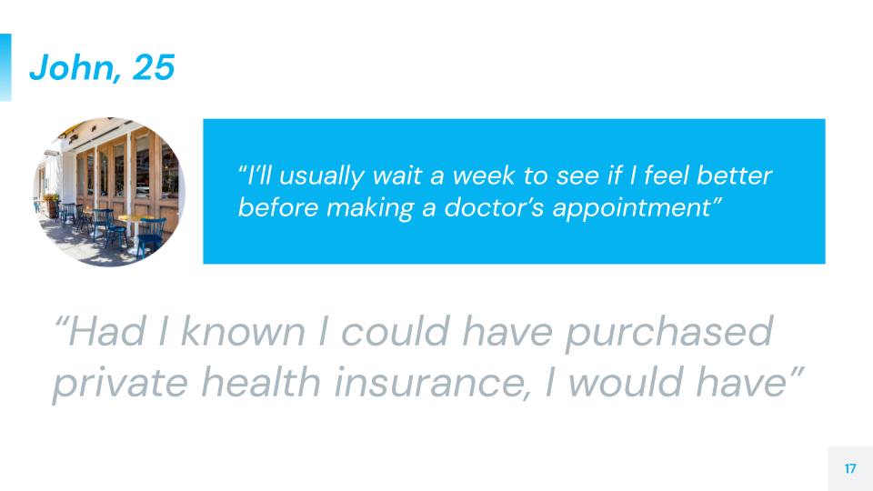
Figure 1: A major quote from John, 25, as he described the challenging aspects of obtaining healthcare

Overall, one of the barriers to healthcare seemed to be time. Anjana, the 20-something-year-old Graduate International student from India, stated that she would typically wait for her symptoms to subside before taking medication. Similarly, John, the 20-something-year-old Wildseed employee, claimed that he would wait to see if his symptoms would last longer than a week before trying to seek medical attention. Anjana and John both exhibit characteristics of people who may view their health as a burden: they would try to find shortcuts regarding their pain and shrug off any forms of uncertainty.
Another barrier to healthcare seemed to be empathy. Gladys, the 70-something-year-old woman with Atrial fibrillation, stuck firmly to the fact that “a good doctor is a kind and empathetic one.” From a number of poor experiences with less-empathetic medical providers, she has now resorted to opting for self-diagnoses and seeking autonomy in her own healthcare. Similarly, Megan, the 30-something-year-old high school teacher, has openly expressed her aversion to going to the doctor despite medical complications, citing the “smugness” of her previous care providers to be the root of her poor experiences with doctors. Considering this, we wanted to pull in a perspective from the other side, one from a medical professional. We interviewed Dr. Garay at Menlo Medical Clinic, and she shared that she feels overwhelmed with the sheer number of patients she sees daily, with little to no time for breaks. Both perspectives–patients and doctors alike–demonstrate a degree of compassion collapse in the healthcare system.
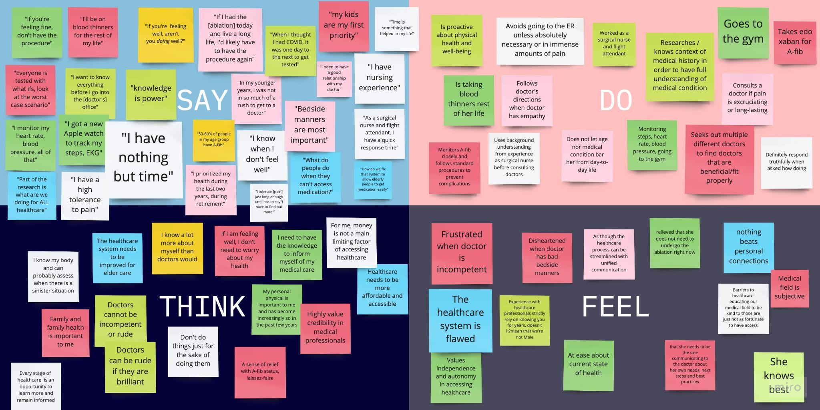
Figure 2: Gladys’s empathy map, as we have mapped out the things that she has said and done and interpreted the things she might be thinking or feeling

Upon further consideration, we deduced that the barriers of time and empathy are valid in obstructing the flow of healthcare, but also realized that they pointed to a greater issue: uncertainty. When patients feel rushed or neglected, they begin to question the system around them: whether the struggle for healthcare is worth it and/or whether they can trust their medical professionals. Chris, the 30-something-year-old high school teacher, demonstrates this uncertainty: he finds that the process of reading healthcare policies is “a pain,” avoids looking through healthcare options, and as a result questions the quality of his healthcare. This is valid–healthcare is often taken care of by parents or guardians until we are thrown into the deep end of healthcare as adults (with, oftentimes, little educational preparation). We have realized that if we can tackle the issue of uncertainty and misinformation, we can greatly ameliorate access to healthcare.

POV and Experience Prototypes
Following our need-finding interviews, we processed the three most insightful and interesting interviews and brainstormed possible solutions. We first crafted Point-of-View (POV) statements for each of Chris, Gladys, and Dr. Garay. These POV statements take the user's insights and needs and attempt to formulate a concise rewording of the problem. The structure of a POV is often as follows: the person we met, what we were surprised to notice, what we wondered, and what it would be game-changing to accomplish.
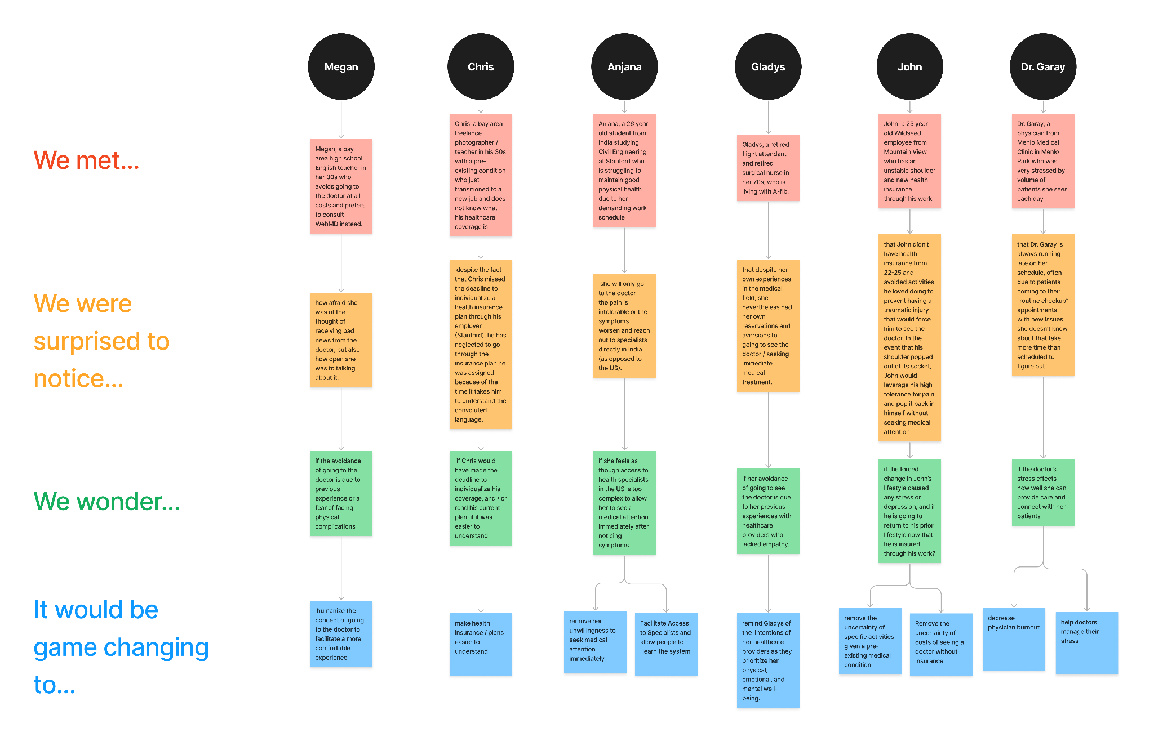
Figure 3: The organizational flowchart of our major POVs, using the We met… We were surprised to notice… We wonder… It would be game-changing to… format

We then leveraged our “game-changing” statements from our POV to extend the analysis a bit further with our How Might We statements, or HMWs. These statements are typically often a series of questions that would provide deeper insight into the brainstorming process–by asking more questions that direct us toward identifying needs and consequent solutions. Through a combination of POVs and HMWs, we were able to brainstorm a number of solutions to solve the problem of uncertainty regarding healthcare. We then wanted to make sure that the solution was iterable and developed experience prototypes, which are designed to test our assumptions about what it is like to engage with the solution we are designing. Below, we have mapped out three distinct paths of our brainstorming process, each starting with a POV, developing into an HMW, resulting in a solution, and being instantiated with an experience prototype.

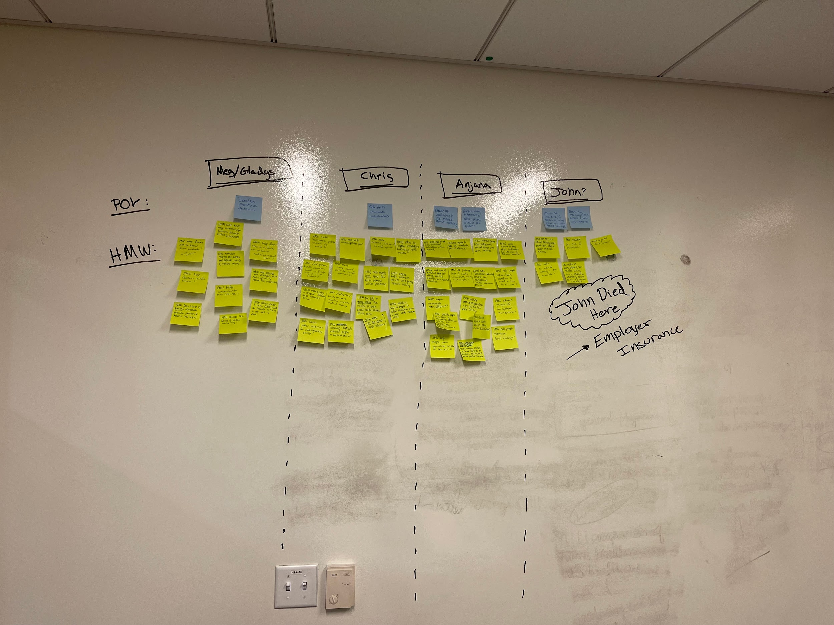
Figure 4: Our brainstorming process to determine the How Might We statements of our users

POINT OF VIEW OF CHRIS
- We met Chris, a bay area freelance photographer/teacher in his 30s with a pre-existing condition who just transitioned to a new job and does not know what his healthcare coverage is.
- We were surprised to notice that despite the fact that Chris missed the deadline to individualize a health insurance plan through his employer, he has neglected to go through the insurance plan he was assigned because of the time it takes him to understand the convoluted language.
- We wonder if Chris would have made the deadline to individualize his coverage, and/or read his current plan if it was easier to understand.
- It would be game-changing to make health insurance understandable for those who receive it from their employers.

HOW MIGHT WE STATEMENTS INSPIRED BY CHRIS
- How Might We Give kids/teens/young adults the initiative to learn more about health insurance policies earlier?
- How Might We Make People CARE about their health insurance policies proactively?
- How Might We Make Health Insurance Policies fun?
- How Might We make healthcare more engaging for a broader audience?

SOLUTIONS AND EXPERIENCE PROTOTYPES INSPIRED BY CHRIS
From our interview with Chris, we have realized that a lack of information or education regarding healthcare is a prevalent issue. In order to combat this ignorance regarding healthcare, we wanted to try to increase engagement in the healthcare learning process. Since Chris has specifically stated that the policies are difficult to read, we wanted to see how we could gamify the process of learning about healthcare. As a result, we brainstormed two solutions to increase engagement in learning about healthcare.

Solution 1: A Scavenger Hunt game that quizzes people on health and healthcare
Considering that we were attempting to gamify the healthcare learning process, we realized that healthcare education would start earlier, specifically for college-aged individuals, so they will be equipped with the relevant knowledge when it is necessary. However, we were unsure of whether or not we could get college students to participate in such an activity. We wanted to test our assumption that young adults (aged 17-22) are interested in learning more about their healthcare policies.
We set up an empty room with a number of obstacles, including knocked-over chairs, tables, and stacks of boxes, so that the room turned itself into an obstacle course of sorts. We then hid a number of healthcare-related questions around the room, some being extremely obvious and some being more subtle. We then invited two students–Katie, a freshman, and Airin, a sophomore (selected due to their fit in the target age demographic)–to navigate the room and attempt to find and answer the questions on a provided sheet of paper. We wanted to make sure that students would opt to seek information about their healthcare. Both Katie and Airin navigated the room and ultimately found and answered the questions, to varying degrees of success (although we did not expect them to get them correct!). Following the experience, we found that both participants seemed stressed about scoring/question accuracy, and both got most of the questions incorrect, further demonstrating a need for education about healthcare.
Ultimately, the students self-reported enjoyment of engaging with the game. Furthermore, we found that checking answers and revisiting questions at the end helped memory retention. Finally, participants stated that they wished they knew more about healthcare and were interested in learning more.

Solution 2: A system where people receive a daily fun fact about their health/health insurance policy
In another attempt to increase engagement in the healthcare education process, we brainstormed a number of solutions, and one of the solutions we embraced was Healthcare Factoids, where people receive a daily fun fact about their health/health insurance policy. Not unlike daily reminders, users would be provided with a randomized daily fun fact that they could learn, bookmark, share, revisit, and hopefully retain. However, we realized that the retention of the daily fact would be the difficult part. Especially considering the rise of technology and short-spurt media like TikTok that have reduced the attention span to six-second videos, we wanted to make sure that people, specifically members of our target audience of college students aged 17-22, would be able to retain information provided to them over a period of time. The assumption we wanted to test was that people will be able to retain short facts or pieces of information for a longer period of time after their initial reading.
We set up an empty room with a single table, atop which were placed four factoids regarding healthcare and general health information. These factoids were specifically chosen because they are not factoids that people encounter on a daily basis, so participants would have to learn and memorize the factoid on the spot.
Our participant, Yara, is a college freshman, who–with little notice, so she could not prepare–was invited into the room to read these four fun facts. She only read the factoids and their corresponding questions, then left the room. She was re-invited into the room after 10 minutes, where she was quizzed on the information she had read earlier. During this initial quizzing, she remembered all of the questions, reciting them to us, but could not remember the answers. After she was reminded of the answers, she left once again. She then returned after another 10 minutes, when she was questioned yet again. This time, her scoring accuracy was one hundred percent correct. This demonstrated that reviewing answers facilitated memory recall, and being exposed to the content numerous times over a period of time resulted in improved memorization. Similar to Airin and Katie, the other participants, Yara also seemed stressed about scoring/question accuracy, but she also similarly stated that she wished she knew more about healthcare and was interested in learning more.

GLADYS AND DR. GARAY
Considering that two of our solutions stemmed from the desire to increase engagement in the healthcare education process, we found that our third major solution was derived from two interviews: Gladys and Dr. Garay. We found that the two of these interviewees combined provided insight into the concerns of compassion collapse in the healthcare industry, and thus attempted to brainstorm solutions to combat this.

POINT OF VIEW FOR GLADYS
- We met Gladys, a retired flight attendant and retired surgical nurse in her 70s, who is living with A-fib.
- We were surprised to notice that despite her own experiences in the medical field, she nevertheless had her own reservations and aversions to going to see the doctor / seeking immediate medical treatment.
- We wonder if her avoidance of going to see the doctor is due to her previous experiences with healthcare providers who lacked empathy.
- It would be game-changing to remind Gladys of the intentions of her healthcare providers as they prioritize her physical, emotional, and mental well-being.

HOW MIGHT WE STATEMENTS INSPIRED BY GLADYS
- How Might We help doctors handle stress?
- How Might We foster a sense of GENUINE connection between patients and doctors that isn’t fake?
- How Might We help patients and doctors get to know each other better and stay up-to-date on each other’s lives?
- How Might We help patients avoid feeling neglected by or disconnected from their doctors?

POINT OF VIEW OF DR. GARAY
- We met Dr. Garay, a physician from Menlo Medical Clinic in Menlo Park who was very stressed by the volume of patients she sees each day.
- We were surprised to notice that Dr. Garay is always running late on her schedule, often due to patients coming to their “routine checkup’ appointments with new issues she doesn’t know about, which takes more time than scheduled.
- We wonder if the doctor’s stress affects how well she can provide care and connect with her patients.
- It would be game-changing to decrease physician burnout and help doctors manage their stress.

HOW MIGHT WE STATEMENTS INSPIRED BY DR. GARAY
- How Might We make visits more efficient?
- How Might We ensure that doctors do not feel rushed when administering care to their patients?
- How Might We provide better support for doctors day to day?

SOLUTIONS AND EXPERIENCE PROTOTYPES INSPIRED BY GLADYS AND DR. GARAY
Seeing that compassion collapse is a barrier to healthcare access in both of the perspectives of Megan and Gladys, and that compassion collapse stems from physician burnout as explored with Dr. Garay, we wanted to brainstorm a number of solutions to reduce physician burnout.
Solution 3: A way to dynamically schedule appointments based on patients’ current issues/needs and doctors' workload, while tracking and helping doctors manage their stress.
Regarding this solution, we wanted to test our assumption that doctors have the time to fill out a survey to dynamically schedule their appointments, between patients. We also wanted to test the assumption that all doctors have similar stressors when relating to patients. In order to test this assumption, we devised a survey with a questionnaire sheet as follows:
- How long did you spend with your last patient?
- How difficult was it to treat their problems/
- How difficult were they to deal with?
- How well did you connect on a personal level?
- How stressed are you right now?
- How tired are you right now?
- How busy is your schedule right now?
- How flexible is your schedule right now?
- How much would you like a break?
- How much are you looking forward to your next patient?
These questions were each accompanied by a slider, where the doctor would indicate on a spectrum their alignment with the question. We then visited the Menlo Medical Clinic and invited Dr. Garay, during a brief window between her patients, to fill out the survey in her office. Regarding pain points associated with the experience prototype, Dr. Garay stated that the survey was too long, and couldn’t be done between patients. Furthermore, the use of sliders was too subjective, and Dr. Garay need more quantitative options/boxes to select. However, regarding the benefits of the experience prototype, we determined that the survey was easy to use, as nothing didn’t work for her. She evidently had no feelings of opposition or frustration when filling out, and she felt that she could answer the survey honestly.
Ultimately, all of our experience prototypes proved our respective assumptions, and all that was left to do was decide on which solution to pursue.

Design Evolution
We went through a number of different iterations for our “final” solution. Our first “solution” that we drafted was shift: scheduling health in for thought. This solution stems from our POV of Dr. Garay, as we wanted to explore an intervention to resolve the physician burnout that results in compassion collapse. However, upon further reflection, we attempted to determine a solution that more closely aligns with our research. This is where EduCare comes into play.

FINAL SOLUTION
From our need-finding research, we noticed that the most significant barrier to healthcare access is uncertainty. The experience prototype with Katie and Airin demonstrated that students are willing to learn more about their health and healthcare if presented in a game format. The experience prototype with Yara demonstrated that students are able to retain completely new information if it is presented repeatedly over time. Our experience prototypes–and the effectiveness of gamification in memory retention–demonstrate that there is a need for a more engaging means of learning about healthcare.
Our final solution, EduCare, offers students aged 17-25 the opportunity to gamify the mundane topic of healthcare. EduCare would allow students to learn, explore, and share with our different tasks and ultimately lead to more preventative care, fewer long-term or serious illnesses, and a healthier society in the long run.

TASKS

Simple Task
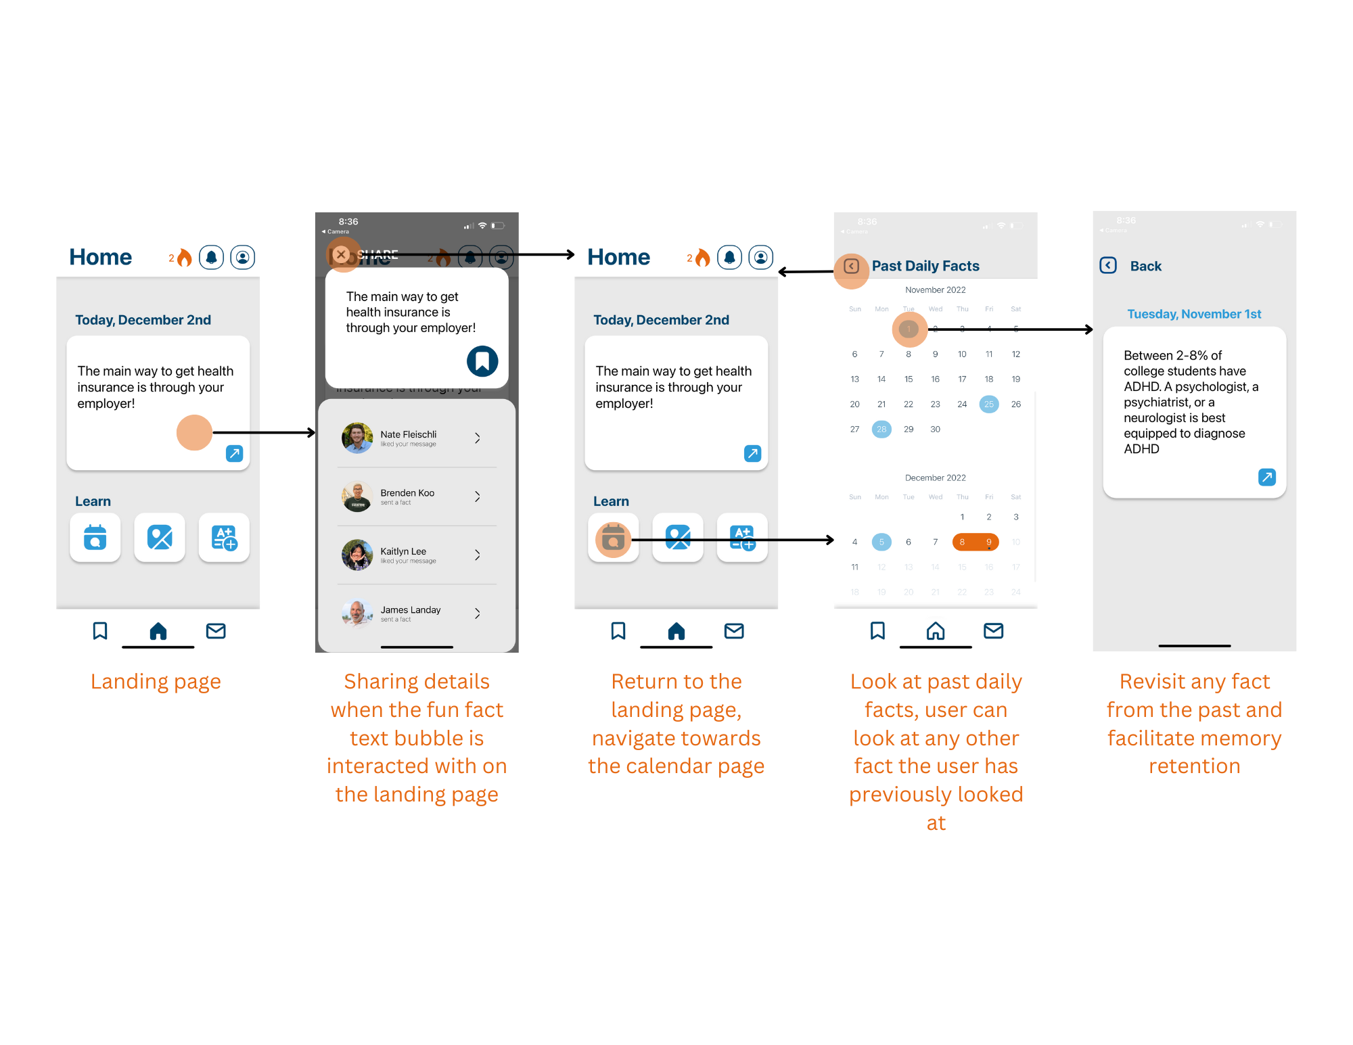
Figure 5: Annotated screens for final simple task flow

Our simple task is to receive a notification, engage with it, and toggle between the current and previous fun facts received. Users should be able to receive daily fun facts, look at the previous fun facts that they have received, and engage with each fun fact, regardless of the day. This simple task relates to our second experience prototype, which has demonstrated that users are likely to retain information when presented with it repeatedly over time. If the fun fact is the most prominent element that user interacts with when they open the app, they would be more likely to retain the information.

Moderate Task
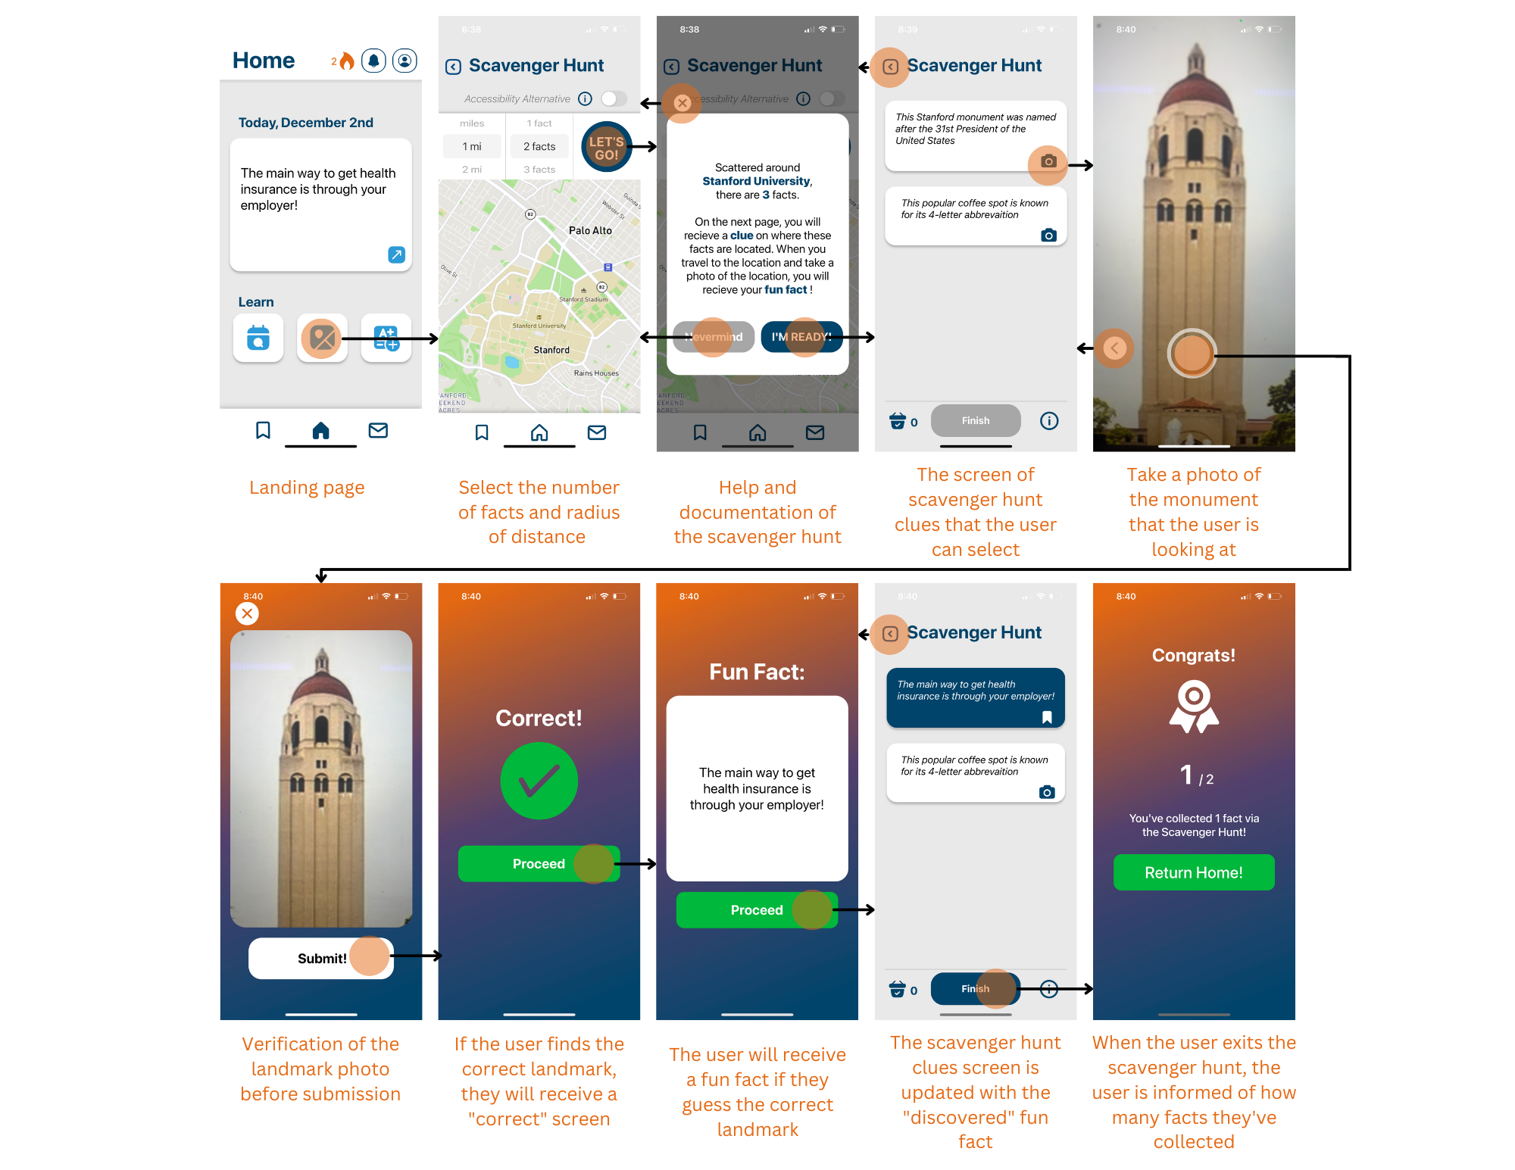
Figure 6: Annotated screens for final moderate task flow

Our moderate task is to engage with one of the learning modules (scavenger hunt) and participate in the search for the facts. The user will be able to facilitate the learning process by using fun and interactive learning activities. The first experience prototype demonstrated that users were able to learn while remaining active, and engaging with their environment facilitated the learning process. The moderate task is important because it adds another dimension to the gamification of the healthcare learning experience.

Complex Task
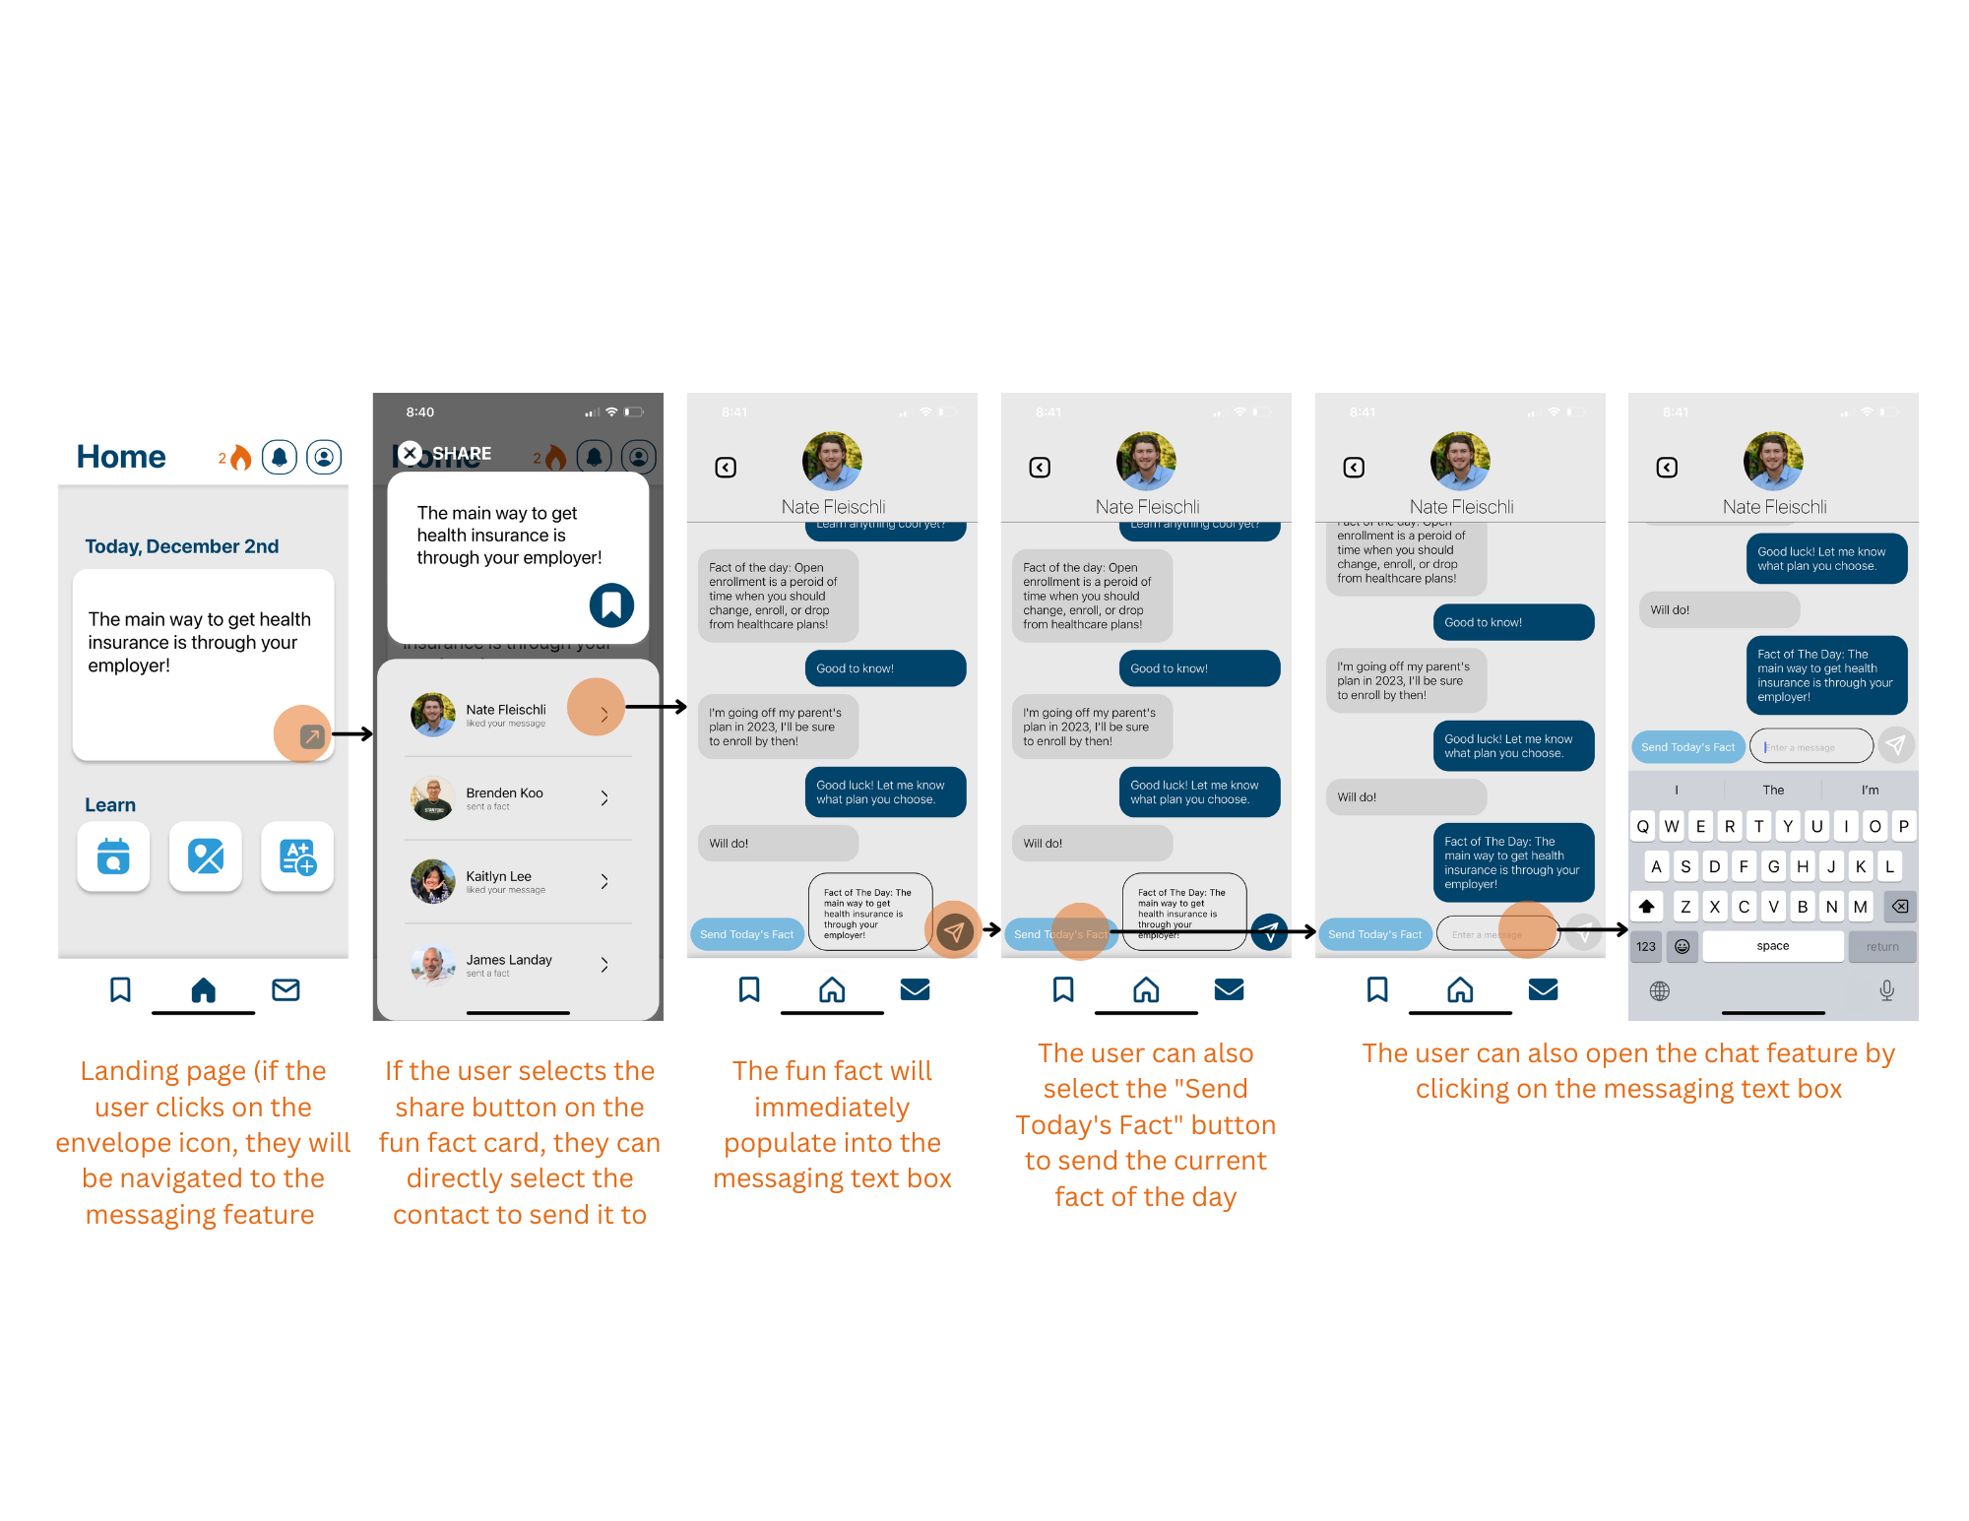
Figure 7: Annotated screens for final complex task flow

The complex task involves the user sharing the current fun fact of the day with their peers, and checking any messages they may have received. Throughout the need-finding process, we determined that one of the more prominent means through which students find success in learning is through teaching one another. We wanted to bring the experience of learning through teaching to life through our messaging and sharing functionalities. By being able to share the fun facts with their friends and networks, the user is able to teach the facts they’ve learned to their peers and simultaneously remind themselves of the information. The user is able to share the current fun fact of the day with just the touch of a button, which makes the sharing and teaching experience a lot easier.

DESIGN EVOLUTION VISUALIZATION(S) AND RATIONALE
Initial Design:
The design process EduCare experienced a number of iterations via different platforms. We explored a number of storyboards and a number of technological media including but not limited to a VR application, a wearable (like an Apple Watch), an Augmented Reality application, a native tablet, and native phone applications. We were unsure of which technological medium to adhere to, but these sketches and storyboards provided some insight into the direction we would enter into. Our sketches are below as follows:
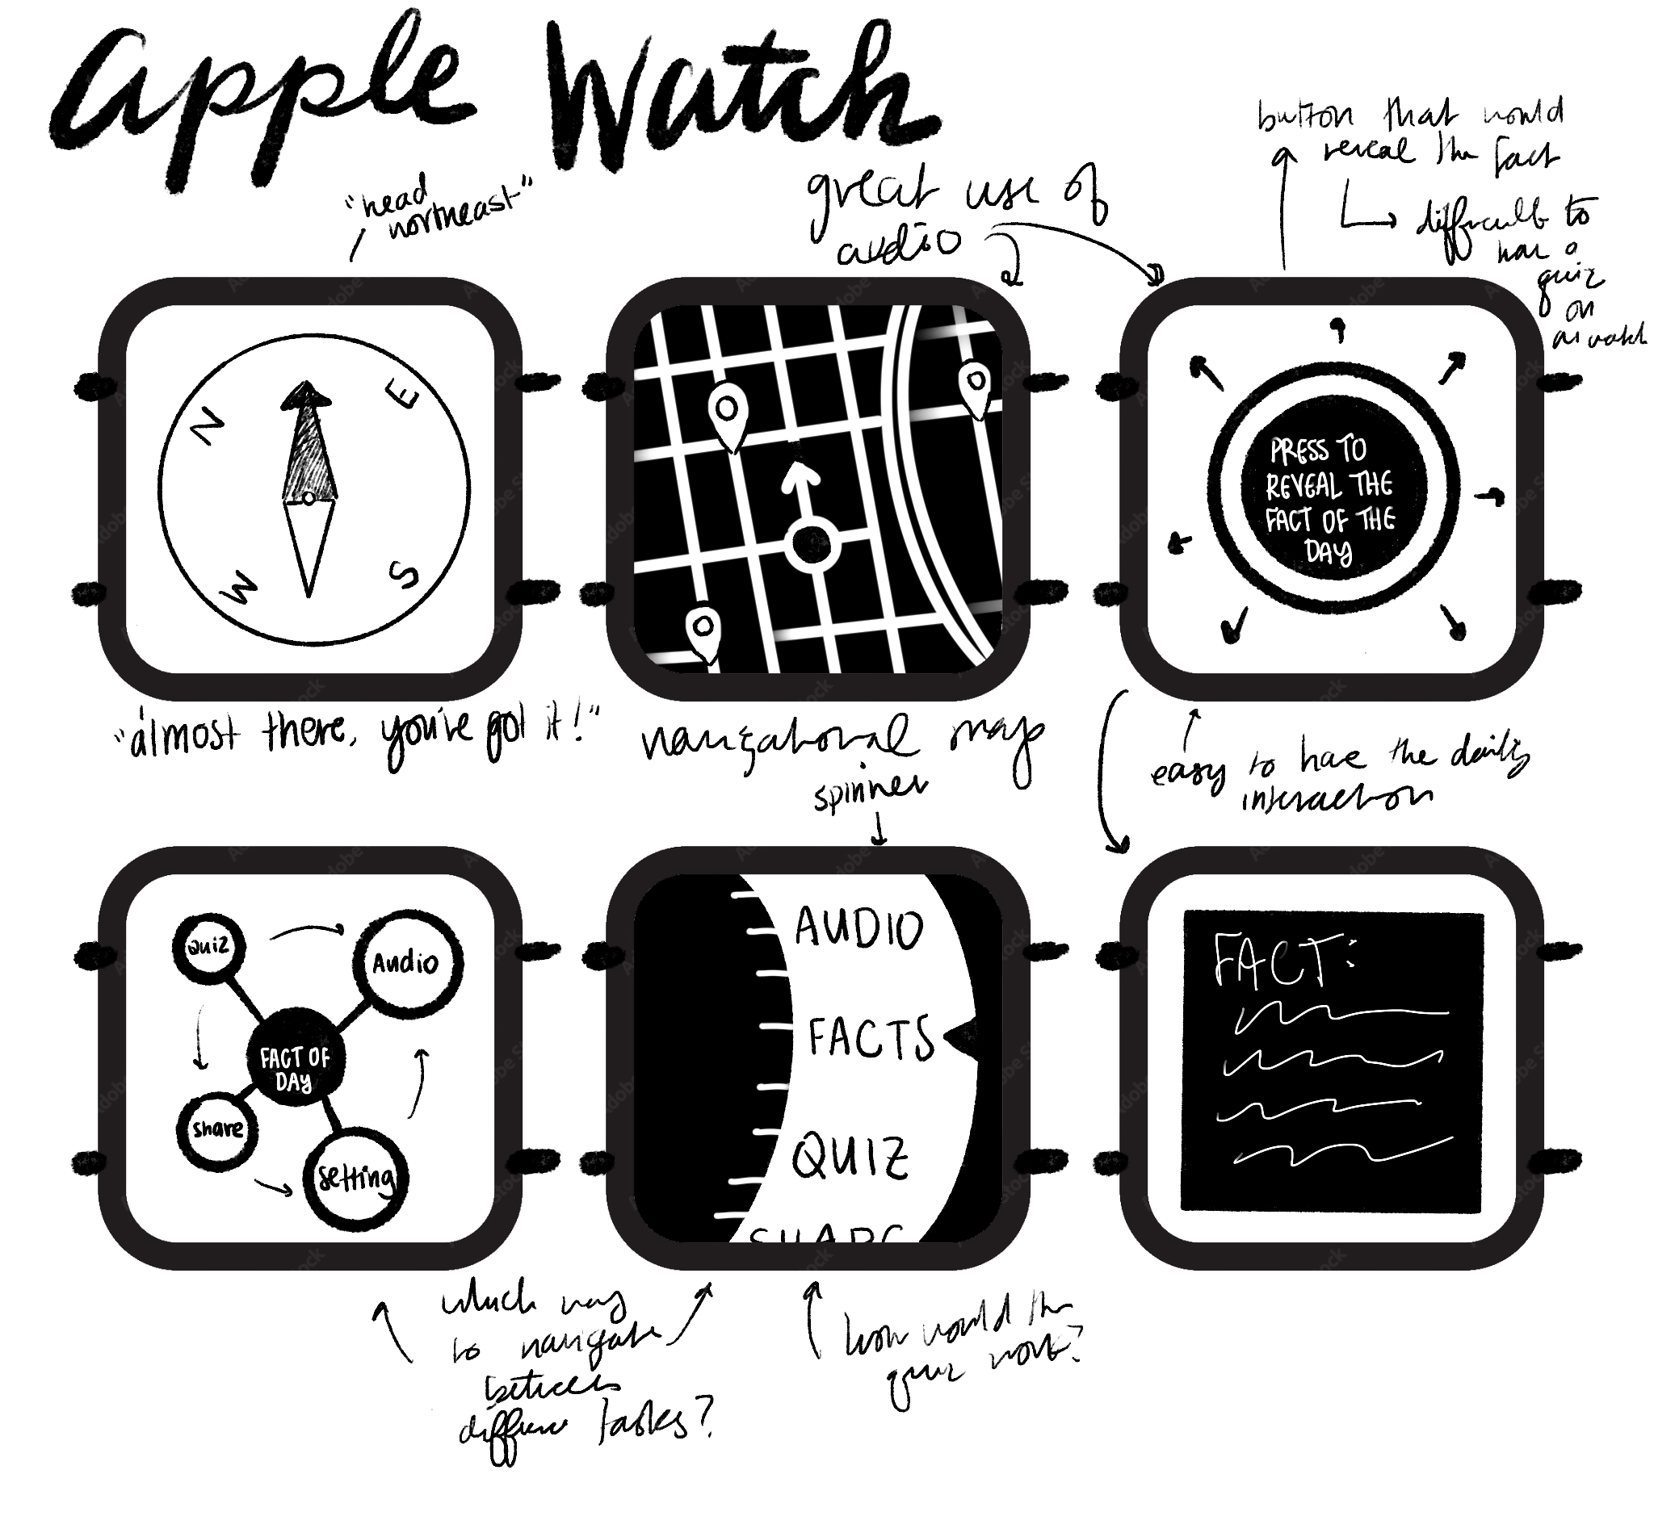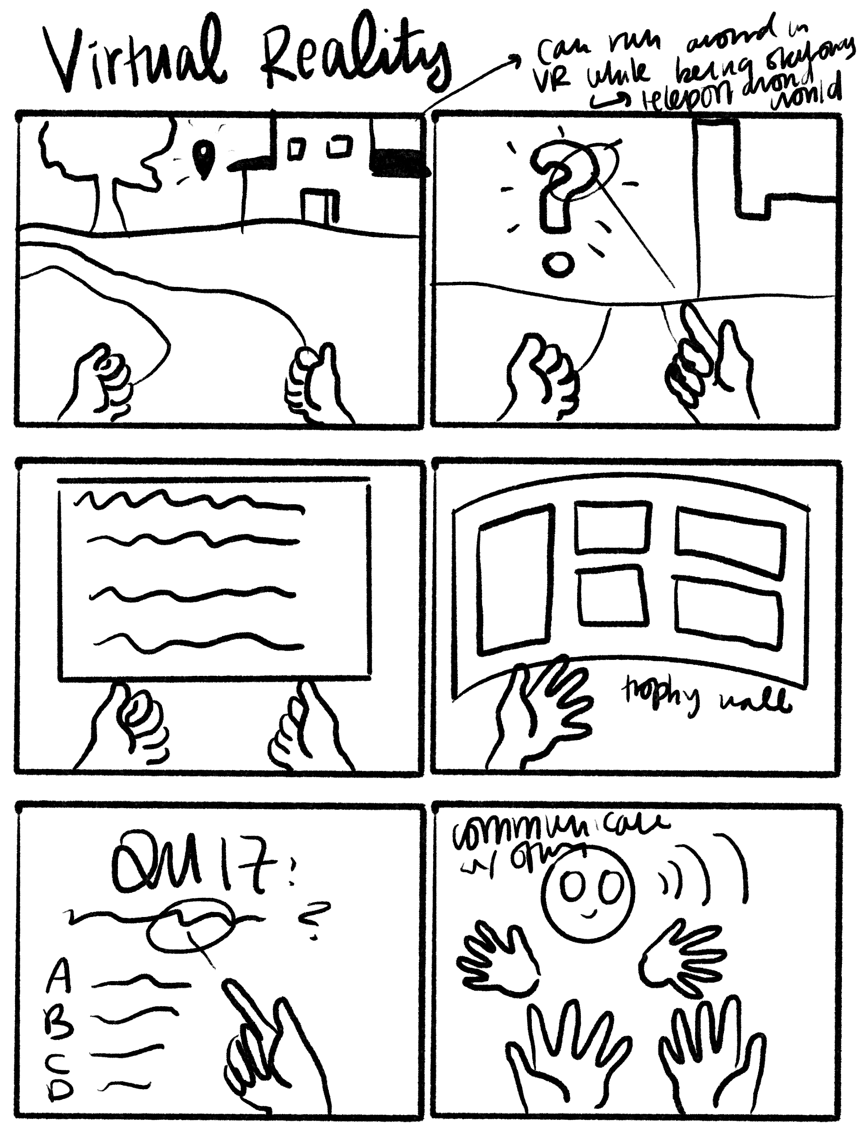
Figure 8: Concept sketches for Apple watch and Virtual Reality applications

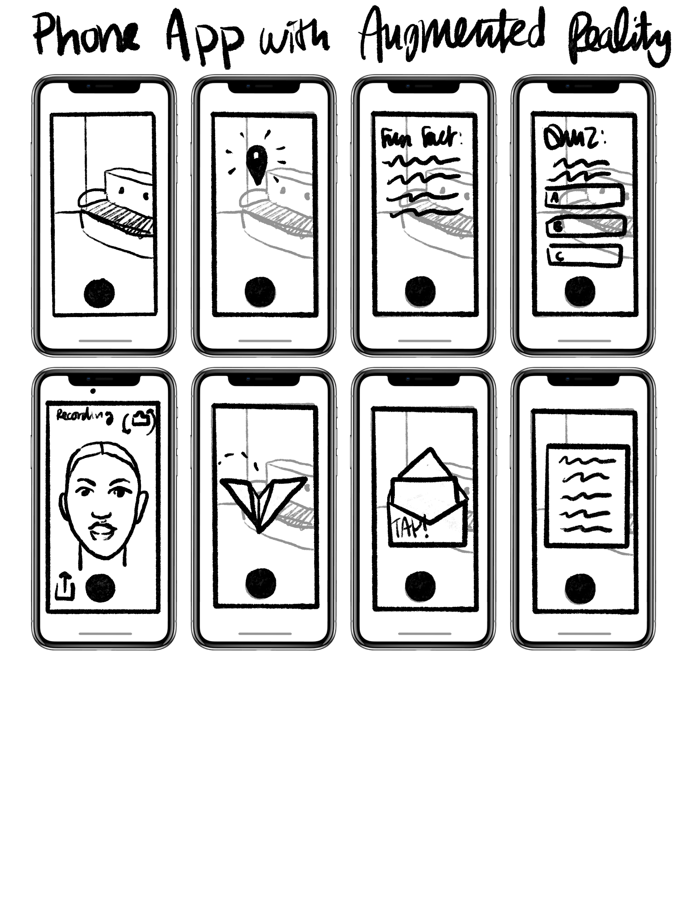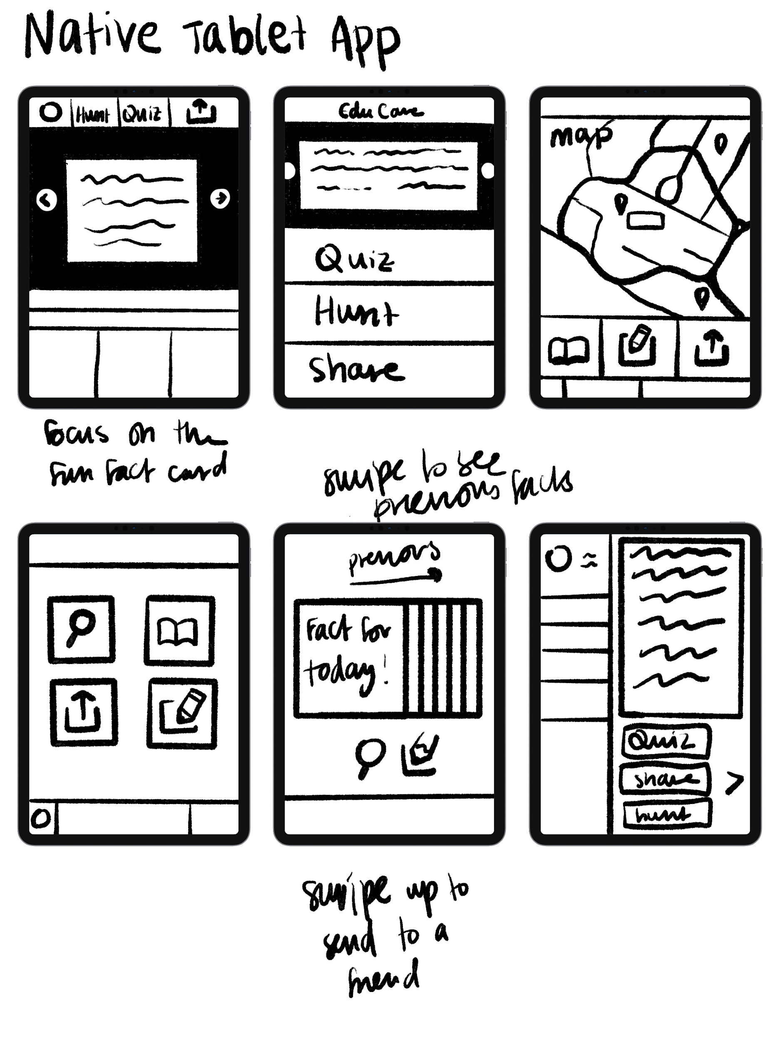
Figure 9: Concept sketches for Augmented Reality and Native Tablet applications
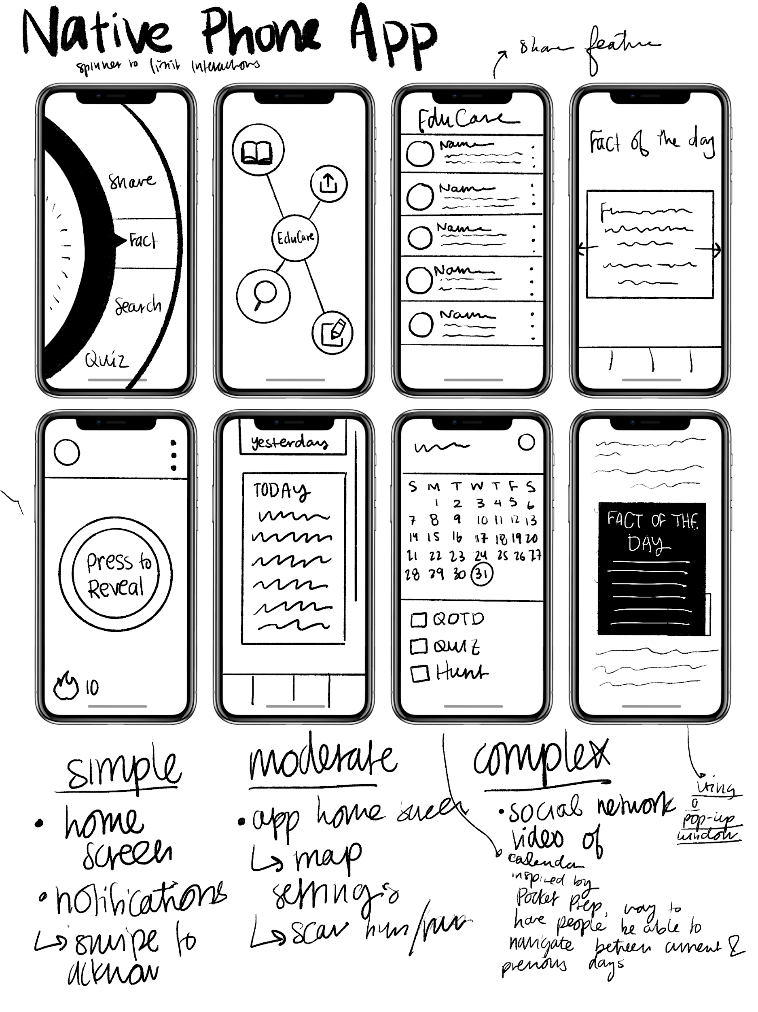
Figure 10: Concept sketches for Native Phone applications

We wanted to look further into the native phone and the augmented reality application. As a result, we mapped out storyboards of both the Native phone application and the Augmented reality application.
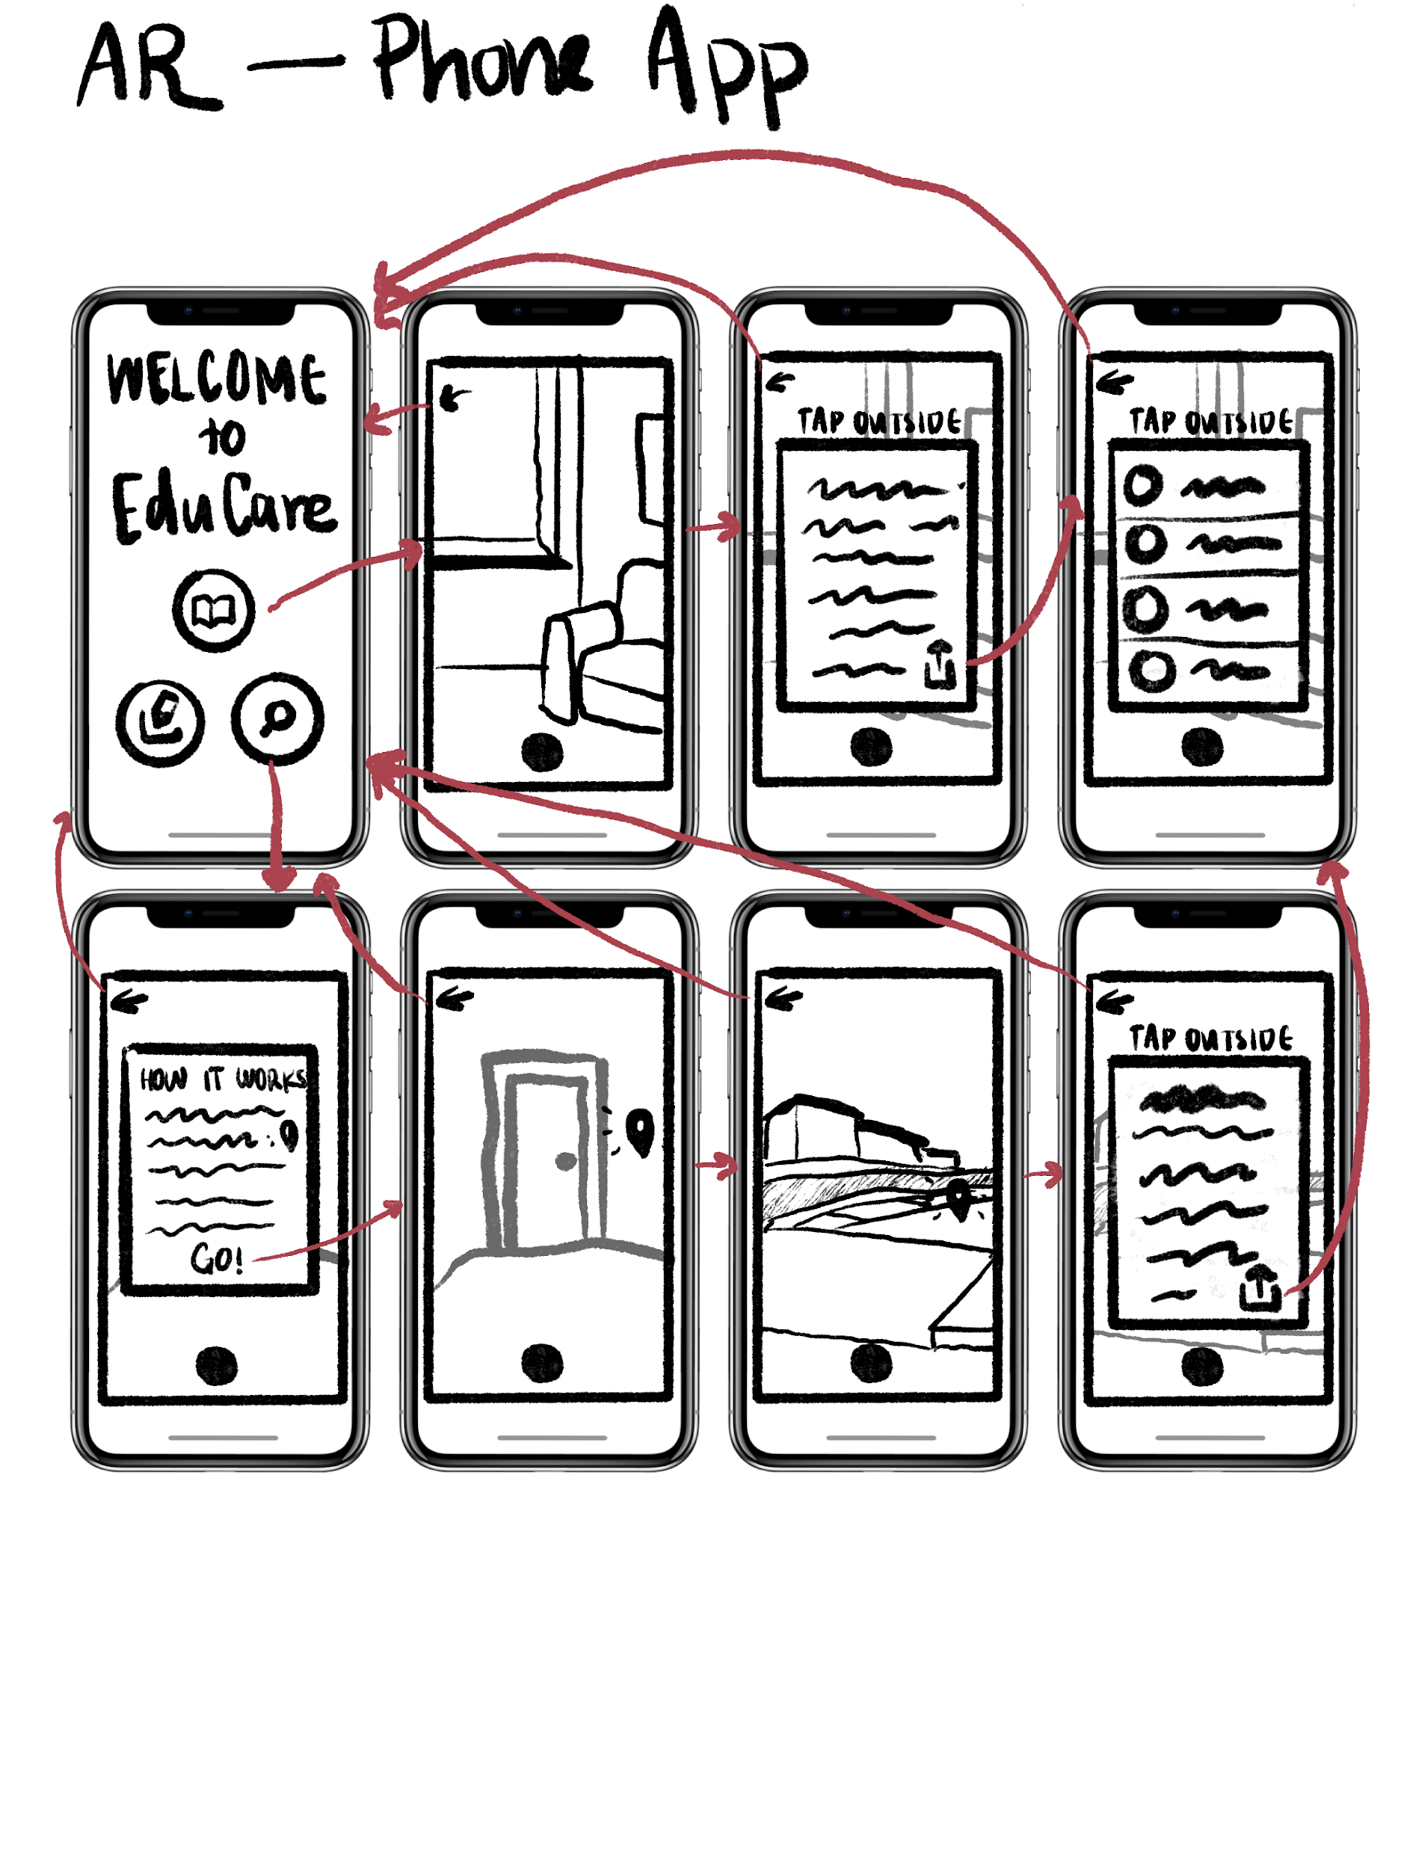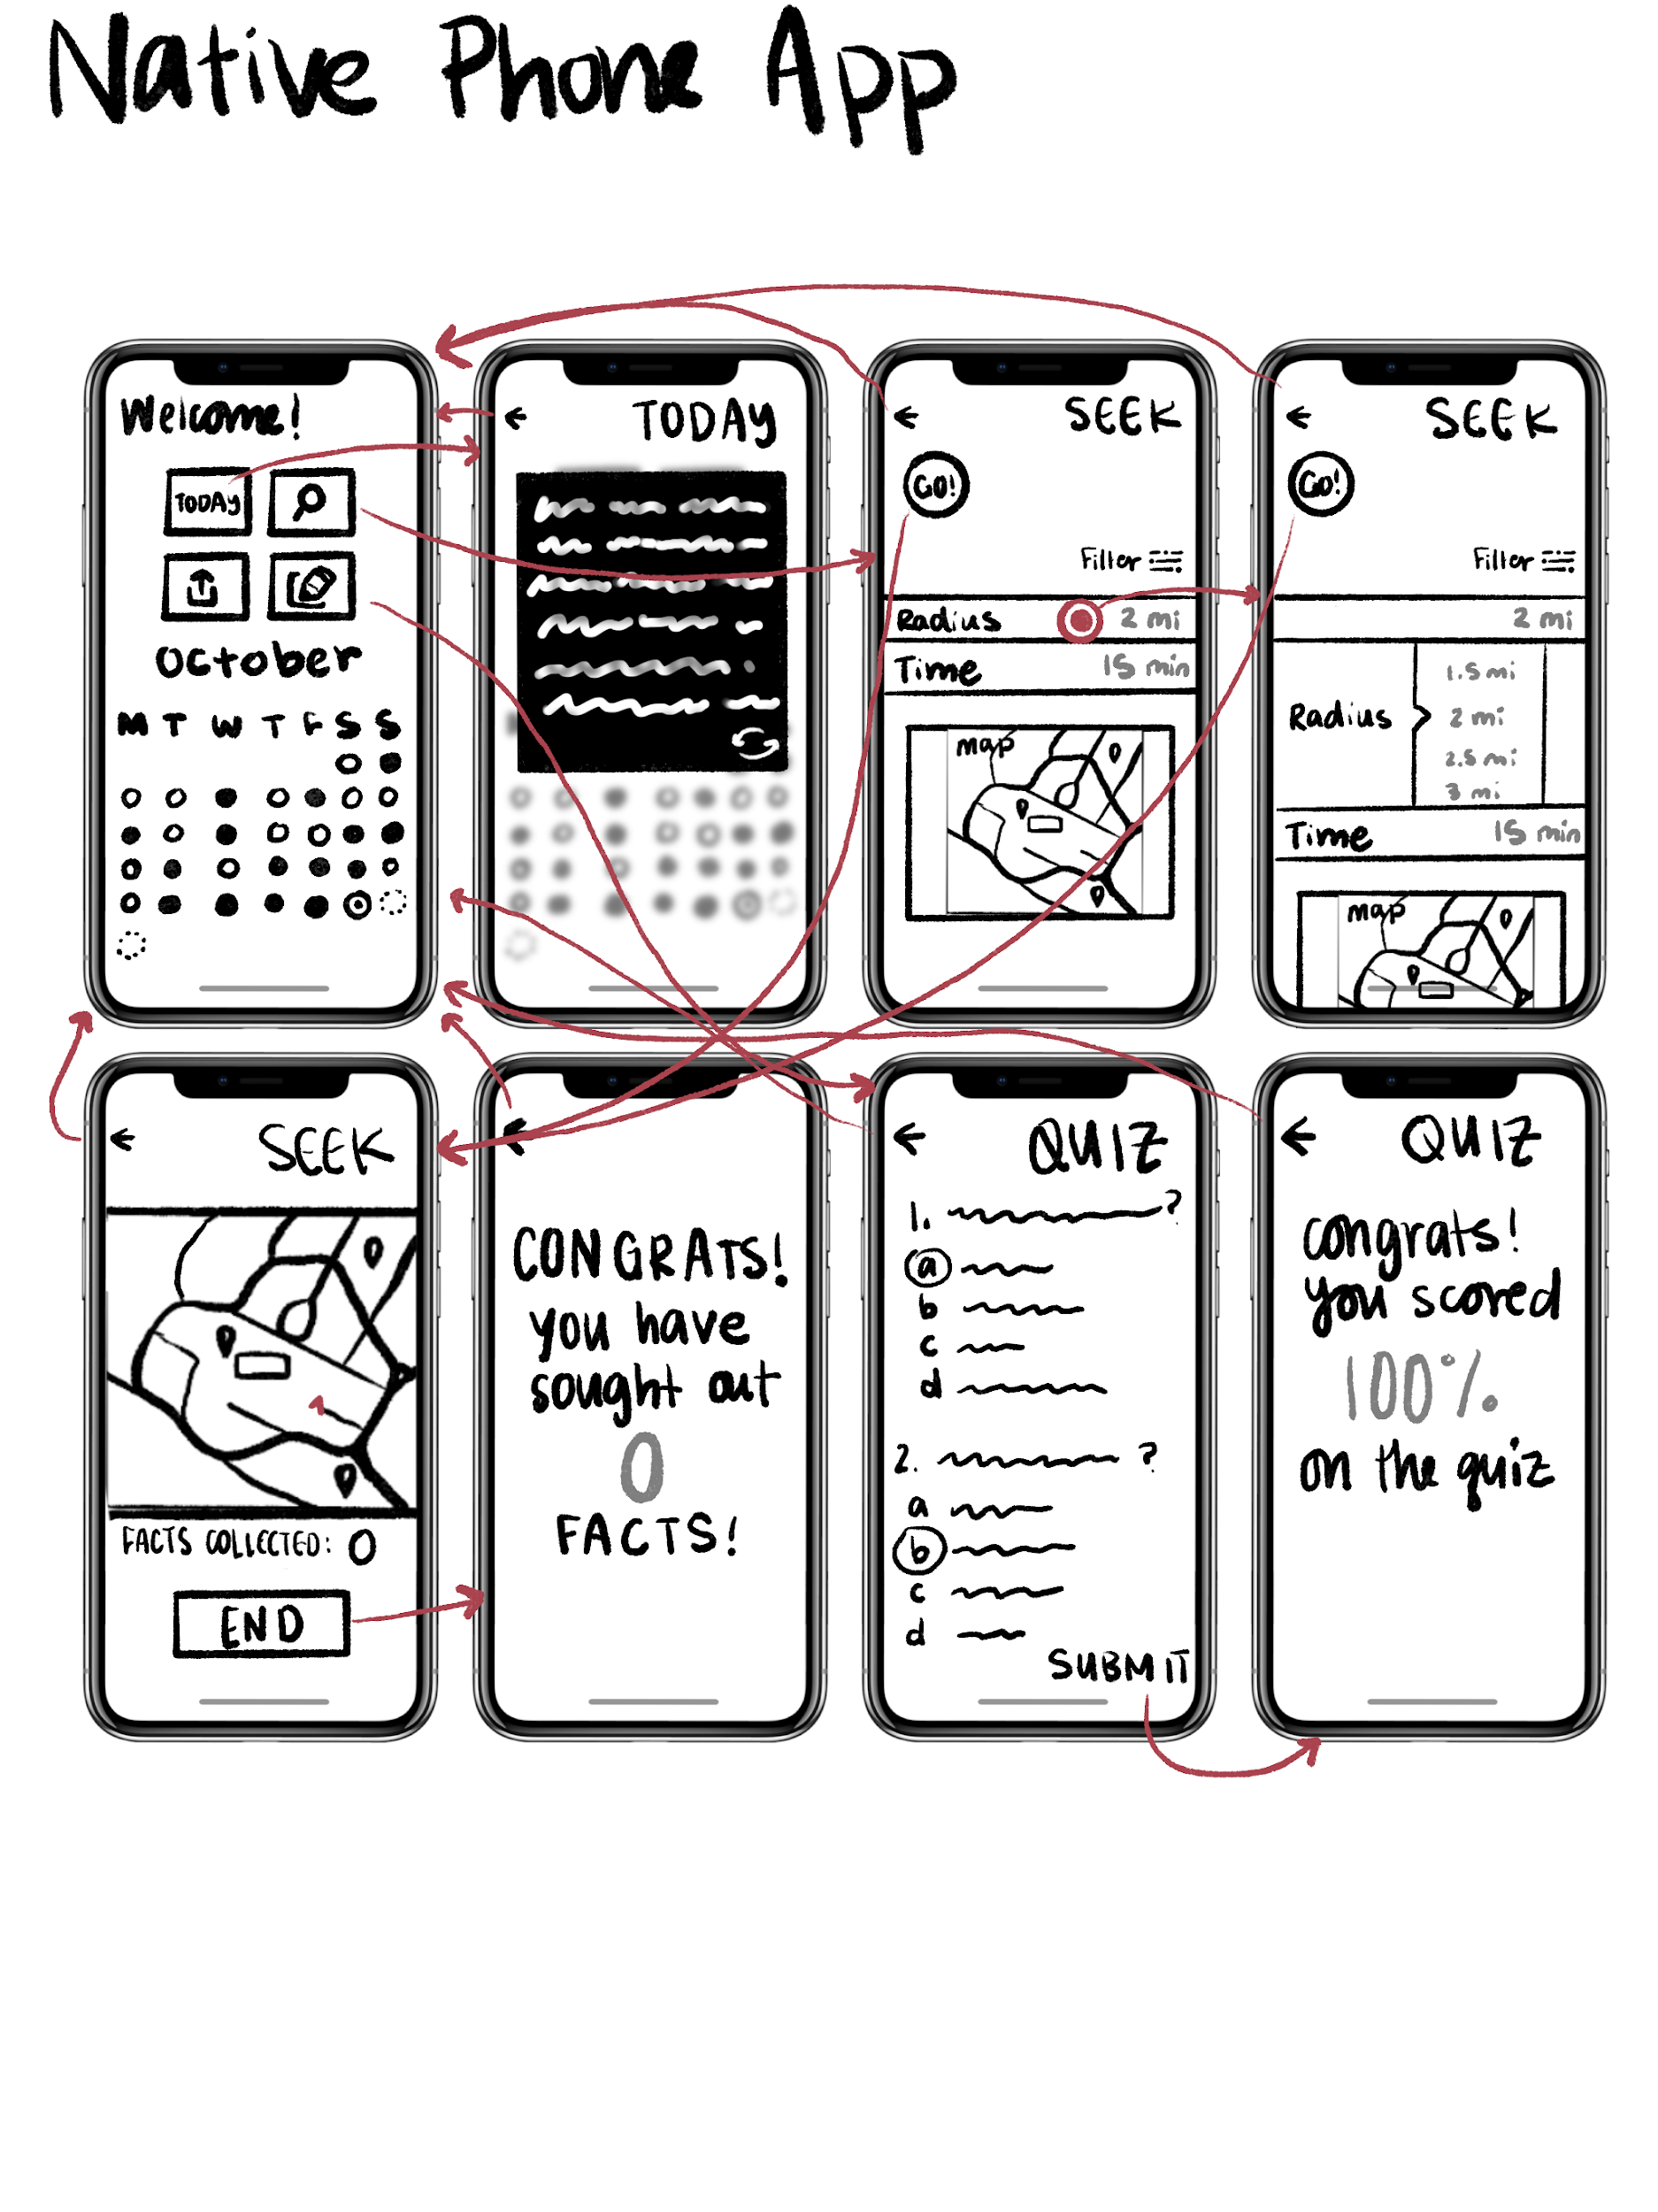
Figure 11: Storyboards for the Augmented Reality and Native Phone applications where users can explore the scavenger hunt feature

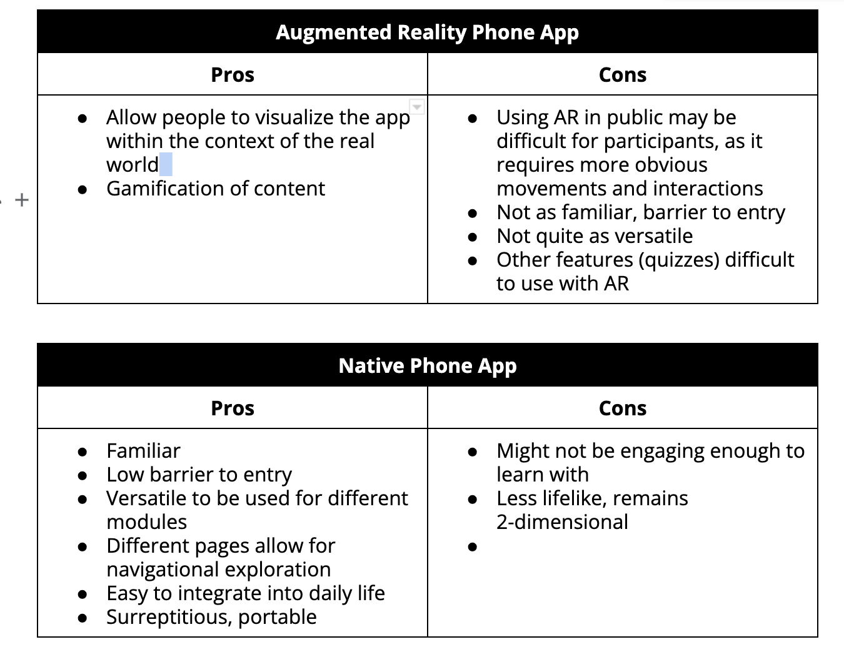
Figure 12: Pros and Cons of augmented reality phone application and native phone application
After exploring the AR and native phone applications, we created Pros and Cons lists for each of the technological mediums. From our pros and cons lists, we realized that the cons of an augmented reality phone application mildly outweighed the benefits. We found that the native phone application would be familiar, with a low barrier to entry, and versatile to be used for different modules. As a result, we decided to move forward with the native phone application.

Lo-fi Prototype:
In creating our lo-fi prototype, we sketched out the major tasks of the application. We mapped out the simple task flow of checking fun facts, the moderate task flow of navigating the scavenger hunt, and the complex task flow of sharing fun facts with friends. We made the lo-fi prototype by hand-drawing the screens on a tablet with the drawing application Procreate. We then printed the drawings to the scale of an iPhone to be used for our lo-fi prototype testing.
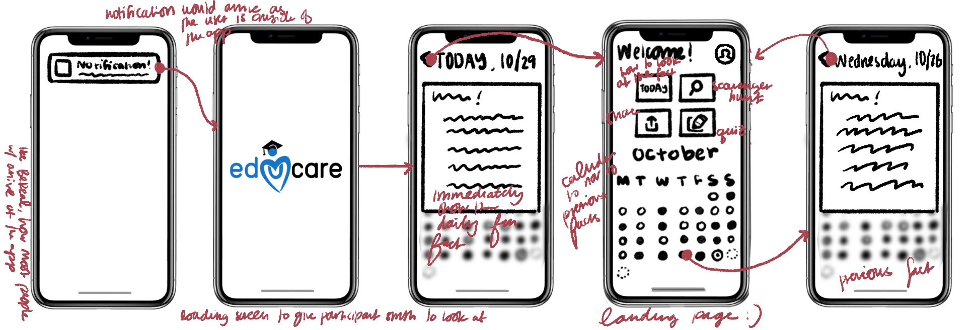
Figure 13: Lo-fi prototype for simple task flow
Usability testing:
We tested our lo-fi prototype by recruiting three participants to navigate through our entire lo-fi prototype and discuss their thought process, pain points, and areas of enjoyment. Our participant group was all randomly recruited spontaneously (meaning little to no forewarning was provided) and all of the participant lo-fi usability tests were conducted on tables away from other people. Two of our participants were recruited outside of Tresidder student union, and one of our participants was recruited outside of Burnham Pavilion. The participants were recruited based on the factors of randomness and age, as we wanted to engage the target group of people ages 17-25–although one of our participants was outside of the target age range to ensure holistic usability from outlier data values. All of the tests were conducted during the midday, and Nate acted as the greeter and the videographer while Brenden acted as the facilitator and the computer.
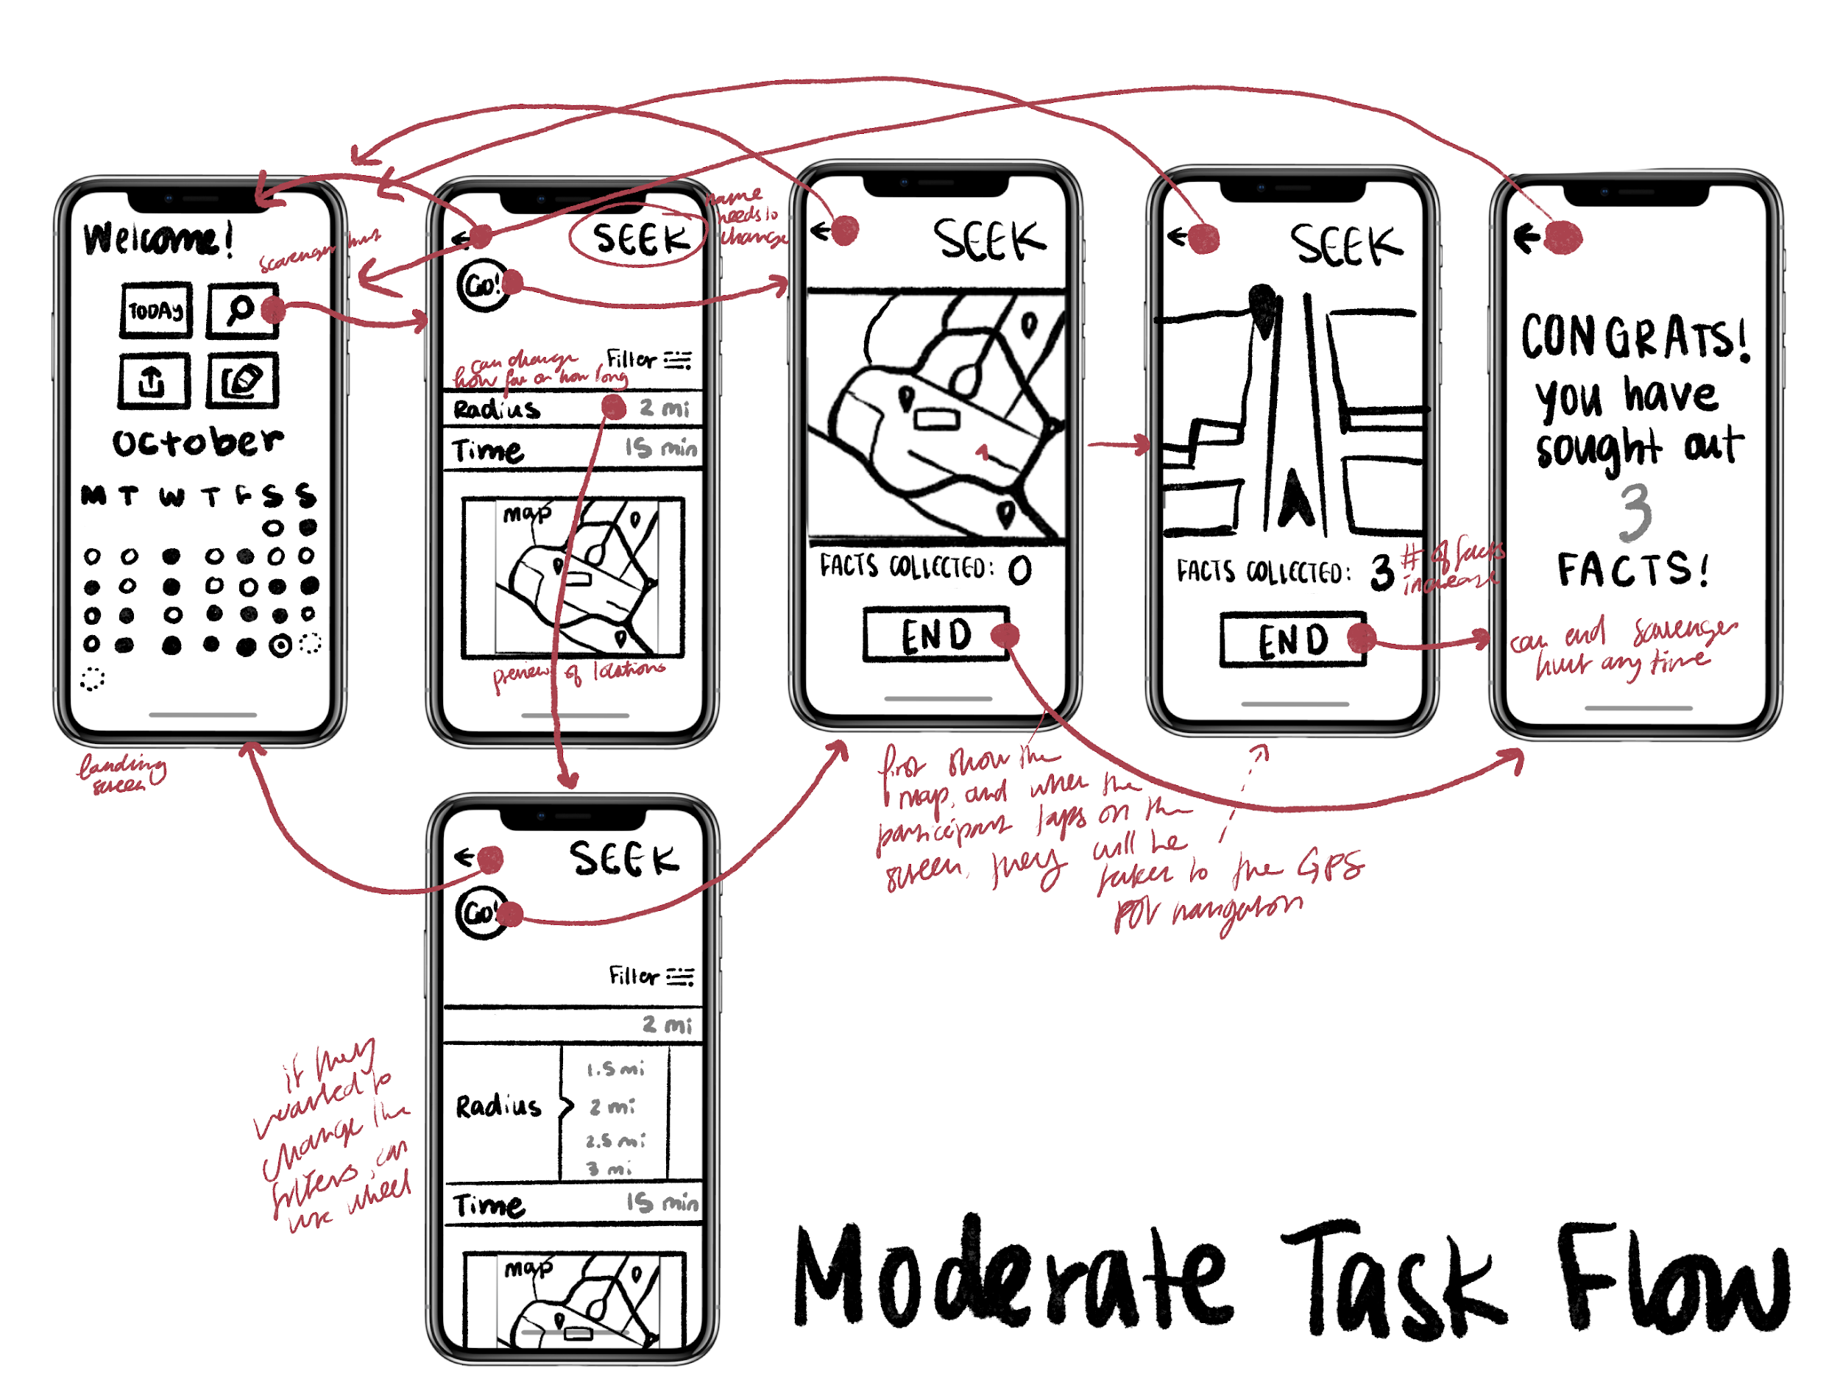
Figure 14: Lo-fi prototype for moderate task flow

Testing Procedure:
- Introduce Team Members
- Ask for participant consent to film
- Provide participant with context about EduCare
- Describe and demonstrate the process of thinking aloud
- Show participant the first screen
- Explain a task and have participants execute the task, repeating with each task (simple, moderate, complex)
- Ask for feedback/concerns, thank participants for time

Our usability testing goals were robustness–measured by the number of screens necessary to complete a task–and efficiency of use–measured by the time it takes to complete a task, as we wanted to understand how we could improve upon our design. We asked our participants to “think out loud,” meaning that they would navigate through our lo-fi prototype and explain their process aloud as they “clicked” through our three task flows.
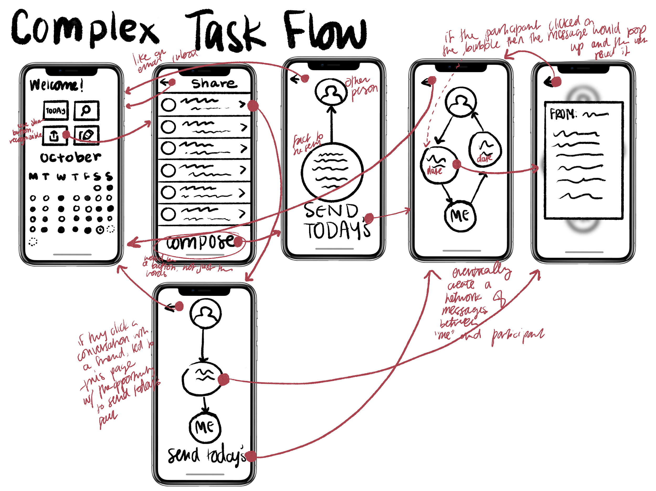
Figure 15: Lo-fi prototype for complex task flow
Results:
On the whole, we found that our participants expressed deep interest in the platform of educating young people about healthcare, showing that there is a need for the solution we devised. However, most of our participants struggled while navigating the scavenger hunt feature of the prototype. They commented that if there was a lot of text on the screen, they would probably just go back. Ultimately, the participants all figured out the system but required some trial and error. Furthermore, our participants did not spend much time exploring other buttons or features outside of the task, indicating that the task flows were effectively communicated with the user. Users responded more efficiently to elements that resembled things they were familiar with (notification banners, calendars, pop-ups) and yet were more hesitant about elements they weren’t used to, such as our messaging functionality that featured a novel layout.
Specifically, one of the more confusing UI elements of the lo-fi prototype was the usage of the magnifying glass icon for the moderate task. Indeed, most of the participants expressed that there could have been a better distinction between the search feature–although there was not one–and the scavenger hunt, since the latter had a magnifying glass icon, which people have associated with the search function.
All in all, we resolved to re-evaluate the iconography to facilitate effective visual communication. We wanted to ensure that, for the sake of efficiency and robustness, all of our UI elements clearly express their functionality to the user. We also decided to refine the layout of the messaging feature, possibly taking into consideration familiar layouts to facilitate efficiency of use. However, we might try to combine this with another aspect of our feedback by adding an integration of the messaging feature into each fun fact to facilitate robustness.

Med-fi Prototype
Before we entered into the process of immediately creating our medium-fidelity, or med-fi prototypes, we first created revised interface sketches, updating our lo-fi prototype sketches to reflect the feedback provided to us in our lo-fi prototype testing. We then translated these refined sketches into our med-fi prototype.
The Med-fi prototype was implemented via Figma for designing and prototyping. We consulted Canva for color schemes and palettes, used Figma plugins (Iconsax 6000+ Icons, Eva Icons, Tabler Icons, and Feather Icons (all by Iconduck)) to find UI various UI elements, and used Adobe Illustrator for certain icons that were not available via plugin.
Major changes from the lo-fi prototype to the med-fi involved changes regarding the menu bar at the bottom of the screen. Previously, with the lo-fi prototype, the menu bar featured a home screen button, a bookmarks button, and a button to add new friends to the network. However, following feedback from our lo-fi prototype, we have added another button to the menu bar: one that navigates the user to the sharing feature of the app. Furthermore, one of the significant changes to the overall prototype was to implement a cleaner aesthetic. We made sure to implement a color scheme of navy blue, red, orange, and yellow.

Simple
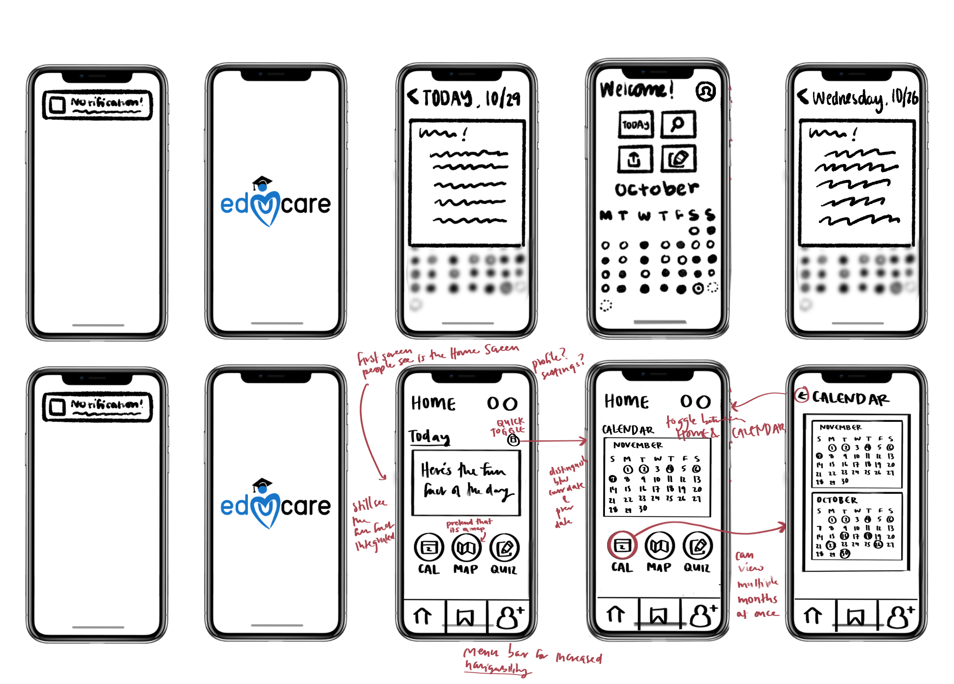
Figure 16: The updated screens for our simple task flow, with the major change being that the fun fact would be prominently displayed on the landing page
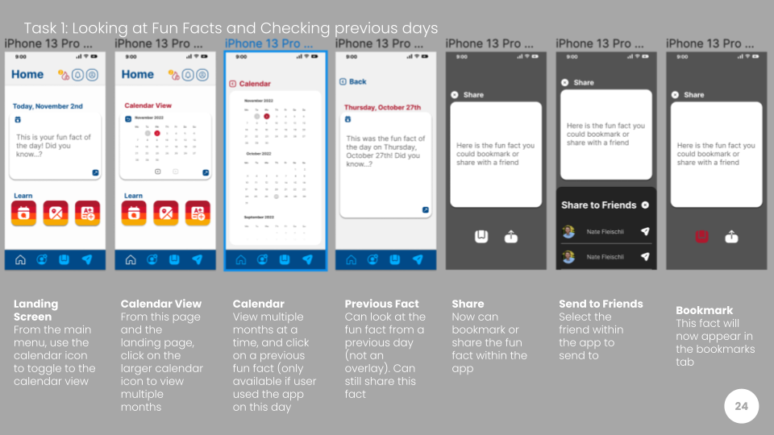
Figure 17: Med-fi prototype for simple task flow
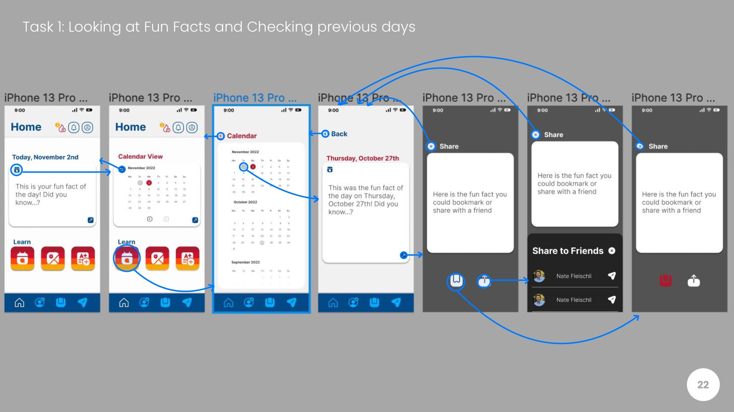
Figure 18: Med-fi prototype for simple task flow with transition arrows

The major changes made to our simple task flow was that the initial screen is not a fun fact overlay, but actually the main menu with the fun fact integrated. If the user wished to navigate to a previous fun fact that they’ve interacted with, they could instead use the the calendar feature as a toggle, so that they can opt to look at previous fun facts instead of being confused by the existence of a calendar on the landing screen. Furthermore, the user can look at a larger scrollable calendar to navigate between months.

Moderate
Regarding the Moderate Task Flow, we did not make super significant changes in our revised sketches. Our initial changes were that the map takes up more space on the initial page. Furthermore, the means to change the parameters (radius, time) is not a scrollable, instead just a drop-down, and the scavenger hunt modality more closely resembles a recognizable navigation system.
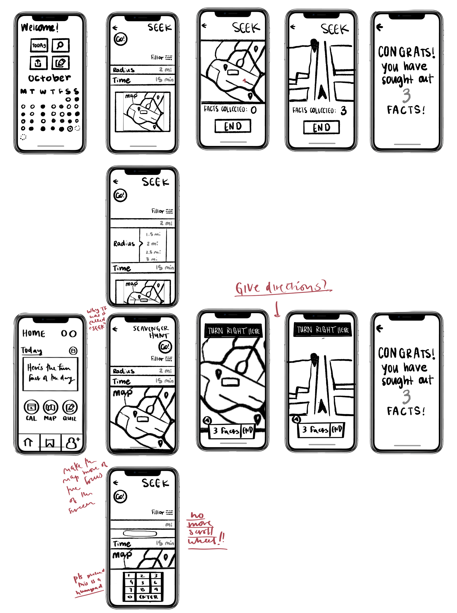
Figure 19: The updated screens for our moderate task flow

However, upon further consideration, we had realized that the navigation feature might take an unrealistic amount of time to implement (and does little to actually facilitate the learning aspect). We decided to replace the navigation feature of the scavenger hunt with a camera feature that allows the user to take a picture of a location indicated by a scavenger hunt clue. If the ML algorithm deems the photo is of the correct location, then the user would be rewarded with a fun fact.
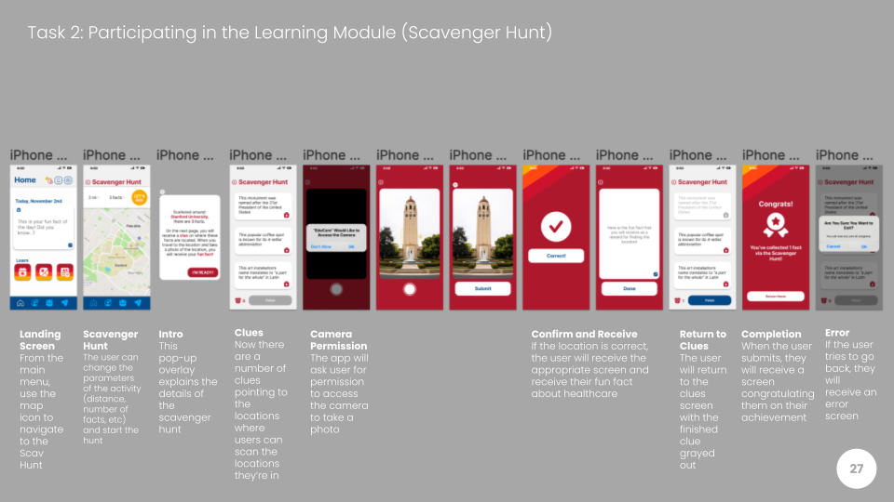
Figure 20: Med-fi prototype for moderate task flow
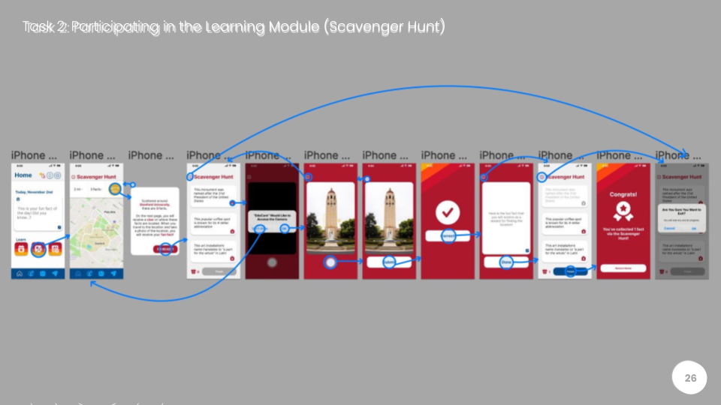
Figure 21: Med-fi prototype for moderate task flow with transition arrows
We also implemented changes by adding help and documentation for the scavenger hunt, and also added warning messages if the user was about to exit the scavenger hunt. If the user was about to exit without saving, they would lose their progress and we wanted to ensure that the user was aware of this.

Complex
The major change implemented in the complex task sketches was to mimic the recognizable UI of other messaging platforms like iMessage. We decided to opt for the simpler means of text bubbles that alternate one another. However, to maintain novelty in the UI, we decided to keep the “Send Today’s” button so that the user could easily send the current fact of the day (progressing towards the usability goal of robustness). We also decided that the fun fact the participants read when they send/receive is no longer an overlay
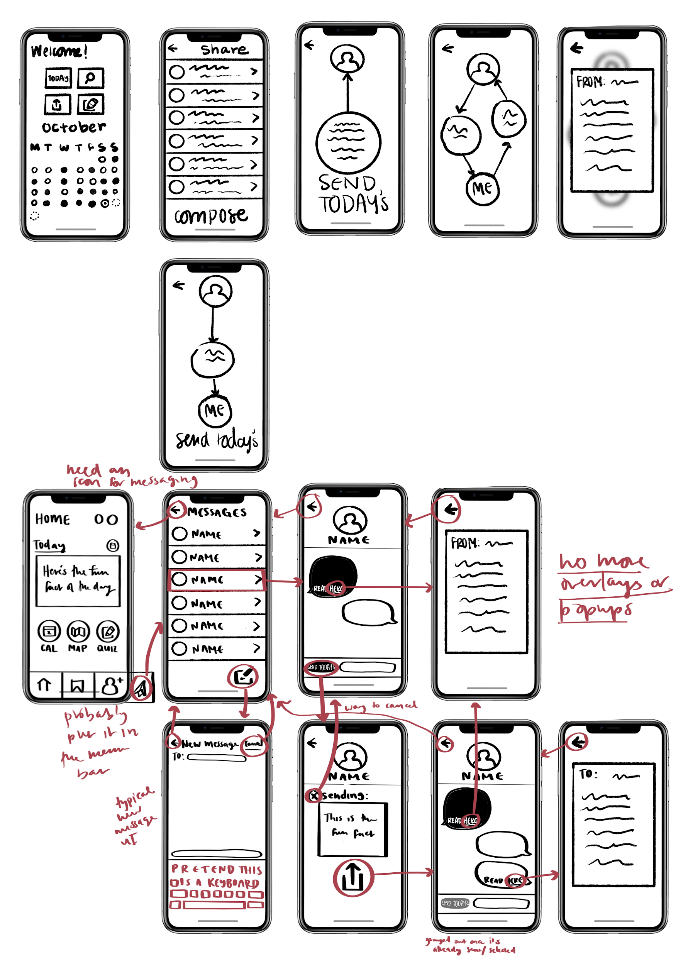
Figure 22: The updated screens for our complex task flow
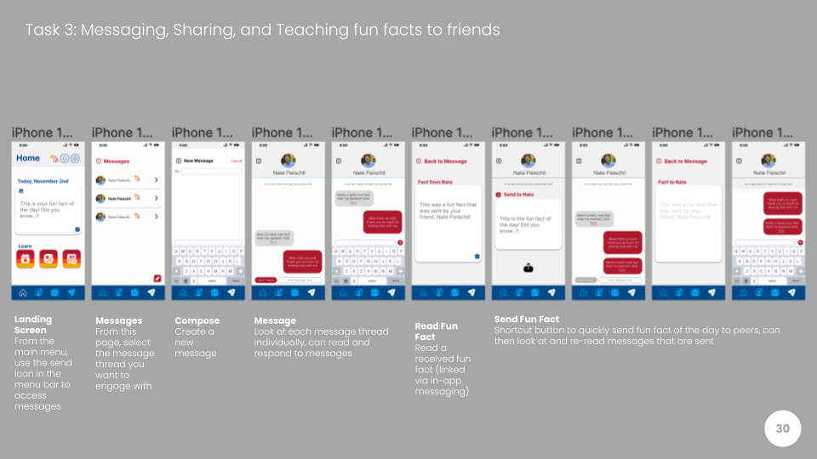
Figure 23: Med-fi prototype for complex task flow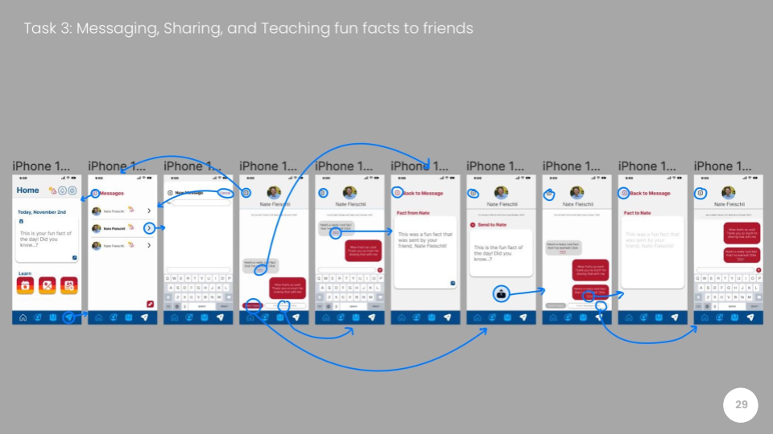
Figure 24: Med-fi prototype for complex task flow with transition arrows
Now, if the user wants to look at the fun fact that their friend or peer might send to them, they would be taken to another screen to view the fun fact, so they can distinguish the fact and easily save it or share with others.

Heuristic Evaluation:
Following the creation of our med-fi prototype, our prototype underwent a heuristic evaluation, as 4 students navigated through our Figma prototype and determined when and where various heuristics were violated. All in all, there were 57 total violations from a scale from 0 to 4. Of those 57, 22 of the violations were deemed severity 3 or 4, and 32 were deemed severity 1 or 2 (with the remaining 3 violations being severity level 0). Of the 57 violations, the most violated heuristic was H4: Consistency and Standards.
Of the level 3 and 4 severity violations, the most violated heuristic was H5: Error Prevention, with 6 violations. The main points of feedback were that certain UI elements were too small, which violated Fitts’ Law. Furthermore, there was an issue with error prevention and the subsequent recovery from errors–if a user were to have requested a friend accidentally, they cannot undo a friend request. Furthermore, certain button labels were confusing or misleading, such as the use of the word “Correct” for the Scavenger Hunt modality. More comments were that fire icon–for streaks–is unintuitive, the same icon performs different functions, and the fun fact disappears after being collected during the Scavenger Hunt.

Severity Level 3 and 4 Violations:
H1: Visibility of System Status
- Severity Rating: 3
  - Problem: The purpose of the calendar is not displayed on the calendar screen.
  - Solution: We changed the labeling of the Calendar View Screen to clearly indicate what the purpose of the screen is.
- Severity Rating: 4
  - Problem: When completing a scavenger hunt task, the button to proceed says “correct.”
  - Solution: We renamed the button to read “proceed.”
H2: Match Between System and Real World
- Severity Rating: 3
  - Problem: The “Send Today’s” Button Text Isn’t Clear.
  - Solution: We modified the text to clearly indicate the button functionality.
H3: User Control and Freedom
- Severity Rating: 3
  - Problem: Users cannot control the months or years in the calendar.
  - Justification: Due to the limitations of Figma, there cannot be an infinite number of months accounted for. In the app, the user would be able to click on the month/year label and scroll to the month or year they wish to navigate to (but only up to the months they’ve been active on EduCare).
- Severity Rating: 3
  - Problem: User cannot go back from Scavenger Hunt Clues to the maps or the home screen without losing progress and data.
  - Fix: We will now have the scavenger hunt preserve gaming data when they leave the screen (simply save and and load data when users shift screens) and the scavenger hunt clues will update every week.
- Severity Rating: 3
  - Problem: The X Button to back out of taking the EduCare Quiz after clicking the quiz button on the home page takes the user to the quiz anyway.
  - Justification: This was a designer error, the X button now returns the user to the home page.
H4: Consistency and Standards
- Severity Rating: 3
  - Problem: The Calendar icon on the fun fact card when the fun fact is viewed from the calendar screen returns the user to the home screen. The home button from the fun fact card screen also returns the user to the home screen. The same calendar icon on the home screen brings the user to the calendar screen.
  - Fix: We have decided to Just get rid of the Calendar view!
H5: Error Prevention
- Severity Rating: 3
  - Problem: On the calendar view, the Icons of days are too small and cannot prevent mistaken taps.
  - Fix: We have decided to Just get rid of the Calendar view!
- Severity Rating: 3
  - Problem: If the user sends a mistaken message, they cannot edit or delete it.
  - Fix: Adding an option to delete messages after they have been sent (although similar to texting and other messaging platforms, messages cannot be unsent).
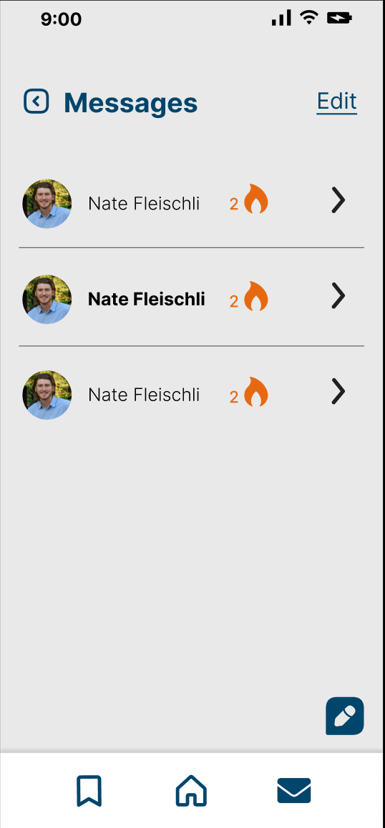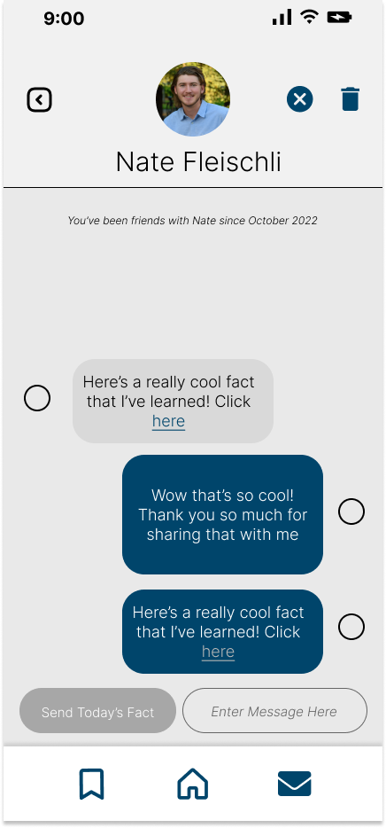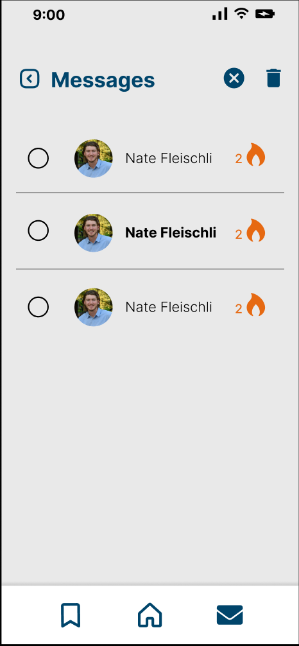
Figure 25: The updated screens that allow the user to now delete messages they want to delete

- Severity Rating: 3
  - Problem: The share/send button/icon on the fun fact window on the landing page is too small.
  - Fix: We are now increasing the size of the share/send button on the fun fact window of the landing page.
- Severity Rating: 3
  - Problem: The fire icon with badge notifications is unintuitive.
  - Fix: We are now including a pop-up window that describes the purpose of the fire icon (for streaks) and changing the placement of the badge notification.
- Severity Rating: 3
  - Problem: The message/text box in the chat feature is too small.
  - Fix: We are now making the text box in the chat feature larger!
- Severity Rating: 3
  - Problem: There is no way to remove a friend request.
  - Fix: We have included an “Undo” button to allow users to immediately retract a friend request if they have made an error
H6: Recognition Rather Than Recall
- Severity Rating: 3
  - Problem: The compose a new message feature does not make suggestions on which friend(s) you may want to send a message to.
  - Fix: We have included a drop-down menu of friends a user may want to message.
- Severity Rating: 3
  - Problem: During the Scavenger Hunt Learning Module, the Fun Fact disappears after location is found.
  - Fix: Once a location is found, the location card with the clue is replaced by the fun fact from the location, and it is able to be added to bookmarks.
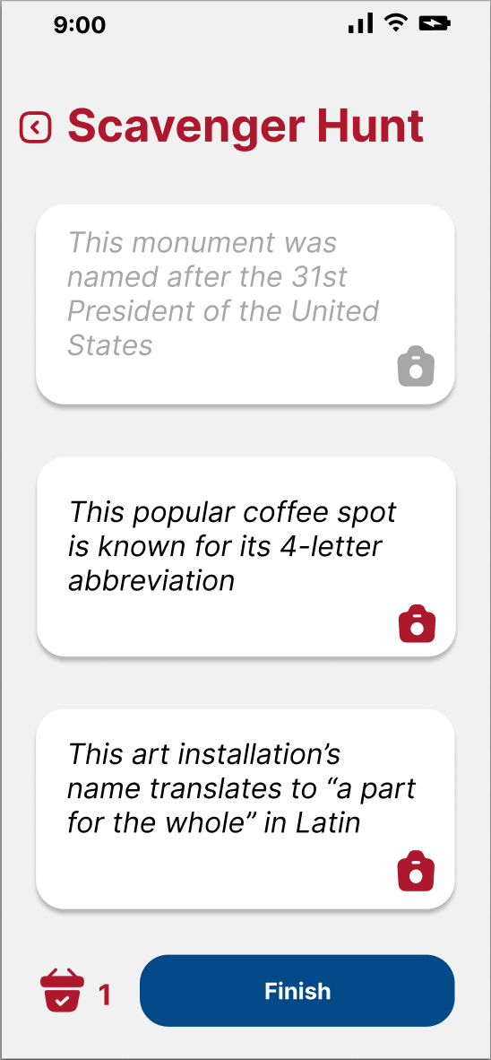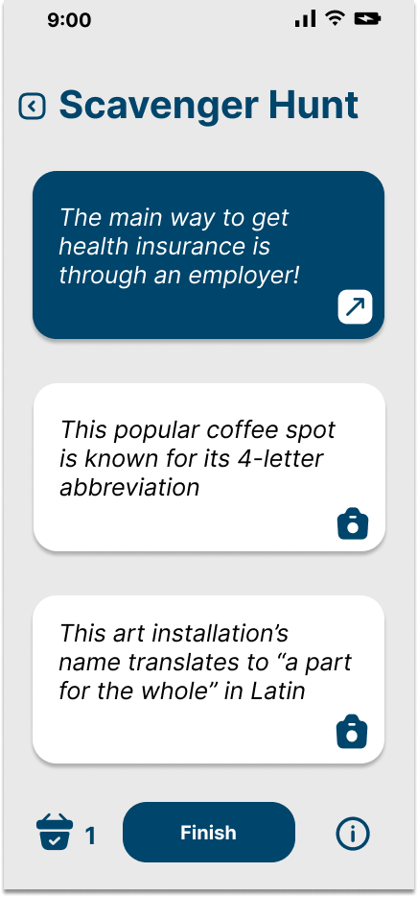
Figure 26: The updated screens that now showcase the collected fun fact after the user finds a location of the scavenger hunt (so that it is also more obvious which one they have completed)
H7: Flexibility and Efficiency of Use
- Severity Rating: 4
  - Problem: The interface asks for camera access permissions for each individual picture being taken.
  - Justification: This will not actually be the case in the hi-fi prototype, this was just a limitation of Figma, the interface will only ask for camera access the first time around.
- Severity Rating: 4
  - Problem: Sharing a fact with a friend takes the user to a chat feature instead of instantly sending the message.
  - Fix: Now, when the user clicks to “share to friends,” the message immediately sends (and the user receives a notification that the message sent and an option to UNDO if it was an accident). If the user clicks on the profile, they go to the messages screen.
H9: Help Users Recognize and Recover from Errors
- Severity Rating: 3
  - Problem: Nothing prevents users from inputting unacceptable numbers for minutes or tasks in the Scavenger Hunt.
  - Fix: We have decided to implement a scroll wheel.
H10: Help and Documentation
- Severity Rating: 3
  - Problem: The instructions for the scavenger hunt only appear once the “Let’s Go” button is clicked.
  - Justification: There is documentation for the Scavenger Hunt, when the user clicks “LET’S GO,” they are taken to the documentation page, where they can then opt out, but we added a clearer opt out UI. We also added an info icon throughout the scavenger hunt to show the documentation pop-up
H11: Accessible Design
- Severity Rating: 3
  - Problem: There is little contrast between bottom nav bar icons color and the nav bar background color.
  - Fix: We changed the entire branding and identity, but specifically altered the bottom navigation icons to be more contrasted from the navigation bar.
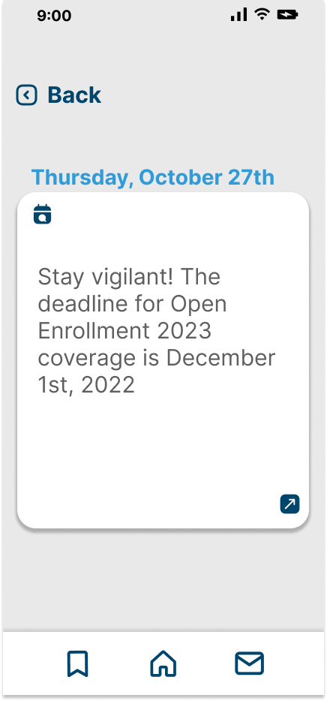
Figure 27: The updated screens that shows the applied changes in the menu bar that have more contrast

- Severity Rating: 3
  - Problem: The interface lacks the ability to type a message without having to use the keyboard, and also lacks text-based alternatives for comprehending information on the screen.
  - Justification: There are text-to-speech functionalities within the keyboard (using iOS keyboards and integrated feature).
H12: Value Alignment and Inclusion
- Severity Rating: 4
  - Problem: “Health and Wellbeing”: There is an inclusive problem between physical disability and the Scavenger Hunt Design. Differently abled people might not be able to engage in the Scavenger Hunt.
  - Fix: We are adding an “Accessibility Alternative,” where users can opt for a more accessible experience, where they will instead type a location name into a text box to receive the fun fact.
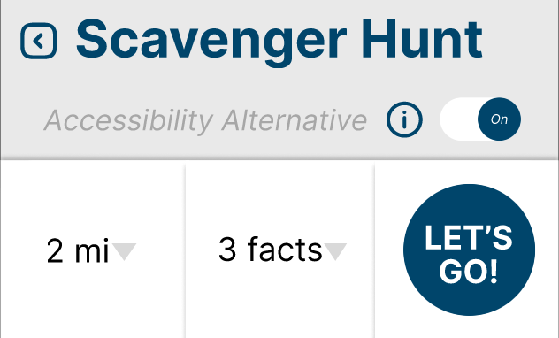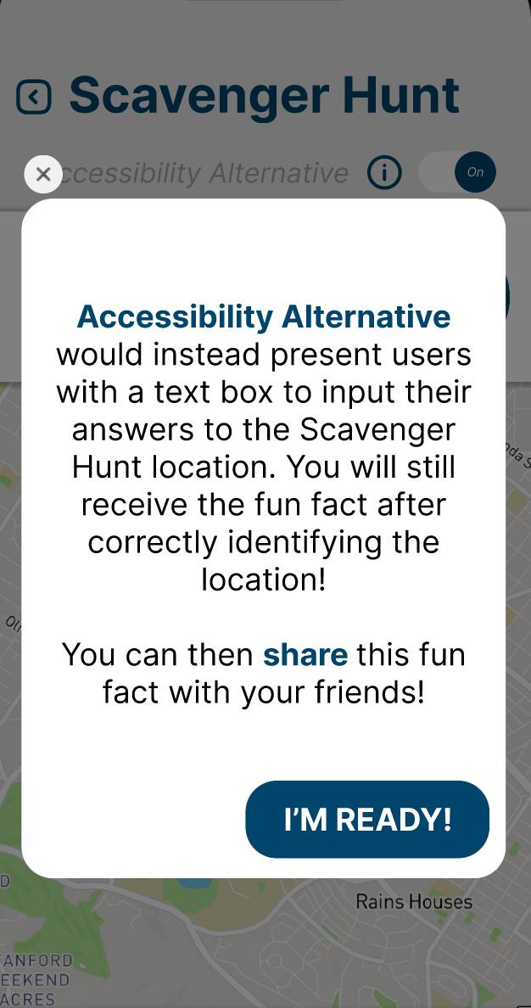
Figure 28: The updated screens that show the Accessibility alternative for the scavenger Hunt
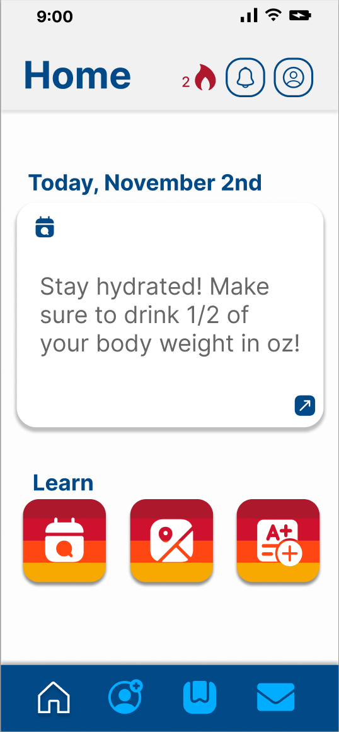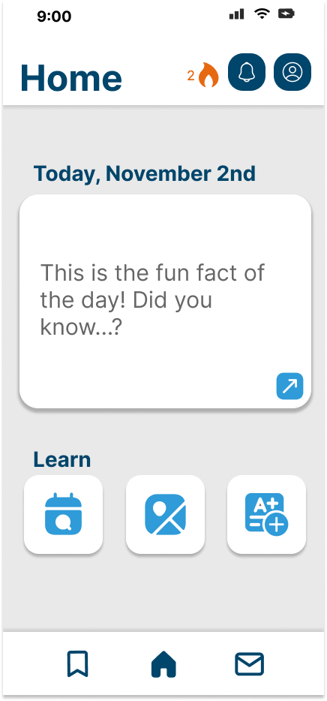
Figure 29: The updated screens that shows the change in the aesthetic and color scheme of the home page

VALUES IN DESIGN
The values that we have identified in our solution are:
- Prevention and Awareness
  - Making the interface as simple and intuitive as possible
- Community-Building
  - Connecting people together to create a shared learning environment
- Health and Wellbeing
  - Giving people the tools to enjoy learning about their health without feeling overwhelmed
We have implemented Prevention and Awareness throughout all elements of our solution. Specifically, being an app designed to educate students about their healthcare, there is an element of prevention and awareness in every element, as we are attempting ensure that our users are always aware of their health and able to seek medical attention before situations arise. By allowing our users to learn, explore, and share with EduCare, we are leveraging the fact that learning about Healthcare can help increase awareness. We are also attempting to help users reach healthcare providers more frequently and create a habit of preventative care. The features that achieve this are the Fun Facts, the Calendar feature for fun facts, and the Quiz Feature.
We have implemented Community-Building in the sharing functionalities of EduCare. When talking to some of our participants throughout the needfinding process, we have determined that an effective means through which students learn is by teaching concepts to their peers. This is how we have achieved the encoded value of community-building. Learning is easier and more fun when completed with others, and students learn better when they teach the content to someone else. The messaging function allows users to build community, as they can not only share fun facts with each other but also add other people to their network and expand their connections.
We have finally implemented Health and Well-being throughout EduCare by encouraging active learning. Similarly to the concept of students learning while teaching others, participants informed us that they sometimes learn well while being active. This is why we have implemented the Scavenger Hunt, where users will have to seek out new information at various locations within their preferred radius. By doing so, we are heling the user be more conscious of their health and take control of their well-being.

Conflicting Values
The two values that most directly conflict with one another are Prevention and Awareness vs Health and Wellbeing. There is an issue with creating an app that advocates for people taking control of their health learning about their healthcare and their health insurance. We want to teach people about insurance and healthcare but not everyone will have the ability to reach certain aspects of the system or have insurance. There are limitations to what we can achieve with EduCare, and although we want people to be aware of their health, we want to be clear that we are educating, not necessarily providing.

Final Prototype Implementation

TOOLS USED
We built our high-fidelity prototype with React Native and Expo CLI. We ran a simulator on Xcode with an iPhone 14 and 14 plus, as well as through the Expo-Go application on an iPhone 12 pro max for testing purposes. Using Expo CLI on top of React Native allowed for easy building, testing, and publishing. Expo has fantastic documentation that details how to implement functionality, which was especially helpful since this was the first React Native application we built. In addition, while we only tested on IOS devices, Expo abstracts away native languages and maps our code to IOS and Android for us. This allowed us to code in one central environment, while still building for both interfaces. In theory, our code should work for Android.
The main disadvantage of using Expo CLI is that it doesn’t support all React Native components. For instance, our third task involves sharing facts with friends. Since there was no chat room component at the expo, this functionality had to be built from scratch.

HARD-CODED ELEMENTS
In order to provide a realistic user experience without a back-end, we hardcoded data into the application. This includes all facts, users + profiles, streaks, images, locations, and calendar dates. This means that every instance of running the application includes the same data.

WIZARD OF OZ
The main features that utilize Wizard of Oz techniques are the user location in the scavenger hunt and questions in the quiz module.

LIMITATIONS
Not all features of the application are completely functional. Here are a few examples:
- Bookmarking facts do not update the bookmarking page.
- You can share the fact of the day from the home screen, but this functionality is not yet implemented into the calendar or bookmarking module.
- In the scavenger hunt module:
  - While it adjusts to the number of facts you request, it does not change the clue locations based on the miles input.
  - The accessibility feature which allows a user to complete a scavenger hunt via text input verification has not yet been implemented.
  - The ‘map’ feature is static and assumes the user is at Stanford.
  - When playing the scavenger hunt, the picture verification feature is not yet implemented and always approves the location found.
- Messaging people in your network does not actually send them a message, but rather populates the screen with your message. If you exit the chatroom, all data will reset to the original conversation. This limitation also applies to deleting friends from your messages.
- User profiles and notifications are static pages and don’t have functionality.

Reflection and Next Steps
Building a legitimate market-viable product in general is a difficult task, even for the best startup founders and engineers. But building one in a group of two over just 10 weeks is, simply put, mad. This quarter taught us equally about teamwork and work ethic as it did about product development and design.
From the start, the design thinking process was a difficult structure to follow. Our gut instinct was to consider our own biases and jump to solutions. We had to learn how to put ourselves aside, go into public with thought and reason, and get in touch with how people really felt. We mastered how to be approachable, considerate of others’ time, and emotionally mature in order to harness what interviewees were telling us while, frankly, cutting out the bullshit. Once achieved, the process flow from information to the solution was again difficult to refrain from a solution mindset, each step begging us to make the jump. However, the most challenging part wasn’t actually the process itself, but rather the timeline and structure of the class. We were forced to pick and proceed in order to finish the class, and this tradeoff was a difficult pill to swallow.
When we showed up for our first Equitable Healthcare studio, it became exceedingly apparent that our section suffered from classic Stanford Duck Syndrome. “What is Healthcare?” Everyone appeared confident but no one truly knew. We weren’t able to recognize this until after our need-finding, but college students are in the same boat. Everyone knows healthcare is important, but no one truly knows what it is. In this way, our studio brought to light that educating ourselves should also be our solution, the final puzzle piece so to speak.
When it finally came to designing and building our product, we learned that one does not exist without the other. The class pushed novelty, and while encouraging this mindset is how innovation occurs, we felt that novelty in the form of devices or functionality didn’t apply to our solution. So we stuck with a classic phone application and leveraged known functionality in order to make the user experience as seamless as possible. What we did make novel though was the variety of learning modules incorporated into our app. Our need finding revealed that college students learn in many different ways, so we made it a goal to provide the user with a range of modalities to choose from. We went above and beyond the three required tasks, adding additional functionality in the form of a quiz module and bookmarking facts. What we realized, in the end, was that our design is what differentiated our product. Any good engineer could build known functionality, but it is the flow of the tasks and the aesthetic of the design which evoke an emotion in the user, and that is what makes a good product.
If we had more time, we would love to finish the functionality of all of the features and add a backend so that the user could actually receive new information and message friends. We would also consider what types of healthcare information are provided, and how we might tailor this information to the user’s needs.
We are extremely proud of what we built, not only because it has a real potential for impact, but because it represents the blood, sweat, and tears that went into the entire process. As a team of two, we learned to be extremely efficient, communicate effectively, and deliver for our teammate no matter the cost. It was this understanding that made our team work and our product amazing. In 2005 Steve Jobs came to Stanford and told the graduating class “stay hungry, stay foolish.” We didn’t truly realize what building a product in 10 weeks entailed. In that sense we were foolish. But our result showed how hungry we were, and I think Steve would be gratified to know we did just that.

