

Be Aware with EduCare
Assignment 5: Lo-Fi Prototype and Pilot Usability Testing

CS 147 Autumn 2022
Nate F., Brenden K.

Introduction
MISSION STATEMENT
Our mission is to educate students about their healthcare to prepare them for any and all life moments, expected and unexpected.

PROBLEM AND SOLUTION OVERVIEW
After talking with numerous college students, we have learned that most young adults (students aged 17-25) are indifferent, uninformed, and uneducated about their healthcare. EduCare gives these people the tools to be proactive about their healthcare and share their learnings with their peers.

Sketches
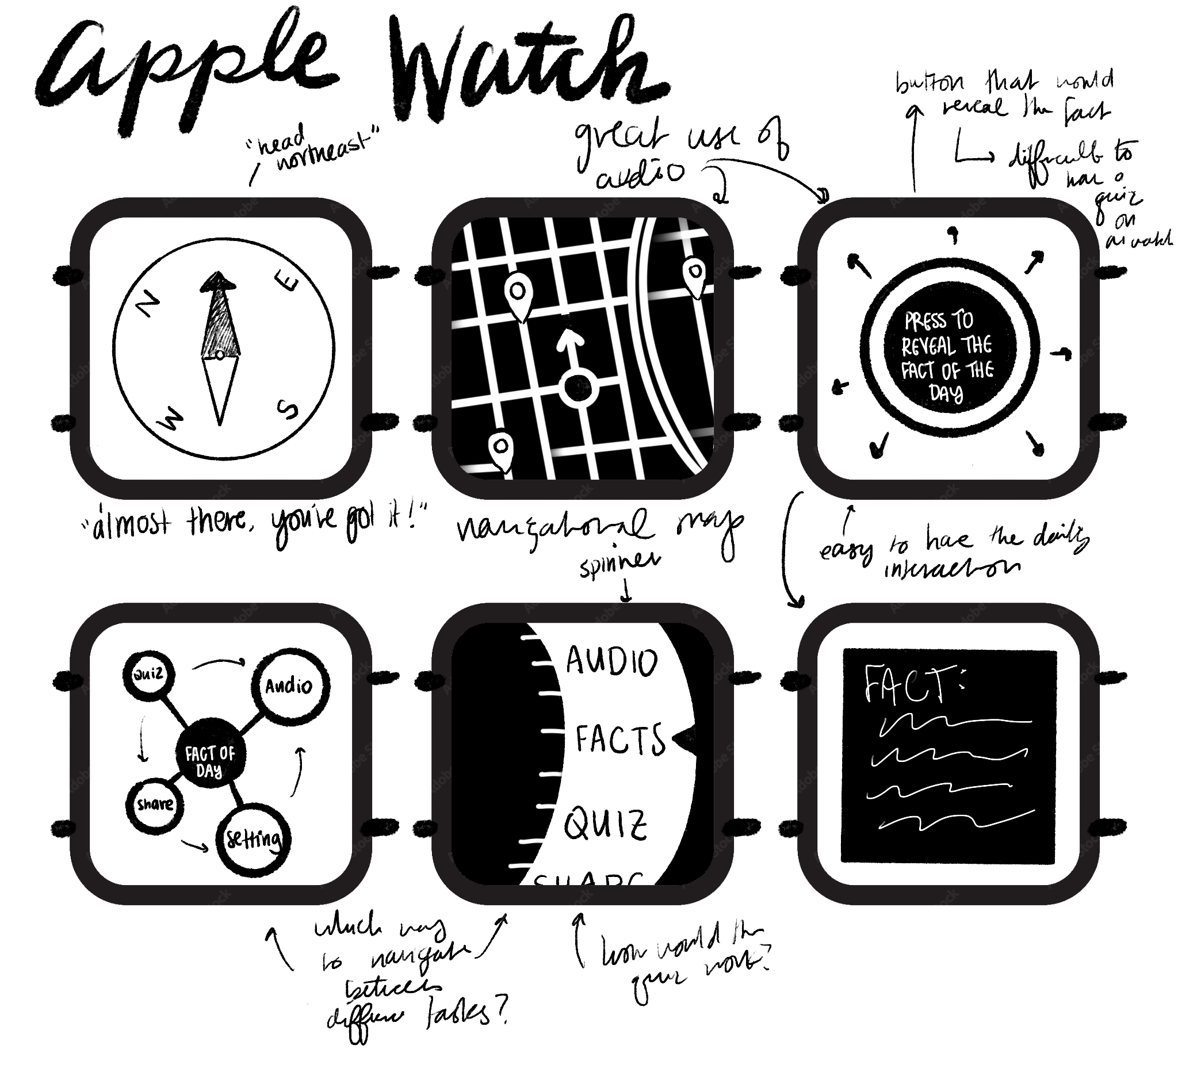
CONCEPT SKETCHES

Figure 1: This is an Apple Watch realization that fills the UI with large icons and utilizes audio features
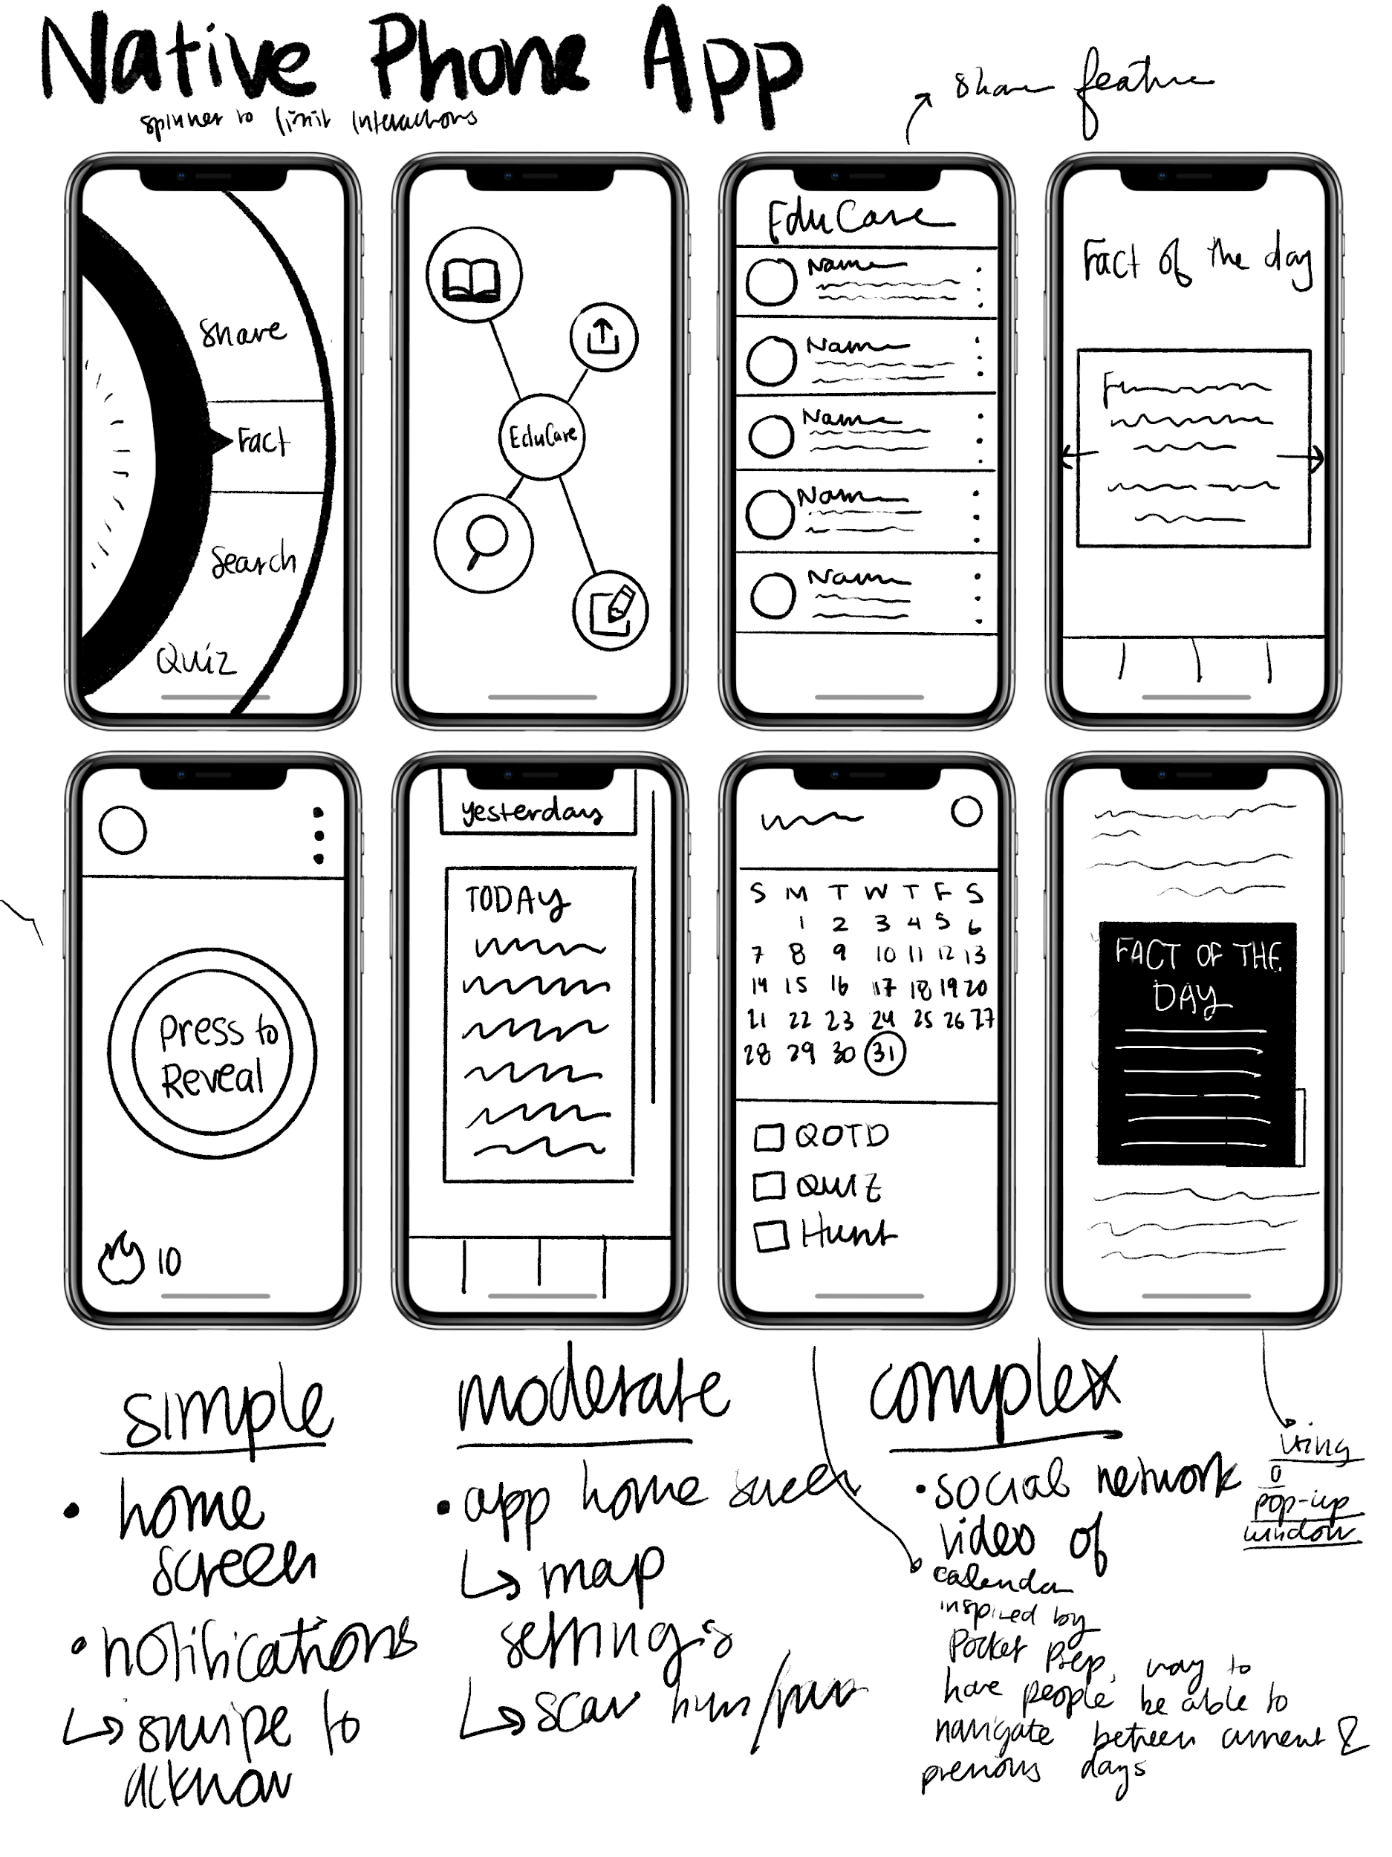

Figure 2: This is a native mobile app realization with an educational/bubbly theme

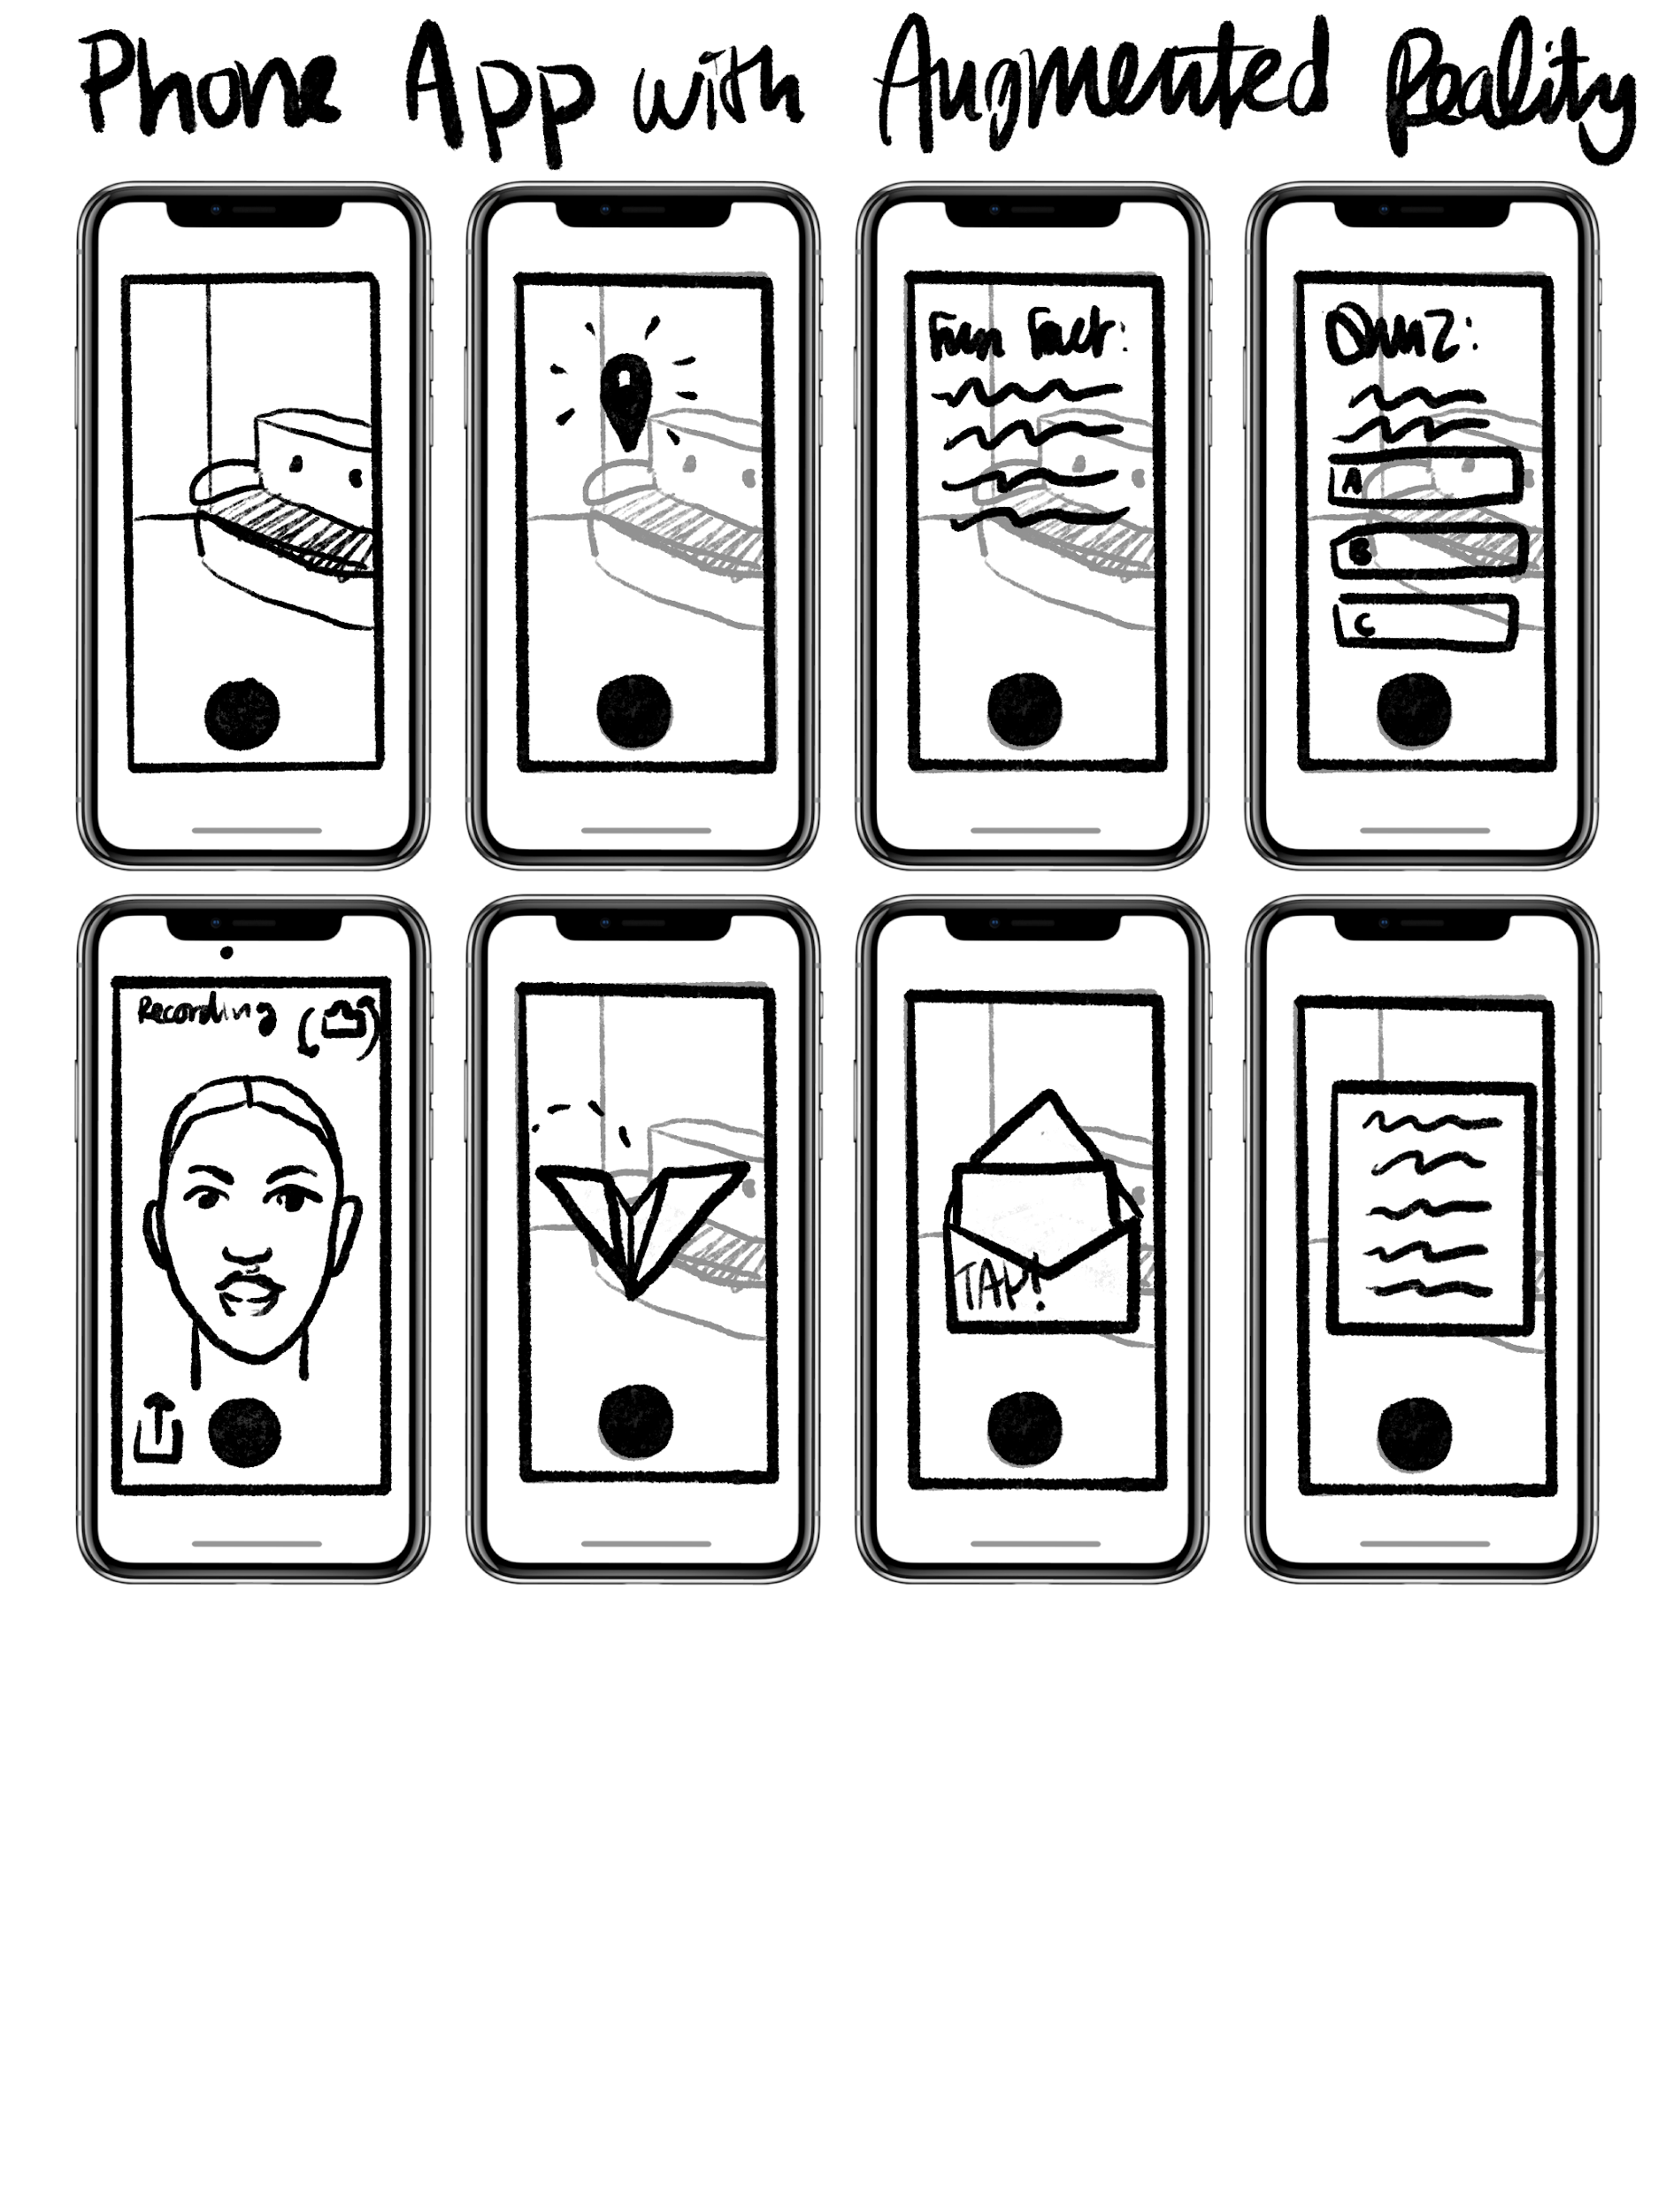

Figure 3: This is an Augmented Reality app that is implemented on a phone

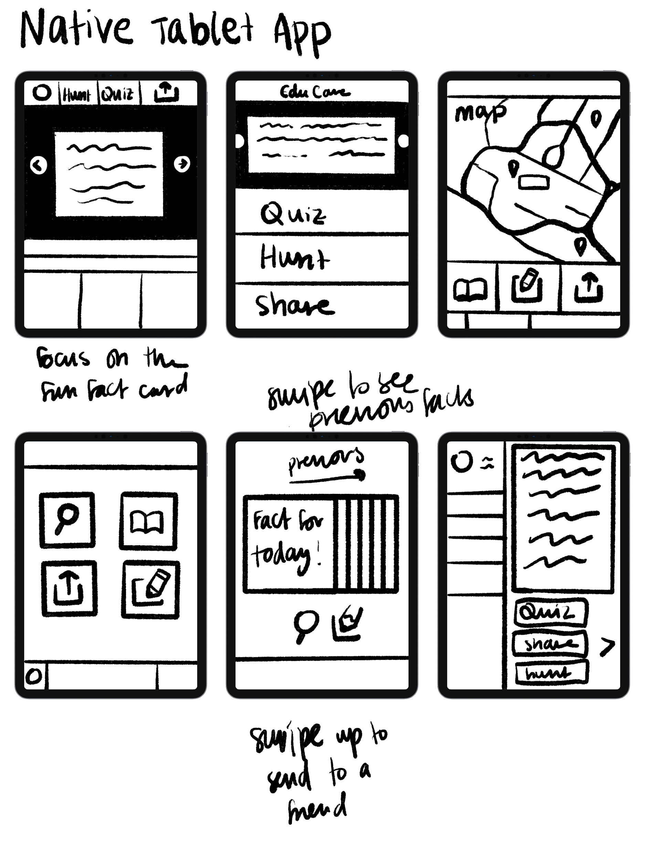
Figure 4: This is a native tablet app realization that gives the essence of a planner or agenda book
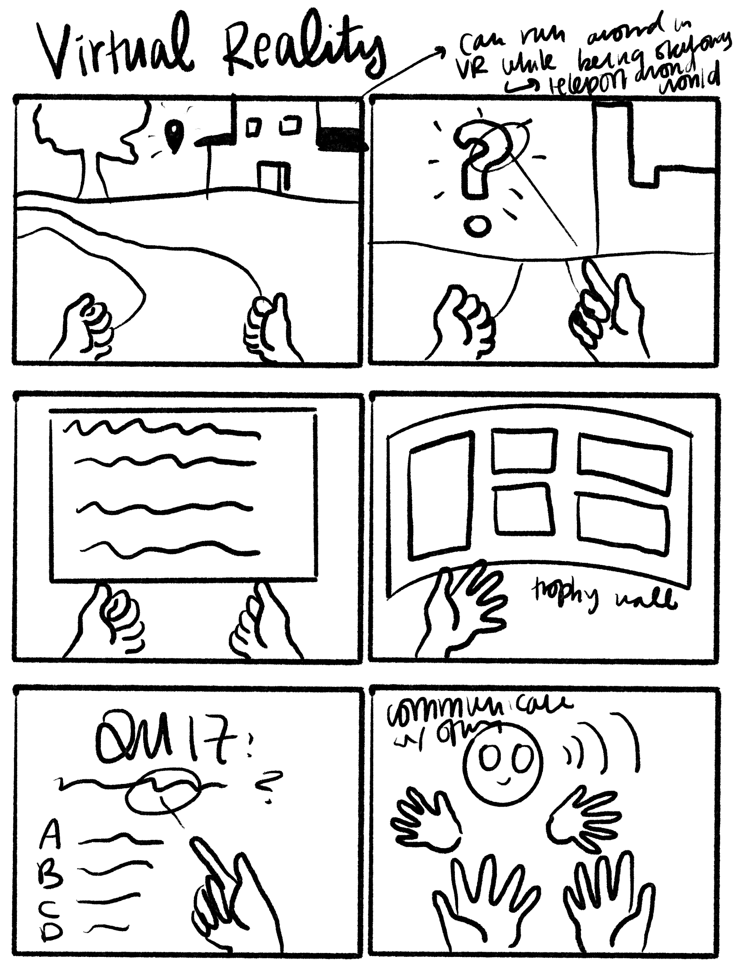

Figure 5: This is a VR realization that allows the participant to engage immersively with the content they are receiving
STORYBOARDS
For the top two storyboards, we decided to narrow our realizations down to the Augmented Reality App and the Native Phone App that uses a clean, educationally friendly interface. We thought that it would be best if the participant would be able to engage with the interface primarily through their mobile phone, to allow the experience to follow them wherever they go. We continued to allow our ideas that we had with other realizations to inform the decisions we made with our final two realizations.

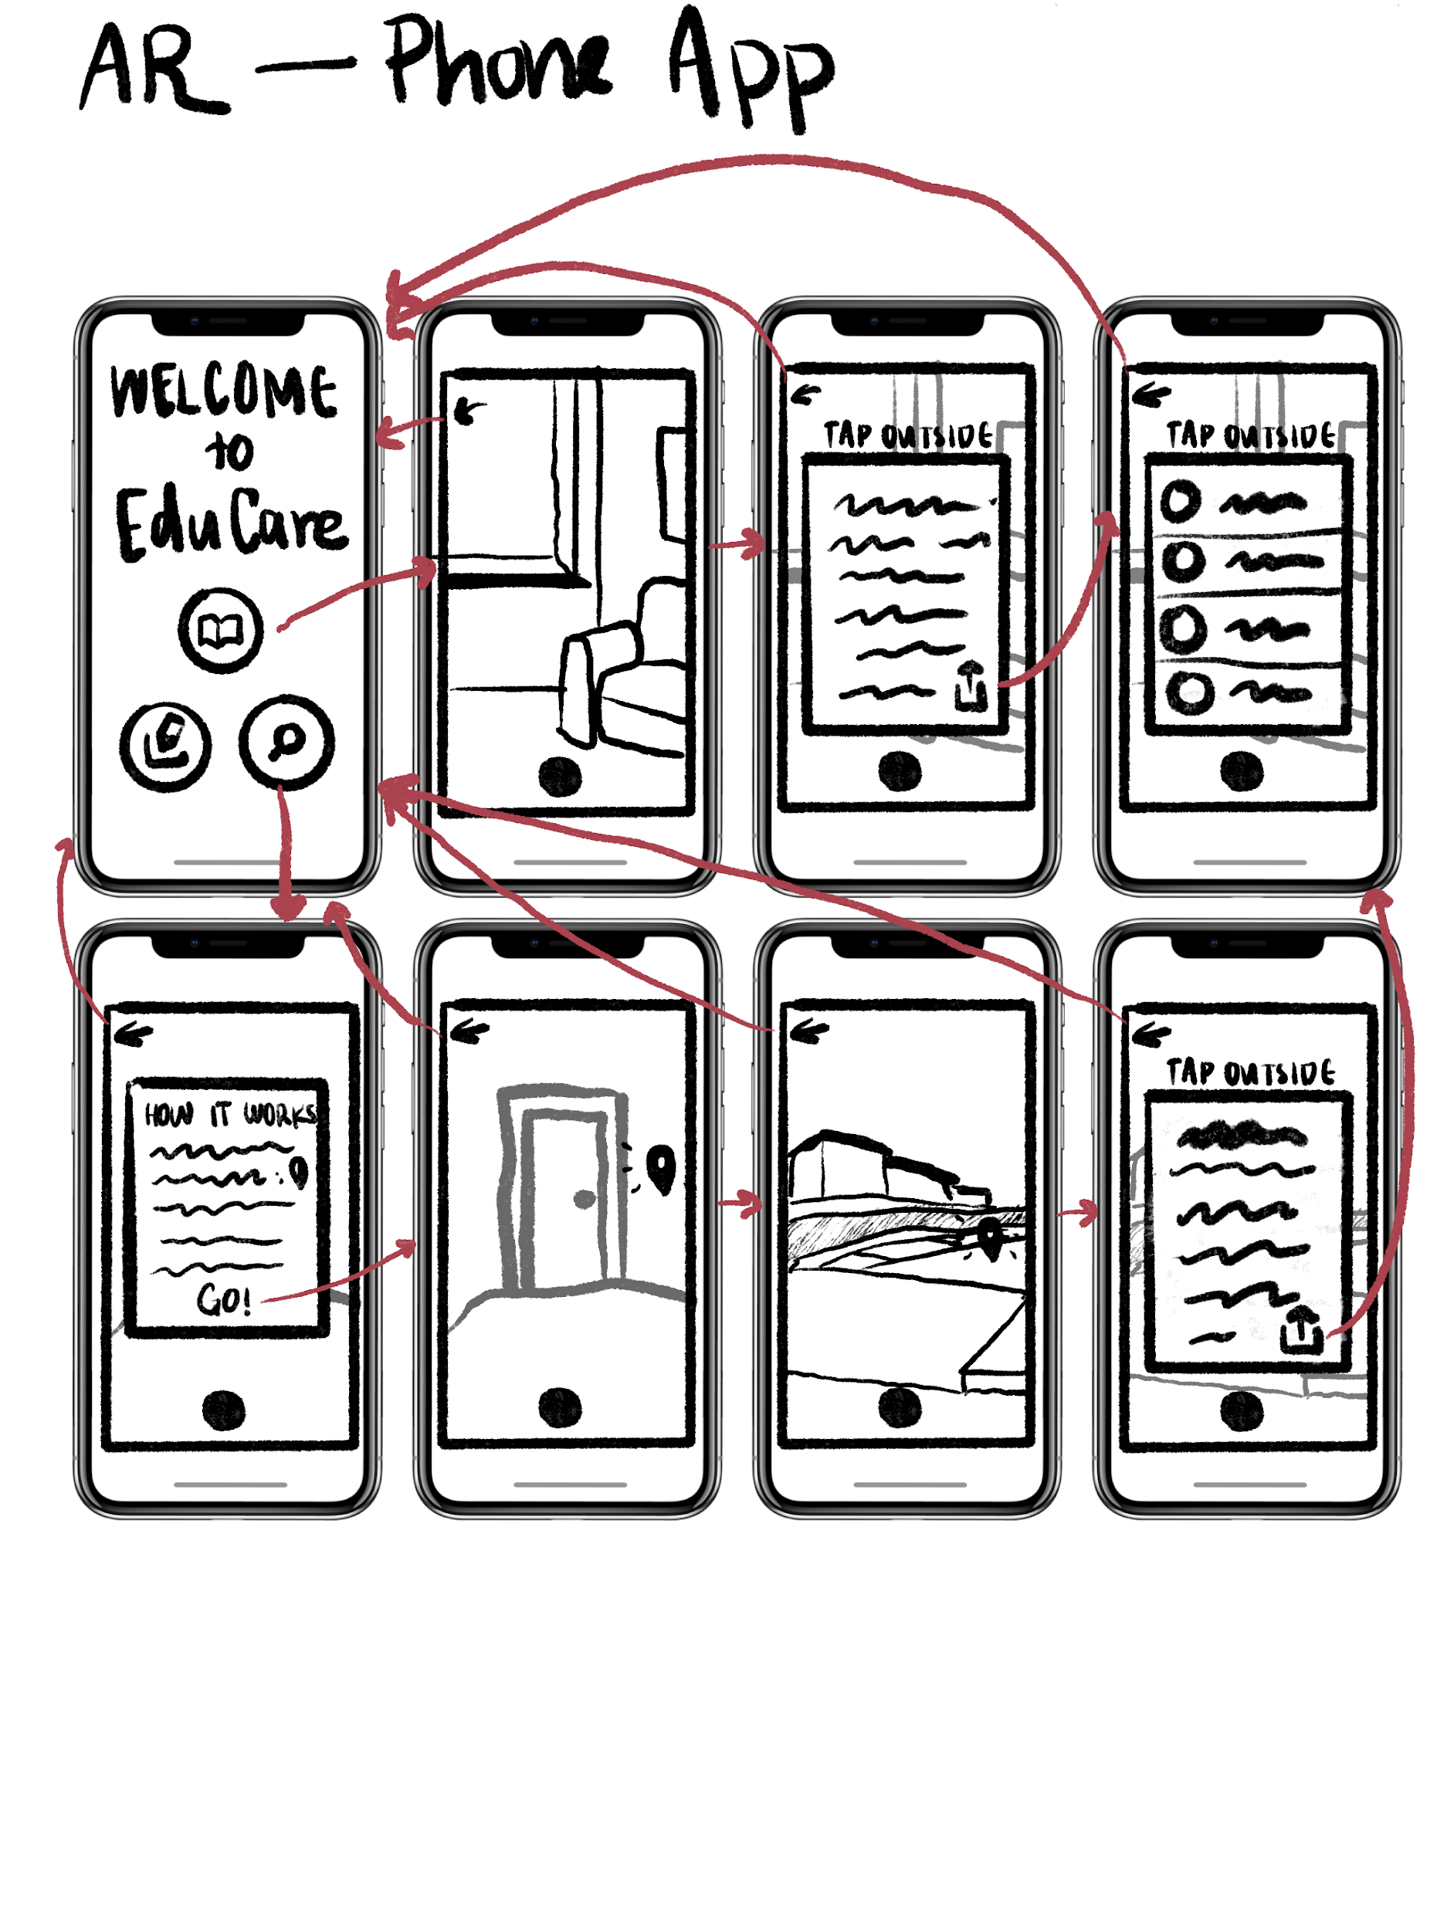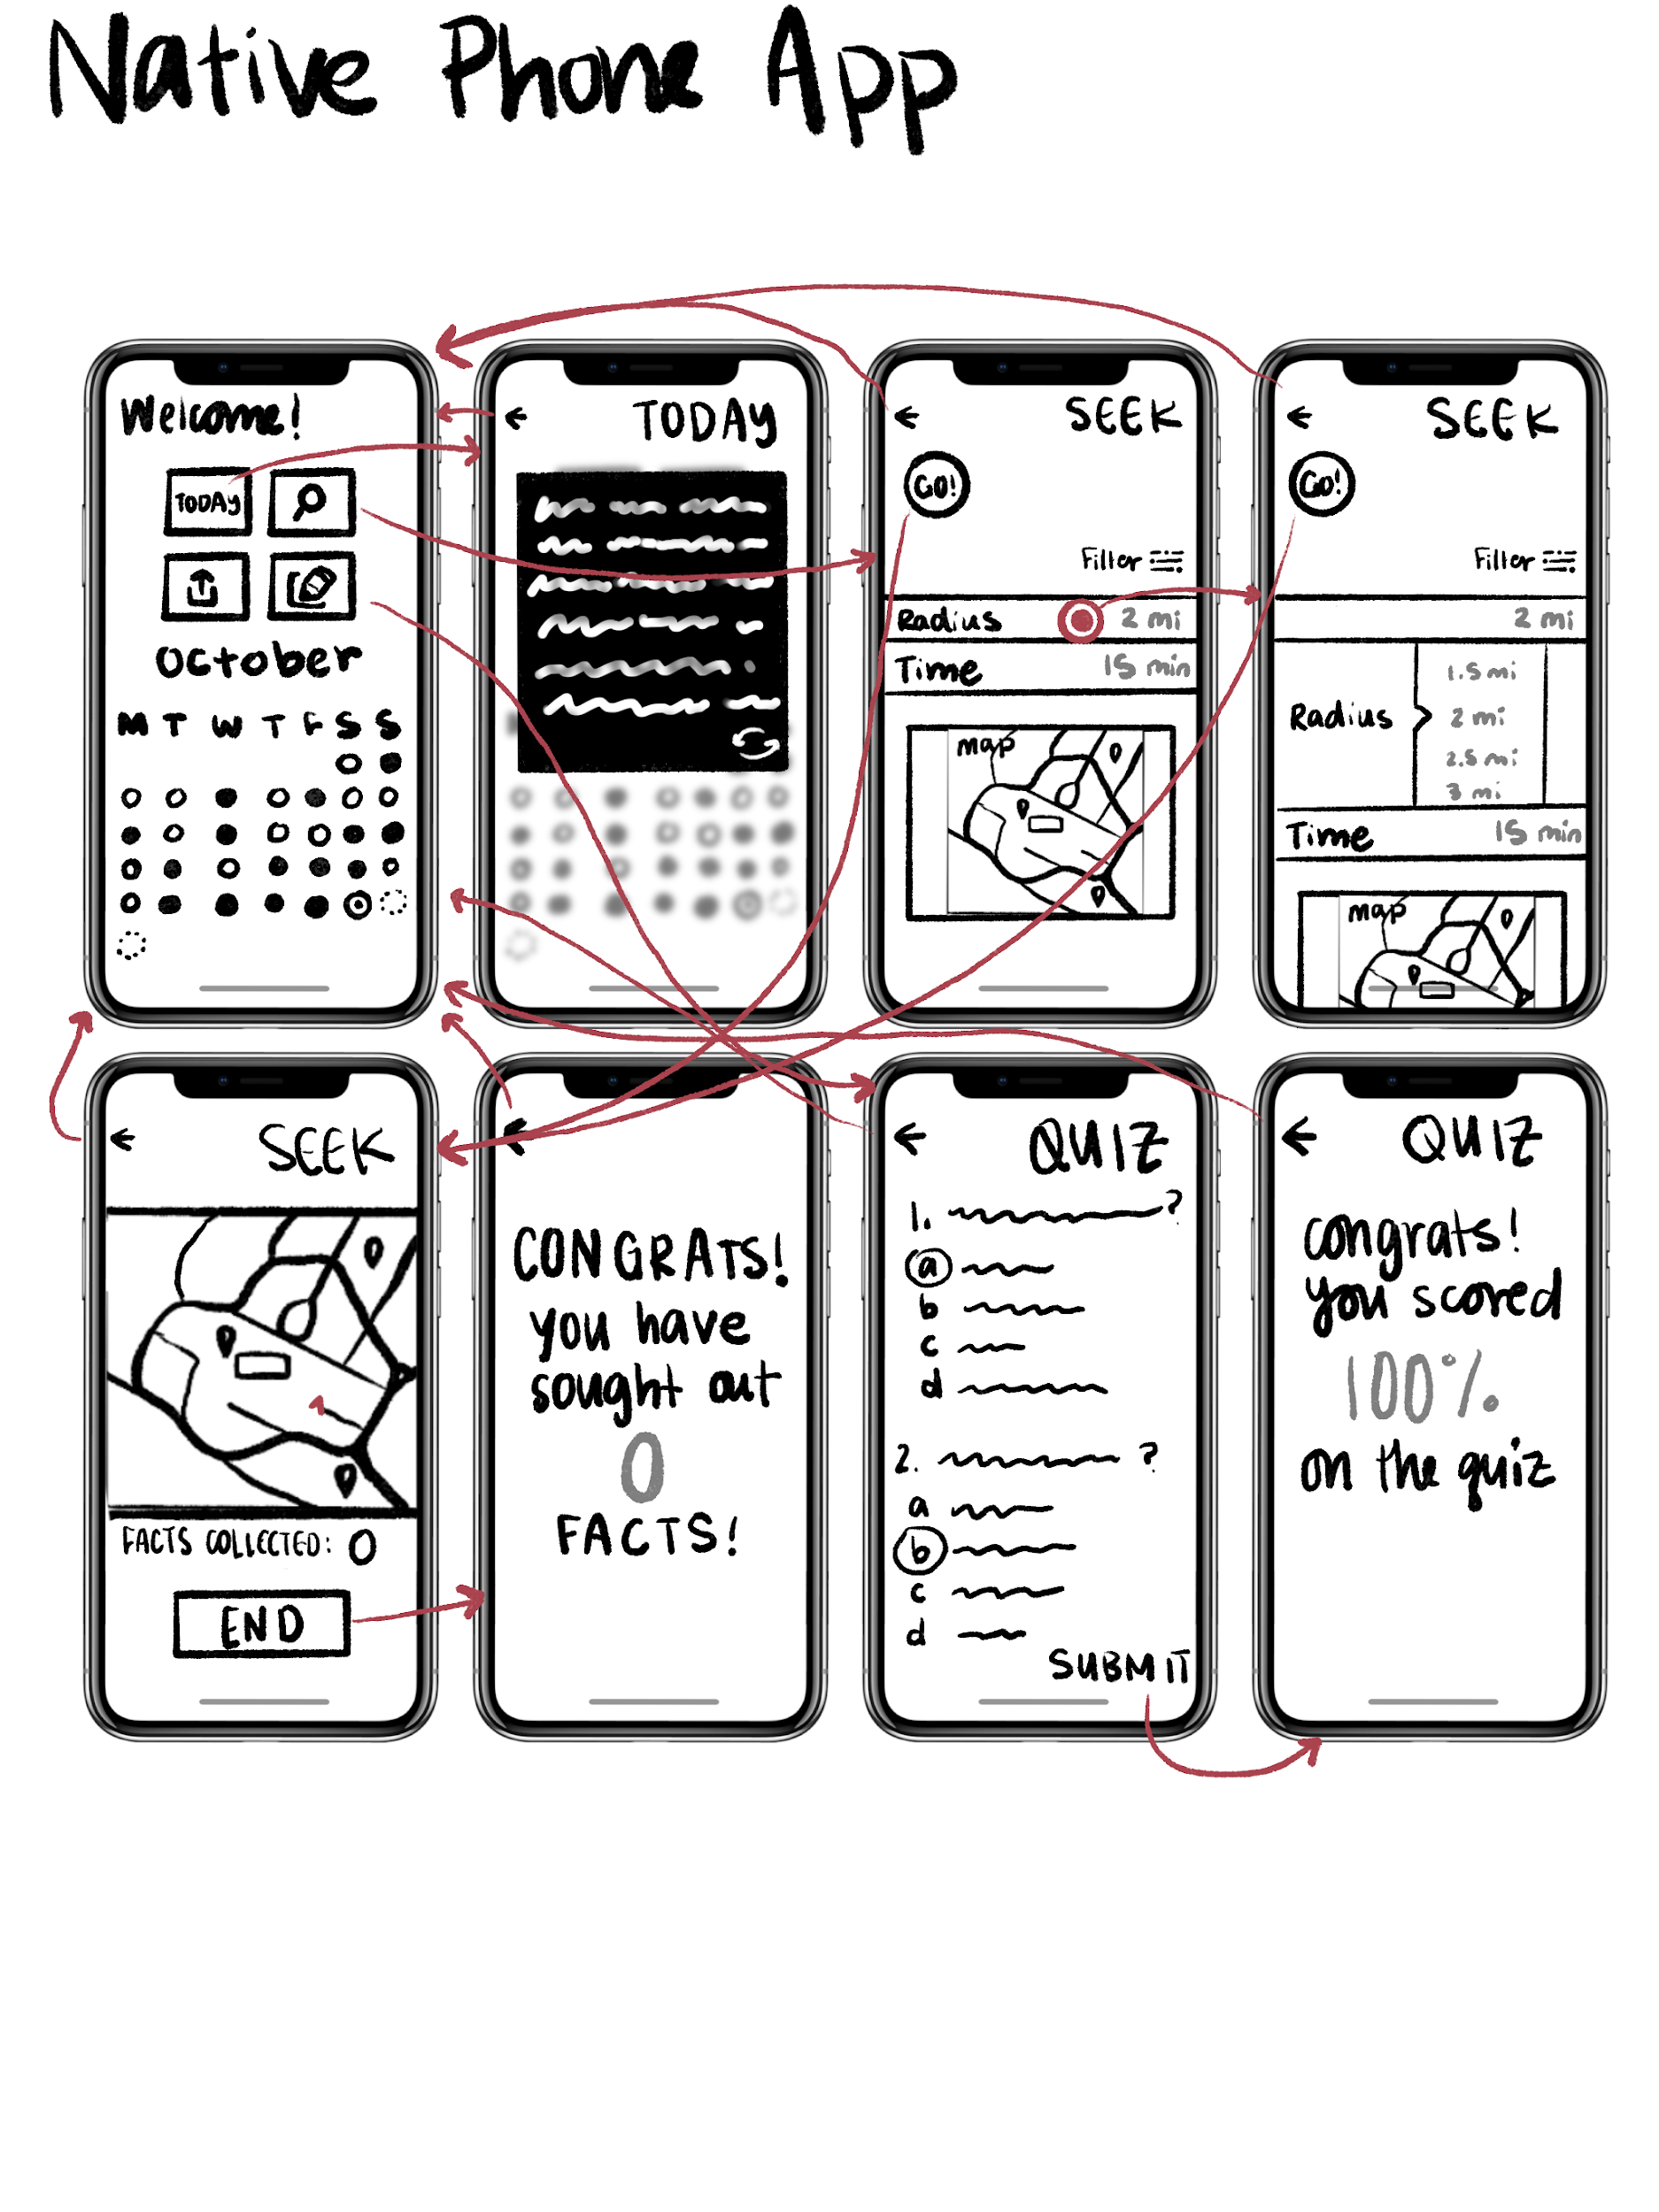
Figure 6: This is an Augmented Reality app storyboard where the participant is able to tie the world into the content they are engaging with
Figure 7: This is a Native mobile app storyboard where the participant is observing a clean interface that resembles a school planner

Final Interface
Augmented Reality Phone App
Pros | Cons
- Allow people to visualize the app within the context of the real world  - Gamification of content | - Using AR in public may be difficult for participants, as it requires more obvious movements and interactions  - Not as familiar, barrier to entry  - Not quite as versatile  - Other features (quizzes) difficult to use with AR

Native Phone App
Pros | Cons
- Familiar  - Low barrier to entry  - Versatile to be used for different modules  - Different pages allow for navigational exploration  - Easy to integrate into daily life  - Surreptitious, portable | - Might not be engaging enough to learn with  - Less lifelike, remains 2-dimensional

After mapping out the pros and cons of both the native phone app and the Augmented Reality app, we have made the decision to continue forth with the native phone app. Due to the varying nature of the features and modules desired by the tasks, it would be easier to achieve with a realization as versatile as the native phone app. The phone app is familiar, subtle, and easy to integrate into daily life. Although there are mild concerns about engagement and liveliness of interaction, this can be something that is emphasized in the UI and UX.

Low-Fidelity Prototype
We sketched our low-fidelity prototypes using Procreate, a drawing app for the iPad. We then scaled these images to the approximate size of an iPhone (for realism) using Adobe Illustrator. We then printed and cut out these screens to create the low-fidelity prototype to be tested.

The simple task is viewing the daily fun facts. Not only can the participant look at the current fun fact of the day, they can utilize the calendar feature in the landing screen to toggle previous fun facts.
The moderate task is engaging with the learning modules. Specifically, the participant can navigate to the scavenger hunt and use the app to travel outside to “search” for facts to learn.
The complex task is sharing any valuable or interesting fun facts that the participant has encountered.

SIMPLE TASK
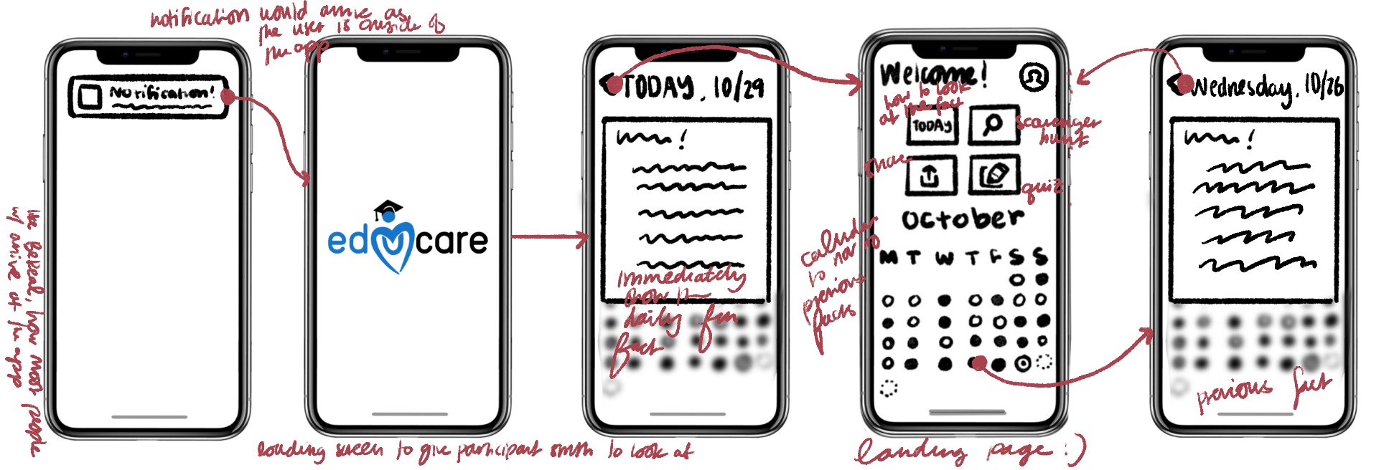
Figure 8: The fact reception flow

MODERATE TASK
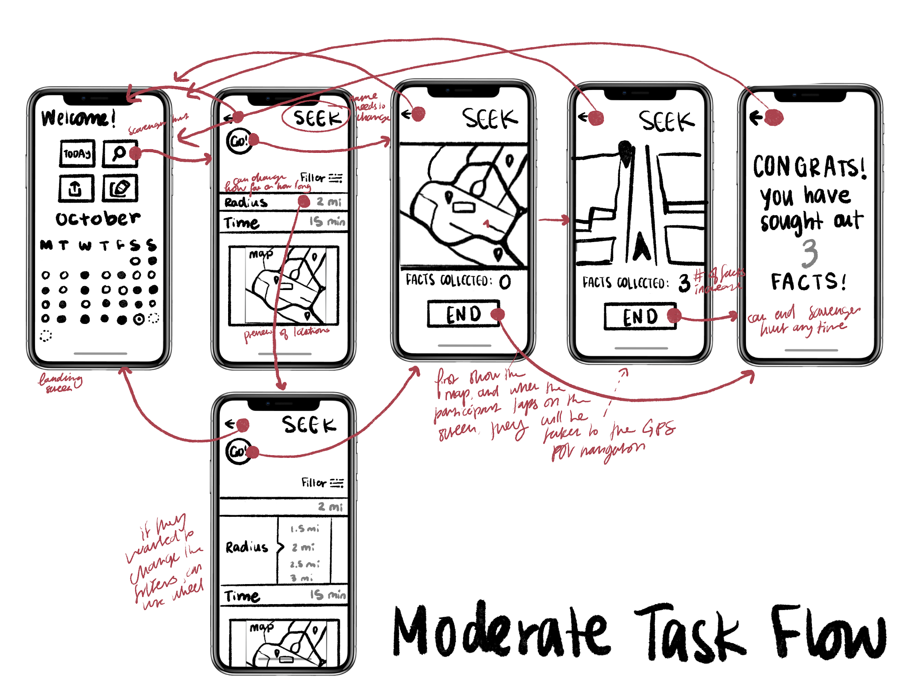
Figure 9: Scavenger Hunt Task Flow

COMPLEX TASK
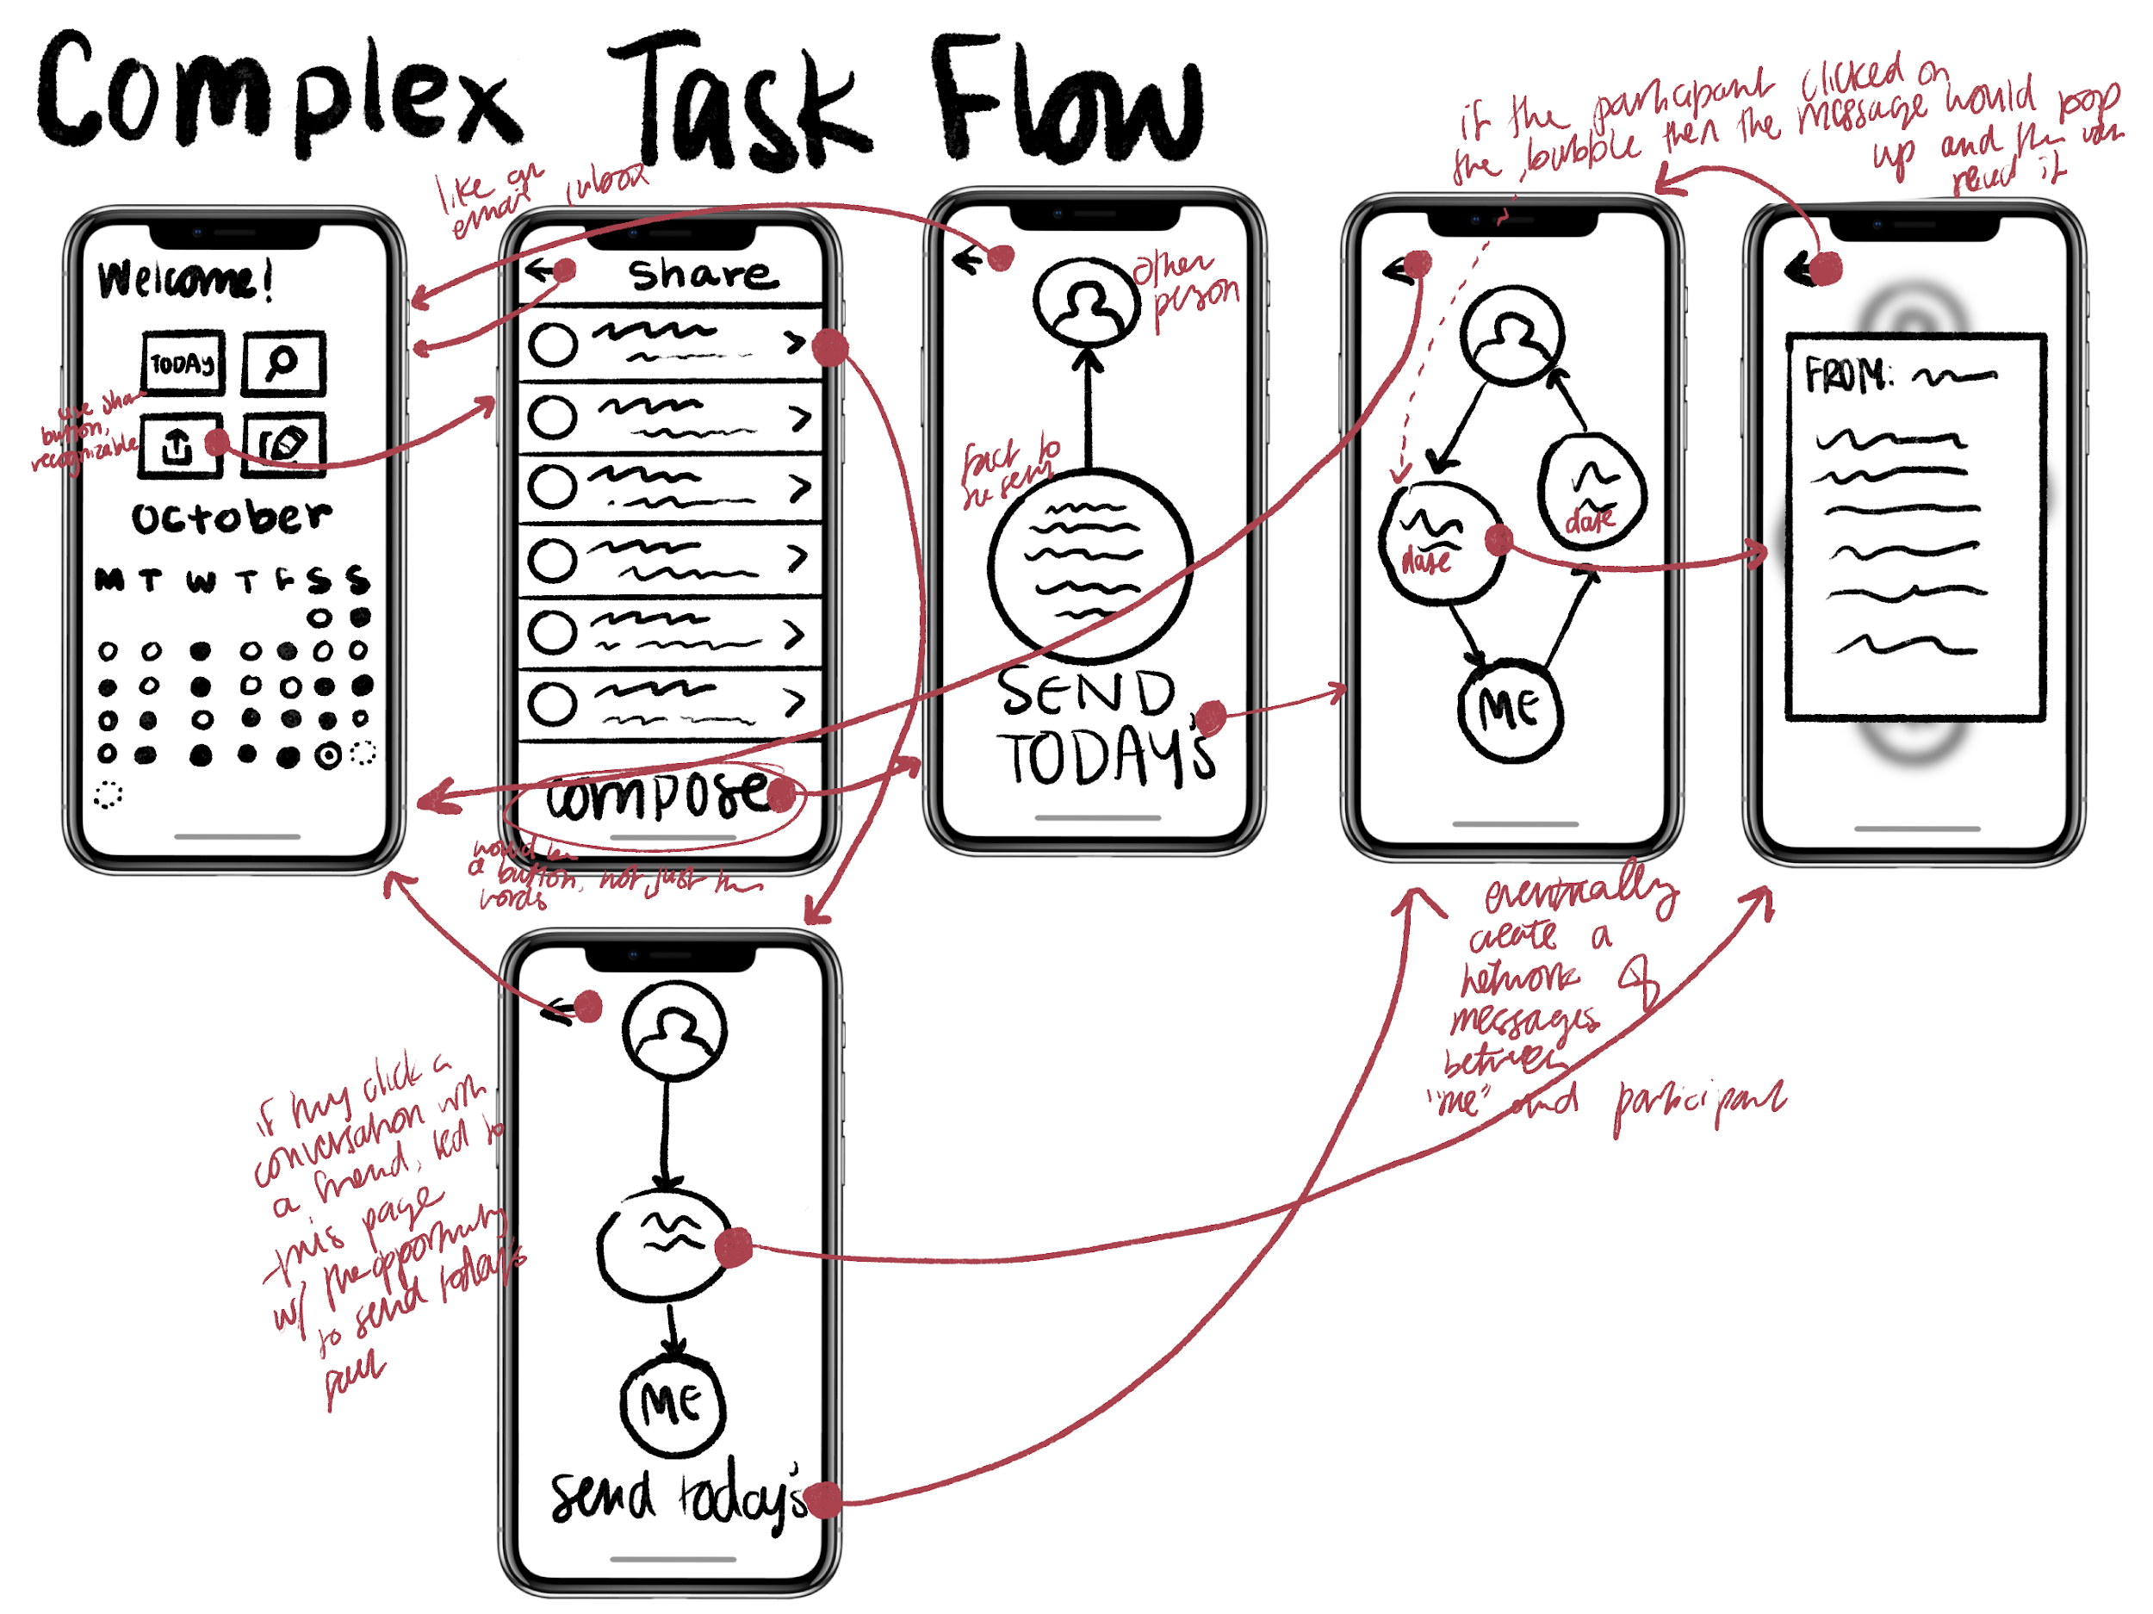
Figure 10: Sharing and Messaging Task Flow
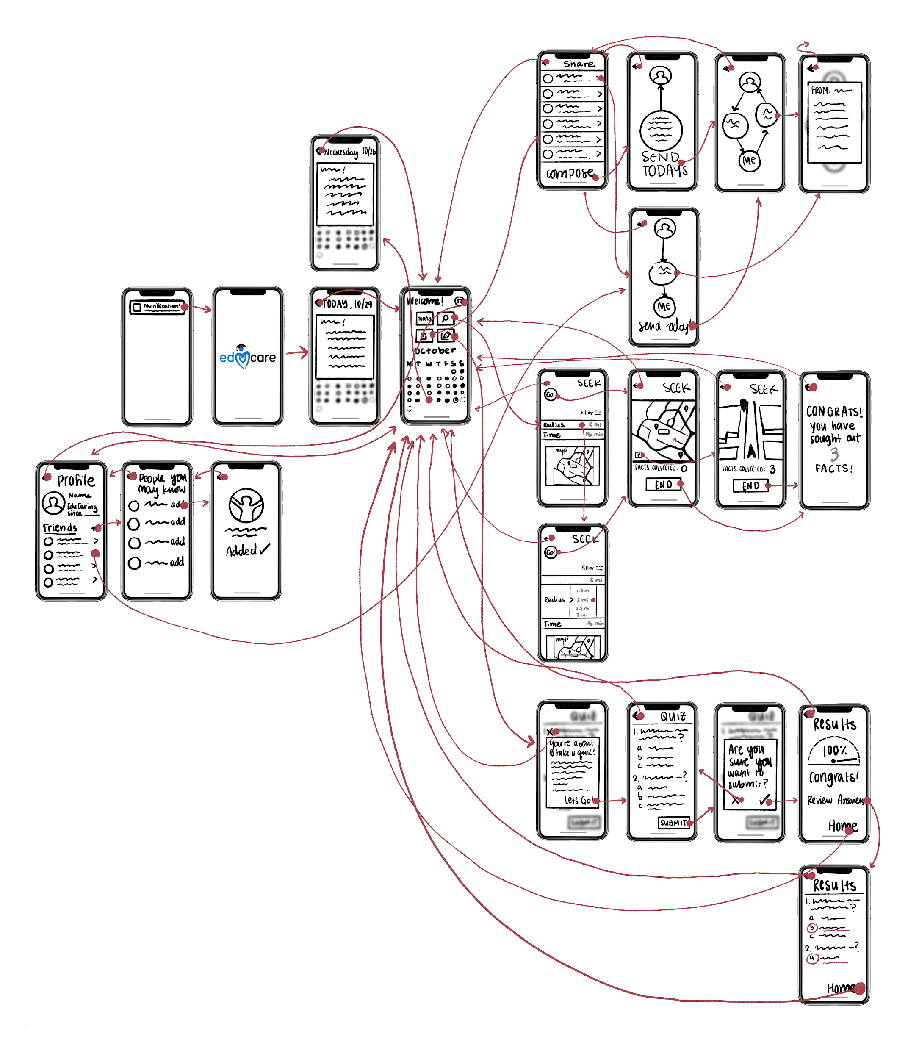
Figure 11: Entire lo-fi prototype system

Testing Methodology
PARTICIPANTS
- Hallie, 20s, UCLA Graduate and Assistant Coach
- Calico, 20s, Stanford student
- Tabitha, 30s, Stanford Gymnastics Coach

We selected our participants somewhat randomly, approaching people who were the approximate age range of our target audience. We wanted to make sure that our interface was usable by anyone who would be within the target age range, not just Stanford students. We also wanted to ask someone just outside of our age range, so as to ensure that the interface is discoverable and interactable by anyone. Participants did not receive any form of compensation except thorough and constant gratitude.
Tabitha and Calico were randomly approached at Starbucks and the outside of Tresidder, respectively. Hallie was approached outside near Burnham Pavilion.

ENVIRONMENT
We conducted our tests in-person with our printed paper prototypes. We made sure to conduct the tests at isolated tables, with nobody else in the immediate vicinity. Two of the tests were conducted outside of Tresidder, and one of the tests was conducted inside Ford Center.

TASKS
- The Simple task is viewing the daily fun facts.
- The moderate task is engaging with the learning module (scavenger hunt).
- The complex task is sharing any valuable or interesting fun facts that the participant has encountered.

TESTING PROCEDURE
- Introduce Team Members
- Ask for participant consent to record session
- Provide participant with context about EduCare
- Describe and demonstrate the process of thinking aloud
- Show participant the first screen
- Explain a task and have participants execute the task, repeating with each task (simple, moderate, complex)
- Ask for feedback/concerns, thank participants for time

USABILITY GOALS:
- Discoverability: the participant is able to have a task in mind and easily identify which buttons to press in order to swiftly complete the task
- Efficiency: the participant can complete tasks quickly

TEST MEASURES:
- Signs of Successes:
  - Tasks completed quickly
  - Eagerness and desire to continue
  - Thinking out loud aligns with intended path of task flow
- Signs of Errors:
  - Exasperation or stress
  - Having to ask how to complete a task
  - Repeated returns to the same (incorrect) screen

TEAM MEMBER ROLES:
- Brenden: Computer, Facilitator
- Nate: Greeter, Videographer

Results
As the participants started their usability testing, they were advised to think aloud, verbalizing their thought processes and communicating their thoughts about the system. On the higher level, people had:
- expressed deep interest in the platform of educating young people about healthcare
- struggled while navigating the scavenger hunt feature of the prototype
- commented that if there was a lot of text on the screen, they would probably just go back
- ultimately figured out the system but required some trial and error

Everyone:
- Was able to quickly complete the simple task
- Was able to quickly and efficiently complete the “quiz”
- Showed deep interest in the concept of using an app to educate youth about healthcare
- Spent little time exploring other buttons or features outside of the task
- Responded more efficiently to elements that resembled things they were familiar with (notification banners, calendars, pop-ups) and were more hesitant about elements they weren’t used to (a different layout for messaging)
Two:
- Confused the scavenger hunt button with the search function
- Were confused by the sharing process
One:
- Was exasperated with how they had to keep going to the previous page
- Found the icons not representative of the task

Discussion
Before entering the discussion regarding the results of the usability test, we have to consider that we could not test the usability of the scavenger hunt, since we represented the map with a stationary image of what a map would look like. However, since the GPS feature is one that many are already familiar with, we hope that this would be effective when implemented.
When asked about their experiences with our lo-fi prototype, every one of our participants shared their interest in an app that is devoted to educating the youth about their healthcare. They had understood the need and the solution.
As observed, the participants responded most positively to elements of the screens that they recognized from their own phone usage. That being said, task one combined UI elements that they have been very familiar with–notification banners, calendars, pop-ups. As expected, none of the participants had any trouble completing the first task.
The second task was a bit more difficult for every participant. Two of the participants had thought that the icon for the scavenger hunt (the magnifying glass) was actually the search engine, and kept gravitating towards the magnifying glass as a way to search for features or task flows they were trying to complete. They would even state, “I don’t know where I would find this, so I’m going to search for it.” When the initial confusion subsided and the participant realized that they had inadvertently ended up where they wanted to be, the participants had a much easier time completing the task.
The third task was also a bit difficult for some of the participants. One participant kept arriving at the same screen and expressed mild exasperation because they were unsure of where to navigate to next. Although they eventually found out the proper flow without having to ask for help, they took a couple wrong turns and made a couple of errors. They were mainly confused about the screen with the speech bubbles of messages between the participant and their “friend,” as they did not understand the message button to be so obvious. Later, they had described that there should be a distinction between “Compose” and “Send” in terms of messaging, since “Compose” seems to indicate that the participant is sending a custom message. Another participant, when prompted with the task of sending a fun fact to a friend, instinctively returned to the page of their fun fact, and tried to send the fact to their friend from that page, and later described that they wished the two features were integrated to an extent.
Another point that was brought up by one of the participants was the concern of screens having too much content, as they described the overwhelming nature of a lot of text on the screen. They stated that if there was a lot of text, they would likely merely return to the previous page and trial-and-error different buttons to figure out the flow.

MOVING FORWARD, WE WILL:
- Re-evaluate the iconography to facilitate effective visual communication
- Consider the idea of a search bar, not only to identify previous fun facts, but also to help participants find features or modules
- Refine the layout of the messaging feature, possibly taking into consideration familiar layouts to facilitate discoverability
- Potentially add an integration of the messaging feature into each fun fact

Appendix
CRITICAL INCIDENT LOG
0 = no problem
1 =cosmetic problem
2 = minor usability problem
3 = major usability problem
4 = usability catastrophe

Hallie
Incident | Incident Log
Got confused by the calendar buttons beneath the pop-up of the fun fact, tried to click them to toggle | 2
Tried to click on the scavenger hunt button to search for scavenger hunt | 4
Got confused by “Seek” as opposed to search | 3
Tried to click the fun fact of the day in order to send it to someone else, sharing it as she would via text | 4
Overwhelmed by the amount of the text on the messaging screen | 1
Thought that two messages between two friends was actually between three friends | 2

Calico
Incident | Incident Log
“And now I’m on a very nice home screen” | 0
The calendar did not have labels and she did not know what day it was | 3
Tried to click on the scavenger hunt button to search for scavenger hunt | 4
Clicked on the quiz button to write a message | 4
Tried to click on the scavenger hunt button again to search for the messaging feature | 4
Recognized the “share” button | 0
Clicked on the recipients button and then “compose” (not as intended) | 2

Tabitha
Incident | Incident Log
Did not know what the notification read | 1
“This is a very nice logo” | 0
Swiped up to remove the pop-up as opposed to using the back arrow | 3
When sending a message, initially clicked on the messages as opposed to sending one | 3
Engaged with the filter on the scavenger hunt | 0
Found profile intuitive | 0
Swiped on the map | 2

