

Fitcoin Final Report
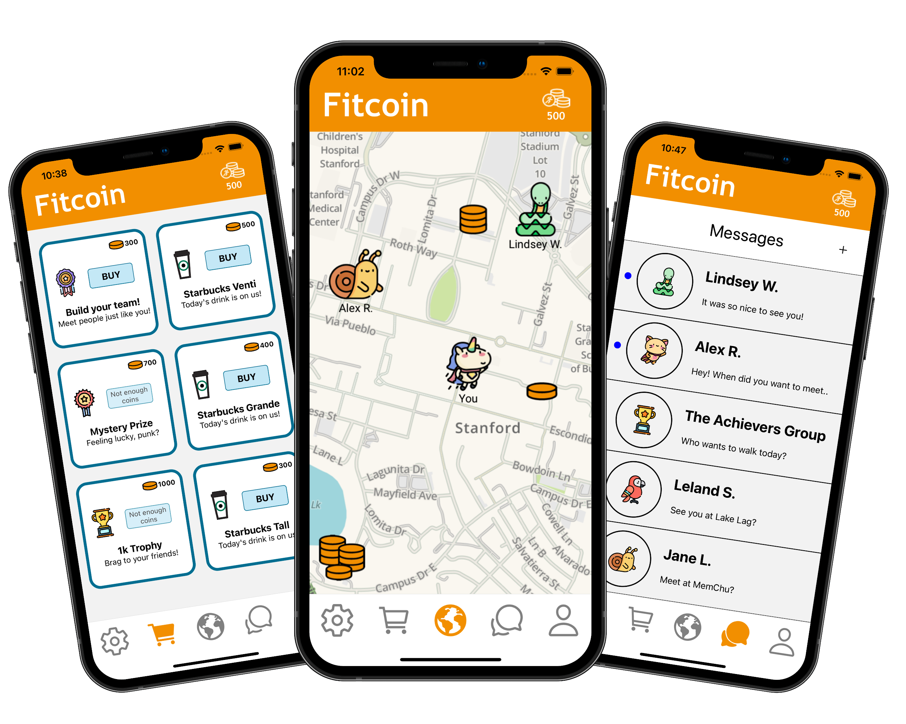

Value Proposition:
Fun Fitness for All

Problem/Solution Overview:
People can’t sustain their healthy exercise habits. Unmotivated by arbitrary health goals, people find exercise monotonous and chore-like. Our solution is to gamify fitness using a mobile app to create social communities and fun activities, making fitness accessible and sustainable for all.

Team Members:







Needfinding Interviews:
We began our project looking into personalized health tracking. Only having informal background knowledge of this domain, we started by interviewing a broad range of users affected as well as industry insiders.
Within the industry, we were able to interview J, an employee of Oura ring. He not only provided context to the industry but gave valuable insight in how personalized health tracking is rarely the sole guide of the user but rather reaffirms and provides validation of how the user is feeling. After J, we interviewed a broad range of users of personalized health tracking products from extreme users to average users to non-users. For extreme users, we interviewed coach C, who has openly admitted to wearing two wearable fitness trackers at once, and Andrew, who is a self-declared biohacker. The average users, Toby and Jereon, both used personalized health tracking systems in their lives but not regularly or obsessively. Finally, Dr. H and Liz, who neither used personalized health tracking systems, provide insight into why some people avoid personalized health tracking.
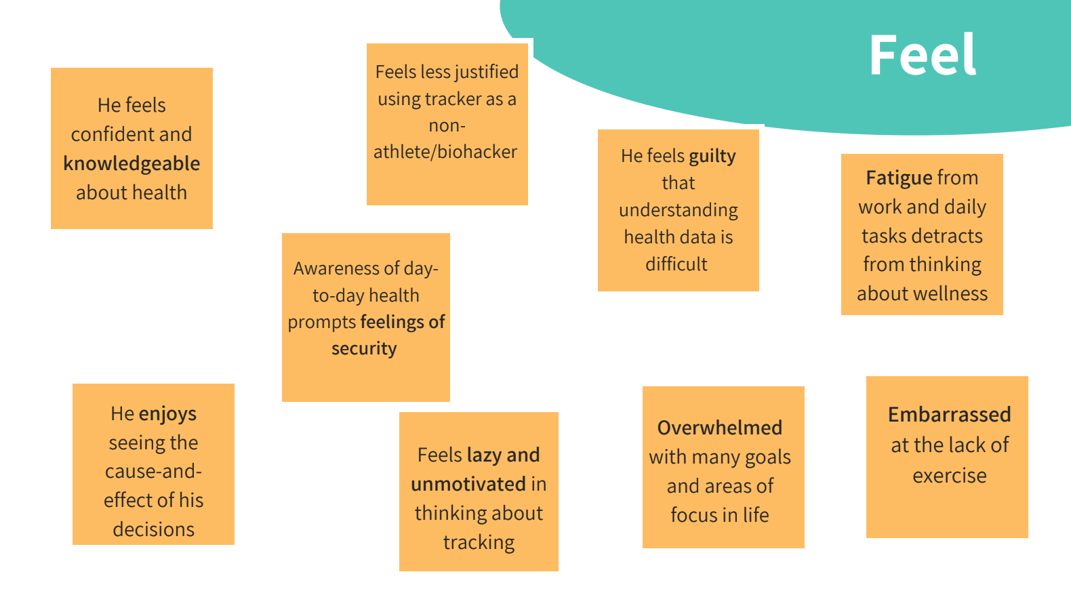
This diverse set of users provided us with a lot of early learnings. For example, we routinely discovered how work often has the most adverse impact on people’s personal health and that health is truly what it ‘means to [them]’. Toby, a young professional, also highlighted the thinning boundaries between work and life in the WFH pandemic situation, saying ‘WFH means work is always there 24/7’ with Dr. H reiterating that ‘curving out time in my [work] schedule is the biggest obstacle’. From these interviews, we created empathy maps to unlock insights.
J’s Interview Empathy Map
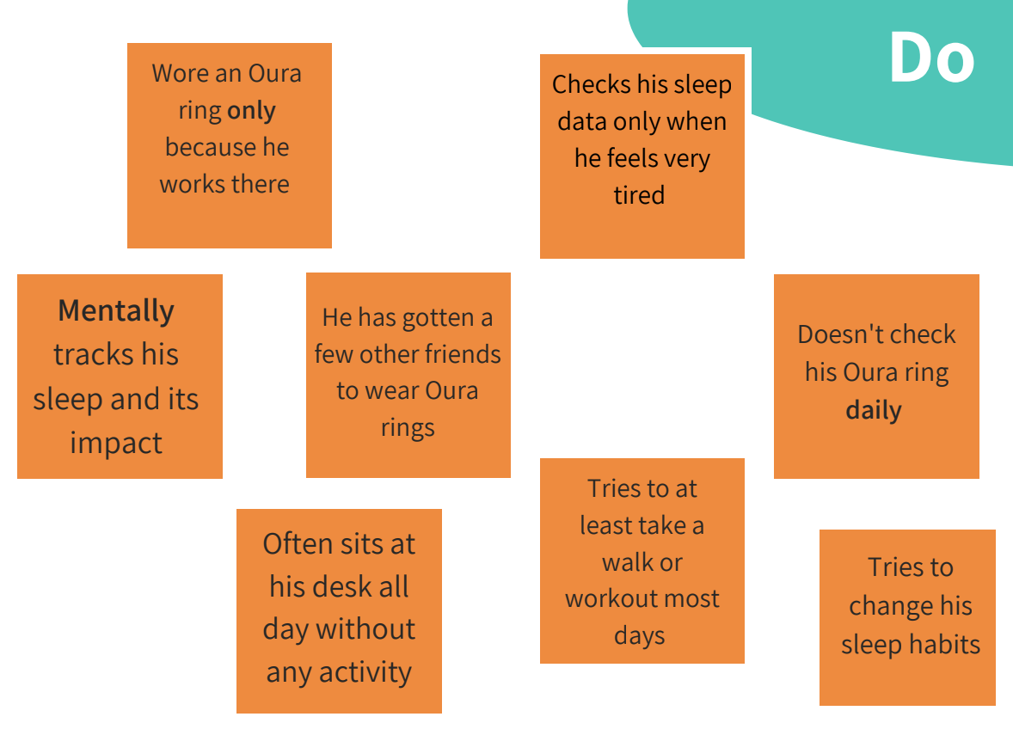
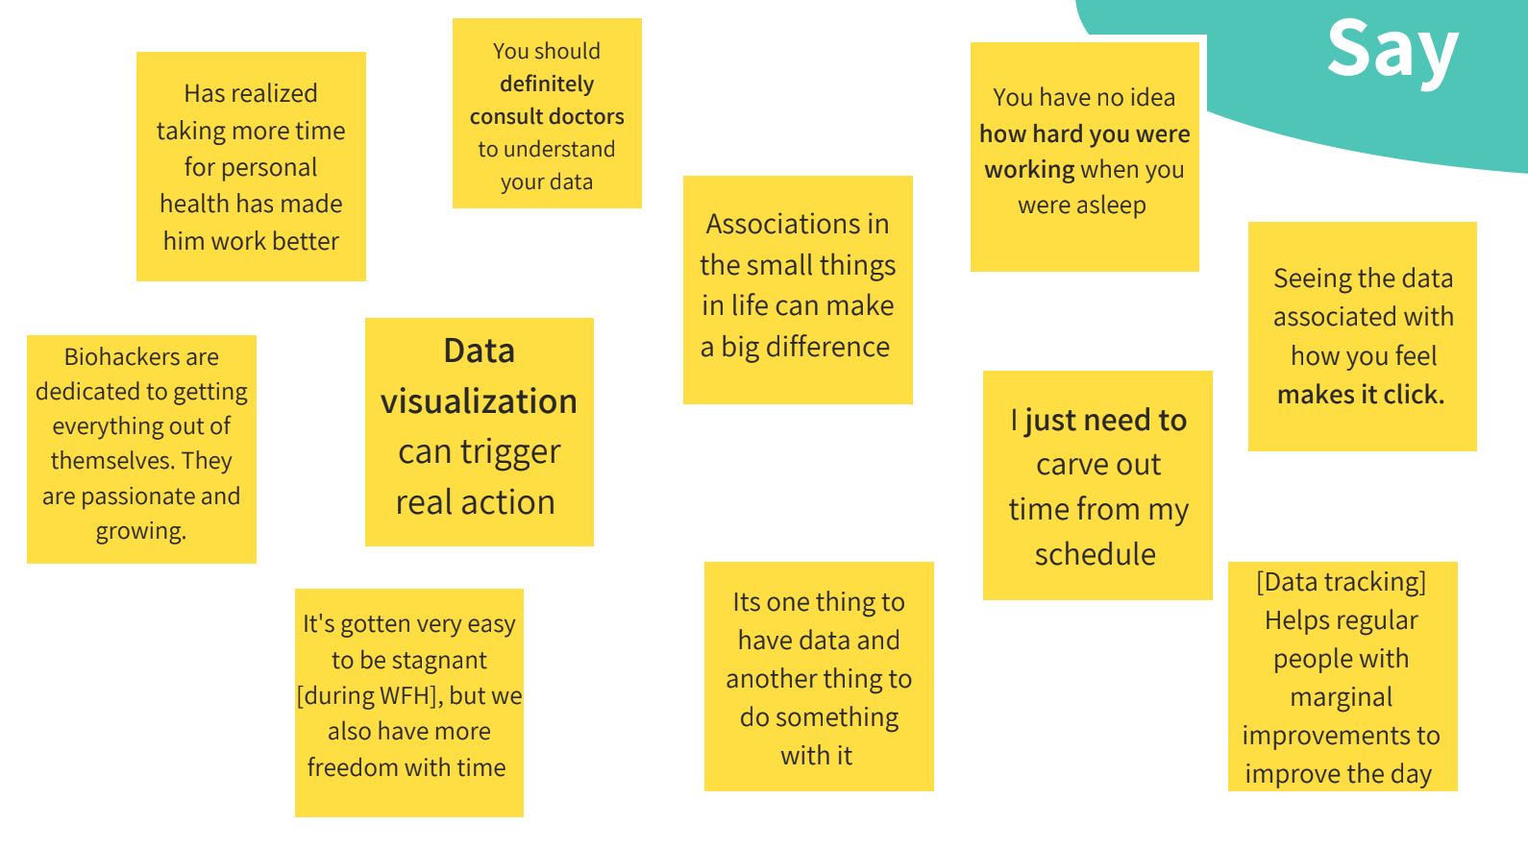

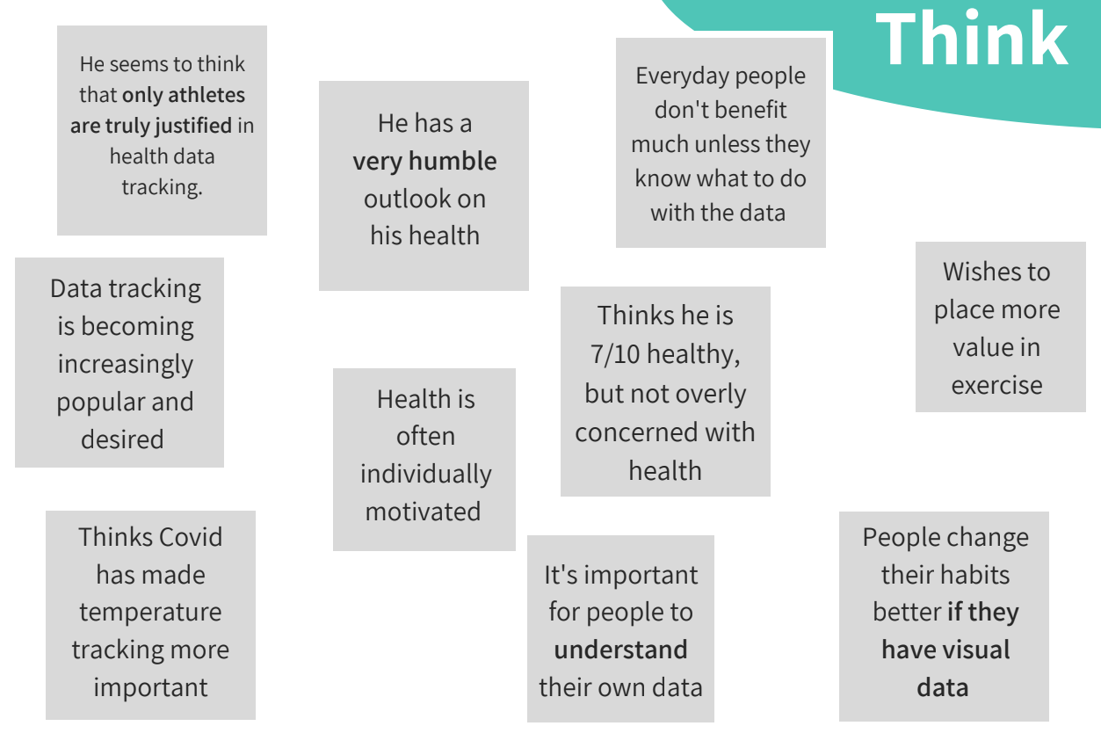

POVs & Experience Prototypes:
We then developed point of views (POVs) for 3 of our most insightful interviews:


- We met Toby, a 24 year old in finance who has been working from home for nearly a year.
  - We were amazed to realize he missed the structure that office life and a gym provided and work now seeped into every aspect of his life.

    - It would be game changing if Toby did not need the structure or environment from a physical space to improve his health and wellness.
- We met Coach C, a Millenial strength coach and ex-athlete who is an extreme user of wearable tracking tech.
  - We were amazed to realize even though she has deep knowledge about the data, she gravitated toward the tech with the sleekest design and most enjoyable user experience.
    - It would be game changing to combine Coach C’s most important data with enjoyable, inspiring design.

- We met Liz, a humble mom who wants to continue to fit in her non-stretch all-cotton jeans.
  - We were amazed that although Liz scoffs at creating numeric fitness goals, she still seeks motivation to feel good and wants to make sure she is staying on track.
    - It would be game changing to motivate people like Liz without numbers and track their progress qualitatively.

These POVs inspired us to create many how might we (HMWs) that then allowed us to explore solutions for each of these.

Toby’s HMWs:
- HMW help employees advocate for their own personal health without appearing to shirk work responsibilities?
- HMW separate work space and home space with WFH?
- HMW help people to build an environment around them that prioritizes their health and wellness?
Toby’s Solution:
- Create a personal health tracking system which businesses can provide to employees that aims for long-term wellness and productivity

Liz’s HMWs:
- HMW illustrate how the data relates to subjective feelings?
- HMW make health data feel like it's not just for biohackers?
- HMW provide and highlight the data that truly matters?
Liz’s Solution:
- Gamify tracking health and wellness for yourself and your personal community

Coach C’s HMWs:
- HMW create an interface that people will use for sheer enjoyment?
- HMW give nonathletes a goal-oriented, health-focused community that encourages wellness?
- HMW make complex health data applicable for everyone?
Coach C’s Solution:
- Create a personal health app for non-biohackers to improve wellness and functional ability over the long term.

Solution Assumptions and Experience Prototypes:
We wanted to test the most critical assumptions of our 3 top solutions so we created an experience prototype for each solution testing with a new user.

Toby’s Solution Assumption:
- Businesses are willing to pay for personal health tracking apps that might sometimes suggest long-term health outcomes at the expense of short-term work deadlines.

Experience Prototype:
To test this assumption, we created an interactive slide deck that provided the user with feedback on their current state of mind and suggestions on how to improve it. The users could click between slides, and we pitched it to a business owner.
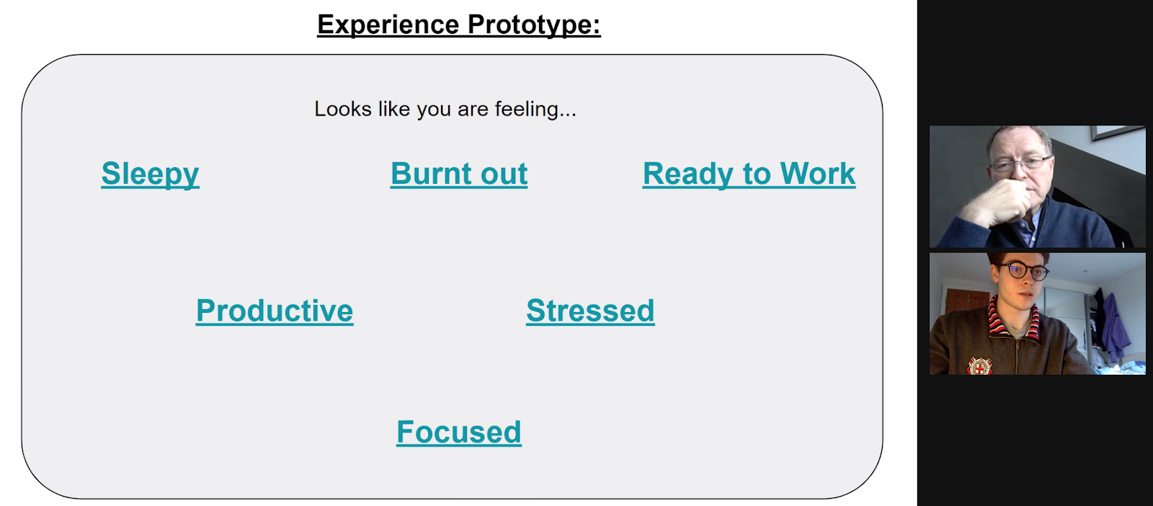
This experience prototype worked in promoting more grounded conversation, especially with someone with less experience of technology. However, the linked slides often prompted confusion.
We still gleaned meaningful insights including validating our solution assumption that businesses are willing to pay for personal health tracking apps. However, the business owner noted that smaller companies might need self-help links as they can’t provide a full service. Lastly we learnt that, even within best businesses, some middle managers won’t be responsive to employees.

Liz’s Solution Assumption:
- People won’t consider their mobile gaming time as onerous health-tracking

Experience Prototype:
To test this, we played a role-playing game via phone with our interviewee by telling him to imagine he was part of a story in which he had decided to try to run more and eat more vegetables.
This experience prototype worked as the novel idea of a treasure chest motivated our interviewee to get out of bed and workout, validating our solution assumption for exercise. However, the interviewee didn’t like the idea of having to compete with those much fitter than him and inputting anything relating to diet took way too long and felt onerous, which invalidated the solution assumption for diet.
Lastly, we also learnt that there was a real emphasis for our interviewee to exercise with people like him not those out of his league as this social element if done correctly could be really compelling to get him to exercise more.

Coach C’s Solution Assumption:
- People who aren't biohackers would be more dedicated to their wellness if they had individualized benchmarks and long-term goals to pursue, with guidance on how to get there.

Experience Prototype:
To test this, we created a set of "screenshots" in google slides that provided the user with customized wellness goals and plans for how to get there.
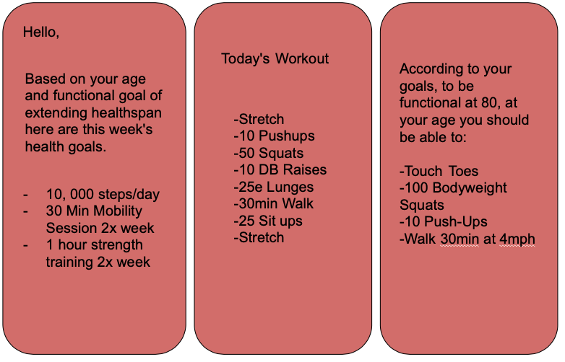

What worked well in this experience prototype was the personalized long term plan for them that they didn’t have to think about. Saying this, there was a concern that the length of the long term goal meant that without short term goals interminitely, they would lose motivation. Although this solution assumption was validated, there were concerns from the user that they would never look for a fitness app as it ‘wasn’t for them’ so any solution would need to be marketed carefully.

Design Evolution:

Final Solution and Rationale
Our experience prototype showed a keen need to make exercise more enjoyable and that by gamifying exercise and incorporating a non-intimidating community, we could encourage people to exercise more. Although we had thought of including a diet aspect to our solution, the experience prototype showed that gamifying diet wasn’t feasible as people deemed it to be onerous. Not only this, but the experience prototypes showcased the need to think of non-athletes needs and desires as different to athletes not just a less extreme version of athletes.
Based on the experience prototype results, our solution was to gamify exercise to make fitness approachable and sustainable for all people. We believe it was fundamental to make exercise fun and also provide social communities for people to be engaged and feel a sense of belonging.

Our 3 tasks:
For this solution, we brainstormed our core tasks. Trying to incorporate the gamification and social elements that were fundamental to our solution, we decided on 3 main tasks:

Simple: Achieve your first coin
  - Basing our fitness app around a coins/point system to gamify exercise meant that the simple and most central task was to achieve coins through exercise, making this our first task.

Medium: Meet your community
  - The social aspect of our app was also vital to keeping people engaged, so the medium task was to interact with your community.

Complex: Spend coins on a reward
  - To really get people engaged with our app for a long-time, we had to provide a way to reward people for their time and effort for getting coins/doing exercise. That’s why we thought it was fundamental to have a task based on spending coins to get rewards for yourself.

Design Sketches
We decided that a mobile application was the optimal user interface for our solution because of their wide-spread usage, flexible interface and the fact that people always keep their phone close at hand, meaning a user could always access our app when out and about.
Our first step in the actual design was to create some sketches that communicated our app’s design fundamentals. The diagram below shows our first attempt.
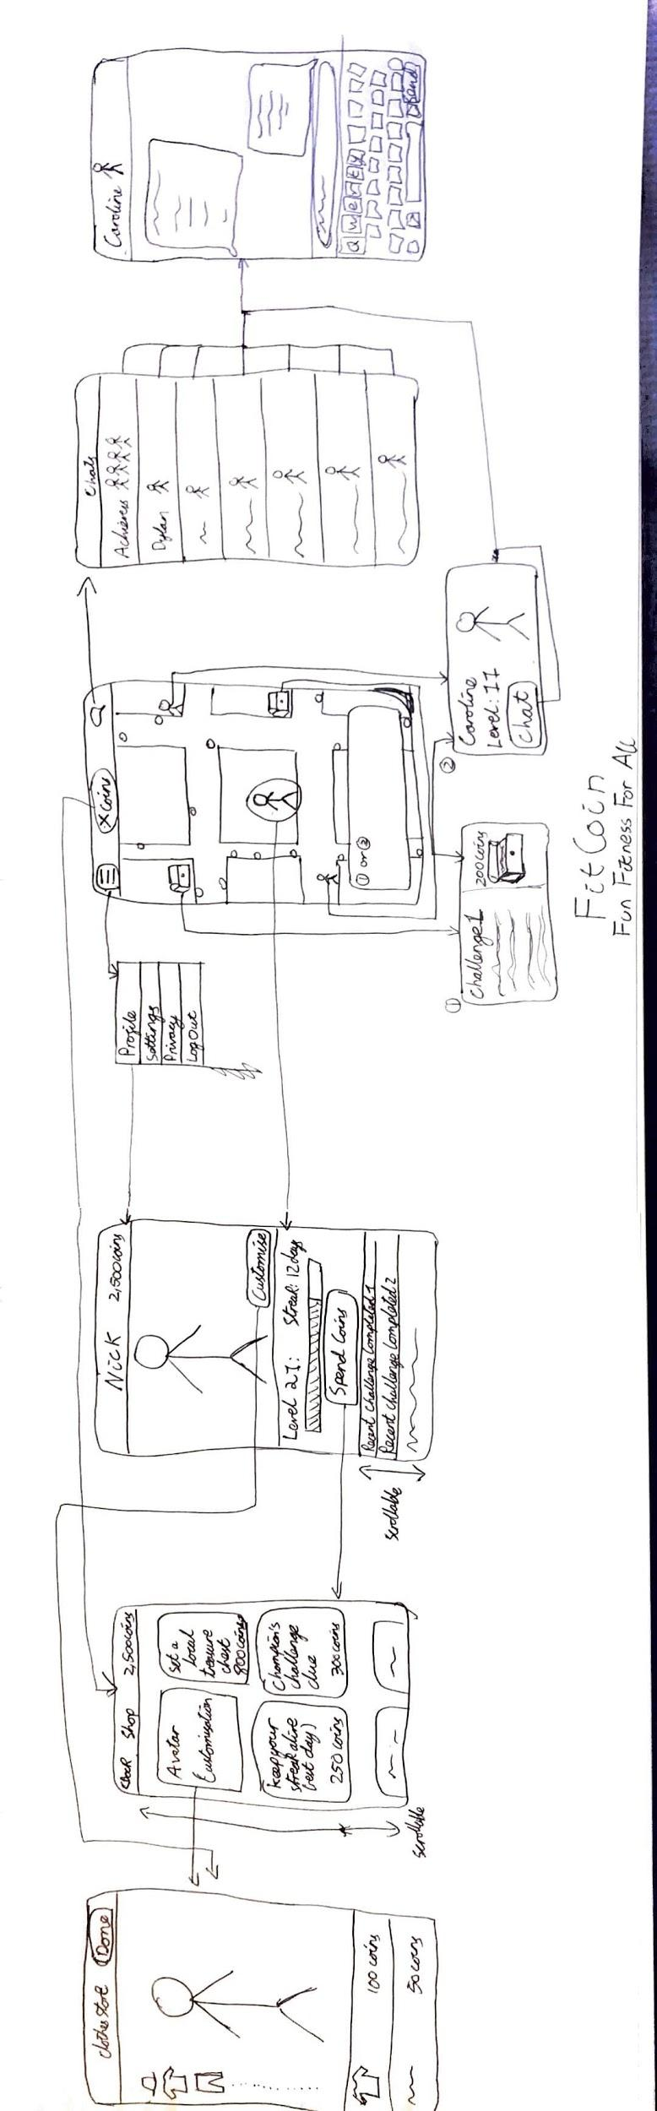

We quickly iterated on this design again through brainstorming sessions. Realising the initial sketches had strayed too far from our core 3 tasks, and we removed the avatar features as this wasn’t supported by our needfinding data.
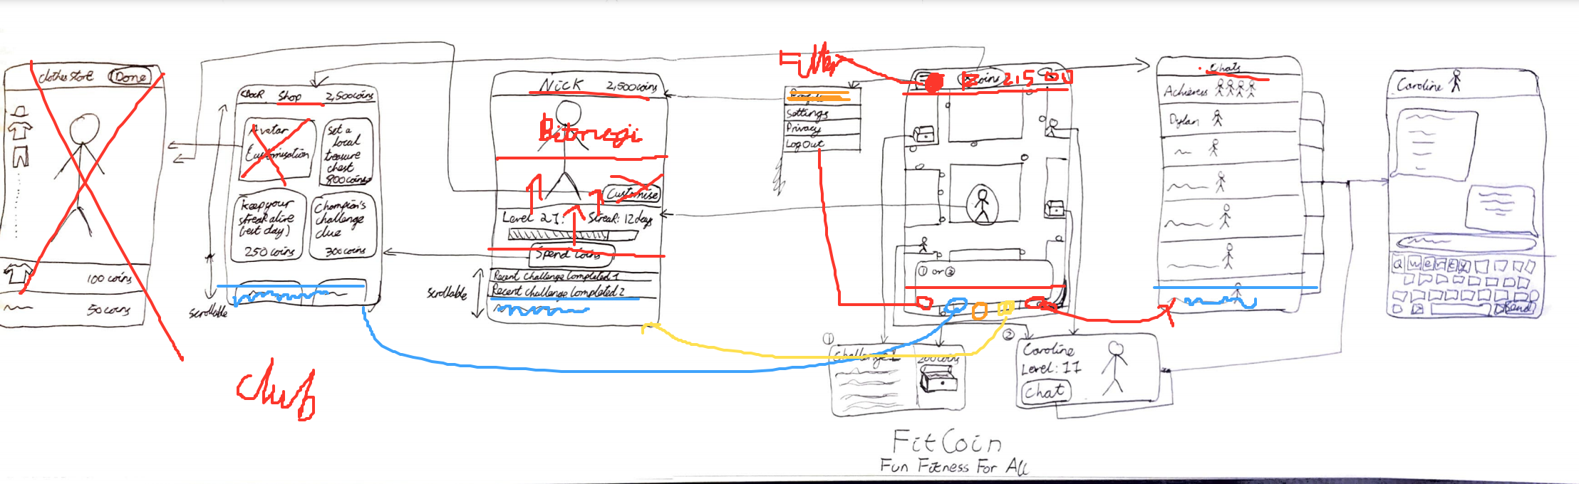
Low-Fi Prototype
After the design sketches, we developed our first prototype to be tested by users. This low-fi prototype was developed through whiteboard drawings that showed each ‘screen’ that was then linked through an invision application. The low-fi prototype can be found here. Below are a sample of the screens which show the map screen, the shop screen, and the chat screen. The blue boxes indicate the clickable areas on the ‘screen’.
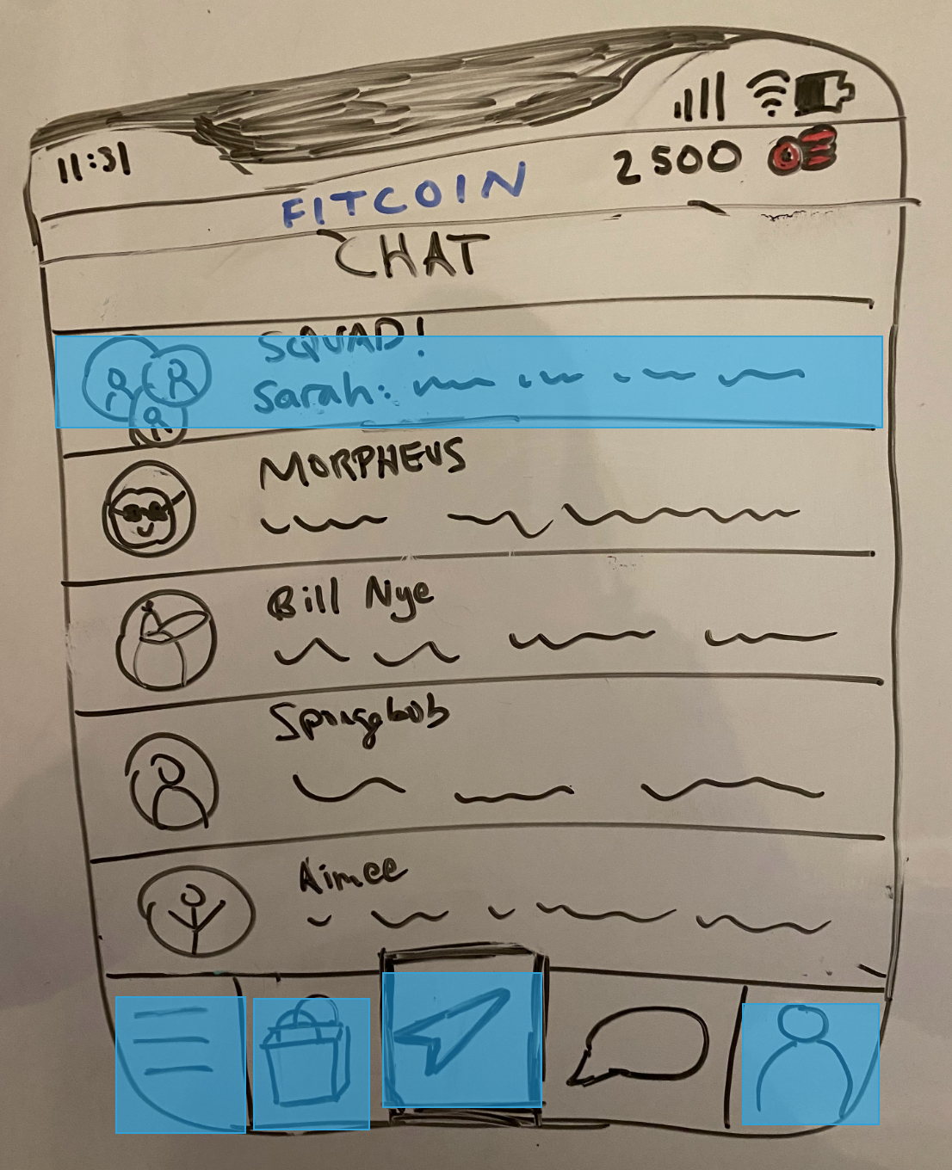
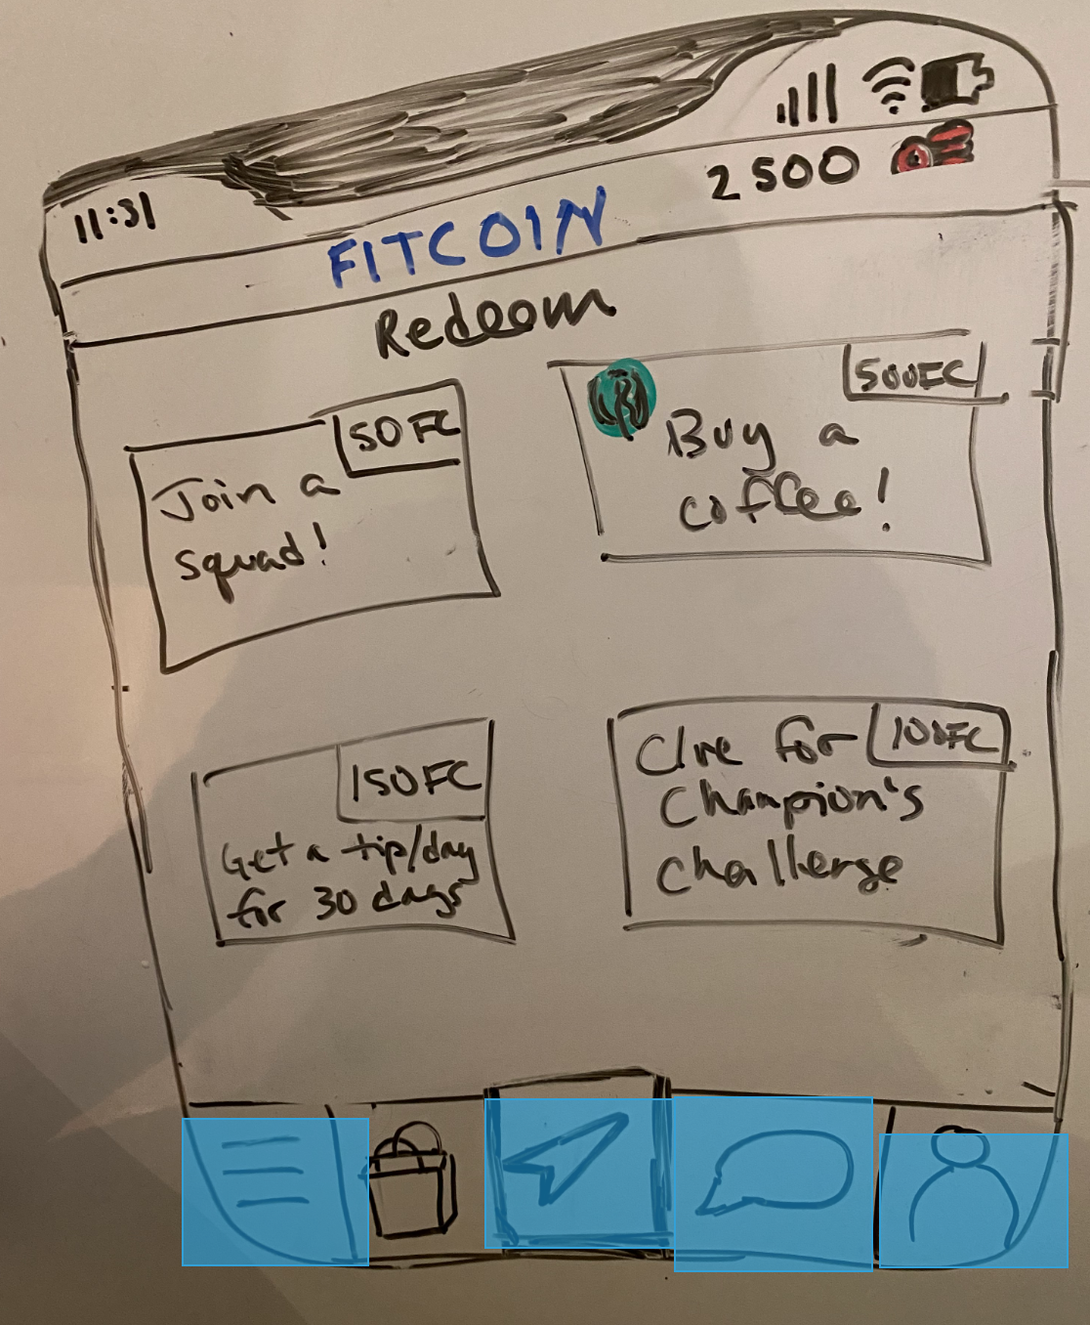
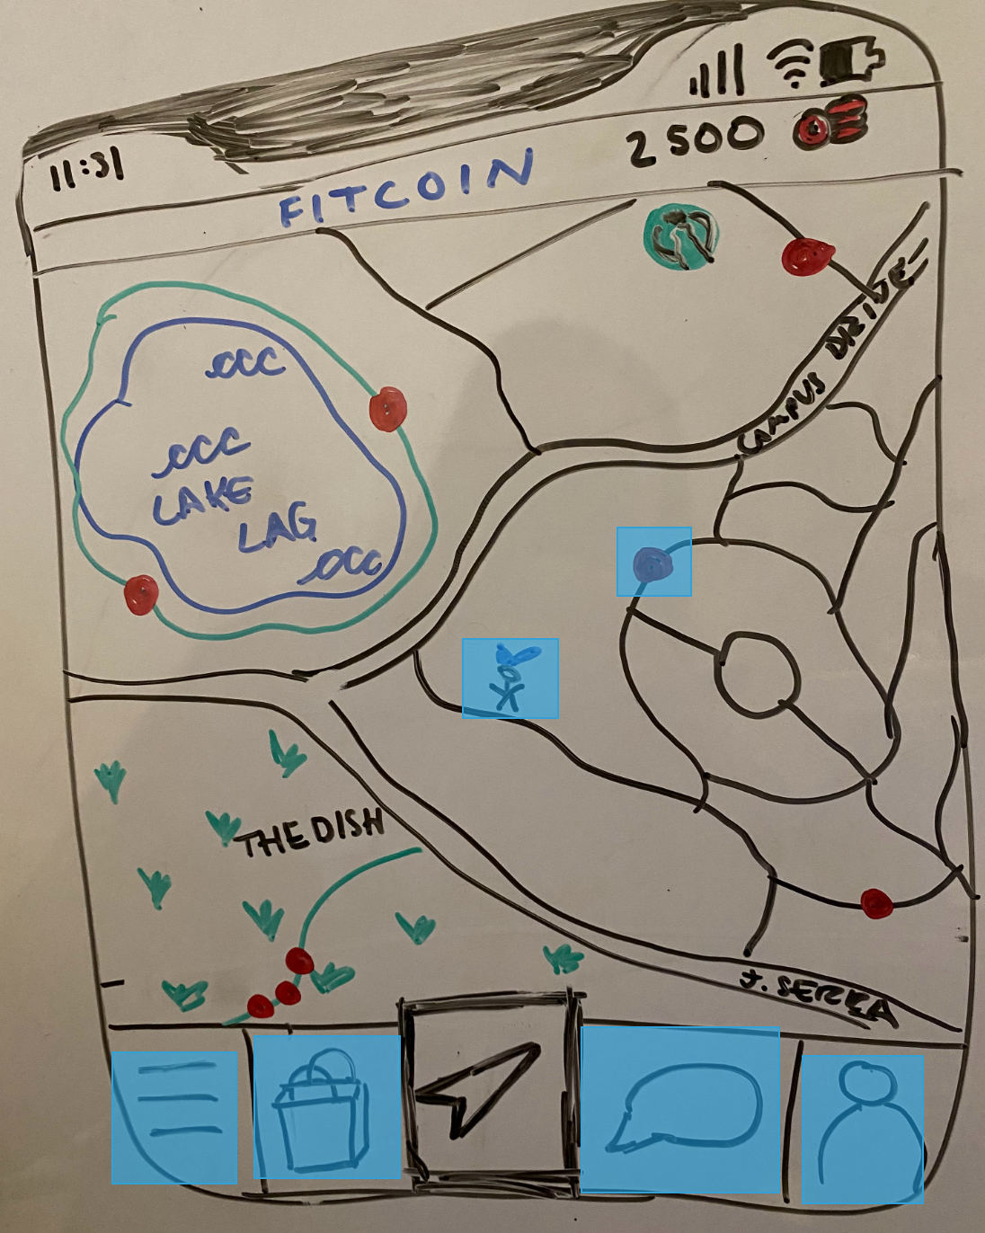
Low-Fi Findings
We tested this application on 3 new users across a range of ages. Our main goal was to ensure that design flow was intuitive for the users and get initial feedback on the design and navigation. To measure this, we not only recorded quotes and qualitative feedback from the users but also measured quantitative performance such as how quickly a user performed each task.
The main feedback of our design was that the medium (interact with the community) and complex (buy a reward) tasks were intuitive and easy to understand but the simple task (get your first coin) took much longer. This was because people didn’t understand that the map was interactive and thought the center button icon was for directions not for a map. People also assumed the person in the middle of the map was themselves not another user, leading to further confusion on how to use the map. Lastly, the coins icon wasn’t clear due to their red colour and ambiguous design in the map.

Med-Fi Prototype
The main revisions for our Med-Fi prototype were based around the map. We changed the arrow icon to a globe icon to indicate a map to avoid confusion with directions. We then clearly labeled the users on the map including adding your own character in the center of the map with a label. We also iterated through 3 designs of the coins on the map to ensure they popped out and settled on 3 icons of coins that represented different amounts.



Coin Design iteration:

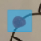

Finally, we kept all the screens vibrant and engaging, as some of the feedback from the low-fi prototype was that the screens were unengaging. Although this was expected from a low-fi whiteboard drawn prototype, it was important to be cognisant of this when we went into the Med-Fi fidelity prototypes.

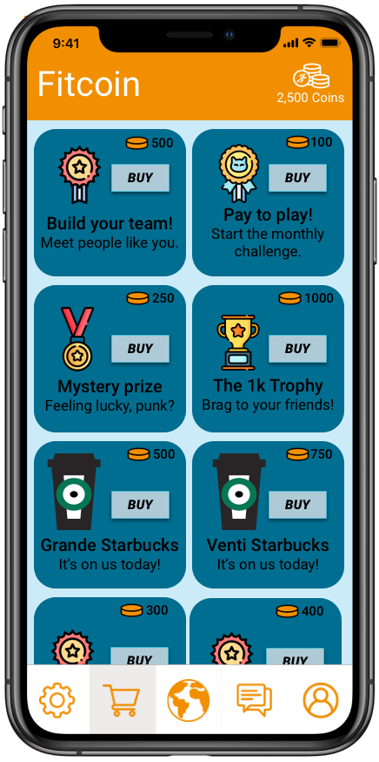
We developed the Med-Fi prototype of a range of different softwares. Icons were built using GIMP-2.10, an open source image manipulation program; Sketch to create each screen's design and Figma to link all the screens together into a final Med-Fi that can be found here. The accompanying ReadMe is here. Below are a sample of the screens from our Med-Fi prototype.
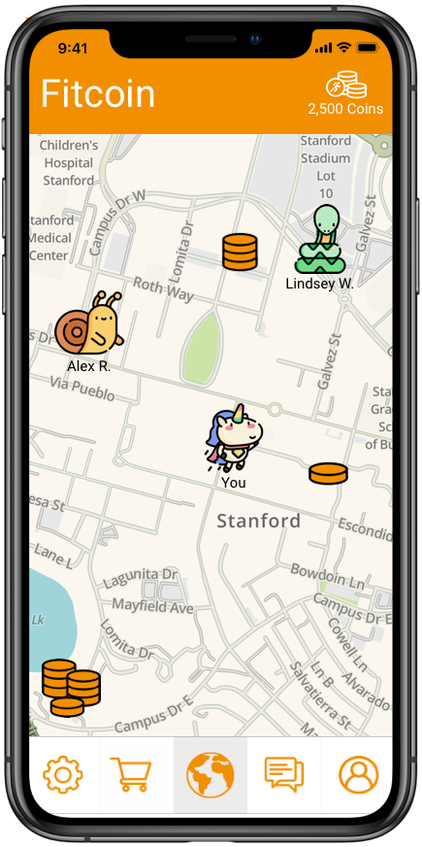
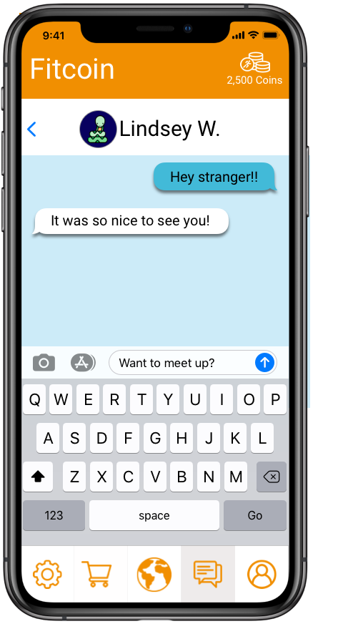

Heuristic Evaluation
After completing the Med-Fi, our classmates had the opportunity to evaluate our Med-Fi prototype using Nielsen’s 10 Heuristics. This heuristic evaluation illuminated more critical problems that need to be addressed in our project.
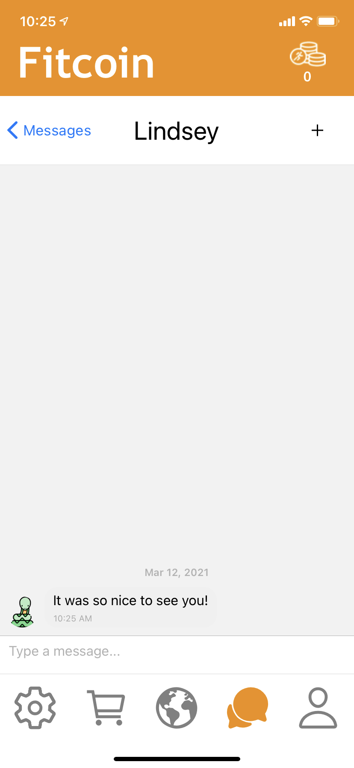
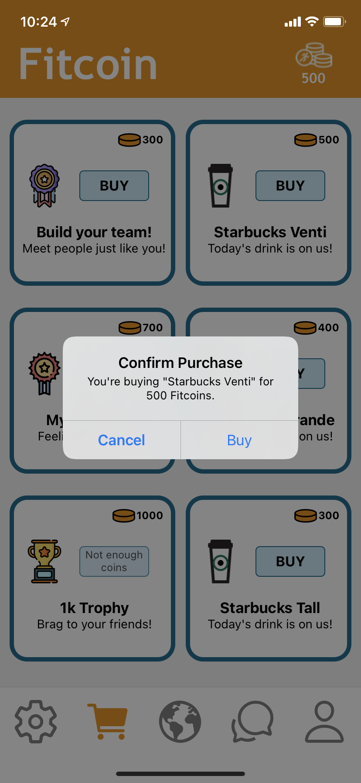
Primarily, the map screen was still not at the standard needed yet. The evaluators stated it was cluttered, inconsistent and incomplete; the back button was unclear and the amount of coins from each stack was unclear. We redesigned several aspects of the map going forward to counteract this, we directly correlated the one coin in a stack to 100 fitcoins, so it was clear how much each stack was worth. We also redesigned the popup screens that result from interacting with a coin or a person on the map. This redesign used more whitespace and simplified the formerly busy screen. These popups were then given buttons to navigate to appropriate screens for most actions to make the map feel complete. We decided not to add a fully functional directions feature because it seemed less central to our tasks and due to time constraints.

Following on, the other major revision resulting from the heuristic evaluation was the lack of confirmation of completion of tasks. Nothing happened in the Med-Fi if you tried to send a message or buy a reward. To fix this, we firstly implemented the messages screen using Gifted Chat. The advantages of this was that it received hard-coded messages initially and allowed the users to ‘send’ them back, allowing for full completion of this task using a Wizard of Oz technique. To rectify the buying of rewards, we implemented confirmation pop-up messages in the shop that allows confirmation or cancellation of a purchase.

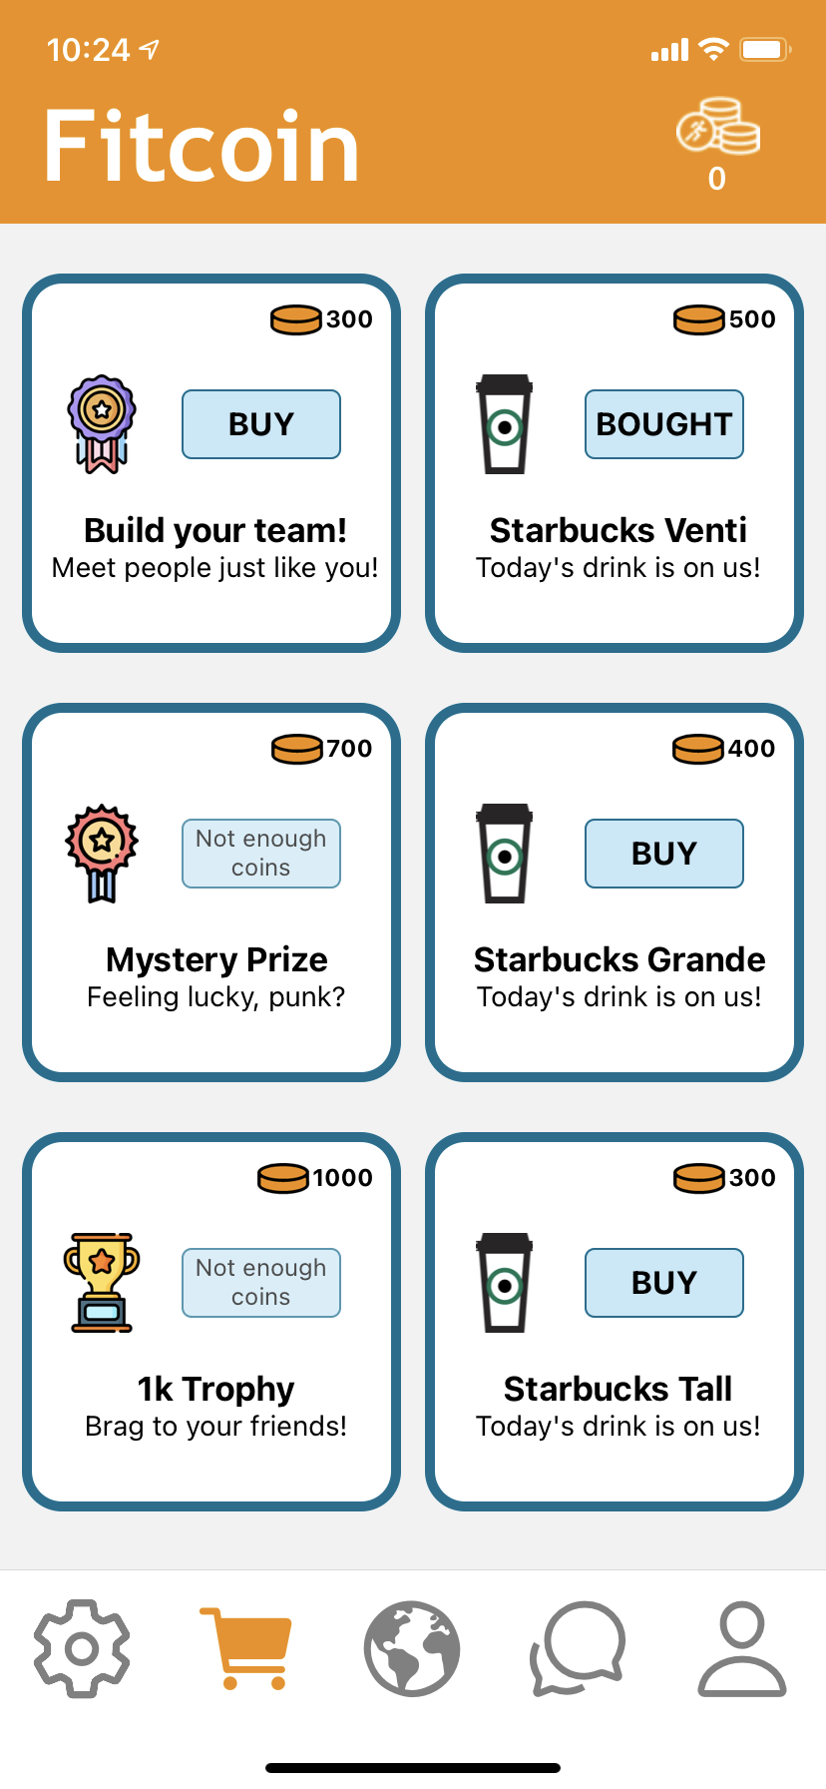
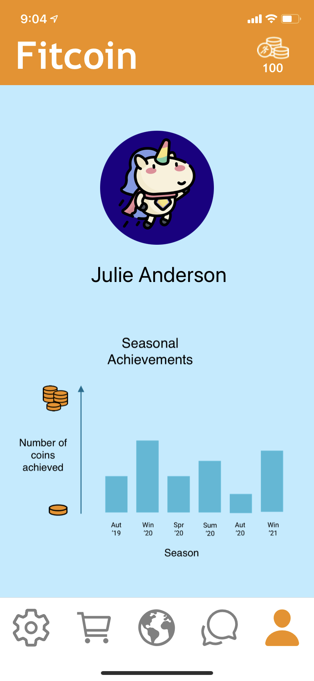
The heuristic evaluation also showcased many minor revisions that needed to be made. Firstly, the profile page was confusing as the graph had no y-axis and the word progress was unclear. We changed these to add a label to the graph titled "Seasonal Achievements" to explicitly state what progress we were graphing. Also we added descriptions to the axes, with "Number of Fitcoins Achieved" to make it clear exactly what was being measured to display user progress. We also removed trophy icons over the graph to simplify the screen and limit confusion. We decided against adding exact coin amounts to the y-axis to avoid making the experience too results based. We decided for our target user, it was more important to see a trend of progress than stressful metrics.

Secondly, the evaluators identified that the shop screen had too many colours and didn’t grey out too expensive items meaning users could accidentally buy them. We were able to rectify these by taking out the background colour of the shop screen as well as greying out the too expensive items, so the shop was more clear and simple to use.

Lastly, the evaluators highlighted that the messages needed to be time stamped and that new Messages should be indicated as they are in other messaging applications. Gifted Chat allowed for time stamps and although we wanted to include blue dots for unread messages, using the hard-coded techniques of Gifted Chat this was unfeasible in the time-scale that we had.

There were some revisions that we believed were unnecessary or infeasible with the constraints and timescale we had. Firstly, onboarding screens. Although this could have been useful, we had no usability data that supported this being necessary and it wasn’t essential to our tasks, so we decided to not to include it in our Hi-Fi.
Secondly, to reduce clutter on the map screen, it was suggested to have a toggle between maps with fitcoins and/or friends with hotspots of local workout areas. We really liked this idea but it wasn’t core to our tasks and with the time frame limitations of a 10 week class, we decided not to implement it in the Hi-Fi.

Hi-Fi Prototype
Having implemented the changes we addressed above as the result of the Heuristic Evaluation, we were left with a more robust app that had more complete task flows. In addition, we moved forward with intention with the knowledge of which features wouldn't be feasible or worthwhile given the time and our core task priorities (directions, onboarding, filters, etc.). Also, due to color and design simplification, our Hi-Fi design was much more aesthetically pleasing and simpler - utilizing whitespace. A major point to consider in our Hi-Fi is that our coin-collecting map feature is meant to be a clear demo of the essence of our app, when in reality the user would move in the world and only collect that coin at the actual location.

Hi-Fi Task Storyboards

Simple Task: Find a Fitcoin
[Collecting a fitcoin adds coins to your stash in the upper right]
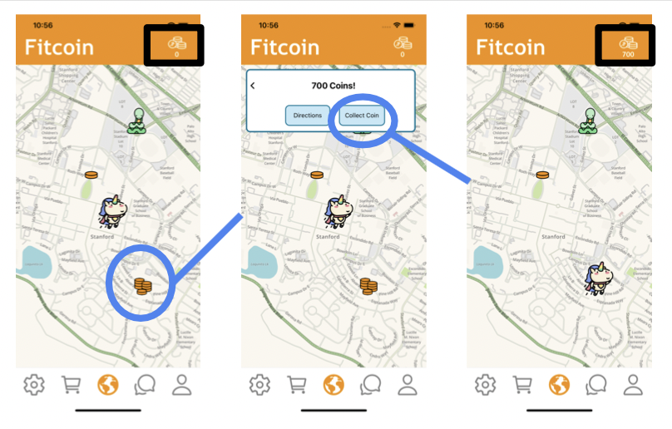

Moderate Task: Connect with Community
[Curved line shows other way to get directly to messages screen]
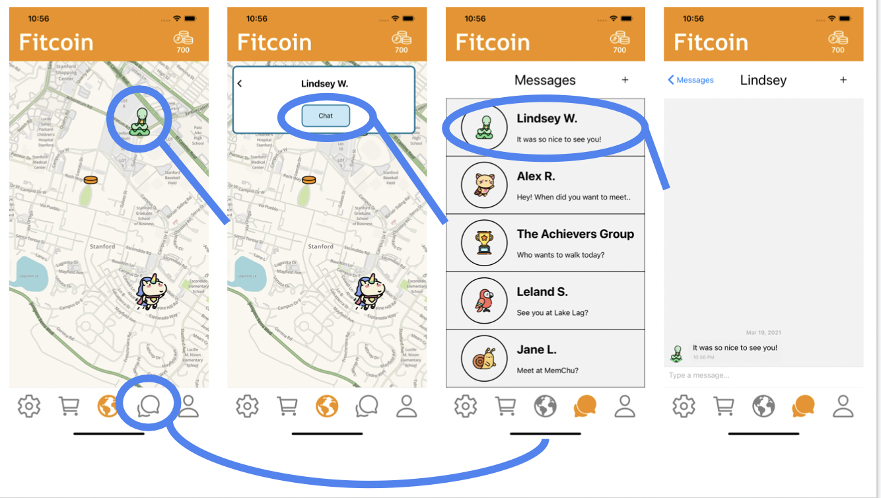

Complex Task: Spend Coins on a Reward
[Buying a reward removes coins from your stash in the upper right]

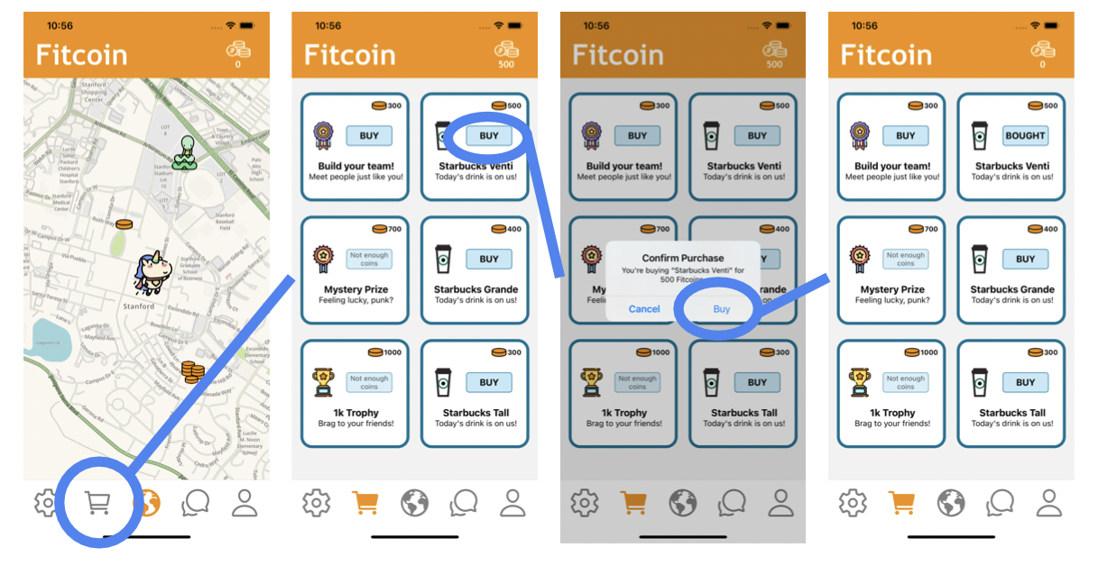

Final Prototype Implementation:

Tools Used:
As we were studying remotely in different countries and time zones we used Slack and Zoom to stay in touch. Slack’s threading function was vital for our work as CS147 often has a myriad of deadlines at similar times, so it allowed us to clearly partition our work up.
For the actual coding of the final prototype, we used Visual Studio as our IDE and React Native to build it. Due to the time constraints, we focused on making our app deployable to iPhones as this is a common mobile device instead of every possible device. To this end, we tested our app in the iPhone simulator in Xcode in Macs and on personal iPhone devices. Lastly, as we had all 3 of us coding separately, we used GitHub to ensure version control and collaborate asynchronously.

Wizard of Oz + Hard-Coded:
As previously mentioned, we used Gifted Chat to hard-code messages into the app so the user could ‘communicate’ with people to complete our medium complexity task.
We also hard-coded the map. This is because it wasn’t possible to create a fully customisable map with AR to help you find fitcoins within 3 weeks. However, it was still pivotal to our app to be able to fully complete the simple task of finding your first fitcoins. Therefore, we implemented a hard-coded map to ensure the user could complete this task.
Lastly, the settings and profile page contains assets that are hard-coded and non interactive. This was because they weren’t necessary for any of the task flows in our app and so weren’t a priority to complete beyond a design perspective in our Hi-Fi prototype.

Summary & Next Steps:
As we looked back over the last 10 weeks as a team, it was striking to see how much we covered between the 3 of us. One of our largest takeaways was the importance of grounding yourself in the consumer needs. Too many times, we distract ourselves from what users really need/desire and so waste time solving a problem that isn’t there.
Secondly, iterating quickly and efficiently. It struck us how much useful feedback we were able to get from a low-fi prototype or even an experienced prototype drawn on whiteboards. If anything, creating the low-fi prototypes allowed us to focus the user on what we were really testing and, for the overwhelming majority of the users, they were able to abstract away from the specifics of how each icon looked and test our key tasks flows even from bare minimum sketches.
We are proud of what we were able to accomplish over this quarter in designing and building fitcoin, and our next steps would be to fully flesh out the app and bring it to market. We believe that having the fully implemented AR map and well-designed and appropriate chat function would have created an app that promoted fun fitness for all.

Some of the Heuristic Evaluation severity 3 and 4 problems heavily overlapped and so for the sake of condensing this report, overlapping points have been condensed into single overarching problems.

