CS 147: Living Spaces Studio
Written Report
Introduction

The Team

Ali S. Ben B. Jeffrey C. Sean C.

Problem Statement
Throughout our user interviews we saw that elderly people and those with physical disabilities had an overwhelming need for helpers: friends, family and even strangers who would take care of their physical needs including laundry, shopping, cleaning, cooking and daily chores.
On the other end of the spectrum, we met with several young professionals and students who struggled to find affordable housing in areas they lived in.

Solution & Value Proposition
To address these seemingly disparate problems, we created HouseMates: a mobile platform that aims to connect home-seekers with help-seekers.
A young, able-bodied person can utilize our platform to browse houses and connect with help-seekers in their city. The elderly or physically disabled people that own these houses can invite such young people to live in their house rent-free or heavily discounted in exchange for them performing basic chores and tasks.

Mission Statement
To make living spaces affordable and accessible.

Sketches of Our 5 Ideas

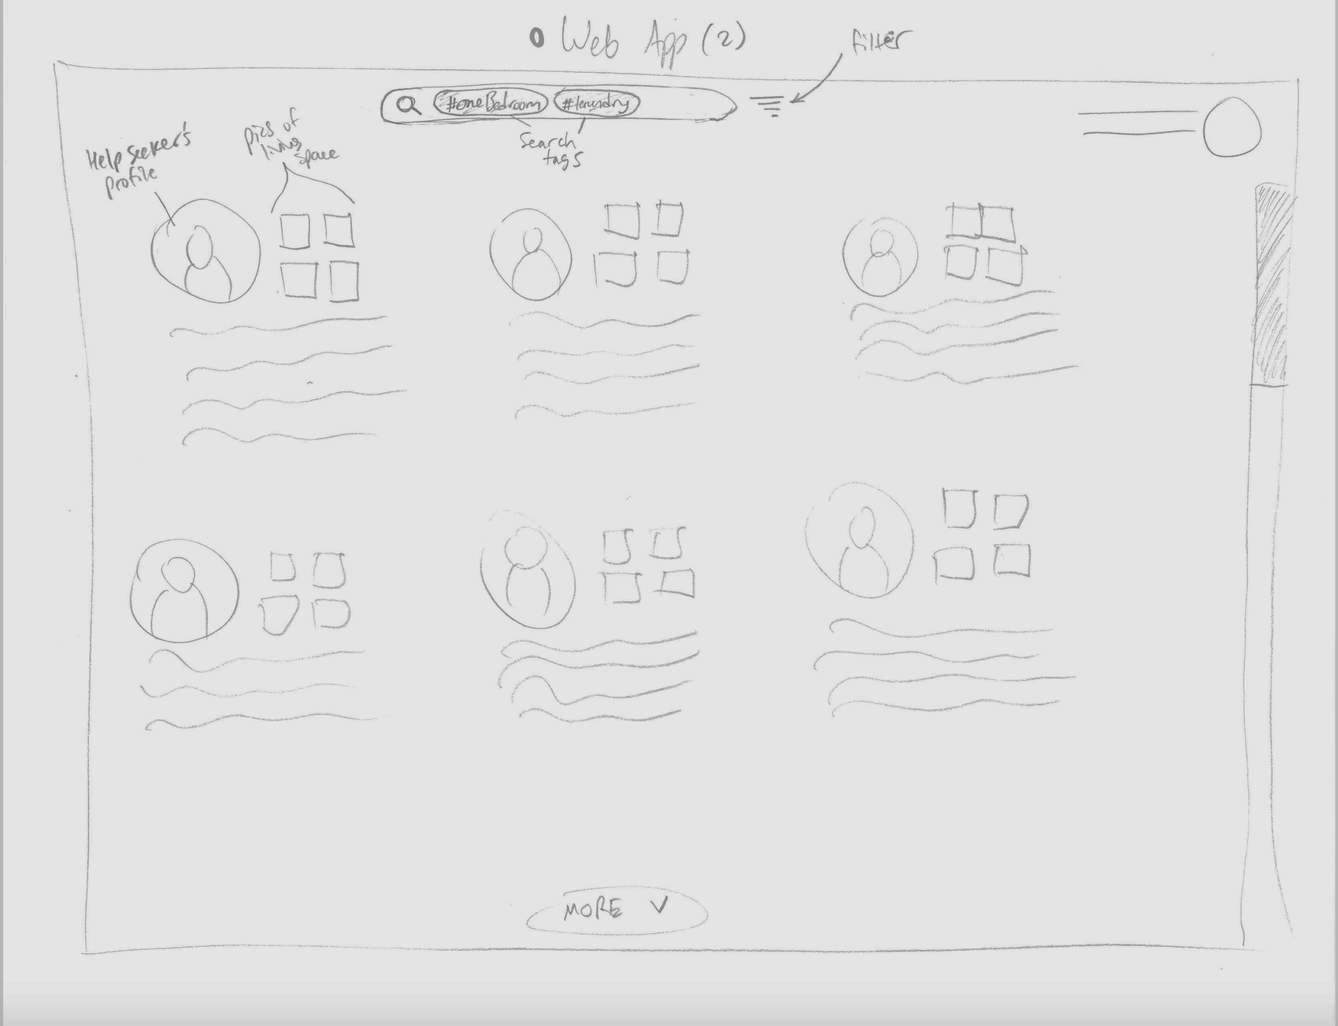
Web app design with search tags: Search for different users based on tags/filters

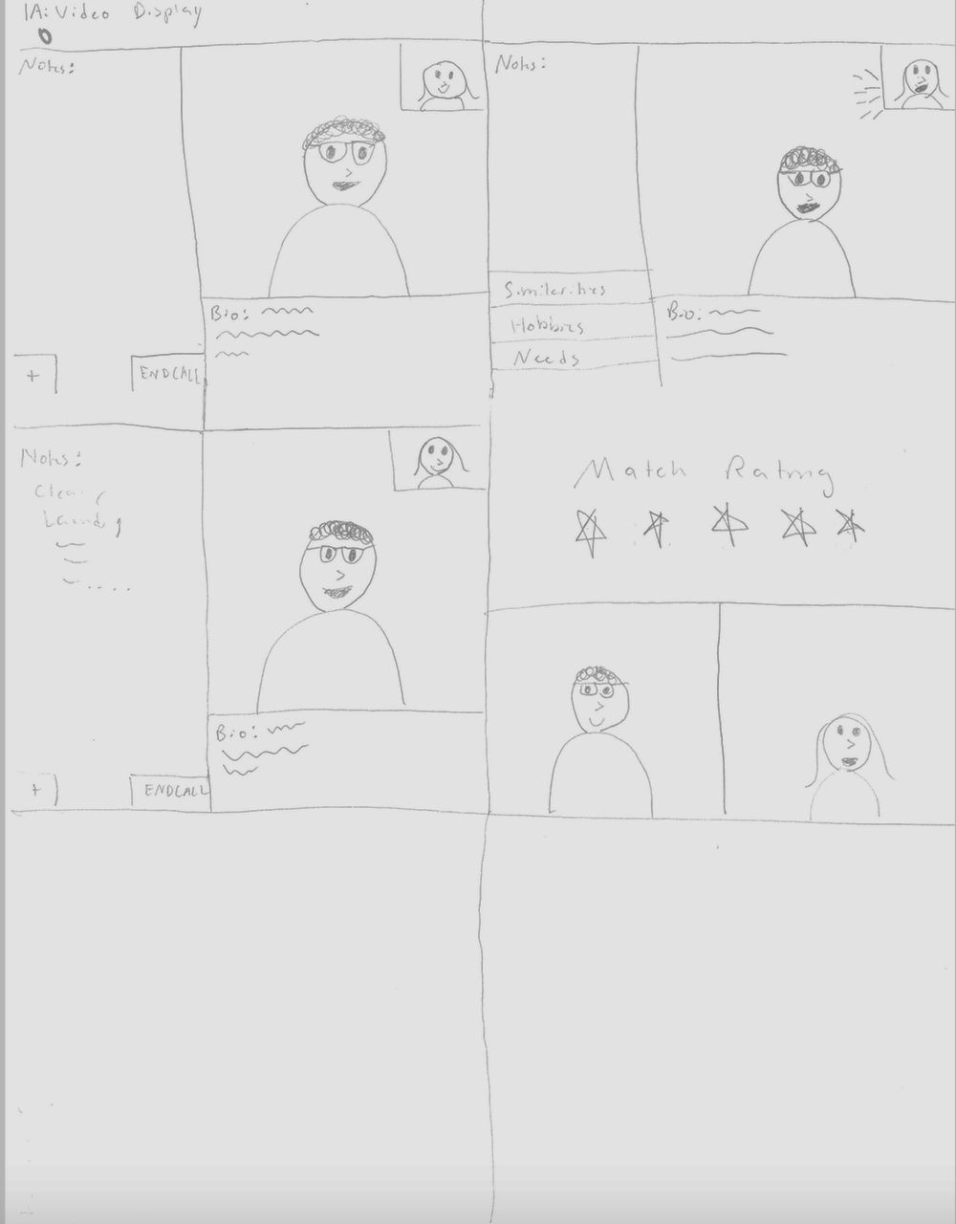

Video Introductions Interface: Allows video introductions with the host and ranking system that allows for short term stays/feedback.
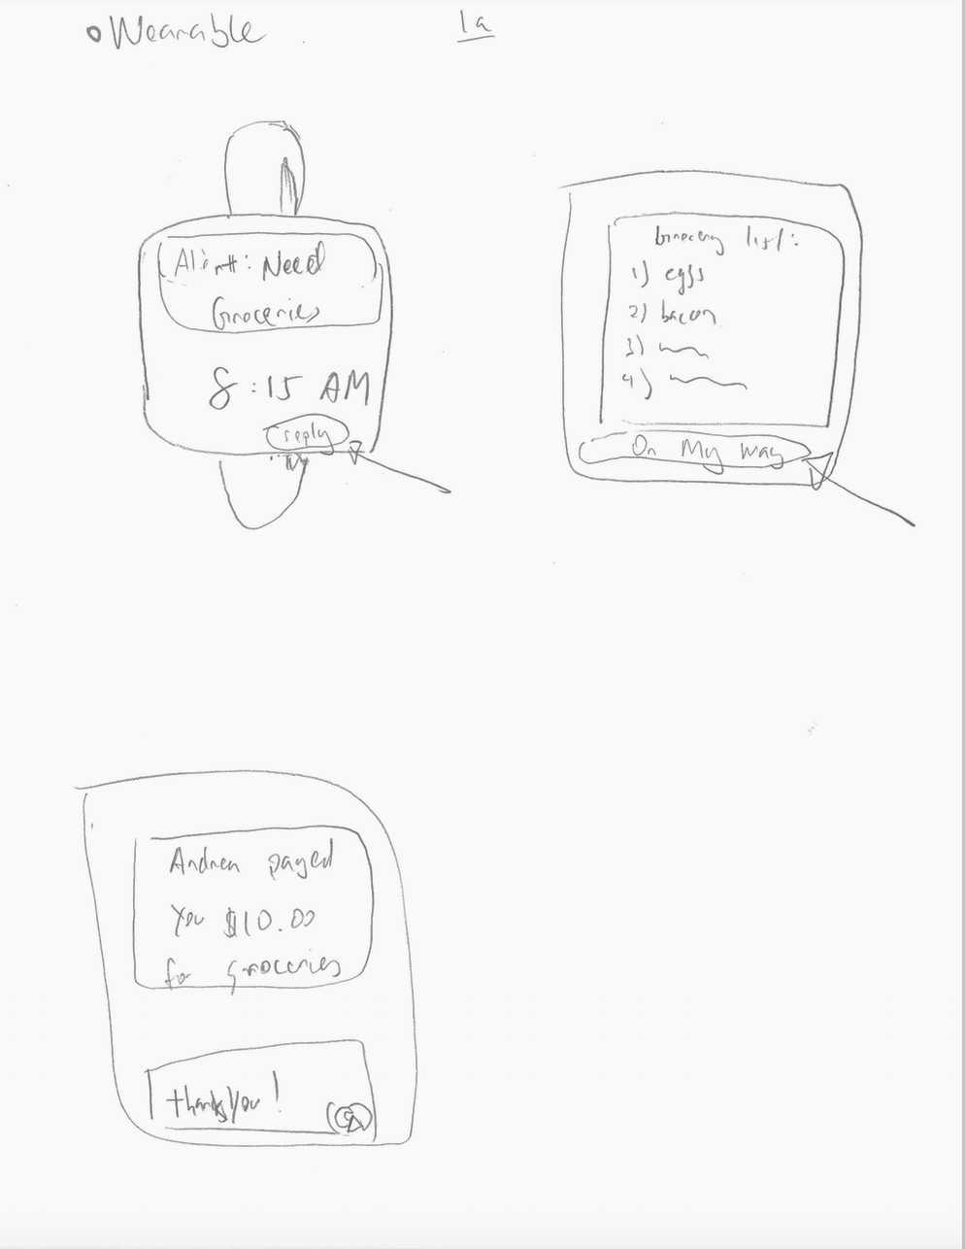
Wearable Device Communications: Allows elderly homeowners to communicate their needs to the renter via wearables.

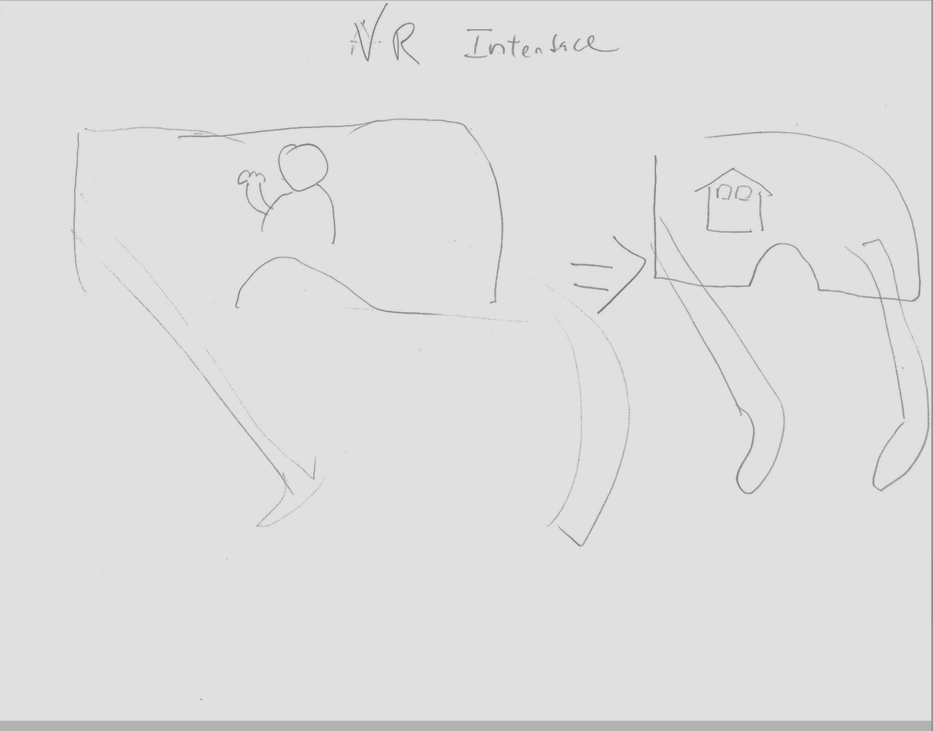

Virtual Reality Interface: Introduces help-seekers with home-seekers through VR so that users can experience homes like they are already living there.

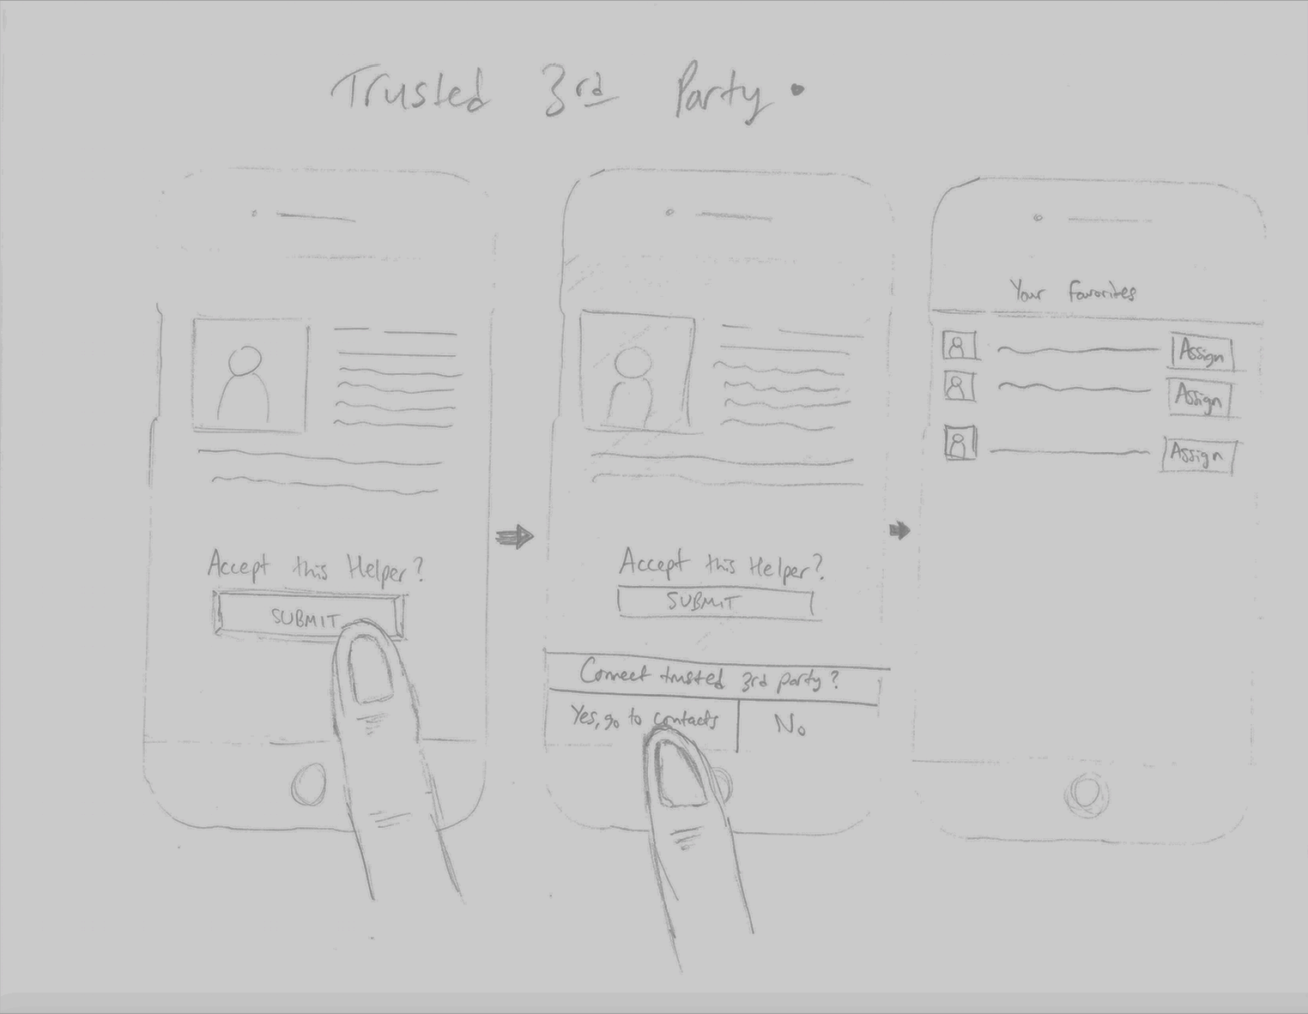
Trusted 3rd-Party Interface: Mobile platform that allows communication between helpers and people seeking housing instead of help-seekers and house-seekers.
Storyboards of Top Designs

Our top two designs are displayed below. The first lets the home-seeker search through possible homes with a filter. The second is a swipe-based matching system that lets users like/dislike hosts one at a time.

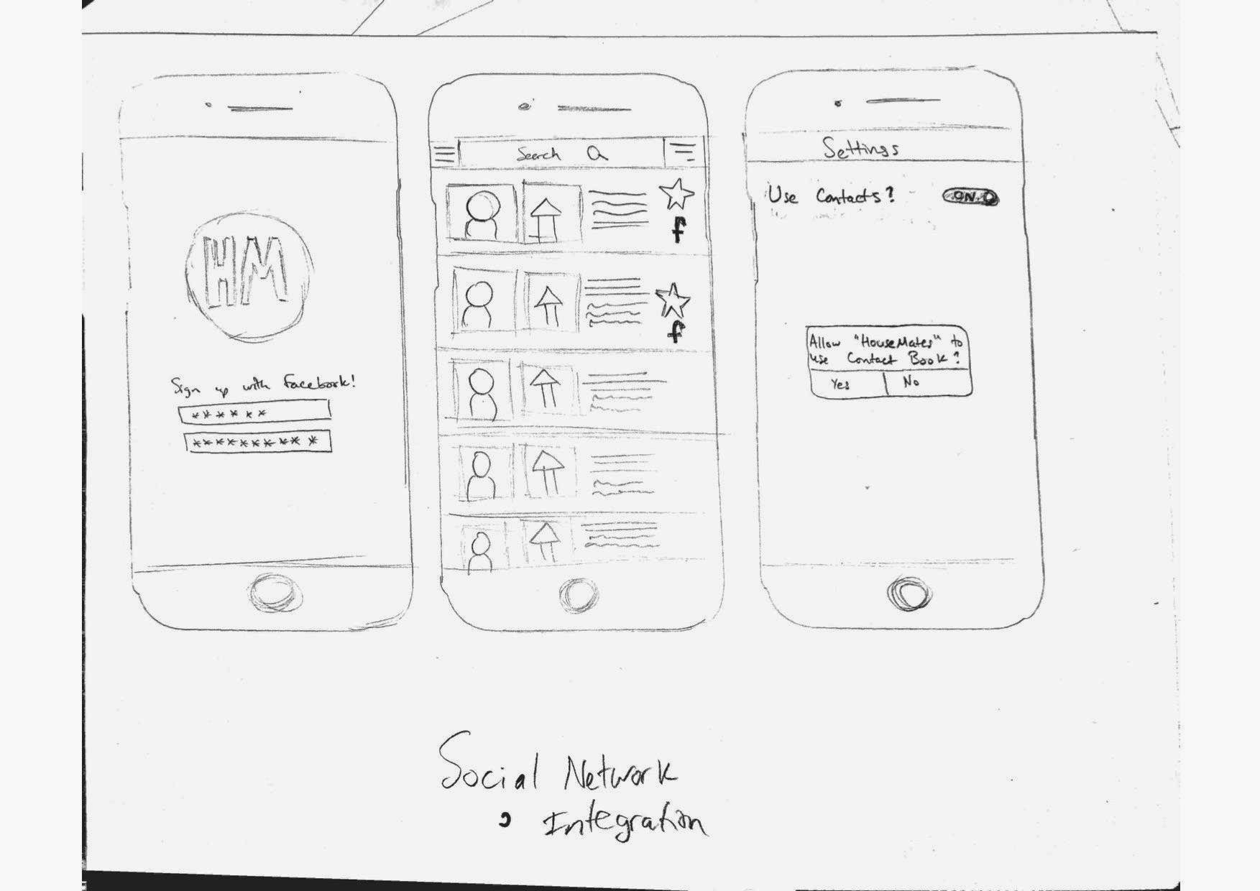
List-Search Storyboard

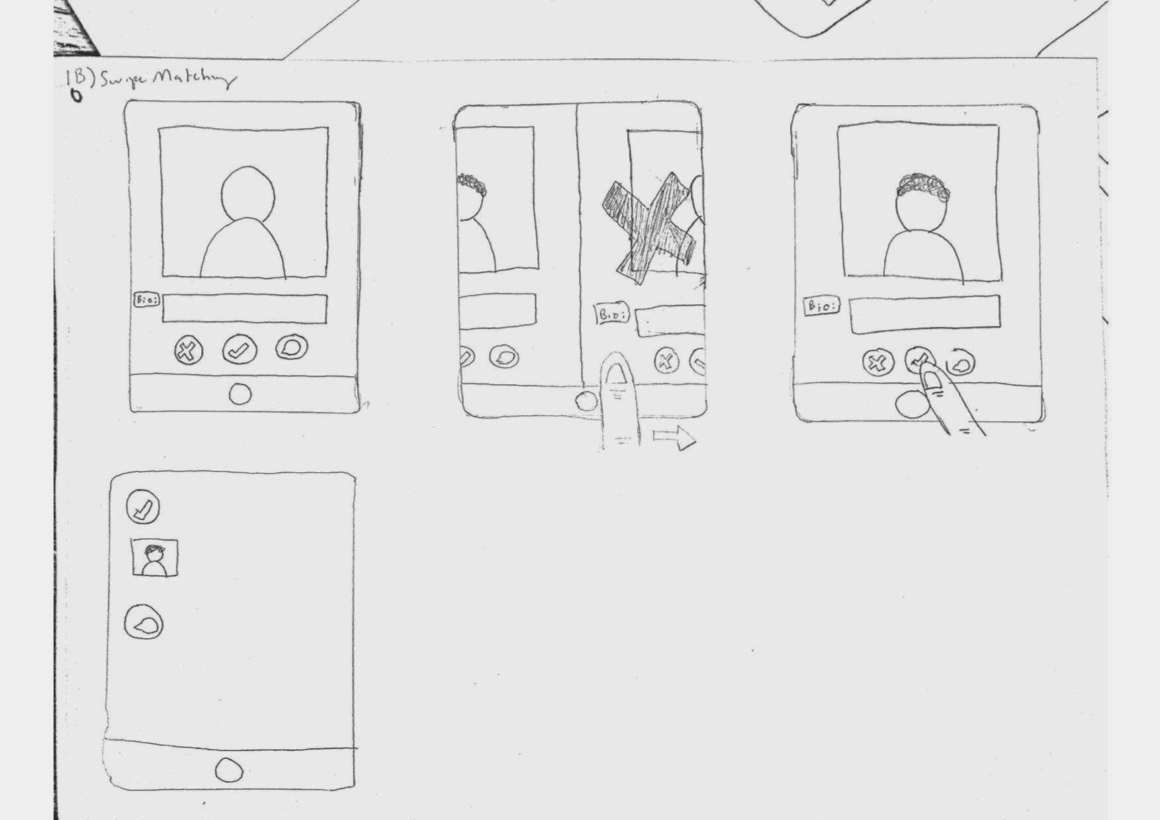
Swipe Storyboard
Selected Interface Design

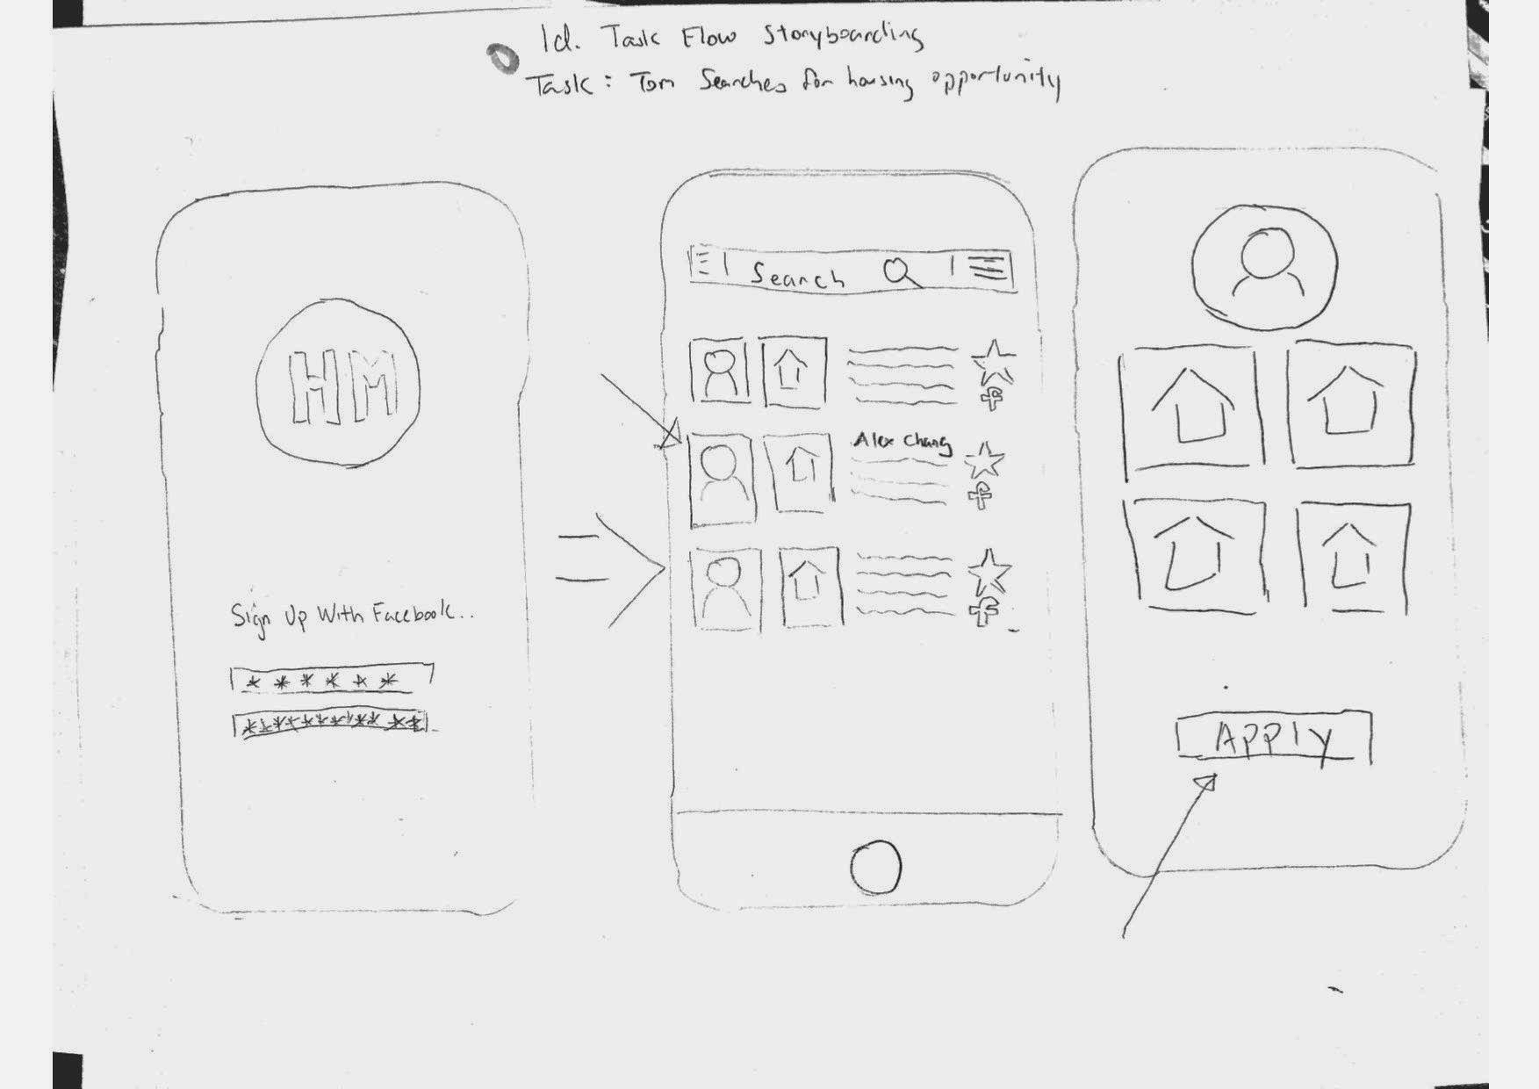
Simple Task: Tom searches for a housing opportunity.

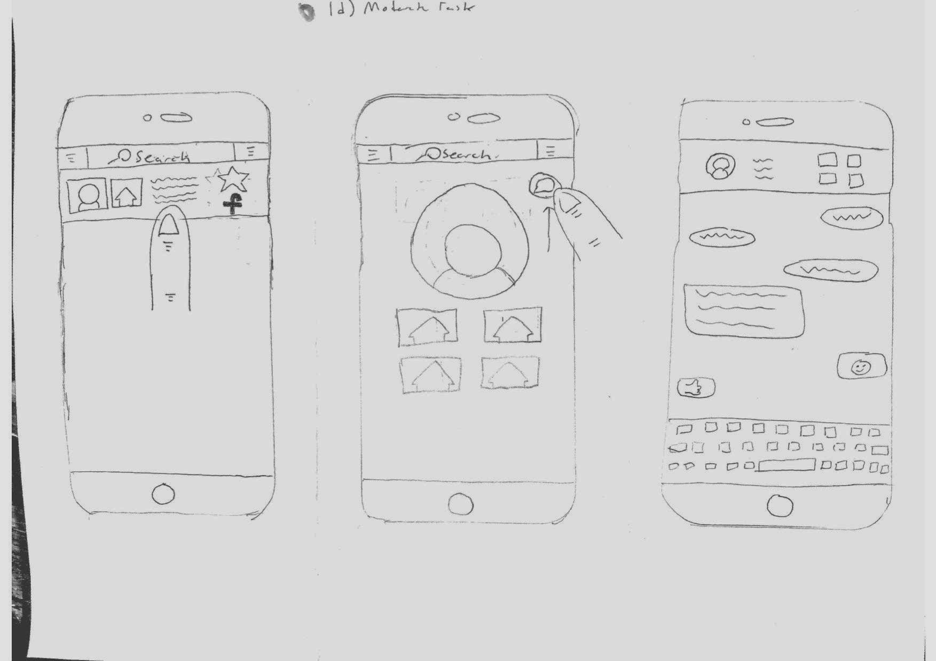
Moderate Task: After seeing what tasks Ernest needs help with and deciding to apply, Tom and Ernest go over expectations of each other and sign/confirm a contract to formalize their agreement.

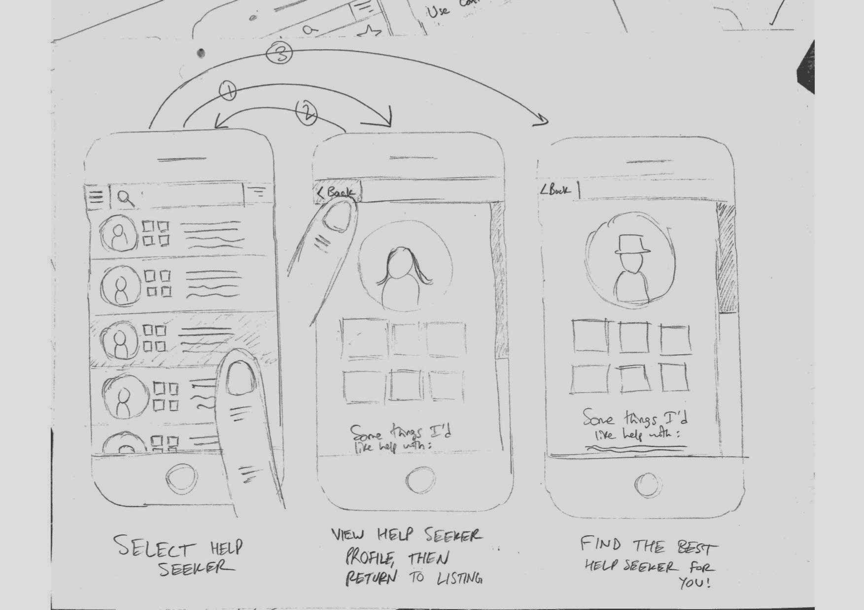
Complex Task: Tom compares 3 different housing opportunities and weighs the pros/cons of each.

Of our top 2 designs, we decided to pursue the list-searching design, because it allows for narrower searches/filtering, and lets the user compare results and help-seekers more easily. The design is also very expandable and allows for swift browsing.

Pros and Cons of Designs:

Swipe Matching:

Pros:
- Simple; to the point
- Large photos on screen
- User spends more time
- Easy to use
- Can show more info about each house per gesture

Cons:
- No Filters
- Slower searching
- One house per gesture
- Difficult to compare hosts
- Difficult to integrate social media
- Too casual

Listed-Search with Social Network Integration (our pick):

Pros:
- Easy access to trusted helpers
- Easier to browse
- Can easily swipe backwards
- Expandable/can add features
- Integration with social media
- Easier communication between renters and homeowners
Cons:
- More complex
- Could look cluttered
- Potentially difficult to read if text too small
- More difficult to use
- Feature heavy

Prototype Description
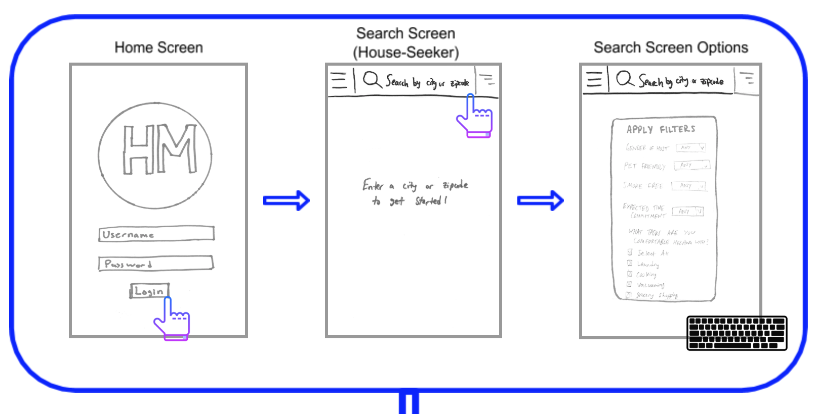
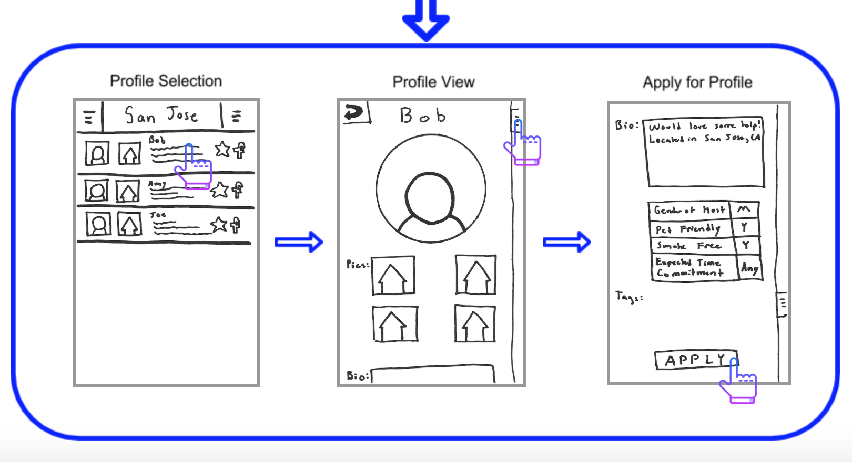
Our prototype is based off a mobile-search application. Users can input their personal information, search for preferences/locations, and apply for their appropriate positions (either help-seeker or house-seeker).
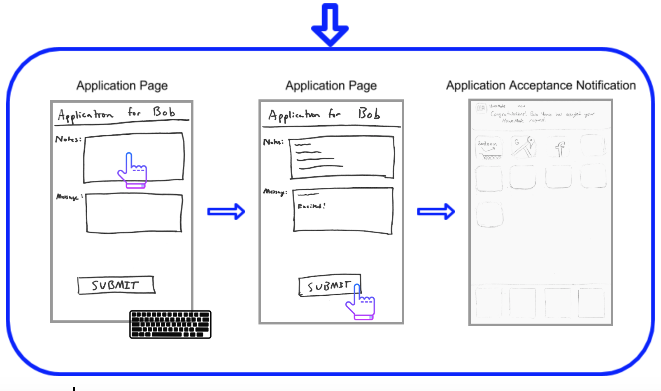
Testing Methodology
- Participants: We tested our low-fi prototype on three participants and garnered valuable insights. We recruited our participants from Town&Country where we sat by a cafe and offered to buy our participants a cup of coffee. After asking many people we finally recruited our three participants. We specifically wanted to test our prototype on younger people as they would likely be the ones who would use HouseMates to find housing and be the ones who sign up their mothers/fathers to host helpers.
  - Lucas King, a 22-year-old recent college grad. He had never volunteered for a charitable organization and was looking for housing in San Francisco.
  - Janet Carlson, a 25-year-old woman who’s a nurse at a local clinic, and lives in East Palo Alto.
  - Pauline Lewis, a 54-year-old woman who lives in Portola Valley with her two kids and husband.
- Environment: We sat inside the cafe in a somewhat secluded corner and invited our participants to sit with their backs turned against the crowd so that they wouldn’t be distracted and could focus entirely on our prototype. 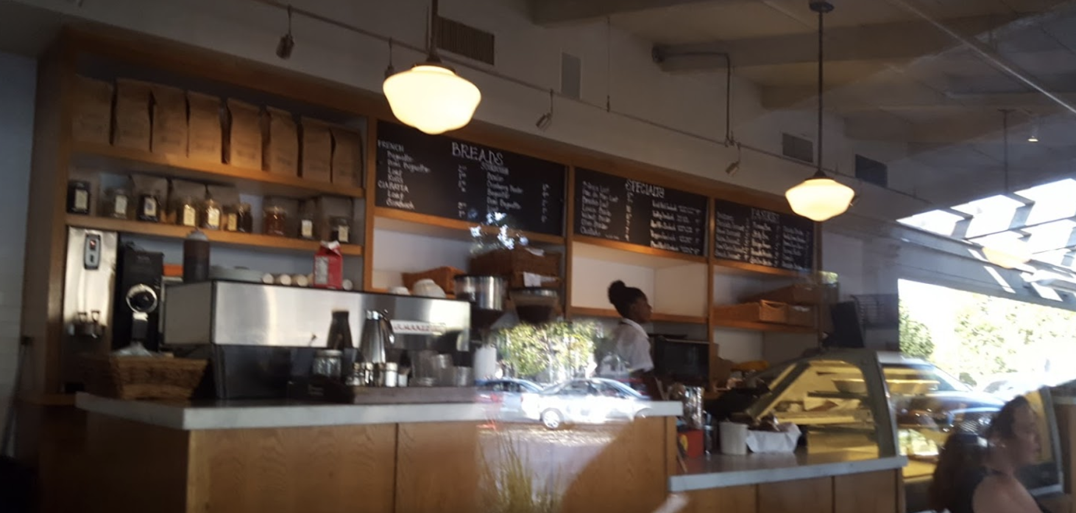

- Tasks: We asked our participants to:
  - Search for a housing opportunity
  - Review what chores you’re comfortable doing and apply to live in a house.
  - Compare 3 different housing options and weigh the pro/cons of each situation
- Procedure: Each participant was asked to sit facing our prototype. We then told them about our project in a two-sentence summary and read our mission statement. We asked for them to be as honest and as critical as they felt comfortable being. We initially explained to them what a paper-prototype was and that we could “switch” screens for them. They were given only three prompts (one for each task), and we only interacted with them if they asked a clarifying question. After testing we asked for overall feedback, including what they did/didn’t like, and suggestions for improvement.
- Test Measures: We were specifically interested in two domains throughout our test: the specific UI-related errors the participants made throughout so that we could identify confusion points, and the clarifying questions they asked about the design to see if anything was non-intuitive, alongside their overall joy and feedback on the application.
- Team Member Roles:
  - Ben/Jeff: took detailed notes on how the user interacted with the prototype.
  - Ali: gave the user the three tasks and the initial objectives overview.
  - Sean: the “app.” He changed screens and interacted with the user.

Results
Throughout user testing we identified four main problems:
- Trust: All three of our users questioned the safety/reliability of such a service. How could they trust someone based simply on a random online profile? Our older participant noted that she would struggle with the idea of signing up her 82-year-old father for this service and potentially risk exposing him to someone dangerous.
- Confusion about “chores” filter: Since our participants were entirely new to the idea of performing someone’s chores in exchange for housing, they were taken aback when prompted to select tasks they were comfortable performing. We received questions like: “What? I’m supposed to laundry for them?”
- Confusion about assessing housing opportunities: Our participants were not comfortable with the idea of browsing houses online without seeing them in detail. They requested an option to tour the house before applying or some better way of knowing what the living situation would be like than pictures.
- Concern about assessing homeowners: Similarly, our users were resistant to the idea of selecting someone to live with based on a such a short profile. They asked for the ability to receive more detailed information about the homeowner, perhaps through video or an in-person meeting.

Discussion

It became clear to us that while our user interface was relatively intuitive for completing the tasks assigned, the idea of HouseMates itself created confusion. In general, it seemed that users felt the proposition HouseMates enables users to make is too serious or too large of a decision to simply happen with a few gestures on a mobile app. Even the idea of doing someone else’s chores proved confusing to participants.

That being said, a lot of the insight gained about how users felt about HouseMates was highly relevant to our earlier brainstorming in terms of what features users would consider essential in a minimum viable product. For example, we previously considered including a 3D-model of each living space listed on the app as a way to show home-seekers their potential living space in greater detail, though we decided on just using a simple photo gallery instead, assuming 3D-models would be excessive. However, each user (independently) mentioned that they wouldn’t feel comfortable agreeing to housing or even applying without more information/discussion about the house. While a 3D-model of each living space might still be excessive, it’s clear that there’s a need for either an in-person tour, a virtual tour, or some other way of conveying more information about the living spaces.

Users also cited concern about trusting the other party when entering into such a serious commitment. Help-seekers need to be able to trust helpers, while home-seekers need to trust hosts in terms of responsibilities, respect, and general expectations of each other. We thought the best way to address this would be through a vetting process, i.e. having HouseMate employees inspect living spaces and interview helpers before allowing them onto the platform. Additionally, allowing a way for a trusted third-party (such as a help-seeker’s family member) to engage with both parties to check in and verify that expectations are being met would’ve almost certainly helped one of our testers feel more comfortable using HouseMates for her father. Lastly, some type of reputation or internal rating system (like Uber’s star-rating/LinkedIn’s endorsements) would be helpful to verify standards were being met continuously.
Word Count: 1498

Appendices

Raw Data

Participant #1
- UI Errors: Long hesitation (~10 sec) before choosing the filter button
- Clarifying questions (summarized or paraphrased):
  - “Are we supposed to do the other person’s laundry?”
  - “How do I know what I’d have to do for them before agreeing?”
- Feedback:
  - Didn’t feel comfortable tentatively agreeing to live with someone with so little information
  - Suggested use of VR to virtually visit a home; didn’t feel a couple pictures would be enough; skeptical of an elderly person taking high-quality pictures

Participant #2
- UI Errors: None noted
- Clarifying questions (summarized or paraphrased):
  - “What’s the [hamburger] menu for?”
  - “Would I just always have to drop what I’m doing to help?”
  - “What if someone’s profile looks good but we don’t get along in person?”
- Feedback:
  - Wanted to see more detailed pictures of the home or an in-person visit
    - In-person visit could also help set expectations, get to know each other before any official contract was made

Participant #3
- UI Errors: Clicked hamburger menu button first when looking for filter, but recognized mistake quickly afterwards
- Clarifying questions (summarized or paraphrased):
  - How does [the help-seeker] know that the person coming and living with [him/her] isn’t dangerous?”
- Feedback:
  - We need some form of accountability and/or vetting of “helpers” so that homeowners aren’t taken advantage of
  - Skeptical that an elderly person would be able to use the mobile app fully (i.e. not just accept the first application)

Consent Forms

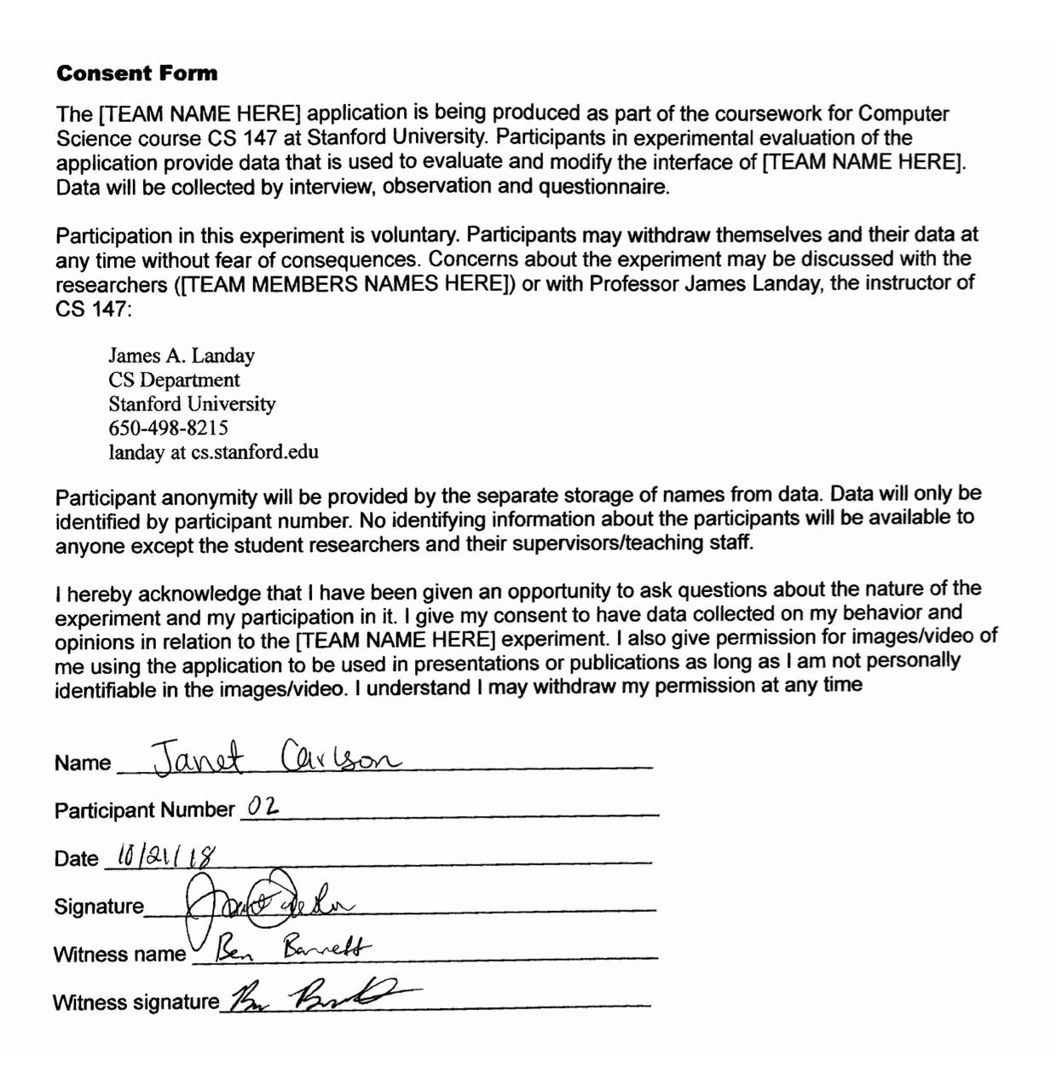
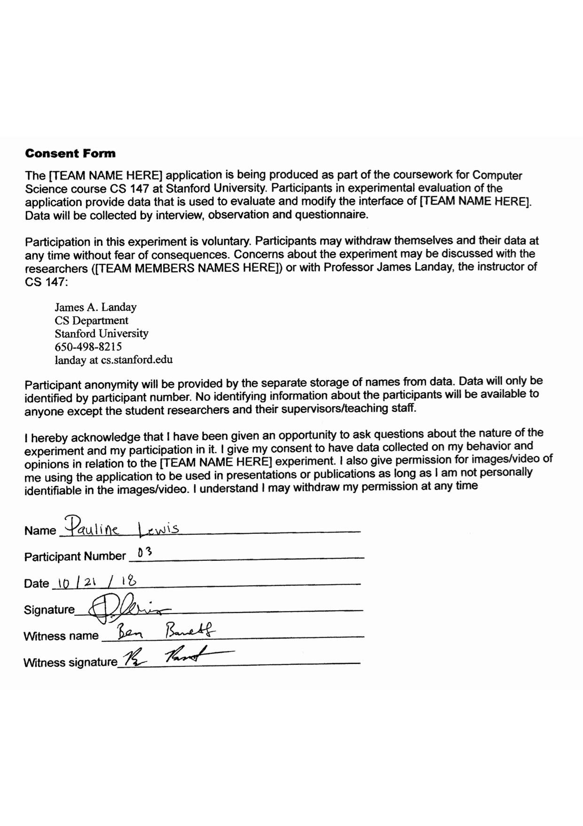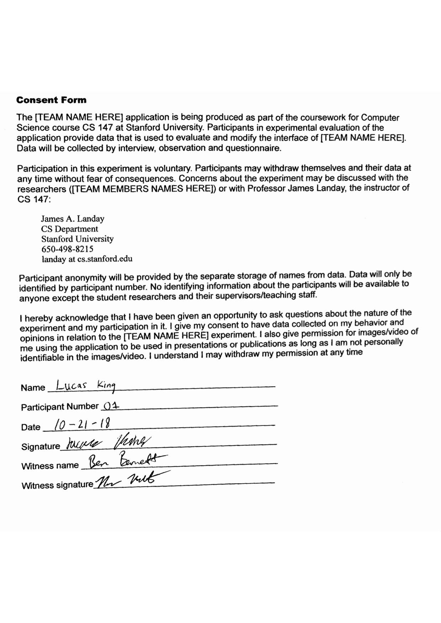

Raw Data

