CS 147: Living Spaces Studio
Written Report: POVs and Experience Prototypes

Introduction

The Team
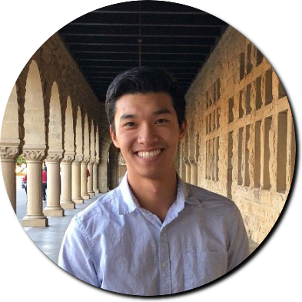
Ali S. Ben B. Jeffrey C. Sean C.

Problem Domain

We want to expand the limits of living spaces by making them more accessible to to members of the community with disabilities or limited mobility.

Original POV

We met Maddy, a recent grad, who is physically restrained following surgery. We were amazed to see that she cannot get groceries, drive, or do any mobile chores without the help of others. It would be game changing to help those with accessibility needs seek help more easily and less stressfully.

Additional Needfinding Results

After creating our initial POV, we interviewed 6 more people. Below are some of the most interesting takeaways.


Julia is a Stanford Student studying computer science. She believes that the biggest challenge with Kids With Dreams is booking spaces that are accessible.


Paige is the manager of Lytton Gardens Assisted Living. She believes that although there are a sufficient number of volunteers, it is a struggle finding a sufficient number of living spaces for the elderly.



Hugh is a Data Analyst in San Diego. He occasionally does volunteer work but only when his friends are volunteering as well. He believes that many people only do volunteer work when it is convenient. When asked how often he helps people, he said “Almost every day. If I’m in a convenient place, I have no problem helping people, especially my house mates.” Hugh has one uncooperative roommate that never reciprocates, and he finds this both upsetting and challenging.

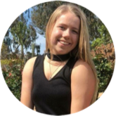
Ellie is a sophomore at the University of San Diego. She spent her summer at an unpaid internship at Paws, a non-profit animal rehabilitation center. She worked here because she wants to be a vet and needs the experience. When asked how often she volunteers, she replied “When I can, I will.”

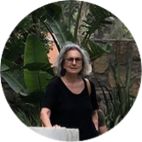
Ayla is an 82 year old Turkish immigrant living alone on the second floor of a San Francisco apartment complex. She has weak knees and relies on a cane to walk. She says “If I carry 10 pounds up the stairs, my back will hurt for a week...I have a really hard time when there is no one around to help me. The boy from the grocery that helped me was gone for 2 weeks and I couldn’t get anything I needed... I had to call my daughter and ask her when she was so busy to come help me eat.”


Anne is Ayla’s 51 year old daughter and works at an investment firm. She has a really busy schedule, 2 kids, and a husband. With regard to taking care of her mother, she says “Not gonna lie, sometimes it’s really hard to take care of mom. I have one other brother but he lives in NY so he’s no help whatsoever. I have an extremely busy job, two pre-teens and a demanding husband. Sometimes I’m just so exhausted. But I love my mom and will do anything to make her more comfortable. I mean, if I don’t go to her help she literally cannot eat.”

HMW’s and POV’s

POV1: We met Paige, it was interesting to see how assisted living involved giving prescriptions, doing laundry, and helping residents travel. It would be game changing to help the volunteers do these tasks in other people’s living spaces alongside their own.

As we honed in on ways to make the live-in elderly care more accessible and versatile, we created the following how might we statement:

HMW 1: “How might we blend volunteering and accessibility to help people function effectively in their living spaces.”

POV2: We met Ayla, it was amazing to see she only had one person helping her for free and results to paying others informally to help her. It would be game changing to help her find other people who are willing to help her in her living space for free.

By focusing our energy on the problem Ayla faced with not finding free help to help her haul in groceries, clean and cook we arrived at the following how might we statement:

HMW2:“How might we help families and communities share the burden of care-giving amongst each other”

POV2: We met Ayla, it was amazing to see she only had one person helping her for free and results to paying others informally to help her. It would be game changing to help her find other people who are willing to help her in her living space for free.

For the same POV statement we now focused on the reward itself and crafted the following statement:

HMW3: “How might we facilitate non-monetary rewards for volunteering”

POV3: We met ayla, it was amazing to see that she no longer trusts any external helper because she was robbed from once. It would be game changing if we could create better trust between helpers and helpees within their own spaces.

Solutions

Solution 1: The best brainstorm solution was building a platform that would help crowdsource best practices for volunteering methods, caretaking and living space organization for people with physical limitations.

Solution 2: A service where volunteers can express what they are willing to help with and help-seekers can indicate the tasks they require support in and are matched based on availability and preferences.

Solution 3: A platform that would allow elderly and people with accessibility needs to lend out their utilities and living spaces in exchange for help. We imagined a young college man living out of an old person’s guest room for free and in exchange do the chores of the house.

Prototypes

Solution 1 Prototype: “Elderlynb”
- This prototype tests the assumption that people (esp. who aren’t close friends) are willing to help others with chores in exchange for non-monetary benefit.
- At this stage, Elderlynb is more of an idea than a product. To “make” the prototype, we limited ourselves to texting and calling (i.e. no in-person communication) during testing, simulating an app or some other platform for connecting users.
- To test Elderlynb, we texted Patrick, offering to cook him a meal on the weekend in return for him driving and buying the ingredients for us. In addition, we promised to reimburse him for the ingredients afterwards if he helped us clean up the kitchen. He was already planning on going to Safeway, so he just added some items to his grocery list to make pasta and met us at Phi Sig, where we cooked and ate together.
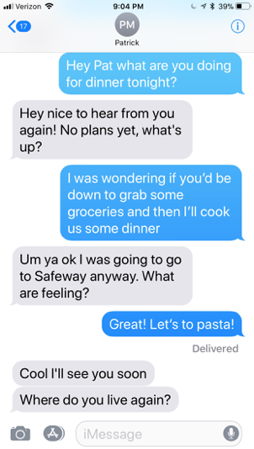
- Although this prototype was pretty different from our vision of Elderlynb, it successfully demonstrated the foundation of the idea: it was incredibly easy for Patrick to get ingredients for us without having to leave our home while also not feeling lazy or like we were burdening Patrick in any way. However, in conversation with Patrick later, we realized that had he already made dinner plans or not been planning on going to Safeway, he may not have agreed to make plans.
- The assumption we tested seemed valid, although it would be ideal to test this prototype between two parties who were even less familiar and elderly.

Solution 2 Prototype: “On My Way”
- Our prototype for On My Way assumes that people will follow through on favors that they informally accept without a penalty system in place. It also assumes that most favors can be completed reasonably easily; in other words, people won’t ask for favors that are simply too big for anyone to accept.
- To make this prototype, we used post-its, markers, and a wall. Favors were to be written on post-its and then stuck to the wall, where others could view them.
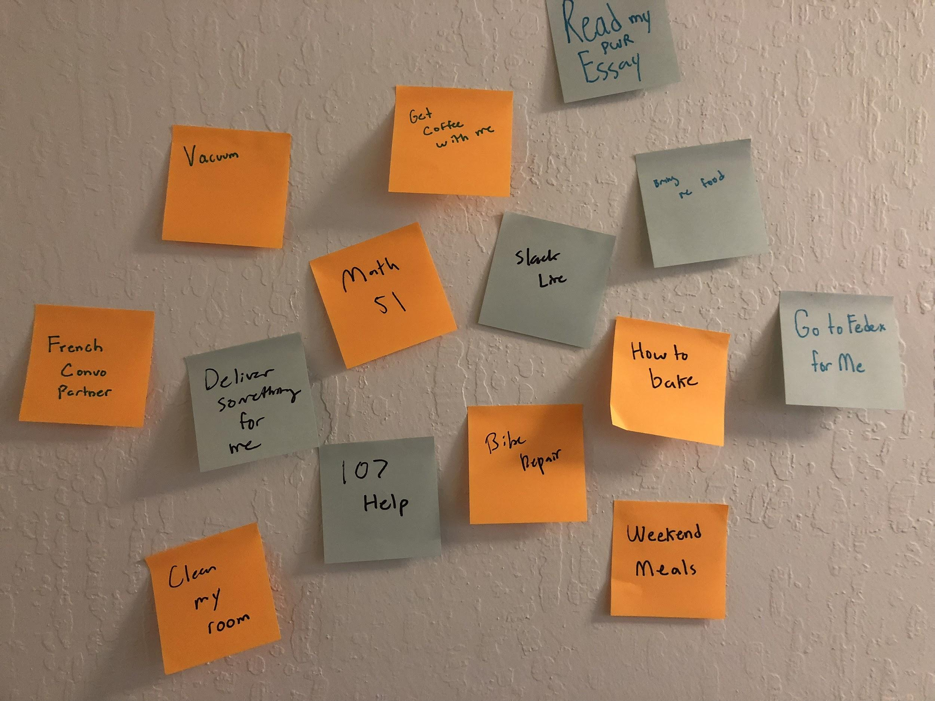
- We gathered 20 Stanford students and asked each of them to write one favor they’d like help with on a post-it. Then, users were asked to either trade favors with others in the room (exchanging post-its), or stick theirs on the wall. Then, if a user saw a favor they could help with on the wall, they removed the post it. Users were not limited to doing just one favor, although the were limited to asking for one favor. Following up a few days later, we found that about 40% of favors claimed had been completed.
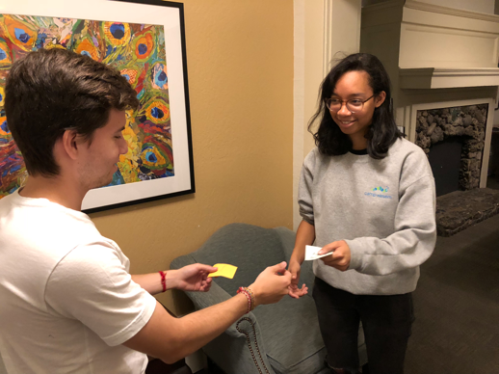
- The prototype was hugely successful in demonstrating people’s willingness to do favors for others without a formal system of accountability, although it’s worth noting that asking someone to do something in person is different than posting a favor on a website digitally.
- The assumption that people follow through on favors they agree upon was somewhat validated in that 40% of favors were completed.
Solution 3 Prototype: “Wikability”
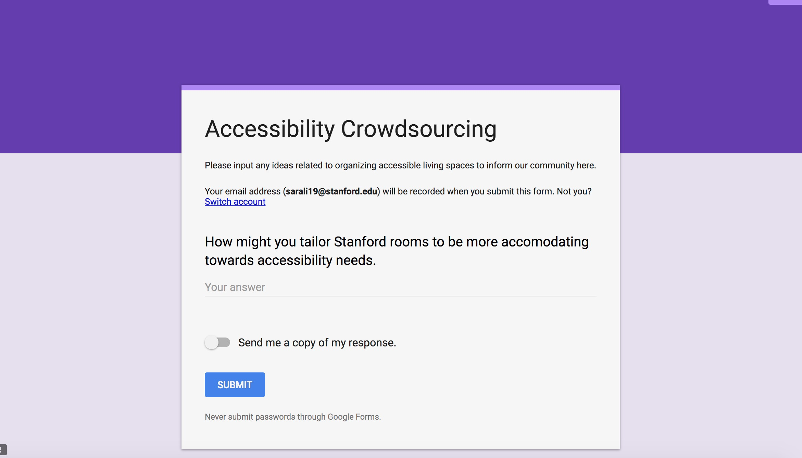
- This prototype tests the assumption that people have tips about making their living spaces more accessible and are interested in getting more recommendations for others.
- To simulate the online platform, we used Google Forms to crowdsource tips and recommendations about making one’s living space more accessible and comfortable.
- After making the Google Form, testing Wikability came down to advertising the survey across friend networks and emailing lists.
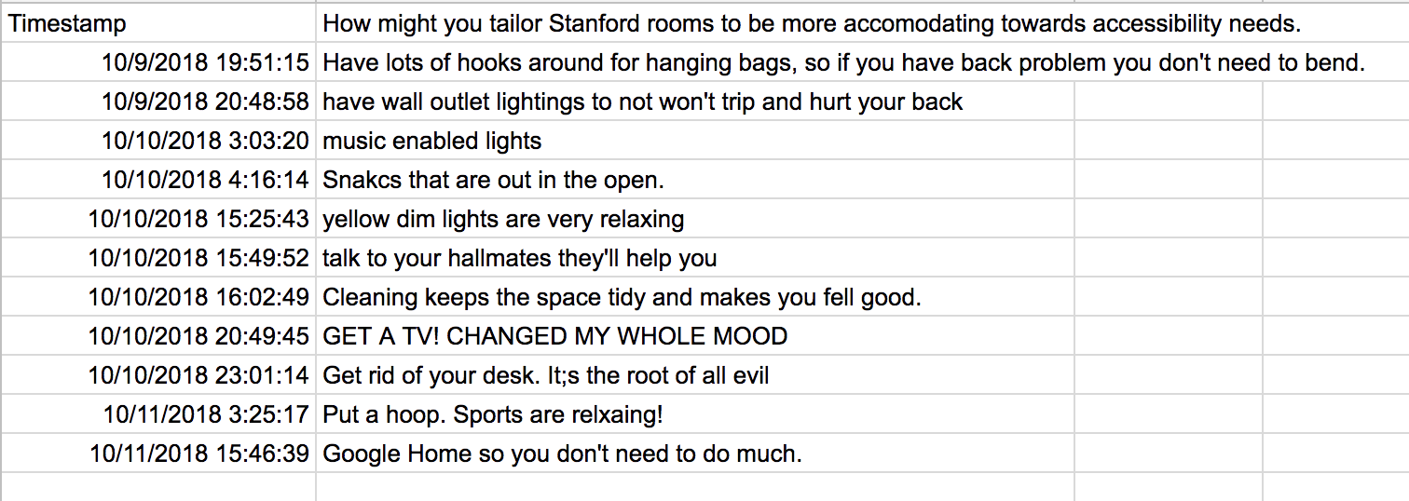
- The prototype failed to reach as wide an audience as we had hoped, but it was successful in gathering a variety of tips regardless. We realized that there is a pretty significant interest in knowing what other people find comfortable in a living space, although it seemed like general education about what makes a place accessible (or not) is somewhat lacking.
- The assumption that people are interested in accessibility related tips was mostly invalidated. We attribute this to a number of possible reasons: our wording and emphasis on comfortability (first) and accessibility (second); the recipients of our emails/ads whom we were asking to survey; belief that rooms--especially at Stanford--cannot be changed in any significant way to better accommodate accessibility even if there were a desire to change them somehow.

Most Successful Prototype

Our most promising prototype was Elderlynb. Despite the limitations of our testing example, we ultimately discovered that enabling people to help each other without going far out of their way provided a huge benefit to both parties. We want to move forward with this solution (or one similar to it) because it also seemed to incorporate many of the reasons we liked our second solution, On My Way, while simultaneously setting up a system of expectations and reciprocation between people as opposed to entirely relying on the goodness of their hearts.

