POVs and Experience Prototypes
Ryan O., Richard V., Samantha K., Aarti B.

Problem Domain
We looked at improving the educational experience for students, both inside and outside the classroom, through technology.

Initial POV:
- We met Kian, an instructor at Stanford University. We were amazed to realize he knows exactly where to look to find resources- going straight to domain experts, allowing him to learn extremely quickly. It would be game-changing to help students find the best way for them to learn faster.

Additional needfinding results

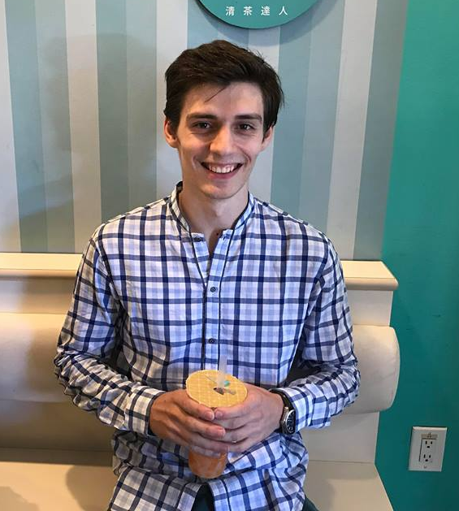
We spoke with Adrian, an American who recently graduated from undergraduate business school in Italy. He efficiently learns material for tests knowing how and where to derive formulas, rather than just memorizing them.
We met Allen, a Professor of Law in Paris. He finds the most important part of his job to be creating new knowledge. He says that people who don’t create things but teach them to others are repeaters, not professors. Within the classroom, he finds the most important trait in students to be curiosity, as that leads to what he believes is true learning, the ability to create new things.
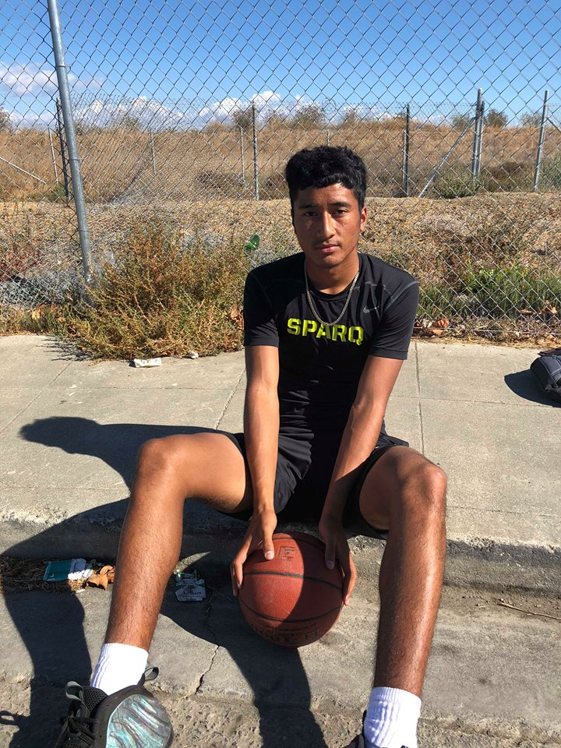
We also talked with Albert, a Junior in High School in East Palo Alto. One of his hardest classes is in Spanish where he finds the teacher often skips over material he doesn’t know because some of his peers came into the class knowing more concepts. He often wishes it could be more like basketball, where he learns by watching a youtube video that is personal and can be repeated as many times as necessary.
We met Annia, a 5 and a half year old kindergartener. She really enjoys class and tries to be engaged by always raising her hand whenever the teacher asks a question. She feels that she is never called on, however, and wishes the teacher would call on up to 12 people instead of just 2-3.
We met Liam, an almost 7 year old in the 4th grade. In school, he dislikes cursive writing as not only does it take too long, slowing down his thought process as he cant write it out fast enough, but he also has to copy pre-written sentences when he would rather create his own stories.

Revised POVs and HMWs
POV #1:
We met Allen, a Law professor from France. We were amazed to realize that he considered the best students to be not the ones with the best grade, but the ones with the most curiosity and interest. It would be game-changing to assist students’ curiosity.

Sample HMWs:
HMW...
- change grading to reflect curiosity
- help kids realize that curiosity is more important than the grade
- let kids who aren't interested in the material not take a class

POV #2:
We met Albert, a high school Junior from Palo Alto. We were amazed to realize that in informal educational pursuits, like learning basketball, Albert felt extremely comfortable learning without direct human interaction—primarily by watching YouTube tutorials. In the formal setting, however, Albert does not feel this way, and has instead accepted defeat in the presence of “bad teachers” or turned to tutors. It would be game changing if we could help students learn and feel comfortable learning educational content without direct human interaction.

Sample HMWs…
- automatically generate youtube videos that feel personal based on existing lecture videos
- assist instructors in ensuring a baseline understanding of material necessary for each lesson and course across students
- allow instructors to continuously provide personal and effective feedback to each student based on their performance and understanding of the material

POV #3:
We met Scott, a PhD student studying Physics at Stanford. We were amazed to realize that for him, learning meant knowing where to look as opposed to memorizing the material. It would be game changing to shift the focus of education away from memorization.

Sample HMWs…
- create a curriculum that encourages people to look up information
- ensure understanding without testing memorization
- make it easy to find/keep track of useful resources
- increase student understanding of lecture material and content in real-time

Best HMWs
- HMW allow instructors to continuously provide personal and effective feedback to each student based on their performance and understanding of the material? (POV #2)

- HMW assist instructors in ensuring a baseline understanding of material necessary for each lesson and course across students? (POV #2)

- HMW increase student understanding of lecture material and content in real-time? (POV #3)

Best Solutions

1. Magic HW (HMW #1)

The idea behind Magic Homework is to create homework that gives the students resources they need to efficiently and effectively learn material. Some sample features could be:
- When students get a question wrong, the moment in the lecture where the teacher taught that material appears before them
- Analyze mistakes in homework and determine which overarching topics the students are struggling on. Offer suggestions and resources they can use to learn the material.
This solution also comes with a few assumptions:
- Students don’t know where to look to find learning materials
- Students will not look up resources on their own but will use them if they are convenient

2. Student Pair (HMW #2)

The idea in this solution is to turn the potential negative of varying skill levels into a positive by pairing up students so that those struggling can get help from someone who knows the material better, and those excelling can learn even better by helping to teach others the material.
This idea also comes with quite a few assumptions like:
- Peer-to-peer teaching is more accessible because students can speak in the language of students
- Struggling students would be willing to accept help from their peers
- Knowledgeable students would be willing to help out those struggling given some incentive

3. Lecture Kit (HMW #3)

The idea behind the lecture kit is to help both students and professors interact in real time during lecture.

Some features of the Lecture Kit might be:
- Anonymized, real-time responses to lecture that the lecturer can see such as “I don’t get it” or “This is fine,” allowing the lecturer to tailor content as necessary to fit the class’ understanding.
- Conduct a real-time analysis of students’ micro-expressions to reveal how students feel about the material

Some of the assumptions that come along with this are:
- Giving lecturers information in real time will aid lecture teaching
- Students display understanding and emotions toward the lecture in facial indicators

Three Experience Prototypes

Magic HW: Origami
Assumption- Students will not search for resources on their own, but will use them if made convenient

We constructed two scenarios to test this assumption :
- Scenario #1 - We model how to fold a butterfly and then tell the subject to do whatever it takes to try and fold the butterfly.
- Scenario #2- We show the subject how to fold the origami, but also hand them a phone with a short 5 minute video that goes step by step through the process.
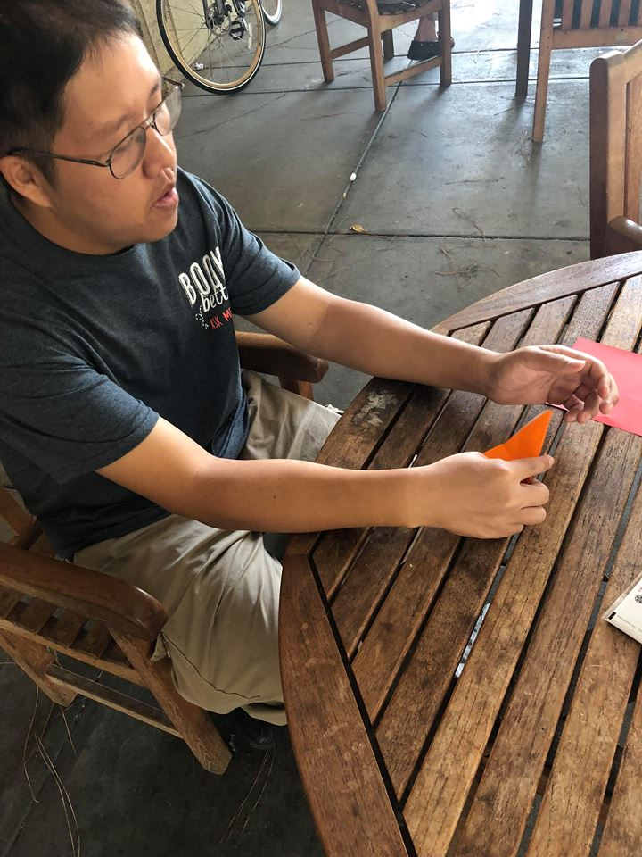
Test Subject 1: Newton. He was in his early 20s and worked at the Stanford Bookstore. He had gone to community college. There are 5 steps involved to creating the butterfly - after step 1, we could see he was visibly confused as to what to do. After thinking for a few seconds, he opted to try a random fold as opposed to looking up what the correct move was. After he made this wrong move, he realized he had no chance of completion and gave up.
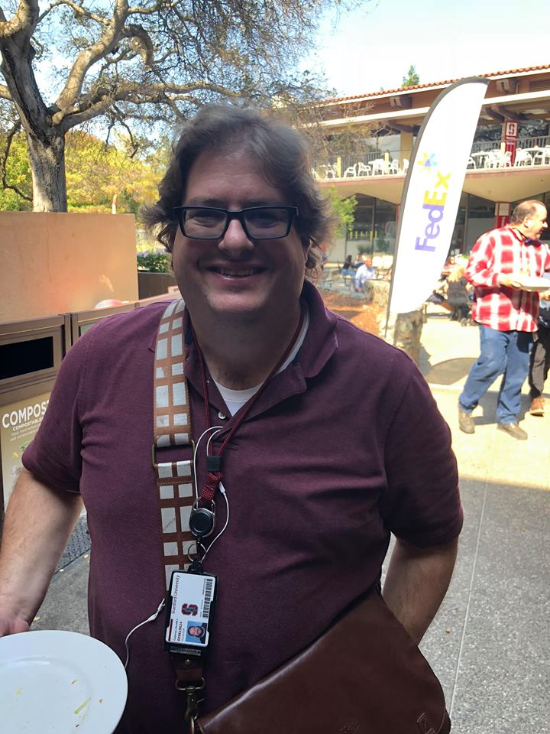
Test Subject 2: Don. He had studied journalism in Canada and now helped people with tech problems. He folded the first 2 steps by himself and then referenced the video throughout other steps, rewinding and rewatching until he could complete the butterfly.
These trials definitely support our assumption that people will not actively look up resources when they are stuck, but will instead make mistakes and dig themselves a deeper hole. Looking up the information on how to fold a butterfly can seem daunting, since the students might not know if there is information readily available, however, when given the resources, Don was more than happy to use them when he got stuck.

Student Pair
Assumption: More knowledgeable students would want to help someone else learn over doing a full assignment themselves.

We also tested a second assumption (that students who are beginners at a subject would be willing to learn from their peers) and the results are included in the Appendix.

Scenario - The interviewee is a high school student, in a class for a language in which they are fluent. The student would be given a sheet of questions from a language test that we found online as “homework” and presented two options - they could either complete the entire sheet themself, or they could help one of us (non speakers) with a couple of questions on the sheet.

Test Subject - Eva, a barista at Coupa in Huang. She is a high school graduate and is fluent in Spanish. She chose to help one of us with a couple of questions on the sheet. She said this was because it was more fun than doing the “homework” herself and she liked to help people and get to know them better.

This supports our assumption that “expert” students would rather help a “weak” student with their homework, rather than doing the entire homework themselves. One unexpected assumption that came out of the interview was the teaching skills of the “expert” student. We had assumed that the expert students would be effective at transferring skills to the struggling students, she was only able to tell us the answers to the questions without explaining.

Lecture Kit: Live Feedback
Assumption- Giving lecturers information in real time will aid lecture teaching

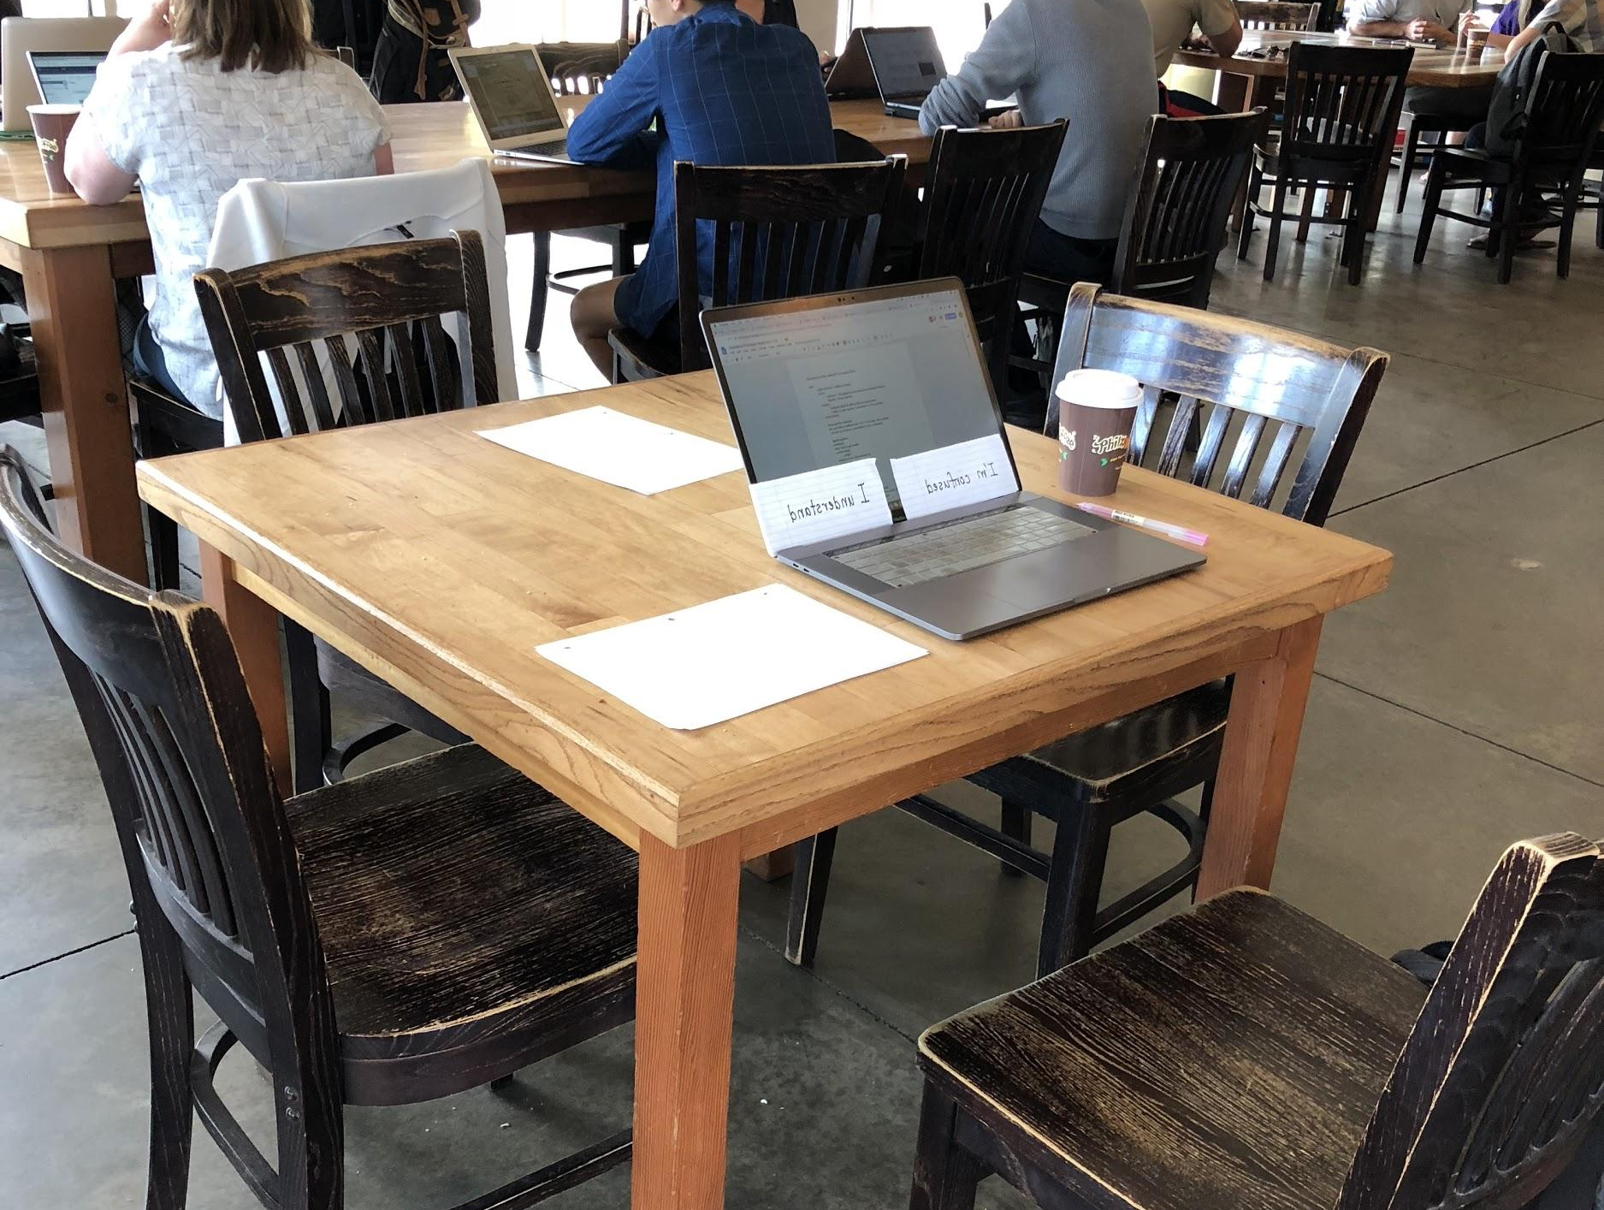
(prototype setup)
Scenario - The subject has to teach a small 5-10 minute lecture on any topic the subject wanted. The subject could draw from work or school experiences, and we gave the subjects sheets of paper and pens to plan out the lecture before beginning.
(feedback sheets)
We conducted two trials, manipulating the style of feedback the lecturer would receive. In one case, the student would hold up sheets of paper saying “I’m confused” or “I understand” throughout the lecture, providing live, direct feedback about their learning. In the second case, the student would not hold up any paper, and feedback would be minimized (no questions during the lecture).

Test Subject #1: John, who works at Enovix, a battery company. When we held up the “I’m confused” paper at various points, John asked us to clarify what we were confused about. This was an additional point that we learned: it was important for him to know what exactly we were confused on so he could elaborate on that point. John seemed surprised by the cards when I brought them up and stated that they were “a little jarring.” A learning point from this is the need to integrate the continuous feedback from the students smoothly so that it doesn’t feel so unexpected when the students indicate their confusion.

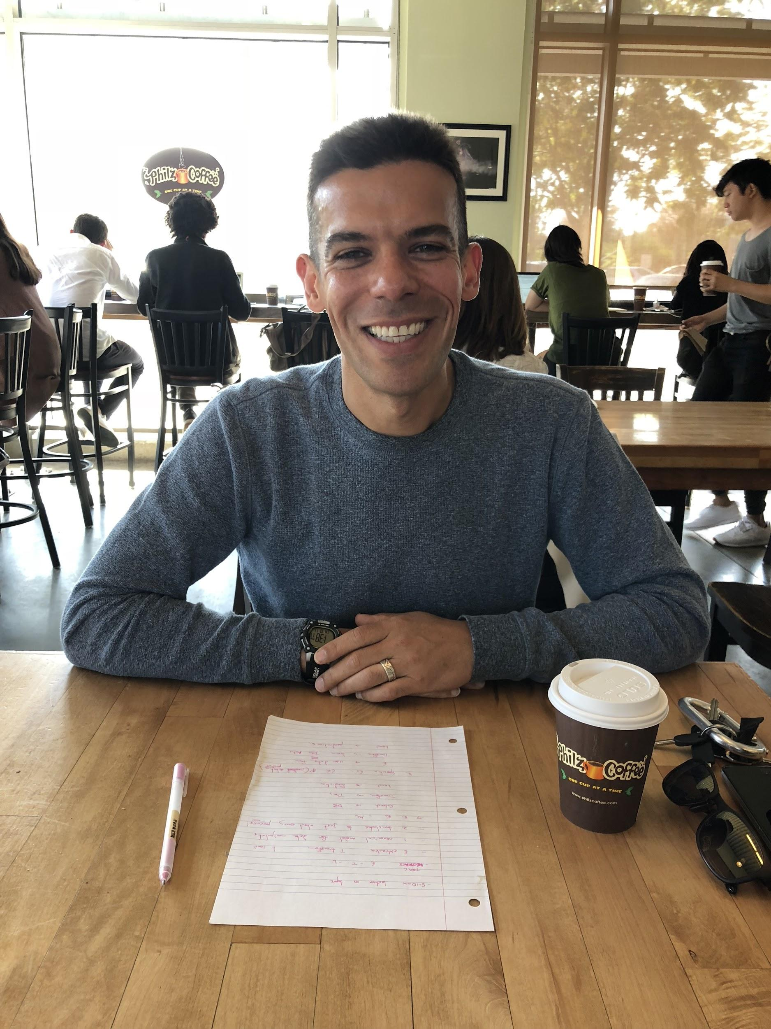
Test Subject #2:: Nick, a machine learning engineer at CreditKarma. He tended to go off topic/off his outline slightly more than John did, and Sam (acting as student in this trial) found herself getting lost about halfway through. We refrained from asking any clarifying questions, however. At the end of his lesson, we asked Nick how he felt that the audience took in the material. He said that he thought we “did a good job taking in the material.” He said that he determined this based on eye contact, saying: “when I internally wanted you to make eye contact, [to] meet and engage with you, I felt you responding to that.”
Both John and Nick tried to keep eye contact with the student the entire time. This seemed to indicate that they were looking for continuous feedback, whether or not this feedback was being provided by the papers. Our assumption that continuous feedback aids in teaching is thus confirmed, though we need to refine the way in which this feedback is provided so it feels smoother to the lecturer. Though we weren’t directly testing this assumption, this confirms an additional assumption that students convey their feelings about a topic through facial expressions.

Conclusion

This week was very informative. We tried to broaden our reach and got some great insights in the process, conducting additional interviews in downtown Palo Alto and some young users in East Palo Alto. We felt that the live feedback could be a bit disruptive to the lecturers, and pairing students comes with the challenge of determining whether the student teachers will actually help the struggling students learn. Providing resources as students struggled, however, seemed to help the students significantly. Thus, we felt that the Magic Homework prototype was the most successful. Our prototype demonstrated that our assumption - that students will use resources only if convenient- was correct. We also believe that AI can be utilized very well in this application and that there are plenty of interesting interface issues that we can explore in the rest of the class.

Appendix

Additional Sample HMWs

POV #1
- change the curriculum to get kids more curious
- let interested students focus less on their grades and foster their curiosity
- enhance student curiosity and make them actually want to learn new material
- change students’ mindsets about grades
- create incentives for students to actually learn rather than just do well on tests
- cater to different students’ backgrounds
- divide a classroom based on skill so that no student is bored
- ensure the flipped classroom style works
- make the flipped classroom style more interesting
- take learning out of a classroom and in the field
- relate topics to things that are related to students’ interests
- remove testing/grading for classes

POV #2
- create lessons that are as personal as a youtube video
- HMW put all education into a youtube video
- HMW use youtube videos as a model for the classroom
- generate videos that feel like personal coaching
- make youtube videos that teach topics on everything
- transform the lecture experience into discovery rather than lecturing at students
- create the experience of sections outside of Stanford - high school sections
- create pseudo-sections using AI with a personalized section leader assistant
- make classroom sizes smaller
- devote more time to each individual student and compile their needs
- make classroom not an average of abilities, alienating the best and the more struggling students, but meet them where they are
- make youtube videos easy to create by the lecturers
- automatically generate youtube videos that feel personal based on existing lecture videos
- connect students to tutors/section leaders
- make class sizes feel smaller
- give students the chance to fail and then get individualized feedback within the context of a large class?

#POV 3
- create standardized tests that reward people based on their ability to find and use knowledge
- reward students for things other than memorization
- teach people how to look for different forms of information
- locate resources to use
- help people practice finding resources
- enhance people’s Google-fu
- get rid of tests and just have students practice finding information and using it
- change the perception of memorizing to foundation-building
- have students discover their way to a solution
- create more hands-on opportunity

Additional Experience Prototype

Student Pair

Assumption: Students who are beginners at a subject would be willing to learn from their peers

We tested this assumption with Sami and Sabine, who we met at the Coupa in Huang. They were also presented with a “homework” in a language that they were unfamiliar with and given two choices - they could do the homework themselves or have one of us tutor them.

Both of them wanted to be tutored as they thought learning from other students would be easier, faster, and provide more help than working alone. Sabine added that before entirely relying on the assigned student, she would “test them” and determine herself if the student was competent, using previous test scores and evaluating their French accent. This was an interesting addition as it supports our new assumption from the first trial: not all expert” students are equal in teaching and skillset ability, and this will affect the learning process.

