Khoi L, David M, Stefan S
Team 4 - Section 12:30
CS147
Prof. James Landay
CA Andrew McCabe
December, 2017

Introduction

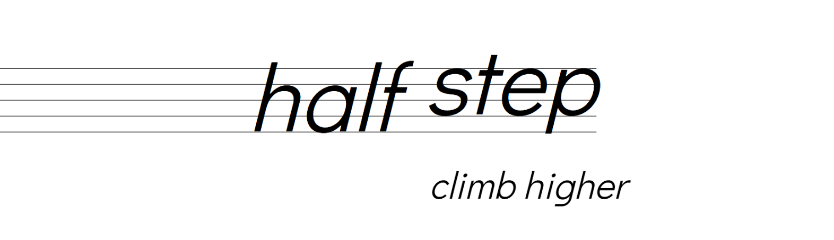
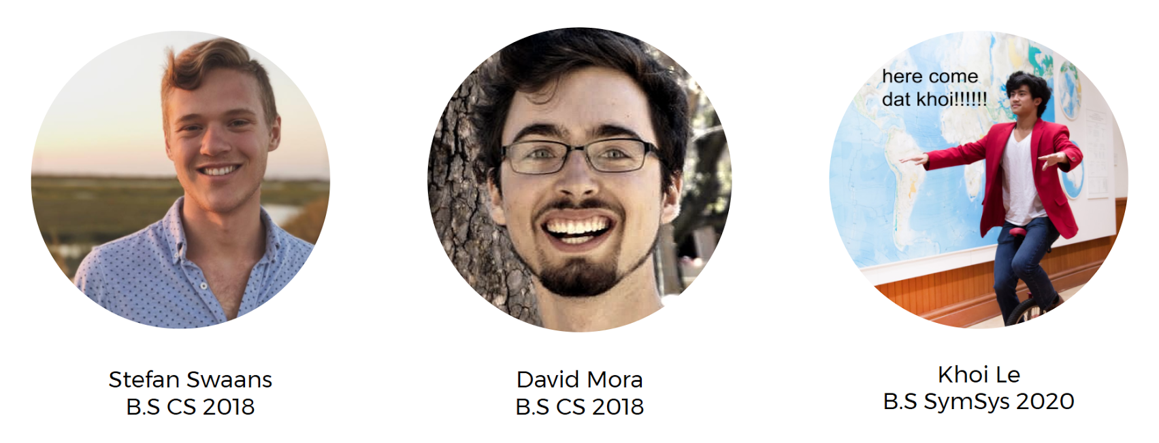
As three developers, we all contributed to the entire process, with Stefan leading the charge on the development of the hi-fi prototype, Khoi heading the website design, and David providing key frameworks during the design process.

Value Proposition
Learn music one step at a time.

Problem and Solution
Overview
Music practice can be unfocused, filled with self-doubt, lonely, and disconnected from your goals and dreams.
half step helps you climb higher by providing bite-sized tasks, near-peer support, and progress tracking.

Problem
Music practice can be lonely and unfocused, filled with self-doubt, and disconnected from your goals and dreams. Particularly for college students, or those moving away from an established community, the clear goals and social support fall away.
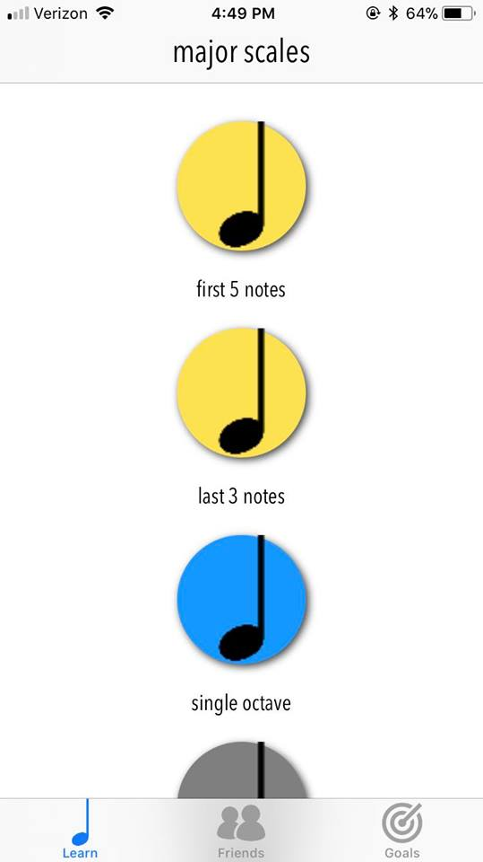
Solution
These problems are addressed in 3 key ways:
- By providing bite-sized tasks toward goals. While learners often know where they ultimately want to end up, many of those we interviewed expressed feeling their practice was often scattered and erratic. Goals composed into immediate actions allows for effective and guided practice.
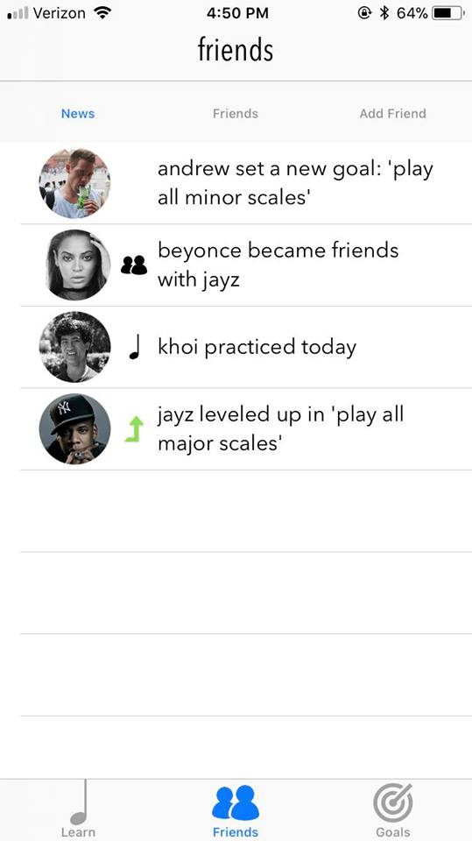
- Near-peer support. While many users expressed the importance of instructor affirmation, finding comfort, motivation, and inspiration from similar learners proved at the heart of nearly everyone’s musical journey. However, many users felt that practice was an experience of self-focus. They preferred to have inspiration from peer musicians rather than practice with them.
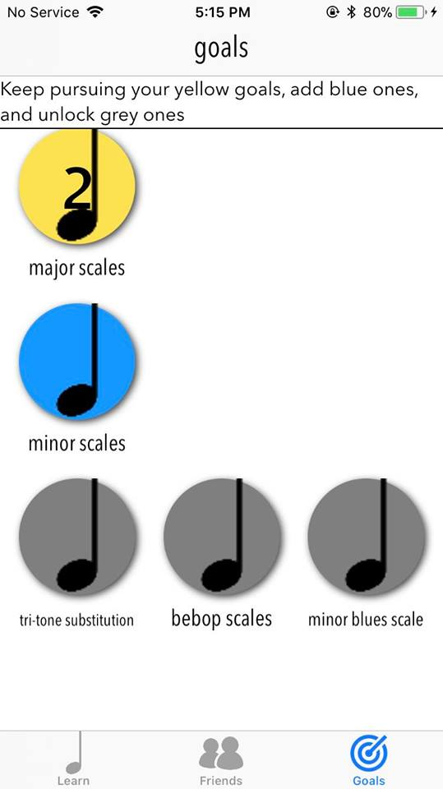
- Progress tracking. Actionable tasks and social support are insufficient, without a sense of accomplishment and progression, both daily and globally. That’s why we structured our interface around continuously seeing noticing and interacting with (for example scrolling past) your completed lessons and goals. During needfinding, a sense of accomplishment arose as crucial to sustained learning.

Tasks​

Simple: Complete current lesson
Why we chose this task: Simple yet central, the act of taking on and accomplishing a bite-sized task forms the core mechanic of how our app guides practice.
Storyboard:
Users open up to the lessons screen (leftmost, row 1) that lists their lessons. Completed lessons are shown as gold, next lessons are shown as blue, and future goals are shown as grey. Users tap the blue lesson to open the lesson module (middle, row 1). Users tap the microphone to record themselves playing the lesson (rightmost, row 1). The app gives them feedback until they play it correctly (leftmost, row 2). Once the user successfully plays it, the app congratulates them (middle, row 2). User progresses to next lesson (rightmost, row 2).
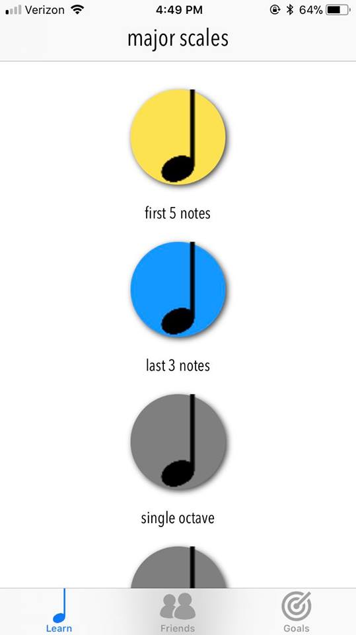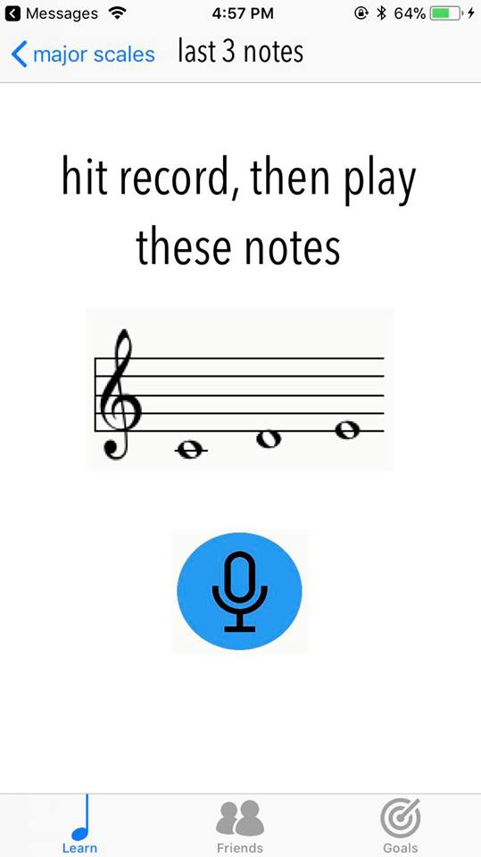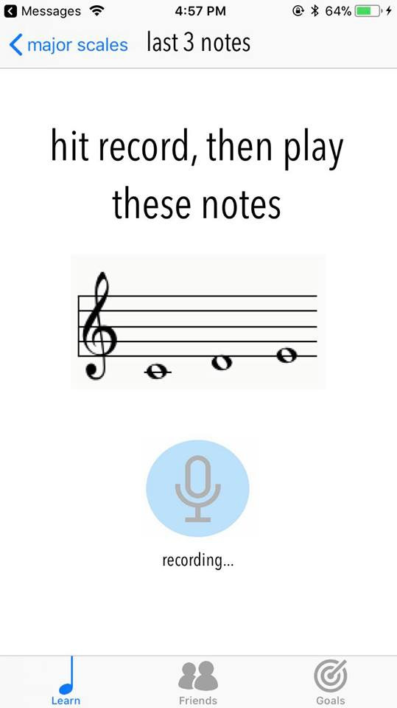
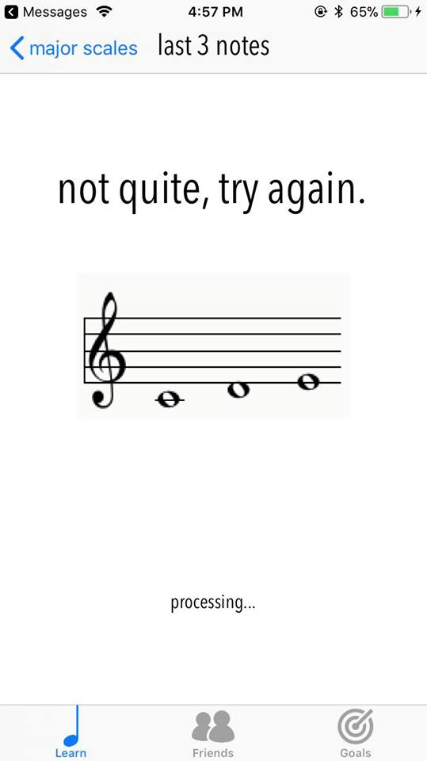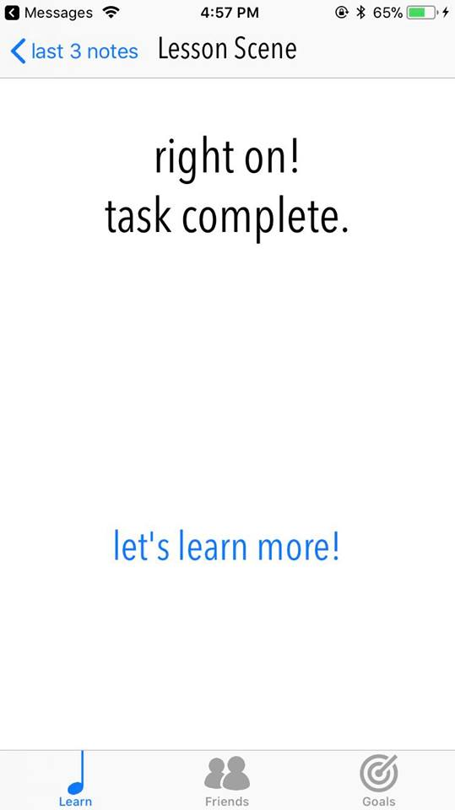

Medium: Add new music learning goal
Why we chose this task: Plotting your music path amongst a myriad of options proved a core pitfall for our interviewed music learners -- if our app was to succeed, we’d have to ensure we nailed a solution to this.
Storyboard:
Users open their goals tab (leftmost). Current goals are shown in gold, available goals are shown in blue, and locked goals are shown in grey. Users can tap available goals to show goal description (middle left). Users can tap the center icon to add it to their goals (middle right). They are then taken to the lesson screen for their new goal (right).
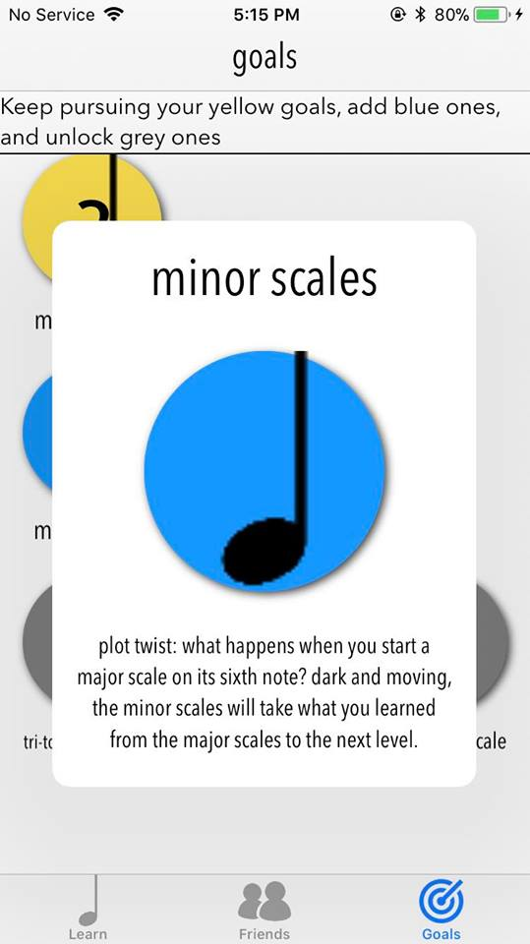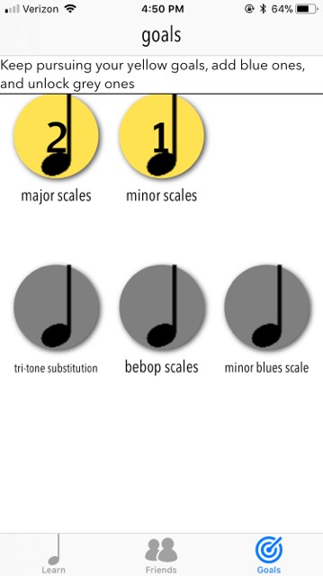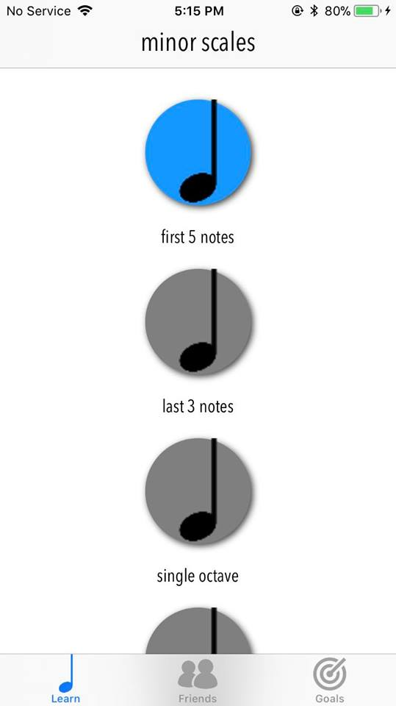

Complex: Be inspired by friends
Why we chose this task: Beyond the practice itself, we knew the social glue and support should be what really fuels the app experience, and wanted to put these interfaces to the test. Many of our users said that they didn’t want to practice with others, but they would feel inspired if they could see when others were practicing and what others were working on. We built a community where looking at someone’s profile (2nd image from the left) would automatically send love to that person (last image on the right).

Storyboard:
Users can open the friends tab to see news from their friends (left). Users can be inspired by seeing when their friends have practiced, set new goals, or leveled up. When users visit their friends’ profiles, the app automatically sends love to their friends (left middle). Users can see their friends’ current goals to inspire themselves (right middle). Users receive love from their friends when their friends visit their profile (right).
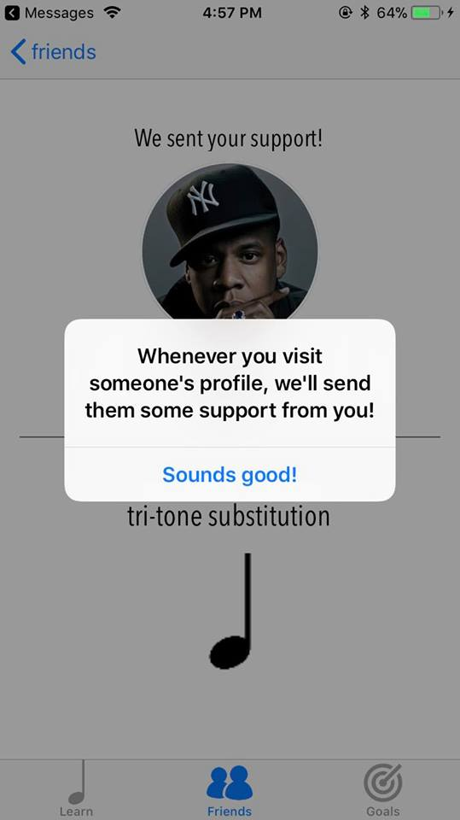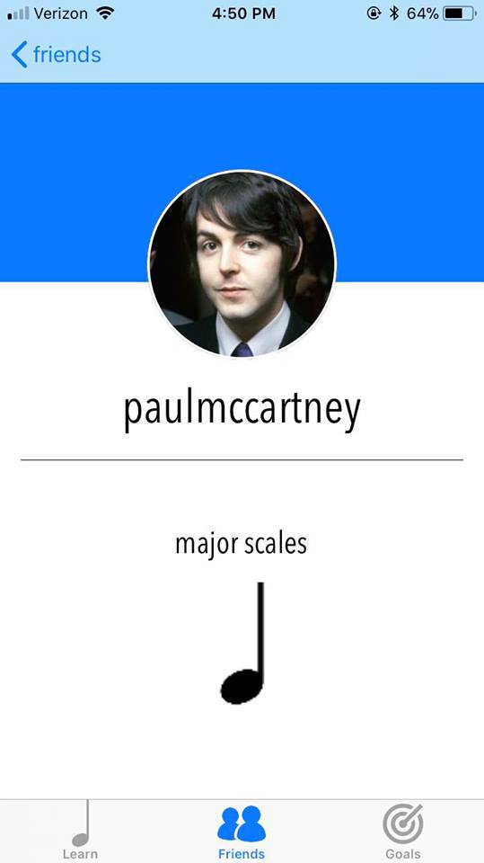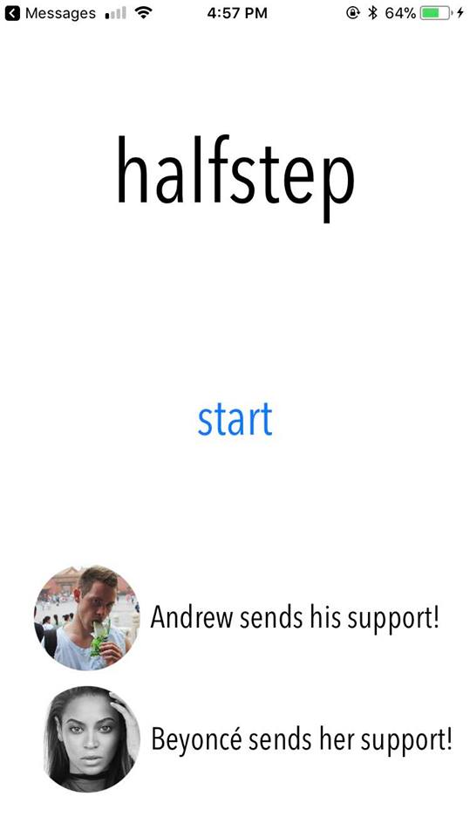

Design​ ​Evolution​

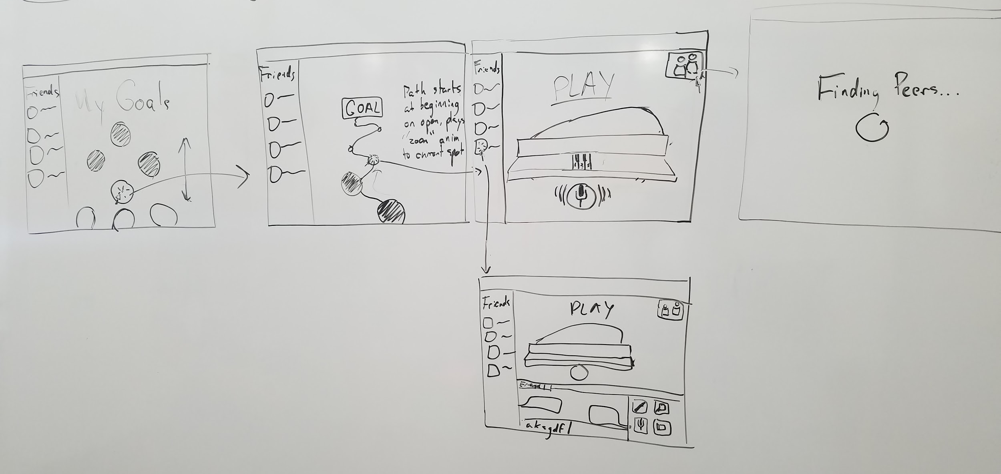
Initial UI Sketch
Originally drawn for a web app, the basic interfaces of halfstep were built to inspire and connect users.

Low-Fi
Choosing a mobile app: Considering an AR practice buddy and web app practice tracker, we ultimately settled on a mobile app, which provided the portability and size optimal for practice sessions we’d observed visiting the practice areas of musicians, such as Sheri, who already used her phone throughout her practice time. Even more, mobile design encourages simplicity, excellent for an app that wouldn’t distract from already challenging practice tasks. As for the circle progression UI, we took a lot of inspiration from Duolingo’s interface.
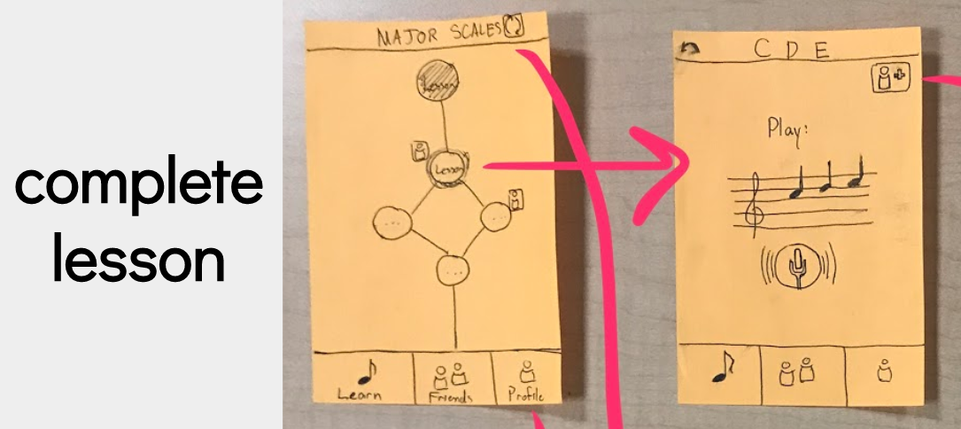
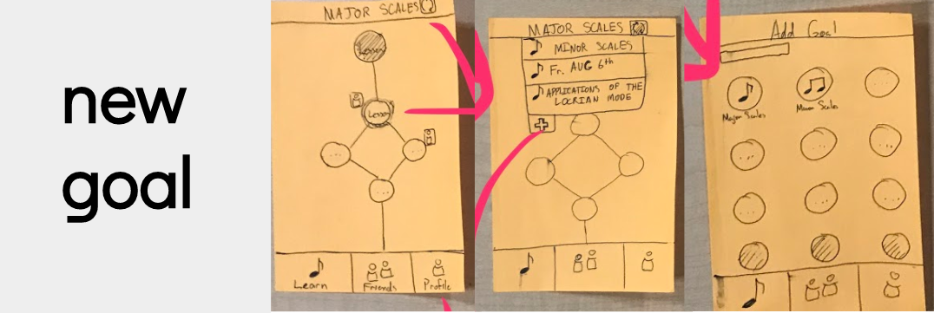
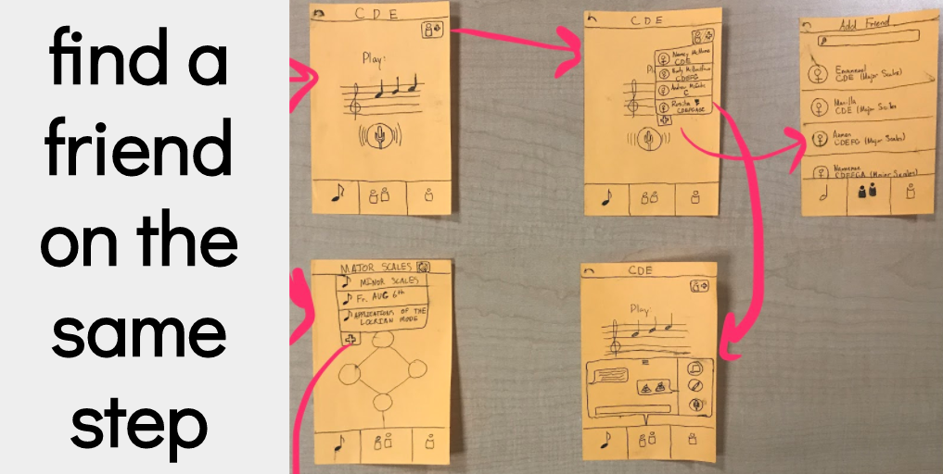

Testing results:
- Difficulty using friend functionality: adding friends and finding friends was a task no one could complete
- Testers were uncomfortable sharing practice progress as it was a vulnerable personal time (we realized that chatting someone else during practice wasn’t a feature that anyone would use)
- Testers wanted to learn from their idols practice habits: surprisingly, testers were hesitant to share their progress (or lack), but were very inspired that of others.
- Testers disliked trophy case, and felt that “awards” and competition was un-music like: musicians are always improving
Revised design directions:
- Friends interface (icons, flow) needed clarification
- Balancing privacy and sharing was completely new, but critical direction, forcing us to rethink what gets shared, how it’s presented, and when.
- Creating a culture of openness about practice emerged as a new consideration
- Accomplishment display: tossing the trophy, we had to develop a new, journey-centric (not completion-centric) paradigm of progress.

Med-Fi
Revisions: Right off the bat, we needed to refine and focus our tasks to more precisely tailor to the new insights surrounding inspiration, progress, and goal setting:
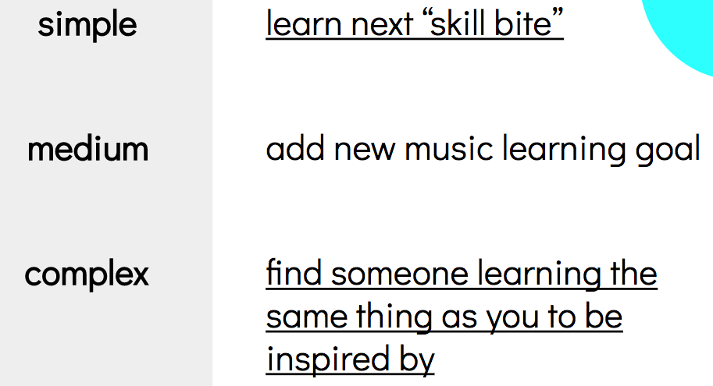

Here were our biggest revisions:
Change 1: Redefine & design social support
Seeing the power of inspiration from peers, but also the reticence nature of speaking about your own progress and skills, we tried to balance the two by creating a feed which focused on time put into practice, and goal completion.
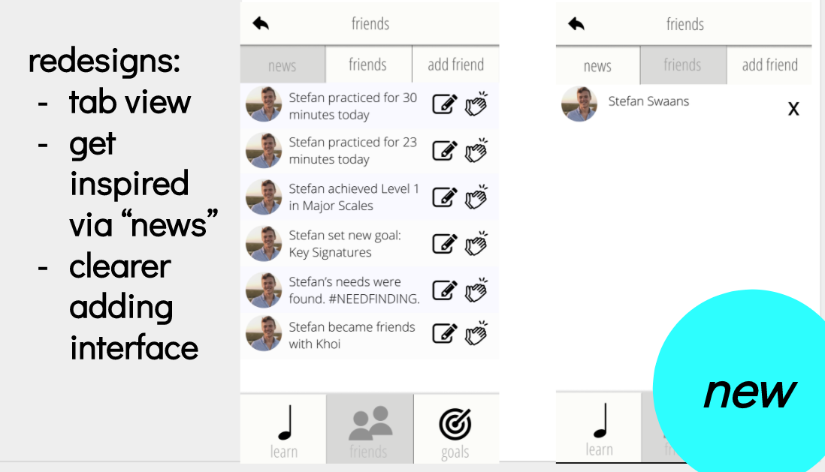
Change 2: Redesign goal setting & finishing
Since users floundered to make sense of selecting new goals, we clarified goals with color (gold for underway, blue for available, and grey for out of reach), created a popup to help clarify what each goal contained, and used the perimeter of the circle to encode progress through the goal.
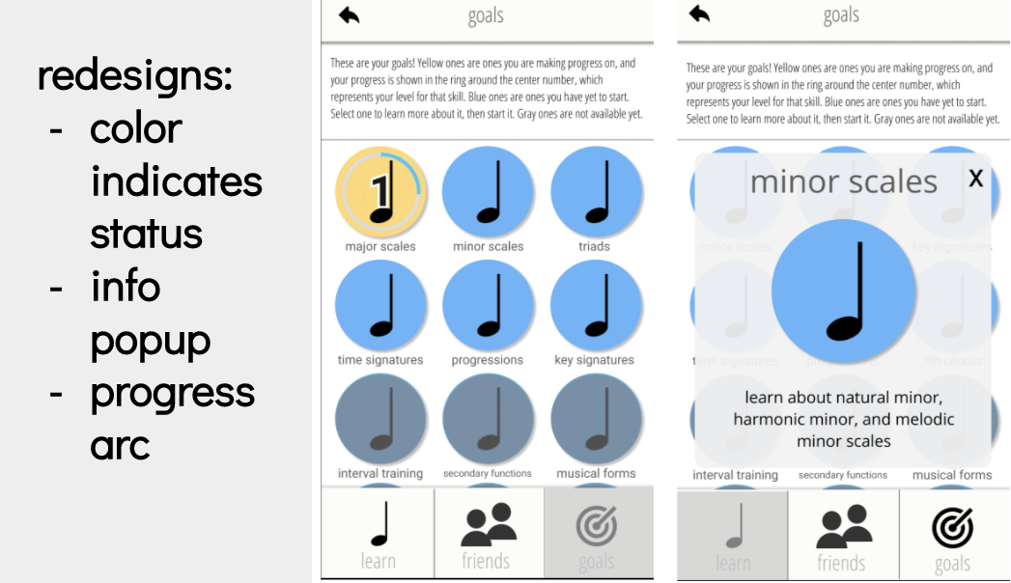
Change 3: Clarify, unify, fun-ify lessons
Firstly, we streamlined the UI by keeping the same icons, colors, and shapes consistent for lessons and goals across all screens, as well as for the recording microphone when completing lessons.
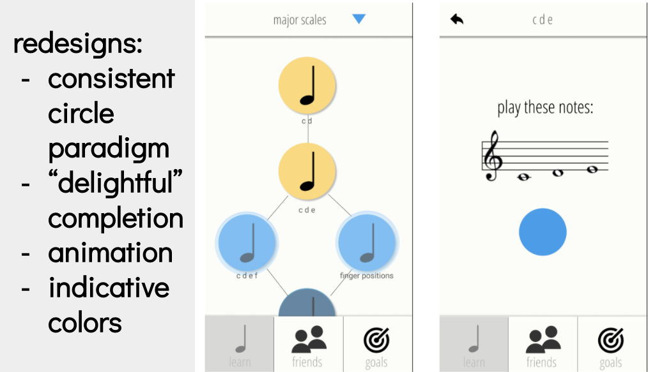
Secondly, building on our needfinding regarding how critical celebration of progress and sense of accomplishment were, we wanted to the action of completing tasks to feel like a small, fun celebration, emphasising your accomplishment.
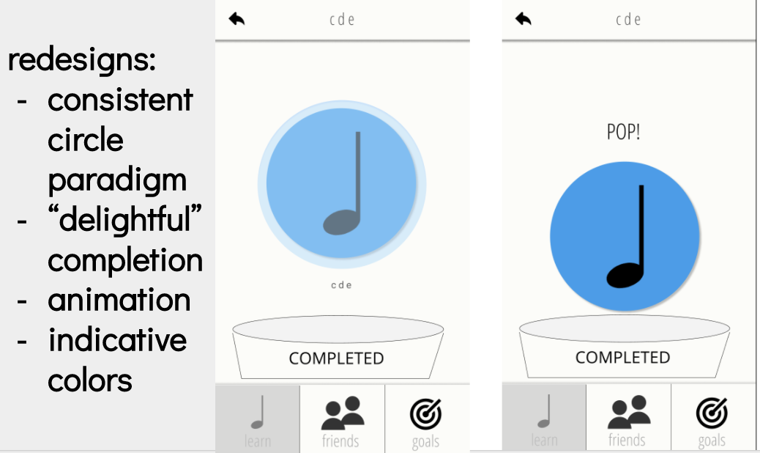

Change 3: Task flow improvement
Challenged by testers difficulty navigating the app, we re-considered the flow from the ground up:
clarifying goal completion...
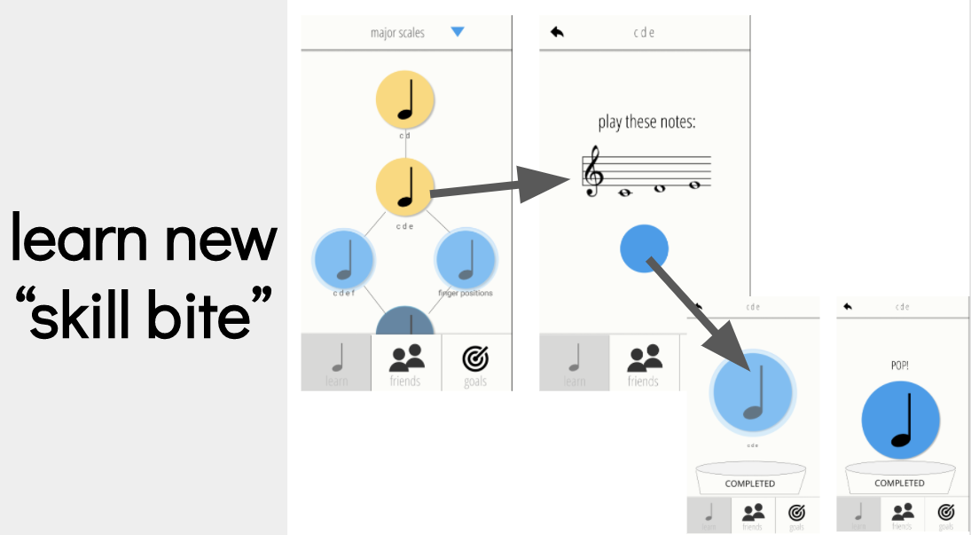

... providing popups which give users freedom, control, and clear context by not leaving the current screen...
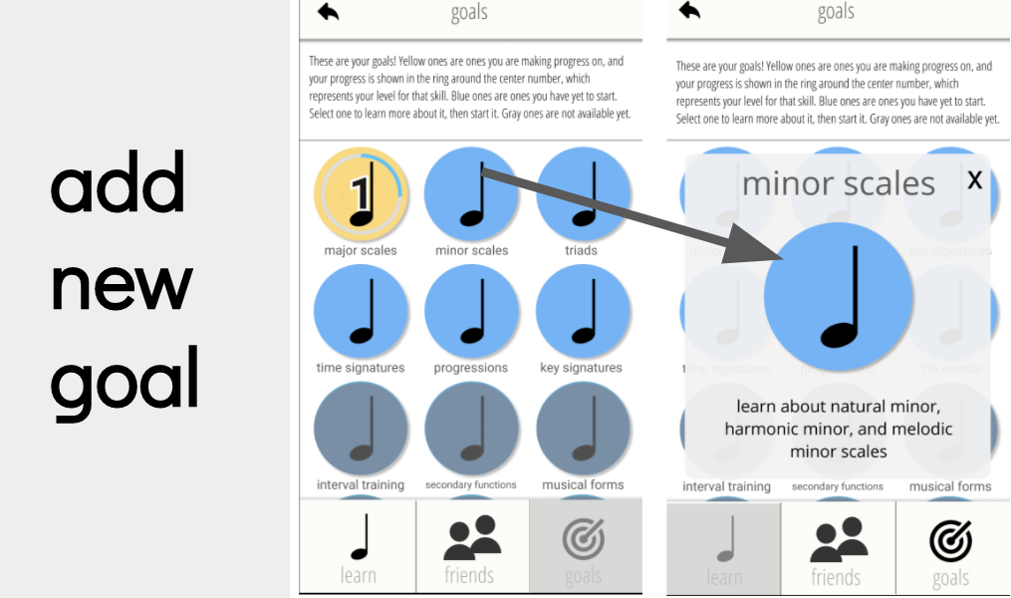
... and coalescing a spaghetti-like social flow into three simple tabs, prominently accessible from the center icon of the bottom tab view (a pattern we copied from various other prominent apps, to follow conventions our user would be familiar with):
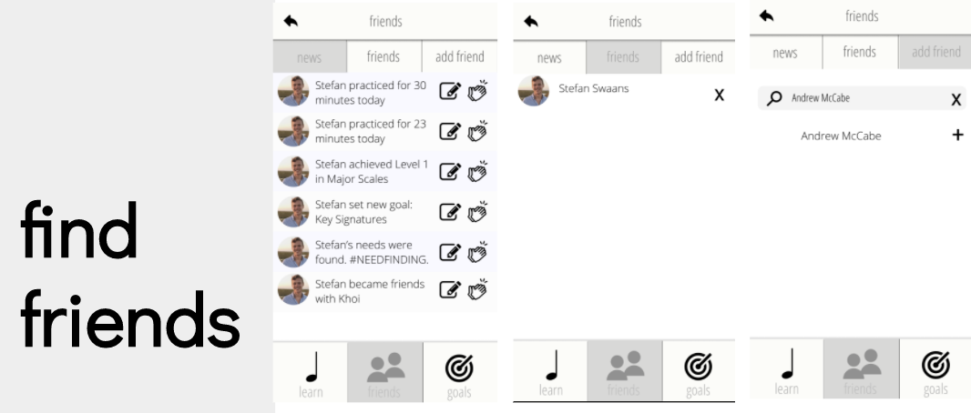

High-Fi
From our initial UI sketch, we took a lot of the aesthetic themes such as circles into our final design. We also kept a lot of the similar segmentation and general concepts, such as the three learn, friends, and goals areas. From our low-fi prototype, we learned that we should improve the friends task flow and experience overall to focus on social support rather than collaboration. From our med-fi prototype, we learned that we should improve the adding goals task flow to be clearer.

Major​ ​Usability​ ​Problems​ ​Addressed​
Summary of HE learning: To be honest, but also humble in that we’re beginners and have a long way to go, we didn’t find the HE evals super insightful, helpful, or well done. Specifically, even the most severe violations merely cited superficial confusions, rather than pushing us to consider the paradigms and constructs we were building the entire experience upon.
Violation, Severity | Description | Suggested Fix | Our Response
H1 / Severity 3 | In news section, it says, “Stefan achieved Level 1”. It’s not entirely clear what the level system is. | Clarify level system, what that means, when a user moves from one level to another | Disregarded. Level system should become clear after initial use.
H1 / Severity 4 | Functional of the microphone/record button isn’t clear. Does it record the player? Or is it just a “I’ve finished playing button”. | If it’s the former - how are you going to implement that and what are you going to do with the recordings? For the latter, why then do the screens following this one have a similar “tap the button” UI? | Add explicit text: “hit record, then play” as well as a and “recording....” label under the now transparent button to show state. (Screen #1)
H3 / Severity 4 | It’s not clear how one actually goes about doing the medium task of adding a new goal (it seems like users have no choice at all in the matter). I see that they become available at some point, but how does a user actually choose which goals they want to learn or not? | Perhaps give users more choice in their learning process! | Added separation into three clear sections: Yellow - currently pursuing, Blue - available, and Gray - locked. This made it clear which ones you could add by tapping on them.
H10 / Severity 3 | In the friend section, what does the book icon do? | Clarify the book icon. | (NA: Removed book icon functionality completely, Screen #2)
H7 / Severity 3 | On top of the learn tab, there is a drop down menu to select goals. It might be redundant because users can also select from the goals tab. Also, it could become cluttered as more goals are added and it becomes infinitely larger. | Prioritize drop down menu contents or move drop down menu to be more standardized with navigation of other screens | We removed the dropdown, after initially thinking it was helpful to provide multiple paths to goals. Ultimately, clarity and simplicity of interface was more important to help focus musicians on their practice. (Screen #3)

Non-HE Changes:
In addition to the HE results, we decided to revamp the friends section to have more positive and inspiring messages for beginners. Rather than saying “Khoi practiced for 2 hours,” it simply says “Khoi practiced today.” We believe that for beginners, this would feel less intimidating. Moreover, we changed our applause system to a system of sending love when profiles were visited. These changes were focused on the community design to promote inspiration and support rather than competition and intimidation. We believe as people progressed in their journey, the level of notification would rise with them, so an expert would get more intense notifications like “Mozart practiced 3 hours today on his minor scales.” Thus, our power users would get more out of it once they passed the point of being intimidated.

Screen revisions: before (left) and after (right)
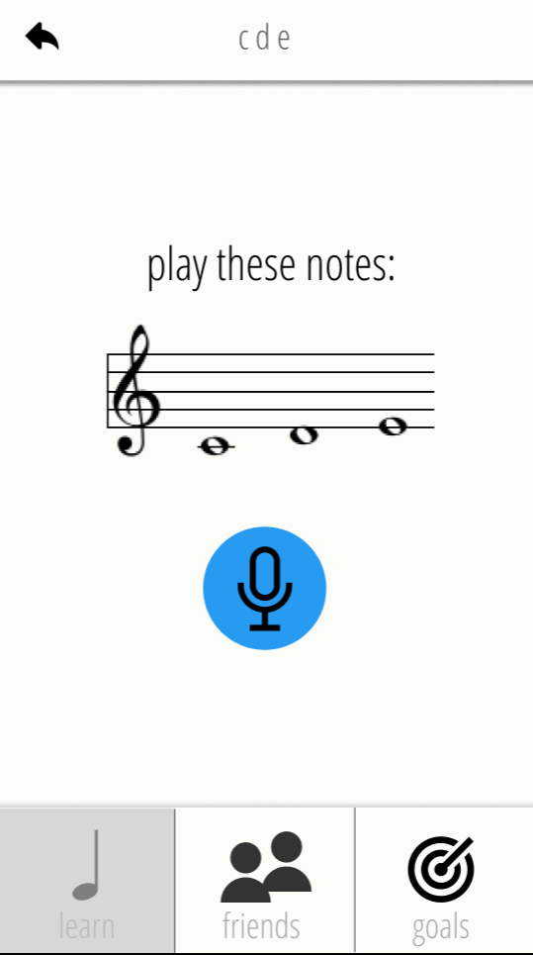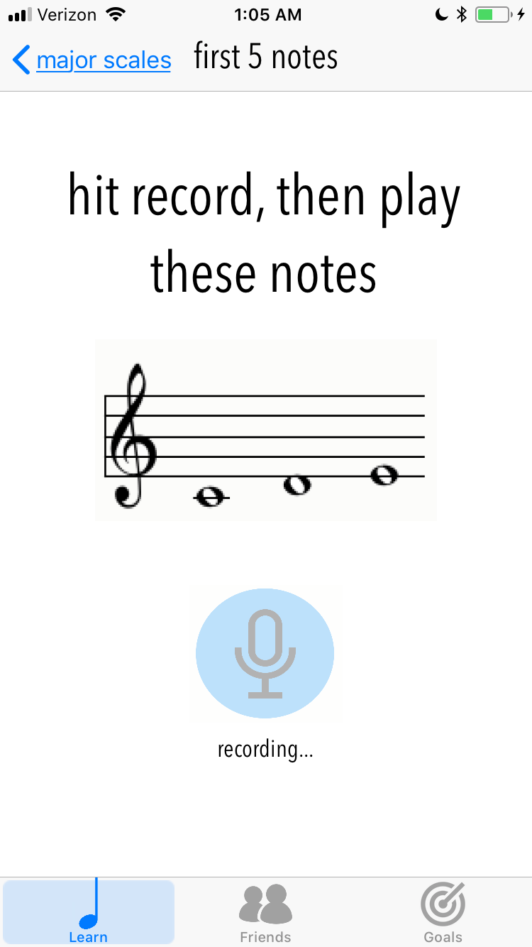
Screen #1: clearer record instructions
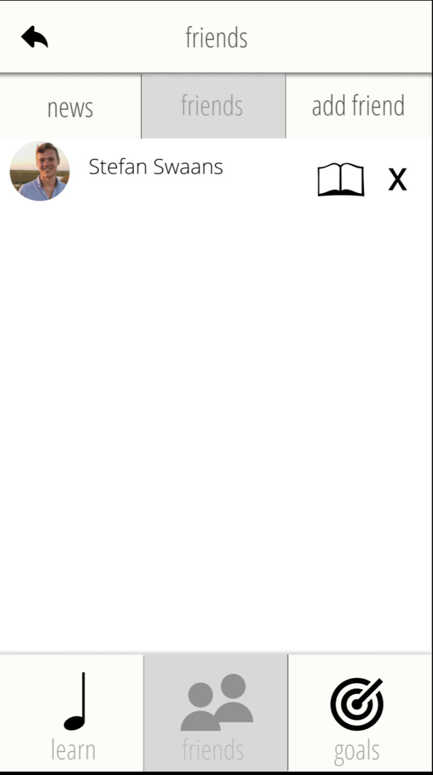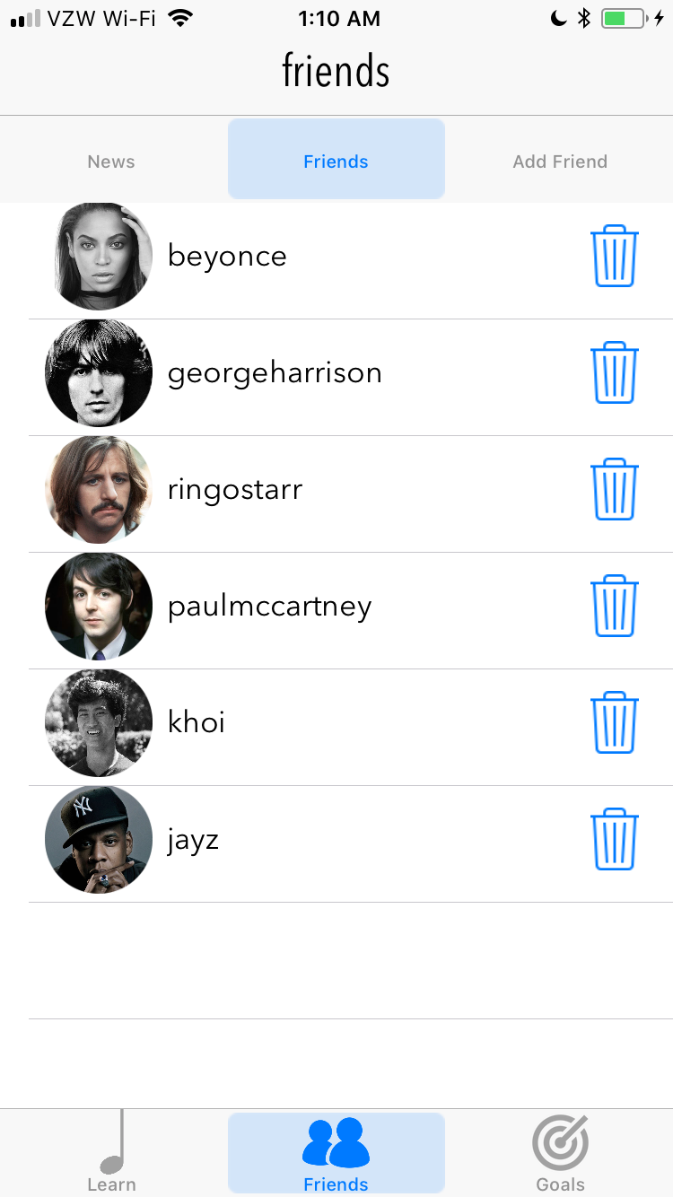
Screen #2: remove “book icon” messaging functionality
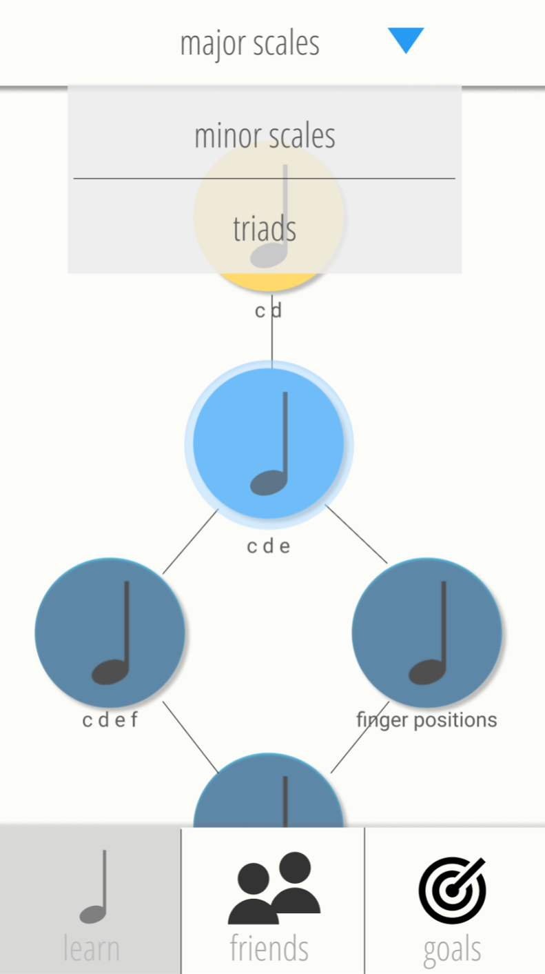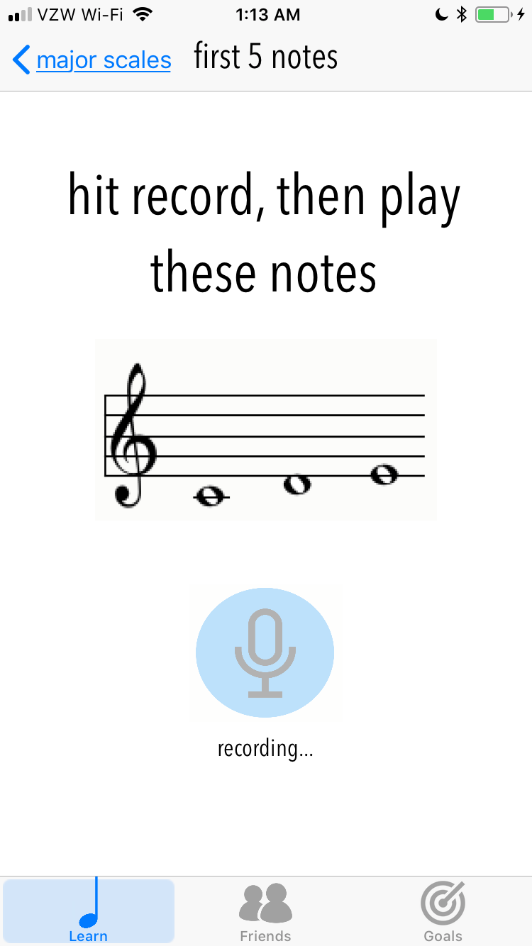
Screen #3: No goals dropdown

Prototype​ ​Implementation​
We built an iOS app with Apple’s native development tools: Xcode and Swift. The visual interface proved powerful and useful, but the overhead and huge amount of code required to setup the basics of the app proved to be a slight obstacle. Particularly for this class, by the time we’d done all the grueling setup, we had no time to really just enjoy building and tweaking things on top of it.

Wizard of Oz
We faked recording you playing notes, made it fail the first time, and succeed the second.

Hard-coded Data
All users, lessons, goals, and user interactions were hardcoded. However, updating completed lessons, goals, progress, and friends was done programmatically.

What is missing and what might you add in the future?
Most absent is the nuanced and different forms of music tasks, beyond playing notes and recording yourself: practicing rhythms in tempo, breathing exercises, ear training, sight reading, warm ups, posture correction. We still would like to add nicer icons, more delightful animations, and pick a better color scheme.

Summary​
Overall, we felt so grateful and privileged to get to have our fledgling design skills challenged and grown this quarter from our wonderful TA, Andrew McCabe, and seasoned, dear leader, J. Landay.
However, we feel that this project is just scratching the surface: the start of insights pushing us in the directions of near-peer support and balancing of privacy, as well as setting vision and viewing progress, are rich and only superficially engaged within the 10 weeks of this course.
However, we’re super proud of the hard we we all put in, and can’t wait to apply our skills!

Appendix

