Group Members: Irene Hsu, Jessica Zhang, Ke Xu
Problem Domain: Life transitions through higher education
Initial POV:
We met Brian, and were amazed to find he needed public deadlines with wide audiences (such as his birthday, holidays, the end of the school year, breaks, etc.) to get his personal projects done. It would be game-changing for people to have more opportunities to showcase their work.
Needfinding Results:
Our first subject this week was Matthew Willis. Matthew is a first-year graduate student in Mechanical Engineering at Stanford. In undergrad, he would keep track of his tasks on a whiteboard which helped him make decisions, prioritize, plan out his tasks, and feel accomplished when he crossed out items on the list. Especially for open-ended tasks, such as writing assignments and long-term planning, he relies on his whiteboard to break them down into smaller tasks. When he moved to Stanford, he wasn’t able to bring his whiteboard and has not gotten one since, which has hampered his ability to prioritize his tasks.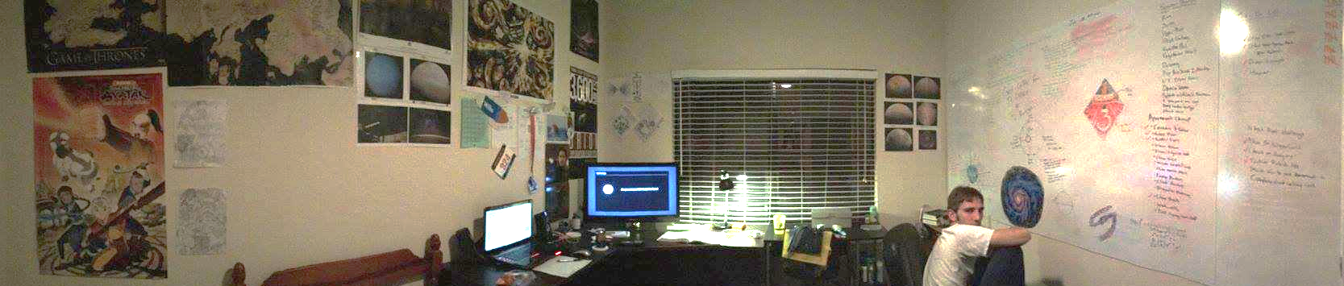
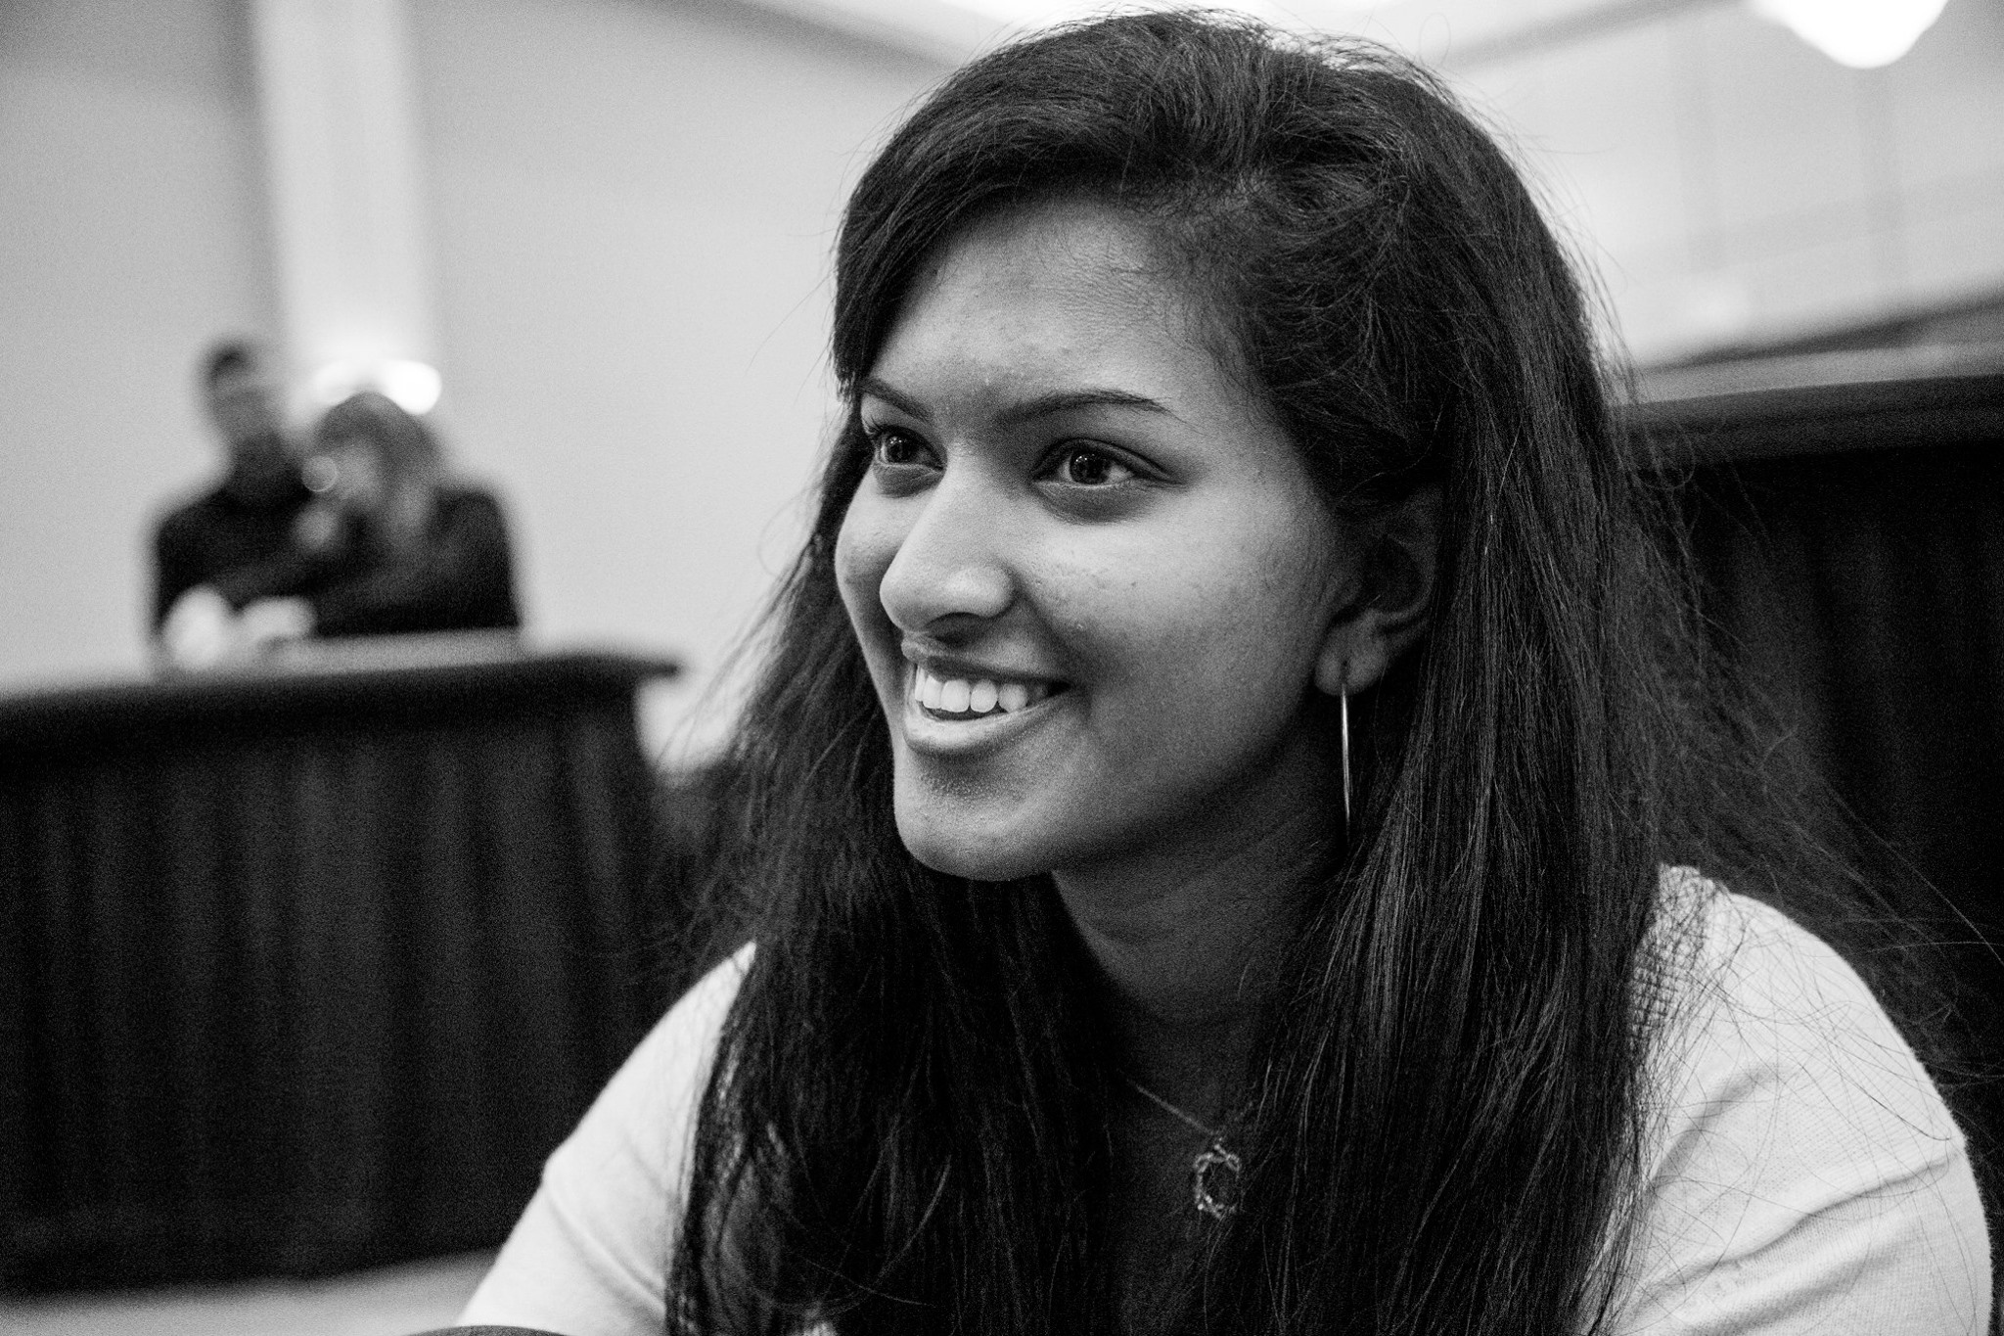
The second subject we interviewed was Somya, an undeclared undergraduate freshman at Stanford University. Somya tracks her productivity every day by color-coding and recording tasks she gets done onto her Google calendar, and is thus able to see which categories she needs to spend more time on to balance her life. Despite this, she is still concerned about not getting to her long-term goals. She said that one of her biggest distractions since coming to Stanford was worrying about what she wanted to do for the next four years.
Our last interviewee is Daniel, who is currently working for Google as software engineer, having just finished his PhD at Carnegie Mellon. He is continuing work on extending his thesis during this time. Daniel does not keep a to-do list, but rather, schedules tasks he will surely forget into his Google Calendar, while tackling his work or research immediately. While he is highly focused, he has found that work has left him drained, and he has little energy and motivation for pursuing tasks that aren’t directly related to his career.
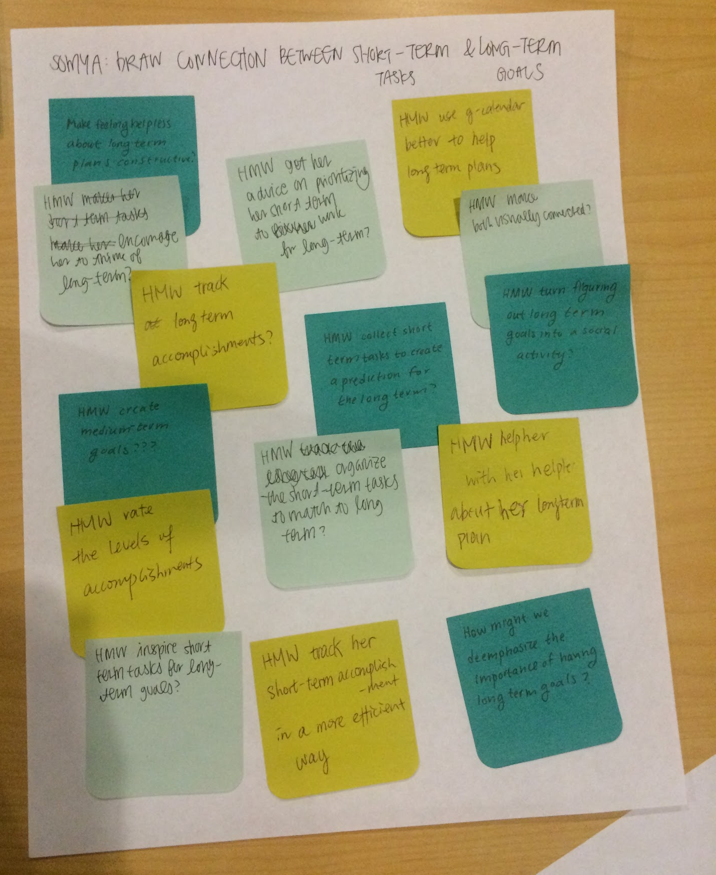
Revised POV:
We met Somya, and were amazed to realize that she is helpless about her long-term plans even though she tracks her short-term accomplishments well on Google Calendar. It would be game-changing for her to be able to draw a connection between her short-term tasks and long-term goals. Some “How might we” questions we generated for Somya included:
-How might we make clearer the connection between her short-term tasks and her long-term goals?
-How might we let her know that others are just as clueless about their long-term plans?
-How might we track the progress of her long-term goals?
-How might we turn planning out long-term goals into a social activity?
-How might we help predict her long-term outcomes based on what she has been spending time on?
-How might we create “medium-term” tasks?
-How might we make uncertainty fun?
-How might we give her the resources to think about her long-term goals?
We met Matthew, and we were amazed to realize how his priorities are not as clear for his tasks now that he doesn’t have access to his whiteboard (way of tracking his tasks). It would be game changing for him to prioritize without the physical reminder. Some “How might we” questions we generated for Matthew include:
-How might we create a virtual representation of the physical reminder?
-How might we constantly remind him of his priorities or goals?
-How might we make having a physical reminder a more positive thing?
-How might we make it easier for him to keep track of his tasks mentally?
-How might we help him get his whiteboard?
-How might we remind him that he needs to get a whiteboard?
-How might we make the whiteboard more portable?
-How might we help mim prioritize his tasks without the whiteboard?
-How might we use the whiteboard to plan his entire life, not just school/career?
We met Daniel, and we were amazed to realize how he had trouble focusing on both his career and personal research after work, even though both are related. It would be game changing to keep him motivated even after work. Some “How might we” questions we generated for Daniel include:
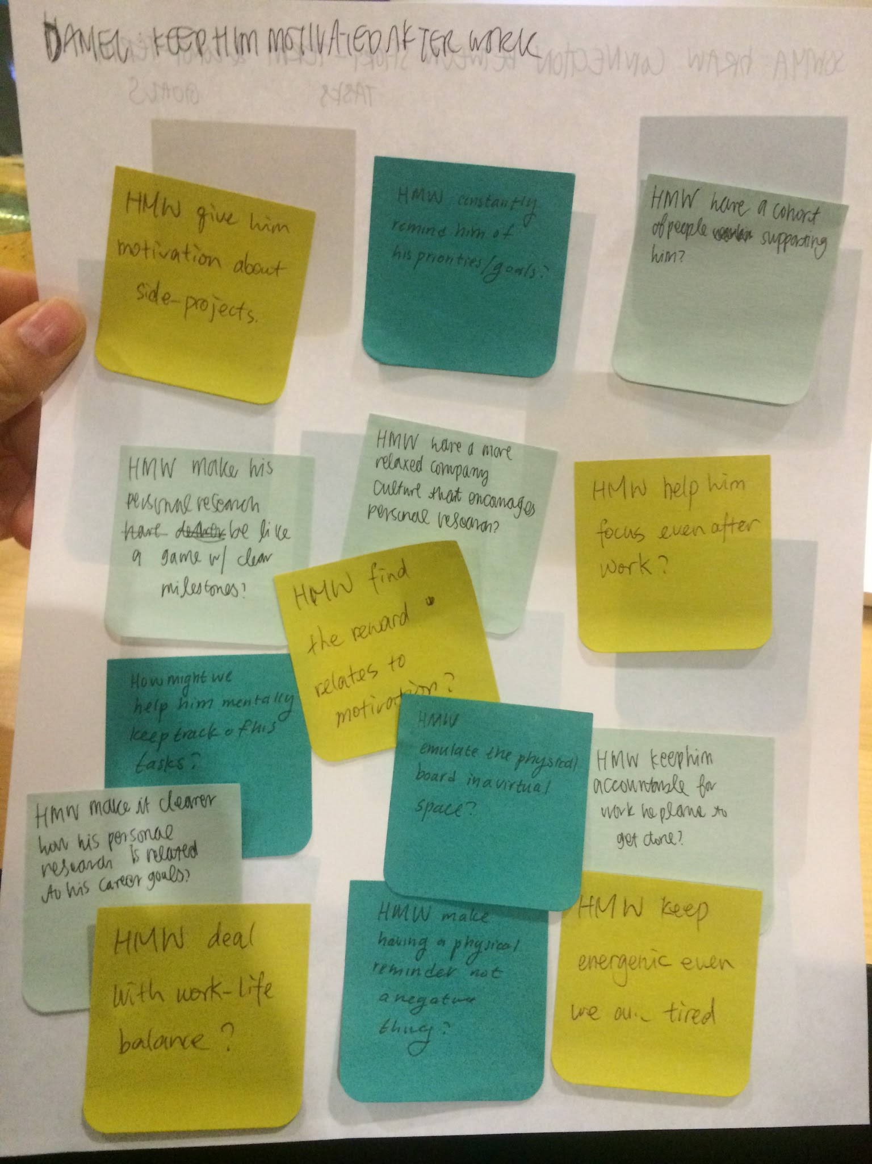
-How might we make his personal research more fun?
-How might we help him stay motivated by having people support him?
-How might we keep him more accountable for work he plans to get done?
-How might we relate his personal research to his career goals more clearly?
-How might we keep him energetic even when he is tired?
-How might we allow him to work on personal projects at work?
-How might we reward him for accomplishing certain tasks?
-How might we make the work-life dynamic more balanced?
-How might we make doing personal projects less tiring?
-How might we give him incentives for finishing his personal projects?

Three Best HMWs:
How might we make clearer the connection between her short-term tasks and her long-term goals? (from Somya’s POV)
How might we make figuring out long term goals into a social activity? (from Somya’s POV)
How might we create a company culture that encourages working on personal projects? (from Daniel’s POV)
Experience Prototypes:
Connecting short-term tasks to long-term goals
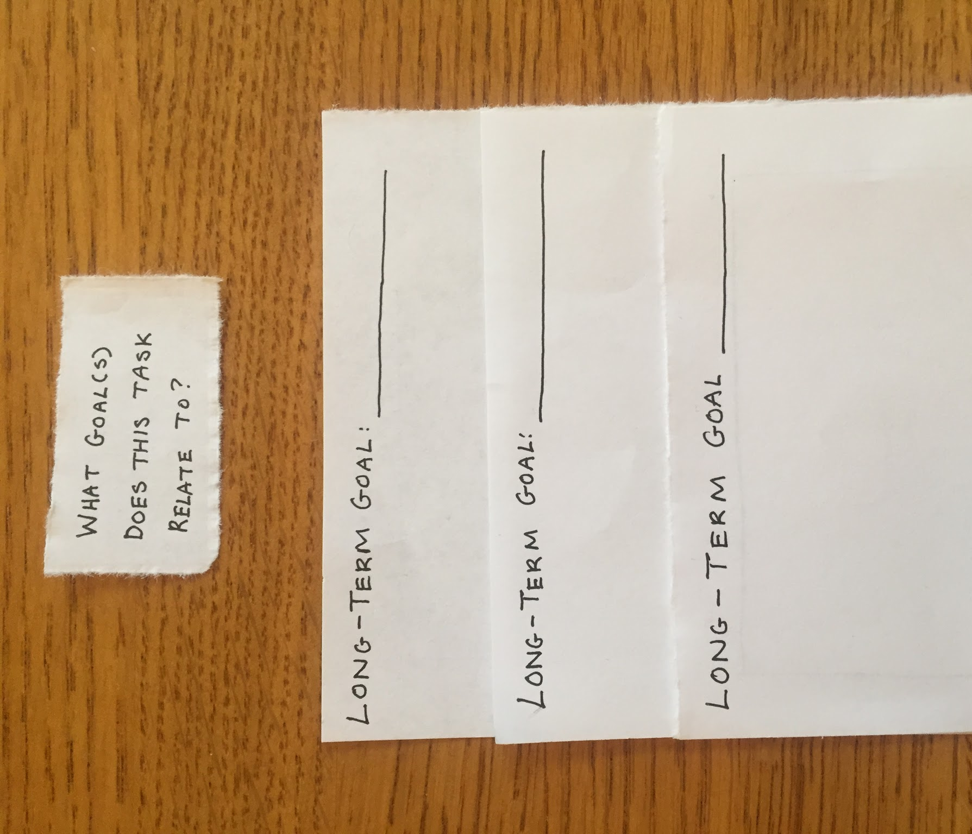
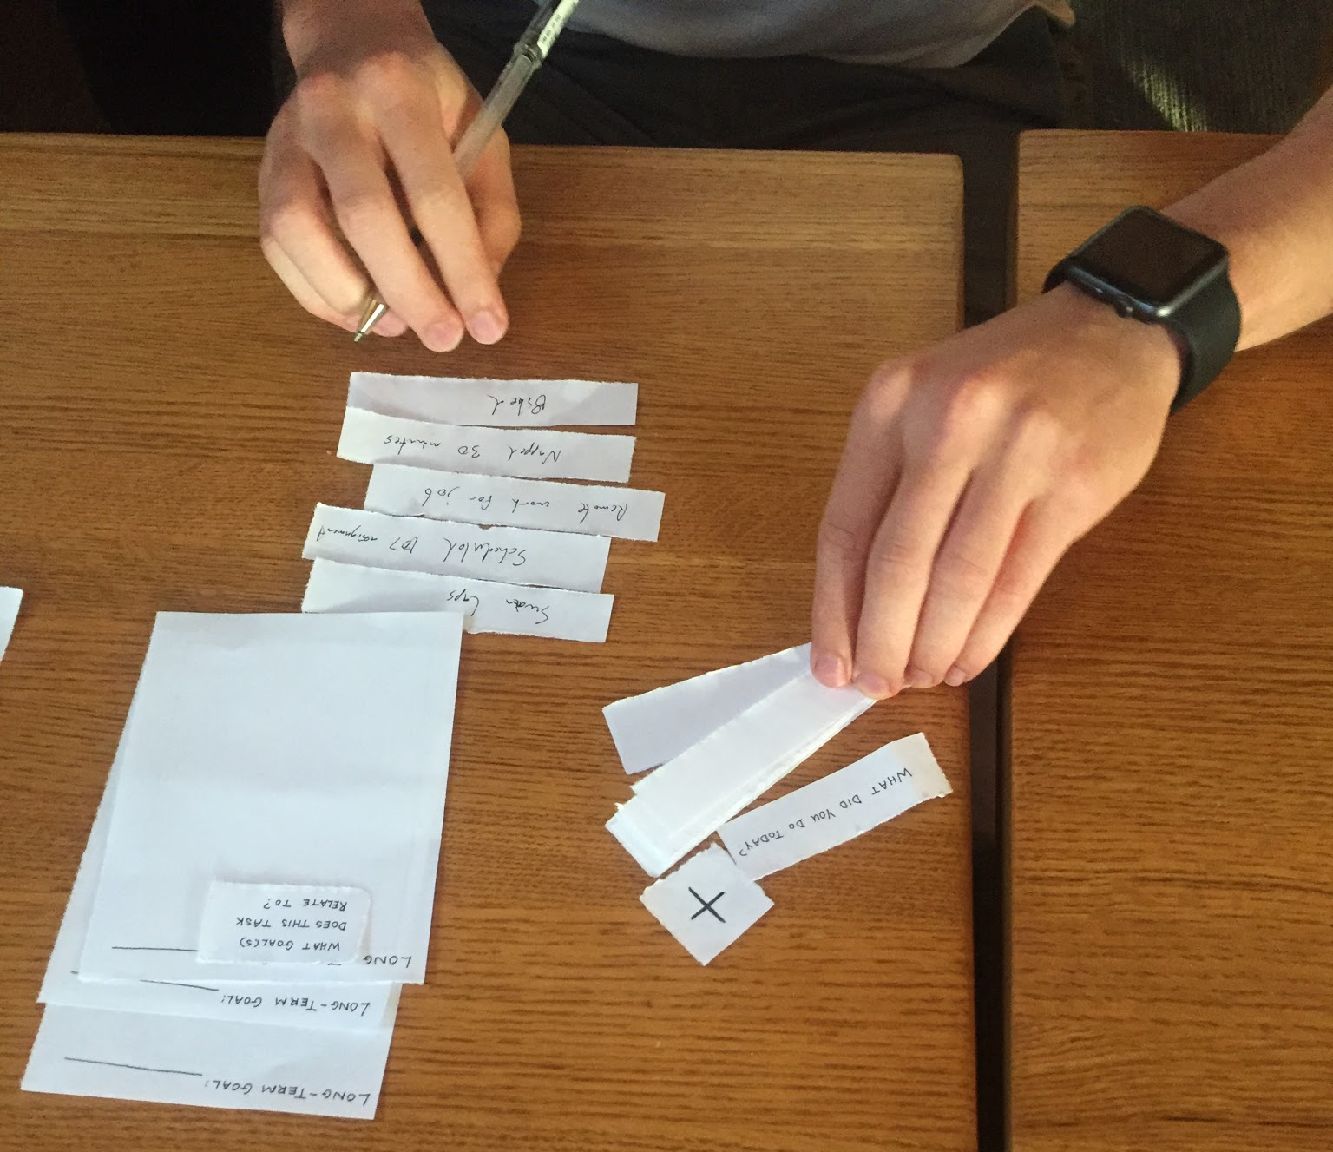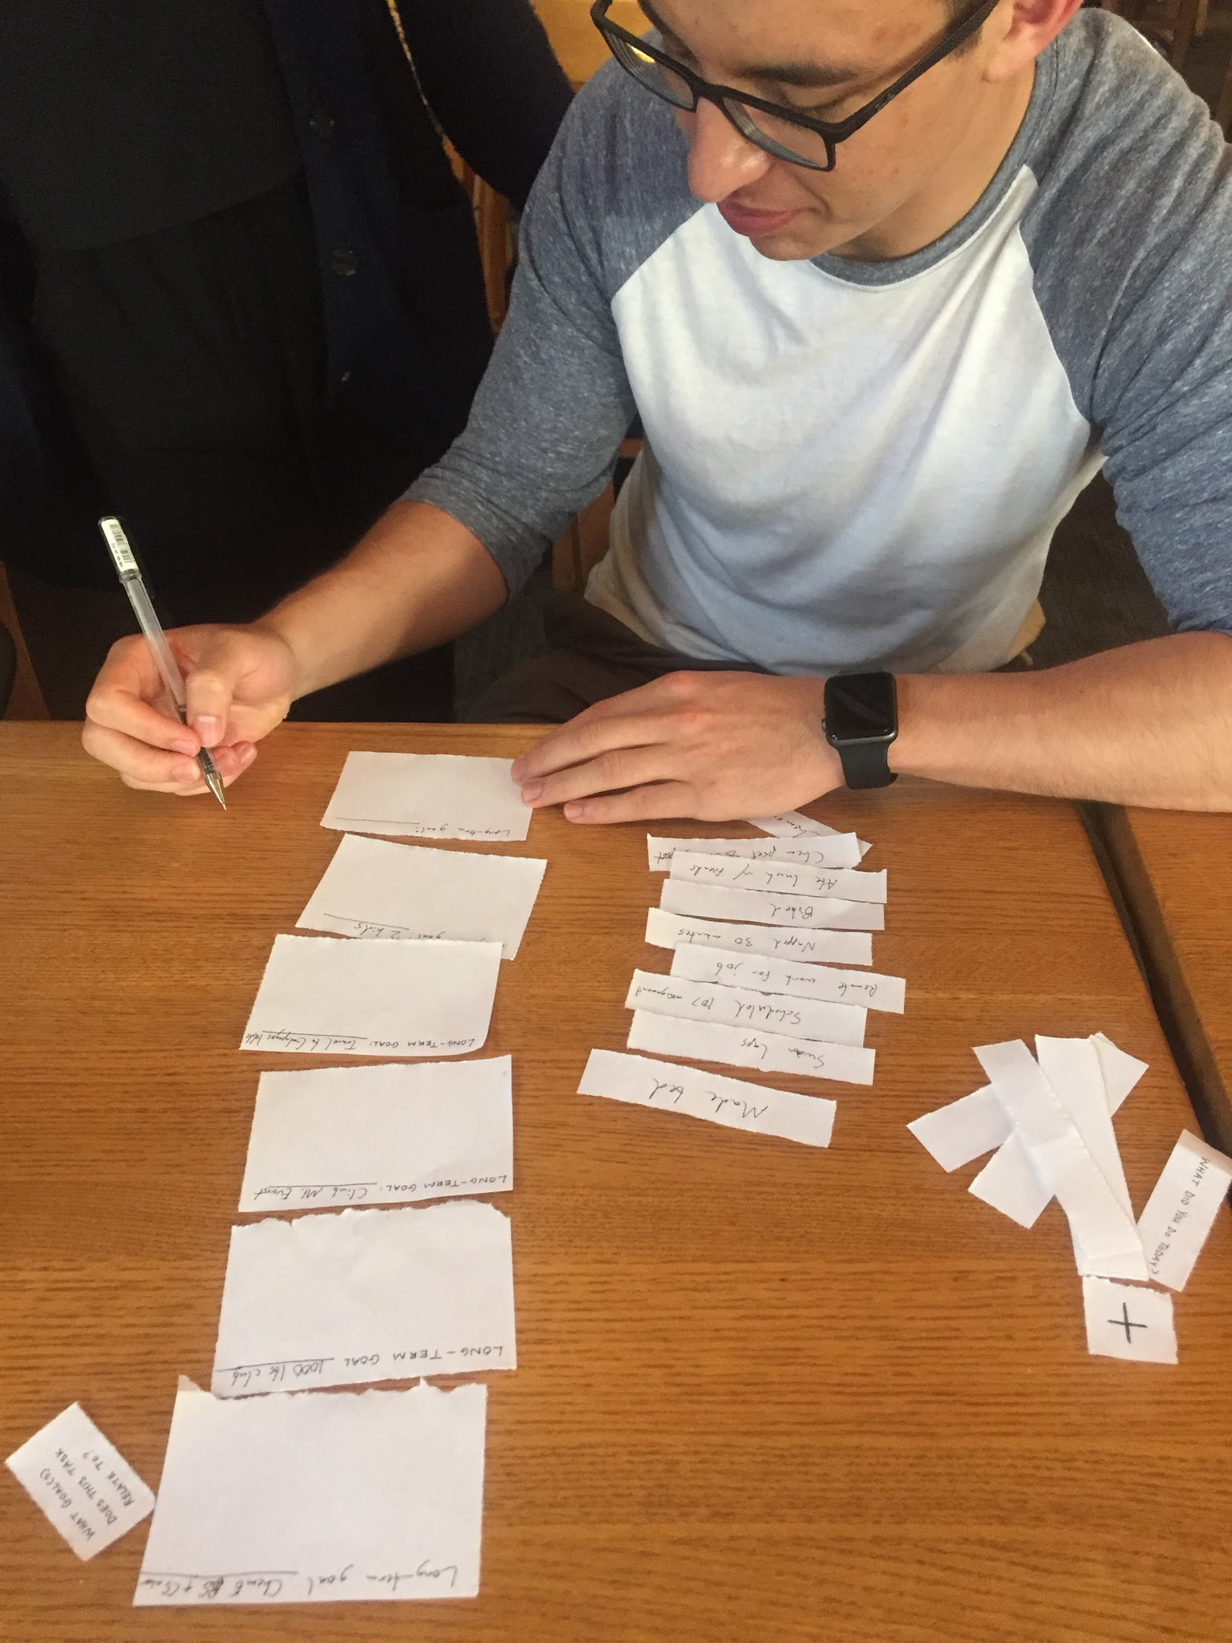
Some of the assumptions we made while creating prototypes were that people care about how their short term tasks factor into their long term goals, that people like to visualize their progress, and that people will be willing to log their tasks throughout the day.
We had our user, junior Caelin Tran, write down completed tasks on strips of paper, categorizing them onto larger panels that represented their long-term goals. After they had categorized their tasks for the day, we would tell them which long-term goal they focused on most for the day and which goal they needed to put more time into. We also provided an overview of their focus trends for each long-term goal, tracking how focused they were during long periods of time.
Allowing the user to categorize their tasks worked as it made them think harder about how the short term tasks related to their long term goals. Having the user recall all the tasks he had performed throughout the day was not as successful as it was hard for him to remember exactly what he did the entire day. The user also noted that it would be useful to quantify each task completed to get a more accurate depiction of the user’s focus for the day.
Our assumptions that the user would care about how their short term tasks factored into long term goals was correct. Our user said that he liked how he was able to see which tasks in the short term contributed to his larger goals. In addition, he agreed that people liked to visualize their progress over time. He disagreed, however, with our assumption that people would be willing to log their tasks every day, saying that it seems like extra unnecessary work to record tasks throughout the day.

Mentorship for developing future plans:
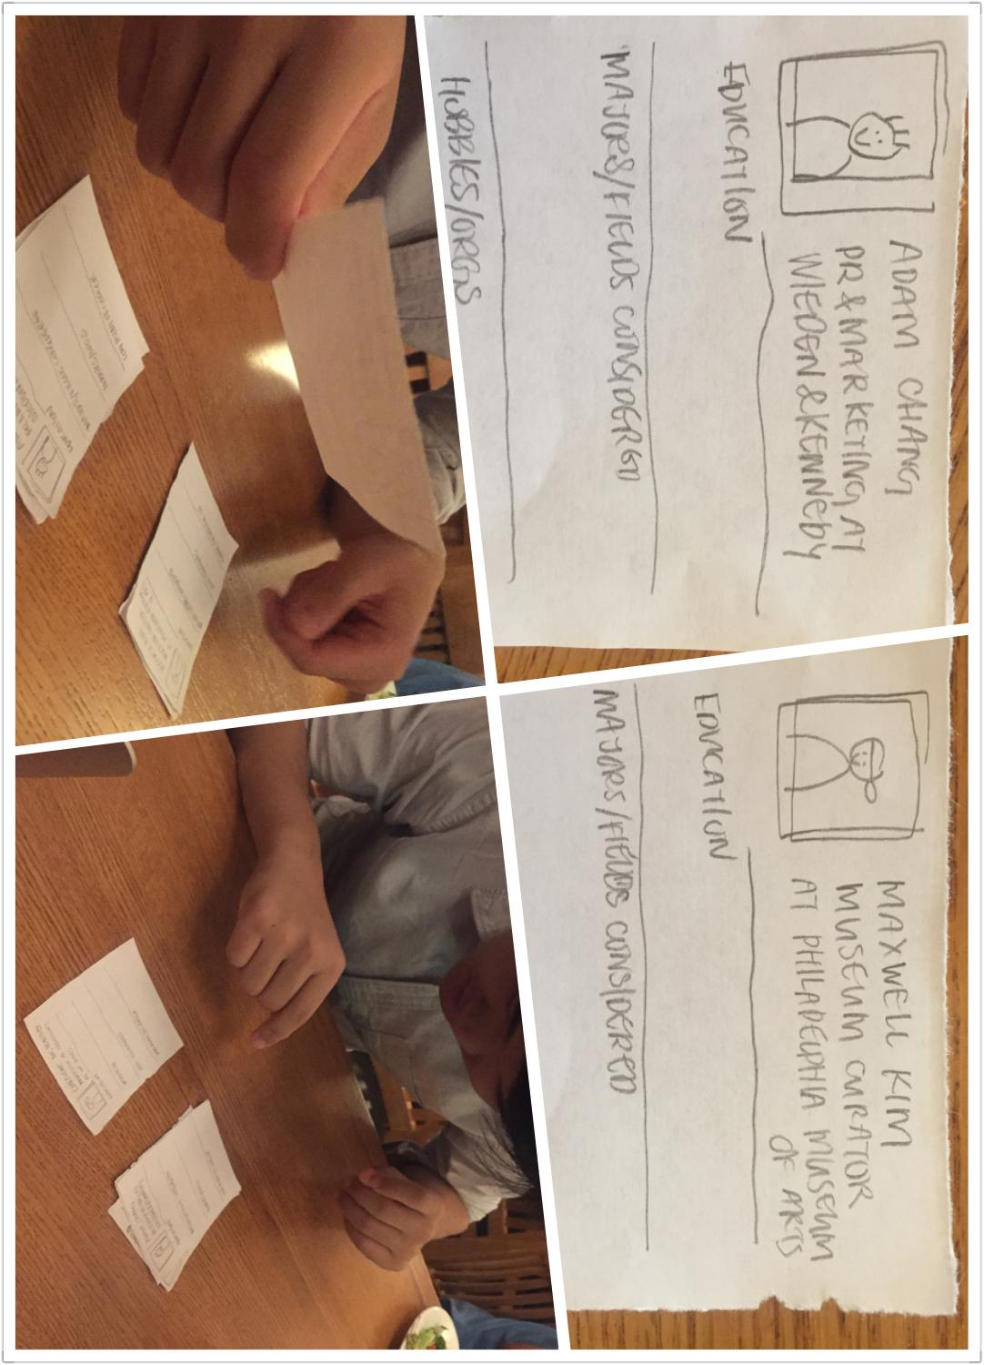
Some of the assumptions we made while prototyping were that people would like mentorship, that there would be people who wanted to help and mentor others and that people would be more comfortable receiving mentorship from those whom they related to.
We created our prototype by making “profile cards” that contained information about the potential mentor, such as their professional profile and hobbies, but also less talked-about information such as the low point of their career, majors they previously considered, etc. Our user, Thomas Lau, was instructed to look through the profiles of potential mentors and select which ones he felt like he would relate to so he could request them as mentors. Once matched, the user would be able to set up meeting times and chat with their mentor.
Our user liked being able to browse through the mentors and having information on the profile like “low-point in career” in order to potentially relate to mentees; thus, we learned that having more emotionally relevant information might help a mentee feel more inclined to talk to a mentor. At the same time, he said that kind of information was not what he necessarily found useful knowing about from a mentor. He also pointed out that the process still seemed impersonal, which came to us as a surprise. In general, he also liked the idea of seeking advice from mentors, verifying our assumption. Our user also noted that it may be hard to find enough mentors to match with mentees, as mentees often outnumber those willing to give advice and help others.
An assumption we developed was that users who were less confident in their careers would be more interested in the personal questions, whereas more confident users would be more interested in the professional aspect of the prototype.
Company culture of working on personal projects
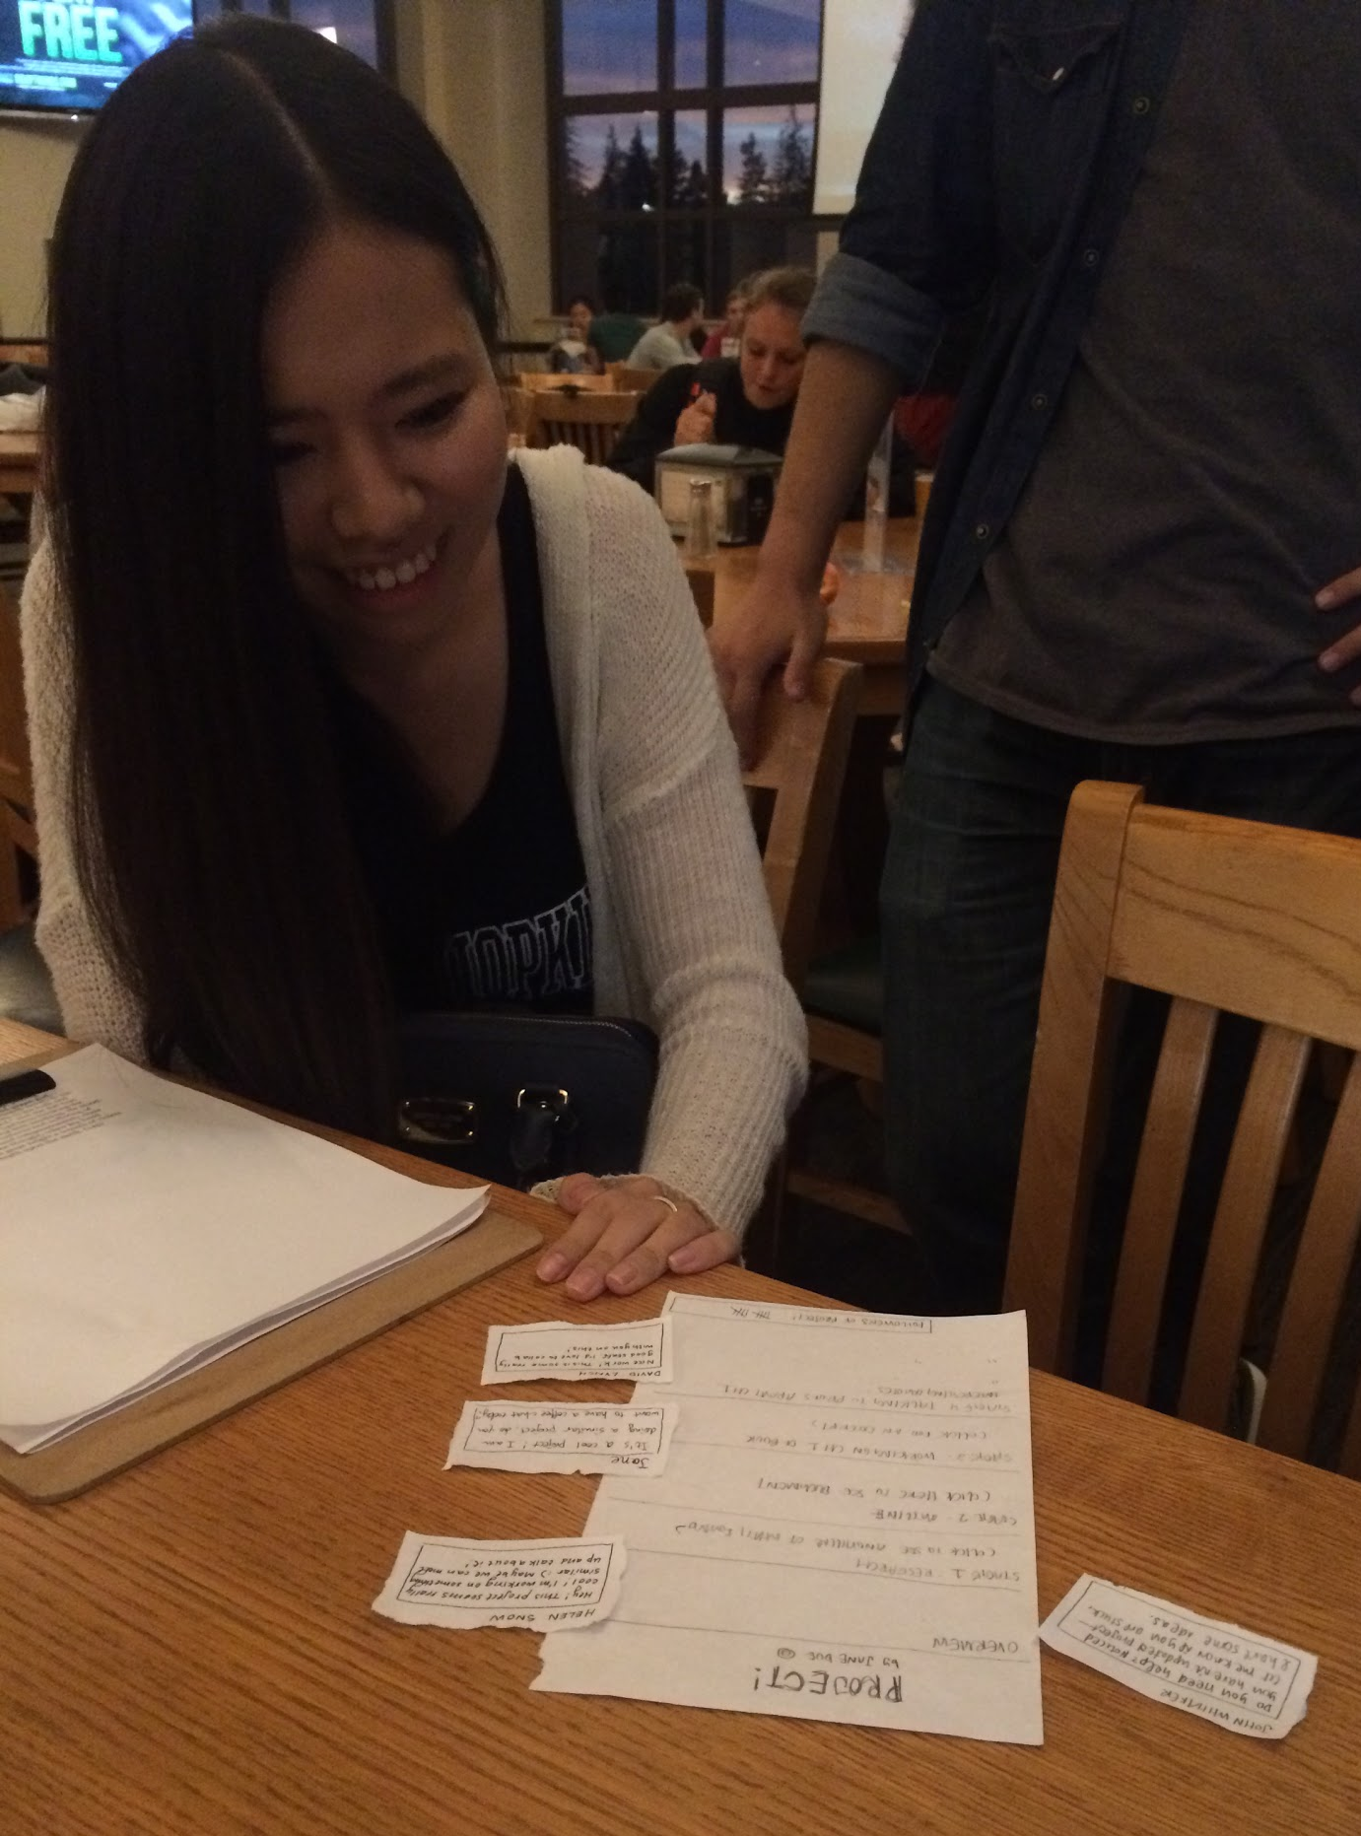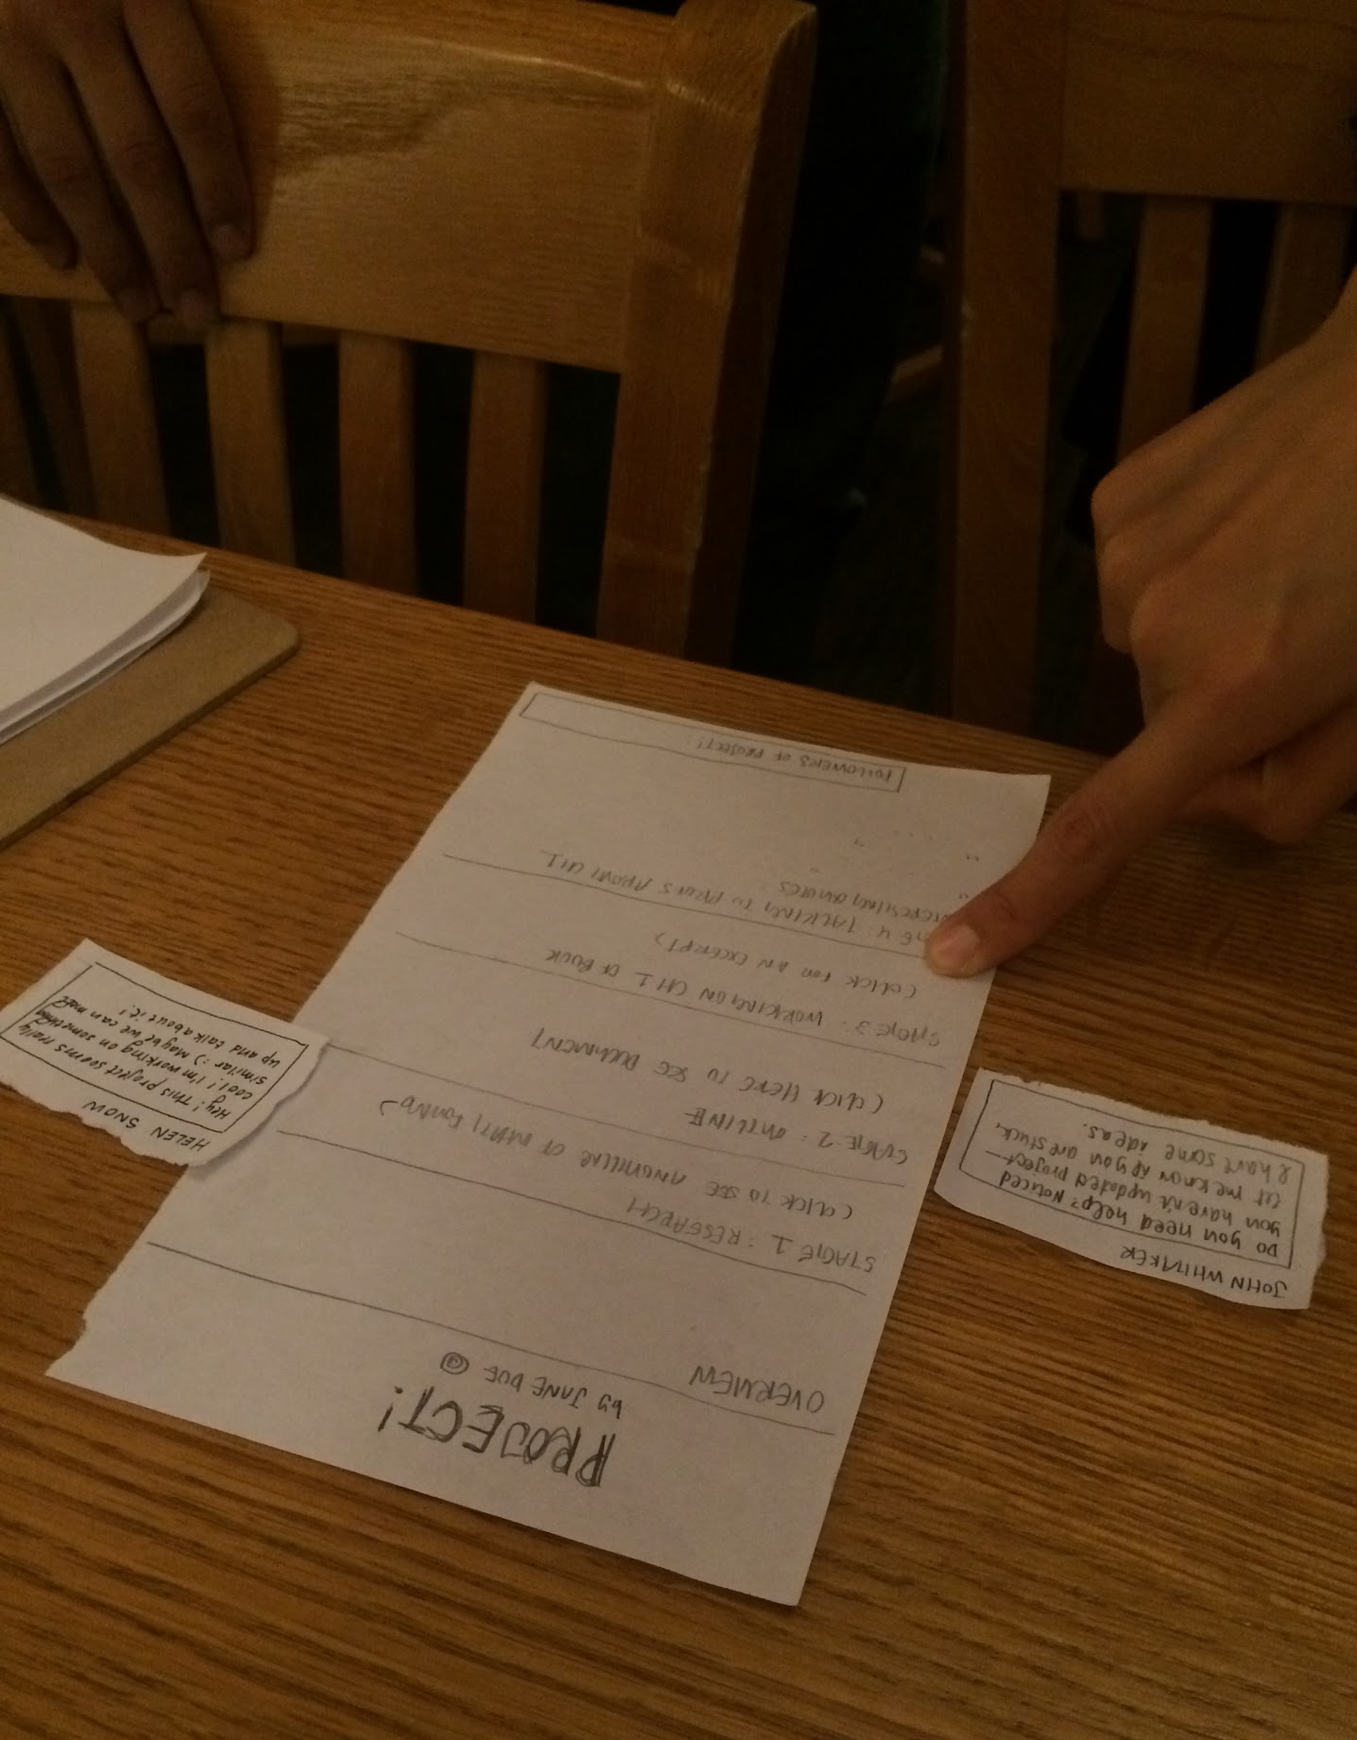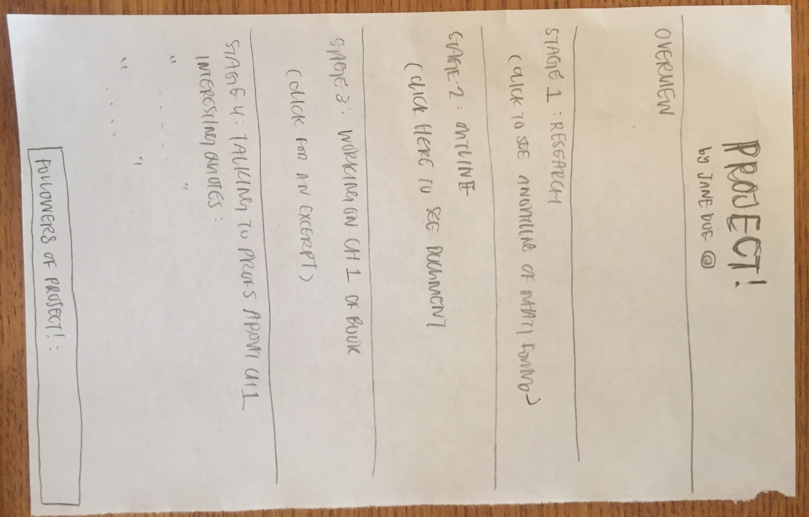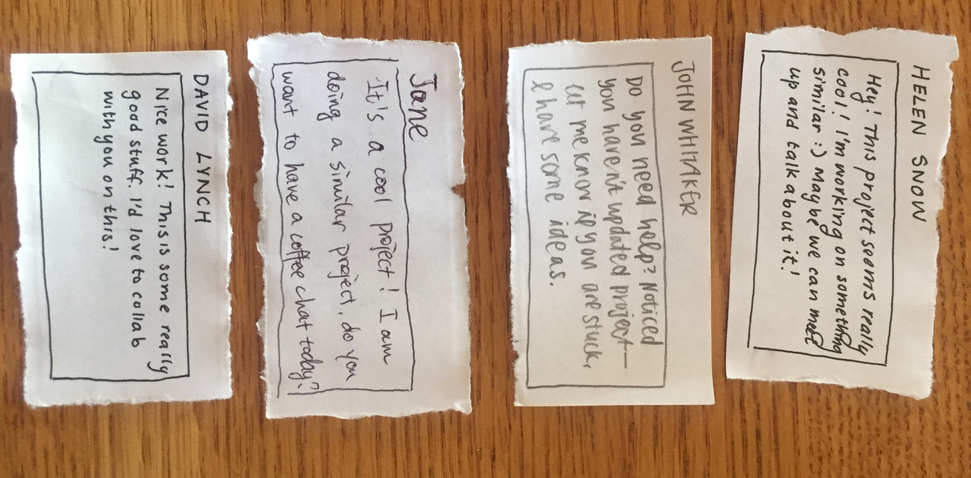
For this prototype, we assumed that users would be motivated by an audience, that there would exist people who would follow a user’s project, and that people would like to share their projects.
We tested our prototype on Sunny Jin, who works at Bank of America as a financial analyst. She browsed through and updated her project plan on a piece of paper, organized by different stages of progress, and then we created the experience of gathering a following and receiving comments and feedback. For instance, we “added comments” by placing post-its with filler comments (such as “let’s collaborate!” and “let me know if you’re stuck!”), and simulated follower accumulation by updating a tally mark at the bottom right corner of the page.
Our user found it motivating to gather followers and find potential collaborators through our prototype, and was also excited to participate as a commenter, verifying our assumptions.
She was, however, concerned about confidentiality. Users may be reluctant to share projects that have to do with work, works that may lead to future publication, or innovative ideas with lucrative outcomes. A dilemma would be, without sharing the most interesting parts of their work, followers may not be interested, but if users share their most interesting work, then the final work will lose its innovativeness because it has already been revealed.
We wonder if limiting the audience to a more exclusive circle will encourage people to share their projects. We also wonder if student users would be more open to sharing their work than professionals.
Most successful prototype
We found that the most successful prototype was the first one, in which we connected the short-term tasks to the long-term goals. Not only did the user find it useful, but he found that it taught him a different way of looking at his short-term goals. He was also excited about the summary report at the end of each day, and the trend report that simulated progress of different long-term goals across time. Ultimately, this prototype verified all our assumptions and was useful to our user, satisfying real needs.

