INNOVATION CHALLENGE
The Dating Game

Introduction
This summer we are going to investigate Dating. For our purposes, we define “dating” to be a form of courtship consisting of social activities done by two persons with the aim of each assessing the other's suitability as a partner in an intimate relationship. Currently, there are lots of tools designed to help people find partners, but very little has been designed that is focused on enabling the event: the date.
A lot of thought and energy goes into dating: figuring out where to go, what to do, what to ask, what to say; managing mixed emotions like anxiety, nervousness, shyness, excitement, caution, and deciding how much to reveal about one’s self and one’s past… all while trying to uphold a positive first impression.
Despite a wealth of tips and advice from friends, books, and the Internet, the everyday practice of dating can be confusing, difficult, challenging, unpredictable, and often soul destroying.
Who said that dating is supposed to be fun?


Dating After College/Graduate School
In college meeting single, interesting, compatible people can be relatively easy. On a college campus, there is a large population of similarly aged and interested people living and socializing in close proximity. However, most students are focused on keeping up grades rather than looking for someone to spend the rest of their lives with. When your college days are finally over, finding the right somebody can get really, really hard!
The choices seem fewer and unknown. There isn’t a single place where you are guaranteed to meet singles. Romance at work is sometimes frowned upon, the bar scene can be awkward, and online dating technology can create an obsession with finding the perfect match.
Where some succeed, others really struggle! DATING AFTER COLLEGE OR GRAD SCHOOL is the focus of our Innovation Challenge.
A Very Short History

Before the invention of dating, it was left to one’s family to decide whom you would marry and when this would occur. Chaperoned outings were the norm, the ultimate goal was not to find someone you could love, but to find someone who could help you bear children or increase the position of your family.

Over the years, dating evolved into an elaborate chain of events. In the 1950s, the boy would first ask the girl to go steady, then pin her once they had developed deeper feelings for one another, and eventually the two would be engaged and married. Of course, only with their parents blessing first!

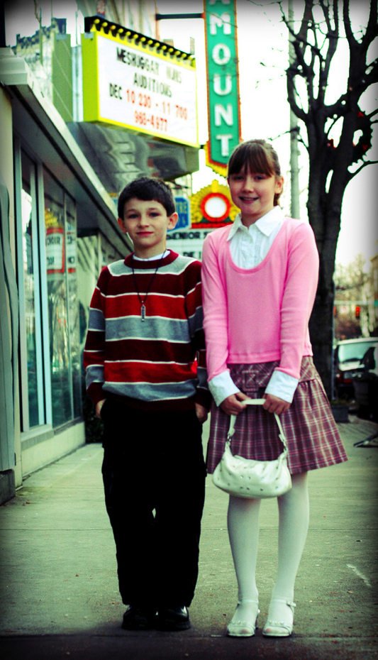

This idea gave way to the notion of popularity and status. Boys and girls wished to be seen with the right partners in the right places. By developing a reputation that one is in demand, one could better “climb the social ladder” and find an optimum mate.

The 1960s brought on a new feminist outlook, and with it way more choices for how the dating game could be played, as evidenced by the actual show The Dating Game, one woman would have the power to choose between many different male contestants competing for her attention.

The dating rituals of Americans changed significantly within the next 50 years when the evolution of the Internet opened our world to online and optimized dating. As far as today’s society is concerned, everything is better when it is easier, quicker and optimized. With today’s new technologies, there is no longer any shared dating ritual maintained by the mass population (especially after college). Most would agree that this makes things harder, not easier for finding a partner to fall in love with, settle down and live happily ever after.

Your Assignment

For your summer project, we’d like you to explore what it’s like to date after college or grad school. Tell us what couples really need and how we can better serve them. Together with your team, you’ll need to define a more specific area of focus for further exploration from your observations. Some possible areas of interest that may be relevant:

- Flirting: some are gifted at it, some are not
- Supporting shy people throughout the dating process
- Getting to know people meaningfully before eliminating them for the next ‘match’
- Positioning one’s self to new people while managing the baggage one may bring to the table (ex. “Don't talk about your ex or divorce settlement on the first date.)
- Humor: some are gifted at it, some are not
- Staying involved in dating over time, despite the discouragement that can surface
- In-person alternatives to online matching
- Environments and activities that support dating
- Creating work environments to support dating
- Making dating fun, not a depressing chore
- Designing for the expression “love finds you when aren’t looking for it”

To be successful in this project, you and your team will need to:

1. See the real world with fresh eyes, spend time with individuals and couples and try to deeply understand their world.
2. Bring back compelling stories, problems and other insights from your work.
3. Find a new perspective on how all this makes sense that suggests new opportunities to make people’s lives better.
4. Create a rich and diverse set of new product and service ideas to develop. These should encompass the world of DATING AFTER COLLEGE, with an emphasis on ideas that are different from what exists in the world today.
5. Present your work in a fabulously creative way to the class in one week.

Do

- Talk to new people, not just your roommates
- Use cameras, audio, video, and drawing to capture your observations.
- Understand how the needs of the specific daters that you study may apply to the larger world.
- Create products and services that solve real needs.
- Create mock-ups of your ideas as early possible.

Don’t

- Provide a rich description of dater’s lives that fails to be actionable.
- Be afraid to push the boundaries of what’s possible.
- Be afraid to fail or try something really “stupid”.
- Come up with another iPhone app

