INNOVATION CHALLENGE
Baby Steps

Introduction
Every year, 4 million new babies are born in America. The first years of life can have a tremendous effect on later success, as early childhood is when our minds and bodies are most rapidly developing. For parents, planning for and having a baby can be a rich and rewarding experience. It can also be extremely stressful, particularly for first-time parents.
Other contextual factors can change the experience of childhood. For instance, one in five children in America are born into poverty, which hinders the ability of some families to provide for their babies. Other children are raised by single parents, while others have an extended family raising them.
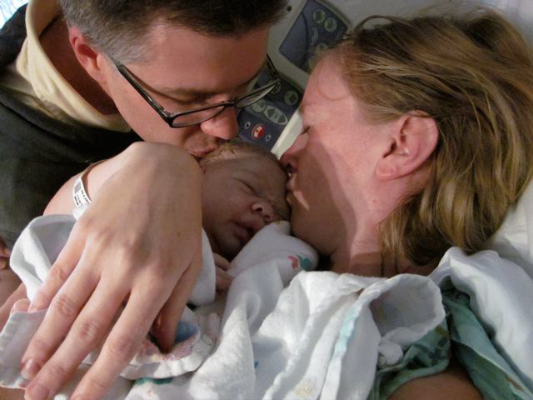

Regardless, having a baby is a life-changing experience. There’s so much new to learn. Parents will deal with feeding, nutrition, pooping, peeing, spitting up, bathing, sleeping, diapering, loving, fussing, crying, acting out, growing, health care, traveling, sharing, learning, keeping their marriage going, holding down a job, all while posting it all on Facebook. As new parents try to get a handle on this whole new world, they are also suffering physically with lack of sleep and strain on their bodies. It’s hard to be the parent of an infant!
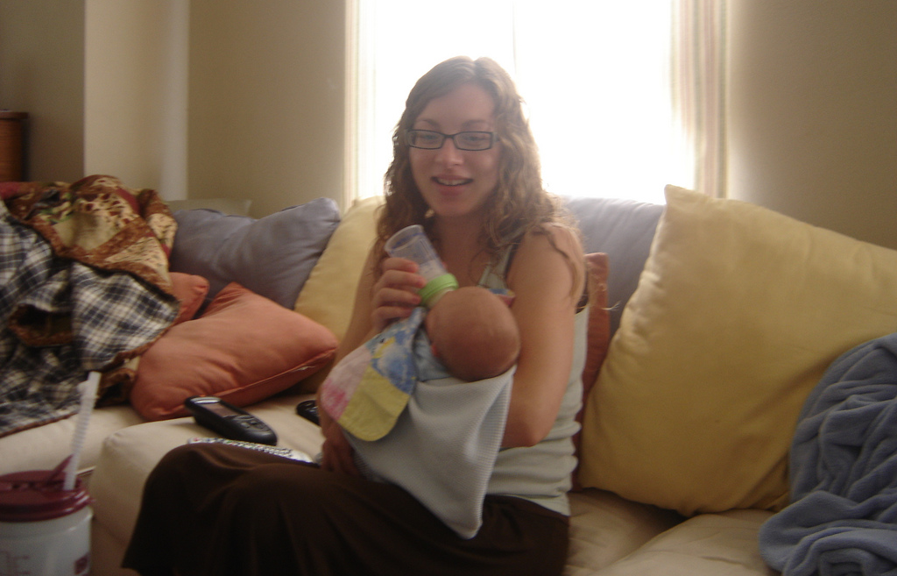

With access to the Internet, Baby Gap, Toys R Us, Day Care, Dr. Spock and Oprah we know a lot about our baby’s developmental milestones, but parenting in the twenty first century is still a tricky business. We can take our babies' survival pretty much for granted, and in this way we differ from all the mothers who have come before us. Instead, we worry about whether our babies will grow up to be happy and productive, a more complicated issue.


Your Assignment

For your summer project, we’d like you to explore what it’s like to care for an infant, from being a brand new parent to having a one-year old child. Tell us what parents and babies need and how we can better serve them. Together with your team, you’ll need to define a more specific area of focus for further exploration. Possible areas might include:

- What it’s like to be a first-time parent coping with the newest arrival
- What do you buy, who do you trust, what’s good what isn’t
- How do you juggle baby, life and work
- How do you survive the first 3 months
- How do you help a baby’s learning in the early stages of infancy
- What it’s like to be a family on a restricted income coping with a new baby.

To be successful in this project, you and your team will need to:
1. See the real world with fresh eyes, spend time with new parents and try to deeply understand their world.
2. Bring back compelling stories, problems and other insights from your work.
3. Find a new perspective on how all this makes sense that suggests new opportunities to make people’s lives better.
4. Create a rich and diverse set of new product and service ideas to develop. These should encompass the world of infant care, with an emphasis on ideas that are different from what exists in the world today.
5. Present your work in a fabulously creative way to the class in one week.

Do

- Get out into the real world, and spend extended time with real people.
- Use cameras, audio, video, and drawing to capture your observations.
- Understand how the needs of the specific family that you study may apply to the larger world.
- Create products and services that solve real needs.
- Create mock-ups of your ideas as early possible.

Don’t

- Provide a rich description of parents’ lives that fails to be actionable.
- Be afraid to push the boundaries of what’s possible.
- Be afraid to fail or try something really “stupid”.

Baby Steps
We are going to help you see parenting with fresh eyes, having you explore a number of people with different relationships to infant care, in a range of different contexts and situations.

