INNOVATION CHALLENGE
Let’s Get Fit!

Introduction
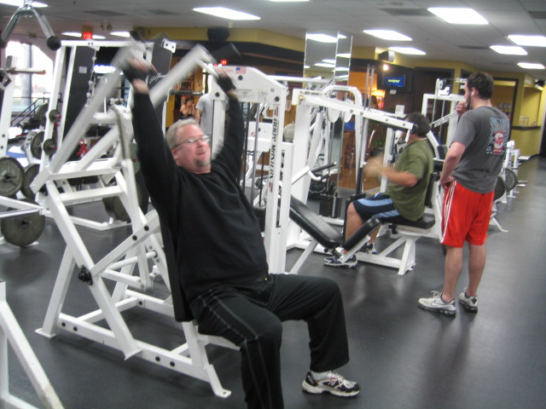
According to the American Heart Association, adults aged 18-65, should exercise 30 minutes a day, 5x a week. How many adults actually do this? As Americans’ waistlines continue to expand, you have to wonder why Americans aren’t pulling their weight in the battle of the bulge.

When you were younger, it was so easy. You showed up to Gym class and the time flew. Class was filled with games of dodge ball, kickball, flag football, and, oh yeah, exercise. Gym class was fun, fast, and healthy. It wasn’t exercise, it was just Gym.
So what happens? As adults, we are busy with jobs, families, responsibilities, and to do lists. Yet, some people establish daily routines that incorporate exercise. Why do others struggle to make the time? Some people run marathons, while others channel surf. Some attend yoga retreats, while others choose to sleep.
There is no shortage of offerings. In fact, the exercise options continue to get more creative. Whoever thought Cardio Strip Aerobics would count as exercise? There are legacy gyms that embrace the art of weight lifting and newer pilates studios ready to help you strengthen your core. You can learn to box, join a softball league, bicycle up mountains, or row in rivers.
While some people choose to make exercise an individual activity, others leverage the power of the group to stay fit. Team in Training has been successful in training nearly 400,000 participants over the past 20 years, from first timers to seasoned athletes, to run marathons, compete in triathlons, and race 100-mile bike rides. China also leverages the power of the group in cities across the country where exercise is a scheduled event. In Wuhan, a central China city, you can hear the music playing over loudspeakers each evening while hundreds of people partake in an evening dance routine in an outdoor park.


As people get busier and busier, time continues to become even more precious. Our challenge is to target those people who don’t make the time. Consider what it means that whole towns are on diets, video games like Wii fit are available at mass, and iPhone apps are ready to make your phone a personal trainer.
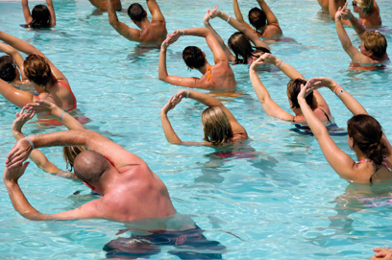

Is our answer then to simply motivate people and use Nike’s, “Just Do It” as the universal mantra to wellness? There is a big difference between exercise designed to optimize athletic performance and exercise that actually keeps one healthy. About half of people who participate in high impact aerobics experience injuries at least once a year. High impact competitive sports in younger people (especially gymnastics) may cause long-term degenerative joint disease. A recent study looked at members of health clubs, and found people who do intense workouts infrequently—once a week or less—are at greater risk for a heart attack. More than 10 million sports injuries are treated each year in the USA. How do we strike the right balance between exercise and health?
Exercise Your Mind
We are going to help you see exercise with fresh eyes, having you explore the needs of a number of people of different ages in a range of different contexts and situations. Here are a few conceptual sound bites to get you started thinking about the possible needs associated with incorporating exercise into everyday life.
Exercise is:
Energizing. Healthy. Fun. Time consuming. Inspiring. Routine. A mental break. Antidepressant. A release. A time to think. A time to not think. Social. Fun in the sun. Morning wake-up. Habit. A game. An addiction.
Your challenge is to help more people incorporate appropriate exercise into their everyday lives. Use the needs you to discover to help shape new opportunities and to create new products, services and experiences.



