INNOVATION CHALLENGE
Let’s Do Lunch!

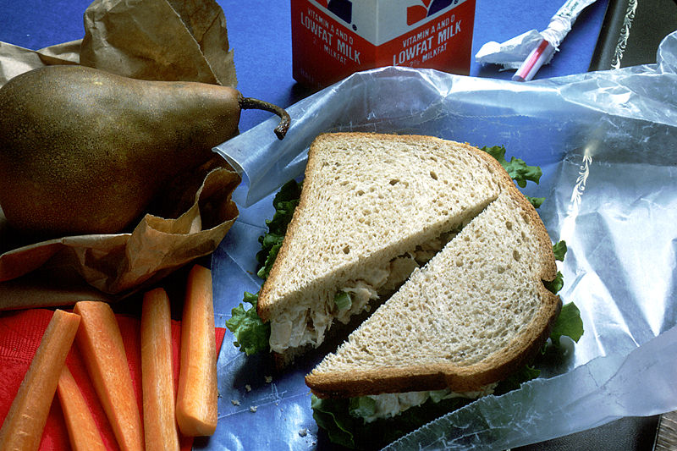
Introduction
Lunch is an everyday activity you probably know well but may never have given much consideration. In our culture this noon-time meal takes on many forms and has a broad range of values associated with it. Lunch is nutritionally important but can be an excuse for the most egregious of fast foods; it is usually scheduled but often overlooked; it can be a public venue for high-powered business deals or a private moment to hide behind a desk and recharge one’s soul. Lunch is both simple and complex, embodying some shared cultural universals but enabling many different individual behaviors and meanings.
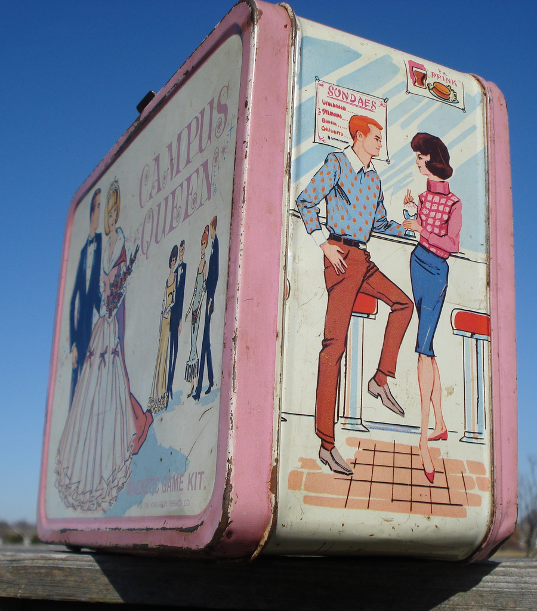
For many, your mother regularly packed a lunch for you to bring to school. You unpacked it precisely at noon with all your friends eyeing the culinary treasures within. The collection of edibles inside satisfied your hunger and possibly enabled you to sharpen your transactional skills; trading piles of your mom’s healthy, but dull carrots for a few indulgent Oreos. A symbol of this daily repast, the lunch box, probably sported a colorful image based on a favorite TV show or film, communicating to all around you some aspect of your emerging taste and identity. Your mom’s mission during the school year was to pack you a nutritious lunch every single day. Your mission was to get her to pack you the coolest snacks being advertised on Nickelodeon. Lunch is clearly more than nutrition at noon.
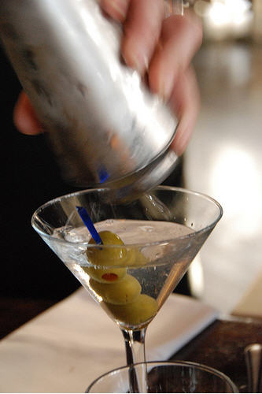
Some adults find themselves partaking in a grown-up version of lunch. Often referred to as the “Three Martini Lunch”, it represents none of the wholesomeness your mother used to pack for you in your lunch box. It is an opportunity to schmooze with your colleagues, your customers, or even your competitors. Networks are forged, alliances are made, and deals get done. It is a perk – a chance to put the meal on an expense account and go all out. Why stop at one martini when you can have three... The venue is just as important as the meal – Who will you see, and who will see you? And, who is going to pick up the bill? Although most people don’t drink a lot at lunch these days, power lunches are a great way to fortify a professional relationship. Let’s get down to business – Let’s do lunch!

Food for Thought
We are going to help you see lunch with fresh eyes, having you explore the needs of a number of people of different ages in a range of different contexts and situations. Here are a few conceptual snacks to get you started thinking about the possible needs associated with having lunch.
Lunch is:
Food. Basic sustenance. Indulgent luxury. A moneymaking industry. Subsidized for kids. Fast food. Slow food. Instant noodles. Caviar. Sausage. Peking Duck. Hamburger. 3 Martinis. Sushi. Cheese. Borscht. Microwave lasagna. Entertainment. Organic. Junk food. Tasteless. A walk outside. Functional. Salad bar. A creative inspiration.
Your challenge is to understand how lunch and its consumption fits into our current culture, to discover new opportunities, and to create new products, services and experiences to satisfy the needs you discover.

OBSERVATION LOCATIONS

- California Street
(Bernie & Kerry)

Group 1
  - KFC
  - Wahoo Fish Taco
  - Molly Stones
  - Harmony Bakery

Group 2
- Mediterranean Wraps
- The Counter
- Tandoori Oven
- Café Brioche
- Country Sun Natural Foods

- University Avenue
(Tina and Terry/Uri)

Group 1
- Pizza My Heart
- Starbucks
- California Pizza Kitchen
- Kan Zeman Restaurant
- Zao Noodles

Group 2
- Whole Foods
- Cheesecake Factory
- Prolific Oven
- Pluto’s
- University Cafe

- Stanford Campus Eateries (Charlotte and Michael)

Group 1
  - Y2E2 Grad Student Basement Kitchen
  - Clark Center
  - Main Quad – people eating lunch outside
  - Old Union

Group 2
  - Law School
  - Book store Cafe
  - Tressider
  - Arbuckle Cafe @ Business School
- Town and Country
(Nicole)

- French Café
- Village Cheese Shop
- Hobees
- Spot a Pizza Place
- Jamba Juice

- East Palo Alto
(Julian)

- Ikea
- Home Depot
- Taco Bell

