ABSTRACT
We are building a system that gets orientation data from mobile devices. This will be done by using tilt sensors and magnetic orientation sensors. We will build a few simple interface prototypes to verify the system. The sample prototypes will include augmented reality based virtual window and a gesture recognizing input methods for handhelds and wristPCs.
Gesture based input can be easier to learn and use in addition to just being more fun to use. These hypotheses will be examined through a comparative user study placing gesture based input next to traditional interaction of current mobile devices and measuring both qualitative and quantitative differences.

TASK ANALYSIS
The target user group is anyone who needs a more easier/efficient method to use mobile devices than traditional input methods. The current interaction method using a stylus or the limited number of buttons has limited the depth of interaction for most users. We are especially looking into lowering the barrier for the novice users.
They will need to use the mobile devices to perform certain tasks using both the traditional interaction methods and our new orientation-based method. More detailed task analysis related to the specific prototype will be stated in the ideation section.

IDEATION
1. Visualization on PC
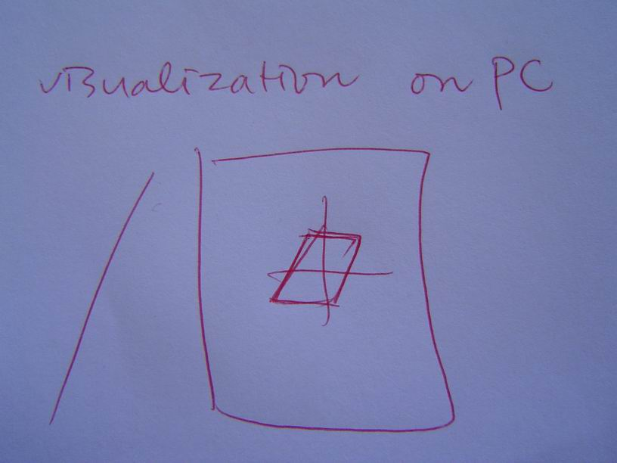
This is mostly for debugging purposes and making the development easier; the application will consist of a simple rendering of the PDA on the PC screen which will move in concert with the PDA in the real world. After getting all the orientation data (tilt and direction), we will display this on the PC to make sure we have interpreted the data correctly and to make it easier to use this data in other prototypes.
2. Debugging application on mobile device
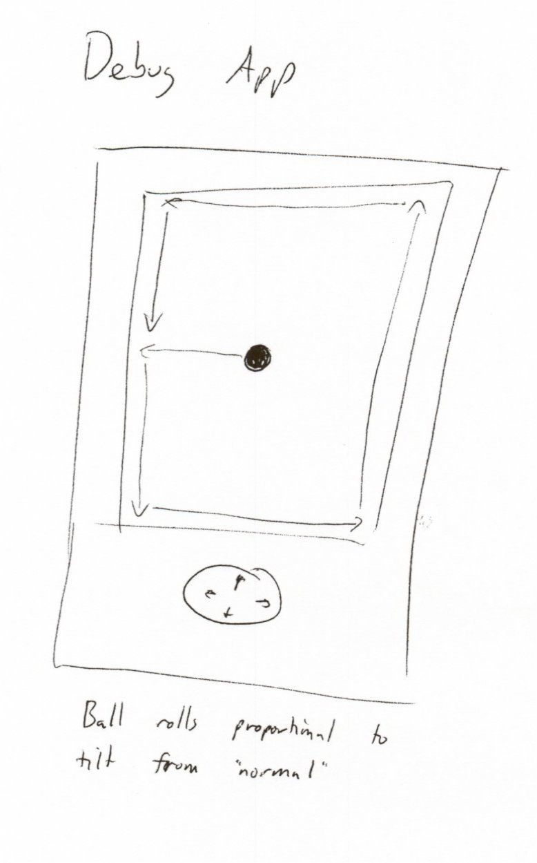
The simplest application on the handheld device to debug the tilting data. The ball will roll proportional to the tilting angle, and stops at the edges of the screen.

3. Marble Madness Game
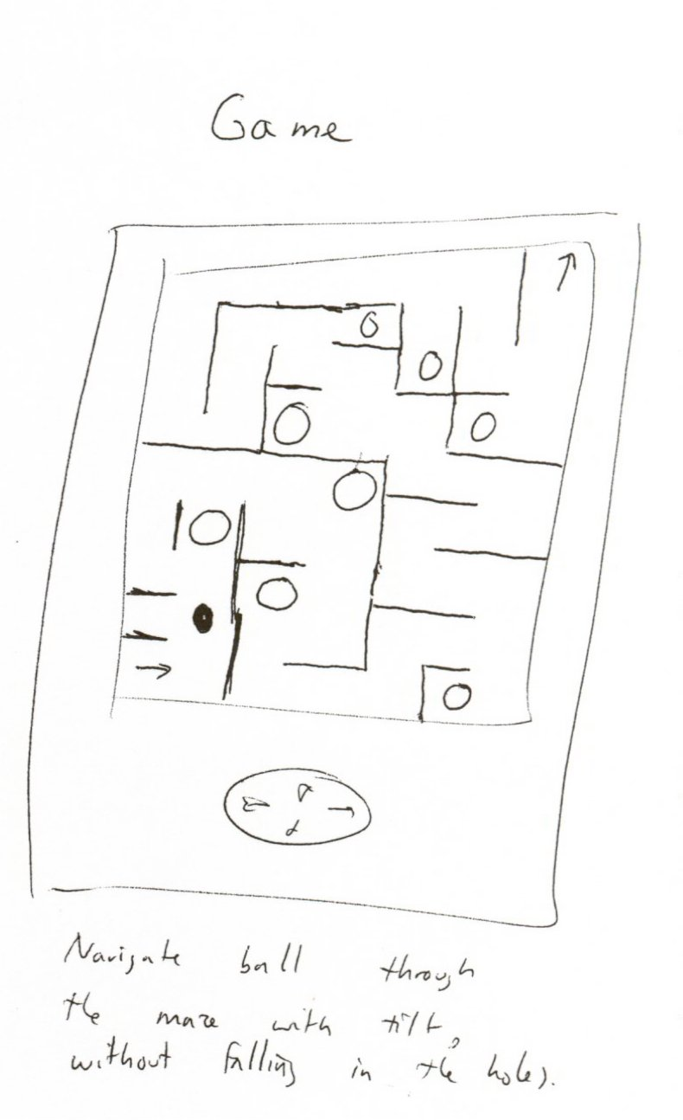
Navigate ball through the maze with tilt without falling in the holes; this is a simple adaptation of a common child’s game, and will provide us with the ability to test basic control skills—how fine-grained can users be with orientation, and how far can they roll the screen before it becomes difficult to see. Are the two compatible? (eg. if the screen roll limit is 10* but the user can only control orientation reliably to 5*, a reasonable tilt-based interface will be difficult to build).

4. Map
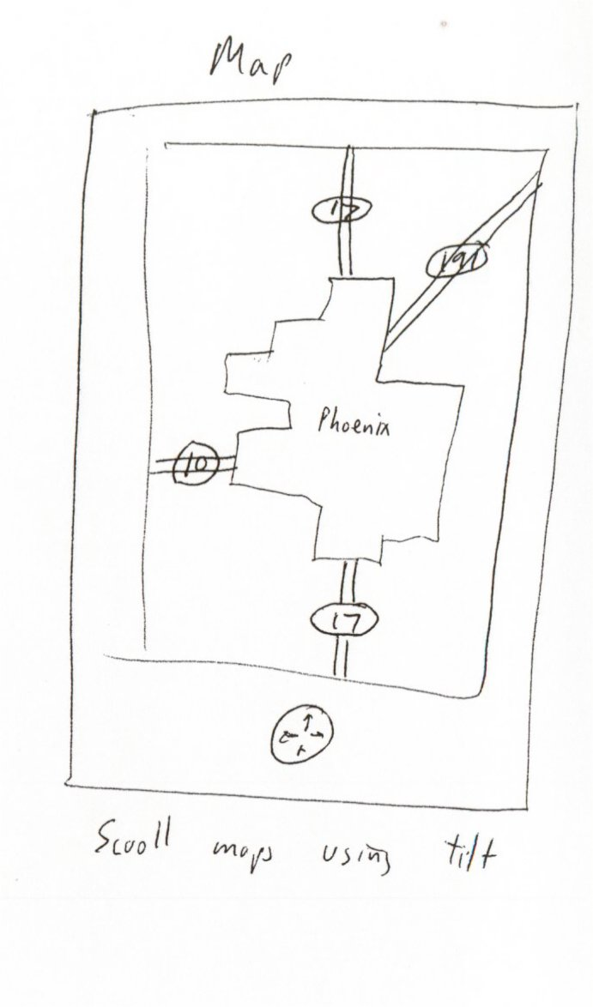
This application will be very similar to (3) under the hood, but implement a more realistic application scenario—playing games, while a very large market, is a seemingly “trivial” application. Navigation, on the other hand, is somewhat more respectable and will provide further data on how users like or dislike orientation-based interfaces.
5. Tilt to move, shake to click
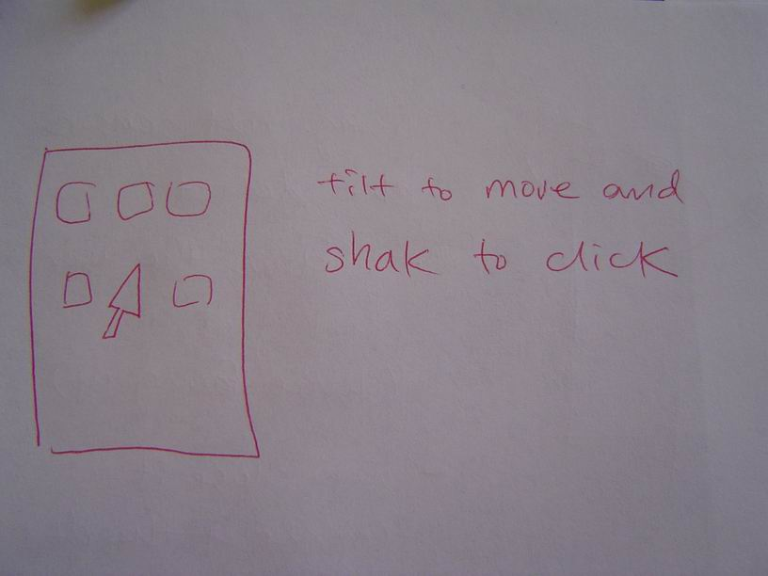
A simple menuing system based on orientation interfaces, we are debating trying to construct a selection mechanism that uses device orientation to move the cursor (tilt data), combined with a sharp shake or jolt to select items (gesture recognition). While we don’t believe this will be a popular interface, we think it could be fun to build and try out, possibly leading us down other interesting paths.

6. Gesture to flip pages / alternate windows
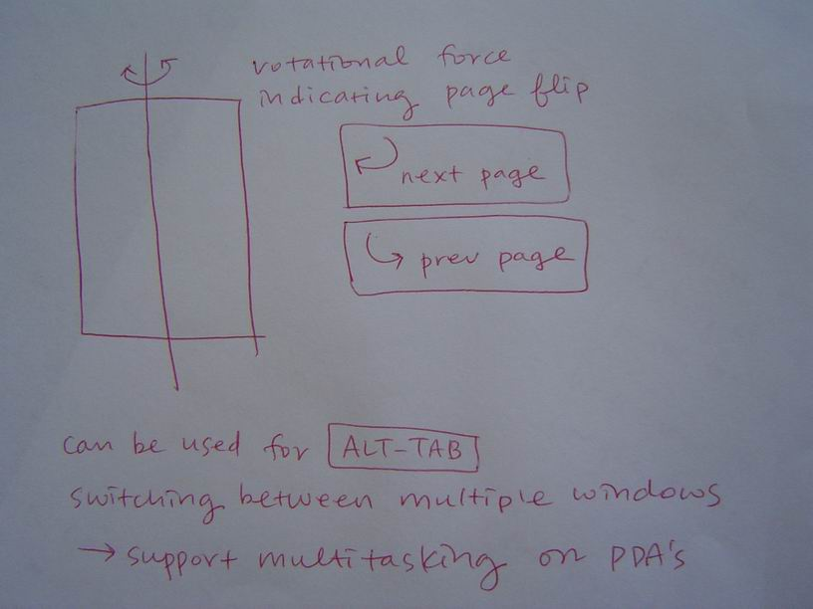
To flip to the next page or the previous page the user needs to rotate the device and come back to its neutral state. If you rotate the device in the same direction as you are flipping a book forward, you’ll get to the next page. If you rotate it in the opposite direction, you’ll get the previous page.
This can also be used to switch windows in the mobile device setting. As an alternative of ALT-TAB on a desktop PC.
7. Using tilting sensors to detect position of wrist strapped device 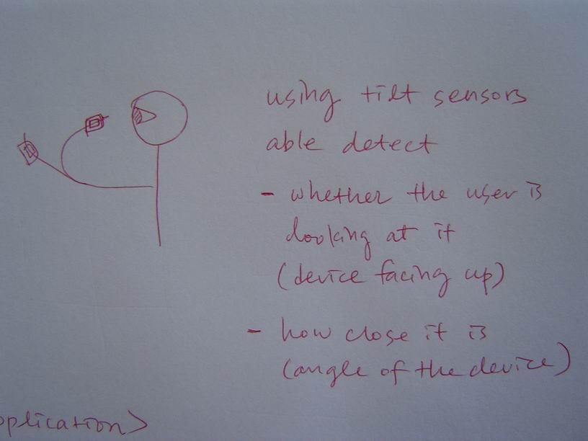
We might be able to guess of the user is looking at it or not by knowing if the display is facing up-right. This can be used to save power by turning off the display when you’re not looking at it. We can also guess how close it is from the angle the device is positioned at. This can be used to show different levels of information in different font size depending on the distance from the face to the device.
8. Virtual Window
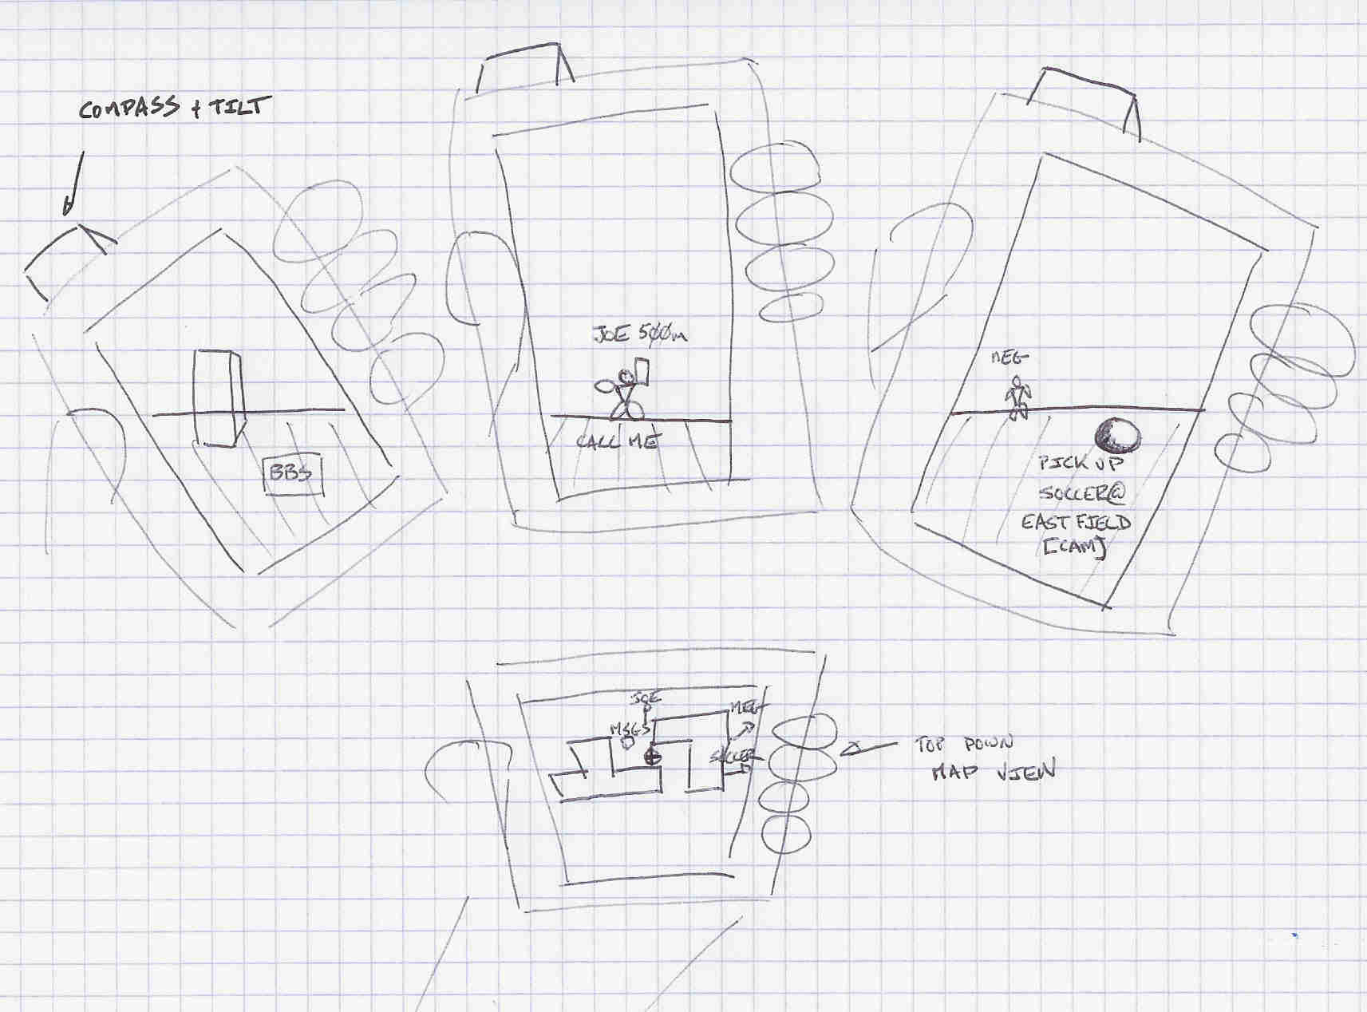
This is used to give 3D directional information to the user. If the device can detect the orientation (Tilt/direction) data and has positional data, the device would be able to display augmented reality data on the screen.
The interface design for the Virtual Window app is based on the Friends list feature in online games like Everquest and City of Heroes. A central server maintains a list of (in this case fictional) friends or points of interest with their locations (positions estimated by Placelab or GPS). The application presents the user with a menu and a 3D display area. The menu allows the user to select items of interest and request that the system display their position.
Once selected, the 3D display presents an icon in the 3D display area if the handheld is pointing towards the object. If the object is not within the display area, an arrow indicates which direction the user needs to turn.

EVIDENCE

Real world gestures such as flipping a page, bringing your watch closer to read or having a window are natural behaviors that users already know. If we use these real world gestures as a metaphor for input methods, we can make use of their prior knowledge to make it easier for novice users. Research on tangible interfaces or direct manipulation has verified this concept. (Schneiderman, Ishii)
We have also had some initial user interviews talking to users. That using a stylus or softkeys have been cumbersome in a real “mobile” setting where they were not sitting down. Users liked the idea of simple and quick interaction of our applications. However they also gave feedback that it should be only used in simple communications and would be even more cumbersome to use in complicated interaction.

FURTHER EVIDENCE
We will continue to get informal user feed back in the process and confirm the direction that we are going. We will also look into more literature that has successfully used real world behavior as a metaphor for interaction methods for further idea development and confirmation of concept.

EVALUATION PLAN
We are still in the early development stage for this application and the idea won't be ready for testing on a large number of users in the next three weeks. For this class, "testing" will mean trying the application out with a focus group of about five users from the class and getting their feedback with videotape and a questionnaire to address the hypothesis. It's almost certain that the application will need more work to fix problems identified with this first round of testing.
After the quarter, we wish to conduct a formal user study to get a quantitative verification on our hypotheses.

IMPLEMENTATION PROGRESS
To date we've built the following embedded hardware for tilt and orientation sensing and the infrastructure to get data from the computer to handheld devices.

The tilt sensors use a 3-axis accelerometer using Analog Devices ADXL202E as described in the project proposal. This system works fairly well after software low-pass filtering and has a time constant of a few Hz, which is suitable for tilt-type sensing. Higher-frequency information is available at the expense of some jitter on the data set. The appropriate filter bandwidth for gesture-based applications is something that needs to be tuned.

The tilt sensors have a static offset and require some calibration at the "factory". This can be hidden from the user, but might need to be exposed to a developer.

The magnetic orientation sensing uses a 3-axis magnetometer. Each axis of the local magnetic field is sensed with an HMC1001 sensor. The low signal level of the magnetometers is amplified by a 30x before being passed to the A/D converters. One nice feature of the HMC1001 is that the polarization of the magnets can be flipped with a set/reset circuit. The embedded microcode makes a field measurement with each polarization of the sensor and takes the difference, canceling out any static offsets in the sensor and amplifier. This means that the magnet calibration routines are more robust than the accelerometer’s.
The magnetometers provide fairly stable readings as long as they are away from a disturbance. Experiments have shown that metal parts in furniture (desks/table tops) have significant magnetic fields. We believe we can detect these disturbances and report them to the user, though we don't as yet have any concrete experience with this.

One change in the hardware side from the proposal is that we are using a laptop with 802.11 networking instead of Bluetooth to transfer data to the handheld device. The bluetooth solution required additional hardware, and ultimately did not save any cables. An advantage of piping the signals through the laptop is that we can do debugging in that environment as well as on a handheld device.

One limitation is that we have only a single prototype right now and several applications that need to share it for development and testing.

