**Visually Presenting Expected Ranges with Measured Data in Commercial Building Systems Supports Energy Optimization**

|  |  |
| --- | --- |
| Matt Garr  Stanford University  Civil & Environmental Engineering Department  Stanford, CA 94305  mattgarr@stanford.edu | Matt Sencenbaugh  Stanford University  Computer Science Department  Stanford, CA 94305  msencenb@stanford.edu |

# ABSTRACT

As buildings are responsible for 74% of US electricity and 39% of total energy consumption, monitoring and optimizing their energy use has received increased attention. A number of software tools have been developed for analyzing energy performance through data visualization. However, the tools do not effectively present measured data nor expected or optimal operating conditions, leading to high cognitive loads for the energy analyst and extensive reliance on domain expertise. This paper outlines a method for visual co-presentation of expected and measured data for one system in a commercial building. It also claims that methods of co-presentation providing contextual ranges better support energy analysts in making recommendations for improved system performance.

**ACM Classification:** H.2.8 [Database management]: Data and knowledge visualization.

**General terms:** Design**,** Human Factors, Management, Measurement, Performance , Reliability, Experimentation.

**Keywords:** Energy management, data visualization, commercial buildings.

# INTRODUCTION

Buildings are responsible for more than 39% of US energy consumption [1], representing a major contribution to greenhouse gas emissions. A major fraction of this consumption is due to Heating, Ventilation, and Air Conditioning (HVAC) systems that are seldom properly commissioned upon construction and whose performance degrades as buildings age. Major opportunities for reduced energy use lie in troubleshooting and optimizing HVAC systems.

Energy managers, responsible for HVAC operations spend much of their time working in a purely reactive mode, ensuring that buildings are operating just well enough to avoid occupant complaints and system alarms. As a result, opportunities for increased efficiency are seldom investigated.

Permission to make digital or hard copies of all or part of this work for personal or classroom use is granted without fee provided that copies are not made or distributed for profit or commercial advantage and that copies bear this notice and the full citation on the first page. To copy otherwise, to republish, to post on servers or to redistribute to lists, requires prior specific permission and/or a fee.

Today, energy managers increasingly have access to a wealth of building energy performance data, provided by more extensive sensor networks and data monitoring and logging systems. Therefore, the opportunity exists to make better diagnoses of building performance. However, these data are typically neither expressively nor effectively [3] presented in visualizations that allow the energy manager to compare expected with actual performance.

In this paper we investigate the question: what visual representations can expressively and effectively present building system expected and measured performance such that energy managers can diagnose problems and make recommendations for improved performance?

A number of systems for visualization of building system performance data have been proposed and prototyped. The BuildingEQ project set forth a prototype tool and data analysis guidelines, but users cited extensive time and domain expertise required to analyze large amounts of data. [2]

Others, such as O’Donnell et al., cite a necessity of domain expertise in analyzing system performance but do not invesigate how a system can express expected conditions that are typically locked in the heads of domain experts. [4]

# EVALUATION

To begin, we ran a pilot study designed to test various methods of presenting expected performance as compared to measured data. Specifically, we investigated the use of written vs. visual presentation of expected operating conditions, and presentation of data in different visualization formats.

Subject responses to our pilot study did not have statistical significance, but open-ended responses helped us develop two hypotheses:

**H1:** Subjects will more accurately diagnose operational errors when supported with preprocessed information than when presented with expected operational ranges.

**H2:** Subjects will more accurately recommend changes to system operation when presented with expected operational ranges rather than preprocessed information.

We designed a second experiment to test these hypotheses creating four graph-based analysis cases as shown in . Cases 1 and 3 were designed for effective diagnosis as the data are color-coded to encode correct / incorrect operational status. However, they lack expressiveness in conveying the full range of acceptable operating conditions.

In contrast, cases 2 and 4 were designed to express the full range of acceptable operating conditions. We expected that case 4 would be more effective in conveying correct operating conditions due to its use of redundant encoding (green color combined with direct overlay used to convey expected operating conditions) as compared with the single encoding in case 2 (comparative slope, not co-located with measured data).

## Method

Eleven students enrolled in Civil Engineering 243, *Predicting and Measuring Building Energy Use* at Stanford University participated in the study. We chose this group of students over a random sample because we expect that their domain expertise and experience analyzing building performance data will allow our results to better generalize to the community of professional building energy managers.

The study was structured as a within group study where subjects were asked to analyze four graphs, shown in , displaying the operational status of a valve over time. For each graph they were required to diagnose correct system operation, identify error conditions by circling areas on graphs, and make recommendations for operational changes. The subjects also answered three questions about each graph on a five-point scale (shown in ) and were given the opportunity to comment on any additional data, graphs, rules, or diagrams that would have aided them in the analysis process.

We also collected self-reported data on the subject’s knowledge of mechanical systems in buildings and degree of reliance on previous experience in completing the exercise.

## Results

Our results suggest that preprocessed data does not help with diagnosis (counter to H1) and that presentation of expected operational ranges supports more accurate recommendations (supporting H2). The evidence supporting these findings is as follows:

Case 1

Case 2

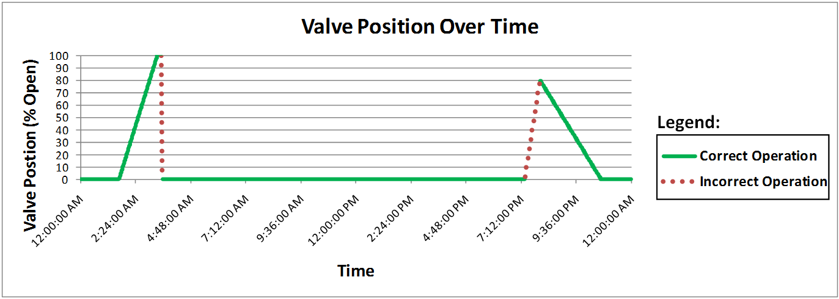

Case 3

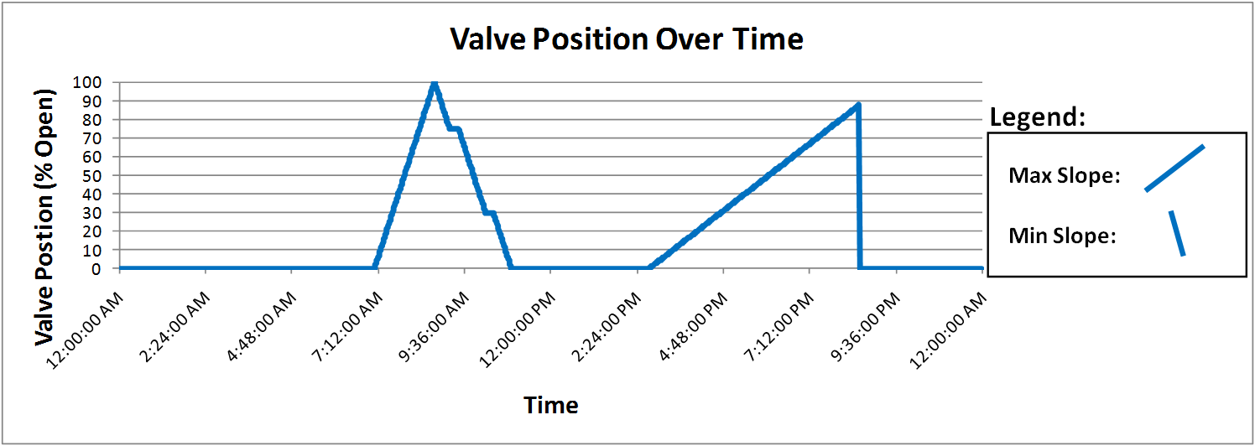

Case 4

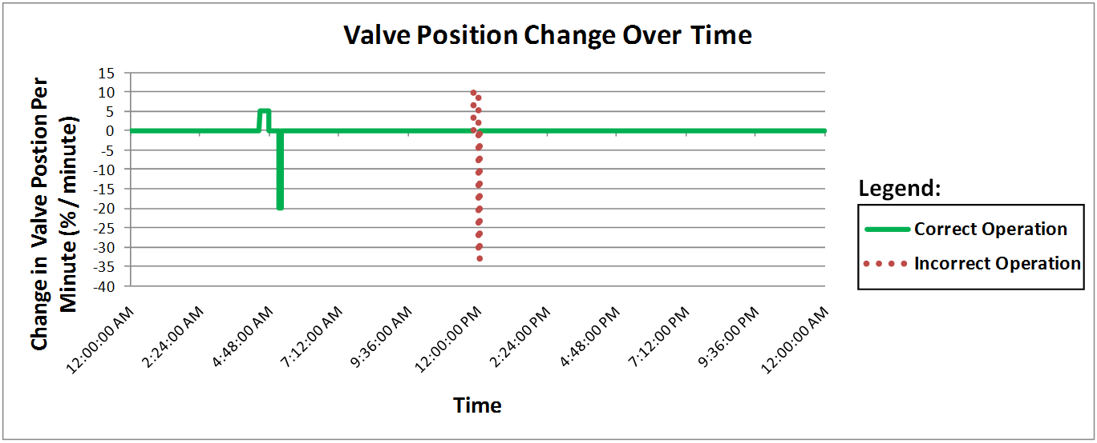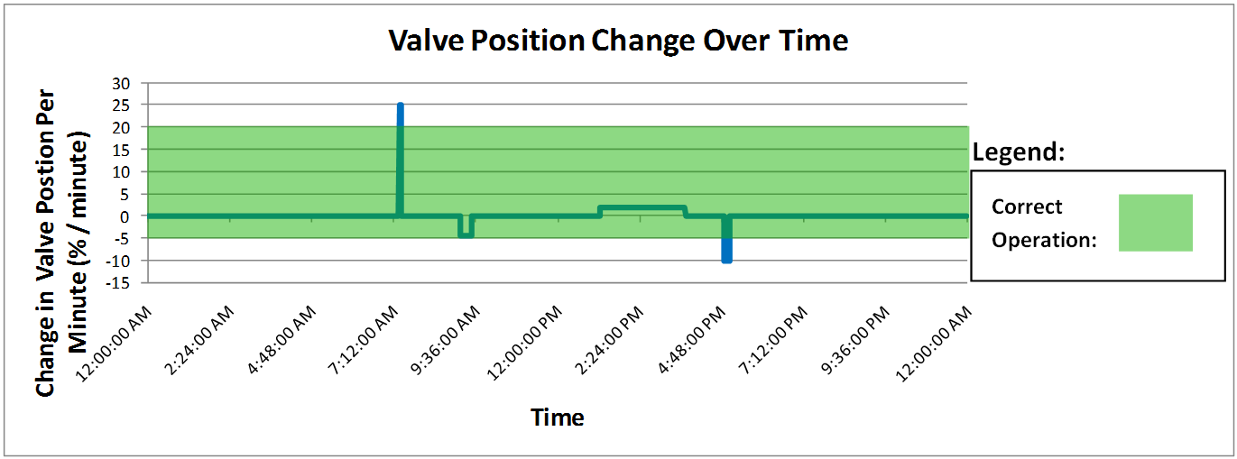

Figure : From top to bottom, experimental cases 1-4. Cases 1 and 3 used a color code to explicitly indicate correct or incorrect operation (dotted line was added for clarity in black and white printing and was not seen by the subjects) while cases 2 and 4 employed visual representations of expected operating range superimposed on measured data.

Counter-intuitively, subjects were less successful in diagnosing errors in both cases when presented with charts where color code explicitly indicated correct or incorrect operation (μ = 0.82, n = 11 for both cases 1 and 3) than when presented with visual representations of expected and actual conditions (μ = 0.91, n = 11 for both cases 2 and 4). These results are not statistically significant (P = 0.56 both



Table : Experimental results from user experiment. Results are presented in the format: (mean (SD, n))

when comparing case 1 with 2 and 3 with 4) but warrant further investigation.

Of subjects who successfully diagnosed the valve operation, there were still errors made in identifying the error itself. In this situation, the error rate varied with graph presentation. In cases 3 and 4, subjects were most successful (μ = 1.0, n = 7 and μ = 1.0, n = 9, respectively). In case 1, one subject did not successfully identify all error conditions (μ = 0.89, n = 9), and in case 2, four subjects failed to do so (μ = 0.61, n = 9).

Subjects more successfully made recommendations for adjustments to system operation when presented with visual representations of expected and actual conditions (μ = 0.45, n = 10 for case 2, μ = 0.45, n = 11 for case 4) than when presented only with color-coded correct and incorrect operation (μ = 0.23, n = 11 for case 1 and μ = 0.18, n = 11 for case 3).

Subjects found it easier to make recommendations for improved system performance in cases 2 and 4 (μ = 3.11, σ = 1.05 for case 2 and μ = 3.90, σ =1.20 for case 4) than in cases 1 and 3, when only presented with preprocessed data (μ = 2.27, σ = 1.27 for both cases 1 and 3). Comparing case 1 and 2 yielded P = 0.077. Comparing 3 and 4 yielded P = 0.049; we did see significance comparing 3 and 4.

## Discussion

**H1:** Surprisingly, we found that our subjects were not better at diagnosing correct performance in cases 1 and 3. We expected that directly encoding correct / incorrect performance with color would make for an effective presentation and lead to accurate and easy diagnosis. This may suggest that simple diagnosis tasks are better left to automated systems than to unreliable human analysts.

**H2:** As we suspected, our subjects made more accurate recommendations based on cases 2 and 4. This is likely explained by the fact that range of expected values is more expressive of desired performance than a simple correct / incorrect encoding.

While recommendation accuracy was equivalent between cases 2 and 4, our data suggest a difference in effectiveness between the two cases. On average subjects found that it was easier to diagnose correct operation and determine appropriate changes to valve operation for case 4 than for case 2 (μ = 4.73 vs. 3.05, P = 0.0001 for ease of diagnosis and μ = 3.90 vs. 3.11, P = 0.15 for recommendations).

In follow-up questions, subjects reported difficulty interpreting case 2 (“It was hard to eyeball slope from legend to chart” and “I’m thoroughly confused. I had to slide another piece of paper around to estimate the slope in the legend”) while praising case 4 (“I really like this green box” and “Best so far!...it should allow for easy interpretation if you want to be able to identify what to change—not do the interpretation for you”).

We suggest that of the cases considered in this study, case 4 is the most expressive and effective presentation of expected operating conditions and measured data. Such a presentation is well-suited to the building energy manager who is highly time-constrained and will therefore not have the time to consider less-effective representations.

# Directions for Future Research

Our conclusions about effectiveness relied upon self-reported experiences. To better quantify the effectiveness of various visualization techniques, research designed to measure cognitive load is recommended.

While our study makes a broad claim that visualization for building system performance must be effective and expressive, our study is limited to one data type. To design whole-building analysis tools, research involving more effective visualization strategies for various data types encountered in commercial building systems is needed.

While our study suggests certain results, our small sample size prevented us from reaching statistical significance in hypothesis testing. A larger study would more concretely test the hypotheses.

# Conclusion

To address the challenges that energy managers face in comprehending and leveraging the large amounts of data collected by sensors in commercial buildings for better energy performance, we investigated visualization strategies that support this task.

In studying two hypotheses we found that our subjects were better able to both diagnose correct system operation and make recommendations for improvements when presented with the expected range of conditions than with preprocessed information alone. However, within the more expressive cases (2 and 4), we identified a difference in effectiveness. We found that a double-encoding (case 4 – spatial and color) leads to easier and more accurate analysis than a single, non-co-located (case 2 – slope comparison) encoding.

Our findings can be used directly to help improve tools for energy analysts, and indirectly as a springboard for future research in the field.

# REFERENCES

1. *Buildings Energy Data Book*, U.S. Department of Energy, Washington, DC, 2008.

2. *Description of European Prototype Tool for Evaluation of Building Performance and the National Tools*, Intelligent Energy - Europe, 2009.

3. Card, S.K., Mackinlay, J.D. and Shneiderman, B. *Readings in Information Visualization: Using Vision to Think*. Morgan Kaufmann, 1999.

4. O'Donnell, J., Keane, M. and Bazjanac, V., Specification of an Information Delivery Tool to Support Optimal Holistic Environmental and Energy Management in Buildings. in *SimBuild 2008*, (Berkeley, CA, 2008).