**Prototyping for Musicians**

***Thu Cool:***

Nathalia Scrimshaw, Thu Ngo, Marilyn Harris, Jamison Searles

Assignment 2

CS 147, Focus Studio

**Part I: Needfinding, Cont.**

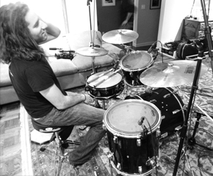

**Initial POV: Brian**

*Drummer by night and electrician by day, juggling a full-time job with a private studio of drum students, two ensembles, a hectic gigging schedule, and building his network of venue hosts and fellow musicians so that eventually he can make a living as a drummer and professional musician.*

**Additional Interviews**

Eric: Classical Pianist and Composer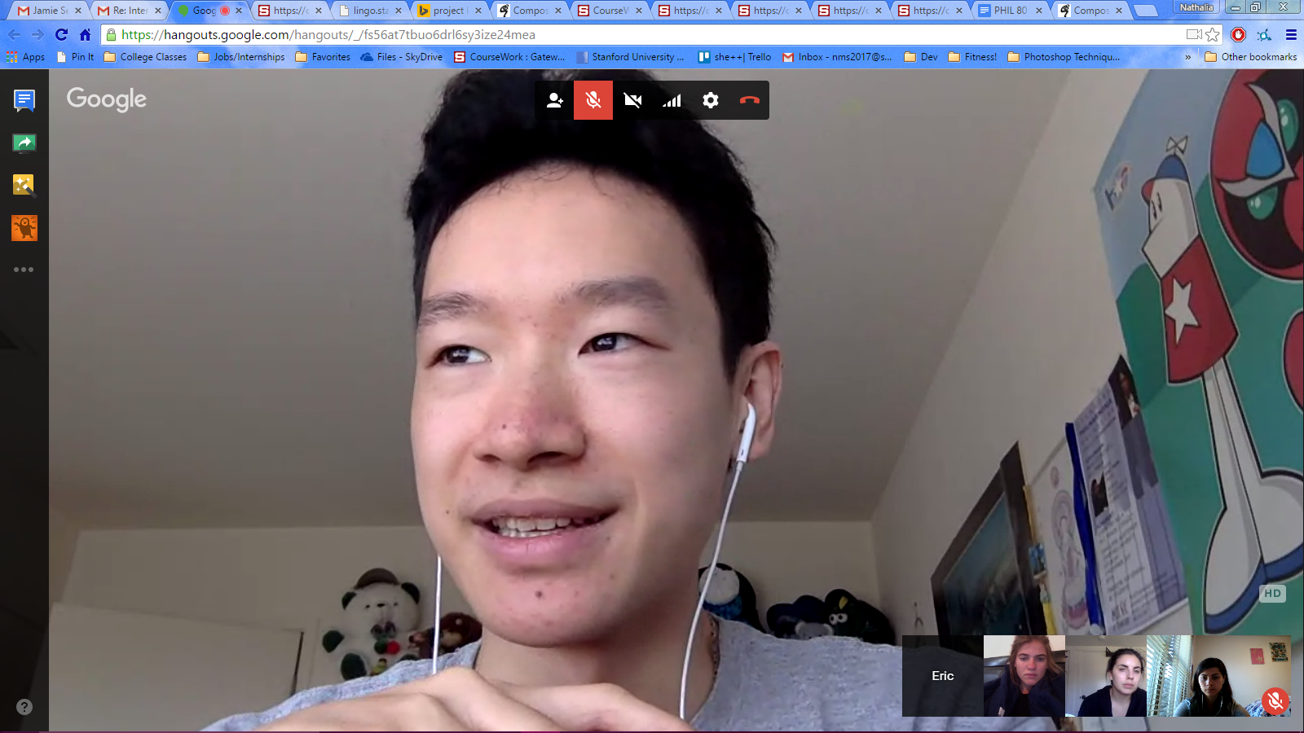

Eric, a Stanford undergraduate who just finished his Masters at the SF Conservatory, is living at home this year and freelancing as a musician while he contemplates pursuing a PhD or continuing his freelance work.

Key insight: **Self awareness and mindset are foundational to Eric’s success as a musician.**

**Eric remembers with great clarity his moments of greatest personal disappointment, but has also learned to develop a mindset that helps him bounce back from moments of perceived failure.** He described his junior recital as “terrible...my worst performance, maybe of my life,” but since then has noted he as adopted a mindset of “Accepting that things get better and worse, and not being too hard on yourself, being kind to yourself.”

**Understanding your own psychology and how it relates to your practice as a musician helps Eric to be more successful in the practice room:** He understands his external and internal motivations: to help him stay on task during rehearsal on a day-to-day basis, he sets himself a medium-term, ambitious goal to drive him to invest the hours in the practice room that will translate to success in a performance.

Joel: Conductor, Singer, Composer

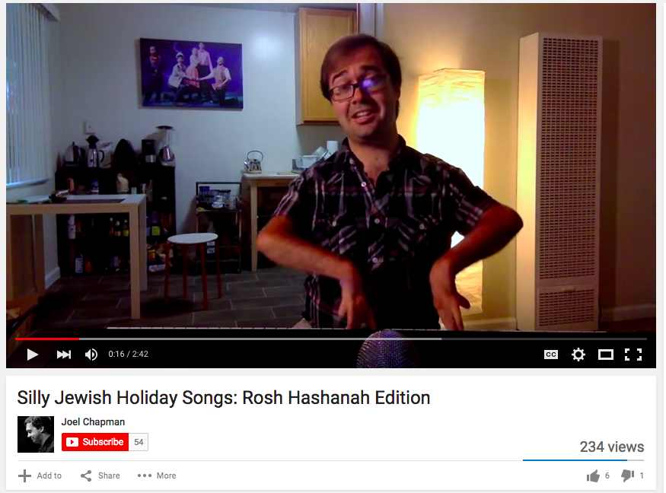

Joel is a recent Stanford graduate with a Masters in Music Technology. In addition to trying to establish himself as a Conductor, Joel sings in a contemporary semi-professional choir *Volti* and is a composer.

**Key Insights:**

* **Singing is distinct from other instruments: because your body plays an integral role in your sound production, emotions deeply affect your ability to perform.** Says Joel, "I've found that singing...can really get you down more than other instruments, just because when you're not succeeding, it's your own body…there's a bigger element of failure and a necessity for resilience for singing versus than from other instruments.”
* **If you are in a highly technical field of music, you have to find a way to make peace with the perfection the discipline demands.** Joel noted that “it can be unhealthy to fixate on that perfection.” For him, adopting a growth mentality and approaching bad performances with the knowledge that it was a learning and growth experience help him to remain optimistic and keep moving forward.

**Part II: Revised POVs and HMWs**

After taking into account all of our interviews, we generated three revised point of view statements:

1. AMANDA: A part time musician in San Francisco, who needs to balance her time and resources as a parent and performer because although she loves performing, she has other responsibilities to her family. It would be game changing if we could provide more resources for her so that she has to work less and can focus her time on performing and practicing.
2. BRIAN: A full-time electrician and part-time musician with a packed schedule who needs to network with other musicians and venues so that he can transition to making a living full time through his music. It would be game changing if we could make it easier for him to connect with other musicians, generate leads for gig opportunities, and help him find more time to practice and hone his craft.
3. ERIC: A San Francisco conservatory graduate, classical pianist and composer who, despite the highly technical and demanding nature of his instrument, maintains a balanced attitude towards the ups and downs in a musician’s career and knows how and when he needs to validate himself on an off day. It would be game changing it we could help other musicians develop Eric’s mindset so that they can build resilience.

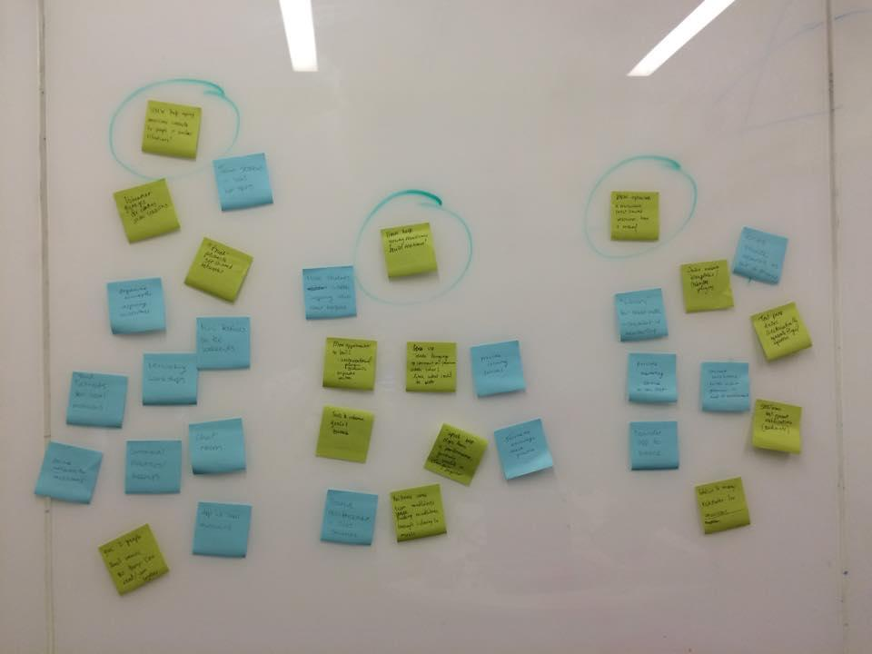

We brainstormed a broad list of “How Might We” statements for each of these POVs....

|  |  |  |
| --- | --- | --- |
| Amanda | Brian | Eric |
| * help musicians build community? * connect musicians to private practice spaces? * find free resources for musicians? * help get children more interested in music? * organize low pressure performing venues? * provide more resources for struggling musicians? * make raising a child less time consuming? * give aspiring musicians capital so they can just focus on developing their career? * make the hustle more energizing instead of frustrating? * find family friendly performance venues? | * allot more time in a musicians schedule to practice? * create common networking spaces for musicians? * create bigger fan bases for new musicians while helping those musicians build their networks? * improve communication between musicians? * help musicians reach new audiences? * help coordinate a teacher’s schedule with teaching and practicing? * make it easier for performers to get their names out? * help aspiring full time musicians build networks? * connect musicians to venues that need performers? * reduce the amount of networking needed to become more popular? | * validate musicians who were nervous about performances? * improve mistake recovery? * help musicians deal with negative feedback? * keep musicians focusing and out of flow state? * help reward young musicians for focused practice time? * help musicians deal with feedback in a positive manner? * integrate positivity into rehearsal structure? * change the way musicians view failure? * provide resources to look at each musician’s performance? * challenge musicians to work towards goals instead of performances? |

**In the end, these were our best 3:**

BRIAN wants to expand his network, but mainly does so by word of mouth.

**HOW MIGHT WE help aspiring musicians connect to people in similar situations?**

ERIC has built his success as a musician on his ability to approach his journey as a musician with a balance of discipline and self compassion.

**HOW MIGHT WE help other young musicians build this kind of resilience?**

AMANDA and BRIAN have limited practice time and capital for marketing themselves.

**HOW MIGHT WE optimize a musician’s most valuable resources: time and money?**

**Part III: Experience Prototypes**

**Mindfulness in Practice**

All our interviewees could identify a vulnerable moment where the emotions could get the best of them and threaten their ability to play and perform well, whether it was anger and self-shaming over a parking ticket on the way to a gig (Brian), or embarrassment and frustration over a “terrible” Junior Recital (Eric). Getting scorching negative feedback, feeling disappointed with their own performances can get in the way of recovering both in the practice room and onstage.

**Our assumption:**

Many musicians could benefit from being more mindful and that being more mindful would allow them to be more resilient.

**How we made the prototype:**

* Brainstormed features of product
* Asks ourselves: should this app help musicians practice with the mindfulness being a feature of the app? Or should the app be catered to musicians and focused strictly on mindfulness?
* Went with the latter to focus on on improving mindfulness in all aspects of a musician’s life
* Created flowchart, with each bubble representing a screen users would see
* Built out screens on paper using flow chart as guide

How we tested:

* Gave to Joel (description above)
* Walked through papers and asked questions

Results:

* Joel found prototype useful

Revisiting Assumption:

* Original assumptions valid

**Practice Space**

Many musicians we spoke with have trouble finding practice spaces. Aspiring musicians with other jobs to juggle are especially in need of potential practice places with flexible hours. For example, Brian expressed his frustration at having to share his space with other musicians whose schedules often conflict with his. Another musician we spoke with, Amanda, has such difficulty finding places to practice that she often must do so in her car.

**Our assumptions were:**

* Available spaces are in limited supply for aspiring musicians.
* Owners of spaces such as homes would be interested in inviting musicians to practice

**How we made the prototype:**

* Considered criteria involved: times, types of spaces, music genre, reviews, and purpose (practice or performance)
* Diagrammed structure of prototype using flow chart
* Used flow chart as outline to create prototype on paper

**How we tested:**

* Friend at Stanford who regularly performs at gigs in area, but doesn’t always have practice space
* Walked through prototype on paper and asking questions

**Results:**

* Said, “Wow, what a way to find a need! What stage is this project in?”
* Saw the review system as a potential problem as bad reviews may hinder a musician from continuing to practice
* Overall very enthusiastic

**Revisiting Assumption:**

* Tester affirmed assumptions were valid

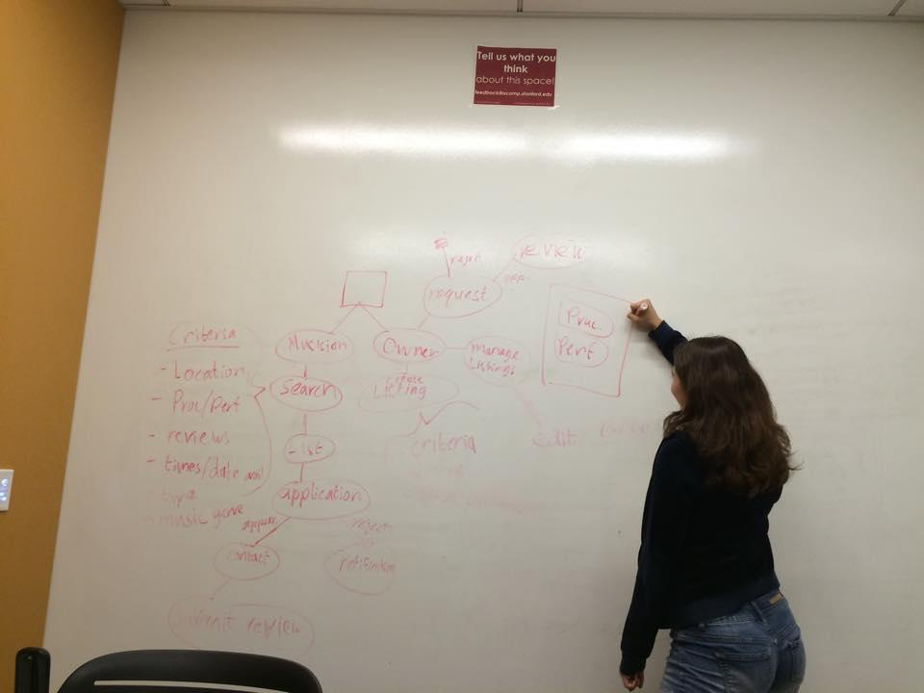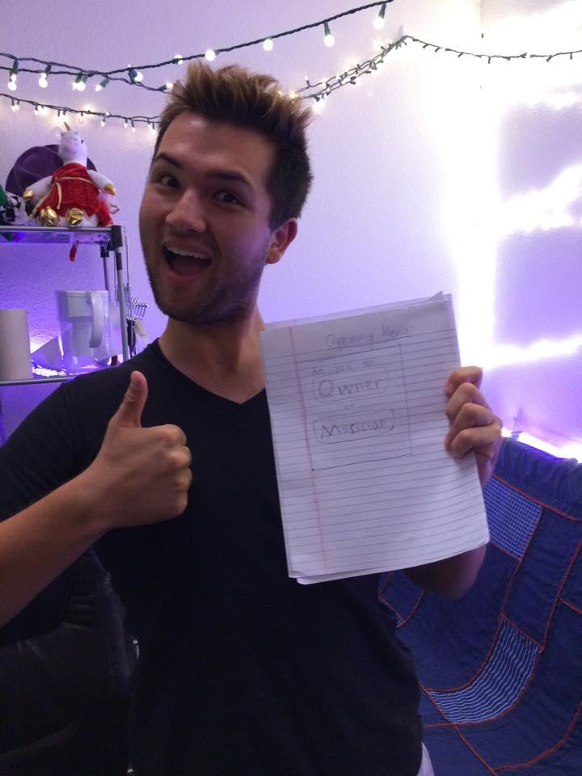

**Exposure**

A recurring problem we noticed amongst our interviewees was they spent a lot of time trying to get their names out, which detracted from the time could spend practicing. A specific example would be Brian, who struggled with the paradox of needing to say “no” to more things so he could focus on improving, but had to “say yes to everything” and attend late open jam session during the weeknights to play with other people and increase his exposure.

**Our assumption:**

* Musicians would benefit from app that helped them find ways to get more exposure

**How we made the prototype:**

* Started by bouncing around ideas like personal marketing managers and an online bulletin board
* Settled on an aggregator that compiled all the open gigs, media hotspots (open bulletin boards, open newspaper ad space, etc ), bands looking for people, and deals for physical resources (business card, poster, and flyer deals) in the local area.
* Followed same creation process as other two prototypes with flow chart and paper

**How we tested:**

* Had Jamie, a guitarist, singer, and songwriter, look through the papers

**Results:**

* She appreciated the “Gigs” feature, as she shared that “it’s hard to put yourself out there.”
* Saw the review system as a potential problem as bad reviews may hinder a musician from continuing to practice
* Commented that the “Resources” option might look too much like advertisements and turn musicians off.
* Suggested that we add a way for musicians to connect with students because many teach part time to make extra money.

Revisiting Assumption:

* Need to find gigs might not be as great as anticipated

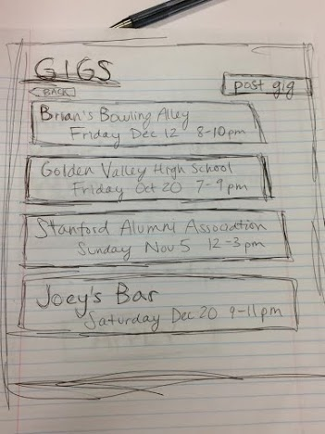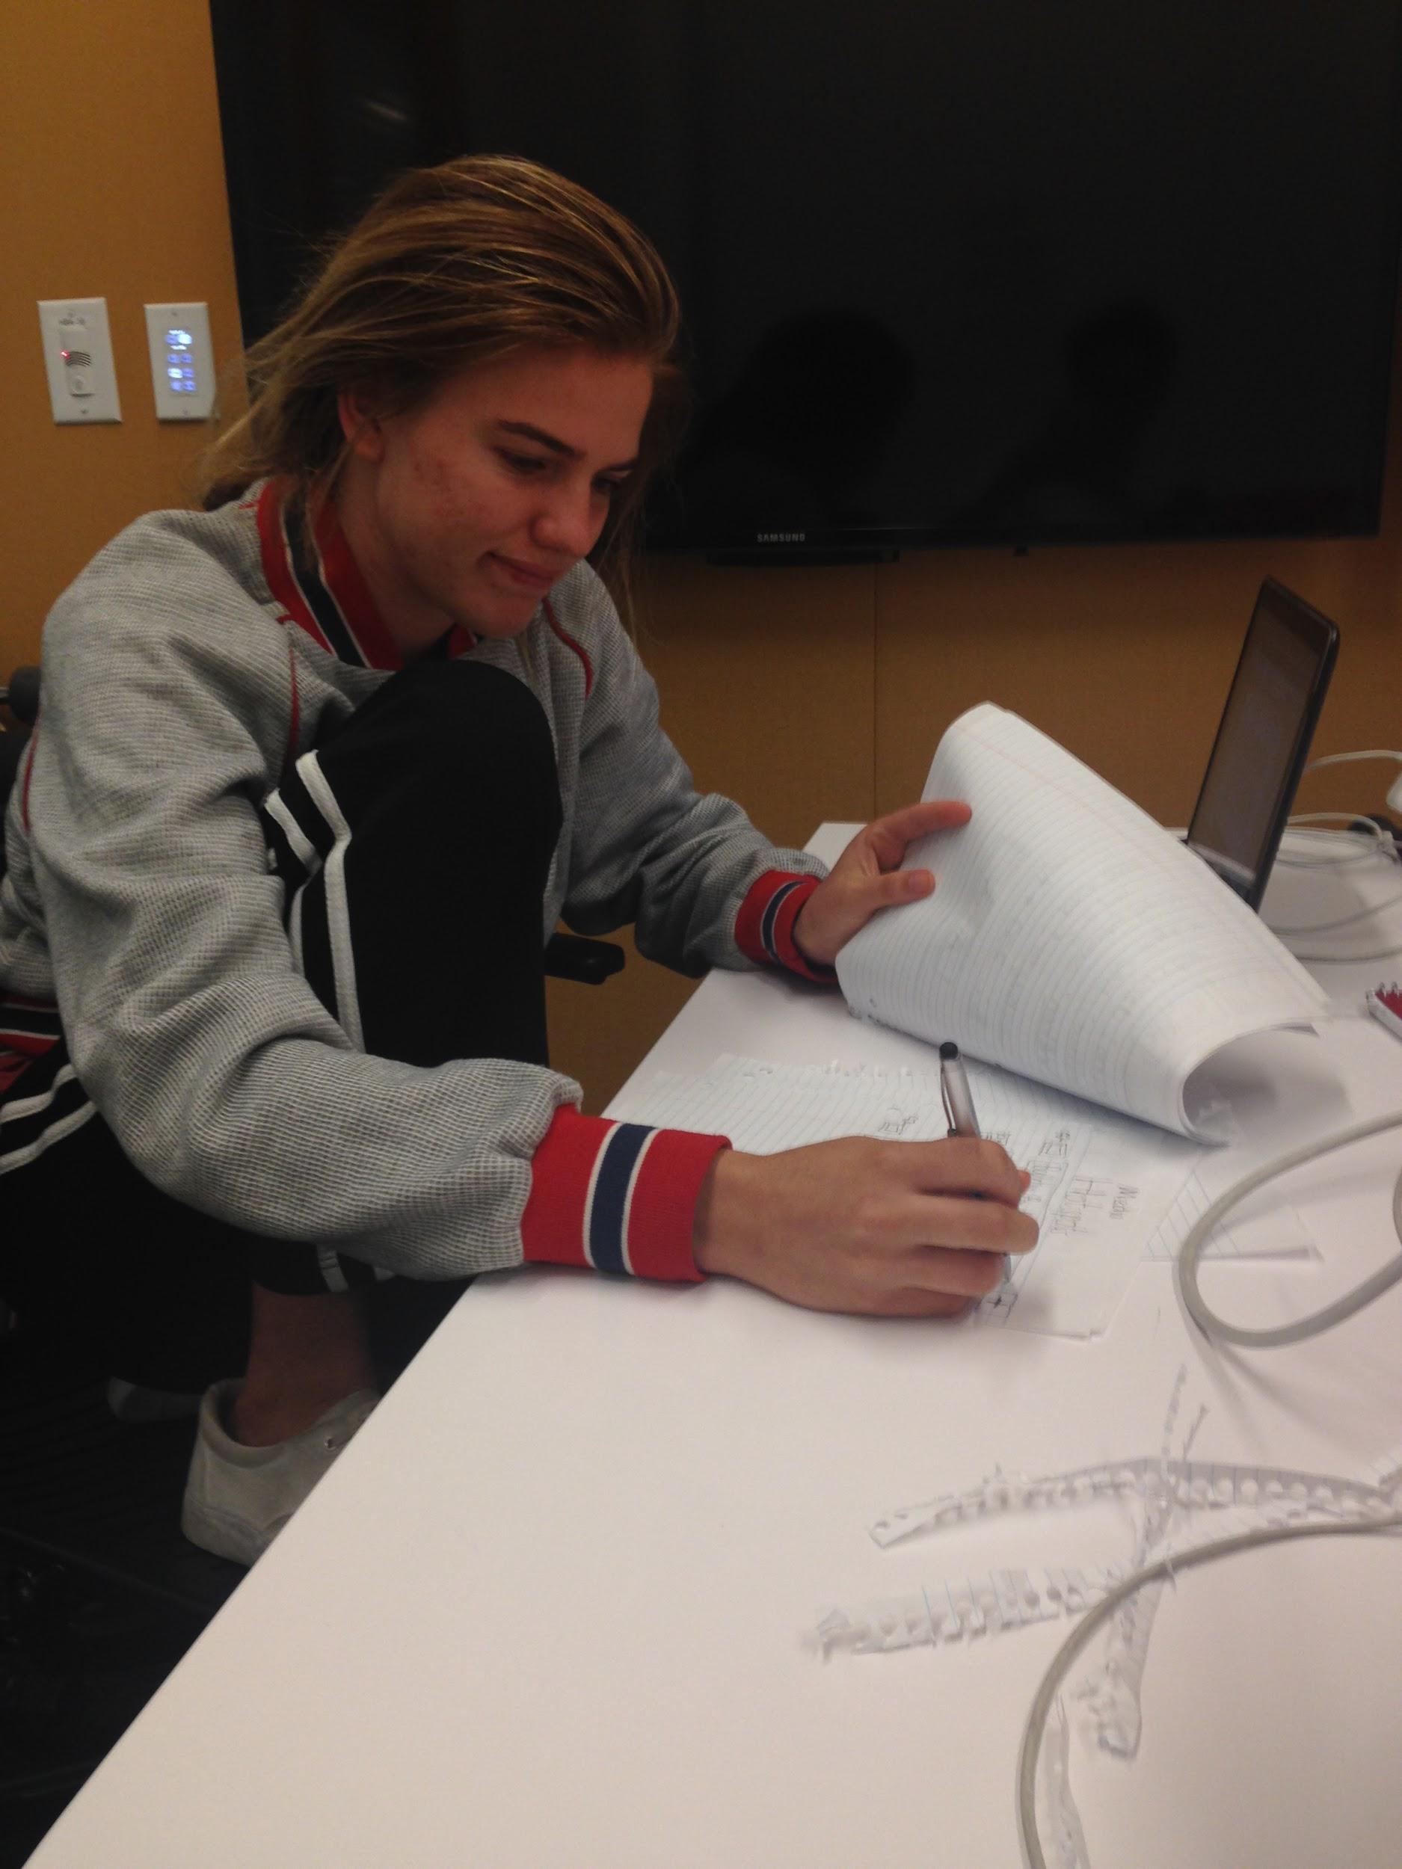

**Most Successful Prototype**

The prototype that was most successful in achieving a desired solution was the one used to help musicians find practice spaces.

* Airbnb for practice spaces
* positive feedback “I would totally use that”
* Simple, creative, addressing a relatively unknown need
* based off the insight of not having practice spaces (Amanda) and needing to network (Brian) → informal, fun way to achieve both