Team Enhancing Dancing
Andrew L, Lloyd L, Sharleen T, Krysten W
October 9, 2015
CS147
POVs and Experience Prototypes

Problem Domain

For our domain of interest, we are focusing on dancers in an attempt to understand their creative and choreographic process individually and in relation to their peers.

Initial POV

We met Andy.

We were amazed to realize that dancers don’t necessarily welcome feedback until a piece is “performance-ready.”

We felt it would be game-changing to allow dancers to feel comfortable with feedback throughout the creative process.

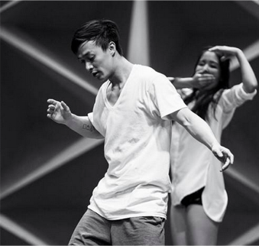

Additional Needfinding

To diversify our audience, we interviewed people who identified with other forms of movement creation outside of hip-hop. Mindy, a professionally trained ballet dancer, and Mel, a competitive Wushu champion both provided insights regarding their creative process in relation to music. Mel’s interview reinforced the importance of understanding music and timing for dance. Mina, a member of Berkeley’s Dragon Boat team, spoke on feedback on athletic techniques strengthening our hunch that people are more open to feedback concerning mechanical versus interpretive movement. Doris, a local Zumba instructor, explained that for her diverse audience, one that includes first-time and consistent students, it is important to establish a mix of simple, basic steps that provide a fallback for beginners and reduces frustration in the learning process.

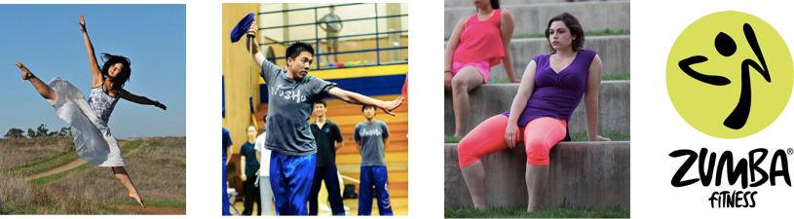

Revised POVs and Initial HMWs

- We met Mel.

We were amazed to realize that musicality—one’s ability to receive and comprehend musical concepts such as rhythm and tempo—is not merely a technical skill. Rather, musicality encompasses the individualistic process of matching movement dynamics to music in a unique manner to transform abstract movements into visual reflections of musical intricacies.

It would be game changing to allow dancers to expand their musicality by examining the musical interpretations of their peers.

Sample of initial HMW statements:

- HMW help dancers understand music visually?
- HMW connect or solidify movement to music?

- We met Tad.

We were amazed to realize that he creates choreography in non-chronological chunks whenever inspiration hits him. For him, the creative process is nonlinear, but the final piece of choreography must be fluid and continuous.

It would be game changing to provide dancers with a means of exploring the relationships between discrete, even disparate sequences of movements to create a unified piece.

Sample of initial HMW statements:

- HMW help dancers overcome “choreo-block?”
- HMW teach dancers to be more aware of their sources of inspirations and creative process?

- We met Andy.

We were amazed to realize that unlike many other creative genres, dancers do not often seek feedback until a piece is “performance ready.” This behavior ultimately is detrimental to the growth of dancers, who do not seek or receive different perspectives during the ideation of a piece. Instead, they gravitate towards taking feedback on “performance ready” pieces very personally.

It would be game changing to allow dancers to reframe pieces of choreography as dynamic “works in progress” in order to establish a new feedback cycle that integrates more effectively with the different stages of the creative process.

Sample of initial HMW statements:

- HMW leverage prior choreography to compare interpretations for similar music?
- HMW make dancers more receptive to feedback early on in the process?

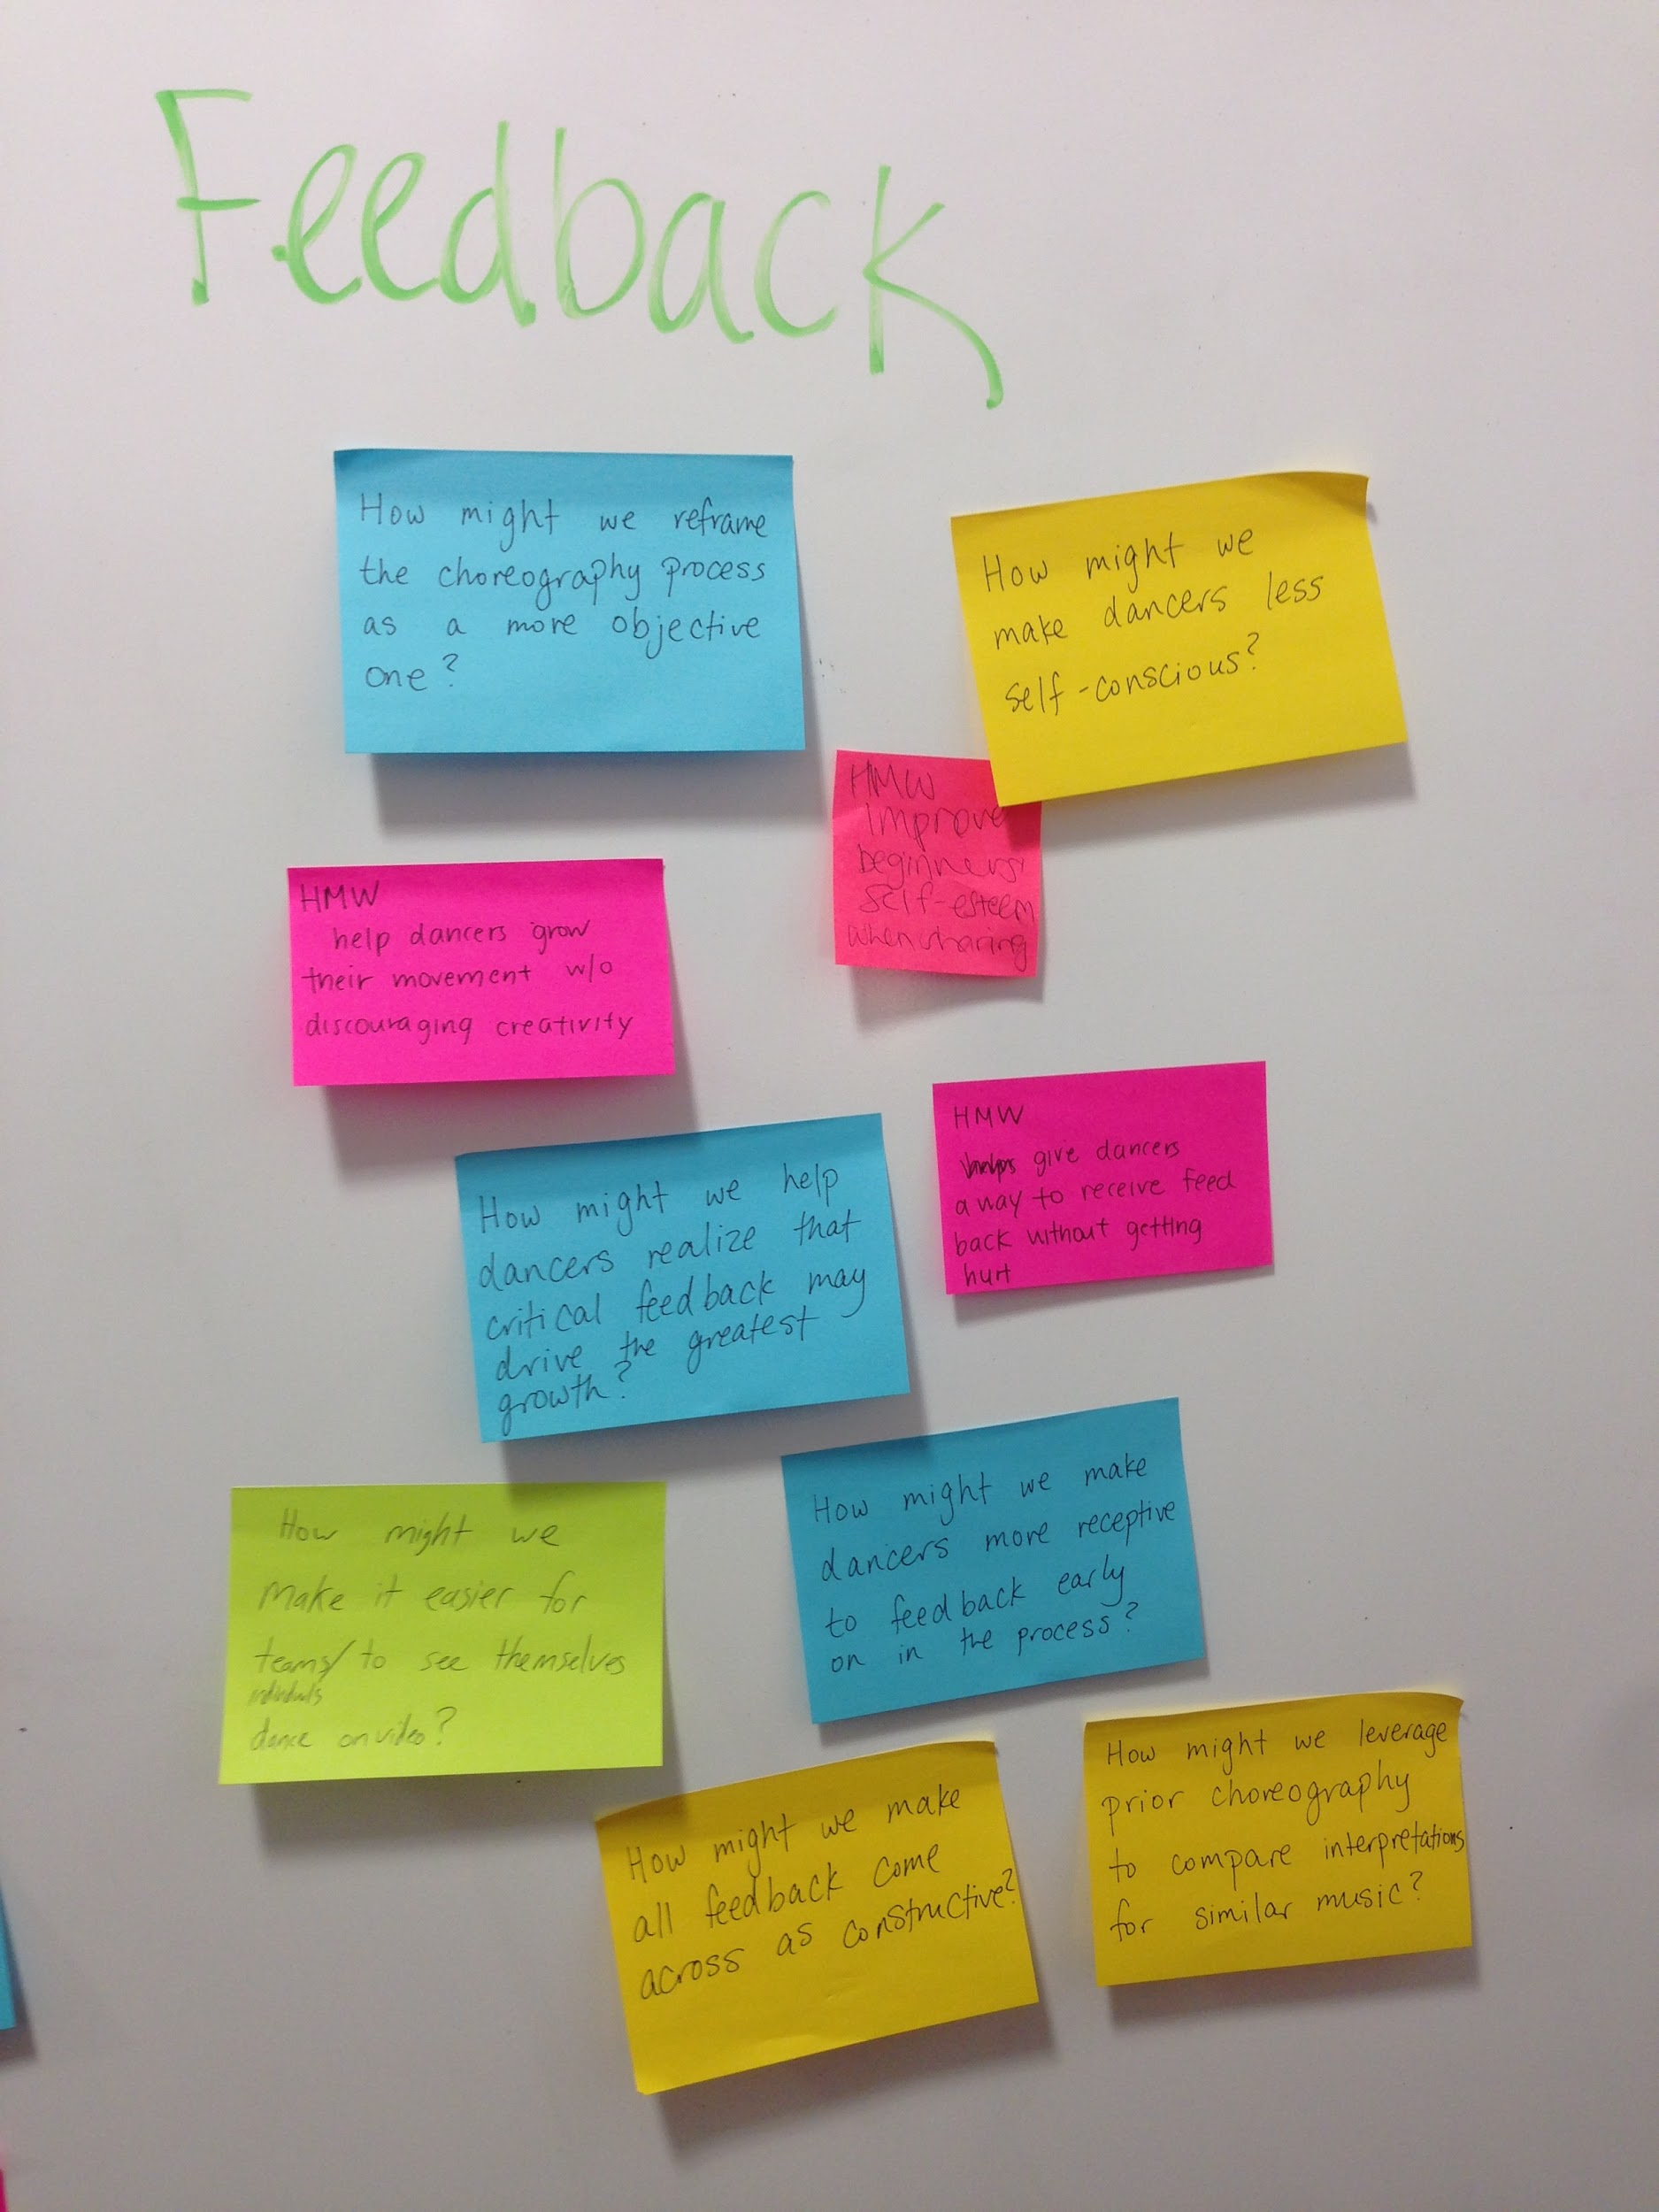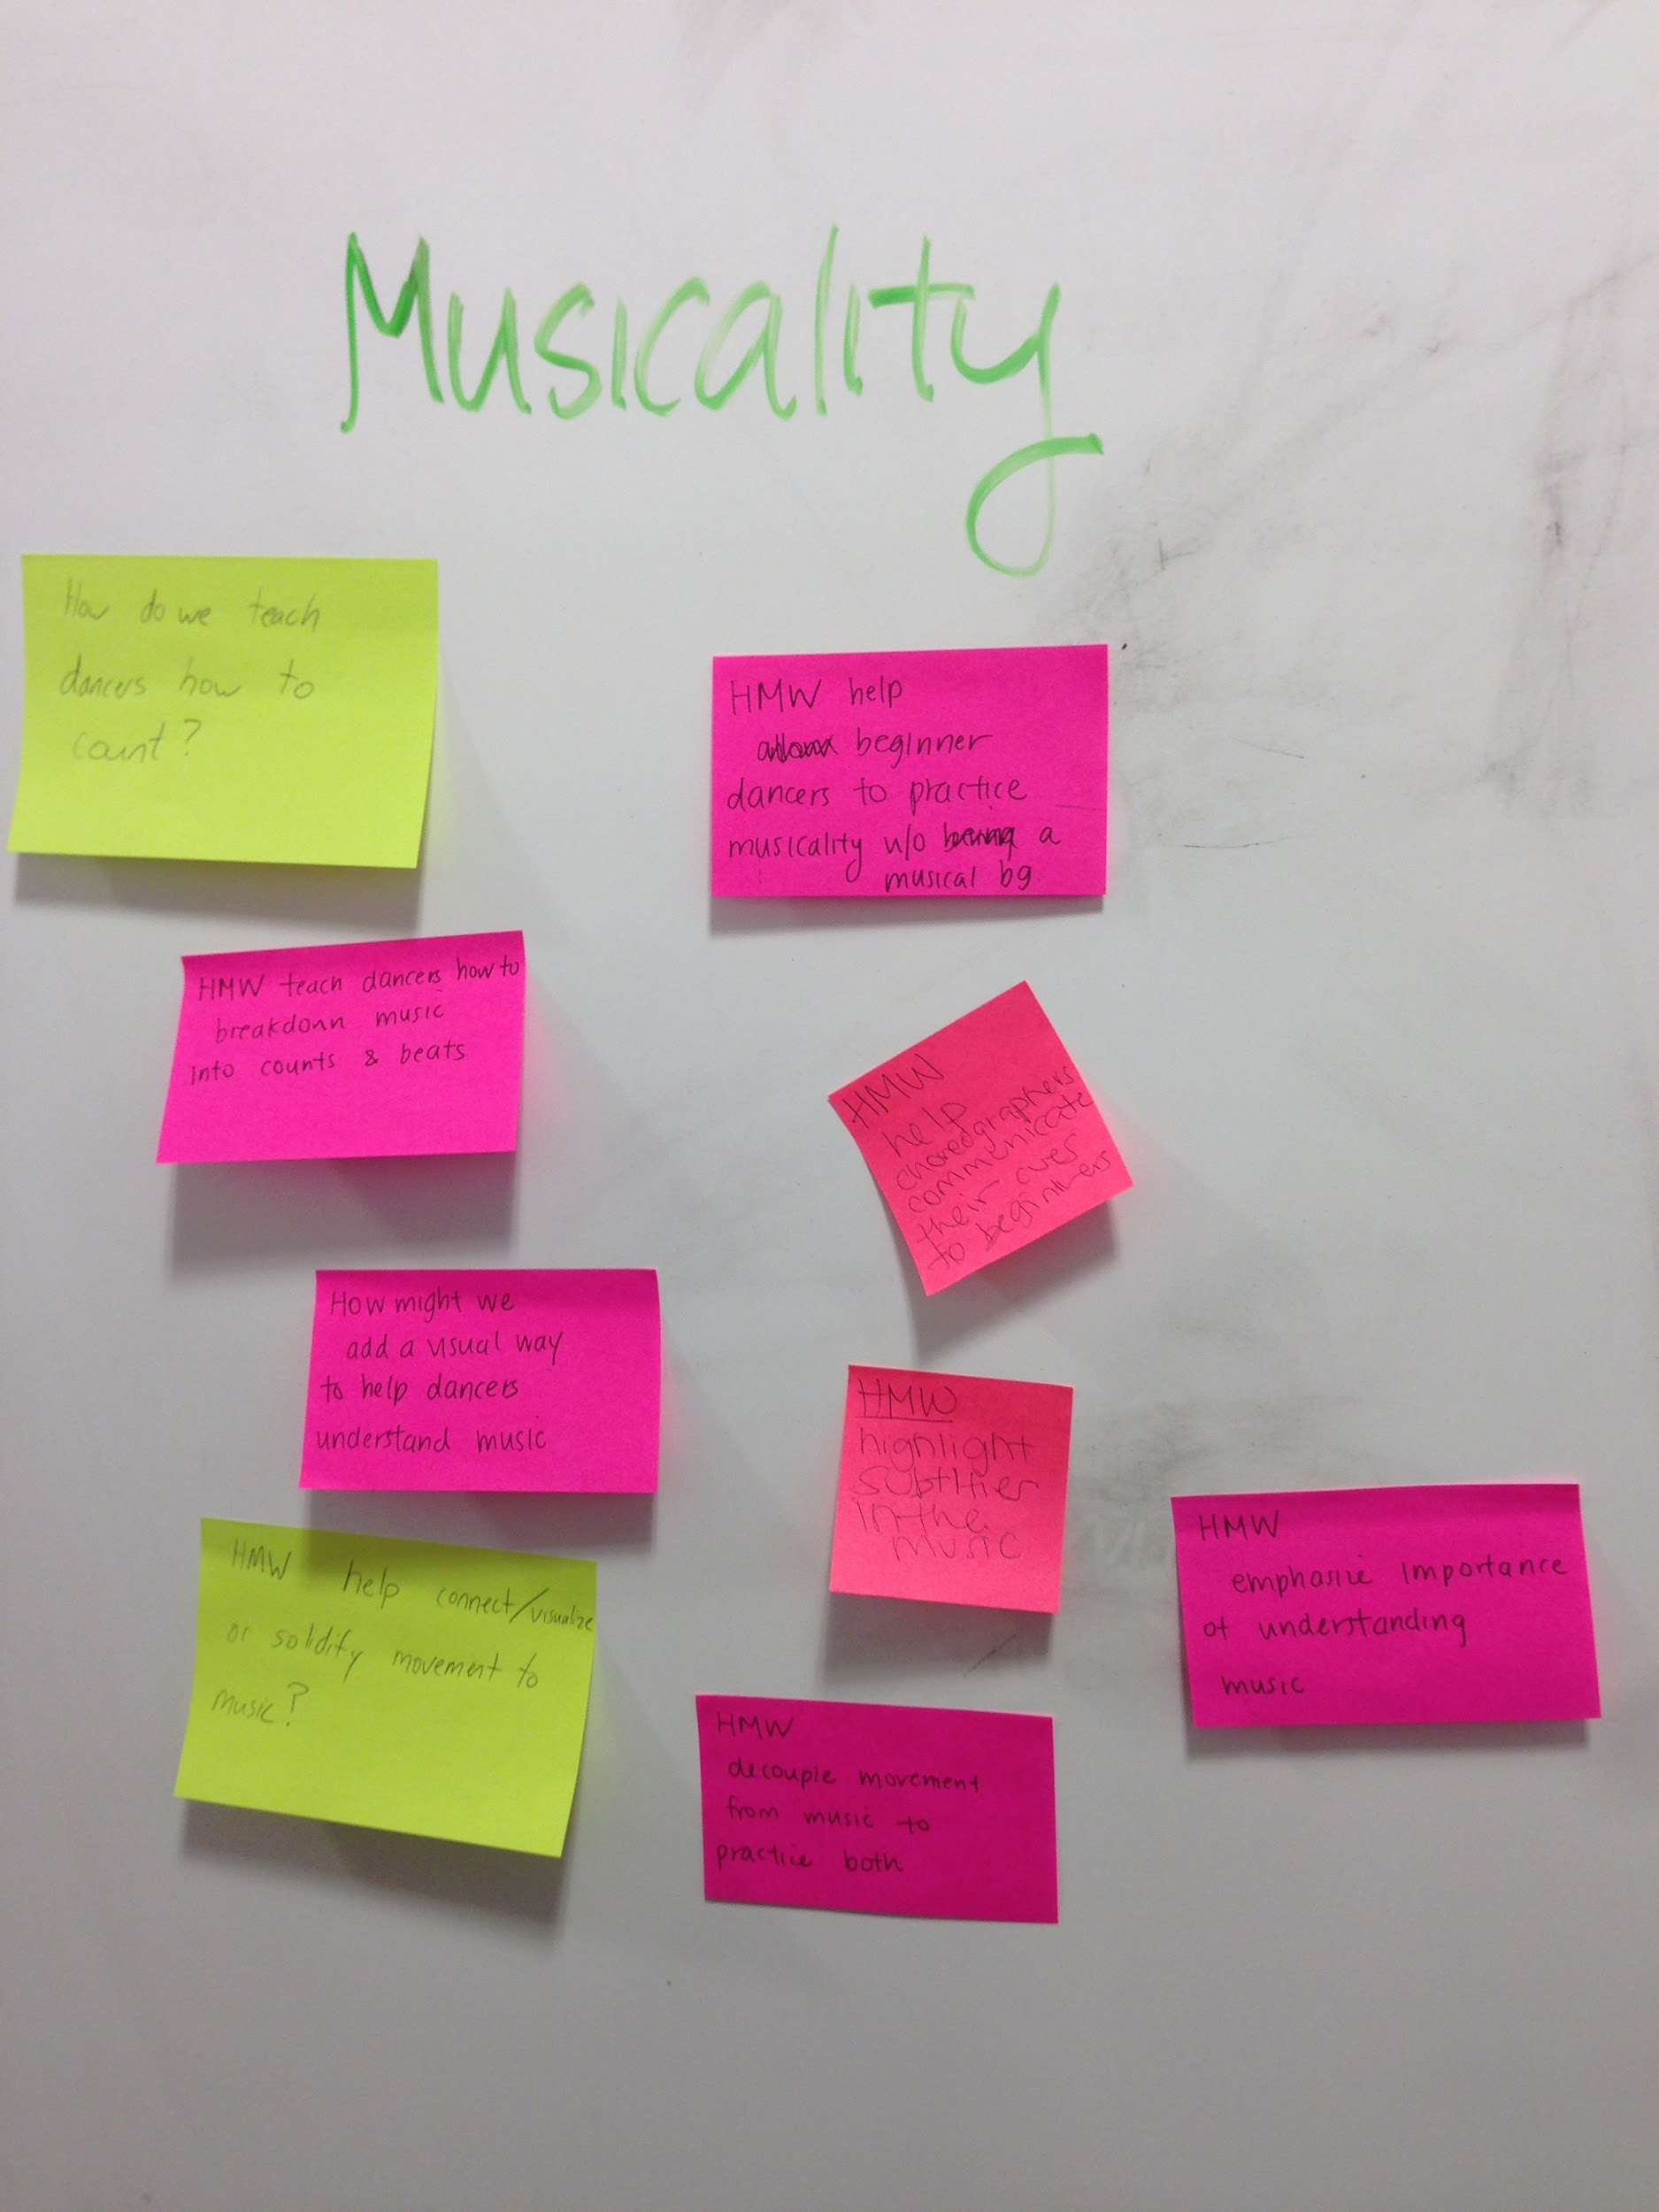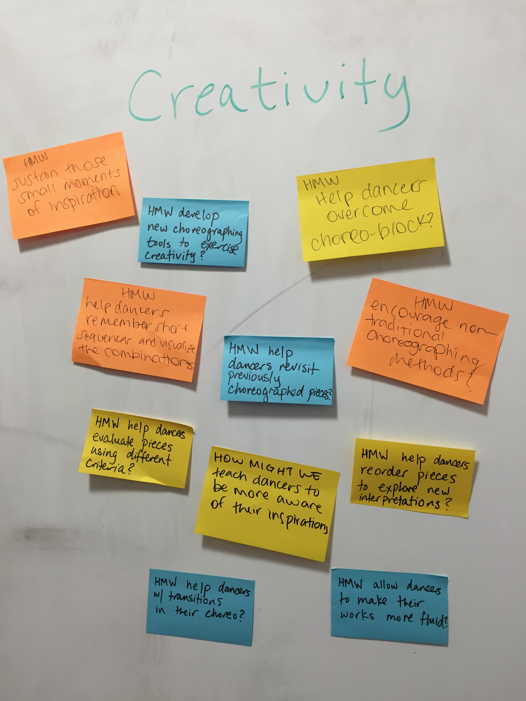

Selected HMWs
- POV 1: HMW help dancers visualize the auditory subtleties of music?

- POV 2: HMW encourage more collaboration in the predominantly individual choreography process?

- POV 3: HMW reframe all pieces of dance as “works in progress” to facilitate more open feedback?

Experience Prototypes

We came up with the following three prototypes: one that simulates live cheering, one that focuses on online collaboration, and one that allows sharing of different choreography to the same song. We tested these amongst eight dancers of varying dance experience and styles in addition to some individuals with no dance experience.

“TAP2CLAP”
For the cheering simulation idea, we tried to address anxieties stemming from receiving feedback and link feedback to timestamps to allow dancers to see specific moments that their audience enjoyed. This solution filters out all types of negative feedback and instead only allows for positive feedback. Overall, we hope to simulate cheering as part of a live audience.

We assumed that dancers will:
- Be comfortable uploading videos and having other people watch.
- Find the cheering-to-timestamp visualization helpful.
- Find it natural to tap/swipe/etc. the screen to “applaud.”
- Not interpret the lack of “cheering” at certain points as negative.

Scenario:
- Giving applause: In order to simulate cheering, the interviewee may tap, swipe, or do anything to the screen that may feel natural. For example, a tap equals a clap, a upswipe equals a shoe throw, etc.
- Receiving applause: We present the interviewee with a histogram visualization of the amount of “tap cheering” corresponding to specific time-stamps.

Roles:
- Viewer: watches the video and applauds with screen interactions.
- Dancer: uploads video and receives applause histogram.

Props:
- Applauding screen: paper/small whiteboard where user can tap to applaud.
- Feedback screen: paper with a histogram of applaud history for a video.

Results:
- Pros - Assumptions 1 and 3 held! Most interviewees agreed with Assumption 2 and 4. The execution for this prototype went smoothly and testing went as expected.
- Cons - Some dancers thought the cheering-to-timestamp visualization would incentivize choosing moves that cater to audience appeal, which is not always the goal for all types of dance. In addition, the feedback may incentivize dancers to focus specifically on their strong points rather than what they need to work on. For self-critical individuals, low points in the histogram may still be taken negatively, contradicting Assumption 4. Finally, we had not previously considered the significant audience of passive watchers, who may not feel compelled to clap while watching videos and thus may not find this experience interesting.
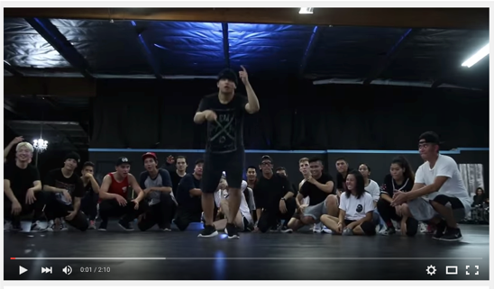
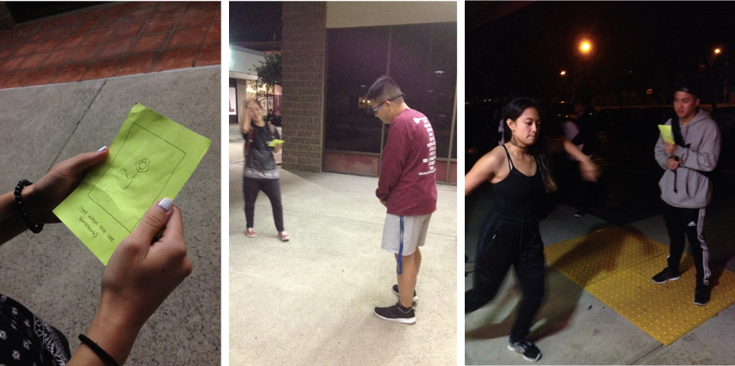
“BOOTS AND CATS”

For this experience prototype, we decided to address insights regarding frustrations surrounding musicality by building off two themes from our needfinding: musicality and feedback reception. We found that the inability to fully understand musicality detracted from a dancer’s choreographic growth and ability to learn pieces from teachers. For feedback, we observed that while all of our users recognized the importance of feedback, they all shied away from seeking feedback either because of emotional attachment to their choreography or technical obstacles that hampered the process of obtaining feedback.

We assumed that dancers will:
- Want to work on musicality but don’t have established means of learning.
- Are emotionally attached to their choreography, which limits receptivity to feedback. A dancer whose intention is to obtain mechanical/objective feedback on movement will be more open.
- Can improve their musicality by listening to music and choreographing frequently.
- Will improve their musicality by viewing other dancers’ interpretations of songs.
- Enjoy giving constructive feedback to other dancers and can do so without being offensive.

Scenario:
- Dancers interact on a platform where music is provided to choreograph to, where they can see other dancers’ interpretations of the same song, and can send comments to each other.

Roles:
- Beginner dancer: listens to music, choreographs and uploads it.
- Intermediate dancer: listens to music and browses videos to see how other choreographers interpreted songs
- All dancers who provide feedback.

Results:
- Pros - Observations backed Assumption 4 and indicate that it would be beneficial to see contrasts between different dancers performing to the same song. Several dancers confirmed Assumptions 2, 3 and 4.
- Cons - We had many unmet expectations during testing. For Assumption 1, we discovered that not everyone has a deep urge to go out of their way to improve their musicality. In fact, some people believed that there is actually no way for people to “improve musicality” since music can be interpreted in innumerable ways. In addition, some people believed that YouTube already provided the platform for choreography comparisons to the same song. Assumption 5 was challenged by testers who felt that malicious users may comment with negative, unconstructive feedback. The most significant downside to this prototype is that it tries to solve too many problems. Since we tried to tackle musicality training, sharing videos, and receiving feedback, our test users were confused about the purpose of the application and generally were not excited about the idea.

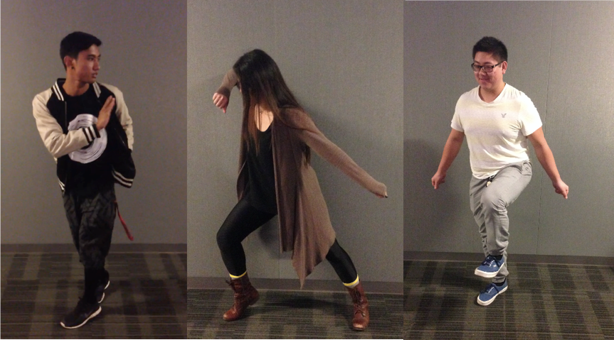

“CHOREOLAB”

Throughout our interviews, a recurring painpoint involved frustration with maintaining motivation throughout the creative process. A lot of our users would feel inspired in the moment and feel an intense surge of creativity and energy; it was really hard, however, for them to sustain that energy. Often times, they would not only lose the motivation to continue, but just completely scrap the idea.

To support spontaneity, we created an experience prototype that assumed dancers:
- Like creating something fun in a collaborative manner.
- Will contribute to choreography that included other people’s different interpretations of the song.
- Enjoy choreographing snippets of a song.

Scenario:
- This prototype involves playing a song for the first dancer, recording a two 8-count dance clip, and “passing it on” by clicking a paper prototype button. The next dancer would watch the video and record the next two 8-counts. This process would continue for a few more dancers before they came together to watch the compiled version.

Roles:
- Starter: chooses a song and choreographs/records up to two 8-counts.
- Contributor: receives the recording and adds on additional 8-counts.
- Passive browser: non-dancer who just wants to watch compilation videos.
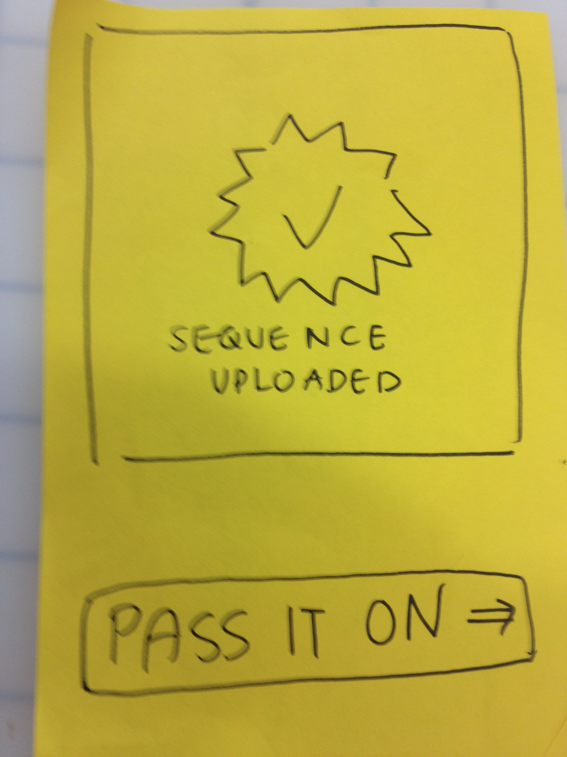

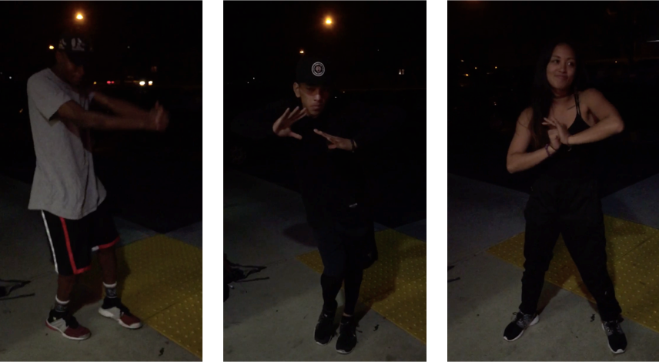

Results:
- Pros - Everyone strongly agreed with Assumption 1, and dancers understood their roles well. Dancers expressed how “cool” it was to watch the final compiled video and noted that this would be a great platform for people to experience a range of diverse interpretations to a single song. Even non-dancers would be interested in watching completed compilations.
- Cons - Some thought that this application did not align with their views on the choreography process but would cater more towards the general public. Others also indicated that the choreography process is an individual one, and often a choreographer needs more than two 8-counts to express their intent. Some users were also concerned that the final result would have too many dancers leading to a choppy end result.

Most Successful Prototype:

We asked interviewees which interaction they favored most, and all pointed to “ChoreoLab.” This experience indirectly helped dancers break out of “choreo-block,” a recurrent frustration encountered throughout our needfinding process. Dani, a dancer from San Jose, enjoyed “building off the last person’s movement” and supported the “flow of one energy” that “ChoreoLab” provided. She explained that “sometimes it’s hard to start and you don’t know where to start. This gives you that jumping off point.” For her and many of our other users, “ChoreoLab” would not necessarily guide the formal choreography process but would be welcomed as a tool to more frequently exercise and expand upon bursts of creativity.

